REHAN JOSEPH
(2404834)
Introduction To Web And Database Concepts
ACCA4023
Assignment 2
10 January 2025


Contents
Introduction 3
Website Screenshots 3
Validation 6
Website Usability 7
Website Accessibility 8
Importance of Accessibility 8
Search Engine Optimization (SEO) 9
Importance of SEO 9
Evaluation of the Website 9
1. Usefulness (Usability and Utility) 9
2. Search Engine Optimization (SEO) 10
3. Accessibility 11
Conclusion 12
Appendices 14
Home.HTML 14
Home and Attraction.CSS 15
Attractions.HTML 22
Beaches.HTML 25
Beaches.CSS 27
Culture.HTML 30
Culture.CSS 33
Contact.HTML 36
Contact.CSS 38

Figure 1 : Home Page 4
Figure 2 : Attractions Page 5
Figure 3: Beach Page 5
Figure 4: Culture Page 6
Figure 5: Contact Page 6
Figure 6:HTML Validation 7
Figure 7:CSS Validation 8
Figure 8 11
Figure 9:Contract Checker 12

Introduction
The website, "Visit Durban," is designed to showcase the vibrant culture, stunning landscapes, and unique attractions of Durban, a coastal city in South Africa. The primary purpose of the website is to serve as a virtual getaway for locals and tourists, offering a comprehensive guide to the city’s top attractions such as beaches, cultural heritage, and iconic landmarks. The website aims to inspire visitors to explore the beauty and diversity of Durban, whether they are planning a relaxing getaway, an adventurous trip, or simply seeking to learn more about the city.
With a visually appealing and user-friendly design, this website targets a diverse audience, including:
- Travel enthusiasts looking for new destinations.
- Families and vacationers searching for activities and accommodations.
- Students and researchers interested in Durban’s cultural and historical significance.
Combining engaging visuals, well-structured content, and interactive features, the website strives to create an immersive experience highlighting why Durban is often regarded as one of the dynamic and welcoming cities of South Africa.

Website Screenshots

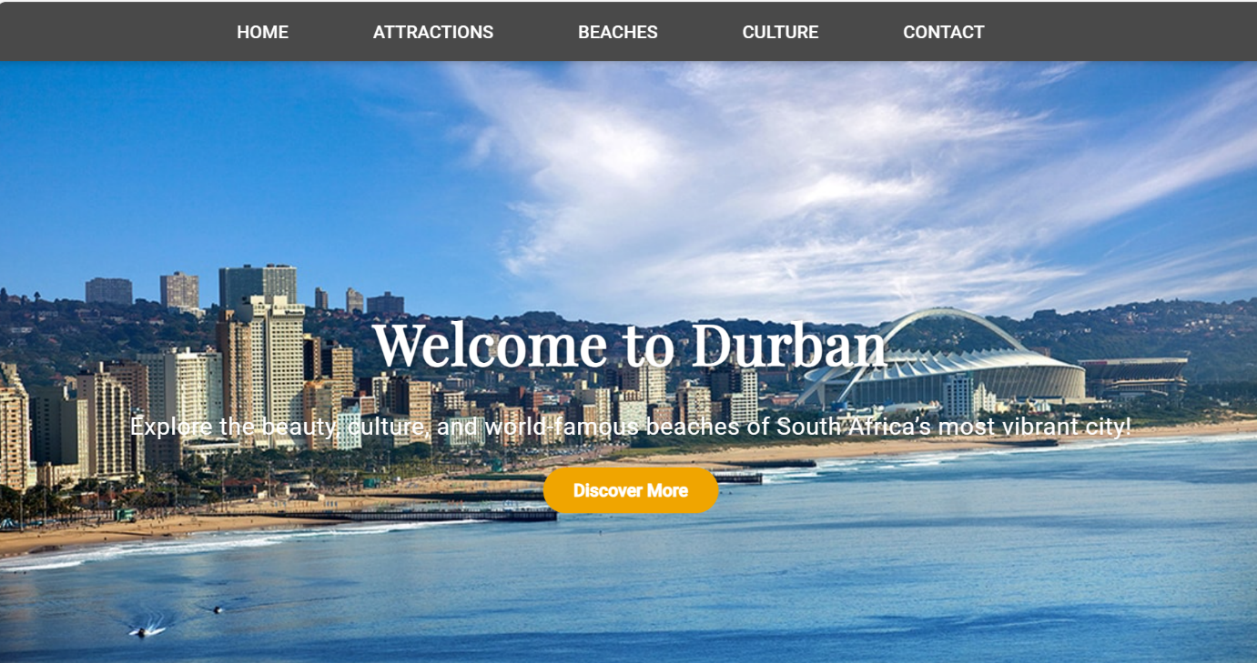
Figure 1 : Home Page
Figure 1 shows the home page of the website from where users can navigate to the rest of the pages.
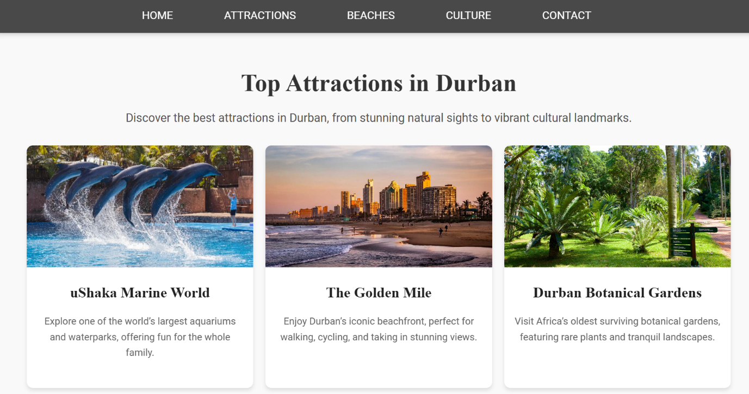
Figure 2 : Attractions Page
The information about top attractions and the beaches are displayed on Figures 2 and 3.
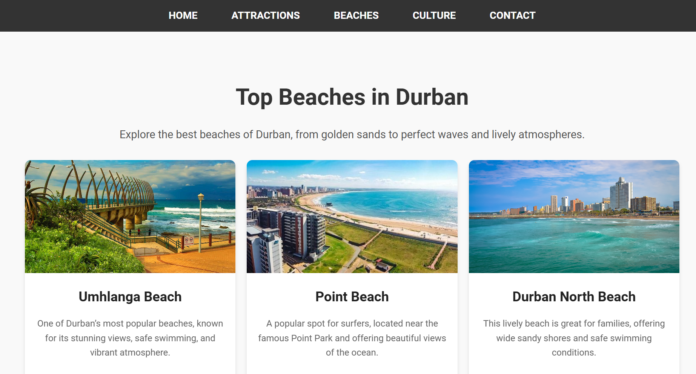
Figure 3: Beach Page
Top beaches in South Africa is displayed in Figure 3.

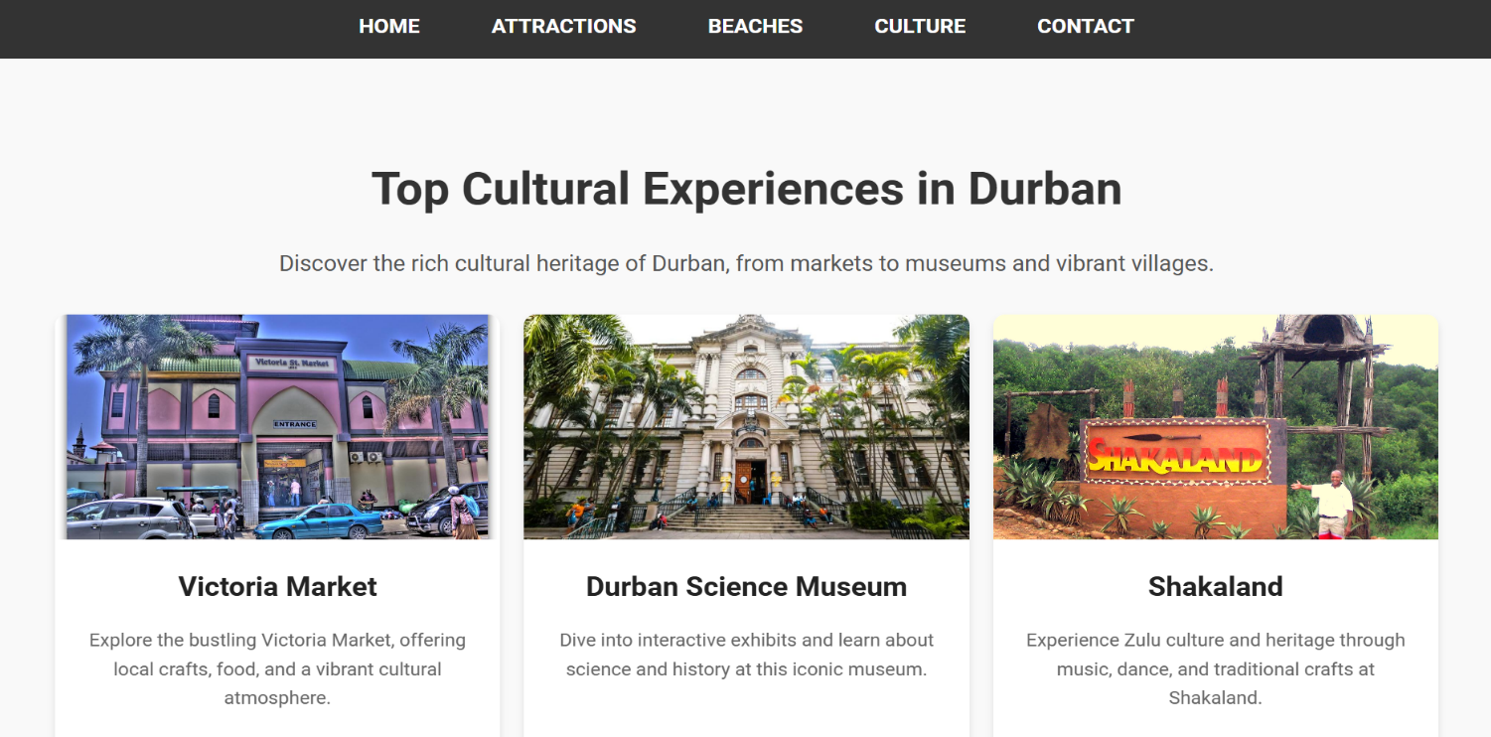
Figure 4: Culture Page
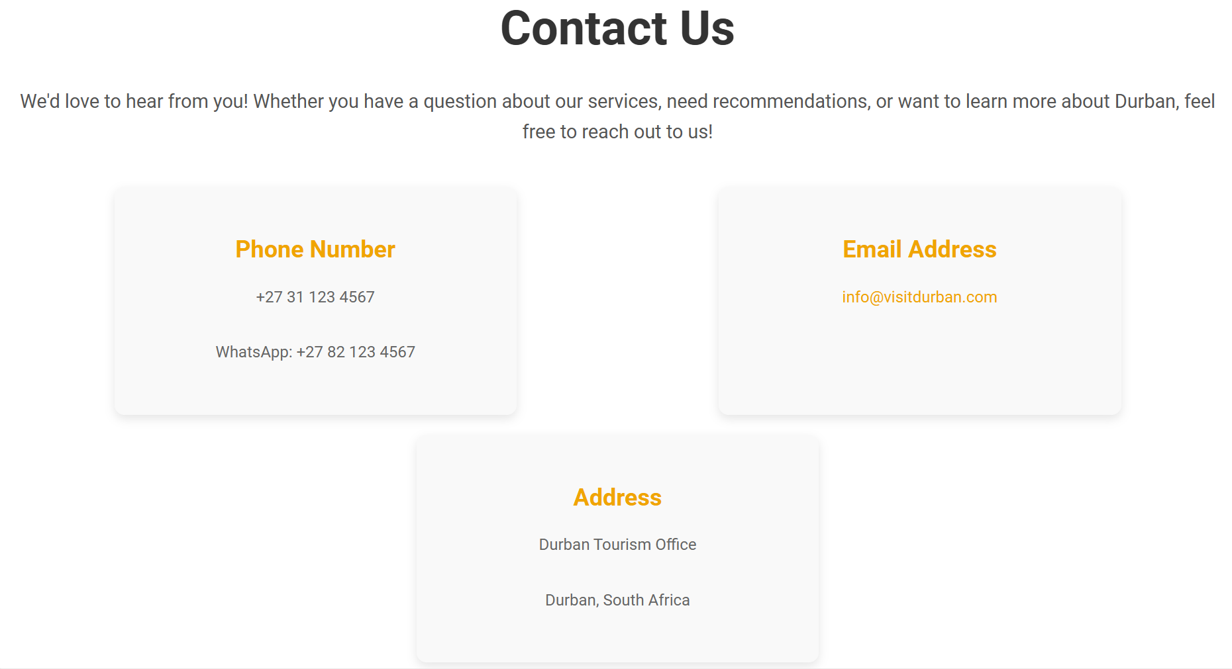
The information about top Cultural locations in Durban is shown in Figure 4.
Figure 5: Contact Page
The Contact Page is displayed in Figure 5.

Validation
Validation is the process of checking if HTML code follows proper syntax and standards.
Why it's important:
- Ensures the code is error-free and works across different browsers.
- Improves website accessibility and SEO.
- Helps create a better user experience by avoiding broken elements.
An HTML validation tool was used to check the code for errors and to fix issues to make the code clean and standards-compliant.

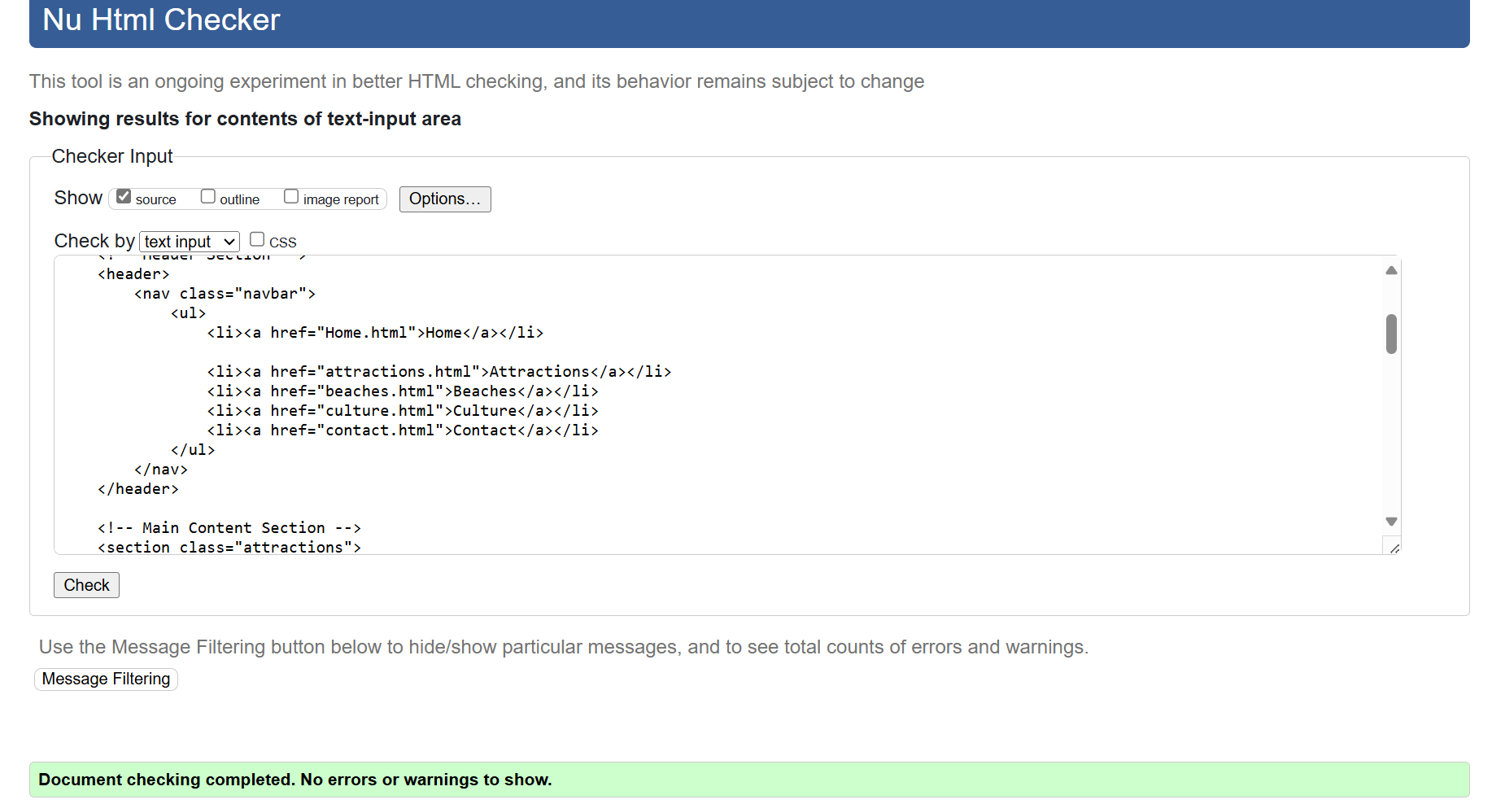
Figure 6:HTML Validation
The HTML file had no errors and was fully valid.

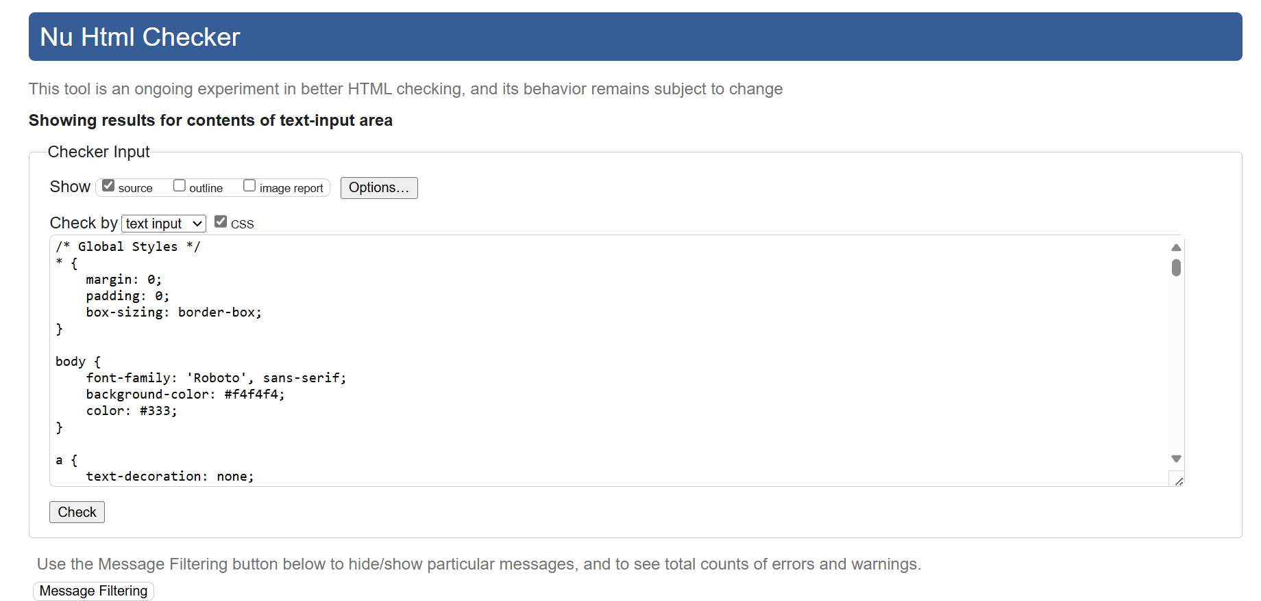
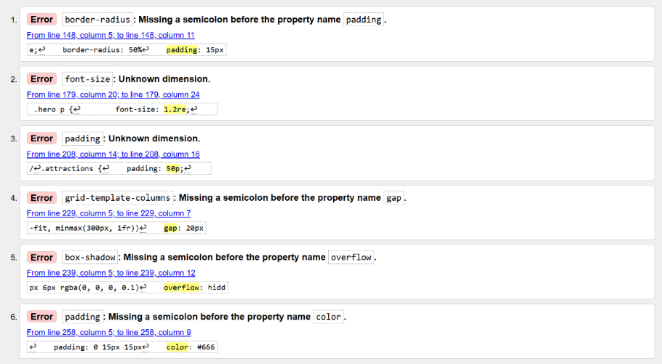

Figure 7:CSS Validation
The CSS file had minor issues, primarily simple typographical errors such as missing semicolons and invalid units. These small mistakes, like forgetting a semicolon or mistyping a unit, can cause styles not to render correctly. They were straightforward to fix and won't impact functionality once corrected.

Website Usability
Website usability refers to the ease with which users can navigate, interact with, and achieve their objectives on a website[1].It is a critical aspect of web development that focuses on creating user-centered designs to enhance the overall experience. A highly usable website ensures visitors can find information quickly, understand the content with minimal effort, and perform tasks efficiently without confusion or errors.
Key components of usability include:
- Ease of Navigation: Users should be able to move through the website intuitively, using well-structured menus and clear navigation paths.
- Clarity of Content: Information should be presented in a readable format, using simple language, appropriate headings, and a visually appealing layout.
- Responsiveness: The website should function seamlessly across different devices and screen sizes, ensuring accessibility for mobile and desktop users.
- Efficiency: Tasks such as filling out forms, searching for information, or contacting support should be simple and fast, reducing user frustration.
A study analyzing INC. 500 company websites found that while some design guidelines are commonly followed, there is significant variation in adherence to usability principles, suggesting that many websites could benefit from improvements in areas such as link appearance and navigation, which are vital for enhancing usability[2].
The importance of website usability lies in its ability to provide a positive user experience, directly impacting a website's effectiveness, engagement, and retention rates. Conversely, poor usability can lead to user dissatisfaction, abandonment, and reduced credibility.

Website Accessibility
Website accessibility means designing a website so everyone, including people with disabilities, can use it. This includes ensuring people with vision, hearing, movement or learning challenges can access and interact with the content[3].
Key parts of accessibility are:
- Perceivable Content: Everyone should be able to see or hear the content. For example, adding captions to videos helps people who are deaf, and using alt text for images helps people using screen readers.
- Operable Features: The website should work with a keyboard or other assistive tools for people who can’t use a mouse.
- Understandable Design: The website should be easy to understand, with clear instructions and simple layouts.
- Robust Compatibility: It should work well with tools like screen readers or voice controls on all devices.

Importance of Accessibility
Website accessibility is a critical aspect of the overall quality of a website, particularly for ensuring that all users, including those with disabilities, can effectively engage with online content. Research indicates that many websites fail to meet accessibility standards, which can significantly hinder the ability of individuals with disabilities to access essential information and services. For instance, a study evaluating consumer health information websites found that none of the sites were fully accessible, highlighting a pervasive issue across various categories of websites, including governmental and educational sites, which performed better but still had significant accessibility violations[4].
The importance of implementing web accessibility strategies is underscored by findings from a qualitative study involving web developers. This research revealed that awareness, experience, and training in accessibility are crucial for creating websites usable by people with disabilities. Developers emphasized the need for organizations to commit to accessibility, which can enhance the overall user experience and interaction with the web[5].

Search Engine Optimization (SEO)
Search Engine Optimization (SEO) is the process of improving a website to appear higher in search engine results, like Google[6]. The better a website’s SEO, the easier it is for people to find it when they search for related topics.
Key parts of SEO include:
- Keywords: The website content should use the right words or phrases that people search for, such as "Top attractions in Durban. "
- Page Structure: Organizing content with headings, subheadings, and short paragraphs to make it clear and easy to read—for both users and search engines.
- Meta Tags: Adding titles and descriptions behind the scenes to help search engines understand what each page is about.
- Image Optimization: Using descriptive names and alt text for images so they show up in image searches.
- Fast Loading Speeds: Making sure the website loads quickly, which search engines prefer.

Importance of SEO
SEO makes it easier for people to find your website, which can bring in more visitors. A website that ranks higher on search engines is more likely to get clicks, making it a powerful tool for reaching your audience. For example, if someone searches "best beaches in Durban," SEO ensures your website appears near the top of the results.
Search Engine Optimization (SEO) plays a significant role in enhancing a website's quality and visibility. It is a process aimed at improving the visibility, volume, and quality of traffic to a website through natural search results, which is crucial for effective Internet marketing strategies [4]. The techniques involved in SEO, such as keyword research, on-page optimization, and off-page optimization, are essential for increasing a website's presence on Search Engine Results Pages (SERPs) [7].

Evaluation of the Website

1. Usefulness (Usability and Utility)
Usability (Look and Feel, Ease of Use)
This website features a clean and user-friendly design that ensures visitors can easily navigate through various sections such as Attractions, Beaches, Culture, and Contact. The layout is consistent across all pages, maintaining a familiar structure with a navigation bar at the top for quick access to key areas. The font choices, such as 'Roboto' and 'Lora', provide clear readability, and the overall color scheme is visually pleasing, which enhances the user experience. The images add visual appeal, while the text remains legible even against background images, making the site both functional and engaging.
Utility (Functionality)
The website’s functionality is strong, with key pages like Attractions, Beaches, and Contact delivering essential information about Durban's tourist offerings. The interactive elements, such as the contact form and navigation menu, work smoothly across different pages. The sticky navigation bar ensures that users can easily access other sections, even as they scroll through content. The contact form is straightforward, allowing users to get in touch easily. One area that could be improved is the load time for images on pages like Attractions, where high-resolution images may cause delays for some users.
Content (Information)
The content across the website is relevant and informative, covering various aspects of Durban’s tourism offerings. Each page provides succinct yet comprehensive details about each attraction, cultural destination, and beach. However, more detailed descriptions, such as opening hours, ticket prices, and visitor reviews, could be added to enhance the richness of the content and provide additional value to users.
Recommendations for Improvement
- Optimize image sizes to improve load times, especially for pages with multiple images (e.g., Attractions).
- Add more detailed content, such as visitor reviews or FAQs, to improve the utility of the website for potential tourists.

2. Search Engine Optimization (SEO)
The website has implemented several key SEO techniques that help improve its visibility in search engines. These include the use of relevant meta tags, proper alt attributes for all images, and clean URL structures. The meta viewport tag is used across all pages, ensuring the website is mobile-responsive and scales well on different devices. This is crucial for SEO, as search engines prioritize mobile-friendly websites.
SEO Techniques Applied
- Title Tags: Each page has a unique and descriptive title, such as "Welcome to Durban" on the homepage and "Top Attractions in Durban" on the attractions page as shown in Figure 8. These titles are optimized for search engines and provide users with relevant information about the page content.
Figure 8

- Alt Text for Images: Every image on the website has an alt attribute, providing descriptions that improve accessibility and SEO. For example, the main image on the homepage has an alt tag describing the image as "Durban City View." This practice enhances search engine ranking while also making the website more accessible.
- URL Structure: The URLs are simple and clean, such as attractions.html, which helps improve SEO by making it clear what the page is about.
Recommendations for SEO Improvement
- Implement and optimize meta descriptions for each page, including relevant keywords to improve click-through rates from search engines.
- Consider adding schema markup to provide search engines with more detailed information about the website's content, such as events, attractions, or reviews.

3. Accessibility
The website has several features that promote accessibility. These include the use of alt text for all images, clear contrast between text and background colors, and a clean layout that supports various assistive technologies. The website’s design follows the WCAG 2.1 principles of accessibility: Perceivable, Operable, Understandable, and Robust.
Evaluation of WCAG 2.1 Principles
- Perceivable: The text on the website is legible with sufficient contrast against the background. The use of alt text for all images ensures that visually impaired users can understand the content through screen readers.
- Operable: The navigation is simple and intuitive. Users can easily interact with the site, whether through mouse, keyboard, or touch. The navigation bar ensures that users can navigate the website easily, even as they scroll.
- Understandable: The language used throughout the website is simple and easy to understand. The structure is logical, and the content is divided into sections for easy scanning.
- Robust: The website is compatible with different browsers and devices, ensuring that it functions well on both desktop and mobile. The use of meta viewport ensures that the site is responsive across different screen sizes.
Tools Used for Accessibility Evaluation
- Contrast Checker: The website has been tested for color contrast and meets the recommended standards for readability as shown by the figure below.
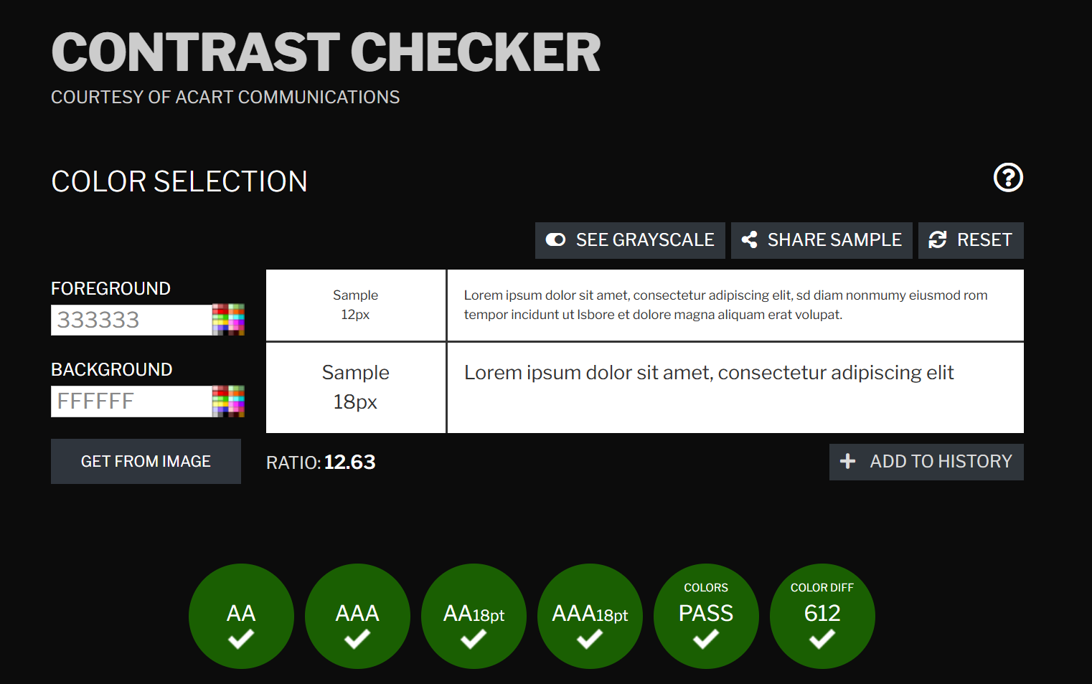
Figure 9:Contract Checker
- aXe and WAVE: These tools can be used to evaluate the website's accessibility further. Based on initial inspection, the website appears to meet accessibility standards, but testing should be conducted to ensure ongoing compliance.

Recommendations for Accessibility Improvement
- Ensure all interactive elements, such as forms and buttons, have proper focus states for keyboard navigation.
- Add skip navigation links to allow users to quickly jump to the main content, which is important for screen reader users.
- Consider implementing accessible forms, ensuring labels are linked to form inputs for better screen reader compatibility.

Conclusion
The Visit Durban website effectively combines usability, functionality, and accessibility to create an engaging and informative user experience. The content is well-organized, and the design is visually appealing, ensuring that visitors can easily access the information they need. SEO techniques are correctly implemented, and accessibility features such as alt text and color contrast have been considered.
For future improvements, it would be beneficial to optimize page load times, enhance SEO through better meta descriptions and schema markup, and ensure that the website continues to meet the highest accessibility standards. By continuing to improve in these areas, the Visit Durban website will be well-positioned to attract more visitors and provide an inclusive and engaging user experience.

References
[1] Ramotion. "Website Usability 101: Definition, Principles and Methods | Ramotion Agency." https://www.ramotion.com/blog/website-usability/ (accessed Jan 10).
[2] J. J. Cappel and Z. Huang, "A Usability Analysis of Company Websites," The Journal of computer information systems, vol. 48, no. 1, pp.117–123, 2007. doi: 10.1080/08874417.2007.11646000.
[3] T. Kotze. "Your Guide to Website Accessibility: Standards and Why it Matters." https://www.itineris.co.uk/blog/website-accessibility-standards/ (accessed Jan 10).
[4] X. Zeng and B. Parmanto, "Web content accessibility of consumer health information web sites for people with disabilities: a cross sectional evaluation," Journal of medical Internet research, vol. 6, no. 2, pp.e19, 2004. doi: 10.2196/jmir.6.2.e19.
[5] G. Hrežo, "Website Accessibility Strategies," ProQuest Dissertations & Theses, 2022.
[6] Ellis Miriam. "What Is SEO? Search Engine Optimization Best Practices." https://moz.com/learn/seo/what-is-seo (accessed Jan 10).
[7] S. Sharma, S. P. Panda and S. Verma, "Role and Analysis of Various SEO Strategies to Improve Website Ranking," 2022. doi: 10.1109/COM-IT-CON54601.2022.9850597.

Appendices

Home.HTML
<!DOCTYPE html>
<html lang="en">
<head>
<meta charset="UTF-8">
<meta name="viewport" content="width=device-width, initial-scale=1.0">
<title>Welcome to Durban</title>
<link rel="stylesheet" href="Website.css">
<link href="https://fonts.googleapis.com/css2?family=Roboto:wght@300;400;500&family=Lora:wght@400;700&family=Playfair+Display&display=swap" rel="stylesheet">
</head>
<body>
<header>
<nav class="navbar">
<ul>
<li><a href="Home.html">Home</a></li>
<li><a href="attractions.html">Attractions</a></li>
<li><a href="beaches.html">Beaches</a></li>
<li><a href="culture.html">Culture</a></li>
<li><a href="contact.html">Contact</a></li>
</ul>
</nav>
</header>

<!-- Main Section with Parallax Scroll -->
<section class="Main">
<div class="Main-content">
<h1>Welcome to Durban</h1>
<p>Explore the beauty, culture, and world-famous beaches of South Africa’s most vibrant city!</p>
<a href="attractions.html" class="cta-button">Discover More</a>
</div>
</section>

<!-- About Section -->
<section class="about">
<h2>About Durban</h2>
<p>Durban is a coastal city that blends a rich cultural history with stunning beaches and a vibrant community. From the Golden Mile to the majestic uShaka Marine World, there’s something for everyone!</p>
</section>

<footer>
<div class="footer-content">
<p>Created by Rehan Joseph| &copy; 2024 | Visit Durban</p>
</div>
</footer>

<a href="#top" class="back-to-top"></a>

<script src="https://cdnjs.cloudflare.com/ajax/libs/aos/2.3.4/aos.js"></script>
<script>
AOS.init();
</script>
</body>
</html>

Home and Attraction.CSS
/* Global Styles */
* {
margin: 0;
padding: 0;
box-sizing: border-box;
}

body {
font-family: 'Roboto', sans-serif;
background-color: #f4f4f4;
color: #333;
}

a {
text-decoration: none;
color: inherit;
}

/* Navbar */
.navbar {
background-color: rgba(0, 0, 0, 0.7);
position: sticky;
top: 0;
width: 100%;
z-index: 100;
padding: 15px 0;
text-align: center;
box-shadow: 0 2px 8px rgba(0, 0, 0, 0.2);
}

.navbar ul {
list-style: none;
}

.navbar ul li {
display: inline-block;
margin-right: 40px;
}

.navbar ul li a {
color: white;
font-size: 18px;
font-weight: 500;
text-transform: uppercase;
padding: 10px 20px;
transition: color 0.3s ease;
}

.navbar ul li a:hover {
color: #f0a500;
}

/* Hero Section */
.Main {
background: url('Images/Main Page backround.jpg') no-repeat center center/cover;
height: 100vh;
display: flex;
justify-content: center;
align-items: center;
color: white;
text-align: center;
position: relative;
background-attachment: fixed;
}

.Main-content {
z-index: 2;
color: white;
}

.Main h1 {
font-size: 3.5rem;
font-family: 'Playfair Display', serif;
font-weight: bold;
margin-bottom: 20px;
text-shadow: 2px 2px 8px rgba(0, 0, 0, 0.6);
letter-spacing: 1px;
}

.Main p {
font-size: 1.5rem;
margin-bottom: 30px;
font-family: 'Roboto', sans-serif;
letter-spacing: 0.5px;
}

.cta-button {
background-color: #f0a500;
color: white;
padding: 12px 30px;
font-size: 1.1rem;
border-radius: 25px;
font-weight: bold;
transition: background-color 0.3s ease;
}

.cta-button:hover {
background-color: #ff8c00;
}

/* About Section */
.about {
padding: 80px 20px;
background-color: #fff;
text-align: center;
box-shadow: 0 2px 8px rgba(0, 0, 0, 0.1);
margin-top: -60px;
}

.about h2 {
font-family: 'Lora', serif;
font-size: 2.5rem;
color: #f0a500;
margin-bottom: 30px;
}

.about p {
font-size: 1.2rem;
line-height: 1.8;
max-width: 800px;
margin: 0 auto;
color: #555;
letter-spacing: 0.5px;
}

/* Footer */
footer {
background-color: #333;
padding: 20px;
text-align: center;
color: white;
font-family: 'Roboto', sans-serif;
}

footer p {
font-size: 1rem;
margin: 0;
}

/* Back to Top Button */
.back-to-top {
position: fixed;
bottom: 20px;
right: 20px;
background-color: #f0a500;
color: white;
border-radius: 50%;
padding: 15px 20px;
font-size: 22px;
display: none;
transition: background-color 0.3s ease;
}

.back-to-top:hover {
background-color: #ff8c00;
}

/* Scroll Animations (AOS) */
[data-aos] {
opacity: 0;
transition: opacity 0.6s ease-out;
}

[data-aos="fade-up"] {
opacity: 0;
}

[data-aos="fade-up"].aos-animate {
opacity: 1;
}

/* Responsive Design */
@media (max-width: 768px) {
.Main h1 {
font-size: 2.5rem;
}

.Main p {
font-size: 1.2rem;
}

.navbar ul li {
display: block;
margin: 10px 0;
}

.about h2 {
font-size: 2rem;
}

.about p {
font-size: 1rem;
}
}
body {
font-family: 'Roboto', sans-serif;
margin: 0;
padding: 0;
line-height: 1.6;
}

h1, h2 {
font-family: 'Lora', serif;
}

/* Attractions Section */
.attractions {
padding: 50px;
background-color: #f9f9f9;
text-align: center;
}

.attractions h1 {
font-size: 2.5rem;
color: #333;
margin-bottom: 10px;
}

.attractions p {
font-size: 1.2rem;
color: #555;
margin-bottom: 30px;
}

/* Grid Layout */
.attractions-grid {
display: grid;
grid-template-columns: repeat(auto-fit, minmax(300px, 1fr));
gap: 20px;
margin: 0 auto;
max-width: 1200px;
}

/* Individual Attraction */
.attraction {
background: #fff;
border-radius: 10px;
box-shadow: 0 4px 6px rgba(0, 0, 0, 0.1);
overflow: hidden;
transition: transform 0.3s ease, box-shadow 0.3s ease;
}

.attraction img {
width: 100%;
height: 200px;
object-fit: cover;
}

.attraction h2 {
font-size: 1.5rem;
margin: 15px 0;
color: #222;
}

.attraction p {
font-size: 1rem;
padding: 0 15px 15px;
color: #666;
}

.attraction:hover {
transform: translateY(-5px);
box-shadow: 0 8px 12px rgba(0, 0, 0, 0.2);
}

/* Responsive Design */
@media (max-width: 768px) {
.attractions h1 {
font-size: 2rem;
}

.attractions-grid {
grid-template-columns: 1fr;
}
}

Attractions.HTML
<!DOCTYPE html>
<html lang="en">
<head>
<meta charset="UTF-8">
<meta name="viewport" content="width=device-width, initial-scale=1.0">
<title>Attractions in Durban</title>
<link rel="stylesheet" href="website.css">
<link rel="stylesheet" href="https://cdnjs.cloudflare.com/ajax/libs/aos/2.3.4/aos.css">
<script src="https://cdnjs.cloudflare.com/ajax/libs/aos/2.3.4/aos.js"></script>
</head>
<body>
<!-- Header Section -->
<header>
<nav class="navbar">
<ul>
<li><a href="Home.html">Home</a></li>

<li><a href="attractions.html">Attractions</a></li>
<li><a href="beaches.html">Beaches</a></li>
<li><a href="culture.html">Culture</a></li>
<li><a href="contact.html">Contact</a></li>
</ul>
</nav>
</header>

<!-- Main Content Section -->
<section class="attractions">
<h1>Top Attractions in Durban</h1>
<p>Discover the best attractions in Durban, from stunning natural sights to vibrant cultural landmarks.</p>

<div class="attractions-grid">
<!-- Attraction 1 -->
<div class="attraction" data-aos="fade-up" data-aos-duration="1000">
<img src="Images/ushaka.jpg" alt="uShaka Marine World">
<h2>uShaka Marine World</h2>
<p>Explore one of the world’s largest aquariums and waterparks, offering fun for the whole family.</p>
</div>

<!-- Attraction 2 -->
<div class="attraction" data-aos="fade-up" data-aos-duration="1200">
<img src="Images/GoldenMile.jpg" alt="The Golden Mile">
<h2>The Golden Mile</h2>
<p>Enjoy Durban’s iconic beachfront, perfect for walking, cycling, and taking in stunning views.</p>
</div>

<!-- Attraction 3 -->
<div class="attraction" data-aos="fade-up" data-aos-duration="1400">
<img src="Images/Garden.jpg" alt="Durban Botanical Gardens">
<h2>Durban Botanical Gardens</h2>
<p>Visit Africa’s oldest surviving botanical gardens, featuring rare plants and tranquil landscapes.</p>
</div>

<div class="attraction" data-aos="fade-up" data-aos-duration="1600">
<img src="Images/Gateway.jpg" alt="Gateway Shopping Centre">
<h2>Gateway Shopping Centre</h2>
<p>Shop, dine, and enjoy entertainment at one of the largest malls in the Southern Hemisphere.</p>
</div>

<div class="attraction" data-aos="fade-up" data-aos-duration="1800">
<img src="images/moses.jpg" alt="Moses Mabhida Stadium">
<h2>Moses Mabhida Stadium</h2>
<p>Experience breathtaking views from the SkyCar or try the Big Swing at this iconic stadium.</p>
</div>

<div class="attraction" data-aos="fade-up" data-aos-duration="2000">
<img src="Images/SunCoast.jpg" alt="Suncoast Casino">
<h2>Suncoast Casino</h2>
<p>Experience world-class entertainment, gaming, dining, and stunning beach views at Suncoast Casino.</p>
</div>

</div>
</section>

<!-- Footer Section -->
<footer>
<div class="footer-content">
<p>Created by Rehan Joseph | &copy; 2024 | Visit Durban</p>
</div>
</footer>

<!-- Initialize AOS -->
<script>
AOS.init();
</script>
</body>
</html>

Beaches.HTML
<!DOCTYPE html>
<html lang="en">
<head>
<meta charset="UTF-8">
<meta name="viewport" content="width=device-width, initial-scale=1.0">
<title>Beaches in Durban</title>
<link rel="stylesheet" href="Beaches.css">
<link rel="stylesheet" href="https://cdnjs.cloudflare.com/ajax/libs/aos/2.3.4/aos.css">
<script src="https://cdnjs.cloudflare.com/ajax/libs/aos/2.3.4/aos.js"></script>
</head>
<body>
<!-- Header Section -->
<header>
<nav class="navbar">
<ul>
<li><a href="Home.html">Home</a></li>

<li><a href="attractions.html">Attractions</a></li>
<li><a href="beaches.html">Beaches</a></li>
<li><a href="culture.html">Culture</a></li>
<li><a href="contact.html">Contact</a></li>
</ul>
</nav>
</header>

<!-- Main Content Section -->
<section class="beaches">
<div class="intro-text">
<h1>Top Beaches in Durban</h1>
<p>Explore the best beaches of Durban, from golden sands to perfect waves and lively atmospheres.</p>
</div>

<div class="beaches-grid">
<!-- Beach 1 -->
<div class="beach" data-aos="fade-up" data-aos-duration="1000">
<img src="Images/Umhlanga Beach.jpg" alt="Umhlanga Beach">
<h2>Umhlanga Beach</h2>
<p>One of Durban’s most popular beaches, known for its stunning views, safe swimming, and vibrant atmosphere.</p>
</div>

<!-- Beach 2 -->
<div class="beach" data-aos="fade-up" data-aos-duration="1200">
<img src="images/point beach.jpg" alt="Point Beach">
<h2>Point Beach</h2>
<p>A popular spot for surfers, located near the famous Point Park and offering beautiful views of the ocean.</p>
</div>

<!-- Beach 3 -->
<div class="beach" data-aos="fade-up" data-aos-duration="1400">
<img src="images/durban north.jpg" alt="Durban North Beach">
<h2>Durban North Beach</h2>
<p>This lively beach is great for families, offering wide sandy shores and safe swimming conditions.</p>
</div>

<!-- Beach 4 -->
<div class="beach" data-aos="fade-up" data-aos-duration="1600">
<img src="images/winkle.jpg" alt="Winklespruit Beach">
<h2>Winklespruit Beach</h2>
<p>A quieter beach located south of Durban, ideal for a more relaxed beach experience away from the crowds.</p>
</div>

<!-- Beach 5 -->
<div class="beach" data-aos="fade-up" data-aos-duration="1800">
<img src="images/bluff.jpg" alt="Bluff Beach">
<h2>Bluff Beach</h2>
<p>Known for its scenic beauty and excellent fishing spots, Bluff Beach is a hidden gem for beach lovers.</p>
</div>

<!-- Beach 6 -->
<div class="beach" data-aos="fade-up" data-aos-duration="2000">
<img src="images/glenashley.jpg" alt="Glenashley Beach">
<h2>Glenashley Beach</h2>
<p>A peaceful beach ideal for swimming and picnicking, with a serene environment for families and friends.</p>
</div>
</div>
</section>

<!-- Footer Section -->
<footer>
<div class="footer-content">
<p>Created by Rehan Joseph | &copy; 2024 | Visit Durban</p>
</div>
</footer>

<!-- Initialize AOS -->
<script>
AOS.init();
</script>
</body>
</html>

Beaches.CSS
/* Global Styles */
body {
font-family: 'Roboto', sans-serif;
margin: 0;
padding: 0;
background-color: #f4f4f4;
line-height: 1.6;
color: #333;
}

/* Navbar */
header {
background-color: #333;
padding: 15px 0;
}

.navbar ul {
display: flex;
justify-content: center;
gap: 20px;
list-style: none;
margin: 0;
padding: 0;
}

.navbar ul li a {
text-decoration: none;
color: #fff;
font-size: 18px;
text-transform: uppercase;
font-weight: bold;
padding: 10px 20px;
transition: color 0.3s ease;
}

.navbar ul li a:hover {
color: #f0a500;
}

/* Beaches Section */
.beaches {
padding: 50px;
background-color: #f9f9f9;
text-align: center;
}

.beaches h1 {
font-size: 2.5rem;
color: #333;
margin-bottom: 10px;
}

.beaches p {
font-size: 1.2rem;
color: #555;
margin-bottom: 30px;
}

/* Grid Layout */
.beaches-grid {
display: grid;
grid-template-columns: repeat(auto-fit, minmax(300px, 1fr));
gap: 20px;
margin: 0 auto;
max-width: 1200px;
}

/* Individual Beach */
.beach {
background: #fff;
border-radius: 10px;
box-shadow: 0 4px 6px rgba(0, 0, 0, 0.1);
overflow: hidden;
transition: transform 0.3s ease, box-shadow 0.3s ease;
}

.beach img {
width: 100%;
height: 200px;
object-fit: cover;
}

.beach h2 {
font-size: 1.5rem;
margin: 15px 0;
color: #222;
}

.beach p {
font-size: 1rem;
padding: 0 15px 15px;
color: #666;
}

.beach:hover {
transform: translateY(-5px);
box-shadow: 0 8px 12px rgba(0, 0, 0, 0.2);
}

/* Footer Section */
footer {
background-color: #333;
padding: 20px;
text-align: center;
color: white;
}

footer p {
font-size: 1rem;
margin: 0;
}

/* Media Queries for Responsiveness */
@media (max-width: 768px) {
.beaches h1 {
font-size: 2rem;
}

.beaches-grid {
grid-template-columns: 1fr;
}
}

Culture.HTML
<!DOCTYPE html>
<html lang="en">
<head>
<meta charset="UTF-8">
<meta name="viewport" content="width=device-width, initial-scale=1.0">
<title>Cultural Experiences in Durban</title>
<link rel="stylesheet" href="Culture.css">
<link rel="stylesheet" href="https://cdnjs.cloudflare.com/ajax/libs/aos/2.3.4/aos.css">
<script src="https://cdnjs.cloudflare.com/ajax/libs/aos/2.3.4/aos.js"></script>
</head>
<body>
<!-- Header Section -->
<header>
<nav class="navbar">
<ul>
<li><a href="Home.html">Home</a></li>
<li><a href="attractions.html">Attractions</a></li>
<li><a href="beaches.html">Beaches</a></li>
<li><a href="culture.html">Culture</a></li>
<li><a href="contact.html">Contact</a></li>
</ul>
</nav>
</header>

<!-- Main Content Section -->
<section class="culture">
<h1>Top Cultural Experiences in Durban</h1>
<p>Discover the rich cultural heritage of Durban, from markets to museums and vibrant villages.</p>

<div class="culture-grid">
<!-- Culture 1 -->
<div class="culture-item" data-aos="fade-up" data-aos-duration="1000">
<img src="Images/Victoria Market.jpg" alt="Victoria Market">
<h2>Victoria Market</h2>
<p>Explore the bustling Victoria Market, offering local crafts, food, and a vibrant cultural atmosphere.</p>
</div>

<!-- Culture 2 -->
<div class="culture-item" data-aos="fade-up" data-aos-duration="1200">
<img src="Images/Science.jpg" alt="Durban Science Museum">
<h2>Durban Science Museum</h2>
<p>Dive into interactive exhibits and learn about science and history at this iconic museum.</p>
</div>

<!-- Culture 3 -->
<div class="culture-item" data-aos="fade-up" data-aos-duration="1400">
<img src="Images/Shakaland.jpg" alt="Shakaland">
<h2>Shakaland</h2>
<p>Experience Zulu culture and heritage through music, dance, and traditional crafts at Shakaland.</p>
</div>

<!-- Culture 4 -->
<div class="culture-item" data-aos="fade-up" data-aos-duration="1600">
<img src="Images/Art.jpg" alt="Arts Gallery">
<h2>Arts Gallery</h2>
<p>Admire a stunning collection of local and international art at Durban’s premier gallery.</p>
</div>

<!-- Culture 5 -->
<div class="culture-item" data-aos="fade-up" data-aos-duration="1800">
<img src="Images/PheZulu.jpg" alt="PheZulu Village">
<h2>PheZulu Village</h2>
<p>Visit PheZulu Safari Park for a unique cultural experience and breathtaking landscapes.</p>
</div>

<!-- Culture 6 -->
<div class="culture-item" data-aos="fade-up" data-aos-duration="2000">
<img src="Images/KwaMuhle.jpg" alt="KwaMuhle Museum">
<h2>KwaMuhle Museum</h2>
<p>Learn about Durban's rich and complex social history at this insightful museum.</p>
</div>
</div>
</section>

<!-- Footer Section -->
<footer>
<div class="footer-content">
<p>Created by Rehan Joseph | &copy; 2024 | Visit Durban</p>
</div>
</footer>

<!-- Initialize AOS -->
<script>
AOS.init();
</script>
</body>
</html>

Culture.CSS
/* Global Styles */
body {
font-family: 'Roboto', sans-serif;
margin: 0;
padding: 0;
background-color: #f4f4f4;
line-height: 1.6;
color: #333;
}

/* Navbar */
header {
background-color: #333;
padding: 15px 0;
}

.navbar ul {
display: flex;
justify-content: center;
gap: 20px;
list-style: none;
margin: 0;
padding: 0;
}

.navbar ul li a {
text-decoration: none;
color: #fff;
font-size: 18px;
text-transform: uppercase;
font-weight: bold;
padding: 10px 20px;
transition: color 0.3s ease;
}

.navbar ul li a:hover {
color: #f0a500;
}

/* Culture Section */
.culture {
padding: 50px;
background-color: #f9f9f9;
text-align: center;
}

.culture h1 {
font-size: 2.5rem;
color: #333;
margin-bottom: 10px;
}

.culture p {
font-size: 1.2rem;
color: #555;
margin-bottom: 30px;
}

/* Grid Layout */
.culture-grid {
display: grid;
grid-template-columns: repeat(auto-fit, minmax(300px, 1fr));
gap: 20px;
margin: 0 auto;
max-width: 1200px;
}

/* Individual Culture Item */
.culture-item {
background: #fff;
border-radius: 10px;
box-shadow: 0 4px 6px rgba(0, 0, 0, 0.1);
overflow: hidden;
transition: transform 0.3s ease, box-shadow 0.3s ease;
}

.culture-item img {
width: 100%;
height: 200px;
object-fit: cover;
}

.culture-item h2 {
font-size: 1.5rem;
margin: 15px 0;
color: #222;
}

.culture-item p {
font-size: 1rem;
padding: 0 15px 15px;
color: #666;
}

.culture-item:hover {
transform: translateY(-5px);
box-shadow: 0 8px 12px rgba(0, 0, 0, 0.2);
}

/* Footer Section */
footer {
background-color: #333;
padding: 20px;
text-align: center;
color: white;
}

footer p {
font-size: 1rem;
margin: 0;
}

/* Media Queries for Responsiveness */
@media (max-width: 768px) {
.culture h1 {
font-size: 2rem;
}

.culture-grid {
grid-template-columns: 1fr;
}
}

Contact.HTML
<!DOCTYPE html>
<html lang="en">
<head>
<meta charset="UTF-8">
<meta name="viewport" content="width=device-width, initial-scale=1.0">
<title>Contact Us - Visit Durban</title>
<link rel="stylesheet" href="contact.css">
</head>
<body>
<!-- Header Section -->
<header>
<nav class="navbar">
<ul>
<li><a href="Home.html">Home</a></li>
<li><a href="attractions.html">Attractions</a></li>
<li><a href="beaches.html">Beaches</a></li>
<li><a href="culture.html">Culture</a></li>
<li><a href="contact.html">Contact</a></li>
</ul>
</nav>
</header>

<!-- Contact Section -->
<section class="contact-section">
<div class="container">
<h1>Contact Us</h1>
<p>We'd love to hear from you! Whether you have a question about our services, need recommendations, or want to learn more about Durban, feel free to reach out to us!</p>

<!-- Contact Information -->
<div class="contact-info">
<div class="info-item">
<h3>Phone Number</h3>
<p>+27 31 123 4567</p>
<p>WhatsApp: +27 82 123 4567</p>
</div>
<div class="info-item">
<h3>Email Address</h3>
<p><a href="mailto:info@visitdurban.com">info@visitdurban.com</a></p>
</div>
<div class="info-item">
<h3>Address</h3>
<p>Durban Tourism Office</p>
<p>Durban, South Africa</p>
</div>
</div>

<!-- Contact Form -->
<div class="contact-form">
<h2>Send Us a Message</h2>
<form action="#" method="POST">
<label for="name">Your Name</label>
<input type="text" id="name" name="name" required>

<label for="email">Your Email</label>
<input type="email" id="email" name="email" required>

<label for="message">Your Message</label>
<textarea id="message" name="message" rows="4" required></textarea>

<button type="submit" class="submit-btn">Send Message</button>
</form>
</div>
</div>
</section>

<!-- Footer Section -->
<footer>
<p>Created by Rehan Joseph | &copy; 2024 | Visit Durban</p>
</footer>
</body>
</html>

Contact.CSS
/* Global Styles */
body {
font-family: 'Roboto', sans-serif;
margin: 0;
padding: 0;
background-color: #f4f4f4;
color: #333;
line-height: 1.6;
}

/* Navbar */
header {
background-color: #333;
padding: 15px 0;
}

.navbar ul {
display: flex;
justify-content: center;
gap: 20px;
list-style: none;
margin: 0;
padding: 0;
}

.navbar ul li a {
text-decoration: none;
color: #fff;
font-size: 18px;
text-transform: uppercase;
font-weight: bold;
padding: 10px 20px;
transition: color 0.3s ease;
}

.navbar ul li a:hover {
color: #f0a500;
}

/* Contact Section */
.contact-section {
padding: 50px 20px;
background-color: #fff;
text-align: center;
}

.contact-section h1 {
font-size: 3rem;
color: #333;
margin-bottom: 20px;
}

.contact-section p {
font-size: 1.2rem;
color: #555;
margin-bottom: 30px;
}

.contact-info {
display: flex;
justify-content: space-around;
margin-bottom: 40px;
flex-wrap: wrap;
}

.info-item {
width: 30%;
padding: 20px;
background-color: #f9f9f9;
border-radius: 10px;
box-shadow: 0 4px 10px rgba(0, 0, 0, 0.1);
margin: 10px;
}

.info-item h3 {
font-size: 1.5rem;
color: #f0a500;
margin-bottom: 10px;
}

.info-item p {
font-size: 1rem;
color: #666;
}

.info-item a {
color: #f0a500;
text-decoration: none;
}

.info-item a:hover {
text-decoration: underline;
}

/* Contact Form */
.contact-form {
background-color: #f9f9f9;
padding: 30px;
border-radius: 10px;
box-shadow: 0 4px 10px rgba(0, 0, 0, 0.1);
max-width: 600px;
margin: 0 auto;
}

.contact-form h2 {
font-size: 2rem;
color: #333;
margin-bottom: 20px;
}

.contact-form label {
font-size: 1rem;
color: #555;
display: block;
margin-bottom: 8px;
}

.contact-form input, .contact-form textarea {
width: 100%;
padding: 10px;
margin-bottom: 15px;
border: 1px solid #ccc;
border-radius: 5px;
}

.contact-form button {
padding: 12px 20px;
background-color: #f0a500;
border: none;
color: white;
font-size: 1rem;
border-radius: 5px;
cursor: pointer;
}

.contact-form button:hover {
background-color: #ff8c00;
}

/* Footer Section */
footer {
background-color: #333;
padding: 20px;
text-align: center;
color: white;
}

footer p {
font-size: 1rem;
margin: 0;
}

/* Media Queries for Responsiveness */
@media (max-width: 768px) {
.contact-info {
flex-direction: column;
align-items: center;
}

.info-item {
width: 80%;
margin: 10px 0;
}
}

