Student name: Beth Jones
Student ID number: 1701476
Programme of study: Photography in the arts
Module: Creative Research. M5X01599.

Using at least 3 examples, consider how image makers have utilised digital technology to explore the surveillance state.
Knowing there are cameras and eyes on us everywhere we go in today’s society changes the way we behave. We are beginning to choose the information that we digitally present more cautiously and how we behave in public places, when we know a CCTV camera hangs above us, we tend to be more likely to do something we shouldn’t if we think no one is watching. But as soon as we think there could be a chance, we’re being observed we act a lot differently. Even seeing a pair of eyes on an object can make us behave better although they’re just a photograph we subconsciously think were being watched.
An experiment was carried out by the university of Newcastle. The objection of the experiment was to see how people acted differently when there was a chance of somebody watching them. They targeted areas where bike theft was high and installed a sign with the text ‘cycle thieves: we’re watching you’ beneath a pair of wide eyes, making the thieves think their being watched by a CCTV camera. This experiment resulted in a decrease of 62% in the areas that the signs were located, proving that people get scared and will react different when they think their being observed. - ‘Cycle thieves we are watching you’, December 12, 2012.
In the 18th century philosopher Jeremy Bentham designed a system of control, the panopticon. A system that could see out, but you couldn’t see where it was looking. The panopticon was originally designed to observe prisoners without them knowing if their being watched or not. The prisoners always knew it was there, however, they never knew when it was watching them. Therefore, prisoners would continuous behave better. Bentham described the panopticon as ‘a new mode of obtaining power of mind over mind in quantity with or without example.’ Also ‘a mill for grinding rouges.’ - Bentham, Jeremy (1843). Memoirs Part I.
Bentham planned to equally apply his design to school, hospitals, asylums etc. the picture below shows what a panopticon used looks like in a prison. Below is a diagram showing what a panopticon in a prison looked like.
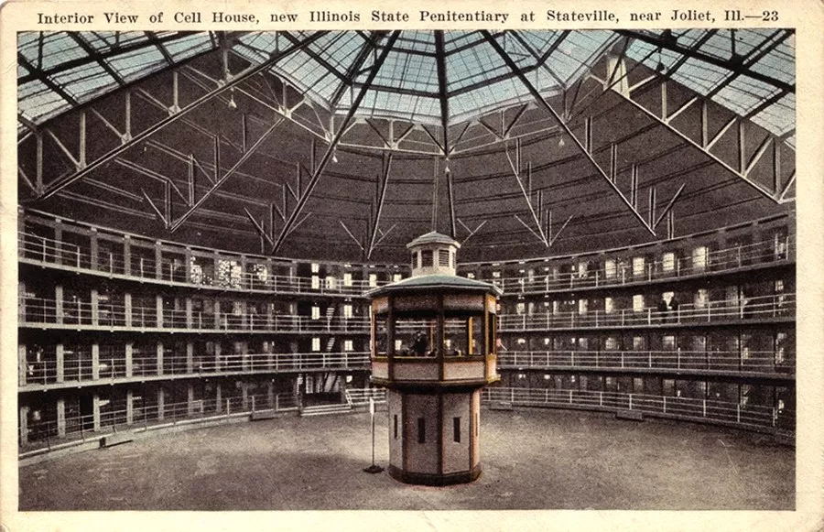
Photograph taken from Google images.

Philosopher Michel Foucault develops Bentham’s panopticon in his book, Discipline and punish. He ‘the object of information, never a subject in communication’- Foucault (1995), discipline and punish. Foucault believes he illustrates the function of discipline as an element of power. In his book discipline and punish Foucault addresses punishment to be more efficient. Back when there was torture, hanging and executing convicts’ people would often gain pity for the criminal and shame the executioner. No one gains anything from execution now along with many political views and laws of the country to ban it. Punishment is no longer focused on the body but the mentality of a person by taking away their human rights. Bentham believed the panopticon was enough for prisoners to behave all the time as they feared being watched every minute of the day. He believes this then will be no need for the act of physical violent punishing of the criminal.
Foucault believed the panopticon was more than just a building but an embodiment of 4 principles. The first persuasive power, how it could see into every cell. The second, obscure power meant the prisoners can’t see where its watching. Direct violence made structural and structural violence made profitable, making prisoners work in benefit to those in power. He believed this could be applied everywhere, in hospitals, offices, schools, the whole country (surveillance state). In 2013 an American computer professional Edward Snowdon, a former CIA employee leaked information from numerous global surveillance programs. This showed the government monitoring phone calls, data kept on computers, etc from all around the countries. Everyone is being monitored in result of the expanding power the government has over us. Foucault is reminding us that surveillance is necessarily a form of control, argued that if your good its fine. However, Foucault argues if your being watched, your kept from freedom.
He who is subjected to a field of visibility, and who knows it, assumes responsibility for the constraints of power; he makes them play spontaneously upon himself; he inscribes in himself the power relation in which he simultaneously plays both roles; he becomes the principle of his own subjection." – Foucault (1995) the birth of the prison pg.202-203.
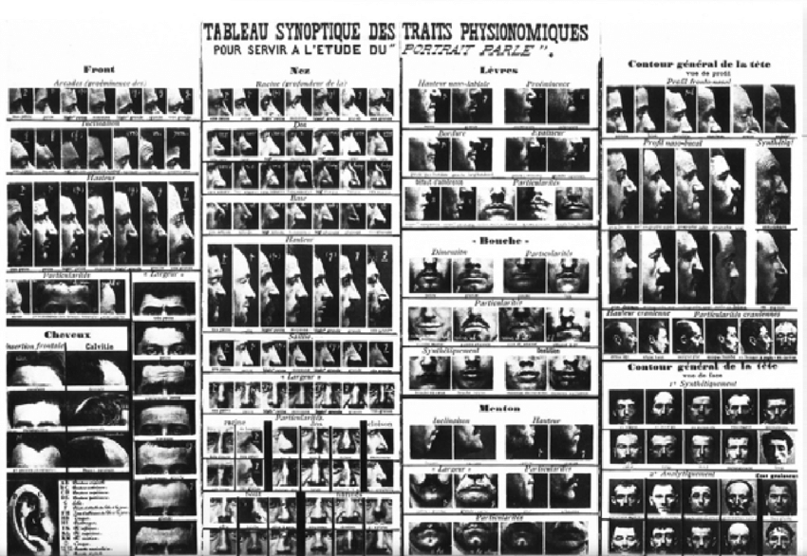
The governments panoptic like structures is an example of the 21st centuries freedom less society. We are always being watched mostly everywhere we go, even on are devises at home, all this information is kept in a data base.

An example of the Bertillon system, photograph from google images.

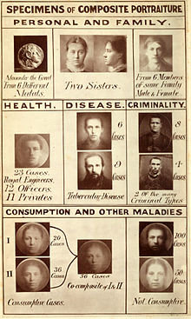
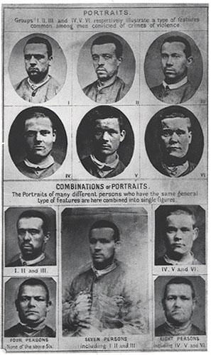
Alphose Bertillon a French officer applied the anthropological technique of anthropochory to law enforcements, creating an identification system based on physical measurements. Bertillon was also the inventor of the mug shot in 1888, he standardised taking photographs of the criminals and documented them for easy and quick access to the individual’s identity. The system he created is known as the ‘Bertillon system’, it consists of 5 measures, head length and breadth, length of middle figure and length of left foot and cubit. ‘Every measurement slowly reveals the workings of the criminal. Careful observation and patience will reveal the truth.’ – Bertillon, visible proofs. Recording people in this detail can be easily used to track inmates, suspects, and repeated offenders. However, his system didn’t work on children because of the changes on the body with age, it was designed for fully grown men. By doing this he catalogues the inmates and their identity is kept. In the early 20th century police began to use Bertillon’s method to photograph murder scenes. Bertillon’s theory was modified later by Francis Galton.

Examples on Francis Galton’s composite portraiture diagrams, photographs taken from google images.

Francis Galton was an anthropologist along with many other titles. He continued to develop Bertillon’s system by creating a technique called ‘composite portraiture’ to create an average face. He would take many exposures of the same photograph and noticed the composite portraits were more attractive than any individual member. Also, he would take two or more portraits by multiple exposures. He then started creating large bodies of work studying human faces and physical characteristics. Galton was interested in power and like to be able to control people’s identities.
He first applied his theory with portraits of convicts to see whether certain facial features could be related to different types of crimes and for the purpose of investigating criminal types. He creates 7 composites portraits of convicted murders, manslaughter or violent robbery. All these portraits were made of around the same size and taken in the same sort of attitude.
‘The special villainous regulations disappear and the common humanity that underlines them has prevailed' ‘They represent not the criminal but the man that’s liable to fall into crime.; - Galton, figure prints, 1892, pg135.
Later Galton created composite photographs of the socially inferior, including the mentally ill and Jews then to ‘heathy and talented’ classed e.g. Doctors, scientists and royal engineers.
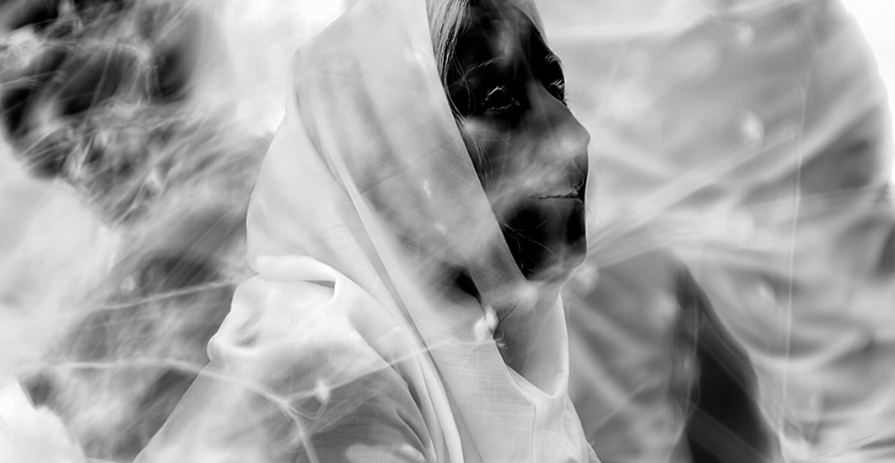

Still frame from incoming, three screen video installation, 52 mins 10secs, with 7.1 surround sound.
In relation to the ideas of Galton and Bertillon’s theories of surveillance and the power to capture many people’s identities back many years ago, I’ve looked into more contempory photographers that capture images by using surveillance to compare the power of new technology which massively impacts the power of the surveillance state. Richard Mosse uses digital technology to explore the surveillance state by shedding light on the trauma refugees go through by witnessing their journey to a safe place in his series of work titled incoming, made in 2013. This artist is Richard Mosse, Mosse hacks the reconnaissance purpose of a thermographic camera. This is military equipment used by the state.
“I am European. I am complicit. I wanted to foreground this perspective in a way, to try to see refugees and illegal immigrants as our governments see them. I wanted to enter into that logic in order to create an image that reveals it.’’- Richard Mosse, Incoming, 2017.
The footage of the refugee camps is transformed into large scale prints sometimes called Heat Maps, as well as a video installation that represents a bank of CCTV cameras, moving left to right continuously in a confusing, unconfutable and similar to a searching motion. Mosse uses this heat sensing camera to turn a critical eye towards governments insufficient attitude and response to human crisis. Also using a long-range border surveillance, he attempts to confront the ways the government regard the refugee. Throughout his work, Mosse weaponizes photographic technologies, using them to confront the viewer and question the documents created. The heat sensing cameras cover 18 miles of the landscape acting as a panopticon system, as the camera detects the body heat there is no where it cannot detect you. There are now large amounts of migration, people fearing for their live in the stay in their country because of many issues, mainly war. These photographs printed on metallic paper and the inverted effect makes the faces unrecognisable, their identity being taken as the effect smudges away their features making almost alienated which reflects on the way their treated. The heat senced cameras can also signify the way the warmth is left behind as the tackled the freezing seas and winter months. ‘Heat grows cold. Peoples attentions drift. Compassion is eventually exhausted.’ – Richard Mosse, Incoming, 2017.
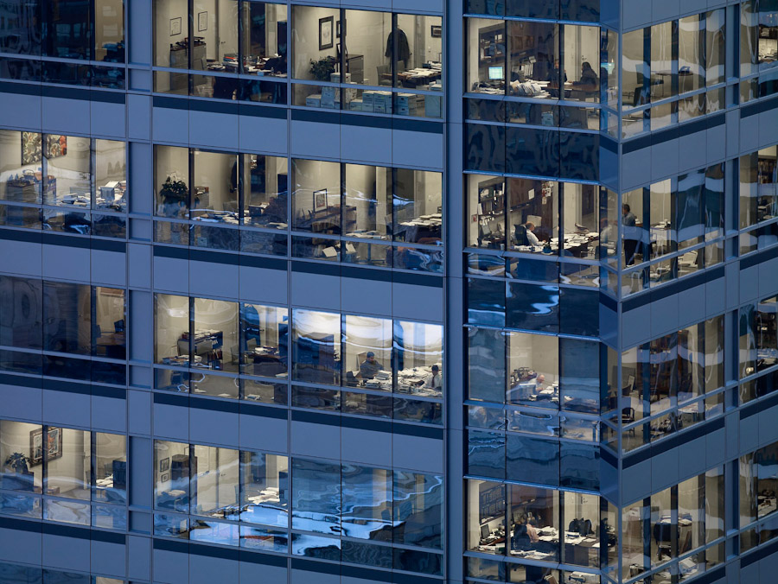
‘The camera is intrusive of individual privacy, yet the imagery that this technology produces is so dehumanised – the person literally glows – that the medium anonymizes the subject in ways that are both insidious and humane.’- Richard Mosse, Incoming, 2017.
The image pictures throughout the whole body of work are powerful and makes us realise to torturous lives they live as their forced to flee from their own homes.
Tc25, Transparent city, Michael wolf, 2008.

Michael Wolf is another contemporary photographer that also created bodies of work whilst capture people of the state. Wolf created a series called Transparent city, throughout this series he positioned himself on rooftops and windows of high buildings, he could see into every window of the next skyscraper of apartments acting as a human panopticon able to look into every room opposite him one at a time. We never think much about being watched in our own home and Wolf during transparent city turns himself into a type of surveillance. Again, like Mosse watching over people without them even realising.
His photographs within the series peer through layers of glass to find people living and working in the urban environment and reflects on this lifestyle. Many people were found watching tv, staring at computer screens and asleep alone in arm chairs. It shows even though city life in chaotic with millions of people that walking the streets every day, most of these people are lonely. He targets the idea of how modern life unfolds within the over populated contemporary city.

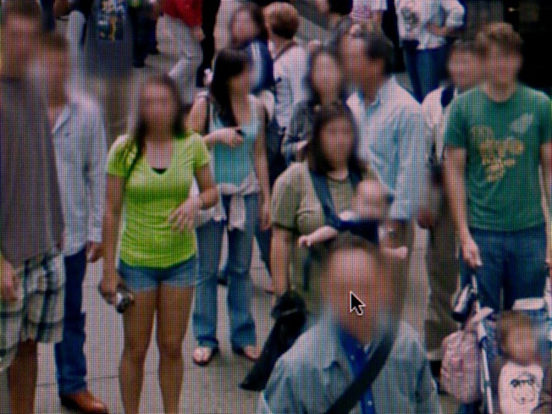
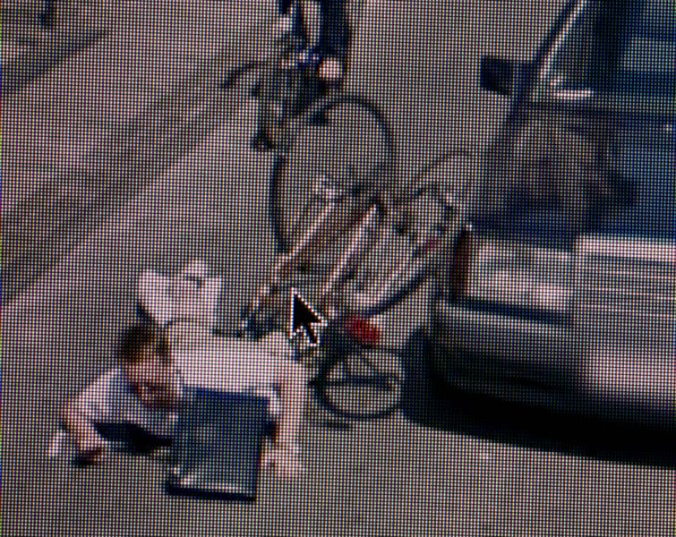
Michael Wolf, 11 & 51, a series of unfortunate events- 2010.

Michael wolf also created a body of work called a series of unfortunate events that was created in 2009/10. All these photographs were taken off a computer screen by using Google special GPS coordinated street view camera vans. He looked around many streets over the world for anything strange and captured what he thought was an unfortunate event, cropped the image and made it his own. The photographs he produced are random from people falling off a bike, drunk people passed out, people kissing, fighting and even peeing behind cars.
It proves cameras are monitoring us all the time, showing how surveillance technology captures every moment of daily lives. The government knows everything, and I think that’s a scary thought we appear on many photographs/cameras that we aren’t aware of. The world is one big panopticon.
‘This, Mosse reminds us, is a human tragedy – our human tragedy. We are all implicated in its unfolding. I was left with the image of a lone man praying in the darkness, his luminous calmness echoing against the confusion and chaos around him; his aloneness, for a few moments, his sanctuary.’ – The guardian, incoming review, 2017.
From Bentham’s invention of the panopticon and Bertillon’s mug shot along with the labelling of criminals etc from Galton, the power to watch and identity people got easy, therefore the surveillance state was created and turned into such a powerful thong and massive part of society today. New ways of surveillance have been created and keep improving with the power of technology. We cannot escape cameras, they are in every street, shop, even in our own homes which Michael Wolf has demonstrated.

(Word count: 2,114)

Bibliography.

Barbican. (2016). Richard Mosse incoming. [online] Available at: https://www.barbican.org.uk/richardmosse-incoming [Accessed 18 Nov. 2018].

bjp_online.com. (2017). [online] Available at: http://www.bjp_online.com?2017/02/mosse/ [Accessed 15 Nov. 2018].

Foucault, M. (1995). discipline and punish. Harmondsworth: penguin, p.198.

Galton. F. (1892), Finger prints. Macmillan, p.177.

Galton.org. (2018). [online] Available at: http://galton.org/essays/1870-1879/galton-1878-nature-composite.pdf [Accessed 12 Nov. 2018].

Galton.org. (2018). Finger Prints by Francis Galton. [online] Available at: http://www.galton.org/books/finger-prints/index.htm [Accessed 12 Nov. 2018].

Hyperallergic. (2018). Hyperallergic. [online] Available at: https://hyperallergic.com [Accessed 19 Nov. 2018].

LensCulture. (2014). LensCulture - Contemporary Photography. [online] Available at: https://www.lensculture.com/ [Accessed 12 Nov. 2018].

Nlm.nih.gov. (2018). Visible Proofs: Forensic Views of the Body: Galleries: Technologies: The Bertillon system. [online] Available at: http://www.nlm.nih.gov/visibleproofs/galleries/technologies/bertillon_image_3.html [Accessed 16 Nov. 2018].

Nott, K. and Bateson, M. (2012). Cycle Thieves, We Are Watching You. [online] plos|one. Available at: https://journals.plos.org/plosone/article?id=10.1371/journal.pone.0051738 [Accessed 12 Nov. 2018].

Philosophy tube (2016). Foucault 2: Government Surveillance & Prison. [video] Available at: https://www.youtube.com/watch?v=AHRPzp09Kqc [Accessed 10 Nov. 2018].

Richardmosse.com. (2018). Richard Mosse | Incoming. [online] Available at: http://www.richardmosse.com/projects/incoming [Accessed 17 Nov. 2018].

The Guardian. (2018). Richard Mosse incoming review. [online] Available at: https://www.theguardian.com/artanddesign/2017/feb/15/richard-mosse-incoming-review [Accessed 10 Nov. 2018].

Works, M., Arrangements, M., Trilogy, M., signed, M., 76, M., Art, M., Events, M. and Cut, M. (2018). Michael Wolf – FY. [online] Christophe Guye Galerie. Available at: https://christopheguye.com/store/michael-wolf-fy [Accessed 19 Nov. 2018].

