
Public perception on decriminalising cannabis in the UK
__________________________________________________________________________
Sean Stevens
Student number: 2029550
January 2024
Acknowledgements
I would like to thank my friends and colleagues for their support whilst I have completed this dissertation.
Declarations
Declaration - This work has not previously been accepted in substance for any degree and is not being concurrently submitted in candidature for any degree.
Signed: Sean Stevens - Date: 02/01/2024
- Statement 1 - This dissertation is being submitted in partial fulfilment of the requirements for the degree of BSc.
Signed: Sean Stevens - Date: 02/01/2024
- Statement 2 - This dissertation is the result of my own independent work/investigation, except where otherwise stated. Other sources are acknowledged by footnotes giving explicit references. A bibliography is appended.
Signed: Sean Stevens - Date: 02/01/2024
- Statement 3 - I hereby give consent for my dissertation, if accepted, to be available for photocopying and for interlibrary loan, and for the title and summary to be made available to outside organisations.
Signed: Sean Stevens - Date: 02/01/2024
- Statement 4 - I hereby give consent for my dissertation, if accepted, to be available on the university’s IT system to those who have consent to use the system.
Signed: Sean Stevens - Date: 02/01/2024
Abstract
The aim of this dissertation was to investigate the public’s perception on decriminalising cannabis and to identify the reasons for that perception. Prior to primary research, the researcher carried out a critical analysis of existing academic literature on the topic of drug law reform and decriminalisation.
A survey was completed to gain a better understanding for the public’s position and opinion on the matter. The review of previous literature on the topic helped identify the questions that were required in order to ascertain this information.
The findings of the survey supported previous literature by showing that there is growing support for decriminalisation as the survey asks directly whether respondents support or oppose it. However, the survey plugs the gap off previous research by allowing respondents to provide, in their own words, the reasons why they either support or oppose the change.
Therefore, the aim of the dissertation was achieved by first establishing and then explaining the reasons for the public’s perception on the matter.
Table of Contents

Chapter 1: Introduction 8
1.1 Introduction 8
1.2 Background and Rationale 8
2. Chapter 2: Literature Review 10
2.1 Introduction 10
2.2 Explore society’s perception on the decriminalisation of cannabis 10
2.3 Identify reasons for that perception 10
2.4 Analyse if decriminalisation would affect crime rates 12
2.5 Assess if decriminalisation would affect drug use 13
3. Chapter 3: Methodology 15
3.1 Introduction 15
3.2 Ethical Practise 15
3.3 Data collection method 16
3.4 Sampling 16
3.5 Conclusion 17
4. Chapter 4: Analysis of results 18
4.1 Introduction 18
4.2 Data Analysis 18
4.3 Participant views 18
5. Chapter 5: Conclusions and Recommendations 23
5.1 Introduction 23
5.2 Summary of Primary findings 23
5.2.1 Explore Society’s perception on decriminalisation of cannabis 23
5.2.2 Identify reasons for that perception 23
5.2.3 Analyse if decriminalisation would affect crime rates 24
5.2.4 Assess if decriminalisation would encourage drug use 24
5.3 Recommendations 24
6. Bibliography 26
7. Appendix 30
7.1 Appendix 1 – Ethics From 31
7.2 Appendix 2 – Copy of Questionnaire and percentage results 46
7.3 Appendix 3 – Responses to Question 3 48
7.4 Appendix 4 – Responses to Question 4 50
7.5 Appendix 5 – Responses to Question 7 52
7.6 Appendix 6 – Responses to Question 8 54

Chapter 1 – Introduction
1.1 Introduction
The purpose of this dissertation was to investigate the public’s perception on decriminalising cannabis in the UK and identify the reasons for that perception. This chapter will provide background information on the topic and provide context to the investigation.
1.2 Background and rationale
Cannabis has featured in human society for thousands of years. The University of Sydney (2017) notes that the history of cannabis dates back to approximately 2800 BC and was its first use originated in central Asia or Western China, and that historic texts described cannabis to treat a variety of different health problems. The illegality of cannabis is a recent decision in UK History. Recreational use of cannabis was outlawed in 1928 by way of the Dangerous Drugs Act (Goguel, N. de 2023).
Whilst remaining illegal in the UK to the present day, the severity of law around cannabis and its classification has changed in recent decades. Goguel (2023b) notes that in the 1990s, former Home Secretary Michael Howard increased fines for possession £2,500, placing emphasis on the criminal nature of the drug. However, the next government took a different approach with the drug. Chambre (2023) details how the Home Secretary in the early 2000s David Blunkett, downgraded cannabis to a Class C drug from Class B. This decision was then later reversed.
These decisions give representation to the difference in opinion and general debate surrounding the drug, which has gone on for some time. Most recently, there have been stark difference of opinions within the policing world. Hymas (2022) notes how police chiefs created a blueprint to treat drug users as a public health issue. In contrast, Taylor (2022) highlights how Police and Crime Commissioners, at a Conservative Party Conference, made the case for harsher criminal laws for cannabis possession and use for cannabis to be reclassified from a Class B to a Class A drug based on recent health data, highlighting road safety as a particular issue surrounding the drug.
Research suggests that arguments for and against decriminalisation centre on a few key points. Supporters for decriminalisation highlight the benefits of treating addicts as a public health problem, with focus on rehabilitation.
Opinion from supporters is a that criminal justice approach is not an effective way to deal with drug use. Parliament.UK (2019) notes that they listened to several advocates of decriminalisation who claimed that the penalties imposed by the criminal justice system are expensive, ineffectual, and worsen the problems related to drug use. Furthermore, criminalisation of drug use heightens the stigma attached to it, which discourages individuals from seeking help. Moreover, prison terms can make drug abuse problems worse and lessen the likelihood of a full recovery.
Ritter (2020) provides more detail on what a decriminalisation model would look like. It would mean alternatives to legal punishments for use and possession. Examples of this would mean fines for possession or diverting offenders into education or treatment options as opposed to a criminal sanction.
Those who present opposition believe that decriminalisation means greater availability of drugs, which would result in increased use in the population. The increased use would then result in more addiction, higher crime rates and greater risk overall. Califano (2007) cites example of decriminalisation in Italy resulting in increased drug use and risk. At that time, Italy had one of the highest rates of heroin addiction in Europe, with over half of AIDS cases linked to intravenous drug use. Such an outcome would clearly be of major concern to legislators when considering such a change in the law.
Supporters also point out how decriminalisation could benefit the state in wider capacity from regulating and taxing drugs and highlight the illicit market’s contribution to more serious crime. Chand (2007) suggests that drugs could be regulated like alcohol and tobacco and subsequently, taxed. The money generated from this could then be put towards education and other rehabilitation programmes. Furthermore, Chand (2007) notes how violent criminal gangs started from the underground drug market and how their rivalries contribute to gun crime as a result. Furthermore, in the UK, the impact of gang related crime is undeniable. Ng (2023) reports a record high in knife related deaths amongst teenagers, apportioned to gangs exploiting vulnerable young people.
These are credible arguments for a change in approach for legislators. Research suggests that no matter what the legislative approach towards drug use, it does not come without risk. Both sides can make compelling arguments either way, therefore this makes it a important topic for consideration and debate, and such a difficult subject for legislators.
Chapter 2 – Literature Review
2.1 Introduction
This chapter will provide an overview of the arguments and perceptions surrounding decriminalising cannabis in the UK. It will provide information about the effects of cannabis and drug use internationally, including its effect on crime rates.
The chapter will address each of the dissertation’s objectives (with the first two being addressed as one). This includes reviewing society’s perception on decriminalisation and the reasons for that.
The dissertation’s objectives are listed as follows:
1) Explore society’s perception of decriminalisation of cannabis
2) Identify reasons for that perception
3) Analyse if decriminalisation would affect crime rates
4) Assess if decriminalisation would encourage drug use
2.2 Explore societies perception of decriminalisation of cannabis
2.3 Identify reasons for that perception
Current evidence suggest a mixed opinion on the topic of drug law reform. The current research questions respondents on the topics of decriminalisation and legalisation. It should be noted that decriminalisation and legalisation are two different things. Turnbridge (2021) explains that the process of making a drug that is legal is known as legalisation. Stated differently, it implies that a drug that was before prohibited is now lawful. Users don't have to worry about getting caught or punished for using the drug. Decriminalisation is the process of eliminating criminal penalties related to the use or possession of a certain substance in amounts below a predetermined threshold. Although decriminalised drugs are still unlawful, the penalties are far less severe.
So, whilst this essay refers to some surveys that relate to legalisation only, it is acknowledged that it is a slightly different question to that of decriminalisation. However, it does provide insight on the respondent’s thoughts surrounding drug reform.
There have been a number of recent polls and surveys on the topic in the UK and in other countries.; ‘the British public is split on whether the recreational use of cannabis should be legalised in the UK, however. While a narrow plurality of 38% opposes such a change, 35% conversely say they would support the legalisation of cannabis for recreational use.’ (R&WS Research Team, 2022). Unfortunately, this report does not provide the total amount of people surveyed. However, it does provide an interesting insight to the views by age demographic. According to R&WS Research Team (2022), Just 21% of people 65 and older and 34% of those between the ages of 18 and 24 would be in favour of legalising cannabis usage for recreational purposes. In comparison, 41% of those aged 35 to 44 and 45% of those aged 25 to 34 say they favour it.
Ipsos (2013) reported similar findings from their survey. Of those surveyed, 53% supported cannabis to be legalised or decriminalised, and 67% wanted a review of Britain's approach to drugs. Therefore, only a small majority from their sample.
Neither of these surveys present any indication for the reason why those surveyed support or oppose decriminalisation. However, a recent Forbes poll in America surveyed the public’s views on why cannabis should remain legal or illegal, therefore gaining an insight on perception. McCarthy (2019) noted that US public support to legalise the drug increased to 66%, with 86% of supporters citing its medicinal benefit and 70% citing freeing up police time as the most popular reasons for law change. In contrast, of those who oppose legislation, 79% believe it would lead to increased car accidents and 69% believe it would leave to people using more addictive drugs.
A YouGov (2023a) poll, dating back to 2019 offers more detail into public perception here in the UK. Gathering data on decriminalisation, this survey notes that 38% believe that sale and possession should remain illegal, 31% believe it should no longer be illegal at all and 24% support decriminalisation (should be regarded as an offence similar to parking fines). 7% answered “Don’t know”.
Separate polls on the subject offer more insight in to why such views are held. A survey on how harmful cannabis is, YouGov (2023b) details that 35% answered fairly harmful, 30% not very harmful, 20% very harmful, 10% not harmful at all and 5% don’t know. Therefore, the majority surveyed here do consider the drug in some way harmful, but just disagree on the severity.
In a poll about decriminalisation and crime rates, YouGov (2023c) notes that 37% believe is would lead to less crime and 26% believe it would lead to more crime. Again, this difference is minimal, but this data suggests a more favourable approach to decriminalisation given that they believe it would lead to less crime. Another poll asked for opinion on decriminalisation and increased drug use. This saw a more of a majority opinion for a certain outcome. YouGov (2023d) shows that 40% believe it would lead to more drug use, with 9% answering that less people would use drugs. 40% answered it would make no difference.
Overall, the YouGov polls referred to above show that opinion is divided on the topic of decriminalisation. However, a total of 55% people agreed current law should be amended, therefore showing support for some form of decriminalisation. It would appear from this data that a reason for this, is that it would lead to less crime.
It is noted that in the research conducted, the respondents are not asked directly why they support or oppose decriminalisation. Therefore, this is justification for the research topic of this dissertation. The primary research in this dissertation will ask respondents to explain clarify, in their own words, the reasons why the public hold their respective views and opinions on decriminalisation.
Going back to the existing literature, the data from YouGov (from those polled who support current drug legislation) suggests that the harm associated with drugs and potential for increased use as factors in their opinion. The National Institute on Drug Abuse (2019) cites how long term use of the drug can affect learning functions and memory, and cause paranoia and breathing problems in long term users.
Another reason for opposition to decriminalisation, could be the stigma toward drug use and drug users. Prance (2021) notes how the findings of a poll conducted by the UK Drug Policy Commission about views towards drug addiction and mental health highlighted how far stigma in the country still has to be overcome. Fourteen percent of respondents agreed with the statement, "People with a history of drug dependence are a burden to society."
Research suggests there is a few reasons for this. One is the language used to describe people who use drugs in culture. McPhee (2021) notes that during his investigation on the subject, he discovered that people who use drugs are portrayed as unproductive citizens in policy texts and the media, with such labels like “work-shy” and “benefits scroungers”. BBC News (2018) reported that the Global Commission on Drug Policy drew up a checklist of words that journalists and politicians should avoid, such as “junkie” and “addict”. It is fair to say such descriptions would not generate much empathy or support from the general public, as it paints a picture of users as lazy and a burden.
Media portrayal is often linked to the negative stigma surrounding drugs and drug dependency. According to Preston (2022) people who have a history of drug use are vilified in the media, according to nearly two thirds of individuals in the UK. References to drug users were disproportionately negative and more likely to be condemning than to be sympathetic, according to research conducted by the UK Drug Policy Commission (UKDPC) into national, regional, tabloid, and broadsheet publications.
How people access the media had changed in the recent decades but there remains a high consumption. Thorpe (2019) reported that physical Newspaper circulation was at 10.4 million in 2018 and that The Guardian is the most widely read digital title with over 5.2 million weekly readers; Daily Mail second with 4.1 million readers, and the Daily Telegraph with 1.8 million. This is an example of the media’s vast reach, and this only considers the top three digital titles. Furthermore, Majid (2023) details how UK trust in the media increased to 37% in 2022. Therefore, the language and portrayal of drug use and dependency in the media will no doubt have some influence on the public’s perception and opinion on the matter.
As outlined in this piece already, there is growing support for decimalisation of cannabis in the UK. However, the research has not always identified the reasons why. Smith (2022) notes that a UK survey shows a 45% support for decriminalisation of cannabis (compared to 43% who oppose) and shows cannabis as ahead of all other drugs for such support. However, (Smith) 2022 details how the respondents are asked why they oppose decriminalisation, but not about why they may support it.
A recent report from Recreational Europe offers some insight. Price (2022) observes that 55% of UK adults favour the legalisation of cannabis for adults and feel it should be regulated by the government, while 52% say there should be no criminal penalties for personal cannabis use. In an effort to understand the reason for support, Price (2022) notes that 50% cited the removal cannabis from the underground market and criminal gangs and 38% cited potential tax revenue. It is important to note that this survey asked for opinion on full legalisation, not decriminalisation. However, it does provide some more context on the public’s perception for reform on the matter.
2.4 Analyse if decriminalisation would affect crime rates
Perhaps the best sample to assess the effects of decriminalisation in to look at Portugal. Bajekal (2018) notes how Portugal became the first country on the planet to decriminalise consumption of all drugs in 2001.
The outcomes of such a radical change have been monitored ever since. In respect of crime, according to Transform Drug Policy Foundation (2021), drug-related offences accounted for almost 40% of Portuguese jail inmates in 2001, a percentage that was much higher than the European norm and linked to 70% of all recorded crimes. and "the percentage of inmates serving prison sentences for drug offences in Portugal has sharply decreased to 15.7% in 2019 — now below the European average. Thus, indicating a positive outcome of the legislative change.
Other countries have since followed Portugal’s suit by reforming law surrounding cannabis. In America, certain states have legalised cannabis altogether. The effects of which have been studied , Dills et al (2021) notes that Following legalisation, violent crime rates in Maine and Nevada fell by 90 and 178 offences per 100,000, respectively, compared to the national trend. However, patterns in many other states followed the national trend. Following legalisation, Alaska's and Massachusetts' violent crime rates rose by 152 and 57 percent, respectively, above the national average. In general, the legalisation of marijuana has not resulted in a sharp increase or decrease in violent crime.
Oregon appears to have been an exception to this. Sheraz (2023) notes how in 2020 Oregon took the bold decision to decriminalize the possession of small amounts of all illegal drugs, this was known as Measure 100. Current assessment of the measure does not indicate it has been successful. Hogan (2022) reports that in the city of Portland, since Measure 110 was introduced there were 90 homicides in 2021, a record annual number. Furthermore, police in the city stated that all forms of crime increased after 110 was implemented.
This does not make for good reading and would certainly aid the case of the those who oppose decriminalisation. Considering the examples from America, decriminalisation does not result in any immediate reduction in crime, rather staying relatively the same or in Oregon’s case, taking a dangerous turn for the worse. The relative success shown by Portugal indicates that decriminalisation benefits from a longer-term strategy.
2.5 Assess if decriminalisation would encourage drug use
This is a contentious topic on the subject of decriminalisation. The fear from those who oppose decriminalisation is that it would lead to rampant drug use in communities. For example, Califano (2007) cites that the legal extension of opening hours in UK pubs led to increased emergency treatment for drink related issues and a spike in crime between 3am and 6am. Furthermore, following Netherlands’ introduction of coffee shops to purchase and use cannabis, the number of young people using it tripled.
Beaumont (2022) details how Oregeon is also suffering in this area; according to a December 2021 analysis, Oregon ranked at the bottom of all 50 states for the percentage of adults and teens who required treatment for substance use disorder but did not receive it. It also ranked second in the US for substance use disorder. In addition, according to medical examiner data, drug poisoning deaths also grew somewhat in 2021.
As already referred to, YouGov (2023d) shows that 40% of UK respondents believe drug use would lead to increased drug use. It is quite possible that the respondents answered this because they themselves would increase drug use on the back of legislation change.
Canada recently legalised cannabis altogether and usage of the drug has increased. Raycraft (2021) notes that based on the Canadian governments most recent survey, 27% of participants reported having used the drug the past year, an increase from 22% from the 2017 survey.
There is evidence to the contrary on this point. For example, BBC News (2023) notes how Scotland has far the highest drug death rate recorded by any country in Europe. This is despite the fact all drug possession is illegal in Scotland. This indicates that legislation alone is not the sole factor contributing to use.
Again Portugal, the world’s longest component of decriminalisation indicates how a long term strategy has proven effective on drug use. According to Bajekal (2018), The rate of drug-related deaths has fallen to one-fiftieth of the US, five times lower than the EU average. From 104.2 new cases per million in 2000 to 4.2 cases per million in 2015, the country's HIV infection rate has decreased. The group aged 15 to 24 years, who are most likely to start using drugs, has seen a general decrease in drug usage. The emphasis here is on long term. Frakt (2020), notes how immediately after the change in Portugal, a study found an increase in drug experimentation. However, most experimentation did not result in regular drug use. This could offer an explanation for some of the results being seen in Canada and Oregon, it may be a short-term reaction to a change in law, people more inclined to try drugs now the legal ramifications are removed.
The outcomes in Oregon since Measure 100 have been attributed to a lack of planning. In respect of the misuse and fatality statistics, Beaumount (2022) highlights that decriminalisation, according to experts, is not the issue. They claim that in light of the escalating overdose issue, what the new measure lacks is an appropriate rehabilitation track. This is a view shared in Oregon. Marshall (2021, quoted in Westervelt, 2021) highlights how Oregon didn’t prepare prior to legislation change; "There were no resources and no mechanisms in [Measure] 110 to actually prepare the health care system to receive those folks”.
Portugal on other hand, considered the situation as a whole. Westervelt (2021) highlights how Portugal took more than two years to transition to a new system which replaced judges, jails and lawyers as those in authority to deal with drug use, instead to doctors, social workers and addiction specialists.
It is clear that decriminalisation will result in increased drug use, at least in the short term. The research in Canada, Oregon and even Portugal is evidence of this. All three found increased use of the drugs that were decriminalised. What is important to consider however is the harm associated to it, Portugal has shown that prior planning for increased use can be managed and can work positively in the long term. Oregon shows how if the funding and infrastructure is not in place prior to decriminalisation, it can have severe consequences.
Chapter 3 - Methodology
3.1 Introduction
This chapter will explain discuss the research methods used for this study. This is known as the methodology. Voxco (2021) explains that the general plan or technique that researchers employ to carry out their study is known as their methodology. It includes methods for gathering data, its procedures for analysing that data, and its general framework. This chapter will breakdown how this dissertation has carried out those functions.
The types of research used for methodology are primary and secondary. Wagh (2022) explains that primary research is data produced by the researcher themselves, through such methods as surveys, interviews, and experiments specifically created for comprehending and resolving the current study challenge.
Secondary research is similar to the research that students do throughout their academic careers. The effort is in sorting through the material that is already accessible and locating data that corresponds with the specific research project. Answers to research questions are already available online, in academic databases, in the news, in published books, journals, etc (McCrocklin, 2018).
The literature review identified that there is a lack of research and study into the reasons why there is support or opposition for decriminalisation. Research and surveys indicate an increasing support for decriminalisation, however it does not the establish the reasons why respondents hold their respective view. For the purpose of this study, in order to gather the true opinions of the public, primary data will be collected through that of a survey.
According to Anpar Research (2020), some of the benefits of primary research are its privacy of data and that is update to date and relevant to the research being conducted. The Farnsworth Group (n,d) highlights that the drawbacks to such research is that it is time consuming and can be time consuming.
3.2 Ethical practice
Conducting research ethically is vital to a study. According to World Health Organisation (2022) respecting the dignity, rights, and wellbeing of study participants requires adherence to ethical principles. In order to guarantee that the proper ethical standards are being observed, an ethics committee should examine any study involving human subjects. This dissertation has taken the relevant steps to ensure ethical practise. For example, the dissertation has been given ethical approval prior to the study following the submission of an ethics form to the University.
Furthermore, informed consent will be obtained from participants prior to involvement in the study. This will be obtained via requested for their voluntary consent prior to taking part in the survey. According to University of Oxford (2021) informed consent is one of the guiding principles of research ethics is informed consent. The aim is for human volunteers to engage research voluntarily after receiving complete information about what it means for them to participate and after giving their consent before doing so. The questionnaire will be anonymous and completely voluntary. This will be achieved by providing the participants with a disclaimer which will include details on the information on the survey and what it means for them to take part.
3.3 Data collection method
This research will use a survey which will aim to gather qualitive research. A survey for data collection. This is a form of primary research and well suited to resolve the challenge of this essay. This will involve exploratory research. Swedberg (2020) explains that exploratory research involves going through a research subject in an effort to find something new and intriguing. As already explained this essay will further research an aspect of a much-debated topic.
There are typically two main approaches to data collection, qualitive and quantitative. McCloed (2023) explains that the process of gathering, examining, and interpreting non-numerical data, such as language, is known as qualitative research. To comprehend how a person interprets and lends meaning to their social experience, qualitative research might be performed. According to Shread (2018) quantitative research works with data that can be translated into numbers or that has a numerical value. Statistics is typically a term given to the fundamental techniques used to analyse numerical data.
This survey will use a survey with open questions, not leading questions and free text boxes in order to best interpret and obtain the participants opinion on the subject matter. This dissertation will collect both qualitive and quantitative data as there will be percentage results on opinion related questions.
The survey will be anonymous, for a couple of reasons. Firstly, from an ethical point of view, as Kang and Hwang (2023) note that research findings consistently mentioned the confidentiality and anonymity principles are preserved and implemented as a means of protecting the privacy of all individuals, establishing trust between researchers and participants and as a way of upholding research ethical standards. The study will be as ethical as possible, so an anonymous survey is best placed to uphold this.
Secondly, this survey will see to obtain public opinion on what can be sensitive topics, illicit drug use and drug reform. The survey has the aim that the respondents be as open and honest as possible in their answers without the fear of judgement or embarrassment. Cleave (2021) supports the notion that anonymity results in not only more honest participants but an increase in response rates as well.

3.4 Sampling
Sampling is necessary in methodology as it is practical and less time consuming than surveying a population. The methodology will use convenience sampling. SAGO (2023) notes that the benefits of Convenience sampling include its simplicity and affordability. Instead of spending a lot of money and resource finding and contacting potential participants, this method enables researchers to swiftly and effectively recruit individuals.
The research will aim to survey between 30-60 respondents, this will include police officers and members of the general public. This will provide a variety of opinions, including lay people and those who have first hand and extensive interaction with drug use and laws. The survey will be sent by social media, in order to obtain a larger and more varied pool of respondents.
3.5 Conclusion
This chapter has addressed the research methods adopted for this study. Ethical approaches have been considered and participant consent has been addressed. The next chapter will provide an analysis of results to the survey.
4. Chapter Four: Analysis of Results
4.1 Introduction
This chapter seeks to examine public perception on decriminalisation of cannabis. The aim of the survey is to gain a better understanding of the public’s detailed opinion on this matter and if their opinions for supporting or opposing decriminalisation are based on any particular reason.
This chapter will be used to analyse and present the findings from the study’s primary research. The primary research was compiled using an online survey to ascertain the public’s perception on decriminalising cannabis. There were 43 responses to the survey, as such this essay acknowledges that such is sample is not necessarily reflective of the country as a whole.
4.2 Data Analysis
According to Northern Illinois University (2022) the process of methodically using statistical and/or logical approaches to characterise and depict, summarise and assess, and analyse data is known as data analysis.
The data analysis in this chapter will address the research question. The data in question was collected and analysed through using questionnaire compiled and published from Survey Monkey.
4.3 Participant Views
Q2) Do you support the decriminalisation of cannabis in the UK?
Question 2 opens the survey with a closed question that asks the respondents if they support decriminalisation of cannabis or not. The aim of the question was to ascertain which ‘side of the fence’ the respondents were on, before establishing their reasons for holding such view later in survey.
Of the respondents, 52% stated that they did not support decriminalisation and 47% stated that they did support it. In terms of percentages, these findings are very similar to the research conducted by Ipsos (2013) and R&WS Research Team (2022), who found opinion of the matter was very much split. Therefore, this initial canvassing of opinion shows there is a similarity in the previous literature on the topic.
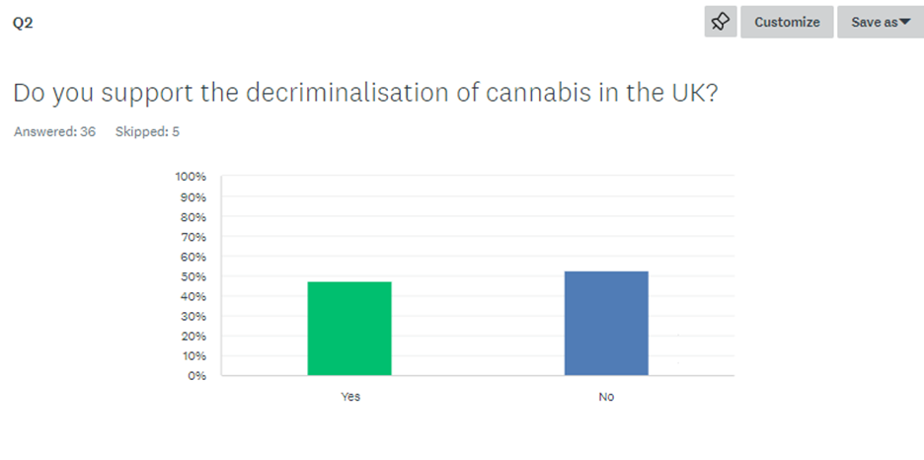
After this question, it is still not clear why the respondents hold their respective view on decriminalisation. This is explored further later in the survey when the respondents are asked to provide their reasons for each respective view.
Q3) Why do you support the decriminalisation of cannabis in the UK? and Q4) Why do you oppose decriminalising cannabis in the UK?
These two questions will be analysed together`. This was split in to two separate questions so that respondents could, based on their answer to the previous question, explain their reasoning in their own words to an open question.
Of those who supported decriminalisation, a clear theme in their reasoning was freeing up police time, as well as changing the overall approach to the issue. Here are a few comments from respondents:
‘I think there are far worse issues we need to concentrate police and court time to. Police resources should be freed up to tackle the issues most harmful to the public. Other countries have shown this can be dealt with as a public health issue.’
‘Free up police and courts time better spent on dealing with dangerous offenders.’
‘We should take note of successful changes in America and Portugal and treat addiction as a public health issue and not criminalise these people.’
‘Pursuing a conviction against persons who use cannabis for recreational purposes is a waste of tax payers money and police officers time.’
‘I don't feel like addicts should be criminalised for small possession. We need to treat drug addiction and a health and social issue.’
These explanations indicate that the respondents do not regard cannabis use as a particularly serious crime or harmful venture. Furthermore, this is a view being shared by police chief themselves. Jenkins (2022) explains how police chiefs will are favouring schemes to treat drug use and possession as a public health issue, with one of the benefits being saving police time.
Another theme was in the respondent’s answers was the benefits to regulating the drug, for economic benefits and to suppress the criminal elements associated to the drug trade. Here a few comments from respondents:
‘We can never win the war on drugs. It is evident that making it illegal does not stop production and use. It should be regulated and taxed for safer use and benefit the economy.’
‘Cannabis is not a harmful drug with next to no negative health impacts. Decriminalisation may also destabilise OCG networks that depend on illicit sales for funding.’
‘By legalising cannabis the production, cultivation and distribution of it can be properly organised and taxed.’
‘Can be regulated and taken out of organised criminal's hands’
‘Legalising cannabis would mean it becomes a taxable, regulated drug. As a result of this the UK economy would benefit and less people would be acquiring it on the black market.’
Again, this is a view matched with the previous literature. Miron (2018) explains that drug reform can result in economic gain because of increases in tax revenue and decreases in drug enforcement spending. This study (albeit in America) provided estimated figure of $106.7 billion in budgetary gains citing increased tax revenue that transfers income from those who illegally produce drugs and consumers to the public purse. It must be noted that this study considered other prohibited drugs rather than just cannabis.
Of those who oppose decriminalisation, there was a consistent theme about the concern that cannabis use leads to increased use among the public and the general effect of using the drug. In respect of drug use, here are some respondent’s comments:
‘I believe it will lead to greater drug use by the general public’
‘I think it is a gateway drug that will lead people to get involved with more addictive drugs such as heroin’
‘I believe that this will only cause more people to participate in the consumption of drugs. I believe that cannabis is a gateway drug to stronger and more dangerous substances.’
In respect of the effects of the drug, here are some respondent comments:
‘Working as a mental health nurse , I have witnessed cannabis use for a lot of my career. I have seen that it can magnify psychiatric symptoms especially if a person is prone to a mental health condition Also sometimes experimenting with cannabis can tempt people to move on to a more damaging illegal substance.’
‘Because of mental health issues associated with the regular use of cannabis’
‘Use of illegal substances have negative impacts to people and their families lives as well as society’
This reason for opposing the idea was not surprising. As the literature review showed, drug users are generally viewed unfavourably amongst the media and therefore the public and the idea of drug use becoming normalised or legal, results in concern from the public.
Q5) Do you believe that cannabis use is safe?
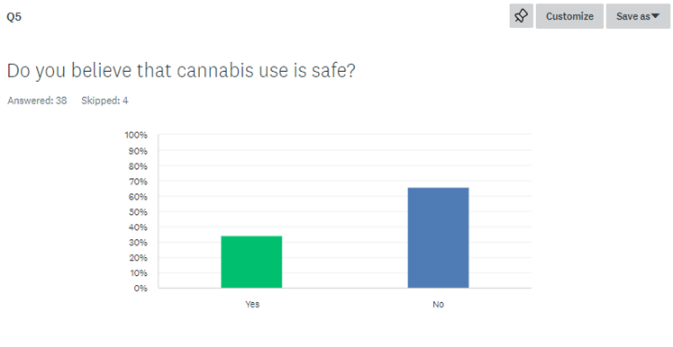
Q6) Would you use cannabis if it was decriminalised?
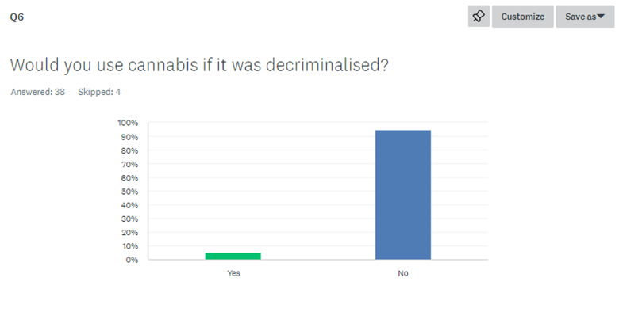
In line with the research aims of this study, the respondents were asked if they would use cannabis if it were decriminalised. The overwhelming response was ‘No’, with 94% stating that they would not use the drug. 5% of respondents said they would.
Furthermore, 65% felt that cannabis use was unsafe and 34% felt that it was safe
This is an interesting response given the support for decriminalisation, the majority of respondents stating that it was unsafe and almost all of them stating they wouldn’t use the drug. That being said, not one single respondent citied the drug being decriminalised for their own personal use as a reason for supporting legislation change. It is of course possible that despite the anonymity of the survey, respondents would not want to admit they would experiment with the drug if it was decriminalised.
When considered with the answers from Question 4, the findings both support and contradict some of the existing literature on the subject. Califano (2007) and Raycraft (2001) evidence how cannabis use increased in the Netherlands and Canada following legislative change, therefore supporting the concern on the respondents about increased use. However, the overwhelming majority of respondents stated that they would not use the drug themselves if it were to be decriminalised.
Q9) Do you believe that cannabis use contributes towards crime rates in the UK?
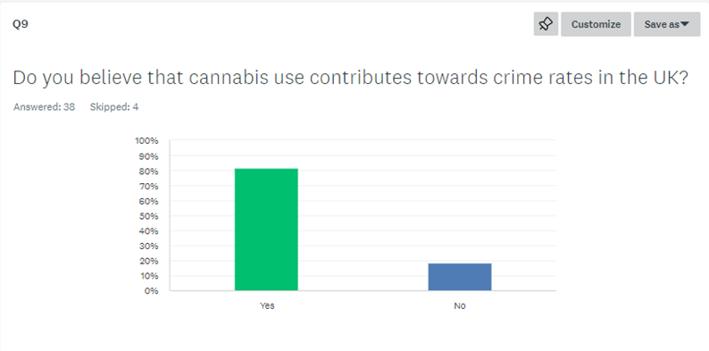
The final question of the survey sought to gain opinion on whether the use of cannabis contributed towards crime rates.
81% of respondents felt that it did and 18% felt that it didn’t. The reasons for why people felt use of the drug contributed can be explained by some of the answers in Question 8, surrounding the negative impacts of the drug.
Here are some of the respondents’ comments:
‘I imagine there would be a spike in offending behaviour at the start’
‘Crime increase gateway drug more people will use if when ordinarily would avoid the use of drugs if want legal’
‘Increase criminally with persons having to afford cannabis whereby crime may be committed to fund their habits’
‘Further crime committed by public who are using cannabis frequently.’
Chapter 5 - Findings and Conclusion
5.1 Introduction
This chapter is the conclusion of the dissertation. It will provide an overall summary of the primary research conducted and then it will revisit the objectives set out at the beginnings to check if they have been met, and how they compare to the literature review. Finally, the chapter with finish with its recommendations following the research.
For clarification, the dissertation’s objectives are as follows:
1) Explore society’s perception of decriminalisation of cannabis
2) Identify reasons for that perception
3) Analyse the effect of decriminalisation on crime rates
4) Assess if decriminalisation would encourage drug use
5.2 Summary of Primary findings.
The primary purpose of this dissertation was to explore the public’s perception of the idea of decriminalising cannabis and identify the reasons they held their respective opinions. The survey (which gathered 41 responses) found that the findings that appeared to support previous research on the topic, in that there is growing support for decriminalisation in this country. However, the majority of those surveyed still support the criminal justice approach to the drug. The reasons for each opinion were explored further in the survey and identified some common themes.
5.2.1 Explore society’s perception of decriminalisation of cannabis
Of those surveyed, 52% stated that they did not support decriminalisation and 47% stated that they did support it. This is similar to previous research on the topic, showing that the idea of decimalisation is growing in support. For example, YouGov (2023a) notes that 31% of those surveyed believe it should no longer be illegal at all and 24% support general decriminalisation.
This was a reasonably simple objective in the dissertation, as it set out which view the public held on the matter before delving into the reasons why. This objective was met by asking the respondents outright at the start of the survey.
5.2.2 Identify reasons for that perception
Following the literature review, this was identified as an unexplored area of this research – particularly in the UK. It was evident from the previous research, and indeed the data from this dissertation, that the public opinion was split on the topic of decriminalisation. The aim of this objective was to establish the reasons for their perception.
This was met by asking the respondents to provide their reasoning in their own words in response to an open question. Of those who supported decriminalisation, there were themes surrounding freeing up police time to deal with more serious crime, treating the matter as a public health issue the benefits of the state regulation of the drug.
5.2.3 - Analyse if decriminalisation would affect crime rates
In the survey, the respondents were asked directly if they felt is cannabis use contributed towards crime rates. 82% believed it did contribute, 18% believed it did not.
Also included in the responses were a number of references that suggest that decriminalisation of cannabis would lead to an increase in crime. Respondents cited that they felt it would lead to more people driving under the influence and committing crime to fund drug habits. Also mentioned was that would lead to users trying harder drugs – and therefore committing a criminal offence.
Its should be noted that this is all the respondents’ opinion, in their own words. The respondents were not asked to elaborate on their reasoning or provide evidence for the same.
5.2.4 - Assess if decriminalisation would encourage drug use
Of those surveyed, 94% stated they would not use the drug if it was decriminalised. 5% of respondents stated that they would.
This is clearly majority showing that they would not use the drug despite a law change. This is contrary to the majority of the evidence in the literature review, indicating that a slackening of drug law in other countries leads to increased drug use. It should be acknowledged that this relies on the honesty of the respondent, something that cannot be evidenced or guaranteed.
There are a number of responses to Q4 and Q8 of the survey, where the respondents cited cannabis being a ‘gateway’ drug and referring to increased drug use, when answering the reasons for them to oppose decriminalisation and what the negative impacts of decriminalisation would be.
This objective has been met by first asking the respondents if they would use drugs after decriminalisation. Furthermore, the respondents have provided responses (indicating decimalisation would lead to increased use) of their own accord in open questions.
5.3 – Recommendations
Following completion of the dissertation, there are the following recommendations:
1) In order for the findings to be truly representative of society’s views on the topic, it is recommended that further research in to the topic is conducted which surveys a much larger sample size of respondents.
2) Further research to be conducted surrounding the effect of decriminalisation of cannabis use on crime rates. This majority of respondents in this dissertation believe that cannabis use contributes towards crime rates. Respondents’ opinion was that decriminalisation would leave to other crime such as driving under the influence or committing crime to fund their habits. However, the respondents were not asked to provide evidence to support this. More up to date research to be conducting using countries or locations (such as US states) who have more recently reformed their drug laws.
3) Education and awareness surrounding cannabis as a substance and those who use it. This dissertation highlights that the press has a strong influence on how drug users are portrayed. If the details and reasons for use and addiction were more publicly available, the drug addiction could be treated as a public health issue rather than being seen purely as a criminal justice matter.
Bibliography
Reference list
Anpar Research (2020). Primary Research vs Secondary Research: Pros & Cons, Types. [online] Anpar Research Ltd. Available at: https://www.anparresearchltd.com/post/primary-research-vs-secondary-research [Accessed 2 Jan. 2024].
Bajekal, N. (2018). Want to Win the War on drugs? Portugal Might Have the Answer. [online] Time. Available at: https://time.com/longform/portugal-drug-use-decriminalization/ [Accessed 24 Jul. 2023].
BBC News (2018). Avoid saying ‘drug user’ to combat stigma, report urges. BBC News. [online] 10 Jan. Available at: https://www.bbc.co.uk/news/uk-42630131 [Accessed 24 Jul. 2023].
BBC News (2023). Scottish government wants drug possession to be decriminalised. BBC News. [online] 7 Jul. Available at: https://www.bbc.co.uk/news/uk-scotland-66133549 [Accessed 28 Jul. 2023].
Beaumont, H. (2022). Oregon’s bold drug decriminalisation sees some success – but use still rising. [online] the Guardian. Available at: https://www.theguardian.com/us-news/2022/apr/04/oregon-drugs-decriminalisation-ballot-measure-110 [Accessed 28 Jul. 2023].
Califano, J.A. (2007). Should drugs be decriminalised? No. BMJ, [online] 335(7627), pp.967–967. doi:https://doi.org/10.1136/bmj.39360.464016.ad.
Chambre, A. (2023). David Blunkett says Labour should consider decriminalizing drugs. [online] POLITICO. Available at: https://www.politico.eu/article/david-blunkett-labour-peer-decriminalizing-drugs-uk-westminster-insider/#:~:text=When%20Blunkett%20was%20home%20secretary [Accessed 23 Jul. 2023].
Chand, K. (2007). Should drugs be decriminalised? Yes. BMJ, [online] 335(7627), pp.966–966. doi:https://doi.org/10.1136/bmj.39360.489132.ad.
Cleave, P. (2021). The Benefits of Anonymous Surveys. [online] SmartSurvey. Available at: https://www.smartsurvey.co.uk/blog/the-benefits-of-anonymous-surveys [Accessed 7 Sep. 2023].
Dills, A., Goffard, S., Miron, J. and Partin, E. (2021). The Effect of State Marijuana Legalizations: 2021 Update. [online] Cato Institute. Available at: https://www.cato.org/policy-analysis/effect-state-marijuana-legalizations-2021-update [Accessed 24 Jul. 2023].
Frakt, A. (2020). Pointers From Portugal on Addiction and the Drug War. The New York Times. [online] 6 Oct. Available at: https://www.nytimes.com/2020/10/05/upshot/portugal-drug-legalization-treatment.html [Accessed 28 Jul. 2023].
Goguel, N. de (2023a). Satanic herbs and royal medicine: a (brief) history of cannabis in the UK. [online] Cannabis Health News. Available at: https://cannabishealthnews.co.uk/2023/01/27/a-brief-history-of-cannabis-in-the-uk/ [Accessed 23 Jul. 2023].
Goguel, N. de (2023b). Satanic herbs and royal medicine: a (brief) history of cannabis in the UK. [online] Cannabis Health News. Available at: https://cannabishealthnews.co.uk/2023/01/27/a-brief-history-of-cannabis-in-the-uk/ [Accessed 23 Jul. 2023].
Hogan, T. (2022). Experiment in Chaos. [online] City Journal. Available at: https://www.city-journal.org/article/experiment-in-chaos [Accessed 27 Jul. 2023].
Hymas, C. (2022). First-time drug users will not be prosecuted under police chiefs’ plan. The Telegraph. [online] 18 Dec. Available at: https://www.telegraph.co.uk/news/2022/12/17/first-time-drug-users-will-not-prosecuted-police-chiefs-plan/ [Accessed 23 Jul. 2023].
Ipsos (2013). Public Attitudes to Drugs Policy. [online] www.ipsos.com. Available at: https://www.ipsos.com/en-uk/public-attitudes-drugs-policy [Accessed 23 Jul. 2023].
Jenkins, S. (2022). Even England’s police want to decriminalise hard drugs – but our posturing politicians won’t listen | Simon Jenkins. [online] the Guardian. Available at: https://www.theguardian.com/commentisfree/2022/dec/20/england-police-decriminalise-hard-drugs-home-office [Accessed 10 Dec. 2023].
Kang, E. and Hwang, H.-J. (2023). The Importance of Anonymity and Confidentiality for Conducting Survey Research. 연구윤리, [online] 4(1), pp.1–7. doi:https://doi.org/10.15722/jrpe.4.1.202303.1.
Majid, A. (2023). Trust in media up in the UK but remains among lowest in the world, Edelman survey finds. [online] Press Gazette. Available at: https://pressgazette.co.uk/media-audience-and-business-data/trust-media-increase-uk-us-edelman/ [Accessed 24 Jul. 2023].
McCarthy, N. (2019). The Arguments For And Against Marijuana Legalization In The U.S. [Infographic]. [online] Forbes. Available at: https://www.forbes.com/sites/niallmccarthy/2019/06/14/the-arguments-for-and-against-marijuana-legalization-in-the-u-s-infographic/?sh=4b2d18be678b [Accessed 23 Jul. 2023].
McCrocklin, S. (2018). Primary Vs. Secondary Research. [online] GeoPoll. Available at: https://www.geopoll.com/blog/primary-vs-secondary-research/ [Accessed 6 Sep. 2023].
McLeod, S. (2023). What’s the Difference between Qualitative and Quantitative research? [online] Simply Psychology. Available at: https://www.simplypsychology.org/qualitative-quantitative.html [Accessed 7 Sep. 2023].
McPhee, I. (2012). ‘Only junkies’: how stigma and discrimination link to rise in drug deaths among Scotland’s poor. [online] The Conversation. Available at: https://theconversation.com/only-junkies-how-stigma-and-discrimination-link-to-rise-in-drug-deaths-among-scotlands-poor-154252 [Accessed 24 Jul. 2023].
Miron, J. (2018). The Budgetary Effects of Ending Drug Prohibition. [online] Cato Institute. Available at: https://www.cato.org/tax-budget-bulletin/budgetary-effects-ending-drug-prohibition [Accessed 10 Dec. 2023].
National Institute on Drug Abuse (2019). Cannabis (Marijuana) DrugFacts. [online] National Institute on Drug Abuse. Available at: https://nida.nih.gov/publications/drugfacts/cannabis-marijuana [Accessed 2 Jan. 2024].
Ng, E. (2023). Knife crime on rise due to ‘teenagers made vulnerable by pandemic’. [online] Evening Standard. Available at: https://www.standard.co.uk/news/crime/london-office-for-national-statistics-england-wales-mayor-b1059248.html [Accessed 23 Jul. 2023].
Northern Illinois University (2022). Data Analysis. [online] Available at: https://ori.hhs.gov/education/products/n_illinois_u/datamanagement/datopic.html [Accessed 17 Nov. 2023].
Parliament.uk (2019). Problem drug use in Scotland. [online] www.parliament.uk. Available at: https://publications.parliament.uk/pa/cm201919/cmselect/cmscotaf/44/4408.htm [Accessed 23 Jul. 2023].
Prance, K. (2021). Stigma as a Barrier to Treatment and Recovery. [online] Rehab Recovery. Available at: https://www.rehab-recovery.co.uk/recovery/stigma-barrier-treatment-recovery/ [Accessed 24 Jul. 2023].
Preston, M. (2022). Drugs In The Media: How Addiction Is Portrayed. [online] Delamere. Available at: https://delamere.com/blog/drugs-in-the-media [Accessed 24 Jul. 2023].
Price, S. (2022). More than half of UK public supports cannabis legalisation. [online] Business of Cannabis. Available at: https://businessofcannabis.com/more-than-half-of-uk-public-supports-cannabis-legalisation/ [Accessed 24 Jul. 2023].
R&WS Research Team (2022). British Public Narrowly Split on Legalisation of Cannabis for Recreational Use. [online] Redfield and Wilton Strategies. Available at: https://redfieldandwiltonstrategies.com/british-public-narrowly-split-on-legalisation-of-cannabis-for-recreational-use/ [Accessed 23 Jul. 2023].
Raycraft, R. (2021). The pros, cons and unknowns of legal cannabis in Canada 3 years later. [online] CBC. Available at: https://www.cbc.ca/news/politics/cannabis-changed-canada-1.6219493 [Accessed 28 Jul. 2023].
Ritter, A. (2020). Decriminalisation or legalisation: injecting evidence in the drug law reform debate | NDARC - National Drug and Alcohol Research Centre. [online] Unsw.edu.au. Available at: https://ndarc.med.unsw.edu.au/blog/decriminalisation-or-legalisation-injecting-evidence-drug-law-reform-debate#:~:text=Arguments%20in%20favour%20of%20decriminalisation [Accessed 23 Jul. 2023].
Sadiq, S. (2023). Portland State University researchers study the impact of Oregon’s drug decriminalization measure. [online] opb. Available at: https://www.opb.org/article/2023/06/19/psu-research-oregon-measure-110-drug-decriminalization/#:~:text=In%202020%2C%20Oregon%20became%20the [Accessed 27 Jul. 2023].
SAGO (2023). Different Types of Sampling Techniques in Qualitative Research. [online] Sago. Available at: https://sago.com/en/resources/blog/different-types-of-sampling-techniques-in-qualitative-research/#anchor3 [Accessed 7 Sep. 2023].
Shread, J. (2018). Quantitative Research - an Overview | ScienceDirect Topics. [online] www.sciencedirect.com. Available at: https://www.sciencedirect.com/topics/social-sciences/quantitative-research#:~:text=Quantitative%20research%20is%20an%20objective [Accessed 7 Sep. 2023].
Smith, F. (2022). What do Britons think of the current approach to drugs and addiction? | YouGov. [online] yougov.co.uk. Available at: https://yougov.co.uk/topics/health/articles-reports/2022/08/11/what-do-britons-think-current-approach-drugs-and-a [Accessed 24 Jul. 2023].
Swedberg, R. (2020). Exploratory Research. [online] Cambridge University Press. Available at: https://www.cambridge.org/core/books/abs/production-of-knowledge/exploratory-research/FD2ABFAD9DE34B44D015606C962A1AF0 [Accessed 7 Sep. 2023].
Taylor, Y. (2022). Police and Crime Commissioners call for cannabis to be made a Class A drug - Cold Chain Federation. [online] Cold Chain Federation. Available at: https://www.coldchainfederation.org.uk/news/police-and-crime-commissioners-call-for-cannabis-to-be-made-a-class-a-drug/#:~:text=A%20group%20of%20police%20and [Accessed 23 Jul. 2023].
The Farnsworth Group (n.d.). Pros and Cons of Primary vs. Secondary Research in Decision Making. [online] www.thefarnsworthgroup.com. Available at: https://www.thefarnsworthgroup.com/blog/primary-vs-secondary-research [Accessed 2 Jan. 2024].
The University of Sydney (2017). History of cannabis. [online] The University of Sydney. Available at: https://www.sydney.edu.au/lambert/medicinal-cannabis/history-of-cannabis.html [Accessed 23 Jul. 2023].
Thorpe, E. (2019). How people in the UK are accessing news: 6 key findings. [online] What’s New in Publishing | Digital Publishing News. Available at: https://whatsnewinpublishing.com/how-people-in-the-uk-are-accessing-news-6-key-findings/ [Accessed 24 Jul. 2023].
Transform Drug Policy Foundation (2021). Drug decriminalisation in Portugal: setting the record straight. [online] Transform Drug Policy Foundation. Available at: https://transformdrugs.org/blog/drug-decriminalisation-in-portugal-setting-the-record-straight [Accessed 24 Jul. 2023].
TurnBridge (2021). Decriminalization vs. Legalization of Drugs. [online] Turnbridge. Available at: https://www.turnbridge.com/news-events/latest-articles/decriminalization-vs-legalization/ [Accessed 2 Jan. 2024].
University of Oxford (2021). Informed Consent. [online] researchsupport.admin.ox.ac.uk. Available at: https://researchsupport.admin.ox.ac.uk/governance/ethics/resources/consent#:~:text=Informed%20consent%20is%20one%20of [Accessed 6 Sep. 2023].
Voxco (2021). What Is Research Methodology. [online] Voxco. Available at: https://www.voxco.com/blog/what-is-research-methodology/ [Accessed 6 Sep. 2023].
Wagh, S. (2022). Research Guides: Public Health Research Guide: Primary & Secondary Data Definitions. [online] researchguides.ben.edu. Available at: https://researchguides.ben.edu/c.php?g=282050&p=4036581 [Accessed 6 Sep. 2023].
Westervelt, E. (2021). Oregon’s Pioneering Drug Decriminalization Experiment Is Now Facing The Hard Test. [online] NPR. Available at: https://www.npr.org/2021/06/18/1007022652/oregons-pioneering-drug-decriminalization-experiment-is-now-facing-the-hard-test [Accessed 28 Jul. 2023].
WHO (2022). Ensuring Ethical Standards and Procedures for Research with Human Beings. [online] www.who.int. Available at: https://www.who.int/activities/ensuring-ethical-standards-and-procedures-for-research-with-human-beings#:~:text=It%20is%20important%20to%20adhere [Accessed 6 Sep. 2023].
YouGov (2023a). Criminalisation of soft drugs e.g. cannabis. [online] yougov.co.uk. Available at: https://yougov.co.uk/topics/health/trackers/criminalisation-of-soft-drugs-eg-cannabis [Accessed 24 Jul. 2023].
YouGov (2023b). How harmful is cannibus to people who regularly use it? [online] yougov.co.uk. Available at: https://yougov.co.uk/topics/health/trackers/how-harmful-is-cannibus-to-people-who-regularly-use-it [Accessed 24 Jul. 2023].
YouGov (2023c). Would the decriminalisation of soft drugs lead to more drug use? [online] yougov.co.uk. Available at: https://yougov.co.uk/topics/health/trackers/would-the-decriminalisation-of-soft-drugs-lead-to-more-drug-use [Accessed 24 Jul. 2023].
YouGov (2023d). Would the decriminalisation of soft drugs lead to more or less crime? [online] yougov.co.uk. Available at: https://yougov.co.uk/topics/health/trackers/would-the-decriminalisation-of-soft-drugs-lead-to-more-or-less-crime [Accessed 24 Jul. 2023].
Chapter 7 – Appendix
7.1 Appendix 1 – Ethics form
APPLICATION FOR ETHICAL APPROVAL

RESEARCH STUDENTS
This form is to be completed by the student within SIX months for full-time students and TWELVE months for part time students, after the commencement of the research degree or following progression to Part Two of your course.

Once complete, submit this form via the MyTSD Doctoral College Portal at (https://mytsd.uwtsd.ac.uk).

This document is also available in Welsh.

RESEARCH STAFF ONLY
All communications relating to this application during its processing must be in writing and emailed to pgresearch@uwtsd.ac.uk , with the title ‘Ethical Approval’ followed by your name.

STUDENTS ON UNDERGRADUATE OR TAUGHT MASTERS PROGRAMMES should submit this form (and receive the outcome) via systems explained to you by the supervisor/module leader.

In order for research to result in benefit and minimise risk of harm, it must be conducted ethically. A researcher may not be covered by the University’s insurance if ethical approval has not been obtained prior to commencement.

The University follows the OECD Frascati manual definition of research activity: “creative work undertaken on a systematic basis in order to increase the stock of knowledge, including knowledge of man, culture and society, and the use of this stock of knowledge to devise new applications”. As such this covers activities undertaken by members of staff, postgraduate research students, and both taught postgraduate and undergraduate students working on dissertations/projects.

The individual undertaking the research activity is known as the “principal researcher”.

Ethical approval is not required for routine audits, performance reviews, quality assurance studies, testing within normal educational requirements, and literary or artistic criticism.

Please read the notes for guidance before completing ALL sections of the form.

This form must be completed and approved prior to undertaking any research activity. Please see Checklist for details of process for different categories of application.

SECTION A: About You (Principal Researcher)
1 | Full Name: |  | Sean Stevens
2 | Tick all boxes that apply: |  | Member of staff: | ☐ | Honorary research fellow: | ☐
 | Undergraduate Student | ☒ | Taught Postgraduate Student | ☐ | Postgraduate Research Student | ☐

3 | Institute/Academic Discipline/Centre:
4 | Campus:
5 | E-mail address: | Sean.stevens@gwent.police.uk
6 | Contact Telephone Number: | 07494487879
 | For students:
7 | Student Number: | 2029550
8 | Programme of Study:
9 | Director of Studies/Supervisor:

SECTION B: Approval for Research Activity
1 | Has the research activity received approval in principle?  (please check the Guidance Notes as to the appropriate approval process for different levels of research by different categories of individual) |  | YES | ☐ | NO | ☒
 |  |  |  |  | Date
2 | If Yes, please indicate source of approval (and date where known): Approval in principle must be obtained from the relevant source prior to seeking ethical approval | Research Degrees Committee |  | ☐
2 |  | Institute Research Committee |  | ☐
2 |  | Other (write in) |  | ☐

SECTION C: Internal and External Ethical Guidance Materials
 | Please list the core ethical guidance documents that have been referred to during the completion of this form (including any discipline-specific codes of research ethics, location-specific codes of research ethics, and also any specific ethical guidance relating to the proposed methodology). Please tick to confirm that your research proposal adheres to these codes and guidelines. You may add rows to this table if needed.
1 | UWTSD Research Ethics & Integrity Code of Practice | ☒
2 | UWTSD Research Data Management Policy | ☐
3 | [List any other relevant documents here] | ☐

SECTION D: External Collaborative Research Activity
If there are external collaborators then you should gain consent from the contact persons to share their personal data with the university. If there are no external collaborators then leave this section blank and continue to section E.
1 | Institution
2 | Contact person name
3 | Contact person e-mail address
4 | Is your research externally funded? |  | YES | ☐ | NO |  | ☐
5 | Are you in receipt of a KESS scholarship? |  | YES | ☐ | NO |  | ☐
6 | Are you specifically employed to undertake this research in either a paid or voluntary capacity? | Voluntary | YES | ☐ | NO | ☐
7 |  | Employed | YES | ☐ | NO | ☐
8 | Is the research being undertaken within an existing UWTSD Athrofa Professional Learning Partnership (APLP)? | If YES then the permission question below does not need to be answered. | YES | ☐ | NO |  | ☐
9 | Has permission to undertake the research has been provided by the partner organisation? | (If YES attach copy)  If NO the application cannot continue | YES | ☐ | NO |  | ☐

Where research activity is carried out in collaboration with an external organisation
10 | Does this organisation have its own ethics approval system? | YES | ☐ | NO | ☐
 | If Yes, please attach a copy of any final approval (or interim approval) from the organisation (this may be a copy of an email if appropriate).

SECTION E: Details of Research Activity
1 | Indicative title: | Drugs reform: The consideration to decriminalise recreational drugs in the UK
2 | Proposed start date: | March 2023 | Proposed end date: | January 2023
Introduction to the Research (maximum 300 words per section)
Ensure that you write for a Non-Specialist Audience when outlining your response to the points below:
- Purpose of Research Activity
- Proposed Research Question
- Aims of Research Activity
- Objectives of Research Activity
Demonstrate, briefly, how Existing Research has informed the proposed activity and explain
- What the research activity will add to the body of knowledge
- How it addresses an area of importance.
3 | Purpose of Research Activity  The purpose of the study is to investigate and evaluate current drug law and policy in the UK. The study will form a conclusion on if the UK is current to double down on it’s approach to drug law or if it is time to treat it as a public health problem as other leading countries have done in recent years.  (this box should expand as you type)
4 | Research Question  Drugs reform: The consideration to decriminalise recreational drugs in the UK  (this box should expand as you type)
5 | Aims of Research Activity  The question this study aims to answer is whether it is still the best or correct option to criminalise recreational drugs in the UK.  (this box should expand as you type)
6 | Objectives of Research Activity  Analyse statistics and research in the subject area of the decriminalisation of recreational drugs in the UK  Explore if criminalisation is still the best option, or if it is time to reform decriminalised model, focused on regulation that treats drug misuse as a public health problem.  (this box should expand as you type)
Proposed methods (maximum 600 words)
Provide a brief summary of all the methods that may be used in the research activity, making it clear what specific techniques may be used. If methods other than those listed in this section are deemed appropriate later, additional ethical approval for those methods will be needed. You do not need to justify the methods here, but should instead describe how you intend to collect the data necessary for you to complete your project.
7 | This essay will consider literature from government research and reports, articles from journalist as well as public surveys and commentary by police and health experts.  The state of current research and debate is levelled towards if its time to consider a change to drug law and policy in the UK.  Current research is considering the impact of current law on drug usage and its social, economic and health impacts.  At present, research is investigating the law changes in other countries and the effect it has had on drug related deaths and addiction in those areas, compared to the current statistics on that in the UK.  This essay will request participation from current Police officers via a questionnaire for their suggestions about drug law reform.  Police officers are the people who see the effects of drugs from users and addicts, and enforce laws in relation to possession and supply every day. Therefore, their opinion on reform would be of particular importance.  The use of an electronic web-based survey method will aid in the collection of a reliable data that is anticipated to assist in addressing the research issue.  Participants will be sent an information sheet and consent form giving full details of the dissertation question.  (this box should expand as you type)
Location of research activity
Identify all locations where research activity will take place.
8 | UK  (this box should expand as you type)
Research activity outside of the UK
If research activity will take place overseas, you are responsible for ensuring that local ethical considerations are complied with and that the relevant permissions are sought. Specify any local guidelines (e.g. from local professional associations/learned societies/universities) that exist and whether these involve any ethical stipulations beyond those usual in the UK (provide details of any licenses or permissions required). Also specify whether there are any specific ethical issues raised by the local context in which the research activity is taking place, for example, particular cultural and/or legal sensitivities or vulnerabilities of participants. If you live in the country where you will do the research then please state this.
9 | (this box should expand as you type)

10 | Use of documentation not in the public domain: Are any documents NOT publicly available? | NO | ☒
10 |  | YES | ☐
11 | If Yes, please provide details here of how you will gain access to specific documentation that is not in the public domain and that this is in accordance with the current data protection law of the country in question and that of England and Wales.  (this box should expand as you type)

 | Does your research relate to one or more of the seven aims of the Well-being of Future Generations (Wales) Act 2015? | YES | NO
12 | A prosperous Wales | ☐ | ☒
13 | A resilient Wales | ☐ | ☒
14 | A healthier Wales | ☐ | ☒
15 | A more equal Wales | ☐ | ☒
16 | A Wales of cohesive communities | ☐ | ☒
17 | A Wales of vibrant culture and thriving Welsh language | ☐ | ☒
18 | A globally responsible Wales | ☐ | ☒
19 | If YES to any of the above, please give details:
 | (this box should expand as you type)

SECTION F: Scope of Research Activity
 | Will the research activity include: | YES | NO
1 | Use of a questionnaire or similar research instrument? | ☒ | ☐
2 | Use of interviews? | ☐ | ☒
3 | Use of focus groups? | ☐ | ☒
4 | Use of participant diaries? | ☐ | ☒
5 | Use of video or audio recording? | ☐ | ☒
6 | Use of computer-generated log files? | ☐ | ☒
7 | Participant observation with their knowledge? | ☐ | ☒
8 | Participant observation without their knowledge? | ☐ | ☒
9 | Access to personal or confidential information without the participants’ specific consent? | ☐ | ☒
10 | Administration of any questions, test stimuli, presentation that may be experienced as physically, mentally or emotionally harmful / offensive? | ☐ | ☒
11 | Performance of any acts which may cause embarrassment or affect self-esteem? | ☐ | ☒
12 | Investigation of participants involved in illegal activities? | ☐ | ☒
13 | Use of procedures that involve deception? | ☐ | ☒
14 | Administration of any substance, agent or placebo? | ☐ | ☒
15 | Working with live vertebrate animals? | ☐ | ☒
16 | Procedures that may have a negative impact on the environment? | ☐ | ☒
17 | Other primary data collection methods. Please indicate the type of data collection method(s) below. | ☐ | ☒
 | Details of any other primary data collection method:  (this box should expand as you type) | ☐ | ☒
If NO to every question, then the research activity is (ethically) low risk and may be exempt from some of the following sections (please refer to Guidance Notes).

If YES to any question, then no research activity should be undertaken until full ethical approval has been obtained.

SECTION G: Intended Participants
If there are no participants then do not complete this section, but go directly to section H.

 | Who are the intended participants: | YES | NO
1 | Students or staff at the University? | ☐ | ☒
2 | Adults (over the age of 18 and competent to give consent)? | ☒ | ☐
3 | Vulnerable adults? | ☐ | ☒
4 | Children and Young People under the age of 18? (Consent from Parent, Carer or Guardian will be required) | ☐ | ☒
5 | Prisoners? | ☐ | ☒
6 | Young offenders? | ☐ | ☒
7 | Those who could be considered to have a particularly dependent relationship with the investigator or a gatekeeper? | ☐ | ☒
8 | People engaged in illegal activities? | ☐ | ☒
9 | Others. Please indicate the participants below, and specifically any group who may be unable to give consent. | ☐ | ☒
 | Details of any other participant groups:  (this box should expand as you type) | ☐ | ☒

Participant numbers and source
Provide an estimate of the expected number of participants. How will you identify participants and how will they be recruited?
10 | How many participants are expected? | 10  (this box should expand as you type)
11 | Who will the participants be? | Police officers  (this box should expand as you type)
12 | How will you identify the participants? | (this box should expand as you type)

 | Information for participants: | YES | NO | N/A
13 | Will you describe the main research procedures to participants in advance, so that they are informed about what to expect? | ☒ | ☐ | ☐
14 | Will you tell participants that their participation is voluntary? | ☒ | ☐ | ☐
15 | Will you obtain written consent for participation? | ☒ | ☐ | ☐
16 | Will you explain to participants that refusal to participate in the research will not affect their treatment or education (if relevant)? | ☒ | ☐ | ☐
17 | If the research is observational, will you ask participants for their consent to being observed? | ☒ | ☐ | ☐
18 | Will you tell participants that they may withdraw from the research at any time and for any reason? | ☒ | ☐ | ☐
19 | With questionnaires, will you give participants the option of omitting questions they do not want to answer? | ☒ | ☐ | ☐
20 | Will you tell participants that their data will be treated with full confidentiality and that, if published, it will not be identifiable as theirs? | ☒ | ☐ | ☐
21 | Will you debrief participants at the end of their participation, in a way appropriate to the type of research undertaken? | ☒ | ☐ | ☐
22 | If NO to any of above questions, please give an explanation
 | (this box should expand as you type)

 | Information for participants: | YES | NO | N/A
24 | Will participants be paid? | ☐ | ☒ | ☐
25 | Is specialist electrical or other equipment to be used with participants? | ☐ | ☒ | ☐
26 | Are there any financial or other interests to the investigator or University arising from this study? | ☐ | ☒ | ☐
27 | Will the research activity involve deliberately misleading participants in any way, or the partial or full concealment of the specific study aims? | ☐ | ☒ | ☐
28 | If YES to any question, please provide full details
 | (this box should expand as you type)

SECTION H: Anticipated Risks

Outline any anticipated risks that may adversely affect any of the participants, the researchers and/or the University, and the steps that will be taken to address them.

If you have completed a full risk assessment (for example as required by a laboratory, or external research collaborator) you may append that to this form.
1 | Full risk assessment completed and appended? |  | Yes | ☒
1 |  |  | No | ☐
2 | Risks to participants  For example: sector-specific health & safety, emotional distress, financial disclosure, physical harm, transfer of personal data, sensitive organisational information
 | Risk to participants:  No obvious risk.  (this box should expand as you type) | How you will mitigate the risk to participants:  (this box should expand as you type)
3 | If research activity may include sensitive, embarrassing or upsetting topics (e.g. sexual activity, drug use) or issues likely to disclose information requiring further action (e.g. criminal activity), give details of the procedures to deal with these issues, including any support/advice (e.g. helpline numbers) to be offered to participants. Note that where applicable, consent procedures should make it clear that if something potentially or actually illegal is discovered in the course of a project, it may need to be disclosed to the proper authorities
 | (this box should expand as you type)
4 | Risks to the investigator  For example: personal health & safety, physical harm, emotional distress, risk of accusation of harm/impropriety, conflict of interest
 | Risk to the investigator:  No obvious risk  (this box should expand as you type) | How you will mitigate the risk to the investigator:  (this box should expand as you type)
5 | University/institutional risks  For example: adverse publicity, financial loss, data protection
 | Risk to the University:  No obvious risk  (this box should expand as you type) | How you will mitigate the risk to the University:  (this box should expand as you type)
6 | Environmental risks  For example: accidental spillage of pollutants, damage to local ecosystems
 | Risk to the environment:  No risk  (this box should expand as you type) | How you will mitigate the risk to environment:  (this box should expand as you type)

 | Disclosure and Barring Service
 | If the research activity involves children or vulnerable adults, a Disclosure and Barring Service (DBS) certificate must be obtained before any contact with such participants. | YES | NO | N/A
7 | Does your research require you to hold a current DBS Certificate? | ☐ | ☒ | ☐
8 | If YES, please give the certificate number. If the certificate number is not available please write “Pending”; in this case any ethical approval will be subject to providing the appropriate certificate number.

SECTION I: Feedback, Consent and Confidentiality

1 | Feedback  What de-briefing and feedback will be provided to participants, how will this be done and when?
The participants will be informed that is an anonymous survey that will contribute in the research topic of the essay.

(this box should expand as you type)
2 | Informed consent  Describe the arrangements to inform potential participants, before providing consent, of what is involved in participating. Describe the arrangements for participants to provide full consent before data collection begins. If gaining consent in this way is inappropriate, explain how consent will be obtained and recorded in accordance with prevailing data protection legislation.
The particpants will be informed that it is entirely their decision to participate and that the survey is not mandatory.

(this box should expand as you type)
3 | Confidentiality / Anonymity  Set out how anonymity of participants and confidentiality will be ensured in any outputs. If anonymity is not being offered, explain why this is the case.
The survey will be anonymous, and will not require any input of personal information from the participants.

(this box should expand as you type)

SECTION J: Data Protection and Storage

 | Does the research activity involve personal data (as defined by the General Data Protection Regulation 2016 “GDPR” and the Data Protection Act 2018 “DPA”)? | YES | NO
1 | “Personal data” means any information relating to an identified or identifiable natural person (‘data subject’). An identifiable natural person is one who can be identified, directly or indirectly, in particular by reference to an identifier such as a name, an identification number, location data, an online identifier or to one or more factors specific to the physical, physiological, genetic, mental, economic, cultural or social identity of that natural person. Any video or audio recordings of participants is considered to be personal data. | ☐ | ☐
 | If YES, provide a description of the data and explain why this data needs to be collected:
2 | (this box should expand as you type)
 | Does it involve special category data (as defined by the GDPR)? | YES | NO
3 | “Special category data” means sensitive personal data consisting of information as to the data subjects’ –  (a) racial or ethnic origin,  (b) political opinions,  (c ) religious beliefs or other beliefs of a similar nature,  (d) membership of a trade union (within the meaning of the Trade Union and Labour Relations (Consolidation) Act 1992),  (e) physical or mental health or condition,  (f) sexual life,  (g) genetics,  (h) biometric data (as used for ID purposes), | ☐ | ☐
 | If YES, provide a description of the special category data and explain why this data needs to be collected:
4 | (this box should expand as you type)

 | Will data from the research activity (collected data, drafts of the thesis, or materials for publication) be stored in any of the following ways? | YES | NO
5 | Manual files (i.e. in paper form)? | ☐ | ☒
6 | University computers? | ☐ | ☒
7 | Private company computers? | ☐ | ☒
8 | Home or other personal computers? | ☐ | ☒
9 | Laptop computers/ CDs/ Portable disk-drives/ memory sticks? | ☒ | ☐
10 | “Cloud” storage or websites? | ☐ | ☒
11 | Other – specify: | ☐ | ☒
12 | For all stored data, explain the measures in place to ensure the security of the data collected, data confidentiality, including details of backup procedures, password protection, encryption, anonymisation and pseudonymisation:
 | (this box should expand as you type)

 | Data Protection
 | Will the research activity involve any of the following activities: | YES | NO
13 | Electronic transfer of data in any form? | ☐ | ☒
14 | Sharing of data with others at the University outside of the immediate research team? | ☐ | ☒
15 | Sharing of data with other organisations? | ☐ | ☒
16 | Export of data outside the UK or importing of data from outside the UK? | ☐ | ☒
17 | Use of personal addresses, postcodes, faxes, emails or telephone numbers? | ☐ | ☒
18 | Publication of data that might allow identification of individuals? | ☐ | ☒
19 | Use of data management system? | ☐ | ☒
20 | Data archiving? | ☐ | ☒
21 | If YES to any question, please provide full details, explaining how this will be conducted in accordance with the GDPR and Data Protection Act (2018) (and any international equivalents, where appropriate):
 | (this box should expand as you type)
22 | List all who will have access to the data generated by the research activity:
 | (this box should expand as you type)
23 | List who will have control of, and act as custodian(s) for, data generated by the research activity:
 | (this box should expand as you type)
24 | Give details of data storage arrangements, including security measures in place to protect the data, where data will be stored, how long for, and in what form. Will data be archived – if so how and if not why not.
 | (this box should expand as you type)
25 | Please indicate if your data will be stored in the UWTSD Research Data Repository (see https://researchdata.uwtsd.ac.uk/ ). If so please explain. (Most relevant to academic staff)
 | (this box should expand as you type)
26 | Confirm that you have read the UWTSD guidance on data management (see https://www.uwtsd.ac.uk/library/research-data-management/) | YES | ☐
27 | Confirm that you are aware that you need to keep all data until after your research has completed or the end of your funding | YES | ☐

SECTION K: Declaration
The information which I have provided is correct and complete to the best of my knowledge. I have attempted to identify any risks and issues related to the research activity and acknowledge my obligations and the rights of the participants.

In submitting this application I hereby confirm that I undertake to ensure that the above named research activity will meet the University’s Research Ethics and Integrity Code of Practice which is published on the website: https://www.uwtsd.ac.uk/research/research-ethics/
1 | Signature of applicant: | Sean Stevens | Date:  21/05/2023

For STUDENT Submissions:
2 | Director of Studies/Supervisor: |  | Date:
3 | Signature: |  | Date:

For STAFF Submissions:
4 | Academic Director/ Assistant Dean: |  | Date:
5 | Signature: |  | Date:

Checklist: Please complete the checklist below to ensure that you have completed the form according to the guidelines and attached any required documentation:
☒ | I have read the guidance notes supplied before completing the form.
☒ | I have completed ALL RELEVANT sections of the form in full.
☒ | I confirm that the research activity has received approval in principle
☒ | I have attached a copy of final/interim approval from external organisation (where appropriate)
☐ | I have attached a full risk assessment (where appropriate) ONLY TICK IF YOU HAVE ATTACHED A FULL RISK ASSESSMENT
☒ | I understand that it is my responsibility to ensure that the above named research activity will meet the University’s Research Ethics and Integrity Code of Practice.
☒ | I understand that before commencing data collection all documents aimed at respondents (including information sheets, consent forms, questionnaires, interview schedules etc.) must be confirmed by the DoS/Supervisor, module tutor or Academic Director.

RESEARCH STUDENTS ONLY
Once complete, submit this form via the MyTSD Doctoral College Portal at (https://mytsd.uwtsd.ac.uk).

RESEARCH STAFF ONLY
All communications relating to this application during its processing must be in writing and emailed to pgresearch@uwtsd.ac.uk , with the title ‘Ethical Approval’ followed by your name.

STUDENTS ON UNDERGRADUATE OR TAUGHT MASTERS PROGRAMMES should submit this form (and receive the outcome) via systems explained to you by the supervisor/module leader.
7.2 Appendix 2 – Copy of questionnaire and percentage results.
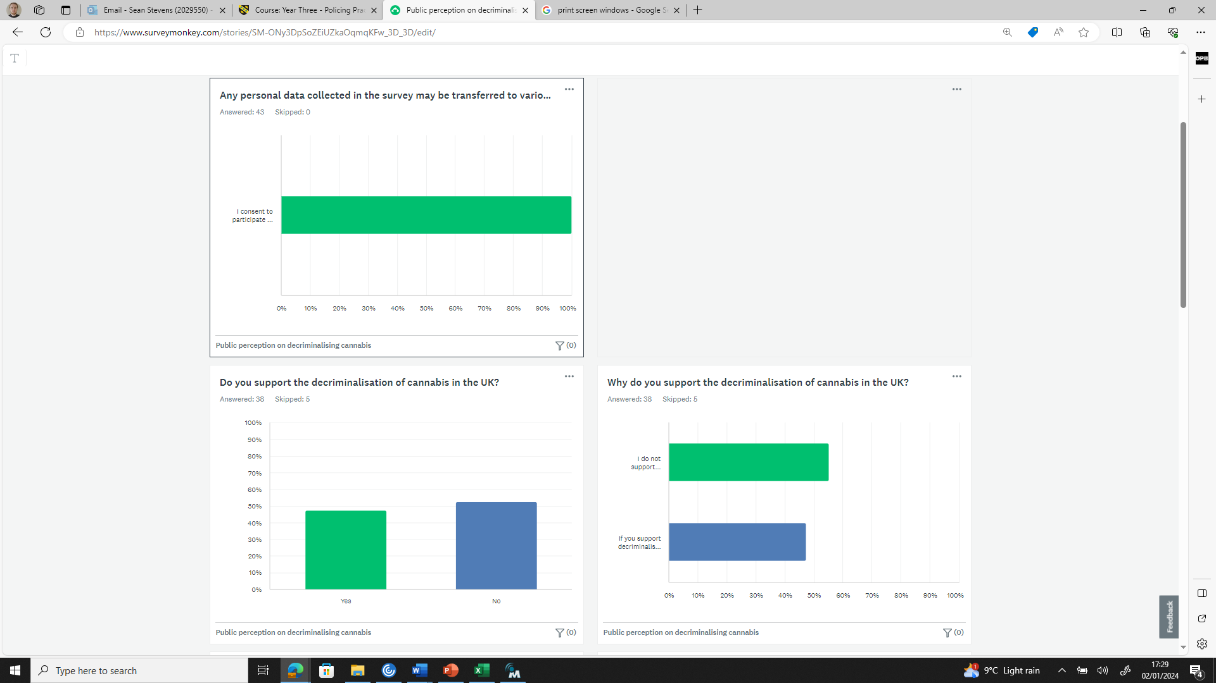
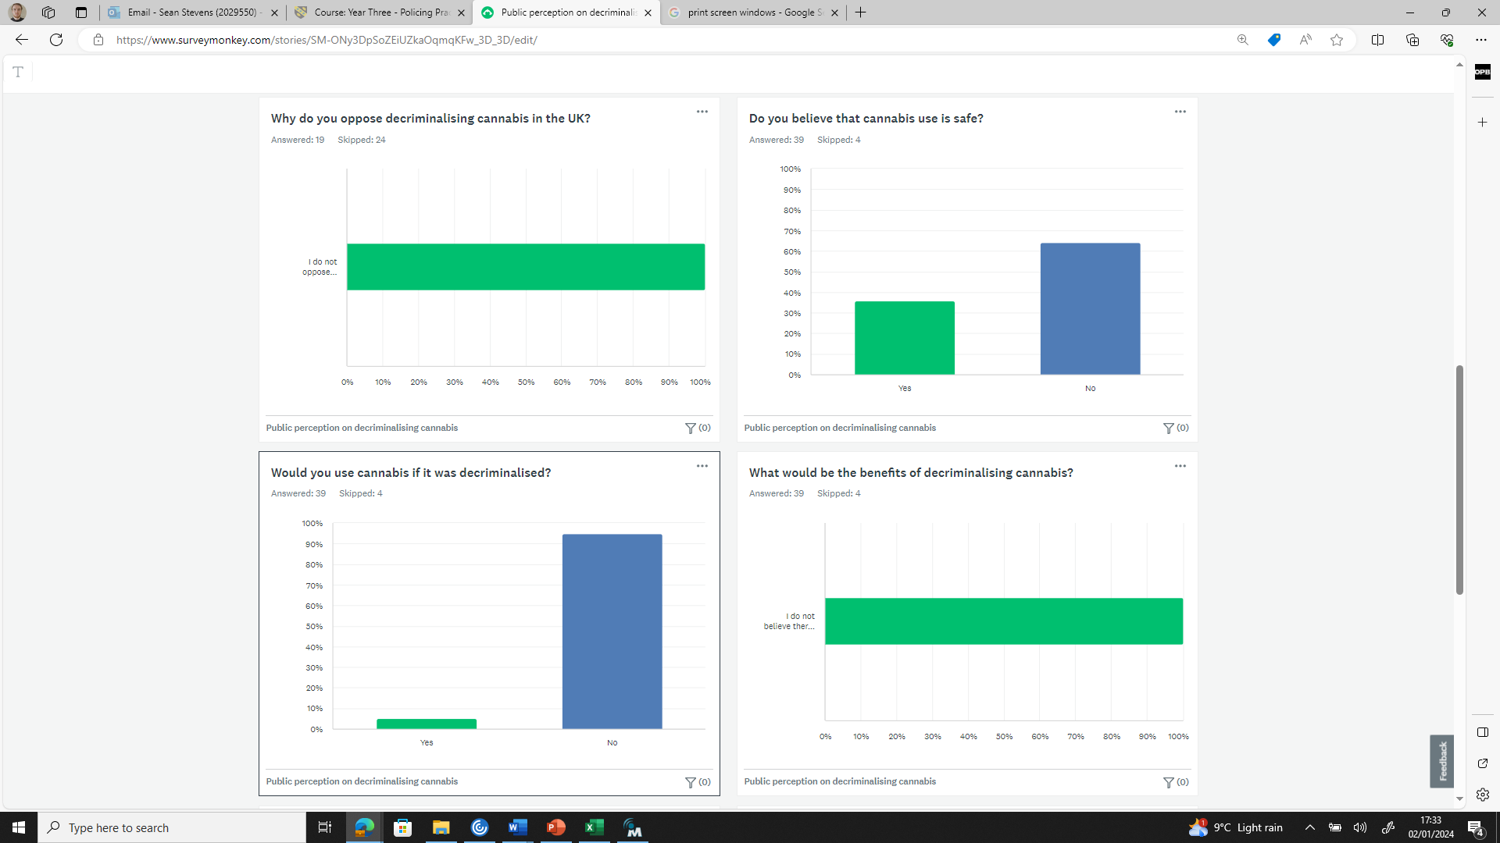
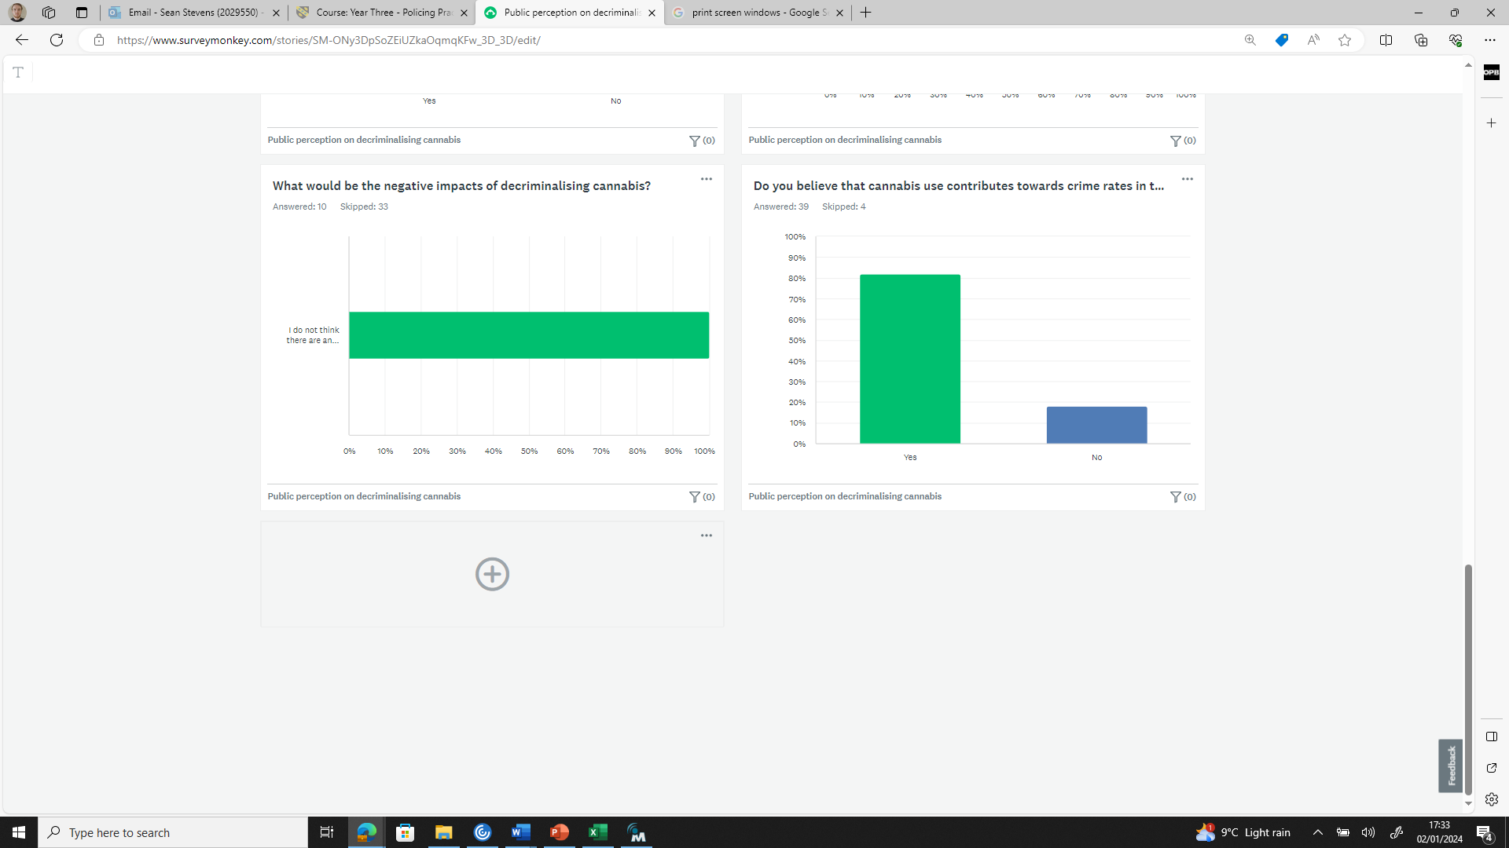
7.3 Appendix 3 - Responses to Q3
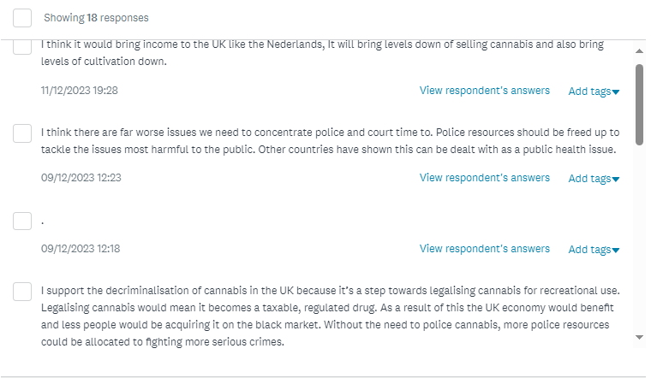
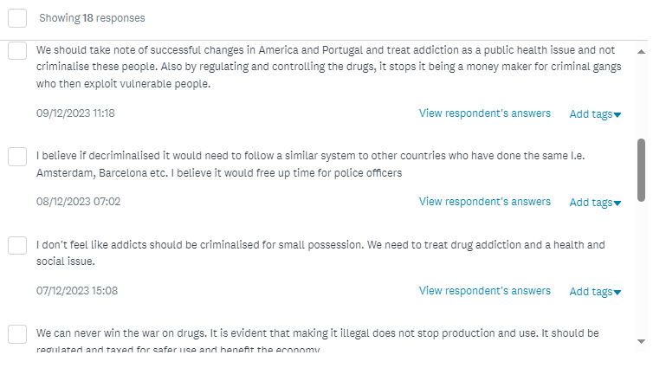
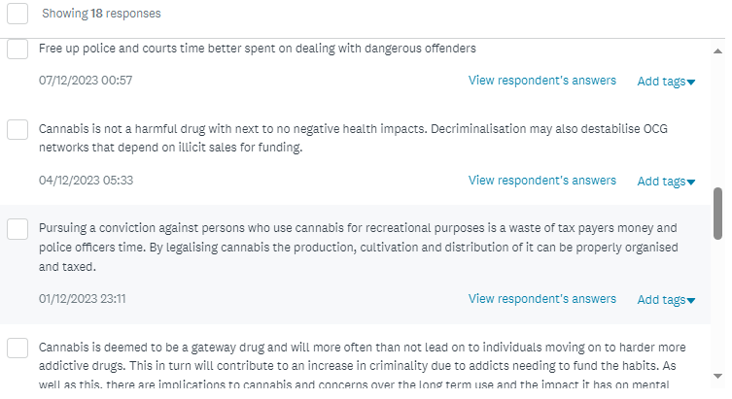
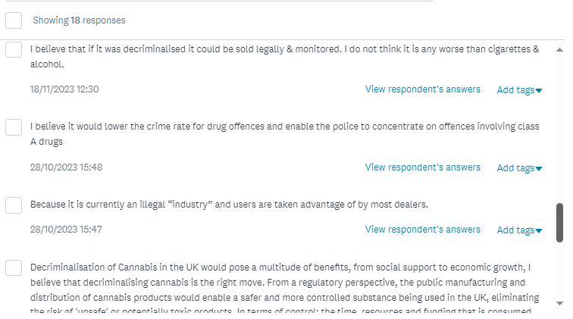
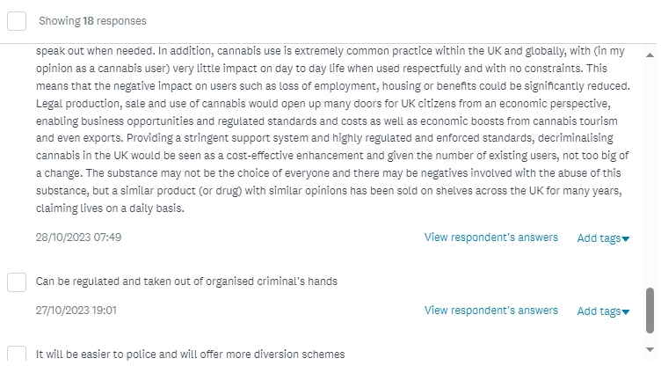
7.4 Appendix 4 - Responses to Q4
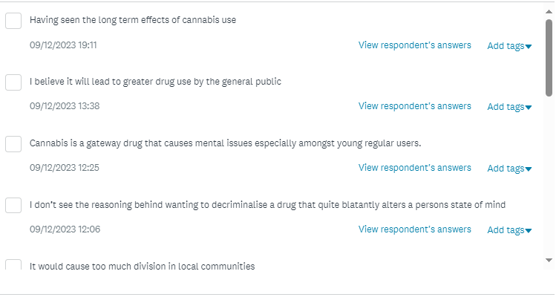
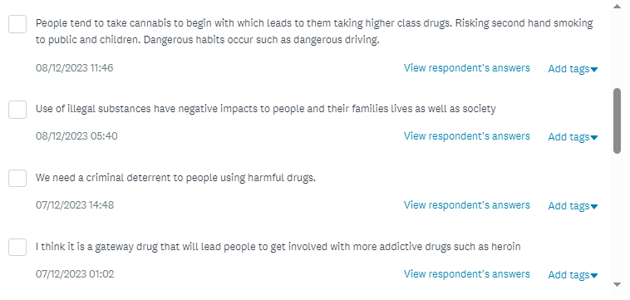
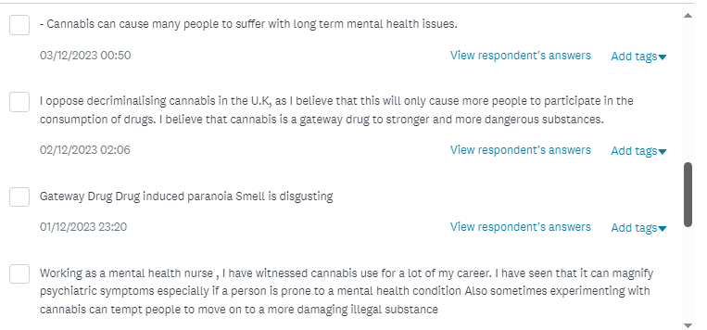
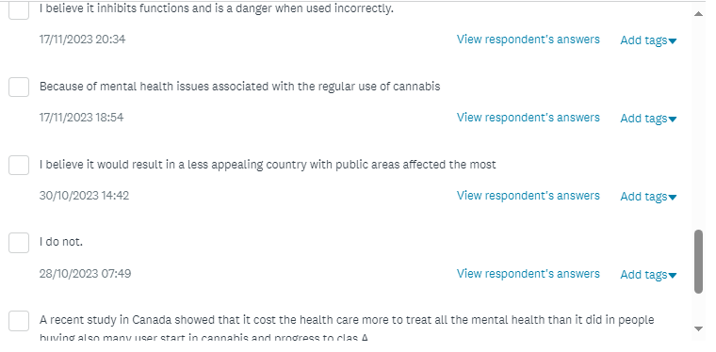
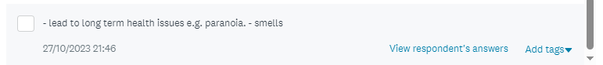
7.5 Appendix 5 -Responses to Q7
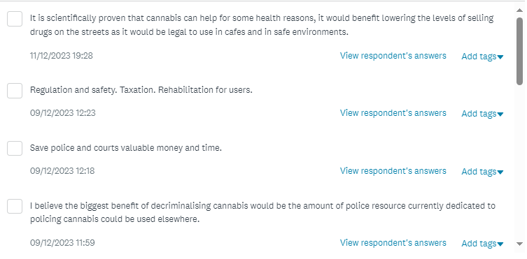
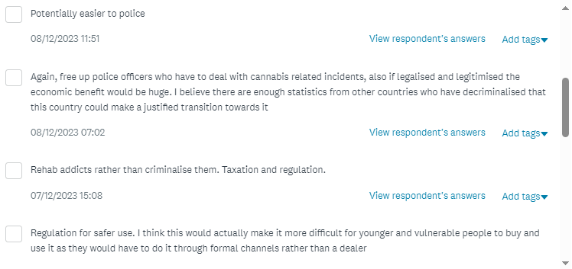
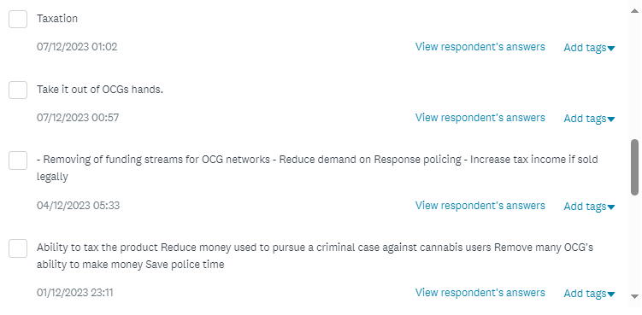
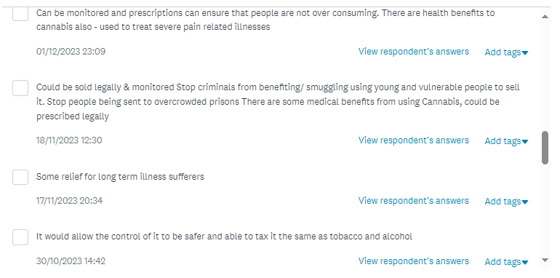
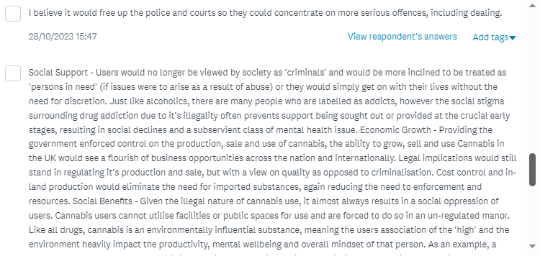
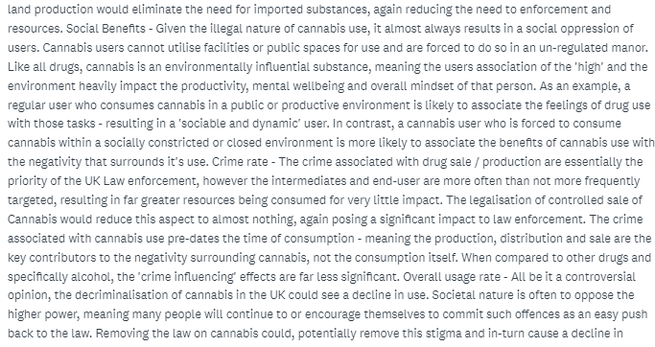
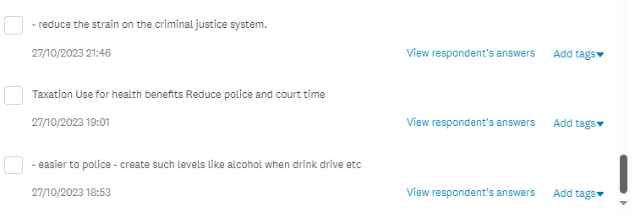
7.6 Appendix 6 - Responses to Q8


