Lab – Understanding Ethernet Cable Standards
Topology
Addressing Table
Device | Interface | IP Address | Subnet Mask | Default Gateway
PC-A | NIC | 192.168.10.1 | 255.255.255.0 | N/A
PC-B | NIC | 192.168.10.2 | 255.255.255.0 | N/A
Objectives
Part 1: Analyze Ethernet Cabling Standards and Pinouts
Part 2: Build an Ethernet Crossover Cable
Part 3: Test an Ethernet Crossover Cable
Background / Scenario
In this lab, you will build and terminate an Ethernet crossover cable and test it by connecting two PCs together and pinging between them. You will first analyze the Telecommunications Industry Association/Electronic Industries Association (TIA/EIA) 568-A and 568-B standards and how they apply to Ethernet cables. You will then construct an Ethernet crossover cable and test it. Finally, you will use the cable you just constructed to connect two PCs together and test it by pinging between them.
Note: With autosensing capabilities available on many devices, such as the Cisco 1941 Integrated Services Router (ISR) switch, you may see straight-through cables connecting like devices.
Required Resources
- One length of cable, either Category 5 or 5e. Cable length should be 0.6 to 0.9m (2 to 3 ft.)
- 2 RJ-45 connectors
- RJ-45 crimping tool
- Wire cutter
- Wire stripper
- Ethernet cable tester (optional)
- 2 PCs (Windows 7 or 8)
- Analyze Ethernet Cabling Standards and Pinouts
The TIA/EIA has specified unshielded twisted pair (UTP) cabling standards for use in LAN cabling environments. TIA/EIA 568-A and 568-B stipulates the commercial cabling standards for LAN installations; these are the standards most commonly used in LAN cabling for organizations and they determine which color wire is used on each pin.
With a crossover cable, the second and third pairs on the RJ-45 connector at one end of the cable are reversed at the other end, which reverses the send and receive pairs. The cable pinouts are the 568-A standard on one end and the 568-B standard on the other end. Crossover cables are normally used to connect hubs to hubs or switches to switches, but they can also be used to directly connect two hosts to create a simple network.
Reflection:
Write a research report (Max word count 600) on Cat 5e and 6 Ethernet cable standards.
  - Analyze diagrams and tables for the TIA/EIA 568-A standard Ethernet cable.
The following table and diagrams display the color scheme and pinouts, as well as the function of the four pairs of wires used for the 568-A standard.
Note: In LAN installations using 100Base-T (100 Mb/s), only two pairs out of the four are used.
568-A 10/100/1000Base-TX Ethernet
Pin Number | Pair Number | Wire Color | 10Base-T Signal  100Base-TX Signal | 1000Base-T Signal
1 | 2 | White/Green | Transmit | BI_DA+
2 | 2 | Green | Transmit | BI_DA-
3 | 3 | White/Orange | Receive | BI_DB+
4 | 1 | Blue | Not Used | BI_DC+
5 | 1 | White/Blue | Not Used | BI_DC-
6 | 3 | Orange | Receive | BI_DB-
7 | 4 | White/Brown | Not Used | BI_DD+
8 | 4 | Brown | Not Used | BI_DD-

The following diagrams display how the wire color and pinouts align with an RJ-45 jack for the 568-A standard.
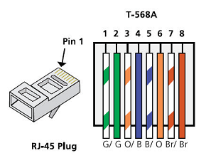
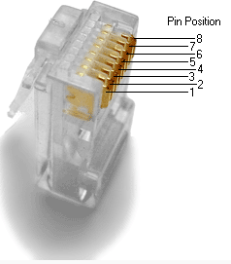
  - Analyze diagrams and tables for the TIA/EIA 568-B standard Ethernet cable.
The following table and diagram display the color scheme and pinouts for the 568-B standard.
568-B 10/100/1000-BaseTX Ethernet
Pin Number | Pair Number | Wire Color | 10Base-T Signal  100Base-TX Signal | 1000Base-T Signal
1 | 2 | White/Orange | Transmit | BI_DA+
2 | 2 | Orange | Transmit | BI_DA-
3 | 3 | White/Green | Receive | BI_DB+
4 | 1 | Blue | Not Used | BI_DC+
5 | 1 | White/Blue | Not Used | BI_DC-
6 | 3 | Green | Receive | BI_DB-
7 | 4 | White/Brown | Not Used | BI_DD+
8 | 4 | Brown | Not Used | BI_DD-
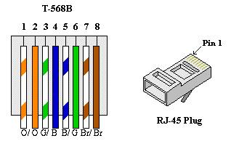

- Build an Ethernet Crossover Cable
A crossover cable has the second and third pairs on the RJ-45 connector at one end, reversed at the other end (refer to the table in Part 1, Step 2). The cable pinouts are the 568-A standard on one end and the 568-B standard on the other end. The two following diagrams illustrate this concept.
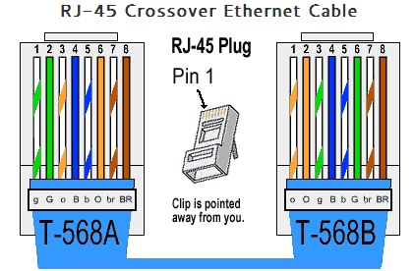
  - Build and terminate a TIA/EIA 568-A cable end.
    - Determine the cable length required. (Your instructor will let you know the cable length you should make.)
Note: If you were making a cable in a production environment, the general guideline is to add another 12 in. (30.48 cm) to the length.
    - Cut off a piece of cable to the desired length and using your wire stripper, remove 5.08 cm (2 in.) of the cable jacket from both ends.
    - Hold the four pairs of twisted cables tightly where the jacket was cut away. Reorganize the cable pairs into the order of the 568-A wiring standard. Refer to the diagrams, if necessary. Take as much care as possible to maintain the twists in the cable; this provides noise cancellation.
    - Flatten, straighten, and line up the wires using your thumb and forefinger.
    - Ensure that the cable wires are still in the correct order for the 568-A standard. Using your wire cutters, trim the four pairs in a straight line to within 1.25 to 1.9 cm (1/2 to 3/4 in.).
    - Place an RJ-45 connector on the end of your cable, with the prong on the underside pointing downward. Firmly insert the wires into the RJ-45 connector. All wires should be seen at the end of the connector in their proper positions. If the wires are not extending to the end of the connector, take the cable out, rearrange the wires as necessary, and reinsert the wires back into the RJ-45 connector.
    - If everything is correct, insert the RJ-45 connector with cable into the crimper. Crimp down hard enough to force the contacts on the RJ-45 connector through the insulation on the wires, thus completing the conducting path. See the following diagram for an example.
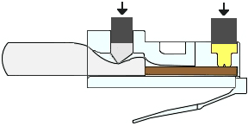
  - Build and terminate a TIA/EIA 568-B cable end.
Repeat steps 1a to 1g using the 568-B color wiring scheme for the other end.
- Test an Ethernet Crossover Cable
  - Test the cable.
Many cable testers will test for length and mapping of wires. If the cable tester has a wire map feature, it verifies which pins on one end of the cable are connected to which pins on the other end.
If your instructor has a cable tester, test the crossover cable for functionality. If it fails, check with your instructor first as to whether you should re-cable the ends and re-test.
  - Connect two PCs together via NICs using your Ethernet crossover cable.
    - Working with a lab partner, set your PC to one of the IP addresses shown in the Addressing Table (see page 1). For example, if your PC is PC-A, your IP address should be set to 192.168.10.1 with a 24-bit subnet mask. You partner’s IP address should be 192.168.10.2. The default gateway address can be left empty.
    - Using the crossover cable you made, connect the two PCs together via their NICs.
    - On the PC-A command prompt, ping the PC-B IP address.
Note: The Windows firewall may have to be temporarily disabled for pings to be successful. If the firewall is disabled, make sure you re-enable it at the conclusion of this lab.
    - Repeat the process and ping from PC-B to PC-A.
Assuming IP addressing and firewall are not issues, your pings should be successful if the cables were properly made.
Reflection
  - Which part of making cables did you find the most difficult?
Inserting the wires into the RJ45 connector and maintaining the correct order._______________________________________________________________________________________
  - Why do you have to learn how to make a cable if you can easily buy pre-made cables?
Replacing one or both connectors of an ethernet cable may be easier than replacing the entire length of cable depending on circumstances.
Reflection:
Write a research report (Max word count 600) on Cat 5e and 6 Ethernet cable standards.
Introduction
The Electronic Industries Association (EIA) and the Telecommunications Industry Association (TIA) have produced structured cabling specifications known as the ANSI/TIA-568 family of telecommunications standards [1]. Twisted-pair cables are rated in categories specified by the standards, with this report focusing on categories 5 and 6e (Cat 5e/Cat 6).
What is Ethernet?
Ethernet is a group of protocols defined by the Institute of Electrical and Electronics Engineers (IEEE) in standards 802.2 and 802.3 [2], that enable communication between devices on a local area network (LAN). Ethernet operates at the physical and data-link layers of the OSI reference model.
Twisted pair cabling is traditionally used in wired LANs as the transmission medium that enables communication between devices. Official cabling standards “provide a single source of specifications and recommendations for a set of structured cables capable of handling everything your building might need to support [1]”.
Cable composition
Both Cat5e and Cat 6 Ethernet cables use either unshielded twisted pair (UTP) or shielded twisted pair (STP) cables as their medium of choice. When wire pairs transmit data, the current formed can produce a magnetic field around the wire, introducing signal noise that may interfere with data transmission. Twisting the wires causes the magnetic fields to flow in opposite directions, negating their effect. STP cables build on this by covering twisted pairs with foil or braided shielding to mitigate further interference and crosstalk.
Cat5e
A Cat5e cable is capable of supporting up to Gigabit Ethernet. Gigabit Ethernet is defined in the IEEE 802.3ab standard and can also be referred to as 1000Base-T. There are 4 wire pairs in a Cat5e cable, and this standard simultaneously sends and receives signals over the same wire pairs [1]. Gigabit Ethernet supports data rates of up to 1 Gbps which a Cat5e cable is certified to carry for distances of up to 100 meters. ANSI/TIA-568 standards from the telecommunications industry association (TIA) specifies Cat5e cable with a bandwidth of 100MHz.
Cat6
Cat6 cables support higher bandwidths than Cat5e. They are capable of supporting up to 10G Ethernet, also referred to as 10GBase-T and defined in the IEEE 802.3-2018 standard. 10G Ethernet supports data rates of up to 10 Gbps which a Cat6 cable is certified to carry for distances of up to 55 meters. The twisted pairs are often shielded and wound tighter than in Cat5e cables which helps to prevent electromagnetic interference. ANSI/TIA-568 standards define a signal bandwidth of 250 MHz for a Cat6 cable.

ANSI/TIA-568 also defines wiring standards for how twisted pair cables should terminate their wires into an 8P8C modular connector (frequently referred to as an RJ45). T568A and T568B are the two slightly different standards that specify the order in which the wires should be placed into an RJ45 connector. The position of the orange and green wire pairs is the key difference between the two standards. If a cable is terminated using the same standard at both ends it is known as a straight-through cable. If both ends are terminated with the different standards it is known as a crossover cable. An image demonstrating the difference is shown below [3]:

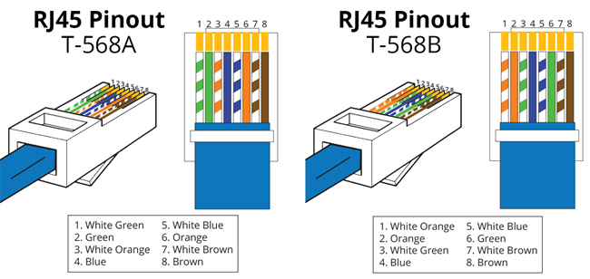

Straight through cables are used to connect dissimilar networking devices, whereas crossover cables allow similar networking devices to be connected directly.

Conclusion
Standardisation of network cabling improves performace and enables reliable connectivity between devices on a LAN. Cables can be chosen based on cost and bandwith requirements, although performance can be impacted with twisted pair cabling as cable length increases.

[1] C. E. Spurgeon and J. Zimmerman, Ethernet: the definitive guide, Second edition. Beijing: O’Reilly, 2014.
[2] ‘IEEE 802.3-2018 - IEEE Standard for Ethernet’. [Online]. Available: https://standards.ieee.org/standard/802_3-2018.html. [Accessed: 12-Dec-2019].
[3] ‘T568A-T568B-Wiring-Standard.png (650×308)’. [Online]. Available: https://morganwu277.github.io/2017/05/27/Straight-Through-and-Crossover-Cable/T568A-T568B-Wiring-Standard.png. [Accessed: 12-Dec-2019].

