Ioana Dinu (2025758)
Reference List:
Allergies and intolerances available at https://www.knowsleynews.co.uk/allergies-and-intolerances-information-for-businesses/ , Accessed on 20/02/2022
Food.Gov.UK available at https://www.food.gov.uk/ , accessed on 22/02/2022
Dishes images available at https://guide.michelin.com/ accessed on 23/02/2022
Dish image available at https://www.gasteinertal.com/en/hotel-stgeorg/ accessed on 22/02/2022
How to Design a Perfect Menu (And Design Tips!) (webstaurantstore.com) accessed on 20/02/2022
Lemonade image available at https://turkishfoodie.com/lemonade/ accessed at 20/02/2022
Menu Writing Explained - Robert Ancill Restaurant Consultant (globalrestaurantconsultant.com) accessed on 20/02/2022
Menu Engineering Course: Make the Most of Your Menu - Welcome to the Course | Rise 360 (articulate.com) accessed on 19/02/2022
Prepare to reopen: how to develop a restaurant menu (typsy.com)accessed on 21/02/2022
Swirl Ornaments available at https://www.freepik.com/free-vector/calligraphic-swirls-ornaments-decorations accessed on 19/02/2022
Wine pairing available at https://www.vivino.com/GB/en/ accessed on 19/02/2022


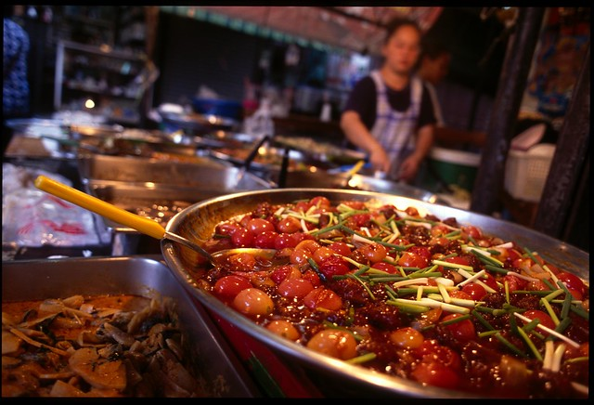

Hotel Trinity

Take away and Delivery Menu

Opening Times:
Monday – 12:00 to 20:00
Tuesday– 12:00 to 20:00
Wednesday– 12:00 to 20:00
Thursday– 12:00 to 20:00
Friday– 12:00 to 20:00
Saturday - Closed
Sunday- Closed
Ewch i food.gov.uk/ratings i ganfod sgôr hylendid bwyd ein busnes neu gofynnwch inni beth yw ein sgôr hylendid bwyd wrth archebu / Go to food.gov.uk/ratings to find out the food hygiene rating of our business or ask us for our food hygiene rating when you order.

To place an order please call us on : 01791234567
Payment over the phone, card only, or electronically on the delivery apps
Collection from: Lampeter Campus, SA48 7ED, Aberaeoron, Caredigion
Or delivery available through Delivero and Just Eat


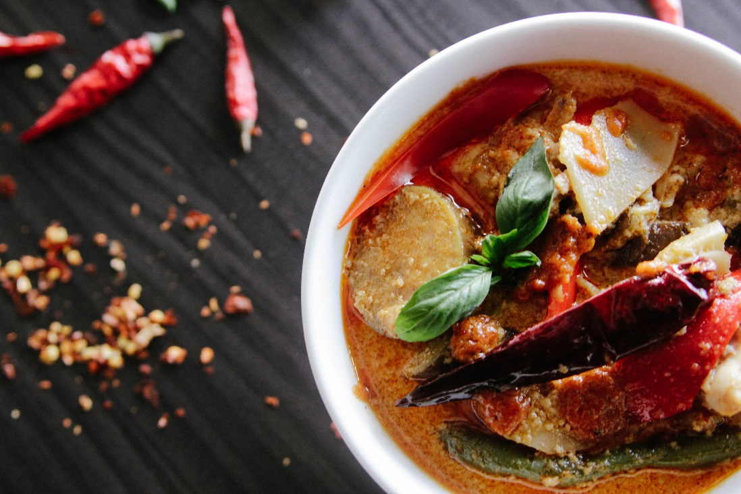


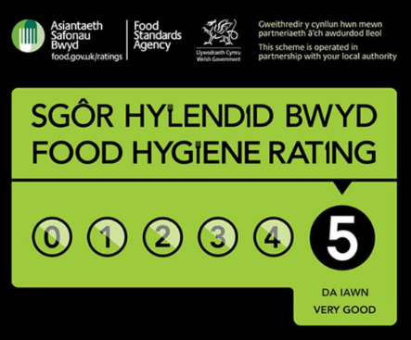
To place an order please call us on : 01791234567
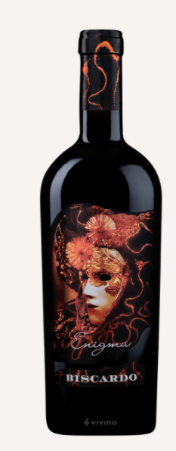
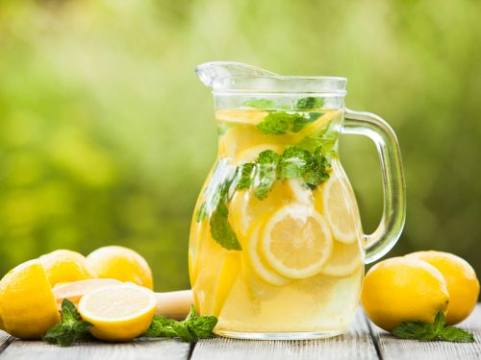
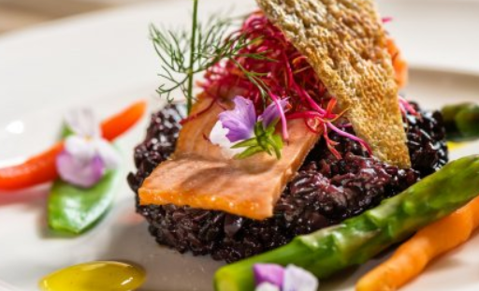
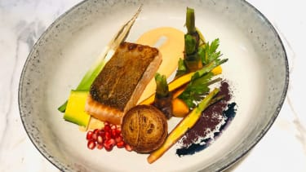
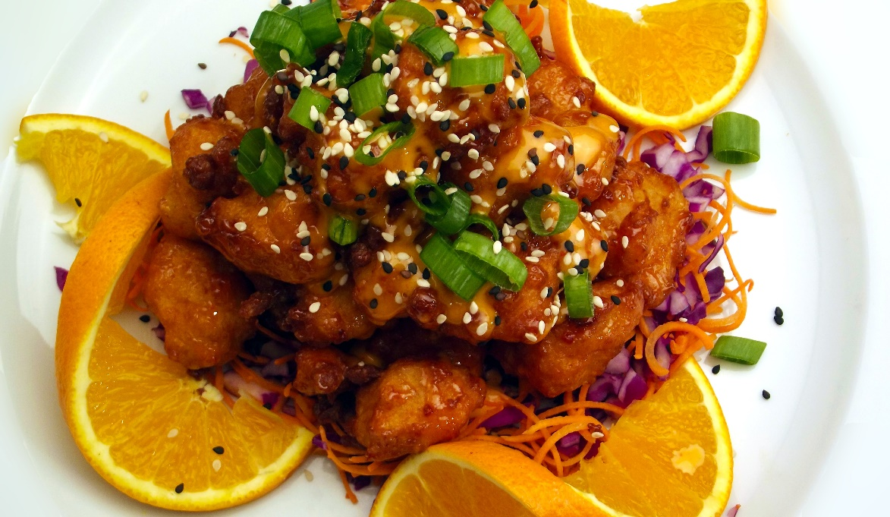
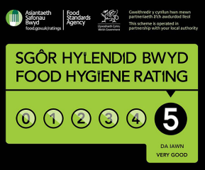
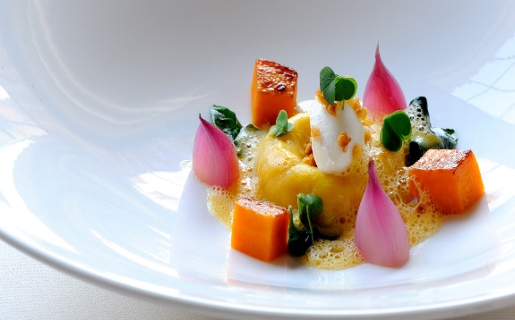
If you have any allergies or intolerances, please inform a member of our staff before placing the order: 01791234567
Drinks & Wines
Italian Sparkling Water/5
Still Water/5
Coffee/6
San Pellegrino Limonade/7
Wine Enigma Biscardo/30
(a perfect match with our Chargrilled Steak)
Wine Bourgogne Chardonnay/32
(Works perfectly with our Wild Salmon)
Wine Selladore/25
(Unforgettable experience with our Pork ribs specials)

To place an order please call us on : 01791234567
Desserts
Cheese Trio with apple and plum chutney/10
Buttermilk vanilla panna cotta/7
Rhubarb crumble/8
Chocolate cake/10
Trinity Honeycomb Cheesecake/12
Fruits salad/10

Starters
Honey & sherry glazed chorizo/4
Celeriac, cauliflower & truffle soup/5
Aunt Marie’s Duck liver parfait/7
Artist’s breads, whipped malt butter/3
Battered halloumi with pesto mayo/4
Battered shrimps & butternut squash

King scallops/10

Hotel Trinity

Diary Free Meals | Vegan | Egg Free | Gluten Free | Tree Nut Free | Peanut Free | Soy Free
Mushroom- Pesto Pizza/9 | √ | √ | √ |  | √ | √
Sun-Dried Tomato & Basil Salmon with Baked Zucchini/12 |  | √ | √ | √ | √ | √
Pasta with Rustic Tomato Cream Sauce/7 |  | √ | √ | √ | √ | √
Chicken Alfredo/10 |  | √ | √ |  | √ | √
Diary Free Desserts | Vegan | Egg Free | Gluten Free | Tree Nut Free | Peanut Free | Soy Free
Black & Blue Berry Crisps/5 | √ | √ | √ | √ | √ | √
Artemis Bonbons/6 | √ | √ | √ | √ | √ | √
Pumpkin Pie Cups/8 |  | √ | √ | √ | √ | √
Double Chocolate Mint Ice Cream/8 | √ | √ | √ | √ | √ | √

Main Courses
Aged Chargrilled Steak/25
(Chunky chips, Bearnaise sauce &Confit tomato)
Pork ribs specials/23
(Italian leaves, potatoes, charred cabbage)
Hunters Duck & Wild Mushrooms/25
(Truffle mash, pancetta, parmesan, onion)
Chicken chargrilled with mixed vegetables/20
(Rice, mushrooms in gravy sauce)
Wild Salmon & Carrot puree/20

