

University of Wales Trinity Saint David School of Engineering

Engine Performance Characteristics (ACHA4003)

oliver powell
2206640
BEng motorcycle engineering
march 2023
Contents
i. Nomenclature iii
1. Introduction 1
2. Testing 2
2.1. Equipment Used 2
2.2. Testing Method 4
3. Results 5
3.1. Raw Data 5
3.2. Findings 7
4. Conclusion 12
5. Evaluation 13
6. References 14

i. Nomenclature
- RPM – Revolutions Per Minute, the rate at which an object is spinning about a normal axis.
- Sweep Test – A smooth increase in engine load/speed with time from idle to maximum governed engine speed.
- Ideal cycle – no losses within the engine, drivetrain or dynamometer system.
- Rev range – Engine speed minimum to maximum in RPM
- $Calorific Potential Power$ = Ideal power output (KW)
- $Fuel Flow Rate$ = Fluid flow (L/s)
- $Specific Gravity of Fuel$ = Weight of fuel compared to water of equal volume (Kg/L)
- $Calorific value of fuel$= “Amount of liberated per unit weight” (Plint & Martyr, 1995) (J/Kg)
- τ = Torque (N.m)
- F = Force (N)
- d = Distance (m)

1. Introduction
This report will gather data from an engine dynamometer session on a Honda four-cylinder 4 stroke engine. The data will be used to generate accurate calculations of engine parameters. The values will be used to understand quality of the engines performance and summarise its ideal working environment. An analysis will be made where the data and findings will be able to prove where the engine may or may not be optimum. Improvements based on the findings will be suggested.

2. Testing

2.1. Equipment Used
A dynamometer was used to acquire quantitative data of engine performance during its operation. The dynamometer uses a series of sensors to monitor engine parameters at various engine speeds. The engine speed is measured using a tachometer. The ability to know the engine speed allows calculations to be made at various stages of the rev range during the test.
To acquire the torque from the engine, an equal force in the opposing direction is applied. Once the difference between the engine force output and the torque being applied by the dynamometer is zero, then the system is in equilibrium, and therefore engine torque output is the same as the applied torque by the dynamometer. The force is measured from two load cells mounted on arms at a calibrated distance from centre.
By definition,
$$τ=F.d$$
Equation 1 – Torque equation
Torque can be calculated from the dyno given we know the distance that the resistance force is being applied from centre.
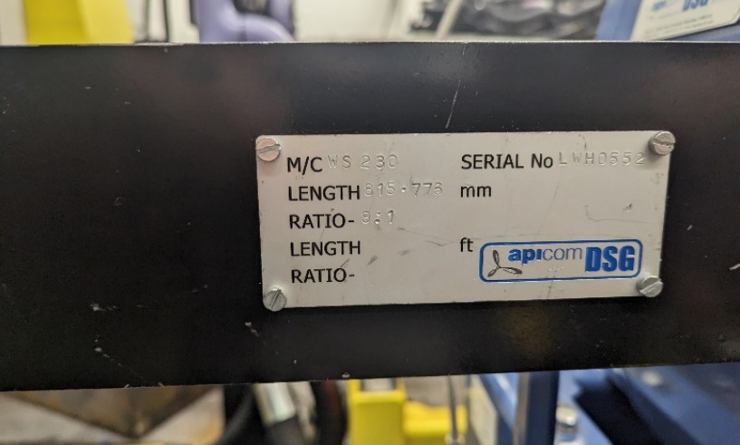
Figure 1 – Load cell distance from centre

A fuel from sensor was used during the experiment to monitor how much liquid fuel was being sent to the engine. The maximum power in an ‘ideal cycle’ can be calculated by considering the calorific value of the fuel.
Therefore, the maximum power output of the engine in an ideal cycle can be defines as,
$$Calorific Potential Power=\frac{(Fuel Flow Rate x Specific Gravity of Fuel) x Calorific value of fuel}{1000}$$
Equation 2 – Calorific Potential Energy
A Lambda sensor “determines the remaining content in the exhaust emission” (Hella.com, n.d.). The Lambda reading about 1, this value can be used to understand how well optimised the engine is combusting.
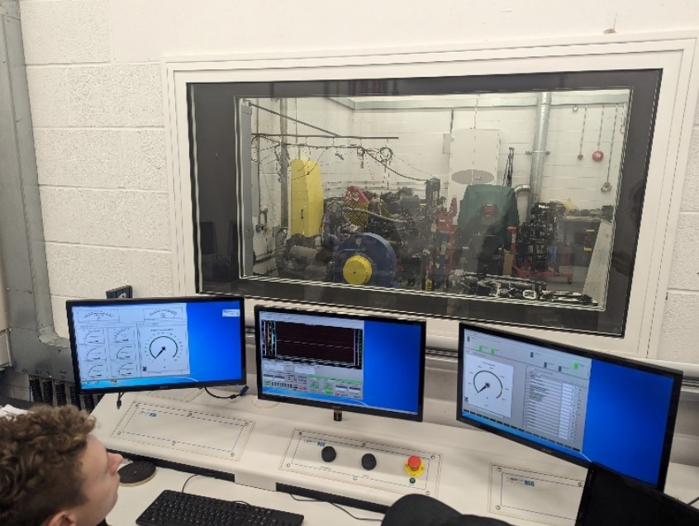
Figure 2 – Data gauges and manual input board for engine control

2.2. Testing Method
- The engine was preloaded into the dynamometer.
- The driveshaft was connected to a load cell unit.
- The arms on the load cell were installed.
- The arm lengths were then accurately measured.
- All connectors and sensors were double checked.
- The dials on the input control panel were set to zero, and the engine was started.
- The engine speed was increased and tested for correct functionality.
- The engine was left at a set engine speed and a brake load was applied to the dynamometer to check for correct functionality.
- The dials were then turned back to zero and idle.
- The engine throttle dial was then slowly turned to increase the engine speed till 5500RPM.
- The brake load was applied.
- Throttle dial was increased as the brake force was increased until the throttle showed maximum opening.
- Here, the forces are in equilibrium and the maximum power of the engine has been reached.
- The throttle was wound back to idle, and a series of sweet tests were conducted.
- Data was gathered from the sweep tests in the form of an excel data spreadsheet.

3. Results

3.1. Raw Data
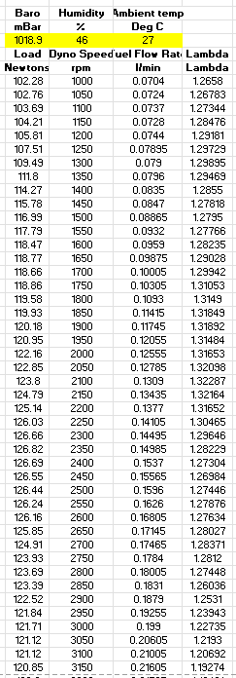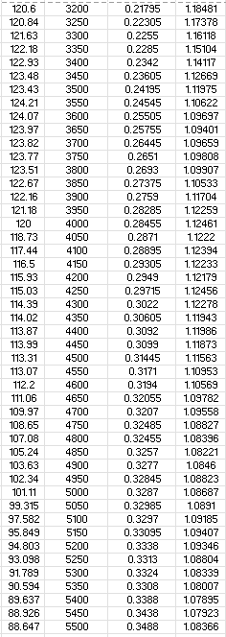
Figure 3 – RAW data gathered from the dynamometer at 50RPM intervals throughout a rev range of 1000RPM – 5500RPM.
Lever arm length - 815.77mm
Ambient temperature – 27ºC
Atmospheric pressure – 1018.9Millibar
Humidity – 48%
Mass of air – 1.0189 Kg/m³
Specific gravity of Unleaded fuel – 0.75Kg/Litre (Sunoco, 2018)
Calorific value of unleaded fuel – 44MJ (world-nuclear.org, n.d.)
Engine capacity – 1600cc
Piston bore diameter – 75mm
Piston stroke length -90mm

3.2. Findings

3.2.1. Fuel Consumption

Table 1 – Engine fuel consumption against engine speed
With a baseline idle of 1000RPM, the engine has a high rate (>80%) of fuel burn compared to other areas within the curve. At idle, the engine is not working at its optimal temperature for combustion resulting in a higher specific fuel consumption. Research from Knauder supports this thesis where “The most significant increase ‘in SFC’ could be observed at the lowest investigated engine speed of 1000 rpm.” (Knauder, et al., 2019). The engine burns less fuel between 1500rpm to 2400rpm. At this point a gradual exponential increase in fuel consumption occurs between 2500RPM to 5500RPM, where the engine is having to use more fuel to overcome the increase in friction. It has been stated that “the impact of heat losses on bsfc is about one-third” (Haywood, 2018). Given the prior, the increase in friction found in this rev range is attributed to the increase in engine temperature and increase in surface friction cycles per unit time.

3.2.2. Torque
Table 2 - Torque output against engine speed
The torque output curve is generally flat, with a variation of only 30% between peak torque a minimum torque, with peak torque occurring at 2350RPM, and staying consistent (within 10%) until 3900RPM. The initial torque of the curve is lower than the mid-range, as the engine isn’t transmitting all the piston pressure to kinetic energy. This is due to the longer piston cycle time, allowing more energy to be lost to heat through cylinder walls. There is a gradual and decline in torque from 3600RPM to 5500RPM as engine speed increases. From equation 1, as the crankshaft rotates, the “distance” changes, therefore, the time spent between TDC, 90º and BDC, is degreasing while engine speed increases. With less time in this rotational phase, there is less time for the torque to be converted into kinetic energy.

3.2.3. Brake Power
Table 3 - Power output against engine speed
The power delivery is very linear throughout the initial 2/3 of the power curve, between idle and 3950RPM. From 3950RPM onwards, the power delivery begins to decrease in relation to the engine speed, achieving peak power of 44KW at 4650PRM. Within this rev range, the frictional and thermal resistance forces are increasing. This alone will cause a decrease in power curve gradient. In addition to this, the engine is not making the most of the combustion phase of the cycle, whereby the pressure within the cylinder is not being converted fully to kinetic energy, and some of the pressure is being lost within the exhaust phase of the cycle. This aligns with the data gathered from the torque curve, as the torque and power curve gradients decrease at similar points as seen in table 4. Furthermore, ”the valvetrain alone is responsible for 10 − 20% of the overall friction losses in the engine “ (Sordo, et al., 2021), indicating an increasing friction loss (and resulting power) when engine revs increase.

3.2.4. Combined Power Delivery

Table 4 - Torque/Power curve

3.2.5. Lambda Consideration

Table 5 - Lambda against Power output
Lambda is a measurement of the stoichiometric burn efficiency in the engine. This value can be used to determine where changes can be made to the fuelling of the engine to achieve optimum performance.

4. Conclusion
Given graphs seen in table 1 and table 4, the engine would be a suitable engine for a city, or commuting vehicle. It provides a flat and wide banded amount of torque that enables a relaxed drivability for a wide variety of driving scenarios. The engines low power makes it unsuitable for high performance application. The efficiency of the engine was between 21.7% - 31.3% which is expected, as similar engines return 25% - 30% (International, n.d.).
Given that the Lambda figures were consistently above factor 1, the engine did not have enough fuel in the combustion chamber. The engine could produce more power, as the calorific value per stroke would be greater, resulting in higher MEP.
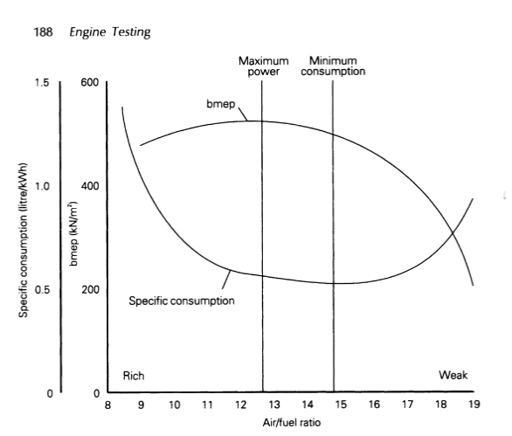
Figure 4 - Air Fuel ratio graph (Plint & Martyr, 1995)
Given the other attributes of the engine, and the former application recommendations for this engine, it is being used optimally, where AFR is around 14.7:1, minimum consumption.

5. Evaluation
The experiment was positively conducted returning consistent data. The data shows that humidity was at 46% for the test, and the ambient temperature was higher than ideal at 27ºC. Both factors could greatly impact the results, and the outcome of the overall conclusion.
The experiment could have been conducted at a range of different temperatures to see how that variable would affect the results. Furthermore, the test could be conducted using an air feed system whereby the air can be filtered to 0% humidity, resulting in the most optimum and accurate results for the given engine.
I feel that my personal performance was adequate. I was keen to test the engine using the dynamometer controls and found a good feel for the characteristics of the engine while doing so. I feel that I could have asked more questions about the dynamometer and its setup, as I had never used a similar setup before.
To improve the experiment, more data could have been gathered from the engine. This might have allowed easier calculation of some of the parameters and allowed for greater understanding of the engine. Taking the exhaust temperature, for example, might have allowed a more conclusive evaluation to the low RPM SFC compared to optimum temperatures at mid RPM.

6. References
Haywood, J., 2018. Internal combustion engine fundamentals. 2nd ed. s.l.:McGraw-Hill.
Hella.com, n.d. LAMBDA SENSOR - CAUSE OF FAILURE, TESTING AND TROUBLESHOOTING. [Online]
Available at: https://www.hella.com/techworld/uk/Technical/Sensors-and-actuators/Test-lambda-sensor-4379/#:~:text=The%20lambda%20sensor%20determines%20the,control%20the%20air%2Dfuel%20ratio.
[Accessed 20 March 2023].
International, A., n.d. How Efficient is Your Cars Engine. [Online]
Available at: https://www.aaa.com/autorepair/articles/how-efficient-is-your-cars-engine
Knauder, C., Allmaier, H., Sander, D. E. & Sams, T., 2019. Investigations of the Friction Losses of Different Engine.
Plint, M. & Martyr, A., 1995. Engine Testing: theory and practice. s.l.:Butterworth-Heinemann.
Sordo, F., Scalzo, G. & Lavella, M., 2021. Friction dissipation in reciprocating internal, Bergamo: s.n.
Sunoco, 2018. Specific Gravity – What Is It And Why Does It Matter?. [Online]
Available at: https://petroleumservicecompany.com/blog/specific-gravity-what-is-it-and-why-does-it-matter/
[Accessed 16 March 2023].
world-nuclear.org, n.d. Heat Values of Various Fuels. [Online]
Available at: https://world-nuclear.org/information-library/facts-and-figures/heat-values-of-various-fuels.aspx

