
information engineering
Uwtsd octorber 2020

octorber 2020
yannick tsobgny
1920006

ENTITY RELATIONSHIP DIAGRAM

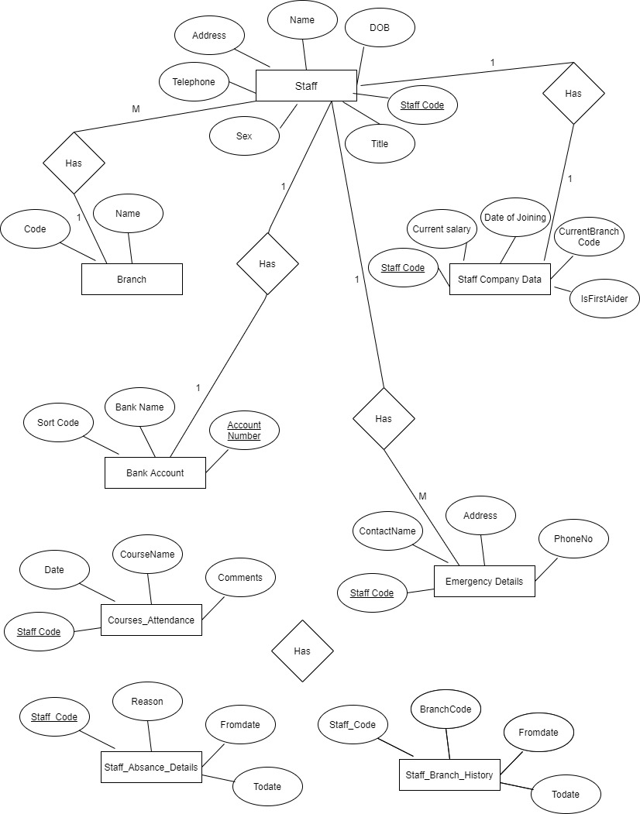

SQL QUERIES (CREATE TABLES)

CREATE TABLE `staff` (
`Id` int NOT NULL,
`StaffCode` varchar(45) NOT NULL,
`Title` varchar(45) DEFAULT NULL,
`Sex` varchar(45) DEFAULT NULL,
`Address` varchar(45) DEFAULT NULL,
`Telephone` varchar(45) DEFAULT NULL,
`DOB` date DEFAULT NULL,
PRIMARY KEY (`StaffCode`)
) ENGINE=InnoDB DEFAULT CHARSET=utf8mb4 COLLATE=utf8mb4_0900_ai_ci;

CREATE TABLE `staffcompanydata` (
`Id` int NOT NULL,
`StaffCode` varchar(45) DEFAULT NULL,
`CurrentSalary` int DEFAULT NULL,
`Joineddate` date DEFAULT NULL,
`IsFirstAider` bit(1) DEFAULT NULL,
PRIMARY KEY (`Id`),
KEY `staffcode_idx` (`StaffCode`),
CONSTRAINT `staffcode` FOREIGN KEY (`StaffCode`) REFERENCES `staff` (`StaffCode`)
) ENGINE=InnoDB DEFAULT CHARSET=utf8mb4 COLLATE=utf8mb4_0900_ai_ci;

CREATE TABLE `staffbranchhistory` (
`Id` int NOT NULL,
`StaffCode` varchar(45) DEFAULT NULL,
`BranchCode` varchar(45) DEFAULT NULL,
`FromDate` date DEFAULT NULL,
`ToDate` date DEFAULT NULL,
KEY `staffcode_idx` (`StaffCode`),
CONSTRAINT `staffcode` FOREIGN KEY (`StaffCode`) REFERENCES `staff` (`StaffCode`),
PRIMARY KEY (`Id`)
) ENGINE=InnoDB DEFAULT CHARSET=utf8mb4 COLLATE=utf8mb4_0900_ai_ci;

CREATE TABLE `branch` (
`Id` int NOT NULL,
`Code` varchar(45) NOT NULL,
`Name` varchar(45) NOT NULL,
PRIMARY KEY (`Id`)
) ENGINE=InnoDB DEFAULT CHARSET=utf8mb4 COLLATE=utf8mb4_0900_ai_ci;

CREATE TABLE `bankaccount` (
`Id` int NOT NULL,
`BankName` varchar(45) NOT NULL,
`Staffcode` varchar(45) DEFAULT NULL,
`SortCode` varchar(45) DEFAULT NULL,
`AccountNumber` varchar(45) DEFAULT NULL,
PRIMARY KEY (`Id`),
CONSTRAINT `staffcode` FOREIGN KEY (`StaffCode`) REFERENCES `staff` (`StaffCode`)
) ENGINE=InnoDB DEFAULT CHARSET=utf8mb4 COLLATE=utf8mb4_0900_ai_ci;

CREATE TABLE `staffabsancedetails` (
`Id` int NOT NULL,
`StaffCode` varchar(45) DEFAULT NULL,
`FromDate` date DEFAULT NULL,
`Todate` date DEFAULT NULL,
`Reason` varchar(45) DEFAULT NULL,
PRIMARY KEY (`Id`),
CONSTRAINT `staffcode` FOREIGN KEY (`StaffCode`) REFERENCES `staff` (`StaffCode`)
) ENGINE=InnoDB DEFAULT CHARSET=utf8mb4 COLLATE=utf8mb4_0900_ai_ci;

CREATE TABLE `emergancydetails` (
`Id` int NOT NULL,
`Staffcode` varchar(45) DEFAULT NULL,
`Address` varchar(45) DEFAULT NULL,
`Contactname` varchar(45) DEFAULT NULL,
`PhoneNo` varchar(45) DEFAULT NULL,
PRIMARY KEY (`Id`),
CONSTRAINT `staffcode` FOREIGN KEY (`StaffCode`) REFERENCES `staff` (`StaffCode`)
) ENGINE=InnoDB DEFAULT CHARSET=utf8mb4 COLLATE=utf8mb4_0900_ai_ci;

CREATE TABLE `courseattendance` (
`Id` int NOT NULL,
`StaffCode` varchar(45) NOT NULL,
`coursename` varchar(45) DEFAULT NULL,
`Date` varchar(45) DEFAULT NULL,
`Coments` varchar(45) DEFAULT NULL,
PRIMARY KEY (`Id`),
CONSTRAINT `staffcode` FOREIGN KEY (`StaffCode`) REFERENCES `staff` (`StaffCode`)
) ENGINE=InnoDB DEFAULT CHARSET=utf8mb4 COLLATE=utf8mb4_0900_ai_ci;

SCREENSHOTS OF CREATED TABLES

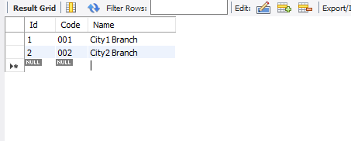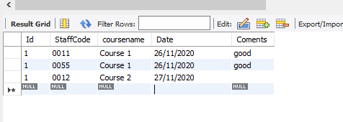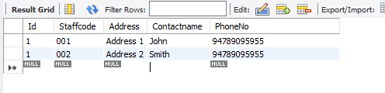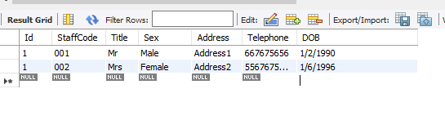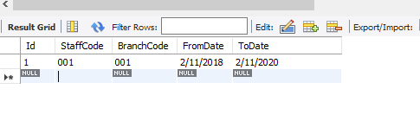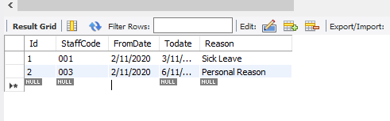

SCREENSHOTS OF FORMS AND NAVIGATION

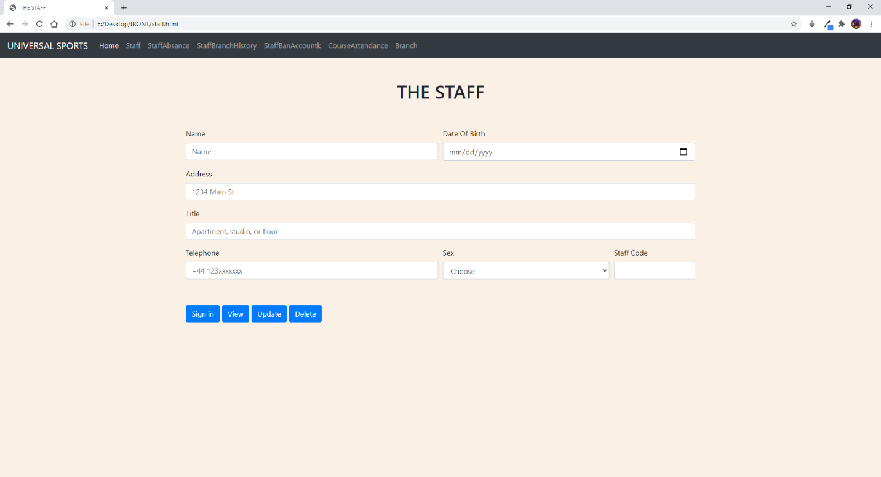

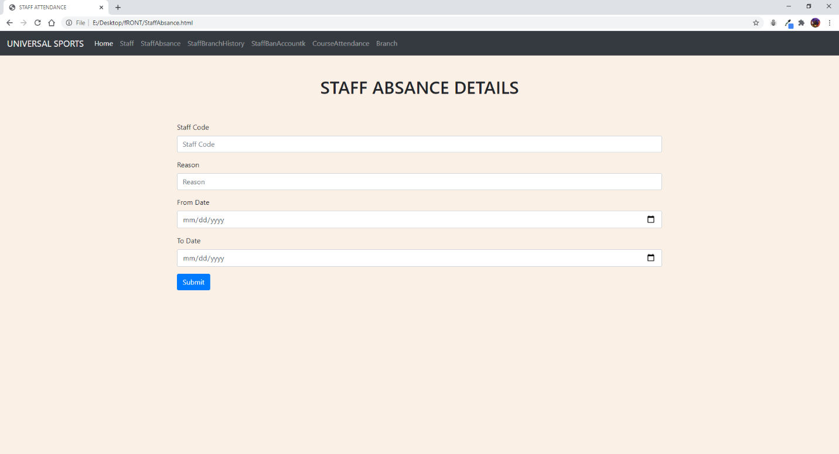

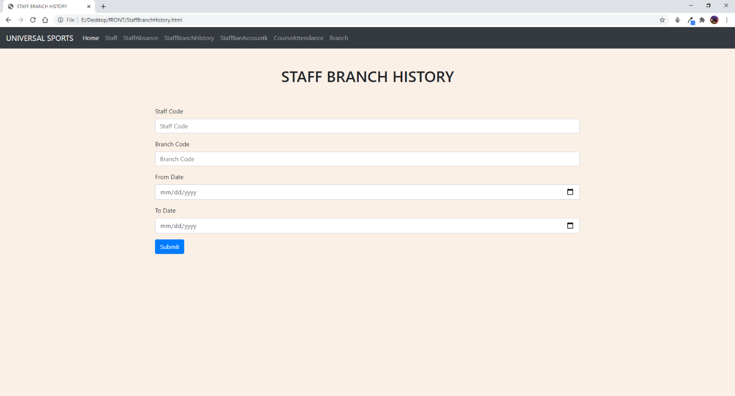

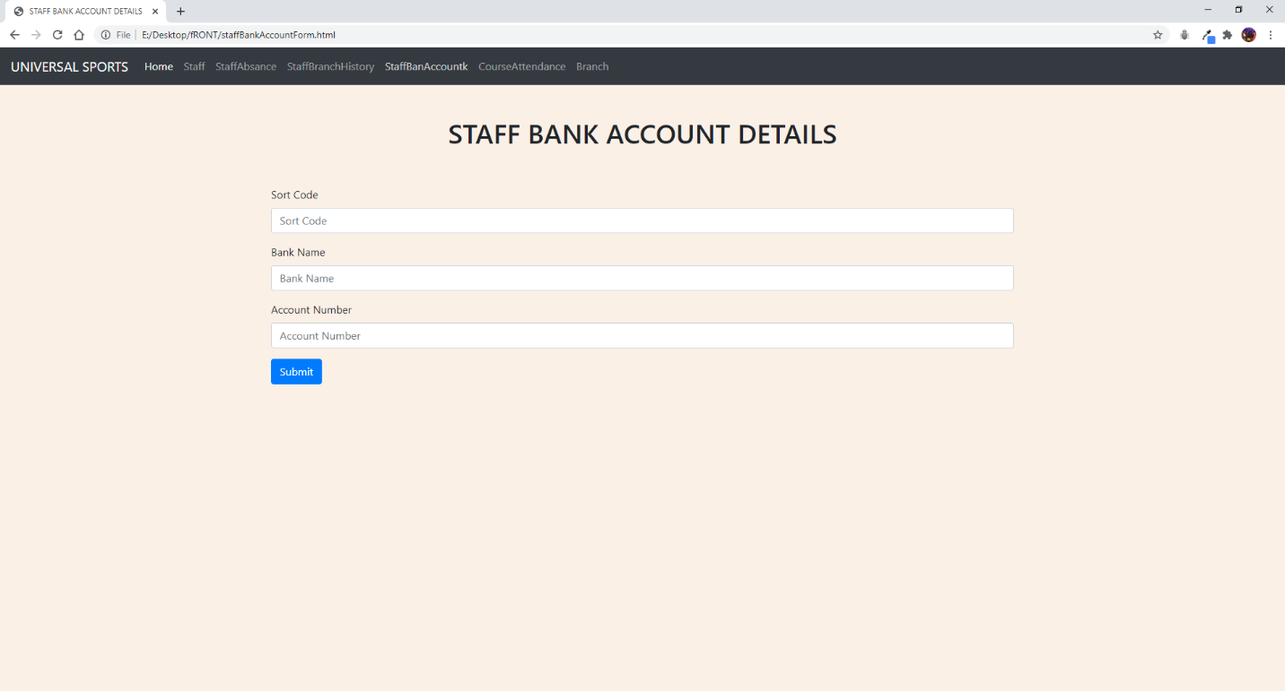

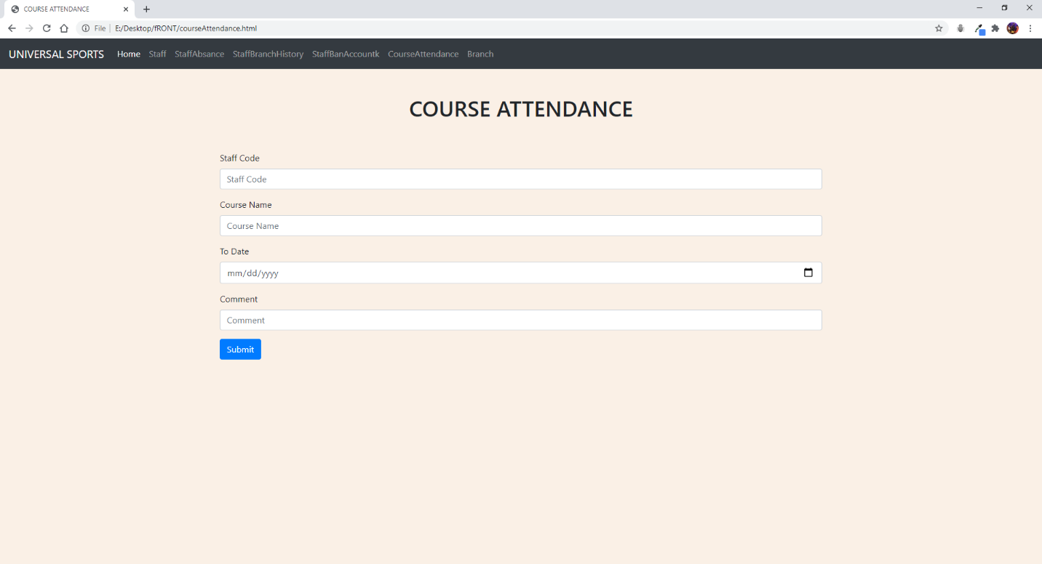

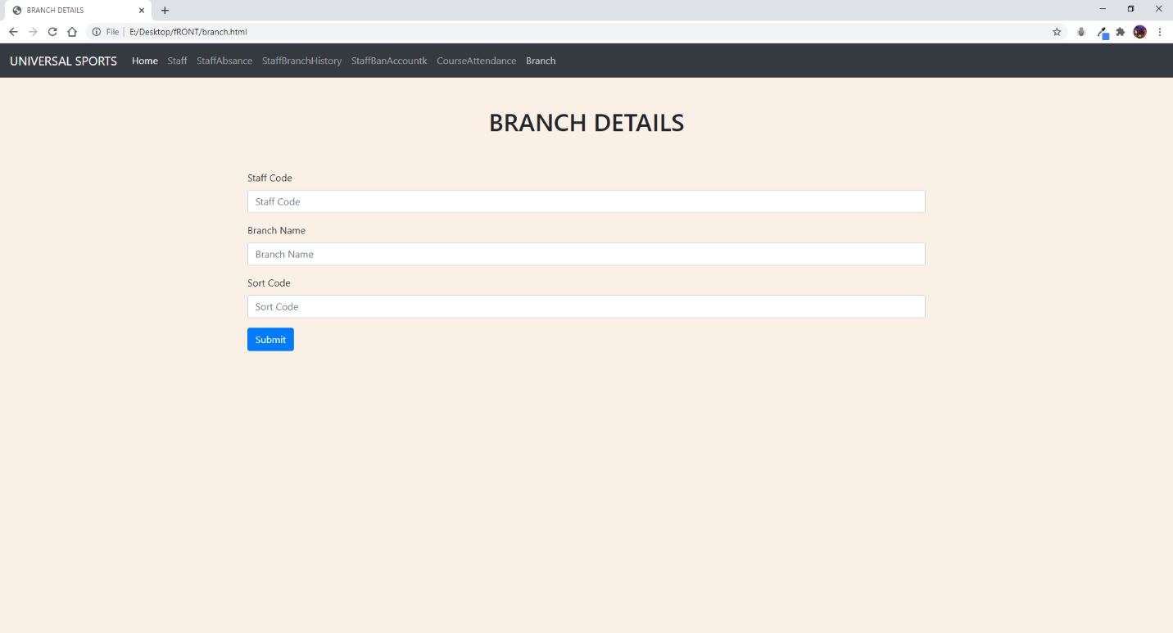

APPENDIX (SOURCE CODES DATABASE)

-- MySQL dump 10.13 Distrib 8.0.21, for Win64 (x86_64)
--
-- Host: localhost Database: Company
-- ------------------------------------------------------
-- Server version 8.0.21

/*!40101 SET @OLD_CHARACTER_SET_CLIENT=@@CHARACTER_SET_CLIENT */;
/*!40101 SET @OLD_CHARACTER_SET_RESULTS=@@CHARACTER_SET_RESULTS */;
/*!40101 SET @OLD_COLLATION_CONNECTION=@@COLLATION_CONNECTION */;
/*!50503 SET NAMES utf8 */;
/*!40103 SET @OLD_TIME_ZONE=@@TIME_ZONE */;
/*!40103 SET TIME_ZONE='+00:00' */;
/*!40014 SET @OLD_UNIQUE_CHECKS=@@UNIQUE_CHECKS, UNIQUE_CHECKS=0 */;
/*!40014 SET @OLD_FOREIGN_KEY_CHECKS=@@FOREIGN_KEY_CHECKS, FOREIGN_KEY_CHECKS=0 */;
/*!40101 SET @OLD_SQL_MODE=@@SQL_MODE, SQL_MODE='NO_AUTO_VALUE_ON_ZERO' */;
/*!40111 SET @OLD_SQL_NOTES=@@SQL_NOTES, SQL_NOTES=0 */;

--
-- Table structure for table `bankaccount`
--

DROP TABLE IF EXISTS `bankaccount`;
/*!40101 SET @saved_cs_client = @@character_set_client */;
/*!50503 SET character_set_client = utf8mb4 */;
CREATE TABLE `bankaccount` (
`Id` int NOT NULL,
`BankName` varchar(45) NOT NULL,
`SortCode` varchar(45) DEFAULT NULL,
`AccountNumber` varchar(45) DEFAULT NULL,
PRIMARY KEY (`Id`)
) ENGINE=InnoDB DEFAULT CHARSET=utf8mb4 COLLATE=utf8mb4_0900_ai_ci;
/*!40101 SET character_set_client = @saved_cs_client */;

--
-- Dumping data for table `bankaccount`
--

LOCK TABLES `bankaccount` WRITE;
/*!40000 ALTER TABLE `bankaccount` DISABLE KEYS */;
/*!40000 ALTER TABLE `bankaccount` ENABLE KEYS */;
UNLOCK TABLES;

--
-- Table structure for table `branch`
--

DROP TABLE IF EXISTS `branch`;
/*!40101 SET @saved_cs_client = @@character_set_client */;
/*!50503 SET character_set_client = utf8mb4 */;
CREATE TABLE `branch` (
`Id` int NOT NULL,
`Code` varchar(45) NOT NULL,
`Name` varchar(45) NOT NULL,
PRIMARY KEY (`Id`)
) ENGINE=InnoDB DEFAULT CHARSET=utf8mb4 COLLATE=utf8mb4_0900_ai_ci;
/*!40101 SET character_set_client = @saved_cs_client */;

--
-- Dumping data for table `branch`
--

LOCK TABLES `branch` WRITE;
/*!40000 ALTER TABLE `branch` DISABLE KEYS */;
/*!40000 ALTER TABLE `branch` ENABLE KEYS */;
UNLOCK TABLES;

--
-- Table structure for table `courseattendance`
--

DROP TABLE IF EXISTS `courseattendance`;
/*!40101 SET @saved_cs_client = @@character_set_client */;
/*!50503 SET character_set_client = utf8mb4 */;
CREATE TABLE `courseattendance` (
`Id` int NOT NULL,
`StaffCode` varchar(45) NOT NULL,
`coursename` varchar(45) DEFAULT NULL,
`Date` varchar(45) DEFAULT NULL,
`Coments` varchar(45) DEFAULT NULL,
PRIMARY KEY (`Id`)
) ENGINE=InnoDB DEFAULT CHARSET=utf8mb4 COLLATE=utf8mb4_0900_ai_ci;
/*!40101 SET character_set_client = @saved_cs_client */;

--
-- Dumping data for table `courseattendance`
--

LOCK TABLES `courseattendance` WRITE;
/*!40000 ALTER TABLE `courseattendance` DISABLE KEYS */;
/*!40000 ALTER TABLE `courseattendance` ENABLE KEYS */;
UNLOCK TABLES;

--
-- Table structure for table `emergancydetails`
--

DROP TABLE IF EXISTS `emergancydetails`;
/*!40101 SET @saved_cs_client = @@character_set_client */;
/*!50503 SET character_set_client = utf8mb4 */;
CREATE TABLE `emergancydetails` (
`Id` int NOT NULL,
`Staffcode` varchar(45) DEFAULT NULL,
`Address` varchar(45) DEFAULT NULL,
`Contactname` varchar(45) DEFAULT NULL,
`PhoneNo` varchar(45) DEFAULT NULL,
PRIMARY KEY (`Id`)
) ENGINE=InnoDB DEFAULT CHARSET=utf8mb4 COLLATE=utf8mb4_0900_ai_ci;
/*!40101 SET character_set_client = @saved_cs_client */;

--
-- Dumping data for table `emergancydetails`
--

LOCK TABLES `emergancydetails` WRITE;
/*!40000 ALTER TABLE `emergancydetails` DISABLE KEYS */;
/*!40000 ALTER TABLE `emergancydetails` ENABLE KEYS */;
UNLOCK TABLES;

--
-- Table structure for table `staff`
--

DROP TABLE IF EXISTS `staff`;
/*!40101 SET @saved_cs_client = @@character_set_client */;
/*!50503 SET character_set_client = utf8mb4 */;
CREATE TABLE `staff` (
`Id` int NOT NULL,
`StaffCode` varchar(45) NOT NULL,
`Title` varchar(45) DEFAULT NULL,
`Sex` varchar(45) DEFAULT NULL,
`Address` varchar(45) DEFAULT NULL,
`Telephone` varchar(45) DEFAULT NULL,
`DOB` date DEFAULT NULL,
PRIMARY KEY (`StaffCode`)
) ENGINE=InnoDB DEFAULT CHARSET=utf8mb4 COLLATE=utf8mb4_0900_ai_ci;
/*!40101 SET character_set_client = @saved_cs_client */;

--
-- Dumping data for table `staff`
--

LOCK TABLES `staff` WRITE;
/*!40000 ALTER TABLE `staff` DISABLE KEYS */;
/*!40000 ALTER TABLE `staff` ENABLE KEYS */;
UNLOCK TABLES;

--
-- Table structure for table `staffabsancedetails`
--

DROP TABLE IF EXISTS `staffabsancedetails`;
/*!40101 SET @saved_cs_client = @@character_set_client */;
/*!50503 SET character_set_client = utf8mb4 */;
CREATE TABLE `staffabsancedetails` (
`Id` int NOT NULL,
`StaffCode` varchar(45) DEFAULT NULL,
`FromDate` date DEFAULT NULL,
`Todate` date DEFAULT NULL,
`Reason` varchar(45) DEFAULT NULL,
PRIMARY KEY (`Id`)
) ENGINE=InnoDB DEFAULT CHARSET=utf8mb4 COLLATE=utf8mb4_0900_ai_ci;
/*!40101 SET character_set_client = @saved_cs_client */;

--
-- Dumping data for table `staffabsancedetails`
--

LOCK TABLES `staffabsancedetails` WRITE;
/*!40000 ALTER TABLE `staffabsancedetails` DISABLE KEYS */;
/*!40000 ALTER TABLE `staffabsancedetails` ENABLE KEYS */;
UNLOCK TABLES;

--
-- Table structure for table `staffbranchhistory`
--

DROP TABLE IF EXISTS `staffbranchhistory`;
/*!40101 SET @saved_cs_client = @@character_set_client */;
/*!50503 SET character_set_client = utf8mb4 */;
CREATE TABLE `staffbranchhistory` (
`Id` int NOT NULL,
`StaffCode` varchar(45) DEFAULT NULL,
`BranchCode` varchar(45) DEFAULT NULL,
`FromDate` date DEFAULT NULL,
`ToDate` date DEFAULT NULL,
PRIMARY KEY (`Id`)
) ENGINE=InnoDB DEFAULT CHARSET=utf8mb4 COLLATE=utf8mb4_0900_ai_ci;
/*!40101 SET character_set_client = @saved_cs_client */;

--
-- Dumping data for table `staffbranchhistory`
--

LOCK TABLES `staffbranchhistory` WRITE;
/*!40000 ALTER TABLE `staffbranchhistory` DISABLE KEYS */;
/*!40000 ALTER TABLE `staffbranchhistory` ENABLE KEYS */;
UNLOCK TABLES;

--
-- Table structure for table `staff company data`
--

DROP TABLE IF EXISTS `staffcompanydata`;
/*!40101 SET @saved_cs_client = @@character_set_client */;
/*!50503 SET character_set_client = utf8mb4 */;
CREATE TABLE `staffcompanydata` (
`Id` int NOT NULL,
`StaffCode` varchar(45) DEFAULT NULL,
`CurrentSalary` int DEFAULT NULL,
`Joineddate` date DEFAULT NULL,
`IsFirstAider` bit(1) DEFAULT NULL,
PRIMARY KEY (`Id`),
KEY `staffcode_idx` (`StaffCode`),
CONSTRAINT `staffcode` FOREIGN KEY (`StaffCode`) REFERENCES `staff` (`StaffCode`)
) ENGINE=InnoDB DEFAULT CHARSET=utf8mb4 COLLATE=utf8mb4_0900_ai_ci;
/*!40101 SET character_set_client = @saved_cs_client */;

--
-- Dumping data for table `staffcompanydata`
--

LOCK TABLES `staff company data` WRITE;
/*!40000 ALTER TABLE `staff company data` DISABLE KEYS */;
/*!40000 ALTER TABLE `staff company data` ENABLE KEYS */;
UNLOCK TABLES.
/*!40103 SET TIME_ZONE=@OLD_TIME_ZONE */;

/*!40101 SET SQL_MODE=@OLD_SQL_MODE */;
/*!40014 SET FOREIGN_KEY_CHECKS=@OLD_FOREIGN_KEY_CHECKS */;
/*!40014 SET UNIQUE_CHECKS=@OLD_UNIQUE_CHECKS */;
/*!40101 SET CHARACTER_SET_CLIENT=@OLD_CHARACTER_SET_CLIENT */;
/*!40101 SET CHARACTER_SET_RESULTS=@OLD_CHARACTER_SET_RESULTS */;
/*!40101 SET COLLATION_CONNECTION=@OLD_COLLATION_CONNECTION */;
/*!40111 SET SQL_NOTES=@OLD_SQL_NOTES */;

-- Dump completed on 2020-11-26 13:46:31

