University of Wales Trinity Saint David
Wales Institute of Science & Art



Application of CAE Processes
Structural & Fluid Analysis
ACHA6010

Benjamin Hilton
2220555
14/12/2025
Table of Contents
Introduction 4
Validation of ANSYS 4
Bimetallic Strip 4
Bimetallic Strip results 5
Axial Force 5
Transverse displacement results 6
Hex Dominant vs Tetrahedron mesh 6
Linear vs Quadratic 7
Element sizing and mesh metrics 8
Optimisation of a Piston for Weight 10
Assembly 10
Material 11
Rigid Dynamics 11
Steady state thermal 14
Static Structural Mesh 15
Final Mesh 18
Static structural 19
Original piston FEA results 20
Piston 2 – Design alteration 23
Design 2 Results 24
Thermal comparison 24
Safety Factor 25
Fatigue life analysis 26
Piston 3 – Material Swap 26
Deformation 27
Factor of safety 28
Comparison of pistons 28
Limitations to CAE 29
Bibliography 30
Appendices 31

Figure 1 - Bimetallic Strip Results 5
Figure 2 - Transverse Displacement Results 6
Figure 3 - Accuracy vs Computational power 7
Figure 4 - Linear vs Quadratic 8
Figure 5 - Element size / Mesh Metrics 9
Figure 6 - Mesh Metrics vs Accuracy 9
Figure 7 - Base Line Piston Assembly 11
Figure 8 - Material Properties Comparison 11
Figure 9 - Pressure vs Crank Angle (Ford Sigma) 13
Figure 10 - Motion Loads 14
Figure 11 - Convections Applied 15
Figure 12 - Base Piston Thermal Results 15
Figure 13 - Piston Mesh Range Comparison 17
Figure 14 - Final Mesh Element Quality 17
Figure 15 - Final Mesh Review 18
Figure 16 - Final Mesh Review (stress) 18
Figure 17 - Static Simulation Setup 19
Figure 18 - Base Piston, Factor of Safety (left), Stress (right) 20
Figure 19 - Baseline Piston Fatigue Failure point 21
Figure 20 - Baseline Piston, Stress and low SF points 22
Figure 21 - Piston V2 Design 23
Figure 22 - Piston V2, Piston ring Alteration 24
Figure 23 - Piston V2 Safety Factor 25
Figure 24 - Piston V2 - Life 26
Figure 25 - Piston V3, Deformation 27
Figure 26 - Piston V3 Factor of Safety 28

Introduction
Computer Aided Engineering (CAE) tools are widely used within modern engineering design to predict structural, Thermal and dynamic behaviour before physical testing. When applied correctly, these tools can reduce cost and development time. However, their accuracy is strongly influenced by modelling assumptions, material data and boundary conditions.
This report evaluates the application of CAE processes using ANSYS to analyse and optimise a piston in an engine assembly. A kinematic, Thermal and structural simulations were used to assess the design and material of a piston using Displacement, Stress and Fatigue results. Validation studies using benchmark solutions are conducted to assess the accuracy of the solver as well as various mesh options and processes before conducting testing on the piston.

Validation of ANSYS

Bimetallic Strip
The thermal validation of ANSYS was carried out using the Bimetallic strip from RFEM (Verification Example 0078). This benchmark analytical solution for thermally induced bending is ideal for validating Ansys’s ability to accurately simulate thermomechanical deformation, which will be relevant when performing analysis on the piston.

This validation used a strip made from copper and Invar, each subjected to a temperature increase of 100°C. Due to the difference in thermal expansion coefficients
- Copper - αc = 2.0×10⁻⁵ °C⁻¹
- Invar - αi = 1.2×10⁻⁶ °C⁻¹
The strip bends, giving the maximum free-end deflection as:
$$u_{z,\text{max}}≈-7.049\text{ mm}$$

Bimetallic Strip results
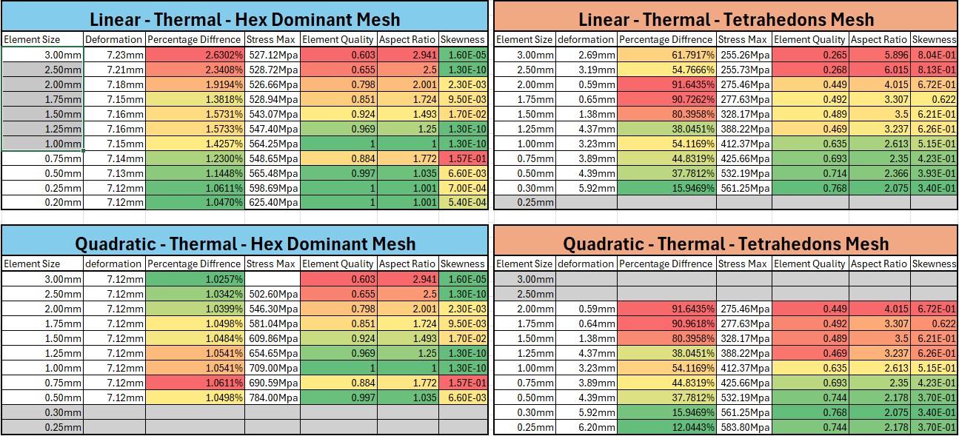
Figure 1 - Bimetallic Strip Results
From the results, we can see that ANSYS is able to consistently produce accurate results when using a hex-dominant mesh, with a discrepancy of only 1.06% relative to the referenced element size from the verification example.
(Dlubal Software, 2018)

Axial Force
The Linear deformation validation was carried out using the bending cantilever with axial force from RFEM (Verification example 0042). This verification case uses a cantilever beam subjected to both transverse bending and axial loading, allowing me to use this case the validate ANSYS's ability to solve deformation in both load cases.

For the maximum transverse displacement due to bending Is

$$u_{z,\text{max}}=\frac{F_{Z}L^{3}}{3EI_{y}}=3557.478 mm$$
Equation 1 - Maximum Transverse Displacement

(Dlubal Software, 2015)

Transverse displacement results
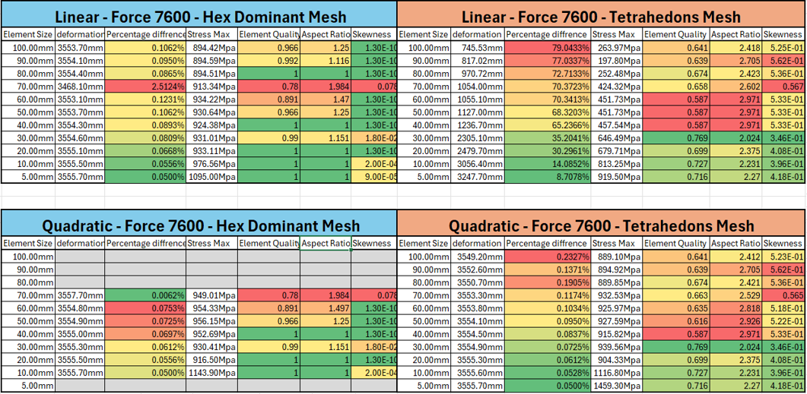
Figure 2 - Transverse Displacement Results

Hex Dominant vs Tetrahedron mesh
Mesh type selection plays a critical role in the accuracy of FEA. The two methods tested were Hex-dominant and tetrahedral meshes, each offering various advantages depending on the component’s geometry being simulated.
Hex Dominant can give extremely strong results in both linear and quadratic simulations compared to tetrahedral meshes. This is partly because the validation geometries are basic and are easy for the hex-dominant mesh to map. This is why we see multiple runs with perfect element quality and aspect. But this comes at the cost of additional Computational power, as it is unable to run as fine mesh with a quadratic compared to the tetrahedra mesh.
Tetrahedra's mesh is still able to produce strong results when used with quadratic, while using less computational power, tetrahedra are better suited to complex geometries where they can create a high-quality mesh, such as are underside of the piston.(Rashmita et al., 2024)
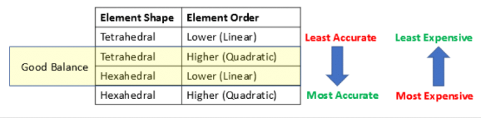
Figure 3 - Accuracy vs Computational power
(FEA Tips, 2019)

Linear vs Quadratic

In the validation tests, each piece was run with both linear and quadratic solving methods to compare the difference. A linear element reads the displacement linearly from the distance between the nodes; for this reason, linear elements don’t capture bending and deformation of the part and require much finer meshes to become accurate. This can be seen in Figure 4 below.
Quadratic elements utilise a nonlinear shape function and capture the displacement between nodes by interpolating using a higher-order polynomial equation. This allows quadratic elements to map deformations more accurately than linear, but with the trade-off of being computationally more expensive than linear elements.
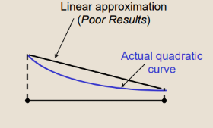
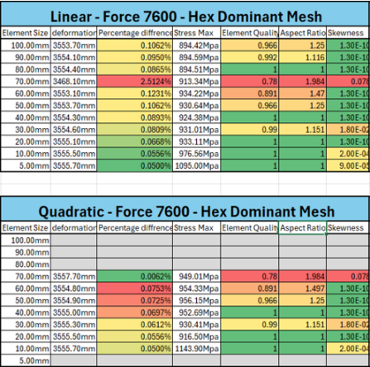
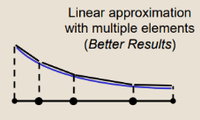

Figure 4 - Linear vs Quadratic

(FEA Tips, 2019)

Element sizing and mesh metrics

When reviewing the validation studies, a clear relationship emerges between element quality, aspect ratio, skewness and the accuracy of the results. These mesh metrics allow the overall quality of the mesh to be assessed. In Figure 5 We can see that when mesh metrics are closer to ideal values, the validation results closely align with the analytical solutions. However, when the mesh becomes coarse and mesh metrics indicate a poor-quality mesh, we can see the discrepancy increase significantly. This demonstrates that mesh quality is a major factor in achieving accurate FEA results and is often more influential than element size alone.
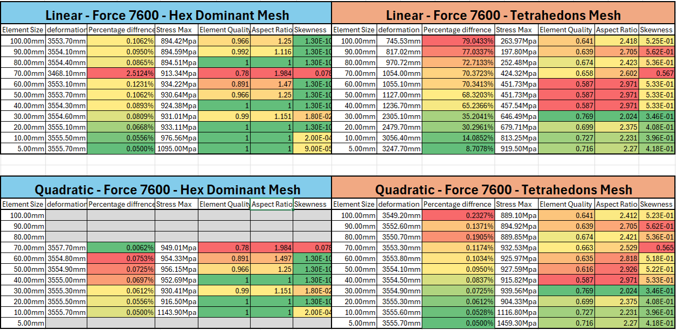
Figure 5 - Element size / Mesh Metrics

This trend is clearly illustrated in Table 1 and Figure 6 with 70mm and 80mm element sizes, where both cases use almost identical mesh sizes. Despite this, the model with poorer element metrics showed a noticeably larger discrepancy. This comparison demonstrates that even with a coarser element size that variations in element quality alone can significantly influence accuracy.

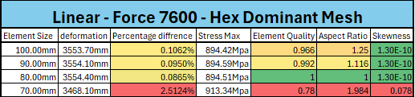
Table 1 Mesh Metrics vs Accuracy
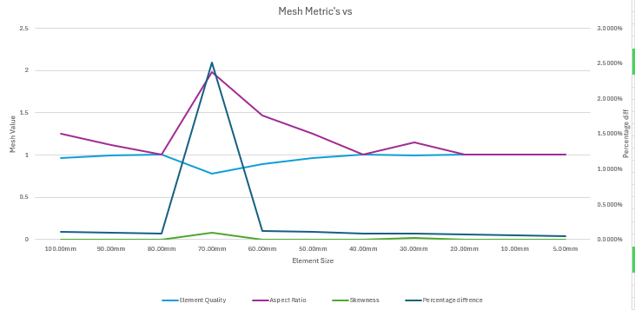

Figure 6 - Mesh Metrics vs Accuracy

Optimisation of a Piston for Weight

To be able to optimise are piston to save weight, we are going to have to test are material and design using Rigid, thermal and static solvers in the program to be able to see how the piston performs under these simulated conditions.

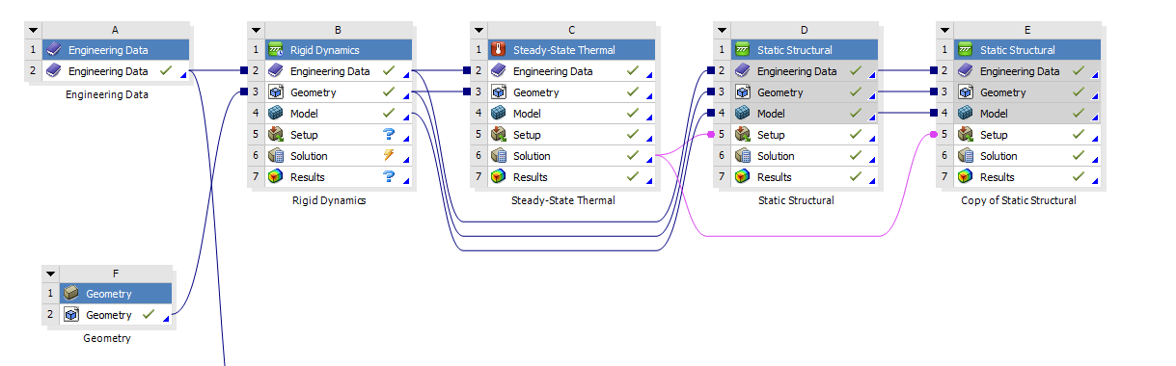
Table 2 - FEA Workbench

Assembly

The assembly used for the FEA study is based on the internal combustion engine and includes the crankshaft, connecting rod, gudgeon pin, and piston. For this study, the piston is the component selected for structural optimisation, while the crankshaft, conrod, and gudgeon pin are treated as rigid.
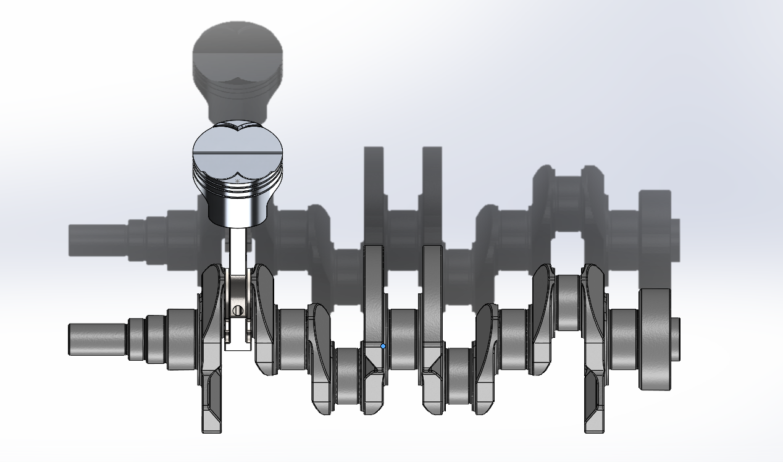
Figure 7 - Base Line Piston Assembly
(Andrew noble, n.d.)

Material
Pistons in the Automotive industry are often manufactured from aluminium alloys, For these simulations ill be using aluminium 6061 as my baseline material what is a used in automotive applications but not typically a piston and a second material of 332 cast aluminium what is a more suitable material for a piston due to its increased silicon content what allows it to have a lower density and less thermal expansion of what is ideal for a piston but this does come at a cost of mechanical properties as show in Figure 7

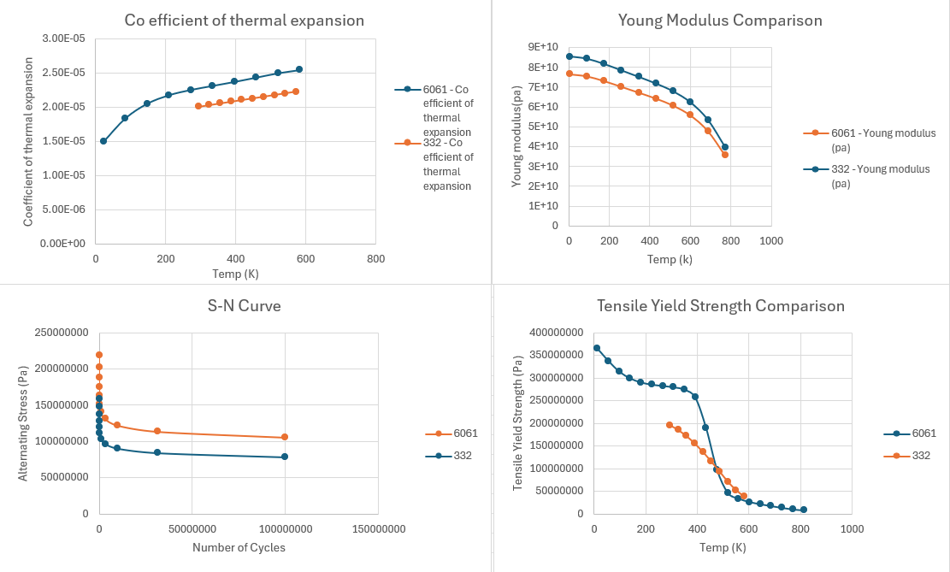
Figure 8 - Material Properties Comparison

Rigid Dynamics

Using Ansys rigid dynamics, we can calculate the motion loads to be used later in are static structural simulation and fatigue.

First, we apply some constraints to the assembly, fixing the individual parts to each other and the crank and piston to the ground, to allow the assembly to move as expected.
Connections
Component 1 | Component 2 | Connection
Crankshaft (Big end) | Conrod (Big end) | Body to Body – Revolute
Conrod (Little end) | Gudgeon pin | Body to Body – Revolute
Gudgeon pin | Piston | Body to Body – Revolute
Piston (Skirts) | Ground | Body to Ground - Translational
Crankshaft (journals) | Ground | Body to Ground – Revolute
Table 3 - Rigid Dynamics Connection
We then apply a velocity to the crank to ground connection to allow the crank to spin at 6000rpm, as this is near redline for the Ford Sigma, so we expect to see the highest loads at this velocity.
We can then work out the step end time, which is how long the transient study lasts, and the time step, which is how often motion loads are recorded from the simulation.

To do this, we use the following equation to calculate how long it takes the piston to do a full revolution and how often it takes for the crank to turn each degree.

$$\frac{6000RPM}{60}=100$$
$$100*360=36000 \\ \frac{1}{36000}=2.778x{10}^{-5}$$

$$TimeStep=2.778x{10}^{-5}$$
Equation 2 - Time Step

$$2.778x{10}^{-5}*360= 0.010008 Sec$$
$$Step End Time= 0.010008 Sec$$
Equation 3- Step End Time

Using this, we can configure the transient solver to give us motion loads for each degree of crank angle for a full revolution,
We can then place a joint probe to measure the motion loads at the gudgeon pin using the gudgeon pin to piston connection.

We can extract the motion loads for are max Compressive and tensile forces on the piston. For this, we are using the sigma pressure data from Owen Williams.

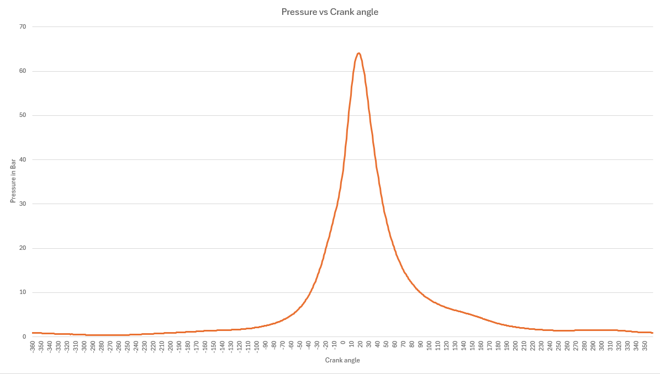
Figure 9 - Pressure vs Crank Angle (Ford Sigma)

(Dr Owen Williams, n.d.)
We then collect the Motion loads for the maximum compressive stress at the peak cylinder pressure at 18 degrees and 64.1 bar of pressure.
And the motion loads at max tensile force, which will be at the minimum motion load in the X axis at 1.8 bar

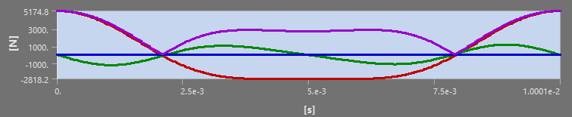
Figure 10 - Motion Loads

Steady state thermal

A thermal study is also done on the piston by applying various thermal loads to various parts of the piston, as seen in the figure below.

Part | Heat Transfer Coefficient (W/(m²K)) | Temperature (°C)
Crown | 497.5 | 928.5
Crown Side | 447.5 | 425
Top and Middle Groove | 437.5 | 190
Oil Groove | 338.75 | 163.75
Underside | 675 | 91.25
Skirt | 462.5 | 107.5
Table 4 - Convections Applied to Piston
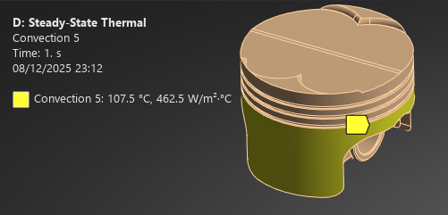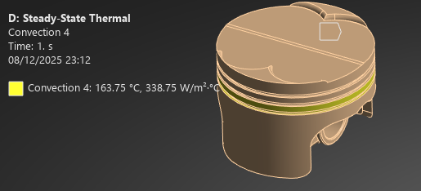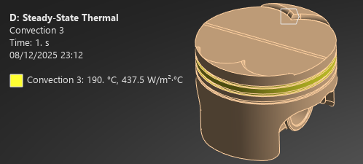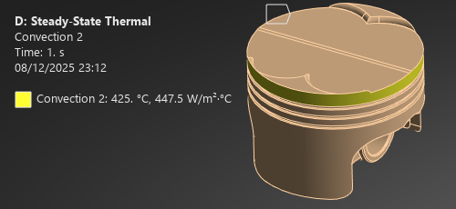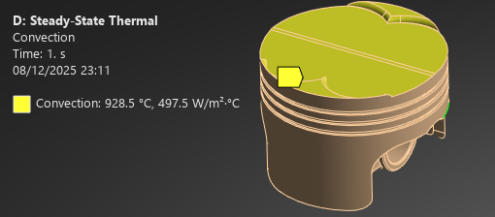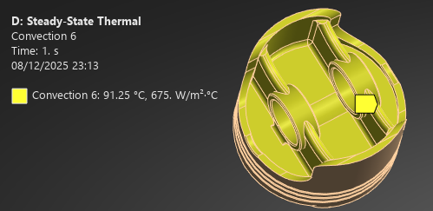
Figure 11 - Convections Applied

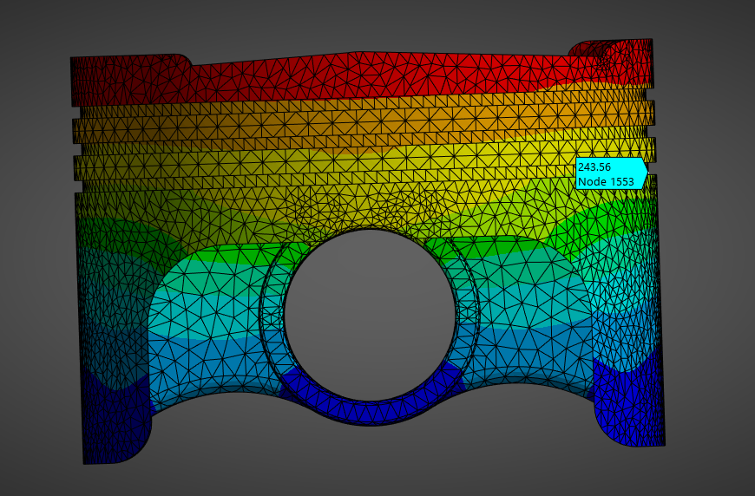
Figure 12 - Base Piston Thermal Results

These results are then fed into the Static structural simulations to apply a thermal condition to the piston.

Static Structural Mesh

From the validation study and research, I'll be using a tetrahedral mesh as it's better at mapping the pistons' complex geometry and will lead to a much higher quality mesh compared with alternatives such as hex-dominant. As well as a quadratic solving method, it's much superior at mapping deformation compared to linear, which is unable to. (Rashmita et al., 2024)

To find are ideal mesh setup, I tested the mesh metrics at various mesh sizes from 7mm to 1mm to see the effects of the mesh metrics and to find the computational limit for the simulation, as well as to see stress inconsistencies in the result.

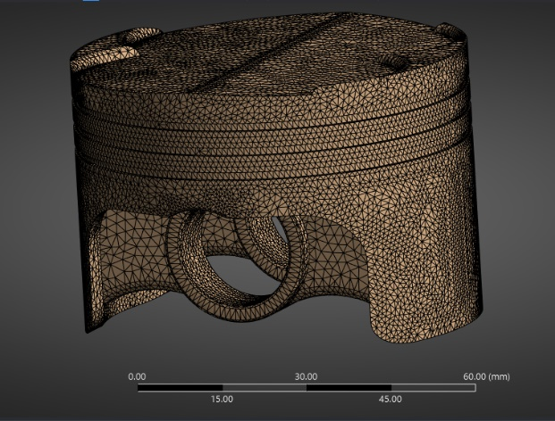
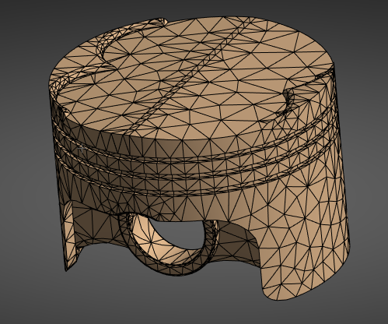
7mm Mesh
1mm Mesh

Element Quality
Element Quality

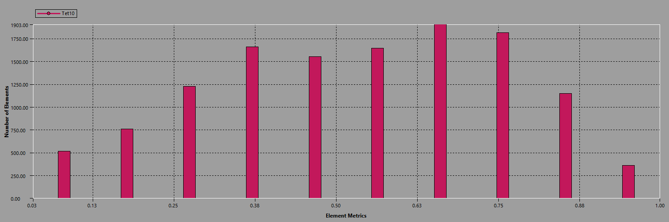
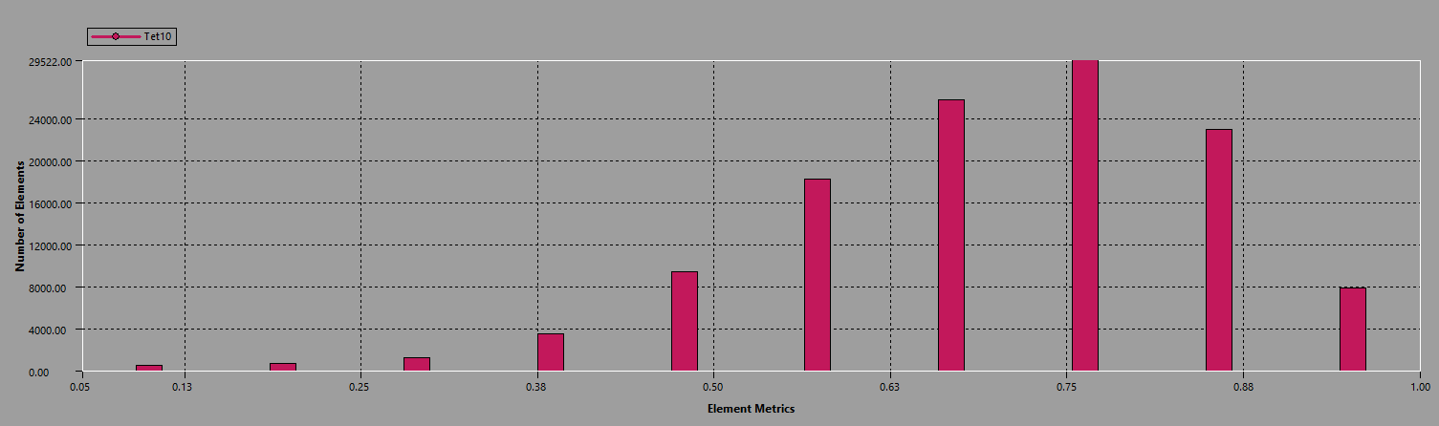

Aspect Ratio
Aspect Ratio
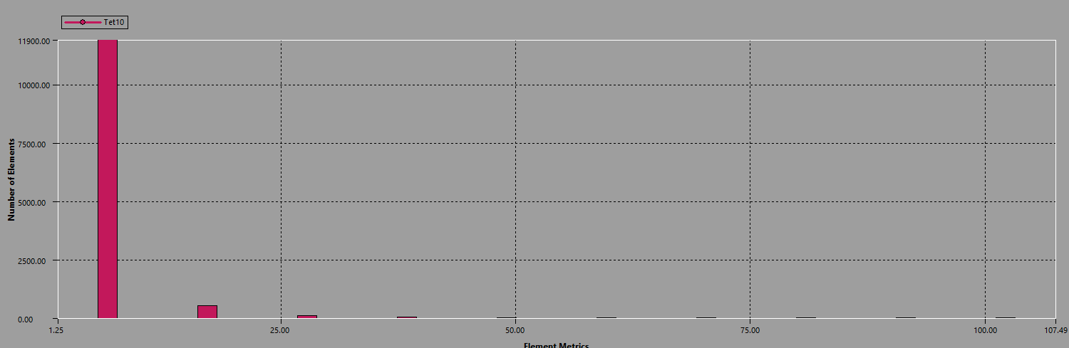
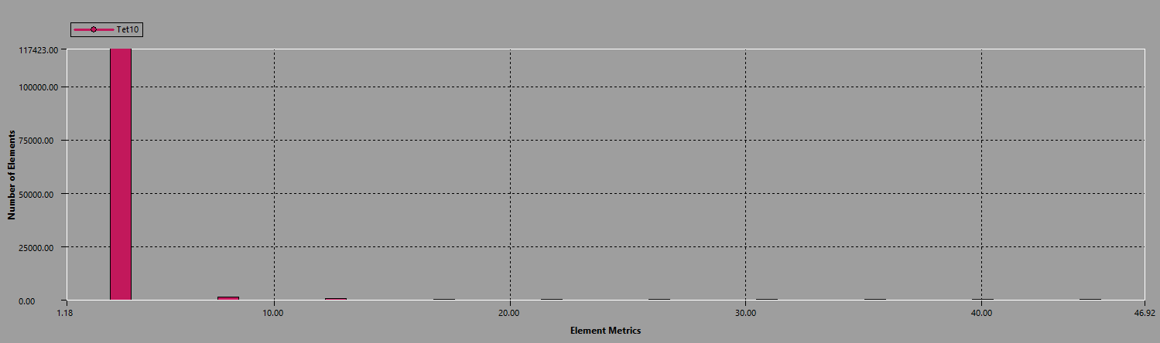

Aspect Ratio
Skewness
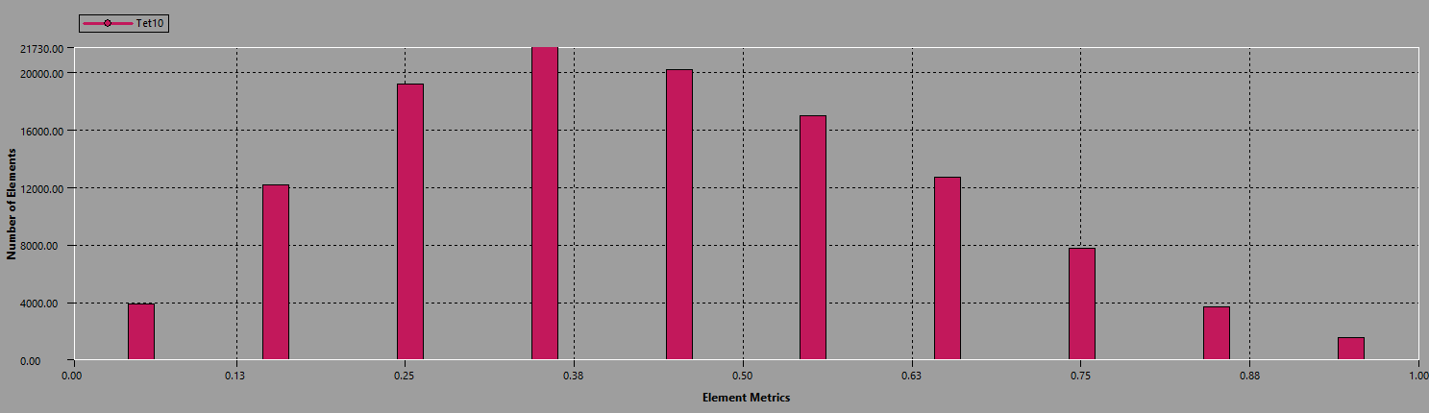
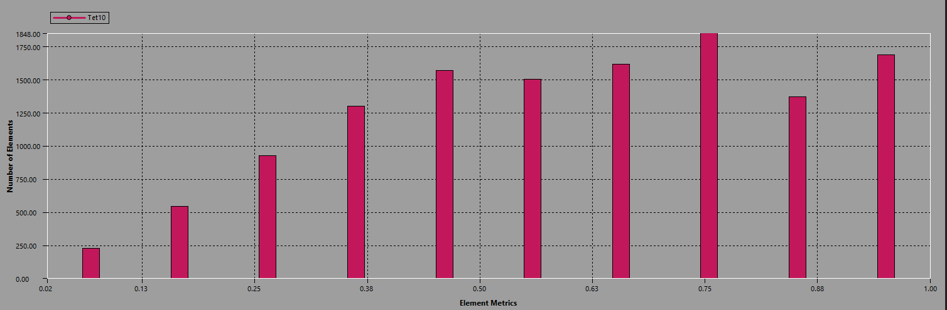

Figure 13 - Piston Mesh Range Comparison

As shown in the table above, we can see that as are piston mesh element size increases, we are in turn getting better mesh metrics up to the computational limit at 1mm mesh for the complete piston. Because of this, we can apply a coarse mesh to the body of the piston and use the mesh element tool to locate spots with poor mesh quality to apply an alternative element size or method.
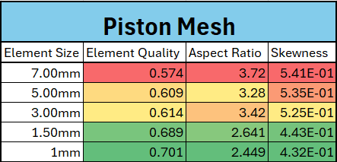
Table 5 - Piston Mesh Results

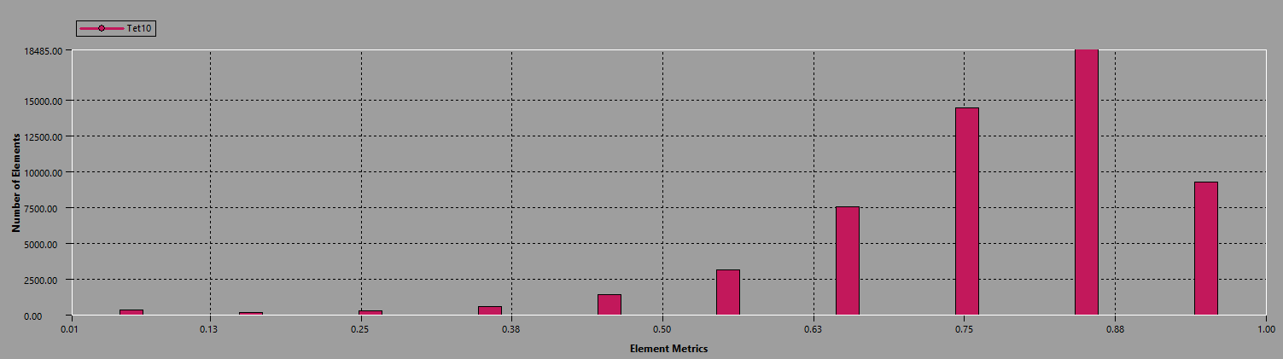
Figure 14 - Final Mesh Element Quality

Final Mesh
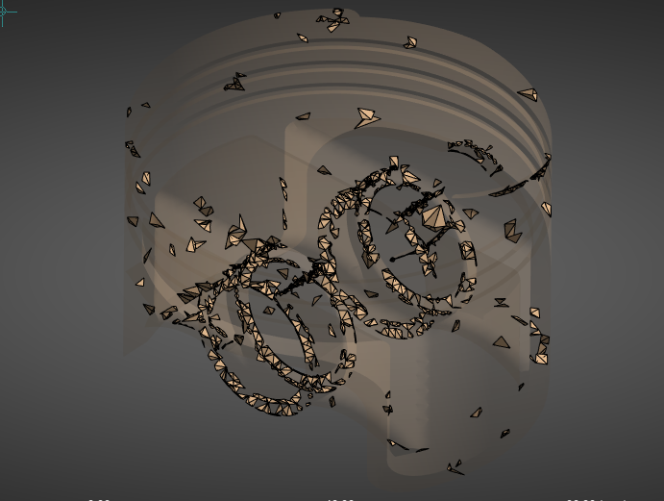
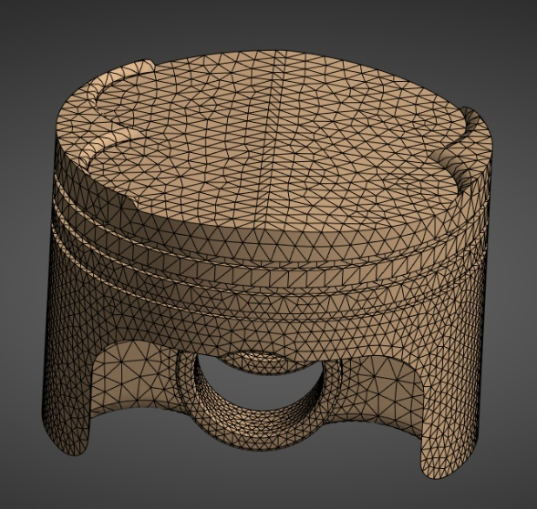
Figure 15 - Final Mesh Review

For the Final Mesh I’m using a 3mm base mesh for the piston as this gives a good overall quality of the meth while still leaving some computational power for applying finer mesh in more complex areas, from looking at 0-0.5 element quality, we can see regions were we are getting poor mesh as seen on figure 15 because of this we I’ve applies a 1.5mm mesh onto the gudgeon pin and a 2mm mesh on to the underside of the piston.

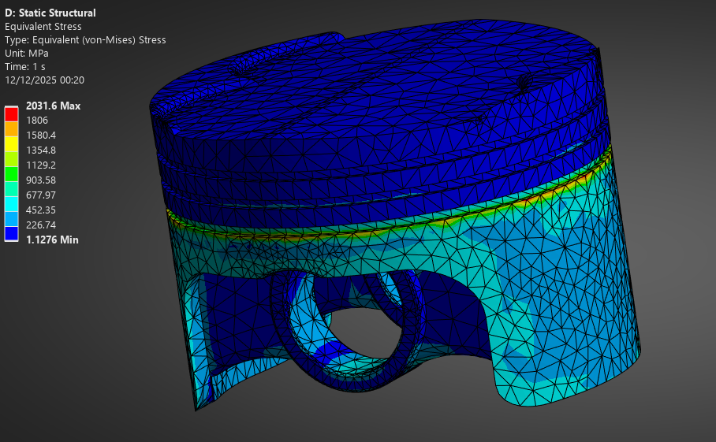
Figure 16 - Final Mesh Review (stress)
Also, when reviewing the mesh with the stress overlay, we can see an area of stress around the oil ring, which tends to be quite inconsistent. To counter this, I’ve also applied a 2mm mesh on the skirts and oil ring grooves to get a more accurate stress reading for this area.

Static structural
Once we’ve set up the mesh for the static structural runs, we can start applying are boundary conditions to are piston. For this, we use weak springs to constrain the piston when we apply are motion loads and pressure to it.
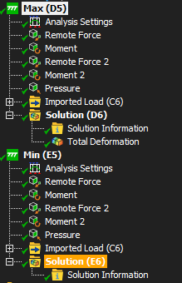
We can then import the motion loads from the Rigid dynamics, and we can import them into are 2 separate static structural simulations.

- Max load
  - 64.1 Bar pressure
  - Motion loads from 17° crank angle
  - Steady State thermal results
- Min Load
  - 1.8 Bar pressure
  - Min motion loads from 217° crank angle
  - Steady State thermal results

Figure 17 - Static Simulation Setup

Using spring to constrain the piston during simulation will induce some error into the result, but it will be minimal compared to fixed supports that will cause the piston to deform around the constraint.

Original piston FEA results

Once the simulation has been completed, the results can be reviewed for maximum stress and displacement, with a fatigue study showing the factor of safety and the predicted life of the piston. These outputs allow me to identify areas of high stress and displacement, stress concentrations, and regions of low factor of safety, which can then be used to optimise the design or material choice.

- For the piston, we are aiming for a minimum safety factor of 1.5
(Subramanyam et al., 2021)

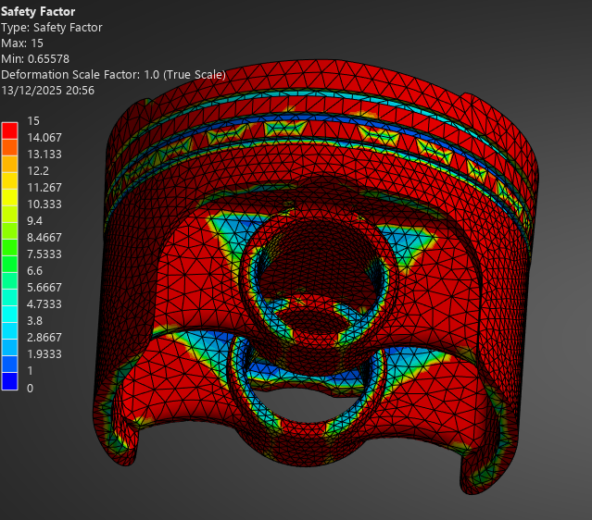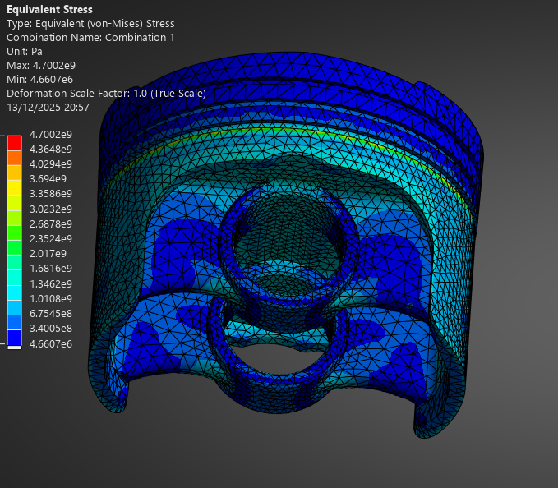
Figure 18 - Base Piston, Factor of Safety (left), Stress (right)
From figure 18 Above we can see a couple of regions with increase stress at the top of the gudgeon pin support particularly follows the Fillet at the top of the support, on the safety factor image we can see a clear reduction in safety factor in this highlighted area, with the lower section operating well within its safety factor requirements, this is also evident in figure 18 (right) where we can see the low stress region where material could potentially be removed.
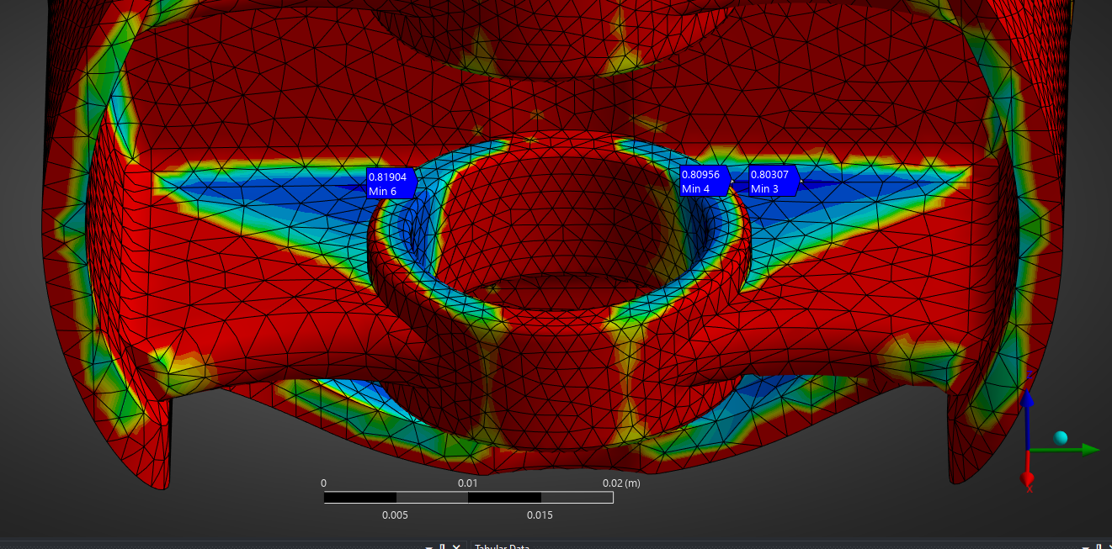
Figure 19 - Baseline Piston Fatigue Failure point
On the inner side of the gudgeon pin support, the fatigue study shows regions operating at a safety factor below 1.0, which will likely lead the piston to fail in this area under these applied loads. The surrounding area highlighted in blue also shows the area of the piston operating loose to the material's limit. This needs to be corrected with a different piston design or a change in piston material. (Zheng et al., 2006)

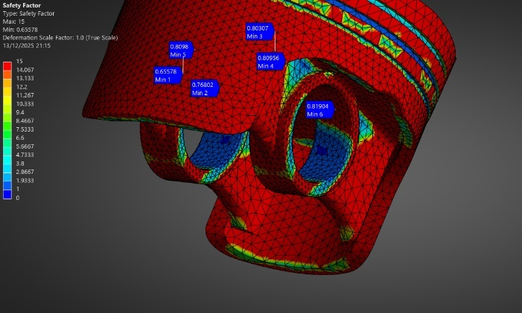
Using the factor of safety once again, we can see some of the weaker elements on the piston being the gudgeon pin and the oil ring. These will need alteration to be in are acceptable range, the stress region on the oil ring can be seen, especially in figure 20 on the
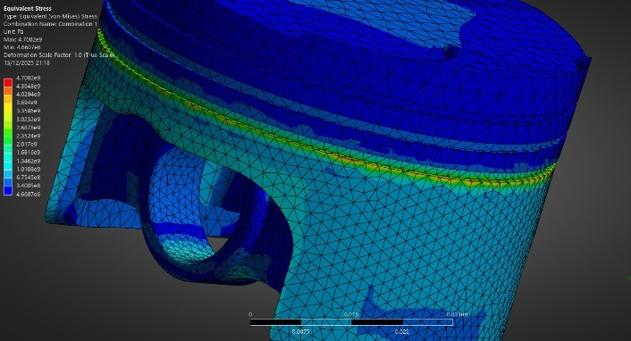
equivalent stress

Figure 20 - Baseline Piston, Stress and low SF points

Piston 2 – Design alteration

For the second design, various features of the piston were altered to remove some of the stress points and increase the safety factor of the piston, such as the following.
- Increased fillet size for the top of the gudgeon pin support
- Fillet added to the support for the gudgeon pin.
- Fillet added to the support of the piston skirt.
- Piston rings 1 & 2 moved up by 2mm to remove the temperature from the bottom ring.
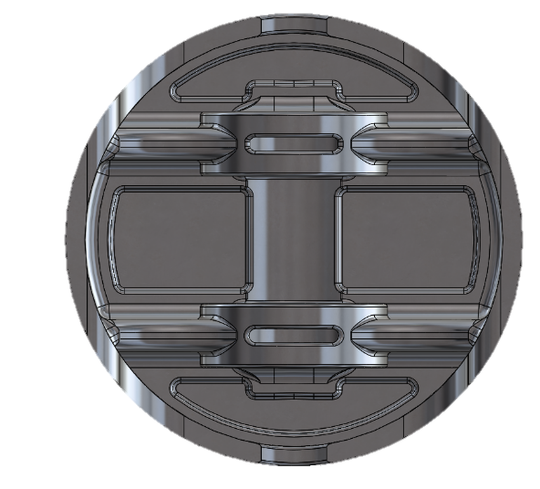
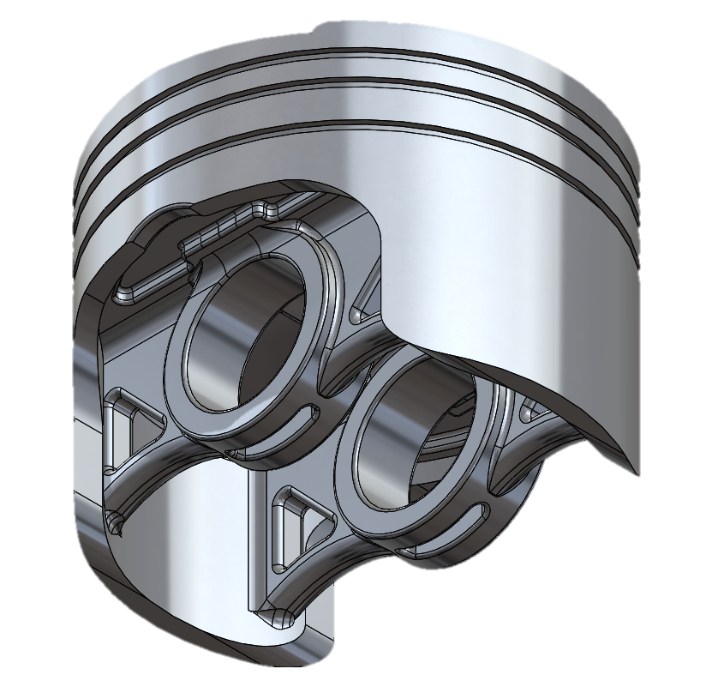
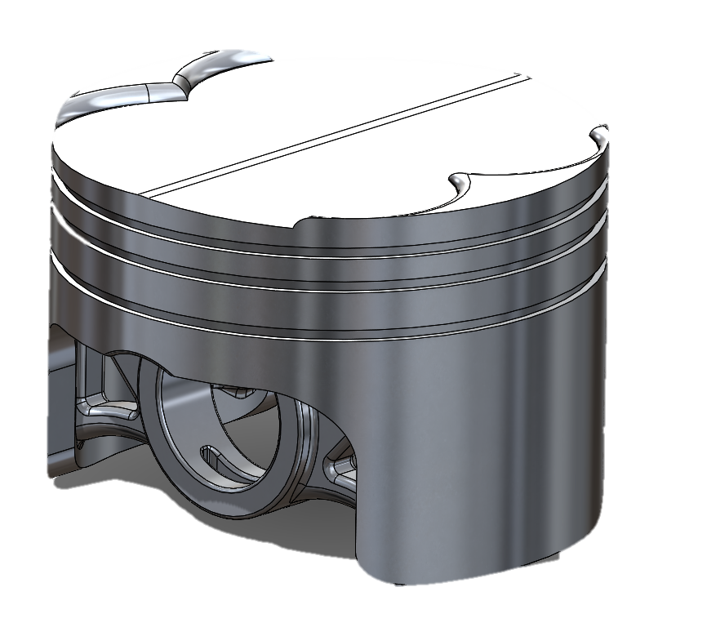

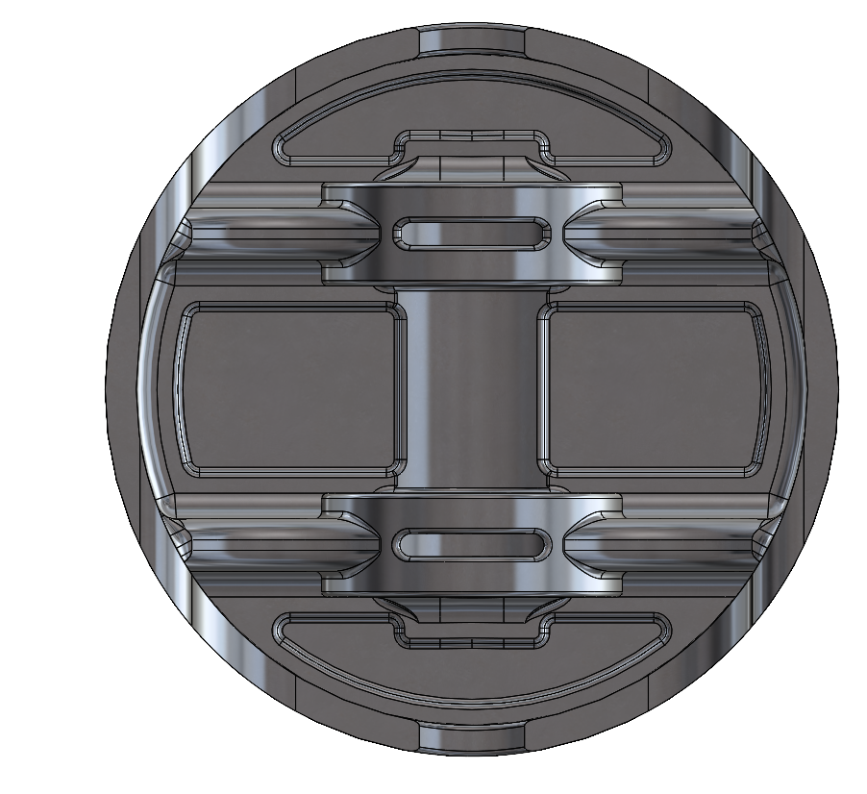

Figure 21 - Piston V2 Design
I also removed material from various parts of the piston to reduce the mass of the piston by 2.89%. This was done by:
- Lower gudgeon pin supports
- Material removed from the underbody of the piston
- Slot removed in a low-stress point under the gudgeon pin

Design 2 Results

Thermal comparison

Comparing designs from the original and the second iteration of the piston, you can see in Figure 22 that I’ve moved the first 2 piston rings up to move the temperature away from the oil ring. This is a current limitation in the piston, as its design fundamentally can’t change, as it must house the oil ring.

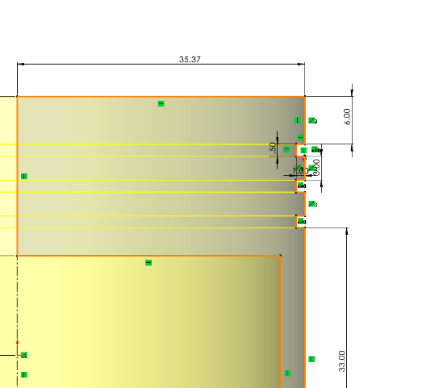
V2 Design
Original Design
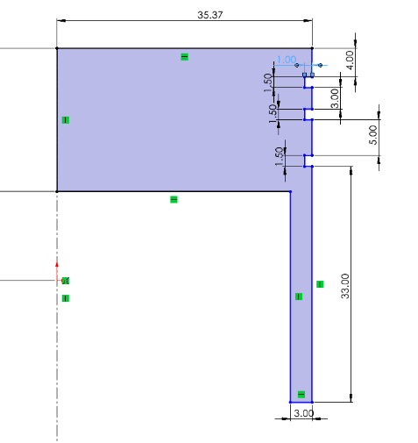

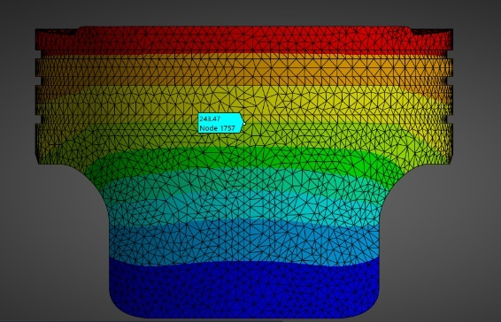
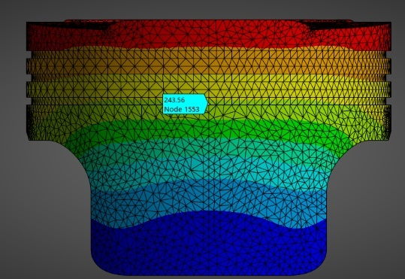

Figure 22 - Piston V2, Piston ring Alteration
From the result here, we can see that despite moving some of the thermal convection away from the oil ring, we only get a decrease of 0.09 degrees when the temperature is probed. This shows that the original design is already optimised for this heat, and the best alternative moving forward would choose a material with better properties under thermal load.

Safety Factor
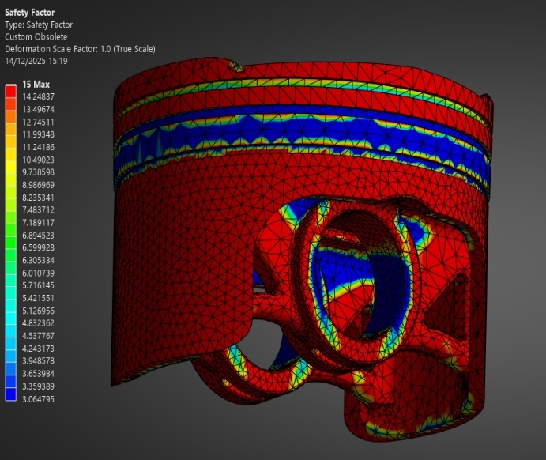
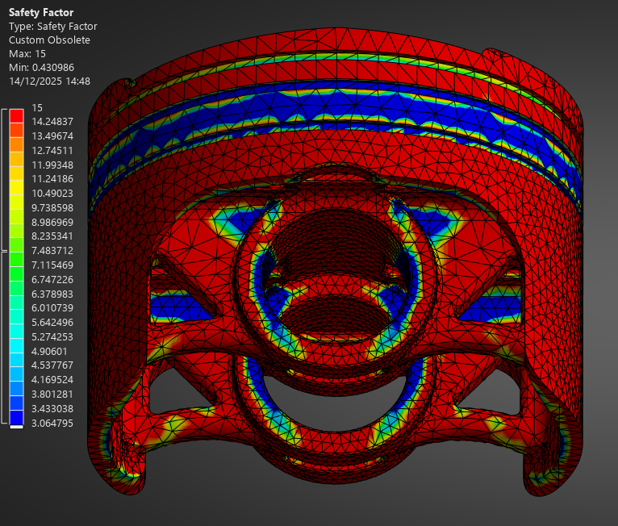
Figure 23 - Piston V2 Safety Factor
From the design change changes we can see a large improvement in overall safety factor in the piston with the majority of the piston over a safety factor of 3 what is a improvement compared to the original design what was close to failure and more weight, this is been achieved from reducing the mass of the piston and therefor reducing loads, as well as improving the design around the high stress areas of the piston.

Fatigue life analysis

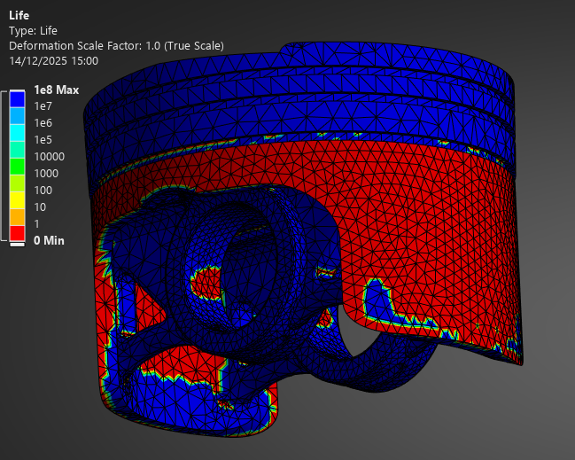
Figure 24 - Piston V2 - Life
On the Fatigue life, we still see a massively inaccurate result with the skirts of the piston failing instantly, which isn’t realistic. Ansys recognises this as a valid result with no errors, so there could possibly be more realistic results from some altered settings and boundary conditions.

Piston 3 – Material Swap

For the final piston design, I’ve swapped the material from 6061 aluminium to A332 Cast aluminium, which is a more realistic material to be used for a piston, as mentioned in the material section. A332 Cast aluminium has a lower density.

Deformation
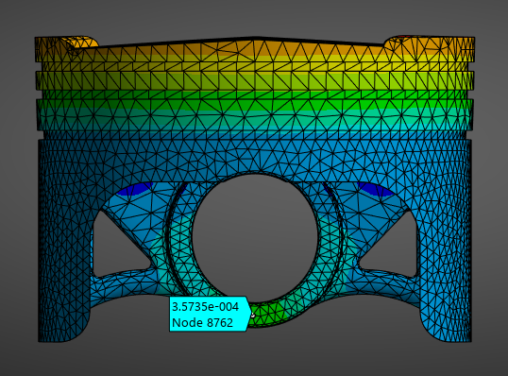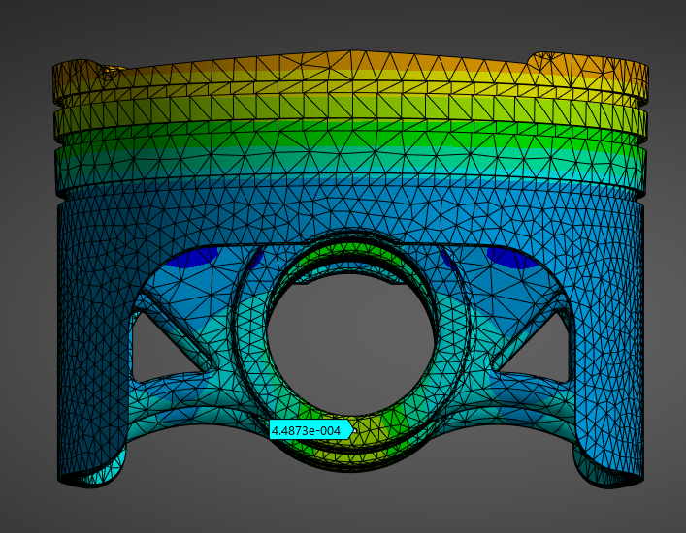
Figure 25 - Piston V3, Deformation
From Figure 25, we can see that using A332, we are getting a reduced amount of displacement by the gudgeon pin. This is ideal, as the tolerance of this part is extremely important and high displacement can cause issues with free play and with the lubrication of the part.

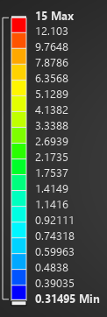
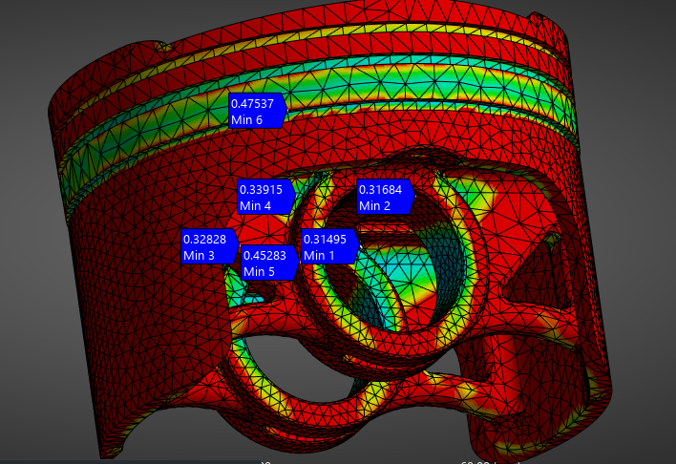
Factor of safety
Figure 26 - Piston V3 Factor of Safety
From the figure above, we can see the factor of safety of the material. First, we can see some extremely high values highlighted in Figure 26. What are the causes of poor mesh quality above the gudgeon pin, as mentioned earlier. Secondly, we can see the area around the gudgeon pin and oil ring showing a safety factor of around 0.7 to 1.5, which is under are limit for this optimisation. This is due to this material having inferior fatigue properties, leading to it having a reduced safety factor around the part.

Comparison of pistons

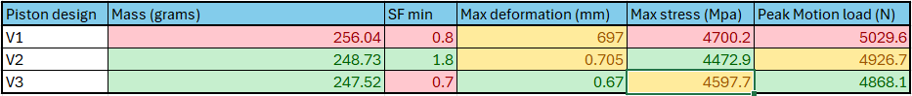
Table 6 - Comparison of Pistons
From the analysis done on the 3 piston options, the ideal piston to be used would be piston design V2 with aluminium 6061. This is significantly lighter than the baseline piston, reducing its motion loads while having more material in key stress areas. 6061 aluminium’s mechanical properties outweigh its losses in density compared to 332 as it's able to keep within are given range for a factor of safety, but more simulation could be done on the thermal expansion in the piston and its corresponding longevity.

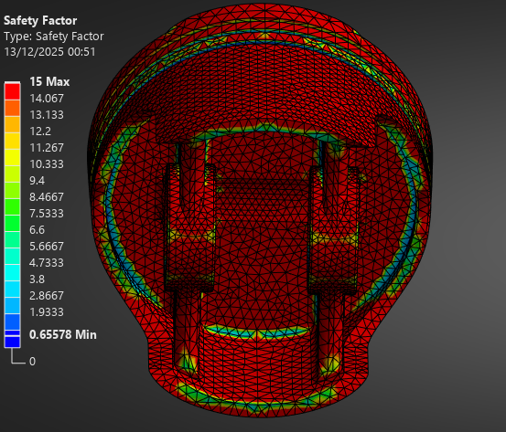

Limitations to CAE

In the simulations, several limitations can be seen with this CAE Study. First, being material data was limited, particularly for the coefficient of thermal expansion and yield strength, what had a lack of thermal-dependent data. The fatigue life analysis didn’t produce any meaningful results for all 3 pistons and failed on each one of them. This could be due to the CAE itself or needing additional information and setup. Using a weak spring as a boundary condition also becomes a limitation, as it gives us altered results from constraining the piston.
Mesh dependency was also a significant limitation, as poor mesh quality around the gudgeon pin supports and oil ring caused high stresses and non-physical stress concentrations, which were reduced with alternate mesh sizing but ultimately affected results.
Topology optimisation was able to remove material by altering fixed points, such as piston rings, skirt, etc., but caused the removed material to make massive stress concentrations.

Bibliography

Andrew noble. (n.d.). Engine assembly.
Dlubal Software. (2015). Verification Example 0042-Bending Cantilever with Axial Force.
Dlubal Software. (2018). Verification Example 0078-Bimetallic Strip Description.
Dr Owen Williams. (n.d.). Sigma pressure data.
FEA Tips. (2019, March 29). Linear vs Quadratic FE Elements. Https://Featips.Com/2019/03/29/Linear-vs-Quadratic-Fe-Elements/.
Rashmita, S. S., Kumari, A., & Aggarwal, S. (2024). Optimization of piston material with aluminium alloy based metal matrix composites. Materials Today: Proceedings, 103, 559–566. https://doi.org/10.1016/j.matpr.2023.09.019
Subramanyam, M., Babu, J., Maruthi, G., Yadav, P., Reddy, M. V. C., & Nishkala, M. T. (2021). Structural Analysis of IC Engine Piston Head for Optimum Convex Shape. In International Journal of Creative Research Thoughts (Vol. 9, Issue 7). www.ijcrt.org
Zheng, H., Tham, L. G., & Liu, D. (2006). On two definitions of the factor of safety commonly used in the finite element slope stability analysis. Computers and Geotechnics, 33(3), 188–195. https://doi.org/10.1016/j.compgeo.2006.03.007

.

Appendices

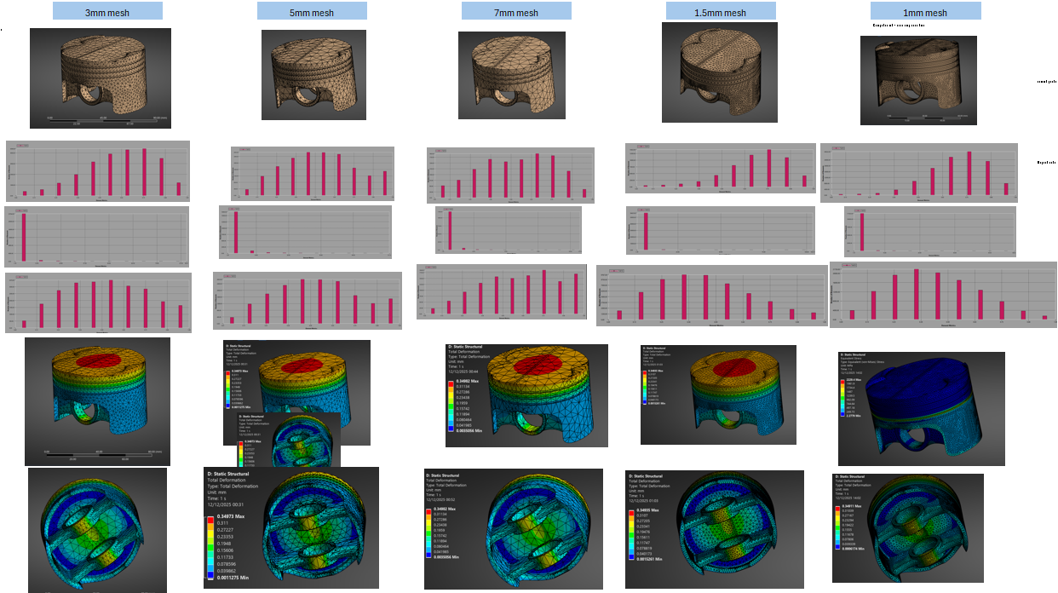
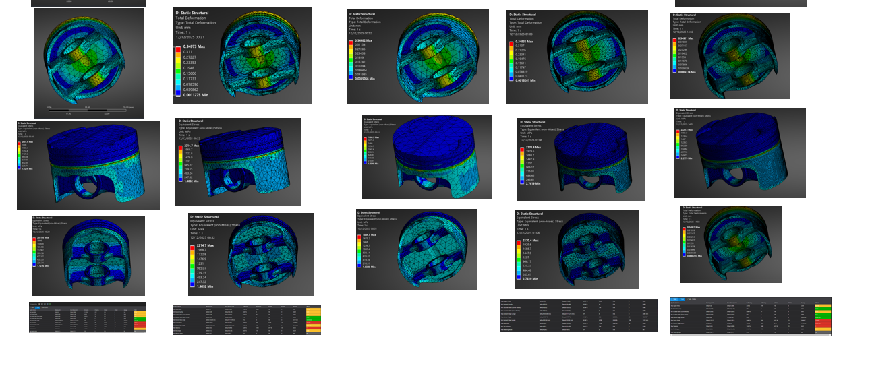

Over the course of the optimisation, the Mesh was kept the same throughout, but this caused issues as we started to lose element quality. Ideally, we need to update the mesh every design iteration


