Changemakers: Creativity and Value Creation
(ACCA5033)

Assignment 1: Innovation
& Research

Michael Dawe (2206831)

Contents
Task A 3
Task B 4
Task C 7
Task D 12
References: 13

Task A
Idea 1:
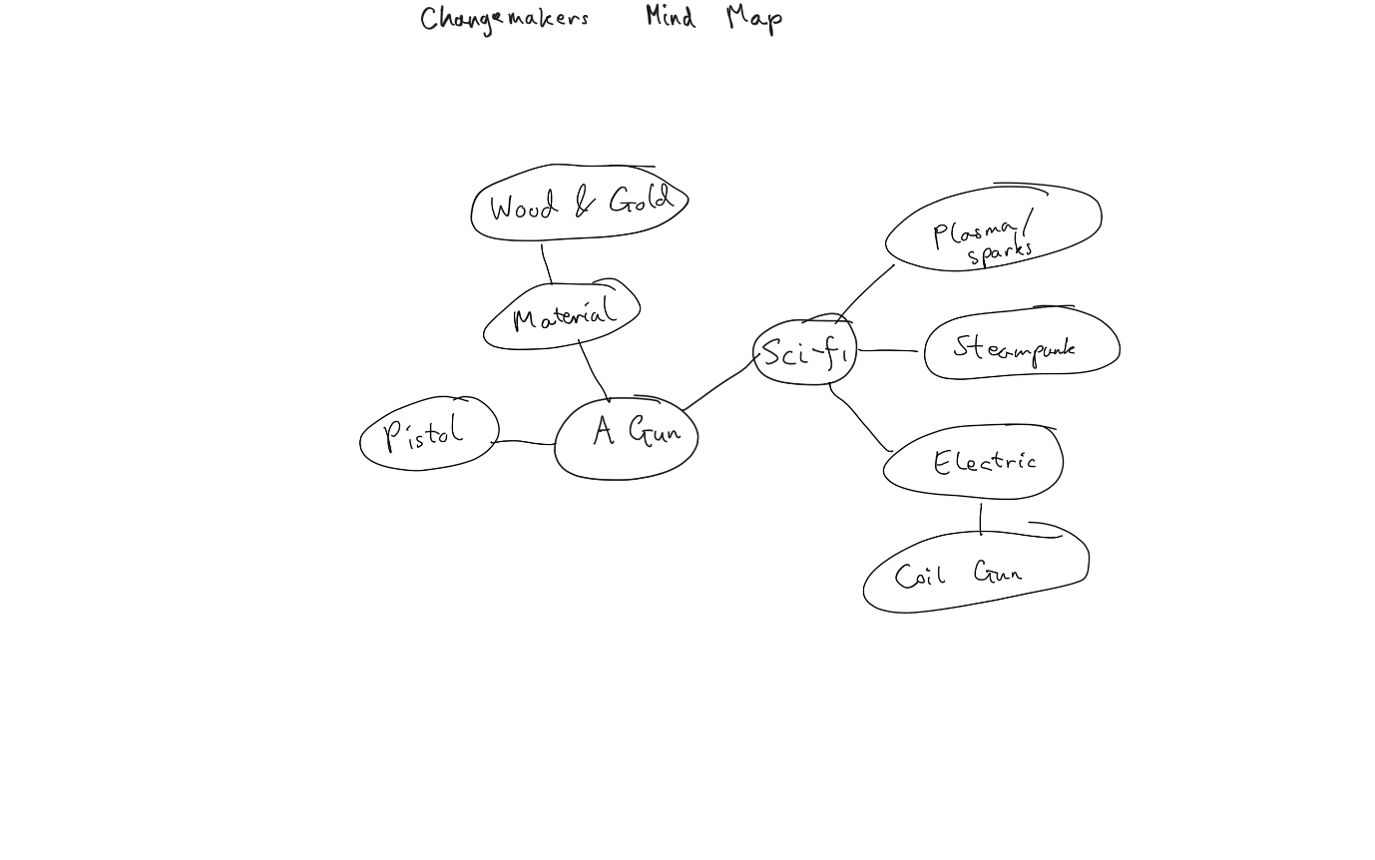
Idea 2:
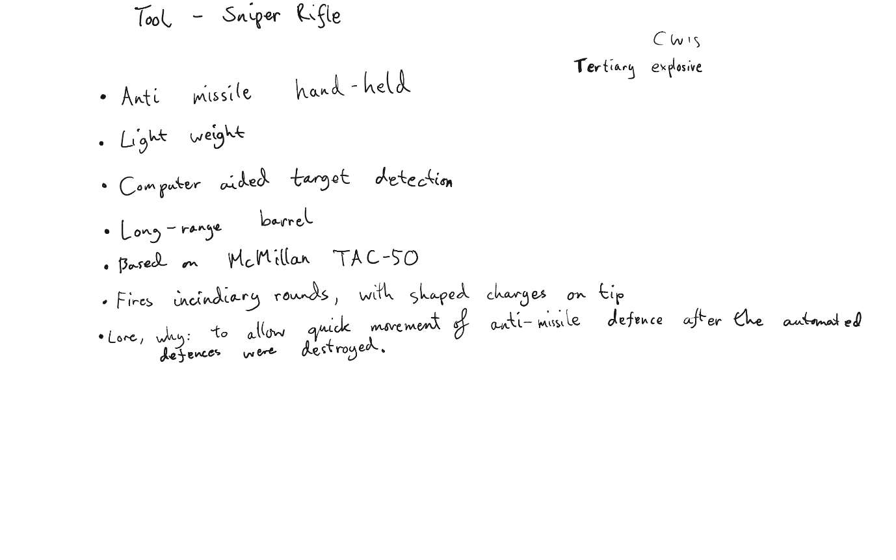

Task B
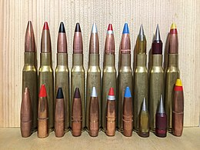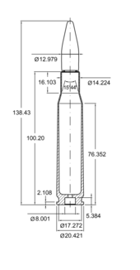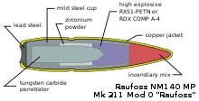
Figure 1-3 (above) [1]
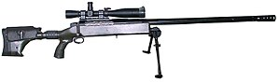
Figure 4 (above) [2]

Figure 5 (above) [3]
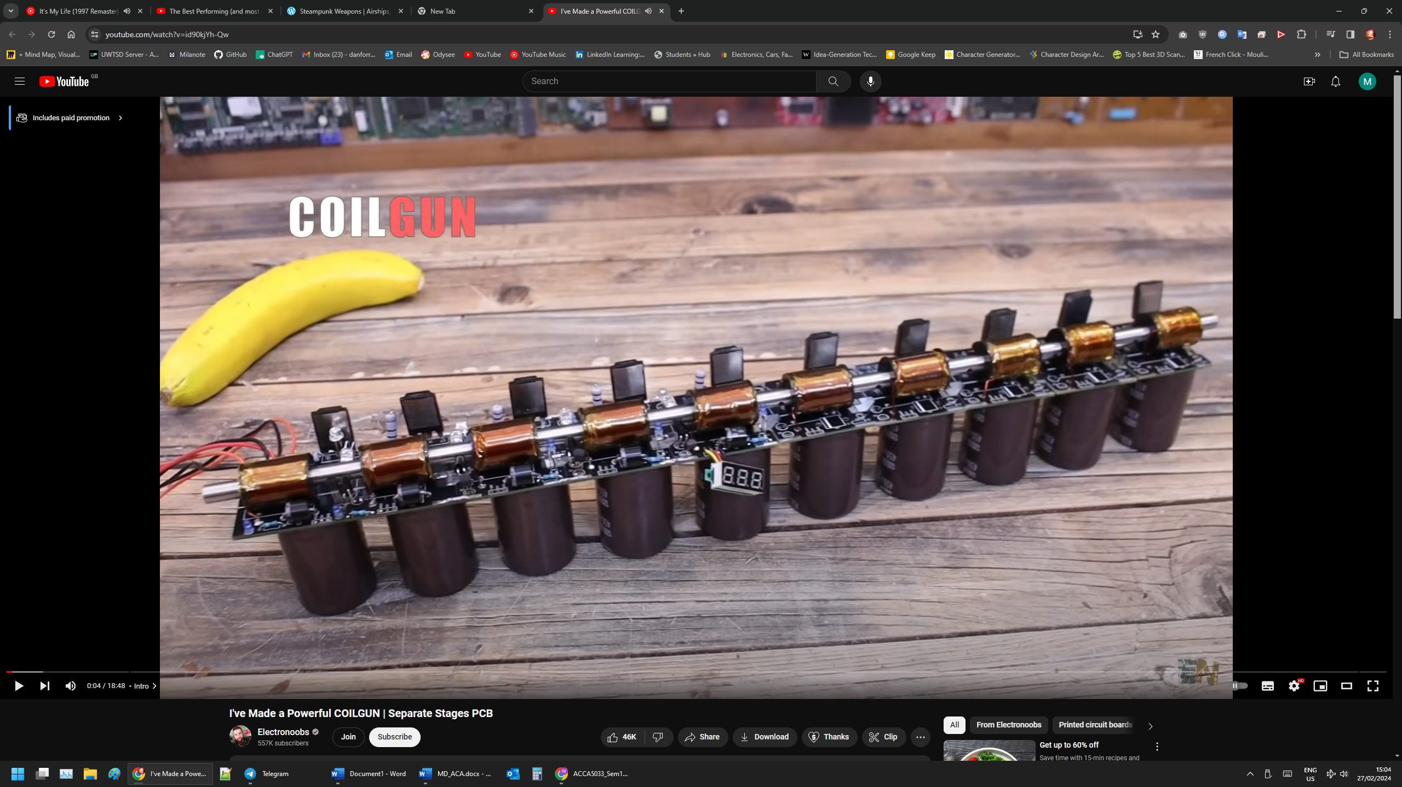
Figure 6 (above) [4]
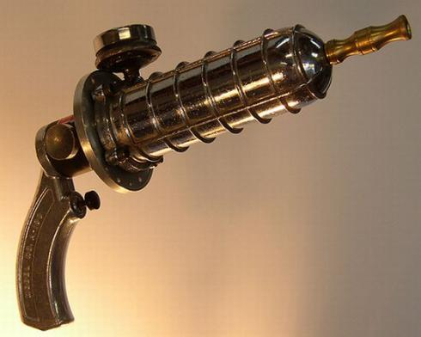
Figure 7 (above) [5]
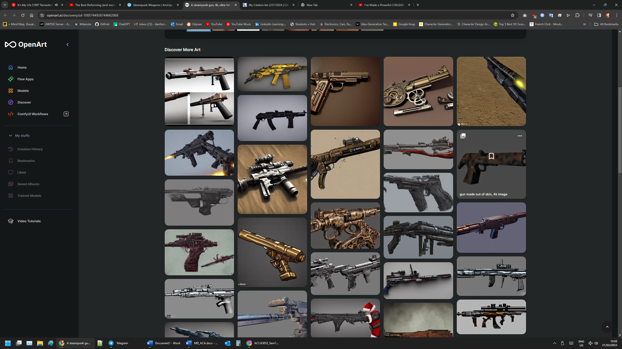
Figure 8 (above) [6]

Task C
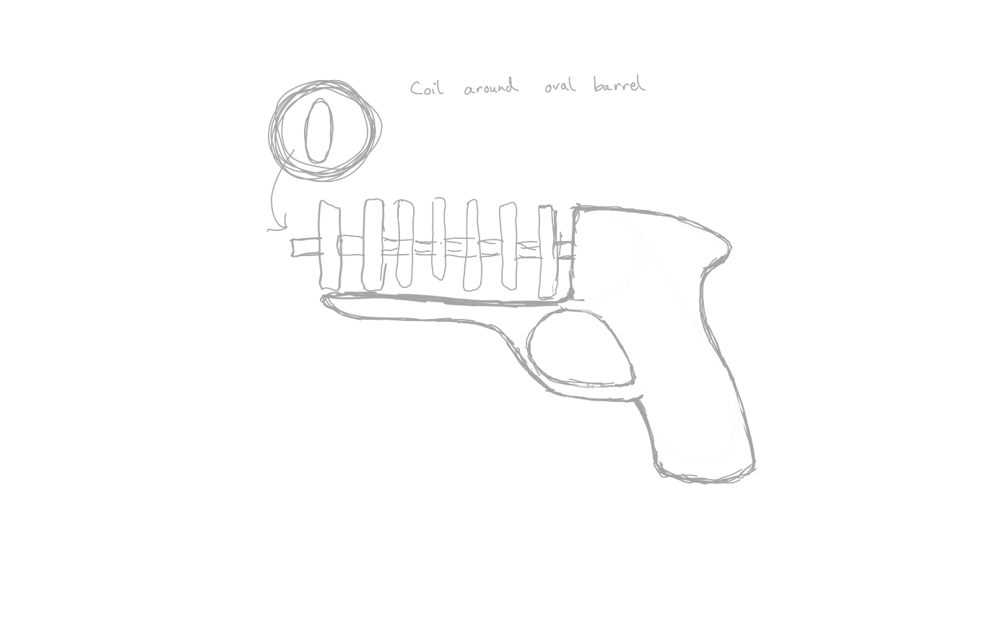
Figure 9 (above) first sketch
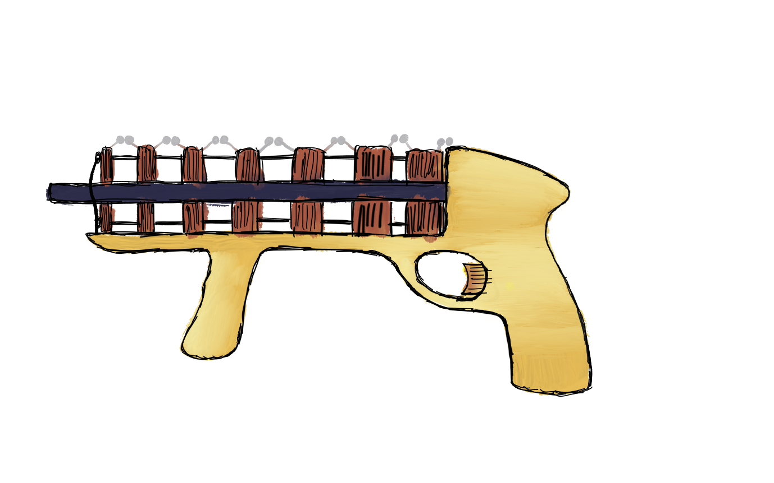
Figure 10 (above) coilgun design side view
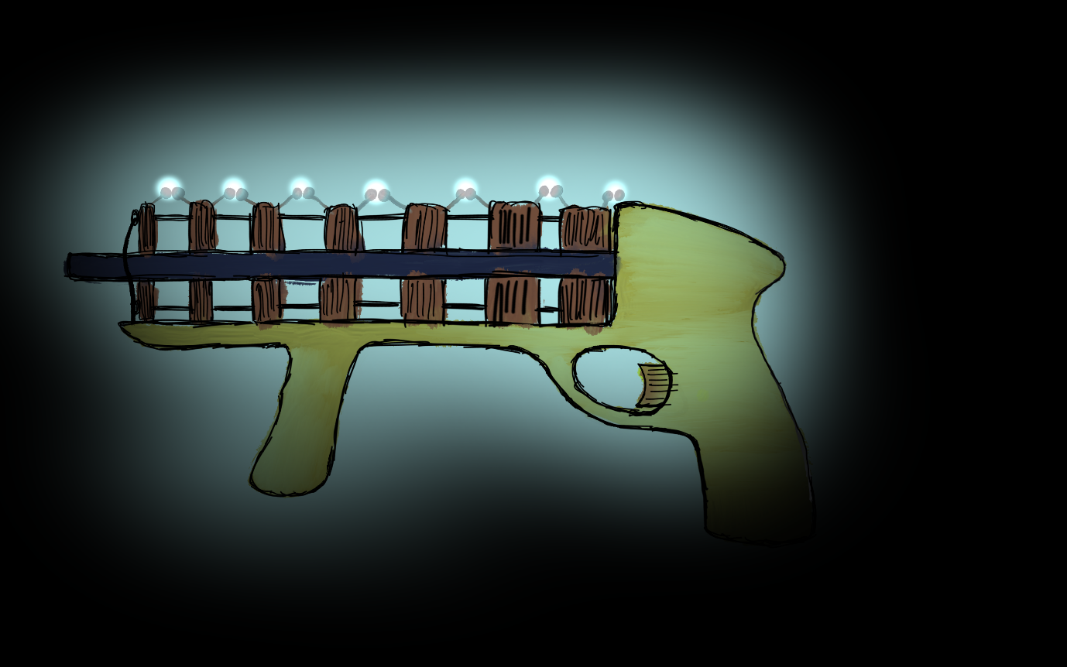
Figure 11 (above) Coilgun design side view in the dark firing
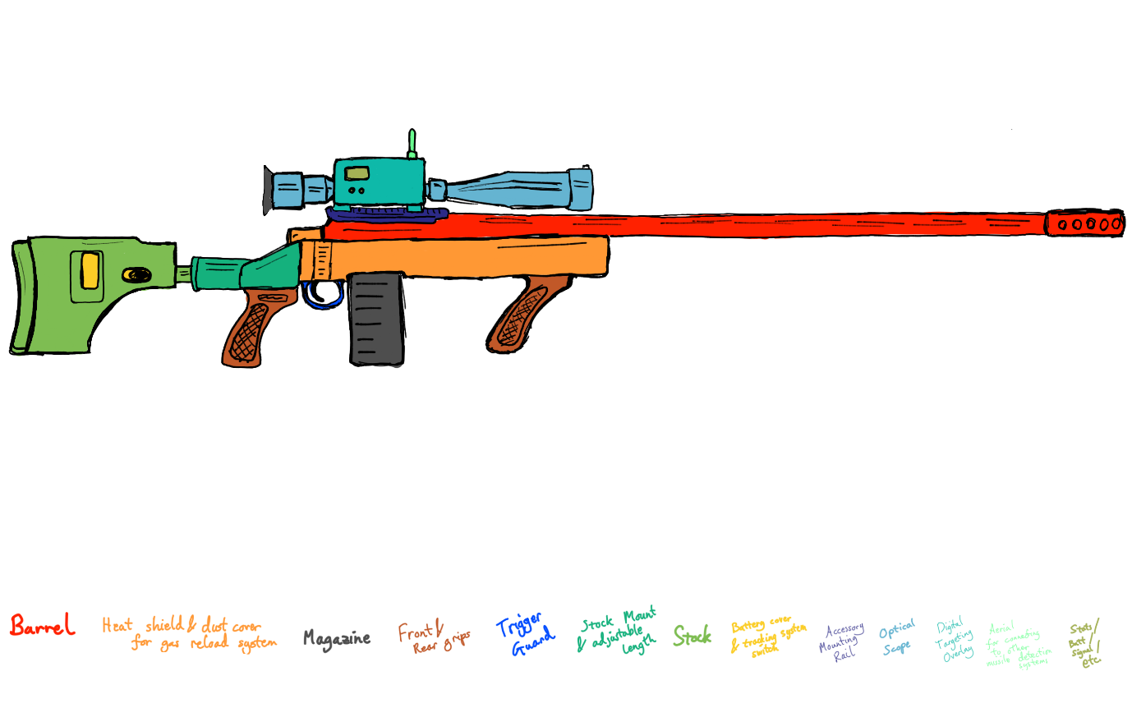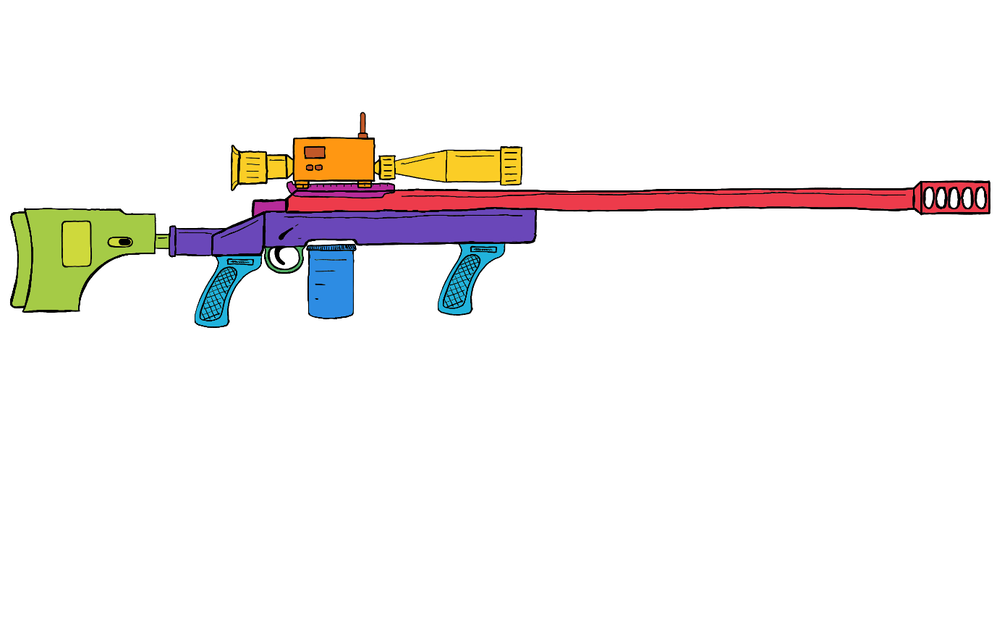
Figure 12-13 (above) Sniper rifle design side view
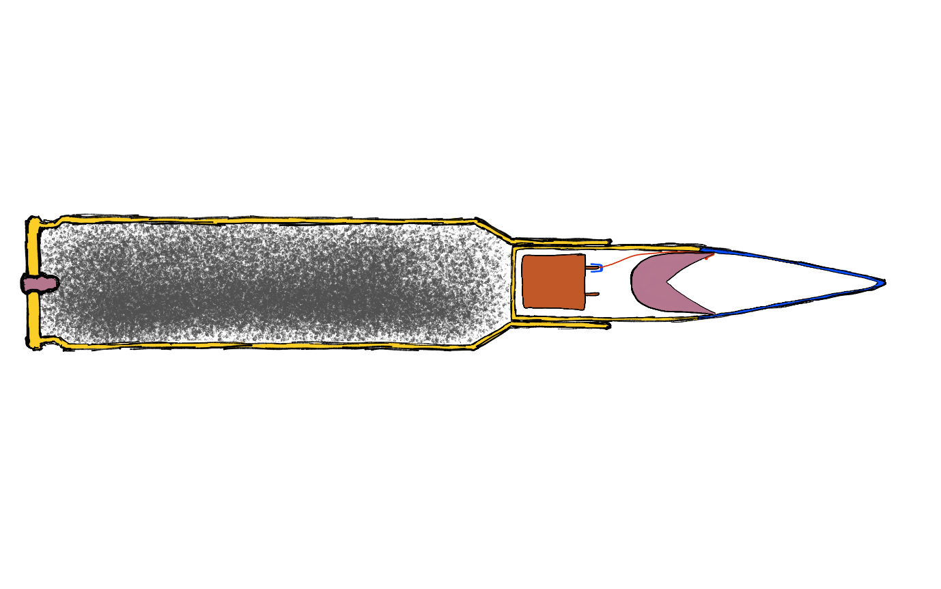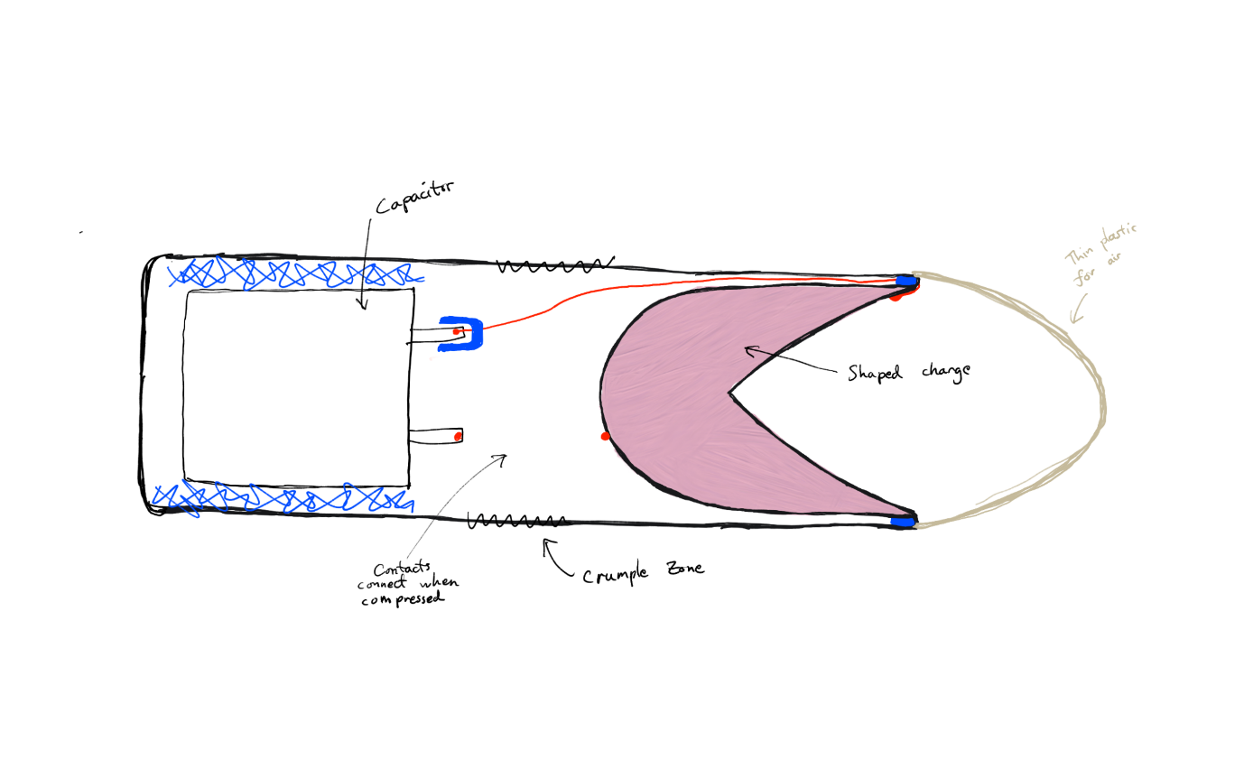
Figure 14-15 (above) Bullet design (shaped charge electrically triggered on impact with missile)
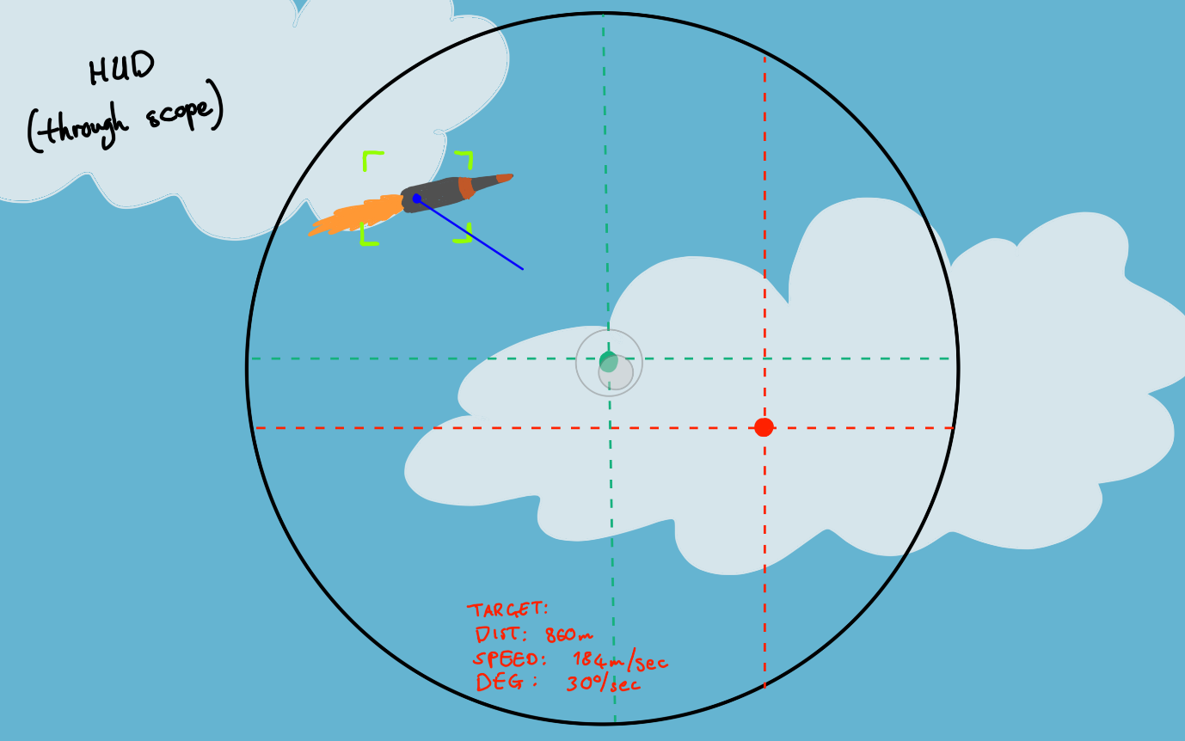
Figure 16 (above) mock up of AI scope.

Task D
My first idea was for a sci-fi gun to be used in a game, perhaps a space fighting scene. This gun might also be used in space, thus needing to be able to fire without oxygen. Using an electric system seemed a good way to do this, and also requires less maintenance and can hold more shots as the bullets don’t require cases with propellant. I chose an electromagnetic coil gun because they are reliable and efficient. Coil guns are also just cool and they’re something I’ve been interested in for a while since seeing youtubers making them.
I wanted to do something with a steampunk aesthetic, maybe using wood and gold or copper. This is not really visible in the rough sketches but would be if I made this in 3D. The main body of the gun would be largely wooden with gold inlayed patterns. The coils would be exposed copper. The spark gaps on the top are not realistic but would add that ‘plasma’ like effect, flashing bright blue when fired.
The bullets themselves would be small iron rods encased in copper, allowing them to engage with riffling in the barrel while still being attracted by the electromagnetic coils. The barrel itself would be made of a sci-fi element that is both hard and not brittle, while not interacting with the magnetic fields.
Research for this was largely into aesthetics. I looked at the shapes and designs used by others for inspiration.

My second idea was based on the prompt Mark gave me, for a sniper rifle to be used as a tool not a weapon. I designed a hand-held missile defence system based on the McMillan TAC-50 which is one of the longest range sniper rifles in real life [2].
The physical design is very similar to the real-life gun, with the main change being the AI integrated HUD computer in the sight. This tracks the missile and performs most of the calculations required for long range shots, rendering a new AR target which the shooter must align to rather than the missile itself. This accounts for the missile’s speed and distance, as well and weather information. The AI module is connected via a radio signal to other missile defence systems and weather monitoring stations.
The bullets themselves contain a small shaped charge under a deformable tip, formed of Tannerite[7] or something similar that can withstand the pressure and heat of being propelled out of the barrel, but can still be detonated electrically on impact with the target missile.
Research for this was limited as I was happy with the first result for long range sniper rifles, the McMillan TAC-50. The AI HUD for assisted aim is based on prior knowledge of image recognition technology and composed of aspects from various places. The blue vector line from the missile is inspired by the blue lines showing which direction an entity is facing in Minecraft[8], the central circle and is inspired by the image stabilization visualization on pixel phone cameras.

References:
[1] “.50 BMG,” Wikipedia, 14-Feb-2024. [Online]. Available: https://en.wikipedia.org/wiki/.50_BMG. [Accessed: 27-Feb-2024]
[2] “McMillan TAC-50,” Wikipedia, 22-Feb-2024. [Online]. Available: https://en.wikipedia.org/wiki/McMillan_TAC-50. [Accessed: 27-Feb-2024]
[3] M. Episkopos, “How the TAC-50 Sniper Rifle earned the world’s longest kill,” The National Interest, 14-Aug-2021. [Online]. Available: https://nationalinterest.org/blog/reboot/how-tac-50-sniper-rifle-earned-world%E2%80%99s-longest-kill-191817. [Accessed: 27-Feb-2024]
[4] Electronoobs, “I’ve made a powerful coilgun | separate stages PCB,” YouTube, 05-Dec-2021. [Online]. Available: https://www.youtube.com/watch?v=id90kjYh-Qw. [Accessed: 27-Feb-2024]
[5] Jgriswoldauthor, “Steampunk weapons,” Airships, Automatons, and Aliens...Oh My!, 09-Nov-2015. [Online]. Available: https://authorjasongriswold.wordpress.com/2015/11/09/steampunk-weapons/. [Accessed: 27-Feb-2024]
[6] “A steampunk gun, 4K, Ultra HD: Stable diffusion,” OpenArt. [Online]. Available: https://openart.ai/discovery/sd-1005744926744662068. [Accessed: 27-Feb-2024]
[7] “Tannerite,” Wikipedia, 17-Jan-2024. [Online]. Available: https://en.wikipedia.org/wiki/Tannerite. [Accessed: 27-Feb-2024]
[8] “Minecraft.” Mojang Studios, Stockholm, 2011

