Professional Career Development

Reflective Review of
Learning Journey

Ancuta Elena Gidoiu

Student number 1905822

Table of Contents
Introduction 3
Part 1 3
Part 2 5
Conclusion .9
Appendices ..……………………………………………………………………………………..10
SWOT Analysis …………………………………………………………………………...11
GO MAD ……..…………………………………………………………………………...12
Personal Development Plan ………………………………………………………………13
References 14

Introduction
Career development is the lifelong process of managing learning, work, and transitions in order to move toward a personally determined and evolving preferred future.
Professional development of career can help an individual to take forward in his career. It may come in the form of formal education and learning; this can include activities like attending seminars and conferences or even networking. Career counselors and advisors believe that any individual can be benefited by the development of professional skills. Professional development comprises of education, mentoring, grooming and observations that can actually help in the enhancement of the employees and workers in a working place. It can include classes, training sessions, workshops, spending time with tutors, mentors and trainers to know how other people deal with the issues, challenges and conflicts. The way to tackle one's professional career depends on the goal of the personal career and the style that he or she prefers to learn. This report aims to reflect and review the personal development of learning styles using the SWOT analysis process.

Part 1
Self-assessment meaning a judgment made by an employee about their own work, abilities, etc., or the process of doing this.
SWOT analysis is a structure that is used to bring out the strengths, weaknesses, opportunities and threats of a person or an organisation (Menga et al., 2015). Identifying one’s skills does help to understand how the person is as a learner. We can determine if our study skills need to be speeded up or if everything is fine with just the way it is. A person can try the process of learning skills questionnaire to figure out how he or she is as a learner.
Learning styles were developed by Peter Honey and Alan Mumford, based on work of Kolb, and they identified four learning styles: Activist, Theorist; Pragmatist and Reflector.
Based on Honey and Mumford learning questions am a Reflector, These people learn by observing and thinking about what happened. They may avoid leaping in and prefer to watch from the sidelines. Prefer to stand back and view experiences from a number of different perspectives, collecting data and taking the time to work towards an appropriate conclusion. .
Here are few learning style questionnaires that would help to understand one better.

Questions | Very rare | Sometimes | Often
Do you participate in group discussions and put your ideas forward? | no | no | yes
Do you have your things ready while studying?  (pen, notebooks etc.) | no | no | yes
Can you easily understand the things that you have learned? | no | no | yes
Can you lead a team well? | yes | no | no

Table 1: learning style questionnaire

SWOT analysis
Analysis
From the table from appendix 3 we can see that the strengths that are analysed are good Communication Skills, good management skills, well organised, and a quick learner. Having good communication skills can lead to good opportunities like good coordination with the employees and co workers. As I have a good management skill and I am a quick learner this can lead me to a high scope for career development in the future. Third I am well organised as a person who likes to keep things handy in order to avoid last minute hastles. This strength of mine can give me the opportunity to improve my skills and job performance in the workplace. Similarly the weaknesses that I have might lead to threats to my career development in the future. Lack of leadership quality, Lacking Work experience and not been able to take up or accept the risks may lead to certain threats.As I lack work experience there would be competition in the workplace. Not having a good leadership quality might lead to face discrimination at the work place. Another weakness that I have is that I am not very comfortable in taking and accepting risks. This weakness of mine can lead to the threat that can finally change in the quality of my life. The threats that one has to face because of his or her weaknesses can often lead to environmental change and also change the quality of life one lives.
The Go M.A.D framework and solution focuses on the thinking, enabling the team and employees to resolve the issues and conflicts in an easier manner to improve productivity. When an organization wants to make a difference, this strategy of Go M.A.D. makes a difference. This framework can increase sale, can reduce cost, saves time and improves performance. This helps in developing an individual as perfect leader, shaping others to contribute in a successful business.
Once this self performing analysis is done we need to work on the weaknesses that we have and the threats that do follow. Here are certain ways in which development of the career growth can be done

Part 2
To look for an expertise list
Expertise describe the abilities, Skills and your knowledge that is needed in order to be successful in a certain role.Go through whatever the expertise has advised you and then decide how you want to develop. Take into consideration competencies of other roles and analyse and decide what is to be done in order to achieve the growth. With the help of this information one can have a better target of his or her learning skills and development of opportunities.
Growth of Professional development and career development
The next thing that is needed to be done is to consider are the short and the long term aims and objectives. It is important to decide if the objective to become strong is in the long or the short term? Various ways can be found to develop and grow.Having a clear idea about this in one’s own mind helps to effective conversations and will allow a person to get through the various available options (Vande Griek et al., 2018).
Considering a Job Shadowing To Look for a Trainer
Job Shadowing is one of the easiest and inexpensive ways to know more about the various roles in the company. If the organisation does not have any formal program then go out to a person whom one should like to shadow. They should also see if they are available or not. If one is not sure whom to go then he can talk to his manager or the business partner.

Find a mentor
The time when a person has established the skills that he or she would like to develop then he should try and find a mentor or a trainer who can provide them with expert advice. Be it a formal or informal, the relationship of mentoring is great for growth development opportunity (Bernard, et al., 2017).
Regular Classes
There are many companies who offer monthly learning opportunities be it in-person or online learning convenience. These classes often include personal development and leadership development discussion. Questions can be asked to the organisational development colleagues.
Investing in Professional membership
An inexpensiveness way for updating of knowledge is professional memberships.Conferences, industry events, workshops and development opportunities, e- newsletters, on demand learning, webinars and journals are admirable investments.
External courses and external learning
Investigation of the external learning convenience is needed to be done. A person then needs to analyse his own skill that he wants to work on and develop or improve. One needs to look at the available options and take into consideration the cost that is involved in attending.
To think wide
At person should have a wide and broad thinking, while thinking about the professional and career development plans one should be thinking about volunteering. Various development benefits are found in volunteering they are, networking, sharpening and retaining old skills, development of new skills, etc.
Audio broadcasting are accessible very easily on own time and these are very effective for for auditory learners. These are also low or sometimes even free of costs(Chan, et al., 2018).
Some group provides opportunities for individuals in similar roles and functions to exchange advice and practices.Participating in the local groups.
To talk to the manager or the leader
After doing certain research and analysis of the goals and the options talking to the manager is much needed. Growth and the areas where development is needed can be discussed with the manger. There are certain things that are to be kept in mind during the discussion are,
All the people are not the same. Some would know exactly what is to be said and how to provide us with the support, while there are many who would not help us with whatever things we would like to know. If career growth is the most important thing that you would want to happen, an individual cannot rely on them. In this case you should definitely go for a second opinion from other expertise.
Barriers in the way of development
Competition among employees is a part and parcel of an employees’ life. Competition can motivate employees to perform better, put in more effort and achieve good results.
Workplace descrimination
Descrimination is how an employee is treated or some unfavourable situations because of some personal characteristic protected by law. Such descriminations occurs when a person makes unfair thoughts about someone with a certain personal character. There are situations when an unreasonable condition is imposed on an individual.
Change in quality of life
The change in quality of life can be noticed after an individual joins an organization. These changes can be majorly noticed and assessed in one's attitude (Sujchaphong, et al., 2019). Quality of life is decided how much an individual is healthy, comfortable and is able to enjoy life.
Support mechanisms are formal method for providing assistance, support and aid small business (Garcia, 2016). There are certain ways by which managers might support the employee’s personal development growth, they are as follows
Create growth plans
The growth plan is very necessary to be done in the very beginning of the work. Take some time to plan things out before you execute them.
Build in growth time
Allow the employees to get engaged in the personal development by giving them some time for professional and personal growth.
Offer new learning experiences
Employees are often more excited about the individual development opportunities whenever it is full of innovation and new ideas. Adding up new variety of interesting experiences is required for improving personal skills. This can have the inclusion of even destination learning, use of technology.

Work on the far reaching benefits
Introduction of the personal development is quite necessary because this helps the employees for broader benefits in the job.
Making Development opportunities
The new way of development and learning is prepared in “one size fits one”, “being bite size” and “real time accessibility” (Strage and Merdinger, 2015). In order to understand the proficiency and the behaviours those are associated with the objectives of the organisations.
Taking an interest in the growth in personal developments
The frequency of the growth generally depends on the weekly/monthly/quarterly business (Brinkert, 2018). It is needed to be found out what interests them other than the regular job scope and support them to continue it. The performance of the employees and their loyalty increases when employees feel that they are getting the support and the power to continue with the Personal dreams and goals
Thinking beyond the formal training
One should go beyond the thinking that the development should take place through formal
Training in class employees can have the interactive session in which they can discuss about the latest trends.

Conclusion
Personal development describes a form framework that one can try to engage and bring out the self-knowledge and level of confidence. It helps to give a structure so that he can be able to complete the tasks effectively. The report has discussed about the personal and professional skills of the workers of the mentioned company. The roles of the personal development help the worker to be confident and positive towards their work. SWOT analysis even helps to consider the personal performance. A personal development plan also helps to understand the competences, desires, and knowledge of the workers.

Appendices

1. SWOT Analysis
2. GO MAD Framework
3. Personal Development Plan (PDP)

Appendices 1. SWOT Analysis

Strengths  - Good Communication Skills  - Well management  - Quick learner  - Well Organised | Weaknesses  ● Lack of leadership quality  ● Lacking Experience  ● Not comfortable taking risks
Opportunities  ● Good coordination  ● High scope for career development  ● Improving skills and job performance | Threats  ● Competition in the workplace  ● Discrimination that is faced in the work place  ● Change in Quality of life.

Appendices 2. GO MAD

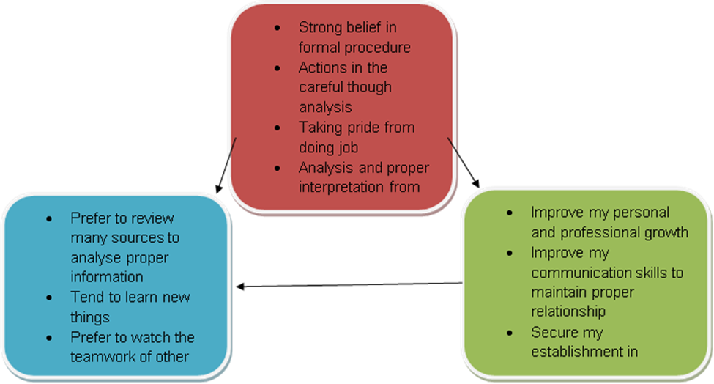

Appendices 3. Plan Development Plan

Personal Development Plan
Objectives | Required Skills | How it can be processed | Required Resources | Timeline
To improve leadership quality | Learning skill  Communication skill | By interacting with other employees | Discuss with the management. | Within 3 months
To Improve performance level | Management skill  Technical skills | With a clear analysis of self position. | Set the objectives before the meeting and the reviews | Within the period of 40 days.
To work in more flexible environment | Communication skill  Leadership skills | By managing the people working within the organization  Should be accustomed with the cultural development of the workplace | Analyse the ways to improve in this field  Letting others act as critical readers. | Within the period of 70 days.

References
https://dictionary.cambridge.org/dictionary/english/self-assessment (accessed 28 Oct. 2019)
https://www2.le.ac.uk/departments/doctoralcollege/training/eresources/teaching/theories/honey-mumford (accessed14 Nov. 2019)
Bernard, J., Chang, T.W., Popescu, E. and Graf, S., 2017. Learning style Identifier: Improving the precision of learning style identification through computational intelligence algorithms. Expert Systems with Applications, 75, pp.94-108.
Brinkert, R., 2018. Career and professional development as levels of engagement in the communication training and development field1. The Handbook of Communication Training: A Best Practices Framework for Assessing and Developing Competence.
Chan, A., Svete, L., Sullivan, P. and Robinson, H., 2018. WAKE FOREST UNIVERSITY'S OFFICE OF PERSONAL AND CAREER DEVELOPMENT: Educating the Whole Person. Career Planning & Adult Development Journal, 34(2).
Garcia, E.V., 2016. Strategic planning: a tool for personal and career growth. Heart Asia, 8(1), pp.36-39.
Menga, E., Dan, A., Lu, J. and Liu, X., 2015. Ranking alternative strategies by SWOT analysis in the framework of the axiomatic fuzzy set theory and the ER approach. Journal of Intelligent & Fuzzy Systems, 28(4), pp.1775-1784.
Strage, A. and Merdinger, J., 2015. Professional growth and renewal for mid-career faculty. The Journal of Faculty Development, 29(1), pp.41-50.
Sujchaphong, N., Nguyen, B., Melewar, T.C., Sujchaphong, P. and Chen, J., 2019. A framework of brand-centred training and development activities, transformational leadership and employee brand support in higher education. Journal of Brand Management, pp.1-17.
Vande Griek, O.H., Clauson, M.G. and Eby, L.T., 2018. Organizational Career Growth and Proactivity: A Typology for Individual Career Development. Journal of Career Development, p.0894845318771216.

