A Security Governance, Risk, and Compliance Framework for NatureGreen (NG)

SUBMI TTED BY:
YASH KUMAR BHARATBHAI PATEL
ID:2517670
UNIVERSITY OF WALES TRINITY SAINT DAVID

I. INTRODUCTION
The high rate of digitisation has greatly enhanced organisational reliance on the cloud services, wireless networks and distributed information systems. This move has increased the necessity of having a strong information security governance that will be able to protect the confidentiality, integrity and the availability of essential data assets. Proper governance involves the strategic alignment, monitoring, risk control, and guarantee procedures, to affirm that security endeavors assist in enhancing organisational goals and sustainability in the long term [1], [3]. The absence of organised governance exposes organisations to uncontrolled risks, operational vulnerability and regulatory exposure, which pose environments where security breach may pose devastating operational and financial impact [4]. NatureGreen (NG), which is one of the fast-growing global firms in the wellness products industry, is operating in such a risk-based environment. It uses a cloud-based environment in its IT ecosystem, and the internal network infrastructure is about 95 percent wireless. In addition, NG's recent move into e-commerce, customer analytics and social media has expanded its online presence and exposed it to cyber threats. Although the organisation has underestimated the power of its intellectual property, client data, and online platforms, NG has no formalised security governance model, formalised risk management procedures, and compliance tools. This lack exposes the organisation to high risk of data breach, disruption of operations, reputation death, and non-compliance in the law.
This report is aimed at creating a holistic, evidence-based security governance, risk, and compliance (GRC) framework that well addresses the operational environment of NG. To do that the report summarises accepted security standards and models, such as governance standards of ISO/IEC 27001, operational control frameworks of the NIST Cybersecurity Framework, modern network protection principles of the Zero Trust Architecture and modern cloud security strategies [7], [12], [18], [23]. The report assesses the weaknesses and strengths of these frameworks through critical analysis and application in a scenario and suggests a mode of combining the models that can be relevant to NG. The phased implementation roadmap and the supporting governance structures are suggested to facilitate the real practice adoption and continuous improvement.

II. LITERATURE REVIEW

A. Information Security Governance
Information security governance is a vital organisational practice that prepares the alignment of security operations with business goals, aided by leadership, and integrated into the organisational culture. Veiga and Eloff emphasize that governance should be based on well-coordinated systems, including policies, responsibility allocation, and commitment of the senior management allowing security to become sustainable and an enterprise-wide process [1]. This view is supported by Nicho who introduces a model of governance process which accentuates upon structured maturity progression, constant improvement and strategic integration within business functions [2]. On the same note, Carcary et al. suggest that information security governance exists on the strategic, tactical and operational levels, and that coordination between them is paramount to effective decision-making on security matters, and managing risk [3]. All these studies lead us to conclude that the issue of governance should be systematic, measurable and strategically placed in the organisation to attain resilience.

B. ISO/IEC 27001 and ISMS Models
One of the most implemented information security management standards is ISO/IEC 27001 which defines requirements to a formalized Information Security Management System (ISMS). According to Hamdi et al., the ISO 27000 series offers organisations with standard and auditable frameworks of both information risk management and controls recording [7]. Nonetheless, research indicates that organisations are likely to encounter difficulties during implementation in case they do not have proper knowledge of the standard, they do not allocate relevant resources or they are not able to get the leadership support [8]. Experiences of the implementation of ISMSs have revealed that the key to success is systematic documentation, stakeholder participation, and continual development of the security procedures [9]. The study by Kamil et al. also contributes that ISO/IEC 27001 also offers legitimacy as a stakeholder perspective given that certification is an indication of compliance with the broadly accepted security expectations [10].

C. NIST Cybersecurity Framework
The NIST Cybersecurity Framework (CSF) is a highly flexible, maturity-centred framework that utilises functional identities of Identify, Protect, Detect, Respond, and Recover. One of the key strengths of this company, as Lanz emphasizes, is its flexibility and ability to be applicable to any industry, especially to dynamic or cloud-based ones [16]. Parmar and Miles also state that NIST CSF assists in better risk prioritisation and ordered ability evaluation and allows organisations to enhance their operational security stance [12]. The studies also indicate that the success of the implementation is also dependent on the human factors, training, and organisational awareness; Rohan et al. believe that these factors play a crucial role in ensuring the NIST controls are successfully implemented [13]. Also, the framework is compatible with maturity models, including the one suggested by Bernardo et al., which facilitates continuing enhancement and benchmarking of cybersecurity capabilities [15].

D. Zero Trust Architecture
As one of the models whose emergence has gained prominence, Zero Trust Architecture (ZTA) is aimed at the removal of implicit trust in networks through the establishment of continuous checks and least-privilege accessibility. As Sarkar et al. show, ZTA is specifically applicable when using cloud-centric environments and wireless networks in which conventional perimeter-based security fails [18]. Mehraj and Banday state that whereas Zero Trust necessitates a redress in architecture and powerful foundations in identity administration, it offers viable long-term resiliencies against credential theft and lateral movement [19]. More research indicates that ZTA is also effective in multi-cloud and microservices ecosystems, enhancing survivability and assurance of operations [20], [21].

E. Cloud security and Multi-Cloud Governance
Since the cloud is relied upon by NG, cloud-first governance is compulsory. Korada points to the concept of confidential computing as one of the ways to ensure the security of sensitive clouds workloads by using hardware-based isolation [22]. According to Abraham et al., multi-cloud environments demand high-level identity federation, encryption, and strict data protection controls [23]. To supplement these results, Mahida and Tyagi point out that cyber threat intelligence accelerates the level of proactive cloud security and advances organisational preparedness [24].

III. CRITICAL EVALUATION OF FRAMEWORKS
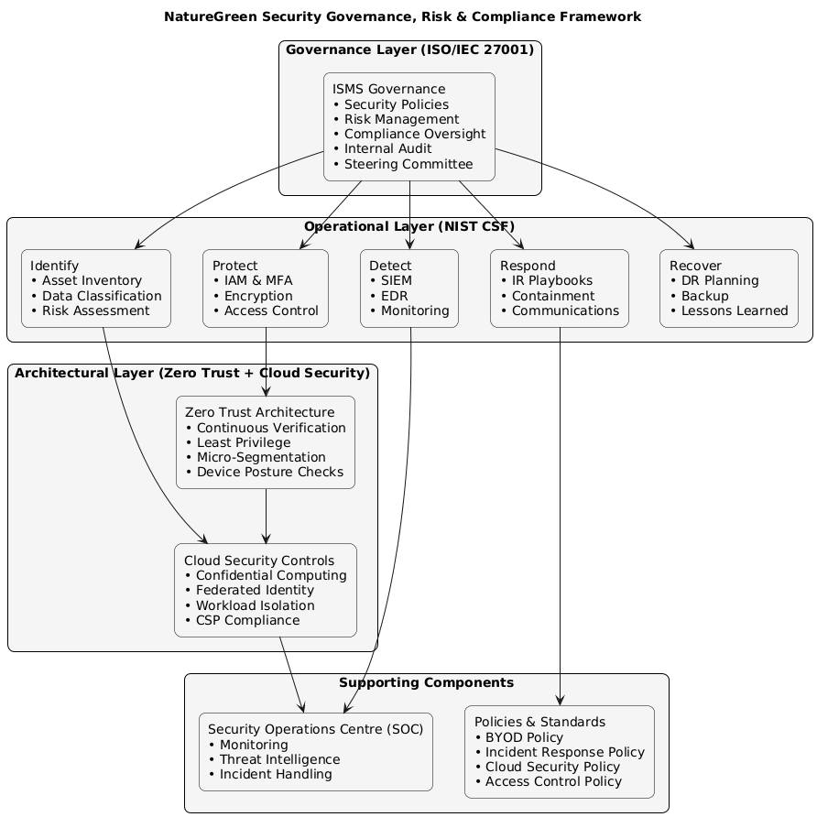
NatureGreen Security Governance, Risk & Compliance Framework
(Source: Creatly)
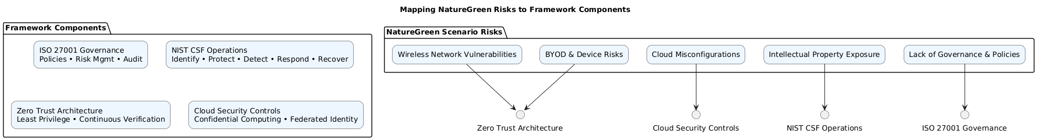
Mapping NatureGreen Risks to Framework Components
(Source: Creatly)
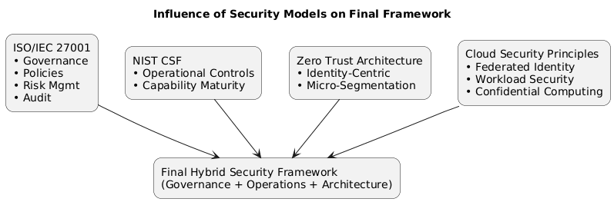
Influence of Security models on final Framework
(Source: Creatly)
The most holistic and intensive basis of formal information security governance is ISO/IEC 27001 as it is designed based on policy development, in-house auditing, and risk management. According to Kamil et al, ISO/IEC 27001 improves organisational legitimacy because it shows compliance to internationally recognised security standards [10]. Hamdi et al. also note that its procedural and process orientation encourages consistency and responsibility within the responsibilities of the business and hence it is advisable in organisations that want to have consistency in their security practices [7]. Some studies however admit that ISO/IEC 27001 may be resource-consuming to organisations that lack well-developed security competencies and may add overheads to operational processes where it is implemented in a strict way [8]. In the case of NatureGreen (NG), ISO/IEC 27001 is hence the best strategic governance model and not an elaborate operational control mechanism.
The NIST Cybersecurity Framework (CSF) is used to supplement ISO/IEC 27001 with more capability-oriented approach aimed at enhancing operational resilience. Lanz notes that the NIST CSF is specifically flexible to the dynamic nature of the environment, allowing organisations working to enhance their security maturity to utilise it [16]. Similarly, Bernardo et al. report that NIST-congruent maturity assessment models can help organisations to compare their state of cybersecurity and facilitate gradual enhancement [15]. In spite of such benefits, NIST CSF does not necessarily offer formal compliance frameworks, governing procedures, and accountability systems, and cannot alone address the strategic governance requirements of NG [12].
Zero Trust Architecture (ZTA) presents architectural protection, which is very useful in the case of wireless, cloud-based, and BYOD environments of NG. Sarkar et al. show that ZTA can greatly decrease the threat of credential theft and inter-network movement across distributed networks [18]. Mehraj and Banday emphasize that ZTA must have the best identity management, redesigning of architecture, and constant verification that is complex but very advantageous in long-term implementation [19]. In the case of NG, a progressive implementation that puts emphasis on identity management and network segmentation is viable and appropriate.
Multi-cloud frameworks Cloud security frameworks also enhance the multi-cloud environment of NG. Korada sees confidential computing as an essential mechanism of securing the sensitive workloads by using hardware-level isolation [22], whereas Abraham et al. present the significance of federated identity, encryption, and robust governance systems in the multi-cloud implementations [23]. Altogether, the literature reveals that the hybrid security model of NG should combine ISO/IEC 27001 that is applied to governance, the NIST CSF that is utilized to ensure operational security, ZTA that is applied to architectural resilience, and cloud-specific controls that are applied to protect the platforms.

IV. PROPOSED SECURITY GOVERNANCE & COMPLIANCE MODEL

A. Model Overview
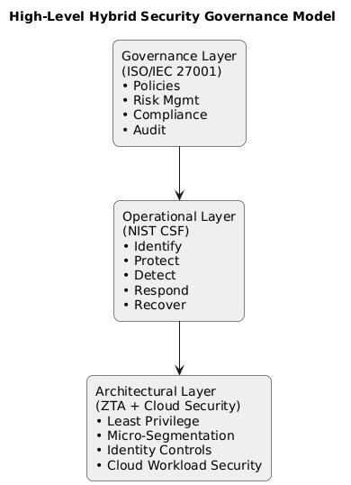
High-Level Security Governance Model
(Source: Creatly)
The security governance and compliance model suggested to be implemented in NatureGreen (NG) incorporates three layers that are complementary to each other and aimed at addressing the strategic, operational, and architectural demands. The Governance Layer, which is founded on ISO/IEC 27001, is the organisational base to policy development, formal risk management, audit processes, and compliance control. This tier offers control, responsibility, and enforcement components needed to organize the security stance of NG. The Operational Layer, in compliance with the NIST Cybersecurity Framework (CSF), is concerned with operational security controls that can be put into practice to help with the daily protection, detection, response, and recovery measures. Lastly, the Architectural Layer, which is based on the zero-trust principles and best practices in cloud-security, implements technical controls to grant identity-focused and least-privilege access to NG in its cloud-reliant and wireless landscapes [18], [22].

B. Governance Structure
An organization should have a well-defined accountability and decision-making. It has the Chief Information Security Officer (CISO) at the core of it who is in charge of strategic oversight. A Security Steering Committee is a cross-functional governance body that gives risk-based decisions. The Data Protection Officer (DPO) will oversee the compliance with GDPR, whereas the Risk Management Team will take regular evaluations and remain adapted to the organisational goals. This is facilitated by a Security Operations Centre (SOC), which is charged with monitoring, management of incidents, and threat intelligence.

C. Risk Management Process
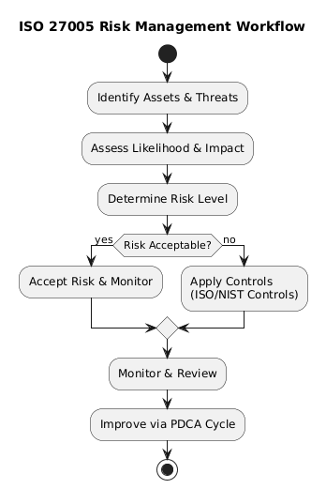
ISO 27005-Based Risk Management Workflow
(Source: Creatly)
The risk management process adheres to the principles of ISO 27005 and the first step is the systematized threat identification in the wireless, cloud, and endpoint environments. The risks are assessed based on likelihood and impact criteria and managed by controls that are in line with ISO/IEC 27001 and NIST CSF. This process is based on a continuous improvement model, and it involves monitoring and reviewing activities as Plan-Do-Check-Act (PDCA) in order to remain relevant and effective.

D. NIST CSF Operational Controls
Operationalisation is organised on the five CSF functions. Activities that are identified are asset inventories, data classification, and business process mapping. Protect includes BYOD containerisation, encryption, role-based access control, and multi-factor authentication. Detect specializes in SIEM, endpoint detection and response, and network anomaly monitoring. Respond encompasses incident playbooks, escalation path, and evidence preservation. Recovery includes recovery-testing, resilience planning, and integration of lessons-learned.

E. Zero Trust Architecture Integration
Zero Trust is more resilient as it implements micro-segmentation, constant authentication, and identity-based access validation. Alternatively, the additional methods that would be used to control them would be device posture check and Secure Access Service Edge (SASE) integration, which ensures a high level of protection across the distributed cloud and wireless infrastructure of NG [18], [19].

F. Cloud Governance Controls
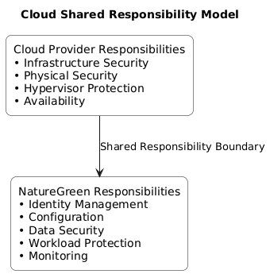
Cloud Governance & Shared Responsibility Model
(Source: Creatly)
Cloud governance uses confidential computing to protect sensitive workloads [22], federated identity management to enforce single access control, contractual compliance vendor auditing, and configuration baselines including CIS benchmarks to keep safe cloud environments.

V. APPLICATION TO NATUREGREEN

A. Wireless Network Risks
The reliance on wireless networking by NatureGreen would expose the company to high interception, rogue access points, and illegal lateral progression. Zero Trust Architecture (ZTA) is a powerful approach to mitigation due to the implementation of micro-segmentation and the absence of implicit trust between services and devices [18]. The use of WPA3 encryption, 802.1X authentication and continuous device-posture validation will further decrease the exposure of the system to spoofing and credential compromise [19].

B. Cloud Service Risks
Being a cloud-reliant organisation, NG needs to deal with risks associated with improperly configured services, insufficient identity controls, and insufficient workload separation. Confidential computing enhances the resiliency of the clouds because sensitive workloads are preserved even when they are processed in the cloud [22]. Complementary controls like encryption, federated identity management, and constant monitoring are used to identify configuration drift and developing threats. The incorporation of the threat intelligence features also improves the insight into the cloud-based attack vectors and facilitates the proactive risk mitigation [24]. NG must also establish a concise joint-responsibility framework with every cloud provider to provide accountability and regulatory conformity.

C. BYOD Risks
Unauthorised access to data, the spread of malware, and the insufficient visibility of the device are the threats posed by the BYOD practices. Mobile Device Management (MDM) offers a level of control, which allows us to implement the encryption, security base, and remote wipe. Sandboxing and containerisation helps isolate corporate data with personal applications and conditional access helps to restrict the system access to compliant devices.

D. Intellectual Property (IP) Protection
The company should also vigorously protect its intellectual property, such as the research formulations and product designs, as they are the assets of NG. Role-based access control (RBAC) is enforced by Data Loss Prevention (DLP) technologies to monitor the flow of sensitive data, whereas least-privilege access is implemented. Watermarking and tracking access control deterring abuse and aid in forensic examination. Different research networks are segregated to minimize chances of external compromise.

E. Incident Response and Continuity
The preparedness of NG to deal with security incidents is improved through a well-structured incident response plan, which is consistent with ITIL practices. Response activities are simplified with defined playbooks, escalation procedures and communication protocols. Frequent simulation training will provide the preparedness of the operations and the organisational resilience in terms of keeping learning.

VI. IMPLEMENTATION ROADMAP
NatureGreen (NG) implementation roadmap is organized into four developmental stages meant to establish the governance bases, create operational capacity, mature security operations and optimize long term resilience. This step-by-step strategy will make sure that NG can introduce the suggested framework in a way which is not only controllable and measurable but resource-saving.

Phase 1: Establish Governance (0–3 months)
Phase one is concerned with putting in place the organisational arrangements needed to promote a sustainable security programme. The initial steps that NG should undertake are the creation of the crucial governance units, such as the Security Steering Committee, Risk Management Team, or the hiring of a Chief Information Security Officer (CISO). These positions are strategic oversight and formal accountability. This should be followed by a thorough gap assessment of the current controls, risks, and compliance requirements of NG against ISO/IEC 27001 and the Government NIST Cybersecurity Framework. On the findings, NG needs to come up with the basic security policy e.g. Information Security Policy, Access Control Policy, Cloud Security Policy and Incident Response Policy. This step defines the strategic path and aligns the objectives of business with security priorities.

Phase 2: Build Capabilities (3–9 months)
The second stage activates the governance base by developing the necessary security resources. Priority controls entail the adoption of Identity and Access Management (IAM) and Multi-Factor Authentication (MFA) as a means of enhancing identity assurance within the cloud and wireless settings of NG. To minimize the risk of horizontal movement, wireless segmentation must be implemented to differentiate corporate, guest and research networks. At the same time, NG must initiate formal documentation of the ISMS in accordance with the ISO/IEC 27001 requirements, an asset, risk, control, and procedure inventory. Such activities play an important role of minimising the exposure to attack surface as well as equipping the organisation to greater security integration in the later phases.

Phase 3: Integrate and Mature (9–18 months)
This stage aims at strengthening and increasing monitoring, response, and resilience. Creating a Security Operations Centre (SOC) will allow us to continuously monitor security and coordinate incidents. Security Information and Event Management (SIEM) and Endpoint Detection and Response (EDR) tools can be deployed to enhance detection and investigating capabilities. To check preparedness, NG would need to perform regular disaster recovery (DR) and incident response (IR) exercises. This is also the stage that continuous compliance monitoring is carried out in order to stay on track with internal policies and regulatory requirements.

Phase 4: Optimisation (18+ months)
The last stage will focus on maximising the security environment within NG by implementing superior and proactive functions. The predictive analytics and behavioural monitoring can be combined to forecast the abnormalities and the new threats. The creation of threat intelligence programmes improves awareness of the situation and risk-based decision-making. Lastly, the total implementation of Zero Trust Architecture, such as continuous authentication, micro-segmentation, and secure service edge integration, will guarantee the long-term stability of the cloud and wireless ecosystem of NG.

VII. CONCLUSION
The suggested hybrid security governance and compliance framework provides a well-organized, reliable, and scalable framework to suit the digital environment of NatureGreen (NG). Combinations of ISO/IEC 27001 strategic governance, the NIST Cybersecurity Framework of operational capability, the Zero Trust Architecture to reinforce the architecture, and the cloud-oriented principles of governance make the model inclusive in all organisational, technical, and regulatory areas. This will be a combined strategy that will see security become part of the strategic direction of NG, whilst being responsive to emerging threats.
The model directly covers the major risk areas facing NG, such as vulnerability caused by the presence of large-scale wireless networking, reliance on cloud solutions, BYOD, and intellectual property protection of high value. The framework promotes accountability, visibility and stable security operations through well-established governance frameworks, risk management procedures, and essential technical controls. The roadmap of phased implementation that goes with it allows the organisation to embrace the framework in a progressive manner, as the capability building is balanced with operational continuity. Development of governance areas, maturing security capabilities and streamline advanced controls over time can help NG attain sustained security improvement.

REFERENCE LIST
- Veiga, A.D. and Eloff, J.H., 2007. An information security governance framework. Information systems management, 24(4), pp.361-372. https://libkey.io/libraries/1422/openurl?sid=google&auinit=AD&aulast=Veiga&atitle=An+information+security+governance+framework&id=doi:10.1080/10580530701586136&title=Information+systems+management.&volume=24&issue=4&date=2007&spage=361&issn=1058-0530
- Nicho, M., 2018. A process model for implementing information systems security governance. Information & Computer Security, 26(1), pp.10-38. https://scholar.google.com/scholar?output=instlink&q=info:5mXWEyInSXcJ:scholar.google.com/&hl=en&as_sdt=0,5&scillfp=7749349350868997662&oi=lle
- Carcary, M., Renaud, K., McLaughlin, S. and O'Brien, C., 2016. A framework for information security governance and management. It Professional, 18(2), pp.22-30. https://scholar.google.com/scholar?output=instlink&q=info:v0Jikqw954AJ:scholar.google.com/&hl=en&as_sdt=0,5&scillfp=6334325418895272319&oi=lle
- Posthumus, S. and Von Solms, R., 2004. A framework for the governance of information security. Computers & security, 23(8), pp.638-646. https://scholar.google.com/scholar?output=instlink&q=info:BAmhNDiruMAJ:scholar.google.com/&hl=en&as_sdt=0,5&scillfp=1691926336454650770&oi=lle
- Magnusson, L., Iqbal, S., Elm, P. and Dalipi, F., 2025. Information security governance in the public sector: investigations, approaches, measures, and trends. International Journal of Information Security, 24(4), p.177. https://scholar.google.com/scholar?output=instlink&q=info:CdJ1LaORw-YJ:scholar.google.com/&hl=en&as_sdt=0,5&scillfp=1421909302118993567&oi=lle
- Antoniou, G.S., 2018, April. A Framework for the Governance of Information Security: Can it be Used in an Organization. In SoutheastCon 2018 (pp. 1-30). IEEE. https://scholar.google.com/scholar?output=instlink&q=info:MABM3Uor93UJ:scholar.google.com/&hl=en&as_sdt=0,5&scillfp=2569948597136965705&oi=lle
- Hamdi, Z., Norman, A.A., Molok, N.N.A. and Hassandoust, F., 2019, December. A comparative review of ISMS implementation based on ISO 27000 series in organizations of different business sectors. In Journal of Physics: Conference Series (Vol. 1339, No. 1, p. 012103). IOP Publishing. https://scholar.google.com/scholar?output=instlink&q=info:4NLCtfbNIAMJ:scholar.google.com/&hl=en&as_sdt=0,5&scillfp=14737305005804603482&oi=lle
- Tatiara, R., Fajar, A.N., Siregar, B. and Gunawan, W., 2018, March. Analysis of factors that inhibiting implementation of Information Security Management System (ISMS) based on ISO 27001. In Journal of Physics: Conference Series (Vol. 978, No. 1, p. 012039). IOP Publishing. https://scholar.google.com/scholar?output=instlink&q=info:3p6qZEBMTLEJ:scholar.google.com/&hl=en&as_sdt=0,5&scillfp=13726574596952084316&oi=lle
- Asosheh, A., Hajinazari, P. and Khodkari, H., 2013, April. A practical implementation of ISMS. In 7th International Conference on e-Commerce in Developing Countries: with focus on e-Security (pp. 1-17). IEEE. https://scholar.google.com/scholar?output=instlink&q=info:uodgd6gtucoJ:scholar.google.com/&hl=en&as_sdt=0,5&scillfp=8532827783423428262&oi=lle
- Kamil, Y., Lund, S. and Islam, M.S., 2023. Information security objectives and the output legitimacy of ISO/IEC 27001: stakeholders’ perspective on expectations in private organizations in Sweden. Information Systems and e-Business Management, 21(3), pp.699-722. https://scholar.google.com/scholar?output=instlink&q=info:np195BbE0DoJ:scholar.google.com/&hl=en&as_sdt=0,5&scillfp=4593020577500413319&oi=lle
- Mirtsch, M., Kinne, J. and Blind, K., 2020. Exploring the adoption of the international information security management system standard ISO/IEC 27001: a web mining-based analysis. IEEE Transactions on Engineering Management, 68(1), pp.87-100. https://scholar.google.com/scholar?output=instlink&q=info:cE6XVYqFs44J:scholar.google.com/&hl=en&as_sdt=0,5&scillfp=12651083476305532745&oi=lle
- Parmar, M. and Miles, A., 2024, May. Cyber Security Frameworks (CSFs): An Assessment Between the NIST CSF v2. 0 and EU Standards. In 2024 Security for Space Systems (3S) (pp. 1-7). IEEE. https://scholar.google.com/scholar?output=instlink&q=info:hBLIdlonTgAJ:scholar.google.com/&hl=en&as_sdt=0,5&scillfp=14158110612866455314&oi=lle
- Rohan, R., Papasratorn, B., Chutimaskul, W., Hautamäki, J., Funilkul, S. and Pal, D., 2023, December. Enhancing cybersecurity resilience: A comprehensive analysis of human factors and security practices aligned with the NIST cybersecurity framework. In Proceedings of the 13th International Conference on Advances in Information Technology (pp. 1-16). https://scholar.google.com/scholar?output=instlink&q=info:JaKEf0SMecwJ:scholar.google.com/&hl=en&as_sdt=0,5&scillfp=193949638798042642&oi=lle
- Dimakopoulou, A. and Rantos, K., 2024. Comprehensive analysis of maritime cybersecurity landscape based on the NIST CSF v2. 0. Journal of Marine Science and Engineering, 12(6), p.919. https://scholar.google.com/scholar?output=instlink&q=info:YGfBb1nZW5MJ:scholar.google.com/&hl=en&as_sdt=0,5&scillfp=6494256118581345902&oi=lle
- Bernardo, L., Malta, S. and Magalhães, J., 2025. An Evaluation Framework for Cybersecurity Maturity Aligned with the NIST CSF. Electronics (2079-9292), 14(7). https://scholar.google.com/scholar?output=instlink&q=info:l1egq3ZuYCwJ:scholar.google.com/&hl=en&as_sdt=0,5&scillfp=12537389316241877034&oi=lle
- Lanz, J., 2024. The Updated NIST Cybersecurity Framework. The CPA Journal, 94(5/6), pp.70-72. https://scholar.google.com/scholar?output=instlink&q=info:xg5jBPPFE4gJ:scholar.google.com/&hl=en&as_sdt=0,5&scillfp=13047817113559062482&oi=lle
- Shukla, S.K., Kole, M., Upadhyay, A.K., Sinha, A., Sharma, P., Sarkar, M., Yadav, S.K. and Chourasia, S.R., 2024. Cybersecurity Frameworks and Models: Review of the Existing Global Best Practices. Productivity, 65(1). https://scholar.google.com/scholar?output=instlink&q=info:BfJqA1xJvuAJ:scholar.google.com/&hl=en&as_sdt=0,5&scillfp=4774733301795905166&oi=lle
- Sarkar, S., Choudhary, G., Shandilya, S.K., Hussain, A. and Kim, H., 2022. Security of zero trust networks in cloud computing: A comparative review. Sustainability, 14(18), p.11213. https://scholar.google.com/scholar?output=instlink&q=info:rWOoDR7JaPgJ:scholar.google.com/&hl=en&as_sdt=0,5&scillfp=3684352302503716505&oi=lle
- Mehraj, S. and Banday, M.T., 2020, January. Establishing a zero trust strategy in cloud computing environment. In 2020 international conference on computer communication and informatics (ICCCI) (pp. 1-6). IEEE. https://scholar.google.com/scholar?output=instlink&q=info:E6-YbVpHvAUJ:scholar.google.com/&hl=en&as_sdt=0,5&scillfp=11645918644770070765&oi=lle
- Adanigbo, O.S., Adekunle, B.I., Ogbuefi, E., Odofin, O.T., Agboola, O.A. and Kisina, D., Implementing Zero Trust Security in Multi-Cloud Microservices Platforms: A Review and Architectural Framework. ecosystems, 13, p.14. https://scholar.google.com/scholar?output=instlink&q=info:18nzuNjjJp4J:scholar.google.com/&hl=en&as_sdt=0,5&scillfp=15571045419316054585&oi=lle
- Ferretti, L., Magnanini, F., Andreolini, M. and Colajanni, M., 2021. Survivable zero trust for cloud computing environments. Computers & Security, 110, p.102419. https://scholar.google.com/scholar?output=instlink&q=info:J-HcJrLfZawJ:scholar.google.com/&hl=en&as_sdt=0,5&scillfp=8497661037672566186&oi=lle
- Korada, L., 2024. Use Confidential Computing to Secure Your Critical Services in Cloud. Machine Intelligence Research, 18(2), pp.290-307. https://scholar.google.com/scholar?output=instlink&q=info:DzlBbvJmB50J:scholar.google.com/&hl=en&as_sdt=0,5&scillfp=9992035583026354707&oi=lle
- Abraham, J., Ashok, P., Gorli, R., Sridevi, S.L., Gopinath, S. and Jaiswal, S., 2025, August. Enhancing data security and privacy in multi-cloud environments. In 2025 World Skills Conference on Universal Data Analytics and Sciences (WorldSUAS) (pp. 1-6). IEEE. https://scholar.google.com/scholar?output=instlink&q=info:9EXt9eY34OwJ:scholar.google.com/&hl=en&as_sdt=0,5&scillfp=7800062826819518493&oi=lle
- Mahida, A. and Tyagi, A., 2025. CYBER THREAT INTELLIGENCE AND INFORMATION SHARING IN CLOUD ECOSYSTEMS. Proceedings on Engineering, 7(1), pp.43-48. https://scholar.google.com/scholar?output=instlink&q=info:FwwccMfxQCAJ:scholar.google.com/&hl=en&as_sdt=0,5&scillfp=16424413651080604646&oi=lle

