Knowledge and Information Management Skills for the Workplace

Student name: Mihail-Bogdan Georgescu
Student id: 1906354
BMSW 5106
Lector name: Seyed Nasirpourosgoei

Executive Summary
The report has discussed information system implemented with John Deere and collects generate knowledge to share sensor in their machinery to gain a competitive advantages. This report has explained the Customer relationship management system to follow guidelines interacting with customers. The report has discuss Porter Five force model to share a competitive attractiveness of IS/IT. This report has illustrates the big data analytics and IoT that helps John Deere with pros and cons of these technologies. The report has recommendation to John Deere its knowledge management practice and reduces challenges. Apart from this, the presentation task discuss about issues or challenges to gain desired knowledge.

Table of Contents
Introduction 4
Company Background (John Deere Company) 4
Task1. Report 5
Information System of John Deere Company 5
Customer Relationship Management System 8
Porter Five Forces Model for IS/IT Sector 10
Big Data Analytics and Internet of Things 12
Recommendation 16
Task2. Presentation 17
Conclusion 22
Reference List 23

Introduction
Knowledge management skills helps employees to innovate, problem solve and communicate information to increase the performance and productivity of firm (Jahanbakhshi et al., 2017). This assignment discuss about information system of John Deere and data collected to generate knowledge to gain a customer attention. The report has explained the use of customer relationship management systems of John Deere with advantage and challenges. Porter Five force model to discuss a competitors and force that impact on business operations of John Deere. It also explained big data analytics and IoT that help to manage the information system of John Deere with pros and cons. The Company must suggest dealing with market challenges and pandemic.

Company Background (John Deere Company)
John Deere is the oldest and largest production of manufacturing equipment and machinery for agriculture purpose (Benes et al., 2014). The Company has factories across the world and allocates their product in more than 160 nations. John Deere employs 73,489 employees and generate across $39.540 billion. The Company helps to deliver outcome and improve the fertility of the farms. John Deere offers productivity, equipment and sustainability to gain a competitive edge.
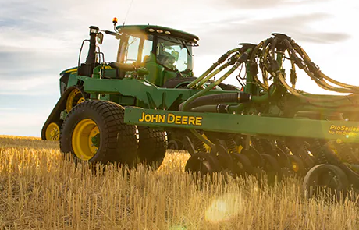
Source: (Jahanbakhshi et al., 2017)

Task1. Report

Information System of John Deere Company
John Deere mainly focuses on information system that helps to developing a routing of equipment and automatic control the technologies (Benes et al., 2014). The agriculture machinery helps John Deere to navigate the information, crop condition monitoring and fertilization to increase the productivity of farms. The farm equipment is mainly based on multipurpose and different data collection, process and displaying data to manage the desirable information (Dewnarain et al., 2019). To solve business problem, John Deere help to develop innovate information system for agriculture purpose to become successful in a competitive market. The Company may implement software and data structure to store wide data range for future growth and success. At John Deere, it mainly focuses on agricultural machinery information system that allows performing data operations and analysis activities (Jahanbakhshi et al., 2017). With the help of smart technology, John Deere must store information about manufacturing into unified data format that allows perform different kinds of operations.

Source: (Ma et al., 2021)
The processed data must be stored by John Deere into configured database for future evidence (Benes et al., 2014). The agriculture machinery information system is intended to used farms machinery and equipments to improve the productivity of farmers. This IT is unique to develop an ability to receive, convert the data and analyze the data for future results (Hu et al., 2020). John Deere may implement sensor in their tractors to collects relevant information regarding production cost, fertilizer and pesticides. John Deere plays an essential role in developing a precision of agriculture that helping to exchange and stored information through sensor, processor, and software package. Agriculture Machinery Information System has a capable to comply with regulation and agriculture production standards to ensure the food safety and security (Jahanbakhshi et al., 2017).
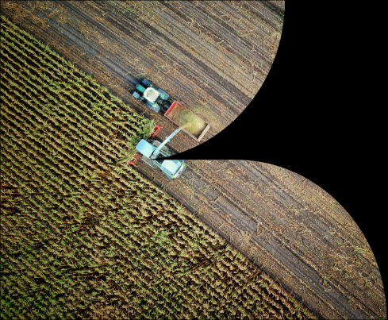
Source: (Benes et al., 2014)
With this help of this information system, John Deere must compile with statistic and history of actions, estimated the yields, estimate cost, and efficiency of farm activities for future growth and development (Vuran et al., 2018). This machinery helps to maintain a strong relationship with farm equipment and surrounding through formulation of information flows. The Company main objective to understand the soft-system and activities of tractor operator and farm manager perform the activities effectively (Ma et al., 2021). The Company manufactures agriculture equipments such as tractors, combines, mowers, and balers for smooth running of farm activities. Farm Manager used sensor on machinery to keep monitoring on farm activities and gain a competitive edge.
John Deere implements a sensor network that provides important kind of data to farmer such as machinery information and agronomic information to improve the production of farms. Both data must be displayed on operator cab or send to mobile as well as computer system to manage the operation effectively (Jayashankar et al., 2018). With the help of machinery technology, farmer can execute and take right decision regarding farm. Fluid level is measured through float sensor and measure the effectiveness of float movement at the farm. This machinery also help farmer to identify any pre-failure indication.
John Deere must understand the power level of machinery to meet the customer needs and demand. Monitoring machinery information is very crucial for farmers and also maintains relevant information about economical crisis (Vuran et al., 2018). For instance, with corn crop farmer require a two week window to getting a planning to want a successful crops. This machinery also helps to know estimate about farm output and profitability of farmer. Furthermore, agronomic data mainly includes yield and soil information to measure the mass flow of grains (Hu et al., 2020). Through sensor, John Deere must collect information about moisture. It also helps to measure the temperature, direction, soil temperature, solar radiation and rain to improve the productivity of the farms (Chatterjee et al., 2020).
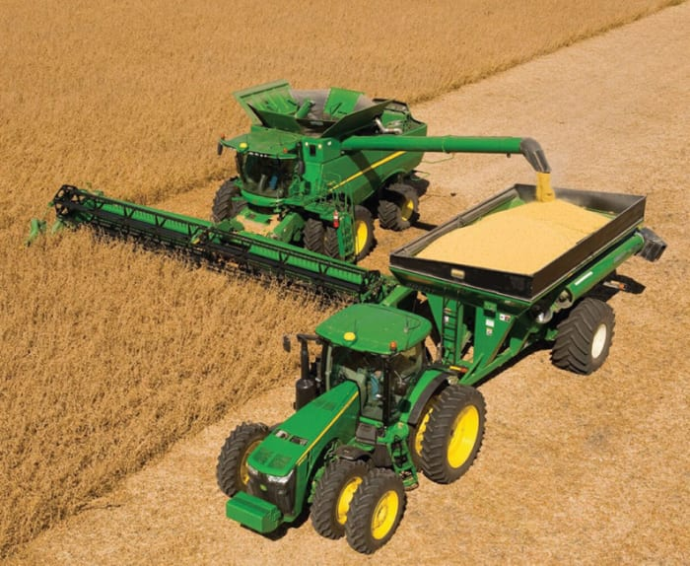
Source: (Vuran et al., 2018)
John Deere mainly focuses on server and modem to transmit the wireless radio waves at monitoring stations (Ma et al., 2021). Farmer can get data to a machine runs outs through GPS to take a right decision. The operational status helps to checked data of full-field information to decide the cost and profitability (Jayashankar et al., 2018).

Customer Relationship Management System
Customer relationship management is a system that helps business to maintain strong relationship with clients as well as farmers (Chatterjee et al., 2020). A CRM system helps John Deere to deal with efficiency of farms, time management, and impress customer to deal with business operation. CRM system is powerful software for John Deere to improve the customer services as well as experiences. At John Deere, professionals share information collects through sensor about farm with their farmer that helps to take a right decision. John Deere mainly focus on customer wants to develop machinery with latest technology that improve productivity of farmers. In this way, John Deere has maintained strong relationship with farmer CRM system helps John Deere to increase sales and profit of the firm (Jayashankar et al., 2018).
CRM platform is connecting with customer through tracking the information of farms with their equipment and machinery. This system helps John Deere to manage the desired information and focus on customer satisfaction (Hu et al., 2020). The Company may use multi-communication channel such as social media, phones, and emails to maintain close relationship with farmers. Through CRM system, John Deere must control over inventory management system and product line to improve the customer experiences. Therefore, John Deere focus on CRM system focuses on financial services to meet the customer needs (Gil et al., 2020). John Deere is responsible to bring equipment and machinery such as tractor, cultivator, steel plows, and cotton planter to gain a customer attention.
CRM system mainly tracks the information and guides them to deal with farm activities effectively. Through CRM software, all customer information sends to John Deere Company to deal for future growth and development. John Deere feel motivated with farmer to begin use of tractor and agriculture equipment to improve the customer experiences (Jayashankar et al., 2018). At John Deere, Manager maintain B2C customer life cycle and they direct resolve the customer problem within less time. CRM system help John Deere with different features such as management, sending instant message, marketing, and B2Cs reach their potential customer easily (Gil et al., 2020). The advantage of customer relationship management system at John Deere is discussed as under:
- Improve Customer Services: Through CRM system, John Deere gathering information to identify the purchasing habits of customers and their preference. CRM system help John Deere to closer understand the needs and wants of customers. With the help of this software, Customer relationship department of John Deere gathering information about customer and meet their needs on time (Chatterjee et al., 2020).
- Reduce Operational Cost: With CRM system, John Deere collects all relevant data for reducing the extra cost with increase the performance of farmers (Guerola et al., 2021). If the CRM system data has been lacking John Deere has facility of backup to recover the customer data for future growth. This system also helps to reduce paperwork, missing flies, and time of manager.
- Marketing and Targeting: Through CRM system, John Deere different kinds of data to target desired customer with the marketing techniques to attract customer (Gil et al., 2020). Sales department collect data from CRM manager to offer service and new machinery to farmer to improve their farming experiences. This system will assist strategically and creativity to meet the customer demand.
- Faster Conversion Rates: At present, customers require to collect information about the company and their product quality (Dewnarain et al., 2019). Through CRM system, John Deere helps farmers to contact with customer to increase sales and profitability.
Challenges of Customer Relationship Management System
- Customer bad Experiences reduce customer loyalty: If employees do not effective deal with CRM system, it decreases flexibility in dealing with customer problems (Dewnarain et al., 2019). Employee becomes helpless when customer ask question and they are not capable to resolve it. So, the customer experiences may become stress, frustrated and take business to its competitors.
- Security Problem: A CRM system is secure, but all customer data are available at a centralized that is threat for smooth running of operations (Guerola et al., 2021). Hacker may exploit the customer information for their illegal purpose.
- Training and development: For effective functioning, John Deere offer training and development program to their staff member to deal with proper functioning of business operations (Gil et al., 2020). Through CRM, John Deere manager may learn and acquire information to understand the customer issues.
- Cost of Implementation: At John Deere, employee may find issues of their employees with CRM system and find out the mistakes (Dewnarain et al., 2019). This CRM system expensive and distract the manpower to perform their task.

Porter Five Forces Model for IS/IT Sector
This model is applied by John Deere to analyze the competitiveness and attractiveness in a competitive market. Information technology sector helps to upgrade with competitors deal in electronic product for farming purpose (Dewnarain et al., 2019). John Deere can use information technology to collects larges data about the corps, harvester and quality standard of crops. In IT Sector, John Deere gain knowledge about pricing structure, seeds and fertilizers to gain a customer attention. Porter five force model helps John Deere with implementation of IS/IT sector discuss as under:
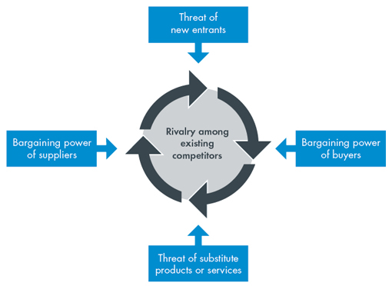
Source: (Guerola et al., 2021)
Competitive Rivalry (High): In this factor, there is a threat of existing rivalries of companies deal in IS/IT sector. There are too many companies without much product differentiation, existing monopoly and lack of core abilities to expand the business in this sector (Adelakun, 2020). Kubota, AGCO and CNH sector are main competitors of agriculture machinery to gain a customer attention. The Company mainly focuses on IT sector to control over inventory and logistics system. Technological companies are aggressive in the rate of innovation and marketing campaign (Gulia, and Chahal, 2020). John Deere must innovate its machinery and tractor to survive in a competitive market.
Threat of Substitute (High): In the competitive IT sector, there are many substitutes available for farmer to reduce the market share. Manual mechanical process is a major substitute that directly impact on John Deere. The Competitors may increase advanced technology to reduce the available of substitute (Shah et al., 2020). John Deere may use IT system to develop new machinery to meet the demand of farmers. John Deere mainly focuses on latest technology and delivers system to gain a customer attention.
Bargain Power Buyer (Low): At present, Buyer becomes more demanding for latest technology and software to improve their farming activities. John Deere has maintained strong presence in the global marketplace (Adelakun, 2020). Therefore, customers have less control over pricing strategy. In the competitive market, John Deere develops their agriculture equipment with latest technology to gain a customer attention. The Company may operate in IT sector to expand the agriculture activities and farming productivity to improve the customer experiences. Therefore, John Deere focuses on new IT system to improve the customer loyalty. In this ways, the Company becomes capable to target low-income customer effectively.
Bargain Power Supplier (Low): All the suppliers to manufacture a company product or deliver service to customer effectively. Supplier of IT sector can charge higher cost that increase the price of the product and impact on buying power of customers (Shah et al., 2020). The Company may focus on IT system to access the weather and adopt latest farming to gain a competitive advantage. Therefore, IT sector may help John Deere to reduce the operational price and improve customer experiences. Powerful suppliers in this field have a negotiating power to extract a higher cost from the firm (Gulia, and Chahal, 2020). Supplier of John Deere has less control over operation because of strong brand value.
Threat of New Entrants (Low): Higher potential is require entering into IT sector and gaining a company’s portion of market. At IS/IT sector, John Deere has a less threat from new entrant due to strong customer base. In this way, the company mainly focuses on technology development and customer needs to become successful in the competitive market (Adelakun, 2020). The Company may use latest IT technology to provide direction to farmers regarding harvesting and other operations. John Deere may differentiate their agriculture machinery to gain customer attention. Due to different agriculture machinery, the threat of new entrant in this sector is low.

Big Data Analytics and Internet of Things

Impact of Big Data Analytics
Big data analytics helps companies to collects their information and use identify to explore new opportunity (Zerbino et al., 2018). At John Deere, Manager used different kind of sensor and software to collect relevant information about crop and monitor the farming capability. Manager of John Deere provide farmer regarding the rainfall, water cycles, fertilizer, and other that helps farmer to take right decision for future development. With smart technology, sensor plugged in tractors and trucks to collect information about real time data from ground (Gulia, and Chahal, 2020). Mobile farm manager helps farmer to discuss about plantation, and follow the ploughing.
Big data help John Deere tracking the performance of market and gain a customer attention. Big data analytics provide opportunities to target new customer and increase sales margin (Bruijl, 2018). Through this analytics, John Deere support local farmers in managing the operations of farms. Farms can easily collect data on their mobile and take right decision regarding production of particular crops. Furthermore, John Deere mainly focuses on data analytic to collects relevant information of farmers to examine the weather and soil condition. John Deere has developed their personal platform named “My Johndeere.com” that help farmer to collect information about harvesting methods. This also help John Deere to take right estimated about crop yielding and method. With the help of data analytics, John Deere must control the growing crop and monitor their performance of crops of different farms. Some benefits of data analytics are discuss as under:
- Enhance Work Efficiency: This analytics help John Deere to access large amount of data and display in proper manner to take right decision (Bruijl, 2018). John Deere Manager motivates employees and local farmers. This action helps John Deere to improve operational efficiency of staff members as well as farm productivity.
- Update with Customer Behavior and Attitude: At present, the customer has a wide range of alternative to manage their farming operations (Gulia, and Chahal, 2020). Due to technology development, customer has changed their attitude toward technological change. John Deere must update with latest technology to meet the customer needs and demand (Zerbino et al., 2018). Data analytics help John Deere to stay updated with customer needs and wants to attain the desired goals.
- Increase quality of product and services: Data analytics help John Deere to improve the farmer experiences with latest agriculture equipment and machinery. This system helps to automated data cleaning and improves the services of customer to gain a competitive advantage.
Disadvantages of Big Data Analytics
- Lack of Alignment with team: The Company has set of team member and analyzed the shared a set of executives to deal with data (Bruijl, 2018). Due to tough competition, John Deer faced difficulty to deal with team member effectively.
- Safety and Security Issues: In the competitive market, John Deere using privacy policy but also face problem in managing data of farms, crops and fake emails that impact on efficiency of crop (Zerbino et al., 2018). Therefore, data analytics is a main threat to business security and impact on brand image.
- Wide Amount of Data: The Company do not have skilled workforce to manage the large amount of data (Gulia, and Chahal, 2020). In this condition, John Deere may convey a wrong message and increase confusion among farmer about production.

Impact of Internet of Things
IoT mainly focus on smart farming to allow farmers to improve the productivity and performance of crop. IoT help John Deere to help farmer to monitor relevant information such as humidity, soil quality, through remote sensor and improve the yield crops (Bruijl, 2018). This technology may help John Deere to use massive data to take right decision on their farms. Through IoT, John Deere monitoring the performance is to improve the productivity and ensure food supply of crop. John Deere mainly focuses on machine learning, and robotic to improve the productivity of farm (Ahmed et al., 2021).
In the competitive market, John Deere mainly focuses on cloud solution and IoT sensor to track and explore growth opportunities. In this way, the company capable is to meet the customer expectation and increase sales margin (Gulia, and Chahal, 2020). Therefore, IoT helps John Deere that helps to enhance the equipment service to gain a customer attention. Through effective communication, John Deere use latest technology to manage the information of business effective and also help farmer to take a right decision. Agriculture IOT main aim to make sure the food safety at different level is to gain a customer attention. John Deere implements IOT sensor to monitor the moisture and acidity level of farms (Atitallah et al., 2020). Iot may improve the performance of workplace as well as soil productivity. Some advantage of IOT at John Deere is discussed as under:
- Reduce operating cost: This strategy help John Deere focus on optimize the business workflow and reduce operational cost (Zerbino et al., 2018). The Company must develop a smart system to monitor the performance of the firm and reduce operational cost.
- Improved Productivity: IoT helps John Deere to manage, monitor and alter employees to improve the performance of farmers and take right decision regarding the work (Atitallah et al., 2020). This technology helps John Deere to protect the information of farmer and improve their farmers.
- Speed: All information of John Deere mainly focus on complete of task with high speed (Bruijl, 2018). IoT makes easy to perform repetitive task and invest their time to gain a customer attention.

Disadvantages of IoT
- Data Breach: In the tough market, hacker may hack the information of relevant customer and their details for illegal activities. The hacker may collect banking details of customer from database of John Deere that impact on goodwill of the firm.
- Complexity: Though Iot, John Deere faced lots of complex operations and behind the business operations (Zerbino et al., 2018). It is difficult to deal with complex task during the IOT system and deal with uncertain condition.
- Connectivity: It is very important for John Deere to focus on internet connectivity to perform their function effectively. IOt may create difficulty for manager and farmer to understand the information.

Recommendation

During the global outbreak, John Deere may faced problem such as unavailability of employee, financial loss and difficult to manage the production units. At the competitive market, John Deere has knowledge and skills to access management system (Ahmed et al., 2021). At Covid-19, Government force to temporary shutdown the factories and follow strict regulation to manage the operations. In the pandemic, John Deere has admitted to reduction in income around 13%. Therefore, John Deere mainly focuses on strategies to gain knowledge to access the data effectively. To ensure knowledge management system, John Deere capabilities is to meet the needs of employee and improve their performance. Some strategies that help John Deere to gain a customer attention are discuss as under:
- Strong Channel: John Deere has knowledge to share with direct contact among people to become successful in a competitive market. Through strong network, John Deere should focus on shared knowledge to deal with contingency (Atitallah et al., 2020). Collaborating with communicates allows customer to learn new technology and events. During the pandemic, John Deere must organize an online session to collect feedback about latest technology and increase the operational efficiency of the firm.
- Motivate Staff Members: To get a desired result, John Deere may encourage their staff member through provide reward, incentive and recognition to increase the sales margin (Ahmed et al., 2021). The Company may set a long term goals and strategies to deal with contingency. Effective communication helps to measure the employee performance through sensor and software. Staff member get motivated help to reach the desired goal within estimated time.

Task2. Presentation

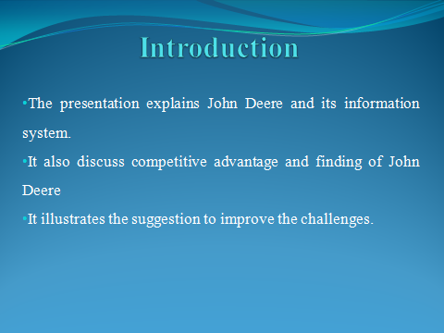
This presentation discusses the brief information on John Deere that is a manufacturing agriculture machinery and equipment to improve the farms productivity. It illustrates finding of John Deere to gain knowledge about system (Pedron et al., 2018). This presentation discusses the limitation and recommendation for John Deere.

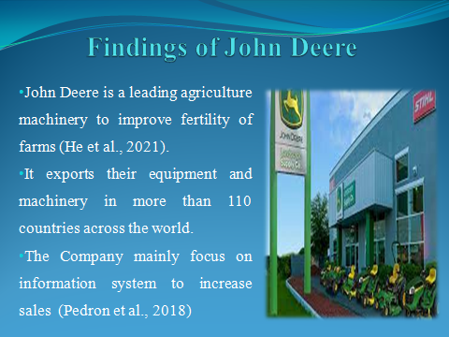
This slide mainly discuss about finding of John Deere to gain a customer attention. John Deere mainly focuses on agriculture machinery information system to collect relevant information regarding customer taste and behavior. John Deere supplies their machinery in more than 110 countries across the world (He et al., 2021). The Company has launched an online site to stay updated with latest software and sensor that help farmer to perform their operation effectively. John Deere must adopt a recycling method to reduce the operational mistakes and gain a customer attention (Lloyd, 2020). John Deere must focus on CRM system to improve the customer experiences.

This slide explains the limitation of John Deere that impact on business operations. During the global outbreak, Government has economical slowdown and temporary lockdown that impact on business operations (He et al., 2021). Furthermore, John Deere face problem from privacy and security issues that impact on business efficiency. Due to big data analytics, John Deere has faced problem of stealing of sensitive data about customers (Jahanbakhshi et al., 2017).
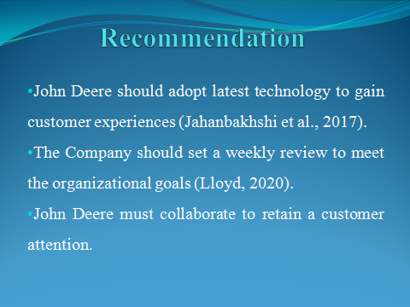
This slide explains the suggestion for John Deere to gain a customer attention. The Company mainly focuses on latest technology to reduce stress and authentication (He et al., 2021). Furthermore, John Deere should effective knowledge to stay updated trends and technology to improve the customer experiences.
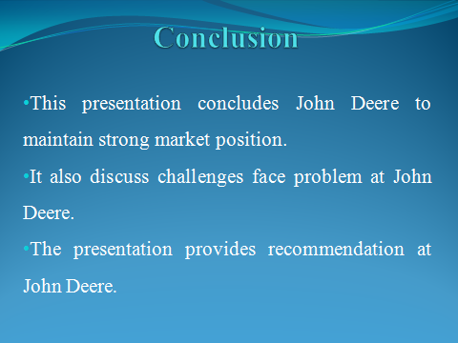
The presentation concludes about the John Deere to stay updated technology to gain a customer attention. It includes information about CRM, information technology and suggestion to improve customer experiences.
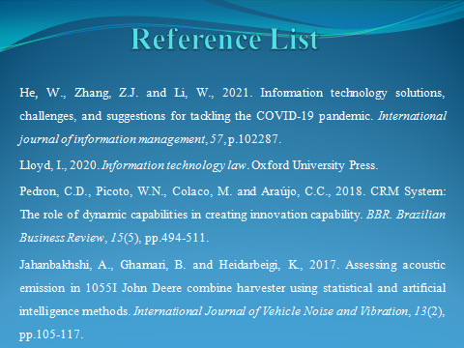

Conclusion
In conclusion, this report has evaluated information system to maintain strong position in the worldwide. The report has examined the customer relationship management system to maintain a strong relationship with customer at John Deere. It has discussed an internet of thing and big data to gain a customer attention. The report has explained challenges and advantages of technologies that impact on business performance. It applied a Porter five force model for John Deere to analyze the competitiveness.

Reference List
Adelakun, A., 2020. Should Porters Five Forces have value in Businesses today. Computing for Business (BSC) Aston University Birmingham.
Ahmed, I., Ahmad, M., Jeon, G. and Piccialli, F., 2021. A framework for pandemic prediction using big data analytics. Big Data Research, 25, p.100190.
Almeida, F. and Santos, J.D., 2020. Annex I–Porter Five Forces. (Almeida, and Santos, 2020)
Atitallah, S.B., Driss, M., Boulila, W. and Ghézala, H.B., 2020. Leveraging Deep Learning and IoT big data analytics to support the smart cities development: Review and future directions. Computer Science Review, 38, p.100303.
Benes, L., Novak, P., Masek, J. and Petrasek, S., 2014. John Deere combine harvesters fuel consumption and operation costs. Proceedings of the Engineering for Rural Development, Jelgava, Latvia, pp.29-30.
Bruijl, G.H.T., 2018. The relevance of Porter's five forces in today's innovative and changing business environment. Available at SSRN 3192207.
Chatterjee, S., Chaudhuri, R., Vrontis, D., Thrassou, A., Ghosh, S.K. and Chaudhuri, S., 2020. Social customer relationship management factors and business benefits. International Journal of Organizational Analysis.
Dewnarain, S., Ramkissoon, H. and Mavondo, F., 2019. Social customer relationship management: An integrated conceptual framework. Journal of Hospitality Marketing & Management, 28(2), pp.172-188.
Gil-Gomez, H., Guerola-Navarro, V., Oltra-Badenes, R. and Lozano-Quilis, J.A., 2020. Customer relationship management: digital transformation and sustainable business model innovation. Economic Research-Ekonomska Istraživanja, 33(1), pp.2733-2750.
Guerola-Navarro, V., Gil-Gomez, H., Oltra-Badenes, R. and Sendra-García, J., 2021. Customer relationship management and its impact on innovation: A literature review. Journal of Business Research, 129, pp.83-87.
Gulia, P. and Chahal, A., 2020. Big Data Analytics for IoT. International Journal of Advanced Research in Engineering and Technology (IJARET), 11(6).
Hu, X., Sun, L., Zhou, Y. and Ruan, J., 2020. Review of operational management in intelligent agriculture based on the Internet of Things. Frontiers of Engineering Management, pp.1-14.
Jahanbakhshi, A., Ghamari, B. and Heidarbeigi, K., 2017. Assessing acoustic emission in 1055I John Deere combine harvester using statistical and artificial intelligence methods. International Journal of Vehicle Noise and Vibration, 13(2), pp.105-117.
Jayashankar, P., Nilakanta, S., Johnston, W.J., Gill, P. and Burres, R., 2018. IoT adoption in agriculture: the role of trust, perceived value and risk. Journal of Business & Industrial Marketing.
Ma, L., Ikbal, M. and Cengiz, K., 2021. Realization of Agricultural Machinery Equipment Management Information System Based on Network. International Journal of Agricultural and Environmental Information Systems (IJAEIS), 12(3), pp.13-25.
Shah, D., Wang, J. and He, Q.P., 2020. Feature engineering in big data analytics for IoT-enabled smart manufacturing–comparison between deep learning and statistical learning. Computers & Chemical Engineering, 141, p.106970.
Vuran, M.C., Salam, A., Wong, R. and Irmak, S., 2018. Internet of underground things in precision agriculture: Architecture and technology aspects. Ad Hoc Networks, 81, pp.160-173.
Zerbino, P., Aloini, D., Dulmin, R. and Mininno, V., 2018. Big Data-enabled customer relationship management: A holistic approach. Information Processing & Management, 54(5), pp.818-846.

