
THE IMPACT OF EMPLOYEE ABSENTEEISM ON ORGANISATIONAL PERFORMANCE
In healthcare organisations – care homes

STUDENT NAME: ANDREEA EMILIA GRIGORAS
STUDENT ID: 1921553
NAME OF UNIVERSITY: UNIVERSITY OF WALES TRINITY SAINT DAVID (LONDON CAMPUS)

DECLARATION

I Andreea Emilia Grigoras, do hereby declare that this dissertation is my own work and it has not been submitted to any other University for a similar degree.

Andreea Emilia Grigoras

05/05/2023

Table of Contents
Chapter 1 - Introduction 4
1.1 Introduction 4
1.2 Aims, Objectives, Research Questions 4
1.3 Purpose, Rationale/Significance of the Research 4
1.4 Research limitations 5
Chapter 2 6
2.1 Literature review 6
2.2 Theories Related to absenteeism 6
2.2.1 Social Exchange Theory 7
2.2.2 Job Embeddedness Theory 7
2.2.3 Resource-based Theory 7
2.2.4 Social Learning Theory 7
2.2.5 Economic Theory 8
2.3 Theories related to motivation 8
2.4 Employee Motivational Factors 10
2.5 The influence of absenteeism on motivation 11
2.6 Employee motivational issues 11
2.7 Impact of Employee Absenteeism on Organisational Performance 12
2.8 Strategies for Reducing Employee Absence in Home Care 12
Chapter 3 13
3.1 Research Methodology 13
3.2 Data Collection and Data Analysis Tools/Techniques 13
3.3 The questionnaire as a Tool in Research 14
Chapter 4 15
4.1 Results 15
4.2 Discussion 22
Chapter 5 25
5.1 Conclusion 25
5.2 Recommendations 25
References 27
Appendix 30

Chapter 1 - Introduction
1.1 Introduction
Employee absenteeism is a typical occurrence and a critical human resource issue that impacts organisational performance in every organisation. Employee absenteeism can result in decreased care quality, increased expenditures, and decreased productivity in the home care industry. Absenteeism refers to the voluntary or involuntary absence of employees from their place of employment, which may be caused by a variety of factors. High absenteeism is a result of inadequate organisational policies, working environment, and management practises. Absenteeism has a detrimental impact on employee performance, productivity, and job satisfaction, and consequently on the performance of the organisation. Due to the importance of providing essential services, healthcare organisations are significantly affected by employee absenteeism (Kocakulah, Timothy Gordon Bryan and Lynch, 2018).
1.2 Aims, Objectives, Research Questions
Research aim
Healthcare businesses rely on their staff to provide patients with high-quality care, but employee absences can negatively affect the organisation's performance. The aim of this dissertation is to examine the impact of absenteeism on the organisational performance of healthcare organisations.
Research objectives:
- To determine the reasons o absenteeism
- To evaluate the effects of employee absenteeism on the organisational performance
- To assess the link between motivation and performance
- To develop a motivation strategy for the organisation in order to reduce staff absenteeism and maintain performance.
Research questions
The following research questions were formulated for the study:
- How does motivation relate to performance?
- How does absenteeism impact on motivation?
1.3 Purpose, Rationale/Significance of the Research
Research purpose
The purpose of this study is to evaluate the effect of employee absenteeism on organisational performance and to establish the link between motivation and performance.
Research significance
The significance of the research topic is an important one for a number of reasons. Absenteeism is a prevalent problem in healthcare organisations, affecting their productivity, expenses, and quality of care. In addition, excessive levels of absenteeism can result in decreasing staff morale and productivity, which can have a detrimental effect on the organisation's overall success. Therefore, it is crucial to comprehend the elements that contribute to employee absenteeism in home care settings and their effect on organisational performance. This research will assist home care organisations in identifying the causes of absenteeism and developing measures to reduce it. It will also provide insights into the relationship between absenteeism and organisational performance and how absenteeism can be managed effectively to improve organisational outcomes. The findings of this research will be valuable for both researchers and practitioners in the field of healthcare management, as well as for policymakers and regulators concerned with increasing the quality and efficiency of healthcare delivery.
1.4 Research limitations
A research study on the influence of employee absenteeism on organisational performance may be subject to a number of limitations. The study may discover a correlation between employee absenteeism and organisational performance, but it may be unable to demonstrate a cause-and-effect link. There may be more variables influencing organisational performance that were not taken into consideration in the study.
Generalizability: The study's applicability to other organisations may be restricted. The study may have been undertaken in a particular sector or setting, and the results may not be applicable to other industries or settings.
The study's conclusions may be constrained by the quality of the data obtained. If the data on employee absenteeism or organisational performance are insufficient or inaccurate, it could have an effect on the study's findings.
The data was acquired through questionnaires and is limited to 50 participants, the study may be hampered by self-report bias. Workers may hesitate to accurately disclose their absences or may exaggerate the reasons for their absences.
External influences: The study may be constrained by external factors that were not controlled for, such as changes in the economy, market conditions, or other events that may influence organisational performance.

Chapter 2
2.1 Literature review
Absenteeism is a significant contributor to the high cost of healthcare provision globally. According to Nijp et al. (2012), healthcare workers exhibit higher absenteeism rates compared to other occupations. Employee absenteeism has a negative influence on service delivery, which lowers patient satisfaction while increasing expenses owing to overtime work and decreasing productivity. In order to maintain employee performance and organisational performance, healthcare organisations must successfully control absence (Hardiki and Rashmi, 2019, p.584).
Absenteeism is a complicated problem, and several circumstances can contribute to its existence and occurrence. According to the literature on absenteeism, conditions like stress, illness, fatigue, job dissatisfaction, and personal problems are linked with absenteeism (Chen & Kao, 2012; Johns, 2011; Kuorinka et al., 2005). For healthcare organisations, absenteeism can have a substantial financial impact because it necessitates hiring temporary workers or paying overtime to substitute for absent employees. High absence rates can also affect productivity, increase mistakes, and decrease the standard of service (Halbesleben & Buckley, 2004; Pines & Keinan, 2005).
Absenteeism can have a remarkable impact on the quality of care provided to patients in healthcare organisations. Patients rely on healthcare workers to provide safe and effective care; however, when employees are absent, it can result in longer wait times and lower patient satisfaction (Han, 2016). According to studies, high absenteeism rates can result in reduced patient safety and increased medical errors (Deery, Walsh, & Guest, 2017; Stagg & Sheridan, 2010).
Employee motivation is the driving force that enhances employees’ performance and productivity. It is a crucial factor for organisational success because it determines the level of engagement and commitment of employees towards their work. Employees who are motivated contribute to a positive work environment, increased job satisfaction, improved job performance, and lower employee turnover (Bridger, 2018, p.8). However, organisations face a variety of challenges when it comes to motivating employees. This literature review also aims to highlight the causes and challenges of employee motivation.
2.2 Theories Related to absenteeism
In the course of the many years that have passed, a great number of studies and questionnaires have been carried out in order to determine the causes of absence. All of these theories of absenteeism make an effort to emphasise the significance of job and non-work elements in the phenomenon of absence. They show that direct incapacity is not the only factor that contributes to absenteeism in the workplace; other factors, in addition to these, contribute. According to the theories, there are two key characteristics that have a direct influence on attendance: incentive to show up to work and accessibility to the workplace. In turn, attendance motivation is significantly determined by a person's level of contentment with the circumstances of their current job as well as by a variety of internal and external demands to attend.
2.2.1 Social Exchange Theory
According to social exchange theory, employee absenteeism is the consequence of an employer-employee cost-benefit analysis. Employees are expected to be absent when the costs of attending work, such as stress, low pay, and lengthy hours, outweigh the benefits, such as job satisfaction and a supportive work environment. This theory proposes that organisations can reduce absenteeism by enhancing the benefits of work, such as by increasing pay and benefits and fostering a positive work environment (Tan, Zhang and Li, 2023).
2.2.2 Job Embeddedness Theory
Employee absenteeism is a consequence of an employee's attachment to their job, their organisation, and their community, according to the job embeddedness theory. When employees have a sense of obligation and commitment to their work, they are less likely to be missing from work (Mitchell et al., 2001). According to this theory, organisations can reduce absenteeism by fostering a sense of community among employees and providing opportunities for employee engagement and participation (Crossley et al., 2007).
2.2.3 Resource-based Theory
According to the resource-based theory, employee absenteeism is caused by a lack of time, energy, and skills. When employees lack the resources necessary to perform their duties, they are more likely to miss work. According to this theory, organisations can reduce absenteeism by providing employees with the resources they need to execute their jobs and by investing in employee training and development (Wright and McMahan, 2011).
2.2.4 Social Learning Theory
According to the social learning theory, employee absenteeism is a consequence of the employee observing the behaviour of others in the workplace. When employees observe others missing work without repercussions, they are more likely to miss work themselves. According to this theory, organisations can reduce absenteeism by fostering a culture of attendance and enforcing consequences for absenteeism (Stewart and Krivan, 2021, p.2)
2.2.5 Economic Theory
According to the theory, people only work to maintain a specific standard of living that depends on their level of financial success rather than out of a real desire to do so. Because instant rewards are necessary for a person to perform successfully, their absence will cause them to put in fewer hours and skip more days at work, which will raise absenteeism (Barmby and Treble, 2011). The need to work is seen from a traditionalist economic perspective as a commodity that competes with other options in the same market.
Because it primarily considers the economic viewpoint, this theory has the drawback of ignoring other factors that lead to absenteeism. But clearly, an employee's choice to attend work or not is driven by factors outside temporary or monetary benefits (Augustino, 2017).
2.3 Theories related to motivation
Workplaces take up a significant proportion of the lives of hundreds of millions of individuals worldwide. Most people are held accountable to authorities inside their work organisations, whether they work in offices, on agriculture, in stores or at petrol stations. Because motivation is widely acknowledged to be a significant antecedent of productivity, both researchers and leaders of the organisations worldwide gave great importance to strategies for motivating such individuals (Deci and Ryan, 2014).
Psychological needs have been one of the most prevalent concepts utilised in research on work motivation. To predict performance and/or job satisfaction, many psychologists have used questionnaires, projective measures, or implicit measures to assess needs. In the tradition of Murray's (1938) personality theory, much of this research has evaluated the intensity of specific needs. Specifically, a significant portion of the research consisted of evaluating the intensity of an individual's need for an emotional state or experience, such as authority, acquisitiveness, or accomplishment, and then employing that value to forecast the individual's behaviours that were anticipated to contribute to those experiences. For instance, need intensity was viewed as a person's differential variable that arose from development and was regarded as a significant predictor of behaviour. Individuals' levels of need strength were assumed to be reflective of their desires, with a higher level of desire for a given general outcome (such as belonging or success) implying a higher level of effort towards that outcome. The study of psychological wants has been explored from a number of different angles, one of which focuses not on the intensity of needs but rather on the degree to which needs that have developed through time and are universal have been satiated as opposed to unfulfilled.
The Self-Determination Theory (SDT) is a motivational theory that has received a lot of attention and is rather thorough. This theory considers psychological needs as fundamental psychological nutrients. As a result, they need to be fulfilled so that they may continue to deliver high-quality work and maintain their psychological health; to the extent that they are not satisfied, there will be adverse effects. According to this theory, competence, autonomy, and relatedness are the three fundamental psychological needs that humans have and are hardwired into their brains rather than acquired via experience (Deci and Ryan, 2014).
Maslow proposed a psychological theory to explain the factors that influence human conduct. According to Maslow’s theory, humans are driven by a hierarchy of needs, with the most basic need being the driving force behind their actions. To illustrate this point, he developed a hierarchical structure of needs, beginning with physiological requirements, then moving on to needs relating to feelings of security, affection, and self-esteem, and finally concluding with requirements for self-actualization. Physiological needs are the most basic survival needs, such as food, water, shelter, and air, followed by security. Individuals require safety and security when their physiological demands are addressed, such as protection from physical injury, financial stability, and a stable environment. Once these needs are addressed, individuals crave social connection and a sense of belonging. Connections with family, friends, and the community are all part of this. Esteem demands refer to the need for others' respect and recognition, as well as the need for self-esteem, self-confidence, and a sense of achievement. Self-actualization needs, the highest level of the hierarchy, refers to the desire for personal progress and fulfilment, which includes reaching one's full potential, creativity, and self-expression. According to Maslow, in order for a person to advance to higher levels of need, they first have to satisfy the wants at lower levels. After an individual satisfies one need, that need is no longer a driving force in their behaviour, and they move on up the hierarchy to meet the needs of the following level. Self-actualization, or the process by which an individual realises his or her potential and finds meaning in one's life, is the pinnacle of a successful existence (Stoyanov, 2017, p.10).
Many organisational psychologists believe that higher-order needs motivate people in the US, Canada, and Western Europe because lower-order needs are usually met. McGregor (1960), in Theory Y Management, made this argument early on. He claimed that since most individuals have met their lower-order needs, their higher-order demands are more relevant in the workplace. He recommended that managers should focus on intrinsic motivators connected to higher-order demands since individuals are compelled to aspire, accomplish, and master their circumstances (Deci and Ryan, 2014).
Motivation and performance are strongly linked in the sense that motivation can have a substantial effect on an individual's performance. Motivation refers to the drive, energy, or excitement that drives an individual to take steps towards the accomplishment of a goal or purpose. When a person is highly motivated, they are more likely to exert greater effort, maintain better concentration, and persevere in the face of obstacles, which can result in enhanced performance. On the contrary, a lack of motivation can lead to decreased performance because individuals may be less engaged, less dedicated, and less inclined to exert the work required to attain their goals (Deci, 2018, pp. 182-195). Motivated people usually achieve more than unmotivated people because they are more focused, devoted, and driven to attain their goals. In conclusion, motivation can have a substantial favourable impact on performance.
2.4 Employee Motivational Factors
Using factor analyses, Kasser and Ryan's research determined that people's life objectives or desires typically fall into at least two broad categories: extrinsic aspirations, which include accumulating wealth, becoming famous, and presenting an appealing and popular image; and intrinsic aspirations, which include developing personally, forming meaningful relationships, and contributing to one's community. This distinction between intrinsic and extrinsic aspiration held constant across 15 cultures, according to a team of researchers (Deci and Ryan, 2014).
Motivators that are intrinsic: Intrinsic motivators are the internal factors that motivate employees to do their jobs. These elements are as follows: autonomy means workers who have control over their work schedules and task assignments are more likely to be productive, mastery refers to employees who are challenged and given opportunities to improve their skills and knowledge are more likely to be motivated at work, purpose associates as employees who believe that their work is meaningful and contributes to a larger goal are expected to stay at their job.
External factors that influence employee motivation are known as extrinsic motivators. These elements are as follows: pay and benefits such as competitive pay, benefits, and rewards encourage employees to work harder, employees who are recognised for their efforts are more motivated to work, career advancement and development implies employees who see opportunities for advancement and development within the organisation are more motivated to work.
Employee absences can negatively affect an organisation's performance in a number of ways, such as decreased productivity when employee absences result in unfinished work and productivity gaps that must be replaced by other staff members, especially in critical departments. This has the effect of lowering productivity levels, which may therefore result in lower output, and lower efficiency. Added costs is when employees miss work and are unable to provide services, the organisation may incur additional fees to temporarily replace them with contract or temporary workers, which will increase labour costs. Costs associated with hiring additional personnel, paying overtime to current workers, and dealing with lost productivity can all rise. Another significant result is poor morale, when one employee is away frequently and in an unpredictable manner, it can have a substantial adverse impact on the morale and job satisfaction of other employees who feel they are taking over. Resentment, poor engagement, and a lack of drive can result from this, which can lower productivity, increase staff turnover, and impair organisational commitment. Lower employee engagement is when employees who regularly miss work may not be fully committed to their jobs, which results in lower engagement to the organisation as a whole. Employee turnover and lower staff retention may arise from this. In addition, poor service to customers can negatively impact an organisation performance. If customer service representatives are frequently missing, it may result in poor service, lengthy client wait times, and other problems that could damage the company's reputation. In conclusion, persistent employee absenteeism might have a negative impact on a company's ability to succeed. In order to secure the best results in terms of productivity, cost effectiveness, employee engagement, and customer satisfaction, organisations must take proactive measures to prevent absenteeism and encourage dedicated attendance (Kocakulah, Timothy Gordon Bryan and Lynch, 2018).
2.5 The influence of absenteeism on motivation
An individual’s level of motivation can be defined as the force that propels them to take action in pursuit of a desired outcome. Motivated people are more likely to work more, pay attention more carefully, and keep going even when things go tough. But the opposite is true; when people are not inspired to work towards their goals, they may be less productive than they otherwise would be. Those who are inspired to take action are more likely to succeed than those who aren't as enthusiastic about their endeavours (Latham, 2016).
When employees miss work, it affects how engaged they are with their work. When they return, they could struggle to get back into the swing of things since they might feel less a part of their employment and it can result in less work engagement. Regular absences can harm a team's spirit. Employee resentment can affect the team's morale when they are forced to cover for absent teammates resulting in a decrease in morale. Moreover, individuals who are regularly absent can miss out on crucial occasions or initiatives, which would lower their level of job satisfaction. Another result could be increased stress and frequent absences can, in some circumstances, create stress for both the absent employee and their co-workers who may need to cover for them at work. In addition, work may not get done while employees are absent, which has a negative effect on overall productivity. Team members may become frustrated and demotivated as a result of this having a negative influence on productivity (Rhoades and Eisenberger, 2002, p.700).
2.6 Employee motivational issues
When it comes to motivating employees, organisations frequently face a number of challenges. Among these difficulties are communication - employee demotivation can be caused by poor communication between employees and management, limited resources – a lack of resources can impair an organisation's ability to provide incentives and rewards to employees, resulting in demotivation. Burnout is another challenge faced by the organisation as well as a negative work culture which can have an impact on employee motivation. Moreover, employees who do not receive recognition for their efforts may become demotivated.
2.7 Impact of Employee Absenteeism on Organisational Performance
High levels of employee absenteeism lead to decreased productivity, revenue loss, and a decline in the quality of care. The absence of medical staff in healthcare settings can have an impact on patient outcomes, resulting in medical errors, increased length of hospital-stay, and increased mortality rates (Chang et al., 2018). Absenteeism costs an organisation money in many ways, from the direct cost of sick leave to the indirect cost of replacing absent employees or paying for overtime hours (Kabene et al., 2006).
Employee absenteeism has a significant adverse impact on organisational performance in home cares. First, absenteeism increases costs due to lost productivity, overtime pay, and hiring temporary workers to fill vacancies (Zhuang et al., 2014). Second, absenteeism has an impact on care quality because it disrupts continuity of care and reduces the number of available carers, resulting in longer patient wait times (Kessler et al., 2013). Third, absenteeism has an impact on employee morale and productivity because it increases the workload for the remaining staff while decreasing motivation and job satisfaction (Garcia-Sierra et al., 2017).
Several factors influence employee absenteeism in home cares, including job dissatisfaction, stress, illness, and burnout. Studies show that workers who are dissatisfied with their jobs are expected to miss work (Garcia-Sierra et al., 2017). In addition, stress, illness, and burnout are predictors of absenteeism in home cares (Schmalenberg et al., 2015).
2.8 Strategies for Reducing Employee Absence in Home Care
Absence management programmes can help organisations mitigate the negative effects of absenteeism on performance. For example, these programmes can boost employee morale, reduce absenteeism, and improve productivity (Nijp et al., 2012). Implementing effective absence management programmes also improves organisational efficiency by ensuring service continuity and minimising service disruption. Healthcare organisations can improve patient outcomes, reduce healthcare-associated infections, lower healthcare costs, and increase staff retention by reducing absenteeism (Chang et al., 2018).
To reduce employee absenteeism, home cares can use a variety of strategies. These include offering a positive work environment, employee support programmes, flexible scheduling, and adequate sick leave and holiday time (Schmalenberg et al., 2015). Furthermore, management can put in place attendance policies that reward good attendance and address absenteeism through counselling and disciplinary measures (Zhuang et al., 2014).

Chapter 3
3.1 Research Methodology
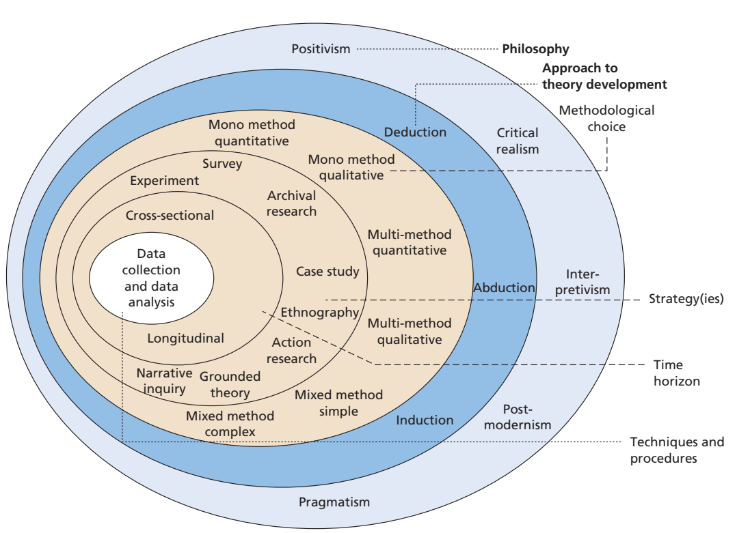

The research was conducted using a quantitative research design, and data was collected from healthcare organisations using a questionnaire.
Type of Research
The descriptive research method is used in this study. The data was gathered using both primary and secondary sources.

3.2 Data Collection and Data Analysis Tools/Techniques
Data collection – the data was collected from 50 employees at Acorn Court care home. Respondents were chosen by using simple random sampling.
Primary Data
The structured questionnaire method was used to collect primary data. The questionnaire comprised of ten questions. Participants were given 30 minutes to anonymously complete the survey, and 56 employees responded. Due to incomplete questionnaires, only 50 responses were used for the final result and analysis.
Secondary Data
Secondary data on employee absenteeism was gathered by consulting numerous online websites, journals, publications, and so on.

Data analysis tools/techniques
Data analysis is a critical step in the research process, involving the organisation, cleansing, transformation, and interpretation of data collected from primary and secondary sources. It is a crucial phase in the research onion, a conceptual framework that depicts the various stages of research, from the broad research philosophy to the specific data analysis. Saunders et al. (2019) created the research onion, which is extensively used in research methodology to guide researchers through the research process.
Moreover, data analysis is a major step in the research process because it enables the researcher to make sense of the collected data and form conclusions based on the findings. Depending on the nature of the research queries and data collected, various methods of data analysis are available, including qualitative, quantitative, and mixed methods.
Before analysis the dataset was inspected for missing data. The data was then analysed using statistical software SPSS. The findings were presented in a variety of formats, including tables, graphs, and pie charts, so that the reader could readily comprehend them. Consequently, it was straightforward to draw conclusions and make suggestions.

3.3 The questionnaire as a Tool in Research
In research and survey research, questionnaires are a common method of collecting data. They can be conducted in various ways, including as online, via mail, or in person, and are used to swiftly and effectively gather data from a big number of people.
Because they provide a standardised method of data collection that makes result comparison and analysis simple, questionnaires are frequently used. Depending on the questions answered, they can be used to collect both quantitative and qualitative data.

Chapter 4
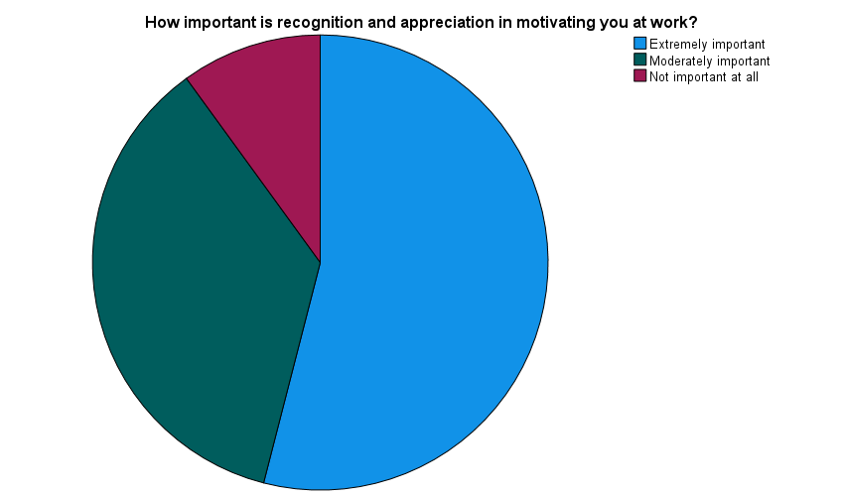
4.1 Results
Figure 1
How important is recognition and appreciation in motivating you at work?
 | N | %
Extremely important | 27 | 54.0%
Moderately important | 18 | 36.0%
Not important at all | 5 | 10.0%
Table 1 Table showing the importance of recognition and appreciation

From the above figure, it is inferred that 54% employee who participated in the survey mentioned that recognition and appreciation is extremely important at work and 36% of employee think that recognition at work is moderately important while 10% employee believe that it is not important at all.
What motivates you more, financial rewards or non-financial rewards?
 | N | %
Financial rewards | 26 | 52.0%
Non-financial rewards | 24 | 48.0%
Table 2 Table showing
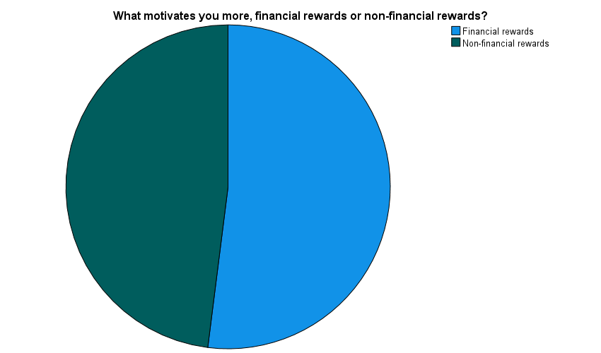
Figure 2
According to the figure, out of the total respondents, 52% think that financial rewards are more motivating, while 48% believe that non-financial rewards act as a motivational factor.
Do you have all the necessary tools and resources to do your job well?
 | N | %
Yes | 44 | 88.0%
No | 6 | 12.0%
Table 3: Table showing

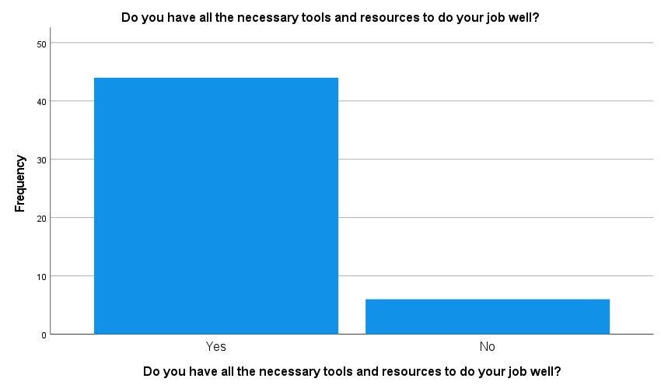
Figure 3 showing the availability of resources at workplace

From the above figure, it is inferred that the majority of the employee, 88%, who participated in the survey mentioned that they have all the necessary tools and resources to do the job well, whereas 12% do not have all the necessary tools.
How likely are you to recommend this company as a place to work?
 | N | %
Most likely | 26 | 52.0%
Cannot say | 15 | 30.0%
Not at all likely | 9 | 18.0%
Table 4: Table showing

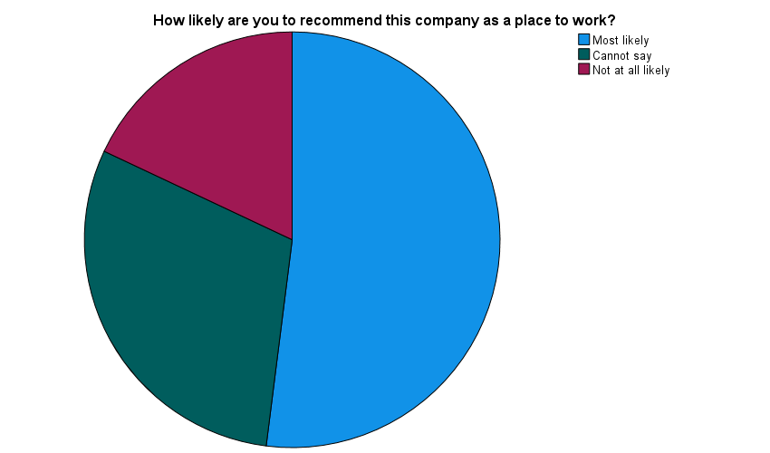
Figure 4 Pie chart showing the likelihood of recommending the company

The above figure shows that 52% of the respondents are likely to recommend the company as a place to work, whereas 30% cannot say and 18% do not recommend it.
How valued do you feel at work?
 | N | %
Not valued at all | 4 | 8.0%
Slightly valued | 17 | 34.0%
Moderately valued | 17 | 34.0%
Extremely valued | 12 | 24.0%
Table 5: Table showing

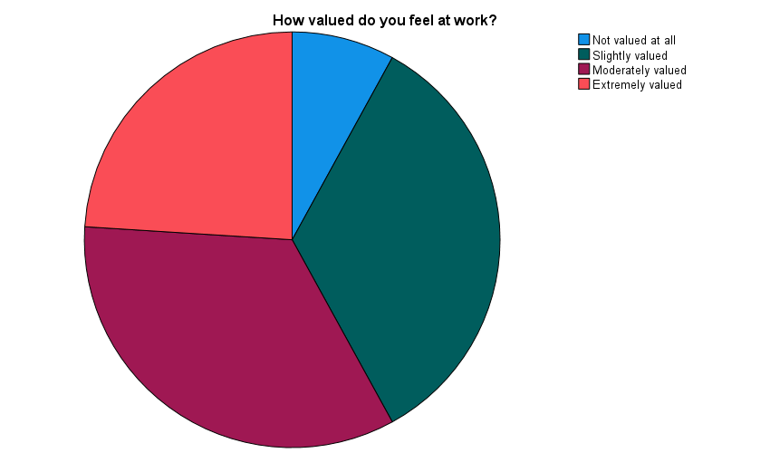
Figure 5 Pie chart showing how valued employees feel at work
From the above figure, it shows that 24% of respondents feel extremely valued at work, whereas 34% feel moderately valued, 34% feel slightly valued and 8% feel that they are nor valued at all.
What are some of the factors that contribute to your job satisfaction? Choose two answers
 | N | %
Job security / Organisational values | 6 | 12.0%
Opportunities for advancement / Autonomy and control | 7 | 14.0%
Opportunities for advancement / Job security | 7 | 14.0%
Opportunities for advancement / Organisational values | 2 | 4.0%
Salary and benefits / Autonomy and control | 5 | 10.0%
Salary and benefits / Work-life balance | 23 | 46.0%
Table 6: Table showing
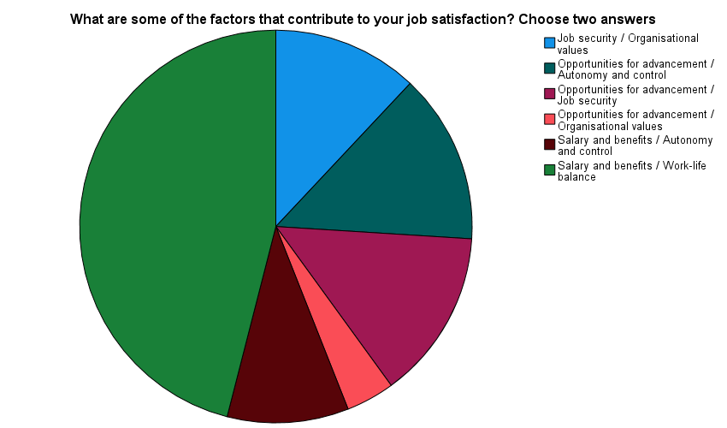
Figure 6 showing the percentage of the factors that contribute to job satisfaction

From the above pie chart and table, it translates that 12% of respondents think that some of the components that contribute to their job satisfaction are job security and organisational values, whereas 14% think that opportunities for advancement and autonomy and control act as factors that contribute to job satisfaction, 14% agree that opportunities for advancement and job security contribute to their job satisfaction. 4% state that opportunities for advancement along with organisational values are factors for job satisfaction and 10% agree for salary benefits and autonomy and control. The vast majority of the respondents, 46%, chose as contributing factors salary and benefits, and work-life balance.
Do you feel that you have opportunities for career growth and development in your current role?
 | N | %
Yes | 28 | 56.0%
No | 22 | 44.0%
Table 7: Table showing
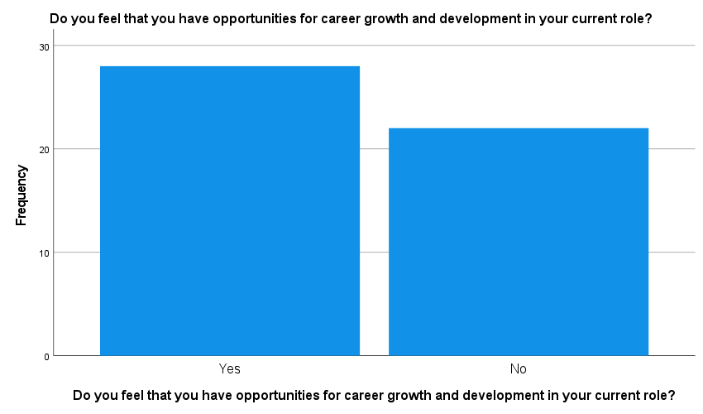
Figure 7 representing the opportunities for career growth and development
From the above figure, it shows that 56% of employees have opportunities for career growth and development in their current role and 44% do not have opportunities for career growth.
Are performance bonuses effective in motivating employees to attend work consistently?
 | N | %
Yes | 22 | 44.0%
Unsure | 10 | 20.0%
No | 18 | 36.0%
Table 8: Table showing
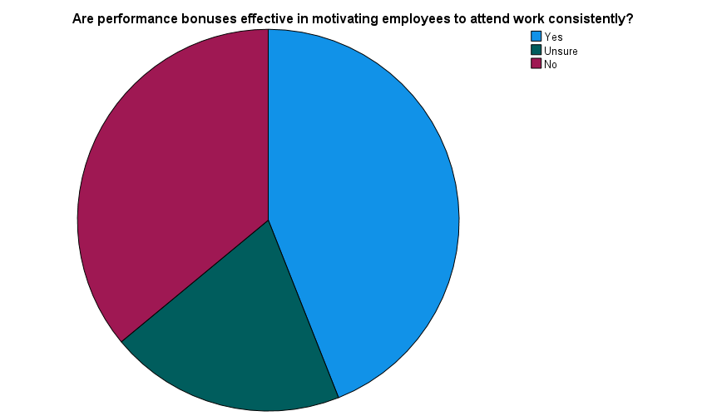
Figure 8
From the above figure, it interprets that 44% of respondents think that performance bonuses are effective in motivating employees to attend work consistently, whereas 20% are unsure and 36% answered no.
Is there a correlation between employee burnout and absenteeism?
 | N | %
Yes | 28 | 56.0%
Unsure | 5 | 10.0%
No | 17 | 34.0%
Table 9: Table showing
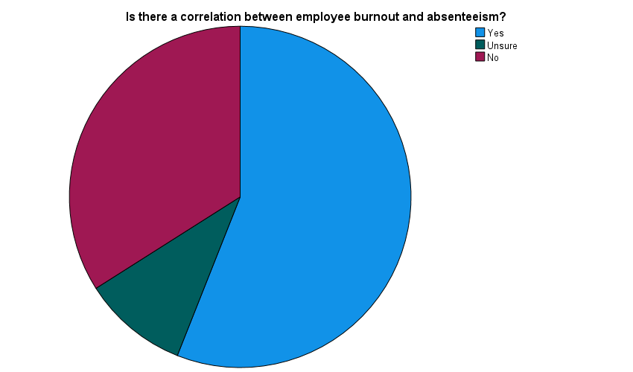
Figure 9
From the above figure, it shows that from the total respondents, 56% consider that there is a correlation between employee burnout and absenteeism, whereas 10% are unsure and 34% disagree.
Have you noticed any changes in team morale or motivation when employees are absent?
 | N | %
Yes | 29 | 58.0%
No | 21 | 42.0%
Table 10: Table showing
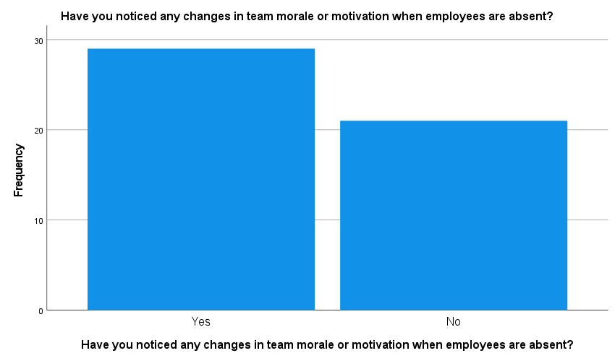
Figure 10
From the above figure, it shows that 58% of employees noticed a change in team morale or motivation when other employees are absent and 42% of respondents have not noticed any change.

4.2 Discussion
• The majority of employees appreciate and consider appreciation and recognition at work to be an important influence in their job satisfaction and motivation. However, a sizable proportion of employees do not value recognition and appreciation, and it is critical for employers to understand and address the reasons for this in order to foster a positive work environment that meets the needs and expectations of all employees.
• Employees favour money and non-financial rewards as motivators in about similar proportions. While financial benefits, like as pay increases or bonuses, are significant to many employees, non-monetary rewards, such as flexible work arrangements, recognition, and opportunities for professional growth, may be more motivating to others. Employers must consider these facts when developing their reward and recognition programmes to ensure that they fulfil the various requirements and expectations of their employees. A well-balanced rewards programme that incorporates both monetary and non-monetary incentives can assist to encourage and engage staff, resulting in higher productivity and job satisfaction.
• The majority of workers are satisfied with the resources and tools provided by their employer for effective job performance. Nonetheless, it is essential to address the concerns of the 12% of workers who lack all the necessary tools to execute their jobs effectively. Employers should routinely assess the requirements of their workforce and ensure that all employees have access to the resources and tools necessary for success in their positions. Providing employees with the necessary resources can aid in enhancing their productivity, job satisfaction, and retention.
• The majority of respondents have a favourable opinion of the company as an employer, and more than half would recommend it to others. However, a sizeable percentage of respondents (30%) either do not have an opinion or are uncertain as to whether they would recommend the company. This may indicate a lack of engagement or a need for the company to improve its communication and transparency. In addition, the fact that 18% of respondents would not recommend the company suggests that there may be substantial problems with the work environment or company culture that need to be addressed. Employers should investigate the reasons for these negative responses and take this feedback seriously. Taking care of these issues can enhance the company's reputation as an employer and boost employee satisfaction and retention.
• Regarding the extent to which they feel valued at work, employees have varying experiences. Despite the fact that 24% of respondents feel exceedingly valued, 42% of respondents feel only slightly or not at all valued. Employers should take note of these findings and implement measures to ensure that all employees feel appreciated and valued.
Providing opportunities for recognition, feedback, and career development can increase employee engagement and sense of worth at work. Employers must also ensure that employees comprehend their role within the organisation and that their contributions are acknowledged. These issues can be addressed to enhance employee morale, motivation, and retention.
• There are numerous elements that contribute to employee job satisfaction, and the relative importance of these factors may vary depending on the preferences and circumstances of the individual. In addition to salary and benefits, other factors such as opportunities for advancement, job security, and work-life balance are significant to a significant proportion of respondents.
Employers should pay close attention to these findings and take steps to ensure they are meeting the requirements and expectations of their employees in these areas. The provision of opportunities for career development and advancement, the provision of competitive compensation and benefits packages, and the promotion of a healthy work-life balance can improve employee satisfaction, motivation, and retention.
• Despite the fact that the majority of employees have opportunities for career advancement and development in their current positions, a significant proportion of employees (44%) do not. This may result in a lack of motivation and engagement on the part of these employees, who may perceive their career opportunities to be limited.
Employers should consider methods to provide more opportunities for career growth and development to their employees in light of these findings. This may involve providing training and development programmes, mentoring and coaching, as well as opportunities to assume new responsibilities or positions within the organisation. Providing clear career paths and promoting from within can also help retain talented employees and foster a growth-oriented culture.
• Respondents are divided on the effectiveness of performance bonuses in motivating employees to show up for work on a regular basis. While a considerable proportion of respondents (44%) believe that performance bonuses are effective, a sizable proportion (36%) believe that they are not.
Employers could consider additional strategies to drive employees to come to work on a consistent basis, such as creating a positive work environment, giving chances for career advancement and development, and recognising employees for their achievements and efforts. While performance bonuses may work well for some employees, they may not be the best or most appropriate incentive for all employees or in all scenarios. Employers should create incentive programmes with the individual needs and preferences of their workforce in mind to guarantee that they are effective in inspiring and engaging people.
• The majority of respondents believe there is a link between staff burnout and absence. Employees that are burned out may feel overwhelmed, frustrated, and disconnected from their work, which can result in increased absenteeism. Employees who feel supported and involved in their work, on the other hand, are more likely to show up on time and perform well.
Employers should take note of these findings and take preventative measures to reduce staff burnout and improve employee well-being. This could involve offering stress management resources, promoting work-life balance, providing mental health support, and building a pleasant work atmosphere. Employers can help minimise absenteeism and improve employee productivity and engagement by addressing the core causes of burnout and supporting employee well-being.
• Employee absenteeism can affect team morale and motivation. When employees are missing, their workload may be moved to other team members, thereby increasing stress and lowering morale and motivation. Alternatively, the absence of individual personnel may result in a loss of specialised skills or experience, which may have an influence on team morale and motivation.
• Employers should investigate methods to limit the impact of employee absences on team morale and motivation in light of these findings. Cross-training employees to ensure they have the appropriate abilities to cover for each other, ensuring that effort is allocated evenly, and recognising and praising employees for their hard work during times of high strain or stress are all examples of this. Employers may help to maintain a healthy and productive work environment by taking steps to mitigate the impact of employee absences on team morale and motivation.
Chapter 5
5.1 Conclusion
Employee motivation is critical for organisational success, and organisations must understand the causes and challenges of motivation. An individual's level of motivation has been shown to have a direct correlation to their level of performance. Employee motivation is influenced by intrinsic and extrinsic motivators, and organisations must strike a balance to ensure that both types are present. In conclusion, motivation has the potential to significantly improve output. Employee motivation can be negatively impacted by issues such as limited resources, a negative work culture, and a lack of recognition. Organisations must communicate effectively, provide adequate resources, foster a positive work culture, and recognise employees' efforts to overcome these challenges. Moreover, the motivation and productivity of an employee have been shown to be influenced by absenteeism. Absenteeism can decrease a worker's commitment to their job and organisation, raise their stress levels, and cause them to feel less satisfied with their work, all of which can have a detrimental influence on their ability to fulfil their job duties.
In conclusion, employee absenteeism is a critical issue that has a negative impact on organisational performance in healthcare settings. It has a negative impact on productivity, morale, and care quality. Absence management programmes that improve employee morale and productivity, reduce absenteeism, and improve service delivery can help to mitigate the negative impact of absenteeism. To ensure continuity of service delivery and improve patient outcomes, healthcare organisations must develop and implement effective absence management policies and procedures. Moreover, absenteeism has been found to be closely related to work engagement, similarly to performance, in terms of employee motivation, well-being, and health. Employees are more likely to show up for work when they are engaged and committed in what they are doing, as work engagement has been shown to be a predictor of absenteeism.
5.2 Recommendations
Employee absenteeism is a major issue that has a negative impact on organisational performance in home care. Absenteeism can be caused by job dissatisfaction, stress, illness, or burnout. Absenteeism raises costs, reduces care quality, and lowers employee morale and productivity. To reduce absenteeism, home care agencies can implement a variety of mitigation strategies, such as creating a positive work environment, offering employee support programmes, and implementing attendance policies. Overall, reducing employee absenteeism is critical to improving care quality and organisational performance in home care. Moreover, the managers' and employees' relationships should be reinforced. There should be as many meetings as possible to allow workers to socialise with their supervisors and share their concerns in order to improve services and productivity in organisations while also reducing absenteeism.
A motivation strategy for the company to reduce absenteeism and maintain performance could be implementing an incentive programme. This could be an effective motivation strategy for reducing absenteeism and maintaining performance in a company. This programme could be designed to reward employees who consistently perform well and have good attendance records. For example, the company could reward employees with bonuses or additional paid time off if they maintain perfect attendance for a set period of time. Employees who consistently meet or exceed performance expectations could also be recognised by the company. Based on the above findings, employees are more likely to feel motivated to come to work and perform at their best when a culture of recognition and positivity is established.
To conclude, the organisations should:
• Establish clear goals and objectives because motivated employees are those who understand what is expected of them and provide regular performance feedback, whether positive or negative, to help employees stay motivated and understand how they can improve.
• Recognize accomplishments by celebrating employee’s accomplishments and recognising their hard work, dedication, and success. This will give the employee a sense of accomplishment and encourage them to strive for their next goal.
• Encourage collaboration: Encourage employees to collaborate on projects and work together. Employees will have a stronger sense of belonging as a result, which will lead to increased motivation and engagement.
• Provide opportunities for professional growth to employees: Allowing employees to grow professionally shows them that you value their professional development. This may increase motivation and loyalty to the organisation.
• Establish and maintain a positive work environment by adopting a positive work environment which boost employee motivation and job satisfaction. As stated above, the manager should encourage open communication, create a team-oriented environment, and cultivate positive relationships with the employees.

References
Augustino, R. (2017) ‘An Assessment on the Impact of Employees Absenteeism on Performance in Local Government Authorities: A Case Of Busokelo District Council’, Core.ac.uk [Preprint]. Available at: oai:repository.out.ac.tz:1744.
Barmby, T. and Treble, J. (2011), Worker Absenteeism and Sick Pay. Cambridge University Press.
Bridger, E. (2018) Employee engagement: a practical introduction. Second edition. London: KoganPage
Chen, F. C. and Kao, Y. H. (2012) ‘Factors influencing absenteeism of nurses: A longitudinal study’, Journal of Nursing Management, 20(6), 786-797.
Crossley, C.D. et al. (2007) ‘Development of a Global Measure of Job Embeddedness and Integration Into a Traditional Model of Voluntary Turnover’, Journal of applied psychology, 92(4), 1031-42 DOI:10.1037/0021-9010.92.4.1031
Deci, E. L. and Ryan, R. M. (2018). Self-determination theory: A macrotheory of human motivation, development, and health. Canadian Psychology/Psychologie Canadienne, 59(3), pp. 182-195.
Deci, E.L. and Ryan, R.M. (2014) The Importance of Universal Psychological Needs for Understanding Motivation in the Workplace, Oxford University Press eBooks. Oxford University Press. Available at: https://doi.org/10.1093/oxfordhb/9780199794911.013.003.
Deery, S., Walsh, J. and Guest, D. (2017) ‘Work-life balance in small and medium enterprises: The impact of workplace support and dependent care responsibilities’, International Small Business Journal, 35(4), pp. 492-506.
Gagné, M. and Deci, E. L. (2017) ‘Self-determination theory and work motivation’, Journal of Organizational Behavior, 38(2), pp. 139-146.
García-Sierra, R., Fernández-Castro, J. and Martínez-Zaragoza, F. (2017) ‘Predictors of absenteeism and its effects on nursing homes' quality of care’, Journal of Nursing Management, 25(6), pp. 493-501.
Hakanen, J. J., Bakker, A. B. and Schaufeli, W. B. (2017) ‘Burnout and work engagement: A thorough investigation of the independency of both constructs’, Journal of occupational health psychology, 22(3), pp. 327-340.
Halbesleben, J. R. and Buckley, M. R. (2004) ‘Burnout in organizational life’, Journal of Management, 30(6), pp. 859-879.
Han, K. (2016) ‘The relationship between nurse staffing and patient outcomes’, Journal of Nursing Administration, 46(9), pp. 438-443.
Hardiki, R. and Rashmi, G. (2019) ‘The impact of employee absenteeism on organizational productivity with special reference to service sector’, International Journal of Research in Humanities, Arts and Literature, 7(4), pp. 581-594
Johns, G. (2011) ‘Attendance dynamics at work: The antecedents and correlates of presenteeism, absenteeism, and productivity loss’, Journal of Occupational Health Psychology, 16(4), pp. 483-500.
Kessler, D., Lunde, P. and Sweeny, D. J. (2013) ‘Employee absenteeism, productivity, and contingency planning in home health care’, Journal of Health Care Finance, 39(1), pp. 19-27.
Kocakulah M.C and Bryan T.G and Lynch S. (2018) ‘Effects of Absenteeism on Company Productivity, Efficiency, and Profitability’, Business and Economic Research, 8. 115. DOI:10.5296/ber.v8i1.12395
Kocakulah, M.C., Timothy Gordon Bryan and Lynch, S. (2018) Effects of Absenteeism on Company Productivity, Efficiency, and Profitability, ResearchGate. unknown. Available at: https://www.researchgate.net/publication/322210258_Effects_of_Absenteeism_on _Company_Productivity_Efficiency_and_Profitability (Accessed: 19 April 2023).
Kuorinka, I. et al. (2005). Standardized Nordic questionnaires for the analysis of musculoskeletal symptoms. Applied Ergonomics, 26(1), pp. 233-238.
Latham, G.P. (2016) Work motivation : history, theory, research, and practice. 2nd edition. Los Angeles: SAGE.
Latham, G. P. and Locke, E. A. (2019). New developments in and directions for goal-setting research. European Psychologist, 24(1), pp. 79-91.
Mitchell, T.R. et al. (2001) ‘Why People Stay: Using Job Embeddedness to Predict Voluntary Turnover’, Academy of Management Journal, 44(6), pp. 1102–1121. Available at: https://doi.org/10.5465/3069391.
Pines, A. M., and Keinan, G. (2005). Stress and burnout: The significant difference. Personality and Individual Differences, 39(3), pp. 625-635.
Rhoades, L. and Eisenberger, R. (2002) ‘Perceived Organizational Support: A Review of the Literature’, Journal of applied psychology, 87(4), pp. 698–714. Available at: https://doi.org/10.1037/0021-9010.87.4.698.
Saunders, M.N.K., Lewis, P. and Thornhill, A. (2019) Research methods for business students. Eighth Edition. New York: Pearson.
Schmalenberg, C. et al. (2015). Essentials of nursing leadership and management. New York: Springer Publishing Company.
Stagg, S. J. and Sheridan, D. J. (2010) ‘Effect of absenteeism on patient outcomes in critical care’, British Journal of Anaesthesia, 104(6), pp. 800-808.
Stewart, R.A.C. and Krivan, S.L. (2021) ‘Albert Bandura: December 4, 1925-July 26, 2021’, Social behavior and personality, 49(9), pp. 1–2. Available at: https://doi.org/10.2224/sbp.11082.
Stoiyanov, S. (2017) An analysis of Abraham Maslow’s A theory of human motivation. London, [England: Routledge.
Tan, J., Zhang, C. and Li, Z. (2023) ‘Why do employees actively work overtime? The motivation of employees’ active in China’, Frontiers in Psychology, 14. Available at: https://doi.org/10.3389/fpsyg.2023.1120758.
The Oxford Handbook of Work Engagement, Motivation, and Self-Determination Theory (2014) Oxford University Press eBooks. Oxford University Press. Available at: https://doi.org/10.1093/oxfordhb/9780199794911.001.0001.
Wright, P. M. and McMahan, G. C. (2011) ‘Exploring human capital: putting ‘human’ back into strategic human resource management’, Human Resource Management Journal, 21(2), 93-104. DOI:10.1111/j.1748-8583.2010.00165.x
Zhuang, X., Xie, F. and Li, W. (2014) ‘Study on the relationship between employee absenteeism and organizational performance’, Journal of Industrial Engineering and Management, 7(1), pp. 231-247.

Appendix

Questionnaire

1. How important is recognition and appreciation in motivating you at work?
- Extremely important
- Moderately important
- Not important at all
2. What motivates you more, financial rewards or non-financial rewards?
- Financial rewards
- Non-financial rewards
3. Do you have all the necessary tools and resources to do your job well?
- Yes
- No
4. How likely are you to recommend this company as a place to work?
- Most likely
- Cannot say
- Not at all likely
5. How valued do you feel at work?
- Extremely valued
- Moderately valued
- Slightly valued
- Not valued at all
6. What are some of the factors that contribute to your job satisfaction? Choose two answers
- Salary and benefits
- Work-life balance
- Autonomy and control
- Opportunities for advancement
- Job security
- Organisational values
7. Do you feel that you have opportunities for career growth and development in your current role?
- Yes
- No
8. Are performance bonuses effective in motivating employees to attend work consistently?
- Yes
- No
- Unsure
9. Is there a correlation between employee burnout and absenteeism?
- Yes
- No
- Unsure
10. Have you noticed any changes in team morale or motivation when employees are absent?
- Yes
- No

