School of International Hotel
BA International Hotel Management

Name: Maria Mihaela Hirs
Student ID Number: 2226556
Module Title: Financial Management for the Hotel Industry (BMIH5007)

Name of Lecturer: Tristan Hawkins

Module Level: LEVEL 5

Table of Contents
Assignment 2 3
Introduction 3
1.0 Trends and patterns in Urban Heights Hotel's financial performance over the past three years 3
1.1 Revenue 3
1.2 Operating Expense 4
1.3 Profitability 5
1.4 Liquidity 6
1.5 Solvency 6
2.0 Key reasons behind the decline in profitability, taking into consideration, real-world events and the current economy 7
3.0 Comprehensive turnaround strategy 7
Conclusion 8
References 10

Assignment 2

Introduction
The costs of the Urban Heights Hotel crisis have grown in light of economic changes and the current COVID pandemic, causing a decline in revenues, occupancy rates and customer satisfaction. It should realize a comprehensive restoration and have a good image as well as the financial solvency intact. The key success factors in recovery and regaining its prestige and top quality hotel in hospitality are promoting the client satisfaction, increasing the revenue streams, reducing the costs, using technology in full, and encouraging community involvement.

1.0 Trends and patterns in Urban Heights Hotel's financial performance over the past three years

1.1 Revenue
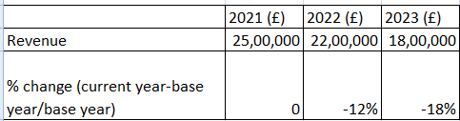
% Revenue change
(Source: Self-Computed from the information given in case study)
What is increasingly worrying is that the bottom line for Urban Heights Hotel between 2021 and 2023 declined significantly from a revenue of £25,00,000 to £18,00,000. The successive downturn in sales of 12 % in 2022 and around a quarter less (18%) in 2023 is indeed a worrying loss of income. These developments can be triggered by such factors as consumers' preference rotation, high competition level and service quality enhancement among service providers. To rescue and revive the business, the most appropriate restoration plan is required that would involve service reformation, customer experience control and promotion strategy in all modern marketing channels.

1.2 Operating Expense
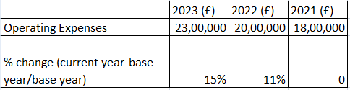
% operating expense change
(Source: Self-Computed from the information given in case study)
The problem of the decline by Urban Heights hotel becomes more complicated due to the rising cost of doing business as it goes from £18,00,000 in 2021 to £23,00,000 in 2023, which is a concern of 15% growth rate. Given a continuous increase of 11% for the year 2022, it confirms management failure in operations, or financial and cost mismanagement. In such deadlock, it would aggravate the money inflows on account of it and that may hinder the business profitability in a longer run as well as future plans. Therefore, a solution should be found that is a mirror of this problem and it is crucial to apply and introduce strong regulatory budget controls combined with process optimization and measures taken to increase the effectiveness as well. Comprehensiveness represents a complete cost management strategy with its innovative approaches, including revenue goal calibration, to be the most important activities to regain health, recover and to be competitive in the deficient market.

1.3 Profitability
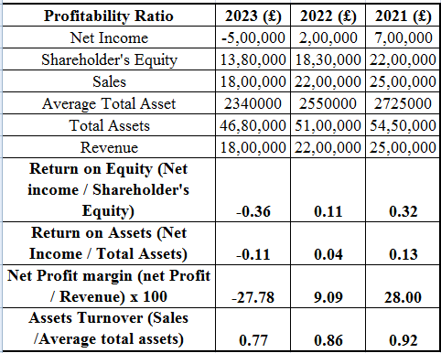
Profitability
(Source: Self-Computed from the information given in case study)
Urban Heights Hotel’s profits ratio is unstable, with this pattern being 3 years reminiscent. The ROE slumped from 0.32 in the year 2021 to the -0.36 in 2023, bringing about a huge loss on shareholders' equity. Furthermore, it can be illustrated through the Return on Assets (ROA) ratio, which became 0.13 in 2021 and then decreased to -0.11 in 2023, signifying ineffective asset management. The -27.78% Net Profit Margin for 2023 incorporates a variable that signifies operational problems as well as a decrease in the asset turnover ratio, which reflects the problems of not using all the assets to generate designated sales (Chakri, Pratap and Gouda, 2023). Considering the performance measures mentioned above, a full rectification process, which will help in bringing back the profit and the operational efficiency, is imperative.

1.4 Liquidity
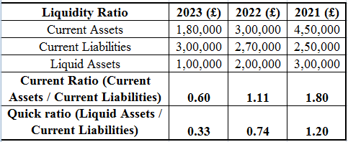
Liquidity
(Source: Self-Computed from the information given in case study)
In the last three years liquidity ratios of Urban Heights Hotel have showed steep decline. The Current Ratio tumbled from 1.80 to 0.60 in 2023, which points to most challenges in meeting short-term financial subscriptions with the present assets. On one hand, the Quick Ratio reduced from 1.20 to 0.33 in the year 2023, which indicates a hit in the liquidity aptitude to meet upcoming expenses from current assets. This liquidity crisis can prevent you from running expenses smoothly on a daily basis especially over emergency expenses causing critical danger to your hotel finances (Ayu et al., 2024). This requires giving special attention to efficient cash flow management so as to safeguard sufficient cash reserves that can cushion against any risks and bolster the assessment that they are in a healthy state.

1.5 Solvency
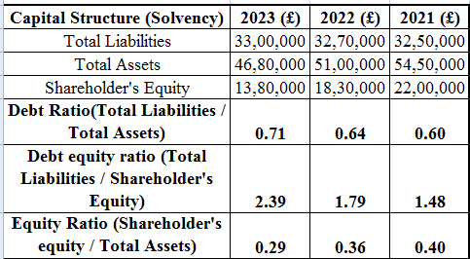
Solvency
(Source: Self-Computed from the information given in case study)
The last three years have witnessed Urban Heights Hotel frequenting debts as its primary source of funding the company assets. In 2021, the leverage ratio stood at 0.60 while in 2023 this ratio increased to 0.71 indicating that their debt holding relative to assets has gone up. Further, the Debt Equity Ratio went on spiking from 1.48 in 2021 to 2.39 in 2023 which is an indication that more recourse to the debt was the only option as compared to shareholder equity. The move carefully increased the leverage of Urban Heights hotel which then made their solvency and the financial stand ever more vulnerable to shocks (Eshonqulov, 2024). Through dissolving from high debts, adjustment tract must establish, as a result, the financial resilience and stable are prerequisites for recovery. Urban Heights Hotel must stress on the key areas through which equity enhancement can be carried out; thus the originality of the investors' interest can be uplifted.

2.0 Key reasons behind the decline in profitability, taking into consideration, real-world events and the current economy
The financial deficit of Urban Heights Hotel is due to the alignment between real-world events and economic trends. Factual evidences include travel cautions arising among tourists and visitor groups at those areas due to COVID-19 impacts. There is also an increase in expenses due to health and safety guidelines implemented (Ahmad and Khan, 2024). Therefore, income in this industry has fallen. To overcome this unpleasant situation, accurate plan execution with pinpoint precision strategy, advanced knowledge of creative advertising, expenditure management tools with a client centric and custodial service approach can complement a successful pathway even in the fluctuating economic environment.

3.0 Comprehensive turnaround strategy
Strategy | Description
Customer Experience Enhancement | Ensure the delivery of remarkable service, personalized experiences, and high quality amenities to get and keep guests; this can be achieved by doing it right and customers’ being happy.
Revenue Diversification | Try to open the new income sources (for example, promoting corporate events, weddings, or exclusive packages) in order to conquer new market segments and rise the overall revenue.
Cost Optimization | Profitability can be improved by conducting an in-depth analysis of expenses, renegotiating contracts with the partners, and implementing cost-saving measures that will not affect the quality of the services.
Marketing and Branding | Invest in well-placed marketing campaigns that spotlight the hotel's unique aspects, capabilities, and value offers to draw in new guests and win back the old ones.
Technology Integration | Employ technology solutions like online booking systems, guest management applications, and data analysis tools for automating process, increasing efficiency, and gaining intelligence for better decision making.
Staff Training and Development | Allocate financial resources towards staff training programs so that employees are furnished with necessary skills for facilitating good services and building the culture of hospitality and professionalism.
Community Engagement | Develop close-knit associations with local businesses, attend local events, and get involved in community projects to upgrade the motel's image and strengthen ties with the community.

Conclusion
Being adaptive and implementing measures early enough, Urban Heights Hotel can be the one opening the path of this restaurant’s success to last long. The hotel will be able to cope with the challenges of external factors in the market with customer satisfaction, increased efficiency, and community involvement, contributing to a better performance in an already crowded market. By upholding their dignity and focus on service, organization, and ethical conduct, Urban Heights Hotel will present an opportunity for success both financially and increase its brand recognition and provides life-time responsibility to their guests.

References
Ahmad, A.A., 2024. Corporate Governance and Its Determinants: A Study on Shangri-La Hotel (Malaysia) Berhad. Available at SSRN 4694743.
Ayu, A.P., Azim, M. and Damayanti, S., 2024. The Importance of Understanding Internal Accounting in Everyday life. Business Management, 3(1).
Chakri, P., Pratap, S. and Gouda, S.K., 2023. An exploratory data analysis approach for analyzing financial accounting data using machine learning. Decision Analytics Journal, 7, p.100212.
Eshonqulov, A.Q., 2024. Assessing the Impact of International Cash Accounting Standards on Financial Statements of Enterprises. European Journal of Contemporary Business Law & Technology: Cyber Law, Blockchain, and Legal Innovations, 1(2), pp.54-62.

