"LIVING WITH CARE: THE OLDER PERSON"
CASE STUDY OF BERNARD

Student Name: Shahida Yasmin
Student Id: 1813926
Module Name: Living with Care: The Older Person
Module Leader: Joanne Davies
Module Code: BMHP6009
Date of Submission: Monday 22 July 2024

Table of Contents

1. Introduction 3
2. Context and Background 3
3. Definition and Discussion of ‘Old Age’ 3
4. Aging Population: Trends and Implications 4
5. Issues Experienced by Older People 5
5.1 Financial Issues, Ageism, and Abuse 5
5.2 Mental and Physical Health Challenges 5
5.3 Impact of the Pandemic on the Elderly Population 6
6. Current Health and Social Care Provision 6
7. Case Study: Bernard’s Health and Social Care Needs 7
7.1 Medical Needs 7
7.2 Social and Emotional Needs 8
7.3 Safety Concerns 8
8. Proposed Support and Interventions for Bernard 9
8.1 Medical Interventions 9
Regular Monitoring of Diabetes 9
Personalized Dementia Care Plan 10
8.2 Social and Emotional Support 10
Facilitating Regular Family Visits and Virtual Meetings 10
Introducing Structured Activities Aligned with Bernard’s Interests 10
8.3 Safety Measures 10
Enhanced Supervision to Prevent Elopement 10
Safe and Supervised Engagement in Meaningful Activities 11
9. Critical Examination of Current Policies and Practices 11
10. Recommendations for Improvement 13
11. Conclusion 13
12. Reference List 14

Introduction
Bernard is an 81-year-old man who resides in a care home with a diagnosis of Type 1 diabetes and Vascular Dementia. Nevertheless, Bernard's health issues and some actions, including wandering and offering help with maintenance work, need intense care, even with family support. The proportion of elderly citizens in the United Kingdom is increasing yearly, and today, more than 11 million people are 65 years old and older, which is 18 percent of the total population. Maryland accounts for 5% of the total population (Age UK, 2023a). This assessment aims to assess Bernard's health and social care requirements, identify any existing issues, and recommend appropriate care approaches and actions to improve his welfare and protect him from harm within the nursing home environment.

Context and Background
Bernard is an 81-year-old man admitted to a nursing care facility where he gets total care because of his numerous medical complications. He requires one week to be treated; the total cost is £850, while his family contributes £345 per week (Age UK, 2023b). Bernard has Type 1 diabetes mellitus, which requires regular monitoring and maintenance of his blood glucose levels, and vascular dementia, which hampers his cerebral function and mental health.
Bernard, who has a rich family life, is a representative of such phenomena in society. Marry said he has one daughter, four granddaughters, three great-granddaughters, and two great-grandsons, though all of them visit him often once a week. Bernard's wife, at 73, admitted that being on the receiving end felt emotional when relatives attended to their spouse. Hence, she rarely visits but instead comes to the facility once a week to see the nursing staff. Bernard was a cricket enthusiast and had many happy years in the Royal Air Force from the 1960s through the 1970s.
Nevertheless, Bernard experiences different difficulties in the current care setting, which is considered friendly towards BME people. Due to his passion for maintenance, he likely practices risky things like climbing the ladders or fuelling the machines himself. Moreover, Bernard was given to roaming and had previously absconded from the facility without supervision; therefore, there is a strong need to augment safety. These difficulties point to the necessity for interventions focused on his medical care as well as behavioural issues.

Definition and Discussion of ‘Old Age’
Traditionally, old age is a chronological construct, with age 65 being the most used age to define it, but this could differ with culture or society. The United Nations, for instance, categorizes old age as starting at the age of 60, while the World Health Organization sets the bar at 65 years. These definitions affect the care since services and policies are implemented in response to the perceived age at which individuals enter older age. There are more than 2500000 people aged 65 years and above in the UK, which is why there is a need to design specific health and social care policies and services for the elderly population (Alzheimer's Association, 2020). Applying these definitions aids in designing suitable interventions and care frameworks for older people to address their needs.

Aging Population: Trends and Implications
The proportion of the elderly population in the UK and internationally is on an upward spiral. In the UK, people 65 years and above make up 18. 5% of the population, with demographic forecasts predicting this ratio will be nearly 25% by mid-century. The international population, which is 60 or above, is estimated to double from 1 billion in 2020 to 2. 1 billion in 2050, according to the United Nations (British et al., 2023).
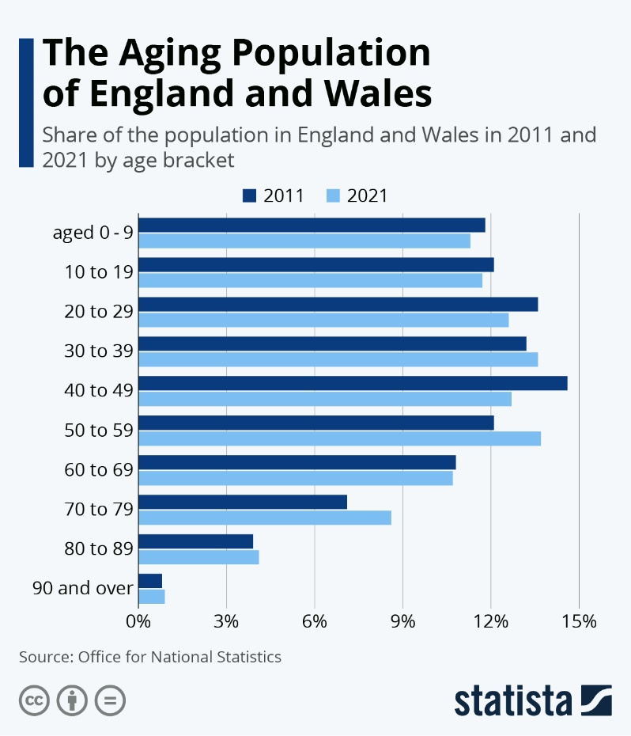
Figure 1: The Aging Population of England and Wales (Source: Statistica)
Several medical and social factors explain this trend in demography. The health sector has recorded numerous improvements in the last few decades, and people live past 60 years, 70 years, and 80 and above (WebMD, 2003). Advances in medicine shortening the illness duration and treatment of chronic diseases, including heart disease, diabetes, and cancer, have also significantly contributed. Also, awareness campaigns in public health and improved living standards have lowered the mortality rates.
Societally, the post-World War II baby boom has resulted in a large cohort now entering old age (British et al., 2023). A significant demographic change raises concerns about one’s capacity to sustain the health and social care delivery system. The issues that the aging population will pose other challenges regarding pensions, employment, and infrastructure adaptation. To manage such challenges, there is the need to design a multifaceted approach that cuts across the health sector, social services, and policy arena to enhance the support systems that cover such a growing population to provide the best solution.

Issues Experienced by Older People

Financial Issues, Ageism, and Abuse
The elderly face significant problems relating to finance and personal funds. About one in six pensioners in the UK are in poverty, and while they are technically retired from work, they are not retired from worrying about how to pay for food, heating, electricity, or even health care. Thus, ageism, as stereotyping, prejudice, and discrimination against people based on their age, is widespread and has an impact on the elderly, as they face exclusion from the workplace, receive poor-quality medical care, and experience social isolation. Research on older adults shows that 64% of people feel that their dignity and respect are violated because of their age (Care Act, 2014). Also, elder abuse persists as a significant concern as about 15. 4 percent of the elderly are vulnerable to one type of abuse or the other, which can be physical, emotional, financial, or neglect.

Mental and Physical Health Challenges
Specifically, depression and anxiety are among the disorders that are typical for older adults, with the overall figure reflecting 22% of men and 28% of women aged 65 and over years (Centre for Ageing Better, 2023). Alzheimer's disease or any kind of dementia is also a concern; presently, there are around 850,000 dementia patients in the UK (WBG, 2023). Continuing with the physical health concerns, older adults suffer from chronic diseases like arthritis, cardiovascular diseases, and diabetes, among others, which subjects them to a rigorous medical care system. Older adults have a significantly high rate of multimorbidity in that they have multiple chronic illnesses; these will require frequent attendance at the medical facilities.

Impact of the Pandemic on the Elderly Population
The communities that have been hit most severely by COVID-19 are the aged. The information clearly illustrates the fact that 89% of people who died from COVID-19 in the UK were 65 years and above. The pandemic has also increased the instances of loneliness due to reduced interaction with others since social distancing measures and certain lockdowns prohibited physical contact (Crimmins, 2018). Earlier this year, Age UK conducted a study that showed that 1. 4 million older persons in England felt even more lonely due to the pandemic (Wagner, 2022). Furthermore, disruption of the regular HC services meant that many older adults could not undergo diagnostic tests or access treatments in good time. Hence, their health deteriorated. The pandemic revealed that older adults are among the most vulnerable groups, requiring efficient social security and emergency response mechanisms.

Current Health and Social Care Provision
It is apparent from the current manifesting health and social care services in the United Kingdom that this generation demands much care to cater to the elderly population. The National Health Service (NHS) is under pressure, and as of January 2021, 4,700,000 people are on a waiting list for treatment. Other welfare services are also suffering; the social care sector is severely short-staffed, and there are approximately 100,000 vacancies at any time (FCA, 2017). The funding for social care remains limited, creating an absence of services for the elderly and support for your elderly relative.
From this perspective, it can be noted that because there seems to be a growing population of older people, the necessity for health and social care services seems likely to grow significantly in the future (Umberson & Karas Montez, 2010). Currently, there are almost 1. 7 million of the population aged 85 and over in the UK, and according to the Office of National Statistics actual projections, the number of people aged 85 and over is to nearly double to reach 3. 2 million by the end of 2040 (Fraga Dominguez et al., 2021). This demographic change will also exert more stress regarding resources on health systems and call for capital-intensive investments in infrastructures, health workforce, and services.
In addition to already apparent issues like long waiting lists for operations, poor social care, and limited availability of specialized care in the case of chronic illness and dementia, it is assumed that the number of older adults will only lead to an aggravation of the current situation. To tackle these problems, there is a need to provide more efficient reforms and boost funding so that health and social care services can fulfil the aging population's demand. This entails increasing Patient and Public Involvement (PPI), extending the community’s care provision, syncing health and social care, and exploring digital service improvements.

Case Study: Bernard’s Health and Social Care Needs

Medical Needs
The focus of Bernard’s medical care is mainly the control of his Type 1 diabetes and vascular dementia. In this case, it is pertinent that diabetes must be managed optimally by frequently measuring blood glucose levels, administering insulin injections, and consuming only particular types of meals to avoid signs of hypoglycaemia or hyperglycaemia. Diabetes is prevalent in the UK, with a population figure of 3. 9 million; therefore, it is essential to control or, better still, eliminate it so that it does not hinder Bernard’s health (Government Office for Science, 2016).
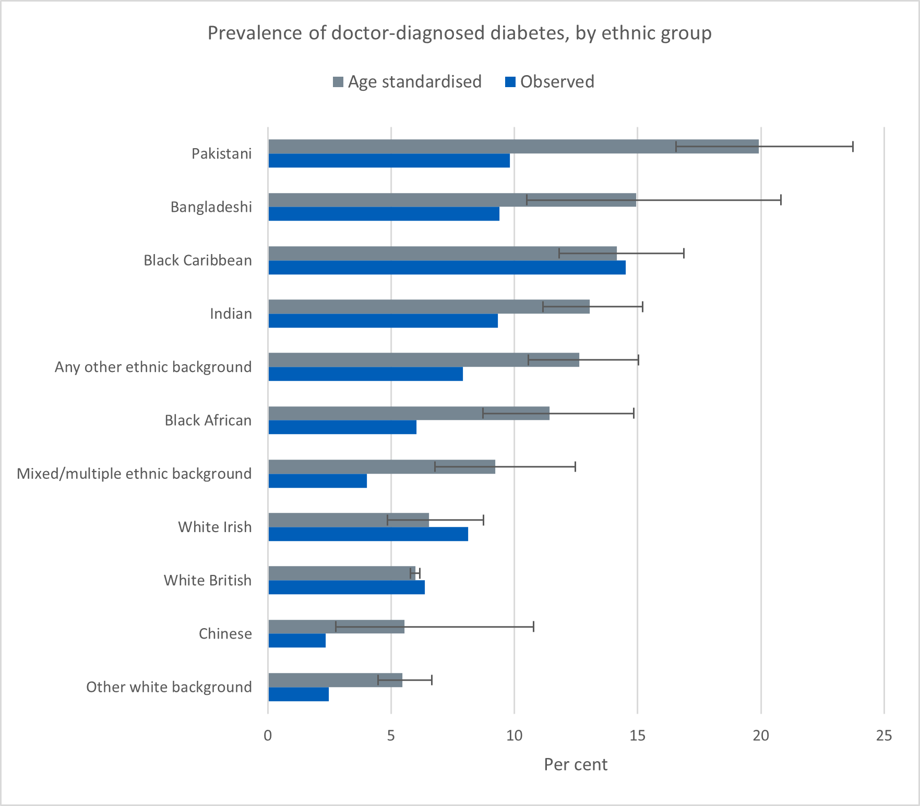
Figure 2: Prevalence of Diabetes Type 1 in UK (Source: The Lancet)
Bernard’s vascular dementia is relatively rare and affects approximately 150,000 people in the UK; therefore, such patients require individual approaches (Ho & Funk, 2018). These are forgetfulness, confusion, and fixation impairment, and therefore, would require a unique care plan, including therapy of cognitive stimulation, periodic medical check-ups, and proper medication that would help to slow down the progression of the disease and enhance his quality of life.

Social and Emotional Needs
Social relations among the family members are crucial to Bernard’s emotional health. Since he has a daughter, granddaughters, and great-granddaughters, they pay him regular visits, so he is socially interactive and not lonely. However, the primary concern identified is his wife, who suffers from anxiety whenever she visits the care facility (Jones & Dolsten, 2024). Letting her occasionally do virtual visits or providing her with more comfortable visiting conditions could lessen her distress while allowing him to remain her spouse.
A third component that must be followed is how a person can get engaged. Bernard likes to talk about his time in the Royal Air Force and watch cricket (TWH, 2021). Ensuring that he can engage in such activities as storytelling sessions, events, and anything related to cricket can immensely boost his feelings and learning.

Safety Concerns
It is another aspect that defines Bernard’s future risk of elopement. Institutional outbreaks that depict him always going to the nearest pub are evidence of increased insecurity that requires better monitoring, and the design of secure facility exits that check on instances where patients go out unsupervised. According to earlier studies, over 60 % of the patients with dementia display symptoms of wandering, meaning that the behaviour needs to be managed to keep Bernard safe (Mayo Clinic, 2023).
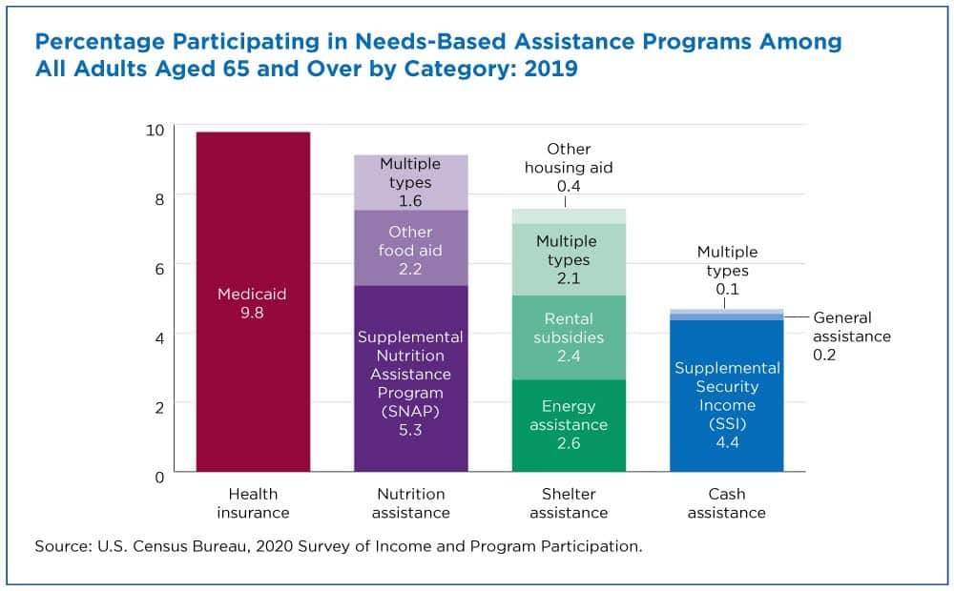
Figure 3: What Happens When Older Adults Struggle to Make Ends Meet? (Source: Census.Gov)
Furthermore, Bernard has some safety issues, as demonstrated by his interest in performing maintenance activities, including climbing up the ladder and interfering with equipment parts (Medici, 2022). To avoid such risks, there should be structured activities that the child engages in in such a manner that such interest is safely and directly supervised. It may be possible to offer Bernard other safe and closely monitored activities that would meet his maintenance interests but, at the same time, will not endanger his life (TGCP, 2022). Thus, considering all these medical, social, emotional, and safety needs and implementing the respective care plan, it is possible to increase the quality of the patient’s life and enhance Bernard’s health.

Proposed Support and Interventions for Bernard

Medical Interventions

Regular Monitoring of Diabetes
As highlighted in the case of Bernard, the Type 1 diabetes disease presents the need to control Bernard’s blood glucose levels constantly. Prevention involves adhering to a schedule of when the patient should check the blood sugar level and when he/she should administer insulin. In the UK, there are about 3 million people with diabetes; among them 3, 00,000 are with type 1, which is comparatively complicated (MHA, 2023). Taking Bernard for consultations with a Diabetes Specialist and preparing a diet plan for him will assist in the regulation of his glucose levels.

Personalized Dementia Care Plan
It can be inferred that Bernard requires a sort of care plan that shall be tailored to address his vascular dementia. They belong to activities that should be delivered to patients, including memory stimulation and problem-solving to reduce further distortion of the brain. Dementia care mapping can effectively enhance patients' quality of life and slow down symptoms' manifestation. Alzheimer’s Society has pointed out that personalized care plans could be helpful (NAO, 2016). It is also essential for him to visit a healthcare professional for checkups and reviews of the medicine doses so that any changes in his health status can be well managed.

Social and Emotional Support

Facilitating Regular Family Visits and Virtual Meetings
Constant communication with family members is essential to Bernard’s psychological system. He can suggest that his family pay more visits and also organize online meetings to minimize loneliness. According to Age UK, significant levels of contact with the family lead to enhanced mental health of the elderly (NHS, 2024). Support in counseling or arranging for less stressful visiting arrangements will ensure that the wife is assured of the husband’s support to sustain the marriage.

Introducing Structured Activities Aligned with Bernard’s Interests
Stimulating the patient with activities that he can appreciate, such as recalling past experiences in the RAF and watching cricket, will go a long way in improving his emotional state (NHS England, 2019). The patient could also benefit from specific organized activities, for example, developing stories for RAF and activities involving cricket. Other research evidence points to the fact that the social Helsinki meaningful activities help to stimulate the reduction of depressive symptoms and improvement of the quality of life for older individuals.

Safety Measures

Enhanced Supervision to Prevent Elopement
Improving supervision is essential in this case since Bernard has often been described as a wanderer. Laminate metal doors, quality locks on doors, and other techniques, such as GPS tracking systems, may be used to minimize cases of elopement. The Alzheimer's Association estimates that up to 60% of dementia individuals develop the tendency to wander, which means that solid precautions need to be put in place (Novotney, 2019). When staff members are trained to identify and prompt intervention of elopement risks, Bernard’s safety will also be improved.

Safe and Supervised Engagement in Meaningful Activities
In case of identifying that the child is too fascinated with maintenance tasks, the appropriate suggestion is to give the child secure and monitored play that resembles his or her interests. Organizing a closely monitored workstation where Bernard can shuffle around performing maintenance like chores can send him to work while protecting himself (Office for National Statistics, 2022). This approach would be helpful to prevent the dangers tied to his unmonitored efforts to help the maintenance team.
Through these medical, social, emotional, and safety interventions, Bernard’s quality of life as a client can be greatly enhanced, and he deserves the highest quality and the best attention.

Critical Examination of Current Policies and Practices
Currently, older adult patients such as Bernard have different possibilities of access to the necessary policy and practice requirements. The legislation guiding the provision of care and support in the United Kingdom is the Care Act 2014, which, among other things, stresses the need to adhere to personalized care and joined-up care (Office for National Statistics, 2023). Thus, although such policies are in place, the gaps have not closed. Thus, in the context of the supply of informal care services, Age UK refers to at least 1. 5 million older people who do not receive adequate care, which shows a shortage of such services (Population, Martin, and Preston, 1994).
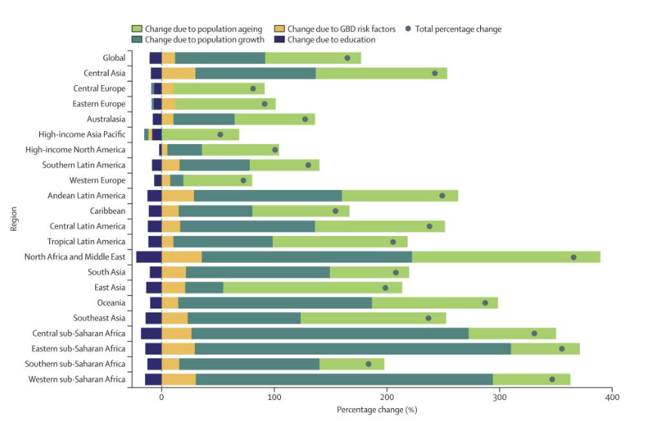
Figure 4: Dementia cases expected to almost triple globally by 2050 (Source: alzheimersclinics)
Government and health service responses have included new mechanisms such as the Better Care Fund, pursuing the purpose of the integration of health as well as social care. Such has been the case, though there are areas of concern, such as funding and staffing, still wanting. This financial challenge exposes the sustainability of many services delivered to the public domain because the National Audit Office indicates that social care services will likely record a £2. 2 billion funding deficits by 2025 (Raymond et al., 2021).
The latest developments, like the NHS Long Term Plan, aim to develop community services and address mortifications like chronic diseases and dementia. Nevertheless, practice varies, and the COVID-19 outbreak has exacerbated resource challenges. For instance, the King’s Fund has pointed out that only 14% of adults requiring care said that services improved in the post-pandemic period (Reeves et al., 2023).
The challenges that need to be closed through enhancement of funding, improvement of staff, and general enhancement of damaging policies to deal with the expanding elderly population: Improved relations between healthcare and social services and the idea of using technology are needed to provide comprehensive and complex care for older adults like Bernard.

Recommendations for Improvement
Interacting more frequently with the caregivers who attend to Bernard and his family would help improve his health and respond to issues as they happen. Caring for such patients requires that the staff be trained adequately on the diseases since over 850000 people in the UK suffer from dementia, while 3. 9 million have diabetes. Some of the proposals that can be adopted to enhance Bernard's safety include adopting renewal technology like GPS tracking, which is a fact that as much as 60% of people with dementia wander (Spiers et al., 2018). Therefore, multidisciplinary meetings for Bernard on his care plan will help assess and revise it to capture Bernard's present needs, which is in line with the Montessori approach of individual care. Everything mentioned can make the staff work more effectively and efficiently and offer vast improvements in the quality of life and care for Bernard.

Conclusion
Bernard’s case presents medical, social, and security issues in managing frail elderly patients with medical problems such as diabetes and dementia. Potential preventive measures include periodic health check-ups, individual care plans for patients with dementia, better communication among families, increased organization and safety precautions. An analysis of the current approaches suggests that there are deficiencies in service delivery, which calls for more funding and integration of services between the health and social care sectors. Proper care linked to using relevant training and tools is crucial to enhance the life expectancy of elderly persons like Bernard and to meet all his or her needs duly.

Reference List
Age UK (2023a). Nearly a million older people just one big bill away from financial disaster as a new report shows the reality of trying to meet the extra costs of aging on a low income | Press release. [online] Age UK. Available at: https://www.ageuk.org.uk/latest-press/articles/2019/april2/nearly-a-million-older-people-just-one-big-bill-away-from-financial-disaster-as-new-report-shows-reality-of-trying-to-meet-the-extra-costs-of-ageing-on-a-low-income/.
Age UK (2023b). The State of Health and Care of Older People. [online] Available at: https://www.ageuk.org.uk/globalassets/age-uk/documents/reports-and-publications/reports-and-briefings/health--wellbeing/age-uk-briefing-state-of-health-and-care-july-2023-abridged-version.pdf.
Alzheimer's Association (2020). Daily Care Plan. [online] Alzheimer’s Disease and Dementia. Available at: https://www.alz.org/help-support/caregiving/daily-care/daily-care-plan.
British Geriatrics Society (2023). Protecting the rights of older people to health and social care. [online] British Geriatrics Society. Available at: https://www.bgs.org.uk/policy-and-media/protecting-the-rights-of-older-people-to-health-and-social-care.
Care Act (2014). Care Act 2014. [online] Legislation.gov.uk. Available at: https://www.legislation.gov.uk/id/ukpga/2014/23.
Centre for Ageing Better (2023). Our Ageing Population | the State of Ageing 2023-24 | Centre for Ageing Better. [online] ageing-better.org.uk. Available at: https://ageing-better.org.uk/our-ageing-population-state-ageing-2023-4.
Crimmins, E. (2018). Trends in Mortality, Disease, and Physiological Status in the Older Population. [online] www.ncbi.nlm.nih.gov. National Academies Press (US). Available at: https://www.ncbi.nlm.nih.gov/books/NBK513090/.
FCA (2017). FCA RESTRICTED Job XXXX -Publication date X/XX/20XX (Main contact: XXXXX) Typesetter XX Typesetting production audit: DRAFT 1 -Full typeset document from final text -Issued XX/XX/XXXX Ageing Population and Financial Services Financial Conduct Authority Occasional Paper 31. [online] Available at: https://www.fca.org.uk/publication/occasional-papers/occasional-paper-31.pdf.
Fraga Dominguez, S., Ozguler, B., Storey, J.E. and Rogers, M. (2021). Elder Abuse Vulnerability and Risk Factors: Is Financial Abuse Different From Other Subtypes? Journal of Applied Gerontology, 41(4), p.073346482110364. doi https://doi.org/10.1177/07334648211036402.
Government Office for Science (2016). Future of an Ageing Population. [online] Government Office for Science. Available at: https://assets.publishing.service.gov.uk/media/5d273adce5274a5862768ff9/future-of-an-ageing-population.pdf.
Ho, J. and Funk, S. (2018). We are promoting young children’s social and emotional health. [online] NAEYC. Available at: https://www.naeyc.org/resources/pubs/yc/mar2018/promoting-social-and-emotional-health.
Jones, C.H. and Dolsten, M. (2024). Healthcare on the brink: navigating the challenges of an aging society in the United States. npj Aging, [online] 10(1), pp.1–10. doi:https://doi.org/10.1038/s41514-024-00148-2.
Mayo Clinic (2023). Type 1 Diabetes - Symptoms and Causes. [online] Mayo Clinic. Available at: https://www.mayoclinic.org/diseases-conditions/type-1-diabetes/symptoms-causes/syc-20353011.
Medici, A. (2022). Health sector challenges and policies concerning aging populations * Population Division iii. [online] Available at: https://desapublications.un.org/file/652/download.
MHA (2023). Facts & stats about older people. [online] MHA | Live Later Life Well. Available at: https://mha.org.uk/get-involved/campaign-us/facts-stats-about-older-people#:~:text=According%20to%20the%20Census%202021 [Accessed 20 Jul. 2024].
NAO (2016). Financial sustainability of the NHS. [online] Available at: https://www.nao.org.uk/wp-content/uploads/2016/11/Financial-Sustainability-of-the-NHS.pdf.
NHS (2024). Adult social care and the NHS: two sides of the same coin | NHS Confederation. [online] www.nhsconfed.org. Available at: https://www.nhsconfed.org/publications/adult-social-care-and-nhs.
NHS England (2019). NHS England» Dementia. [online] England.nhs.uk. Available at: https://www.england.nhs.uk/mental-health/resources/dementia/.
Novotney, A. (2019). The Risks of Social Isolation. American Psychological Association. [online] Available at: https://www.apa.org/monitor/2019/05/ce-corner-isolation.
Office for National Statistics (2022). Voices of our aging population - Office for National Statistics. [online] www.ons.gov.uk. Available at: https://www.ons.gov.uk/peoplepopulationandcommunity/birthsdeathsandmarriages/ageing/articles/voicesofourageingpopulation/livinglongerlives.
Office for National Statistics (2023). Profile of the older population living in England and Wales in 2021 and changes since 2011 - Office for National Statistics. [online] www.ons.gov.uk. Available at: https://www.ons.gov.uk/peoplepopulationandcommunity/birthsdeathsandmarriages/ageing/articles/profileoftheolderpopulationlivinginenglandandwalesin2021andchangessince2011/2023-04-03.
Population, N.R.C. (US) C. on, Martin, L.G. and Preston, S.H. (1994). Medical Demography: Interaction of Disability Dynamics and Mortality. [online] www.ncbi.nlm.nih.gov. Available at: https://www.ncbi.nlm.nih.gov/books/NBK236668/ [Accessed 20 Jul. 2024].
Raymond, A., Bazeer, N., Barclay, C., Krelle, H., Idriss, O., Tallack, C. & Kelly, E. (2021). Our ageing population - The Health Foundation. [online] www.health.org.uk. Available at: https://www.health.org.uk/publications/our-ageing-population.
Reeves, C., Islam, A. & Gentry, T. (2023). The State of Health and Care of Older People in England 2023. [online] Available at: https://www.ageuk.org.uk/globalassets/age-uk/documents/reports-and-publications/reports-and-briefings/health--wellbeing/age_uk_briefing_state_of_health_and_care_of_older_people_july2023.pdf.
Spiers, G., Matthews, F.E., Moffatt, S., Barker, R.O., Jarvis, H., Stow, D., Kingston, A. & Hanratty, B. (2018). Impact of social care supply on healthcare utilization by older adults: a systematic review and meta-analysis. Age and Ageing, 48(1), 57–66. doi:https://doi.org/10.1093/ageing/afy147.
TGCP (2022). Creating a Dementia Plan. [online] www.thegoodcaregroup.com. Available at: https://www.thegoodcaregroup.com/live-in-care/dementia-care/creating-dementia-care-plan/.
TWH (2021). Budget of the U.S. Government F I S C A L Y E A R 2 0 2 4. [online] Available at: https://www.whitehouse.gov/wp-content/uploads/2023/03/budget_fy2024.pdf.
Umberson, D. and Karas Montez, J. (2010). Social relationships and health: A flashpoint for health policy. Journal of Health and Social Behavior, [online] 51(1), pp.54–66. doi https://doi.org/10.1177/0022146510383501.
Wagner, M. (2022). Alzheimer’s Disease and Dementia Nursing Diagnosis & Care Plan. [online] NurseTogether. Available at: https://www.nursetogether.com/alzheimers-disease-dementia-nursing-diagnosis-care-plan/.
WBG (2023). WBG responds to the National Audit Office report on Social Care Markets. [online] www.wbg.org.uk. Available at: https://www.wbg.org.uk/article/wbg-responds-to-the-national-audit-office-report-on-social-care-markets/ [Accessed 20 Jul. 2024].
WebMD (2003). Type 1 Diabetes. [online] WebMD. Available at: https://www.webmd.com/diabetes/type-1-diabetes.

