Site investigation Case study of new building on the Swansea foreshore
By Steffan Pryce-Griffiths

Intro

Swansea County and City have come to an agreement with the Marriot hotel
to create a new restaurant and ice- cream parlour on the Swansea foreshore. The building will be located between the car parks of both the County hall and Marriot hotel. The building will be made up of a restaurant, café bar, ice cream parlour, kitchen, food- stores and on the second floor, there is to be self-contained managers apartments and staff welfare facilities. By my company I’ve been inquired to do the tendering for the work, undertaking a full site investigation which include the historical background, desktop study which I will provide archival material. I will give my recommendations on which elements of the site investigations I find most significant and applicable to the site from the information and evidence I have gathered. Additionally, stating the building regulations/ codes of practice I find legible and the most suitable foundation suited for the building with the aid of sketches.

Site preview

The building is to be located just out the front of the Marriot hotel. This new purposed building will share the available car park space of the Marriott hotel and County Hall. There are around 250 car spaces between the both but obviously, this will reduce with the new building. This building is just off from the road that goes from Swansea to Mumbles subsequently this will create more traffic and may be problem with the job itself with delivery’s, travelling and parking for contractors.

Figure 1

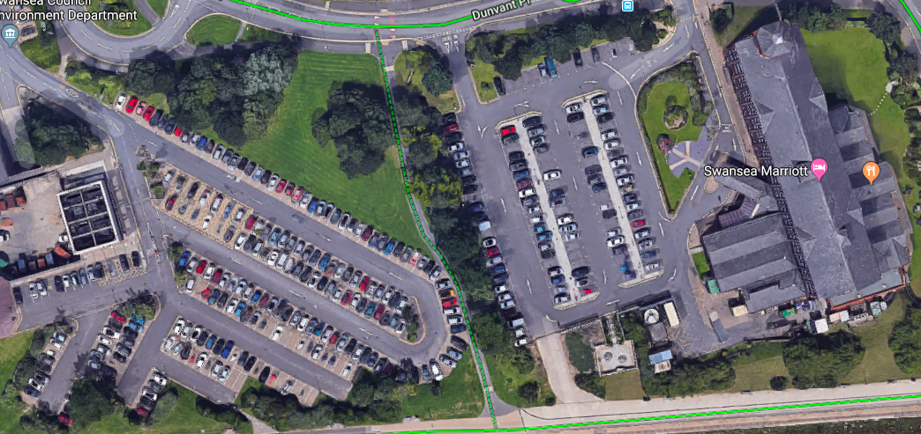

Historical background

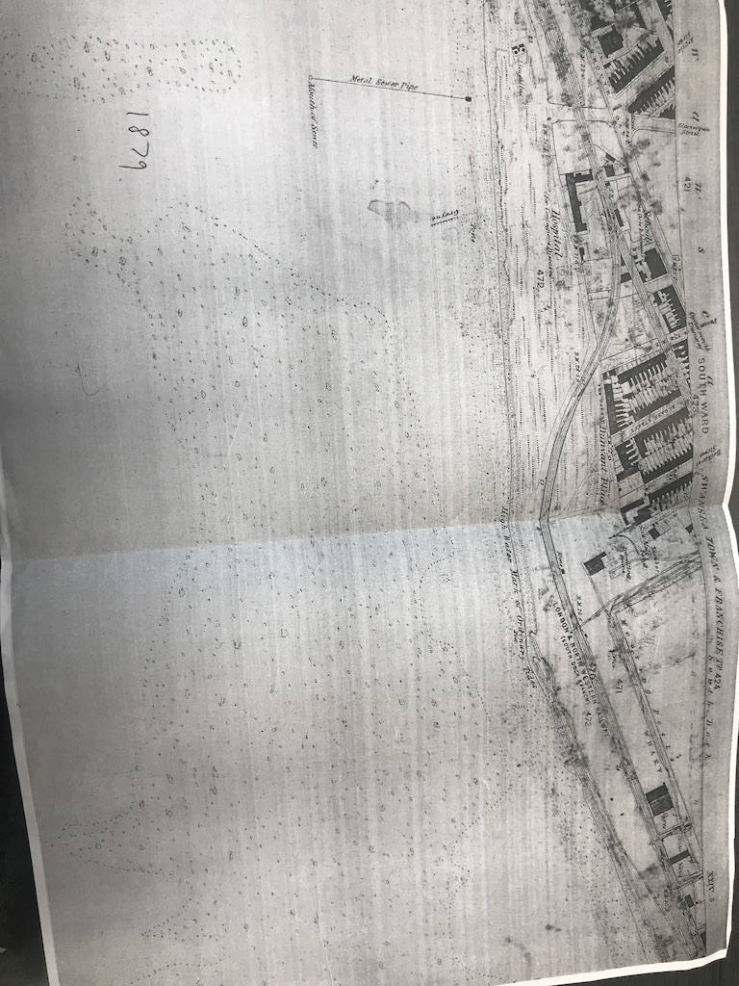
- From the historical archives gathered we can see there use to be a train track running through the Swansea foreshore. It was known as the Mumbles railway and building commenced under the act of parliament in 1804. This suggests that there could be some sort of contamination left in the ground with coal and oil used to operate the trains, which means there could be ashes. Figure 2

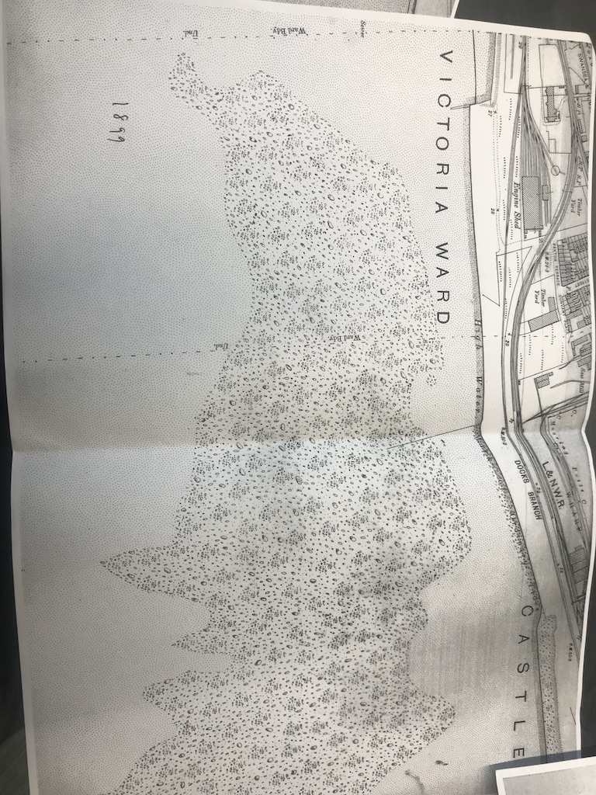
- 1899 archive- Reveals there was a timber yard not far from the plot the building is going on. This means there could be leftover of rich copper- chrome-arsenic, which is used to preservative the timber and could have been spilled in the process wood treatment

Figure 3

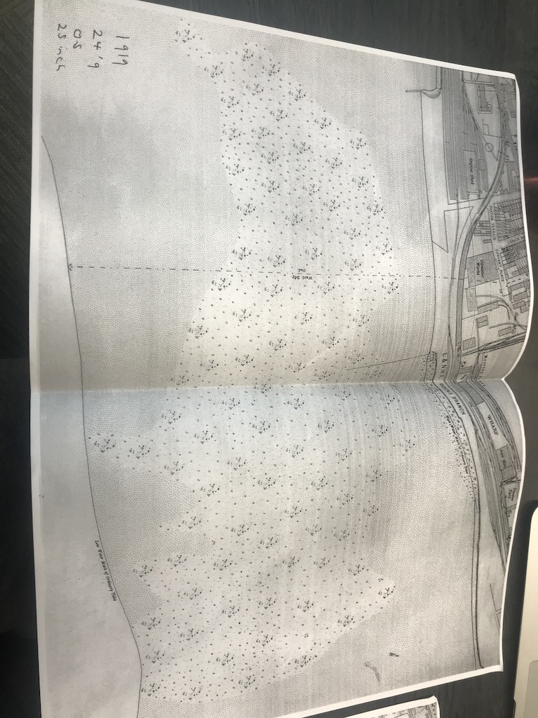
- 1919 archive- We can see there is a canister works on the archive but not sure what type. This also suggests that there could be some sort of contamination left from this.

Figure 4

In world war 2, Swansea was highly targeted due to its importance of the docks and ports as it supported the “military-based industries and munitions manufacture, with the port supplying an important distribution centre for weapons and troops” (Elphick, 2019). Advocates that there could be unexploded bombs in the ground of the site.

Surface Geology
The photo below shows the bedrock and superficial from using the geology of Britain viewer. The photo has a colour geology key which determines what surface an area is. The building will be going on the yellow/ orange of the photo.
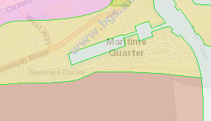

Figure 5

Bedrock- The bedrock was described as mudstone, siltstone and sandstone and derives from the “South wales coal formation. It is known as Sedimentary Bedrock and approximately developed around “310 to 318 million years ago in the Carboniferous Period” (British Geological Survey 1998 - 2017 (c)NERC mailto:www-bgs@bgs.ac.uk, 2019). “They are detrital, forming deposits reflecting the channels, floodplains and deltas of a river in a coastal setting (with periodic inundation from the sea)” (British Geological Survey 1998 - 2017 (c)NERC mailto:www-bgs@bgs.ac.uk, 2019).

Superficial description: “cale deposit with Blown Sand. Deposits formed up to 3 million years ago in the Quaternary Period. Local environment previously dominated by wind-blown deposits” (British Geological Survey 1998 - 2017 (c)NERC mailto:www-bgs@bgs.ac.uk, 2019).
.
Setting: “wind-blown deposits (U). These sedimentary deposits are aeolian in origin. They are detrital, comprising medium- to fine- grained materials, forming lenses, beds (and locally) dunes” (British Geological Survey 1998 - 2017 (c)NERC mailto:www-bgs@bgs.ac.uk, 2019).

Boreholes- Using the borehole from the County hall which is the closest to the new building. Earlier I spoke about there ashes been left, by looking at the county borehole it shows the top layer of the ground consisted of ashes. It shows it’s predominantly made up of loose, light grey sand and soft clay which are poor soils to build on.

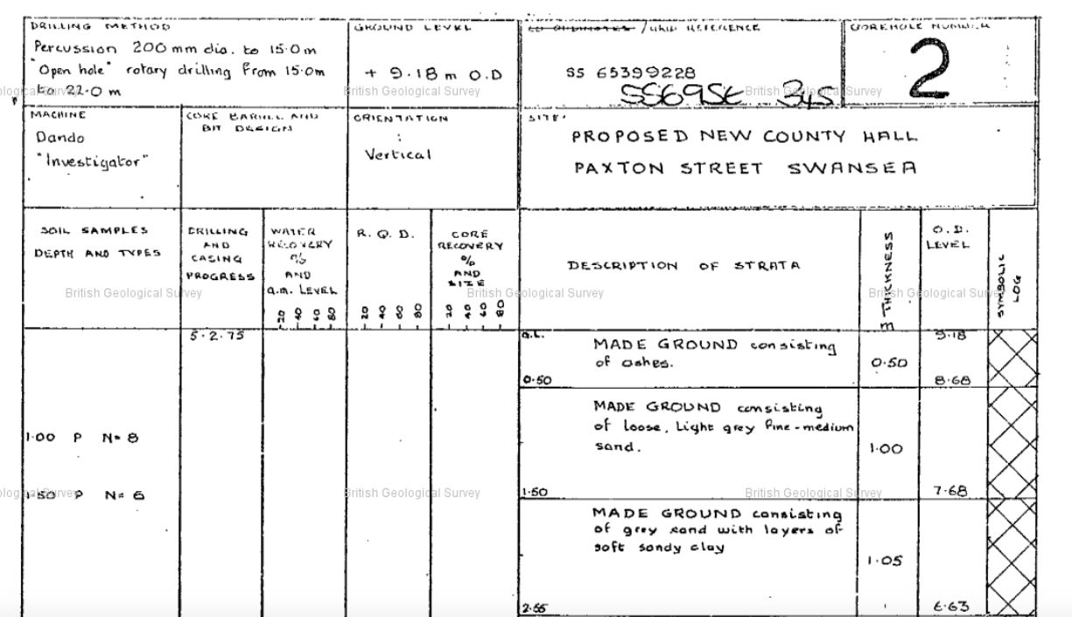

Figure 6

Suitable foundation- Raft foundation

In any type of construction specifying an exact cost for a ‘typical’ project is incredibly difficult, a lot of it depends on the soil characteristic and the speciation of the project. ‘” However, since excavations are generally much less than with traditional foundations, spoil removal costs are generally much lower. Site excavation also takes less time, as does preparation and concrete pouring times, which reduces labour costs. In general, for sites without complex structural load requirements, raft foundations cost significantly less than traditional approaches and if suitable I believe it should be considered for the project” (Default Admin (2019). Raft Foundation Construction: Uses, Types and Cost.)
‌The foundation I have decide to choose is a Raft/Mat foundation due to the poor ground conditions which I found out from geology Britain finder. It was said that soil type could be a mixture of Mudstone, Siltstone and Sandstone. These soils types are to be considered poor soils to which couldn’t bear the capacity of the building on a strip or pad foundation. The Raft foundation is formed from a reinforced concrete slab of uniform thickness, with thickening of perimeter which will typically cover a large area. Normally where settlement or differential settlement is likely to occur on the foundation and this case its more than likely this will happen. The concrete slab will rest on the soil that covers over the entire area of the building; therefore, the building is supported and the weight can be transferred to the ground. This reduces the stress on the soil, unlike a Pile foundation which applies pressure on smaller zones/ individual footings.
How to construct a Raft foundation
The earth is firstly covered with a waterproof plastic sheet, a 3” thin layer of blinding “concrete is poured just to create a perfectly flat and level base for the foundation” (Understand Building Construction. (2019). Raft or Mat Foundations.).
A waterproof plastic sheet is laid over the earth, and a thin 3" layer of blinding concrete (PCC) is poured just to create a perfectly flat and level base for the foundation. A waterproofing layer is placed then with the “reinforcement steel for the raft slab is put in to place” (Understand Building Construction. (2019). Raft or Mat Foundations.). The concrete is tipped after the steel has been installed. The concrete will be “poured to the desired thickness, which is usually in the range of 200mm (8") to 300mm (12") thick for small buildings: this can be much thicker if heavy loads are to be carried” (Understand Building Construction. (2019). Raft or Mat Foundations.). After this, a waterproofing layer is installed, and then reinforcement steel for the raft slab is tied in place. After all the steel has been put in place, concrete is poured to the desired thickness, which is usually in the range of 200mm (8") to 300mm (12") thick for small buildings: this can be much thicker if heavy loads are to be carried” (Understand Building Construction. (2019). Raft or Mat Foundations.).
The edge is prone to erosion on a Raft foundation, it’s important that it’s treated properly to prevent this.

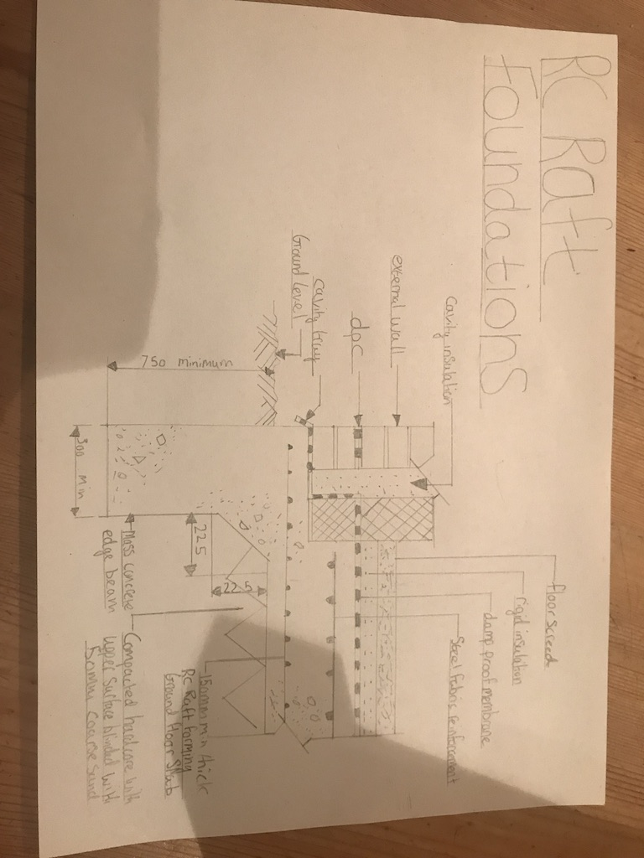

Figure 7

The information I’ve gathered from the borehole of the building adjacent reinforces the poor ground where the majority of the borehole of the civic centre is made up of loose, light grey sand and soft clays which is probably going to be the case on our desktop study.

Safety
The building getting built is only two story’s and the raft foundation should be capable of withstanding this bearing capacity. The raft only requires a shallow, excavation, therefore reduces the risk of an excavation collapsing.

Time
A raft foundation will have a reduction on the time taken to complete the groundworks as the raft can be poured in one or two pours unlike piled which will need much more time and labour.

Cost
Lastly from value engineering the section of work I believe the client will be able to save money as the raft will require less labour, fewer materials, less concrete, less concrete wagon visits and less time spent during the construction process of the raft.

Building regulations / codes of practice for the site investigation
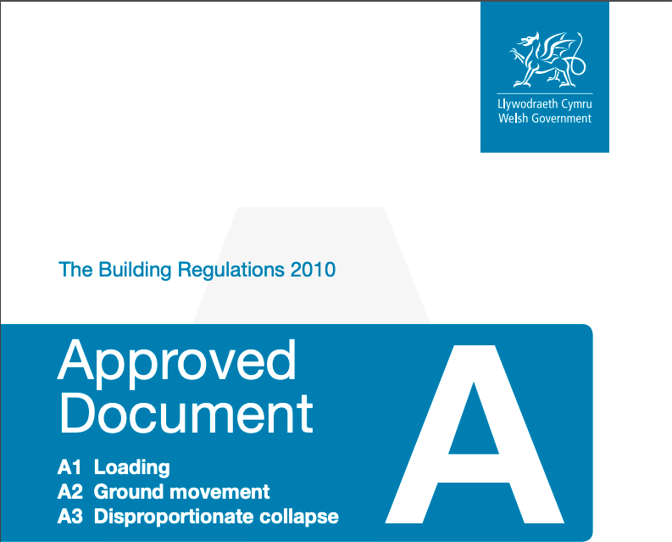

Figure 8
Approved-Document-A-Structure.
Approved Document A structure presents guidance on building regulations with design standards and guidance on building situations. It prevents the building making any other structural integrity on any other surrounding buildings and using the building act 1984 as a legal status.

BS 8004:2015 Code of practice for foundations- recommendations on the design of the foundation whether its deep or shallow. “It covers the design, construction, monitoring and maintenance of spread foundations, pile foundation and raft foundation” (Shop.bsigroup.com. (2019). BS 8004:2015 Code of practice for foundations). This standard should be used because it takes in to “account the advanced foundation technology over the past 30 years, providing up to date guidance needed to implement the requirement of Eurocode 7” (Shop.bsigroup.com. (2019). BS 8004:2015 Code of practice for foundations). It presents key elements of how foundations should be made conferring with limit state principles.

BS 10175:2011 Investigation of potentially contaminated sites- This standard looks at Contaminated land contains harmful chemicals which could be potentially be presented as risk to human health or environment. This places objectives for users to follow
- “Set the objectives of an investigation
- Develop a strategy for the investigation
- Identify risks arising from the presence of contamination
- Design the different phases of the investigation
- Carry out sampling, field testing and laboratory analysis
- Conduct risk assessment of a potentially contaminated site” (Shop.bsigroup.com. (2019). BS 10175:2011+A2:2017 Investigation of potentially contaminated sites. Code of practice)

BS 5930: 2015 Code of practice for ground investigations-
BS 5930:2015 “presents an update on the requirements for the investigation of sites in order to assess their suitability for construction and to identify the characteristics of a site that affect the design and construction of the project” (https://www.ags.org.uk, 2015). It associates the environment and safety to properties and land adjacent to its which will need to be considered with this building.
‌
BS EN ISO 16133:2018 and 15175:2018: Soil quality British standard- is an update in requirements for investigations of sites, evaluating the sites and soil materials in “relation to their role as a source of contamination of groundwater and their function in retaining, releasing and transforming contaminants” (https://www.ags.org.uk, 2015b). It targets “contaminated land management identifying and strategies, methods for sampling, soil processes and analytical methods” (https://www.ags.org.uk, 2015b)
.

Recommendation
There would need to be a process of scanning of the site first to see if there were any unexploded material left over or embedded in the ground of the site. This should be planned in the construction work being carried to minimum the risk to people involved.

A sample of the soil needs to be taken for a WAC test (waste acceptance criteria) this will determine how the soil will behave once its buried in land fill. More importantly you will need to take the results to a tip to see if they’re able to take the waste and this could affect the cost of the disposal. Especially if a piled foundation is chosen this could increase the price of the foundation by about 5 times. As the piles would need to be drilled to around 20metres to reach bedrock, meaning more soil needed to be excavated and more concrete used to fill these piles.

Bibliography:

Elphick, S. (2019). World War II. [online] Explore-gower.co.uk. Available at: http://www.explore-gower.co.uk/gower-gallery/7-caves/comment/50-culverhole1 [Accessed 11 Dec. 2019].
Bgs.ac.uk. (2019). Geology of Britain viewer | British Geological Survey (BGS). [online] Available at: http://mapapps.bgs.ac.uk/geologyofbritain/home.html.
‌ Understand Building Construction. (2019). Raft or Mat Foundations. [online] Available at: http://www.understandconstruction.com/raft-foundations.html [Accessed 6 Dec. 2019].

Default Admin (2019). Raft Foundation Construction: Uses, Types and Cost. [online] Heaton Products Ltd. :: NON-MECHANICAL PLANT & BUILDING PRODUCTS SPECIALIST. Available at: https://www.heatonproducts.co.uk/news-information/raft-foundation-construction-uses-types-and-cost/#piled [Accessed 10 Dec. 2019].
Shop.bsigroup.com. (2019). BS 10175:2011+A2:2017 Investigation of potentially contaminated sites. Code of practice. [online] Available at: https://shop.bsigroup.com/ProductDetail?pid=000000000030362551 [Accessed 6 Dec. 2019].
Shop.bsigroup.com. (2019). BS 8004:2015 Code of practice for foundations. [online] Available at: https://shop.bsigroup.com/ProductDetail/?pid=000000000030301521 [Accessed 6 Dec. 2019].

https://www.ags.org.uk (2015). BS5930:2015 – the new version of the Standard on Ground Investigation is now available. [online] AGS. Available at: https://www.ags.org.uk/2015/07/bs59302015-the-new-version-of-the-standard-on-ground-investigation-is-now-available/ [Accessed 25 Nov. 2019].
https://www.ags.org.uk (2015b). BS5930:2015 – the new version of the Standard on Ground Investigation is now available. [online] AGS. Available at: https://www.ags.org.uk/2015/07/bs59302015-the-new-version-of-the-standard-on-ground-investigation-is-now-available/.
‌

Figure 1 https://www.google.co.uk/maps/@51.6136797,-3.9450874,173m/data=!3m1!1e3

Figure 2: Swansea library and County Archive service

Figure 3: Swansea library and County Archive service

Figure 4: Swansea library and County Archive service

Figure 5 http://mapapps.bgs.ac.uk/geologyofbritain/home.html

Figure 6 http://scans.bgs.ac.uk/sobi_scans/boreholes/370246/images/10677923.html

Figure 4 Chudley, R. and Greeno, R. (n.d.). Building construction handbook eleventh edition. 11th ed. p.265.

Figure 5 https://www.labc.co.uk/sites/default/files/EXT.Approved-Document-A-Structure.JMCN_.v1.030417.pdf. (2019). [image].

