The Ceremony of an Atomised Culture

St Peter’s Church is a church in Lampeter. Lampeter is a small market town in the county of Ceredigion which is in west Wales which is in the United Kingdom. It was built sometime between 1867-70; built over where a 2 previous church had stood prior (Lloyd, 2006). I did not go inside of the church but I visited the graveyard. Like the church itself, many of the monuments and graves in the graveyard are built in a high Victorian or gothic style (Lloyd, 2006) . There, I looked at all the various graves and monuments as well as take pictures of them to observe how a growing trend of individuality in our culture impacts the way we commemorate the dead. As a lot of the graves (particularly the older graves) are inscribed in Welsh. As Welsh is a language that I do not speak, I have had to translate them through Google Translate. In the following report, I do not promise to answer this, but I do invite you all to consider this possibility.
Exterior of Saint Peter's Church in Lampeter:
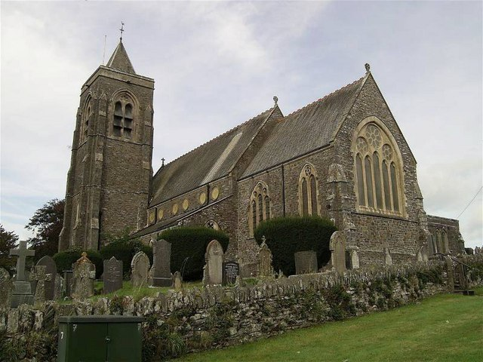
Coordinates: 52°6'55"N 4°4'56"W
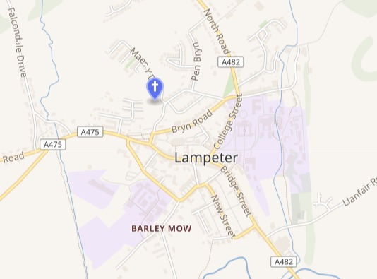
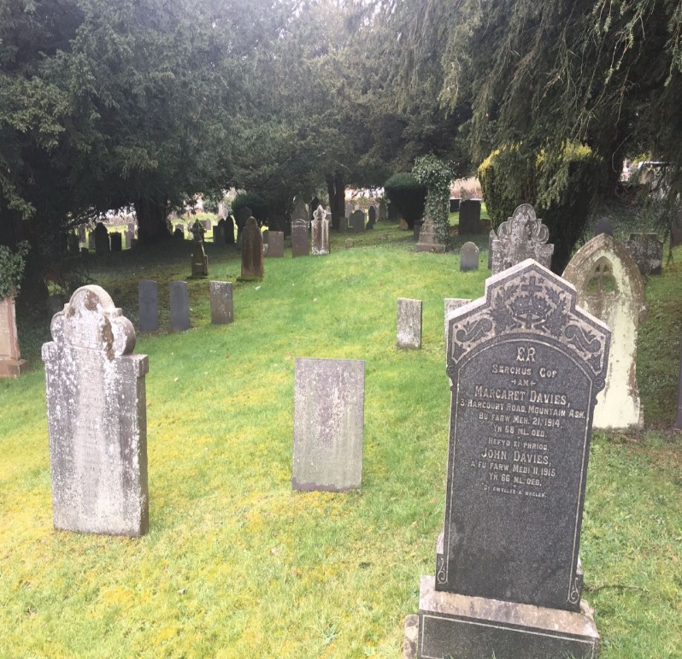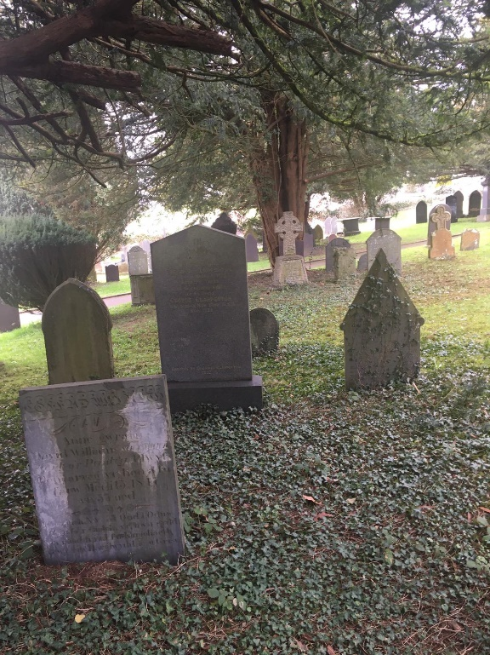
The oldest part of the churchyard is the porch in front of the church’s south-west tower. The graves are typically gothic styled. Though the churchyard is built over an earlier one, some gravestones from the older site still reside such as one dedicated to Lady Jane Lloyd of Maesyfelin, who died in 1706. Her stone panel stands out particularly as it is the only one that has a Baroque sort of aesthetic.
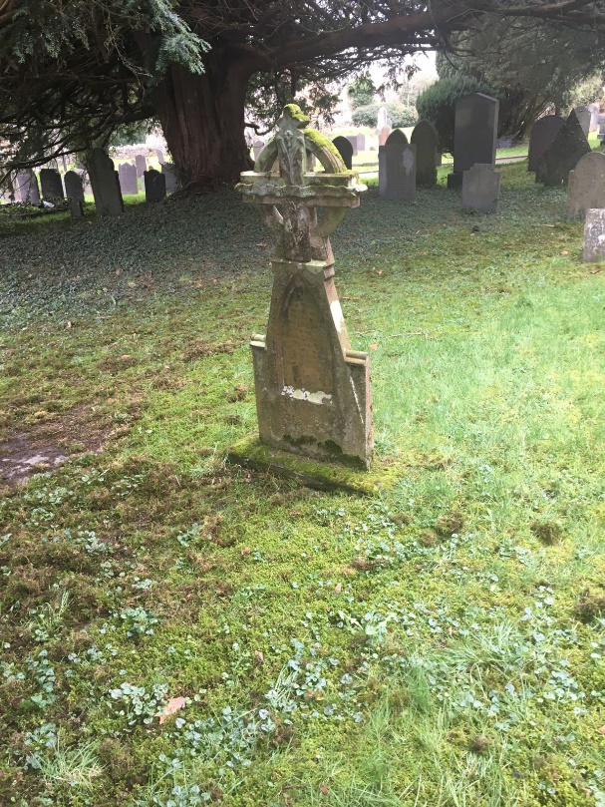
Religious iconography is ubiquitous in this part of the churchyard. Individuals have historically found a sense of identity in religion and this is very much reflected in the aesthetic style of some of the monuments. These aesthetic choices are seldom found in new monuments. Could this be due to industrial methods of mass producing headstones stripping away the uniqueness of most modern headstones or is it to do with modern culture being so consumed by ideals of individuality that identity no longer needs to be found in religion or art? And does this affect the perceived sanctity of how we commemorate the dead?

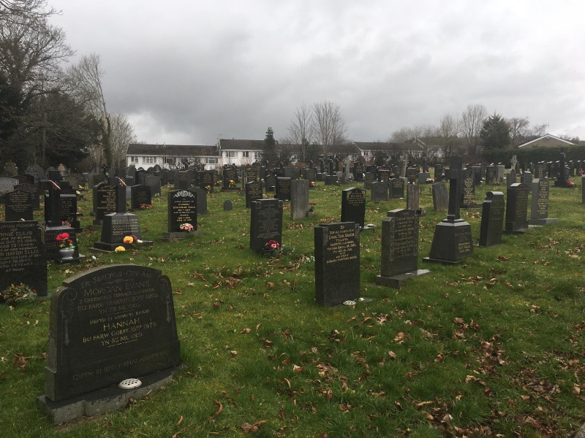
The north-west section of the churchyard was presumably built much later than the church and the rest of the graveyard as the earliest date of death I could find was 1934. A lot of the newer graves are pretty plain looking with little aesthetic diversity between. Most graves are made from shining marble with gold inscriptions. As they are modern graves, most of them were probably mass produced in a factory using machinery than chiselled by hand. This could be one way that industrialisation effects the aesthetics quality of commemoration in the modern era.

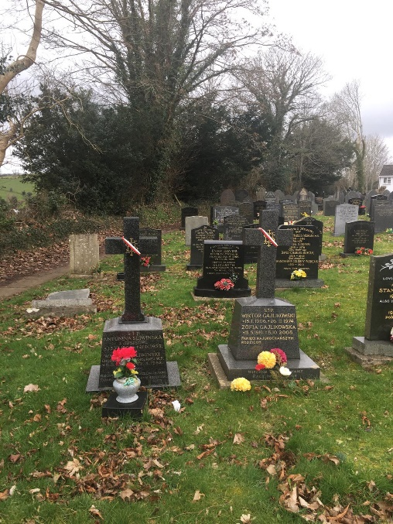
Also in the north section are graves of Graves of Polish people who moved to Lampeter during and after World War 2. The graves are marked with ribbons representing the Polish flag. Although these are individual graves, individuality seems to be expressed through national identity.

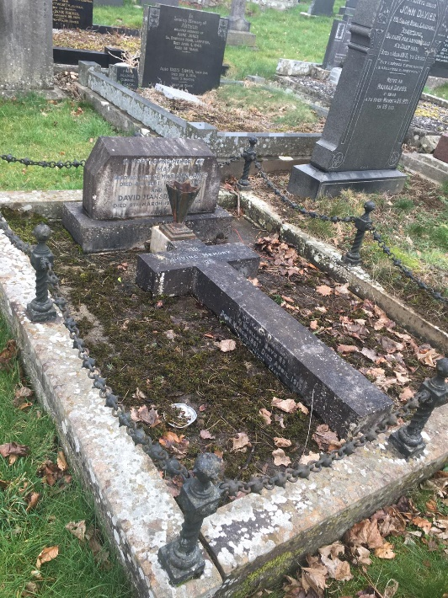
Some graves in the north section have secondary monuments. Some secondary monuments were added at a much later date. It is clear that some people still honour their ancestors enough to create a communal burial. As the process off adding secondary burials must be expensive, this tradition may mostly still survive amongst though are wealthier. This can mean that tribal identity that found through family may be mostly reserved for the upper classes.
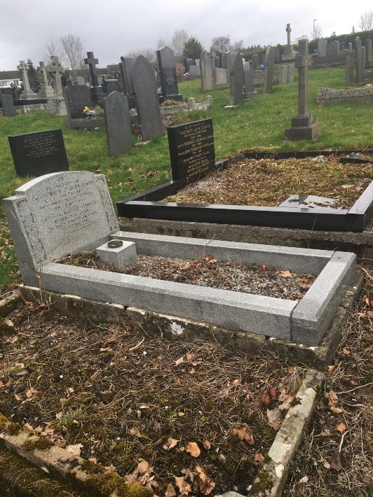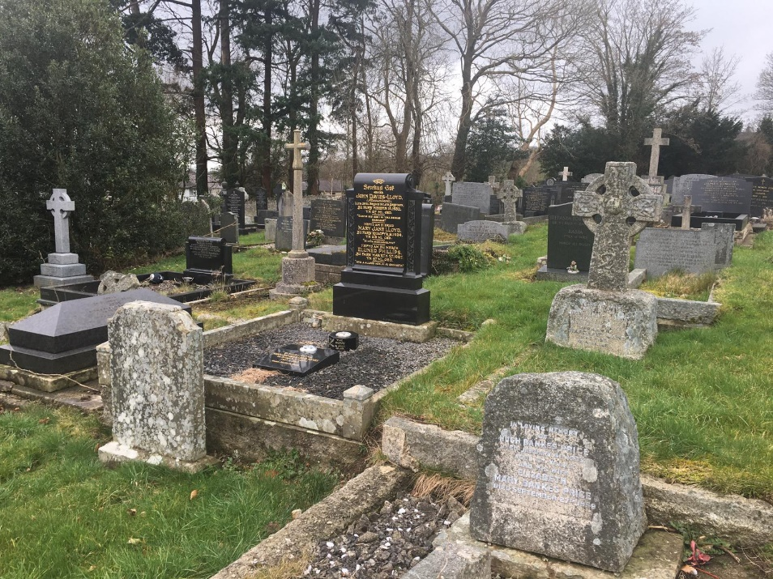Some graves are built much later and do not visually complement the others. The aesthetic style is a little bit jarring due to discrepancies between dates of burials.

Welsh monument dated around the time of the church's inception:
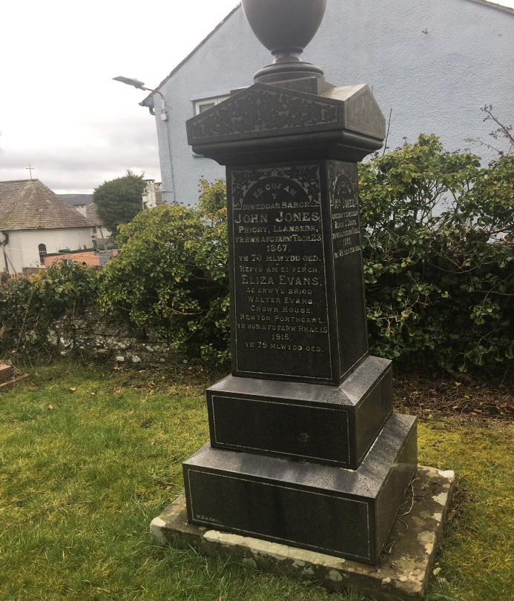
The above monument is at the back of the porch of the churchyard. Inscribed in Welsh, the writing translates in English to: “In the memory of the late reverend John Jones who died on the 23rd of November 1867 at 70 years old. Also for his daughter Eliza Evans and beloved wife of Walter Evans of Crown House, Newton Porthcawl who died on december 15th 1915 at 79 years old”.
It is a monument to a reverend who died around the same time that the church was built. Due to the aesthetic sophistication and craft put into this monument, it is likely that Reverend John Jones from a wealthy family and/or was a respected figure in his family. It is not only a monument to Reverend John but of his daughter. The reverend’s daughter is commemorated in relation, not only to her father but of her husband, Walter even though the memorial is not commemorated to him. This may be due to patriarchal and patrilineal cultural attitudes towards marriage and family. It is unclear as to whether any of those individuals are buried around the monument but a monument commemorating more than one person is common among older monuments rarer among newer ones. From the data that I have gathered, I guess that the typical family unit at the time was more communal than the typical family today and that many individuals wanted to be, or at least were expected to be, remembered in relation to their loved ones.

'Pauper graves' of poor people who worked at Lampeter Workhouse:
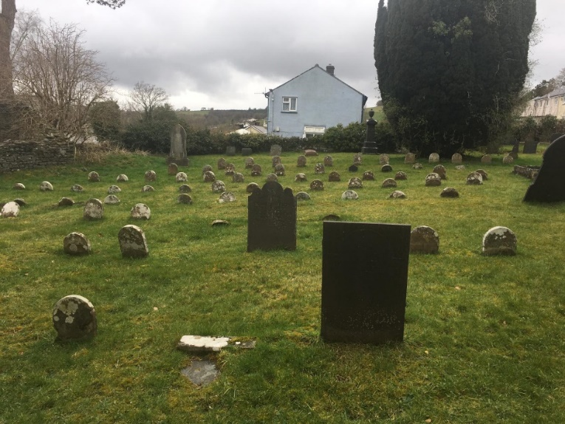

Located in the south-west are ‘pauper graves’ where poor people who lived in Lampeter’s workhouse are buried. Most graves are marked with headstones, usually standing no taller than one foot. There are exceptions to this as some graves are marked with taller headstones that have more inscriptions. As these residents were poor, they most likely could not afford more intricate headstones, hence the lack of aesthetic sophistication. This area of the graveyard seems as though it was planned in terms of economic efficiency rather than to visually complement the surrounding areas of the churchyard. Each grave is for an individual person; usually with only their name, birthyear and death year. This can be reflective of how atomising living conditions were for the poor at the time of their burial. Poor people may not have had the luxury of being buried with their families. The fact that the pauper’s graveyard is separated from the rest of the graveyard is most likely due to class distinctions.
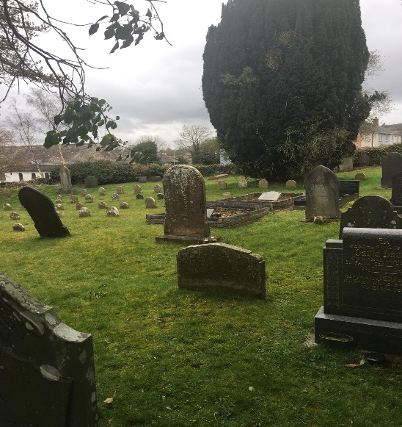
As these observations were only made through simple observation, it is difficult to decipher exactly what is happening within a larger society by looking at one graveyard. A graveyard is only a part of the wider picture when considering wider societal issues. There was not much to reflect on as most graves were lacking in overall context. The reason they may lack context may be because they represent something personal to the loved ones who may pay tribute at the site. This, to me, does not sound individualistic and seems to reflect the fact that humans still yearn for ritualisation. Ritualising a ceremony just makes sense to people. It is an indelible need that resides in humanity. There is no data that can ever prove such a phenomenon but I feel it knowledge that is inherent.
Bibliography:
Lloyd, Thomas. (2006). Carmarthenshire and Ceredigion. Orbach, Julian., Scourfield, Robert. New Haven, CT: Yale University Press

