

Financial Management Practices of Indian International Students: A Comparative Analysis between the UK and India
BY
SHUBHI PUSHKARNA
(2230035)

PROJECT SUPERVISOR: DR. NITHEESH MURUGAN KALIYAMURTHY

Project submitted as part of the requirements
for the award of Master of Science In
Data Science and analytics
By University of Wales Trinity Saint David

July 2024

Abstract
This dissertation presents a comparative analysis of personal finance budgets among international students originally from India who now reside in the United Kingdom. The report examines how these individuals manage their finances in the context of financial and economic transitions. By leveraging personal finance datasets from both regions, the research aims to identify key differences and similarities in financial management practices, shedding light on the influence of economic conditions and contrast budgeting.
Quantitative data was gathered through structured surveys targeting Indian international students in the UK, focusing on income sources, spending habits, savings behaviors, and debt management. R tool has been used to perform comparative analysis and the ARIMA model, is employed to reveal significant trends and correlations in financial practices between the UK and India. The ARIMA model was particularly useful for analyzing time-series data, helping to predict future financial behaviors based on past trends. Additionally, qualitative insights were obtained through in-depth interviews with a subset of participants, shedding light on socio-cultural influences on financial decisions. These interviews highlighted themes such as financial adaptation, cultural views on money, and the challenges of managing finances abroad.
The findings highlight distinct financial behaviours shaped by the interplay of economic conditions and contrast financial management between UK and India. The Project underscores the importance of economic factors and financial education in enhancing the financial well-being of international students. This dissertation contributes to the literature by offering insights into the dynamic intersection of personal finance, migration, and budgeting adjustments. The findings from this comparative analysis offer a holistic understanding of the financial realities, hurdles, and effective strategies adopted by international students. This valuable insight equips prospective movers with crucial information to prepare adequately for their overseas endeavours, ensuring they are well-informed about budgetary considerations beforehand.

Keywords: personal finance, international students, comparative analysis, financial management, India, United Kingdom, cultural adaptation, economic factors, savings, expenditure, debt management.

Acknowledgement

I would like to extend my sincere appreciation to my wonderful supervisor, Dr. Nitheesh Murugan Kaliyurthy, whose wise counsel and helpful suggestions were extremely helpful in the formulation of my research project. He guided me through the process of carefully crafting a cohesive and well-written proposal, which served as the basis for my research endeavours.
I also have a great deal of gratitude for my parents and friends, whose constant support and intellectual contributions have always encouraged my creative thinking. Their support has been a constant source of motivation for me throughout this quest. My sincere gratitude goes out to my friends, whose help, insightful conversations, and meaningful input greatly influenced the project's conclusion. Their efforts had a critical role in attaining the intended result, and I am extremely grateful to them.

Table of Contents

CHATPER 1 5
1. INTRODUCTION 5
1.1. Budget Analysis and Management 7
1.2. Problem Statement 7
1.3. Aim 7
1.4. Objectives 8
1.5. Budget Analysis with Data Analytics 8
CHAPTER 2 9
2. LITERATURE REVIEW 9
2.1. The Advantages of Individual Budgeting 12
2.2. United Kingdom Financial Systems and Management 17
2.3. India's Financial Systems and Management 17
2.4. Types Of Methods For Budgeting 27
2.5. Gap Analysis 29
CHAPTER 3 32
3. METHODOLOGY 32
3.1. Project Plan 35
3.2. Project Contingency Plan for Dissertation 36
CHAPTER 4 38
4. IMPLEMENTATION AND DESIGN 38
CHAPTER 5 61
5. Results 61
CHAPTER 6 63
6. Future Work 63
CHAPTER 7 64
7. Conclusion 64
Chapter 8 66
8. Reflection 66
9. References 67

CHATPER 1

INTRODUCTION

In an increasingly interconnected world, the mobility of students across international borders has become a prevalent phenomenon, accompanied by significant financial implications. This dissertation delves into the financial experiences of a specific demographic: Indian international students residing in the United Kingdom (UK). The study focuses on how these students navigate and manage their personal finances amidst the economic transitions associated with international migration.
The decision to study abroad represents a substantial financial commitment for international students, encompassing expenses ranging from tuition fees and accommodation to daily living costs and leisure activities. For Indian students in particular, studying in the UK presents both opportunities and challenges, shaped by factors such as currency exchange rates, cost of living disparities between countries, and access to financial support mechanisms.
In this modern era of "data science and advanced analytics," virtually every facet of our daily existence is meticulously recorded in digital format. A plethora of diverse data types, spanning commercial, financial, healthcare, multimedia, Internet of Things (IoT), and environmental spheres, contribute to this vast reservoir of information.
In the world of personal finance, having a thorough grasp of the complex behaviours and patterns that characterise people's money management is essential for both wise policy decisions and efficient financial planning. However, the dearth of comprehensive data sources that offer specific information on both income and expenses makes it difficult to perform a full study of personal financial budgets. Comparing financial behaviours between nations like India and the UK, which have quite different economic environments and cultural norms, highlights this problem even more.
This report aims to provide a comprehensive comparative analysis of the personal finance budgets of Indian international students in the UK, drawing insights from both quantitative and qualitative data. The application of statistical tools such as the R programming language facilitates detailed comparative analysis and the identification of significant trends in financial management practices between the UK and India.
By synthesizing both quantitative and qualitative findings, this dissertation aims to contribute valuable insights into the dynamic intersection of personal finance, migration, and cultural adaptation. Understanding the financial strategies and challenges faced by Indian international students in the UK is crucial not only for academic discourse but also for informing policies and support services aimed at enhancing the financial well-being of international student communities.
Through a nuanced exploration of financial behaviors and economic influences, this project seeks to equip prospective international students with essential knowledge and preparedness to navigate the financial landscape of studying abroad. Ultimately, this dissertation underscores the significance of economic factors and financial literacy in fostering a positive and sustainable international student experience.

Budget Analysis and Management

Budget management is analysing current expenditures, categorizing purchases, and tracking cash flow. These are all steps in managing a budget. By scrutinizing the budget, one may keep track of their income and contrast it with their outgoing expenses over time. Making crucial decisions for upcoming financial goals might be aided by conducting a budget analysis.
This dissertation will conduct a comparative analysis on personal finance budget datasets of a select group of international students. Specifically, the report will focus on examining how these students manage their finances amidst the economic transitions associated with studying abroad. The project will delve into various aspects of personal finance, including income sources, expenditure patterns, savings strategies, and approaches for financial management.
The analysis will also incorporate qualitative insights along with the quantitative data gathered through in-depth interviews with a subset of international students. These interviews will provide contextual understanding of the socio-cultural factors influencing financial decision-making among students studying abroad. Themes such as financial adaptation strategies, cultural perceptions of money, and challenges faced in managing finances in a foreign country will be explored to enrich the quantitative findings.
The findings of this study are expected to contribute valuable insights into the complex dynamics of personal finance management among international students.

Problem Statement

In today’s globalized world, individuals frequently relocate across countries, resulting in substantial adjustments to their financial management and budgeting practices. This report seeks to address the challenge of understanding and comparing the personal finance budgeting practices of individuals who have relocated from India to the United Kingdom. By examining these transitions, the study aims to identify the key differences and similarities in how individuals manage their finances before and after moving to a new country, particularly focusing on the influence of cultural and economic factors on their financial behaviours.
  - Aim
This project aims to conduct a comparative analysis of personal finance budgets for Indian students in the UK identifying key differences and similarities in financial management practices, providing insights of economic factors on personal finance.

Objectives

- Review relevant papers and credible literature to identify key economic factors and financial management practices (cost of living, savings, budgeting) for Indian students studying abroad.
- Identify and adapt an appropriate methodology for constructing the report and conducting the analysis.
- Collect comprehensive personal budget data from four Indian students who currently live in the UK and previously lived in India to conduct a comparative analysis between the two countries.
- Clean, analyze, and perform comparative analysis of the datasets using R Tool.
- Analyze findings and results from the comparative analysis to draw conclusions.

Budget Analysis with Data Analytics

Armed with data analytics one may effectively make operational decisions for their daily lives by having access to more than simply financial insights and balances. Data on operational performance and cost analysis combined may offer new insights into how to allocate resources and prioritize requirements in the most efficient and transparent way [1].
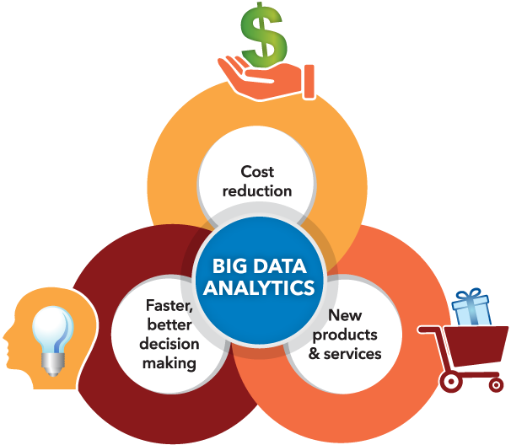
Figure 1. Importance of big data analytics in budget analysis [1]

Budget analysis entails evaluating financial data to decide how to distribute resources to effectively meet budget goals and objectives. Finding trends and patterns in financial data is one of the key advantages of data analytics in budget analysis. By doing so, one can estimate future revenue and expenses, spot areas of overspending or underspending, and allocate resources more wisely.

CHAPTER 2

LITERATURE REVIEW

To attain financial stability and long-term financial goals, personal finance management entails making well-informed decisions about earning, spending, saving, and investing money. People who manage their personal money well are better able to prepare for the future, handle unforeseen financial problems, and satisfy their present requirements. Budgeting, saving, investing, and debt management are important aspects of personal finance management.

Every family has a household budget that lists all of the family's monthly expenses as well as the sources of revenue. Although forecasts are not always accurate, they serve as a foundation for essential modifications in the event of deviations, and as such, budgets should be maintained flexible to account for this. Individuals who manage their budgets typically create targets or goals, which vary depending on the individual and serve as a clear indication of what they hope to accomplish in the future. As a result, budgeting entails goal-setting and tracking actual performance against projected performance. It's a method that is vital to the majority of organisations and people's personal money, and it need the participation of management at all levels [3].

Personal budgeting has historically been seen as a means of reducing expenditure, with a primary emphasis on allocating money to different costs. Budgeting, however, has many more applications in the intricate financial landscape of today. It keeps track of anticipated earnings and outlays and aids in financial decision-making by evaluating present and potential future costs and advantages. People need to realise that their personal budget is a component of the wider economic system and that it may both impact and be influenced by it. This process is influenced by the economic environment.[3]

It's crucial to take into account both controllable and uncontrolled aspects while making a personal budget. Personal spending patterns and sources of income are examples of controllable elements; uncontrolled factors might include changes in the labour market, the state of the economy, or unforeseen costs. Here, a flexible budget is advantageous. A flexible budget, according to Joseph Baggot, allows for modifications depending on actual financial circumstances and adjusts to changes in income and spending. In comparison, a fixed budget stays the same regardless of changes in expenditure or revenue. Personal budgets with flexibility can better account for changes in income, offering a more precise and realistic financial plan. This flexibility enables people to plan for a range of events, both positive and negative, and to keep their finances stable in a variety of economic circumstances. As a result, a well-crafted budget becomes more than just a tool for allocating funds; rather, it is a dynamic instrument for handling personal finances in a way that takes future and current economic conditions into account [3].

Establishing financial goals that direct your planned financial actions and are expressed in monetary terms as a budget is the fundamental idea behind personal budgeting. In this process, your actual financial performance will also be compared to these predetermined targets, and any discrepancies will be addressed with corrective action.

- Setting Objectives
Setting attainable financial objectives is essential for personal budgeting, just as it is in businesses. These objectives may include paying off debt, purchasing a house, or just learning how to spend money more wisely on a daily basis.

- Making Budgets
To divide your income between savings, investments, essentials (rent, utilities, food), and discretionary expenditure (entertainment, eating out), you create multiple budgets. This planning guarantees that all costs are met without going over budget and lets you see where your money is going.

- Constant Observation and Evaluation
Constantly keeping an eye on your expenditure and comparing it to your budget is essential to personal budgeting. For instance, you should be aware of this divergence if you budgeted $200 for eating out but ended up spending $250.

- Implementing Corrective Measures
Corrective action is required when deviations occur. This might entail identifying ways to raise your income, making adjustments to your budget for the upcoming month, or reducing your discretionary expenditure.

- Adaptability and Flexibility
When creating a budget, flexibility is crucial. A flexible budget adapts to changes in your financial condition, such as a rise at work, unforeseen costs, or variations in utility bills, as opposed to a set budget that stays the same no matter what. This flexibility keeps your finances stable and guarantees that your budget stays reasonable and reachable.

- Organising and Managing
Personal budgeting that works requires control and strategy. Planning makes ensuring you have a financial plan, while control is monitoring your progress and making necessary corrections. By using a dual strategy, you may stay on course to meet your financial objectives.

- Financial Situation
It's critical to comprehend how your own finances fit into the overall economic system. Your budget may be affected by changes in the economy, including inflation, interest rate changes, and employment trends. Knowing these things enables you to prepare for changes and modify your spending plan appropriately.

2.1. The Advantages of Individual Budgeting
Personal budgeting gives you a complete view of your financial situation if you adhere to these guidelines. It supports you in making wise financial decisions, preventing overspending, setting aside money for emergencies, and more successfully reaching your financial objectives. Essentially, a personal budget that is properly handled may be a very effective instrument for achieving financial success [3].

It is not a recent phenomenon that budgeting and financial management are important organisational and institutional variables.
Nonetheless, there are many worldwide perspectives on budgeting and budgetary control, and over time, a number of models and ideas have been linked to them, particularly those put forth and held by different authorities and schools of thought. The budget drives executions in an integrated manner and coordinates income, expenses, finance, and all other connected sectors. Budgets also give people the ability to make decisions on their cash management system with some hindsight and knowledge of the outcomes. Therefore, the fundamental idea of budgeting and budgetary management is that it is an all-encompassing, cohesive system that functions as a coordinated process that affects every sector, right from an individual to an organisation [3].

When Owler and Brown (1965) said that budgets should be considered from a humanistic perspective, they placed the idea of budget inside the theoretical framework. This is due to the fact that the human element of budgeting holds far greater significance than accounting methods. Any budgetary system's ability to succeed depends based on its approval by the individuals tasked with overseeing the budget and the employees who are impacted by it. Making budgets and allocating accountability are insufficient; behavioural factors also need to be considered. Owler and Brown (1965) correctly and clearly highlighted this reality when they said, "Yet, it is also necessary to consider the behavioural aspects of a system." If the individuals using the system are not taken into consideration and are not invited to participate in it, the system will be unsuccessful [3].

As previously said, one implicit interpretation of budgets and budget target setting is that they serve as a tool for control. Just as planning by itself may not always result in the implementation of a suggested course of action, budgeting proposals likewise require good control in order to be relevant. The primary goal of budgetary control is to implement the suggested course of action as stated in the budgetary framework in a way that is both functional and efficient. Budgetary control, as defined by Brown and Howard (2002), is a cost-controlling system that involves creating a budget, assigning responsibilities, coordinating the department, comparing actual performance to the budget, and acting on the results to attain maximum profitability. The Institute of Cost and Management Accountants (1990) defined it as "the establishment of budget relating the responsibility of executives to the requirement of a policy and the continuous comparison of actual with the budgeted result either to secure by individual action, the objective of that policy or to provide a basis for its revision," according to their own definition. According to the aforementioned viewpoints, measuring real performance is necessary to attain (budgetary) management and for the purpose of conducting an accurate assessment and evaluation, performance has to be regularly monitored against the allocated objective. [3].
People all throughout the world work to make their financial life better. Their financial decisions (saving, borrowing, spending, etc.) are made with the goal of enhancing their health, well-being, and financial standing by protecting and growing their assets. But making financial decisions might often prove to be very difficult. People living in today's world are seeing a rapid transformation of the financial system due to the expansion of the global economy, advances in technology, and the development of financial goods and services (such as loans that are easily accessible). If responsible financial behaviour is not exercised, people may find themselves in an unfavourable financial situation (FinB). A person's financial situation might have a detrimental effect on the economy as a whole [4].
First, financial inclusion, financial literacy, financial competence, or certain FinBs are the only areas of personal finance research that is currently available. In the field of financial inclusion, FWB (Financial well-being) is still a relatively new word, albeit [4] noted that there is still less study on FWB than there is on general well-being. To quantify FWB, previous research has either used objective metrics like income, savings, debt-to-income ratio, or a single statement satisfaction question. People with comparable objective financial circumstances, however, could see their FWB in various ways (i.e., positively or adversely).

The two cornerstones are financial literacy and financial inclusion. Financial literacy increases demand by letting people know what they may demand, whereas financial inclusion works from the supply side by delivering the financial goods and services that people need. Developing nations like India struggle with low demand, limited accessibility, and low literacy rates. The capacity of the populace to successfully manage their own money determines the state of the country's financial system [5]. In India, financial literacy has grown to be a significant problem in recent years. The general public is ignorant of basic financial concepts related to managing daily finances and long-term savings.
Numerous research on financial inclusion and literacy have been carried out on occasion both in India and around the world. In a US-based study, Hilgert, Hogarth, and Beverly found a statistical relationship between financial knowledge and habits pertaining to saves, investments, credit management, and cash flow [5].

Previous studies have mostly ignored the importance of confidence and motivation in favour of objective financial knowledge and quantifiable behaviours .However, Fernandes et al. claimed that financial literacy can only predict 0.1% of variations in FinBs based on their meta-analysis. However, a number of scholars, like Vlaev and Elliott and Xiao and Porto (2017), have attested to the greater significance that motivation and confidence play in elucidating important FinBs. Understanding how FinBs interact with elements of financial literacy can be crucial to creating financial education initiatives that help people reach their financial objectives [5].
The research that has already been done focuses mostly on the impact of specific traits on one or more chosen important behaviours independently. Since every personal financial management domain has a unique but substantial influence on people's well-being, it is imperative to incorporate a variety of these domains [5].

The present study aims to provide a thorough comparison research of personal financial budget residing in Swansea, Wales, and India. It will look at a number of topics, such as savings rates, investing habits, cost of living, income levels, and spending categories including housing, food, transportation, and healthcare. In addition to highlighting disparities in discretionary spending on entertainment and leisure. The report aims to provide a detailed understanding of the differences in personal finance management between these two distinct economic environments by utilising a range of data sources and research, including studies on financial literacy, national financial education strategies, and comparative financial well-being.

The study will compare personal finance budgets in the UK and India, focusing on a number of important aspects including income, spending, savings, and financial behaviours. Here is an overview based on available research and statistical data.

Earnings and Outlays Income Ranges
UK: As of 2023, the average yearly pay in the UK is around £31,461 [6]. When compared to India, the income is often larger, which has an impact on the ability to budget.
India: With estimates of about ₹4,80,000 (about £4,800) annually, the average yearly pay in India is much lower.

Living Expenses

UK: Living expenses are considerable, especially in big cities like London. Transportation, housing, and utilities account up a large amount of the monthly budget. For instance, depending on the area, the typical monthly rent might vary from £700 to £1,500.
India: Living expenses are comparatively cheaper. Urban and rural housing expenses differ significantly, however in a metropolis like Mumbai, the typical monthly rent is between ₹15,000 and ₹50,000 (about £150 and £500).
Investments and Savings
UK: Household savings in the UK have been comparatively low, at between 5 and 10% of disposable income.
India: Due to a cultural focus on saving and a lower reliance on credit, Indian households have historically had greater savings rates, frequently setting aside 20–30% of their income.
Investing Preferences
UK: Real estate, pensions, and equities are the most popular places to invest. Participation in retirement programmes and the stock market is rather significant.
India: Gold, fixed deposits, real estate, and mutual funds are among the most popular investment options. Although it is increasing, stock market participation is still less than in the UK.

Knowledge of finance

UK: Access to financial resources and instruction is broad, and financial literacy is comparatively strong. Still, there remain disparities, especially among younger and lower-class populations.
India: There is a decrease in financial literacy, however this is changing as a result of public and private sector efforts to promote financial literacy. The differences between rural and urban settings are substantial [7].

The comparison research reveals clear disparities in personal finance management in India and the UK. Higher living expenses and a stronger reliance on credit counteract higher income levels in the UK, whereas higher savings rates and a societal predilection for debt avoidance balance lower income levels in India. Understanding how the economic and cultural environments in both nations influence financial behaviours and budget management techniques requires an awareness of these distinctions.

Studies that compare the personal finance practices of people in different geographic areas look at the ways in which different circumstances affect how people handle their finances. These studies offer insightful information on the variations and convergences in financial behaviours that are influenced by financial systems, and economic situations.

2.2. United Kingdom Financial Systems and Management

The United Kingdom's financial system is distinguished by its high level of sophistication and development. The Financial Conduct Authority (FCA) asserts that consumer safety and transparency are highly prioritised in the UK's well-regulated financial system (Financial Conduct Authority, 2021) [8]. Numerous variables impact the financial behaviours of individuals in the United Kingdom, including as

Cost of Living: The cost of living in large cities like London is quite expensive, which affects how people plan their spending[10].
Credit availability: The United Kingdom has a strong credit framework, with a large population using personal loans and credit cards. These factors can affect how much money people spend and save [9] .

The cultural perspective on saving and investments places a strong focus on owning a property and saving for retirement, which is reinforced by tax breaks for these investments and savings [11].
Government Support: The United Kingdom's social welfare system offers unemployment compensation and health insurance, among other benefits that may have an impact on an individual's personal financial management [12].

2.3. India's Financial Systems and Management

India, on the other hand, has a varied financial system that is impacted by both contemporary financial tools and heritage. Recent years have witnessed a notable surge in financial inclusion and digital payments in the nation, as reported by the Reserve Bank of India (RBI) [13]. In India, the following are important variables that affect financial behaviour:

Variable Income Levels: People's financial budgeting is impacted by the significant differences in income levels among various demographic groups and geographic areas [14].
Cultural Norms: Alongside contemporary banking services exist traditional habits like investing in gold and saving with chit funds [15].
Access to Financial Services: Even with advancements, there may still be barriers to formal banking and credit services, especially in rural regions. These obstacles might have an impact on people's spending and saving behaviours [16].
Initiatives from the government: initiatives such as the Jan Dhan Yojana seek to improve financial inclusion by making banking services available to a greater number of people [17].

The internal ability to make decisions based on what is best for one's finances in a certain socioeconomic setting is known as financial competence. Thus, it includes all of the consumer's knowledge, attitudes, abilities, and behaviours related to resource management as well as their comprehension, selection, and utilisation of financial services that meet their needs [18].
Globally, policymakers are focused on devising approaches to enhance the financial stability, diversity, and well-being of families inside the financial system. In the last several decades, these goals have shifted focus to people's financial potential. On the one hand, people who manage their money wisely and communicate with financial service providers well are also more likely to reach their financial objectives and enhance the welfare of their family. Financially involved citizens, on the other hand, support the growth of the financial sector, which is closely linked to economic expansion . The internal ability to make decisions based on what is best for one's finances in a certain socioeconomic setting is known as financial competence. Thus, it includes all of the consumer's knowledge, attitudes, abilities, and behaviours related to resource management as well as their comprehension, selection, and utilisation of financial services that meet their needs [18].

Financial capability surveys can quantify part of this internal capacity that can be observed directly, as well as the way that internal capacity interacts with the environment that makes it possible. For instance, knowledge and cognitive abilities may be measured directly: if a respondent is well-versed in the subject, she is likely to provide an accurate response to the knowledge question (if the question is well-crafted). However, financial literacy cannot be measured in isolation from outside variables like the availability of financial products and the amount of resources. For example, if a person's salary is so insufficient to even support her current necessary requirements, she may not even consider planning for her old life. This is why assessing attitudes—that is, the reasons behind actions or inaction, as well as the degree of care for certain issues—helps paint a more complex picture of a person's capacity.

A standard financial aptitude survey typically falls short of understanding the specifics of families' financial behaviour. First, because it can occasionally be challenging to determine whether a particular approach is superior to another, and
second, since it takes more questions to fully comprehend these intricacies than can be included in a typical survey. Nonetheless, there are experimental studies that record financial transactions over durations ranging from six months to a year by visiting a small number of families every two weeks, as in the financial diaries reported by Collins and colleagues (2009) [18].

The desire for instant or current pleasure over potential future advantages might be seen as time orientation. One major factor preventing financial success is short-term temporal orientation (TO), or the need for instant satisfaction [14]. Indeed, Shepard and Turner (2019) offered proof that, in their sample of 64 nations, the positive correlation between future orientation and well-being (as evaluated by health, happiness, life satisfaction, and FWB) is strong across cultural and national boundaries. According to Kooij et al.'s (2018) meta-analysis, possessing future time views refers to an individual's subjective expectations and beliefs about their future, which encompass the capacity to establish and work towards long-term objectives as well as postpone pleasure [4].

Studies have shown that college students struggle with money management. Many students are prone to overspending and lack the discipline of budgeting (Archuleta, Dale, & Spann, 2013), Brougham et al. [19] found that college students are more likely than the general population to have compulsive buying tendencies, which are defined as the inability to control impulsive spending and illogical purchase decisions. According to Brougham et al., the general public is thought to have a prevalence rate of around 5.8%, whereas students have a prevalence rate of 6% to 15% [19].

The terms retirements, investments, and savings are not often understood by regular pupils. Many people might not understand how crucial it is to begin these disciplines as soon as feasible. An detailed set of statistics about the prevalence of these practices among students was provided by Yang and Lester (2016). It was discovered that 28% of students had investments in stocks, 21% in bank certificates of deposit, 9% in gold, 6.5% in real estate, and 6.5% in mutual funds. Of the students, 91.3% had savings accounts. When it comes to how students invest their money, these figures could even go against the grain.
It's crucial to remember that even while 91.3% of students may have an account, this doesn't always mean that they save money [19]. Additionally, Yang and Lester discovered a connection between student views and investing and savings behaviour. Students were less likely to be saving and investing their money the older their predicted retirement age was [19].

The financial behaviours of students have been found to be significantly impacted by financial socialisation during childhood. "The process of acquiring and developing values, attitudes, standards, norms, knowledge, and behaviours that contribute to the financial viability and individual wellbeing" is the definition of financial socialisation
The phrase "family financial socialisation," which describes how students' "families approached values, attitudes, and behaviours that relate to a student's financial viability and well-being," is frequently used in studies to link this idea to parental influence. According to research, family life and financial attitudes have an impact on how pupils internalise financial concepts and make financial decisions [19],

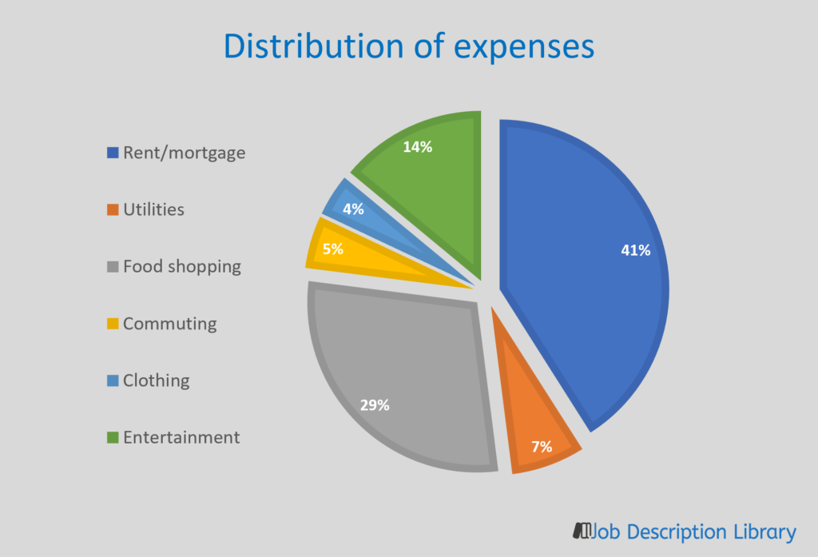

Figure 2. Distribution of monthly living costs [20]

Analysing personal budgeting and financial management requires an understanding of the UK's monthly living expense distribution. The main types of living expenditures are explained here, and they include rent, utilities, groceries, transportation, clothes, and entertainment.

1.TheRent
In the UK, especially for those living in cities, rent is usually the single biggest expenditure for both individuals and families. Depending on the property's size, nature, and location, rent might vary greatly.
Average Rent: In 2023, the Office for National Statistics (ONS) reported that the average monthly rent in the United Kingdom was around £730. However, it is important to note that average rentals in big cities such as London might reach £1,600 per month [21].
Regional Variations: The UK Housing Market Survey shows that, although London continues to be the most costly city, rental prices are also higher than average in Manchester, Edinburgh, and Birmingham [22].

2. Utilities
Gas, water, electricity, and other costs associated with running a home are considered utilities. The use, size of the household, and energy efficiency of the house can all affect these expenditures.
Average Utility prices: According to the ONS, the average UK household spends between £130 and £160 a month on utilities, with energy prices accounting for the majority of this amount [23].
Seasonal Variations: Because more energy is used throughout the winter, utility bills might change seasonally.

3. Grocery
Another significant cost area is food shopping, which includes purchasing foods and home goods.
Monthly Grocery Spending: The ONS Family Spending Survey estimates that UK families spend between £250 and £350 on groceries each month. Depending on family size, shopping habits, and dietary choices, this quantity may change [24].
Cost of Living Adjustments: Inflation, Brexit-related supply chain problems, and local product availability are a few of the variables that might affect food prices.

4. Commuting
Commuting Expenses for travelling to and from work or school such as public transportation fares, fuel, and vehicle maintenance.

Average Monthly Cost of Commuting: Depending on the method of transport and distance travelled, the Department for Transport projects that the average monthly cost of commuting is between £60 and £150. For instance, an Oyster card for Zones 1-3 in London may cost users of public transport about £150 a month [25]
Regional Variations: Because public transport is used more frequently and gasoline prices are greater in urban areas, commuting expenses are typically higher there.

- Clothing expense:
The cost of clothing and shoes for both individuals and families is covered by clothing expenditures.
Typical Clothes Spending: According to the ONS Family Spending Survey, the typical family spends between £70 and £100 on clothes and shoes each month. The amount can change according on seasonal requirements, family size, and fashion tastes [26].
6. Entertainment Expenses for hobbies, eating out, films, sports and other leisure activities are included in the category of entertainment.
Average Entertainment Costs: The ONS estimates that the average UK household spends between £150 and £200 on entertainment each month. Depending on lifestyle preferences and the availability of nearby entertainment alternatives, this might vary greatly .
In the UK, according to the above research , monthly living expenses vary greatly depending on a number of variables, including location, size of household, and personal preferences. Based on the aforementioned information, the typical monthly costs are broken down as follows:
Rent: £730 (more in London, on average)
Energy costs: £130–£160
Food Purchasing: £250 – £350
Travel expenses: £60 to £150
Clothes: £70–£100
Amusement: £150–£200
Although these numbers give a broad idea, actual costs may vary greatly based on individual situations and local cost variances.

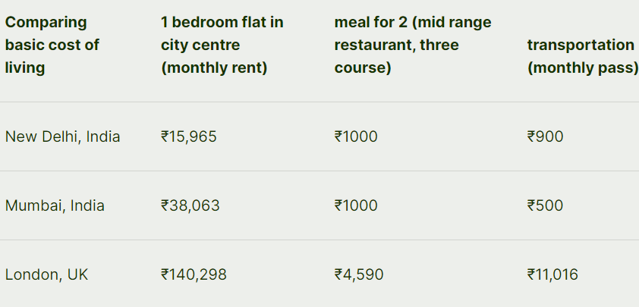
Figure 3. Comparison table of living cost between UK and India [29]

Comprehending the disparities in living expenses among various urban areas is vital when assessing personal financial management, particularly for those contemplating job or educational transfer. The above table is a comparison of the basic cost of living between London, United Kingdom, and New Delhi, Mumbai, India. In comparison to other major cities throughout the world, the monthly rent for a one-bedroom apartment in New Delhi's city centre is about ₹15,965. However, due to its dense population and vibrant economy, Mumbai, the financial centre of India, has far higher rental costs, at about ₹38,063 per month. With an average monthly rent of around ₹140,298—one of the highest rental costs globally—London, one of the world's most important financial centres, offers a striking contrast. The price of eating out also differs greatly between different cities. A three-course dinner for two at a mid-range restaurant in New Delhi comes to about ₹1,000, which is a reasonable amount. Mumbai, which has greater total living expenses, but provides a consistent dining experience for around ₹1,000.
The price of the same dinner in London, on the other hand, rises to almost ₹4,590, demonstrating the significant disparity in eating costs brought about by the greater cost of living here. Additional evidence of these differences comes from transportation expenses. As a result of the availability of many transport choices and subsidies, the monthly transit pass in Mumbai is somewhat less than that of New Delhi, at 500. A monthly transit pass in London, on the other hand, costs around 11,016, highlighting the hefty price paid for comprehensive and effective public transport networks. These comparisons highlight the enormous variances in economic conditions and lifestyle that affect individual budgeting and financial decisions, and they clearly show the disparities in living costs between New Delhi, Mumbai, and London [29].

Upon reviewing the research on the typical financial circumstances of college students, the question still stands: Why? Although there is a lot of study on the effects of student economics, a few elements are frequently mentioned.
These elements include personal beliefs like materialism and demographic characteristics like gender [19].

There are many gender stereotypes, particularly in relation to wealth. Some scholars concentrate only on this correlation, whilst others merely record findings.
Based on the demographic inquiries made at the start of their surveys. According to a number of studies (Beierlein & Neverett, 2013; Dvorak & Hanley, 2010; Lusardi & Mitchell, 2007; Peng, Bartholomae, Fox & Cravener, 2007), [19] males frequently score higher than women on financial literacy exams. Additionally, compared to males, it seems that women are often less interested in money and personal finance courses.

When it comes to expenditure, gender disparities are also common. Women were more likely than males to write checks for inadequate cash and to regret a purchase, according to one study [19]. According to Hogan, Bryant, & Overymyer-Day and Pinto, Mansfield, & Parente [19], women also often report having larger credit card balances. Although research by Koran, Faber, Aboujaoude, Large, & Serpe [19] found identical rates of obsessive shopping across both genders, women appear to have much stronger inclinations towards compulsive buying than males do. Helga Dittmar discovered that the disparity in compulsive buying behaviours across genders is less in younger samples , which might account for this discrepancy. about merchandise [19].
It follows that younger males are more likely to purchase for leisure. Each gender has acknowledged the specific places in which they want to spend their money. Women typically overpay on consumer items, whereas males typically splurge on entertainment and food [19].
Helga Dittmar observed that younger samples had a smaller gender disparity in compulsive buying habits, which she attributed to ageing (2005), about consumer items (Graves & Savage) [19].

Age is another factor that modifies even the gender inequalities in income, as was previously established. Actually, studies have repeatedly demonstrated a negative correlation between age and compulsive buying [19].
Furthermore, research indicates that debt tends to rise with age, with older students and upperclassmen accruing higher debt loads than their younger counterparts [19].

People's daily decisions are greatly influenced by their values and beliefs. Because various generations encounter distinct parts of society, college students often admire traits that older folks have either moved on from or have not experienced.
According to Roberts and Jones (2001), compared to earlier generations, today's college students were brought up in a culture that places a higher importance on status and power gained via wealth. Because of this, compared to pupils in previous generations, youngsters nowadays are more likely to have materialistic attitudes and a drive for riches. Materialism is a broad term that encompasses a variety of ideas, from consumer culture to conceptions of matter, but it essentially refers to the idea that spending and material things eventually lead to success and happiness [19].

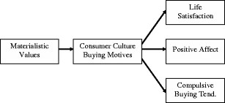

Figure 4. Diagram showing the relationships between materialism, consumer culture purchasing intentions, wellbeing, and compulsive buying [27]

A person's level of wealth accumulation stock and derivatives market investments, retirement planning ,and credit card and debt-related behaviour have all been studied in the past. Achieving financial well-being (FWB) is a significant life aim that leads to happiness and contentment. The complexity of financial goods and the shifting social context have made financial planning a more challenging endeavour. The majority of nations in the globe are seeing reductions in their post-retirement benefits. Social benefit programmes are essentially non-existent in many developing nations, including India, thus people must save and invest for their retirement. Therefore, it becomes essential for people to acquire financial understanding [28].
Financial behaviour is a function of financial knowledge and attitude, according to the financial management framework by Parrotta and Johnson [28] that emerged from the family resource management model. They also maintain that sound financial management results in sound financial management. Positive financial behaviour would make one happy and pleased with their financial situation. The financial well-being of working professionals has not been extensively studied by scholars using this idea in the past. Research has shown that those with a better understanding of money are better at making financial plans [28].
Apart from financial planning, it has been observed that enhanced financial literacy promotes favourable financial practices such as monitoring spending and creating a budget, meeting bill deadlines, making credit card payments in full, saving consistently, and investing, among other beneficial financial actions. Financial behaviour is not as essential in explaining financial well-being as financial attitude, according to Xiao et al. [28]

2.4. Types Of Methods For Budgeting

In forecasting, a variety of methodologies are employed, such as zero-based, crowd-sourced, top-down, and bottom-up methods. Any given methodology can be approached using both qualitative and quantitative methods. Comparatively, quantitative analysis is based more on mathematics, whereas qualitative analysis is based on the budget owner's judgment. Thus, there are advantages and disadvantages to both qualitative and quantitative forecasting techniques [30].

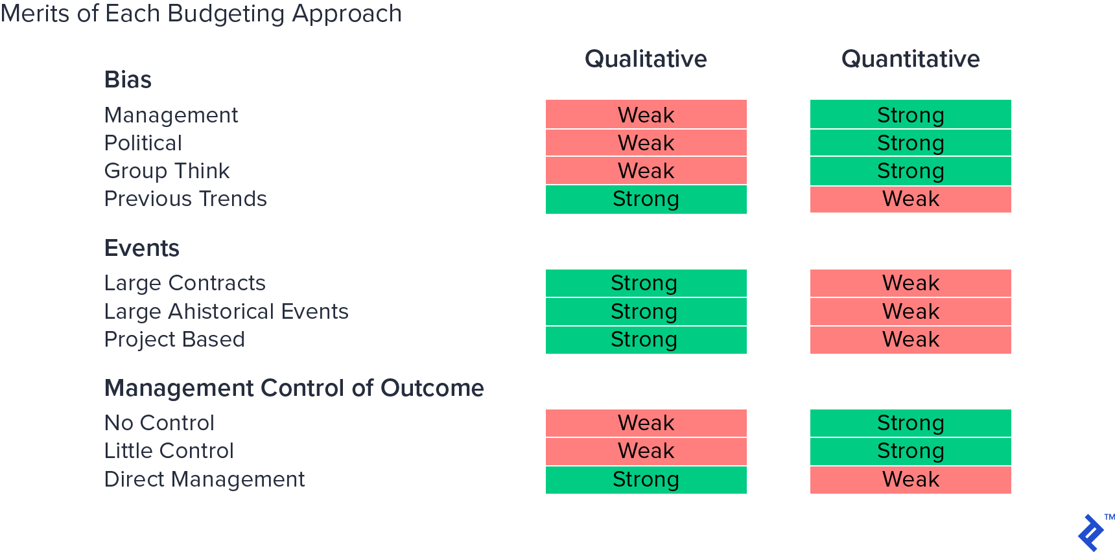
Figure 5 : Benefits of both qualitative and quantitative method of budgeting [1]

Political considerations are important to consider when assessing budgeting solutions since prejudice may significantly reduce their effectiveness. Whether it stems from a salesperson's desire to "game the system" to increase the probability of winning the bonus or from senior management's need to accomplish targets in order to satisfy investors, bias will often result in pressure throughout the budgeting process [30][31].

Given their potential to provide assumption-based error checks, quantitative procedures are better suited for collaboration with qualitative processes. Because of its overall impartiality and rapidity, Warren recommends using a quantitative method. It also examines trends of corporate growth and the "function-defining" connections between revenue and expenses of the company. These techniques are better suited for scenario planning and can offer a solid foundation for rolling predictions and benchmarking [30][31]. Predictive analytics using machine learning (ML) algorithms yields information that people or organizations may utilize to develop the AI's operating guidelines. For a few key parameters, this produces superior outcomes. The average profit and a person's lifetime financial value are both doubled by predictive analytics. Big data has enormous potential because of its use in algorithmic trading for the financial industry.

2.5. Gap Analysis
The existing body of research on comparative analysis of personal budgets in the UK and India has mainly focused on broad economic comparisons using macroeconomic indicators such as average income levels, cost of living indices and general spending categories. These studies often rely on large-scale data sets that provide a generalized view of personal budgeting in each country. While this approach is statistically rigorous, it tends to overlook the individual nuances and microeconomic factors that significantly influence personal budgeting. For example, previous studies may have provided valuable information on national averages and trends, but they have failed to capture the variability and individual experiences that shape financial decisions at the household level.
Additionally, relying on purely quantitative methods means that the rich context provided by qualitative data, such as personal stories, cultural influences and individual financial strategies, is often lacking. This leaves a gap in understanding how demographic factors, personal circumstances, and cultural context specifically influence budgeting decisions in a more nuanced and humane way.
Moreover, previous studies often provide a static snapshot of personal budgets, ignoring dynamic aspects such as changes over time and regional differences within countries. Most studies focus on urban centres such as London in the UK and Mumbai in India, ignoring the large economic and cost of living differences in rural areas and small towns. There is also a lack of longitudinal studies which follow changes in personal budgets over time, which are crucial to identify trends and evolution models influenced by factors such as inflation, changes in economic policy and global economic conditions.

In addition, although these studies largely discuss economic factors, they rarely immerse themselves in personal and cultural influences which play an essential role in financial decision -making, such as family structure, lifestyle preferences and standards cultural. This narrow perspective limits the ability of existing research to provide a comprehensive understanding of personal budgeting across the full range of economic and socio-cultural dimensions.
This dissertation addresses these important gaps by adopting a mixed approach combining qualitative and quantitative methodologies to provide a more holistic view of personal budgeting in the UK and India.By focusing on a dataset from four specific individuals, this study delves deeper into the personalized aspects of budgeting at a micro level, capturing nuances and individual experiences that are often missed in broader studies. This approach allows you to carry out a detailed analysis of the conclusion, revealing information on how specific demographic factors, personal circumstances and cultural contexts affect decisions at the budget.
The integration of qualitative data using detailed thematic interviews or studies with quantitative data not only confirms statistical results, but also enriches analysis, providing deeper context and understanding. For example, quantitative data can reveal differences in healthcare costs, while qualitative information can explain how individuals perceive and manage healthcare costs, providing a more complete picture.
In addition to this personalized approach, the study takes into account the temporal and geographical context, providing a dynamic and representative vision of personal budgeting.
By selecting individuals from different regions and considering changes over time, the study is able to uncover how personal budgets vary and change based on geographic and temporal factors, which are often overlooked in previous studies. This allows you to identify trends and patterns that reflect the real-world complexities of personal finance. Additionally, by examining personal and cultural influences on budgeting decisions, your research fills a critical gap in understanding the interactions between economic and sociocultural factors.
This comprehensive approach not only improves the validity and reliability of our findings through data triangulation, but also provides concrete, actionable insights for policymakers and individuals.
By understanding the unique economic circumstances and challenges faced by individuals, we are able to provide targeted advice on policy interventions, financial planning strategies and support programs, thereby making a significant contribution to the field and addressing the real challenges faced by people in the UK and India.

Furthermore, a thorough examination of certain income levels and specific spending subcategories is absent from the literature. A thorough analysis of personal budgets across various income levels and particular spending sub-categories, such as investments, savings, and leisure activities, is required. Current research often compare average earnings and broad categories of expenditure. While purchasing power parity (PPP) adjustments are used in certain research, this is not always done and the effects of these changes on the comparative analysis are sometimes not well explained. For more reliable comparisons, a standardised technique for PPP adjustments and a thorough examination of their effects are required.
A large portion of the research that is currently available is based on quantitative data, without qualitative insights that may contextualise the quantitative results. A deeper knowledge of personal budgets might be obtained by using qualitative data from focus groups, interviews, and case studies in addition to the quantitative study. Ultimately, although recent research outlines the distinctions between personal budgets in the UK and India, it frequently neglects to consider the consequences of these conclusions for economic and policy choices. Future studies should include suggestions based on the comparative analysis and relate findings to real-world consequences for economic planning and policy-making.
In order to fill these gaps and provide a more thorough and useful knowledge of personal budgets in these two different economic situations, a multidisciplinary approach integrating economic research with insights from sociology, cultural studies, and public policy would be needed.

CHAPTER 3

METHODOLOGY

The Onion Methodology is perfectly suited for this dissertation, offering a structured and systematic framework to manage the complex comparison of personal finance budgets among Indian international students in the UK. This methodology allows to organize my research into distinct layers, beginning with fundamental questions about financial management and extending to the various methods used, including quantitative questions and qualitative interviews. Each layer of the Onion Methodology ensures that different aspects of the research, such as data collection with the R tool and ARIMA model for quantitative analysis, as well as qualitative insights into socio-cultural influences, are thoroughly addressed and integrated. The hierarchical structure of the methodology supports a logical progression from detailed data analysis to broader discussions on economic conditions and financial education. This approach enhances the clarity and depth of the report, facilitating a comprehensive examination of the financial behaviours and strategies employed by international students as they navigate their economic transitions.
The pragmatism approach aligns perfectly with this dissertation, focusing on practical solutions and real-world applications. It permits the flexible use of both quantitative and qualitative methods, ensuring the research remains pertinent and influential. By emphasizing practical outcomes and customizing strategies to the specific context, pragmatism facilitates the integration of various perspectives and methodologies, leading to a thorough understanding of financial behaviors. This approach ensures that the project not only contributes to theoretical knowledge but also provides actionable insights for Indian international students managing their finances in the UK.
In the context of the Onion Methodology, a deductive approach is well-suited for my dissertation, as it starts with a theoretical framework on financial management among international students. This approach involves formulating specific hypotheses based on existing theories, such as the impact of financial education on budgeting effectiveness. By collecting and analyzing quantitative data through structured surveys, as well as gathering qualitative insights from interviews, I can test these hypotheses and validate the theoretical concepts. This method ensures a structured and focused investigation, leading to robust conclusions about the financial behaviors of Indian international students in the UK.
This dissertation employs an experimental approach within the Onion Methodology framework, treating the research process akin to a scientific experiment. It begins by formulating hypotheses regarding financial management among Indian international students in the UK. These hypotheses are tested rigorously through quantitative surveys and qualitative interviews, resembling the data collection and analysis phases of an experiment. The structured approach ensures systematic progression from hypothesis testing to drawing conclusions, offering insights into the financial behaviours and influences affecting this student demographic.
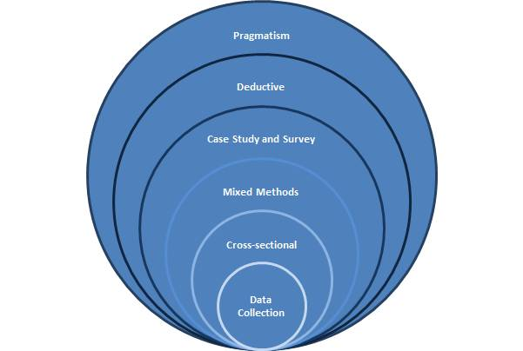
Figure 6. Research Onion Framework [35]
The mixed-methods technique, which integrates the advantages of both quantitative and qualitative procedures, is a good fit for this study. Through the use of quantitative methods to discern overarching patterns and qualitative methods to delve into individual experiences and contextual elements, this methodology offers a thorough and intricate comprehension of personal finance budgeting habits amid global mobility. The knowledge gathered from this research will be useful in determining sensible financial practices and possible resources for assistance for those going through comparable changes.

The cross-sectional phase of this dissertation uses surveys and interviews to capture current financial practices among Indian international students in the UK. It provides a snapshot of income sources, spending habits, savings, and debt management, allowing for comparisons across different student groups based on demographic factors. This approach offers insights into how these students manage their finances in the UK context, contributing to a comprehensive understanding of their financial behaviours.

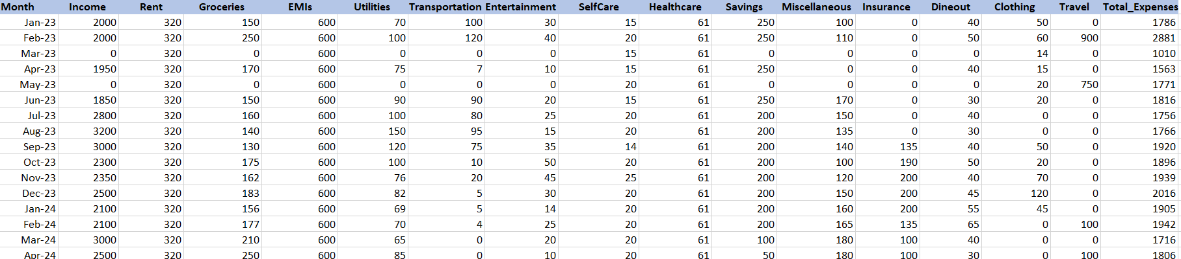
Figure 7. Screenshot of one of the budget datasets used for this project
This report covers the extraction of critical data from multiple journals, books, and articles from reputable sources like IEEE, Google Scholar, and Springer Link in order to comprehend the background and personal budget management in two different countries as of mentioned in the literature review.

3.1. Project Plan

The Gantt chart spans from April 1, 2024, to July 4, 2024, and outlines the project phases: Topic Finding, Literature Review, Methodology, Data Collection, and Report Writing and Findings.
Detailed Project Plan
1. Topic Finding (April 1 - April 30, 2024)
In the initial phase, the focus is on selecting and refining the dissertation topic. Preliminary research from April 1 to April 10 led to the topic selection on personal finance budgets. Between April 12 and April 20, detailed research defined the research questions. A meeting with the supervisor on April 25 provided feedback and approval. Resource planning from April 27 to April 30 identified necessary tools and guidelines. This phase is complete.
2. Literature Review (May 1 - May 23, 2024)
Starting May 1, relevant literature was gathered until May 9, followed by critical evaluation from May 12 to May 15. The introduction and preliminary bibliography were drafted from May 16 to May 18. The literature review was finalized between May 19 and May 23, integrating the evaluated sources comprehensively. This phase is complete.
3. Methodology (May 27 - June 28, 2024)
From May 27 to June 7, methodologies for data collection and analysis were selected, including surveys, interviews, and ARIMA modeling. The chosen methods were implemented from June 10 to June 28, involving survey distribution, interviews, and preliminary data analysis using R. This phase is complete.
4. Data Collection (June 10 - June 20, 2024)
Data collection took place from June 10 to June 20, involving structured surveys and in-depth interviews with Indian international students in the UK. This phase is complete.
5. Report Writing and Findings (June 21 - July 4, 2024)
Data analysis and conclusion drawing occurred from June 21 to June 24. The main body of the dissertation was written from June 1 to June 27, covering findings, discussion, and conclusions. The final stage, from June 28 to July 4, involves proofreading and incorporating feedback. This phase is currently in progress.

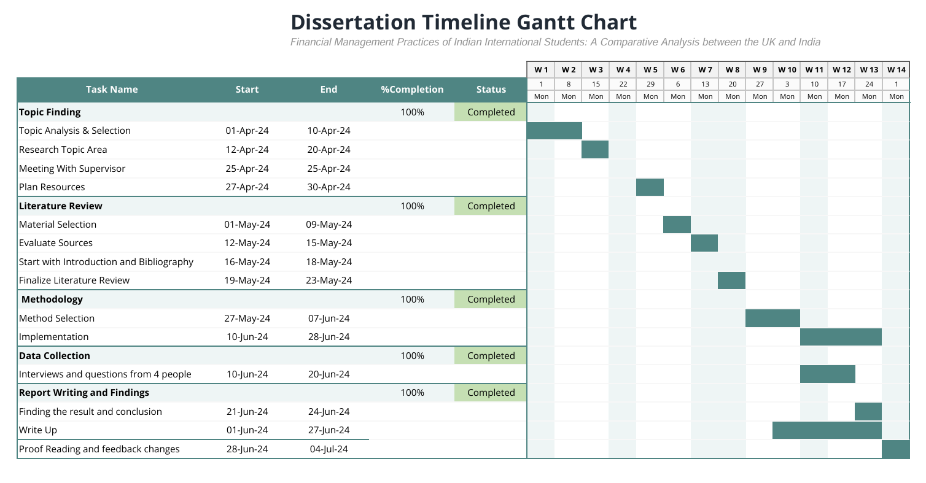
Figure 8. Screenshot of Gantt Chart prepared in excel for this project

3.2. Project Contingency Plan for Dissertation

1. Data Collection Delays: Meeting and collecting data through interviews among people can be time consuming and cause delay for the completion of the project. To mitigate this risk, we can schedule interviews well in advance and maintain a flexible timeline to accommodate follow-ups or can make online forums.
2. Technical Issues with R Tool : Risks might include a high learning curve or technical issues with the R tool. To address this, we have to set aside additional time for troubleshooting, and when problems arise, ask friends or online forums for help.
3. Finding relevant and credible literature for the report: Inability to obtain necessary readings or sources might impede development. Mitigate this risk by making use of several online databases and libraries.
4. AIRMA Model Complexity: It might be difficult to use and interpret the ARIMA model effectively. To mitigate this risk, we have to set aside more time to learn the model and consult mentors or professionals who are knowledgeable in ARIMA. To guarantee correct application, make significant use of internet materials and practice.

CHAPTER 4

IMPLEMENTATION AND DESIGN

This section presents a thorough comparison of personal budgets between residents of India and the United Kingdom. The goal is to understand spending patterns and financial allocations across various categories such as Income, Rent, Groceries, EMIs, Utilities, Transportation, Entertainment, Self-Care, Healthcare, Savings, Miscellaneous, Insurance, Dining out, Clothing, and Travel. This report provides insights into the differences in budget allocations between these two countries by utilising the power of R programming and its visualisation capabilities.
The R code provided performs a detailed analysis of monthly budget data for individuals from India and the UK. It involves several key steps: data import and preprocessing, descriptive analysis, and time series forecasting using ARIMA models. The code helps in understanding and comparing the spending patterns of individuals from the two countries across various budget categories.
Initially, the code imports necessary libraries for data manipulation and visualization, such as dplyr, ggplot2, tidyr, readr, lubridate, and readxl. It sets the working directory and reads multiple Excel files containing budget data for individuals from India and the UK. The datasets are then combined into two separate data frames: india_budgets and uk_budgets, each containing the budgets of individuals along with additional columns for Person and Country.

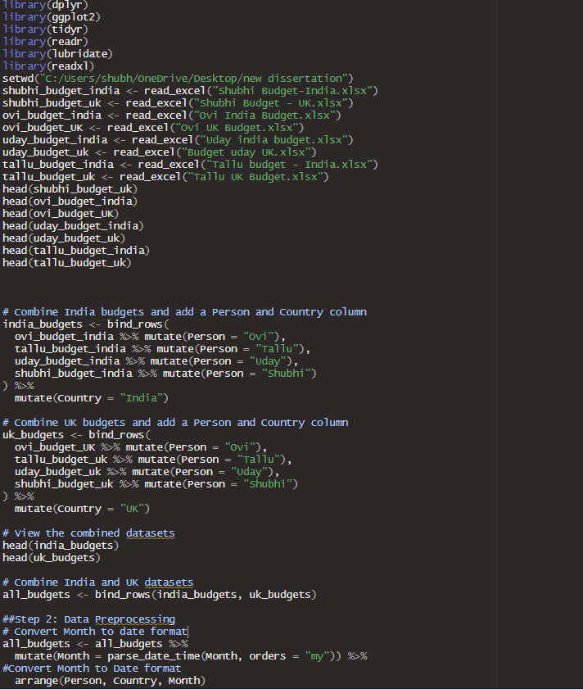
Figure 9. Screenshot of the R script for uploading and combining the datasets
After merging the datasets, the code converts the Month column to a proper date format using the parse_date_time function from the lubridate package. This step ensures that the data is chronologically ordered for accurate time series analysis. The combined dataset, all_budgets, is then inspected using the str and summary functions to understand its structure and summary statistics.
The descriptive analysis part of the code summarizes the average budget expenses for each person in both countries using the summarise function. The summarized data is then transformed into a long format to facilitate visualization using ggplot2. Bar charts are created to compare the mean values of different budget categories for each individual in India and the UK.
For a more detailed comparative analysis, the code generates line plots for each budget category, such as Income, Rent, Groceries, EMIs, Utilities, Transportation, Entertainment, SelfCare, Healthcare, Savings, Miscellaneous, Insurance, Dineout, Clothing, Travel, and Total_Expenses. These plots display the monthly trends for each person, enabling a visual comparison of spending patterns between the two countries.

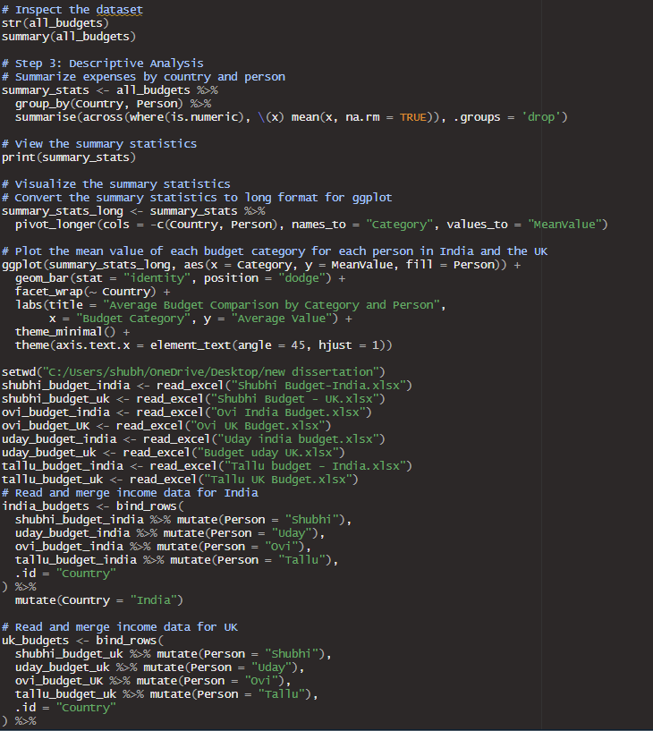
Figure 10. Screenshot of R script to generate the mean value make line plots
In the subsequent analysis, we employed the AutoRegressive Integrated Moving Average (ARIMA) model to forecast future values for various budget categories across different time series data. ARIMA is a powerful and widely used statistical technique for time series forecasting, which combines three components: autoregression (AR), differencing (I), and moving average (MA). This model is particularly effective for data that shows trends and patterns over time, making it suitable for predicting future budget values based on historical data.
The first step involved fitting ARIMA models for individual budget categories, such as Income, Groceries, Rent, EMIs, Utilities, Transportation, Entertainment, SelfCare, Healthcare, Savings, Miscellaneous, Insurance, Dineout, Clothing, Travel, and Total Expenses. For each category, the code utilized the auto.arima function, which automatically identifies the best-fitting ARIMA model parameters by minimizing the prediction error. This approach ensures that the chosen model is optimal for the given time series data. After fitting the ARIMA models, we extracted summary statistics to understand the model's performance and accuracy.
Following the model fitting, we used the ARIMA models to generate forecasts for each budget category, predicting values 12 months into the future. The forecast function allowed us to obtain these future values based on the patterns identified by the ARIMA models. To visualize the forecasted values, we employed the autoplot function, which generated plots showing both the actual historical data and the predicted future values. These plots provided a clear visual representation of how each budget category is expected to evolve over the next year, enabling us to compare and contrast the anticipated trends between India and the UK.
The ARIMA model was accurate for the project as it
analysis provided key insights into the future financial behaviors of individuals in India and the UK across various budget categories. Here's a summary of the results and conclusions:
- Future Trends Forecasted: By applying ARIMA models to historical budget data, we forecasted the next 12 months' values for each budget category, including Income, Groceries, Rent, EMIs, Utilities, Transportation, Entertainment, SelfCare, Healthcare, Savings, Miscellaneous, Insurance, Dineout, Clothing, Travel, and Total Expenses.
- Country Comparisons: The forecasted data allowed for a comparative analysis between India and the UK. This comparison highlighted potential differences in spending and saving patterns across the two countries, providing valuable insights into regional financial behaviours.
- Budget Category Insights:
  - Income and Expenses: Forecasts for income and total expenses can help identify potential discrepancies or surpluses, aiding in better financial planning.
  - Essential Expenses: Categories such as Groceries, Rent, and Utilities showed trends that could indicate future financial pressure points, guiding individuals to allocate resources more effectively.
  - Discretionary Spending: Insights into categories like Entertainment, SelfCare, and Travel can inform individuals about their potential future discretionary spending capacity.
- Financial Planning: The predictive capability of the ARIMA models provided actionable insights for strategic financial planning. Individuals could adjust their budgets to accommodate anticipated changes, such as increasing savings in response to predicted higher expenses in certain categories.
- Strategic Adjustments: For instance, if the forecasts indicated a significant rise in rent or groceries, individuals might plan to allocate more resources to these areas. Conversely, if savings trends are expected to improve, this could inform future investment strategies.
In conclusion, the ARIMA model analysis facilitated a detailed understanding of future financial trends, enabling individuals in India and the UK to make informed decisions and strategic adjustments in their budgeting and financial planning. This comparative study not only highlighted regional differences but also equipped individuals with the knowledge to better manage their finances in the coming year.

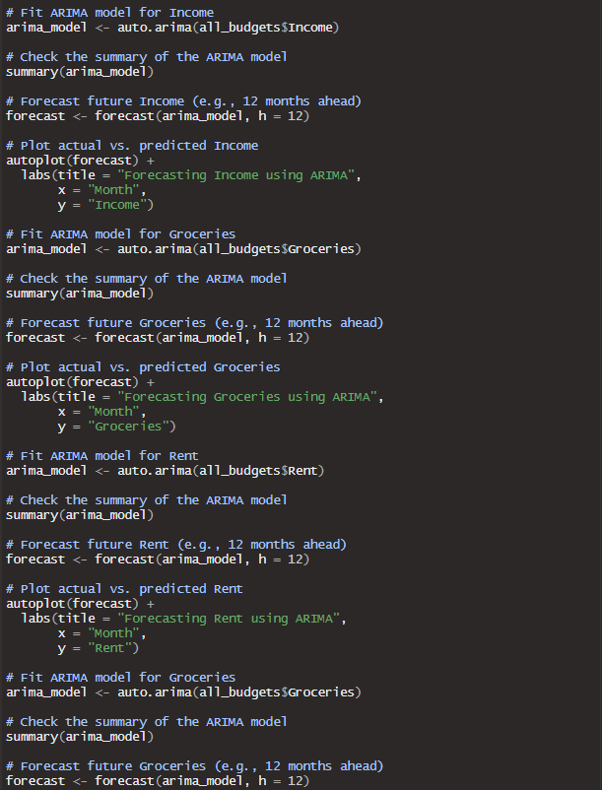
Figure 11. Screenshot of fitting the ARIMA Model
Through this comprehensive analysis, the ARIMA models helped us gain insights into the future financial behaviors of individuals in India and the UK across various budget categories. By forecasting these values, we could identify potential areas of financial concern or opportunity, providing a basis for strategic planning and decision-making. For instance, understanding predicted increases in categories like Rent or Groceries could prompt individuals to allocate more resources towards these expenses in their future budgets. Conversely, anticipated savings trends could inform financial goals and investment strategies. Overall, the use of ARIMA models in this analysis not only facilitated a detailed comparative study between India and the UK but also equipped us with actionable insights for future financial planning.
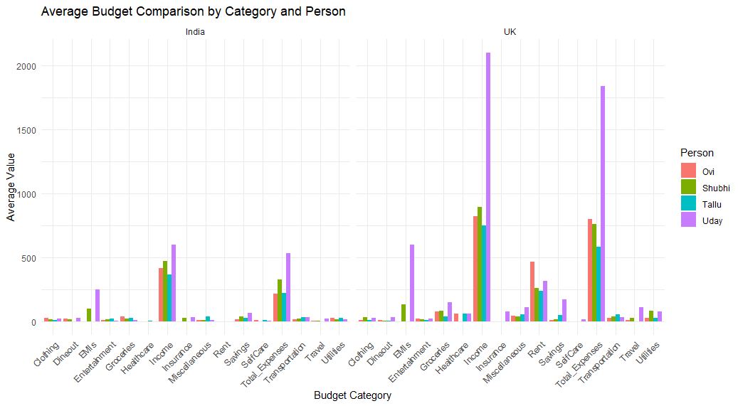
Figure 12. Screenshot of the plot representing Average Budget comparison by Category and Person
The graph presents a thorough analysis of typical budget values for four persons (Ovi, Shubhi, Tallu, and Uday) in two different countries—India and the UK—across a number of categories. The categories include a broad spectrum of financial issues, including different types of costs and revenue. Bar plots are used to depict the comparison; each bar shows the average value for a certain budget category for a given person. To provide a clear side-by-side comparison, the analysis is split into two panels: one for India and one for the UK.
Income
India: The average income for all individuals is relatively modest, with Uday having the highest average income, followed by Shubhi, Tallu, and Ovi. This suggests a possible hierarchy in earnings among the individuals.
UK: The average income values are significantly higher compared to India. Uday again leads with the highest income, but the difference between individuals is more pronounced. This indicates higher earning potential or different economic conditions in the UK.
Essential Expenses
    - Groceries: In both countries, grocery expenses are consistent and relatively similar among individuals, though the absolute values are higher in the UK, reflecting possibly higher living costs.
    - Rent: Rent expenses show a stark difference between the two countries. In the UK, rent is significantly higher for all individuals, highlighting the higher cost of housing compared to India.
    - Utilities: Similar to groceries, utility expenses are higher in the UK, indicating higher living costs. The difference between individuals within each country is minimal.

Discretionary Spending
- Entertainment: Entertainment expenses are modest in India, with slight variations among individuals. In the UK, entertainment spending is higher, particularly for Uday, suggesting a higher allocation towards leisure activities.
- Travel: Travel expenses follow a similar trend, being higher in the UK. This could indicate more frequent travel or higher travel costs in the UK compared to India.

Savings and Financial Services
- Savings: Savings exhibit considerable variation. In India, savings are moderate across individuals, with Shubhi and Tallu saving more on average. In the UK, savings are generally higher, reflecting possibly higher disposable income or different saving habits.
- Insurance: Insurance expenses are also higher in the UK, suggesting either more comprehensive insurance coverage or higher insurance costs. This category shows significant differences among individuals, indicating varied prioritization of insurance.

Miscellaneous and Other Categories
- Miscellaneous Expenses: These expenses vary widely between individuals and countries, indicating diverse spending patterns on non-essential items.
- Healthcare: Healthcare expenses are higher in the UK, possibly reflecting higher healthcare costs or different healthcare needs and coverage.
Comparative Insights
- Overall Spending: The overall spending in all categories is higher in the UK than in India. This is evident in essential expenses like rent and utilities, as well as discretionary spending such as entertainment and travel. This suggests a higher cost of living in the UK.
- Income vs. Expenses: While incomes are higher in the UK, expenses also rise correspondingly. This balance might indicate different economic conditions and living standards between the two countries.
- Individual Differences: Within each country, individual spending patterns show variability, with Uday consistently spending more in almost all categories, both in India and the UK. This could be due to higher income or different personal preferences and lifestyle choices.
The plot effectively illustrates the differences in budget allocation between individuals in India and the UK, highlighting both the higher income and higher living costs in the UK. This comparative analysis provides valuable insights into how financial priorities and expenditures vary between countries and individuals, which can inform financial planning and decision-making processes.
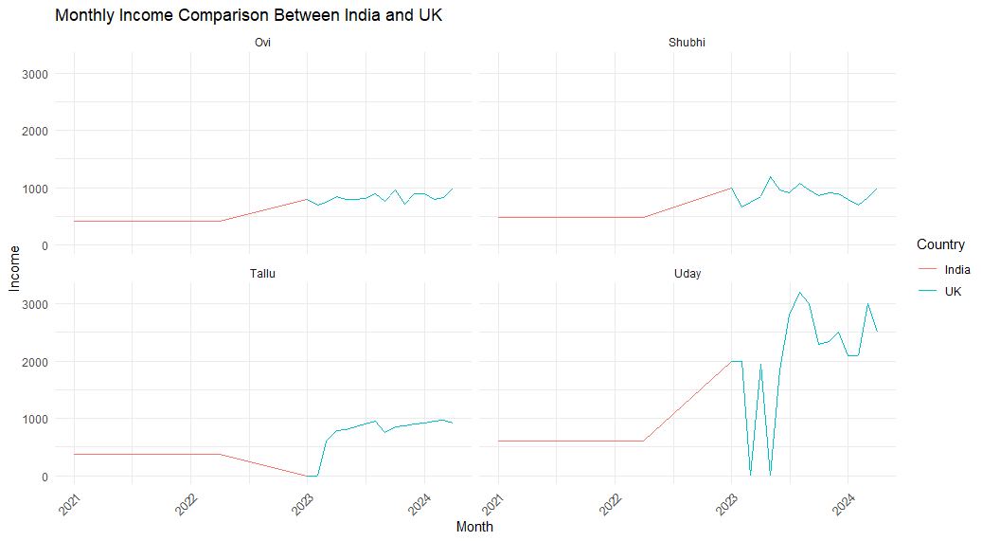

Figure 13. line graphs comparison of Income between 4 people

The graph provides a detailed comparison of monthly incomes for four individuals—Ovi, Shubhi, Tallu, and Uday—across two countries, India and the UK. This comparison spans several years and illustrates how each person's income has evolved over time in both countries. The plot is divided into four subplots, each representing an individual's income trajectory.
Ovi's Income Trajectory
- India: Ovi's income remains constant until mid-2023, after which there is a noticeable increase. The income stabilizes after this rise, indicating a period of financial growth.
- UK: Upon moving to the UK, Ovi's income shows a steady increase, eventually stabilizing at a higher level compared to India. This suggests a significant improvement in earnings post-migration.
Shubhi's Income Trajectory
- India: Similar to Ovi, Shubhi's income remains flat until mid-2023. The subsequent increase in income signifies a positive financial change during this period.
- UK: In the UK, Shubhi's income demonstrates more variability, with fluctuations around a generally higher average than in India. This could imply a more dynamic or volatile income environment in the UK.
Tallu's Income Trajectory
- India: Tallu's income remains stable and relatively low until the end of 2022. There is a slight decline before a dramatic increase as Tallu transitions to the UK.
- UK: The move to the UK marks a substantial rise in Tallu's income, which quickly stabilizes at a higher level. This indicates a significant financial improvement post-relocation.
Uday's Income Trajectory
- India: Uday's income is stable until mid-2023, followed by a substantial increase, reflecting a notable rise in earnings.
- UK: Uday experiences the most significant income fluctuations in the UK. Despite the volatility, the general trend indicates a higher income level than in India, pointing to greater earning potential but also more income variability.
- Income Levels: Across all individuals, incomes are higher in the UK compared to India. This is consistent for each person, suggesting a general trend of higher earning potential in the UK.
- Income Stability: While incomes are higher in the UK, there is also more fluctuation and variability, particularly noticeable for Uday and Shubhi. This might indicate a more volatile job market or variable compensation structures in the UK.
- Financial Growth: Each individual shows a marked increase in income upon transitioning to the UK. This consistent rise underscores the economic opportunities available in the UK compared to India.
- Temporal Trends: The increases in income generally occur around mid-2023 for those transitioning from India to the UK. This timing might correlate with specific career advancements or economic conditions favorable to income growth.

The graph effectively highlights the differences in monthly incomes for four individuals before and after relocating from India to the UK. It illustrates not only the higher income levels achievable in the UK but also the associated income variability. This analysis provides valuable insights into the financial impacts of migration and the economic opportunities in different geographic contexts.

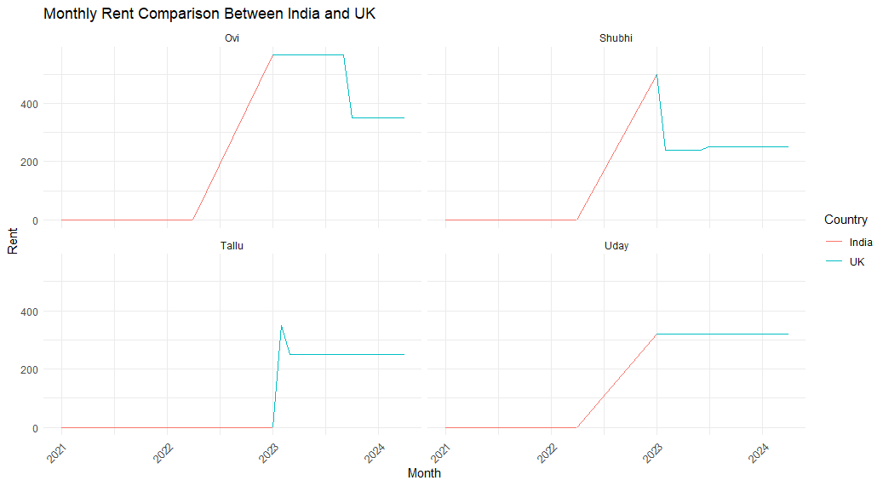

Figure 14. Rent comparison between UK and India

The graph titled "Monthly Rent Comparison Between India and UK" provides a visual representation of rent trends for four individuals (Ovi, Shubhi, Tallu, and Uday) over a period from 2021 to 2024. Each panel within the graph corresponds to one of these individuals, showcasing their rent expenses in both India (depicted in red) and the UK (depicted in blue).
For Ovi, the graph indicates that rent expenses in India were negligible until mid-2023, followed by a significant increase. Upon moving to the UK, Ovi's rent initially decreased but later stabilized at a lower value compared to the peak in India. This suggests a transition to more affordable or stable housing in the UK.
Shubhi's rent trend shows a constant low level in India until mid-2023, after which there is a sharp increase. In the UK, Shubhi's rent experiences an initial drop post-relocation, then stabilizes. This pattern indicates a significant change in housing costs and adjustments to more affordable living arrangements in the UK.
Tallu's rent remains stable and low in India until the end of 2022, with a noticeable increase following relocation to the UK. In the UK, Tallu's rent rises significantly but stabilizes quickly at a higher level, suggesting the establishment of a more permanent housing solution.
Uday's rent expenses in India show no change and remain low until mid-2023, when there is a dramatic increase. After relocating to the UK, Uday's rent expenses rise significantly and stabilize at a higher level. This pattern is consistent with the other individuals, highlighting a significant financial impact due to the higher cost of living in the UK.
Overall, the graph demonstrates that all individuals experienced higher rent expenses upon moving to the UK, reflecting the higher cost of living for housing in the UK compared to India. Despite the initial increase in rent expenses, the values quickly stabilize, indicating successful transitions to stable accommodation in the UK. This analysis provides valuable insights into the financial implications of migration, particularly concerning housing costs.

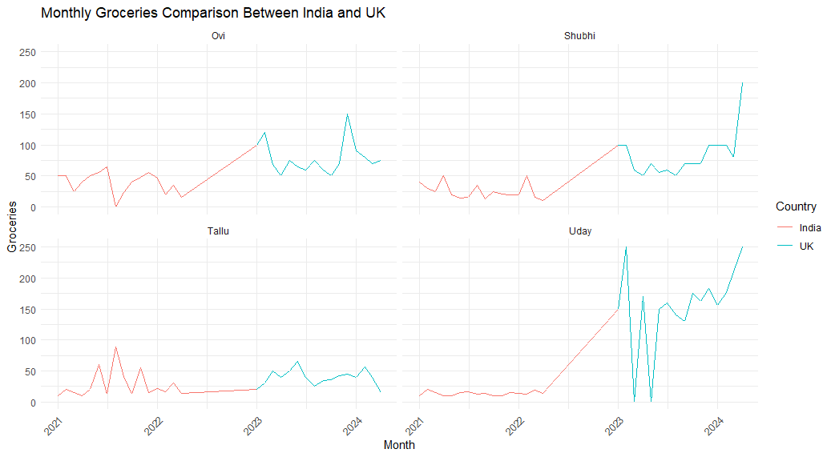

Figure 15. Screenshot of Groceries comparison between UK and India
The chart illustrates the monthly grocery expenses of four individuals—Ovi, Shubhi, Tallu, and Uday—in India and the UK from 2021 to 2024. Each subplot represents the expenditures of one individual, with red lines indicating expenses in India and blue lines representing expenses in the UK. Notably, each individual shows a distinct pattern in their spending habits. Ovi and Shubhi exhibit relatively stable expenses in India, followed by a significant rise once they move to the UK. Tallu's expenses in India demonstrate some fluctuation before stabilizing, and upon moving to the UK, a slight increase is observed. Uday's expenditure shows a substantial rise towards the end of the observed period, especially when moving to the UK.
Overall, the comparison underscores a consistent trend across all individuals: grocery expenses are significantly higher in the UK than in India. The data suggests that moving from India to the UK leads to increased grocery spending, reflecting the higher cost of living in the UK. Each individual's spending patterns, while unique, collectively illustrate the broader financial impact of geographical relocation on daily living expenses.

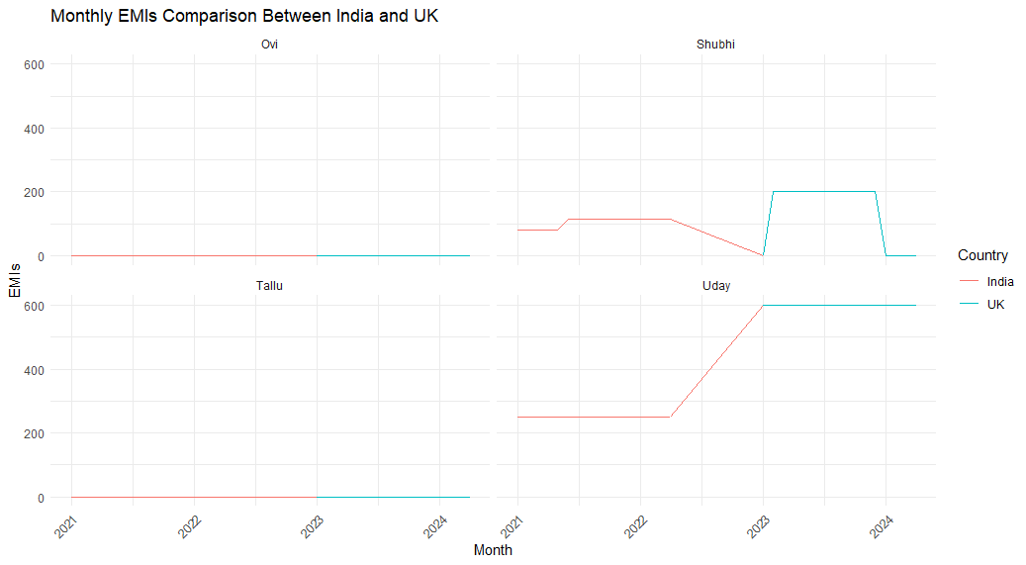
Figure 16. Screenshot of EMIs comparison graph between UK and India
The chart displays the monthly Equated Monthly Installments (EMIs) of four individuals—Ovi, Shubhi, Tallu, and Uday—in India and the UK from 2021 to 2024. Each subplot corresponds to one individual, with red lines denoting EMIs in India and blue lines representing EMIs in the UK.
For Ovi, the data shows no EMI payments in either country, indicating no financial commitments in terms of installments during the observed period.
Shubhi's EMI payments are consistent in India, beginning around 100 units in early 2022, increasing slightly, and then decreasing before moving to the UK. In the UK, Shubhi's EMIs spike to around 500 units for a short period in 2023, before dropping to zero, suggesting a temporary financial obligation that was fully paid off or resolved quickly.
Tallu's EMI data indicates no payments in both India and the UK throughout the period, similar to Ovi, indicating no installment-based financial commitments.
Uday's EMI payments in India start around 50 units in early 2022, gradually increasing to about 300 units by mid-2022, and then remain stable. Upon relocating to the UK in early 2023, Uday's EMI payments remain at 300 units, indicating a consistent financial obligation despite the geographical change.
Overall, the comparison highlights varied financial commitments in terms of EMIs among the individuals. While Ovi and Tallu have no EMI commitments in both countries, Shubhi and Uday show notable differences. Shubhi's EMIs are significantly higher in the UK, albeit for a brief period, indicating a short-term but substantial financial obligation. Uday's consistent EMI payments before and after relocation suggest a stable and ongoing financial commitment. This comparison underscores the diverse financial landscapes and obligations faced by individuals when transitioning between countries.

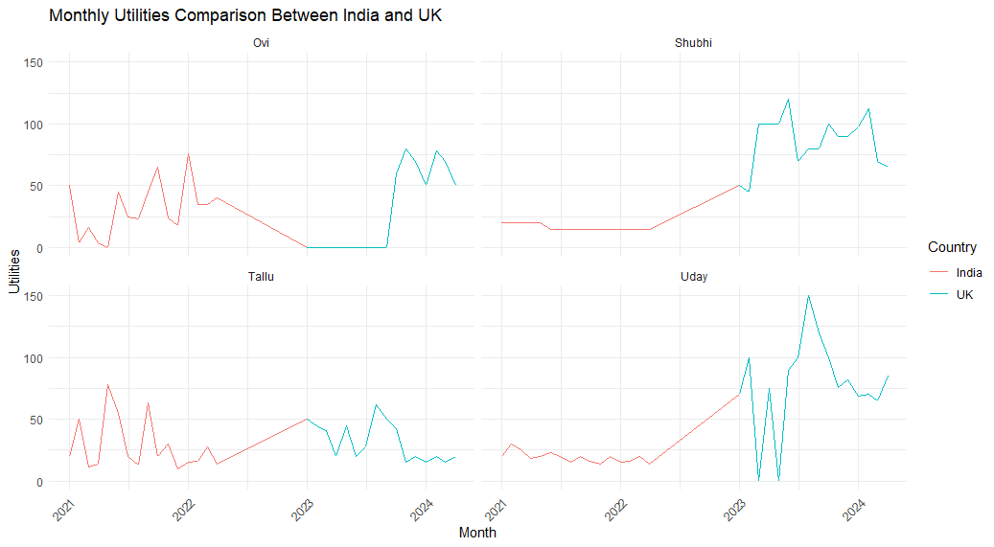

Figure 17. Comparison Plots of Utilities between UK and India
The chart compares monthly utility expenses for four individuals—Ovi, Shubhi, Tallu, and Uday—in India and the UK from 2021 to 2024. Key observations are:
- Ovi: Utility costs in India fluctuate between 20-60 units, with occasional peaks near 100 units. After moving to the UK in early 2023, expenses stabilize around 60-80 units, showing a higher but steadier cost.
- Shubhi: In India, expenses are stable at about 20 units, slightly increasing towards late 2022. In the UK, starting in early 2023, costs rise significantly to 80-120 units, indicating a marked increase in utility expenses.
- Tallu: Utility costs in India vary from 20-80 units. After relocating to the UK in early 2023, expenses initially drop to around 40 units but then stabilize between 40-60 units, reflecting less variability and a slight overall decrease.
- Uday: Expenses in India are stable and low, around 10-20 units, gradually increasing from mid-2022. After moving to the UK in early 2023, costs sharply rise to around 120 units before stabilizing around 80 units.
In summary, utility expenses are generally higher and more stable in the UK for all individuals compared to India, highlighting the increased cost of living after relocation.

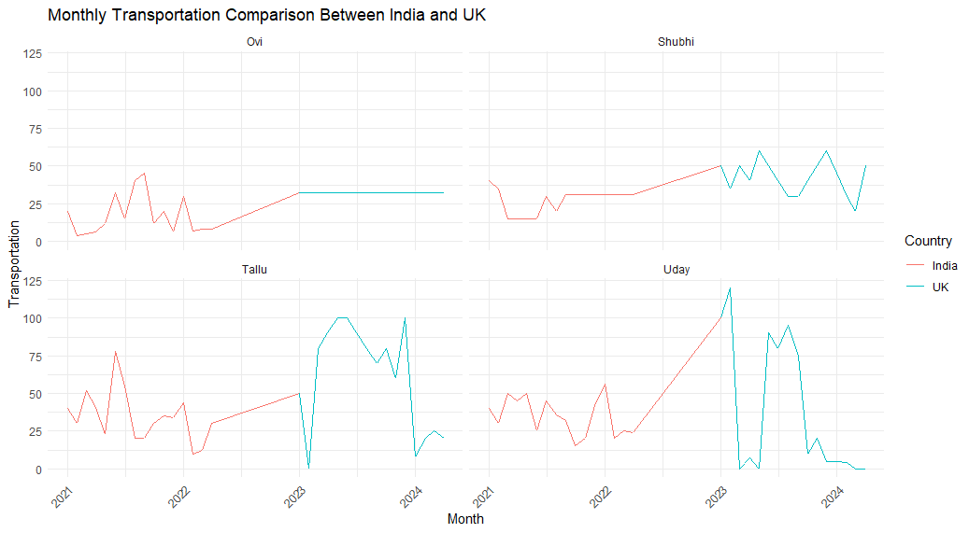

Figure 18. Comparison of transportation expense between UK and India
The provided graph presents a comparison of monthly transportation data between India and the UK among 4 people : Ovi, Shubhi, Tallu, and Uday. For Ovi, India’s transportation data shows slight fluctuations from 2021 to early 2023, with values generally under 50, stabilizing around 25 afterwards. The UK's data for Ovi starts in early 2023 and remains stable at 25. In the Shubhi category, India's data initially drops slightly in 2021 and then stabilizes, with a modest increase beginning in late 2023. The UK's data for Shubhi appears from late 2023, fluctuating between 25 and 50.
For Tallu, India's data fluctuates significantly from 2021 to early 2023, with values ranging from 25 to 75, before stabilizing and dropping in early 2023. The UK's data for Tallu starts in early 2023, peaks around 100, and then drops sharply by 2024. In the Uday category, India's data shows minor fluctuations from 2021 to early 2023, remaining under 50, followed by a sharp increase starting mid-2023 and peaking around 125. The UK's data for Uday begins mid-2023, initially peaking near 100 before declining significantly towards 2024.
Overall, the analysis reveals that India's transportation data for Ovi and Shubhi is relatively stable with moderate fluctuations, while Tallu and Uday exhibit more pronounced variability and peaks. In contrast, the UK's transportation data, available only from early 2023 onwards, shows significant peaks followed by sharp declines in categories like Tallu and Uday. This comparison underscores differing transportation trends and volatilities between India and the UK over the observed period, suggesting possible underlying factors influencing these differences.
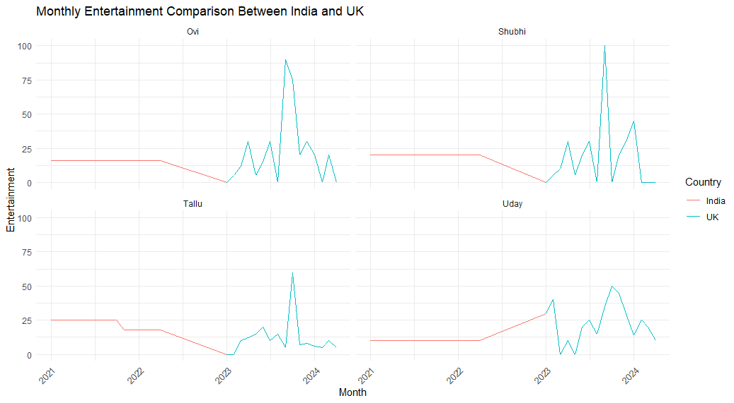

Figure 19. Comparison Entertainment between India and UK
The comparison of monthly entertainment data between India and the UK across the four people (Ovi, Shubhi, Tallu, and Uday) reveals distinct patterns and suggests several insights about the entertainment consumption trends in the two countries.

- Consistency vs. Volatility: India exhibits a consistent and steady pattern in entertainment consumption, suggesting a stable market with less sensitivity to external events. In contrast, the UK's entertainment consumption is more volatile, reflecting a market that is highly responsive to specific stimuli and changes.
- Market Dynamics: The steady trends in India may indicate a mature market with well-established consumption habits, while the UK's fluctuating trends might reflect a more dynamic and rapidly changing market environment.
- Cultural Differences: The differences in patterns could also point to cultural variations in how entertainment is consumed. India's consistent trends might suggest a preference for routine and steady engagement, whereas the UK's peaks and troughs indicate a culture that thrives on events and novelty.
Overall, the comparison suggests that India's entertainment market is characterized by stability and predictability, whereas the UK's market experiences significant fluctuations, driven by events, seasons, and other external factors. This reflects broader cultural, economic, and market dynamics in the two countries.
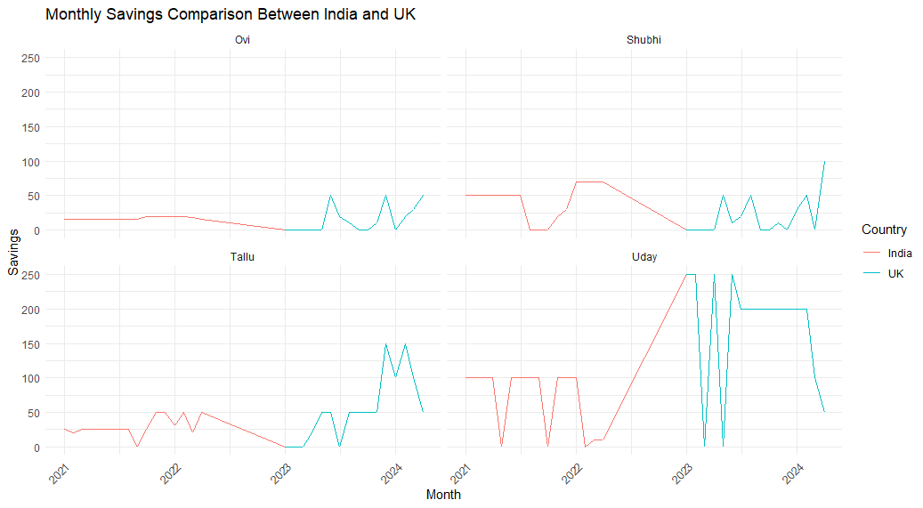
Figure 20. Savings Comparison between UK and India

The graph illustrates the monthly savings trends for four individuals—Ovi, Shubhi, Tallu, and Uday—comparing their savings between India and the UK over the period from 2021 to 2024. Each subplot represents an individual's savings, with red lines indicating savings in India and blue lines representing savings in the UK.
For Ovi, savings in India remain relatively flat, whereas savings in the UK show an upward trend starting around mid-2023. Shubhi’s savings in India have some fluctuations and eventually decline, while her UK savings start around mid-2023 and show a gradual increase. Tallu's savings in India exhibit slight variations before dropping to zero, with a significant increase in UK savings beginning in early 2023 and peaking in early 2024. Uday’s savings pattern in India shows a decrease followed by a rise in late 2023, while his UK savings, which begin around early 2023, increase sharply before declining slightly.
Overall, the data highlights that all four individuals began saving in the UK later than in India, but their UK savings have generally shown an upward trend, suggesting a potential financial benefit or preference for saving in the UK during the observed period.

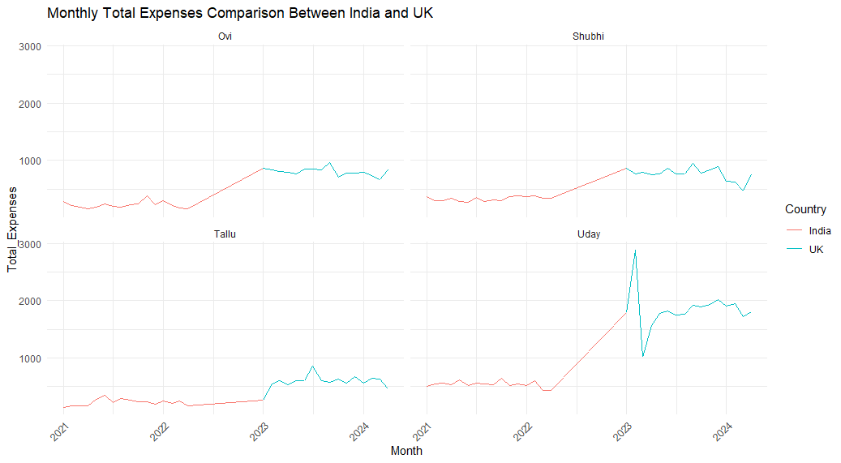
Figure 21. Comparison of Total Expenses between India and UK

The chart titled "Monthly Total Expenses Comparison Between India and UK" displays the total monthly expenditures for four individuals (Ovi, Shubhi, Tallu, and Uday) over a span of several years. The data is segmented into two distinct periods: while living in India and after moving to the UK.
For each individual, there is a noticeable increase in total expenses upon moving to the UK, as indicated by the shift from red (India) to blue (UK) lines. Ovi and Tallu exhibit relatively stable expenses in India, but their costs rise significantly in the UK, maintaining a higher but steady level thereafter. Shubhi's expenses also increase upon relocating to the UK but show less fluctuation compared to others. Uday's expenses present a dramatic rise with substantial spikes, highlighting possibly high initial settlement costs or other variable expenses, before stabilizing at a higher average compared to his time in India.
This comparative analysis illustrates the higher cost of living in the UK for Indian students, emphasizing the need for enhanced financial management to accommodate the increased expenses in a foreign country. The steady expenditure patterns in the UK also suggest that while the initial adjustment phase may involve considerable spending, expenses tend to stabilize over time

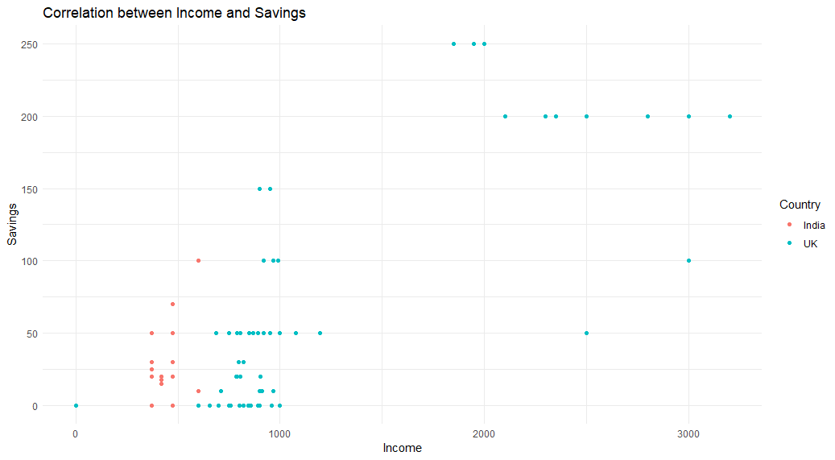

Figure 22. Correlation graph between Income and Savings
The scatter plot visualizes the relationship between income and savings for individuals in India and the UK. Each dot represents a data point, with red dots corresponding to India and blue dots to the UK.
In India, the savings tend to cluster at lower income levels, with a range up to about 150 units of savings. There is a noticeable concentration of data points around the lower income range, with fewer savings as income increases. Conversely, the UK shows a broader distribution of savings across higher income levels. UK savings data points extend up to around 3000 units of income, indicating a positive correlation between higher income and higher savings.

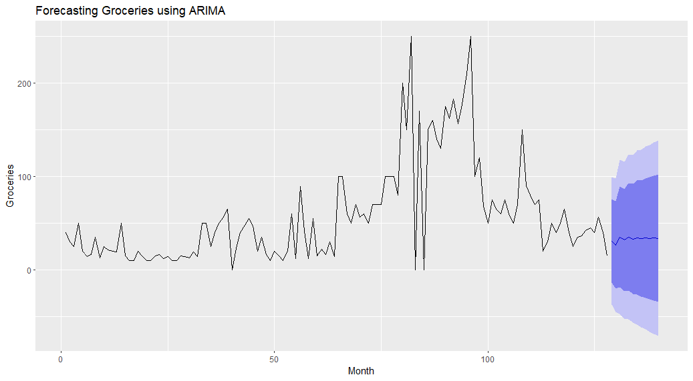
Figure 23. Groceries Prediction using ARIMA model
The plot displays a time series forecast of grocery expenditures using the ARIMA (AutoRegressive Integrated Moving Average) model. The black line represents actual grocery expenses over time, showing fluctuations and peaks. The shaded blue region represents the forecasted values along with their confidence intervals.
Initially, grocery expenses show a fluctuating but generally stable pattern. Around the midpoint, there is a significant increase, peaking above 200 units. Towards the end of the observed period, expenditures decrease but remain variable. The ARIMA model projects a continuation of this trend with a gradual increase, as indicated by the forecast line. The confidence interval widens over time, reflecting increasing uncertainty in the prediction.

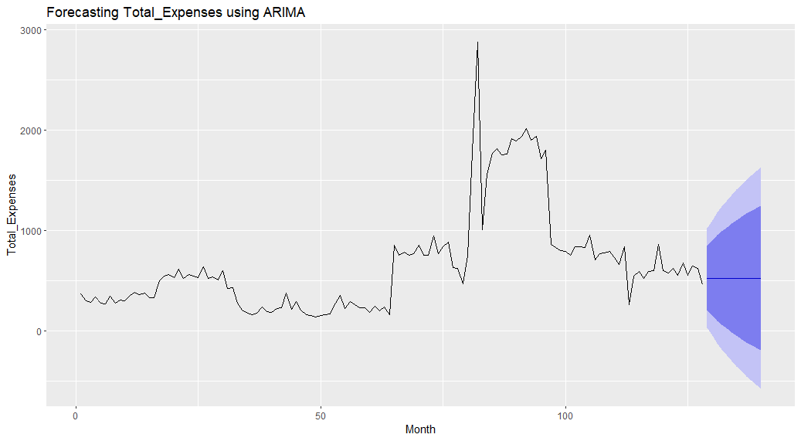
Figure 24. Total expenses prediction using ARIMA

The provided plot illustrates the forecasting of Total Expenses over a period using the ARIMA model. The black line represents the actual total expenses recorded each month, while the blue line projects the predicted future expenses for the next 12 months. The shaded area around the blue line indicates the confidence intervals, showing the range within which future expenses are expected to lie.
The forecast suggests a fluctuation in total expenses with a general upward trend over the next year. The confidence intervals, represented by the shaded area, widen over time, reflecting increasing uncertainty in the predictions as the forecast horizon extends. This projection can help in budget planning and financial decision-making for the coming months.

CHAPTER 5

Results

The comparative analysis of personal finance between Indian students living in the UK and their previous financial situations in India reveals significant insights. The data was gathered from four participants: Ovi, Shubhi, Tallu, and Uday, focusing on various aspects such as income, rent, and total expenses.
Monthly Income Comparison
The monthly income comparison chart illustrates a distinct increase in earnings for each participant u. pon moving to the UK. Ovi, Shubhi, Tallu, and Uday all experienced a noticeable rise in income, which remained relatively stable once settled in the UK. This suggests that while the income potential is higher in the UK, it also indicates a consistent financial environment once the initial transition period is over.
Monthly Rent Comparison
The analysis of rent expenditures shows a marked increase for all participants after relocating to the UK. In India, rent expenses were either minimal or non-existent. Upon moving to the UK, all four participants faced higher rent costs. For instance, Ovi and Shubhi's rent expenses spiked significantly after moving, stabilizing at a higher level in the UK. This sharp rise underscores the substantial difference in housing costs between the two countries.
Monthly Total Expenses Comparison
The total expenses comparison chart highlights the overall increase in monthly expenditures after moving to the UK. Each participant showed a pattern of higher spending in the UK compared to their time in India. Ovi and Tallu had stable but increased expenses, while Shubhi's expenditures showed less fluctuation. Uday, however, experienced dramatic spikes, indicating possibly high initial settlement costs before stabilizing at a higher average. This overall trend signifies that Indian students face higher living costs in the UK, impacting their financial management strategies.
Forecasting Total Expenses Using ARIMA
Using the ARIMA model for forecasting future total expenses provided valuable insights into anticipated financial trends. The model, which was applied to the total expenses data, projected an increase in expenses over the next 12 months, with a range of possible values indicated by the confidence interval. This forecasting capability is crucial for helping students plan their finances effectively, anticipating future costs, and managing their budgets proactively.
The dissertation overall reveals that Indian students in the UK encounter higher living costs, especially in terms of rent and overall monthly expenses. Despite the increase in income, the financial burden remains significant, necessitating effective financial management practices. The use of the ARIMA model for forecasting provides a predictive edge, enabling students to plan better for future expenses. Combining these insights with future work could help develop strategies that support the financial well-being and academic success of international students.

CHAPTER 6

Future Work

In future work, expanding the comparative analysis to encompass diverse international student cohorts would provide valuable insights into the financial challenges experienced by Indian students, facilitating a deeper understanding of whether these challenges are unique or shared. This comparative approach could serve as a foundation for developing more inclusive strategies aimed at supporting international students globally in managing their financial circumstances effectively.
Furthermore, future research endeavours could focus on designing and implementing targeted financial education initiatives tailored specifically for international students. These programs would concentrate on essential skills such as budgeting, savings techniques, and debt management, aiming to bolster financial literacy and resilience within this demographic. Such interventions have the potential to significantly enhance the overall well-being and academic success of international students.

CHAPTER 7

Conclusion

Providing a thorough comparative analysis of Indian student’s personal finance budgets in the UK and their financial practices before leaving India was the main goal of this dissertation. Significant insights into the financial behaviours, obstacles, and tactics of these students were obtained using a mixed-methods approach that included both quantitative and qualitative interviews.
The quantitative information gathered via structured questionnaires showed clear differences between the two nations' income sources, spending, savings, and debt management practices. Key distinctions between the UK and India were shown by comparative analysis, including higher living expenses and a greater reliance on part-time work in the UK. The robustness of the results was increased by using the ARIMA model in R for the comparison analysis, which was very useful in spotting patterns and creating forecasts based on past data.
The quantitative results were contextualised well by qualitative information gleaned from in-depth interviews, which also revealed socio-cultural impacts on financial decision-making. A more comprehensive picture of the students' financial experiences was provided by the themes that developed, including financial adaption tactics, cultural perspectives on money, and the difficulties of managing finances abroad.
The findings of this dissertation underscore the necessity for focused support networks and the difficulty of managing finances for overseas students. Academic institutions and decision-makers may use these findings to design financial literacy initiatives, enhance financial assistance packages, and formulate guidelines that lessen the financial burden that overseas students must bear.
In summary, by providing a thorough comparative study of Indian student’s financial habits in India and the UK, this dissertation adds to the larger conversation on the financial management practices of foreign students. Future research can build on this foundation by exploring longitudinal trends, broader demographic analyses, and the impact of financial education initiatives. Ultimately, the efforts and findings from this project, together with the proposed future work, aim to develop strategies that enhance the financial well-being and academic success of international students.

Chapter 8

Reflection

My understanding of personal money management among Indian students in the UK has been furthered by completing this dissertation, which has been both challenging and enlightening. The project required a blend of quantitative and qualitative research methods to achieve a comprehensive analysis.
Gathering information on a range of financial practices and sociocultural effects required the use of structured questions based on personal budgeting and in-depth interviews. Quantitative analysis, particularly using the ARIMA model, was crucial for identifying trends and predicting future financial patterns. The model's handling of time-series data proved essential for forecasting.
The socioeconomic environment and cultural beliefs impacting financial decisions were highlighted by the qualitative insights gleaned from interviews. These conversations yielded important subjects, including financial adaptability and obstacles in a foreign economic environment.
My abilities in data analysis, critical thinking, and study design were enhanced by this procedure. Balancing quantitative data with qualitative narratives required careful methodological consideration, enhancing my appreciation for the complexities of cross-cultural financial studies.
This dissertation has strengthened my commitment to rigorous research and provided a foundation for future scholarly work, equipping me with the tools to address complex research questions in financial studies.

References

- SAS. “Big Data Analytics - What It Is and Why It Matters.” Sas.com, 2019, www.sas.com/en_gb/insights/analytics/big-data-analytics.html
- GOV.UK. (2021). 2030 Roadmap for India-UK future relations. [online] Available at: https://www.gov.uk/government/publications/india-uk-virtual-summit-may-2021-roadmap-2030-for-a-comprehensive-strategic-partnership/2030-roadmap-for-india-uk-future-relations.
- Isaac , Lambe , et al. “A Systematic Review of Budgeting and Budgetary Control in Government Owned Organizations .” Https://www.iiste.org/, 2015, core.ac.uk/download/pdf/234630204.pdf.
- Sehrawat, Kanchan, et al. “Understanding the Path toward Financial Well-Being: Evidence from India.” Frontiers in Psychology, vol. 12, 21 July 2021, https://doi.org/10.3389/fpsyg.2021.638408.
- Biswas, Shubhra, and Arindam Gupta. “IMPACT of FINANCIAL LITERACY on HOUSEHOLD DECISION-MAKING: A STUDY in the STATE of WEST BENGAL in INDIA.” International Journal of Economics and Financial Issues, vol. 11, no. 5, 18 Sept. 2021, pp. 104–113, https://doi.org/10.32479/ijefi.11759.
- Grifoni, A. and F. Messy (2012), "Current Status of National Strategies for Financial Education: A Comparative Analysis and Relevant Practices", OECD Working Papers on Finance, Insurance and Private Pensions, No. 16, OECD Publishing, Paris, https://doi.org/10.1787/5k9bcwct7xmn-en.
- “News, Career, Founders & Entrepreneurship in India - NCFE India.” Finbik, 5 June 2024, finbik.com/. Accessed 5 June 2024.
- Financial Conduct Authority. “FCA.” FCA, 2024, www.fca.org.uk/.
- Bank of England. “Bank of England.” Bankofengland.co.uk, 31 Oct. 2019, www.bankofengland.co.uk/.
- Field, Andy. “Discovering Statistics Using IBM SPSS Statistics. .” Pflege, vol. 27, no. 6, Dec. 2013, pp. 430–430.
- ---. “HM Revenue & Customs.” GOV.UK, 19 Feb. 2019, www.gov.uk/government/organisations/hm-revenue-customs.
- Gov.uk. “Department for Work and Pensions.” GOV.UK, 12 June 2019, www.gov.uk/government/organisations/department-for-work-pensions.
- author. “Reserve Bank of India.” Rbi.org.in, 2019, www.rbi.org.in.
- National Sample Survey Office. (2020). Household consumption expenditure survey. Ministry of Statistics and Programme Implementation, Government of India.
- Kumar, Nitin. “Financial Inclusion and Its Determinants: Evidence from India.” Journal of Financial Economic Policy, vol. 5, no. 1, 5 Apr. 2013, pp. 4–19, https://doi.org/10.1108/17576381311317754. Accessed 6 Mar. 2020.
- World Bank. “World Bank Group - International Development, Poverty, & Sustainability.” World Bank, 2019, www.worldbank.org
- “Pradhan Mantri Jan-Dhan Yojana | Department of Financial Services | Ministry of Finance.” Www.pmjdy.gov.in, www.pmjdy.gov.in.
- Making Sense of Financial Capability Surveys around the World a Review of Existing Financial Capability and Literacy Measurement Instruments. 2013.
- Widener, Katharine N. “Financial Management Issues of College-Aged Students: Influences and Consequences.” Financial Management Issues of College-Aged Students: Influences and Consequences, 1 Jan. 2017. Accessed 19 June 2024.
- Fennel, Andrew . “Average Cost of Living in the UK 2022 + Affordability Study.” StandOut CV, Mar. 2022, standout-cv.com/cost-of-living-uk.
- “Private Rental Market Summary Statistics in England - Office for National Statistics.” Www.ons.gov.uk, www.ons.gov.uk/peoplepopulationandcommunity/housing/bulletins/privaterentalmarketsummarystatisticsinengland/october2022toseptember2023#:~:text=1.-. Accessed 19 June 2024.
- “Home.” HomeLet, https://homelet.co.uk/.
- “Expenditure - Office for National Statistics.” Www.ons.gov.uk, www.ons.gov.uk/peoplepopulationandcommunity/personalandhouseholdfinances/expenditure.
- “Family Spending in the UK Statistical Bulletins - Office for National Statistics.” Www.ons.gov.uk, www.ons.gov.uk/peoplepopulationandcommunity/personalandhouseholdfinances/expenditure/bulletins/familyspendingintheuk/previousReleases.
- “Transport Statistics Great Britain: 2023.” GOV.UK, www.gov.uk/government/statistics/transport-statistics-great-britain-2023.
- “Consumer Trends, UK - Office for National Statistics.” Www.ons.gov.uk, www.ons.gov.uk/economy/nationalaccounts/satelliteaccounts/bulletins/consumertrends/julytoseptember2023.
- Dittmar, Helga, and Pallavi Kapur. “Consumerism and Well-Being in India and the UK: Identity Projection and Emotion Regulation as Underlying Psychological Processes.” Psychological Studies, vol. 56, no. 1, 18 Feb. 2011, pp. 71–85, https://doi.org/10.1007/s12646-011-0065-2.
- Bhatia, S., Singh, S. Exploring financial well-being of working professionals in the Indian context. J Financ Serv Mark (2023). https://doi.org/10.1057/s41264-023-00215-x
- “Cost of Living in India: Your Guide.” Wise, 26 Sept. 2017, wise.com/us/blog/cost-of-living-in-india.
- S. Pushkarna and T. H. Walcott, "Managerial Budget Improvements Using Data Analytics," 2023 International Conference on Computing, Electronics & Communications Engineering (iCCECE), Swansea, United Kingdom, 2023, pp. 121-126, doi: 10.1109/iCCECE59400.2023.10238582
- “How to Build a Budget That Lasts the Full Year | Toptal®.” Toptal Finance Blog, www.toptal.com/finance/budgeting/quantitative-tools-for-the-budgeting-process
- Warren, E. (2017). How to Build a Budget that Lasts the Full Year. https://www.toptal.com/finance/budgeting/quantitative-tools-for-the-budgeting-process. Available at: https://www.toptal.com/finance/budgeting/quantitative-tools-for-the-budgeting-process
- Rafael, Chidi. “UNDERSTANDING the RESEARCH ONION: AN ILLUSTRATION.” Nairaproject.com, 2016, nairaproject.com/blog/understanding-the-research-onion-methodology.html.

‌

