

Strategic Management (LCMB7003)

Strategic Analysis of Apple Inc


Student name: Jinalben Gujrati
Student Number: 2212012
Lecturer: Dr Hossein Shokri
Word count: 5000-6000

Table of Contents

Introduction…………………………………………………………………………………………… 2
Apple Inc’s Background……………………………………………………………………………... 2
Macro-Environment Analysis……………………………………………………………………….. 4
PESTEL Analysis………………………………………………………………………………….. 5
Micro-Environment Analysis………………………………………………………………………… 6
Industry Life Cycle………………………………………………………………………………… 6
Porter’s Industry Five Forces Analysis…………………………………………………………..8
Internal Analysis…………………………………………………………………………………….. 12
Apple Inc’s Strategic Resources and Capabilities……………………………………………. 12
Value Chain Analysis……………………………………………………………………………. 12
Primary Activities……………………………………………………………………………… 14
Secondary Activities…………………………………………………………………………... 14
VRIO Analysis of Distinctive Resources and Capabilities…………………………………… 15
SWOT Analysis…………………………………………………………………………………... 16
Strategies to Sustain Competitive Advantage…………………………………………………… 17
Growth Strategies…………………………………………………………………………………... 19
Green Strategy and CSR………………………………………………………………………… 20
Conclusion………………………………………………………………………………………….. 23
Recommendation…………………………………………………………………………………… 23
References………………………………………………………………………………………….. 24

Introduction
This is a strategic analysis of the famous technology company named Apple Inc. This report will briefly discuss the background and mission of the multinational company including its objectives in business. To understand the potential advantages and disadvantages of the company the macro environment, as well as the microenvironment, should be analyzed in detail. At first, a macro environment analysis will be performed where the PESTEL analysis of the company will be discussed. This will be followed by a micro environment analysis of the company where the industrial life cycle and Porter's Industry 5 forces will be analyzed in detail. After that, an internal analysis will be performed where the company's strategic resources and capabilities will be discussed with the value chain analysis. Various primary and secondary activities of the value chain analysis will be discussed briefly. Another two major aspects of internal analysis which are VRIO analysis of distinctive resources and capabilities and SWOT analysis will be performed. This company currently holds an advantage in the competitive domain therefore various strategies to sustain these advantages will be discussed. Some strategies to maintain growth and some green strategies will also be talked about. Finally, this report will conclude with set up recommendations to boost the way for further prosperity in the future.

Apple Inc’s Background
Apple Inc. is a famous American Technology cal multinational company that was established as “Apple Computer Company” in the year 1976 by 3 people named Steve Jobs, Steve Wozniak, and Ronald Wayne. The company's headquarters is located in California in the United States of America. In the present time, Apple is the largest company of Technology in terms of revenue. From a study of 2023, Apple has been confident as the biggest company globally by capitalizing on the market (Apple Inc, 2023). The iPhone, iPad Mac, Apple Watch and Apple TV are among apple’ product lines.
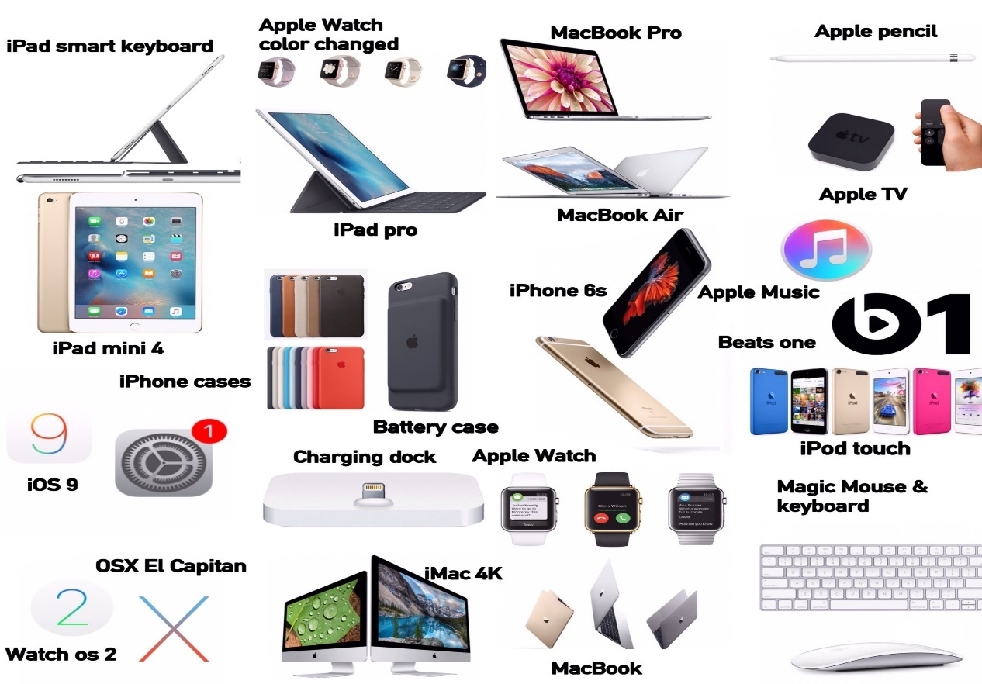
(Source : https://in.pinterest.com/pin/377458012499454505/)
It provides a range of personal and business software programmes, including iOS, macOS, iPadOS, watchOS, iCloud, Applecare, Apple pay etc with the Apple store, Apple arcade, Apple news+, Apple Fitness+, Apple card etc. The corporation has a commercial presence in the Americas, Eeurope, the Middle East, Africa and Asia-Pacific. The US’s city of Cupertino, California is Apple’s home.
There are 1,64,000 emplyoees are working. Apple has experienced significant growth, becoming one of the most valuable companies in the world. In 2021, Apple’s market capitalization exceeded $2 trillion, making it first publicaly traded U.S. company to reach this milestone. Apple is also recognized for its commitment to environmental sustainability and ethical business practices.
During the fiscal year ended in September 2022(fy 2022), the firm recorded revenues of US$ 394,328 million, an increase of 7.8% over FY2021. The company’s operating margin in FY2022 was 30.3% as oppoed to FY2022’s operating margin of 29.8%. the firm reported a net margin of 25.3% in FY2022, down from 25.9% in FY2021 (Marketline Advantage, 2023).

Figure: Last 5 year’s total revenue and net profit of Apple inc.
Source: (Marketline Advantage, 2023)

Macro-Environment Analysis
A Macro-Environment Analysis analysis shows that Apple Inc. operates in an ever-changing macro-environment where a wide range of factors might affect the company's success. The company's capacity to identify opportunities and threats, develop competitive advantages, and stay ahead of the pack on its understanding of these factors.
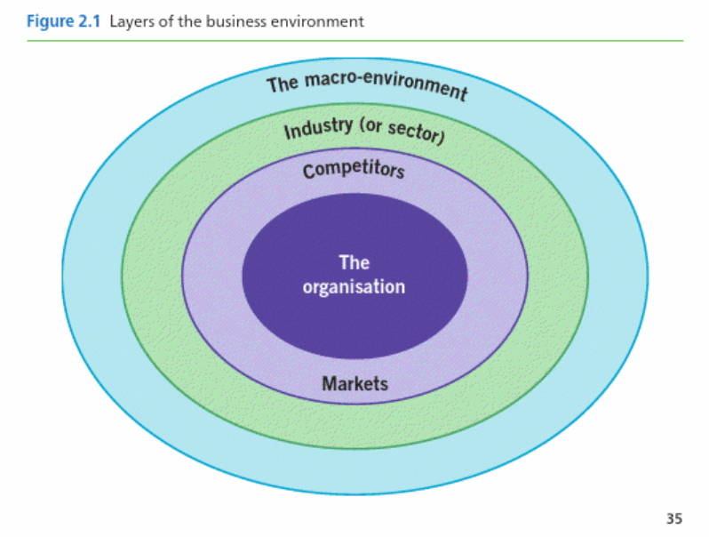
Source: (Whittington, 2020)

PESTEL Analysis
When it comes to analysing the external factors that might have an effect on a business, the PESTEL analysis is a valuable strategic tool. The political, economic, social, technological, Apple Inc.'s external environment might be illuminating.
Political: Apple is in za highly regulated industry, which means political factors may have a significant impact on the company's bottom line. The company's operations, supply chain, and bottom line may be significantly impacted by trade regulations, tax restrictions, and data protection obligations (Cohen, and Lee, 2020).
Economic: Apple is a multinational corporation; thus, it can operate in a wide range of economic environments. The company's top line, bottom line, and investment spending are all vulnerable to changes in inflation, interest rates, and exchange rates. The health of the economy and consumer spending patterns also have a role in the company's bottom line. In 2020, COVID 19 pandemic had a significant impact on global economy which afeect Apple’s revenue and sales. (Apple Annual Report, 2020).
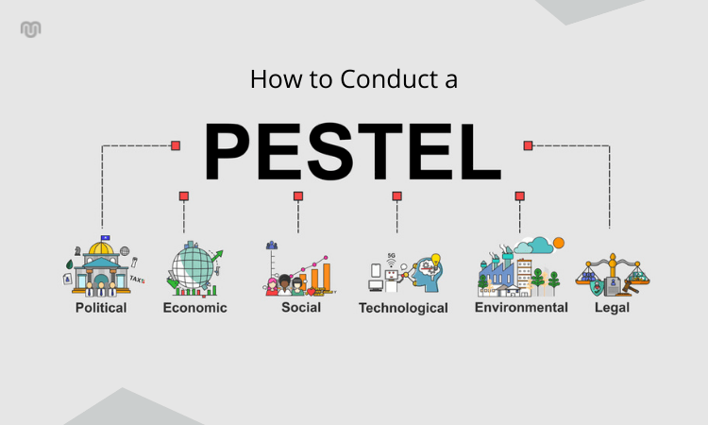
Figure: PESTLE Analysis
(Source: Upmetrics, 2021)
Social: Apple's bottom line might be negatively affected by changes in customer preferences, lifestyle trends, and cultural mores because of the company's focus on serving the end user. A company's reputation and brand image also rely on its social responsibility, ethical business practices, and customers' confidence in such areas.
Technological: As a technology company, Apple is dependent on constant innovation in the field. Rapid technological change poses a threat to the company's product development pipeline, manufacturing processes, and overall competitiveness (Apple, 2023). Technology-related factors, like cybersecurity threats, data protection legislation, and intellectual property laws, may have a significant impact on business as usual.
Environmental: Apple's operations, supply chain, and reputation may be affected by environmental factors such as climate change, environmental laws, and resource shortages. Company-wide initiatives to enhance sustainability have an impact on both brand image and loyalty.
Legal: Apple must adhere to a number of rules and regulations because of the specifics of its industry (Apple, 2023). Legal issues, such as those pertaining to patent and copyright regulations, consumer protection laws, and antitrust prohibitions, might have an effect on the company's operations, supply chain, and bottom line.

Micro-Environment Analysis
The micro environment is a critical aspect of a company’s marketing strategy, as it directly imapcts its ability to meet the needs and expectations of its target customers and to remain competitive in the market (Kotler & Keller, 2016). The company’s supplier are primarily located in Asia, and its key competitors include Samsung, Google, and Microsoft etc (Marketline Advantage, 2023)

Industry Life Cycle
Every industry from the beginning to the decline of its market goes through various stages of the life cycle (Nwodo, and Anumba, 2019). The life cycle of the product often refers to the cycle of initiation of the services to the decline in effectiveness in the market. There are mainly 4 stages of the life cycle of the industry which are following.
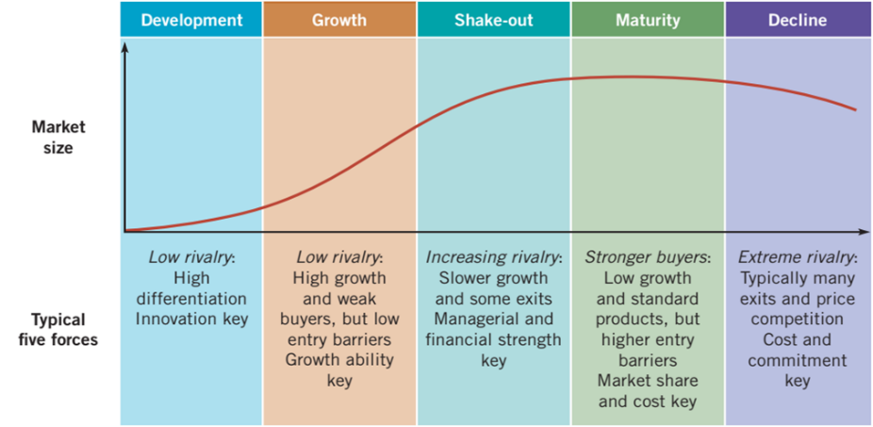
Source: (Whittington, 2020)
The development stage is the stage where the product of the industry first came to the market and started to experience its initial boom.
The next stage is the growth stage where the company focuses on the promotional strategy to experience a gain in the number of customers and market share.
In the next stage, known as the maturity stage, the company faces saturation in the market share. It indicates that the highest number of potential customers has been gained by the industry over time.
The last stage is the declining stage where the company may have to face declining sales and revenue in the market share of the industry (Ramesh et al., 2022).
While designing a product the company has to follow some essential points like manufacturer, material, retail, distribution, use, and the declining life of the product. The famous technological company Apple is currently going through the mature stage of the product life cycle. Apple has been continuously manufacturing various goods and products like mobile phones, laptops, various accessories, iPods watches, etc for a very long time. This goodwill is known to all its customers. Due to enhancing strategies and the good quality of the product, many customers do not change the brand for a very long time despite Apple being a very high-end brand. Even the recent ones are also unable to affect the revenue and the sales of this company so much. These incidents indicate that Apple is currently going through the mature stage. During its long lifetime, Apple has faced many competitors in all sectors. Some of them are various brands like Huawei, Lenovo, Samsung, and Xiaomi. Apple has a target audience that belongs to mainly the middle and upper-income groups of society as they have the opportunity to afford such high-quality expensive products. The main characteristics of Apple for being in the maturity stage are determined by analyzing its sales. In this stage, the rate of increasing sales seems to have declined because of the saturation in the market. However, the number of overall sales is maintaining its value at a stable rate. In the meantime, many competitive companies have entered the market with some genuinely good products. To maintain its brand image and production at the top level Apple has taken some important strategies. The company has to maintain the strong personality of the brand that will attract new customers by giving them trust in the product. Apple is manufacturing various devices and applications that are very user-friendly. Apple has realized the importance of connection in the community. That is why they have focused more on rethinking processes. The most important aspect of maintaining its brand value is to identify the needs and preferences of the customers to solve what they actually need (Apple, 2023). The company also has a unique proportion of value that helps them to avoid price wars. Lastly, it is very important to remain in the mature stage that the company should adopt the new advanced technology and the needs of the upcoming customers very rapidly.

Porter’s Industry Five Forces Analysis
Porter’s five forces is a widely used framework for analyzing the competitive forces in an industry. It was developed by Michael Porter in 1979 and includes five factors that influence Bargaining power of suppliers, Bargaining power of buyers, Threat of new entrants and Threat of substitutes.
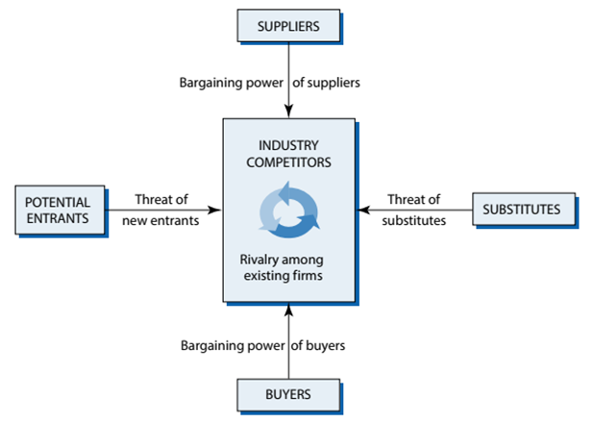
Five forces | Description | Intensity
Competition among the industries | The company of Apple has an Upper Hand in the market of Technology. However, they have to face various other competitive companies such as Google Inc., Samsung Electronics Co., Ltd., the Hewlett-Packard Company, and Amazon, Inc. Apple has invested a significant amount of time and money in research and development purposes (Nasır, S., 2019). The Other companies mentioned also have invested they are capitals in the same purposes to meet the demand of the customers. The very low switching cost also makes this field very competitive. To counter this threat Apple is now focusing on diversifying its products to maintain its position in market share. | The risk of this threat is very high at the present time.
Buyers’ bargaining power | As there are various options in the hands of the buyers, it enables them to switch between the companies very easily. Two types of bargaining power namely individual bargaining power and collective bargaining power. In the case of Apple, individual bargaining power possesses a weak link because the loss of one customer contributes a very negligible amount of revenue loss for the company (Quaye and Mensah, 2019). Whereas, the collective bargaining of the customers may cause huge defections in the marketplace. | This factor possesses a high risk for the company of Apple.
The problem of new entrants in the market | This problem of entering new players into the market is not a common problem for Apple because the target market Apple is medium and high-income people. As the number of people in this section of society is less compared to the middle and average or below-average-income people, other companies often target these sections for their market (Ghadge et al., 2021). The cost to establish a new company in the technology industry is very high. List the number of players in the section. Establishing brand recognition like Apple's is not an easy task. Any initial players cannot possess a threat to this company. | This problem possesses less amount of a threat to the company of Apple.
Supplier's bargaining power | Apple has the upper hand to switch from one supplier to another at a very low switching cost. This helps Apple to secure a strong position while negotiating with the supplier. | This threat is quite low for the company of Apple.
The threat of substitute products | The substitute products of Apple do not contain as many features as Apple (Sharpe, R., 2021). Therefore, the possibility of customers to switch into some substitutes is quite low. | This threat is low for Apple.

Internal Analysis
Performing an internal analysis helps a business evaluate the value of its own resources, personnel, and core competencies. Financials, management, human resources, and manufacturing procedures are all examined as part of this process (Piwowar-Sulej, 2021). By looking within, a company may gauge its readiness to achieve its strategic objectives and identify areas for expansion.

Apple Inc’s Strategic Resources and Capabilities
Apple Inc. is a tech giant that has consistently wowed customers with game-changing products. The company's success may be attributed, in part, to the strategic resources and capabilities it has developed.
Strategic Resources
Apple's reputation is one of its most precious assets. Apple has amassed one of the largest and most influential fan bases in the world. Successfully differentiating itself from competitors in the market, the firm has been able to attract and retain customers who are willing to pay a premium for its products (Schneiders, 2011).
The company's supply chain is one of its most valuable strategic assets. The company's supply chain is so efficient and integrated that it can rapidly produce and dispatch high-quality goods (Chien, et al., 2022). Partnerships with its suppliers, strict attention to quality assurance, and a commitment to environmental responsibility form the basis of Apple's supply chain management.
Apple's ability to do research and development is a valuable strategic advantage. The company invests much in R&D so that it may provide its customers cutting-edge products and services that can keep up with their changing needs. Apple's R&D efforts concentrate on expanding into new markets, improving existing ones, and developing cutting-edge technologies.
Capabilities
Apple's capabilities include its design abilities. The items of this brand are renowned for their simplicity and utility. Apple's design expertise is founded on a dedication to the user experience, which yields simple and straightforward interfaces.
Apple also excels in marketing and advertising, an essential competency. The company's reputation has grown and it has attracted new customers as a result of its creative and effective advertising campaigns (Chazin, 2007). Apple is able to successfully market its goods because it cares about its customers and makes an effort to develop genuine connections with them.

Value Chain Analysis
Business strategists use Value Chain Analysis to chart and assess the steps required to create a product or provide a service. Using a value chain analysis, businesses may break down their processes into their individual steps, such as raw material sourcing, manufacturing, and distribution. The goal of analysing these procedures is to identify areas for saving money, increasing output, and setting oneself apart from the competition.
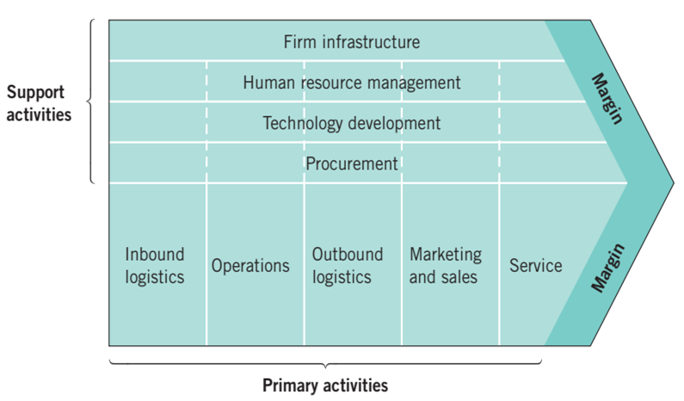
Source: (Whittington, 2020)
The majority of the value chain consists of primary processes, with secondary ones providing essential support (Cambridge University, 2022). Primary activities include things like inbound and outbound logistics, operations, marketing and sales, and customer support since they are essential to the creation and delivery of a product or service. Main activities that depend on support activities include procurement, research and development, human resource management, and physical plant maintenance.
The process of acquiring, storing, and distributing raw materials and other supplies required for production is known as "inbound logistics" A company's "operations" are all the processes it employs to transform raw resources into a finished product or service. Outbound logistics includes the distribution of finished commodities to end users. Marketing and sales include both promoting and selling a product or service to customers. Service and support should continue even after a product has been purchased.
The term "procurement operations" refers to the process of acquiring raw materials and other components for use in production. Activities that strive to generate new technologies or enhance current ones are collectively known as "technology development activities," which might involve research and development among other things (La Fleur, and Dlamini, 2022). Human resource management includes tasks including recruiting, indoctrination, and management. Businesses' "infrastructure activities" consist of things like accounting, legal, and administrative work.
The capacity to examine one's value chain is crucial to a company's ability to save money, increase productivity, and gain a competitive advantage. Dissecting the steps, it takes to manufacture a product or provide a service may help a company become more productive and efficient (Khan, et al., 2020). Businesses may utilise Value Chain Analysis to help them differentiate themselves from competitors and increase the value they provide to customers.

Primary Activities
Apple Inc.'s product creation and sales depend on the success of many key processes within the company's value chain. Among the most crucial are:
Inbound Logistics: The phrase "inbound logistics" is used to describe the procedures involved in the acquisition, storage, and distribution of raw materials, components, and finished products. Apple's supply chain is so well-organized that the corporation can dependably order and receive high-quality components from its vendors (de Miguel, 2019). Inbound logistics Apple’s 2019 supplier’s list has around 800 manufacturing spaces and 200 suppliers (Marketline Advantage, 2023)
Operations: A company's "operations" are the steps it takes to get from raw materials to a finished product or service. Apple's business plan is to continue developing cutting-edge goods that can evolve with customer preferences (HBR, 2020). Apple’s success fully reaches its clients through both direct and indirect routes also company frequently chooses prime sites Apple successfully reaches its clients through both direct and indirect routes. The company frequently chooses prime sites for its outlets. It also runs an online storefront.
Outbound Logistics: The term "outbound logistics" is used to describe the procedures necessary to deliver finished items to end users. Apple has a global distribution network that enables them to reach customers everywhere in the world.
Marketing and Sales: Salespeople and marketers work together to get a product or service in the hands of consumers. Apple's marketing and sales activities are focused on growing the company's good name and connecting with customers on a deep level (Tien, et al., 2019).
Service: "Service" refers to any follow-up efforts to help customers after a purchase. Apple values its customers highly, which is why it provides a wide variety of service plans. As a whole, Apple is committed to establishing its reputation as a company that consistently delivers high-quality products and services to its customers.

Secondary Activities
Apple Inc.'s primary business would not be sustainable without the many auxiliary activities that support it throughout the value chain. Activities that fall within this tertiary category include:
Procurement: The term "purchasing" is used to describe the action of acquiring materials and supplies for use in production (Ricardianto, et al., 2022). Apple has a complex supply chain and procurement process that depends on its suppliers to provide high-quality materials.
Technology Development: Creating new tools and improving upon those already in use are all aspects of technological development. Apple invests much in R&D to create innovative products that customers will find valuable.
Human Resource Management: Human resource management entails a wide range of tasks, including recruitment, training, and supervision (SHRM, 2022). Apple's innovative and multicultural workforce is a result of the company's rigorous talent acquisition and management practises.
Infrastructure: A company's infrastructure consists of its physical structures, its information technology systems, and other assets, as well as the processes that keep them running smoothly. Apple is committed to building and maintaining a reliable infrastructure because it is essential to the success of the company and the delivery of high-quality products and services to its consumers.
By engaging in these activities, Apple is able to maintain its core business and continue providing outstanding products and services to its customers (Podolny, and Hansen, 2020). These responsibilities are crucial to Apple's long-term success since they ensure the value chain runs smoothly.

VRIO Analysis of Distinctive Resources and Capabilities
The glorious history that Apple has had in the industry, its identifiable brand name, its one-of-a-kind approach to product design, its closed ecosystem, its proprietary hardware and software, its dedication to continuous innovation, and its efficient business practises all contribute to Apple's competitive edge. Because of these qualities, Apple has been able to maintain its position as the leader in the technology business, and its rivals have found it difficult to replicate the company's success.
Resource/capability | Value | Rarity | Imitability | Organization
Brand reputation | V | R | I | O
Innovative product | V | R | I | O
Financial resources | V | R | I | O
Supply chain | V | - | - | O
Intellectual property | V | R | - | O
(Source: Apple 2023 and Apple annual Report 2020)
Value: The high regard in which Apple goods are regarded by the purchasing public is shown by consistent sales and committed customer bases for Apple products. The sustained success of Apple may be attributed to the company's attention to design aesthetics, user-friendliness, and top-notch quality. Apple products are known for their innovative and user-friendly designs (Edelberg, and Kilrain, 2020). The high functionality and long-lasting nature of the firm's goods are also contributing factors to the success of the company.
Rarity: Since a large number of other firms also manufacture electronic devices such as cellphones, computers, and other electronic equipment, Apple's goods do not stand out as being particularly unique. On the other hand, Apple is able to differentiate itself from its competitors in the industry because to the exceptional value it delivers to customers via its innovative design philosophy, user interface, and ecosystem of goods and services. Since the company has created both its own hardware and software, it enjoys a significant competitive advantage over other businesses in its industry.
Imitability: The popularity of Apple's products has encouraged competitors to create products that are similar to Apple's, but these imitations have not been as successful. It is difficult for Apple's rivals to reproduce the company's goods since Apple maintains a closed environment and creates its own hardware and software (Study Smarter, 2022). In addition, the corporation places a high importance on innovation and regularly introduces novel goods and services. Because of this, it will be difficult for rivals to stay up.
Organization: Apple's organisational structure is efficient and well-organized, which enables the company to rapidly develop and release new products. Apple's design team, which is overseen by Chief Design Officer Jony Ive, has played a significant role in the development of the company's recognisable aesthetic. Because Apple's marketing and retail operations are so well run, the business is able to remain in constant communication with its clients.

SWOT Analysis
A SWOT analysis may be used to evaluate the potential strengths, weaknesses, opportunities and tthreats of an organisation. The following is a summarised version of Apple Inc.'s SWOT analysis.

Figure: SWOT analysis
(Source: Business Documents, 2023)
Strengths:
- Apple has a strong brand identity, and its goods are recognised and admired all over the world. Apple's outstanding brand image allows it to charge premium prices for its products.
- Apple's groundbreaking iPhone, iPad, and MacBook are the direct result of the company's investment in research and development. Apple's ability to master this area is a major reason for the company's continued success in terms of product innovation.
- Apple typically ranks among the world's most profitable firms, thanks to its strong balance sheet and ample cash reserves.
- Apple has a massive retail footprint both to its own retail locations and an approved reseller network that spans the world.
Weaknesses:
- Apple's high prices might affect the firm financially if consumers decide not to buy as many of the company's products (Apple, 2023).
- Because of how much the iPhone contributes to Apple's revenue, the company is vulnerable to changes in the smartphone market.
- Apple's products may not appeal to customers with unique requirements because of their limited customization options.
Opportunities:
- Apple might expand its operations into emerging markets to take advantage of the vast untapped potential in such regions.
- With the Apple Watch and AirPods, Apple has a potential to become a major player in the wearable technology market.
- Apple Music, Apple TV+, and iCloud are just a few of the company's subscription services that have the potential to boost the company's recurrent revenue.
Threats:
- Apple has tough rivals in all of the markets it services, but the smartphone market is exceptionally competitive.
- Preferences of Customers If it wants to stay competitive, Apple must continue to innovate as customer preferences change (Sgroi, 2021).
- If customers respond to economic uncertainty by cutting down on purchases, Apple might see a drop in revenue.

Strategies to Sustain Competitive Advantage
Apple has choices for keeping its competitive advantage according to many strategic studies including Porter's Generic Strategy and the Ansoff Matrix.
Porter’s Generic Forces
The three pillars of Porter's generic approach are cost leadership, differentiation, and concentration.
Differentiation: By creating ground-breaking innovations that set it apart from rivals, Apple has effectively adopted a differentiation strategy. This strategy allows Apple to charge premium pricing for its products while yet being competitive (Study Smarter, 2022). Apple's distinctive approach to design, software, and hardware helps set it apart in the competitive smartphone and computer sectors.
Cost Leadership: According to Porter's generic strategy, Apple has the option of pursuing cost leadership as a secondary strategy. The strategy's end game is to undercut rivals' prices without compromising on product quality. This runs against to Apple's premium brand image, but it might help the company expand into new markets and increase earnings in places where consumers are price-conscious. Apple may, for instance, provide lower-priced variations of its items or package services in order to provide more value to its customers. Apple has worked hard to earn its reputation as an industry leader in quality and innovation, therefore it's crucial that this strategy be implemented with precision.

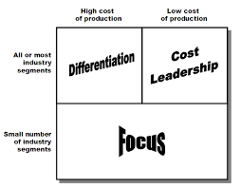
Figure: Porter’s Generic Forces
(Source: HBR, 2020)
Focus: As a marketing tactic, Apple has zeroed in on certain demographics including those in the creative sectors, students, and business owners. Apple has achieved widespread success in appealing to these niches by developing a deep understanding of their needs.
The Ansoff Matrix
In addition to Porter's Generic Strategy, Apple may also use the Ansoff Matrix to devise means of preserving its competitive advantage. The Ansoff Matrix rests on the four pillars of product innovation, market expansion, market penetration, and portfolio diversification.
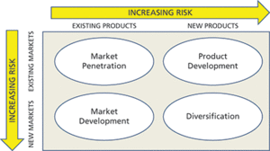
Source: (Ansoff Matrix,2019)
Figure: The Ansoff Matrix

Market Penetration: Apple may be able to increase its market share if it reduces prices, expands its retail presence, and improves its connection with consumers (Kotapati, et al., 2020.). Apple hopes to maintain its competitive advantage and even increase its market share with this strategy.?
Product Development: Apple's dedication to innovation is shown by the company's continued success in creating and releasing ground-breaking new products and services. This strategy may aid Apple in maintaining its competitive advantage and attracting new customers.
Market Development: Apple may be able to boost its market share by exploring and penetrating new areas and demographics. This strategy will help Apple gain more customers and maintain its current market share.
Diversification: If Apple wants to keep growing, it may want to consider entering new areas. If successful, Apple's new strategy might reduce the company's reliance on the iPhone's sales.
To stay ahead of the competition in the long term, Apple may use strategies including differentiation, emphasis, market penetration, product development, market growth, and diversification. Apple's dedication to the invention and its ability to stay ahead of the competition has allowed it to maintain its position as a worldwide leader in technology.

Growth Strategies
Apple may use International Strategies and Entry Mode Strategies in addition to the Ansoff Matrix when it enters new international markets.
International Strategies
Apple may use regional adaptation, international standardisation, and global rollout in their international strategy.
Localization: To "localise" a product is to adapt it to the needs and preferences of a certain market. By catering its products and services to local cultures, languages, and regulations, Apple may increase its customer base and market share in those regions (Rong, et al., 2022).
Standardization: One example of standardisation is the provision of same or nearly identical products and services all across the globe. Apple may use standardisation to maintain a consistent product experience for customers across languages and cultures, save expenses, and boost output.
Transnational Strategy: Transnational approaches combine localization and standardisation to maximise global efficiency while yet being sensitive to local needs. Apple may find a happy medium between global uniformity and regional customization by adopting a transnational strategy.
Entry Mode Strategies
Apple may enter a market in a number of ways: through export; via licencing; via franchise; via joint venture; or via wholly-owned subsidiary.
Exporting: The process of taking locally produced products and services to overseas markets is known as "exporting." Apple could increase its cash flow, expand into new markets, and build relationships with retailers and customers if it increased its exports.
Licensing: Apple may licence its intellectual property to other companies for a fee. This includes patents, trademarks, and copyrights. By licencing, Apple may earn money and expand its worldwide market share without taking on significant risk or making significant investments.
Franchising: The practise of licencing Apple's trademark and business model to a third party in exchange for financial gain. Without taking on significant investment or risk, Apple may be able to increase its retail presence and brand image in overseas countries via franchising.
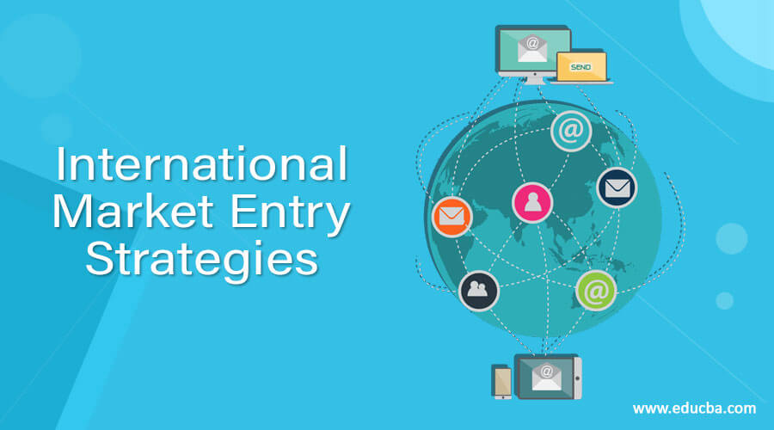
Figure: Entry Mode Strategies
(Source: Bai, et al., 2019)
Joint Ventures: When two or more businesses form a joint venture, they pool their resources, share the risks, and divide the profits and losses. Apple's ability to use the knowledge, connections, and resources of local partners makes joint ventures an ideal vehicle for expanding into new markets (Bai, et al., 2019).
Wholly-Owned Subsidiaries: Establishing a new business in an international market via acquisition or starting one from scratch is an example of a wholly-owned subsidiary. While creating wholly-owned subsidiaries in foreign markets might boost Apple's control, flexibility, and profitability, doing so would involve a significant financial investment, as well as a willingness to take on significant risk.

Green Strategy and CSR
In the current economic context, it is imperative that corporations like Apple prioritise green strategy and CSR initiatives. Companies are under increasing pressure to demonstrate environmental and social responsibility as a consequence of growing public concern about climate change and the need for sustainable practices.
Green Strategy
The utilisation of renewable energy sources, lowering of greenhouse gas emissions, and creation of environmentally friendly product designs are all parts of Apple's green strategy (Rani, et al., 2023). For instance, by 2030, the company anticipates having a supply chain and final product with zero net carbon emissions. Furthermore, Apple uses 100% renewable energy to power its global operations, and the corporation has reduced the carbon footprint of its products via design and material choices. An extra motivation for customers to recycle their old equipment is provided by Apple's recycling plan.
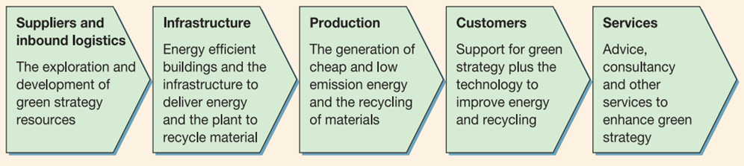
Figure: Green strategy value chain
Corporate Social Responsibility
As a company that has always been forthright about its practises, Apple has also set the standard for CSR. Organisational policy explicitly forbids the use of forced labour, child labour, or unsafe working conditions in any part of the company's supply chain. Apple has been publishing an annual Supplier Responsibility Report since 2007, and it has been highlighting the company's efforts to improve the working conditions of suppliers and lessen their environmental effects ever since (Apple, 2023).
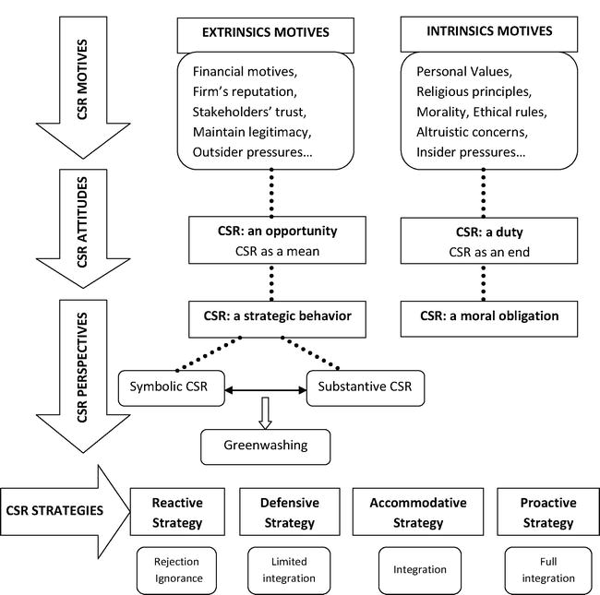
(Source: Orlando, B. 2022)
Apple has also given back to communities all across the globe. The ConnectED project is only one of several educational initiatives the company has taken on to provide resources to schools in low-income areas. Apple has donated to several humanitarian efforts, some of which have dealt with natural catastrophes or the recent COVID-19 epidemic (Apple, 2023).
Carroll’s CSR Pyramid

Source: (Baden, 2016)
Green CSR
Apple Inc. has a strong commitment to business ethics and corporate social Responsibility. Apple's commitment to environmental awareness and CSR is shown through the company's Clean Energy Programme and other green CSR initiatives (Azim, and Nahar, 2020). Apple will invest in renewable energy projects like solar and wind farms to compensate for the energy used in its operations and supply chain. To further encourage its customers to responsibly dispose of their outdated Apple hardware, Apple has launched Apple Renew. Daisy, a recycling robot custom-made for the initiative, disassembles electronics to recover useable components and reduce waste. All of Apple's facilities, including data centres, offices, and retail stores, will use renewable energy. The company's activities in the United States and 25 other nations have already surpassed this goal. Apple is making an effort to reduce its environmental effect by increasing its usage of renewable energy and switching to electric vehicles. By 2030, the company promises, it will have eliminated all emissions. In all aspects of its business and supply chain, Apple is committed to reducing its water footprint. The company's offices and stores are equipped with water-saving fixtures and recycled-water cooling systems (Apple, 2023).

Conclusion
Apple Inc.'s reputation and history of inventive product design provide it an edge over the competition. Procurement and human resource management assist inbound logistics, operations, marketing, sales, and the company's value chain. Greening and CSR have been examined as growth and sustainability strategies. Apple's investments in renewable energy, carbon footprint reduction, and supply chain working conditions demonstrate its commitment to environmental sustainability and social responsibility. Apple Inc.'s innovative products and strict corporate procedures have shaken the electronics sector. Apple Inc. can retain its technical leadership and competitive advantage by focusing on growth, sustainability, and social responsibility.

Recommendation
Apple Inc.'s external and internal environments, resources and capabilities, value chain, and development goals all point to a need for the corporation to retain a commitment to innovation, sustainability, and social responsibility. Apple needs a bigger R&D budget if it wants to stay up with its consumers' ever-evolving demands. The corporation may look into entering new overseas markets using entry mode strategies like strategic alliances or joint ventures in order to further grow its worldwide reach.
Apple should continue its efforts to reduce its carbon footprint, invest in renewable energy sources, and improve working conditions in its supplier chain. This will not only help the environment, but also boost the company's image and bring in more eco-conscious clients. Apple's internet marketing and exposure might be enhanced to boost sales and attract a larger audience. Putting all of your eggs in one basket, like iPhones, might be risky business for certain companies. If Apple implements these suggestions, it will be able to keep its competitive edge and sustain its rapid expansion.

References
Apple Inc, (2023), About us, available at https://www.apple.com/in/, [Accessed on 19 th April]
Apple Inc, (2023), Mission, available at https://www.apple.com/in/, [Accessed on 19 th April]
Apple, (2023), Apple Life Cycle Management, available at
Apple, 2023, “Apple Trade Compliance”, Available at: https://www.apple.com/legal/more-resources/gtc.html [Accessed on 17th April 2023]
Apple Inc. Form 10-K Annual Report 2020 Available at https://investor.apple.com/sec-filings/sec-filings-details/default.aspx?FilingId=14624294
Ansoff Matrix’ (2019) A Dictionary of Publishing. 1st edn. Oxford University Press.
MarketlineAdvantage(2023),https://advantage-marketline com.ezproxy.uwtsd.ac.uk/HomePage
Azim, M.I. and Nahar, S., 2020. How Green Is The Apple? Understanding Apple’s CSR Disclosure Practices. Azim, MI; Nahar, S, How Green Is The Apple? Understanding Apple’s CSR Disclosure Practices, Accountancy Business and the Public Interest, 2020, 19, pp. 309-329.
Business Documents, 2023, “Simple SWOT Template ”, Available at: https://business-docs.co.uk/downloads/simple-swot-template/ [Accessed on 17th April 2023]
Baden, D., 2016. A reconstruction of Carroll’s pyramid of corporate social responsibility for the 21st century. International journal of corporate social responsibility, 1(1)
Cambridge University, 2022, “What is a value chain? Definitions and characteristics”, Available at: https://www.cisl.cam.ac.uk/education/graduate-study/pgcerts/value-chain-defs [Accessed on 17th April 2023]
Chazin, S.M., 2007. Marketing Apple: 5 secrets of the world's best marketing machine. Marketing Apple. E-book.
Chien, C.H., Chen, P.Y., Trappey, A.J. and Trappey, C.V., 2022. Intelligent supply chain management modules enabling advanced manufacturing for the electric-mechanical equipment industry. Complexity, 2022.
Cohen, M.A. and Lee, H.L., 2020. Designing the right global supply chain network. Manufacturing & Service Operations Management, 22(1), pp.15-24.
Kotler, P. & Keller, K. (2016). Marketing Management, 15th edition. Pearson Education Limited, p. 60-70
de Miguel, A.P., 2019. TRANSPARENCY, THE KEY TO TRUST IN THE WORLD OF BUSINESS AND BRANDS. Black Brands: In the Age of Transparency, p.69.
Edelberg, J. and Kilrain, J., 2020, October. Design Systems: Consistency, Efficiency & Collaboration in Creating Digital Products. In Proceedings of the 38th ACM International Conference on Design of Communication (pp. 1-3).
Ghadge, A., Er Kara, M., Mogale, D.G., Choudhary, S. and Dani, S., 2021. Sustainability implementation challenges in food supply chains: A case of UK artisan cheese producers. Production Planning & Control, 32(14), pp.1191-1206.
HBR, 2023, “How Apple Is Organized for Innovation”, Available at: https://hbr.org/2020/11/how-apple-is-organized-for-innovation [Accessed on 17th April 2023]
https://www.apple.com/ca/business/docs/resources/Apple_Lifecycle_Management.pdf [Accessed on 19 th April]
Khan, S.A., Badar, M.A. and Alzaabi, M., 2020. Productivity improvement using DMAIC in a Caravan Manufacturing company. International Journal of Productivity and Quality Management, 30(2), pp.234-251.
Kotapati, B.A.P.U., Mutungi, S., Newham, M., Schroeder, J., Shao, S. and Wang, M., 2020. The antitrust case against Apple. Available at SSRN 3606073.
La Fleur, J. and Dlamini, R., 2022. Towards learner-centric pedagogies: Technology-enhanced teaching and learning in the 21st-century classroom. Journal of Education (University of KwaZulu-Natal), (88), pp.4-20.
Nasır, S., 2019. Marketing Strategies in Competitive Markets and Challenging Times. In Brand Culture and Identity: Concepts, Methodologies, Tools, and Applications (pp. 248-271). IGI Global.
Nwodo, M.N. and Anumba, C.J., 2019. A review of life cycle assessment of buildings using a systematic approach. Building and Environment, 162, p.106290.
Orlando, B. (2022) Corporate social responsibility. Edited by B. Orlando. London, United Kingdom: IntechOpen.
Piwowar-Sulej, K., 2021. Human resources development as an element of sustainable HRM–with the focus on production engineers. Journal of cleaner production, 278, p.124008.
Podolny, J.M. and Hansen, M.T., 2020. How Apple is organized for innovation. Harvard Business Review, 98(6), pp.86-95.
Quaye, D. and Mensah, I., 2019. Marketing innovation and sustainable competitive advantage of manufacturing SMEs in Ghana. Management Decision, 57(7), pp.1535-1553.

Ramesh, M., Deepa, C., Kumar, L.R., Sanjay, M.R. and Siengchin, S., 2022. Life-cycle and environmental impact assessments on processing of plant fibres and its bio-composites: A critical review. Journal of Industrial Textiles, 51(4_suppl), pp.5518S-5542S.
Rani, G.M., Pathania, D., Umapathi, R., Rustagi, S., Huh, Y.S., Gupta, V.K., Kaushik, A. and Chaudhary, V., 2023. Agro-waste to sustainable energy: A green strategy of converting agricultural waste to nano-enabled energy applications. Science of The Total Environment, 875, p.162667.
Rayna, T., Striukova, L. and Fauchart, E., 2023. Commercialization Strategies of Large-Scale and Distributed Open Innovation: The Caseof Open-Source Hardware. California Management Review, p.00081256231161628.
Rong, K., Kang, Z. and Williamson, P.J., 2022. Liability of ecosystem integration and internationalisation of digital firms. Journal of International Management, 28(4), p.100939.
Schneiders, S., 2011. Apple's secret of success-traditional marketing vs. cult marketing. Diplomica Verlag.
Sgroi, F., 2021. Food traditions and consumer preferences for cured meats: Role of information in geographical indications. International Journal of Gastronomy and Food Science, 25, p.100386.
Sharpe, R., 2021. The importance of digital communication competence in the competitive advantage context of the UK professional business sector. University of Salford (United Kingdom).
SHRM, 2022, “Human Resource Manager”, Available at: https://www.shrm.org/resourcesandtools/tools-and-samples/job-descriptions/pages/human-resource-manager.aspx [Accessed on 17th April 2023]
Statista, 2023, “Global revenue of Apple from 2004 to 2022”, Available at: https://www.statista.com/statistics/265125/total-net-sales-of-apple-since-2004/ [Accessed on 17th April 2023]
Study Smarter, 2022, “Apple Marketing Strategy”, Available at: https://www.studysmarter.co.uk/explanations/business-studies/business-case-studies/apple-marketing-strategy/ [Accessed on 17th April 2023]
StudySmarter, 2022, “Apple Global Strategy”, Available at: https://www.studysmarter.co.uk/explanations/business-studies/business-case-studies/apple-global-strategy/ [Accessed on 17th April 2023]
Upmetrics, 2021, “How to Conduct a PESTLE Analysis Explained with Example”, Available at: https://upmetrics.co/blog/pestle-analysis [Accessed on 17th April 2023]
Whittington, R. (2020) Exploring strategy : text and cases /. 12th ed. Harlow :, Pearson,.

