Name: Morgan jones
Student number: 1706863
Module : (ACCA4017)
Course: Electric and Electronic Engineering

Contents
Name: Morgan jones 1
Introduction 2
PART A (UNDERSTANDING) 3
PART B (IMPLEMENTATION) 3
Exercise 1: 5
Exercise 2: 6
Exercise 3: 8
Bibliography 11

Introduction
In this assignment I will be covering my understanding of C programing via three specific questions and my ability to implement the C code to build a minimum of two working and fully functional programs with full code break down, testing results and my annotated code

PART A (UNDERSTANDING)

A1. What is a variable and why are they important in writing programs?
A variable is a container they are used as a symbol or name that marks a value. In the expression a + b. a and b are the variables. Variables can represent numeric values, characters, character strings, or memory addresses.
Variables are important as they allow a programmer to write adaptable programs which means instead of entering data directly into a program you can use variables to represent the data. [1]
A2. Explain why the for-loop can also be referred to as a counting-loop and give an example of when you would use it.
A popular type of loop is one that is controlled by an integer that counts up from an initial value to an upper limit this is called a counting loop or for-loop which is used for implementing a set of statements repeatedly until a specific condition is met. an example of this when you are displaying numbers from 1 to 50 you may want to set the value of a variable to 1 and display it 50 times, increasing its value by 1 on each loop iteration.
A3. Explain what an array is, what their features are, and give an example of when you would use one.
An array is a data configuration, which can hold a fixed-amount element of the same data type. An array is used to store variables of the same type. [2]
An array contains aspects that have the same data type. The aspects are stored in successive memory locations. Any 2-D array aspects are stored row by row in successive memory locations. Array names can represent the address of the starting factor and the array size should be present and mentioned in the statement. Array size must be a constant expression. [3]

PART B (IMPLEMENTATION)
The following exercises become increasingly more challenging. You don't need to complete all the exercises to pass this assignment. Marks will be awarded for attempting the exercises – a partial solution will still gain marks.

For each exercise below:

- Identify specific problems in completing the exercise.
  - You may also constrain a problem (simplify it) to produce a simpler solution that may act as a stepping stone to solving the real problem
- Write a clear analysis of the solutions (the thought process behind them) – what logical stages are required. You could use a flowchart or pseudocode.
- Show a C code listing with annotations
- Show testing (screenshots) that clearly demonstrate that the solutions work under all circumstances.

Exercise 1:
Show how variables can contain different types of values by declaring three variables that contain a name, a measure of height (e.g. 1.81cm) and a person's age (e.g. 32). Input these values and display them on the screen.
1 Different types of values
1.1 Identify the problem: (break down into smaller problems, write individual stages)
1. User enters 3 values (name char, height (e.g. 1.81cm) float, age integer)
2.Store values
3.Print values on the screen
1.2 Annotated Code
#include <stdio.h>
int main()
{
float height;//variables to hold height input
int age;//variables to hold age input
char name[100];//variables to hold name input

printf("Enter your age\n");
scanf("%d", &age);//User enters age value
printf("you entered %d as your age\n", age);
printf("enter your height in cm\n");
scanf("%f", &height);//User enters height value
printf("you entered %.2f as your height in cm\n", height);
printf("enter name:\n");
scanf("%s", name); //User enters name value
printf("your name is %s", name);

}
1.3 Testing
1.3.1 Normal values
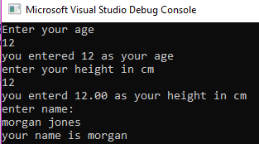
Result: Program ran as expected, all section filled and displayed

Exercise 2:
Allow the user to enter the dimensions of shapes shown below (Figure 1), then calculate the area of the blue shaded part. Note: The triangular area in the centre is empty.

Figure 1 Calculate Shaded Area
Note:
Area of circle is given by $A=πr^{2}$
Area of triangle is given by $A=\frac{\left(b×h\right)}{2}$
1.1 Identify the problem: (break down into smaller problems, write individual stages)
1. User enters radius to calculate circle area
2. Store in result (float)
3. User enter height and base values to calculate triangle area
4. Store in result (float)
5. formula to calculate area of shaded section
6. Store total
7. Print total on the screen

1.2 Annotated Code
#include <stdio.h>
// Area of circle is given by A=πr^2
//Area of triangle is given by A = ((b×h)) / 2

void main()
{
float radius, base, height;
float circlearea, triarea, totalarea;
printf("enter the radius of the circle\n");
scanf("%f", &radius); // enter radius
circlearea = 3.142*radius*radius; // area formula
printf("the area of the circle is %2.f\n", circlearea);
printf("enter the base of the triangle\n");
scanf("%f", &base); // base length
printf("enter the height of the triangle\n");
scanf("%f", &height); // height
triarea = base * height / 2; // area formula
printf("the area of the triangle is %2.f\n", triarea);
totalarea = circlearea - triarea; // shaded formula
printf("area of shaded section %2.f", totalarea);
}

1.3 Testing
1.3.1 Normal values
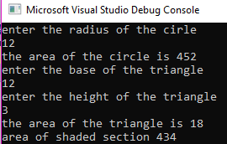
Result: Program ran as expected, correct answer calculated

Exercise 3:
Write a program that allows the user to enter the price of 5 products into an array. Once all the prices are entered calculate the total price, and then calculate the total price plus 20% VAT.
1 Different types of values
1.1 Identify the problem: (break down into smaller problems, write individual stages)
1. User enters 5 values
2.Store values
3.add 20% VAT
4.Print end value on the screen
1.2 Annotated Code
#include <stdio.h>

int main()
{
int p, sum = 0, i, value, total_cost, vat; // variables

printf("How many products do you have ?\n");
scanf("%d", &i);

printf("Enter the %d products price(s) to the nearest pound\n", p);

for (i = 1; i <= p; i++)
{
scanf("%d", &value);
sum = sum + value;
}

printf("total price without VAT = %d\n", sum);

vat = 20 / 100 * value * 5;
total_cost = vat + sum;
printf("The total price is %f", total_cost);
return 0;
}

1.3 Testing
1.3.1 Normal values
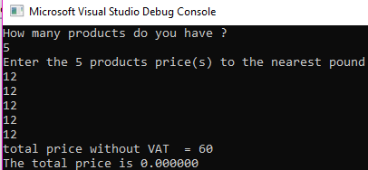
Result: Program ran as expected until the VAT was to be added. Only answer is 0.00

Exercise 4:
Build a fruit machine game which represents the 3 reels of symbols using numbers ranging from 1 to 5. Allow the user to have as many goes as they like (the numbers are chosen randomly each time).

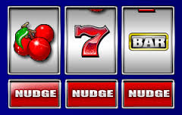

The value of 5 will be treated as the “Jackpot” symbol. The scoring will be as follows:

- Any three of the same numbers (excluding fives) will pay a bonus of 20 points e.g.
4 4 4
3 3 3
1 1 1, etc.

- Any combination of two fives will pay out 100 points e.g.
5 5 3
5 4 5
5 5 1, etc.

- Three fives pay out the big jackpot of 2000 points.

The points the player has scored should be displayed and the player should be asked if they wish to make another spin. It could look something like this:

Non-cumulative score version Cumulative score version
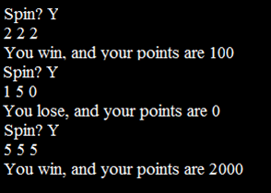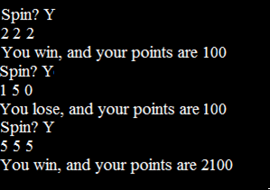

Bibliography

[1] | V. Beal, "variable," [Online]. Available: https://www.webopedia.com/TERM/V/variable.html. [Accessed 09 February 2019].
[2] | "Computer Programming - Arrays," [Online]. Available: https://www.tutorialspoint.com/computer_programming/computer_programming_arrays.htm. [Accessed 01 February 2019].
[3] | D. THAKUR, "Characteristics of Arrays in C," [Online]. Available: http://ecomputernotes.com/what-is-c/array/what-are-the-characteristics-of-arrays-in-c. [Accessed 05 February 2019].

