UNIVERSITY OF WALES
TRINITY SAINT DAVID

STRATEGIC MANAGEMENT
MODULE: LCMB7003

NAME: MOHAMMED FARHAN KUNHAYI
LECTURER: GLADIUS KULOTHUNGAN & CHARLES OHAM
STUDENT ID: 2132168
COURSE: MASTER’S IN BUSINESS ADMINISTRATION

Table of Contents
Introduction 3
Business Model of Nike: 4
Key strategic issues: 5
Porter’s five forces: 5
SWOT: 6
Mendelow’s Stakeholder Analysis: 7
Resource Based view Strategy: 8
McKinsey 7S Model: 9
Value Chain: 10
Analysis of the strategic options of Nike for sustaining in the market 12
Ansoff Matrix 12
Porter’s Generic Strategies 14
Strategic Clock 15
Recommendation 17
Conclusion 19
Reference List 21

Introduction
Nike Inc was built by Phil knight and Bill Bowerman back in the 1964. The brand is a well-known footwear company which produces many other products such as sports equipment and accessories, sports gears etc. The company, Nike Inc is situated in Oregon, North America. The organization is setting goals and objectives which help them to increase their sales rate and employee retention capacity. John Donahoe is the CEO of the company while Mark Parker is the Executive Chairman of the organization. The brand made its foothold with the name of ‘Blue Ribbon Sports’ back in 1964 but later in 1971, on 30th May, the term Nike was officially substituted with the blue-ribbon sports (Asbari, Hidayat and Purwanto, 2021). The brand uses athletes in order to demonstrate their products and services as the company believes that people will become athletes by wearing their products. The eye-catching football cleats which is worn by many footballers around the globe helps Nike to promote their product. The global football star Cristiano Ronaldo still uses their products and work with the company. Many such athletes are inclined towards the brand for the immense growth. The products of the brand differ and also a lot variation is offered to the market by the managing team of Nike. This helps to hold the trust and loyalty which was created by the company. The company faced major backlashes regarding child labour, breaching labour laws, underpaying to the labours also the company major losses when the ECCHR launched a complaint about the criminal activities which was culminated by the brand to the Uyghur Muslims of the Xinjiang province of China (Bhalla et al., 2020). The use of Sulphur Hexafluoride in order to fill out the cushion bags, this particular gas is harmful in nature and this gas was used by the Nike and nearly 277 tonnes of Sulphur hexafluoride was used in the year 1977. Furthermore, the company also blamed for polluting the environment and the Yangtze River, which is the third largest river of Eurasia. Furthermore, Nike Inc claims to mitigate the carbon and greenhouse gases emissions by 65% by the year 2030 (Nandan and Mitra, 2020). The football team of Oregon University is sponsored by Nike. The following report will be highlighting on several marketing factors and strategic approach which helped them to improve their business. The report will be discussing various sustainable approaches which are taken into consideration by the company in order to ameliorate the business. The various sustainable approaches will help the business in the near future. Various model and objectives will be highlighted inside the report which will depict the marketing strategy of Nike Inc.
Business Model of Nike:
Every firm needs a strong business model since it is an essential part of the overall business plan. Nike has a sound business strategy, which has contributed to its success. The following are the main costs that the business must cover:
Value statement is the key components of a good value offer are personalization, cost savings in product and price discovery, and transaction via product delivery (Overton et al., 2020).
Revenue Model: The organisation may generate profits and receive greater returns thanks to the revenue model. The revenue model that is used is as follows:
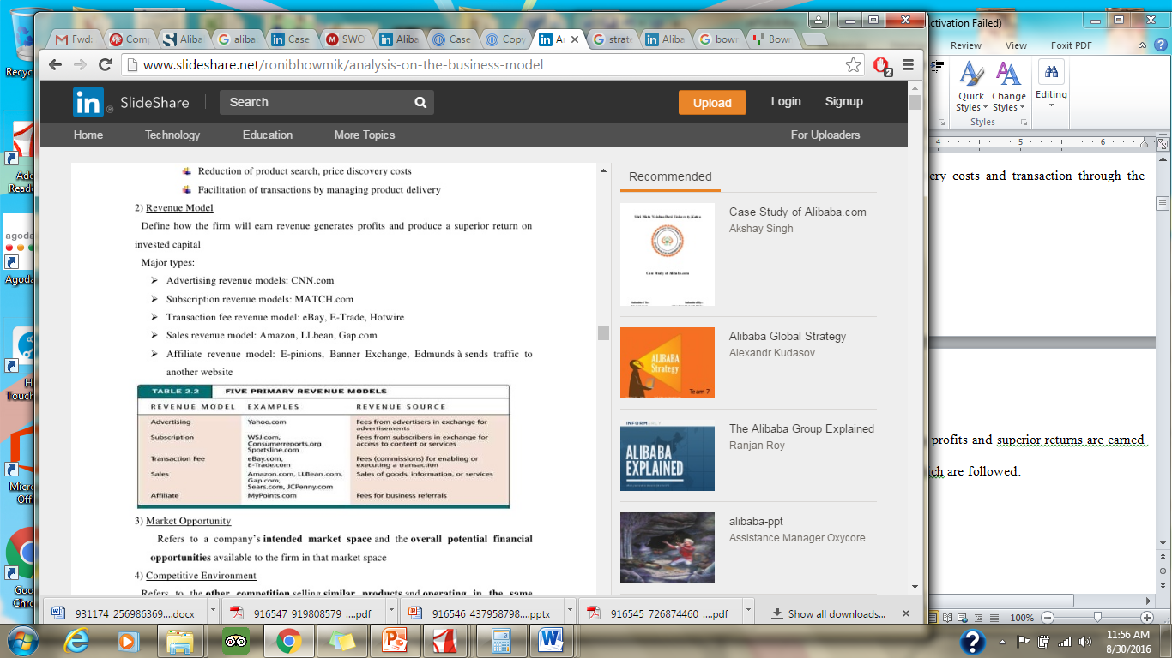
Market Opportunity: Nike planned to take advantage of the European market's overall financial prospects.
Environment of Competition: Nike has several rivals that are willing to provide goods of a similar nature in the sports accessories sector. Adidas and eBay are two fierce competitors for the corporation who use similar commercial tactics.
Nike's cheaper price approach, which is unmatched by other competitors, gives the corporation a competitive advantage.
Market Approach This Company’s executives each has a special set of leadership abilities that have enabled the business to expand into new areas.
Organizational development: With Phil Knight's help, the business was able to arrange its personnel and attempt to complete the whole process.

Key strategic issues:

Porter’s five forces:
An effective tool for analysing Nike's competitive environment is the Porter's Five Forces model. The five forces are as follows:
Threat of entry of new firms:
Nike is keen to go up against every business that enters their market. The contest was viewed as a means of encouraging the developing sports accessory business to expand. In comparison to Europe and the US, just 33% of sports accessories are used in Europe(Benzaghta, et al 2021). As it is included into the firm goals, the corporation will focus on preventing new entrants, yet the presence of brand-new entrants would be causing external challenges. The competition made it possible to readily overcome the challenges. By fostering global impact and innovation, the business was able to establish a reputation.
Rivalry among the competitors of the brand:
The market for sports accessories is expanding. Adidas is Nike's top competitor according to eBay. The sports accessory market in Europe is dominated by Adidas and Nike. The business made a significant move by acquiring Adidas Europe and other subsidiaries. This action has aided the business's development, growth, and potential. Adidas had previously invested in the creation of waterproof shoes and accessories, which were known as the waterproof sneakers, before Nike debuted the sports accessories with the innovation. This demonstrates how intensely competitive the market is.
Bargaining power of the Suppliers:
There are certain business collaborations, which support the operations of the sports accessory businesses and the outside research and development. Designers supply the designing infrastructure that aids in manufacturing, sales around the globe, and customer relations(Djellabi, 2021). The firm receives assistance from American International Underwriters Europe in obtaining high-quality consumer insurance. Nike receives assistance from its suppliers in dealing with quality control and reputation. Sports accessories need these kinds of vendors because they will aid in defending the consumer.
Bargaining power of the Buyers:
The willingness to buy sports items is absolutely essential to the business' success. Additionally, because of the company's global operations, international business is another factor in its success. Through its storefronts, the organisation helps small companies succeed in the marketplace(Vlados, 2019). When picking Nike, consumers will be in a better position to decide. Due to its safe retail locations and durable products, the corporation Nike has a sizable consumer base.
Threat of the Substitutes in the market:
The Nike firm provides a practical way for small businesses to thrive. The firm has access to a sizable market where it can carry out the manufacturing. The market for sports accessories does not now have a new replacement, although it is conceivable. The technique of marketing is the most efficient approach to expand a firm.

SWOT:
Strengths: The Business Nike has certain advantages that contributed to their quick growth. The tactics put into practise assisted in promoting development. Due to the company's globalisation and the success of its expansion plan, it has been able to make money. It did a terrific job of solidifying its position in the sports accessories sector by purchasing a tiny sports company in Europe(Puyt, et al 2020). The business is known for its expansion plans and achievements across the world. Nike enjoys a dominant position in the world market. The organisational structure was developed with a global presence in mind. Even while the firm was still developing, it had already begun to take big chances that ended up making it very successful.
Weakness:
The business Given that Nike is a well-known manufacturer of sporting goods, the variety of its clients is enormous. Although technology is advanced, skilled workers are still required. The business occasionally lacked appealing marketing strategies. Because of the company's labor-intensive nature, providing high-quality design comes at a high expense. There is a requirement for the corporation to downsize the workforce(Quezada, et al 2019). The business must use cost-effective tactics to cut back on the expenditures that will limit its ability to raise profits. Despite being a worldwide corporation, Nike's activities have a significant impact on the US economy, therefore failure there would be detrimental. There is a requirement for more marketing.
Opportunities:
Because of its strength, there is a larger chance that Nike will expand. Since Europe has a strong foundation, there are more opportunities to access new markets. If the corporation joins the Indian market, there will probably be repercussions. Nike was a well-known brand for sporting goods, which aided in the company's international growth(Isabelle, et al 2020). The local sports accessory behemoths are up against stiff opposition. The aggregator model, which lowers costs and streamlines operations, served as the foundation for the company plan. The other markets then adopt this concept.
Threat:
The fiercely competitive CEOs posed the biggest danger to the firm Nike. The market for sports accessories is expanding quickly, thus Nike's business techniques must be improved to have a firm grip on the industry. In the sports accessory market, Google Europe is a formidable competitor. Since the business is so varied, there are various verticals that might pose a danger to Nike(Juliana, and Nyoman 2019),. In order to get a bigger market share, Adidas employs techniques that are comparable to those used by Nike. Since the European market accounts for a sizable portion of sales, the effects of the worldwide market are noticeable during tough times. However, the business Nike was able to overcome the crisis that is happening globally.

Mendelow’s Stakeholder Analysis:
Mendelow's matrix is both fascinating and helpful in influencing Nike's group of stakeholders. There are two aspects of this that need to be examined: the group's interest in the organisation and its power on the organisation. The knowledge in the field in which it fits well and the requirements of the organisation that needs a lot of access may be used to classify the definition of power in a variety of ways. The matrix may be used by Nike to identify threat areas and support various stakeholder groups. The development of a new strategy and the modification of an existing one will both benefit from the use of this instrument.
The four matrix divisions are the following:
High Power, Low Interest: Nike must satisfy them in order to maintain their business. The organisation might shift them into the important player box by making the stakeholders happy.
High Power, High Interest: When there is significant power and interest, the important participants are found in this kind of matrix. They can successfully affect the approach because they have the ability and motivation to do so(Anastasiu, Gavriş, and Maier, 2020). Nike has the choice to invest in this sort of stakeholder and decide whether to educate the stakeholders. When they are discussed and taken into account at board meetings, this form of stakeholder group may provide the support that is anticipated.
Low Power, Low Interest: When Nike's stakeholder group falls into this category, they usually put out the least amount of effort. The group receives very little attention due to the low levels of interest and impact. The adjustments are not facing any opposition.
Low Power, High Interest: Despite having little influence, the Nike stakeholders' degree of curiosity is considerable. Nike should take advantage of this sort of interest in the group by giving them as much information as possible to prevent them from joining any other forces.
Therefore, Nike should concentrate on the "important players group" since they will influence the company's decision-making. The low-power, high-interest group is also useful since it may be changed through investment.

Resource Based view Strategy:
This view that is resource based holds the assets of the company that is essential for the input for the companies like Nike. This helped the company in getting the advantage in the getting the advantage in the derivation of the combinations. For the type that has the advantage in the competition and there is a need for the company for the matter of the resources that is hetero generous. This will not lead in the imitation and the subscription of the products this the type of the strategy that has been considered then the company that have the return that will be average(Baxter, 2019).
Phil Knight's management and leadership style serves as the main resource. Under his leadership, the organisation was able to achieve greater heights. Among the entrepreneurs in his field, he was the youngest company leader. He has a significant impact on the nation's ability to revolutionise the internet. Phil Knight was able to undertake partnerships with other businesses and create a number of subsidiaries, strengthening his control, thanks to the strategy's integration. Because of its power, it was able to create businesses like Reebok and Woodland. The simplicity of the sports accessories and the ease of use a feature of the items are two aspects of Nike's competitive advantage. The firm works in the sizable market of Europe and seizes the chance to capitalise on the underserved sports accessory industry.The volume of the goods produced in Europe is enormous. All different sorts of vendors will be attracted by the seller-based income model. This sector has a lot to offer because the forums of this kind will make it easier for small businesses to make money. The market for sports accessories is quickly developing, which means there will be more clients in the future. The goal of the strategy and its execution is to keep the sports accessory market at the top. expanding both the design and manufacture of sports gear. Nike aims to keep its position as a market leader. Because of the successful approach, there are now business prospects and the need for inexpensive labour for companies like Nike that improve sporting goods.

McKinsey 7S Model:
Nike has adopted the 7S model developed by McKinsey to help the corporation operate better. The following are the 7S strategic frameworks:
Strategy: Convenient design of the tactics makes it possible to conduct commerce in any nation on earth. This is the world's and Europe's greatest type of sports accessory (Aluru and Sathvika, 2020). The sports industry's commerce system has been driven, which is advantageous to service providers, retailers, and customers.
Structure: The organisation of Nike has various segments. The worldwide, regional headquarters and corporate subsidiaries are the three distinct categories into which the hierarchical structures may be divided. This really aids the business in sustaining its globalised strategy and alsocontrols its regional influence(Jelonek, et al 2022).
Nike has received the Trust Pass accreditation, which signifies that the firm offers customers a sense of security and that customers would feel comfortable while purchasing any goods. Nike is the owner of the rights to a variety of patent sports gear.
Employees: Rewarding those who work hard and exhibit excellence (Denga, Vajjhala, and Rakshit, 2022). Nike anticipates that its workers will be able to uphold the highest standards of integrity and devotion. Employees may receive prizes and recognition from the firm.
Style: Nike adheres to a certain brand of style and leadership. The system is adaptable, and new ideas are always being developed to improve the way things look. The emphasis of thefirm places a strong emphasis on cooperation and holds that by working together, regular people can produce extraordinary outcomes.
Skills: Phil Knight's exceptional leadership and management abilities aid the business in achieving success. A strong sort of technology of research that aids in the creation of the items has been enhanced by the design of Nike Europe's products.
Subordinate: Nike stands apart from other brands in its industry because to a few distinctive traits. They always put the needs of the consumer first. Through teamwork, the team works incredibly well. To survive the cutthroat climate of sports accessories, changes are accepted. The personnel at Nike are passionate and zealous about the work.

Value Chain:
The Nike model has been altered and now includes features of a virtual service. The conventional value chain method entails obtaining the materials, producing the goods, and delivering them, but Nike cannot use this kind of value chain. The business never makes an offering without first serving and satisfying its customers(Kim, Qian and Zhang, 2020). There isn't a Nike product that offers a platform for users to create value and get value from others. Operations of virtual values are included in the Nike value chain model. Nike makes considerable use of technology, which enhances the designs(Caballero-Morales, 2021). The marketing, customers, sales, marketing, and customer service are the foundation of the value proposition.Input, information processing, and output are the three basic operational phases. The inputs include signing up for a job with a business that aids in addressing supply chain issues. The Nike items have a propensity to influence the manufacturing process and facilitate commercial connections for Nike customers. Information is chosen, arranged, synthesised, and distributed during the procedure. When customers and suppliers establish a connection, Nike is considered to have completed the product design. Customers are both an input and an output. The following is a list of Nike's workflow:
The product designs are matched, and the customers and suppliers are listed according to the company's strategic perspective.
The providers and buyers establish relationships, share product designs, and create listings. This comprises the specifications and capabilities of the product.
To provide value for the consumers, the company's goods attempt to control the production process.
The outward portion, which involves client negotiations, is over.
Within the Nike Stores and Outlets, the provider and the customer communicate.
Factors on to which there is dependency of Strategic Management decision:
• Culture: Nike has a distinctive culture. It functions as an ecosystem where customers, retailers, and third-party service providers have a chance to succeed. The firm prioritises its consumers.
• Organizational structure: This dual stock class governance is fundamentally different from the organisational structure. The European political system served as inspiration for Nike's distinctive governance structure (Waymerand Logan, 2021). The partners in the partnership have the power to nominate the majority of the directors who would run Nike's board of directors.
• Innovation: Nike consistently develops innovative products to make its consumers' lives easier.
• Technology: Rather than being restricted to a certain market area, NikeInstead, Nike has expanded its business by using technology in all facets to create a variety of product designs.
• CSR: Nike is dedicated to a variety of environmentally friendly programmes. This involves a range of humanitarian endeavours as well as the broadening of the advantages to the community and the environment as a whole. The company's approach is to try to include social responsibility into its overall business plan.
• Ethical and environmental challenges: The company Nike tends to adhere carefully to a certain code of ethics. The company's business model is created in a way that it has no impact on the environment. To all workers, executives, and directors, the company applies.of the business. The firm is dedicated to provide top-notch services to its users, customers, business partners, and stockholders. The important principles and regulations that help to regulate the kind of business will be outlined with the aid of the product concept. Nike has the only authority to decide how the code should be interpreted.

Analysis of the strategic options of Nike for sustaining in the market
The sustenance strategy of the organization can be determined by implementing models and theories. In this particular case, The Ansoff Matrix model will be used in order to understand the various objectives and strategies of the company.

Ansoff Matrix
The Ansoff matrix is utilised to depict the planning and strategies used by the organization in order to enact the business and also helps to understand the growth of the market. The following points and strategies have been used by Nike in order to ameliorate their business.
Market Penetration: The name itself suggests the strategy. This objective deals with the selling of products within an established market. The company's major goal in doing this is to support the current products' ability to keep their market share. Advertising, price tactics, and additional types of tools for personal selling will be used to accomplish this. Increased market penetration in Europe, a crucial region for Nike, will aid in establishing dominance (Kim, 2020). The competitors would disappear as a result of the market's restructuring. Designing a price plan and marketing initiatives that would make the market less alluring for competitors is necessary. This is taken by the organization which will help them to penetrate inside the market and work according to the needs of the organization.
Market development: Development is required in order to ameliorate the business. The revenue must generate from every part of the globe which will define success for the company. The organization differs in various ways such as, improvised supply chain management which helps them to distribute more inventory which turns to increase sales rate (Standaert, 2022). By this process, the company generates more profit by selling the product for cheaper rate which defines lower sales margin but more profit.
Product Development: The economic strategy used by businesses to introduce new products in the current market is called product development. Nike's product development strategy is centred on innovation, meticulous analysis of the in-depth understanding of client needs, and being the first to explore a market. Additionally, the business emphasises athleticism, upgrading its items as sporting goods.
Diversification: Nike's diversity allows it to provide new products to new markets. This is a risky form of strategy because the company is entering a market with very little experience. The riskiest form of diversification took place when Vanguard Group, Inc. acquired 50% of the investment in the prosperous Nike for a share of 108,615,256. This is taken into consideration by the organization which will help them to diversify their services which will be available in the market.

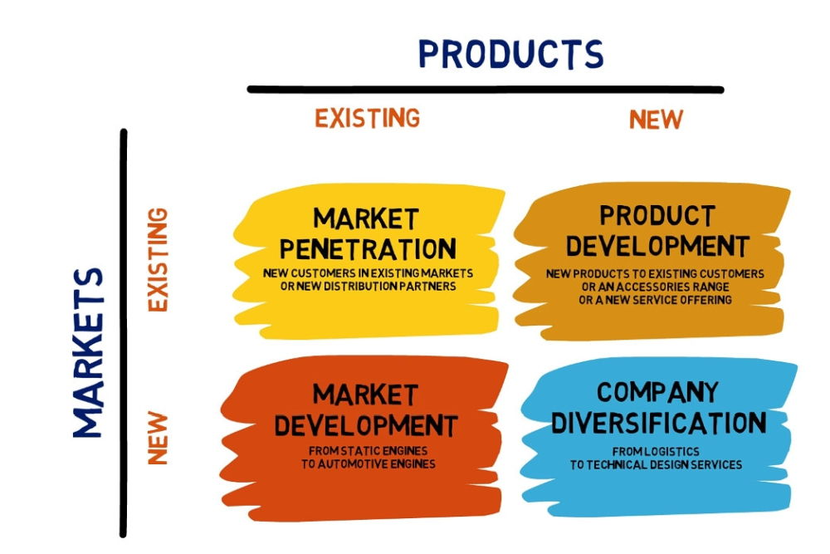

Figure 1: Ansoff Matrix
(Source: Quezada et al, 2019)

Porter’s Generic Strategies
The porter’s five forces will be evaluated for Nike Inc, in order to understand their business.
Barrier to Entry: Some businesses will offer higher-than-average returns. As a result, there will be a number of competitors, which would lower Nike's level of profitability (Hendriks, 2021). New businesses are attempting to imitate Nike's business strategy. Targeting a specific industry is the typical strategy for entry into the B2B market, which is used by Nike. Nike's niche market is also shared by brands like Adidas, Puma, Reebok, and Under Armour.
Bargain power of the buyers: Consumers have the capacity and right to negotiate because they exert pressure on businesses and affect how sensitive consumers are to price fluctuations. The majority of Nike's high- and medium-income consumers have their own websites. The firms are unable to negotiate for a lesser sort of price, and the requirements are set in accordance with Nike (Clarissia, 2020). The need for customers to bargain for their own rights exists. Customers' negotiation skills frequently influence the company's policies.
Substitutes Availability: When there is an increase in the price of the product, the number of substitutes tends to increase the likelihood that buyers will look for an alternative. The large firms' own websites are the significant replacements. Customers who are intending to do business with MNCs won't be using Nike's platform, but instead will be getting in touch with the business directly to avoid using a middleman.
Competition: The majority of industries utilise this as a criterion for assessing industry competitiveness. Competitors often engage in aggressive competition against one another and occasionally non-financial techniques are also used. Websites like adidas.com, puma.com, and reebok.com are competitors of Nike.com. Customers may easily use websites that are free and straightforward, thus they won't be using Nike's Business - to - business platform (Sukma, Lubis and Utami, 2019).

Strategic Clock
Bowman introduced the Strategic Clock, which assists to determine the various strategies and the benefits. The following 8aspects of the strategic clock will be discussed in the following report,
Minimum Value and price: The mentioned company Nike Inc cannot opt for this method. This aspect delves into the effective cost strategies so that more number of customers can be attracted towards the business (Tian et al., 2020). This is a forced implementation where the mentioned company have to take part and no such differentiation is made on the products.
Low price: The low capital leaders are the companies which take active part in it. The margin of the sales is low hence the low prices are a cause. Nike Inc will be sustaining in this aspect only if the supply chain can be managed successfully by providing big inventory supplies, which will lower the distribution cost (Diantari and Jokhu, 2021).
Hybrid: The hybrids category is experiencing growth because of the products' higher perceived value at a lower price. Nike may build a solid reputation by charging reasonable pricing, but here the volume is a problem.
Differentiation: Consumers will consider Nike's products as having a better value if the company differentiates itself more. The execution of a branding strategy is necessary in addition to the differentiation tactics.
Focused differentiation: These are the designer-type products that are available in this type of category. There is no requirement for the actual worth; only the perceived value. For this kind of category, Nike needs to focus on markets with greater profits.
Increased Price: There may be times when a corporation raises prices without raising the worth of the product. Nike can increase prices as a short-term strategy, but doing so will not be advantageous over the long term, benefit.
Higher price / Lower Value: This is an instance of monopolistic pricing where Nike would not be concerned with value but would instead know that customers would still buy the products despite increased prices (Aluru and Sathvika, 2020). Nike would ultimately suffer from this.
Low value/ Standard price: This market segment's practise of charging low rates for high-quality goods would cause Nike to lose a significant portion of its market share. For Nike, this is not a favourable situation.
The massive sports gear company Nike still has additional opportunities to investigate. Product diversification is crucial for a business to thrive on the e-commerce and retail market. Given Nike's value chain and business model, part of the company's future strategy will be to secure and improve its supply chain in order to enhance its market share, boost its profits, and keep competitors at bay. The company's intended initiatives include a range of client services, marketing techniques like target marketing, which would aid in growing the customer base, and the ongoing addition of innovative tools and capabilities (Sukma, Lubis and Utami, 2019).Over the years, this has enabled users to benefit from free services by monetizing their user base. Nike is attempting to diversify its business beyond trading platforms and into the management of client relationships. Nike's growth is likely to spark heated rivalry from Global Source and providers of specialised B2B services. Nike will probably have a better future if the business expands further while posing a danger to customers.

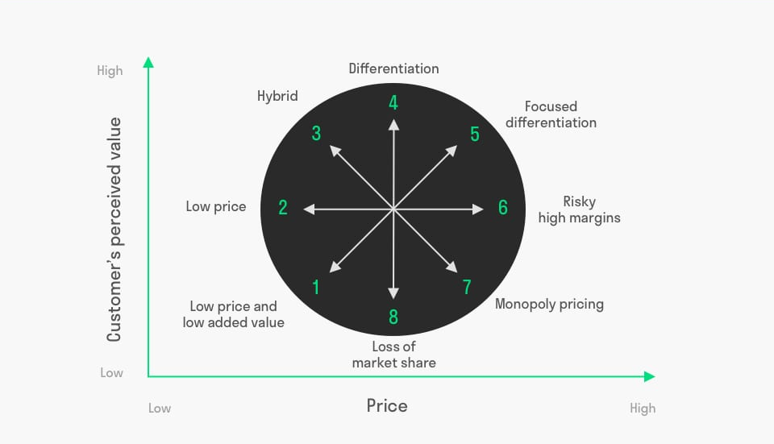

Figure2: Strategic Clock
(Source: Isabelle et al., 2020)

Recommendation
Based on the analysis, several recommendations will be made to the organization, Nike Inc in order to ameliorate the business. Nike already, established their market and the company can generate more revenue by growing much more in the established market and can also retain the present customer base and can also monetize. The recommendations are as follows,
- Monetizing the buyers: Whilst also placing more emphasis on monetizing customers through membership, commission, and internet marketing services, the company's revenues can be increased. The sellers compete for the available ad space when using the display marketing solution. The cost of the advertisement will depend on the amount of impressions. This is how users are made profitable. Monthly storefront fees are required, and other tools are available to support the vendors(DOMINGUEZ, 2020). Through the display management and pay per performance business model, the corporation receives a 25% profit share. For its pay per performance and display management business models, Nike must capitalize on and monetize its user base(Djellabi, 2021).
- Retention of the buyers and engagement: Through concentrating on the engagement, retention, and feedback of the providers and the buyers in the platform, the revenue can be accelerated in another efficient way. Promotional events will increase sales while putting a strong emphasis on customer retention(Asbari, Hidayat and Purwanto, 2021). Understanding customer expectations and evolving needs will be aided by the involvement of suppliers and purchasers. Increased use will result in happiness and engagement, which will help the business earn incentive and other economic advantages.
- Employee laws and regulations: The Company has faced several charges and backlashes regarding their employee laws and regulations. The company misused the labors by paying them less and over timing at their work. Moreover, the South Asian region offers cheap labors which are being used by the neoliberal organizations such as Nike, Adidas and other organizations. The laborers are often exposed to dangerous chemicals which can affect their health in the long run(Diantari and Jokhu, 2021). The organization must look upto their laws and regulations for the employees which will eventually ameliorate the business.
- Active Buyer Growth: The buyers of the organization, must grow in order to ameliorate the business which will be done by the expanding the business and the market. The focus must be on the growing economies of the world so that the market strategy can be opted according to needs of the target audience (Hendriks, 2021). The more the expansion the better sales rate.
- Involvement with the target audience: The most important factor for any organization is to organize their target audience in order to communicate on relevant issues with the customers (Frost, 2019). The organization must listen to the target audience so that the drawbacks can be rectified in order to bring more smoothness into the structure.
- Green Business: The future world is looking forward to live in a much better environment. The businesses around the globe are replicating their business into a more green system which works alongside with the environment rather than harming the climate. The emission of greenhouse gases must be mitigated via sustainable approaches so that the business can be perfect for the present and the future (Li et al., 2020). The sustainable approach must be taken into consideration by the supply chain management manager which produces carbon emissions from the distribution process.

Faster and free shipping are essential, and the prices of the products must be competitive, according to the General Manager of Nike.com United states of america. The use of content marketing is crucial. It is advised that Nike buy some of the web businesses situated in the EU so that it can maintain a competitive edge. There is a requirement for widespread communication, and the Internet is an excellent promotional tool. Nike must employ a differentiation strategy if it desires to boost productivity. Achieving international prominence will be encouraged by sponsorship of events. It's crucial to take advantage of the newly developed market. By 2025, the corporation anticipates an increase from Brazil of 15.3 billion dollars. Russia, Chile, Mexico, the United Arab Emirates, and Uruguay are plenty of other countries that company Nike is looking forward to implement their models.
Conclusion
In 1964, Phil Knight and Bill Bowerman founded Nike Inc. The firm is a well-known footwear manufacturer that also makes a variety of other goods, including sports gear and accessories. Nike Inc. is a business located in Oregon, America. The company collaborated with many sports athletes around the globe and sponsored them with top end products. Nike utilizes the known celebrity faces from the sports industry which helps them to boost their work force and productivity. The main goal of the organization in the modern day is to run their business in a sustainable environment which helps the climate instead of harming it. The report highlights the various marketing strategies which are enacted by the organization which assists them to perform well in the market. The brand is a popular brand, and the products and services of the company are utilized by the people of the world. The report also catered to the various successful business strategies the organization can opt for which will enhance their performance in the current market. Furthermore, the report also suggests some recommendations which can be implemented by the organization so that the improvisation can be done within the given period of time. The report also highlights at the drawbacks of the organization and the severe crimes like child labor, exposing children to harmful gases and not paying the deserving capital which is given to employees. These less-paid laborers often turned their back towards the organization and at times the organization failed to hear their words and instead the protestors were brutally charged with other cases. The company cannot benefit from making business like this. There are several departments and sectors where the brand can improvise their journey which will help them to gain the trust and loyalty from the target audience. Furthermore, the report justifies the marketing techniques by utilizing some models and theories, such as Porter’s five forces, Ansoff Matrix, Strategic clock etc which depicted the various skills and strategies of the organization. The barriers were also discussed which the organization have to cross carefully or else breaching several factors will lead to damaging circumstances for the above mentioned organization Nike. The brand is also using the modern day strategies which are required in order to adapt with the changes. The various factors were discussed in the report where the company has to work to enhance their market presence, as there are many such competitors who are trying surpass the organization with their innovative strategies.

Executive Summary
The Nike Inc, was developed by Phil Knight and Bowerman. The company makes sports accessories and gears and believes that anyone who fits into their outfit is an athlete. The organization focuses on sports accessories and on their shoes department which is flourishing day by day. The report establishes the various factors how the company runs their business and the report also portrays the amelioration of the business. The management and leadership technique of Phil Knight made the company famous around the globe. The brand is growing day by day and is trying to cope up with modern facilities and also adapting with the required changes which are needed in order to sustainable growth of the organization. The report highlights the various marketing strategies which are enacted by the organization which assists them to perform well in the market. The brand is a popular brand, and the products and services of the company are utilized by the people of the world.

Reference List
Aluru, S.S. and Sathvika, J., (2020). Study role of technology (App) in millennial engagement by masstige shoe brand Nike. https://repository.iimb.ac.in/handle/2074/19614
Anastasiu, L., Gavriş, O. and Maier, D., (2020). Is human capital ready for change? A strategic approach adapting Porter’s five forces to human resources. Sustainability, 12(6), p.2300.https://www.mdpi.com/2071-1050/12/6/2300/pdf
Anastasiu, L., Gavriş, O. and Maier, D., (2020). Is human capital ready for change? A strategic approach adapting Porter’s five forces to human resources. Sustainability, 12(6), p.2300.https://www.mdpi.com/2071-1050/12/6/2300/pdf
Asbari, M., Hidayat, D.D. and Purwanto, A., (2021). Managing employee performance: From leadership to readiness for change. International Journal of Social and Management Studies, 2(1), pp.74-85. https://ijosmas.org/index.php/ijosmas/article/view/12
Baxter, G., (2019). A strategic analysis of Cargolux Airlines International position in the global air cargo supply chain using Porter’s Five Forces Model. Infrastructures, 4(1), p.6.https://www.dinastirev.org/JEMSI/article/download/613/383
Baxter, G., (2019). A strategic analysis of Cargolux Airlines International position in the global air cargo supply chain using Porter’s Five Forces Model. Infrastructures, 4(1), p.6.https://www.dinastirev.org/JEMSI/article/download/613/383
Benzaghta, M.A., Elwalda, A., Mousa, M.M., Erkan, I. and Rahman, M., (2021). SWOT analysis applications: An integrative literature review. Journal of Global Business Insights, 6(1), pp.55-73.https://digitalcommons.usf.edu/cgi/viewcontent.cgi?article=1148&context=globe
Benzaghta, M.A., Elwalda, A., Mousa, M.M., Erkan, I. and Rahman, M., (2021). SWOT analysis applications: An integrative literature review. Journal of Global Business Insights, 6(1), pp.55-73.https://digitalcommons.usf.edu/cgi/viewcontent.cgi?article=1148&context=globe
Caballero-Morales, S.O., (2021). Innovation as recovery strategy for SMEs in emerging economies during the COVID-19 pandemic. Research in international business and finance, 57, p.101396.https://www.ncbi.nlm.nih.gov/pmc/articles/PMC7857984/
Caballero-Morales, S.O., (2021). Innovation as recovery strategy for SMEs in emerging economies during the COVID-19 pandemic. Research in international business and finance, 57, p.101396.https://www.ncbi.nlm.nih.gov/pmc/articles/PMC7857984/
Clarissia, S.M.S., (2020). A study on Ansoff Matrix Technique: As a growth strategy and an adaptive learning technique adopted in the leading brand of products. BIMS Journal of Management, p.18. https://bimskol.org/pdf/E-copy-BIMS-Journal-Management-Kolkata-Vol5-Issue-1-July-(2020).pdf#page=26
Denga, E.M., Vajjhala, N.R. and Rakshit, S., (2022). The Role of Digital Marketing in Achieving Sustainable Competitive Advantage. Digital Transformation and Internationalization Strategies in Organizations, pp.44-60. https://www.igi-global.com/chapter/the-role-of-digital-marketing-in-achieving-sustainable-competitive-advantage/290620
Diantari, N.P.E. and Jokhu, J.R., (2021). The Impact of Instagram as a Social Media Tool on Consumer Purchase Decision on Nike. JurnalIlmiahManajemen dan Bisnis, 7(1), pp.116-127. https://www.neliti.com/publications/459999/the-impact-of-instagram-as-a-social-media-tool-on-consumer-purchase-decision-on
Djellabi, R., Giannantonio, R., Falletta, E. and Bianchi, C.L., (2021). SWOT analysis of photocatalytic materials towards large scale environmental remediation. Current Opinion in Chemical Engineering, 33, p.100696.https://air.unimi.it/bitstream/2434/853619/3/COCHE-D-21-00031_R1.pdf
Djellabi, R., Giannantonio, R., Falletta, E. and Bianchi, C.L., (2021). SWOT analysis of photocatalytic materials towards large scale environmental remediation. Current Opinion in Chemical Engineering, 33, p.100696.https://air.unimi.it/bitstream/2434/853619/3/COCHE-D-21-00031_R1.pdf
DOMINGUEZ, L., (2020). Nike vs. Adidas. International Relations Journal (2020), (39), p.37. https://internationalrelations.sfsu.edu/sites/default/files/documents/IR_Journal_Final%(2020)20.pdf#page=38
Frost, S., 2019. Nike In Politics: How Political Consumerism Impacts Corporate Social Responsibility. https://cedar.wwu.edu/scholwk/2019/2019_poster_presentations/53/
Hendriks, L., (2021). How consumer perception regarding corporate social responsibility can be improved by Nike’s. https://theses.ubn.ru.nl/handle/123456789/11101
Isabelle, D., Horak, K., McKinnon, S. and Palumbo, C., (2020). Is Porter's Five Forces Framework Still Relevant? A study of the capital/labour intensity continuum via mining and IT industries. Technology Innovation Management Review, 10(6).https://www.timreview.ca/article/1366
Isabelle, D., Horak, K., McKinnon, S. and Palumbo, C., (2020). Is Porter's Five Forces Framework Still Relevant? A study of the capital/labour intensity continuum via mining and IT industries. Technology Innovation Management Review, 10(6).https://www.timreview.ca/article/1366
Jelonek, D., Tien, N.H., Dao, M.T.H. and Minh, D.T., (2022). Comparative analysis of business strategy of Vietnamese real estate developers: the use of Hoffer matrix. International journal of multidisciplinary research and growth evaluation, 3(1), pp.197-204.https://www.researchgate.net/profile/Nguyen-Tien-32/publication/358022086_Comparative_analysis_of_business_strategy_of_Vietnamese_real_estate_developers_The_use_of_Hoffer_matrix/links/61ebd60d8d338833e3895b47/Comparative-analysis-of-business-strategy-of-Vietnamese-real-estate-developers-The-use-of-Hoffer-matrix.pdf
Jelonek, D., Tien, N.H., Dao, M.T.H. and Minh, D.T., (2022). Comparative analysis of business strategy of Vietnamese real estate developers: the use of Hoffer matrix. International journal of multidisciplinary research and growth evaluation, 3(1), pp.197-204.https://www.researchgate.net/profile/Nguyen-Tien-32/publication/358022086_Comparative_analysis_of_business_strategy_of_Vietnamese_real_estate_developers_The_use_of_Hoffer_matrix/links/61ebd60d8d338833e3895b47/Comparative-analysis-of-business-strategy-of-Vietnamese-real-estate-developers-The-use-of-Hoffer-matrix.pdf
Juliana, J.P.E. and Nyoman, Y.N., (2019). Factors influencing competitiveness of small and medium industry of Bali: Porter’s five forces analysis. Russian Journal of Agricultural and Socio-Economic Sciences, 89(5), pp.45-54.https://cyberleninka.ru/article/n/factors-influencing-competitiveness-of-small-and-medium-industry-of-bali-porter-s-five-forces-analysis
Juliana, J.P.E. and Nyoman, Y.N., (2019). Factors influencing competitiveness of small and medium industry of Bali: Porter’s five forces analysis. Russian Journal of Agricultural and Socio-Economic Sciences, 89(5), pp.45-54.https://cyberleninka.ru/article/n/factors-influencing-competitiveness-of-small-and-medium-industry-of-bali-porter-s-five-forces-analysis
Kim, E., Qian, T.Y. and Zhang, J.J., (2020). Strategic visionary management as enabler of commercial sport management. In Managing Sport Across Borders (pp. 41-63). Routledge. https://www.taylorfrancis.com/chapters/edit/10.4324/9780429316036-2/strategic-visionary-management-enabler-commercial-sport-management-euisoo-kim-tyreal-yizhou-qian-james-zhang
Kim, J.K., Overton, H., Bhalla, N. and Li, J.Y., (2020). Nike, Colin Kaepernick, and the politicization of sports: Examining perceived organizational motives and public responses. Public Relations Review, 46(2), p.101856. https://www.sciencedirect.com/science/article/pii/S0363811119302590
Kim, M., (2020). How Phil Knight made Nike a leader in the sport industry: Examining the success factors. Sport in Society, 23(9), pp.1512-1523. https://www.tandfonline.com/doi/abs/10.1080/17430437.(2020).1734329
Nandan, M. and Mitra, S., (2020) Analysis of Lean Production and Growth of Nike Inc. https://www.brainwareuniversity.ac.in/brainwave/archive/pdf/Vol-2-Issue-1-May-(2021)/2_1518097104_Final_13-21.pdf
Nica, I., Chiriță, N. and Ionescu, Ș., (2021). Using of KPIs and Dashboard in the analysis of Nike company's performance management. Theoretical & Applied Economics, 28(1). https://www.researchgate.net/profile/Ionut-Nica-2/publication/351123152_Using_of_KPIs_and_Dashboard_in_the_analysis_of_Nike_company's_performance_management/links/60927337458515d315f79753/Using-of-KPIs-and-Dashboard-in-the-analysis-of-Nike-companys-performance-management.pdf
Nike, I., (2020). Nike. Inc.(NKE) MSCI ESG Ratings: https://www. msci. com/esg-ratings/issuer/nikeinc/IID000000002144314, Accessed on, 15. http://media.muckrack.com.s3.amazonaws.com/portfolio/items/14635599/Sales_copies.pdf
Nike. just do itNike.com. Available at: https://www.nike.com/fr/?cp=24158993452_search_%7Cnike+com+uk%7C10689553113%7C127071954935%7Ce%7Cc%7CEN%7Cextended%7C542905328367&ds_rl=1252249&gclid=Cj0KCQiA5NSdBhDfARIsALzs2EAS6SGF4UTF949Lxkus9ojEXl33bWHUXLFlMgPyh0nkcLM1Nb_F0yAaApwlEALw_wcB&gclsrc=aw.ds (Accessed: January 5, 2023).
Puyt, R., Lie, F.B., De Graaf, F.J. and Wilderom, C.P., (2020). Origins of SWOT analysis. In Academy of Management Proceedings (Vol. (2020), No. 1, p. 17416). Briarcliff Manor, NY 10510: Academy of Management.https://www.mdpi.com/2075-5309/10/1/16/pdf
Puyt, R., Lie, F.B., De Graaf, F.J. and Wilderom, C.P., (2020). Origins of SWOT analysis. In Academy of Management Proceedings (Vol. (2020), No. 1, p. 17416). Briarcliff Manor, NY 10510: Academy of Management.https://www.mdpi.com/2075-5309/10/1/16/pdf
Quezada, L.E., Reinao, E.A., Palominos, P.I. and Oddershede, A.M., (2019). Measuring performance using SWOT analysis and balanced scorecard. Procedia Manufacturing, 39, pp.786-793.https://www.sciencedirect.com/science/article/pii/S2351978920305023/pdf?md5=687087bd62df967220f795e49ae82fe3&pid=1-s2.0-S2351978920305023-main.pdf
Quezada, L.E., Reinao, E.A., Palominos, P.I. and Oddershede, A.M., (2019). Measuring performance using SWOT analysis and balanced scorecard. Procedia Manufacturing, 39, pp.786-793.https://www.sciencedirect.com/science/article/pii/S2351978920305023/pdf?md5=687087bd62df967220f795e49ae82fe3&pid=1-s2.0-S2351978920305023-main.pdf
Standaert, W., (2022). Product digitalization at Nike: The future is now. Journal of Information Technology Teaching Cases, 12(1), pp.28-34. https://journals.sagepub.com/doi/abs/10.1177/2043886920963286
Sukma, D., Lubis, P.H. and Utami, S., 2019. Analysis of Marketing Strategy of MinyeukPret Using STP, Ansoff Matrix, and Marketing Mix. https://easpublisher.com/media/features_articles/EASJEBM_210_601-606_c_wHtxsK3.pdf
Vlados, C., (2019). On a correlative and evolutionary SWOT analysis. Journal of Strategy and Management.https://www.sciencedirect.com/science/article/pii/S2352484720312257
Vlados, C., (2019). On a correlative and evolutionary SWOT analysis. Journal of Strategy and Management.https://www.sciencedirect.com/science/article/pii/S2352484720312257
Waymer, D. and Logan, N., (2021). Corporate social advocacy as engagement: Nike's social justice communication. Public Relations Review, 47(1), p.102005. https://www.sciencedirect.com/science/article/pii/S0363811120301326
Zha, M., Tian, T., Xu, W., Liu, S., Jia, J., Wang, L., Yan, Q., Li, N., Yu, J. and Huang, L., (2020). The circadian clock gene Bmal1 facilitates cisplatin-induced renal injury and hepatization. Cell death & disease, 11(6), pp.1-14. https://www.nature.com/articles/s41419-020-2655-1

