

Student Name : Dhirajkumar Parmar
Student ID: 2421256
Supervisor Name : Haoran Liu

Research Proposal

The Impact of Content Marketing on Brand Awareness in the UK Fast-Food Industry

Table of Contents
1. Introduction 5
1.1. Background of the Research 5
1.2. Research Problem 6
1.3. Research Rationale 7
1.4. Research aim, objectives and questions 7
1.4.1. Aim 7
1.4.2. Research Objectives 8
1.4.3 Research Questions 8
2. Literature Review 8
2.1. Content Marketing 8
2.2. Brand Awareness 9
2.3. The Relationship Between Content Marketing and Brand Awareness 9
2.4. Literature Gap 9
2.5. Theoretical Framework – AIDA Model (Attention, Interest, Desire, Action) 10
3. Methodology 11
3.1. Research Onion 11
3.1.1. Research Philosophy 11
3.1.2. Research Approach 12
3.1.3. Research Design 12
3.1.4. Research Choice 12
3.1.5. Research Strategy 13
3.1.6. Time Horizon 13
3.2. Sampling 13
3.2.1. Population 13
3.2.2. Sampling Method 14
3.2.3. Sample Size 14
3.3. Data Collection Method 14
3.4. Data Analysis 15
4. Expected Findings 15
5. Limitations 15
6. Timeline 16
7. Conclusion 16
8. References 17

1. Introduction

1.1. Background of the Research
In the past few years, content marketing has become an important tool for brands to build awareness, engagement and loyalty among their consumers, especially in very competitive industries, such as the fast-food sector. The United Kingdom fast food market is expected to show steady growth and will grow at a compound annual growth rate of 5.6% during the period 2022-2028 and is estimated to reach a valuation of about $64.68 billion by 2028; growth in the market is expected to be driven by robust consumer demand and large opportunities available in the market.
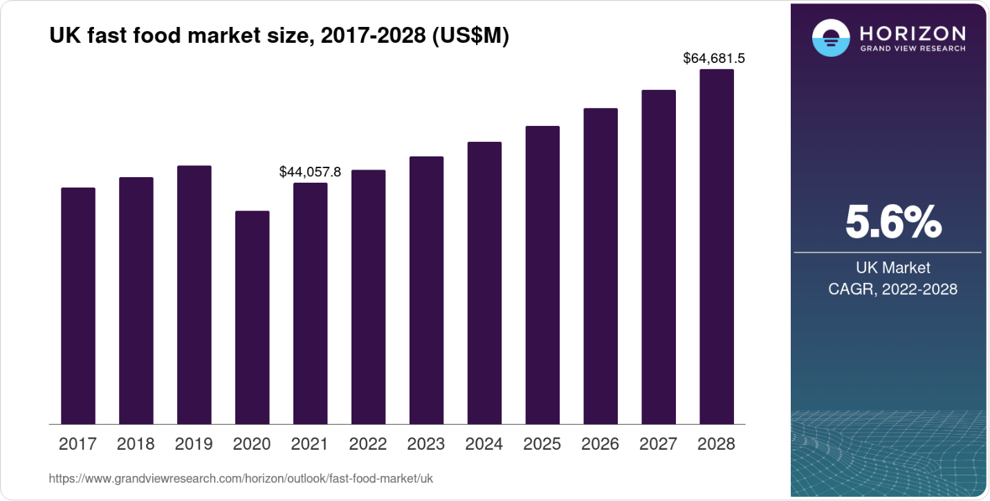
Figure 1:UK Fast-Food Market Size (2017–2028) in US$ Million
(Source: Horizon Grand View Research (2025). UK Fast Food Market Outlook. https://www.grandviewresearch.com/horizon/outlook/fast-food-market/uk)
Content marketing involves the targeted development and delivery of valuable, relevant, and coherent content for the purpose of gaining and retaining a well-defined audience with the goal of stimulating profitable consumer behaviour (Patil et al., 2024). The United Kingdom fast-food sector, worth more than GBP15bn a year, faces intense competition with the world's best-known brands such as McDonald's, KFC and Burger King, at the same time as it battles the rise of its local brands and delivery-focused rivals. Within the context of such an environment, effective digital storytelling and genuine representation of the brand becomes central to differentiation and achieving long-term sustainability (Fatorachian et al., 2025).
The rising of the digital platforms has radically reshaped traditional marketing practises. Specifically, social media, work with influencers, and user-created content have become crucial processes through which brand image and influence on consumer opinion can be enhanced. Influencer-packed campaigns do not disrupt the growth of brand social networks and increase customer interest faster as evidenced by Benevento et al. (2025) and conducted on social media platforms like Twitter or TikTok. Additionally, content marketing provides fast-food companies with the pivotal channel to deal with the social issues of the ethics, sustainability, and health, and thus transform the negative publicity into brand reinforcement opportunities. As a result, an in-depth understanding of the mutual impact between strategies of content marketing and brand awareness is essential towards strengthening brand competitiveness in the fast-food industry in the United Kingdom (AlFraihat et al., 2025).

1.2. Research Problem
Despite significant digital investment, many fast-food brands operating in the United Kingdom still face obstacles to having consistent brand awareness, due to scattered marketing strategies, negative publicity and an oversaturated marketplace. Reports documenting unethical practices, such as mistreatment of employees and strikes over remuneration, have adversely impacted on the brand reputation and caused consumer trust, especially well-known fast-food chains (e.g. McDonald's and KFC). These scandals negatively affect the effectiveness of more conventional approaches to marketing and reinforce the urgent need to engage in genuine, consumer-focused online interaction (Fatorachian et al., 2025).
Additionally, while content marketing is widely used, a significant number of brands are not using it to achieve lasting differentiation. The main issue that is connected with such a phenomenon is the lack of consistency in the deployment of narratives, including the lack of custom content and correspondence to values that the consumers share. According to recent research done by AlFraihat et al. (2025), the findings describe how brand loyalty and behavioural engagement contribute to the defines of consumer brand loyalty through content-led brand precipitation; meanwhile, the application of content-led brand precipitation among fast food brands is less than sufficient. Furthermore, research from emerging markets demonstrates that the use of the marketing mix alone is not enough for building equity without integrated content approaches (Ahmed et al., 2024). The UK fast food industry is therefore presented with a challenge to make digital content matter into brand experiences that can be meaningful and trust based while helping to rebuild and strengthen awareness among ethically conscious and digitally active consumers (Fard et al., 2025).

1.3. Research Rationale
This research is relevant because it contributes to a current need for evidence-based information that relates to the impact of content marketing on brand awareness in the UK fast food sector. By analysing digital marketing, influencer marketing and story-telling techniques, the research aims to inform practitioners on how to create a coherent and value-based communication that improves consumer perception and loyalty. Conclusions, Implications, and Theoretical Implications The results advance the academic and managerial understanding of the function of content marketing in facilitating sustainable brand positioning in an intensely competitive and negatively ethical marketplace (Patil. et al, 2024; Fatorachian et al., 2025).

1.4. Research aim, objectives and questions

1.4.1. Aim
The aim of this research is to examine the impact of content marketing strategies on enhancing brand awareness within the UK fast-food industry.

1.4.2. Research Objectives
- To identify the key content marketing strategies used by fast-food brands in the UK.
- To analyse the impact of these content marketing strategies on brand awareness in the UK fast-food industry.

1.4.3 Research Questions
- What is the key content marketing strategies used by fast-food brands in the UK?
- What is the impact of these content marketing strategies on brand awareness in the UK fast-food industry?

2. Literature Review

2.1. Content Marketing
Content marketing can be described as a strategic form of marketing in which the primary direction is put on generating and sharing valuable, relevant, and regular content to acquire and keep a well-defined group, resulting in the final realization of profitable customer behaviour (Rahman, 2024). This strategy focuses on construction of narratives, brand authenticity and consumer interactions as mediated through digital platforms, such as social media, company websites, and video content. In the fast-food industry, the sound use of content marketing means to combine entertainment with advertising communications in enhancing the emotional and trust bond between the consumers (Patil et al., 2024). This type of strategy helps to sustain relationships with all consumers over an extended period and strengthen brand presence in the competitive digital ecosystem (Fatorachian et al., 2025).

2.2. Brand Awareness
Brand awareness refers to how well consumers identify and remember a particular brand in a particular range of products (Anand, 2025). It forms an important part of brand equity and greatly influences consumer preferences and intentions to buy. In the fast-food sector, companies with high brand recognition can maintain market dominance despite growing competition as depicted in the case of McDonald's or KFC (Fard et al., 2025). Marketing endeavours, such as advertising, social media campaigns, and endorsements from influencers, help in adding to the familiarity and trust factor among the target audiences (Sánchez Garza et al., 2024). Hence, brand awareness is the sedimentary pillar for long-term profitability and consumer loyalty.

2.3. The Relationship Between Content Marketing and Brand Awareness
Content marketing is a key element in boosting brand awareness with consistent communication of brand values, narratives and offerings through digital platforms (AlFraihat et al., 2025). Interactive and informative material enhances consumer memory, emotional bond, and trust which add to brand name. In the context of the Fast-Food Industry for example, visually appealing and relatable content sent out via the social media mechanisms went a long way to attract attention and subsequently to strengthen brand recall, especially for younger segments of consumers. Moreover, good content marketing contributes to behavioural engagement, which acts as a mediating variable in the relationship between exposure and long-term and strong brand attachment (Benevento et al., 2025).

2.4. Literature Gap
While the role of social media and digital marketing in consumer behaviour has been covered extensively in the literature; empirical research examining the implications of content marketing for brand awareness specifically in the UK fast-food industry is limited. The studies analyzed by Fard et al. (2025) and Patil et al. (2024) were largely concerned with broad-based digital engagement strategy but did not require the specific content-marketing processes including storytelling, influencer partnerships, and user-generated content. Benevento et al. (2025) also noted the use of influencer driven storytelling to increase engagement on platforms such as TikTok and Instagram; however, they failed to examine its long-term impact on recall of brands. In fact, AlFrait et al. (2025) discovered that despite an improvement in emotional attachment, the interactive digital content has not been examined effectively in mature markets regarding the measure of quantitative brand awareness. In addition, few studies involve research on the significance of digital narratives for promoting sustainable differentiation of brands in highly competitive market situations where consumers' concern for value and ethical considerations increasingly dominate. This study is designed to explore the impact that content marketing strategies have on generating brand awareness in the fast food market in the UK fast food market and seemingly fills a significant void in the empirical literature based on their longer-term, quantitatively measurable impact in a mature market situation (Fatorachian et al., 2025; Patil et al., 2024).

2.5. Theoretical Framework – AIDA Model (Attention, Interest, Desire, Action)
The research is based on the AIDA model which identifies the cognitive stages of Attention, Interest, Desire and Action in which consumers go through after being exposed to marketing communications. Within the framework of content marketing, eye-catching elements and storytelling appeal can attract, informative posts can raise interest, persuasive storytelling can generate a desire, and an invitation can elicit action (Guzmán Valle et al., 2024). The model provides a conceptual framework for analysing the mechanisms explained by which fast-food brands drive attraction and conversion among consumers through online consumer experience content. It systematically utilizes communication strategies and correlates them with consumer behavioural responses as well as brand awareness (Rahman, 2024).

3. Methodology

3.1. Research Onion
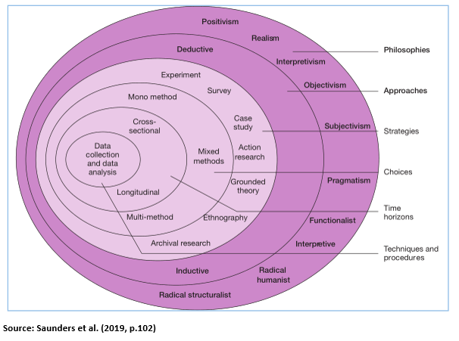
Figure 2: Research Onion
(Source: Saunders, 2019)

3.1.1. Research Philosophy
The research has employed a positivist research philosophy as the focus on observable and measurable phenomena and the analysis of objective data. Positivism enables testing of hypotheses and drawing of cause/effect relationship through statistical means. It especially suits well quantitative inquiries, as it encourages organization data gathering and positional evaluation, thus permitting the formulation of consistent conclusions. As a result, this philosophical position coincides with the aim of researching the role of content marketing in brand awareness using empirical data (Park et al., 2019).

3.1.2. Research Approach
The proposed research is going to utilize a deductive approach to the research, where it will begin with exploring the available theories and academic sources related to content marketing and brand awareness, and then proceed to the stage of testing the hypotheses based on theoretical assumptions. A deductive paradigm provides an investigative method of generating hypothesis-based analyses to provide support or contrary evidence to theoretical suppositions, therefore providing a logical development of an expansive theoretical construct to a tightly fitting empirical evidence. This approach to methodology is especially suitable in positivism-based questions when the researchers use quantitative information to either prove or disprove theoretical hypotheses (Ghanad, 2023).

3.1.3. Research Design
This study uses a quantitative research design to obtain numerical data by the study subjects and uses statistical methods to analyse the relationship between content marketing and brand awareness. The design provides measurable insights and thus improves the objectivity and reliability. By making use of quantitative techniques, the researcher can use statistical tools-such as regression analysis, to determine trends, pattern, and correlation among variables (Hyer, 2024). Such an approach ensures easy structured collection of data and is especially suitable for those studies involving large samples.

3.1.4. Research Choice
This research follows a mono-methodological design, as it only involves a quantitative methodology, whereby structured questionnaires are used in the data collection. The use of only one modality of methodology provides some consistency to the interpretation of data, and it suits the positivist epistemology where objectivity and numeric value are important. The process of research becomes less complex because the mono-method enables the researcher to provide an in-depth analysis of the results instead of encompassing the complexity of data integration. As a result, it is best adapted to researchers involving the investigation of correlations between specific variables (Hyer, 2024).

3.1.5. Research Strategy
The suggested survey methodology is based on the idea to efficiently acquire data from a large sample of fast-food consumers. By using standardized instruments this approach helps in statistical comparison and gives the chance to generalize the results. The use of online questionnaires allows for improved access and ease of use by participants, which can thus ensure a heterogeneous range of responses. This approach has become very popular in marketing research and is used to quantitatively measure attitudes, preferences, and perceptions (Ghanad, 2023).

3.1.6. Time Horizon
The cross-sectional time frame will be chosen, which gives focus to the data taken at one period to determine the current influence of content marketing on brand awareness. The methodological decision is economical in terms of costs and efficient in time saving as the researcher will be able to obtain the real-time consumer viewpoints. It is especially suitable when the researcher wants to find correlations between variables but does not have to track the study over a long period (Hyer, 2024).

3.2. Sampling

3.2.1. Population
The target market for this research will include all consumers who habitually purchase fast food from leading UK brands such as McDonald's, KFC and Burger King. This cohort is suitable as such customers are the immediate recipients of the effects of digital content marketing strategies. By focusing on fast-food consumers, it becomes possible to gain a better understanding of the importance of online marketing in influencing the way we perceive brands (Fatorachian et al., 2025).

3.2.2. Sampling Method
This research paper will employ a purposive sampling method, where the sample size will be composed of individuals who regularly use a fast-food restaurant such as McDonald, KFC, and Burger King in the United Kingdom. This kind of methodological approach is considered appropriate as it allows researchers to purposely target subjects that have first-hand exposure to fast-food marketing content so that it ensures the acquisition of relevant and interesting responses to help in the systematic analysis of the effects of content marketing on brand awareness (Park et al., 2019).

3.2.3. Sample Size
This research will involve the selection of 50 fast-food consumers. This is believed to be the adequate sample size that would allow reaching statistical reliability and, at the same time, be subject to a feasible data analysis. A diverse sample will be in terms of age groups, sex and favourable inclinations, and thus present a well-balanced expression of customer point of view. Such a large sample size is considered adequate in quantitative research, which employs surveying as one of the methods (Ghanad, 2023).

3.3. Data Collection Method
Data collection will be performed using Google Forms and shared with acquaintances and relatives living in the United Kingdom and who visit fast food restaurants on a regular basis. The employed methodology offers increased accessibility, promotes cost-efficiency, and offers speed in data acquisition as well as focusing on respondents familiar with UK fast food brands (Hyer, 2024). The instrument is closed-ended and uses a five-point Likert scale to evaluate the participant's perception of content marketing and brand awareness. Online publication offers wide access and convenience and at the same time, it saves costs and time. Furthermore, this modality allows for structured data organisation and automated capture of the response, which allows for a strong quantitative analysis (Hyer, 2024).

3.4. Data Analysis
The obtained data will be analysed using SPSS software to ascertain correct statistical interpretation. Regression analysis will be used to establish the correlation between variables in content marketing and levels of brand awareness. Descriptive statistics will provide data trend summary, while inferential analysis will help to objectively test hypotheses. Using SPSS is more effective in testing the data to increase reliability and to make empirical conclusions in a structured manner (Ghanad, 2023).

4. Expected Findings
The planned study envisions that the enactment of effective content marketing tools, including digital narratives, collaborations with influencers, and interactive campaigns on social media channels, will create a significant increase in brand cognition in the fast-food segment of the United Kingdom. It is expected that true, consistent, and purpose-driven content will help in improving recall among consumers, building trust, and develop emotional links with brands. The results would also suggest that visual and narrative-oriented material would have a positive effect on consumer interest and devotion, and the results of this approach would be long-term brand distinction. Additionally, the research could suggest how consumers are more positive to content with ethical, sustainable, and health-conscious values, hence touching contemporary expectations in the United Kingdom market (Patil et al. 2024; Fatorachian et al. 2025)

5. Limitations
There are several limitations in this study. The small sample size of 50, which was chosen using purposive sample techniques involving familiar persons and family members living in the United Kingdom is chief among them because it can limit transfer of findings to the larger population. Secondly, the use of self-reported online survey tools can throw up possibilities of response bias or social desirability effect, where the respondents tend to provide favourable answers instead of giving their real opinions. Thirdly, such a strict focus on high-profile fast-food brands, namely, McDonalds, KFC, and Burger King, can fail to capture smaller or emerging UK brands that do not necessarily use the same kind of approach in marketing. Also, the cross-sectional approach is used in this study, which immediately presents the consumer perceptions in a single instance in time and excludes the possibility of assessing the long-term impact of content marketing on brand awareness. Moreover, there are external variables that can have a significant impact on brand perception in the absence of content marketing actions, for example, price promotions, seasonal campaigns, ethical scandals (Hyer, 2024; Al-frakhat et al., 2025).

6. Timeline
Main activities and stages

7. Conclusion
The research aims to explore the impact of content marketing on brand awareness in the fast-food industry in the United Kingdom. Employing a quantitative analytical framework, this study attempts to look for the kinds of content strategies which may turn out to be efficacious and assess their impact on customer recognition and customer loyalty. This investigation is expected to provide substantial knowledge about the ways mainstream storytelling and audience engagement heighten brand visibility in the contexts of made-for, competitive marketplaces. The results will contribute to theoretical understanding and act as an empirical approach to fast-food businesses in developing evidence-based marketing plans that strengthen consumer bond and improve brand loyalty.

8. References
Abd Al Rahman, M. (2024) Content marketing is a strategic marketing approach focused on creating and distributing valuable, relevant, and consistent content to attract and retain a clearly defined audience, ultimately aiming to drive profitable customer action. University of Roehampton, June 2024. Available at: https://www.researchgate.net/publication/381697872_Content_marketing_is_a_strategic_marketing_approach_focused_on_creating_and_distributing_valuable_relevant_and_consistent_content_to_attract_and_retain_a_clearly_defined_audience_ultimately_aiming_to_
Ahmed, S., Saad, A. T., Chowdhury, S. R., Sobhani, F. A., Hassan, M. S. and Islam, M. A. (2024) ‘Impact of marketing mix elements on the brand equity of online food delivery services: an emerging economy perspective’, Cogent Business & Management, 11(1). Available at: https://www.tandfonline.com/doi/full/10.1080/23311975.2024.2380018
AlFraihat, S. F. A., Ali, A. M., Hodaifa, G. and Alghizzawi, M. (2025) ‘The Impact of Digital Content Marketing on Brand Defence: The Mediating Role of Behavioural Engagement and Brand Attachment’, Administrative Sciences, 15(4), 124. DOI: 10.3390/admsci15040124.
Anand, A. (2025) ‘Brand Awareness’, International Journal for Multidisciplinary Research, 5(3). DOI: 10.36948/ijfmr.2023.v05i03.3571. Available at: https://www.researchgate.net/publication/389503004_Brand_Awareness
Benevento, E., Aloini, D., Roma, P. and Bellino, D. (2025) ‘The impact of influencers on brand social network growth: Insights from new product launch events on Twitter’, Journal of Business Research, 189, 115123. Available at: https://www.sciencedirect.com/science/article/pii/S0148296324006271
Chowdhury, S., Faruque, M., Sharmin, S., Talukder, T., Mahmud, M., Dastagir, G. and Akter, S. (2024) ‘The Impact of Social Media Marketing on Consumer Behavior: A Study of the Fashion Retail Industry’, Open Journal of Business and Management, 12, pp. 1666–1699. DOI: 10.4236/ojbm.2024.123090.
Elliott, C., Truman, E. and Black, J. E. (2025) ‘Food marketing to teenagers: Examining the digital palate of targeted appeals’, Appetite, 207, 107912. Available at: https://www.sciencedirect.com/science/article/pii/S0195666325000650
Fatorachian, H., Arboleda, E. and Linh, T. T. (2025) ‘Digitalisation and customer engagement in fast-food SMEs: enhancing brand presence through social media’, Cogent Business & Management, 12(1). Available at: https://www.tandfonline.com/doi/full/10.1080/23311975.2025.2508927
Francis, S. J., Murugesu, G. and Bimdini, U.D.Y. (2024) ‘Influence of Social Media Marketing on Consumer Behavior in the Fast-Food Industry: Special Reference to Colombo, Sri Lanka’, Kelaniya Journal of Management, 13(3), pp. 138–155. DOI: 10.4038/kjm.v13i3.7807.
Guzmán Valle, M. de los Á., Arbulú Ballesteros, M. A., Guzmán Valle, C. A., Montes Ninaquispe, J. C., Pantaleón Santa María, A. L., Ruiz Chacón, S. V., Lamadrid Aldana, M. and Castro Muñoz, W. T. (2024) ‘Potential Impact of Sustainable Business Practices: Brand Equity in Fast Food and Millennials’ Purchase Intentions’, Sustainability, 16(9), 3768. DOI: 10.3390/su16093768.
Moayery Fard, H., Jikidze, E. and Namgalauri, A. (2025) ‘Investigating The Impact of Brand Awareness and Brand Image on Repeat Purchase in The Fast-Food Industry of Georgia’, Frontline Marketing Management and Economics Journal, 5(10), pp. 14–24. DOI: 10.37547/marketing-fmmej-05-10-02. Available at: https://www.researchgate.net/publication/396484017_Investigating_The_Impact_of_Brand_Awareness_and_Brand_Image_on_Repeat_Purchase_in_The_Fast-Food_Industry_of_Georgia
Patil, S. K. and Seetalad, S. M. (2024) ‘Analyzing the impact of content marketing on brand awareness’, ShodhKosh: Journal of Visual and Performing Arts, 5(3). DOI: 10.29121/shodhkosh.v5.i3.2024.5517. Available at: https://www.researchgate.net/publication/392925734_ANALYZING_THE_IMPACT_OF_CONTENT_MARKETING_ON_BRAND_AWARENESS
Sánchez Garza, M. N., Sánchez Limón, M. L., Sánchez Tovar, Y. and Qalati, S. A. (2024) ‘Marketing activities effects on brand awareness generation, image and loyalty in the social networks of a public higher education institution’, Cogent Business & Management, 11(1). Available at: https://www.tandfonline.com/doi/full/10.1080/23311975.2024.2318809
Zahra, T. (2025) ‘The influence of social media marketing on consumer brand engagement and brand knowledge in fast food products’, Manajemen dan Bisnis, 24(1), p. 12. DOI: 10.24123/mabis.v24i1.844. Available at: https://www.researchgate.net/publication/390641570_The_influence_of_social_media_marketing_on_consumer_brand_engagement_and_brand_knowledge_in_fast_food_products

