
Mike Davies (2415959)
2415959@student.uwtsd.ac.uk
Assignment 1: E-Portfolio
ACCA4025: Learning in the Digital Era (Computing & Electronics)
Computing (Data & Information Systems)

Contents
e-Portfolio 1
Task 1 – Written summary 2
Task 2 – Mind Map & Academic poster 3
Task 3 – Automatic Referencing tool 4
Task 4 – e-Portfolio creation and review 6

e-Portfolio
https://sites.google.com/view/ldeassignment1/home
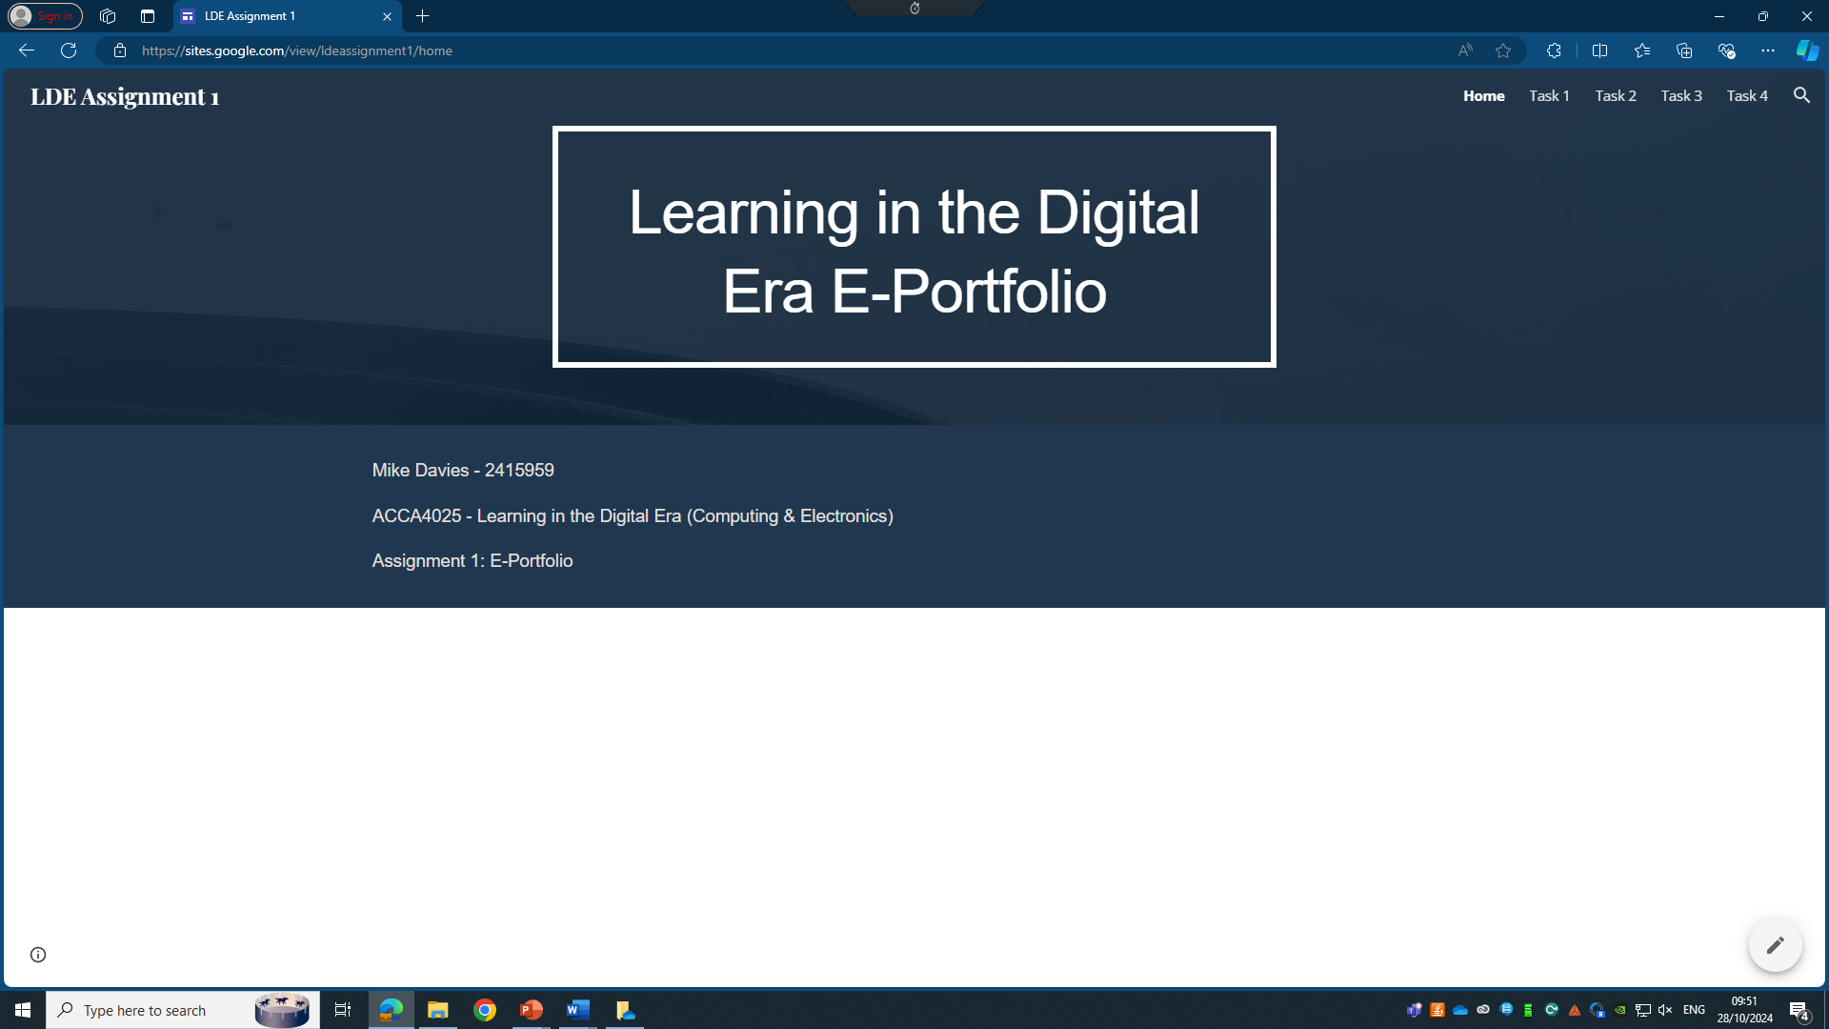

Task 1 – Written summary
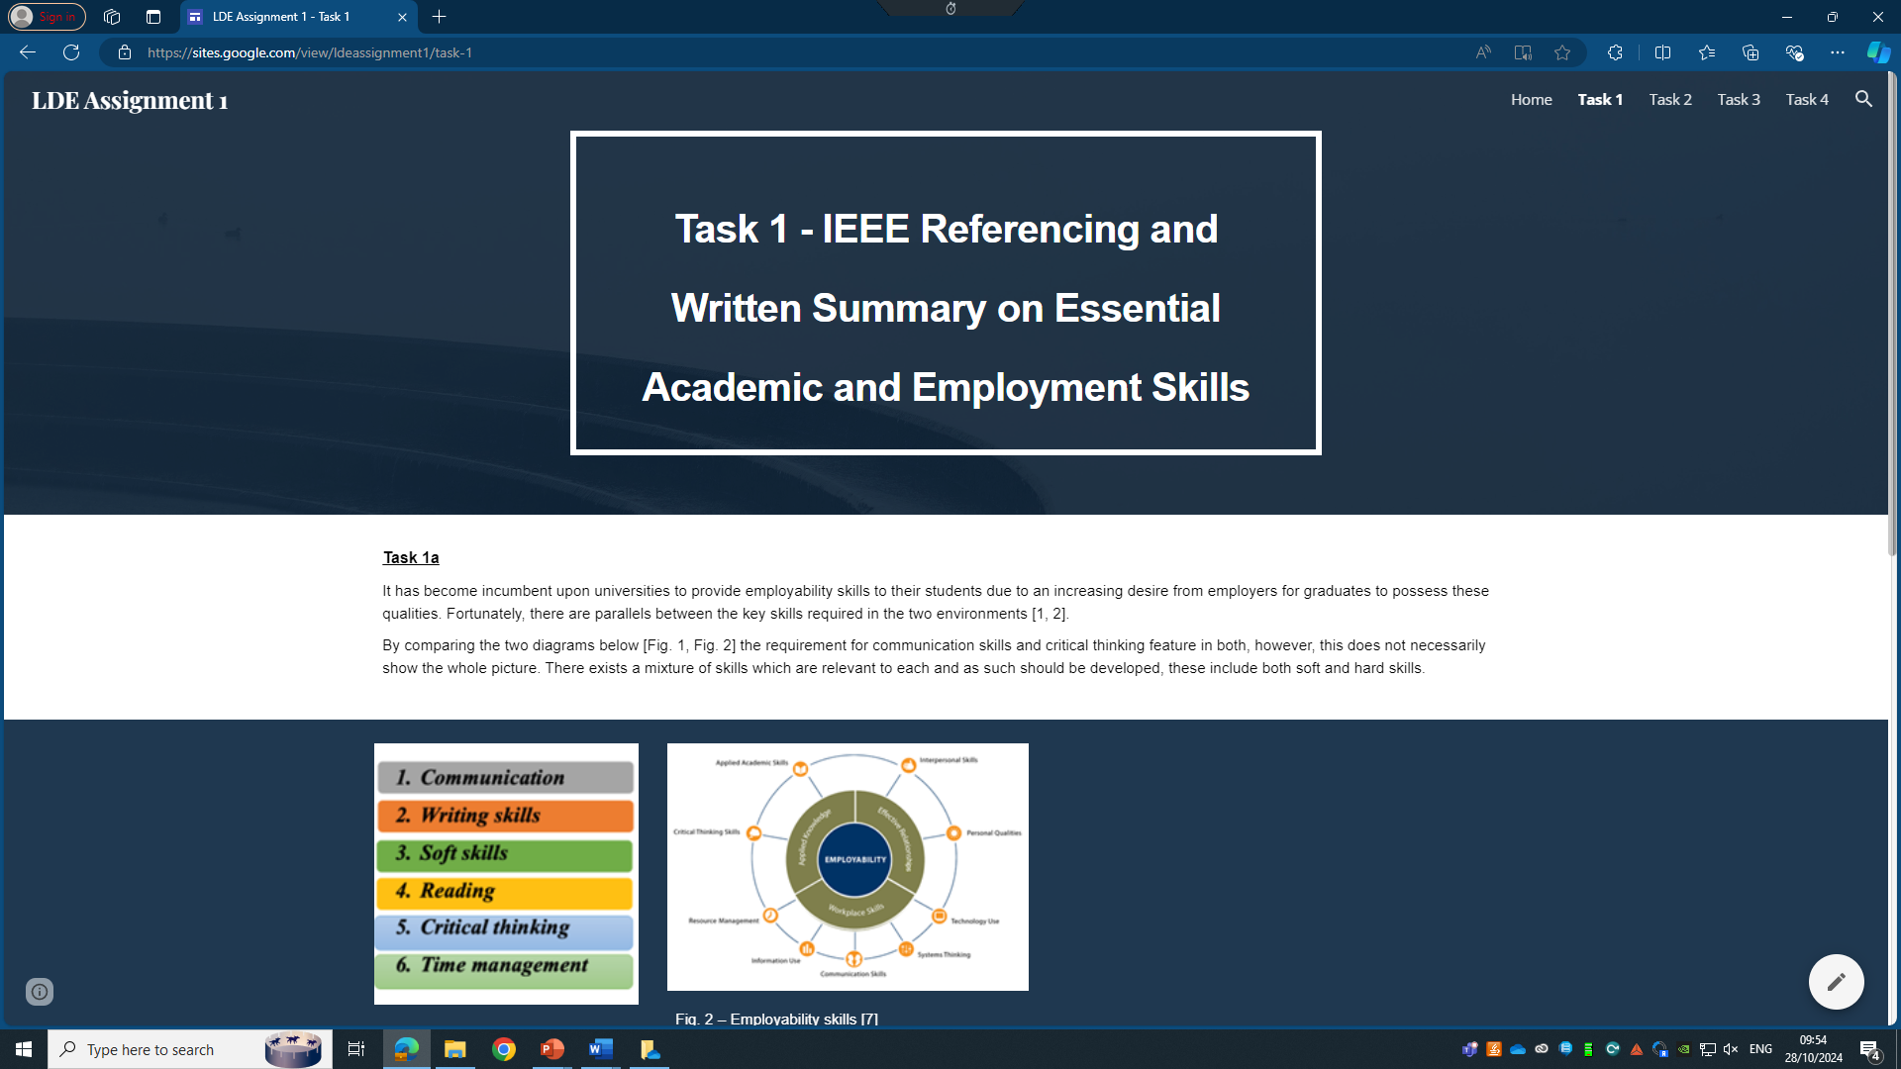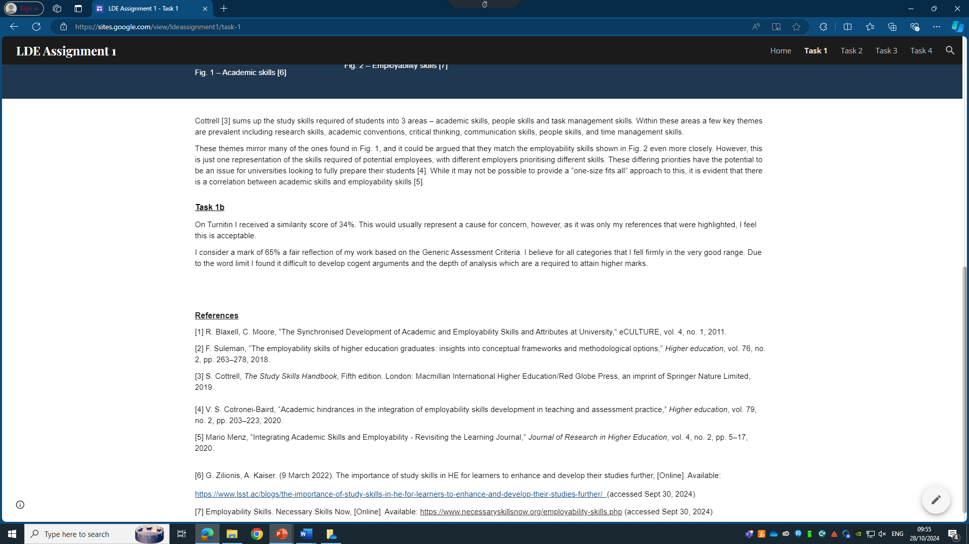

Task 2 – Mind Map & Academic poster
Mind Map: https://mm.tt/app/map/3462448848?t=C1AEBKlkIO
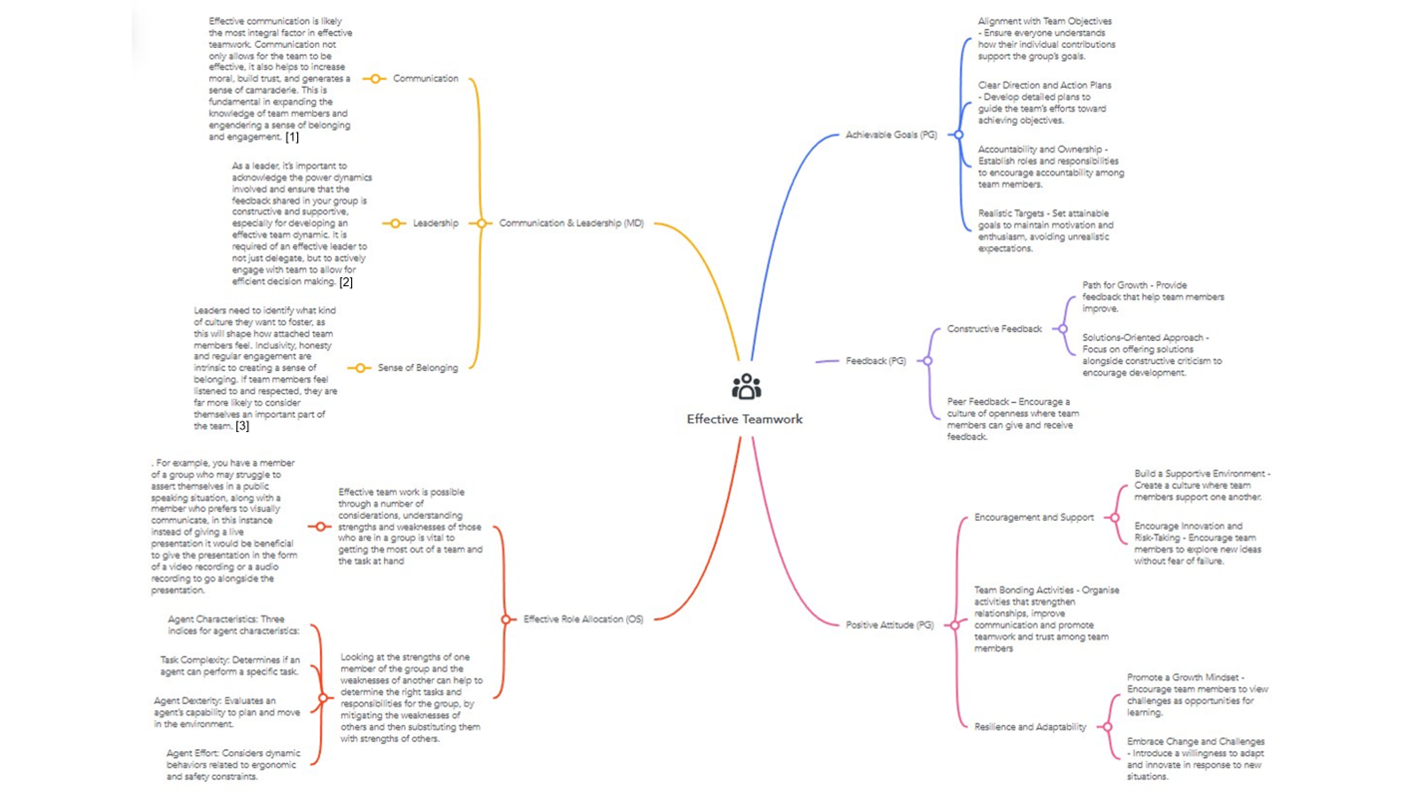
Poster: Poster.pptx
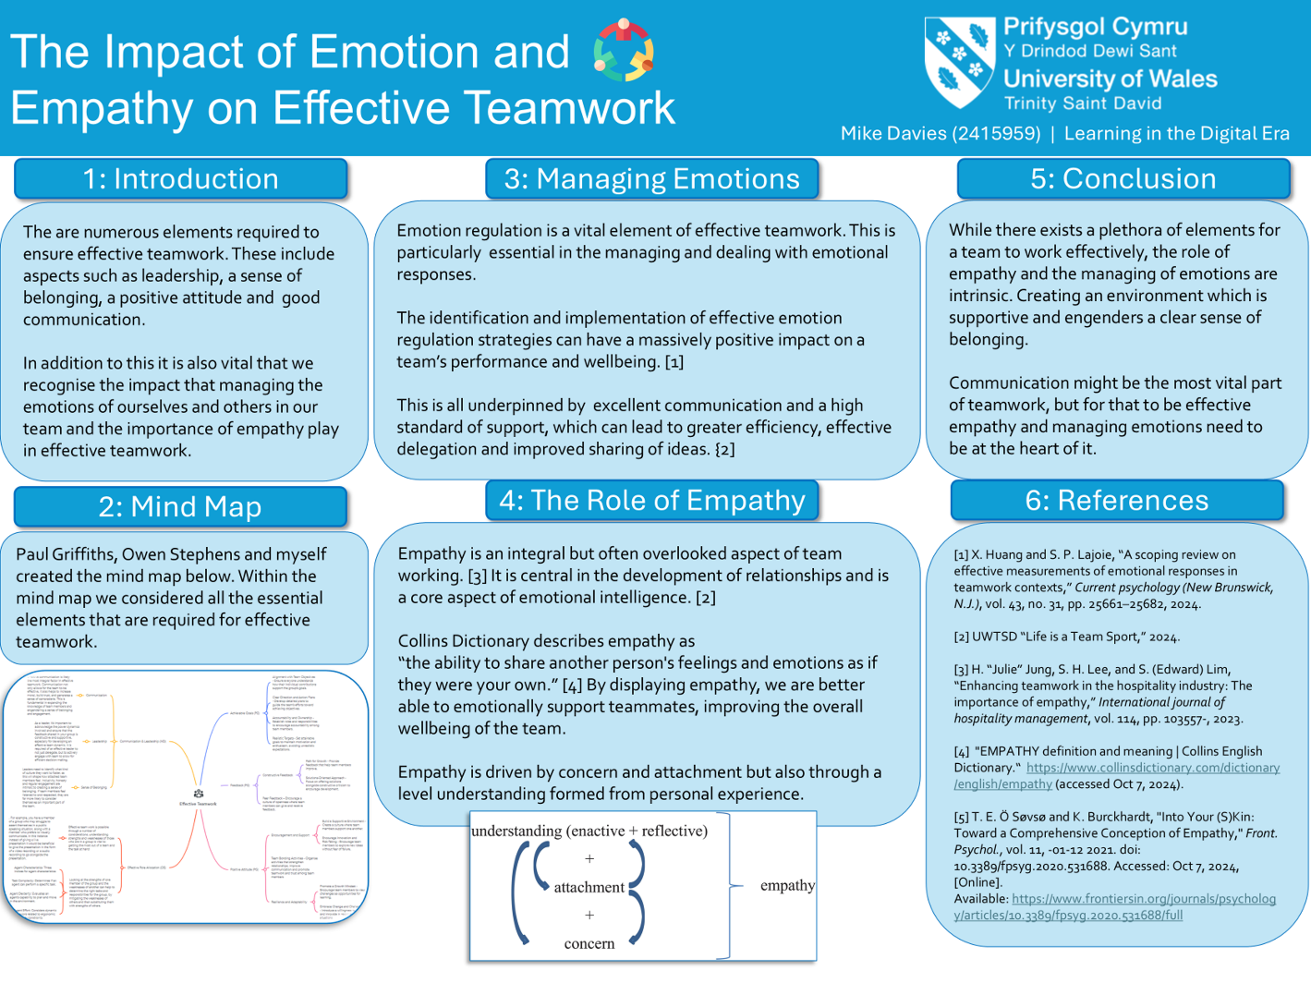

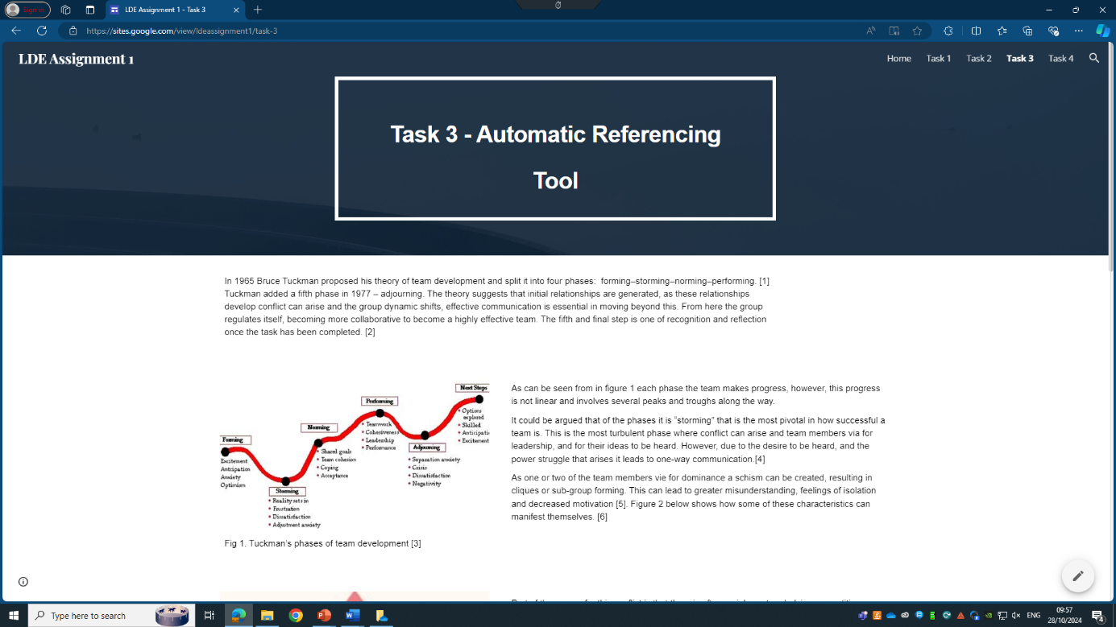
Task 3 – Automatic Referencing tool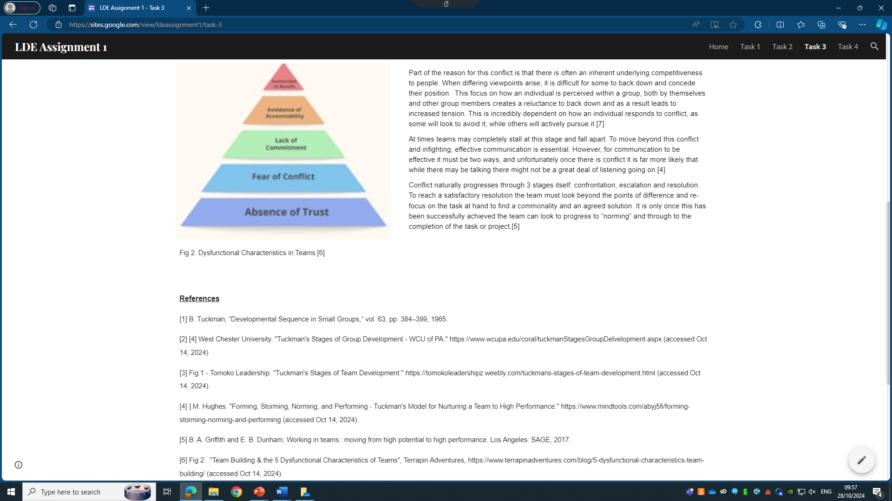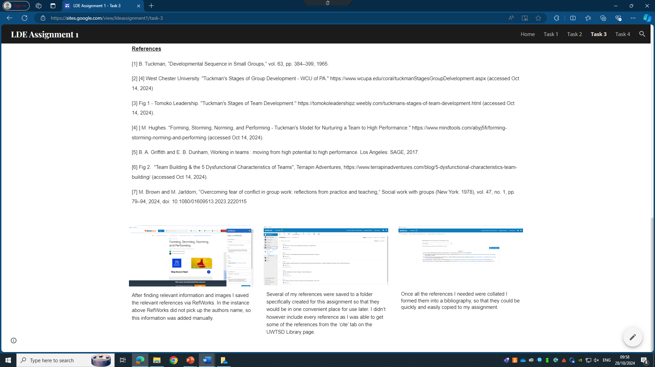

Task 4 – e-Portfolio creation and review


