Full interface & testing
Farley staines
2204098

Table of Contents
1. Introduction 5
2. Full-Colour Storyboard Analysis 5
2.1. Main displays 5
2.1.1. Home screen 5
2.1.2. Game screen 5
2.1.3. Settings screen 6
2.1.4. Sub settings screens 6
3. User Feedback Methodology and Results 7
3.1. How feedback was collected 7
3.2. Feedback results 7
3.2.1. Positive feedback 7
3.2.2. Negative feedback 7
3.3. Expected vs Unexpected 8
3.3.1. Expected feedback 8
3.3.2. Unexpected feedback 8
4. Future Data Collection 8
4.1. Automatically collected data 8
4.1.1. Usage Statistics 8
4.1.2. Performance Metrics 8
4.1.3. Player behaviour 9
4.1.4. Technical data 9
4.2. Manually collected data 9
4.2.1. Users experience feedback 9
4.2.2. Emotional response data 9
4.2.3. Qualitative data 9
4.2.4. Social interaction data 9
4.3. Collected usage vs emotional data 9
5. Usability viewpoint 10
5.1. How it would have differed 10
5.2. Conflicts 10
6. Conclusions 11
7. References 11
8. Appendices 12
8.1. Design prototype link 12
8.2. Design navigation 13
8.3. Home screen 14
8.4. Settings screen 14
8.5. Sub settings screen 15
8.6. Sub settings pop up screen 17
8.7. Stats screen 18
8.8. History screen 19
8.9. Play new game screen 19
8.10. Create new game single player 20
8.11. Create new game multiplayer 21
8.12. Game screen pop up 23
8.13. Playing the first round of a game 24
8.14. Watching someone play their round 27
8.15. Playing the second round of a game 29
8.16. Previous game screens 32
8.17. Win/lose screen 33

Table of Figures
Figure 1- home screen 5
Figure 2- game screen 6
Figure 3- settings screen 6
Figure 4- audio settings 7
Figure 5- visual settings 7
Figure 6- control settings 7
Figure 7- navigation between each screen 13
Figure 8- home screen 14
Figure 9- settings screen 14
Figure 10- audio settings screen 15
Figure 11- visual settings screen 15
Figure 12- colour settings screen 15
Figure 13- colour settings screen 16
Figure 14-notification settings screen 16
Figure 15- help and support screen 16
Figure 16- visual settings pop up 17
Figure 17- colour settings pop up 17
Figure 18- notification pop up 17
Figure 19- stats screen 18
Figure 20- full game history screen 19
Figure 21- single game history screen 19
Figure 22- choose new game option 19
Figure 23- create new single player 20
Figure 24- customize game options 20
Figure 25- join multiplayer game with code 21
Figure 26- join local multiplayer game 21
Figure 27- the lobby of a multiplayer game 21
Figure 28- configure multiplayer game 22
Figure 29- game screen, settings pop up 23
Figure 30- game 1, select dice 1 24
Figure 31- game 1, roll dice 1 24
Figure 32- game 1, continue or end turn 1 24
Figure 33- game1, select dice 2 25
Figure 34- game 1, roll dice 2 25
Figure 35- game 1, continue or end turn 2 25
Figure 36- game 1, select dice 3 25
Figure 37- game 1, end turn 26
Figure 38- game 1, game over screen 26
Figure 39- opponents turn 1 27
Figure 40- opponents turn 2 27
Figure 41- opponents turn 3 27
Figure 42- opponents turn 4 27
Figure 43- opponents turn 5 28
Figure 44- game 2, select dice 1 29
Figure 45- game 2, roll dice 1 29
Figure 46, game 2, continue or end turn 2 29
Figure 47- game 2, select dice 2 30
Figure 48- game 2, roll dice 2 30
Figure 49- game 2, continue or end turn 2 30
Figure 50- game 2, select dice 3 30
Figure 51- game 2, roll dice 2 31
Figure 52- game 2, end turn 31
Figure 53- player 1 previous round 32
Figure 54- player 2 previous round 32
Figure 55- player 3 previous round 32
Figure 56- player 4 previous round 32
Figure 57- lose screen 33
Figure 58- win screen 33

Introduction
This report analyses the development of a UWTSD-themed mobile game inspired by Zombie Dice's mechanics. Building upon previous wireframe designs, it presents full-colour storyboards, user feedback analysis, and plans for future data collection. The project aims to create an engaging, user-friendly interface while maintaining a UWTSD's theme. Through iterative design and user testing, the interface has evolved to balance usability principles with a compelling user experience.

Full-Colour Storyboard Analysis

Main displays

Home screen
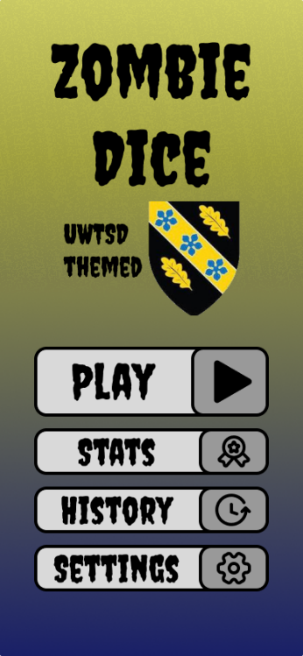
The updated home screen showcases several key interaction design principles. The vertical layout follows Fitts's Law [1] by placing interactive elements in easily reachable areas. The button styling stays consistent across every page, with the home screen having clear icons next to buttons so that it adheres to Jakob Nielsen's [2] heuristic of recognition over recall, making navigation intuitive. The gradient background from yellow to dark blue creates visual hierarchy and depth, while also matching the colour scheme of UWTSD.
The visual hierarchy is well-structured, with the game title being most prominent, followed by the UWTSD logo underneath and then the action buttons, this follows the F-pattern reading behaviour [3]. The addition of high contrast between text and background, particularly in the buttons, ensures good readability and meets accessibility guidelines.
The main differences between the new and old are that the UWTSD logo has been positioned below the title of the game; this was changed so that the title stands out more with the font being increased. Another difference is the stats and history buttons have been split into their own buttons, making navigating their own screens easier. The buttons have also been repositioned and the text centralised with the text on every screen sharing the same font since users found that the font fit the theme of the game.
Figure 1- home screen

Game screen
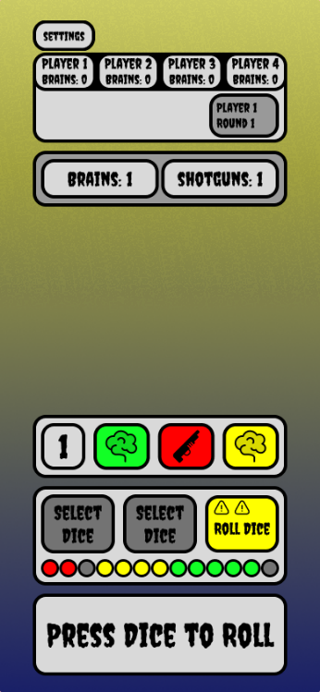
The new game screen cleans up some areas that were not needed or too cluttered. With the layout following the principle of progressive disclosure [4], showing only relevant information for the current game state. The score tracking area has been simplified based on user feedback, finding that the information was too cluttered or confusing by what it means. The brains and shotguns counters use the same consistent style throughout the game. The colour-coding of dice (green, red, yellow) provides immediate visual feedback about dice types. Additionally, there is a danger sign that corresponds to a certain dice colour; furthermore, there is an icon representing what the dice has rolled. These all follow the principle of natural mapping [5], showing the difficulty levels.
Figure 2- game screen
The play area that was originally going to be in the centre was changed to a colourful display of the previous dice that were rolled which used to be in the box next to the player scores, which users found confusing. in order to keep the list of previous dice rolls they were repositioned in the centre as the main visual display. The box that was going to keep track of scores and round information has been changed into a scrollable box that keeps track of the previous games that players have completed.
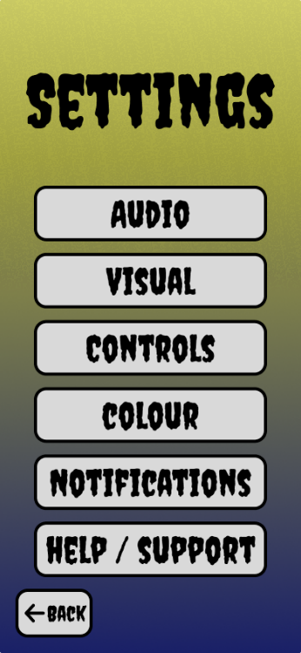
Other changes include narrowing down the size of each element so that they are all the same size, moving the settings button into the top left corner, keeping it out of the way, and making it less dominant on the screen.
Figure 3- settings screen

Settings screen
The new settings screen keeps the consistent gradient background while providing sufficient contrast for the settings options. The button layout follows the principle of serial position effect [6], placing common settings options at the top where they're most accessible. The interface employs a clear visual hierarchy with the title prominently displayed at the top, followed by equally weighted option buttons. The font remains consistent while ensuring suitable readability, which follows accessibility guidelines for text contrast and size.
The back button has been moved from its original location to the bottom left across every screen it is on. Since users considered it out of place, making the placement at the bottom follow platform conventions while still supporting one-handed operation. The buttons have been made large and cover more of the screen, with the text inside being centred.

Sub settings screens
Each of the screens that fall under the settings screen has been adjusted and made more consistent. The back button has been moved to the button left to follow platform convention. Each button on the page now fixes at the bottom of the screen, making it easier to reach. The buttons have also been resized making every button about the same size, in order to keep consistency.
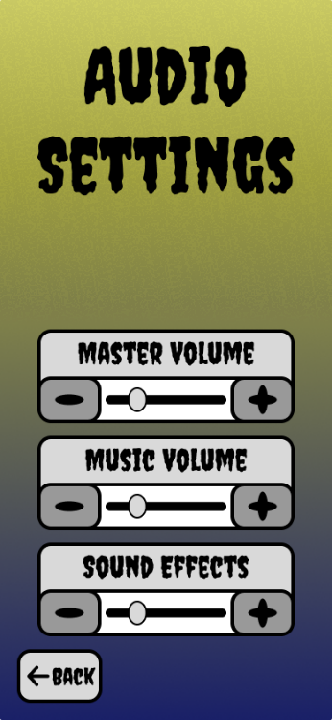
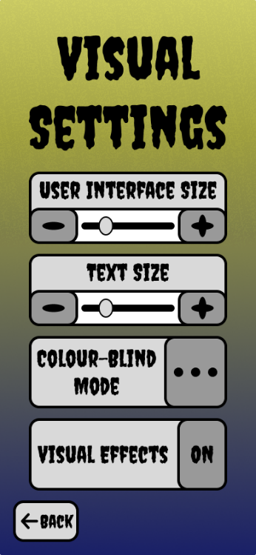
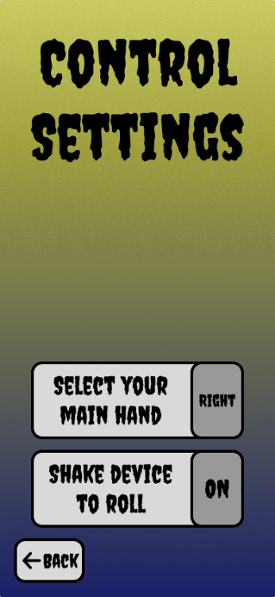
Figure 4- audio settings
Figure 5- visual settings
Figure 6- control settings

User Feedback Methodology and Results

How feedback was collected
To collect feedback for the full-colour design, interviews were set up between some new and returning participants. For returning participants, they were given the full-colour design and could navigate it freely. Whereas for new participants, an explanation was given before playing, explaining what the game is and how to play, then handed a demo for them to navigate. While they navigate the designs, feedback was asked about what they thought about the design; on top of this, information was collected about what they were doing and how they navigated around.

Feedback results

Positive feedback
Users particularly praised the thoughtful colour scheme, with it using two complementary colours for the background as well as it being a gradient background instead of a solid colour. User also liked that the background and button style stayed consistent throughout each screen. The font tested in the wireframe has continued to be other, and users liked it as it helps to set the scene, in addition to still being readable. The interface elements received positive remarks for their sizing and placement, with there being a good variety of button options. The customisation options were also well received, with users appreciating the ability to modify various settings, including audio and visual settings, as well as the dice colours.

Negative feedback
A primary concern was the lack of clear in-game instructions, with users expressing confusion about the basic gameplay mechanics and therefore having to explain the rules again. A few navigation issues were identified, particularly regarding the absence of an obvious exit button when playing a game and a missing scroll bar display for scrollable content. The absence of some common features, such as no visual animation when winning and tooltips for buttons when hovering over them, made it confusing about what was happening or what something does. Additionally, multiplayer was considered as missing some information that could make joining games easier.

Expected vs Unexpected

Expected feedback
Some of the feedback I was expecting was being able to customise the game more, including the background and dice; this was left out as it is required to play the game but can be added in later. There were several comments made about an in-game tutorial explaining how to play and navigate the menus; again, this is a feature that could be added in further down the development path. Other feedback that was received, was how the layouts were clear and navigation through the game menus were easy.

Unexpected feedback
One of the main things that was observed was how very few people were able to navigate to every screen. Appendix 8.16 shows the results of a previous round that happened in the same game. These screens could be accessed through tapping the round under the player scores. Another piece of feedback that was received were people not knowing how or where to quit the game, with people assuming the quit option in the settings pop-up (appendix 8.12) refers to saving the settings and continuing the game, whereas the settings would save automatically, and the quit option takes you back to the home screen. Some more unexpected feedback includes missing information that they would probably expect, like a scroll bar on scrollable content and tooltips for each button explaining what it does.

Future Data Collection

Automatically collected data
A list of data that will be collected automatically through in game analytical services.

Usage Statistics
Usage statistics will allow analysis of player engagement and measure game success. Key data includes session length, frequency, and timing patterns, helping optimise server resources and plan maintenance around player activity. Collecting game completion rates and success rates helps identify if games are too long or difficult, enabling appropriate adjustments to improve player experience. [7]

Performance Metrics
Performance metrics are required for maintaining game quality and player satisfaction. Automated logging systems monitor app load times, frame rates, battery usage, device specifications, and crashes. This data helps optimise the game across different devices, quickly identify and resolve technical issues, and ensure a smooth gameplay performance.

Player behaviour
Player behaviour data tracks in-game actions and decisions, including win/loss ratios, scoring patterns, feature usage, and tutorial completion rates. This information reveals if the game mechanics are effective, the difficulty levels are appropriate, and players understand the gameplay. This data will help to balance game elements, improve tutorials, and ensure features enhance the overall experience. [8]

Technical data
Technical data is collected through system API calls, by tracking hardware and software configurations used by players. By monitoring device types, operating systems, screen resolutions, and network quality, we can understand common player setups. This helps optimize game performance across different platforms and inform decisions about minimum requirements and feature support.

Manually collected data

Users experience feedback
User experience feedback collected through surveys, forms, and questionnaires complements quantitative data with qualitative insights. Players provide satisfaction ratings, feature requests, bug reports, and preferences through in-app prompts and external platforms. This reveals player feelings about the game, desired features, and pain points, helping prioritise improvements that maximise enjoyment. [9]

Emotional response data
Emotional response data gathered through micro-surveys, emoji reactions, and feedback questionnaires reveal how different game elements affect player feelings. By tracking enjoyment levels, frustration points, and emotional engagement, we can understand if the game creates the intended responses. This will help identify problems and ensure game mechanics contribute to a positive experience.

Qualitative data
Qualitative feedback is collected through in-app systems, surveys, interviews, and focus groups, which all provide a deeper insight into player behaviour and preferences. User reviews, suggestions, and personal experiences offer contextual information that metrics alone can't capture. This helps understand player motivations, identify unexpected issues, and gather innovative ideas directly from the community.

Social interaction data
Social interaction data is tracked through in-game features, forums, and social media; these all reveal how players connect and engage with each other. By monitoring community interactions, sharing patterns, and multiplayer preferences, we can identify valuable social features and improve player connections. This helps understand how social elements affect player retention.

Collected usage vs emotional data
Usage data collection is mostly automated, leveraging built-in analytics tools to gather objective, quantifiable metrics such as session times, feature usage, and player progression. This data provides clear, measurable insights into player behaviour but lacks context about the emotional drivers behind these actions. In contrast, emotional response data requires more direct player engagement through surveys, feedback forms, and interactive prompts, making it more challenging to collect consistently [10]. While usage data can tell us what players do, emotional response data tells us why they do it. This complementary relationship between the two data types is crucial; usage data might show players abandoning a feature, but only emotional response data can reveal if this is due to frustration, boredom, or technical issues.

Usability viewpoint

How it would have differed
The difference between usability compared to user experience is that usability focuses on functionality, efficiency, and ease of use for the user whereas user experience focuses on emotional aspects, engagement, and the enjoyment of playing it.
For the menu structure to be for pure usability, the menu structure would need to be flattened, reducing the number of layers that would need to be navigated. Essential functions would be immediately accessible, eliminating the need to navigate through multiple screens to reach common settings like audio or controls.
For the game interface to focus on usability, it would need to prioritise function over form, enlarging the interactive elements and adding numerical values alongside colours. The dice interface would be simplified with prominent action buttons and clear status indicators, removing any decorative elements that don't directly contribute to gameplay.
The settings screen would be reorganised based on usage frequency rather than category. The most commonly adjusted options would appear at the top level, while related settings would be grouped together. This would focus on reducing navigation steps rather than maintaining thematic grouping.
The statistics and history screen would be merged into one view, prioritising recently played games and key performance metrics; however, when tested, participants didn’t like it and preferred the two screens to be split. The interface for this would be to minimise scrolling and tapping, presenting the most relevant information immediately without requiring navigation between sections.

Conflicts
An area of conflict was the amount of information present on the game screen. The wireframe tried to focus on usability by getting in as much information at the top of the screen that could fit while remaining readable; however, it came out as cluttered and confusing for new players. In addition, it also tried to accommodate UX, with the centre of the screen open to fancy animation and design. The final design came out focusing more on usability rather than UX by moving some of the information from the top towards the centre of the screen.
Another area of conflict was the stats and history screen. With them originally merged together, so that everything was in one place; however, during user testing for the wireframes, participants expressed how they should be split into their own screen. As users preferred the screens split, that is what went forward, ensuring the two screens remain separated.
Another area that could have expanded more was how much colour customisation there was for on-screen elements, with options to change the colour of several more elements like the background and buttons. However, this could cause issues like readability, so the number of elements was limited to just the dice.

Conclusions
The development process revealed several key findings that shaped the final design. User testing highlighted the importance of clear navigation, consistent styling, and intuitive gameplay instructions. For implementation, priority should be given to adding in-game tutorials, visual feedback mechanisms, and clearer multiplayer features. Future development should focus on expanding customization options, implementing analytics systems for data collection, and enhancing social features while maintaining the balance between usability and user experience that emerged through testing. These improvements will help create a more engaging and accessible gaming experience.

References
[1] Interaction Design Foundation, ‘What is Fitts’ Law?’, https://www.interaction-design.org/literature/topics/fitts-law. Accessed: Jan. 07, 2025. [Online]. Available: https://www.interaction-design.org/literature/topics/fitts-law
[2] A. Jain, ‘10 Heuristic Principles – Jakob Nielsen’s (Usability Heuristics)’, https://www.uxness.in/2015/02/10-heuristic-principles-jakob-nielsens.html. Accessed: Jan. 07, 2025. [Online]. Available: https://www.uxness.in/2015/02/10-heuristic-principles-jakob-nielsens.html
[3] K. Pernice, ‘F-Shaped Pattern of Reading on the Web: Misunderstood, But Still Relevant (Even on Mobile)’, https://www.nngroup.com/articles/f-shaped-pattern-reading-web-content/.
[4] UXPin, ‘What is Progressive Disclosure? Show & Hide the Right Information’, https://www.uxpin.com/studio/blog/what-is-progressive-disclosure.
[5] K. Sherwin, ‘Natural Mappings and Stimulus-Response Compatibility in User Interface Design’, https://www.nngroup.com/articles/natural-mappings/.
[6] J. Yablonski, ‘Serial Position Effect | Laws of UX’, https://lawsofux.com/serial-position-effect/.
[7] Macrometa, ‘What Types Of Operational Data Are Critical In Gaming?’, https://www.macrometa.com/articles/what-types-of-operational-data-are-critical-in-gaming.
[8] iXie, ‘The Role of Player behavior Analytics in Gaming’, https://www.ixiegaming.com/blog/role-of-player-behavior-analytics-in-gaming/.
[9] M. Chakryan, ‘The Power of Data Collection in the Video Gaming Industry - CCC International’, https://ccci.am/the-power-of-data-collection-in-the-video-gaming-industry/.
[10] A. Hanlon and T. Tuten, ‘Collecting emotion and sentiment data’, https://anacanhoto.com/2024/08/26/collecting-emotion-and-sentiment-data/.

Appendices

Design prototype link
Interactive view of each screen
https://www.figma.com/design/MXs7jAANuOrD7On7TB0b2w/usability-2?t=oGniN7rNaTCxd5aP-1
navigate through each screen as if it was on a phone
https://www.figma.com/proto/MXs7jAANuOrD7On7TB0b2w?node-id=0-1&t=oGniN7rNaTCxd5aP-6

Design navigation
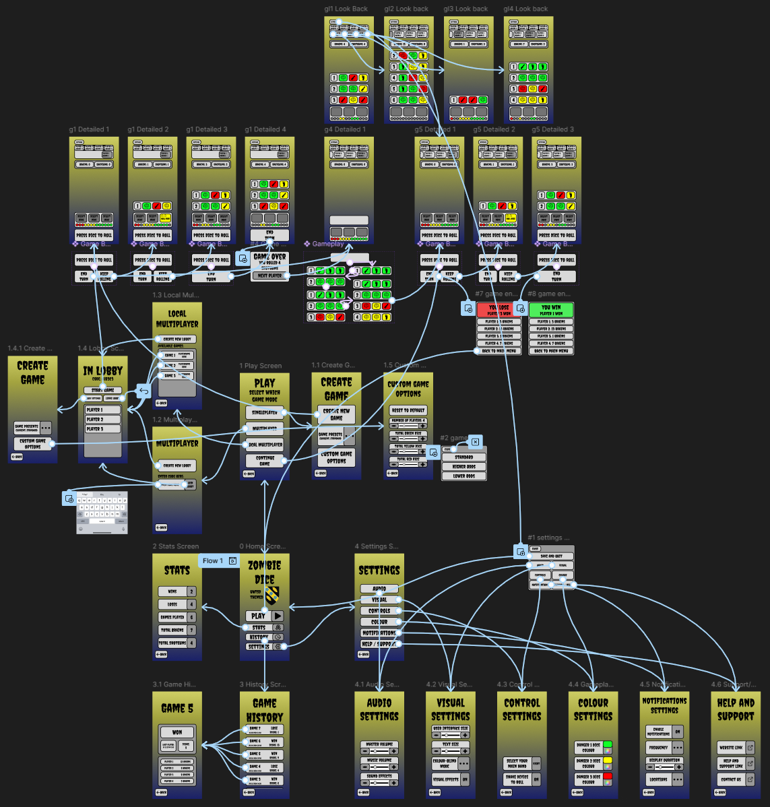
Figure 7- navigation between each screen

Home screen
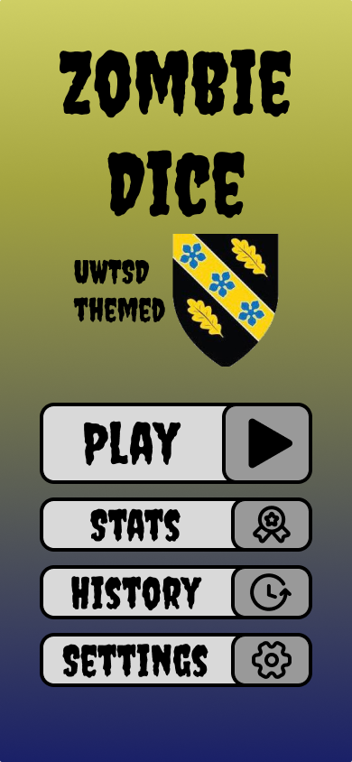
Figure 8- home screen

Settings screen
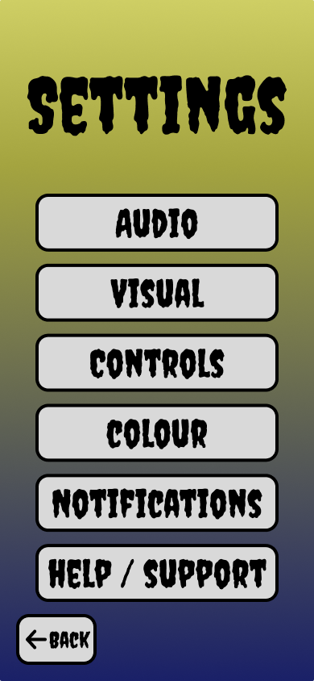
Figure 9- settings screen

Sub settings screen
A list of all the sub menu from the settings screen.
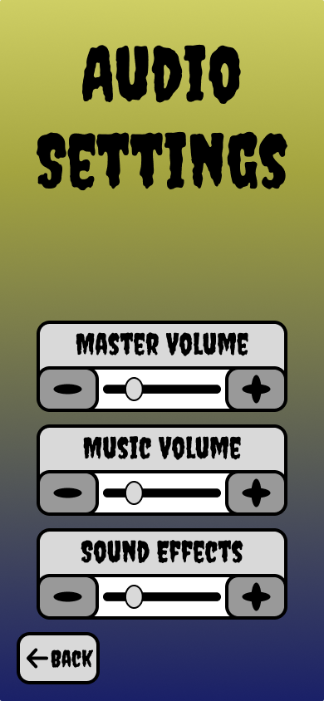
Figure 10- audio settings screen
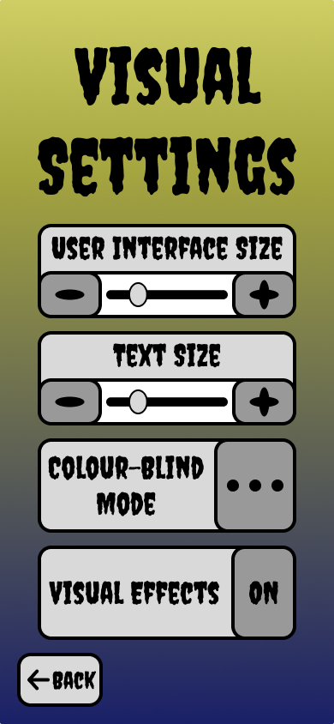
Figure 11- visual settings screen
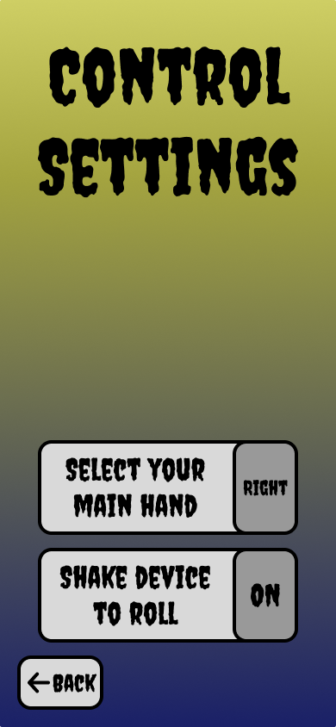
Figure 12- colour settings screen
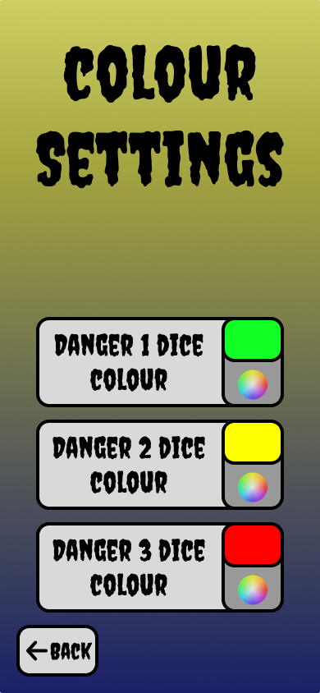
Figure 13- colour settings screen
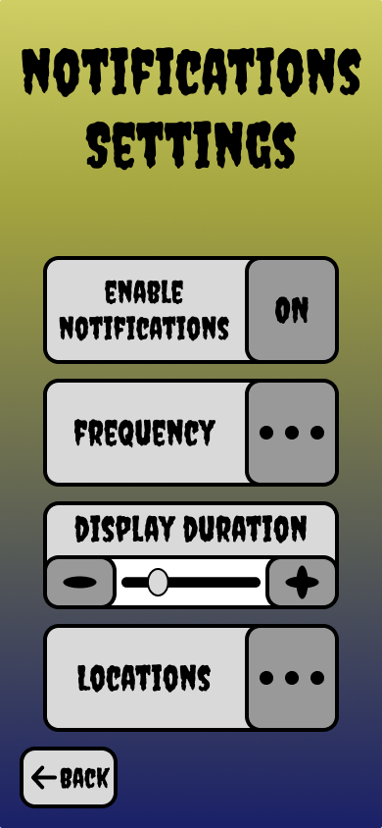
Figure 14-notification settings screen
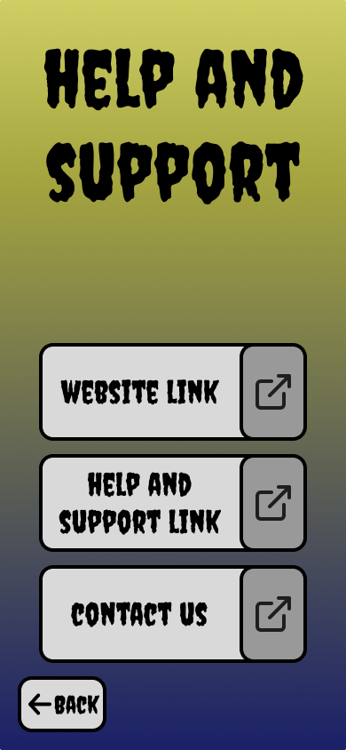
Figure 15- help and support screen

Sub settings pop up screen
All the pop ups from the sub menu of the settings screen.
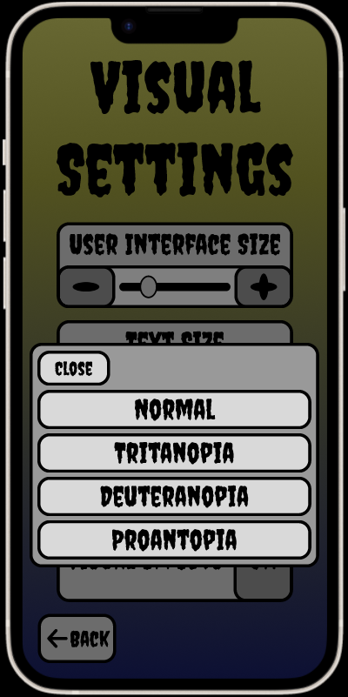
Figure 16- visual settings pop up
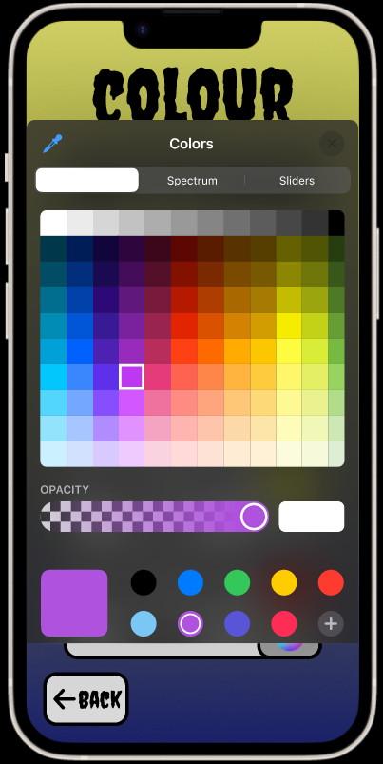
Figure 17- colour settings pop up
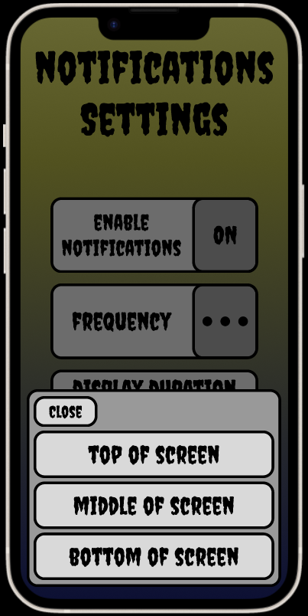
Figure 18- notification pop up

Stats screen
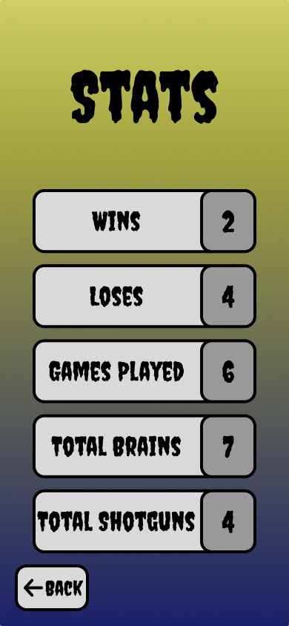
Figure 19- stats screen

History screen
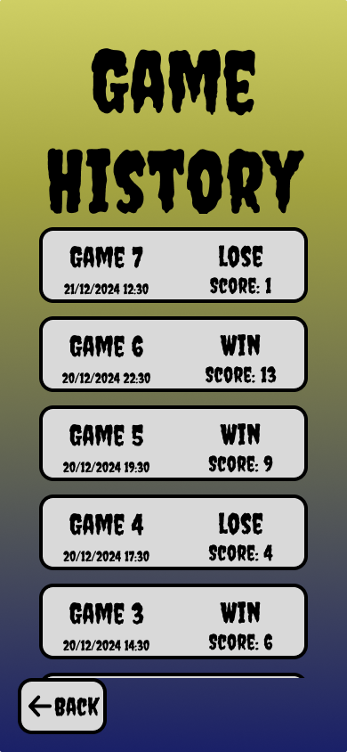
Figure 20- full game history screen
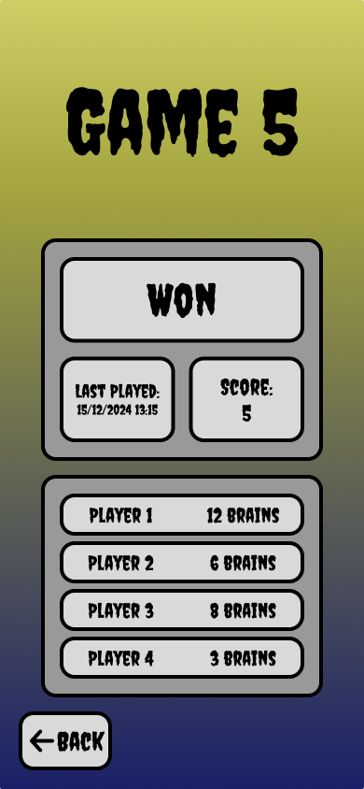
Figure 21- single game history screen

Play new game screen
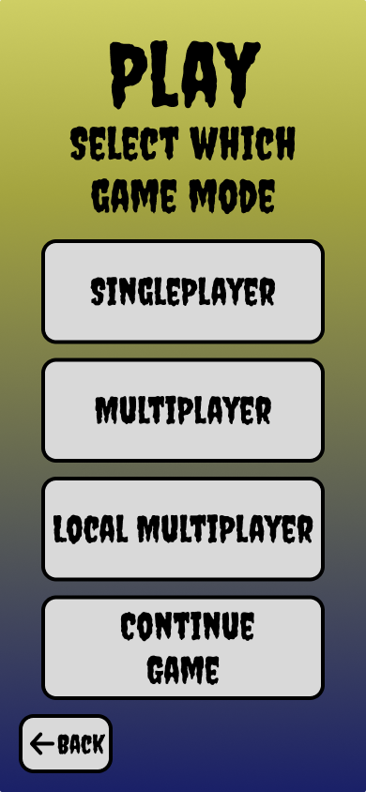
Figure 22- choose new game option

Create new game single player
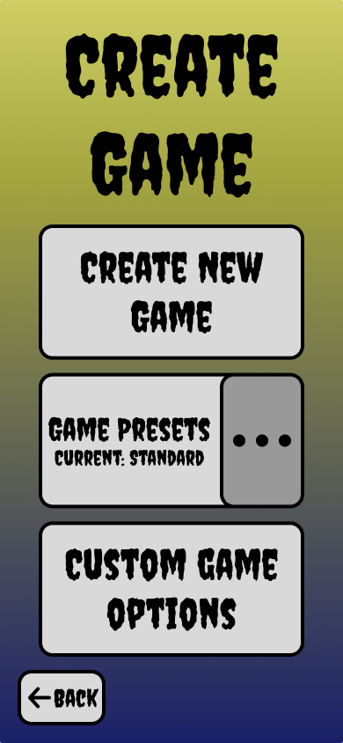
Figure 23- create new single player
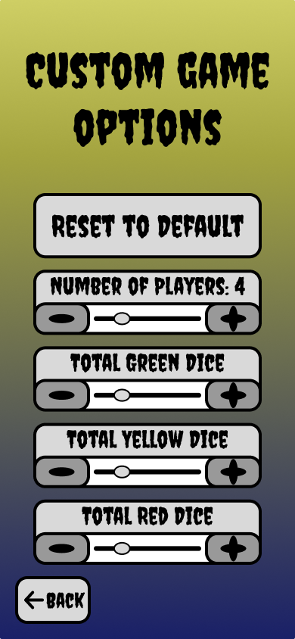
Figure 24- customize game options

Create new game multiplayer
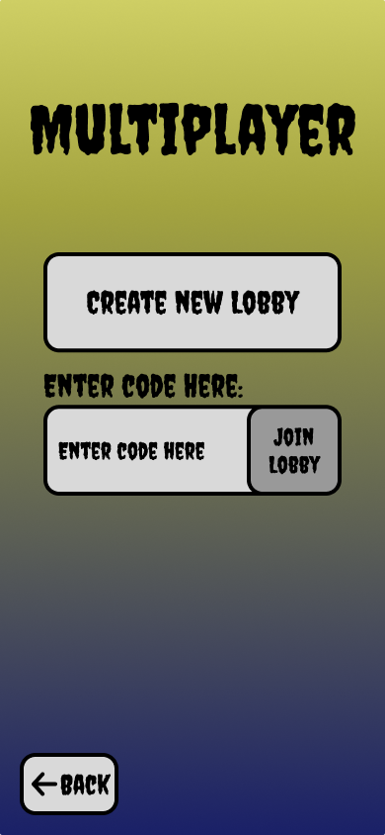
Figure 25- join multiplayer game with code
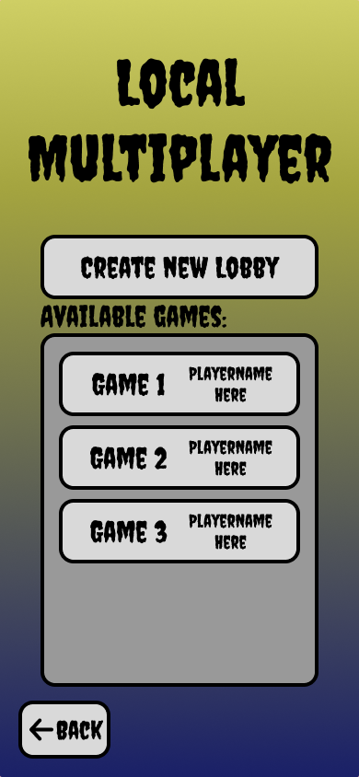
Figure 26- join local multiplayer game
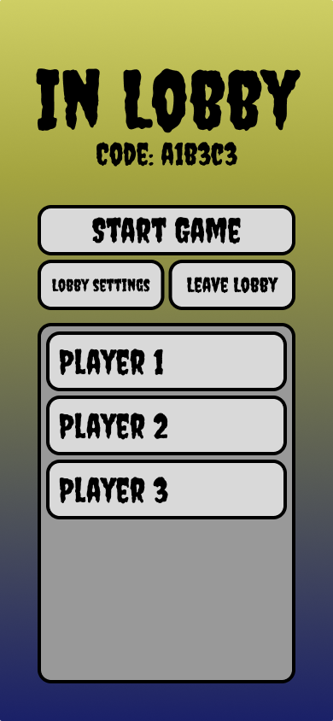
Figure 27- the lobby of a multiplayer game
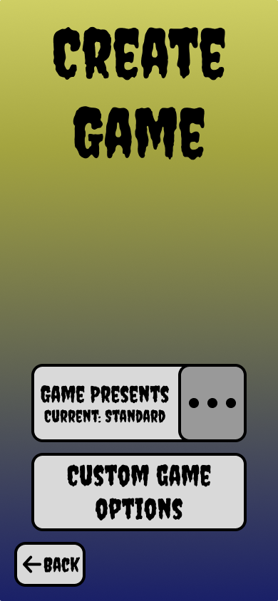
Figure 28- configure multiplayer game

Game screen pop up
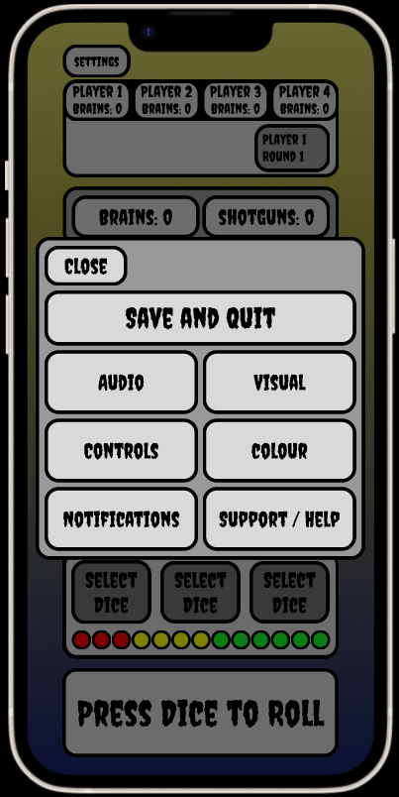
Figure 29- game screen, settings pop up

Playing the first round of a game
The screen order for which the game is played for the first round.
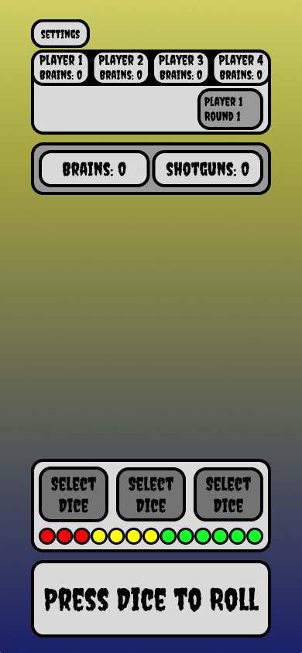
Figure 30- game 1, select dice 1
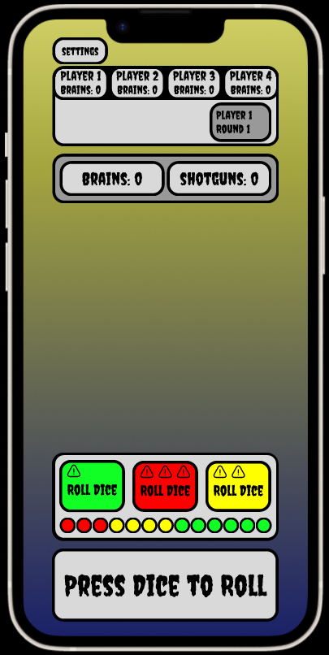
Figure 31- game 1, roll dice 1
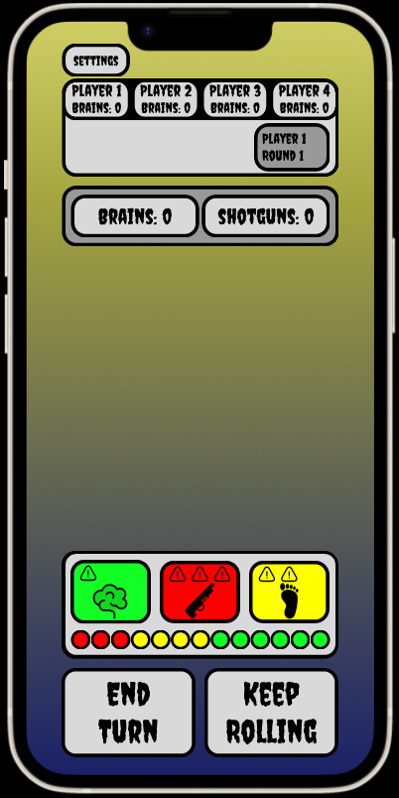
Figure 32- game 1, continue or end turn 1
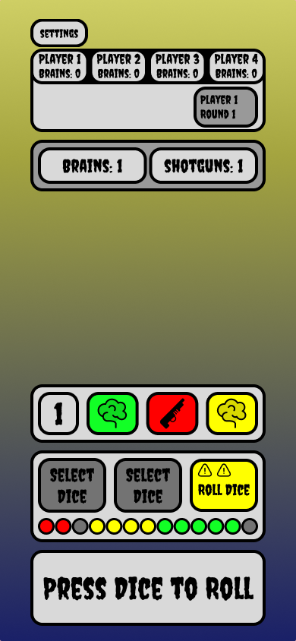
Figure 33- game1, select dice 2
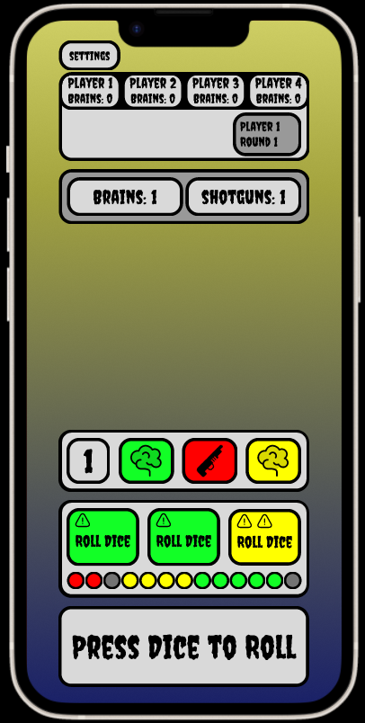
Figure 34- game 1, roll dice 2
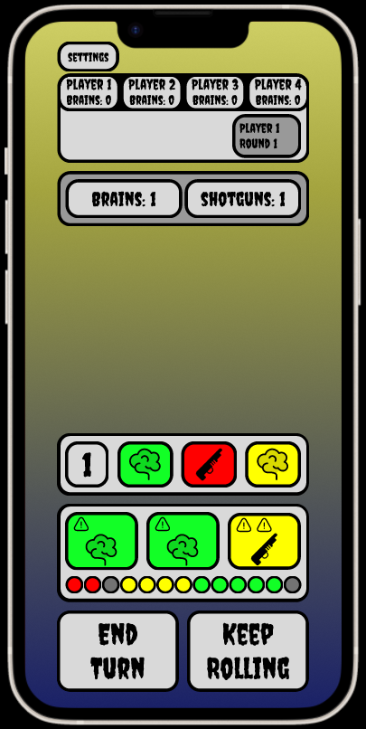
Figure 35- game 1, continue or end turn 2
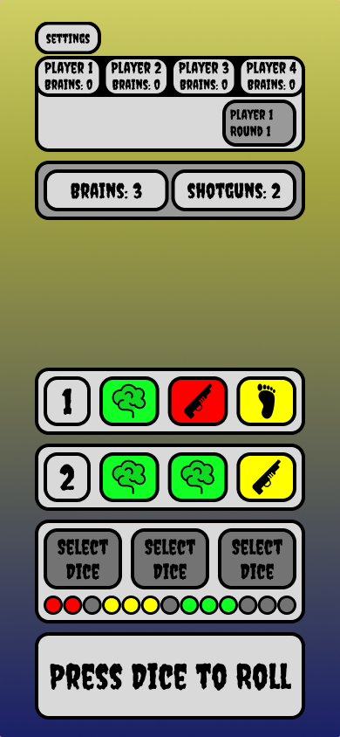
Figure 36- game 1, select dice 3
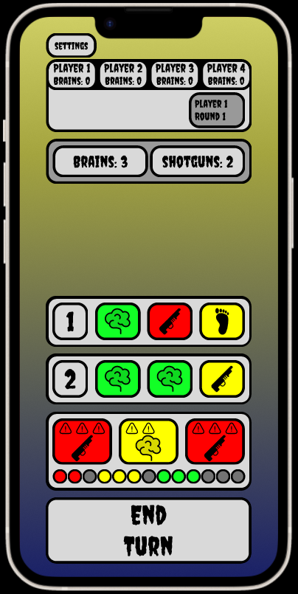
Figure 37- game 1, end turn
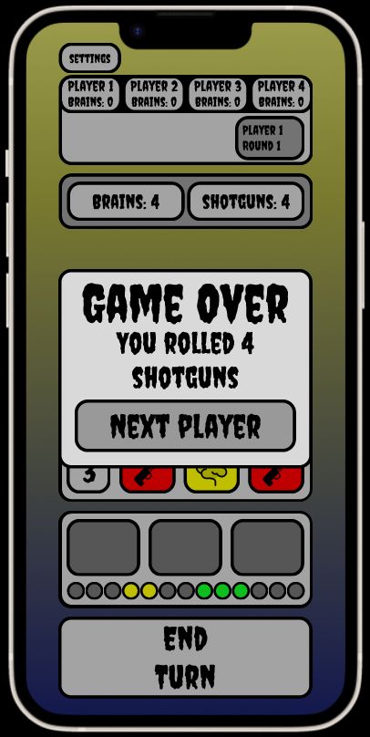
Figure 38- game 1, game over screen

Watching someone play their round
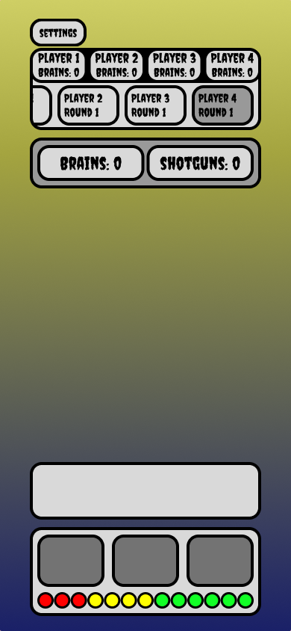
Figure 39- opponents turn 1
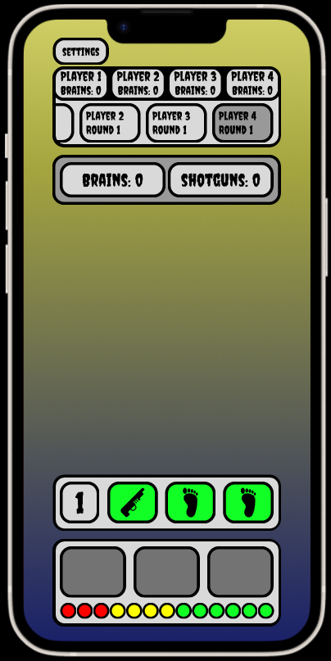
Figure 40- opponents turn 2
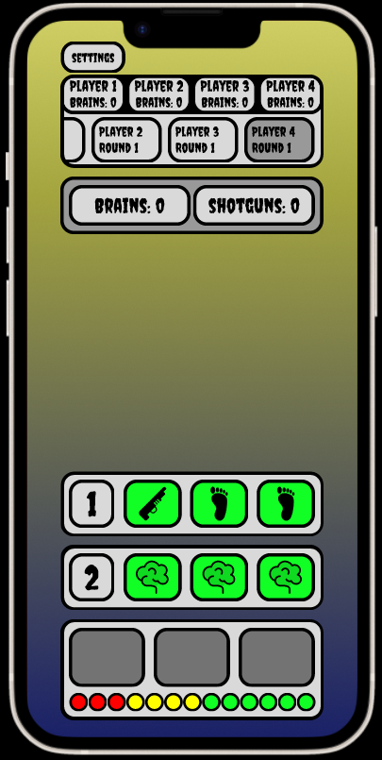
Figure 41- opponents turn 3
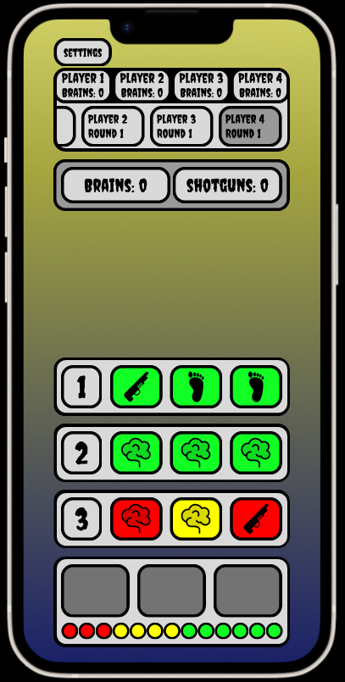
Figure 42- opponents turn 4
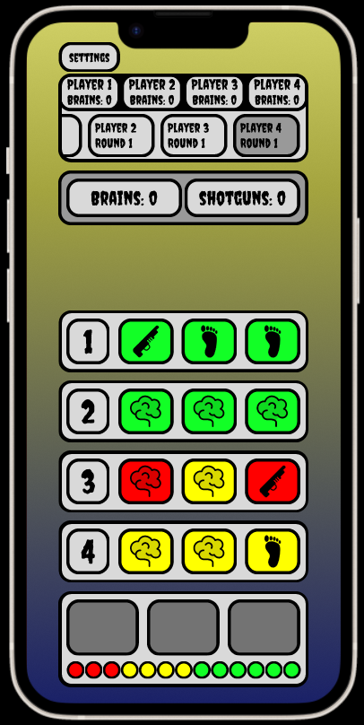
Figure 43- opponents turn 5

Playing the second round of a game
The screen order for which the game is played for the second round.
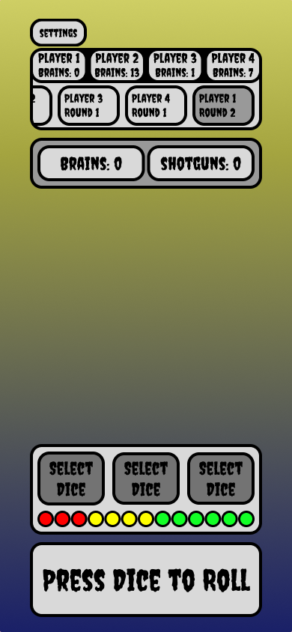
Figure 44- game 2, select dice 1
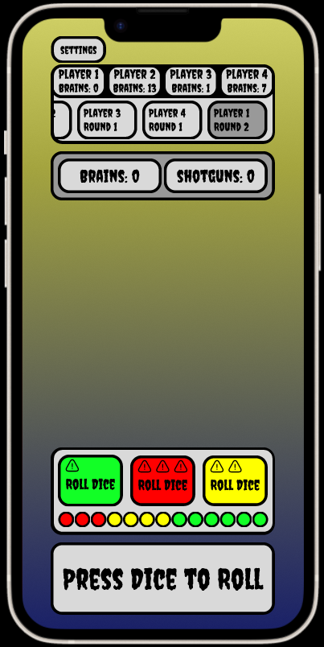
Figure 45- game 2, roll dice 1
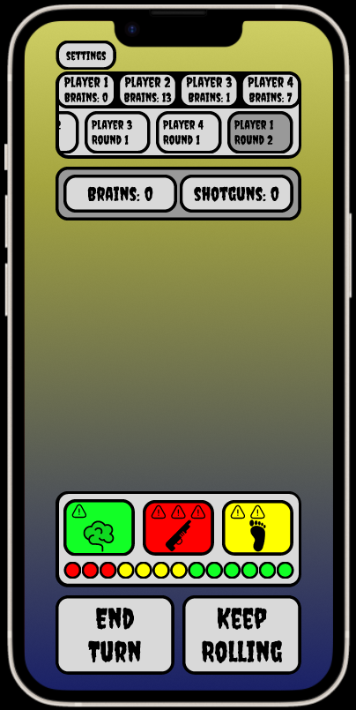
Figure 46, game 2, continue or end turn 2
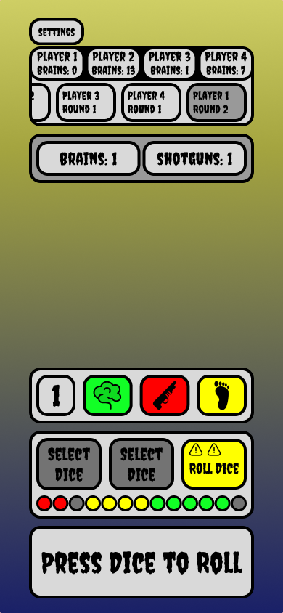
Figure 47- game 2, select dice 2
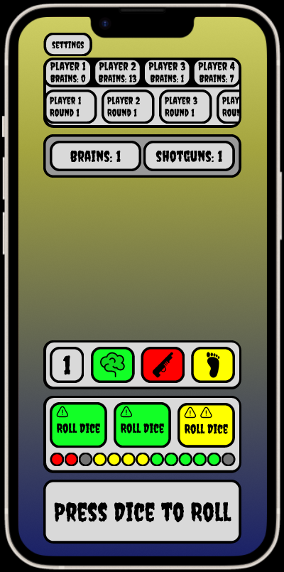
Figure 48- game 2, roll dice 2
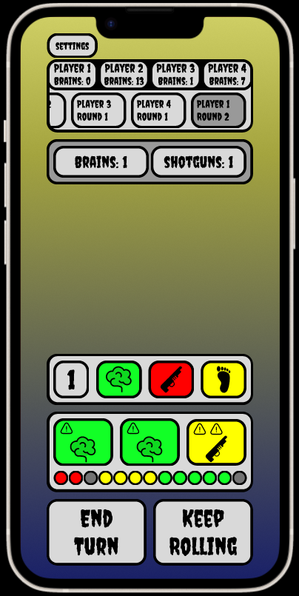
Figure 49- game 2, continue or end turn 2
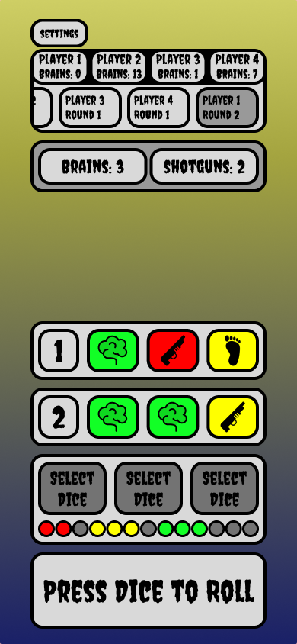
Figure 50- game 2, select dice 3
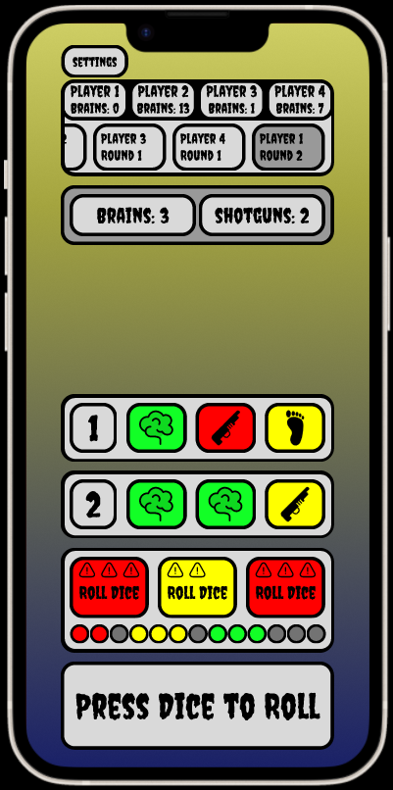
Figure 51- game 2, roll dice 2
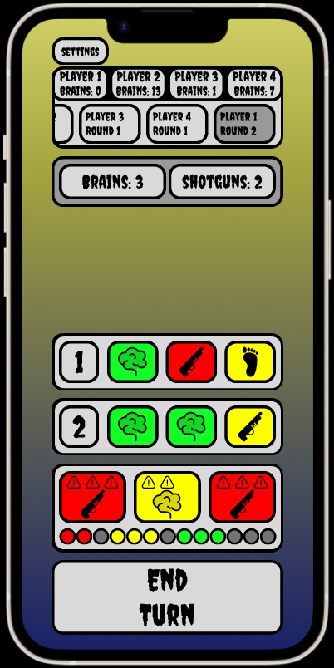
Figure 52- game 2, end turn

Previous game screens
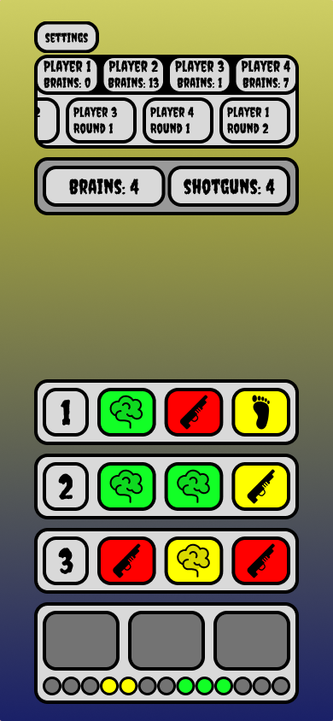
Figure 53- player 1 previous round
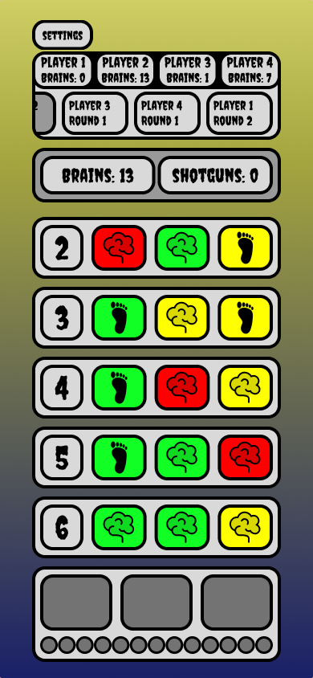
Figure 54- player 2 previous round
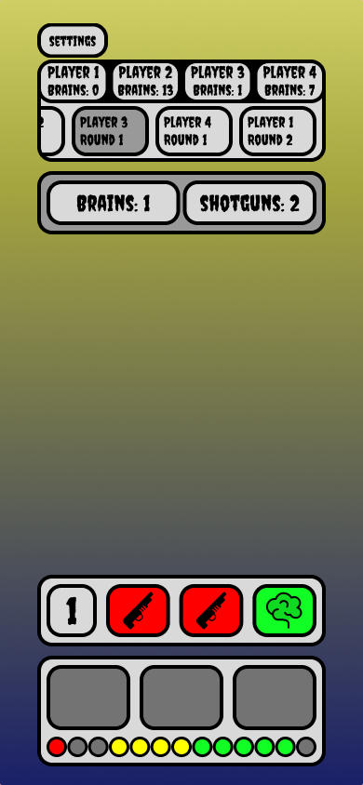
Figure 55- player 3 previous round
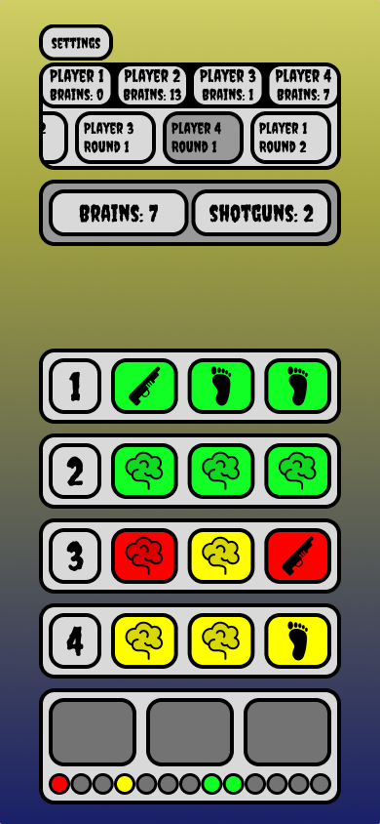
Figure 56- player 4 previous round

Win/lose screen
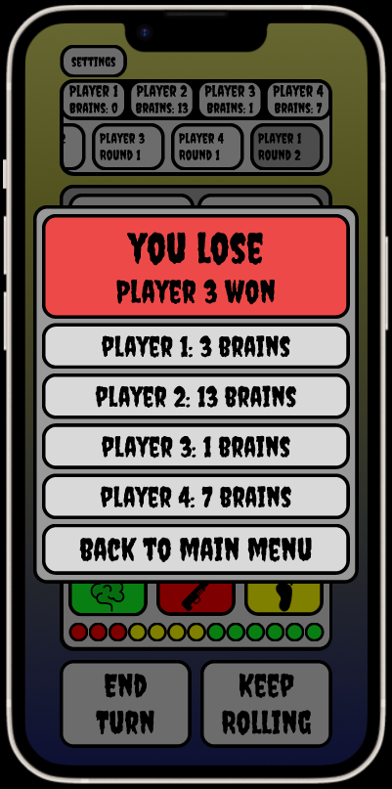
Figure 57- lose screen
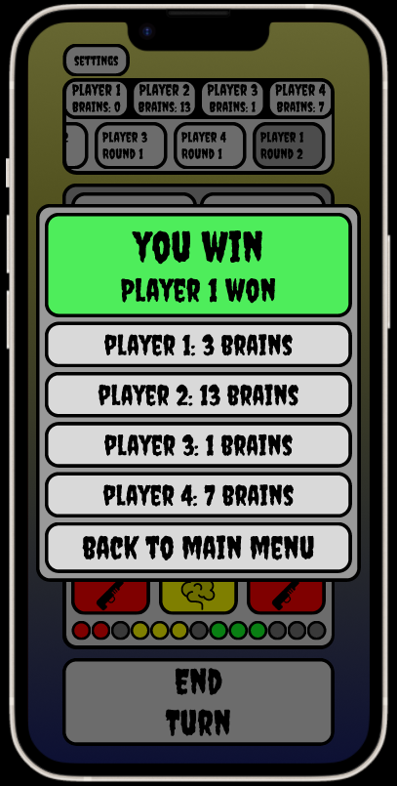
Figure 58- win screen

