Submerged Combustion Vaporiser Inlet Flow Control Valve 2017/2018

A dissertation submitted in partial fulfilment of the requirements for BEng (Hons) Manufacturing Systems Engineering

By: Stephen Thomas
Supervisor: Robert Goodson
27/04/18

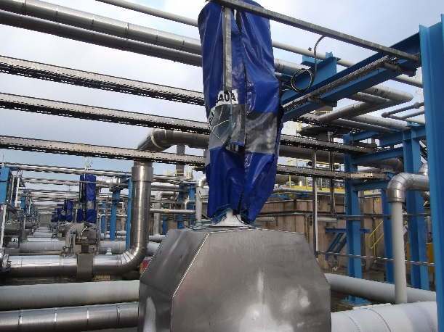

This page is intentionally left blank

Executive Summary
Introduction/ Background
This project is introduced to analyse the performance of a Submerged Combustion Vaporiser (SCV) inlet flow control valve. A pneumatically controlled globe valve is used to control the flow of Liquefied Natural Gas through an (SCV), which becomes vaporised and then pumped into the National Grid (LNG System). The control valve is operated by a process control operator through a Digital Control System known as DELTA V. The current control valve design is oversized for the amount of flow going through it. This is putting the process at risk of initiating an Emergency Shut Down, thus impacting the profitability generated for the company. Oscillation of the inlet flow control valve is jeopardising the process and customers demand.
Aims and Objectives
Project Aim:
The main purpose of this project is to implement a system that will accurately control the flow of LNG through the SCV inlet flow controller, without jeopardising the safe performance of the LNG Process. An effective & efficient control system will ensure that the nominated Natural Gas flow demand is always achieved and the risk of high financial costs from none compliance of Natural Gas flow nominations is reduced.
Project Objectives:
- Define the process fault
- Define the LNG process
- Carry out comprehensive research to understand the basic working principles of a flow control valve / globe valve
- Investigate the current performance of a SCV inlet flow control valve in use and research possible alternatives that would generate better control.
- Measure the process performance by investigating the current impact to the LNG process by obtaining process data such as trends.
- Analyse defects and identify the route cause.
- Calculate the SCV cost implications to the company.
- Improve process performance by eliminating or minimising the route cause.
- Based on the data generated and assumptions made, design a new control system for the SCV that will enhance control to the panel Operator.
- Calculate new flow coefficient value.
- Implement a control system and analyse result.
Table of Contents
Introduction 6
Project Gantt Chart 7
What is LNG? 8
Natural Gas to Liquefied Natural Gas 8
LNG Transportation 9
Storing LNG (Liquefied Natural Gas) 9
LNG Unloading Arms and the LNG Carriers 9
LNG Process 10
Submerged Combustion Vaporiser 11
SCV Process Diagram 12
SCV Digital Control System Diagram (DELTA V) 13
LNG Process, SCV and HP Pumps DCS Overview 14
SCV Operation Cost Calculations 15
SCV Inlet Flow Control Valve 16-17
Globe valve Diagram 18-19
SCV Inlet Flow Control Valve FV-174-044OA Specifications 20
SCV Inlet Flow Control Valve FV-174-044OA Flow Current Performance 21-22
SCV Inlet Flow Control Valve FV-174-044OA Potential Solution Idea 23
SCV Inlet Flow Control Valve FV-174-044OA Flow Coefficient Value 24
SEVERN GLOCON LTD Calculations 24
SCV Inlet Flow Control Valve FV-174-044OA Trim Calculations 25-26
New and Current Trim Characteristics 27
New Trim Design 28
Fitting the New Trim 28
New Trim Specifications 29
Progression 30
Company Plan 31
Change in Circumstances 32
Method Statement 33
Implementation of Trim 34-39
Tuning of the Actuator 40-41
Testing 42-44
Cost 45
Conclusion/Evaluation 46-49
Bibliography 50
Appendix 51-103

Nomenclature

SCV: Submerged Combustion Vaporiser
LNG: Liquefied Natural Gas
NG: Natural Gas
DCS: Digital Control System
ESD: Emergency Shut Down

Acknowledgement

I wish to express gratitude to all members of the operations department at Dragon LNG who helped me with this project. The whole department gave continuous encouragement and invaluable support through this development. The operations department being exceptionally knowledgeable, trained me and was always available to help me gain my qualifications as a process operator while I was carrying out this project.
I am deeply appreciated to Jo Lewis who helped me with my personal training plan and development through the company. Knowing that my apprenticeship was coming to an end, she helped me gain qualifications and prepared me for interviews for which I am extremely grateful.
Finally, I would especially like to thank my family for putting their faith in me and being a constant source of motivation. Thank you so much for your unflagging love and never ending support.
Introduction
1. Background
Submerged Combustion Vaporisers have stainless steel tubes which are submerged in hot water. The water can be heated by using fuel gas to ignite a flame, hot water from the COGEN process or combined COGEN hot water and fuel gas. When the SCV is operating in COGEN hot water mode, the process becomes 80% efficient. However, this cannot always be achieved. LNG is pumped through the SCV at a pressure of up to max120Barg which will vary depending on the National Grids system working pressure. The LNG becomes vaporised in the SCV to produce Natural Gas at a temperature of 6°C. There are 6 SCV’s on the LNG process, each SCV has an Emergency Shutdown high set point rate of 175 Tonne/Hour, a Max Send Out rate of 150Tonne/Hour and a Minimum Send Out rate of 55 Tonne/Hour. Each SCV inlet flow control valve (FV-174-044OA) will open 9% to achieve the Minimum Send Out rate of 55Tonnes/Hour and at 28.6% it will reach the 175Tonne/Hour for the Emergency Shutdown activation. These output limitations cause the control valve to oscillate aggressively between 9% and 28.6% and increase the risk of a potential ESD activation on the LNG process.
Poor process design has impacted the performance of the LNG process, which has created financial penalties given to Dragons LNG by its shareholders (50% Shell and 50% PETRONAS). Design alterations to the trim of the SCV’s inlet flow control valves (FV-174-044OA), both mechanically and instrumentally would produce a smoother valve control and the SCV’s performance would be greatly enhanced. To do this, a flow Coefficient value will be calculated for trim manufacturing purposes.
1.2. Aims and Objectives
The project is aimed to develop a robust and practical operating system that will improve process control for both the panel operator and the process and eliminate or reduce the risk of ESD activations from poor SCV inlet flow control. The chosen approach should be productive enough to not only enhance better control but also greatly reduce the likelihood of the process tripping due to SCV failure. The current internal trim of SCV inlet control valve FV-174-044OA and flow coefficient value will be analysed. This will enable calculations to be made to determine the new trim specification of the inlet flow control valve FV-174-044OA. The current operations training plan at Dragon LNG enables access to information regarding the LNG process. As a qualified process operator, isolations, purging, decommission and recommission of equipment will be carried out along with assisting various departments with the project.

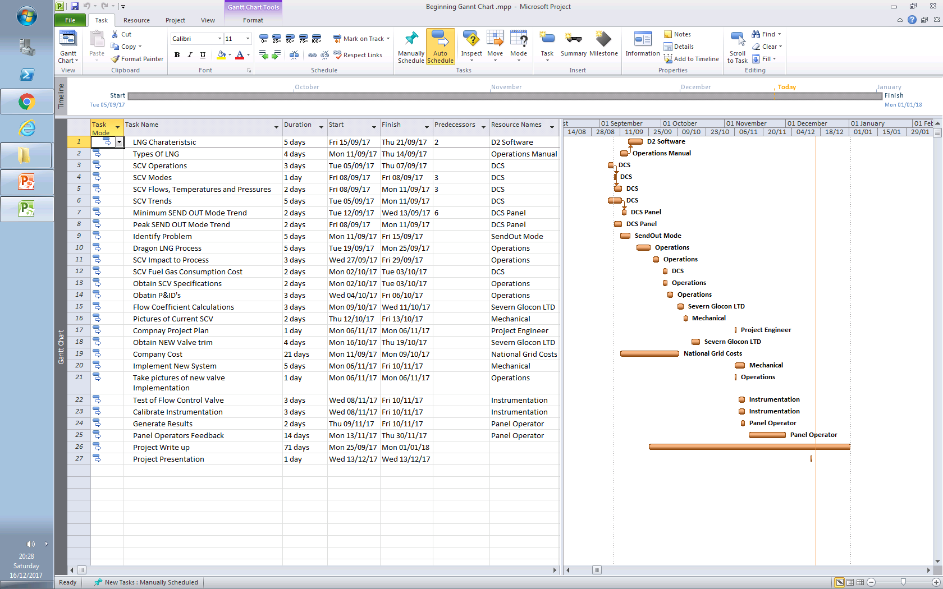
Project Gantt Chart

What is LNG?
Liquid Natural Gas (LNG) is odourless, colourless, non-corrosive and non-toxic. LNG is only flammable when mixed with concentrations of oxygen between 10-15%. LNG consists of 90-95% methane with the remainder of the percentage being Nitrogen, Ethane, Propane, I-pentane and N-pentane. However, the consistency of methane will vary depending on where the LNG comes from. This will become relevant when deciding to bottom or top fill in the LNG tanks (Density related). Natural Gas is extracted from the earth’s crust and is cooled to -160°C, this drop-in temperature converts the state of the Natural Gas from a gas to a liquid. This change in state also changes the volume from 600:1m³ .This change in volume allows for larger quantities of Natural gas to be transported in the form on LNG.
Figure 1: Natural Gas to Liquefied Natural Gas Process (Mail, 2018)
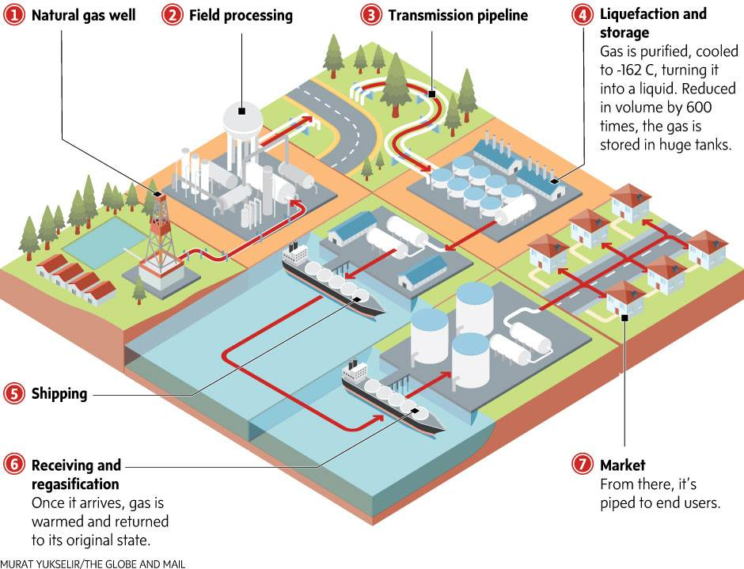

Natural Gas is extracted from the earth and compressed to a field process unit which removes impurities from the Natural Gas. Natural Gas is then compressed to a liquefaction unit and cooled using a compandor and various coolers. The Natural gas is cooled in this process to -160°C and converts the gas to a liquid. This liquid is known as LNG and the ratio has changed from 600:1m³. The LNG is then pumped to storage where it is pumped on various carries such as a Moss or Membrane type LNG carriers. These carriers have a storage capacity of 210,000m³ and 320,000m³.

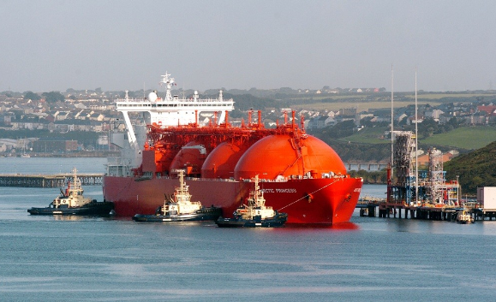
Figure 2: LNG Carrier (Dragon LNG, 2018)

LNG Transportation – Liquid Natural gas is transported in special double-hulled ships built using two different technologies known as Moss Rosenberg (Spheres) and membrane (using materials with an expansion coefficient or practically nil). On arrival to the jetty, the 4 operating arms are attached to the carrier which can be seen in figure 2. The LNG is then pumped to the storage tanks (2 x 160,000m³) from the LP (Low pressure, 7Barg) Pumps on the carriers. The LNG is then either topped or bottom filled in the storage tanks and this will depend on the density of the LNG being delivered.
Storing LNG (Liquid Natural Gas) - The two LNG storage tanks have a capacity of 160,000m³. The LNG storage tanks are made from reinforced concrete as an outer shell. Perlite insulation is used to keep the inner tank cool, this inner tank is constructed from 9% Nickel alloy.
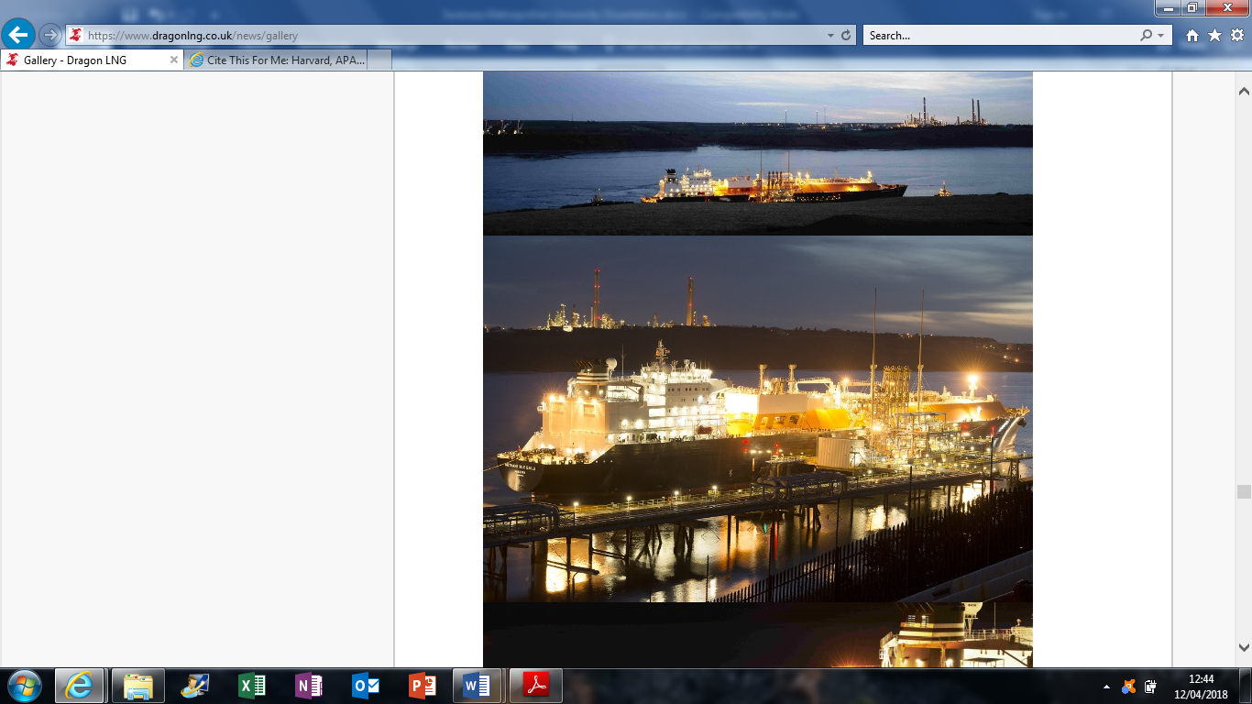
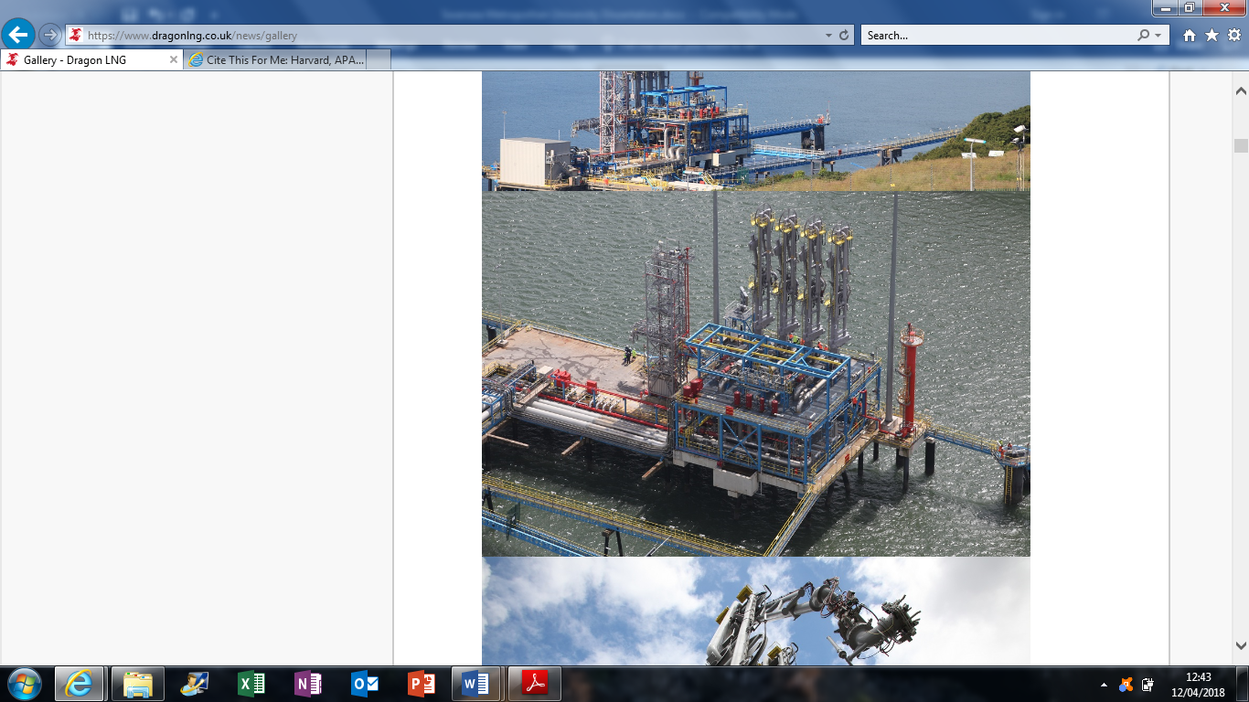
Figure 3: LNG Unloading Arms and the LNG Carrier (Dragon LNG, 2018)
Dragon LNG’s Process

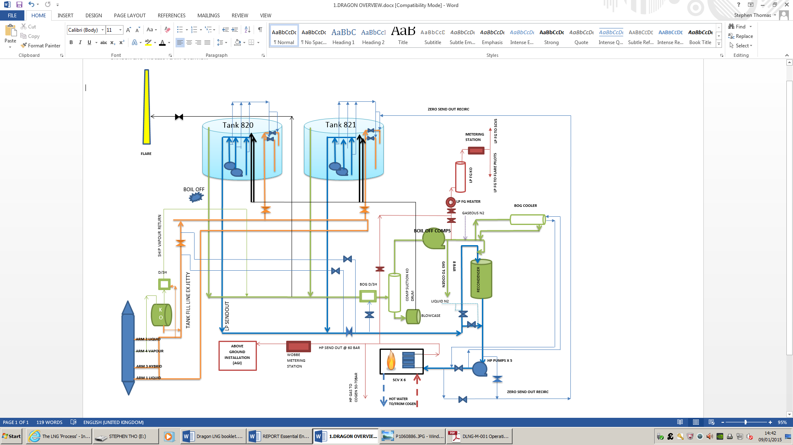
Figure 4: LNG Process (Appendix 1)
Dragon LNG Stores Liquefied Natural Gas and vaporises the LNG into Natural Gas by using Submerged Combustion Vaporisers. Dragon LNG operates the process for its two shareholders (50%PETRONAS and 50%Shell). The shareholders monitor the prices of Natural gas in the National Grid and will send nominations for Dragon LNG to meet. These Nominations will last from several hours up to months depending on the inventory storage and price. If the nominations are missed, Dragon LNG will be fined. When Dragon LNG has been nominated, LNG is pumped from a storage tank into a Recondenser. The Recondenser mixes the BOG (Boil Off Gas) with the LNG before it is fed to the High-Pressure Pumps (X5) and then pumped through a Submerged Combustion Vaporiser before it goes to the National Grid or COGEN. BOG is produced when the process is in Zero Send Out Mode (not sending gas to the National Grid). BOG is given off from keeping the system in a cryogenic condition and the pressure begins to build up. The only way to remove this pressure is to flare, burn it at COGEN or send out to the National Grid, hence the reason for a Recondenser.
SCV (Submerged Combustion Vaporiser)

Figure 5: Submerged Combustion Vaporiser. (Dragon LNG, 2018)
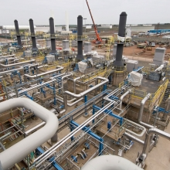

Submerged Combustion Vaporisers (SCV’s) system requires approximately 1.5% of the total vaporised LNG as fuel, which adds a significant operating costs to the LNG process. For this reason, SCV’s are used only where no other free heat source is available. SCV’s can also be used to utilise boil off gas. In a submerged combustion vaporiser, LNG flows through a tube coil fabricated from stainless steel that is submerged in a water bath. Water in the bath is heated by direct contact with hot effluent gases that exit its burner. Exhaust gases from the burner are sparged into the water through a distributor located under the heat transfer tubes. This causes rapid circulation of the water through the tubes resulting in a very high thermal efficiency and high heat transfer rate. (Mokhatab et al., n.d.).
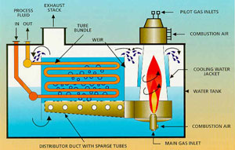
Figure 6: SCV Diagram. (Hydrocarbononline.com, 2018)
As combustion takes place in the SCV to maintain a temperature of 40°C, the PH level alters. To control the PH level at 7.5, Caustic is used at a controlled dosage rate. This Caustic also helps control the NOX (Nitrous Oxide) emissions produced by the SCV’s combustion process.
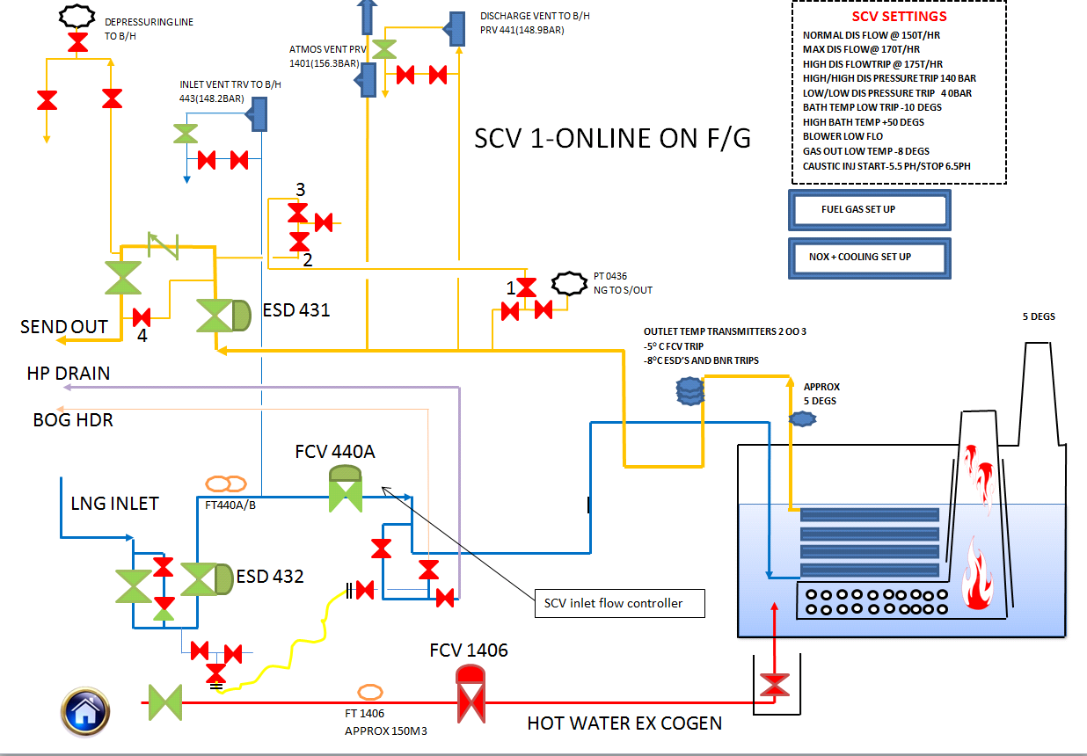
Figure 7: SCV Process Diagram. (Appendix 2)
The SCV inlet control valve FCV 440A is oscillating aggressively when being operated by the panel operator. The Suction ESD 432 and discharge ESD 431 will activate (close) when the SCV limits have been met. These limits are indicated in figure 7 with SCV limitations such as the max flow tripping point, temperature tripping point and caustic injection rate for PH control. Hot water from COGEN is controlled at FCV 1406 to maintain the temperature in the SCV at 40°C. As LNG enters the SCV at -160°C the temperature in the water bath will start to drop, hence the need for COGEN hot water or Fuel gas for combustion. When the SCV is operating on COGEN hot water the LNG process becomes 80% efficient because the COGEN cooling towers are no longer needed due to the SCV’s taking the heat for the water bath.
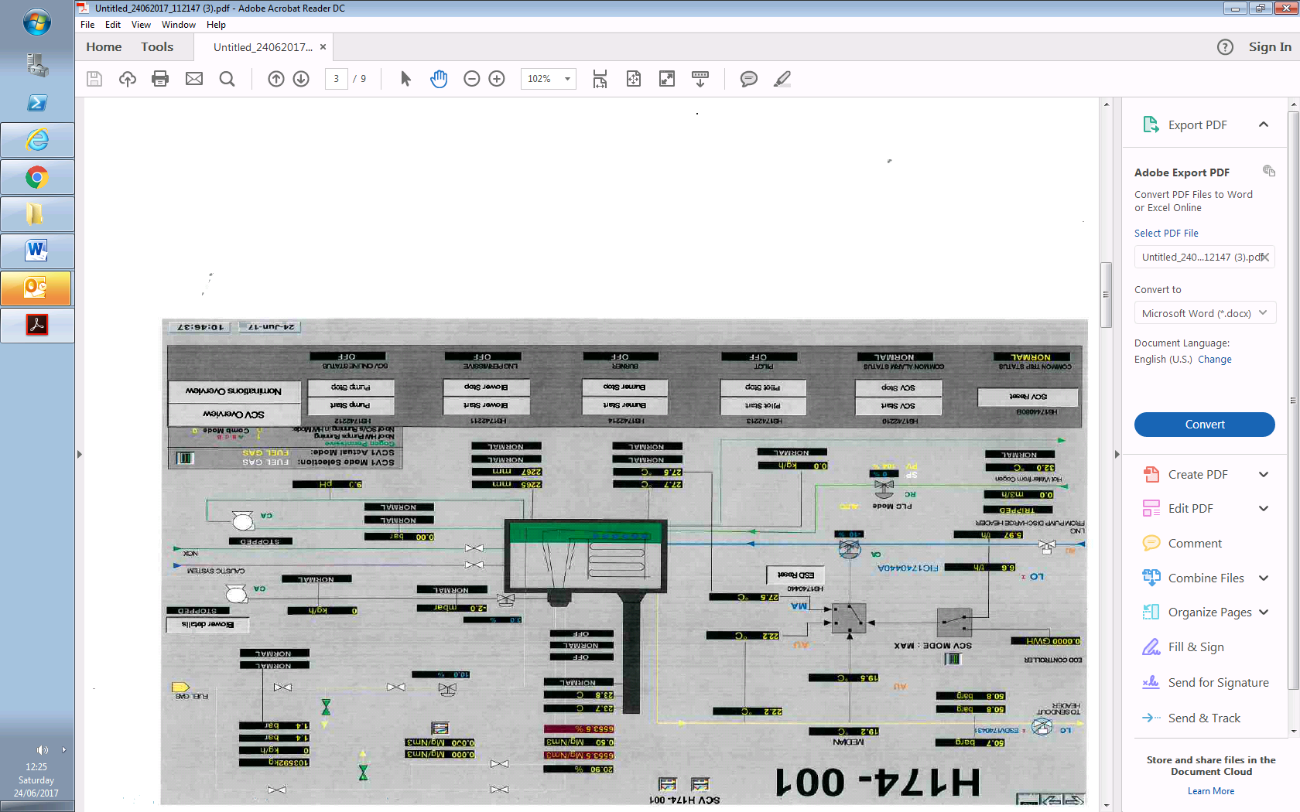
Figure 8: SCV Digital Control System Diagram (DELTA V). (Appendix 3)
Cascade control, Auto control and Manual control are all available for operating an SCV. Generally, Cascade control is the better operation of optimum performance because various control valves operate together to maintain flows, pressures and levels which can be seen in figure 8. For example, the LNG inlet flow control valve will open a set percentage depending on the EOD (End of Day Controller), SCV water bath temperature, the SCV discharge temperature and discharge pressure. However, currently the panel operator cannot use Cascade control or Auto control for the SCV because the SCV inlet flow control valve is too big to control the amount of LNG flow through the heat exchanger section of the SCV. Currently to control the flow going through the SCV, the panel operator will put the LNG Inlet flow control valve into manual and increase or decrease the set point by 0.1% intervals to meet the flow demand. If the set point is increased by more than 0.1%, the SCV trips and this has a knock-on effect by tripping the HP pumps, Recondenser and ultimately the send out process. If this scenario does occur, the panel operator will be given 30 minutes to get the process back online. If the natural gas being sent to the National grid is not at the right specification, the National Grid will issue a 30 minute warning before it shuts the main send out valve on LNG process. This will then lead to nominations being missed and fines being placed on the company.
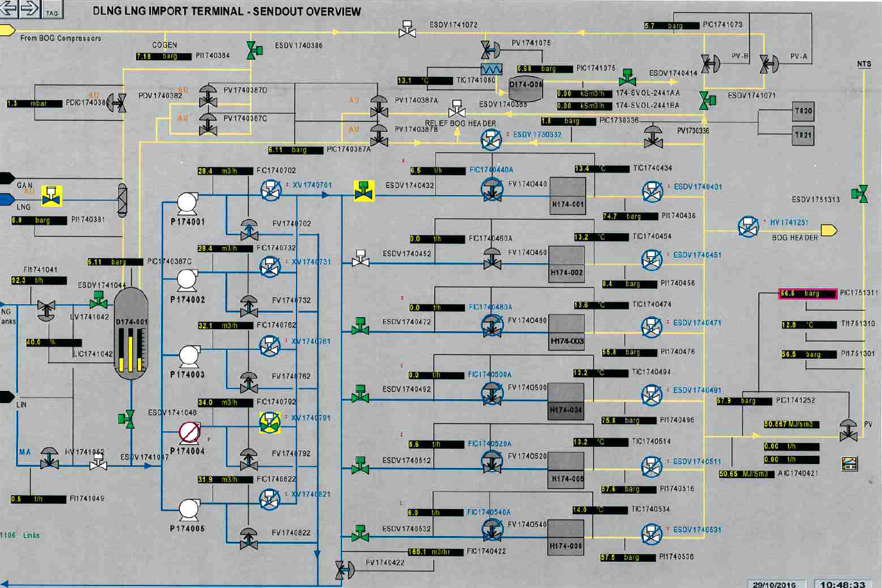
Figure 9: LNG process, SCV and HP pump DCS Overview. (Appendix 4)
SCV Send Out Flow Controllers
6 x SCV’s
SCV Inlet Flow Controllers
5 x HP Pumps

The DCS overview shown above indicates all the equipment used for Send out Mode to be achieved. The SCV inlet flow controller is impacting the process upstream and downstream of the flow control valve. The HP pump upstream of the SCV will trip when a large amount of oscillation occurs on valve FCV440A. This trip will result in pressure loss (<120Bar) and cause the SCV to trip and the nominations will potentially be missed thus, resulting in customer fines. There is a high-pressure kickback line on the HP pump for protection purposes however, this kickback cannot open quickly enough to relief the pressure to the BOG header.

SCV Operation Cost Calculations
Cost to Customer from Inventory Usage (Natural Gas) on the LNG Process and COGEN
7.24 tonnes of Natural Gas an hour is used on COGEN for Combustion purposes.
1.1 tonnes of gas is used for 1 SCV operation, there are 6 SCV’s
100 tonnes = 1.5GW
1.1 tonne = 1100 kg
Formula
(Kg x 53.814) / 3600000 = GW/H
1 SCV = (1100 x 53.814) / 3600000 = 0.016443 GW/H
Each SCV uses 0.016443 GW/H of Gas
7.24 tonnes = 7240 kg
(7240 x 53.814) / 3600000 = 0.1082 GW/H
COGEN uses 0.1082 GW/H of Gas
Price Calculation-
LNG process
1 GW/H = 34121.28 Therms
1 Therm = £0.3768 this value varies depending on National Grids prices.
(1 SCV) 0.016443 GW/H = 561.06 Therms
561.06 Therms X £0.3768 = £211.407/ H
£211.407 x 24Hours = £ 5,073.777 for each SCV (5,073.777 x 6 SCV’s = £ 30,442.668 LOSS
COGEN
0.1082 GW/H = 3691.92 Therms
1 Therm = £0.3768
3691.92 X £0.3768 = £1,391.115456/H
£1,391.115456/H X 24 = £ 33,386.77 a day loss
Electricity Produced
COGEN Producing Total =£14,862.0
Total Loss = (-£33,836.77)-(£14,862.0) = £18,974.77 LOSS
SCV Inlet Flow Control Valve

Figure 10: SCV Inlet Flow Control Valve FV-174-044OA. (Appendix 5)

The SCV inlet flow control valve is a globe valve fitted with an actuator that will move the valve to the desired percentage (0 – 100%), this is set and controlled by the panel operator. The icing indicated on the lagging of the control valve and the line going to the SCV indicates that LNG is present in the system. The laggings is designed to protect the control valve and pipework from damage. The lagging also helps contain any loss of contaminates in the system, in this case LNG.
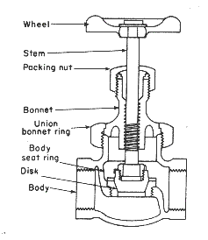
Figure 11: Globe Valve Diagram (Hydrocarbononline.com, 2018)
The control valve will open and close by operating an actuator from the control room on the control panel. The actuator moves the stem of the valve and the disk begins to move with the stem. LNG will then begin to flow through the valve to the SCV where it will be vaporised and then sent to the National Grid to have odours injected into the Natural Gas and then sent to various consumers.

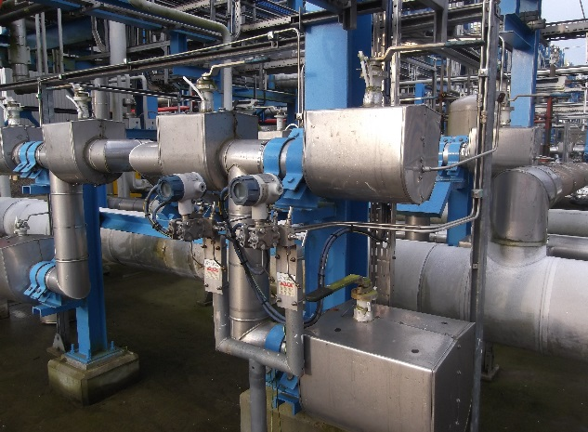
Figure 12: Cryogenic Feed Line (Appendix 6)

The icing indicated on the lagging of the feed line going to the SCV inlet flow control valve specifies that LNG is present in the line. There are various flow transmitters and pressure gauges on this line for visual indication. These transmitters can be seen in figure 11.

Figure 13: SCV Inlet Flow Control Valve FV-174-044OA. (Appendix 7)
FV-174-044OA has a protective cover over the actuator to protect the operation of the control valve against the environment. The valve is also lagged to protect the integrity of the pipework.

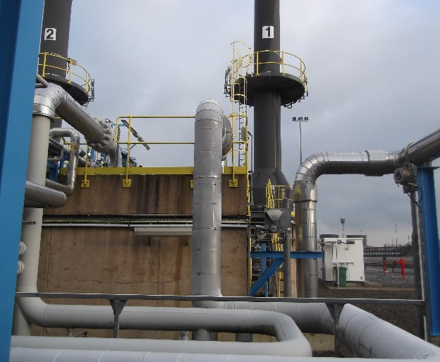
Figure 14: SCV (Appendix 8)
The discharge of FV-174-044OA feeds into the top of the SCV and into the water bath to be vaporised. The unlagged line on the discharge of the SCV is Natural Gas being sent to the send out header and then to the National Grid
SCV Inlet Flow Control Valve FV-174-044OA Specifications
Figure 15: FV-174-044OA Specifications. (Appendix 9)
SCV Inlet Flow Control Valve FV-174-044OA Flow Current Performance

Trends
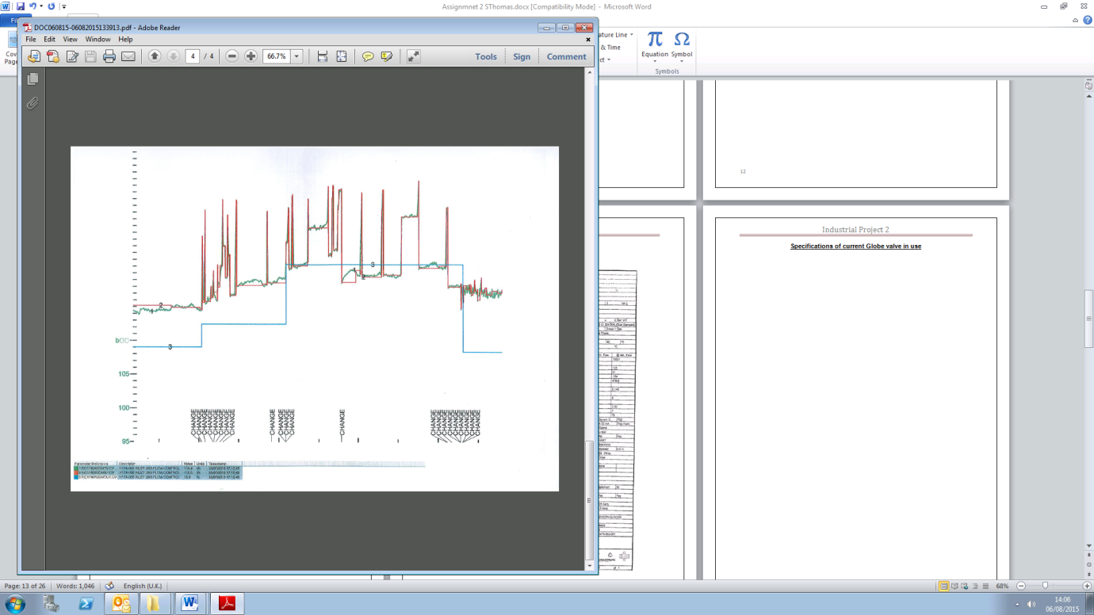
Trend are generated from the Digital Control System to specify the performance of the process and equipment. Trends are used to show how control valves are operating and faults can be found by analysing the data of a trend. Trends from the SCV Inlet Flow Control Valve FV-174-044OA flow will now be examined to identify the current issues that the control operators are facing.
Figure 16: FV-174-0440A current performance 1. (Appendix 10)
Set Point
Oscillation
Oscillation
Set Point
This trend Identifies the performance of the control valve when it is being used to control the amount of LNG going through an SCV (Sending out Natural Gas to the National Grid). The Blue coloured trend is the set point of the control valve which is controlled by the panel operator, essentially the demand. The Red and Green coloured trends are indicating FV-174-0440A opening and closing percentages to meet the set point demand set by the panel operator. The output of the control valve is designed to be the same as the set point trend shown in Blue. This is clearly not the case, the valve is showing oscillation and very poor control is present. Alarms are shown on the trend to indicate that the SCV is within the tripping parameters.
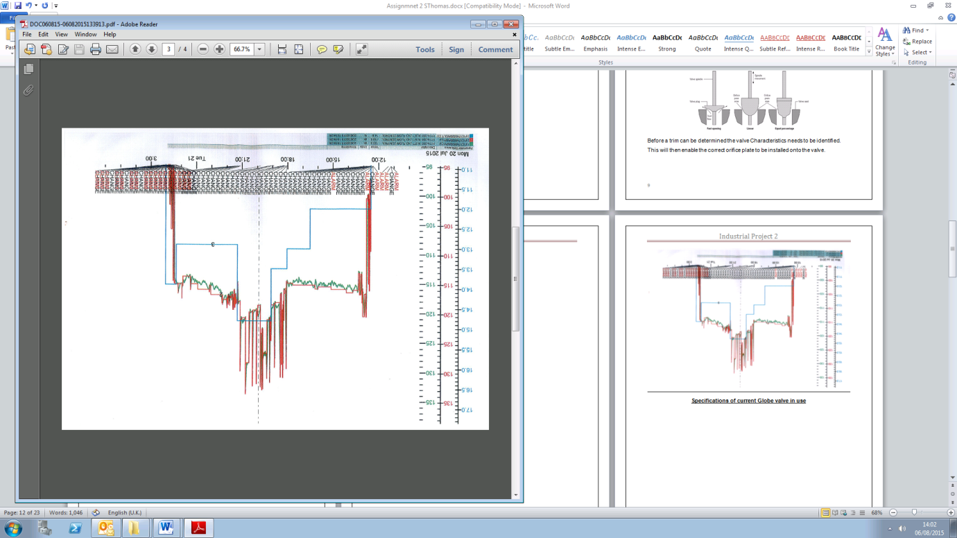
Figure 17: FV-174-0440A current performance 2. (Appendix 11)
Set Point
Oscillation
This trend shows the performance of the SCV inlet flow control valve FV-174-0440A being used over the whole SEND OUT Mode period of 15 Hours (Sending Natural Gas to the National Grid). Again, very poor performance is shown and over the 15 hours send out period the valve was oscillating. As the set point was increased (Blue Trend) the valve opened too much, and this can be seen by the aggressive oscillation (Red Trend). The set point was increased from 12% to 14.7%, as the valve opening reached 13.5% it began to oscillate, thus jeopardising the performance of the SCV. This is clear evidence that with the valve open just 13.5%, it begins to lose control and oscillate. This proves that the valve is too big to control the amount of LNG going to the SCV effectively and an alternative control method must be implemented.

SCV Inlet Flow Control Valve FV-174-044OA Potential Solution Ideas
At this point the LNG has been defined, the LNG process has been explained, the SCV inlet flow control valve specifications and trends have been obtained and analysed and a conclusion has been generated which determined that the valve is too big to control the amount of flow going through the SCV. Having spoken to each shifts panel operators it was clear that every shift struggles to control the amount of LNG going through the SCV and it’s putting the process at risk of initiating an Emergency Shutdown. The panel operators must put the control valve into manual and control the set point by using 0.1% intervals and even then, the valve struggles to control the flow. The LNG process was designed so the panel operator would put in the nomination figure sent by the shareholders into the EOD (End of Day) controller and the controller would operator all the SCV inlet flow control valves together to meet the nomination. However, this has never been possible because of poor design of the LNG process. If this issue was resolved, then the EOD controller could be used, and this would make meeting the nominations a lot easier.
Having spoken to operators, engineers and various maintenance departments, it was concluded that the best cause of action would be to change the trim of the control valve mechanically and instrumentally. Essentially this means that the internals of the control valve will be made bigger and the actuator will be tuned to meet the new trims performance. For this project, only one SCV will be used and tests will be carried out to determine if it should be implemented on all 6 SCV’s. In these discussions with other departments, it was concluded that the LNG pipeline must not be cut into because of safety issues regarding LNG. Initially, a split range control system was advised however, because this system requires two control valves working together to control the amount of flow, it meant that the LNG line would be cut into and a new smaller pipe would be welded onto the system. This was clearly not ideal because of the nature of LNG and it could also affect the integrity of the pipework.
SCV Inlet Flow Control Valve FV-174-044OA Flow Coefficient Value

To establish what the new trim size should be for FV-174-0440A, a flow coefficient value known as Cv will be calculated. Cv values are used by manufactures for establishing what control valve characteristics are needed to meet the demand of the process.
Standard flow equations and flow coefficients values can be used to predict a valves head loss for any given flow rate. The two most common flow coefficients used are Cv and Kv. The Cv flow coefficient, often used for control valves, is defined as the flow of water at 16 °C, in gallons per minute, at a pressure drop of 1psi across the valve. Many manufacturers publish Cv values for their valves in the fully open position, which can be rapidly used to calculate the flow rate or pressure drop. (Valves - Torque, Head Loss, and Cavitation Analysis - Manual of Water Supply Practices, M49 (1st Edition), 2001)
After carrying out research, a company was contacted called ‘SEVERN GLOCON LTD’ which is based in Gloucester. This company constructs valves to meet the demands of the customer. The current valve specifications, SCV characteristics and the LNG process data was all sent to SEVERN GLOCON LTD and a new Cv value was calculated for the construction of a control valve trim. The information given to Dragon LNG by this company can be seen in the Appendix 12, 22 and 50. To check the Cv result given by SEVERN GLOCON LTD was correct, independent calculations were carried out.
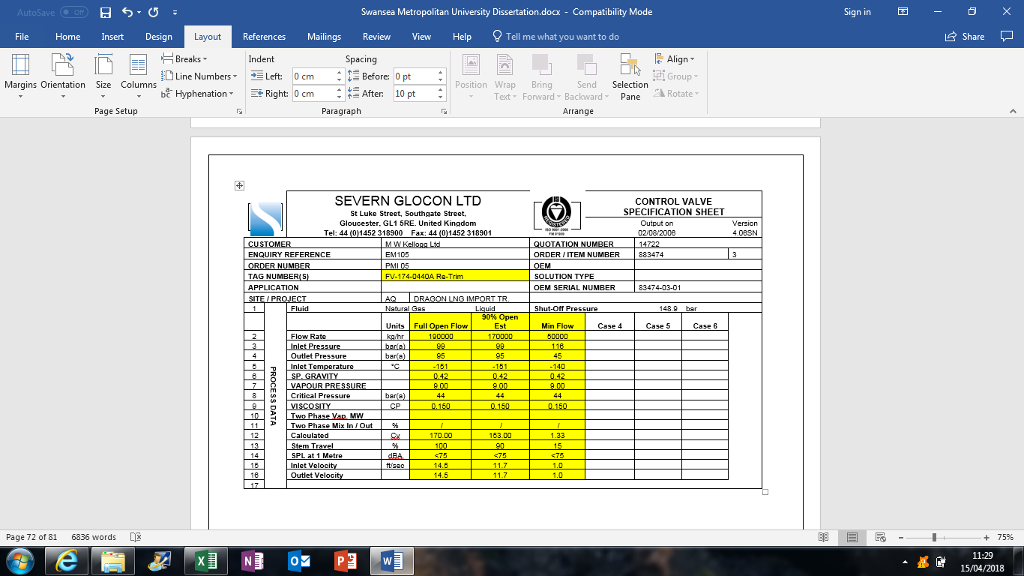
Figure 18: SEVERN GLOCON LTD Calculations (Appendix 12)
For the three different modes of the SCV (Normal, Max and Peak) a Cv value was generated based on the information that was sent. From looking at these results a Cv value of 170 was calculated and it’s this figure that will be used to construct the new trim for the control valve. This Cv was chosen over the other two values because the valve will be in the fully open position with a CV of 170 at a max send out rate which indicates that the valve will be able to operate correctly.

SCV Inlet Flow Control Valve FV-174-044OA independent Trim Calculations

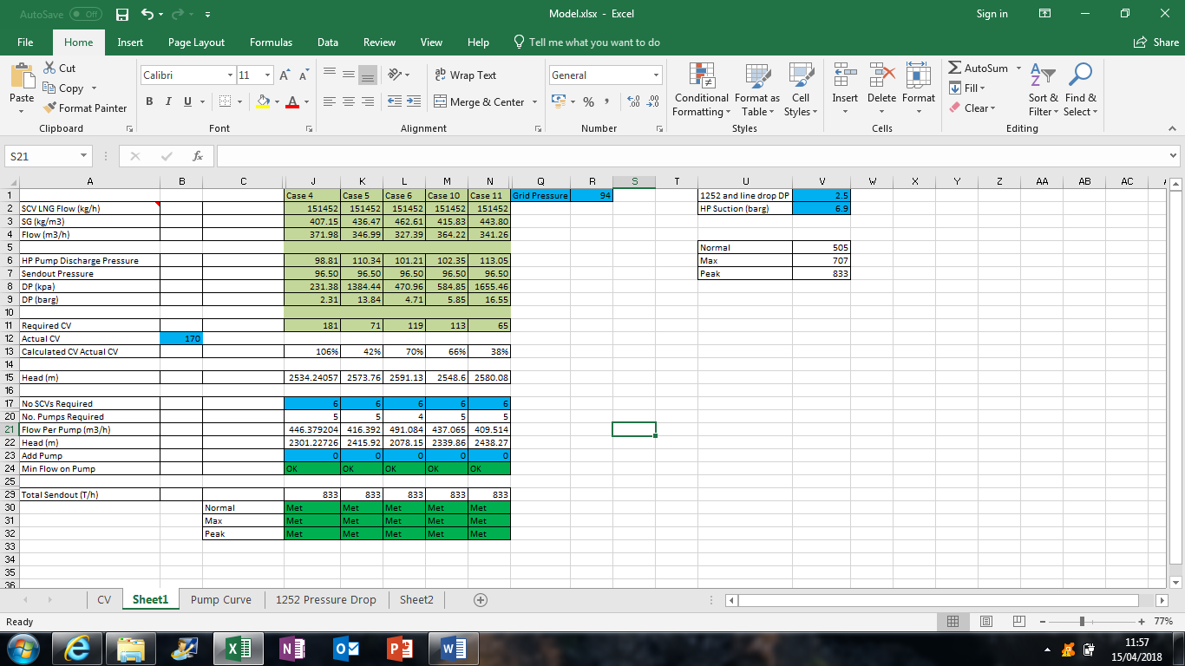
Figure 19: Trim Calculations. (Appendix 13)
NEW CV Value
Independent calculations were carried out by inputting formulas and process information into Excel to establish the new Cv value. 5 different send out mode cases data were put into the Excel spread sheet along with the National Grid pressure (94Barg) and the 1252 send out header control valve pressure drop.
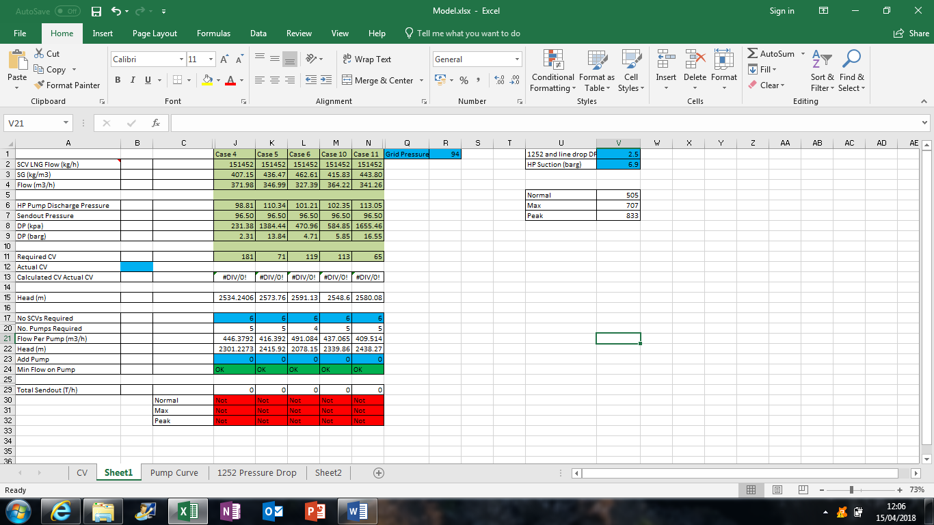
Figure 20: Trim Calculations input. (Appendix 14)
An ‘Actual Cv’ value was put into the Excel sheet indicated in blue. Currently this block is blank, and this is setting the 3 modes (Normal, Max and Peak) red. The current Cv value for the faulty control valve is 300. This value will now be put into the Excel sheet for the ‘Actual Cv’ value. This number will then be dropped until one of the mode boxes goes red in colour again.
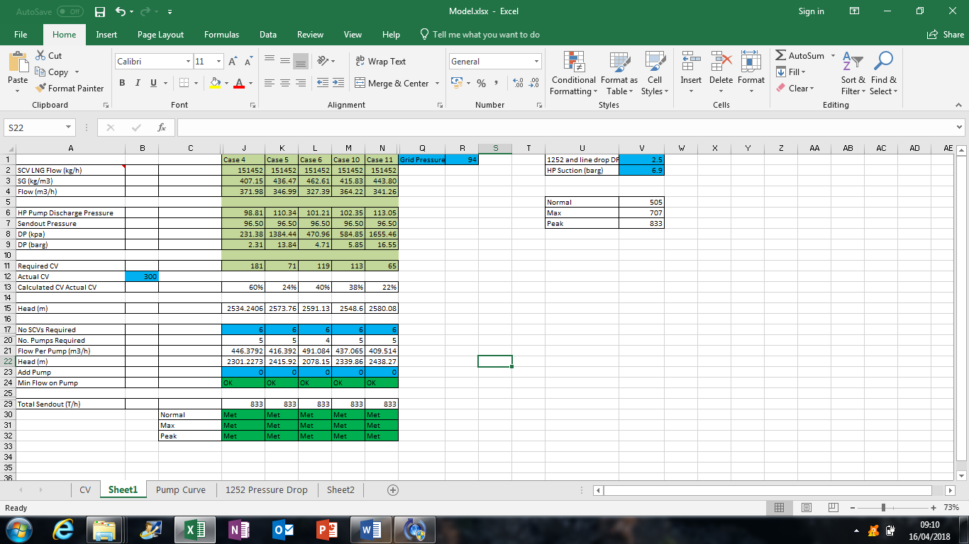
Figure 21: Trim Calculations Old CV input. (Appendix 15)
The old CV value of 300 was put into the sheet and as expected all three send out modes are now showing green. This figure will now be dropped until one of the send out modes turns red. As the ‘Actual Cv’ input value changes so will some of the data in the sheet.
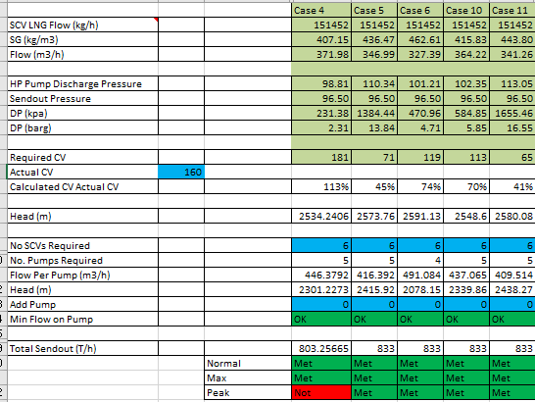
Figure 22: Trim calculations CV Input dropped. (Appendix 16)
The ‘Acutal Cv’ Value was dropped from 300 until one of the send out mode went red. A Cv input of 160 changed Case 4 peak send out to Red. This indicated that the Cv value had been dropped too much and needs adjusting.

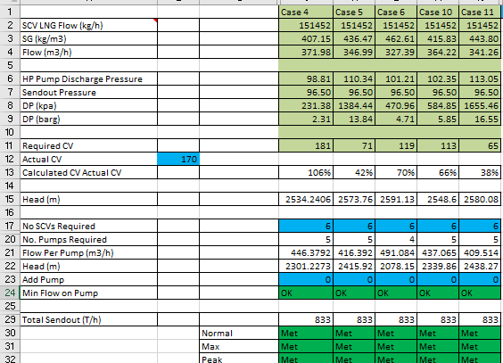
Figure 23: Trim Calculation Final Result. (Appendix 17)
The ‘Actual Cv’ was increased from 160 to 170 and all modes indicated green which proves that the manufactures Cv value was correct. Trend Characteristics of the current and old Cv value will now be constructed.

New and Current Trim Characteristics

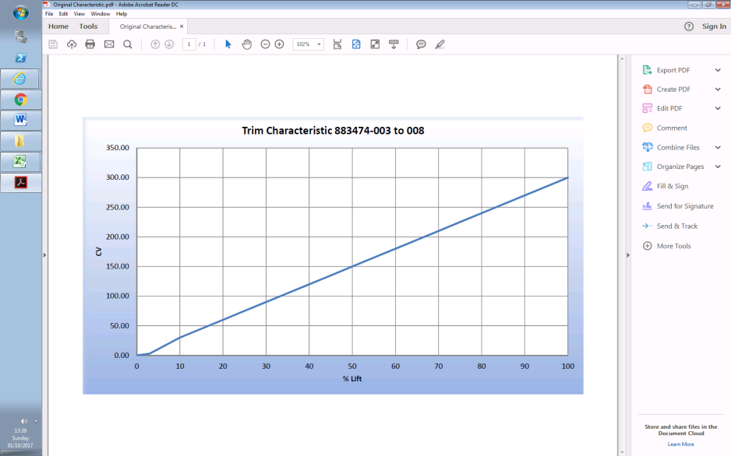
Figure 24: Current Trim Characteristics (Appendix 18)
Based on the information provided by Dragon LNG a trim characteristic graph of the current Cv value (300) was constructed. As the valve begins opening at 4% a flow starts to go through the valve. However, because the valve internals are oversized, the new design should indicate a flow at 20%+.

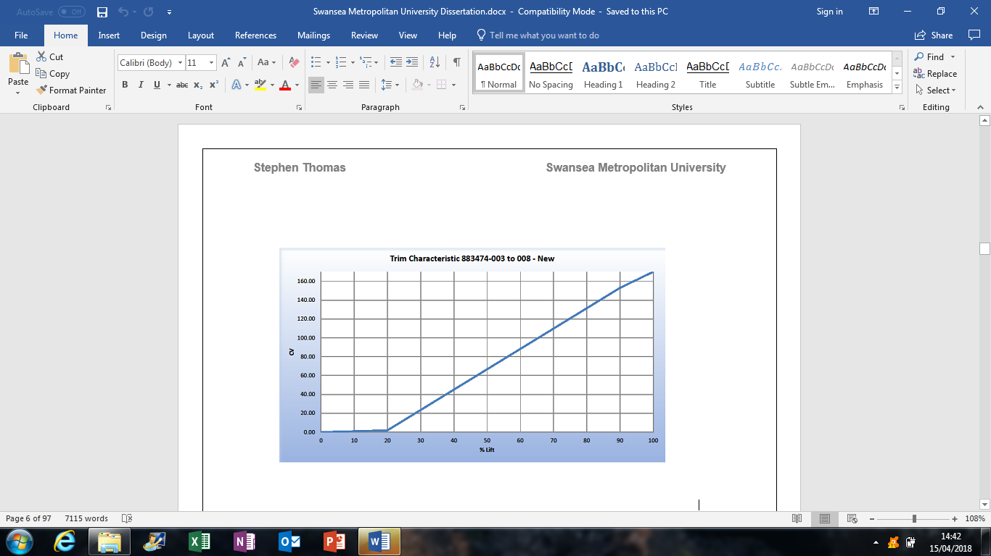
Figure 25: New trim Characteristics (Appendix 19)

Based on the new Cv result from the independent calculations and manufactures calculations a new trim characteristic was constructed. The Cv value has been dropped from 300 to 170 and the lift percentage (Valve Opening) has increased to 20%. This trend indicates what the new valve operation should look like for optimum performance.
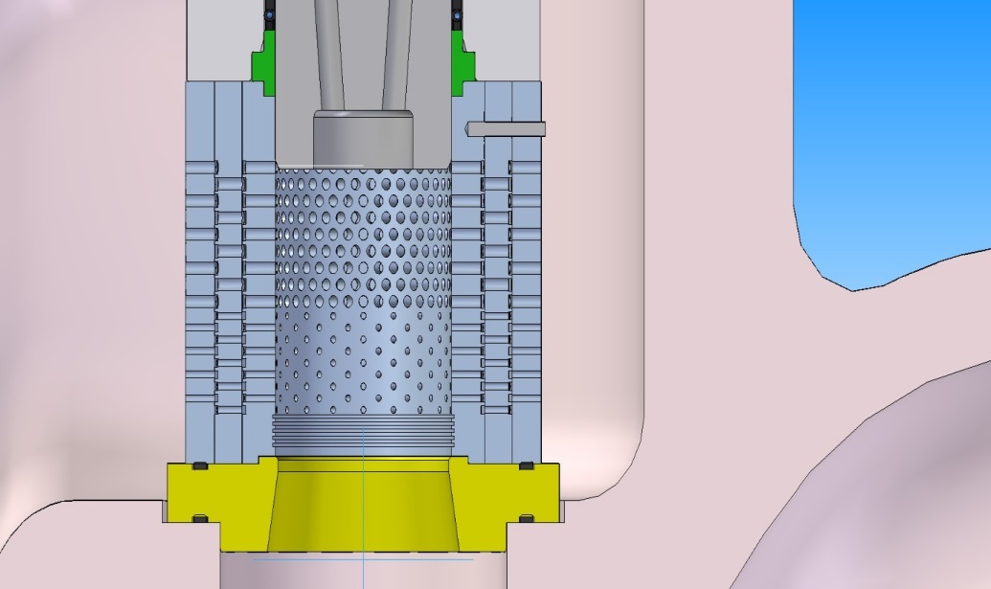
Figure 26: New trim Design. (Appendix 20)
A new trim design was constructed by ‘SEVERN GLOCON LTD’ to show what it will look like when implemented into the SCV inlet flow control valve FV-174-044OA. The new trim will be subject to stresses being applied by the HP pressure of up 120Barg and the temperature of -160°C. The trim design has holes varied in size to relief and BOG (Boil Off Gas) produced in the system, this is to prevent the valve gassing up and failing. The trim will be made bigger to fill out the internals and produce better control.
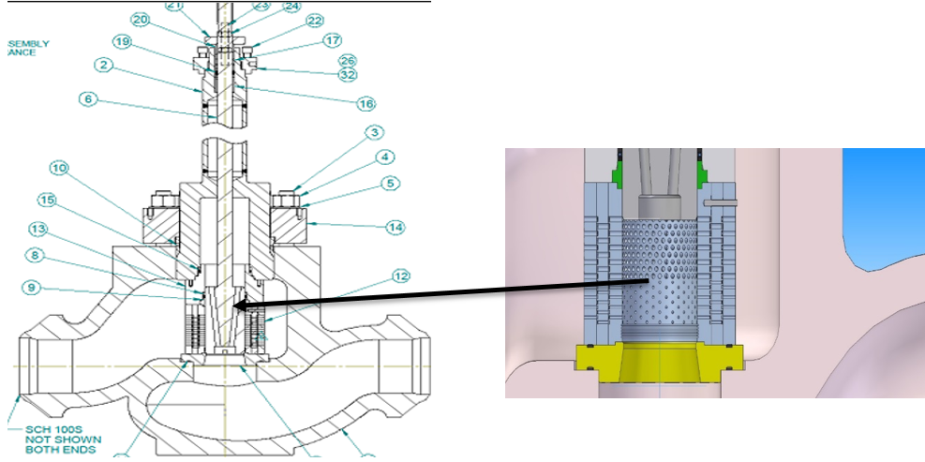
Figure 27: Fitting the New Trim. (Appendix 21)
Figure 27 specifies where the new trim will be implemented into the control valve. To do this, the valve will be stripped into parts by removing the actuator, stem, valve wheel, plugs etc. All of which can be seen in the new design specifications in Appendix 22.

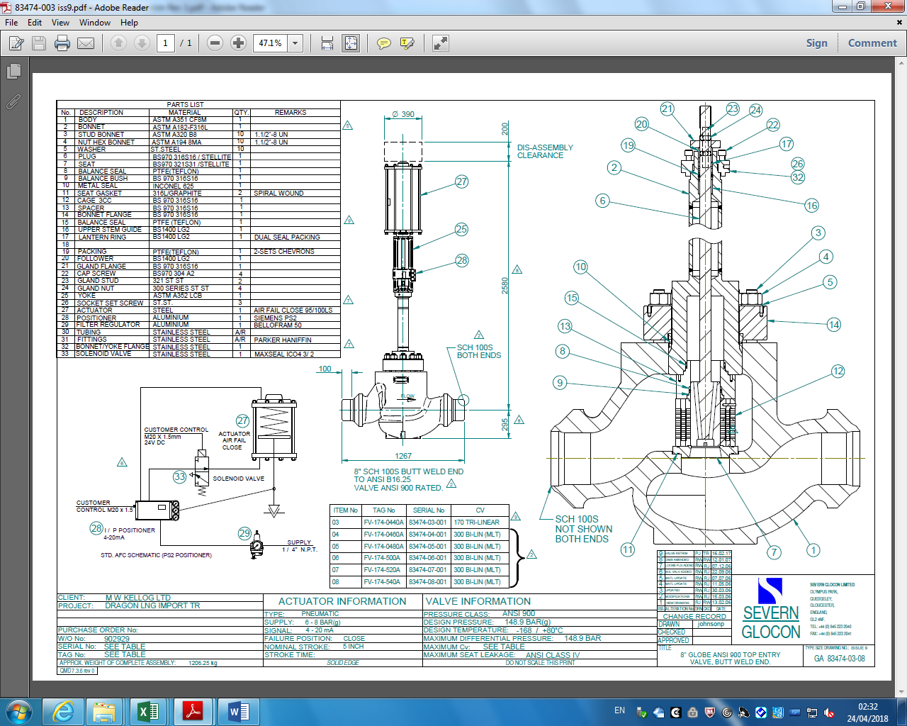
Figure 28: New Design Specifications. (Appendix 22)
Progression
Currently through this project the problem on the LNG process has been defined and the impact of this fault has been established by carrying out research internally such as performance trends, operator feedback and DCS Data. Solutions to remedy this problem have been discussed between departments in Dragon LNG such as Mechanical, Instruments, Operations and Process Engineers. It was concluded that the LNG line should not be cut into because of the nature of LNG and the stress this would create of the pipe work which could lead to failure. Therefore, it was decided that a new trim should be implemented into the housing of the current SCV inlet flow controllers.
A company was contacted called ‘SEVERN GLOCON LTD’ to construct a new trim based on the valve specifications and LNG Process data that was sent to the company. The company sent designs, calculations and a new flow coefficient (Cv) value for the trim of the control valve. The current Cv value is 300 and this was dropped to a Cv of 170 by SEVERN GLOCON LTD. To back this value, further independent calculations were made by using Excel. Formulas and different process values based on the LNG process were implemented into this software and a Cv value of 170 was established.
A Company implementation plan will be constructed to install the new trim and tune the actuator. A test will then be carried out to see how it performs when it is being used to control LNG while sending Natural gas to the National Grid. This plan will consist of scaffolding being constructed, Operation preps such as isolations and purging, Mechanical removal and installing the trim, Instruments removing the actuator and disconnecting the power cables. A procedure method statement will then be constructed by operations to carry out this job effectively and safely.

Company Plan
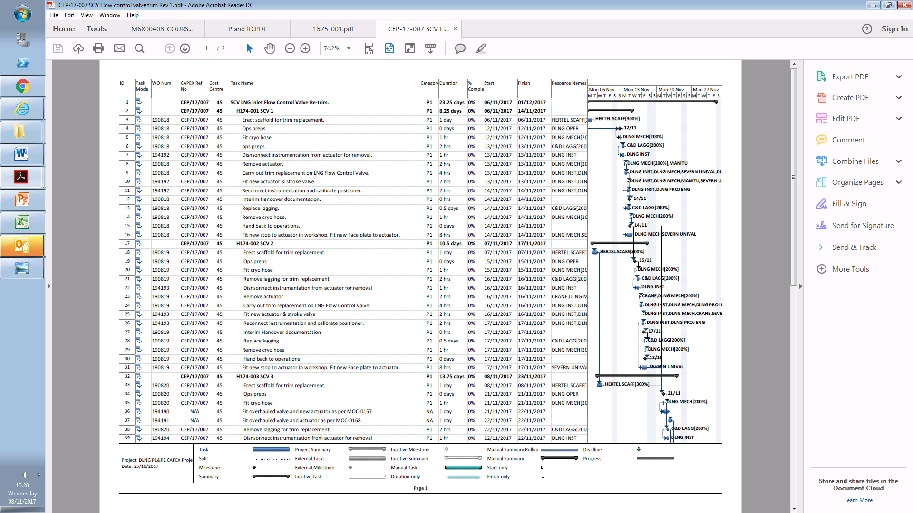
Figure 29: Company Plan (Appendix 23)
Change in Circumstances
After further discussion with members of Dragon LNG it was decided that because the circumstances had changed (Shutdown Period) it would be more practical to install the trim on all 6 SCV’s while the LNG process is shut down for maintenance. This makes the implementation less cost effective because the equipment is already shut down for maintenance. Also, if an SCV is taken out for maintenance or shut down due to failure then this prevents the LNG process from going into Peak Send Out mode. This mode requires 6 SCV’s in operations to get 833Tonnes/Hour of Natural Gas into the National Grid. The shareholders PETRONAS and Shell must be contacted 4 weeks before any SCV can be shut down. If Dragon LNG has declared that Peak Send out is available and an SCV is shutdown then fines will be placed upon Dragon LNG. Therefore, the implementation of all 6 SCV’s while the plant is shut down for maintenance has been advised because the shareholders have already been informed of the circumstances regarding the shutdown.
A method statement with the task, ‘Removal of the actuator assembly and fit a new travel stop. Re-locate the positioner to reflect the new travel and then re-pipe the positioner. Valve Sn; 83474-03-01. (8” ANSI 900 Cryogenic Severn Globe Control Valve, 5” Travel) will now be constructed. This method statement will include details of how the task is going to be carried out and by whom. Once the method statement has been constructed it will need to be authorised by the Health and Safety department along with the planning department and then a work request can be raised to carry out the project tasks.

Method Statement
DATE: 06/11/2017
JOB NO: 223774
SITE DETAILS Dragon LNG, Main Rd, Waterston, Milford Haven, SA73 1DR
CUSTOMER: Dragon LNG.
SITE CONTACT DETAILS Roger Jenkins Tel; 01646 691730
TASK: Removal of the actuator assembly and fit a new travel stop. Re-locate the positioner to reflect the new travel and then re-pipe the positioner. Valve Sn; 83474-03-01. (8” ANSI 900 Cryogenic Severn Globe Control Valve, 5” Travel)
SPARES REQUIRED: - Travel Stop (on site) Actuator seal (kit on site)
LIST OF TOOLS & EQUIPMENT Lifting Equipment (Supplied by Site if Required) Small Hand Tools.

PROCEDURE

- Obtain the correct safety document or permit.
- Ensure you are working on the correct valve. IF UNSURE ASK.
- Carry out POWRA and ensure (if any) correct safety equipment listed on permit is in place, (Special PPE, scaffolding, etc.).
- Ensure correct isolations are in place and actuator is fully de-pressurized.
- Remove Instrumentation.
- Attach temporary regulated temporary air supply to underside of actuator and drive valve off its seat, remove coupling and release pressure.
- Remove gland flange, the remove actuator and lay down in safe place then transport to workshop.
- Remove three tie rod bars from the actuator and replace one at a time with the screwed rod provided complete with one bearing on each screwed rod.
- Remove the other three tension rods, completely from the actuator assembly.
- Then slowly release the tension on the springs using the long-screwed rods in place.
- Overhaul actuator using new soft goods plus fitting the new travel stop provided.
- Re-assemble the actuator using the tension rods ensuring the cap is taken down evenly to meet the top cap.
- Replace the three tie rods into the holes and tighten down, then remove the long tie rods and replace with the other original tie rods.
- Drill and tap positioner bracket into its new position onto the yoke so when the actuator is at 50% open the positioner arm is horizontal. Then re-make the pipework to all air connectors as required.
- Take the actuator assembly to the valve and using a lifting aid lift the actuator above the valve body.
- Clean and re-grease the Actuator mounting spigot on the Bonnet, re-fit the Actuator.
- Re-fit the Gland Flange.
- Attach temporary regulated air supply to the underside of the Actuator, ensure plug is fully in its seat, fully travel the Actuator and bring back down to 5” travel and re-attach coupling.
- Stroke the valve several times to ensure smooth operation.
- Adjust Gland Packing by tightening the Gland Flange evenly taking care not to damage the Plug Stem.
- Remove temporary air supply and re-fit original Instrumentation.
- Using temporary supply connected to the positioner, re-calibrate and check operation.
- Have isolated supplies re-instated and check Instrument Tubing and Actuator for leaks.
- Clear the work area ensuring all tools have been removed and work area is tidy.
- Return Permit and sign off.
Severn Unival Ident No MS-223774.
Implementation of Trim
Figure 30: Scaffolding Erected. (Appendix 24)
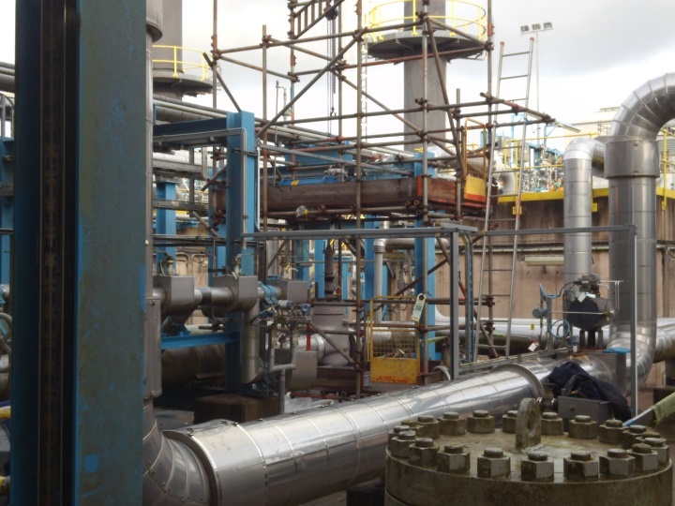
To begin this task of changing the trim, scaffolding was constructed to reach the valve and allow operations to carry out isolations and purge the system through with nitrogen. ‘Hertel’ is a contract company based on Dragon LNG who constructed this scaffolding and will also decommission the scaffolding once the job has been completed.

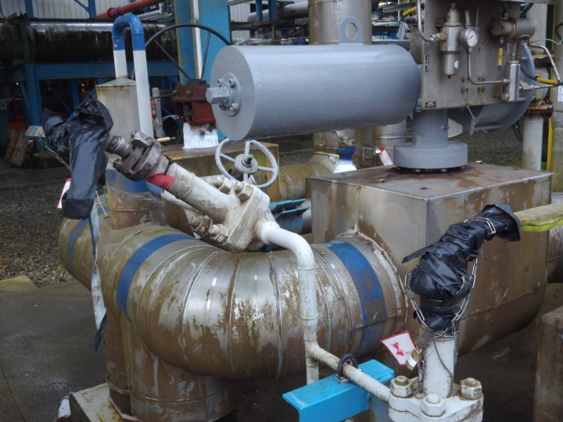
Figure 31: Isolations. (Appendix 25)
This is the line feeding LNG to the SCV inlet flow controller. Here it can be seen the line has been isolated and the valve for purging the line through with nitrogen has also been isolated. There are red tags with locks and chains going around the valve to prevent it opening. The keys from the locks are then removed and taken to the permit cabin where the keys will be issued with every permit associated with the job. Only once all the permits are handed back the locks can be removed.
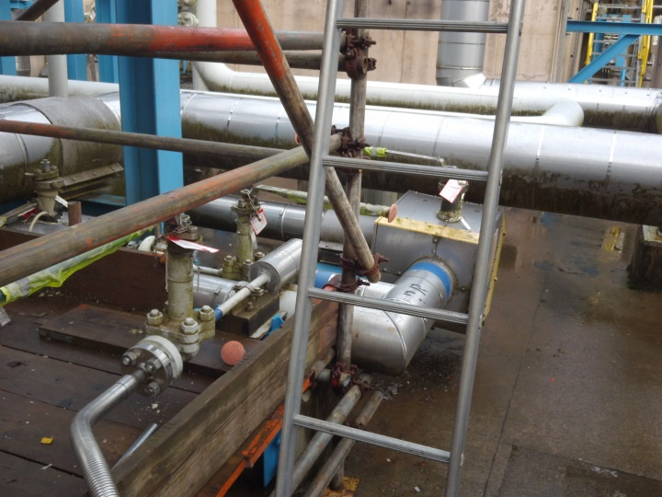
Figure 32: Discharge Isolation. (Appendix 26)

From the discharge of the SCV inlet flow controller to the SCV there are some bypasses which were isolated, and the discharge line as seen in figure 32 was also isolated and purged using nitrogen. Nitrogen is an inert gas and purging removes any dangerous substances that could potentially cause harm, in the case LNG.

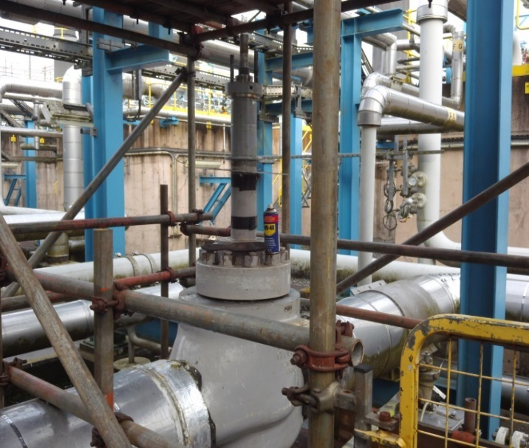
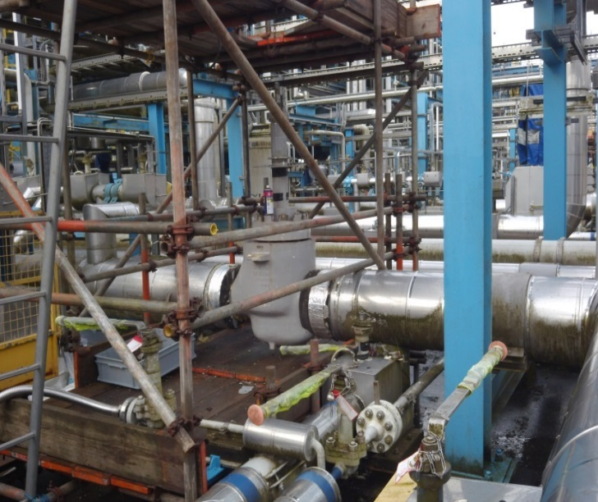
Figure 33: Actuator removed and Stem Exposed. (Appendix 27)
When the isolations had been put in place and the system had been fully purged and de-pressured to remove the LNG from the line, work could commence. The actuator was removed by the instrument department and the stem of the valve was exposed. The nuts holding the stem into the valve can now be removed using a chain to jack the stem up onto the scaffolding platform.
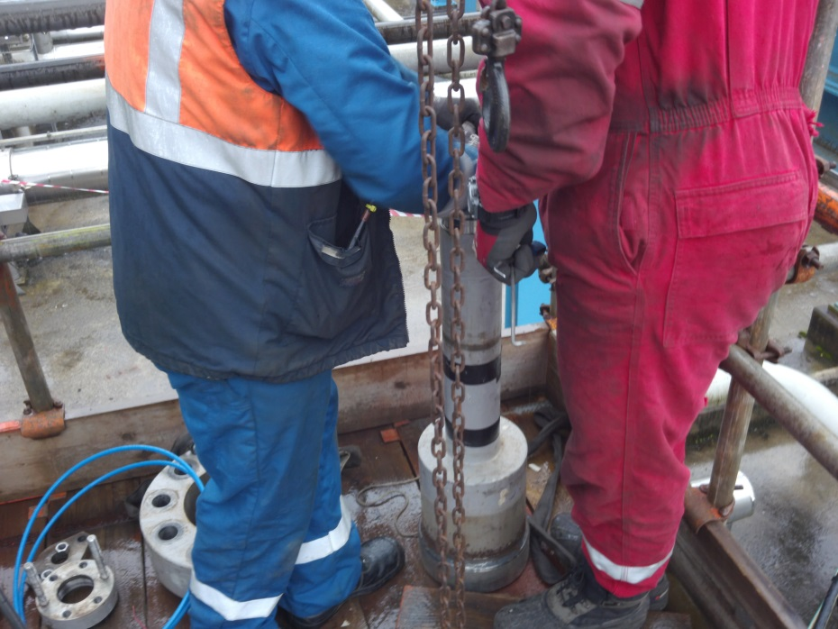
Figure 34:Stem Removed. (Appendix 28)
By usng the chain on the scaffolding platfom located above the control valve, the stem could be jacked up from the housing of the SCV inlet flow controller. This job was carried out slowly because as the stem was pulled out, there was some BOG (Boil Off Gas) present in the valve. The mechical fitters waited 20minutes for the BOG to disserpate, a gas test wass carried out and then they carried on with the task.

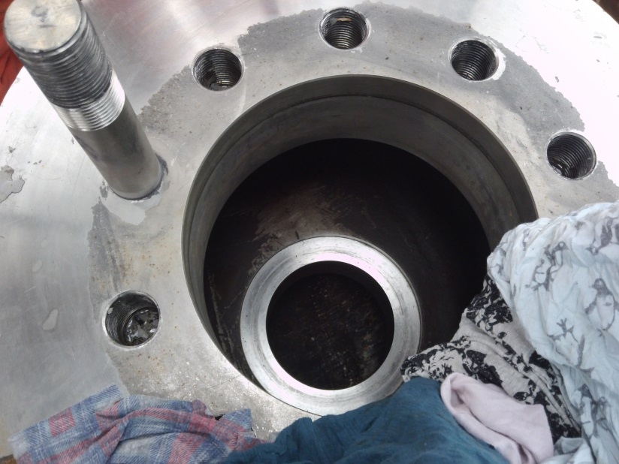
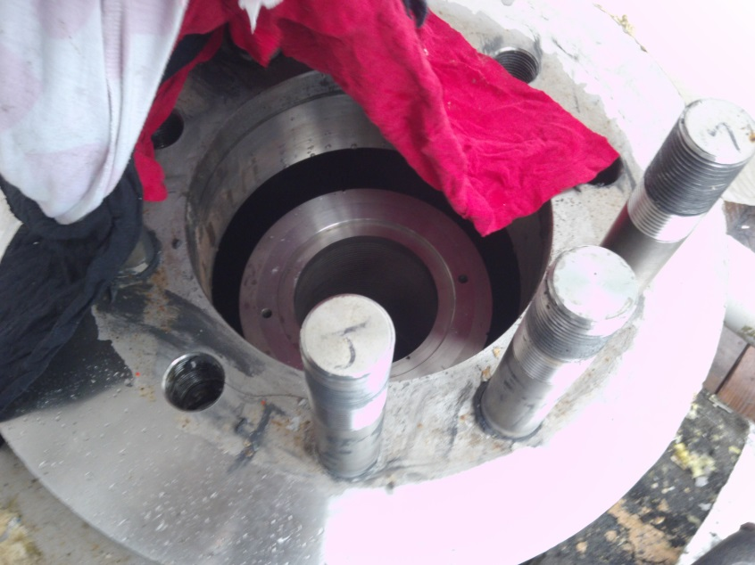
Figure 35: Trim Exposed. (Appendix 29)

When the stem was removed the trim could be seen in the housing of the control valve. This trim can now be removed and the line can be inspected prior to a new trim being fitted into the housing.
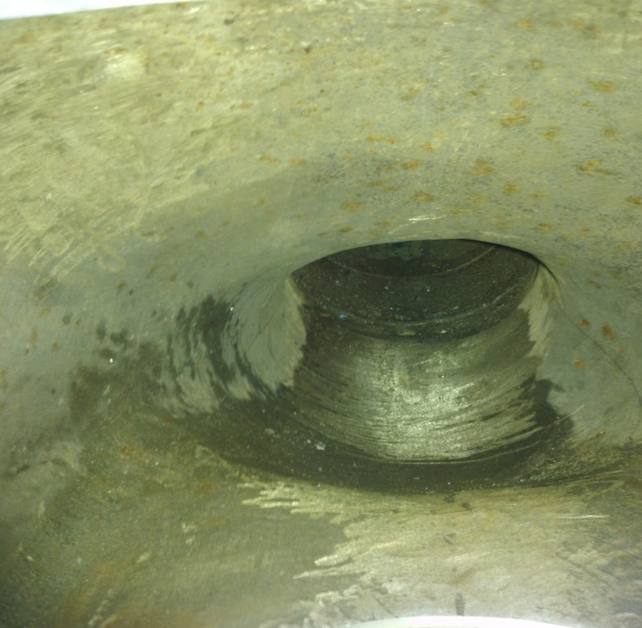
Figure 36: Pipe Inspection. (Appendix 30)
The trim was removed from the housing and the pipe was inspected for damage and any contamination. While this task was being carried out, it was raining outside and this caused some water to enter the housing. The water entering the valves housing must be limited becauase when LNG is lined back up to the control valve it will start to flash off (BOG) and this can cause problmes when operating the control valve.

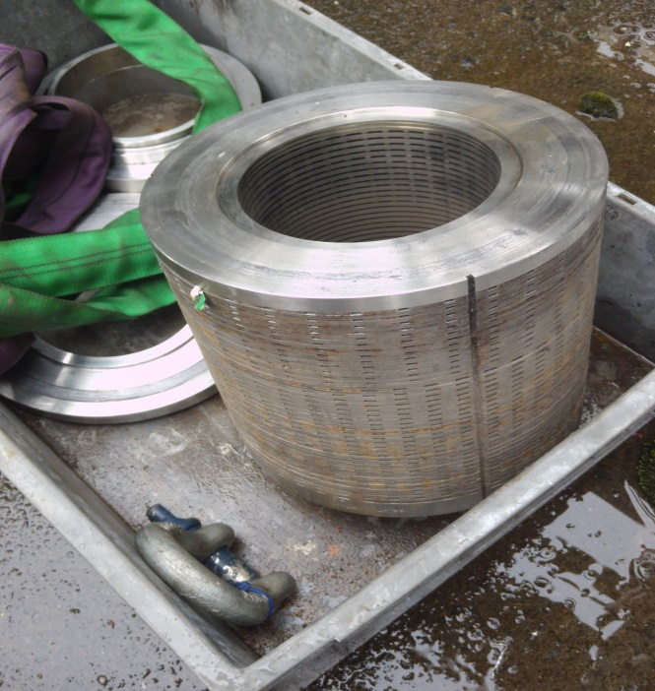
Figure 37: New trim and Gaskets. (Appendix 31)
The trim was replaced on site and not the work shop. All the parts were brought to the SCV inlet control valve. These parts consisted of the trim, and two gaskets for bolting on the stem to the control valve.

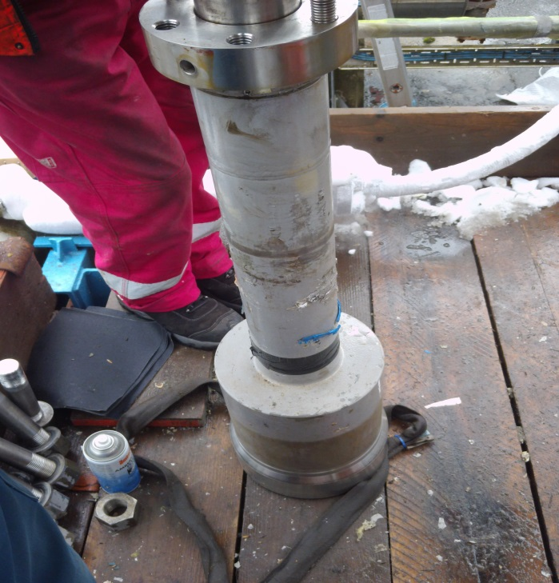
Figure 38: Installing Stem. (Appendix 32)
The trim was fitted into the housing and the stem was installed back into the control valve. To do this task a chain was used on the upper level scaffolding platform to jack the stem up so it could be fitted back into the housing correctly.

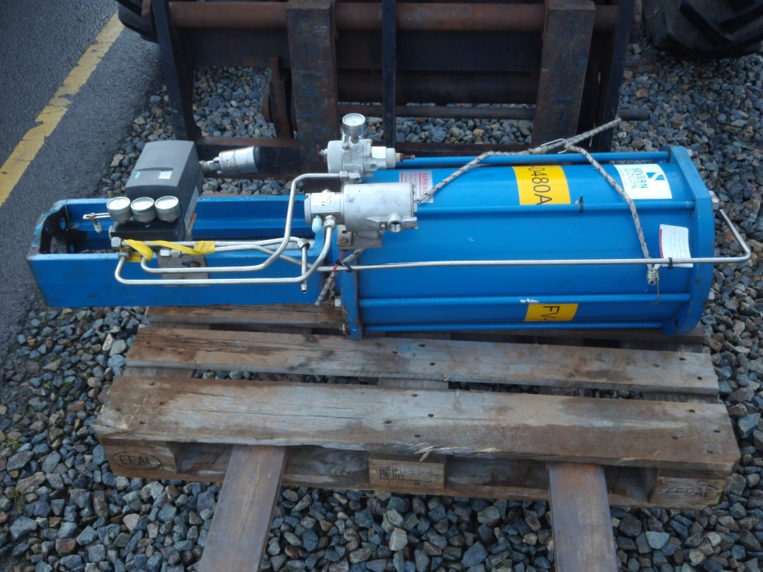
Figure 39: New Actuator. (Appendix 33)

An acuator was installed onto the new valve to produce better control. currently this acuator is not tuned so it cannot be used. However, once this actuator has been tuned the control for the SCV will be enhanced and the chances of tripping the LNG process will be greatly reduced.

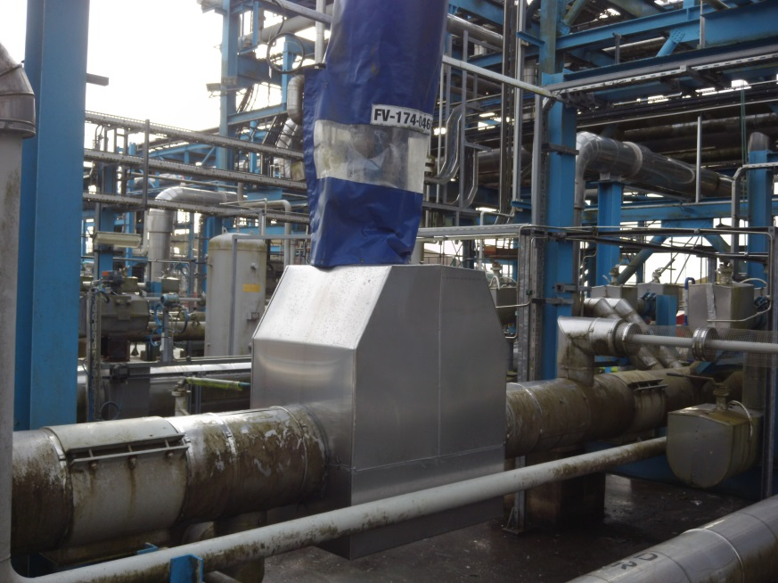
Figure 40: New Control Valve . (Appendix 34)
The valve has now been installed along with the actuator. The protective cover has been placed over the top of the actuator and the line has been de-isolated ready for operations to recomission the line to the control valve and to the SCV. This will take serval hours as the line will need to be cooled down gradually to prevent thermal shock to the system

Tuning of the Actuator
when the method statement had been completed and all relevent jobs asscioated with the implemetation of th new trim had been complete, the job could be signed. However, before the control valve could be recomissioned the instrument department tuned the valve by using the DELTA V software. The results from tuning the valve are as follows,
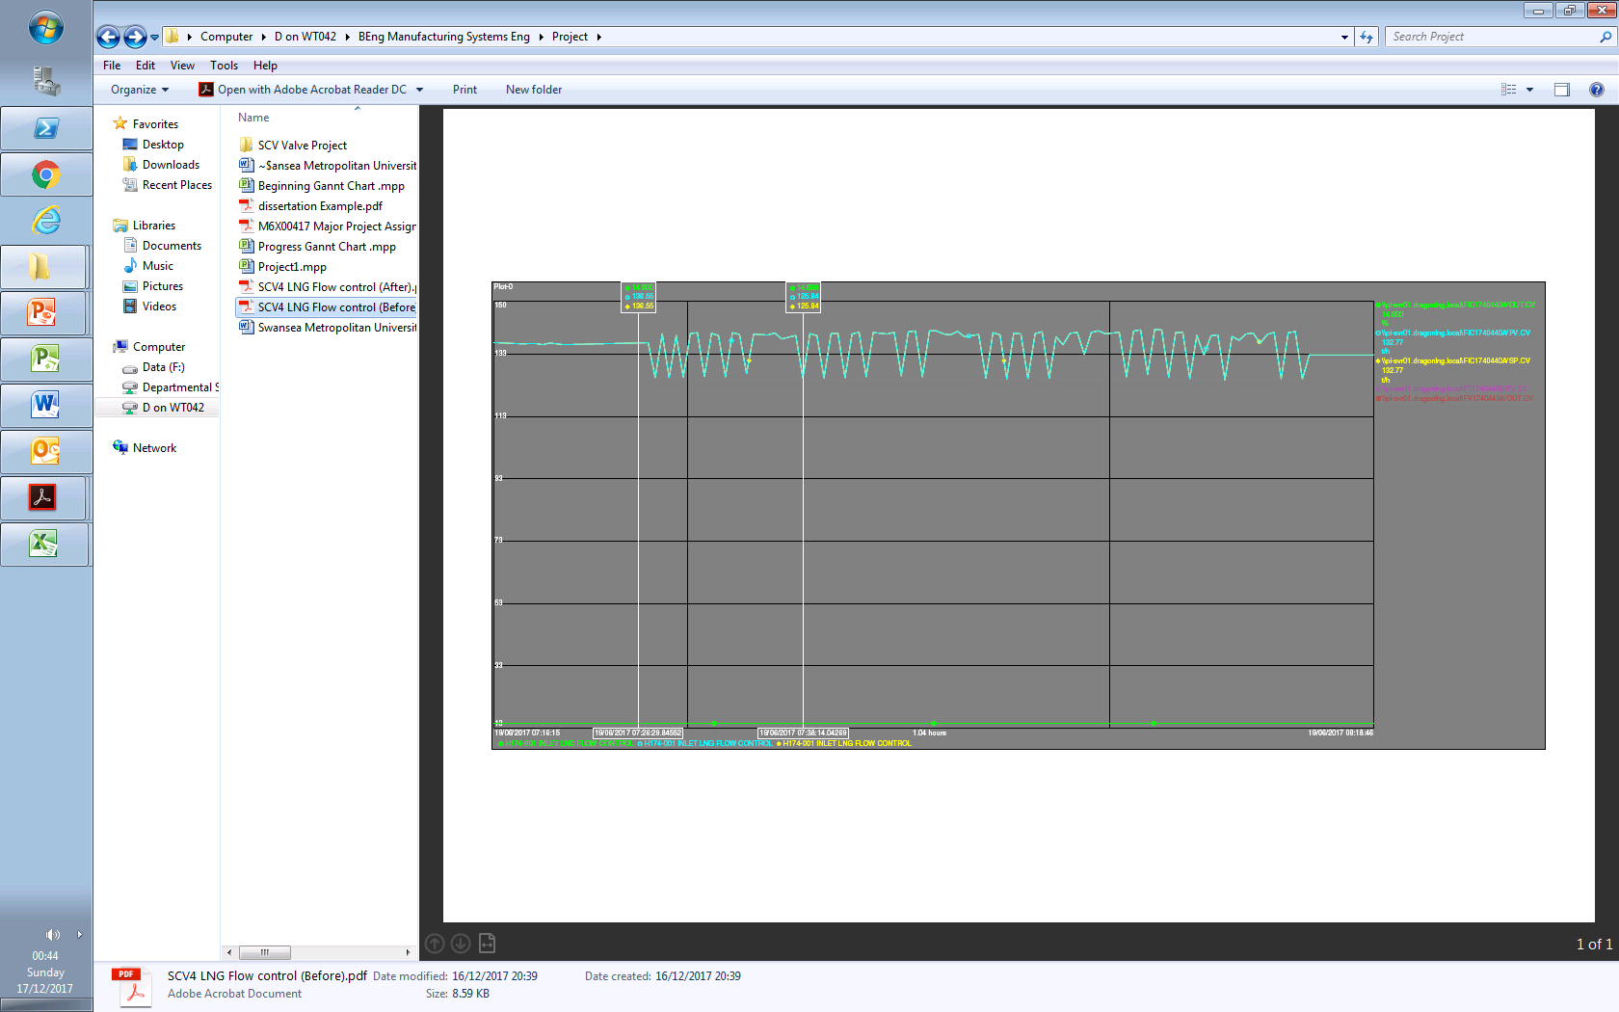
Figure 41: Tuning the new Actuator. (Appendix 35)
Set Point
Oscillation
Set Point
This trend specifies the perfornace of the control valve before it has been tuned. The control valve is at a constant setpoint (Green) located at the bottom of the graph and the valve begings to open and close (Oscillation). This oscillation can be seen at the top of the graph shown in Blue and Yellow. Clearly this valve can’t be used yet until this matter is resolved.
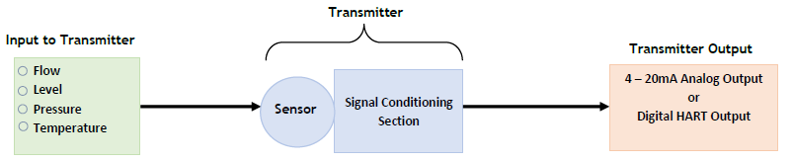
Figure 42: Producing a Siganl. (Instrumentationtoolbox, 2018)
Damping will be carreied out to tune this control valve. In addition to to update time, damping is the amount of time it takes for the output of the transmitter to reach 63.2% of its final value after a step change has been made by the panel operator to the input. It is often used for stablising control loops and preventing false trips. (Instrumentationtoolbox, 2018)
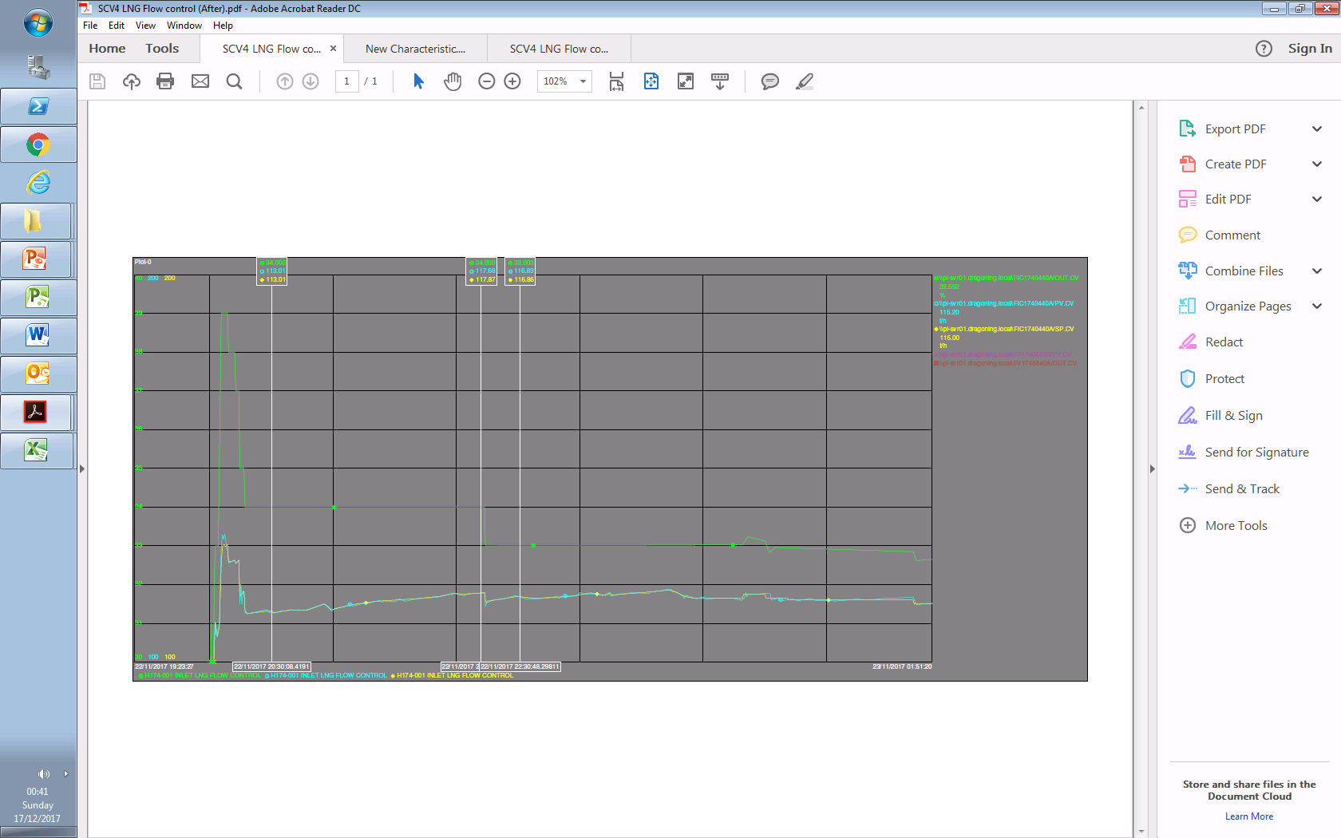
Figure 43: Tuned Control Valve. (Appendix 36)
Control
Set Point
Set Point
Control
From damping the control valve, it can be seen that the valve is now operating corretly. There is still oscillationg present in the system however, this will have minimal effect to the process. From looking at the diagram it can be seen that as the set point is increased (Green) the control valve operates the same way (Blue). This control valve is now ready to be used for controlling the LNG flow going through the SCV.
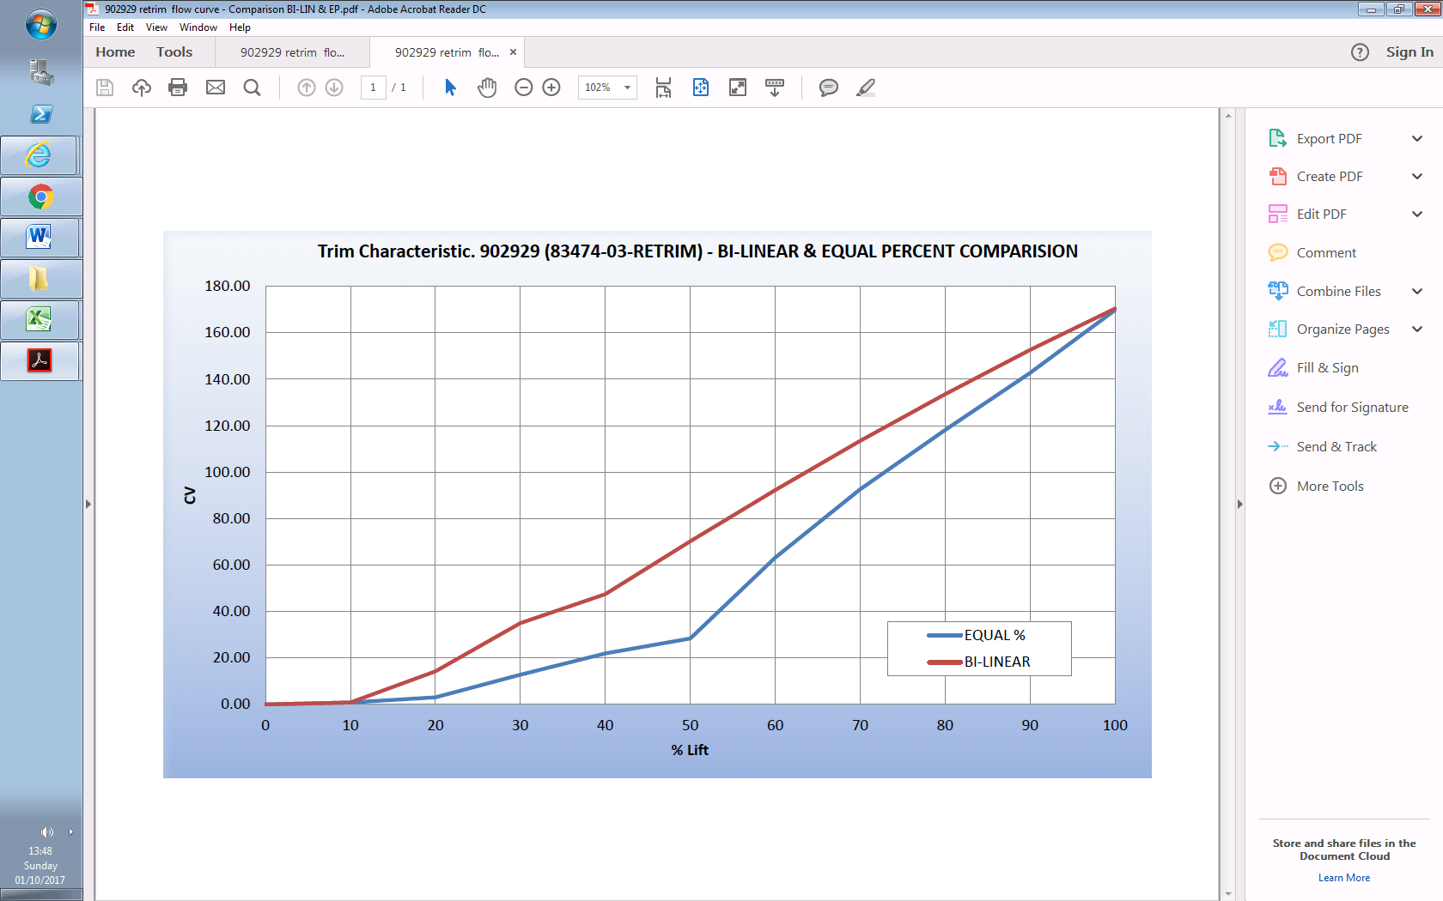
Figure 44: Trim Charecteristics Comparison. (Appendix 37)
The blue trend of this graph specifies what was aimed for through the project. The demand was that the valve opened above 20%, in this case 50% and then the flow was controlled as it opened to 100%. The red line indicates what was achived. From looking at the red trend, it can be seen that better steady control has be acomplished.

Testing
Instruments had confirmed that the valve had been tuned and was ready for use. In order for this valve to be used, the LNG process had to go into Send Out mode. This mode can only be achieved when a nomination has been sent by one of the shareholders (Shell and PETRONAS). However, due to the inceasing demand in the market for Natural Gas, the LNG process went into Send Out Mode with 3 SCV’s being used (Minimum Send Out). The results are as follows,
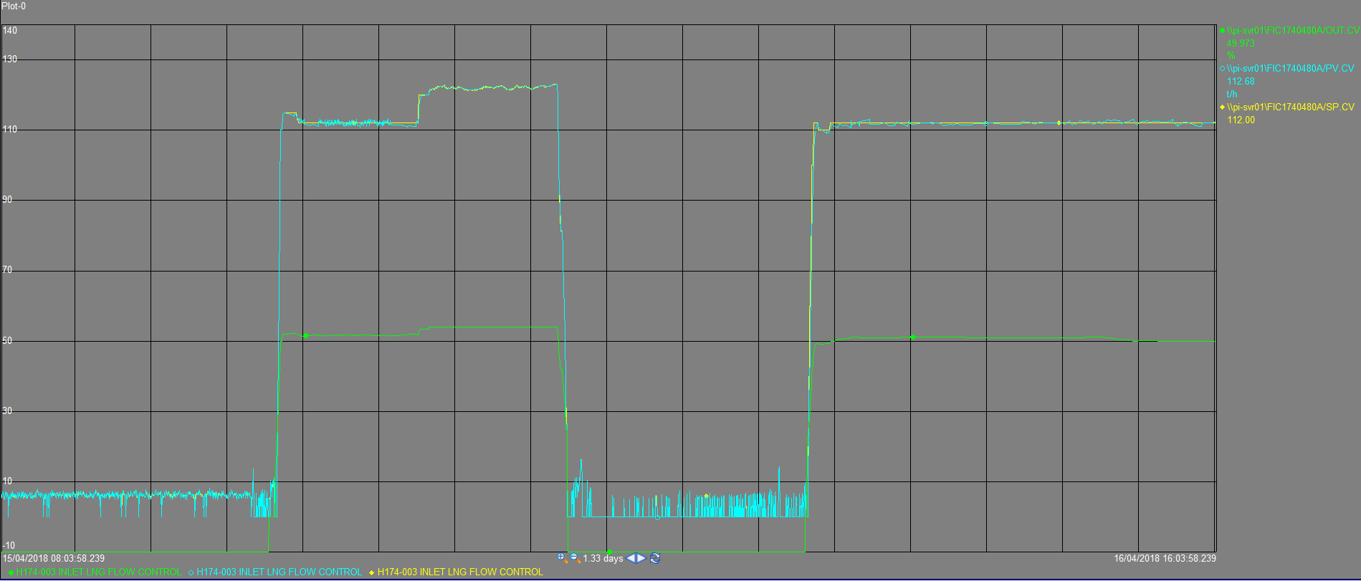
Figure 45: SCV 1 Tuned Trim. (Appendix 38)
Set Point
Control
Set Point
Control
The testing of the SCV inlet flow control valve on SCV 1 was successful. Clearly there is better control present with very minimal oscillation. The EOD (End Of Day) controller was used for this scenario to control all the SCV’s output, not inidvidually in manual. The EOD controller, as descussed before is used to meet the nominations set by the sharholders by controlling the output on all SCV’s in use. The Panel operator inputs the figure into the EOD controller and the inlet flow control valves on all SCV’s begin to operate to maintain the demand. The Green trend is the set point being adjusted by the EOD to increase or decrease the flow to meet the demand. The Blue trend is the valve opening and closing to meet the set point changes. It can be seen that as the set point changes, so does the control valves output.

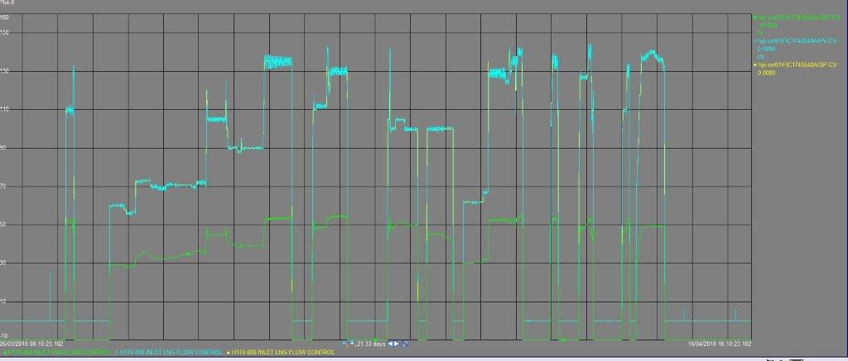
Figure 46:SCV 2 Send out Period Trend. (Appendix 39)
Set Point
Control
This trend specifies the send out period from the 26/03/18 – 16/04/18. This nomination was set because of the LNG carriers that were unloading into the SCV storage tanks. As the LNG tankers unload the pressure in the LNG process increases and the only way to remove this pressure is to either flare or send out to the National Grid. Through this send out period the oscillation is again minimal which proves that the installation and tuning of the control valve was successful on SCV 2. Again, the EOD controller was used to control the flow going through SCV 2 to meet the nomination demand. The set point is indicated in the colour green which is being controlled by the EOD controller. The Blue colour trend is the valve opeing and closing to meet the demand of the EOD setpoint.

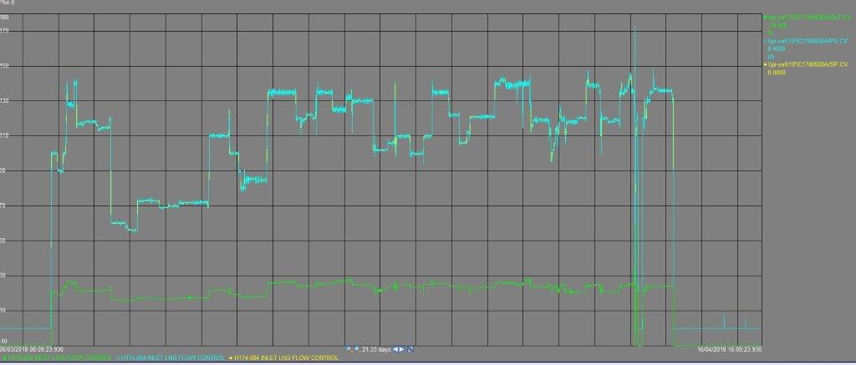
Figure 47:SCV 3 Send out Period Trend. (Appendix 40)
Control
Set Point
The control on SCV 3 was also successful. Simular to SCV’s 1 and 2 the EOD controller was used to control the flow through the SCV’s from 26/03/18 – 16/04/18. Very little oscillation is present in the system.
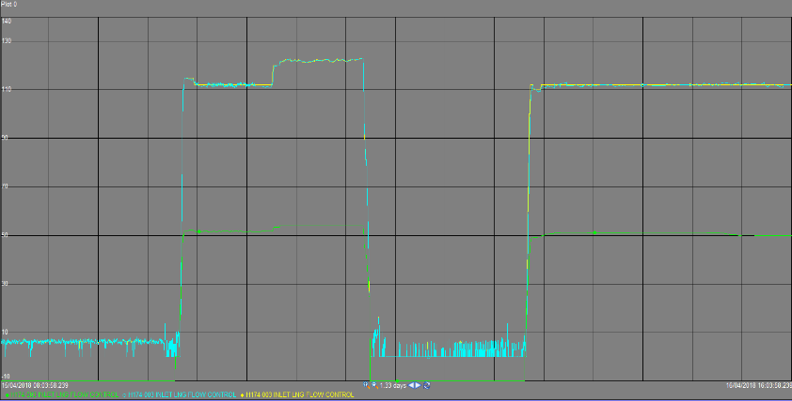
Figure 48: Comparison Results. (Appendix 41)
New Trim
Old Trim
From looking at these comparisons in performance it is clear that the implementation of the new SCV inlet flow control valves has achieved greater control. The Cv was reduced from 300 to 170 with the new trim fitted into all the SCV’s while the shutdown period was being carried out. Overall the panel operators are very happy with the outcome of this control and the likelyhood of the process tripping due to oscillation is very minimal.

Cost

Figure 49: Implementation Cost. (Appendix 42)
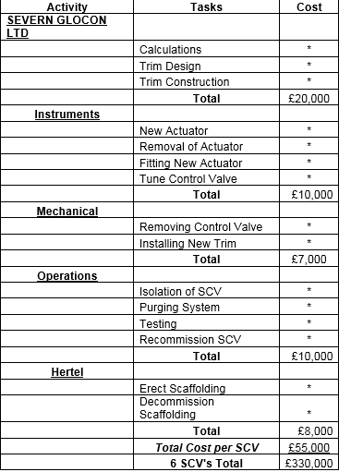

The implementation of the project cost £55,000 per SCV making a total investment of £330,000 for all 6 SCV’s. Dragon LNG insisted that this project must be carried out because of the implications being faced by the panel operators trying to control the flow going through an SCV. The biggest cost in this project was the man power from each department, it took multiple departments working together to make this implementation successful which removed these individuals from other tasks on site.
Conclusion/Evaluation
A problem was presented by Dragon LNG regarding the LNG process. It was discussed that the SCV inlet flow control valve on all 6 SCV’s was causing problems for the panel operator and putting the process at risk of initiating an ESD. As a qualified process operator, it was the responsibility of the operations designate to isolate equipment, purge the system, recommission equipment, gas test the area, assist the mechanical department with fitting the new trim, and investigate the fault prior to the trim being fitted and monitor the results. These faults were found by analysing the trends of the SCV’s when the process was in Send Out mode. These finding were then presented to the Process Engineer who was given the task of monitoring this project. To begin this project, a Gantt chart plan was constructed to give deadlines and tasks to be completed within a time frame. Research was then carried out to establish what LNG is, how LNG is transported, how LNG is stored and how the LNG process operates. Research was then carried out into the operation of a SCV and how this is affecting the LNG process. To gather this research, data from the DCS was obtained and various books were used on Dragon LNG’s data base to find diagrams and operation limitations of an SCV. The costs associated with running the SCV’s established how each send out mode (Normal, Peak and Max) can influence the running costs. It was found that one SCV in use would generate a cost of £5,073.77 and 6 SCV’s in use for Max send out would generate a cost of £ £30,442.66 in a 24-hour period. The SCV inlet flow control valve was found to be a globe valve and the function of this control valve was researched, and specifications were gathered from Dragon LNG’s data base. These specifications were required for designing a solution to the control problem currently present. To understand more about the problems the panel operators were facing, research was carried out by obtaining trends from the valve when it was being used for sending LNG into the SCV. These trends identified the performance of the control valve and concluded that there was a massive issue of poor control. When all the data was collected, a discussion took place between the departments to decide on the best possible action to take to solve this problem. It was decided that the best course of action would be to implement a new trim into the current globe valve housing. This meant that the LNG line would not be tampered with, such as welding and cutting, and the integrity of the pipeline would remain reliable. A valve manufacturing company named ‘SEVERN GLOCON LTD’ was contacted by Dragon LNG’s process engineer to construct a new trim that would meet the LNG process demands. The LNG’s process data such as the SCV, HP pumps, and Recondenser was sent to this company along with the current valve specifications so a new CV value could be generated, and a new trim could be constructed.
‘SEVERN GLOCON LTD’ carried out their own calculations and generate a new flow coefficient value (Cv) of 170. A new trim was then constructed to meet the demand of the flow coefficient value and meet the valve specifications. To confirm that these calculations were correct, further independent calculations were carried out. To do this, formulas and the LNG process data were put into an Excel spreadsheet and a result of 170 was generated. This confirmed that the Cv value correct. Data was sent to Dragon LNG by SEVERN GLOCON LTD identifying the new trim design and the specifications. It could then be seen from this data how the trim would be implemented into the housing of the existing control valve. A company plan was then constructed by Dragon LNG to implement the trim into all SCV inlet flow controllers, not one as previously stated. The company plan identified deadlines, tasks and departments in charge of the tasks. The circumstances changed from implementing the system on 1 SCV to installing the trim on all 6 SCV’s. This was decided by Dragon LNG because there was currently an ongoing shutdown present on the LNG process and this made the implementation of the project less cost effective. A method statement explaining how to carry out the job was created, and this was approved by the process engineer and the health and safety department. Once the SCV had been insolated, de-pressured, purged and gas tested. The method statement was then given to the mechanical department. When the new trim was installed, the actuator that controls the control valve had to be tuned by the instrument department. This then aloud for tests to be carried out when a nomination was sent. Trends of the SCV performance was taken and it concluded that the problem had be solved. There was little oscillation present in the system and the EOD controller was being used to control the flow on all SCV’s for the first time. The cost to implement this system on 1 SCV was £55,000 and all 6 SCV’s was £330,000. This was costly to the company. However, it was decided that this cost made little difference should a fine be placed on Dragon LNG by its shareholders. Dragon LNG was extremely happy that this project was implemented as it had reduced the chances of the process tripping and resulting in fines being placed on the company. The panel operators are extremely happy because they now have better control over the SCV inlet flow control valves and they can now use the EOD controller which has never been used before.

Through this project an apprenticeship program was being carried out through Dragon LNG. The program helped with gaining experience and implementing new skills that had been taught through the training program. At the end of the apprenticeship program there was no job available at Dragon LNG due to company circumstances. However, a job was found at Valero as a process operator on the white oil units (Unifiner and HTU1). This affected the project massively, new skills had to be taught and learned through Valero’s training package in a 3 month period which was very intense, no more information could be obtained through Dragon LNG and these extenuating circumstances also affected the BEng (Hons) Manufacturing Systems Engineering course at university. As a key member of this project, some amendments could have been implemented into the project to make it better. These amendments include, better time keeping, more responsibility and better planning. However, this project has been successful and the customer (Dragon LNG) is extremely happy with the result.

Bibliography
- Mokhatab, S., Mak, J., Valappil, J. and Wood, D. (2014). Handbook of liquefied natural gas. 1st ed. Oxford: Elsevier, p.43.
- Mail, T. (2018). How the liquefied natural gas process works. [online] The Globe and Mail. Available at: https://www.theglobeandmail.com/report-on-business/breakthrough/how-the-liquefied-natural-gas-process-works/article13261693/ [Accessed 12 Apr. 2018].
- Dragon LNG. (2018). Gallery - Dragon LNG. [online] Available at: https://www.dragonlng.co.uk/news/gallery [Accessed 6 Nov. 2017].
- Mokhatab, S., Mak, J., Valappil, J. and Wood, D. (n.d.). Handbook of liquefied natural gas. 1st ed. Oxford, p.43.
- Hydrocarbononline.com. (2018). LNG Vaporizers. [online] Available at: https://www.hydrocarbononline.com/doc/lng-vaporizers-0001 [Accessed 3 Feb. 2018].
- Roymech.co.uk. (2018). Fluid Valve Notes. [online] Available at: http://www.roymech.co.uk/Related/Valves.html [Accessed 13 Apr. 2018].
- Butterfly Valves - Torque, Head Loss, and Cavitation Analysis - Manual of Water Supply Practices, M49 (1st Edition). (2001). 1st ed. [Place of publication not identified]: American Water Works Association (AWWA), p.23.
- Instrumentationtoolbox. (2018). what is Damping in Process Transmitters. [online] Available at: http://www.instrumentationtoolbox.com/2017/04/what-is-damping-in-process-transmitters.html#axzz5Cq9qndnv [ [Accessed 13 Apr. 2018].

Appendix

Figure 4: LNG Process (Appendix 1)

Figure 7: SCV Process Diagram (Appendix 2)

Figure 8: SCV Digital Control System Diagram (DELTA V). (Appendix 3)

Figure 9: LNG process, SCV and HP pump DCS Overview. (Appendix 4)

Figure 10: SCV Inlet Flow Control Valve FV-174-044OA. (Appendix 5)

Figure 12: Cryogenic Feed Line. (Appendix 6)

Figure 13: SCV Inlet Flow Control Valve FV-174-044OA. (Appendix 7)

Figure 14: SCV (Appendix 8)
Figure 15: FV-174-044OA Specifications. (Appendix 9)
Figure 16: FV-174-0440A current performance 1. (Appendix 10)
Figure 17: FV-174-0440A current performance 2. (Appendix 11)

Figure 18: SEVERN GLOCON LTD Calculations (Appendix12)
 |  | SEVERN GLOCON LTD  St Luke Street, Southgate Street, |  |  |  | 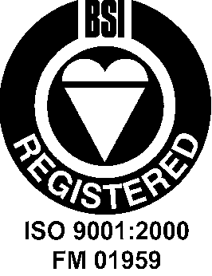 | CONTROL VALVE  SPECIFICATION SHEET
 |  | Gloucester, GL1 5RE. United Kingdom |  |  |  |  | Output on |  |  | Version
 |  | Tel: 44 (0)1452 318900 Fax: 44 (0)1452 318901 |  |  |  |  | 02/08/2006 |  |  | 4.06SN
CUSTOMER |  |  | M W Kellogg Ltd |  |  | QUOTATION NUMBER |  | 14722
ENQUIRY REFERENCE |  |  | EM105 |  |  | ORDER / ITEM NUMBER |  | 883474 |  | 3
ORDER NUMBER |  |  | PMI 05 |  |  | OEM
TAG NUMBER(S) |  |  | FV-174-0440A Re-Trim |  |  | SOLUTION TYPE
APPLICATION |  |  |  |  |  | OEM SERIAL NUMBER |  | 83474-03-01
SITE / PROJECT |  |  | AQ | DRAGON LNG IMPORT TR.
1 | PROCESS DATA | Fluid | Natural Gas |  | Liquid | Shut-Off Pressure |  | 148.9 | bar
 | PROCESS DATA |  | Units | Full Open Flow | 90% Open Est | Min Flow | Case 4 | Case 5 | Case 6
2 | PROCESS DATA | Flow Rate | kg/hr | 190000 | 170000 | 50000
3 | PROCESS DATA | Inlet Pressure | bar(a) | 99 | 99 | 116
4 | PROCESS DATA | Outlet Pressure | bar(a) | 95 | 95 | 45
5 | PROCESS DATA | Inlet Temperature | °C | -151 | -151 | -140
6 | PROCESS DATA | SP. GRAVITY |  | 0.42 | 0.42 | 0.42
7 | PROCESS DATA | VAPOUR PRESSURE |  | 9.00 | 9.00 | 9.00
8 | PROCESS DATA | Critical Pressure | bar(a) | 44 | 44 | 44
9 | PROCESS DATA | VISCOSITY | CP | 0.150 | 0.150 | 0.150
10 | PROCESS DATA | Two Phase Vap. MW
11 | PROCESS DATA | Two Phase Mix In / Out | % | / | / | /
12 | PROCESS DATA | Calculated | Cv | 170.00 | 153.00 | 1.33
13 | PROCESS DATA | Stem Travel | % | 100 | 90 | 15
14 | PROCESS DATA | SPL at 1 Metre | dBA | <75 | <75 | <75
15 | PROCESS DATA | Inlet Velocity | ft/sec | 14.5 | 11.7 | 1.0
16 | PROCESS DATA | Outlet Velocity |  | 14.5 | 11.7 | 1.0
17 | PROCESS DATA
Inlet Pipe Size & Sch | ins | 8 0.594" Th. | Actuator Type | Pneumatic Cylinder |  |  | ACTUATOR | 47
Outlet Pipe Size & Sch | ins | 8 0.594" Th. | Actuator OEM / Model | P2CN |  |  | ACTUATOR | 48
Insulation | ins | 0 | Size / Spring | C | STD/2 |  | ACTUATOR | 49
Design Pressure | bar(g) | 148.9 | Travel ins / Fail Action | 5 | Modulating AFC |  | ACTUATOR | 50
Design Temp. Min/Max | °C | -168/80 | Air Supply / Setting | 6 | 6 | bar(g) | ACTUATOR | 51
Valve Model No. | 5494 |  | Act. Orientation | Vertical |  |  | ACTUATOR | 52
Size In / Out | 8 |  | Handwheel | None |  |  | ACTUATOR | 53
Body Style | Globe |  | Travel Stops | None |  |  | ACTUATOR | 54
Body Material | 316 SS ASTM A351 CF8M |  | Tubing / Fittings | Metric St St |  | A-LOK SS | ACTUATOR | 55
Valve Rating | ANSI 900 |  | Open / Close / Trip Time | 0 | 0 | 0 | ACTUATOR | 56
End Connections | Butt Weld |  | Positioner Manf / Type | Linear PS2 HART Exia |  |  | ACCESSORIES | 57
End Finish / Prep. | ANSI B16.25 Fig. 2a |  | Input Signal | 4-20 mA |  |  | ACCESSORIES | 58
Bonnet Type | Cryogenic |  | Signal Action | Increase to open |  |  | ACCESSORIES | 59
Bonnet Material | 3 |  | Airset Manf / Model | 1/4" NPT Bellofram 50 |  |  | ACCESSORIES | 60
  F316 + TP316 / 316L
Bellows Material | None |  | L. Switch/P. Trans Type | None |  |  | ACCESSORIES | 61
 |  |  | L. Switch/P. Trans Pos'n | N/A |  |  | ACCESSORIES | 62
Body / Bonnet Bolting | A320 Gr.B8 Cl2/A194 Gr8MA |  | Q EV Boosters | None |  |  | ACCESSORIES | 63
Gasket Material | Spiral Wound SS/Graph. |  | Pilot Valves | None |  |  | ACCESSORIES | 64
Gland Packing | PTFE Chevrons |  | Airlock Valve | None |  |  | ACCESSORIES | 65
 |  |  | IP Conv'tr Manf/Model | None |  |  | ACCESSORIES | 66
 |  |  | 2 | Maxseal type ICO4 24v 8w EExd St.St |  |  | ACCESSORIES | 67
  Solenoid Model
Seat Size ins / Type | 3.88 | 3CC | Energise To | N/A |  |  | ACCESSORIES | 68
Cv / Characteristic | 170 | TrI-Linear | Volume Tank/Accessories | None |  |  | ACCESSORIES | 69
Balancing | PTFE Seal |  | Elec. Certification | Class 1 Zone 2, Gas Group IIA T3 |  |  | MISC | 70
Flow Direction | Over |  | PED Level | 97/23/ECC |  |  | MISC | 71
Trim Material | 316 SS / Stellite SA |  | Cleaning | Standard |  |  | MISC | 72
Seat Leakage | ANSI Class IV |  | Special Paint Spec | See QA Plan QP883474 |  |  | MISC | 73
 |  |  | Valve (RAL 7036) Grey | WMWK28-170-000-PI-SP-037 Sys 6. |  |  | MISC | 74
Baffles | No | None | Actuator (Blue) | 8827-05-005 Issue 883474 |  |  | MISC | 75

Figure 19: Trim Calculations. (Appendix 13)

Figure 20: Trim Calculations input. (Appendix 14)

Figure 21: Trim Calculations Old CV input. (Appendix 15)

Figure 22: Trim calculations CV Input dropped. (Appendix 16)

Figure 23: Trim Calculation Final Result. (Appendix 17)

Figure 24: Current Trim Characteristics (Appendix 18)

Figure 25: New trim Characteristics (Appendix 19)

Figure 26: New trim Design. (Appendix 20)

Figure 27: Fitting the New Trim. (Appendix 21)

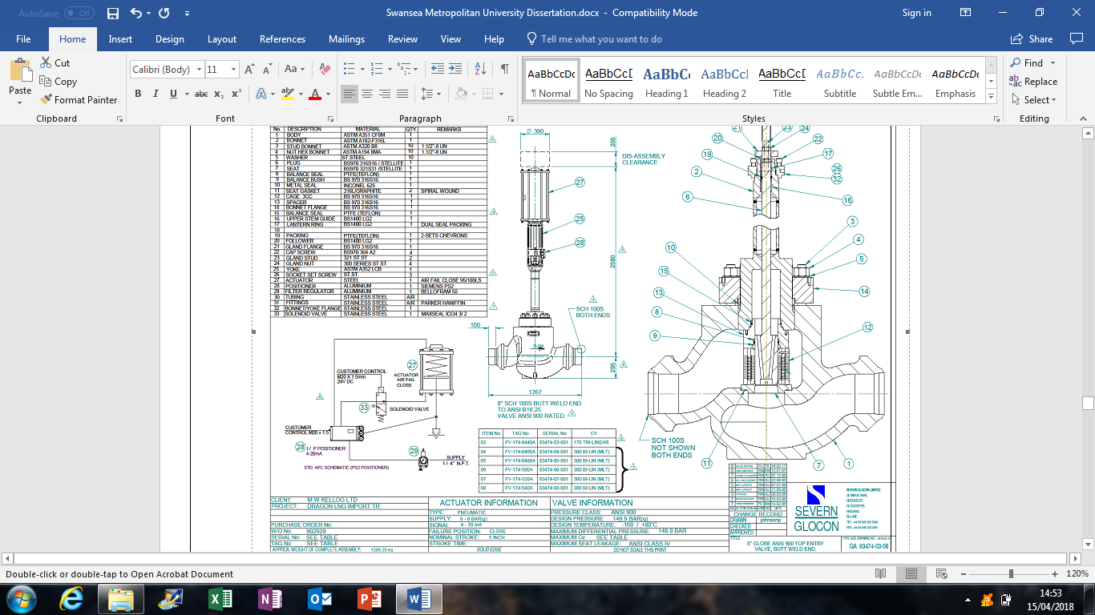
Figure 28: New Design Specifications. (Appendix 22)
Figure 29: Company Plan (Appendix 23)

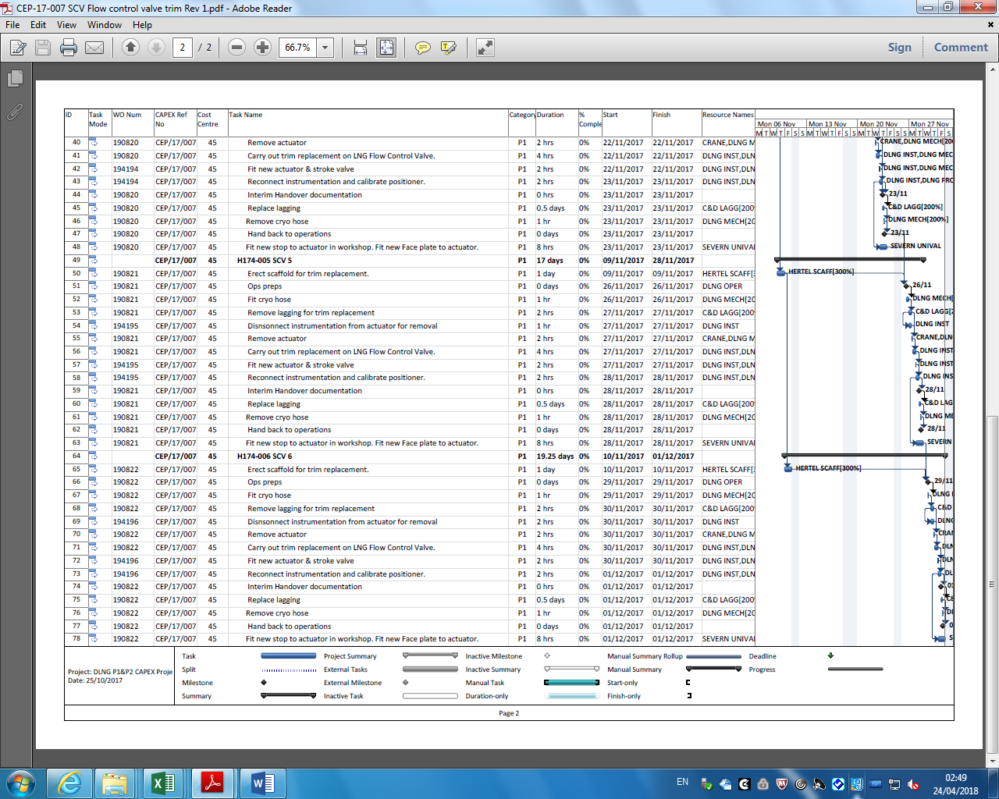

Figure 30: Scaffolding Erected. (Appendix 24)

Figure 31: Isolations. (Appendix 25)

Figure 32: Discharge Isolation. (Appendix 26)

Figure 33: Actuator removed and Stem Exposed. (Appendix 27)

Figure 34:Stem Removed. (Appendix 28)

Figure 35: Trim Exposed. (Appendix 29)

Figure 36: Pipe Inspection. (Appendix 30)

Figure 37: New trim and Gaskets. (Appendix 31)

Figure 38: Installing Stem. (Appendix 32)

Figure 39: New Actuator. (Appendix 33)

Figure 40: New Control Valve . (Appendix 34)

Figure 41: Tuning the new Actuator. (Appendix 35)

Figure 43: Tuned Control Valve. (Appendix 36)

Figure 44: Trim Charecteristics Compariosn. (Appendix 37)

Figure 45: SCV 1 Tuned Trim. (Appendix 38)

Figure 46:SCV 2 Send out Period Trend. (Appendix 39)

Figure 47:SCV 3 Send out Period Trend. (Appendix 40)

Figure 48: Comparison Results. (Appendix 41)

Figure 49: Implementation Cost. (Appendix 42)

TPG 4140
CALCULATIONS IN NATURAL GAS COURSE
Prof. J.S. Gudmundsson
September 2012

Molecular Weight

M can be found from the gas composition, using an Excel sheet. An example is shown below (gas composition from GPA 1998).

Components | Molecular weight | Mole fraction
 | g/mole | yi
Methan, CH4 | 16,042 | 0,8319
Ethan, C2H6 | 30,07 | 0,0848
Propan, C3H8 | 44,10 | 0,0437
i-Butane, C4H10 | 58,12 | 0,0076
n-Butane, C4H10 | 58,12 | 0,0168
i-Pentane C5H12 | 72,15 | 0,0057
n-Pentane C5H12 | 72,15 | 0,0032
Hexane C6H14 | 86,18 | 0,0063
Heptane C7H16 | 100,21 | 0
Hydogen, H2 | 2,02 | 0
Nitrogen, N2 | 28,01 | 0
Oxygen, O2 | 32,00 | 0
Carbon dioxid, CO2 | 44,01 | 0
Hydrogensulfid, H2S | 34,08 | 0
Dihydrogenoksid, H2O | 18,02 | 5
 | Σ Mole fraction | 1,0000
Total molecular weight gas | 20,43 | g/mole

M = 20.43 g/mol = 20.43 kg/kmol

Specific Gravity

Definition of specific gravity, ratio of the molecular weight of natural gas to that of common air (without water vapour). M taken from above.

M_{gas} = γ 28.97 [kg/kmol]

γ = 0.705

The subscript gas is not necessarily used.

The specific gravity was also calculated in the Excel sheet, rounded up to γ = 0.71

Reduced Pressure and Temperature

Reduced pressure and temperature are also called pseudocritical pressure and temperature, expressed as

where the subscript c stands for critical.

Key’s Rule is used to obtain the critical pressure and temperature for natural gas mixtures

The critical pressure and temperature for individual natural gas components are available in handbooks and tables. The symbol y_{i} stands for mole fraction.

For the natural gas composition taken from GPA (1998) critical pressure and temperature were estimated to be 4.57 MPa and 218 K.

Based on the Excel sheet, the corresponding numbers are 4.6 MPa and 218 K.

Critical pressure and temperature can also be obtained from semi-empirical equations based on specific gravity, for example from Rojey & Jaffret (1997)

[MPa]

[K]

Such equations tend to be based on natural gas found in certain oil and gas provinces.

There is an error in the critical temperature equation in Rojey & Jaffret (1997). There should be a plus in the equation, as shown above.

Using a specific gravity of 0.705 the critical pressure and temperature are estimated 4.606 MPa and 215 K. These are reasonably close to the above values.

Compressibility Factor

Assuming a pressure of 80 bara and temperature of 30 C the z-factor can be estimated from the figure below (commonly called the Standing-Katz diagram)

The reduced pressure is

and the reduced temperature

Read from diagram z = 0.79

The reduced pressure and temperature from the Excel sheet are 1.75 and 1.39. That is, exactly the same.

The Hall-Yarborough method in the Excel spreadsheet is considered one of the more accurate semi-empirical equations for z-factor.

Read from spreadsheet z = 0.7831

Gas Density

Need molecular weight, z-factor and the local temperature and pressure.

Using the values obtained above, the density of the gas at 80 bara and 30 C can be calculated as

kg/m³

The same result is obtained from the Excel spreadsheet, which also gives the viscosity as 0.0139 mPa.s

Friction Factor and Reynolds Number

The friction factor in commercial pipes can be calculated from the Haaland equation

where n = 3 for natural gas pipelines ( n = 1 for liquid flow). The Reynolds number is give by

and the relative roughness by k/d.

Pressure Drop Horizontal Pipeline

In general, equations for pressure drop in pipelines can be used to calculate the pressure drop, the diameter and the flow capacity, depending of which of the variables are given and what result is required. Approximate calculations can be carried out for gas pipelines using the Darcy-Weisbach equation

where average gas properties are used.

For illustration purposes, assume 7 MSm³/d flowrate (10 % of Ormen Lange). Assume inlet pressure 200 bara and outlet pressure 100 bara. Assume 500 km distance. Therefore, pressure gradient (200-100)/500 km = 20 bar/100 km. Assume constant temperature of 10 C.

The simplest way to find the z-factor is to use the available Excel spreadsheet. At 200 bara and 10 C the z-factor is 0,6806. At 100 bara and 10 C the z-factor is 0.6638. The average z-factor is therefore 0.6722. From spreadsheet, average density 194 kg/m³ and average viscosity 0.0218 mPa.s.

The velocity depends on the pipeline diameter and mass flowrate. To know the mass flowrate we need the density of the gas at standard conditions, use Excel spreadsheet and assume z = 1. We note that 1 atm = 1.01325 bara. Density at s.c. 0.864 kg/m³. Therefore the mass flowrate is

kg/s

Average velocity is given by

such that

Assuming an average friction factor of 0.015 the diameter can be estimated

giving a diameter of 0.19 m and an average flow velocity of 2.4 m/s (from spreadsheet). The corresponding Reynolds number is about 40 million and a friction factor of 0.0544.

Calculating again

gives a diameter of 0.24 m and an average flow velocity of 1.9 m/s. The Reynolds number is about 40 million so the friction factor will be the same.

Therefore, a couple of iterations give a pipeline diameter of about 240 mm (about 9-1/2 inch).

A similar iteration procedure can be followed using the pressure drop in gas pipelines equation, but it is more involved and will not be illustrated her.

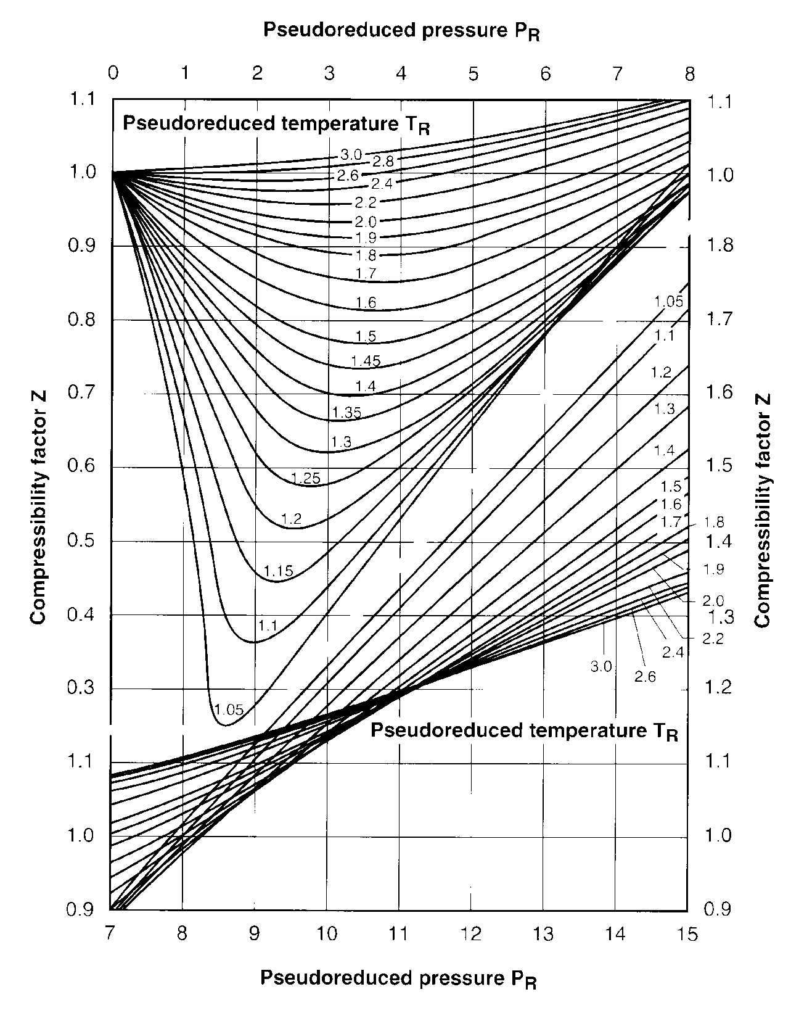

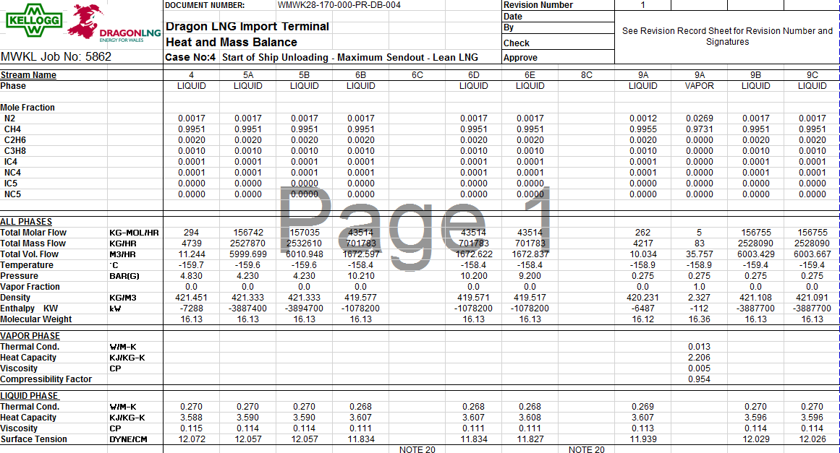
Figure 50: Data from SEVERN GLOCON LTD. (Appendix


