Reflective report Joseph Omar

The group/team-working dynamic
In the first meeting of the group project we talked about initial ideas for the line launcher and possible ways to design it, when sitting in this meeting I realised that we as a group worked together very well, we all had ideas for what we wanted this project to be like, everyone had a point to put across and I feel like no one was left out, nor did I think that someone was not being inactive during this discussion.
We worked diligently when discussing different types of power to launch the squash ball, people gave valid criticism when needed and not just said yes to every idea that we brought to the table, we asked essential questions and how each design would work and talk through each one in detail.

Time management/team organisation

Here’s where I think our team was lacking in some regards, when it came to time management we where not the best at time, some time we would leave some parts of the project to the last minute, when it came to the first test run of the project we did not have anything built yet. However, team organisation was not as bad as time management, when we organised meetings we did turn up to them we also turned up when we agreed to go in the work shop.

Communication (both face-to-face and when apart).
When we where in meeting communication was very good amongst the group we all got our points across and we all listed to each other and didn’t interrupt some mid-sentence, however there where times when we talked to each other and Microsoft teams and on messenger that there was a lack of detail in what we where saying but it was in very rare that I would pick up on this point.

The concept and technical design activities

When it comes to the concept design we went with something simple, a spring powered line launcher, we would have two springs on each side of the barrel with the spring going into hole we drilled into the bar, the bar itself would go through the barrel so we can fire the squash ball we would have a rail on the top with the trigger system with this we could pull the trigger system back along the rail screw it in place and activate the actuator to release the bar to allow the squash ball the fire. The members of our group would design each part then pull it into a 3d assembly
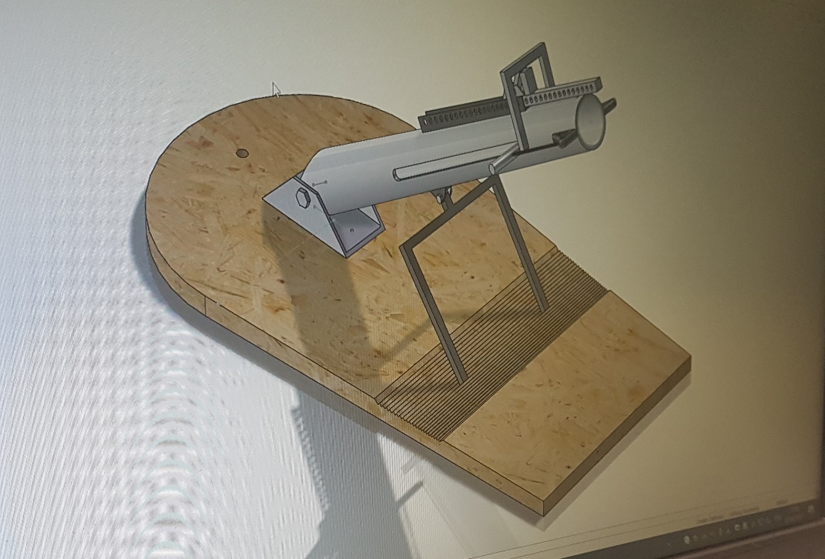

The prototyping and building phases

When it came to building what was on the 3d model we did encounter some design flaws and rectified them, we took a look at the part under the barrel and concluded it would not give that much control of the angel of witch we could fire the line launcher
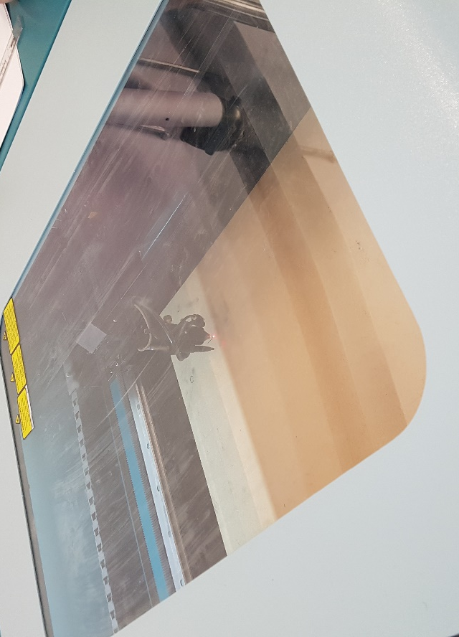
We used this material as the base for our line launcher and with it we made a better way to adjust the angle of which we would fire at
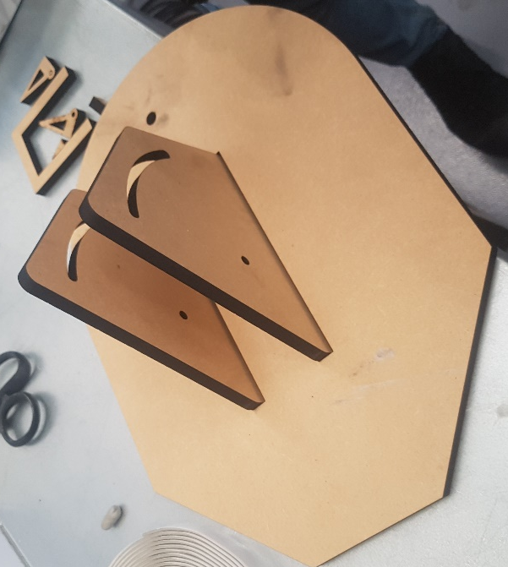
Here was our new idea for angle adjustment we would put the barrel in between the two stands drill holes in the barrel and put a screw where the holes are in the stand to keep it on place, we would then put to more holes in the barrel so we can slide the barrel up and down the circular part of the stand
.
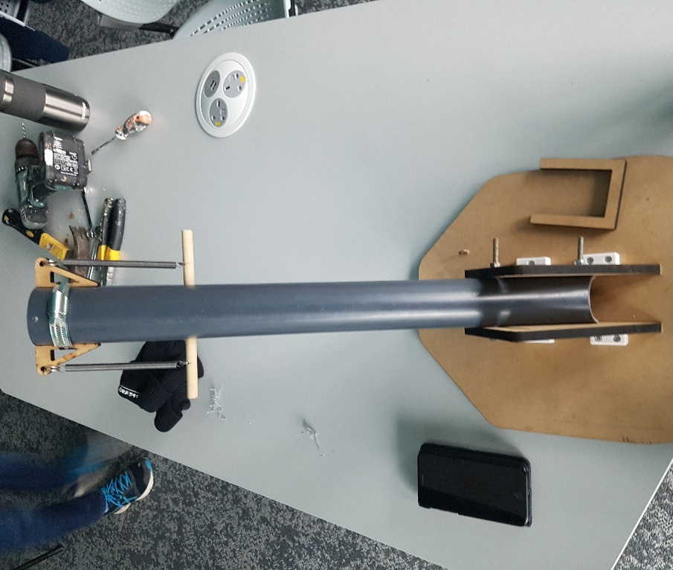
Here’s what it looked like after we placed the barrel in between the two stands.
We decided to keep the idea of the bar and the springs but then we encounter a sight problem of how to keep the mount at the top of the barrel in place, we then quickly came up with the idea of using jubilee clips of hold it in
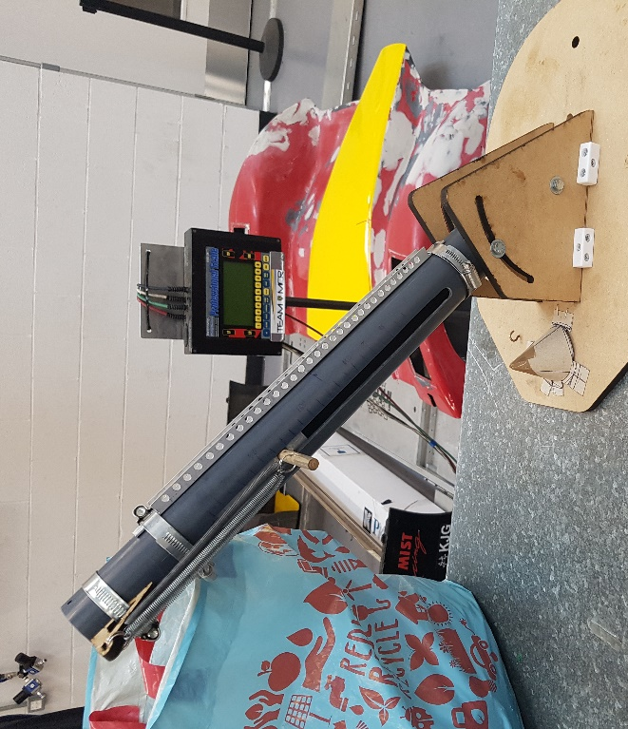
We then made the rail and put it on top of the barrel and used 2 jubilee clips for it one on the top and one on the bottom to keep it secure
Lastly, we had the actuator and the trigger system to install we had a lot of problems with this task because there was certain complications with how much power the actuator was out putting the make the trigger work unfortunately we were not able to complete this part of the line launcher

If I had to say something to myself at the beginning of the project that I know now would be.
Make sure the team is meeting up more consistently
Make sure you keep a track of due dates for the project
Finally to make sure your team have the correct measurements and Know what you are doing in the workshop before hand and not during it.

