BIM
COMPLIANCE OF BIM MATURITY

NAME OF STUDENT: SHALOM JOSEPH
STUDENT ID: 2113608
NAME OF AWARD: BSC CIVIL ENGINEERING
MODE: FULL TIME

TABLE OF CONTENTS

LETTER 1
APPENDIX 5
REFERENCES 12

Shalom Joseph
Lead Site Civil Engineer
Marg & Wills Construction
2 Leigh Hill Rd
Cobham KT11 2HS

16/01/2024

Neath Port Talbot Council
The Quays, Brunel Way
Neath SA11 2GG

Subject: BIM Maturity Compliance for Port Talbot Infant School Project

I hope this letter finds you in good health. I am writing to provide an outline of our all-encompassing approach for the Port Talbot Infant School Project, with an emphasis on our strict adherence to the Sustainable Communities for Learning Programme's Building Information Modelling (BIM) maturity requirements which the Welsh Government holds to its standards. We have a comprehensive understanding of the critical role that BIM plays throughout the entire lifecycle of a modern construction project, from initial design to long-term asset management, which informs our methodology. The BIM process encompasses all factors of a structure's lifecycle and is a rich, multidimensional informational resource, as opposed to merely a three-dimensional representation.

Our approach is consistent with the principles of the ISO 19650 series, a globally recognised standard that addresses the information management of constructed assets throughout their entire life cycle utilising BIM. This consists of ISO 19650-1 and ISO 19650-2, which, respectively, address the delivery phase of assets and the concepts and principles governing information management at a strategic level.
Fundamental to our methodology is the adoption of a Common Data Environment (CDE), in accordance with ISO 19650 recommendations. By providing a structured process for accumulating, managing, and disseminating documentation, the graphical model, and non-graphical data for the entire project team, the CDE will serve as the foundation of our information management strategy. The implementation of a CDE guarantees that all relevant parties are provided with coordinated, up-to-date, and consistent information, consequently mitigating the potential for data loss or misunderstanding. ISO 19650 1 states that the information containers required for asset management should be moved from the Project Information Management system (PIM) to the Asset Information Management (AIM) system upon the completion of the project. The remaining project information containers, including the archived ones, should be maintained as read-only files to assist in resolving disputes and permit the extraction of key insights. The Environmental Impact Report (EIR) should explicitly state the duration for which project information containers will be retained in the records.
Our BIM Execution Plan (BEP) will specify the procedures for the generation, distribution, and control of information. The plan will be customised to perfectly correspond with the RIBA Work Programme, guaranteeing the efficient integration of BIM procedures throughout every phase of the undertaking. In addition to stipulating the required technologies and software, the BEP will establish transparent protocols governing data exchange, and quality control procedures.
We shall secure Levels of Detail (LOD) and Levels of Information (LOI) that are in accordance with your demands and correspond to each stage of the RIBA. By following this systematic approach, the model is developed with the requisite level of precision and thoroughness, thereby delivering reliable and pertinent information throughout each stage. As an illustration, in the preliminary design phase, the model will comprise rudimentary spatial configurations and conceptual design components, with subsequent stages delving into comprehensive specifications of materials and systems. Please see Appendix 1.
Our objective is to enable smooth integration of the Building Information Modelling (BIM) model with a Computer-Aided Facility Management (CAFM) system in the post-construction phase so that the asset can be efficiently monitored and maintained throughout its entire lifecycle. By incorporating comprehensive asset data, this integration will facilitate the school's effective administration and management, ultimately guaranteeing its long-term viability and simplifying maintenance processes.
To ensure that our team possesses the necessary skills to attain Building Information Modelling (BIM) maturity, we will organise extensive training sessions that centre on the most recent BIM technologies and adherence to global benchmarks. By consistently pursuing new knowledge and adjusting our strategies, we guarantee that the project team will always be ahead of BIM implementation methodologies.
Throughout the duration of the project, we are dedicated to sustaining transparent channels of communication with you. Consistent reporting shall constitute an essential component of our methodology, providing updates pertaining to the implementation of Building Information Modelling (BIM), monitoring of progress, and resolution of any encountered challenges. Regular feedback sessions will be arranged to attend to any concerns that may arise and to verify that our methodology continues to correspond with your expectations and the goals of the project. Our dedication lies in providing an infant school that surpasses the benchmarks established by the Sustainable Communities for Learning Programme and is equipped with cutting-edge facilities. By employing rigorous strategizing, proficient implementation, and strict adherence to BIM maturity criteria, our objective is to guarantee the triumphant culmination of this endeavour in an environmentally conscious and productive manner.
We eagerly await further discussion of these plans and are prepared to implement any modifications suggested by you to bring them into conformity with the objectives and standards of the Neath Port Talbot County Council.
We appreciate your consideration of our approach. We are greatly enthused by the prospect of seeing this endeavour materialise.

Sincerely,
Shalom Joseph
Lead Site Civil Engineer
Marg & Wills Construction

APPENDIX
Over time, project information changes to reflect different stages of design evolution. Two areas are used for information management: graphical work in 3D model environments and non-graphical text data from manufacturers. From early massing to sketch design and technical collaboration, design frequently centres around an asset. The building asset and digital data are obtained by the clients for later usage. Understanding and agreeing on the level of information need at each design development stage is essential to minimising wasted effort and rework.
Project schedules are divided into eight phases by the RIBA Plan of Work, an industry-wide method of design development that includes Concept Design, Spatial Coordination, and Technical Design. However, managing graphical and non-graphical data as well as identifying design responsibilities are necessary for output management.
Below includes an example of a client’s level of information need through an LOD and LOI format highlighting the difference throughout the RIBA stages of a project:

- Stage 0-1: Preparation
  - LOD 100: Conceptual models with basic massing or block models.
  - LOI: Basic project data, initial requirements, and expected outcomes.

- Stage 2: Conceptual Design
  - Description
    - Visual components that express the overall ideas of the design. putting the system's configuration on show in relation to the internal and external context, along with the crucial project requirements, to satisfy the client.
    - It is expected that the ideas of materiality, scope, colour, and context will be communicated through basic descriptions. Expect intentional coordination with different professions to demonstrate general design themes.
  - Purpose
    - To enhance overall spatial coordination and provide a visual depiction of conceptual suggestions, it is imperative to establish crucial requirements such as primary system maintenance and access zones.
  - Specific to Project:
    - LOD 200 – Schematic Design
    - LOIN: General model of the school layout, preliminary material selections.
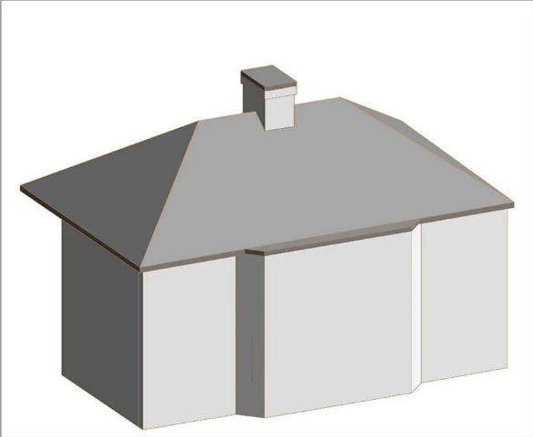
    - LOI: Early design documents, initial environmental impact assessments, and cost estimates.
Figure 1 Shows a mass model.
- Stage 3: Spatial Coordination
  - Description
    - Visual data is utilised to provide more intricate elucidations of the design's refined concepts. Enhanced communication among all professions.
    - Visual development showcasing the overall coordination of scale and the primary relationships among different architectural elements.
    - Can generate a detailed plan for a specialised manufacturer or subcontractor, enabling them to proceed with the technical design, manufacturing, and installation. It is expected that the inclusion of critical dimensional coordination, performance criteria, and finish quality would be anticipated.
  - Purpose
    - Visual representations are used in the Design Development stage to check the specifications for the Technical Design stage and improve spatial coordination.
  - Specific to Project:
    - LOD 300 – Detailed Design
    - LOIN: Detailed architectural, structural, and MEP models with accurate dimensions.
    - LOI: Detailed design documentation, specific material specifications, and environmental strategy documentation.
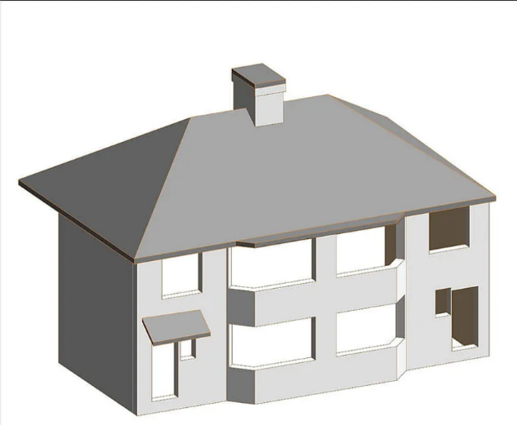
Figure 2 Shows a shell and core model.
- Stage 4: Technical Design
  - Description
    - Visual data that illustrates the established principles of the design that justify the purchase. Enhanced communication across all professions. Illustrations that depict the connections between different architectural components and the harmonisation of proportions in a comprehensive manner.
    - Graphical representation of the system that accurately depicts its dimensions and emphasises its main performance characteristics.
    - The graphic information displayed may vary depending on the specific visual requirements, such as scope of work drawings, laying out, floor loading, etc.
    - Installation aspects that are often associated with the model element and adjacent projects are prepared autonomously.
  - Purpose
    - To provide a visual representation of concepts during the technical design stage, which aids in achieving comprehensive spatial coordination.
  - Specific to Project:
    - LOIN: Fully coordinated and detailed models suitable for construction, including integration with other building systems.
    - LOI: Construction details, finalized specifications, compliance with Welsh Building Standards, and safety protocols.
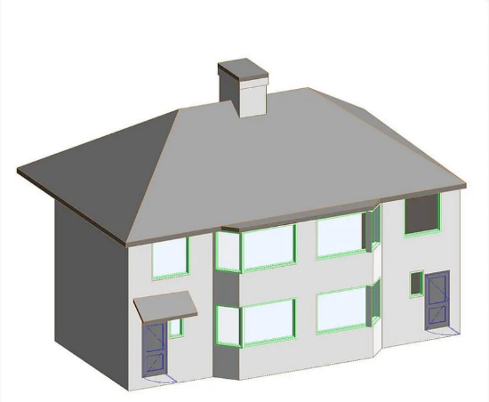
Figure 3 Shows a standard survey model.
- Stage 5: Construction
  - Description
    - Visual data providing extensive information to facilitate installation or construction. Enhanced communication across all professions.
    - Visual representations illustrating the optimal alignment of the dimensions and interactions of the construction's components.
    - An accurate visual representation of the system, emphasising its important performance characteristics and providing sufficient information for installation purposes.
    - Installation aspects that are commonly associated with the model element and surrounding projects are prepared autonomously.
  - Purpose
    - To provide sufficient information for the construction or installation of essential products.
    - to be revised using the definitive choices made during the construction phase.
  - Specific to Project:
    - LOD 400 – Fabrication & Assembly
    - LOIN: Models detailed for fabrication, installation, and assembly processes.
    - LOI: Installation guides, construction schedules, and safety checklists
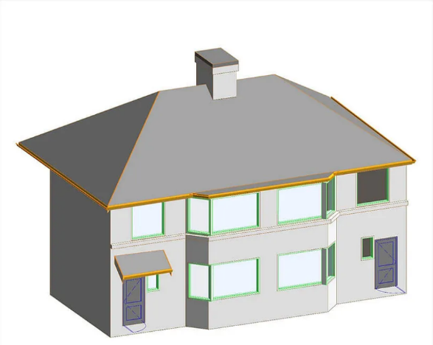
Figure 4 Shows a detailed survey model.
- Stage 6: Record
  - Description
    - Visual documentation, such as record drawings, that displays an accurate representation of the systems and goods installed in the completed asset, together with any relevant references to associated information.
    - Conducting surveys of the completed product, such as laser scanning, can provide both geometric and visual data.
  - Purpose
    - Visual data illustrating the decisions made at the conclusion, including any alterations implemented during the construction phase.
    - The purpose is to provide a future point of reference for maintenance, product replacement, and disassembly during the operational stage of the building's life cycle.
    - Any form of authentication that presents conclusive outcomes, such as findings from a survey, will be classified inside this category.
  - Specific to Project:
    - LOD 500 – As-built
    - LOIN: Final as-built model reflecting the constructed facility, incorporating all changes and deviations from the initial design.
    - LOI: Comprehensive as-built documentation, including final construction details, materials used, and any alterations from the original design.

- Stage 7: In Use
  - LOD 500: Remains relevant for facility management and potential future refurbishments.
  - LOI: Continuously updated with real-life performance data, maintenance records, and modifications or upgrades to the facility.

The levels of detail (LOD) and levels of information (LOI) are subject to modification as the project stakeholders' requirements for information intensify throughout the RIBA stages. In the early stages, the primary focus is on obtaining essential knowledge and understanding concepts. As the project progresses, it becomes crucial to have operational data and detailed requirements for facility management, construction, and handover. Adhering to the evolving levels of development (LOD) and levels of information (LOI) for the Port Talbot Infant School project will provide a comprehensive and meticulous implementation of Building Information Modelling (BIM), facilitating effective decision-making, construction management, and long-term facility operations.

REFERENCES

- BS EN ISO 19650‑1:2018. (2018). London: British Standard Institute.
- BS EN ISO 19650‑2:2018. (2018). London: British Standard Institute.

