

Managing Enterprise (BMSW4011)

Certificate in Higher Education – Skills for the Workplace

Task 1: Business plan, and reflection

Business Plan of Brewtopia

Student Name: Elena Alexandra Benghiac
Student ID: 1812479
Lecturer: Jaliya De Silva
Date of Submission: 06.03.2026
Executive Summary
In the corporate setting, innovation is quite effective for boosting the financial performance and future growth probabilities. Moreover, it led the firms to target potential consumers and boost the future growth probabilities. Aligning with this aspect, the report has considered the case study Brewtopia that is going to launch its innovative business in London, UK. The estimated budget of the firm has been addressed in the report. It has been analysed that the business is going to maintain sustainable approaches within the market and target health-conscious and plant-based food lovers within the market. The overall marketing strategies and key business objectives are addressed in this report.
Table of Contents
Part 1- Business Plan 3
Introduction 3
Main Analysis 4
Details of the company name and product 4
Rationale of the Business Idea 4
Business Type 5
Aim and mission statement of the business 5
Physical Aspects 6
Key Human Resources 6
Core marketing operations 7
Market Research processes 7
Relevant Financial Resources 9
Competitor Analysis 10
SWOT analysis 10
Conclusion 12
Part 2- Individual Reflection 13
References 16

Part 1- Business Plan

Introduction
Business innovation is effective for targeting potential consumers and enhancing the future growth probabilities (Awwad, 2024). The report includes a business plan with its aim, USP and marketing process. It also addresses the financial projections and key financial resources that may help it to ensure market success.

Main Analysis

Details of the company name and product
Brewtopia is planning to launch a cafe based on sustainable initiatives through reusable cups, compostable packaging and a partnership with local charities. The company is going to operate from The Green Park, London, UK and adhere to the UNSDG Goal of 7, and 12 and 13 to promote sustainable initiatives within the community (Sdgs, 2026). In short, the cafe is going to include a lifestyle brand appealing to Gen Z and millennial who are eco-conscious and healthy food lovers. The company is going to boost its brand presence through the tagline of Coffee without compromise – sustainable, ethical, and unforgettable. It also includes preparing coffee from the beans that are imported from sustainable farms.
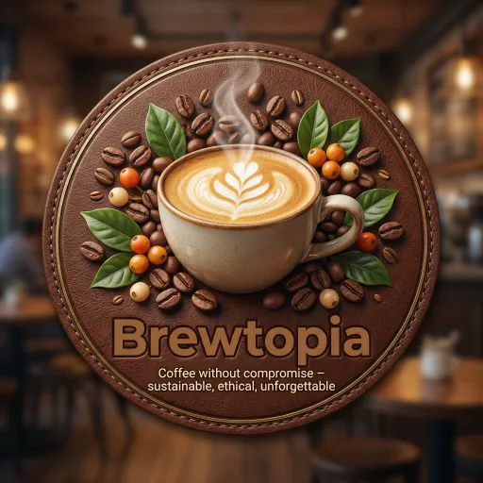
Figure 1: Brand Logo of Brewtopia
(Source: Self-developed)

Rationale of the Business Idea
During my academic journey, I became aware of the cafe concept through some industry experts that has helped me to gather insight regarding the terms and conditions. Moreover, currently, most of the F&B lovers prefer sustainable beverages and foods that are cost-effective and healthy (Francis et al. 2024). Hence, I have decided to come out with the plan of a sustainable cafe.
Since I have expertise and knowledge on cafe businesses and associated terms and conditions, I am highly confident enough to ensure the stability and brand image of the business. Being interested in cafe businesses and determining the sustainable beverage needs of the communities, I am quite passionate about launching my own business and targeting potential consumers.

Business Type
The addressed business is going to operate as a sole trader in London, UK and target the health-conscious food lovers within the market.
Pros- Plata Jr and Pascual (2022) addressed that, sole traders are quite effective for its instant, low-cost setup, direct retention and exclusive operational control. Hence, it can be suitable for maintaining the product price affordable and maximising customer engagement.
Cons- It has multiple drawbacks, including business continuity concerns, unlimited liability, and issues in capital raising and so on (Jones and Talbott, 2022). It may cause issues for the venture in maintaining operational efficiency.

Aim and mission statement of the business
Mission statement- The core mission of the addressed business is to be an ethical and sustainable F&B venture all over the UK through its cost-effective and quality-based products. In this aspect, going to include ethical sourcing, zero-waste operational activities to promote an eco-friendly business model within the market.
Aim- The aim of the business is to include community hubs and Instagrammable environments to promote sustainable awareness and photogenic drinks offerings that are going to be designed for social sharing.
SMART Objectives
Objective 1- To hire 4 marketing experts to design attractive and engaging content to target potential consumers within the next 2 months
Objective 2- To invest 5% of the net revenue in technological tools like Crayon, AlphaSense, and Similarweb to analyse the customer trends and maximise the customer loyalty within the next 5 months
Objective 3- To maintain at least 5 social media posts of the products and services every week to raise customer awareness within 8 months
Objective 4- To boost the customer engagement rate by 20% by providing exclusive F&B services in the next 12 months
USP- The core USP of the business includes a community hub for raising sustainable awareness, zero-waste operational activities, an Instagrammable aesthetic and ethical sourcing.

Physical Aspects
Location- The Green Park, London, UK.
Rationale- Since London is considered the international attraction of coffee, and consumers highly prefer sustainable and eco-friendly food materials, London is going to be an ideal market for enhancing the financial stability and overall brand image within the market (Shams et al. 2025).
Map
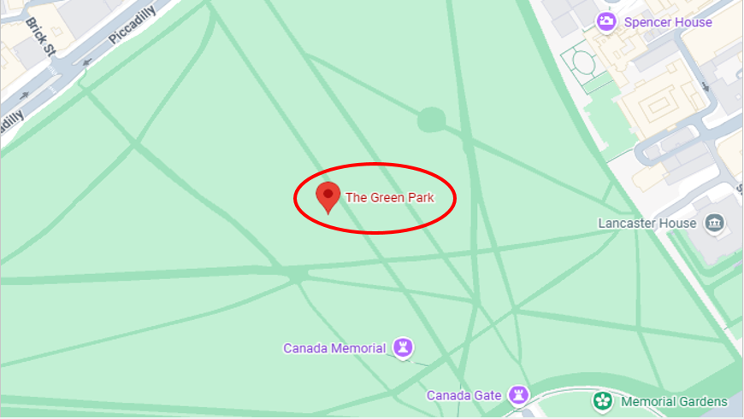
Figure 2: Location of the Proposed Business
(Source: Google, 2026)

Key Human Resources
Human resources is quite effective for a business to enhance productivity, maintain exclusive services, and enhance customer loyalty (Agustian et al. 2023). Aligning with this aspect, the considered entity is going to hire 15 employees at the initial stage, including 4 marketing experts. Additionally, the firm is going to operate through a functional organisational structure. The HR department is planning to hire expert staff through online job advertising on LinkedIn, Monster, and Indeed.
The entity is going to hire employees for the sales, marketing, HR and finance departments.
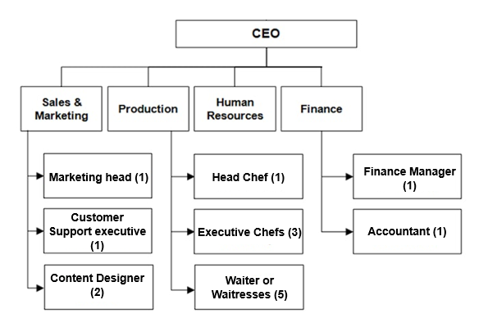
Figure 3: Estimated Organisational Structure of Brewtopia
(Source: Self-developed)

Core marketing operations
As opined by Jusuf (2024), marketing strategies are the most vital practices of businesses that help in increasing product awareness and targeting potential consumers within the market. In this aspect, the proposed entity is planning to follow Facebook posts, branding of the products and business cards. It can be effective for enhancing the awareness of the products and services within the market and enhancing the financial performance (Lestari, 2023). Additionally, the entity is planning to conduct multiple offline marketing campaigns through association with some event partners like Good Look Events, TMB Events, MGN Events, and so on.

Market Research processes
Primary
In terms of gathering the key information regarding the customer needs and overall market trends, the following section is going to consider the marketing managers from Costa Coffee and Starbucks.
Q1. What are the most common operational issues a cafe owner may face during operational activities in the initial stage?
Costa Coffee Marketing Manager- As per my views, most of the cafes faced issues due to the staff turnover, poor skills of the workforce and cash flow issues.
Starbucks Marketing Manager- Operational consistency, cost and inventory management are some of the common issues a cafe may face at the initial stage of its operational activities.
Q2. In which season is the customer demand for F&B services remaining at its peak?
Costa Coffee Marketing Manager- I feel that the year ending, especially December and January are the peak season of F&B demand in the UK.
Starbucks Marketing Manager- According to my experience, cafes faced extreme pressure and demand for services during the summer season.
Q3. Mention some strategies that help you to motivate your employees and coordinate among the departments to provide exclusive services?
Costa Coffee Marketing Manager- Our company highly focuses on employee perks and benefits to motivate employees and guide them to meet the company's needs and deliver exclusive consumer services.
Starbucks Marketing Manager- We are highly committed to maintaining the staff awards and recognition, such as performance-based promotion, incentives, training and learning processes, that help the workers to feel valued.
Secondary
Current Trends of Cafe Businesses in the UK
Considering the cafe industry in the UK, most of the food lovers are preferring plant-based alternatives and experience-led venues. It led the industry to estimate a value of 6.7 billion GBP by the end of 2026. Most of the consumers prefer to order F&B products online, including social media pages and company websites. It helps the firms to enhance the product and service awareness within the market. The report of the UK Cafe industry has addressed that the overall market share of the industry is 42.10% as per 2025 (Mordor Intelligence, 2026).
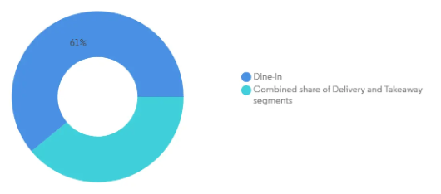
Figure 4: Overview of the Cafe Industry in the UK
(Source: Mordor Intelligence, 2026)
Associated issues with the Cafe Services in the UK
The cafe owners in the UK are facing issues regarding the skill shortage of employees and diverse changes in customer preferences and behaviour. Additionally, the remote working process is also impacting the future growth probabilities of the companies that are affecting the overall brand image of the entities. As per the report of the industry, more than 100,000 vacancies were available in the cafes as of 2024 (Employment Hero, 2025). It indicates the poor labour conditions of the ventures.
Effective Strategies to Mitigate the Issues
Expert hiring- The businesses must focus on hiring expert marketing staff to maintain the service quality and target potential consumers. It may improve the sales rate and ensure a competitive edge within the market.
Technological Innovation- The businesses can prioritise technological implementation to promote efficiency and accuracy in the service process. It may help the business to boost collaboration and maintain an effective hiring process through ATS-friendly technology.
Rationale- In collecting the primary data from the marketing experts of Starbucks and Costa Coffee, the ongoing issues and customer needs are determined. It may help the proposed business to set strategies as per the data and ensure future growth probabilities (Susanti, 2025).

Relevant Financial Resources
Cost of the business- Initially, the business is going to start its operational activities with 42,000 GBP.
Resources- The business is going to launch its operational activities based on bank loans and personal capital.
Feasibility- Since this bootstrapping approach ensures maximum control, it is highly feasible for starting the business in London, UK.
12 Month Cash Flow Estimation
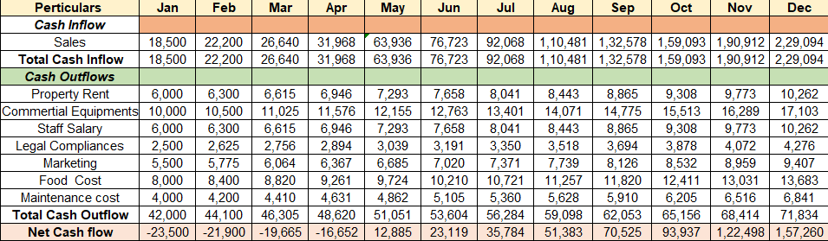
Figure 5: Estimated Budget Plan of the Proposed Business
(Source: Self-developed)

Competitor Analysis
Competitors | Business Model | Pricing Strategy
Costa Coffee | Freemium + Direct to consumer or DTC approach (Costa, 2026) | Competitive pricing strategy
Starbucks | Freemium + Subscription model | Value-based pricing strategy
Origin Coffee | DTC + Subscription-based model | Premium Pricing strategy
Key Lessons- As per the competitor analysis, it has been analysed that most of the cafes are following a DTC and premium-based model to target potential buyers and enhance their financial stability. In this context, the proposed entity must focus on the penetration pricing strategy to target budget-conscious and healthy F&B buyers (Almestarihi et al. 2024).

SWOT analysis
Strengths | Weaknesses
- Diversified product portfolio  - Preferable location that is famous as an international hotspot for coffee | - Lack of supply channel  - Poor market experience
Opportunities | Threats
- Cost-effective and sustainable product range  - Strong financial back-up | - Immense market competition  - Supply chain issues and diverse consumer preferences
Analysis
Concerning the diversified portfolio and the potentials like the financial back-up, the venture can deal with market volatility in its initial stage.

Conclusion
Business innovation helps a firm to promote diversification and adopt innovation in its operational activities. The report has outlined a business innovation of Brewtopia that is going to offer sustainable products in F&B services, along with focusing on community development. The financial projections and marketing strategies of the ventures have been addressed in this report.

Part 2- Individual Reflection
At the initial stage of attending the lecture series, I have analysed multiple aspects of the F&B industry along with the ongoing market trends. In this aspect, I got familiar with the terms and conditions of the cafes along with the legislative aspects. In this aspect, I have gained the knowledge of strategic planning, communication abilities, problem-solving capabilities and risk management. Based on my communication skills, I have maintained transparency and coordination with my batch-mates and mentors. Communication skills are quite effective for individuals in maintaining collaboration with others and improving the overall quality of the work process. As a result, I have learned new concepts and skills that have helped me to ensure my future career as a business entrepreneur. My decision-making capabilities are also vital for analysing the situations based on the lectures that have helped to fetch an overview of the current F&B industry in the UK.
I have also been able to determine the level of an entrepreneur and the way they handle dynamic market conditions to make innovative changes. During the financial evaluation for the creative business venture, I have also analysed that critical thinking and decision-making skills are mandatory for personnel to master the dynamic business conditions of the UK. In this context, one of the most noteworthy skills that I have been able to fortify during the lessons includes critical thinking skills, analytical reasoning and financial management skills. This can also be beneficial for my future career goals and anticipated skill development plans for me. Financial analysis and allocation of monetary resources are essential for budget estimation and ensuring future success rate. Hence, I can state that it may help me in boosting my career growth and ensuring success in the desired job role in the corporate industry.
On the other hand, I have determined that my time management and data analysis skills are causing issues for me in maintaining the innovative and diverse concepts of ensuring the success rate of the ventures. Time management skill is quite effective for a person in maintaining the work process in a structured and effective manner and maintaining an organised pattern within the work. Aligning with this factor, I can state that it may hamper my entire work process, along with maintaining the entrepreneurial role in my future.
In conducting the lecture series, I have analysed the budget estimation that is associated with the risks associated with the business process. In this aspect, I must focus on my time management skills and improve my entire workflow process for maintaining an informative and structured manner. In this aspect, I can segment the tasks into some smaller segments and trace the average time of completing each task. It may help the structured pattern of the work process and ensure the future growth probabilities. Furthermore, I must focus on my data analysis skills that may help boost the accuracy of the work. In this aspect, I must focus on the YouTube tutorials and podcasts that may help to boost my data analysis capabilities in the future.
Declaration
I confirm that I have not presented any AI generated text as my own work. I confirm I have copies of my drafts, notes, and other resources I used before, and after the use of AI tools which I may be asked to provide in evidence.

References
Agustian, K., Pohan, A., Zen, A., Wiwin, W. and Malik, A.J. (2023) ‘Human resource management strategies in achieving competitive advantage in business administration’, Journal of Contemporary Administration and Management (ADMAN), 1(2), pp. 108-117. Available at: https://journal.literasisainsnusantara.com/index.php/adman/article/view/53
Almestarihi, R., Ahmad, A.Y., Frangieh, R.H., Abualsondos, I.A., Nser, K.K. and Ziani, A. (2024) Measuring the ROI of paid advertising campaigns in digital marketing and its effect on business profitability. Available at: https://www.researchgate.net/profile/Ibrahim-Abu-Alsondos/publication/377573548_Measuring_the_ROI_of_paid_advertising_campaigns_in_digital_marketing_and_its_effect_on_business_profitability/links/65b4ef8779007454973c077d/Measuring-the-ROI-of-paid-advertising-campaigns-in-digital-marketing-and-its-effect-on-business-profitability.pdf
Awwad, B. (2024) The AI revolution: Driving business innovation and research, Vol. 388, Springer. Available at: https://link.springer.com/book/10.1007/978-3-031-54383-8
Costa (2026) Matcha for every corner of the UK. Available at: https://www.costa.co.uk/ [Accessed on: March 1, 2026]
Employment Hero (2025) Hospitality Takes a Hit on Jobs – but Modest Hiring Growth Could Signal a Shift. Available at: https://employmenthero.com/uk/news/hospitality-sector-faces-labour-crisis/#:~:text=Staffing%20shortages%20have%20hit%20venues,2.7%25%20across%20total%20UK%20employment. [Accessed on: March 2, 2026]
Francis, D.V., Dahiya, D., Gokhale, T. and Nigam, P.S. (2024) ‘Sustainable packaging materials for fermented probiotic dairy or non-dairy food and beverage products: challenges and innovations’, AIMS microbiology, 10(2), pp. 320. Available at: https://pmc.ncbi.nlm.nih.gov/articles/PMC11194616/
Google (2026) The Green Park. Available at: https://www.google.com/maps/place/The+Green+Park/@51.5045693,-0.1459873,17z/data=!4m6!3m5!1s0x4876052881ff2bd9:0xdb5ab148cad5f1a3!8m2!3d51.5039416!4d-0.1434016!16zL20vMDFoYzR0?entry=ttu&g_ep=EgoyMDI2MDIyNS4wIKXMDSoASAFQAw%3D%3D [Accessed on: March 1, 2026]
Jones, S.H. and Talbott, S. (2022) ‘Sole traders? The role of the extended family in eighteenth-century atlantic business networks’, Enterprise & Society, 23(4), pp. 1092-1121. Available at: https://www.cambridge.org/core/journals/enterprise-and-society/article/abs/sole-traders-the-role-of-the-extended-family-in-eighteenthcentury-atlantic-business-networks/8D5DB051D7B4250C2F47F9A4282E2B55
Jusuf, D.I. (2024) ‘Integrated Marketing: A Powerful Strategy for Increasing Brand Awareness’, Best Journal of Administration and Management, 2(3), pp. 104-109. Available at: https://internationalpublisher.id/journal/index.php/Bejam/article/view/149
Lestari, V. (2023) ‘Strategic approaches to marketing management in contemporary business environments’, Advances: Jurnal Ekonomi & Bisnis, 1(5), pp. 255-268. Available at: http://advancesinresearch.id/index.php/AJEB/article/view/210
Mordor Intelligence (2026) United Kingdom Cafes And Bars Market Size & Share Analysis - Growth Trends and Forecast (2026 - 2031). Available at: https://www.mordorintelligence.com/industry-reports/united-kingdom-cafes-&-bars-market [Accessed on: March 1, 2026]
Plata Jr, R.B. and Pascual, E.A. (2022) ‘Relationship between the Taxpaying Benefits Satisfaction and the Business Performance of Sole Proprietors in Nagcarlan Central Business District’, The International Journal of Business & Management, 95(1), pp. 14-14. Available at: https://d1wqtxts1xzle7.cloudfront.net/126027978/100951220222873-libre.pdf?1767438347=&response-content-disposition=inline%3B+filename%3DRELATIONSHIP_BETWEEN_THE_TAXPAYING_BENEF.pdf&Expires=1772450464&Signature=
Sdgs (2026) The 17 Goals. Available at: https://sdgs.un.org/goals [Accessed on: March 2, 2026]
Shams, S.R., Brown, D.M. and Hardcastle, K. (2025) Sustainable Marketing: Strategic Marketing for People, Planet and Profit, Springer Nature. Available at: https://books.google.co.in/books?hl=en&lr=&id=VnFREQAAQBAJ&oi=fnd&pg=PR6&dq=Since+London+is+considered+the+international+attraction+of+coffee,+and+consumers+highly+prefer+sustainable+and+eco-friendly+food+materials,+London+is+going+to+be+an+ideal+market+for+enhancing+the+financial+stability+and+overall+brand+image+within+the+market&ots=pd4XTBL1H6&sig=as0b0ECe7JEjKcIzr7zFAr4nunE&redir_esc=y#v=onepage&q&f=false
Susanti, L. (2025) ‘Product Marketing Strategy Using Digital Marketing Technology’, Journal of Social Science and Business Studies, 3(1), pp. 386-391. Available at: https://gemapublisher.com/index.php/jssbs/article/view/128

