

Module: International Meetings Management for the Hotel industry
Module Code : BMIH6007
Title: Event Strategic Planning and Delivery Considerations for a Winter International Meeting Report
Student name: Monica Clementina Radu
Student number: 2209717
Lecturer’s name: Kathryn Flynn
Word Counted: 2749

Table of content

- Introduction......................................................................................................3
- The event cycle................................................................................................4
- Event concept...................................................................................................5
- Aims and objectives of the event......................................................................7
- Event management...........................................................................................8
- Event budget.....................................................................................................9
- Industrial trends, issues and impacts..............................................................10
- Situational and cultural considerations...........................................................12
- Conclusion......................................................................................................14
- References......................................................................................................15

Introduction
Digital adoption throughout the MICE( Meetings, incentives, conferences, and exhibitions) of the hospitality sector relates to the incorporation and application of technological devices and services to improve business procedures, and operational effectiveness, including the overall visitor experience( Allen et al. 2022). Trhe curent event is designed as a winter wonderland expo that can collaborate with the technology and hospitality industry to discaover innovative technologies like Robotics, Augumented Reality (AR), Virtual Reality (VR), gamification, app development and the Internet of Things (IoT). These technologies can elevate the guest experience across the Uk based hospitality segment ( Rahimi et al.2022). The main goal of this event is to provide innovative technologies to assist lodging facillities and dinning establishments in streamlining their businesses and providing patrons with more individualised services. This event aims to celebrate the holiday ambience while addressing issues unique to the wintertime and increase the efficiency of their-in-house operations like housekeeping, Food&Beverage oulets reducing the staff requirements or solving real-time managerial problems. This event was selected in response to the increased need in the hotel industry, particulary around the wintertime of year incuding Christmas, and technologically advanced activities. During the middle of cooler temperatures and holiday demands, winter poses obstacles for hotels and dining establishments as they work to deliver confortable interiorsand customised encounters. Experts in the business may gain knowledge concering how to use IoT, AR, as well as other innovative technologies to improve the experience of visitors and set the business apart in an increasingly competitive, environment ( Cranmer et al. 2021).
The location of the event will be the Village Hotel of Edinburgh, Scotland. The venue of the event has been chosen because it has large conference rooms with a capacity of 500 visitors and state-of -the-art system. The Village hotel rooms are equipped with advanced IT support for presentation, accommodation discounts, Wi-Fi, and a parking facillity.

The event cycle
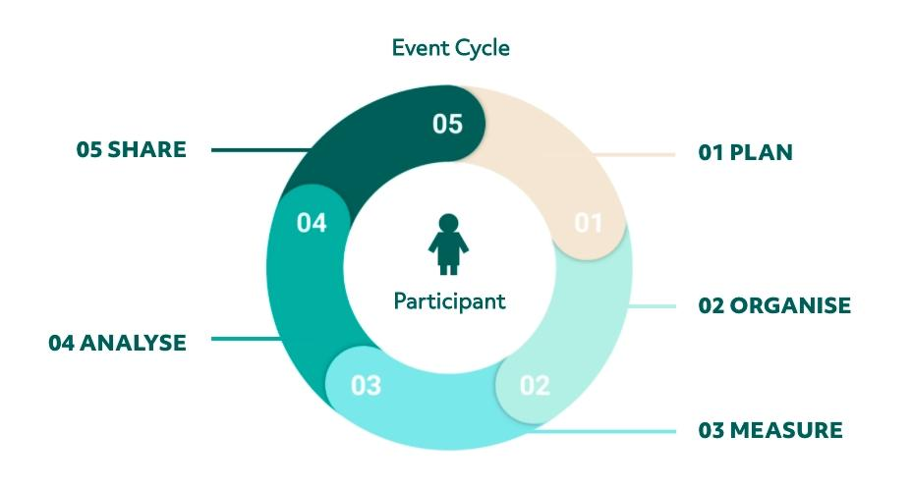
The event cycle is circular sequence in which the activities unfold by creating a seamless experience for the visitors. With its strategic paradigm, Event Cycle guarantees that every aspect of event management, from audience involvement to logistics, is carefully considered. Every stage privides a specific function and aids in methodically directing the event from its inception to its evaluation.

Figure 1: Event Cycle
( Source : LYYTI 2024)
The event cycle comprises 5 stages:
Planning: It is the initial stage where the previous key results have been analysed for setting current event goals and objectives while identifying the realistic budget and ideal participants for the venture ( Allen et al. 2022). Here, is this stage, the planning for the winter wonderland expo has been developed and the primary aims, and SMART objectives have been identified. The selection of venue at the Village Hotel, Scotland has been chosen with the group and number of the targeted audiences from the Hospitality industry and technological leaders. Budgetig, venue reservations, presenter, or technological vendor selection, and handling logistical issues like transport and hotel reservations are important factors to take into account while planning an event ( Nolan, 2020). Building alliance and obtaining sponsorship from IT and hotel companies are other tasks of the preparation stage.
Organising : In this stage, the target demographic is reached out to about the event employing a variety of media, such as internet ads, promotional emails, and social networking sites like Facebook and Instagram ( Whitfield et al. 2024). Here , organisingthe Winter-themed Expo incresing sales of tickets remain the main objectives. To draw more guests, the event will emphasise its festine holiday atmosphere and interactive technology demonstration. Marketing materials highlight partenerships with IT businesses for demos and sector expertise for promotions. Measuring: In this stage, the visitors of the event measure their perceived value from feedback with an Experience Value Score(EVS)( Berners, 2024). Here is the Village Hotel implements all the designs. Visitors can discover realistic tech locations, dynamic kiosks, or smart room management set up in the event venue. Some demos display the real-time uses of such VR or AR innovations and invite experts to discuss the way IoT and AR may improve customer service. Employees supervise logistics including supplies and transport, manage population movement, provide technological assistance, and make sure the gathering runs well. Analysing: In this post-event stage, the feedback and EVS score need to be analysed to discover the results ( Berners, 2024). Interwievs and survey responses are used to get input from supporters, suppliers, and visitors. The event’s profitability is evaluated by the selling of passes, comments from audience, and sponsor involvement. The fiscal performance is assessed in comparison to the budgeted amount, considering money from endorsement along with the sale of tickets ( Weiss, 2021). Sharing: It is the final stage where the findings and learnings from the event have been documented and shared for action points to change according to the feedback (Shaukat, 2021). The Winter Wonderland Expo and other activities of comparable scope will benefit from the usage of the information in subsequent years.
Event concept
The Winter Wonderland Expo is designed as a MICE event which is merged with the theme of the winter festival incorporating digital technologies. The concept of the event is to showcase the usage of AR, VR and IoT technologies to create personalised and immersive guest experiences during the wintertime ( Ferdinand, et al. 2021). Maslow's hierarchical model provides 5 categories which emerge with the next stages only after the satisfaction of the previous stage.
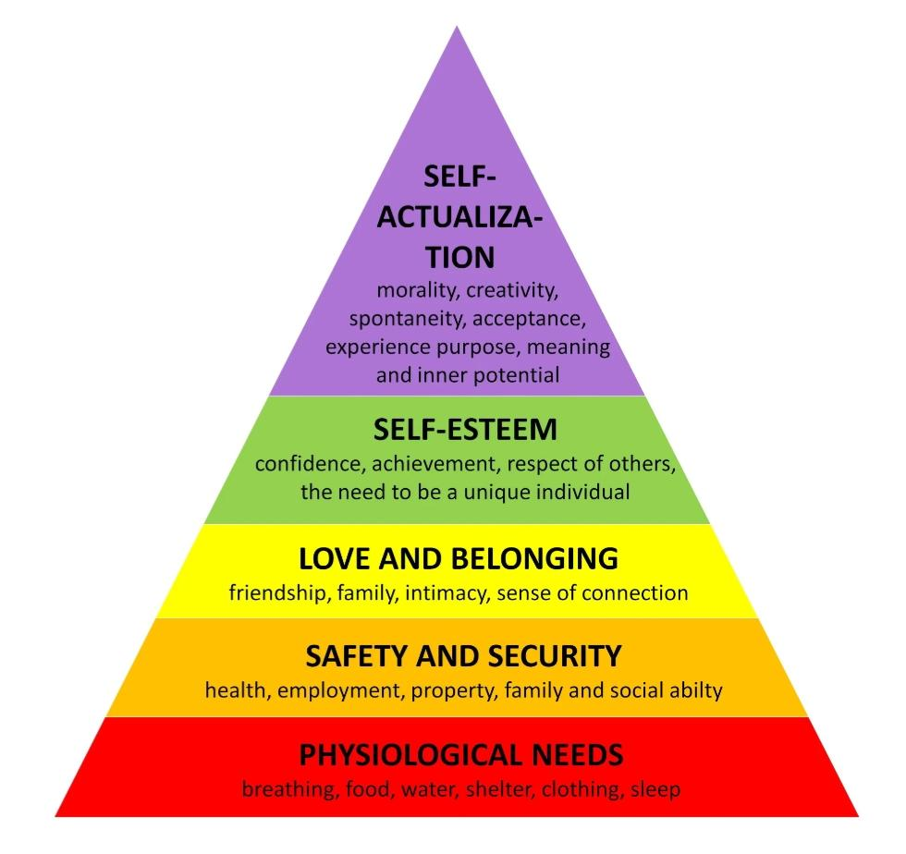
Figure 2: Maslow's hierarchical needs
( Source: Anuyah et al.2023 )

Phisiological needs: providing water and meals to both workers and visitors and venue booking. Safety needs: health and safety protocols and reduction of anxiety. Love and belongings: networking and collaboration between attendees and workers. Self-actualization: The event will use voice commands and mobile app technology to adjust hands-free check-in, temperature and lightning and the VR technique provides virtual tours for winter-themed holiday environments.

Aims and objectives of the event
Aims
This event aims to address the challenges faced by hospitality companies in catering superior experiences, esspecially during winter.

Specific | - To give hospitality companies a place to experiment with the newest technologies available.  - To give experts in hospitality as well as technology organising events a chance to interact and estalish cooperation agreements.
Measurable | - To display IoT, AR, and VR innovations that are specially made for the winter.  - To promote sustainability and effciency for a better guest experience
Attainable | - To bring together professionals in technological advances and hospitality industries to share views and optimal procedures  - To educate the visitors regarding emerging technologies
Relevant | - To find answers to issues related to visitor convenience, client engagement  - To look for client security that lodging, companies confront throught the wintertime transition
Time-bound | - Within 6/12 months

Table 1: SMART Objectives

Event management
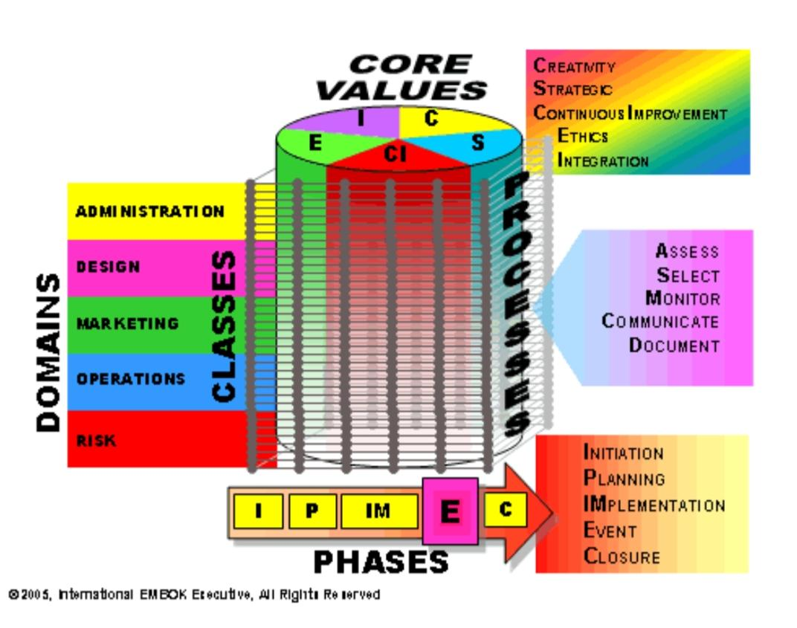
Different skills and resources are essential to manage this event, like detailed attention, strong organisational management and fiscal ability are critical for sponsors, events and partners. EMBOK model can be used to create the framework for this event management. This model provides a 3D description of the skills and knowledge required for the development of any event in terms of Domains, Processes and Phases.

Figure 3: EMBOK Model
( Source: Thomas and Stephens, 2022)

Domain: The leaders must possess problem-solving and multitasking ability to handle adaptability issues. The event will look at how lodging facilities and dining establishments may collect and use customer data while protecting confidentiality to provide customised encounters which cater to specific tastes ( Ferdinand, et al. 2021).
Phases: It involves engaging AR activities with a seasonal concept, personalised cultural activities, and specially designed room setup.
Processes: The resources like venue permits, schedules, transportation booking and logistic must be done before the event. Resources like event equipment and travel arrangements with the supply of first-aid, budget, and insurance are needed to ensureseamless delivery of services.
Event Budgets
Category | Resources | Amount
Rental venue | The Village Hotel | £40,000
Technological set-up for technology ( Io, AR and VR) | Sounding, lighting, stage, presentation space, kiosk setup | £20,00
Staffing ( Hospitality and tech support) | Caterers, event coordinators, tech support | £12,00
Event promotion and marketing | Advertising on social media, online ads, and email | £1000
Catering services and miscellaneous | Audience attendees, volunteers, caterers, backstage support | £16,00
Costs Transportation | Hiring drivers, parking management | £4000
Total expenses | - | £49,800

Table 1: Budget for the winter expo event

Industral trends, issues, and impacts
Trends
According to EHL Insights (2024), the current major hospitality trends that revolutionise the hospitality industry include the incorporation of AI for contactless service, AR, robotic and cloud-based solutions for hyper-personalisation and customer loyality improvement, digitalisation and ghost kitchens for better food production and culinary experiences. For example, hotels like Starwood Hotels, Premier Inn, and Best Western have used AR and Virtual tour to enhance their client experience since 2018. It has enhanced its online revenue by 135% from the hotels that are not using those (Glion, 2023). VR toolkits like Vuforia, Maya and Crygine hggelp to develop better marketing campaigns and informative processes for booking which provides an immersive ecxperience in comparison to the accommodating processe and flight search. For exemple, Marriott International offers in-room VR headsets which are loaded with VR podcast and Accor Hotel offers an AR-enabled app to allow customers to virtual tour other landmarks and surreal experiences ( Weiss, 2021). Starwood Hotels uses Beacon technology to connect AR with markets and send information to the customers with the help of virtual keys which enable the door unlocking with their phone ( Heald and Hodges, 2020). Sustainable and green events are now becoming the major focus in reducing carbon footprints and lowering travel emissions. For example, Holiday Inn uses eco-friendly materials, sustainable venues, promoting virtual attendance and minimising waste. To incrase participation, event planners are leveraging AI and data analytics to learn about attendees interests and make personalised suggestions ( Glion, 2023). According to Berners, (2024), to boost engagement, gamification, augumented reality, and multimedia applications are additionally utilised. For example, Thistle Holtels uses the spin-the-wheel game to attract revenue and direct booking ( Abdullah et al. 2023). This winter wonderland event can use personalised apps like EventMobi or Whova to offer visitor speaker profiles and schedule maps to enable networking features and connect directly with meetings.
Issues The necessity for Uk-based restaurants and hotel to stayup to date with quickly developing innovations like the IoT, AR and VR representsone of the main concerns. Currently, personalised and comprehensive client experiences have become increasingly dependent on the use of this technology, but many firms in the lodging industry are finding it difficult to implement. According to Bladen et al. (2023), the possible health and safety risks include injuries related to winter wonderland expo event, large gathering and insufficient safety gear or pre-event training. In order to mitigate those emergencies medical support with regular quality checking must be done. Effective incorporation of modern technologies within current structures is the difficult part, and it may need large investements in facilities and employee education (Bladen et al. 2022). During the winter season, the UK hospitality idustry faces client maintenance challenges regarding safety and freezing weather and keeping them engaged while offering a welcoming and festive environment ( Bates et al. 2023). Managing extra operational costs like healing, power usage hikes, seasonal fluctuations, and demands are the other obstacles ( Uk Hospitality, 2023). Green sustainable practices need upfront investment which can enhance the budget (De Boer and Koning, 2022). The high expense of incorporating innovative technology including IoT, AR or VR. In addition to a substantia beginning cost, such gadgets also need periodic repair and employee development. Post-Brexit and pound devaluation have affected the Uk hospitality segment facing long-term difficulties including trade, investment, and labour relation in terms of profitability and shortage of skills.
Impacts As articulated in Revfine(2019), world wide IoT, AR, VR in the UK-based hospitality market size tends to elevate at a CAGR of 25% till 2026. Such a trend has a direct bearing on the winter expo because the main objective of this event is to demonstrate how IoT, AR and VR may revolutionise the visitor experience within thye hotel sector. In immediate response, visitors will be able to engage with these advances in technology, transforming the event from a conventional meeting into a sensory overload that is in line with the most recent technical developments. The event incorporates these recent developments by providing engaging kiosks or climate-responsive technological displays, for instance.

Situational and cultural consideration
The situational considerations: include seasonal timing, pandemic considerations, and technical readiness of the Uk-based hospitality industry.

Strenghts | Weaknesses
- Wintertime leverage cultural and festive feels which is ideal for the UK-based hospitality business and surges during demand periods.  - Combining the winter theme with IoT and VR technologies set this event apart from other events.  - This event targets hoteliers, technology expert, hospitality professionals and restaurant owners.  - Edinburg is a famous tourist destination, and the venue offers necessary tech-driven.  - This event possesses diverse sources of revenue including Kiosk rental, sponsorships, sale of passes and sponsorships. | - The operating cost of this event is huge due to staffing and incorporation of technology requirements.  - Not all staff or visitors are tech-savvy or technologically sound which may limit their understanding of the winter theme.  - As sponsorship is the major revenue source of this event, any issues with operations may negatively affect the success of the event.
Opportunities | Threats
- Participants of this event may come from a variety of experiences, and the event appeals to a multicultural business.  - Personalised guest experience is experiencing high demand in the UK.  - Expansion of the hybrid model, for example, both virtual and in -person attendance may have the potential to attract large groups of audiences.  - A larger turnout and increased interaction may be achieved by ensuring this event is welcoming, offers bilingual assistance, and has varied groups and presenters. | - This event may face economic challenges post-Covid-19and Brexit which may impact the sponsorship opportunities and affect ticket sales.  - This event may cause budget constraints and limit participation while adopting AR and VR technologies.  - In Scotland, the winter weather might be unpredictable which may affect logistical arrangements and affect attendance of the participants.

Table 2: SWOT analysis

Cultural considerations
The winter festival is one of those important festivals which is celebrated from September to December in a calendar year. In the UK, apart from the Christmas event, there are several shows or events which are practised thoroughly. For example, according to VisitBritain (2024), the Lord Mayor's Show is one of the many historic and royal events. This event is held on the second Saturday annually on the mark of the Lord Mayor of London. If this event can be practised in the hospitality industry on that day, then more consumers will be attracted. Brand recognition will be doubled if proper service can be provided ( UK Hospitality, 2023). According to Heald and Hodges (2020), instead of just celebrating Christmas, this event will have winter-themed attractions like technological innovation which renders visiting throughout the colder months more enjoyable. A broader spectrum of the Uk hospitality workers, especially those who might not enjoy Christmas, will find this celebration appealing because it does not have a specific seasonal theme. Birmingham's Frankfurt Christmas Market has been practised for decades. It gives a touch of German tradition to the city. In this winter wonderland event, food, and culinary options for a range of ethnic preferences, such as vegan, halal, vegetarian and kosher requirements, will be provided during the event. In addition to guaranteeing diversity, this improves the entire encounter for guests with all kinds of cultures.

Conclusion
Based on the above discussion, it can be concluded that the use of technology in the Uk-based hotel industry has increased since the epidemic, and this event offers an opportune venue to hightlight the most recent developments. UK-based event coordinators, hospitality specialists, or technology suppliers will be ready to observe directly how these innovations may be used to give visitors smooth, effective, and pleasant experiences. This winter wonderland expo event will implement and use different digital technologies, including smartphone apps, self-service machines, online reservation systems, digital food options, wireless payments and managing guest channels utilising EMBOK and Maslow's model. Cultural sensitivities in knowing the background of the cultures which is practised in the Uk during the winter event also help in the delivering the output accordingly. Historical events practised by the hotels will attract consumers and will increase the bonding between the service provider and the end customer. The ultimate representation of the event helps to promote fairnees and power dynamics among the cross-cultural and lingual persepectives

References:
Abdullah, S.I.N.W., Sriganeshvarun, S., Kean Tat, F., Subramaniam, T., and Mohd Mustafa, A.A., 2023. Going green: the impact of green initiative events on environmental practice intentions. Journel of Sustainability Science and Management, 18(8), pp.1-23.
Allen, J., Harris, R. And Jago, L., 2022. Festival &special event management. John Wiley & Sons.
Anuyah, O., Badillo-Urqiola, K. and Metoyer, R., 2023, April. Characterizing the technology needs of vulnerable populations for participation in research and design by adopting Maslow's hierarchy of needs. In Proceedings of the 2023 CHI Conference on Human Factors in Computing Systems (pp.1-20).
Bates, D.W., Levine, D.M., Salmasian, H., Syrowatka, A., Shahian, D.M., Lipsitz, S., Zebrowski, J.P., Myers, L.C., Logan, M.S., Roy, C.G. and Iannaccone, C., 2023. The safety of inpatient health care. New England Journel of Medicine, 388(2), pp.142-153.
Berners, P., 2024. An events Industry Takes Shape: A Case Study of the Uk and Poland. Taylor & Francis.
Cranmer, E.E., Urquhart, C., Tom Dieck, M.C. and Jung, T., 2021. Developing augumented reality business models for SMEs in turism. Information & Management, 58(8), p.103551.
De Boer, W.I. and Koning, R.H., 2022. Willingness to Pay for Professional Road Cycling Events. In The Economics of Professional Road Cycling (pp.181-193). Cham: Springer International Publishing.
EHL Insights, 2024. Top 10 Trends in the Hospitality Industry in 2024. Available at: https://hospitalityinsights.ehl.edu/hospitality-industry-trends [ Accessed on : 27 October 2024].
Event Cycle, 2024. Event Materials into Donations Repurposing. Available at: https://www.eventcycle.org/ [ Accessed on: 27 October 2024].

Ferdinand, N., Wesner, S., Chidzey, M., and Rossetti, G., 2021. 2 The International Events Environmental. EVENTS MANAGEMENT , p.35.
Glion, 2023. Technology in the hospitality industry: looking towards the future. Available at: https://www.glion.edu/magazine/technology-in-hospitality-industry. [Accessed on: 27 October 2024].
Heald, D. And Hodges, R., 2020. The accounting, budgeting, and fiscal impact of COVID-19 on the United Kingdom. Journal of Public Budgeting, Accounting & Financial Management, 32(5), pp.785-795.
LYYTI, 2021. Introducing the Event Cycle – The core of Event Success Management. Available at : https://www.lyyti.com/en/blog/introducing-the-event-cycle-the-core-of-event-success-management [ Accessed on 27 October 2024].
Nolan, E., 2020. The supply and design of several types of venues for business events. International Journel of Tourism Cities, 6(4), pp. 691-710.
Rahimi, R., Thelwall, M., Okumus, F. and Bilgihan, A., 2022. Know your guests' preferences before they arrive at your hotel: evidence from TripAdvisor. Consumer Behavior in Tourism and Hospitality, 17(1),pp.89-106.
Revfine, 2019. How Augmented Reality is Transforming the Hospitality Industry. Available at: https://www.revfine.com/augmented-reality-hospitality-industry/ [Accessed on: 27 October 2024].
Shaukat, F., 2021. The UK Events Industry in the Covid World: Challenges and Lessons in Management. Lingua. Language and Culture, 20(2), pp.78-84.
Thomas, K. And Stephens, S., 2022. Understanding the Management Theory in Event Management: A Conceptual Framework. SSRN Electronic Journal. Available at: https://www.researchgate.net/publication/359601245_Understanting_the_Management_Theory_in Event_Management_A_Conceptual_Framework/ [Accessed on: 27 October 2024].
UK Hospitality, 2023. The economic contribution of hospitality. Available at: https://www.ukhospitality.org.uk/insight/economic-contribution-of-hospitality/ [Accessed on: 27 October 2024].

VisitBritain, 2024. VisitBritain launches multi-million-pound campaign inspiring visitors to ‘See Things Differently’, driving bookings to Britain. Available at: https://www.visitbritain.org/news-and-media/industry-news-and-press-releases/visitbritain-launches-multi-million-pound-campaign [Accessed on: 27 October 2024].
Weiss, J.W., 2021. Business ethics: A stakeholder and issues management approach. Berrett-Koehler Publishers.
Whitfield, J., Gouthro, M.B. and Moital, M. Eds., 2024. The Routledge Handbook of Events and Sustainability. Taylor & Francis.

I confirm that I have not used any AI tools in the research and creation of this assignment. I confirm that I have not presented any AI generated materials as my own work. I confirm I have copies of my drafts, notes, and other resources I used, which I may be asked to provide in evidence.

