

Master of Business Administration
International Business pathway

Strategic Evaluation and Competitive Advantage Enhancement
Of IKEA UK: A Strategic Management Consultancy Report
Assessment: Individual Report. Weight: 100%
Module Name: Strategic Management
Module Code: LCMB7003
Lecture Name: Dr. Hoang Nguyen
Student Name: Om Sadrakar
Student ID: 2526083
Word Count: 4903
Submission Date: 12/08/2026

AI Use Acknowledgement
I would like to acknowledge that I use the ChatGPT (https://chatgpt.com/), which helped in the preparation of this assignment to assist my presentation of my work.
I used ChatGPT to:
- Review the clarity and organisation of my writing.
- Assist in enhancing grammar and sentence readability where necessary.
I can assert that I have not used AI generated work as my personal original analysis. All of the outputs have been critically reviewed, edited, and verified before being added to this assignment. Every research, interpretation, analysis, conclusions, recommendations, and reference are my own. I do have my notes and other materials that were used during the preparation of this assessment which I will avail should there be the need to do so.
______________________________________________________________________________
I also admit that Grammarly (https://www.grammarly.com/) was used when creating this assignment.
I have checked Grammarly to:
- Proofread grammar, spelling and punctuation.
- Enhance fluency and readability in the sentence.
- Review writing consistency.
I confirm that Grammarly was used only as a proofreading and language support tool. I carefully reviewed all suggested changes before accepting them and remain fully responsible for the final content of this assignment.
Table of Content
1. Introduction 5
2. Organisational context and overview 5
2.1 Company background 5
2.2 Mission and vision 5
2.3 Business model 5
2.4 UK furniture retail industry 6
2.5 Major competitors 6
2.6 Market position 7
3. External and Internal Strategic Analysis 7
3.1 External Environment (PESTEL) 7
3.2 Internal Analysis (VRIO) 10
3.3 SWOT Analysis 12
4. Comprehensive and holistic evaluation 14
4.1 Corporate social responsibility 14
4.2 Balanced scorecard 15
5. Strategic choices and implementation 17
5.1 Current business level strategy 17
5.2 Industry competitiveness 18
5.3 Strategic growth options through Ansoff’s matrix 19
5.4 Strategic recommendation 19
5.5 SAFe evaluation 20
5.6 Strategy implementation 21
5.7 Risks 21
6. Reflection 23
7. Conclusion 25
References 26

1. Introduction
This report analyses the strategic position of IKEA UK and gives recommendations on how it can enhance its long term competitive advantage in the UK furniture retail market. Developed with the viewpoint of a strategic management consultant, the report critically analyses the external and internal environments of IKEA UK through the well-known strategic management models. It also evaluates corporate social responsibility activities of the organisation, performance of its operations and its strategic decisions and then presents an evidence based strategy and implementation plan to help in the long term organisational prosperity, competition and sustainability.

2. Organisational context and overview

2.1 Company background
IKEA was established in 1943 in Sweden by Ingvar Kamprad, and is one of the largest home furnishing retailers in the world today, with a reputation of providing affordable, practical and sustainable furniture (IKEA, 2025). IKEA has been a newcomer in the UK since 1987 and has developed a good presence both in brick and mortar and online. As the branch of Ingka Group, IKEA UK is still measuring its omnichannel strategy growth as well as fostering customer value, innovation, and environmental sustainability.

2.2 Mission and vision
The vision of IKEA is “to create a better everyday life for the many people”. The business concept, oftentimes known as the mission, is “to offer a wide range of well-designed, functional home furnishing products at prices so low that as many people as possible will be able to afford them” (IKEA, 2026b).

2.3 Business model
IKEA UK has a cost leadership business model based on provision of home furnishing products of good design, functionality and sustainability at reduced prices (IKEA, 2025a). The firm also derives value by allowing it to achieve large scale purchases, flat packs product design, self service retailing, as well as effective global supply chain management, all of which lead to low operational costs. Its omnichannel strategy incorporates physical stores, online shopping, click and collect services, and home delivery which further increases customer convenience, and it helps to sustain long term profitability and competitive edge in the UK market (Han, 2022).

2.4 UK furniture retail industry
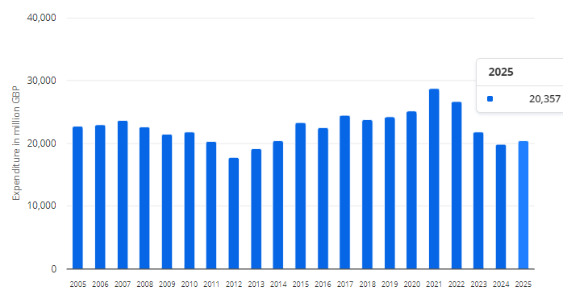
Figure 1: Annual expenditure on furniture and furnishings in the United Kingdom
(Source: Statista, 2026)
The UK furniture retail market is among the largest home appliance markets in Europe which is fuelled by high consumer demand for affordable, sustainable, digitally accessible, home furnishings. The UK household spending on furniture and furnishing demand had reached about 20.4 billion pounds in 2025 which was a recovery to 19.8 billion pounds in 2024 (Statista, 2026). Achieving this, the development of e-commerce and omnichannel retailing has increased competition in the market between leading retailers, such as IKEA, Dunelm, Wayfair, and John Lewis, which contributes to the ongoing innovation and customer-driven business strategies.

2.5 Major competitors
IKEA UK is a range within a very competitive furniture retail market and shares the market with some of the established retailers, including Dunelm, Wayfair UK, John Lewis, Argos, and B&Q with reported revenues of annually 1.71 billion and annual sales of retail stores around 4.93 billion, respectively (Globenewswire.com, 2022). Competitors can be differentiated by offering a variety of products, by omnichannel services, offering high-end products, and outstanding customer experience, necessitating IKEA UK to always solidify its cost leadership, innovation and sustainability practices (Kencebay and Ertugan, 2025).

2.6 Market position
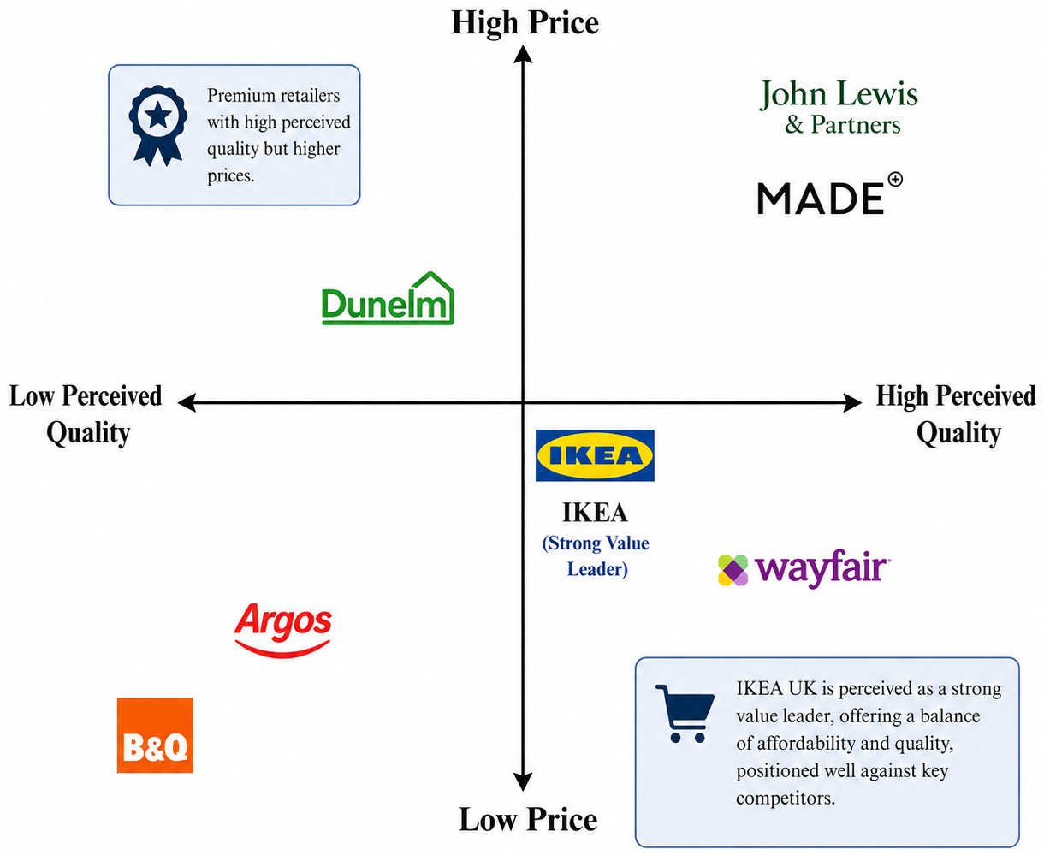
Figure 2: Market position of IKEA
(Self-developed)
The perceptual map shows that IKEA UK has a good position in the market with a capability to balance between price and perceived value adequately. Also, unlike the quality products offered at a higher cost by higher-end retailers like John Lewis, IKEA offers effective and fashionable products at affordable costs. IKEA has better quality perceptions as compared to Argos and B&Q and its value positioning is also better as compared to Wayfair. This unique market positioning enhances the customer loyalty, brand equity and sustainable competitive advantage in the furniture retail market of the UK.

3. External and Internal Strategic Analysis

3.1 External Environment (PESTEL)
Factors | Description | Impact
Political | The UK Government has committed to achieving Net Zero emissions by 2050, encouraging businesses to adopt renewable energy, sustainable sourcing, and circular economy practices. IKEA UK's climate positive strategy aligns closely with these national environmental policies, strengthening its sustainability leadership (Gov.uk, 2025; Ikea, 2024) | Opportunity
Economic | 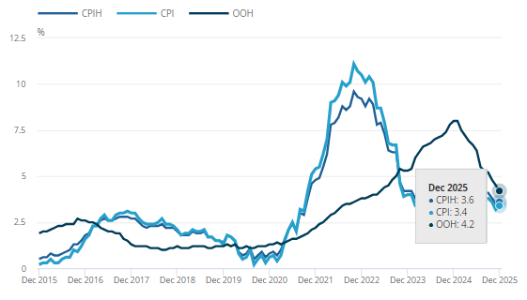  Figure 3: CPIH and CPI annual inflation rates rose for the first time since July 2025  (Source: Ons.gov.uk, 2026)  The UK continues to face inflationary pressures, with the Consumer Prices Index (CPIH) increasing by 3.6% in December 2025. Rising living costs reduce consumers' disposable income and discourage expenditure on discretionary products such as furniture, while simultaneously increasing retailers' operating costs (Ons.gov.uk, 2026). | Threat
Social | Consumer demand for sustainable home furnishings continues to increase as environmental awareness grows. Additionally, UK household expenditure on furniture and furnishings reached approximately £20.4 billion in 2025, demonstrating continued market demand for affordable and sustainable furniture solutions despite economic challenges (Statista, 2026). | Opportunity
Technological | Digital transformation continues to reshape UK retailing. Recent research indicates that 20% of UK consumers now begin product searches using AI platforms, while 87% consider AI generated recommendations helpful. These trends create opportunities for IKEA UK to strengthen its omnichannel strategy through artificial intelligence, data analytics, and digital personalisation (Cawley, 2026) | Opportunity
Environmental | Increasing regulatory pressure and stakeholder expectations require retailers to reduce carbon emissions, minimise waste, and improve recycling throughout their supply chains. Failure to meet sustainability commitments may increase compliance costs and damage corporate reputation in an environmentally conscious market (Gov.uk, 2025). | Threat
Legal | The Data (Use and Access) Act 2025 introduced further changes to UK data protection legislation alongside the UK GDPR, requiring retailers to strengthen customer data governance and privacy compliance. Non compliance may result in regulatory penalties, financial losses, and reputational damage (Gov.uk, 2025). | Threat
Table 1: PESTLE analysis
(Self-developed)
The PESTLE study demonstrates that IKEA UK has a dynamic external environment, with sustainability and digital transformation being the most potential development drivers and economic uncertainties and regulatory demands being challenges. Politically, the UK aim of Net Zero by 2050 is sustainable, and renewable energy investments and circular economy regulations may help IKEA compete. Social trends may also help this possibility since the UK home furnishing sector is strong due to rising customer demand for eco-friendly items and yearly expenditure of 20.4 billion.
In contrast, 3.6% inflation reduces consumer buying power, makes them price sensitive, and raises operating expenses. IKEA's cost leadership approach has helped company manage these constraints, but economic unpredictability may restrict its profitability. Technological advances like artificial intelligence and omnichannel shopping may improve operational efficiency and consumer experiences. IKEA's failure to invest in digital innovation might hurt them if competitors adopt technology quicker. The need to invest in compliance, sustainable sourcing, and governance systems is growing as UK environmental and data protection laws tighten. As long as IKEA UK relies on its sustainability leadership, digital capacities, and operational performance and adapts to economic and regulatory changes, its external environment is favourable.

3.2 Internal Analysis (VRIO)
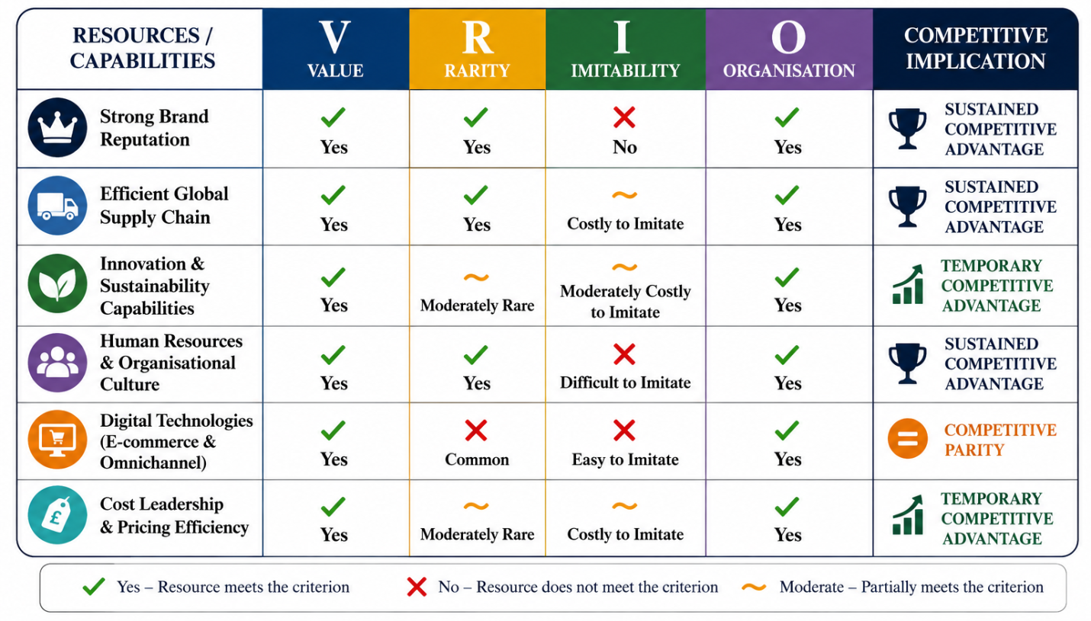
Figure 4: VRIO analysis
(Self-developed)
The VRIO model determines the sustainability of competitive advantage of the resources and capabilities of IKEA UK by considering their value, rarity, imitability and organisational support. The IKEA brand is one of the strongest strategic assets of the company at the global level (IKEA, 2026a). The corporation has continuously been listed in the list of the most valuable retail brands in the world, which has boosted the customer trust and loyalty. The advantage of this resource is in the fact that it mirrors the clientele that grows to be loyal, and it helps to gain market share, whereas the fact that it is difficult to copy as the reputation is good and the brand is developed over decades makes competitors hard to follow. IKEA is well structured to capitalise on this resource by creating integrated marketing and continuous customer experiences which have led to an end-lasting competitive advantage (Zhou, 2024).
A personal ability is also an efficient global supply chain of IKEA. Long term deals with suppliers, flat pack product design and large scale procurements help the firm to realise high cost efficiencies, without compromising their product quality (Mahdavi and Olsen, 2017). These competences facilitate the IKEA cost leadership strategy, by lowering transportation, warehousing and production expenses. Despite the fact that competitors can co-opt, this is difficult and will incur huge investment, experience, and economies of scale to match IKEA in terms of integrating its global supply chain network.
IKEA UK is also well placed in its strategy in terms of innovation and sustainability. The organisation has invested hugely into renewable energy, circular economy, recycled materials, and digital retail technologies, such as artificial intelligence and omnichannel services (IKEA, 2025b). These resources generate customer value through enhancing efficiency in operations and aiding consumption that is nature friendly. Nevertheless, sustainability practices are becoming more popular throughout the furniture retail market and making them less rare but still valuable (Ogunmola and Kumar, 2024). Other good internal capabilities are human resources and organisational culture. The customer centred philosophy, employee development programme and collaborative culture at IKEA encourages innovation and operational excellence to continue (IKEA, 2026b). Such intangible resources are inherent in the organisation and are not easy to imitate creating further competitive advantages.
However, some internal resources are only competitive parity. Digital technologies, such as e-commerce platforms and mobile apps, are useful and became popular, but now are covering the entire retail sector (Wilson, Johnson and Brown, 2024). Other competitors like Dunelm, Wayfair, and John Lewis have built similar digital capabilities, diminishing their uniqueness. In general, the VRIO analysis shows that the brand image, integrated supply chain, organisational culture, and operational effectiveness of IKEA UK meet all four VRIO requirements that bring sustainability and competitive advantages. On the other hand, digital capabilities and sustainability programs only produce short-lived benefits as they get more prevalent in the UK furniture retail sector (Wulf et al., 2024).

3.3 SWOT Analysis
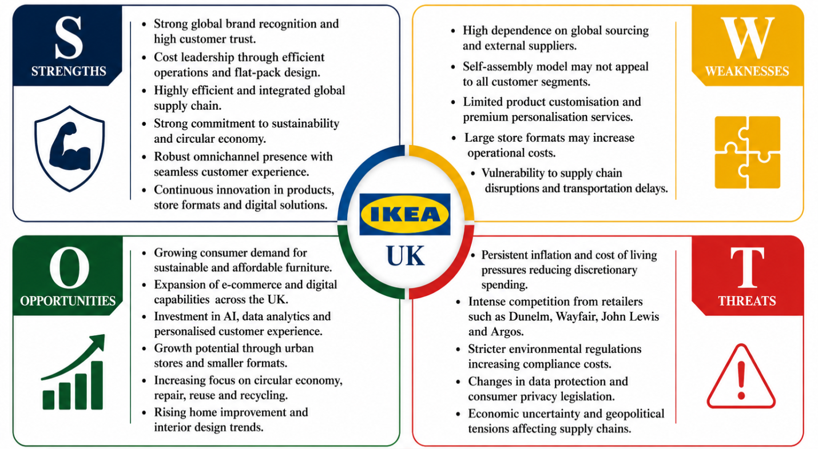
Figure 5: SWOT analysis
(Self-developed)
The SWOT analysis incorporates the results of the external and internal analyses to assess the overall position of IKEA UK in the business in the UK furniture retail market. Global recognition of its brand, efficient supply chain, cost leadership strategy, and sustainability are the greatest strengths of the company. The resources will help IKEA UK offer quality, practical products at a low cost and still remain efficient in its operations. Additionally, customer satisfaction and long term competitiveness is enhanced by its well-established omnichannel retailing mode and sustained commitment to innovation (Rahman et al., 2025).
Although these are the strengths, IKEA UK has a number of internal weaknesses. It is highly dependent on international sourcing causing it to be vulnerable to disruptions in the supply chain, geopolitical animosity and volatile transportation expenses (Ha, Lee and Kim, 2025). Regardless of the effectiveness of the self assembly business model in terms of minimizing operational costs, it might not meet the demands of every type of customer, such as consumers who want fully assembled furniture or high-end services highly personalized. Additionally, its product designs might be too standardised to deal with the highly customised preferences of consumers.
There are many external environment opportunities to grow upon. The growth in consumer sensitivity to sustainability, the rise of the online retail business, and demand for inexpensive home furnishing products are all part of good market conditions in favour of IKEA UK (Sin et al., 2021). Further enhancement of customer engagement, operational efficiency, and environmental performance can be achieved through further investment in artificial intelligence, data analytics, and circular economy efforts. Also, the opportunities to enter the new consumer groups in the United Kingdom are available because of smaller urban store forms and better online services.
In its turn, there are a number of external threats, the strategic approach to which should be closely considered. The ongoing inflation and increased cost of living is further weighing down on discretionary spending by consumers, adding to the price war within the furniture retail sector (McKinsey & Company, 2020). Key competitors like Dunelm, Wayfair, John Lewis, and Argos are constantly advancing their digital operations, merchandise and customer experience. In addition, more rigid environment protocols, changing data protection laws, and supply chain risk can be an addition to compliance and operational expenses.
Altogether, the SWOT analysis shows that IKEA UK has major strategic strengths more than the weaknesses. The organisation is in a good position to leverage the new sustainability and digital transformation opportunities and reduce the external risks with the help of its effective operations, a good brand image, and constant innovation. However, the ability to stay competitive will be demanding long-term investment in technology, supply chain resiliency, customer experience, and environmental friendly business activities as a solution to the fast changing UK retail business environment.

4. Comprehensive and holistic evaluation

4.1 Corporate social responsibility
Corporate Social Responsibility (CSR) is also incorporated in the corporate strategy of the IKEA UK company, and this shows how the company is determined to generate value on customers, society and the environment in the long term. In its People and Planet Positive strategy, IKEA is aiming at becoming climate neutral, engaging in circular business, responsible sourcing, and better affordability, and increasing social wellbeing (IKEA, 2024). As an example, IKEA has a long-term goal of being climate positive by 2030 and making less greenhouse gas emissions, through investments in renewable energy and sustainable materials, as well as energy efficient operations. These endeavours enhance the reputation of the company as a sustainability leader as well as fueling the growing consumer interest in green products.
Cost leadership, customer happiness, and long-term development business goals show IKEA's CSR approach. Renewable energy, waste reduction, and resource efficiency investments reduce the operation costs in the long run and contribute to its low pricing policy (Yang, Zhou and Gao, 2025). Due to environmental awareness, buy back schemes, recycling facilities, and green product lines help retain customers (Mahalakshmi et al., 2024). Supply chain resilience and risk service may also be assessed via ethical sourcing standards and supplier partnerships that help in strengthening the competitive edge of IKEA UK.
Although they have these characteristics, there are a number of difficulties. Climate-positive operation in a multidimensional global supply chain requires continual financial investment and supplier compliance, which may increase short-term operating costs (Runtuk, Ng and Ooi, 2024). Moreover, Das et al. (2025) suggest that a high volume consumption strategy like IKEA might be contradictory with the larger sustainability objective even while large-scale activity is performed to build a circular economy. Nevertheless, it is necessary to remain transparent and have quantifiable environmental reporting and ongoing innovation to prevent greenwashing (Sneideriene and Legenzova, 2025). In general, the CSR strategy of IKEA UK displays strong strategic alignment it has with its business and corporate objectives as it enhances the performance in all four strategic areas: environmental performance, operational efficiency, customer trust, and competitive advantage. Its holistic strategy places the organization at a strategic position to record sustainable growth as well as being responsive to the emerging stakeholder demands and regulatory provisions.

4.2 Balanced scorecard
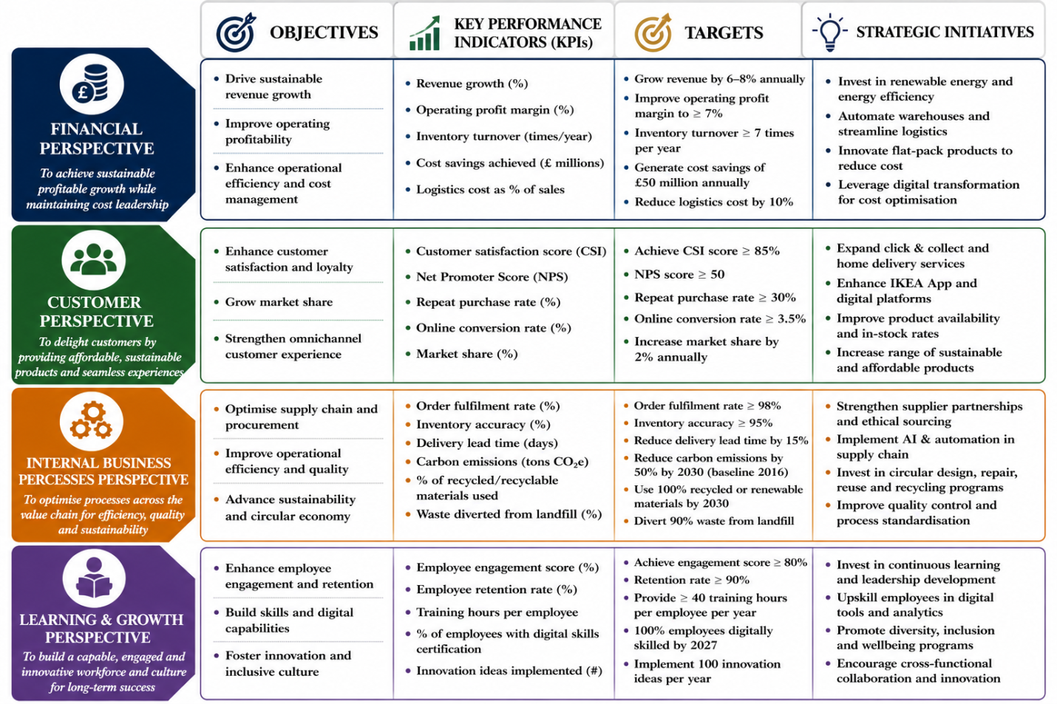
Figure 6: Balance score card
(Self-developed)
The Balanced Scorecard (BSC) created by Kaplan and Norton (1992) offers an in-depth template on how to transform organisational strategy into align able performance results by incorporating financial and non-financial measurements (Madsen, 2025). The Balanced Scorecard, unlike conventional performance measurement systems, which only majorly look at the performance of organisations in terms of financial performance, looks at organisational performance in four aspects linked together namely Financial, Customer, Internal Business Processes, and Learning and Growth. In the case of IKEA UK, Balanced Scorecard helps the company to achieve its vision of creating a better everyday life for the many people by focusing its operation processes with its strategic focus on affordability, sustainability, innovation and customer value.
In terms of Finances, the key goal of IKEA UK is to have sustainable growth in revenues but continue to focus on its cost leadership strategy (IKEA, 2024a). Some of the key performance indicators (KPIs) are annual revenue growth, operating profit margin, inventory turnover and cost reduction achieved due to efficiency in operations. The right targets would be to boost the sales per year, enhance profit margins and the logistic cost reduction by optimising the supply chain. Smart projects like renewable power investments, work automation, the flat pack product design, and digitalization are great moves towards a reduction of costs and increase in the profitability in the long term (IKEA, 2024b).
Customer perspective aims at reinforcing customer satisfaction, loyalty and the market share (Pereira et al., 2025). IKEA focuses on offering low-priced home furnishing solutions of high quality and sustainable with smooth experiences at its omnichannel. Customer satisfaction (60%), Net Promoter Score (22) and repeat purchase rates, online to be converted and market share are relevant KPIs (Ey.com, 2024; Comparably.com, 2024). Some of the strategic initiatives would be the growth of click and collect, developing digital shopping platforms, product availability, and overall making more sustainable products to enhance customer relationship and brand loyalty.
The Internal Business Processes lens evaluates IKEA UK's value chain activities. The company prioritises procurement, inventories, product development, supply chain resilience, and circular economy. These KPIs include order fulfilment, inventory accuracy, delivery lead times, carbon emissions, and waste minimisation. Targets include improving supply chain efficiency, using more recycled materials, reducing operational waste, and improving delivery (Waqar et al., 2025). Continuous investment in AI, warehouse automation, and sustainable sourcing supports these operational aims.
Finally, the Learning and Growth viewpoint emphasises human capital, organisational culture, and innovative skills. IKEA UK promotes employee engagement, diversity, digital skills, and leadership development for long-term competitiveness (IKEA, 2026a). The KPIs include employee engagement, staff retention, individual training hours, innovation adoption, and digital capacity development. Continuous staff training, leadership development, digital skill development, and workplace inclusivity foster cooperation and creativity.
In general, the Balanced Scorecard matches IKEA UK's purpose, strategic goals, and operational performance. The framework will enable IKEA UK assess its strategic performance holistically and maintain a sustained competitive edge in the ever-changing UK furniture retail market via financial discipline, customer value, operational excellence, and continual organisational learning.

5. Strategic choices and implementation

5.1 Current business level strategy
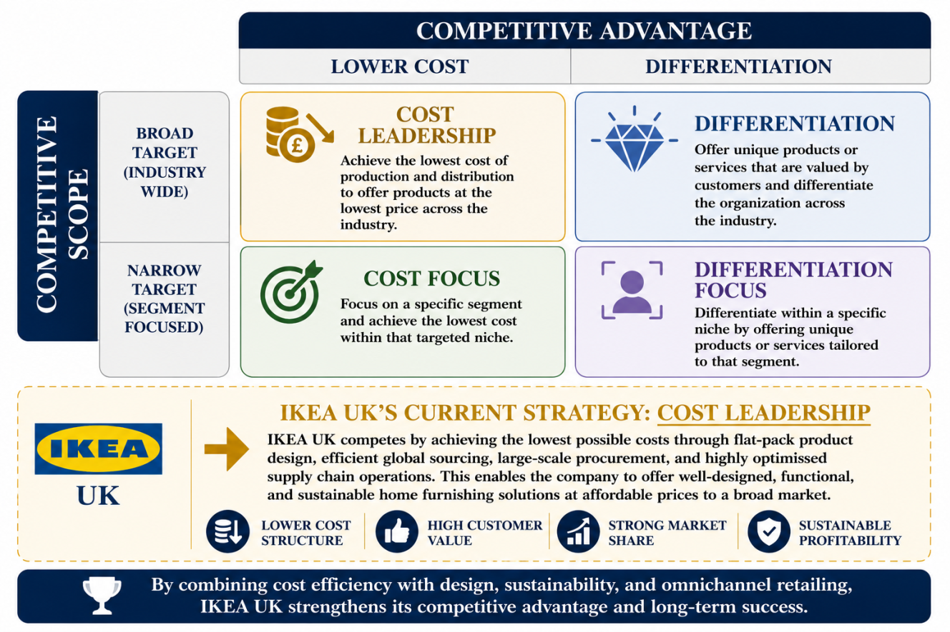
Figure 7: Porter’s generic forces to determine IKEA’s current business level strategy
(Self-developed)
The current level of strategy of business of IKEA UK can be best described using the Cost Leadership Strategic pathway of Porter. The company also attains competitive advantage by providing competent well designed, functional, and sustainable products in terms of home furnishings at affordable prices (Ludmir, 2023). The flat pack product design, efficient global sourcing, large scale procurement, and highly optimised supply chain operations, enabling IKEA to minimise production and distribution costs. At the same time, the company values itself by means of Scandinavian design, sustainability and omnichannel retailing (Lagin et al., 2022). Therefore, IKEA UK has achieved cost efficiency and customer value in a way that enhances the market share, profitability and the long term competitive advantage.

5.2 Industry competitiveness
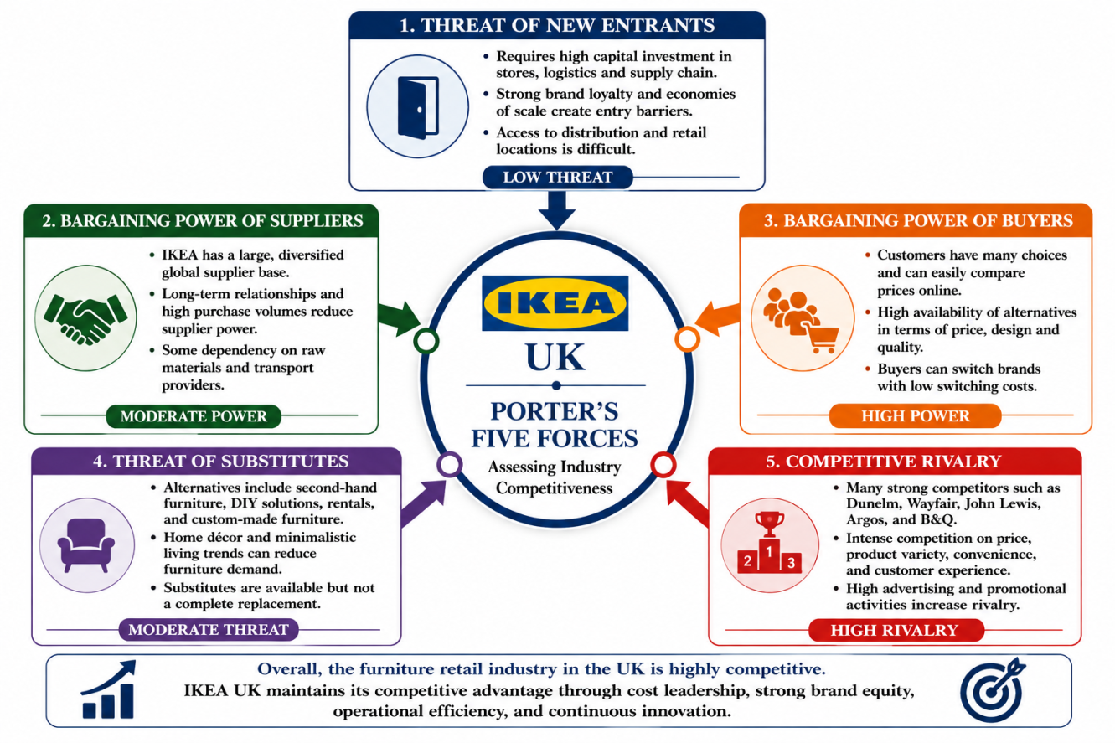
Figure 8: Porter’s five forces to determine industry competitiveness
(Self-developed)
Porter's Five Forces show that the UK furniture retail sector is typified by a high level of competitive rivalry based on the position of developed contenders, which include Dunelm, Wayfair, John Lewis, Argos, and B&Q. Buyer bargaining power is high as customers can easily compare prices and move across retailers (Matsumoto, Kamai and Kanazawa, 2024). Supplier power is average because of the large global sourcing network and long term supplier relationship of IKEA (Sharma et al., 2026). The threat of substitutes is moderate, customers can either opt to take second hand furniture or tailor-made products. The risk of entry is comparatively low since much capital investment and brand recognition as well as economies of scale provide barriers that are profound enough to prevent any other company that might be looking to join the industry to create any impact that IKEA UK can counter (Karagkouni and Dimitriou, 2025).

5.3 Strategic growth options through Ansoff’s matrix
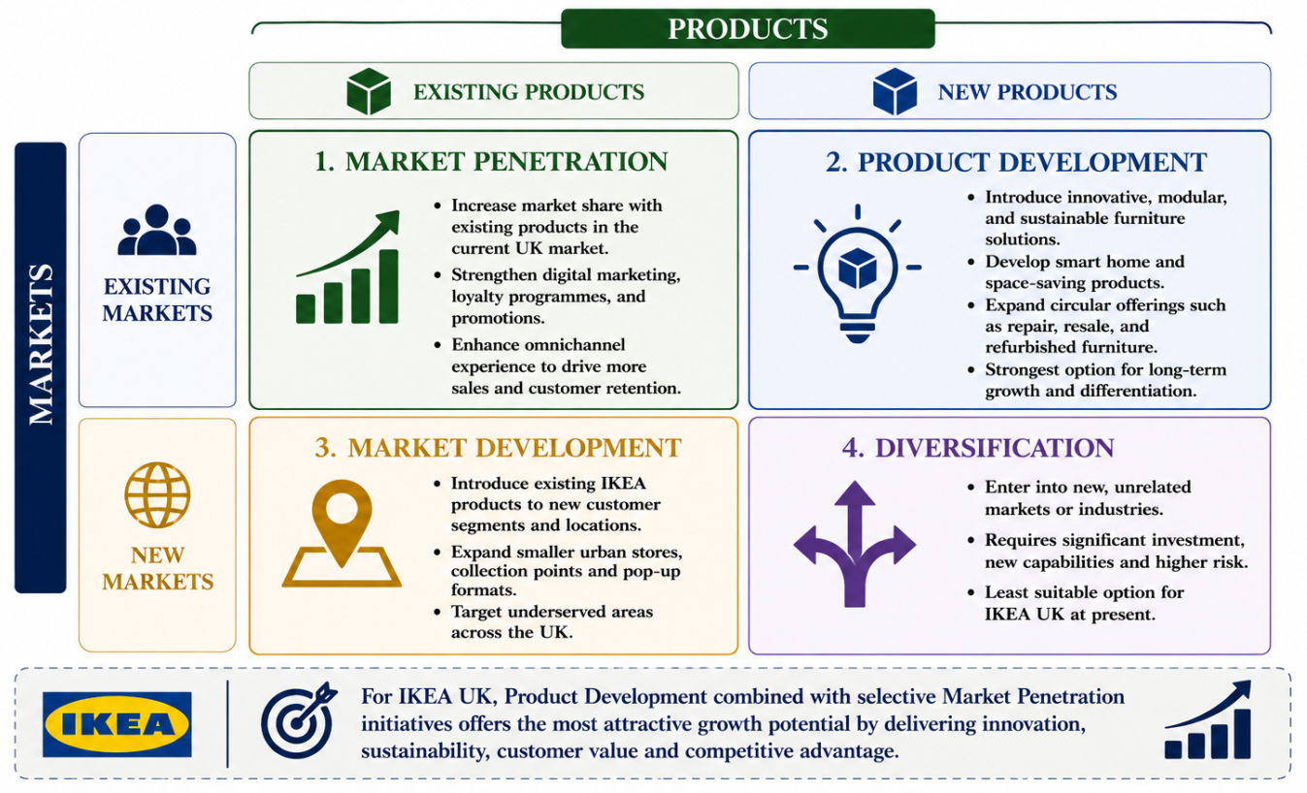
Figure 9: Ansoff’s matrix to determine strategic growth option
(Self-developed)
The Matrix of Ansoff highlights four strategic development options to IKEA UK market penetration, market development, product development, and diversification. The UK market is already established, and thus has the possibility to boost sales with the help of greater online marketing, loyalty systems and omnichannel services (Febriani, Sopha and Wibisono, 2025). Market growth presents a chance to make smaller city outlets and pick-up sites to serve undervalued areas. The best strategy to adopt is product development since it will introduce innovative, modular and sustainable furniture, which will be responsive to evolving consumer preference and strengthen the sustainability agenda at IKEA (Mengistu et al., 2024). Diversification to unrelated markets on the other hand would also carry significant investment and strategic risk (Kwon, Bae and Liu, 2025). Thus, the most adequate strategic fit is the product development, which is supported by selective market penetration initiatives, as such they will help IKEA UK to enhance its competitive advantage, customer value, and long term growth.

5.4 Strategic recommendation
As per the above analyses, Product Development is advised as the best growth strategy to apply to IKEA UK. The company is supposed to diversify their innovative, modular, and sustainable home furnishing products besides incorporating digital technologies like artificial intelligence-induced personalisation and virtual reality shopping experience. The strategy follows the mission of IKEA of offering cheap and practical products and addressing the rising demand of consumers due to their sustainability and smart living solutions. Through the ability to strengthen product innovation in addition to its proven cost leadership plan, IKEA UK can strengthen customer value, market share, brand differentiation and attain sustainable long run competitive advantage in the UK furniture retail sector (Rodrigues and Brandão, 2020).

5.5 SAFe evaluation
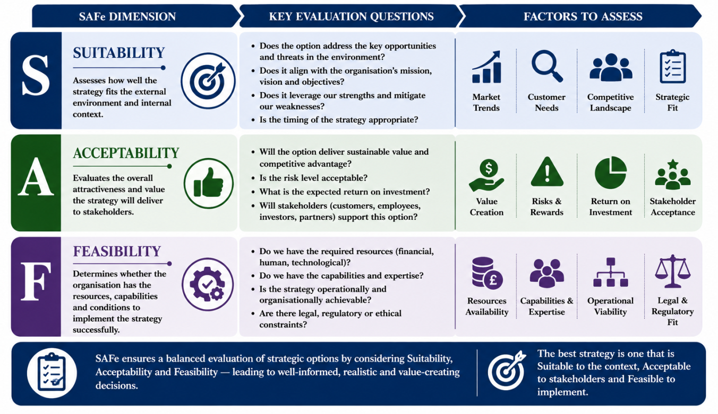
Figure 10: SAFe framework to evaluate strategic options
(Self-developed)
The SAFe framework supports the proposed Product Development strategy. Regarding Suitability, it deals with growing consumer demand on sustainable, innovative and smart home furnishing product lines and react to the competitive pressures in the UK market. With regards to Acceptability, the strategy is likely to enhance customer satisfaction, brand loyalty, and increase long term revenue growth though it will cost a lot in terms of research and product innovation (Wang et al., 2024). Feasibility-wise, IKEA UK has the financial capabilities, global procurement chain, solid brand image, digital capabilities, and innovation capabilities to build the strategy and maintain a competitive edge.

5.6 Strategy implementation
The recommended Product Development strategy can only be successfully implemented through a structured, and a staged approach. The first step IKEA UK needs to take is to invest in research and development to develop novel, modular, and sustainable furniture products that will meet the evolving consumer preferences (Muhammad Suandi et al., 2022). At the same time, the company needs to become more digital by incorporating artificial intelligence-based personalisation, augmented reality online shopping, and enhanced data analytics into its platform into the omnichannel (Jasim, Puthineedi and Jha, 2026). Partnership with suppliers is the key to use more recycled and renewable materials and to remain cost-effective and quality products. Training programmes should also be initiated by the organisation to increase digital skills and help bring change to the organisation (Guerra, Danvila-del-Valle and Méndez Suárez, 2023). Moreover, the delivery of sustainable products and improvement of interactions with customers should be promoted with the help of targeted marketing campaigns. Key performance indicators such as the growth in sales, customer satisfaction, market share, success rate of innovations, and sustainability performance should be constantly tracked (Oliveira, Belitski and Perez-Vega, 2025). This gradual adoption will reduce the level of disruption in operations and will help create sustainable business development and long term competitive advantage.

5.7 Risks
Risk ID | Risk Description | Category | Likelihood | Impact | Risk Rating | Risk Owner
R1 | High research and development costs may reduce short term profitability during new product development. | Financial | Medium | High | High | Finance Director
R2 | Delays in sourcing sustainable raw materials may disrupt production schedules and product availability. | Supply Chain | Medium | High | High | Supply Chain Manager
R3 | Customers may demonstrate limited acceptance of newly developed sustainable or modular furniture products. | Market | Medium | Medium | Medium | Marketing Director
R4 | Implementation of artificial intelligence and digital technologies may increase cybersecurity and data privacy risks. | Technology | Medium | High | High | IT Director
R5 | Employee resistance to organisational change and new technologies may delay successful implementation. | Human Resources | Low | Medium | Medium | HR Director
R6 | Strong competitive responses from retailers such as Dunelm, Wayfair, and John Lewis may reduce the effectiveness of the recommended strategy. | Strategic | High | Medium | High | Chief Executive Officer
Table 2: Risk register
(Self-developed)
Risk mitigation should be effectively implemented by active planning, constant monitoring, and teamwork among the stakeholders during the implementation of the strategy. IKEA UK needs to embrace a gradual investment that will help reduce financial risk and maximise supplier diversification to promote resilience in the supply chain (Yan et al., 2023). Extensive employee training and change management programmes will also help in successful adoption of new technologies and processes (Handrich and Otterbach, 2024). Online protection and adherence to UK GDPR must be embedded with strong cybersecurity. Moreover, the risks of customer acceptance will be minimized through the constant market research and pilot product releases, and actionable competitor analysis and performance monitoring will allow making strategic adjustments in time (Alghamdi and Agag, 2024). All these measures will help to reduce the risks of implementation and contribute to sustainable organisational performance.

6. Reflection
Description: This evaluation demanded a thorough strategic analysis of IKEA UK using the recognised strategic management theories and models to examine the competitiveness of the organisation and give a suitable business strategy. The process entailed a thorough research on the activities by studying academic journals, company reports, industry publications and market statistics to explore the external environment, internal capabilities, corporate social responsibility activities, operational performance and strategic options IKEA UK. A variety of frameworks such as PESTLE, VRIO, SWOT, Balanced Scorecard, Porters Five Forces, Porters Generic Strategy, Ansoffs Matrix and SAFE were utilized to come up with evidence based strategic recommendations backed by theoretical concepts.
Feelings: Initially in the assessment, I was challenged by the need to combine different strategic management models into a business analysis. One of the issues I was worried about at the start of the process was the choice of the best strategic recommendation to make and still maintain all the models of analysis. However, the further I went with the research, the more I was convinced that I could use strategic management theories and critically analyse the organisational performance. The assignment has boosted my abilities and mine in deciphering business data and offering viable strategic suggestions backed with scholarly evidence.
Evaluation: The methodical gathering of information based on credible scholarly resources and industry experts was one of the best features of my approach prior to conducting the analysis. This helped me to come up with evidence based arguments backed by the existing market statistics and theoretical bases. Moreover, the application of several strategic frameworks enabled me to analyze IKEA UK in various aspects instead of using one tool of analysis. However, the it was a time-consuming process since it involved a careful interpretation of a lot of information and logical links between every part of the report. Another factor that needed to be considered when choosing the most appropriate strategy involved a strike between theory and business realities.
Analysis: The evaluation showed that strategy management systems are complementary to each other when used in a systematic manner. As an illustration, the PESTLE analysis revealed the existence of external opportunities and threats and the VRIO framework assessed the internal capabilities that generate competitive advantage. These findings were included in the general strategic analysis of SWOT, but they were used to examine the options of strategy by Porter's Five Forces and the Matrix of Ansoff. Lastly, the purpose of suitable, acceptability and feasibility of the recommended Product Development strategy allowed its evaluation on the basis of the SAFe framework. This combined effort enhanced the validity of the recommendations and bolstered the essence of scientific based decision making in strategic management.
Conclusion: All in all, this assessment contributed greatly to my knowledge of strategic analysis and formulation of business level strategies. I gained more confidence in the ability to use the strategic management theories and critically analyse the performance of organisations and to translate the knowledge gained in theory into practical business advice. My research, analytical and academic writing skills also strengthened during the course of experience.
Action Plan: I will also enhance my skills in the analysis of internal business data in large amounts in future strategic management projects by elaborating more sophisticated methods of critical evaluation and contrasting different strategic frameworks of business. I will also improve my data interpretation abilities by adding more financial and operational performance metrics and a qualitative analysis. Moreover, I will set aside additional time to organize the general report format before starting analysis to achieve even greater syntheses between theoretical frameworks, empirical evidence and strategic suggestions. Such practice will allow me to create more detailed, systematic, and professional-structured reports on strategic management.

7. Conclusion
The conclusion of this report is that IKEA UK is well positioned in the market and competitive due to cost leadership, efficiency in its operations and sustainability. The Product Development strategy suggested is the one that has the best prospect of increasing the competitive advantage through increased innovation, customer value, and long term growth. Risk management and effective implementation will help achieve long-term organisational performance on the UK market.

References
Alghamdi, OmarA. and Agag, G. (2024). Competitive advantage: A longitudinal analysis of the roles of data-driven innovation capabilities, marketing agility, and market turbulence. Journal of Retailing and Consumer Services, 76, p.103547. doi:https://doi.org/10.1016/j.jretconser.2023.103547.
Cawley, C. (2026). New study reveals how AI is reshaping how people shop online — But they still don’t really trust it enough. [online] TechRadar. Available at: https://www.techradar.com/pro/new-study-reveals-how-ai-is-reshaping-how-people-shop-online-but-they-still-dont-really-trust-it-enough [Accessed 02 Aug. 2026].
Comparably.com (2024). IKEA NPS & customer reviews. [online] Comparably. Comparably.com. Available at: https://www.comparably.com/brands/ikea-com [Accessed 01 Aug. 2026].
Das, A.K., Hossain, M.F., Khan, B.U., Rahman, M.M., Asad, Z. and Akter, M. (2025). Circular economy: A sustainable model for waste reduction and wealth creation in the textile supply chain. SPE Polymers, 6(1). doi:https://doi.org/10.1002/pls2.10171.
Ey.com (2024). How IKEA transformed both customer experience and employee satisfaction. [online] Ey.com. Ey.com. Available at: https://www.ey.com/en_nz/insights/consulting/how-ikea-transformed-both-customer-experience-and-employee-satis [Accessed 6 Aug. 2026].
Febriani, A., Sopha, B.M. and Wibisono, M.A. (2025). Dynamic capabilities for omnichannel transformation in MSMEs: A comparative case study of fashion and furniture sectors. Journal of Open Innovation: Technology, Market, and Complexity, [online] 11(1), p.100498. doi:https://doi.org/10.1016/j.joitmc.2025.100498.
Globenewswire.com (2022). Ikea, DFS, and B&Q among leading retailers in the UK furniture and floorcoverings market | globaldata plc. [online] GlobeNewswire News Room. Available at: https://www.globenewswire.com/news-release/2022/07/12/2477740/0/en/IKEA-DFS-and-B-Q-Among-Leading-Retailers-in-the-UK-Furniture-and-Floorcoverings-Market-Globaldata-Plc.html [Accessed 03 Aug. 2026].
Gov.uk (2025). Data (use and access) act 2025: Data protection and privacy changes. [online] GOV.UK. Gov.uk. Available at: https://www.gov.uk/guidance/data-use-and-access-act-2025-data-protection-and-privacy-changes [Accessed 6 Aug. 2026].
Guerra, J.M.M., Danvila-del-Valle, I. and Méndez Suárez, M. (2023). The impact of digital transformation on talent management. Technological Forecasting and Social Change, 188(0040–1625), p.122291. doi:https://doi.org/10.1016/j.techfore.2022.122291.
Ha, Y., Lee, C. and Kim, S. (2025). The IKEA effect in supply chain relationships: Mediating role of power types on supply chain sustainability. International Journal of Managing Projects in Business, 18(3). doi:https://doi.org/10.1108/IJMPB-12-2024-0298.
Han, X. (2022). Analysis and reflection of IKEA’s supply chain management. pp.154–160. doi:https://doi.org/10.2991/978-94-6463-098-5_19.
Handrich, M. and Otterbach, M. (2024). Digital employee training with digital adoption platforms boost learning and knowledge management of corporate IT systems. International Journal of Knowledge Management, 20(1), pp.1–19. doi:https://doi.org/10.4018/IJKM.358005.
IKEA (2024a). IKEA sustainability strategy – IKEA global. [online] IKEA. IKEA. Available at: https://www.ikea.com/global/en/our-business/reports/ikea-sustainability-strategy-240904/ [Accessed 03 Aug. 2026].
Ikea (2024). Our sustainability strategy. [online] Ikea.com. Available at: https://www.ikea.com/gb/en/this-is-ikea/climate-environment/the-ikea-sustainability-strategy-pubfea4c210/ [Accessed 6 Aug. 2026].
IKEA (2024b). Our sustainability strategy for 2030. [online] Ikea.com. IKEA. Available at: https://www.ikea.com/in/en/this-is-ikea/about-us/the-ikea-sustainability-strategy-making-a-real-difference-pubb5534570/ [Accessed 6 Aug. 2026].
IKEA (2025a). IKEA Culture and Values. [online] www.inter.ikea.com. IKEA. Available at: https://www.inter.ikea.com/en/how-we-do-business/ikea-culture-and-values [Accessed 04 Aug. 2026].
IKEA (2025b). IKEA sustainability strategy. [online] IKEA. Available at: https://www.ikea.com/global/en/images/IKEA_Strategy_2025_2030_pdf_V2_New_d4052a55f9.pdf [Accessed 6 Aug. 2026].
IKEA (2025c). The story of IKEA – ikea global. [online] IKEA. Ikea. Available at: https://www.ikea.com/global/en/our-business/how-we-work/story-of-ikea/ [Accessed 6 Aug. 2026].
IKEA (2026a). Diversity and inclusion. [online] Ikea.com. IKEA. Available at: https://www.ikea.com/in/en/this-is-ikea/work-with-us/diversity-and-inclusion-pub3d25e8e8/ [Accessed 6 Aug. 2026].
IKEA (2026b). IKEA supply chain operations decarb catalogue – IKEA global. [online] IKEA. IKEA. Available at: https://www.ikea.com/global/en/our-business/reports/ikea-supply-chain-operations-decarb-catalogue/ [Accessed 6 Aug. 2026].
IKEA (2026c). The IKEA vision, values and business idea. [online] IKEA. IKEA. Available at: https://www.ikea.com/us/en/this-is-ikea/about-us/the-ikea-vision-and-values-pub9aa779d0/ [Accessed 01 Aug. 2026].
Jasim, K.M., Puthineedi, V.B. and Jha, A.K. (2026). AI-powered personalization in online fashion stores: Exploring the impact on shoppers’ perceived risk and intention to buy and recommend. Information & Management, [online] 63(4), p.104347. doi:https://doi.org/10.1016/j.im.2026.104347.
Karagkouni, A. and Dimitriou, D. (2025). Barriers and initiatives to access international market for European cross-border regions. Economies, [online] 13(6), pp.154–154. doi:https://doi.org/10.3390/economies13060154.
Kencebay, B. and Ertugan, A. (2025). Understanding the mediating effect of brand equity on sustainability and omnichannel operation and phygital experience. Sustainability, [online] 17(5), pp.1878–1878. doi:https://doi.org/10.3390/su17051878.
Kwon, T.H., Bae, S.C. and Liu, C. (2025). Diversification and firm risk: New evidence on exchange rate exposure. Journal of International Financial Markets Institutions and Money, 101, pp.102158–102158. doi:https://doi.org/10.1016/j.intfin.2025.102158.
Lagin, M., Håkansson, J., Olsmats, C., Espegren, Y. and Nordström, C. (2022). The value creation failure of grocery retailers’ last-mile value proposition: A sustainable business model perspective. Cleaner and Responsible Consumption, 7, p.100088. doi:https://doi.org/10.1016/j.clrc.2022.100088.
Ludmir, C. (2023). How sustainability and affordability can go hand-in-hand: The case of Ikea. [online] Forbes. Forbes. Available at: https://www.forbes.com/sites/claraludmir/2023/11/24/how-sustainability-and-affordability-can-go-hand-in-hand-the-case-of-ikea/ [Accessed 6 Aug. 2026].
Madsen, D.O. (2025). Balanced scorecard: History, implementation, and impact. Encyclopedia, [online] 5(1), p.39. doi:https://doi.org/10.3390/encyclopedia5010039.
Mahalakshmi, S., Nallasivam, A., Kumar, S.H., Kalavathy, K.S. and Desai, K. (2024). Sustainability by design: IKEA’s eco-friendly marketing efforts. Advances in economics, business and management research, [online] pp.145–161. doi:https://doi.org/10.2991/978-94-6463-374-0_14.
Mahdavi, M. and Olsen, T.L. (2017). Designing effective supply chains in strategic alignment with demand characteristics and market requirements. Foundations and Trends® in Technology, Information and Operations Management, [online] 10(2), pp.89–204. doi:https://doi.org/10.1561/0200000049.
Matsumoto, T., Kamai, T. and Kanazawa, Y. (2024). Examining bargaining power in the distribution channel under possible price pass-through behaviors of retailers. Journal of Retailing and Consumer Services, [online] 76, p.103601. doi:https://doi.org/10.1016/j.jretconser.2023.103601.
McKinsey & Company (2020). Perspectives on retail and consumer goods. [online] McKinsey. Available at: https://www.mckinsey.com/~/media/McKinsey/Industries/Retail/Our%20Insights/Perspectives%20on%20retail%20and%20consumer%20goods%20Number%208/Perspectives-on-Retail-and-Consumer-Goods_Issue-8.pdf [Accessed 02 Aug. 2026].
Mengistu, A.T., Dieste, M., Panizzolo, R. and Biazzo, S. (2024). Sustainable product design factors: A comprehensive analysis. Journal of cleaner production, 463, pp.142260–142260. doi:https://doi.org/10.1016/j.jclepro.2024.142260.
Muhammad Suandi, M.E., Amlus, M.H., Hemdi, A.R., Abd Rahim, S.Z., Ghazali, M.F. and Rahim, N.L. (2022). A review on sustainability characteristics development for wooden furniture design. Sustainability, 14(14), p.8748. doi:https://doi.org/10.3390/su14148748.
Ogunmola, G.A. and Kumar, V. (2024). A strategic model for attracting and retaining environmentally conscious customers in e-retail. International Journal of Information Management Data Insights, [online] 4(2), pp.100274–100274. doi:https://doi.org/10.1016/j.jjimei.2024.100274.
Oliveira, F., Belitski, M. and Perez-Vega, R. (2025). Sales digitization and sales process optimisation for firm performance: Evidence from European firms. Technological Forecasting and Social Change, 217, pp.124172–124172. doi:https://doi.org/10.1016/j.techfore.2025.124172.
Ons.gov.uk (2026). Consumer price inflation, UK. [online] Ons.gov.uk. Office for National Statistics. Available at: https://www.ons.gov.uk/economy/inflationandpriceindices/bulletins/consumerpriceinflation/december2025 [Accessed 07 Aug. 2026].
Pereira, Schmitt, B., Cordeiro, B.A., Schmitt, B., Gabriela, M., Eugenia, S. and Gonçalves, M.C. (2025). Factors of customer loyalty and retention in the digital environment. Journal of Theoretical and Applied Electronic Commerce Research, [online] 20(2), p.71. doi:https://doi.org/10.3390/jtaer20020071.
Rahman, S.M., Carlson, J., Chowdhury, N.H., Gudergan, S.P., Wetzels, M. and Grewal, D. (2025). Share of time in omnichannel retailing: Definition and measurement. Journal of Retailing, 101(2). doi:https://doi.org/10.1016/j.jretai.2025.04.001.
Rodrigues, C. and Brandão, A. (2020). Measuring the effects of retail brand experiences and brand love on word of mouth: A cross-country study of IKEA brand. The International Review of Retail, Distribution and Consumer Research, [online] 31(1), pp.1–28. doi:https://doi.org/10.1080/09593969.2020.1768577.
Runtuk, J.K., Ng, P.K. and Ooi, S.Y. (2024). Challenges and solutions in working with green suppliers: Perspective from a manufacturing industry. Sustainability, 16(20), p.8744. doi:https://doi.org/10.3390/su16208744.
Sharma, A., Saboo, A.R., Borah, S.B. and Adhikary, A. (2026). Supplier concentration and firm performance: The role of relative size, relative reputation, and network position. International Journal of Research in Marketing. doi:https://doi.org/10.1016/j.ijresmar.2026.01.006.
Sin, L.G., Utama, A.A.G.S., Pandey, S., Pandey, R., Harsha, Y.S.S.V.S., Massand, A., Safitri, A.D.I., Yan, N.P., Kee, D.M.H., Yue, W.S., Zhin, P.M. and Hui, Y.J. (2021). A case study of the factors that affect consumer behavior in IKEA. Asia Pacific Journal of Management and Education(APJME), 4(2), pp.20–28. doi:https://doi.org/10.32535/apjme.v4i2.1068.
Sneideriene, A. and Legenzova, R. (2025). Greenwashing prevention in environmental, social, and governance (ESG) disclosures: A bibliometric analysis. Research in International Business and Finance, 74, p.102720. doi:https://doi.org/10.1016/j.ribaf.2024.102720.
Statista (2026). Furniture purchase trend in the UK 2025. [online] Statista. Available at: https://www.statista.com/statistics/301022/annual-expenditure-on-furniture-and-furnishings-in-the-united-kingdom-uk/?srsltid=AfmBOopF0_GeJHt-in8m01mrLw2IvJH6DcgvbJQE6xQfpNthZvCWdMJL [Accessed 09 Aug. 2026].
Wang, F., Wang, Y., Han, Y. and Cho, J.H. (2024). Optimizing brand loyalty through user-centric product package design: A study of user experience in dairy industry. Heliyon, [online] 10(3), pp.e25484-e25484. doi:https://doi.org/10.1016/j.heliyon.2024.e25484.
Waqar, A., Houda, M., Ahsan, M. and Nisar, S. (2025). Enhancing project performance through sustainable supply chain management: A comprehensive analysis of residential construction practices. Environmental Challenges, 18, p.101075. doi:https://doi.org/10.1016/j.envc.2024.101075.
Wilson, G., Johnson, O. and Brown, W. (2024). Exploring the impact of digital transformation on marketing strategies in the retail sector. Preprints.org, [online] 1. doi:https://doi.org/10.20944/preprints202407.2371.v1.
Wulf, F., Hagedorn, L., Munier, L., Balder, J., Mathi, C., Stark, R. and Pfriem, A. (2024). Towards digitalization of the circular economy in the furniture industry. Sustainable Production and Consumption, 52. doi:https://doi.org/10.1016/j.spc.2024.10.010.
Yan, X., Li, J., Sun, Y. and De Souza, R. (2023). Supply chain resilience enhancement strategies in the context of supply disruptions, demand surges, and time sensitivity. Fundamental Research, [online] 5(2). doi:https://doi.org/10.1016/j.fmre.2023.10.019.
Yang, X., Zhou, H. and Gao, J. (2025). Enhancing renewable energy productivity and energy efficiency of energy projects: How does cost of capital influence? Energy Strategy Reviews, 57, p.101608. doi:https://doi.org/10.1016/j.esr.2024.101608.
Zhou, S. (2024). Analyzing IKEA Brand’s media marketing strategies and improving customer experience through inductive reasoning approach. Journal of Education, Humanities and Social Sciences, [online] 27(4), pp.392–399. doi:https://doi.org/10.54097/1d1p0r71.

