Qualification: CIPD Diploma in Applied Human Resources

Module Name: Contributing to Resourcing and Talent Planning (5ARPT)

1. Be able to review and evaluate an organisations approach to talent planning
2. Be able to recommend ways to improve an organisations approach to talent planning
3. Be able to contribute to people resourcing activities

Word Count: 3,046

Student Name: Alys Owens
Student Number: 2005306
CIPD Membership Number: 56652305


By signing below, I confirm that the work/evidence presented is my own, unaided work. I understand the regulations pertaining to candidate malpractice and the action that may be taken as a result.

Signed:
Dated: 13/09/2020

Contents Page

Item | Content | Page No
1 | Evidence Matrix listing evidence for every assessment criteria (ACs) | 3
2 | Personal Statement for LO1 including reference list | 5
3 | Evidence to support LO1 | 7
4 | Personal Statement for LO2 including reference list | 23
5 | Evidence to support LO2 | 25
6 | Personal Statement for LO3 including reference list | 29
7 | Evidence to support LO3 | 31
8 | Bibliography/Resources | 64

Candidate name: ALYS OWENS |  |  |  | CIPD membership No
Qualification Title: CIPD Diploma in Applied Human Resources |  |  |  | ULN
Unit  Code | Unit Title | Assessment  Criteria No | Evidence  Description |  | Evidence  Reference  No | Assessor initials | I/V initials if sampled
5ARTP | Contributing to Resource and Talent Planning in an organisation | 1.1,1.2,1.3 | Personal Statement LO1 |  | EV1
5ARTP | Contributing to Resource and Talent Planning in an organisation | 1.1 | Use of sub-contractor analysis |  | EV2
5ARTP | Contributing to Resource and Talent Planning in an organisation | 1.1,1,3 | Gap Analysis |  | EV3
5ARTP | Contributing to Resource and Talent Planning in an organisation | 1.1 | My intended work plan |  | EV4
5ARTP | Contributing to Resource and Talent Planning in an organisation | 1.1, 1.2 | Limited job advertisement |  | EV5
5ARTP | Contributing to Resource and Talent Planning in an organisation | 1.2,1.3 | Retention figures |  | EV6
5ARTP | Contributing to Resource and Talent Planning in an organisation | 1.2 | Historic “Manager’s Guide” folder |  | EV7
5ARTP | Contributing to Resource and Talent Planning in an organisation | 1.2 | Discrete request for CV to release talent |  | EV8
5ARTP | Contributing to Resource and Talent Planning in an organisation | 1.2 | Review & analysis of Jobs Indeed historic account |  | EV9
5ARTP | Contributing to Resource and Talent Planning in an organisation | 1.2 | Pembrokeshire County Council demographic page |  | EV10
5ARTP | Contributing to Resource and Talent Planning in an organisation | 1.2 | Extract from the “Economic Profile of Pembrokeshire”  PACEC 2015 |  | EV11
5ARTP | Contributing to Resource and Talent Planning in an organisation | LO1,LO2,LO3 | Witness Statement from HR Manager |  | EV12
5ARTP | Contributing to Resource and Talent Planning in an organisation | LO1,LO2,LO3 | Witness Statement from Business Owner |  | EV13
5ARTP | Contributing to Resource and Talent Planning in an organisation | LO2 | Personal Statement LO2 |  | EV14
5ARTP | Contributing to Resource and Talent Planning in an organisation | 1.3 | Comms to staff about pay |  | EV15
5ARTP | Contributing to Resource and Talent Planning in an organisation | 2.1,3.1 | Organisational Chart |  | EV16
5ARTP | Contributing to Resource and Talent Planning in an organisation | 3.1 | Personal Statement LO3 |  | EV17
5ARTP | Contributing to Resource and Talent Planning in an organisation | 3.2 | Evidence of collaboration |  | EV18
5ARTP | Contributing to Resource and Talent Planning in an organisation | 3.4 | Job advert |  | EV19
5ARTP | Contributing to Resource and Talent Planning in an organisation | 3.5 | Evidence of timely progression |  | EV20
5ARTP | Contributing to Resource and Talent Planning in an organisation | 3.2,3.3,3.4,3.5 | Email exchanges |  | EV21
5ARTP | Contributing to Resource and Talent Planning in an organisation | 3.6 | Resourcing requisition form |  | EV22
5ARTP | Contributing to Resource and Talent Planning in an organisation | 3.6 | Experience questionnaire from candidate |  | EV23

EV1
Personal Statement LO1
Reviewing and evaluating the approach to talent planning by the organisation I work for.
Scope: Business as Usual
1.1
Mark Hunter Ltd did not have a HR function until June 2019. This appointment favoured a single team (CIPD 2015f.) with a long term aspiration of the development of the model promoted by Ulrich (1997) There were therefore no written planning policies or activities that I could review or historic data for me to evaluate and forecast effectively for future years (Taylor 2016) but a stable environment was present. There was no organisational chart for me to view the structure of the organisation for critical roles, potential gaps or succession need. No job descriptions.
On evaluation through discussion with the business owner (EV13), the extent of workforce and talent planning has held an informal, inconsistent approach with no clear method or individual lead. Many existing employees have been developed internally or recruited due to familial or friendship connections affecting employee brand (Taylor 2016.)The business owner confirms he likes this approach; trusted people of a known background are a good choice for him. There was also evidence of long term use of sub-contractors with specific talent (EV2). Any vacancy advertising is done through Jobs Indeed where an account has been held for some time. No internal “job board” on site or use of social media. No use of external recruitment agencies for key roles, only for zero hour staff.
The HR Manager and I carried out an effective review, analysis and evaluation through gap analysis to identify positive change needs (CIPD 2018). (EV3) (EV12)Many of the areas of weakness were known prior and my appointment was to help address some of these. The business owner had been made aware and how I could contribute. (EV4)
1.2
The Jobs Indeed account provided internal information for me. I studied the postings and volume and calibre of applicants linked to the postings. The postings gave me internal information on style and content; they were very basic with minimal information given. (EV5) Adverts were not supported with an outline of duties and responsibilities against best practice (Armstrong 2012.)Salary, benefits, branding, post code were absent. I was also able to calculate retention figures from the payroll system. (EV6)
The business owner informed me that the need for a role would “just appear” as opposed to through identifying gaps and would be dealt with by a manager connected with the area. Several people therefore made postings.
I was shown an internal “Manager’s Guide/Handbook” during my evaluation. (EV7) The content was thorough and it had been compiled by a business consultant utilised in 2009. There was a section entitled “Looking for staff”, a structured section on how to recruit and interview. It had not been distributed. There was no electronic copy so I was asked to review it. (EV4)
No CV’s were held electronically or hard copies and no register of skill sets that people held. No competency framework to illustrate developmental needs. I discovered that one employee unknowingly could have been progressed further and filled a gap in talent at a crucial time. On me asking for her CV it was discovered. This person has since been mobilised and promoted (Taylor 2019) (EV8)
External information sources of labour were apparent primarily from analysing external applicants through Jobs Indeed. I gained valuable insight into where the applicants were from and how many applicants we were receiving for each role. (EV9)
In looking at trends in demand and supply I looked at various external job sites to see the volume of vacancies in the locality. It varied due to season, holiday times. Our ability to recruit cleaners for example was challenging as the market in this sector is “tight” There is a need to draw on the recommendations of Taylor 2016 and focus on employer branding, development initiatives. (Ladjemi 2014) External information surrounding social demographics provided some insight into the age profile of the county. Pembrokeshire County Council web page revealed the following from the 2011 census:
17% are aged under 16, 25% are aged 65 and over.
Around 73% of the population aged 16-64 are in employment. (EV10)
I also viewed evidence provided by PACEC (Public And Corporate Economic Consultants) in 2015, “Economic Profile of Pembrokeshire” this confirmed and expanded on the above especially in the areas of migration where young adults left to seek higher education opportunities but did not return in the same volume. (EV11)
1.3
In conclusion there was little evidence of planning activities for addressing potential needs at the outset of my review. There was little knowledge or analysis of market trends. On evaluation the 4 stages of best practice recommended by Taylor (2016) were absent other than a managerial judgement approach being confirmed. The gap analysis (EV3) conducted highlighted what was needed and led to improvements to support future demands through talent requirement, growth and those needing succession. It also enabled the mobilisation of some of the workforce into better suited roles. (EV8) (EV12)(EV13)
Alys Owens

Evidence to support LO1
EV2

Title: Identification of use of sub-contractors within organisation
Scope: Haverfordwest Site: 2015-2020
Role identified | Length of use of services | On-going?
Management accountant | 5 years+ | Yes
Health and Safety Manager | 2 years | No - recruited
Electrician | 2 years | Yes
Paint Sprayer | 5 years+ | No – same person now recruited to employment
Farm collection driver | 5 years+ | No – usage stopped due to Cvid and change in collection contract

EV3
HR Gap Analysis: Area: Recruitment and Selection: Resourcing and Talent Planning
Conducted by: Sara Jones, Alys Owens | Commencement Date: May 2020

Area | What we know and have | What HR needs to know and/or have? | RAG Status
Labour Market Analysis | Nothing in writing or evidence based, all individual local knowledge held by business owners and other employees | Overview of employment status of the County. Data on our staff turnover, demographics of the workforce we have. Analysis of applicants that we attract – location and volume. Competitor analysis. | Green. Not urgent.
Workforce Planning | No evidence. Reactive as opposed to proactive. No organisational chart to see structure formation or hierarchy. No evidence of objectives or strategic KPI’s | Organisational chart. Knowledge of status of individual roles in the hierarchy. Identification of critical drivers. Clarity on reporting lines. Skills held within workforce. Longer term a pay scale with banding and competency framework. Knowledge of any expansion plans, retirement, succession gaps, proposed automation. Setting of HR KPI’s – operational and strategic.  Recruitment strategy.  Vacancy ID form | Amber
Recruitment &  Selection | An account on Jobs Indeed with historic adverts on there.  Known roles.  Legacy starter pack not ideal on equality and diversity. Best practice not observed historically. | Cultural change.  Job descriptions.  Employee Handbook.  Suitable and sufficient advertisement templates.  Use of branding.  Trialling recruitment agency for benchmarking.  Interview invites email templates.  Interview style chosen.  Interview questions written and scored.  Post interview email templates.  Recruitment email templates.  Monitoring form and starter pack that meets regulations.  Training for managers on Equality Act and recruitment and selection.  Jobs Indeed account access needs restricting for GDPR and reviewing and legacy applications removed. | Red
Staff retention | TBD | Better employment opportunities.  Performance management and reviews.  Incentive scheme.  Improved communications and consultation.  Exit interviews based on the “psychological contract” | Amber
Career Development & Planning | Some thought of and some people developed but not through any formal review or system or plan – it just happens | Look at opportunities for apprenticeships, trainees. Look at training needs. Develop a repository for holding known skills of current employees. | Amber
Succession Planning | Nothing in place – more reactive than proactive | Examination of “key” roles and impact of loss to the business if they left. Examine supervisor roles that support key roles. | Amber
Retirement & Dismissal | Retirement not often experienced within the business. Dismissal avoided due to no system. Insurance company NFU often involved and phone calls to ACAS for guidance if needed. No disciplinary records but some letters on individual files | Discover what generally happens around retirement in the business. Establish knowledge surrounding this.  System now in place by us for disciplinary route. Still need to draft standard letters to improve our efficiency and consistency.  Disciplinary tracker now formed and beginning to be populated – needs expansion and formulas in it. Electronic personal folders need to be created with password protection. | Red
Performance Management | No system in place | Whole system needs to be brought in. Training for managers needed. | Red
Employer Branding | Nothing in place for recruitment | Adverts need to be branded. Benefits need to be included in adverts plus more detail on the company and duties and responsibilities | Red
Job Design | Nothing in place. Some roles are fulfilling tasks that are not appropriate to the role. The employee has taken a task and over time retained it but its best placed elsewhere. | Roles need examining and reviewing and job descriptions written. Tasks need to be broken down and re-assigned if not with the appropriate person. | Red

EV4

From: Sara Jones
To: MH&SH
Tue 14/04/2020 14:04

Hi S*** and Mark,

Alys start's her HR Apprenticeship course on the 21st April and Mark you mentioned that she could start with us that week on the 20th April which unbelievably is next week!

She is currently working through her L3 Food Safety with my set up just for business awareness and she is going to complete her L3 First Aid with me as well imminently. I thought this would be helpful as she can be a first aider then for H'west when things are more back to normal.

Her commitment to Trinity college and course work is one day a month - the first Wednesday in every month apart from August.

We discussed her working for you 4 days, 32 hours a week - it probably would be best in light of college if she had every Wednesday off to get into a do college work routine but say if you'd prefer something different.

To give the role fullness may I suggest that long term Alys becomes the HR AND Training Manager - taking responsibility for ensuring everyone is trained in what they should be and managing a training matrix. This will take some pressure off the Ops managers and ensure certificates and evidence is in place and up to date for EHO visits. It will also help with reducing liability - example the ******** case where he had not had any training that we could evidence.

These are my tentative plans for her for the next 3-6 months if in agreement with you. This is aside of getting up to speed with the business which G*** and I will do. Alys has her own car etc and i think an occasional presence of HR at Cardiff and Swansea now and again going forward longer term would be good as well.

- To learn how to and take responsibility for placing all job adverts on jobs indeed, enhancing them by making standard job adverts that link with job descriptions. Monitoring applicant levels, shortlisting and providing managers with shortlist. Assisting with interview scheduling, invite emails/letters, actual interview, obtaining references.
- Ensuring applicants receive confirmation of their interview outcome, liaising with Sh*** and the team supervisors on their starting dates and administering starter packs and getting their name onto a training matrix.
- Ensuring that communication happens when someone leaves - being the key person to ensure S*** is informed of last working day and that her (Alys) own records are up to date.
- To obtain emails for most members of staff increasing any lists held. Use these to ensure people's contact details held are still current and that their next of kin is still current.
- Use the same email process to get all persons through the L1 Food Safety course that need to at Totally Welsh Direct. Manage this ensuring staff complete it, do the test and issue the certificates to the relevant managers. Pick up those with no email and ensure they complete it via hard copies.
- To complete the L3 FAW via me and then take the company lead on 1st Aid, sort out training for identified persons, source course or arrange one. Also pick key people to be Appointed Persons, train them how to make the emergency calls and what to say. Regularly check and replenish first aid kits.
- To watch all the free ACAS videos on HR matters and to read the whole of the ACAS web site and the employment section of GOV.UK and the CAB site.
- Develop the performance review system - then bring in performance reviews and start setting them up and setting people targets. Maybe first in Cardiff with G***. Create a better tracker spreadsheet - this logs who's had performance reviews and when and the outcome, who's been disciplined when and what for. Work with me on setting managers/supervisors targets.
- Create and finalise a comprehensive bank of company standard letters drawing from ACAS ready to be used for different disciplinary stages.
- To work with E**** ensuring that the job descriptions that have been successfully reviewed with E****'s team are issued formally and terms of employment. To check on the outcome of E****'s performance review meetings.
- To work with me on completing/finalising other job descriptions. Issue other terms of employment - large project that will involve drafting each individual one and issuing them.
- To help me in completing the employee handbook and get that issued electronically.
- To begin to get involved with disciplinary cases with a view to taking the lead as time goes on.
- To keep on top of all her college work and studies.
- To assist me on creating the next training courses H&S and Fire Safety.
- Any else you feel of importance

Sara

EV 5
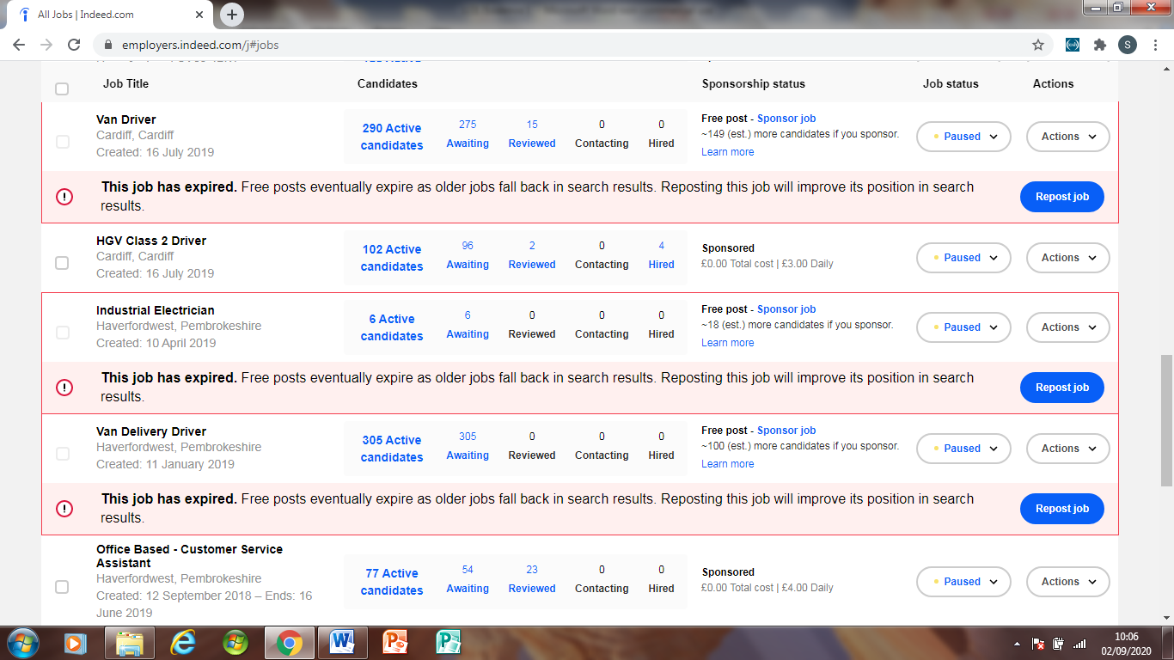

Office Based - Customer Service Assistant

Job Description
Due to expansion within our business, we require an additional individual to join our administration team. Friendly and patient telephone manner, computer literacy and ability to use Excel spreadsheets essential.
The job is full time hours over 5 days, with one working day being a Saturday.
Job Type: Full-time

This was the original wording for the advert.

EV 7


EV8
Alys Owens <alys@totallywelsh.co.uk>
Fri 11/09/2020 10:37

To:
You
M*** D*****e.pdf
123 KB

Many thanks
Alys Owens
HR Assistant

T: 01437 760166
M: 07484 013997
E: alys@totallywelsh.co.uk

From: Lab MH <lab_mh***.com>
Reply to: Lab MH <lab_mh***.com>
Date: Wednesday, 10 June 2020 at 12:58
To: Alys Owens <alystotallywelsh@hotmail.com>
Subject: Re: CV for Job description

Hi, Alys,

Please find CV attached.

Many Thanks
M**** D****e

Mark Hunter Ltd.
The Fresh Produce Centre
East Estate, Withybush Business Park
Haverfordwest
Pembrokeshire
SA62 4BW

Tel : 01437 760166

On Tuesday, 9 June 2020, 14:00:42 BST, Lab MH <lab_mh@yahoo.com> wrote:

Hi, Alys,

Give me until tomorrow morning and I'll sort it for you. Is there a specific format that you would want it written in?

Many Thanks
M*** D****e

Mark Hunter Ltd.
The Fresh Produce Centre
East Estate, Withybush Business Park
Haverfordwest
Pembrokeshire
SA62 4BW

Tel : 01437 760166

On Tuesday, 9 June 2020, 12:03:16 BST, Alys Owens <alystotallywelsh@hotmail.com> wrote:

Hi M****,

I hope you are well and have had a nice weekend 😄
I am currently getting through everyone's job description and yours in next in line
It would be a massive help to me if I could have your CV please? I will need it asap if that is okay? and I can get this sorted for you

Many Thanks

EV 9
Analysis of Jobs Indeed applicants for Haverfordwest Site

ROLE | No OF APPLICANTS | From County | Percentage
Head Production Manager | 23 | 3/23 | 13%
Quality Control Assistant | 127 | 106/127 | 83%
Trainee Accountant | 65 | 39/65 | 60%
HGV Apprentice | 5 | 5 | 100%
Office Manager | 23 | 21/23 | 91%
Senior Supervisor | 39 | 31/39 | 79%
Dairy Filler Operator | 28 | 23/28 | 82%
Industrial Electrician | 6 | 5/6 | 83%
Van Delivery Driver | 305 | 215/305 | 70%
Office Based Customer Services Assistant | 77 | 67/77 | 87%

Conclusion
The number of applicants did depend on how long the role was advertised for. Due to there not being one main lead on recruitment, length of posting varied. However I can conclude that the local labour market is our pool particularly in the lower skilled roles. This aligns with the insights of Stephen Taylor and Carol Woodhams in their chapter on Resourcing and Talent Planning (Human Resource Management: People and Organisations 2nd edition)
The only significant variance for the Head Production role which holds a salary of £55,000 and this has attracted talent from all over the UK. This confirms the aforementioned author’s reference to job seekers from the national market actively looking for skilled, specialist roles with higher salaries and relocation packages.
The trainee accountant role offered a graduate an opportunity with a structured development plan and thus attracted a wider pool, again referred to by the authors Taylor and Woodhams.

EV10

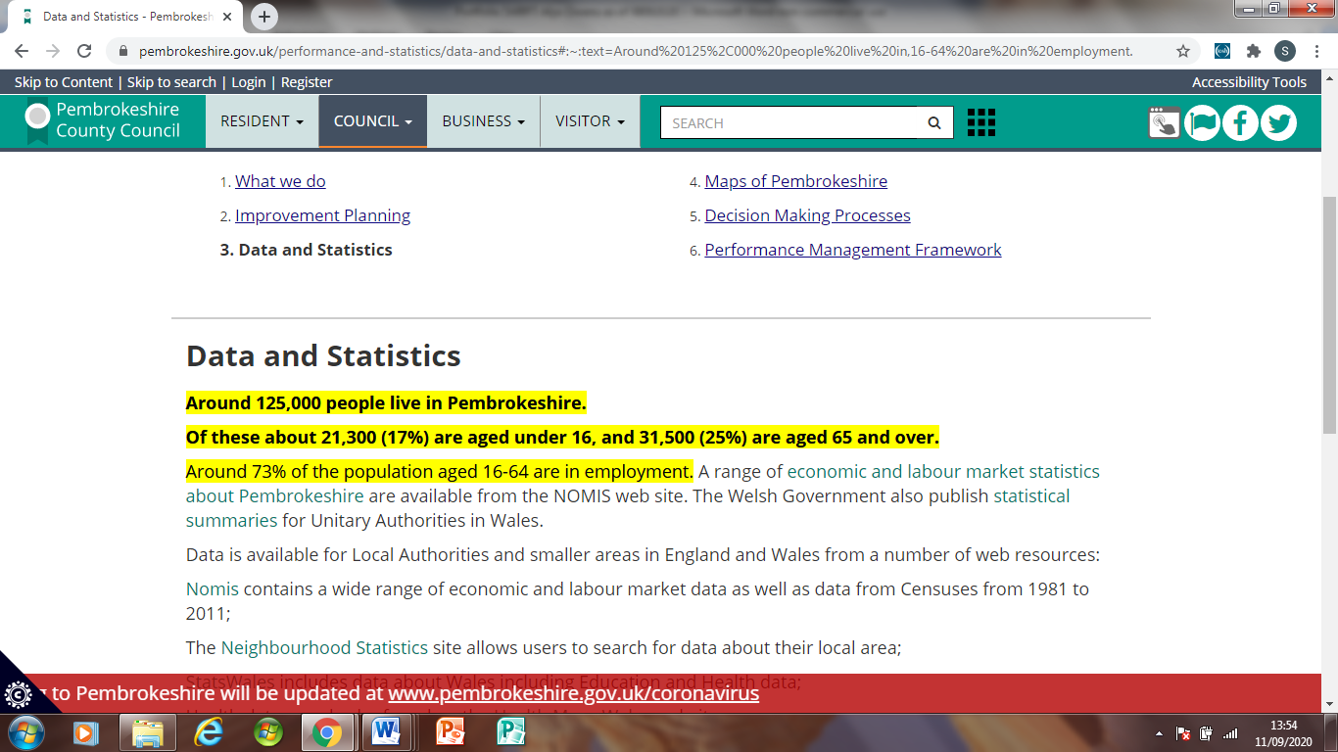

EV11
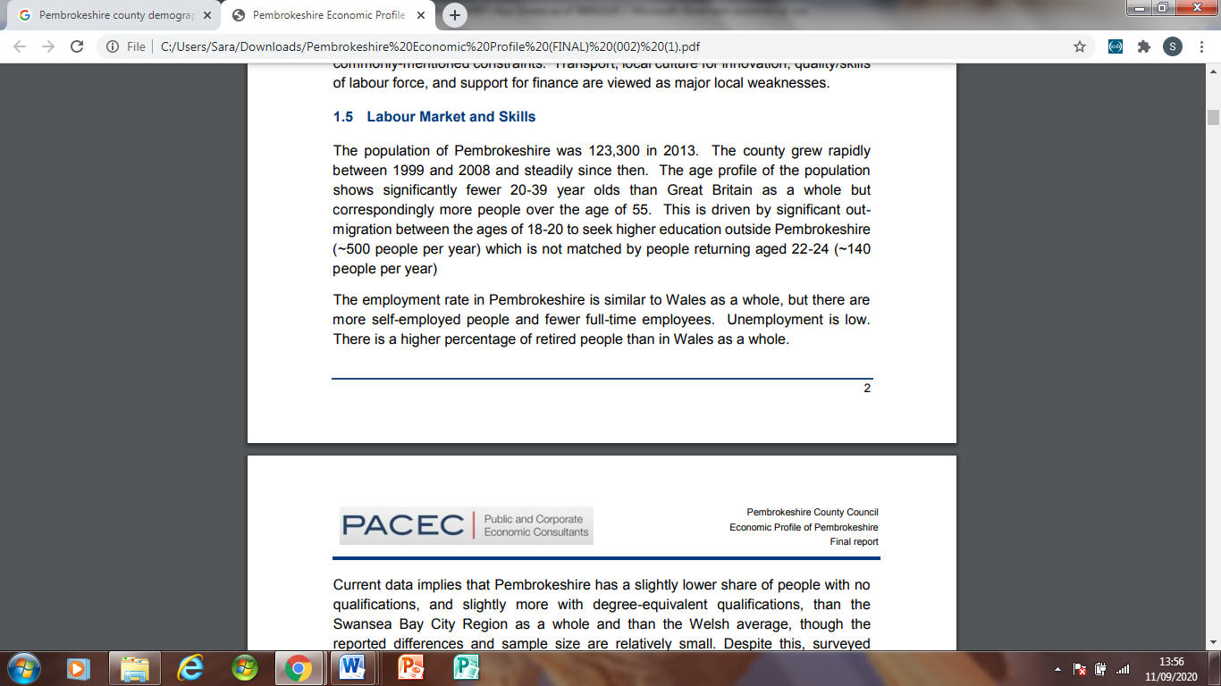
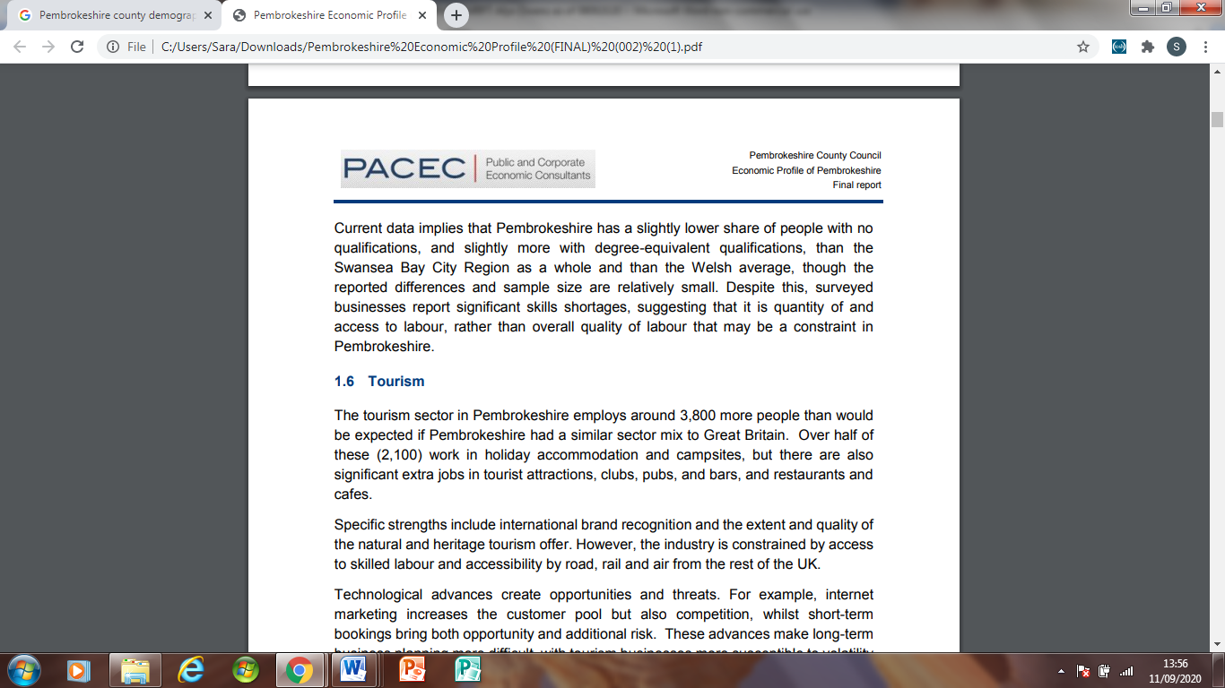

EV12
Welsh milk, from Welsh cows, bottled in Wales
Llaeth Cymreig, o wartheg Cymreig, wedi'i boteli yng Nghymru

Witness Statement for: LO1, LO2, LO3 achievement against assessment criteria
Sara Jones, HR Manager, Mark Hunter Ltd T/A Totally Welsh
Date: 7th September 2020

Until Aly’s recruitment in March 2020 I had been the sole member of the HR function. The function rose from my appointment in September 2019. For the months in-between her start I had been dealing reactively with employee issues and historic employee/employer relationship problems.
When Alys started she quickly discovered through discussion with me and the business owner the lack of a HR system in place and that we had much to do. (LO 1.3) Alys has been incredibly busy and has had to get up to speed with many HR issues very quickly. This has been a fantastic opportunity and challenge for her that she has embraced.
Do to no purposeful HR function existing there was no formal policies or procedures to review and one of the first exercises we did together was to discuss what Alys thought should be within an entire HR system and to carry out a gap analysis. We did a few different ones which included one to assess resourcing and talent planning which is in her evidence.(LO1.1) There has been so much to do to improve upon and this gap analysis has also required Alys to champion a cultural change in resourcing and talent planning. We have discussed change management and the change curve and Alys has witnessed this occurring within the work force and the management team. She has done well in this area through building rapport with all levels of staff. As her mentor, I’d say that it has not been easy for Alys due to little being in place but she has viewed this as an opportunity to learn and to be part of bringing in a system that is of a high standard.
Alys strove to find out as much internal information as possible surrounding historic resourcing. She reviewed internal structures, history of existing staff and how they were recruited, looked at some personnel files and through this identified gaps in our compliance with GDPR and equality. Improvements were made to access rights to the jobs advertising account and also staff starter packs and monitoring forms. She also identified that our brand was not strong through examining the content of our adverts and what we lacked in promotion. (LO1.2.1.3)
Alys has been heavily involved with all improved recruitment stages and now manages recruitment projects independently. Her last project was to recruit a trainee accountant and eventually credit controller in which I had no involvement at all. She attended meetings and virtual discussions on this gap identified in the workforce via the need to succession plan. She participated on decisions on the type of role and candidate profile required with the business owner (LO3.1,3.2). She strengthened adverts, drafted job descriptions ready for the new roles, managed receipt of applications, and processed them, shortlisted, interviewed and followed up.(LO 3.3,3.4,3.5) She has drafted interview questions herself for my approval and these have been fair and point based, usually following the STAR format. She has also then inducted the persons appointed, on one occasion going in on annual leave to ensure a new person felt welcome. She has received much praise in this area from me, the business owner and the company management accountant. (LO3.6) Alys also reflected on what went well and what could have been improved with me in discussion after the appointment. She then reported on this to me and the business owner fully. One area particularly was to the need to firm up the finer detail of the recruitment need from the outset with all stakeholders fully. This led to an improvement in that a “Resourcing Requisition” form was created. (LO3.6)
Although her portfolio is based on “business as usual” I can confirm that Alys also supported me fully during Covid 19 whereby I had to lead on the furlough of staff and carry out voluntary and non-voluntary redundancies. In this period she talked to staff, helped me make fair decisions and process and prepared letters. She also participated in meetings with the business owner and her contribution usually demonstrated a very fair perspective on equality. Please note that it is not the culture of the business to minute meetings and meetings are often spontaneous.
Alys has made suggestions for longer term improvements such as recruiting using social media and she has carried out an analysis of our legacy pool of applicants on Jobs Indeed to give us some idea of who’s applying and from where. (LO1.2) I’m aware that she is going to review this again in 12 months. Alys has also looked at other job sites and local companies recruitment style and incentives (LO1.2) She also researched demographics on the local authority web page and a report commissioned by the local authority. (LO1.2)
Alys also identified a gap whereby staff were being recruited without approval by the business owner. Alys worked with me on creating a form to prevent this from happening and to harmonise what was said to perspective employees. Alys also worked with me on a format to be used by the managers when appointing someone.
She has recently got involved with a project assessing the extent of needs being met on the recruitment and retention of cleaners ( LO1.3) She has worked with the Compliance Manager on assessing the adequacy of existing approaches. She beforehand took a collaborative approach, convened and chaired meetings with this manager plus the factory manager and supervisor. The outcome was improvements to working conditions offered to this tight market. Alys suggested flexibility in hours, paired working with friends, help with transport – all received well and agreed upon. (LO2.1) The advert is currently live now that Alys did and I think she has even got involved with rota scheduling!
Alys has also been involved with L&D in that we needed to get a Level One mandatory training pack out to all general factory staff for evidence of food safety training. Alys supported me in designing the pack and then has designed L&D training matrices on Excel. None existed electronically beforehand following her review of L&D activities. Achievements were held on individual personnel folders with no ability to view need strategically (LO1.2) Alys managed solely the dissemination and recording of this pack for our 2 cold store depots and worked collaboratively in dissemination of it at our main site. This also involved receiving the completed packs back, marking the content and issuing completion certificates and updating the matrices.

Yours sincerely,

Sara Jones
HR Manager
Totally Welsh

Registered Office : Mark Hunter Ltd, The Fresh Produce Centre, East Estate Withybush, Haverfordwest, Pembrokeshire, SA62 4BW.

Telephone : 01437 760166 Website : totallywelsh.co.uk

EV13
Welsh milk, from Welsh cows, bottled in Wales
Llaeth Cymreig, o wartheg Cymreig, wedi'i boteli yng Nghymru

8th September 2020
I am the business owner of Mark Hunter Ltd, T/A Totally Welsh
I am happy to confirm that Alys Owens, HR Assistant has been involved with the following activities since she started working with us on the 20th April 2020:

- Discussions and meetings with me and the HR Manager surrounding our history of working ways and specifically the way we have identified gaps in the workforce and recruited in the past. She’s reviewed what we have done up to when she started and then has begun to bring change with the HR Manager her mentor.
- Discussions on individual people and their skill and experience. Organisational structure. Plans for the future for staff.
- Discussions about how we could improve on the way we recruit and retain such as using social media and offering more to employees.
- Improving adverts and exploring different ways we can advertise.
- Getting job descriptions together to help with recruitment campaigns and what we are looking for in people.
- Alys was involved early on with a recruitment campaign led by the HR Manager for a senior member of staff, a Lead Engineer. Following this through her experienced gained, she took the lead on the recruitment of a Trainee Accountant. In this task she had to work with a sub-contractor and Alys worked well with this person. I felt the whole exercise went very well.

To add to this Alys has made many positives suggestions and improvements and very recently has done a good job on the recruitment campaign for cleaners which has always been a challenge.

EV14
Personal Statement for LO2
Make reasoned recommendations for how the organisation can maintain an appropriate number of people with the skills required by the organisation.
Scope: Business as Usual
I can evaluate and conclude from my review that the organisations approach to talent planning has mainly been done informally through the approach of “managerial judgement” (Taylor 2019) The business owner is a mature man with significant experience in his business sector as do two other key managers on the management team. He has also chosen to use familial and friendship relationships to both retain and recruit people of trust. This has proved worthwhile as many employees have been with the company a long time and these tend to be ones recruited in this way.
However, benchmarking against Taylors (2016) best practice for core talent planning, with respect to forecasting demand I have drawn that the organisations activities do not address needs as well as they could, particularly in light of business growth. There is a lack of strategic planning in line with the Ulrich best practice model of the “3 legged stool” Gaps have appeared in the workforce through growth or sometimes even obvious inevitable departures and only then the full need is recognised. This is a reactive approach as opposed to proactive best practice or “systematic” (Taylor 2019.)Some “working back from costs” (Taylor 2019) occurs but due to no competency framework or aligned pay structure, costs for talent can again be assessed from managerial sector led judgement. I’ve identified, through discussion with the HR Manager, that this has caused some unhappiness over perceived pay inequalities within the workforce which led to communications being sent out in a bid to calm and reassure employees. (EV 15) I recommend formalising through objective setting and HR KPIs, comprehensive people planning and succession planning activities.
When addressing identified gaps plus forecasting required skills; again the organisation is falling short (Taylor2019.) There was some evidence of mobilisation and the retention of valued people, I witnessed through my evaluation four instances of effective mobilisation but this was spontaneous and more chance based as opposed to planned. Key contributors and critical professionals (Cascio et al 2017) were not supported and on many occasions sub-contractors were taken on to fill talent gap and some have been visiting the site for considerable years at a higher cost than employees. A lack of a HR function and collaborative approach to planning (CIPD 2019) had removed the ability to review workforce planning for many years. I was unable to examine any retention statistics (CIPD 2014) I recommend improving knowledge of the labour market and more retention incentives.
In making other recommendations I feel first and foremost that the HR function needs to be actively informed of business operational and strategic objectives, visions and growth plans so prediction of skill requirements can be made. Initially in the prime stage of the HR function evolving, the function was brought in too late, which has led to continuation of workforce gaps and overuse of sub-contractors and agency staff at an expense to the business. If the visions and plans are to be made known; the HR function can then consider them against the economic, demographic, political, legislative and technological status for skill demand (Taylor 2019) they can also assist in change management.
As the HR function existence has lengthened the impact in talent planning with respect to demand and supply can already be seen. There has been some recent evidence of backing up key positions (Rothwell 2010.) I have been actively involved in recruitment of a trainee accountant to fill a recognised gap through retirement and most recently a recruitment campaign for a head production role to assist with forecasted growth. There has also been identification of a “tight market” existing for specific roles. (Taylor 2019) This has been achieved mainly by the drafting of an organisational chart enabling us to view holistically the structure. (EV16) This then led to identification of those employees who are approaching retirement “thoughts” and those roles who are key and potentially only one person deep. This analysis needs to continue and as a second recommendation that aspiration discussions take place through the introduction of a performance management and review system. There is a need to review through this chart compilation, reporting lines, reward and role clarity.
I feel that a swift review of the talent pool we currently hold is critical so we can consider mobilisation, career progression for suitable and interested employees. (Hirsch 2018) This has been concluded following the discovery of a member of staff with a high skill level being underutilised.(Ungemah 2015) We hold employees’ email addresses and (under the correct parameters) could provide a template for them to populate with skills held.
We need to review the over use of sub-contractors and examine the need for employees to be recruited into these roles. We also need to review the effectiveness of using agency staff through a demand and forecast exercise. These reviews are essential for costs and stability.
There is a need to continually improve on the quality of our recruitment campaigns and analysis. We need to improve on selection methods. (CIPD 2015)We need to strengthen our brand and brand awareness and look at increasing staff retention schemes. In comparison to local competition my analysis of adverts highlighted that we did not list the benefits of working with us or resolve any barriers to employment through incentives.
With the improvements being progressed then the approach to planning would be relevant to the organisation’s needs.

Alys Owens

Evidence to support LO2
EV15

Dear Totally Welsh / Totally Welsh Direct employee
We do hope that this email finds you all safe and well. We write about 2 keys areas:
- Covid -19
- Staff Pay
Covid 19
We would like to take this opportunity to firstly thank you for all your hard work and efforts made during the last 5 months. We refer to not only working but working alongside personal worry and concern about the global pandemic happening around us. Thank you for “keeping business as usual” as usual as we possibly could under the circumstances.
We now want to remind you of the on-going need to keep safe from the Coronavirus and to practice good hygiene, especially hand washing and when coughing and sneezing. Please also try and remember to socially distance.
We ask as we have carried out a second risk assessment following concern that measures are being relaxed and that travel restrictions are being lifted. We are confident some of you will have read about recent outbreaks occurring in food manufacturing sites. We wish to avoid this obviously, we want our staff to stay healthy and we wish business to carry on.
To this effect we do ask you to be vigilant and not to become complacent as localised outbreaks are still possible. Please also remind people when and if you can. We as part of the management team are no exception and we have had to remind ourselves to try and lead by example.
Our Compliance Manager Scott will be out and about checking site compliance soon and making sure that we are keeping you as safe as we can and that we have sufficient on-going controls in place. You can speak to Scott if you have any concerns and also any ideas on how we can improve in keeping us safe.

Staff Pay
Obviously the impact of Covid 19 has hit many companies, we included, but we do not wish to use it as an on-going excuse for not reviewing pay and we won’t.
We are aware of some unhappiness over pay within our workforce. It’s only fair to say that we have faced financial challenges. Sadly, and you may not all be aware but there have been some casualties in that we have had to make some redundancies across the business. This has not been what we wanted but we have been fortunate, through strong financial leadership that the number of redundancies has been minimal compared to other similar businesses.
We are in a position now to tell you that there is to be a job evaluation exercise to be starting from within the HR function. The purpose of this is as follows:

- To evaluate roles against a competency matrix ensuring that the pay people receive is appropriate for the duties and responsibilities they hold
- To ensure that any new roles created are matched against the competency matrix and the advertised pay is appropriate for the duties and responsibilities they hold
- To publish, to all staff, a transparent pay structure based on the outcome of the above – graded with escalating pay bands within it
- Where appropriate, following this exercise, lift pay accordingly in areas where required and consider a general pay increase
- Create a workable on-going system whereby pay is reviewed fairly, equally and proportionately

Please note no individuals pay will be reduced through this exercise
We anticipate this major exercise starting at the end of August with a target completion date of the end of September.

Sara Jones HR Manager on behalf of Mark and Shan H*****

EV16

EV17
Personal Statement for LO3
Be able to contribute to people resourcing activities
Scope: Business as usual
3.1
Through examination of the newly drafted organisational chart for succession planning (EV16) I identified that there was a Management Accountant “RB” who was a unique talent with his skill set and of an older age. Within confidential discussion with my line manager and the business owner it was revealed to me that the role holder had been struggling recently in work with workplace interpersonal difficulties and challenges at home through bereavement of a close family member. The role holder had also been making errors. This aspect of the situation was being managed through engagement with the HR Manager. With these performance and wellbeing factors to consider plus his age, we held concerns over the longer term prospects of his retention - the role he fulfils and the gap it would leave. Due to the intervention being an unknown and unpredictable quantity plus no knowledge of his retirement plans, although inevitable, we decided to invest in the recruitment of a Trainee Management Accountant. (EV12)
3.2
The business owner and the HR Manager asked for me to take the lead on the recruitment campaign. I had gained experience of the whole process through the recruitment of a Lead Engineer (EV12) alongside the HR Manager and it was felt that this was the opportunity for me to take the main lead and show a collaborative approach to planning (CIPD 2019). The business owner did request that I collaborated with the current sub-contracted accountant who had been with the company some time. (EV18 )It was agreed that this person “KJG” would review the advert and job description to be drafted for the sector specific content such as required qualification aims. (EV21) They would also prepare a set of sector specific interview questions alongside my general ones. My manager, the HR Manager would be available for support, coaching and mentoring if required.
3.3
The procedure and planning I followed as lead on the campaign mirrored that of the one for the Lead Engineer. I drafted the job description and advertisement. (EV19) I collaborated with KJ and the business owner on firming up specifics about the role. With respect to the existing role holder “RB” I understood the legislative parameters of the Equality Act with equality and diversity and referred to various web based resources such as ACAS 2015, CIPD 2015, CAB, GOV.UK and Age UK so that I acted professionally in any conversations with “RB” surrounding his age and unknown retirement plans and timings of. I was conscious of not leaving this person with any feelings of being replaced or got rid of. (CIPD 2012) I also shared with him early on the recruitment campaign. Prior to and during my recruitment campaign I again drew on the above web based sources for legislative provisions and good practice. (EV21) I also had to consider how to conduct the interviews in the face of Coronavirus and the Health Protection (Coronavirus Restrictions) Wales Regulations.
3.4
I arranged an initial virtual meeting with “KJG” to plan and prepare for the agreed role. We discussed the proposed advert, the advertising medium and potential pool, joint availability, questions. (EV19) (EV21)I discussed with “KJG” the legal boundaries such as equality and diversity and GDPR for the entire process ahead.
3.5
The whole recruitment campaign was completed in 7 – 8 weeks, my initial contact with KJ being on the 25th June and the role holder starting with us on the 17th August. (EV20) (EV21)
3.6
The outcome following the initial sift of applicants was 10 were interviewed. 3 went through to the second interview. The final outcome was that there were 2 appointable persons. The offer went to GB.
The effectiveness of the campaign was high. From the interviews we appointed the Trainee accountant but were also able to offer a second role that appeared during the campaign for the role of Credit Controller to our second choice candidate. I reflected and reported on the campaign and the only area I would have done different was gaining full confirmation and agreement of the salary. (EV12)
Alys Owens

Evidence to support LO3
EV18
From: Alys <alys**********@*****.com>
Sent: Thursday, 25 June 2020, 09:42
To: K***************
Subject: Trainee Accountant
Hi K***,
I'm Alys, I'm not sure if we have emailed before but I work in HR with S***,
As you know we are looking in recruiting a Trainee accountant. I have drafted a job advert up;
It would be brilliant if I could have some feedback for this role, e.g are the qualifications correct, hours.
I look forward to hearing from you and will be lovely to work on this with you
Trainee Accountant
An excellent opportunity has arisen for a trainee accountant to work for our growing company Totally Welsh. The chosen candidate will need to be working towards ACCA/CIMA qualification or equivalent. If you have aspirations for a career in finance and looking for development within the financial management function, then this role is for you.
Job Information
- Full-time role whilst studying to become an accountant
- 40 hours a week
- 8am-4pm (9am-5pm)
Ideal candidate;
- Hard working
- Confident in building strong relationships
- Diligent but efficient working practices
- team Player
- Working towards becoming a fully qualified accountant
Skills needed;
- Having excellent written and spoken communication
- Having high attention to details
- Being proactive and self-motivated
- Having IT skills
- Being able to work with a team
- Having interpersonal abilities
- Being able to work under pressure
- Having math skills
- Being friendly and tactful
- Organisational skills
Many thanks
Alys

From: k******@*****.com
Sent: 25 June 2020 14:45
To: Alys <alys*******@hotmail.com>
Subject: Re: Trainee Accountant

Hi Alys,
Lovely to hear from you.
Thank you for forwarding the job advert. Is it okay if I consider this and send any amendments/suggestion over to you by tomorrow morning?
Kind regards
K***

Alys
Thu 25/06/2020 14:47
To: k******@******com

Hi K***,
Yes, no problem at all. Wasn't too sure on what days you work!
If you want to call me tomorrow or email my number is 07484013997

Thanks,
Alys

From: Alys [mailto:alys******@hotmail.com]
Sent: 26 June 2020 14:42
To: k******@******.com
Subject: Trainee Accountant
Hi K***,
I hope the tweaks are okay. I am happy to post the advert after you have confirmed that you are happy.
I didn't feel the need to expand it much as I am pretty confident it will be a popular advert and people will jump at this opportunity. I'm confident it will sell as it is.
Thank you for your time today - was lovely to speak to you
Alys

EV19
Trainee Accountant Advertisement
An excellent opportunity has arisen for a Trainee Accountant to work for our growing company Totally Welsh. The chosen candidate will need to be working towards (or applying) an ACA/ACCA/CIMA qualification or equivalent. This role is an opportunity to fulfil your career in financial accountancy. If you have aspirations for a career in finance and looking for development within the financial management function, then this role is for you.
Job Information
- Full-time role whilst studying to become an accountant
- 40 hours a week (Could vary due to time studying or university times)
- 8am-4pm (9am-5pm)

Ideal candidate;
- Hard working
- Confident in building strong work relationships
- Diligent but efficient working practices
- Team Player
- Working towards becoming a fully qualified accountant

Skills needed;
- Having excellent written and spoken communication
- Having high attention to details
- Being proactive and self-motivated
- Having excellent IT skills
- Having previous experience of using accountant software packages e.g. SAGE, Excel
- Being able to work with a team
- Having interpersonal abilities
- Being able to work under pressure
- Having excellent mathematics skills
- Being friendly and tactful
- Organisational skills

Qualifications
- Minimum of 2 A Levels (or equivalent)
- Minimum of 3 GCSE (or equivalent) 1 being Mathematics

From: K <k******@******.com>
Sent: 26 June 2020 16:28
To: 'Alys ' <alys******@hotmail.com>
Subject: RE: Trainee Accountant

Hi Alys,

Please see the attached. I have made some additional tweaks and these suggestions have been highlighted.

Hope that’s okay.
Kind regards

K***

From: Alys [mailto:alys******@hotmail.com]
Sent: 27 June 2020 10:17
To: K*********
Subject: Re: Trainee Accountant

Hi K***,

Brilliant thank you! Need to run it past Mark and then I can put the advert out.

Thanks for all your help
Alys

EV 20
From: K******<k****@******.com>
Sent: 01 July 2020 11:22
To: 'Alys' <alys*******@hotmail.com>
Subject: RE: Trainee Accountant
Hi Alys,
I can see that the advert has now become live, which is great.
Please could you forward me the CV’S and applications as and when you receive them.
Hope this is okay.
Kind regards,
K***

Alys
Wed 01/07/2020 15:40
To: K******
Hi K***,
I have had 37 people apply for the role - it is still live so I'm sure there will be more.
I have not had to the chance to look over any yet. Will be in touch soon
Many thanks
Alys
K*****@btinternet.com
Wed 01/07/2020 16:04
To: You
Hi Alys,
That's exciting. 🙂
Looking forward to seeing the CV's soon.
Kind regards,
K***
EV 21
Alys
Fri 03/07/2020 10:07
To: K*****
Hi K***,
Just an update on Jobs Indeed. I currently have 54 candidates. Think it is best to close the advert on Monday morning.
I have had a quick look and some candidates have generated automatically and some candidates are from all over the UK. I have scanned through a few and we have some very strong candidates.
With COVID, are you going to be on-site at all any time soon? if not, we could Facetime next week and have a chat and go through the CV's
I am in Cardiff today, in a few meetings, therefore, I will only be able to email today
I look forward to hearing from you
Alys
K****@******.com
Fri 03/07/2020 10:44
To: You
Hi Alys,
Thanks for the update.
I wonder if it is too soon to close the advert after just one week, perhaps a closing date could be added to the advert instead?
I'm fully available for a virtual meeting next week. I'm okay with Microsoft Teams and Zoom, would either of these work for you?
Also, I'm very keen to see the applications that we've received ☺️ Is there any chance you could send me through some of the key candidates prior to our meeting?
I've also just had call from a contact of mine in Hays, she has requested an introduction with you after seeing the advert. Let me know your thoughts regarding this.
Have a good day in Cardiff.
Kind regards,

Alys
Mon 06/07/2020 13:59
To: k*****@*****.com
Hi K***,
Sorry for the delay in the reply!
I do hope you have had a great weekend. Bit of a mad Monday for me!
Yes, zoom works best for me - I am happy to set up a meeting for this week. Tomorrow or Thursday suits me 🙂
I have 73 candidates at the minute - looking very good
Let me know what time and day works best for you. Be nice for us to talk properly rather than texting and emailing
Regards,
Alys
K***** <k****@*******.com>
Mon 06/07/2020 22:32
To: You
Hi Alys,
That’s great, Thursday works well with me, just let me know a time that suits.
In order that I can get up to speed prior to Thursday, could you forward me the CV’s that you’ve had to date.
Kind regards,
K***
Alys
Tue 07/07/2020 08:21
To: K J Geary
Hi Kath,
Yes, no probs I will send them over asap. It's no1 on my list this morning.

10 am okay with you?
Thanks
Alys
Alys Owens
Tue 07/07/2020 09:28
To: K*********

Trainee Accountant .docx
345 KB
Hi K***,
Hope this is okay for you!
Thanks
Alys
Alys
Tue 07/07/2020 11:22
To:K******
Hi K***,
Here are the Zoom details for Thursday!
Meeting ID: 723 4017 6325
Password: 3ZEhHC
Thanks,
Alys
K******<k*****@*****.com>
Tue 07/07/2020 22:54
To: You
Thanks Alys,
See you on Thursday.

K***
K*** <k***@*****.com>
Thu 09/07/2020 12:20
To: You
Hi Alys,
Great speaking today, as promised here is my shortlist of candidates for interview. They are in order of preference:

1. AE
2. JC
3. GB
4. BF
5. LL
6. FP
7. LG
8. KB
9. SJ – (I would like more info here, a very short CV).
10.HA and LG (I’m not sure about these two candidates)
Speak soon,
K***
Alys
Thu 09/07/2020 12:27
To: K******
Hi K***,
Thank you. My order of candidates is;
- AE
- JC
- GB
- SJ (Explore Cv)
- BF
- FP
- LG
- KB

No to H*** and L**
Thanks
Alys
Alys
Fri 10/07/2020 12:10
To: K******
Hi K***,
Apologies on my behalf, there was a 2-page gap on his application, and I did not see his CV at the bottom of his personal statement.
Sorry - I did think it was odd there was only a personal statement!!
If you could let me know - have you had S***'s email? what did you think of A***'s CV?
Many thanks
Alys

K***@******.com
Fri 10/07/2020 13:15
To:You
Hi Alys,
I think they both deserve an initial interview.
We're going to have a busy 3 days. I will keep the dates you have mentioned free.
Speak soon,
K***

Alys
Mon 13/07/2020 11:40
To: K****
Trainee Accountant Tasks.docx
216 KB
Hi K***,
Are you happy with this as a small task to give to the candidates? Emily thought this would be useful to see their ability and it is similar to some exercises she had completed in Accountancy interviews.
Your feedback would be greatly appreciated as they are expecting to receive an exercise this afternoon.
Many thanks,
Alys
K***** <k****@******.com>
Mon 13/07/2020 14:19
To: You
Hi Alys,
I hope this is okay, feel free to amend:-
Prior to the interview please investigate the Mark Hunter Ltd Company Accounts, year ending 31st July 2018, these can be found online at Companies House.
During your virtual interview we would like to discuss your findings. If you wish to support your analysis with graphical representation, please ensure that a copy is emailed to us by Friday 17th July 2020.
Please feel free to call me if you wish to discuss this further.
Kind regards,
K***

Alys
Mon 13/07/2020 14:23
To: K****
Hi K***,
All looks good to me! In my first email, I did say to return it the day before their interview.
I am excited to see what they come back and create for us!
Many thanks
Alys
K****@******.com
Thu 16/07/2020 11:08
To: You
Hi Alys,
As promised, my Skype username name is k*****@*********.com.
Speak soon,
K***
Alys
Thu 16/07/2020 15:57
To: K*****
Hi Kath,
I just want to go over a list now ready for next week of what's done and what is outstanding.
Here are the 8 candidates;
- SJ
- AB
- FP
- AE
- BF
- LL
- GB
- LG

I am waiting on LL's Skype email. I have attached a word document of the timetable including interview details. Date and time slots. Expected salary.
I have prepared my questions from what I feel we should ask. They are attached in the email also. I feel like we can learn a lot from these questions and learn what type of person/worker they are.
To make it a fair process - I will be scoring candidates on how well they have answered and the exercise/task we gave them to complete before the interview. When deciding between very good candidates this makes it easier to compare and to fulfil the choice.
We did speak last week on Accountancy questions? Correct me if I'm wrong as my memory is not great - Are you happy to form accountancy questions?
I hope this helps - trying to get my head sorted today as it is Friday tomorrow. It has been lovely preparing this with you K***, I'm really looking forward to next week.😄
Speak soon,
Alys
K***** <k*****@******.com>
Fri 17/07/2020 14:23
To: You
Hello Alys,
Thank you for the attached, this will help me plan for next week. I’ve also enjoyed us working together and I’m very much looking forward to meeting our selected candidates next week.
These are the accounting questions I would like to ask:
1. Discuss the accounting task that was set.
2. Please explain the difference between Profit and Loss Accounts and the Balance Sheet Statement.
3. Please explain your understanding of double entry bookkeeping.
4. What is your understanding of accruals and prepayments?
5. If you were working on a project and you became aware that you weren’t going to complete the work by the given deadline, what would be your course of action?
6. As a trainee accountant you will have access to private and confidential information. How would you ensure that such information was kept private?

Hope these are ok. Let me know what you think.
Feel free to call me this afternoon if you wish to discuss the above. Shall we also have a catch up on Monday morning before the first interview?

Kind regards
K***

Alys Owens
Fri 17/07/2020 15:12
To: K*****
Hi K***,
Monday morning will be lovely! Shall we Zoom?
Many thanks
Alys
K*****@******.com
Fri 17/07/2020 15:22
To: You
Yes, that's great. 🙂
Alys
Mon 20/07/2020 09:09
To: K*******
Zoom at 11 am??
Alys is inviting you to a scheduled Zoom meeting.
Topic: Catch up
Time: Jul 20, 2020 11:00 AM London

Join Zoom Meeting
https://us04web.zoom.us/j/78230660173?pwd=RCtZVGUxSjlyWXdqMmxhWi9xd2ptZz09
Meeting ID: 782 3066 0173
Passcode: 9jrws9
Thanks,
Alys

K*****@******.com
Mon 20/07/2020 09:21
To: You
Hi Alys,
Have you had a report etc. from this morning candidate?
K***
Alys
Mon 20/07/2020 09:25
To: k******@*******.com

Hi K***,
No!! - I haven't chased him because I do not feel I should be as it would not be fair to others. It was very clear in my email.
This will affect his scoring as he has not read the email properly.
Speak soon,
Alys 🙂

Email sent to chosen candidates inviting to virtual interviews.
Dear …………………………,

Thank you for applying for our Trainee Accountant role with Mark Hunter Ltd, T/A Totally Welsh.

We are interested in discussing your application further. We would like to invite you to a virtual interview to discuss the job requirements and learn more about you.

You will have an initial interview with myself Alys Owens HR Assistant, Kath Geary Accounts Manager.

Prior to the interview, we would like you to complete a small exercise. You will be sent the exercise via email on Monday 13th of July.

Please note, you will need to submit your exercise by 3 pm the day before your interview slot. We will then refer to it during your interview.

Please reply to this email at your earliest convenience confirming attendance, your preferred day and time slot, and which of these options work best for you. Can you please also indicate your pay expectation for this role so we can ensure that we are not wasting your time if we cannot meet it.

Virtual medium options:
- Zoom
- Skype
- FaceTime
- WhatsApp

Preferred date and time;

Monday 20th of July – 9:30hrs
Monday 20th of July – 11:00hrs
Monday 20th of July – 13:30hrs
Monday 20th of July – 15:30hrs

Tuesday 21st of July – 9:30hrs
Tuesday 21st of July – 11:00hrs
Tuesday 21st of July – 13:30hrs
Tuesday 21st of July – 15:30hrs

Thursday 23rd July – 9:30hrs
Thursday 23rd July – 11:00hrs
Thursday 23rd July – 13:30hrs
Thursday 23rd July – 15:30hrs

If none of these options are suitable, please let me know what your availability is for next week.

Regards,
Alys Owens
HR Assistant
Totally Welsh

Email to unsuccessful candidates

Dear ………………………

Thank you for your application for the Trainee Accountant at Mark Hunter Ltd T/A Totally Welsh. We really appreciate your interest in joining our company and we want to thank you for the time and energy you invested in applying for our job opening.

We received a large number of applications, and after carefully reviewing all of them, unfortunately, we have to inform you that we won’t taking your application any further.

We really do appreciate your interest in our company. We hope you’ll keep us in mind and apply again in the future should you see a job opening.

If you have any questions or need additional information, please don’t hesitate to contact me by email alys@totallywelsh.co.uk

We wish you every personal and professional success in the future

Once again, thank you for your interest in working with us.

Regards
Alys Owens HR
Totally Welsh

Time slots for Virtual Interviews
Name | Time | Virtual Medium | Salary
SJ | Monday 20th 1:30pm | Zoom  Meeting ID: 799 8855 0288  Passcode: 5RDPmv | £23,000
AB | Tuesday 21st 11am | Zoom  Meeting ID: 722 6243 7184  Passcode: 9YRuN0 | £19,000/£20,000
FP | Tuesday 21st 3:30pm | Zoom  Meeting ID: 790 7517 3098  Passcode: 3NbLrs | Wanted to see if we could fund
LG | Wednesday 22nd 10:30am | Zoom  Meeting ID: 761 6839 1150  Passcode: 9e1SM6 | Did not say
AE | Thursday 23rd 9:30am | Zoom  Meeting ID: 731 6196 7953  Passcode: 5SLdnH | £15,500-£18,000
BF | Thursday 23rd 11am | Zoom  Meeting ID: 797 6860 6721  Passcode: 8ptBza | 15-19K
LL | Thursday 23rd 1:30pm | Skype | £19,000
GB | Thursday 23rd 3:30pm | Skype  g********@****.com | £11

Interview Questions Trainee Accountant Monday 20th / Tuesday 21st / Thursday 23rd July

Q.1 What attracts you to this role? |  | 10

Q.2 Where do you see yourself in 5 years’ time? |  | 10

Q.3 What are your strengths and weakness’ |  | 10

Q.4 What aspects of work do you really enjoy? |  | 10

Q.5 What do you want to get out of this role specifically? What’s your plan? |  | 10

Q.6 How would you describe yourself? |  | 10

Q.7 What is your understanding of equality act? |  | 10

Q.8 Discuss the accounting task that was set |  | 10

Q.9 Please explain the difference between Profit and Loss Accountant and the Balance sheet statement |  | 10

Q.10 Please explain your understanding of double entry bookkeeping |  | 10

Q.11 What is your understanding of accruals and prepayments? |  | 10

Q.12 If you were working on a project and you became aware that you weren’t going to complete the work by the given deadline, what would be your course of action? |  | 10

Q.13 as a trainee accountant you will have access to private and confidential information. How would you ensure that such information was kept private? |  | 10

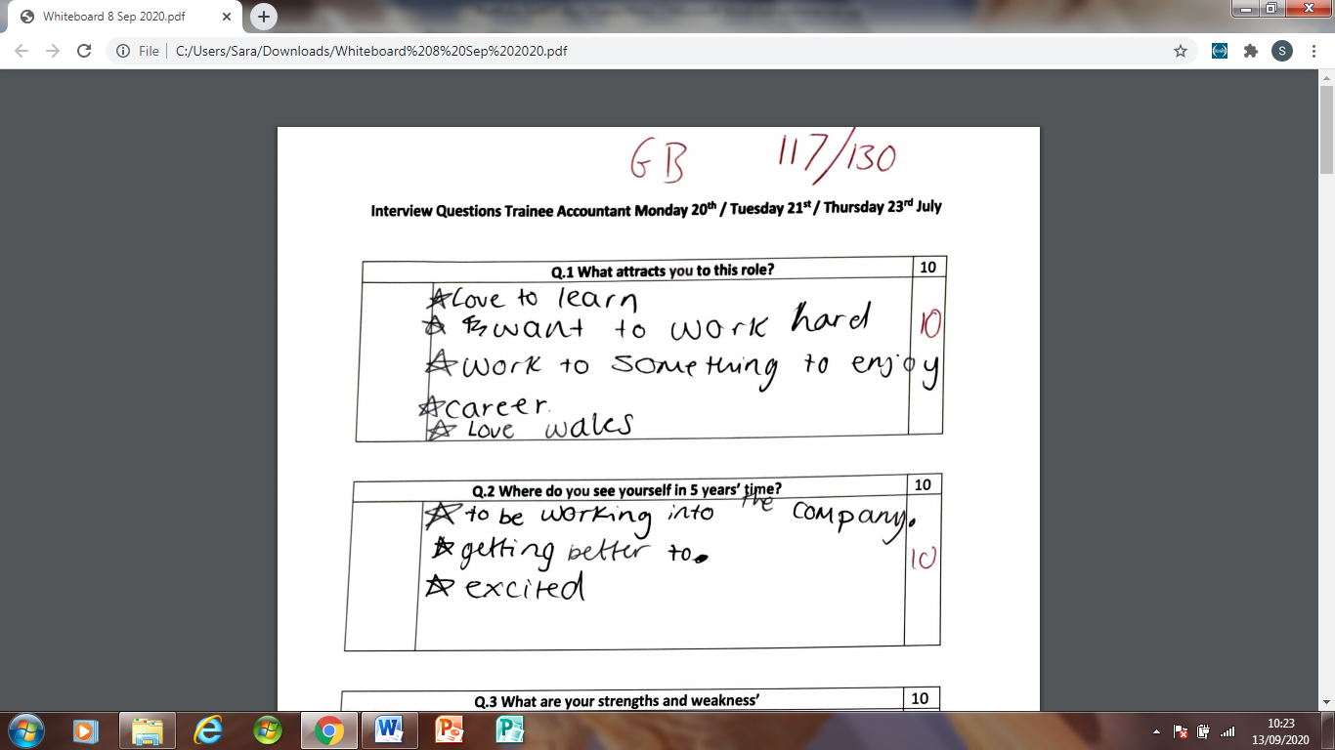
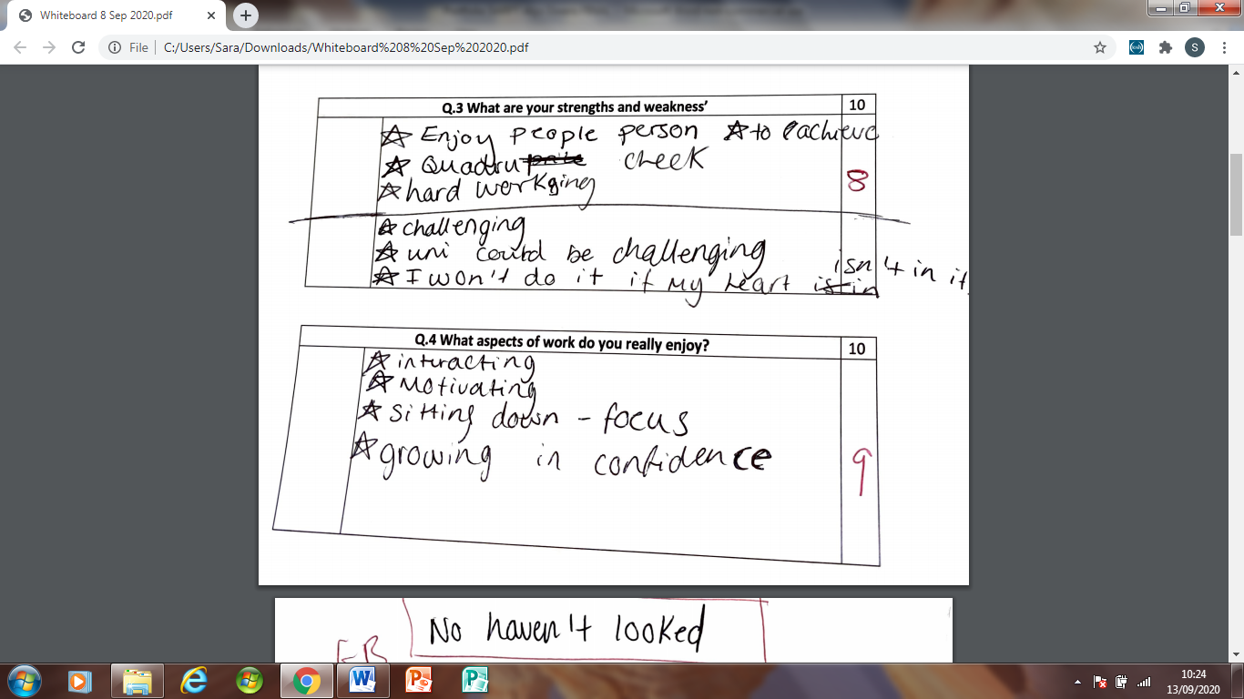
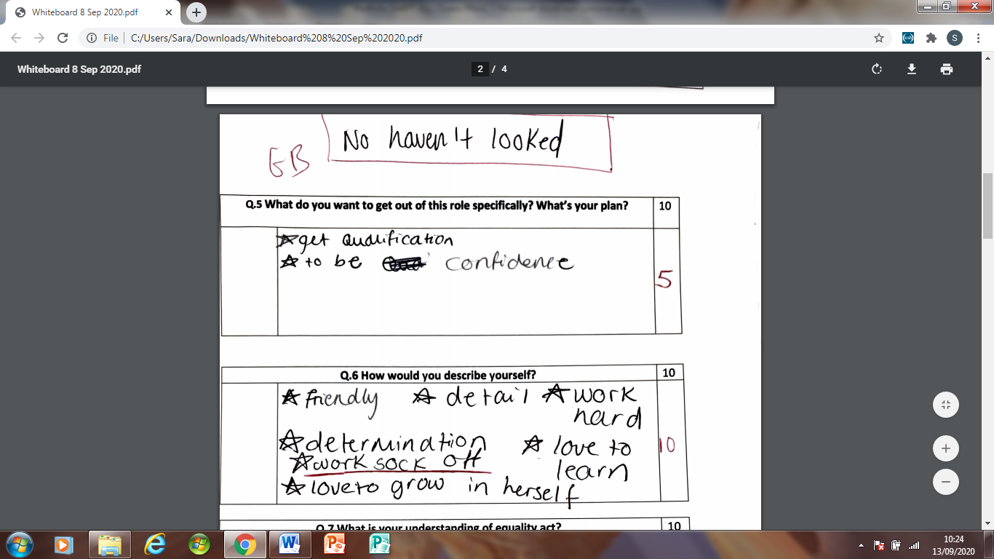
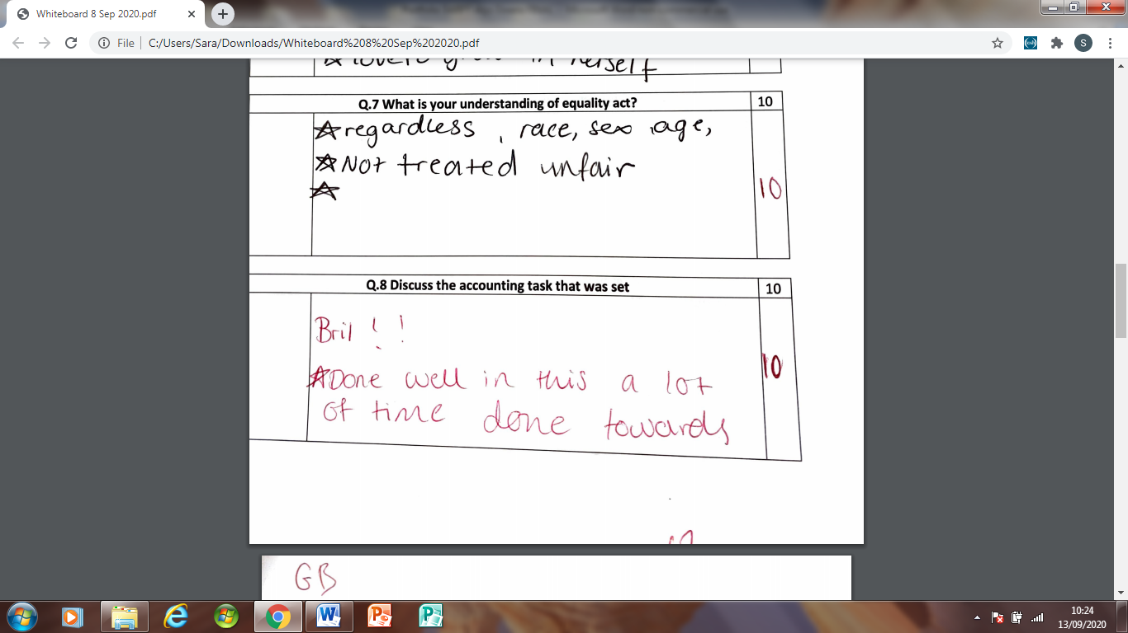
Email inviting the short list to a second interview

Thank you for taking the time to discuss the Trainee Accountant role with us on Thursday. We really enjoyed getting to know you and learning about your skills. You have put a lot of time and effort into applying for the role. It was lovely to hear that you researched Totally Welsh further.
We would like to invite you on-site to meet Kath and I. An opportunity to explore the office and to discuss the role further.
If you could let me know your availability next week. Once confirmed, I will then plan times, safety with COVID etc.
I look forward to your response,
Alys Owens HR Assistant
K********* Accounts Manager
Totally Welsh

Trail of emails corresponding with our short lift candidates

G********* <g**********@*****.com>
Fri 24/07/2020 14:15
To: You

Hi Alys
Thank you so much for your email. I would be thrilled to attend an on-site visit next week to meet Kath and yourself.
I am free all day Tuesday 28th and all day Thursday 30th. If these days are not suitable please let me know, then I could try to reschedule my other commitments.
I look forward to hearing from you.

Kindest regards
G*****

Alys
Tue 28/07/2020 09:17
To: G*********
Hi G*****,
I have received your email. I am going to catch up with K*** this morning. Very busy yesterday.
I will be in touch later today.
Many thanks,
Alys

Alys
Tue 28/07/2020 19:28
To: G*******
Hi G******,
Does Thursday 4:30pm suit you?
Many thanks,
Alys

G******* <g********@gmail.com>
Tue 28/07/2020 19:38
To: You
Hi Alys,
Thursday at 4.30pm is great with me. I’ll see you and K*** then.
Many thanks
G****
Alys
Thu 30/07/2020 08:52
To: G*********

Hi G*****,
The address and postcode to the depot - ******************************
I will meet you at the entrance as the gate is locked.
Please sanitize your hands before entering the building.
If you would kindly fill out track and trace. (I will provide you with one)
Social distancing measures will be in place. But if you would like to bring a face cover please do so.
I look forward to seeing you at 4:30 pm today
Many thanks,
Alys

G******** <g********@*****.com>
Thu 30/07/2020 13:10
To: You

Hi Alys,
Thank you for this information.
Looking forward to meeting you at 4.30pm.
Regards
G*****

Email offering chosen candidate the job role

Dear G**********,

Following your recent interview, on-site visit for the role of Trainee Accountant at Mark Hunter Ltd (T/A Totally Welsh), we are very pleased to inform you that your application has been successful and we are delighted to offer you the post on the terms outlined below:-

• We offer you this full-time permanent position on a starting salary of £23,000 per annum.
• The role will involve working 40 hours per week over 5 days.
• We will provide funding for you to attain a professional accountancy qualification.
• You will be subject to a 6 month satisfactory probationary period.
• A salary review will take place following your first 12 months of employment.
• Holiday entitlement is statutory.

We are very much looking forward to you joining the team here at Totally Welsh and we hope that you will formally accept this offer confirming your proposed start date by return of email.

Many thanks,
Alys
Totally Welsh

Email from candidate accepting the role
Hi Alys,

Thank you for the clarification.

I am delighted to accept the offer for the position of Trainee Accountant, and I am looking forward to working with you and the team.

Would a start date of Monday 17th be acceptable to you or is that date to soon? If this date is agreeable, then would an 8am starting time be suitable?

I shall await your reply.

Many thanks again.

EV 22
Email from the business owner after appointing Trainee Accountant

M*** H***** m**********@**********.com
Friday, 7 August 2020 at 16:09
To: Alys Owens <alys@totallywelsh.co.uk>

Hi Alys,
All good with the attached.
Well done on the G***** recruitment, you did a lot of good work.
M***

Text Message from colleague “KJ” after recruitment

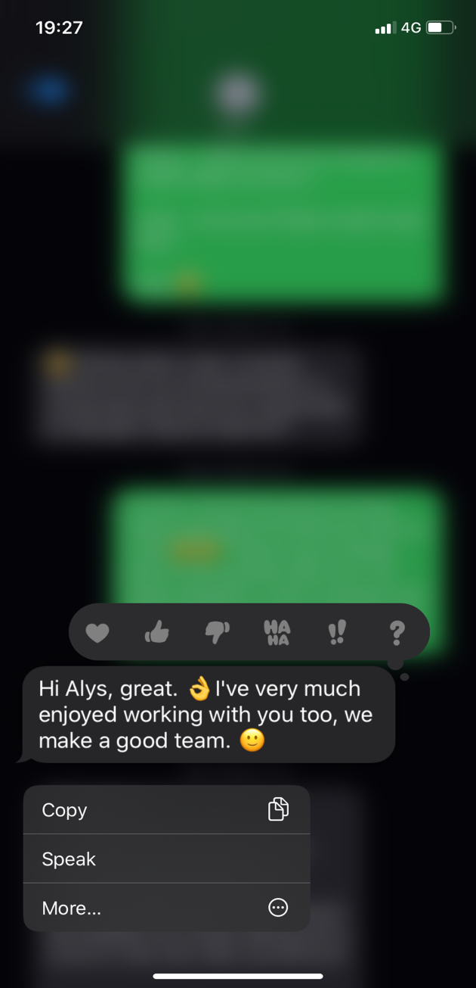

EV22
Resourcing Requisition

ROLE NEEDED:

Which site is the role for?

Has it been approved and given the ok?

Ideal start date

Salary range

Any specific qualifications required?

Hours required to work

Shift patterns

Weekends

Flexibility

Use of vehicle involved?

POST APPOINTMENT

Will a computer be required?

Will a Phone be required?

Any PPE?

Do you want any checks made on or after job offer? E.g. References. Licences. Qualifications

EV23

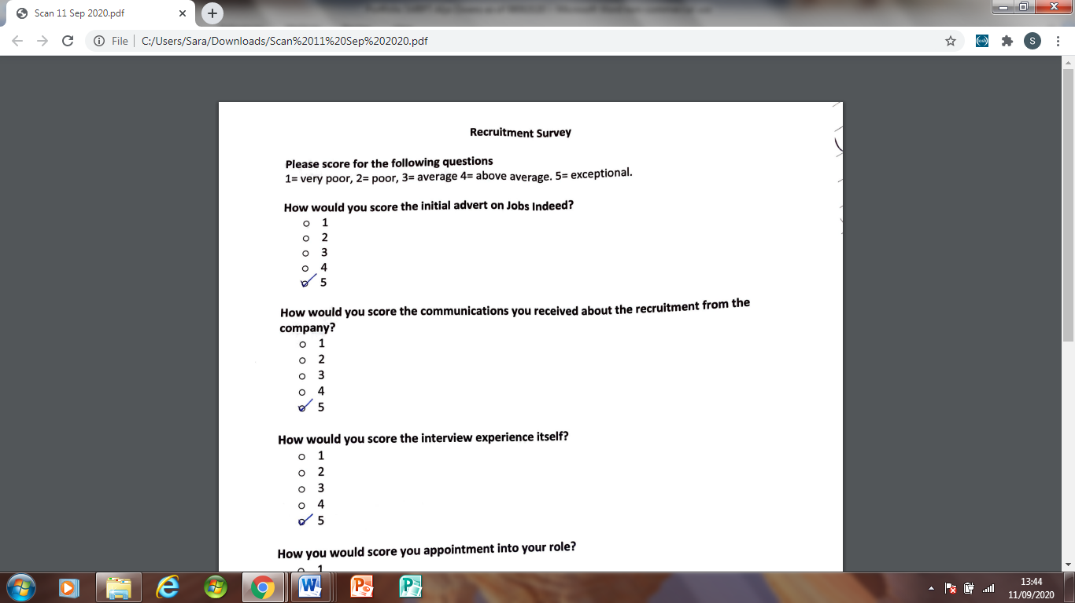

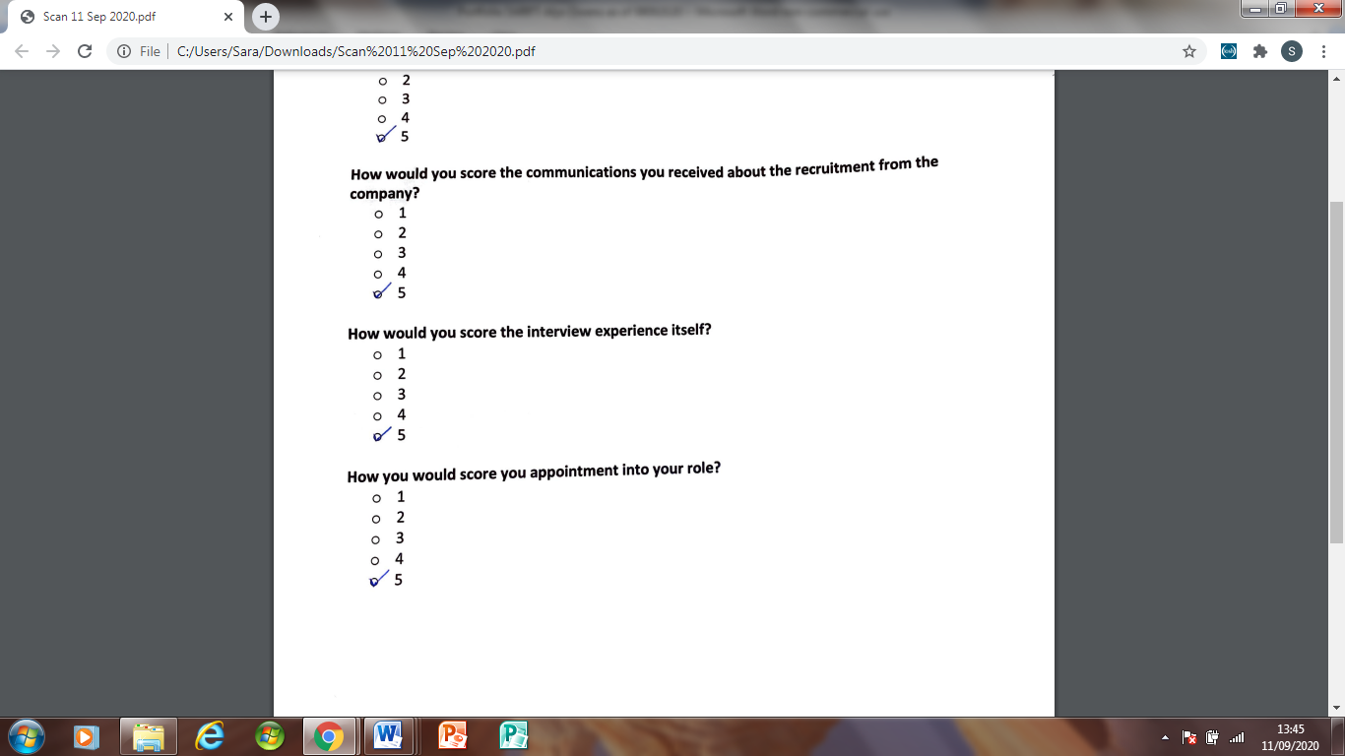

Research Bibilograpy
CHARTERED INSTITUTE OF PERSONNEL AND DEVELOPMENT. (2012) Performance and retirement practices – get it right! [online]. Policy report. London: CIPD.
CHARTERED INSTITUTE OF PERSONNEL AND DEVELOPMENT. (2014) Employee turnover and retention [online]. Factsheet. London: CIPD.
CHARTERED INSTITUTE OF PERSONNEL AND DEVELOPMENT. (2015) Selection methods [online]. Factsheet. London: CIPD.
Armstrong, M. (2012). Armstrong's Handbook of Human Resource Management Practice. London
GUION, R.M. (2011) Assessment, measurement, and prediction for personnel decisions. 2nd ed. Hove: Routledge.
LADJEMI,K (2014) 5 irresistible employer brand messages: Recruiter
LEWIS, D. and SERGEANT, M. (2015) Employment law: the essentials. 13th ed. London: Chartered Institute of Personnel and Development.
ROTHWELL 2010 Effective Succession Planning: Amacom
TAYLOR, S. and WOODHAMS, C. (eds). (2016) Human resource management: people and organisations. London: Chartered Institute of Personnel and Development. Second edition

