
Skills for the Workplace
Module Assignment Submission
Student Name: | Howard Carl Lewis
Student Number: | 2011712
Module No: | BMSK4007
Module Title: | Digital Skills and Personal Branding

Statement of Confirmation of Authenticity
By the act of making this submission, the student declares that this is the work of the student named above. The work has not, in whole or in part, been knowingly presented elsewhere for assessment, or where assessment has been built on a previous assessment, this has been identified. Where materials have been used from other sources it has been properly acknowledged. If this statement is untrue, the student acknowledges that an assessment offence has been committed.
Attention is drawn to the plagiarism and unfair practice policies of both the University and of ILM.
Permission for ILM to use this script
ILM uses learners’ submissions – on an anonymous basis – for assessment standardisation. By submitting, both the centre and the learner agree that ILM may use this script on condition that identifying information is removed. However, if you are unwilling to allow ILM use this script, please refuse by ticking the box: □

Table of Contents

What has been the impact of 21st Century Technologies on the modern workplace? 3
Evaluate the appropriate use of modern technologies and social media in the workplace generally 3
Explore the use of modern technologies and social media in own workplace 3
How can Personal branding help YOU? 4
Your LinkedIn Profile to promote your Personal Brand 4
Evaluate the value of other social media platforms to enhance networking and career prospects 4
Examine the impact of Personal Branding on your own employability 4
Discuss personal and professional security and safety online. 4
References 6
Appendix 1 7
Appendix 2 8

What has been the impact of 21st Century Technologies on the modern workplace?

First of all, I would like to talk about the Connectivity we can now experience due to the 21st century inventions within the workplace. The Cloud has a massive impact on in the workplace, it is a way of people and co-workers to stay in touch (connected) whilst not having to be present or even in the vicinity of one and other. It is also a way of sharing work or personal documents, which in this current pandemic and the number of lockdowns we are receiving, we can still manage to complete work and studies from home due to this.

Another we have are the Phones: Here we have another astonishing invention that has impacted the workplace immensely, due to the fact now that they can also keep us in touch with one and other. The phone can mean fixed or mobile, the landline was the first way of communicating by phone. Before this there was no way of communicating across a large distance easily. The landline was invented on February 14th, 1876 by Alexander Graham Bell, and it has revolutionised communications. Upgrading from there we now have powerful pocket computers that fit nicely in our pockets. “Alexander Graham Bell’s sketch of the telephone was filed for patent just two hours before a rival inventor Elisha Gray, Gray filed a declaration of intent to file a patent for a similar device”. (quote taken from google search).

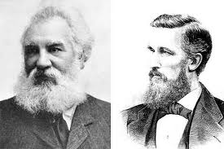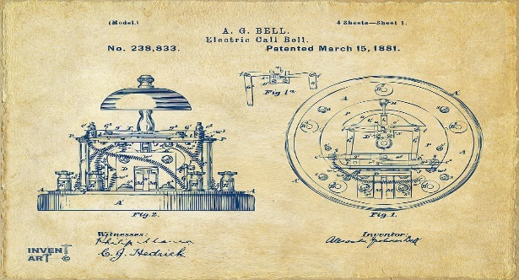
Image taken from Google Images - featuring left: Alexander Graham Bell, right: Elisha Gray.
Patent Image found at: Alexander Graham Bell Patent - Bing images

Mobile phones have excelled in recent years due to the technology of the 21st century. They not only allow us to contact one and another from vast ranges, but we now have the technology to send e-mails, messages (SMS), digital images (photos) also many other amazing features and applications that help with aspects of daily work or actual life.
Android and Apple have advanced to the top of the phone and tablet technology market, exceeding beyond anything we thought could happen, from looking at a static telephone many years ago now. Amongst the phones and tablets we have something else that has helped the workplace advance in recent years, one of these being they have downloadable or pre-installed applications for all suitable devices that can still be sent or used between multiple devices, although apps tend to need internet or even Wi-Fi to be used, it is very rare in these days a business does not depend on the internet to be able to function successfully.

The internet or Wi-Fi I would say is the most crucial of all the technologies, as it runs and manages a lot of our devices or computers. It allows us to send something to help others quite simply by just sending a link to a page or profile. With using and having the internet on our devices or any of our technology we can send and report almost anything that is needed, and at a speed of next to nothing compared to the paper copies we would have to send by post in which we all relied on not too long ago. Another bonus to having the internet in the workplace is that we have access to the whole world at a button, by that I am talking about social media. Social media is now one of the best way of promoting yourself or your business, be it through self-promoting or business advertising. Someone’s self or businesses can be viewed depending of course on the privacy settings you apply to the page that you have created, so basically you can pick and choose who sees your profiles or business pages. This is definitely the best way that you use Personal branding. LinkedIn is a preferred way of business branding as it is a business only media platform, where employees are endorsed for their skill set within their job roles, for all to see. Again, users must be mindful of the privacy settings.

Evaluate the appropriate use of modern technologies and social media in the workplace generally.

Due to the pandemic, we are currently all experiencing, I have used the knowledge from when I was able to work and run my own plumbing and heating business. In my own experiences whilst working, I never needed a social media platform to help me or even promote myself, as I was subcontracted through family members for the whole time (18 years). I do see the benefits from having a personal brand or social media platform to promote yourself, because it is a way of people seeing you as an individual and can also see if you are suitable to give an interview too.

We have a way of staying connected now thanks to the cloud. We are able to transfer, edit and fill out documents whilst on the go, as long as we have all 3 key components: Mobile phones or portable devices, Wi-Fi and the Cloud. Starting with the mobile phone, we are able to upload documents and also share them between multiple viewers or companies, where you might be required to complete forms and documents whilst on the go. In order to upload these said documents or even just an image or a message you will need Wi-Fi or phone credit/internet packages. Wi-Fi is a way of connecting to the internet whilst using your mobile on the go, Wi-Fi is now everywhere as its probably one of the best inventions of the 21st century. Think of the cloud as a massive virtual bank for storage, it holds all your personal and shared documents forever, and is there at your discretion for whenever needed.

Due to today’s current Global Pandemic Covid-19, many companies have benefitted from remote working, utilising modern technologies which has aided with employees working from home, where employees have been asked to work from home using things such as Virtual Private Network (VPN), company portals and so on. Not only that we have all these options at a click of a button, but we also now have more secure ways to access the data we want to see, by using advanced technology such as retinal recognition, face recognition and fingerprint recognition.
Due to the fact that 21st century technology has excelled, we have older machines now made nearly obsolete or at least used a lot less, like the fax machine, landline telephones, morse code etc. Morse code is still used but less often, usually in places that do not have internet access or not on land, we do have CB radios to talk from sea to land, that are more likely to be satellite run.

Explore the use of modern technologies and social media in own workplace.

Whilst exploring the uses of modern technology and social media in the workplace, I have found there are a lot of pros and cons to having this access available.

Telephones and Mobiles: (PRO) The use of telephones have modernised and revolutionised a lot over the years, we find them a vital part of everyday business. We are able to order and arrange product supply, meetings and talk business to business without being in the same room. Now that the landline telephone has evolved to the mobile phone, we are now able to accomplish this whilst even being on the move. The other use of the mobile phone in the workplace is that we are able to check emails on the go, as this was only accomplishable not so long ago by accessing the office computers. Which was restrictive with time if you have meetings, appointments, or away from the work.

Laptops, Tablets and iPad: (PRO) These are portable devices that can also connect to the internet or Wi-Fi, you can access all your data from the Cloud once connected and can then carry out any advertising, promoting and general business. You can also access your professional branding and constantly check and update pages such as LinkedIn. With these devices you can also access your personal accounts whilst on the go i.e., Facebook, Instagram, Snapchat. These allow you to keep in contact from across the globe without having to be in the same room, we can use video chats whilst on the move and that can be a great help when an employee needs to show you something rather than explain.

Aid and recruitment: (PRO) One of the good things about the use of social media in the workplace, is that you can view or advertise job vacancies easily. Especially now with the use of the personal branding, you are able to apply and send your CV and covering letter directly to the employer usually via a submission form.

Marketing and employer brand. (PRO) Sharing your or even looking at somebody’s business page gains the advantage of advertising with this, it allows people to see any up-and-coming events such as business fairs, marketing promotions and offers that may be taking place in the near future or can help the release of a new product/promotion for your own business.

Professional networking: (PRO) Networking within the office allows you to communicate on a larger scale with your peers, customers or even other businesses. Sometimes you could even be on the phone to all of the above at the same time with the use of MICROSOFT TEAMS, ZOOM or SKYPE are just a few examples.

Security: (CONS) With the use of social media platforms, it can leave you vulnerable to hackers, virus’s or security breaches. Any one of these alone is detrimental to anyone let alone a business or franchise. This can expose you as an individual if personal data is easily accessible, which can then open you up to being attached by hackers, viruses and even cyberbullied. (Facebook, Snapchat, Instagram, LinkedIn and many more).

Personal social media: (CONS) Personal social media can be a very bad thing in the workplace, as now companies are introducing and relying on this technology to advertise and promote more. By doing so it allows the workers to be able to access their own personal social media and using it as an excuse to do hardly any or even no work. This can be a fine line as some people can sabotage from the inside and again whilst these are allowed in the workplace then you will always be susceptible to being exposed to a cyber-attack.

Telephones and Mobiles: (CONS) With the mobile phone being such a big part of work and everyday life, it is hard to see if the employee is using their phone in the right way. Meaning that they can sit on their own phone and not completing the workloads set for them, this can be a big issue if the employee is to be using phones as part of their job role. Due to various workplace policies and regulations, if you ask to see a personal phone it can be classed as an invasion of privacy, so can be very difficult for a company to identify unpermitted use of personal phones.

Your LinkedIn Profile to promote your Personal Brand.

Feed | LinkedIn – Hyperlink to my personal Linkedin profile (this profile has been created purely for this assignment purposes)
Here I have put the link to one of my professional branding media sites, LinkedIn is a way of promoting yourself to an employer in a professional way. For example, you can upload your professional qualifications and grades from all types of education and previous work history. As long as you update it constantly you can always show your full potential to whoever is looking. Using this site, you can also upload pictures from previous employment and field jobs, this way other employers can see how effective and presentable your work actually is first-hand.

Evaluate the value of other social media platforms to enhance networking and career prospects.


Image taken from Google Images.

Facebook has a few sister pages within its social media platform, that allows you to advertise unwanted goods (Facebook marketplace), you can advertise your business through it as well. Most of the Facebook business pages I have seen are well presented and have a very good description of previous work, accompanied by pictures to prove the presentation of the mentioned work. This in recent years has been a very good way of promoting, establishing and opening a new business. Most of all it has a very easy way to set pages up and to promote by using the step-by-step guides that are easily followed. As this is a social media site, you are able to invite or tag people to view the page and to set the page security settings to restrict who and what you would like viewable to people on the page you have created using the Facebook safety, security policies and agreements. This is a way of covering yourself as much as you possibly can in your power to avoid being cyber hacked.

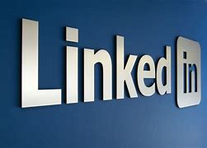

Image taken from Google Images.

LinkedIn is a business media platform that allows you to advertise or are looking for work, it is also a place that you can upload your skills and qualifications so that other employers know what they are getting when looking to fill a position within their company and to fit a certain criteria. By doing this you are creating a personal brand of yourself.


Image taken from Google Images.

Rated people have sister companies and third-party representatives that share your details on your behalf and only with your permission with other Rated sites such as ratemybuilder.com, ratemyplumber.com etc. these are just a few other sites you can promote your business and personal brand. But in another way, all together. These are mainly trade based sites that are very crucial to your business if you sign up creating an account as it is all reviews from previous customers, so your personal brand is in their hands, but as long as you are presentable, respectable and polite but also do presentable work without causing issues or damage this can be amazing to your company name and logo.

Examine the impact of Personal Branding on your own employability.

Facebook is another way of promoting your business too, I myself have recently reopened my public page to access, so people can view my own personal plumbing business: Lewis Plumbing & Heating. By adding your professional business page, you are not only promoting the business but promoting yourself on a professional platform for others to see. Amongst this page I have an optional review section for feedback, I have been subcontracted for the duration that I have had my business just simply from family or the people I know. Social platforms and advertising are beneficial to many businesses but not essential to all in my experience, I can see the benefits to having them as I was recently told from my previous employer: “forever promoting is forever working”, he has always promoted his business and has done really well from it, so he has advised me that if I ever want to open my business back up to advertise and promote first defiantly. Whilst working alongside my previous employer I was linked with his other business promoting platforms such as: Ratemyplumber.com. Ratemybuilder.com and a few others that helped promote work through advertising and reviews.

Discuss personal and professional security and safety online.

Security is a big risk whilst working online, whilst using social media and showing off our day-to-day stuff leaves yourself open as we tend to store details or announce personal business online without a care. Cyber hacking has been an issue since we have been able to access the internet, if you set your business page to public you have more chance of being hacked as it is open for all to see so the best way to protect yourself and your personal information is to set your accounts to private and only give it out to people that needs the information or to whom ever you want to see it. There are a few ways to keep your online presence, stored data and transactions safe. Some of these include using the following resources:

Anti-Virus software – examples: -

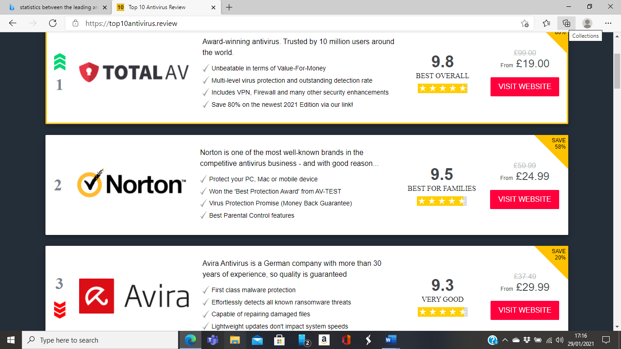

Image taken from - https://top10antivirus.review

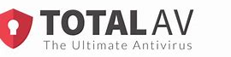
Image taken from - Google Images

TOTALAV is the leading anti-virus software at the moment, although this does change every year, as all the anti-virus software designers create new and improved brilliant ways to keep our personal data and online presence safer for us to use.

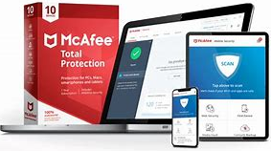
Image taken from – Google images.

I personally use McAfee for all of my remote and online devices, McAfee is only ranked number 8 in the best and leading according to the online top 10. I have found that McAfee have the best multi anti-virus software that I find easy to install and use, Also I have used McAfee for many years to protect my devices and it has always been reliable for me.
(own preference)


Image taken from Google Images.

Norton is another of the leading anti-virus software that can also cover all of your devices and personal documents, As I mentioned above it has also been around for years and is one of the well-known names for anti-virus software. I have friends and associates that will not use anything other than Norton.

General Data Protection Regulation (GDPR)
“This is a ruling intended to protect citizens within the European union, these regulations apply to all businesses established in the European union and to businesses established outside of the European union insofar as they process personal data about people within the EU”.
(ref from the www.dummies.com)



Images taken from Google Images.

Lock Icon Safety Sites that show in the images above, are trusted and verified sites, these are safe to use and are confidential. Safety online is key as you will or may have all there is to know about you on there, so when using any site online it is recommended that we see the lock icon in the corner displayed next to the web address.

According to: - support.google.com
“Check if a site’s connection is secure.
To see whether a website is safe to visit, you can check for security info about the site. Chrome will alert you if can’t visit the site safely or privately”.
“What a security certificate is.
When you go to a site that uses HTTPS (connection security), the website’s never uses a certificate to prove the website’s identity to browsers, like Chrome. Anyone can create a certificate claiming to be whatever website they want.
To help you stay safe on the web, Chrome requires websites to use certificates from trusted organisations”.

When your online to promote or establish a business there are a few ways you can keep yourself extra secure by simply not tagging the people you do not know fully, saying that it is not only the people you tag that can get into your personal details, but it can also occur if you do not have or set your privacy settings to private and invite only to safeguard your personal information. Not only that by clicking on random links you are also leaving yourself open to cyber hacking.

References

- “Alexander Graham Bell’s sketch of the telephone was filed for patent just two hours before a rival inventor Elisha Gray, Gray filed a declaration of intent to file a patent for a similar device”. (quote taken from google search). Pg. 3

- Image taken from Google Images - featuring left: Alexander Graham Bell, right: Elisha Gray. Pg. 3

- Patent Image found at: Alexander Graham Bell Patent - Bing images Pg. 3

- “forever promoting is forever working”, Pg. 6

- “This is a ruling intended to protect citizens within the European union, these regulations apply to all businesses established in the European union and to businesses established outside of the European union insofar as they process personal data about people within the EU”. (ref from the www.dummies.com) Pg. 7

- “Check if a site’s connection is secure. To see whether a website is safe to visit, you can check for security info about the site. Chrome will alert you if can’t visit the site safely or privately”. Pg. 7

- “What a security certificate is. When you go to a site that uses HTTPS (connection security), the website’s never uses a certificate to prove the website’s identity to browsers, like Chrome. Anyone can create a certificate claiming to be whatever website they want. To help you stay safe on the web, Chrome requires websites to use certificates from trusted organisations”. Pg. 7

- VPN, LinkedIn, Facebook, Instagram, Snapchat, Microsoft Teams, Zoom, Skype, Facebook Marketplace, Rated People, ratemybuilder.com, ratemyplumber.com, Lewis Plumbing & Heating, TOTALAV, McAfee, Norton, GDPR. (references include anti-virus, video and audio software’s, businesses, and social media sites)

Appendix 1

- Image taken from Google Images - featuring left: Alexander Graham Bell, right: Elisha Gray. Pg. 3

- Patent Image found at: Alexander Graham Bell Patent - Bing images Pg. 3

- Feed | LinkedIn – Hyperlink to my personal LinkedIn profile
(this profile has been created purely for this assignment purposes) Pg. 5

- Image taken from Google Images featuring Facebook logo. Pg. 5

- Image taken from Google Images featuring LinkedIn logo. Pg. 5

- Image taken from Google Images featuring: Rated People logo. Pg. 5

- Image taken from - https://top10antivirus.review Pg. 6

- Image taken from - Google Images featuring: TotalAV logo. Pg. 6

- Image taken from - Google Images featuring McAfee logo. Pg. 7

- Image taken from - Google Images featuring Norton logo. Pg. 7

- Image taken from - Google Images featuring lock icon logo. Pg. 7

- According to: - support.google.com Pg. 7

Appendix 2

