
Master of Business Administration (MBA)
Module: Marketing Management
Module Code: LCMB7024
Lecturer(s): Laila Maazouz; Taonga Kaonga Sobere-Snithers
Assignment Title: Assessment Component 1 – Marketing Environment Analysis

Student Name: Rambhai Vejabhai Modhavadiya
Student ID: 2516705

Assessment Topic: Marketing Environment Analysis for Pioneers and Followers in the UK EV Industry: A Comparative Study of Tesla (Pioneer) and Ford (Follower)

Table of Contents
List of Figures 4
1 Task 1 Macro Marketing Environment Analysis (Pioneer vs Follower in the EV Industry) 5
1.1 Macro Actor 1: Political & Legal Forces (Decarbonisation policy + market rules) 5
1.1.1 Why this actor matters 5
1.1.2 Evidence of the policy-driven demand shift 6
1.1.3 Opportunity/threat implications for Tesla (pioneer) 8
1.1.4 Opportunity/threat implications for Ford (follower) 9
1.1.5 Table: Political/Legal actor impact on competitive position (Tesla vs Ford) 10
2 Macro Actor 2: Technological Forces (battery economics + charging infrastructure + digital capability) 10
2.1 Evidence: ecosystem maturity and remaining “infrastructure constraint” 10
2.2 Implications for Tesla (pioneer) 12
2.3 Implications for Ford (follower) 12
3 TASK 2: Strategic responses to sustain growth (Tesla as pioneer vs Ford as follower) using Porter + Ansoff 14
3.1 Tesla (pioneer): scaling differentiation into an ecosystem-based advantage 14
3.1.1 Porter: Differentiation with selective cost-leadership logic 14
3.1.2 Ansoff: market penetration + diversification as the growth engine 15
3.2 Ford (follower): dual-track strategy profit pools now, capability-building for EV scale 16
3.2.1 Porter: Focused differentiation (commercial) + transitional strategy discipline 16
3.2.2 Ansoff: market development + product development enabled by ecosystem partnerships 17
4 References 19

List of Figures
Figure 1 UK Zero Emission Vehicle (ZEV) Sales Targets (Cars vs Vans), 2024–2035 6
Figure 2 UK Battery Electric Vehicle (BEV) Market Share and New Registrations, 2021–2025 (vs 2025 Mandate Target) 7
Figure 3 Most Popular Battery Electric Vehicles in the UK (Top 10) and Tesla’s Market Share, 2025 8
Figure 4 Growth of Rapid and Ultra-Rapid EV Chargers in the UK, End-2024 to End-2025 11
Figure 5 Porter’s Generic Strategies Matrix: Competitive Advantage (Cost vs Differentiation) and Scope (Total vs Niche) 14
Figure 6 Tesla Ansoff Matrix 15

Task 1 Macro Marketing Environment Analysis (Pioneer vs Follower in the EV Industry)
In PESTLE, UK political/legal forces in the EV industry are market-design mechanisms that affect demand and profitability (Kotler et al., 2020), generate coercive compliance pressures (DiMaggio and Powell, 1983), and reorganize rivalry and barriers (Porter, 1980).

Macro Actor 1: Political & Legal Forces (Decarbonisation policy + market rules)

Why this actor matters
Political/legal forces in the EV industry do not simply affect marketing; they shape the market. Regulation, a transition period, and mandates produce a imposed demand (and non-compliance penalties), so that product portfolios, prices, and channel incentives become competitive variables that are policy-influenced. This is consistent with the sentiment that the macro-environment has the potential to transform the game by changing the attractiveness of markets and the available strategic options to firms (Kotler et al., 2020).

Evidence of the policy-driven demand shift
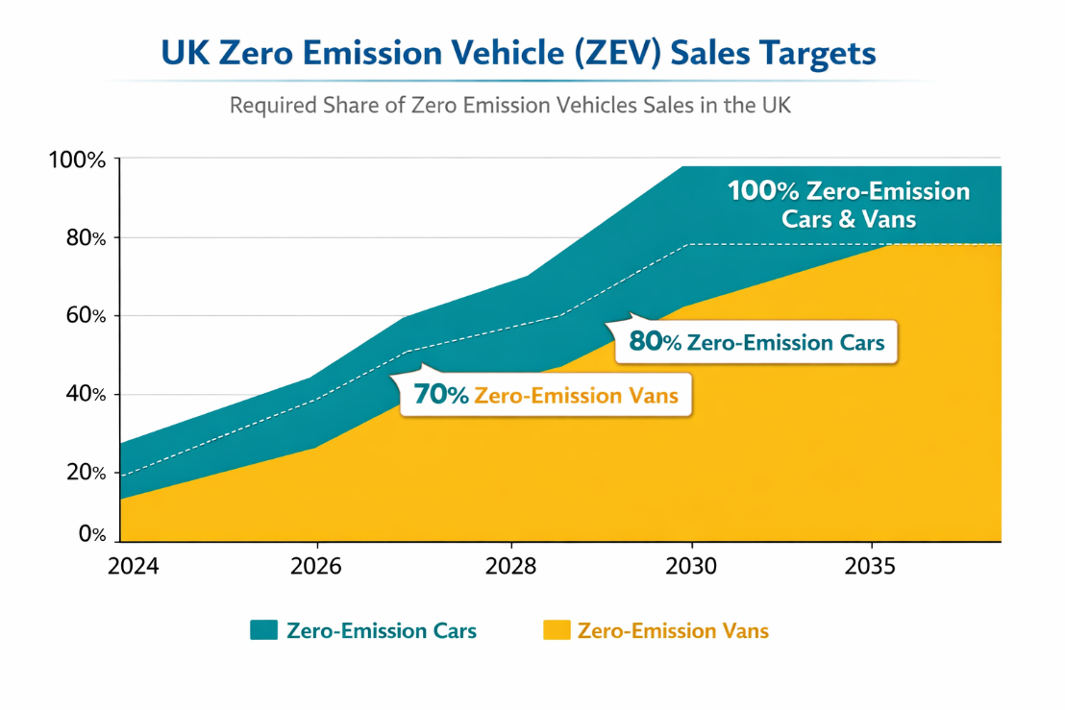
Figure 1 UK Zero Emission Vehicle (ZEV) Sales Targets (Cars vs Vans), 2024–2035
Source: (UK Government, 2024).
The Zero Emission Vehicle (ZEV) requirement in the UK was a legally formalized increase in the level of required zero-emission sales quota. Governmental messages prove the course: 80% of new vehicles and 70% of new vans are to be zero-emission in 2030, and 100% in 2035 (UK Government, 2024). The requirement that at least 22%. of new car sales must be zero-emission by 2024, as is mandated by industry and advocacy summaries (EVA England, n.d.), supports the idea that compliance is progressive and escalating.
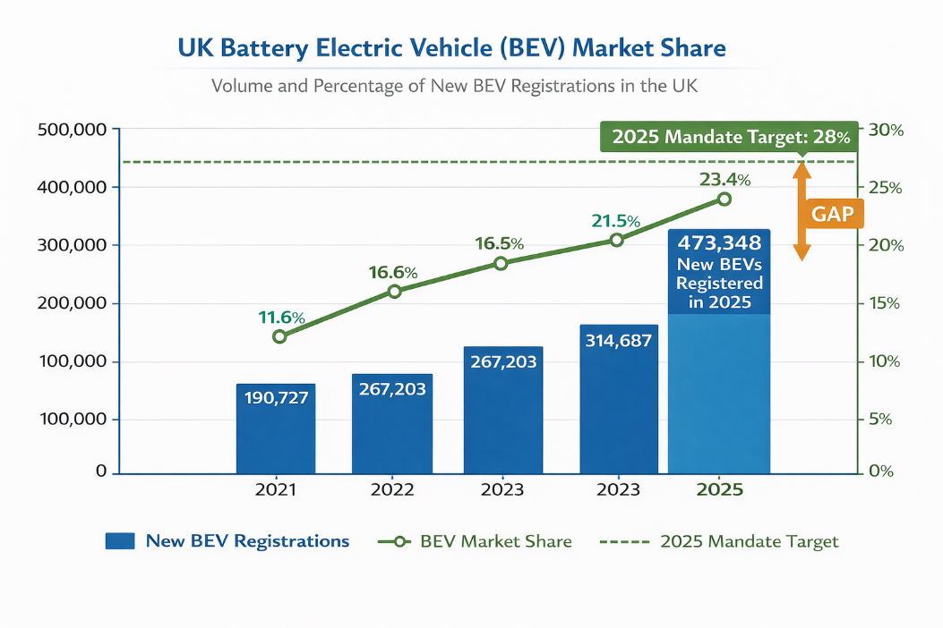
Figure 2 UK Battery Electric Vehicle (BEV) Market Share and New Registrations, 2021–2025 (vs 2025 Mandate Target)
Source: (SMMT, 2026).
Market evidence indicates demand is responding, but not to the policy ambition completely. In 2025, Society of Motor Manufacturers and Traders registered 473,348 new BEVs, which put BEVs at 23.4% market share nearly one in four new-car sales (SMMT, 2026). SMMT marks out a mandate gap (28% target), forcing companies into discounting, fleet prioritisation and credit trading, fuelling price contention and cost of customer-acquisition, reworking incentives, budgets and positioning (SMMT, 2026; Large, 2026).

Opportunity/threat implications for Tesla (pioneer)
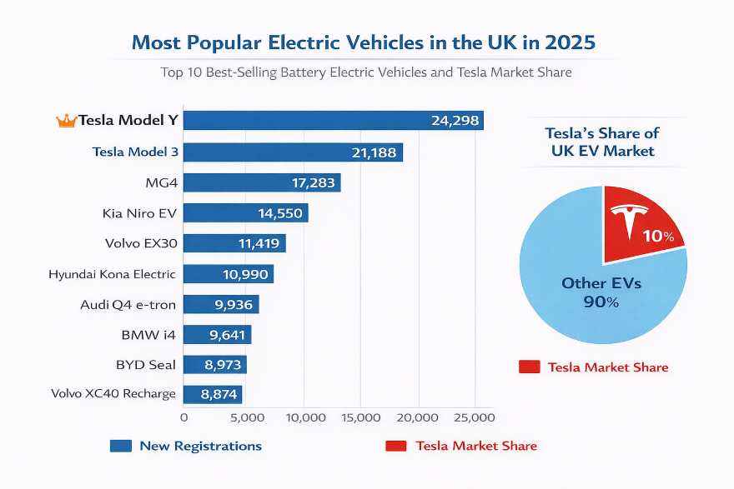
Figure 3 Most Popular Battery Electric Vehicles in the UK (Top 10) and Tesla’s Market Share, 2025
Source: (Tesla, 2026).
Opportunity: regulation reinforces category legitimacy and Tesla’s pioneer positioning. As a pure-EV company, Tesla is advantaged by policy that encourages category adoption its marketing initiative is no longer focused on educating the market but gaining preference in the market (Kotler et al., 2020). This is supported by demand and visibility: the Tesla Model Y has registered 24,298 in the UK in 2025, which is the most popular EV in the UK (Tesla, 2026). Competitively, positionally, this maintains the differentiation edge of Tesla (technology-driven brand meaning, EV credibility) and reinforces salience as a necessary antecedent of loyalty and price forbearance (Dreiling and Bican, 2022).
Threat: policy-driven mainstreaming increases competitive crowding and price pressure. When regulation compels every manufacturer towards EVs, Tesla will neither be an early-mover and the competitiveness will grow (Porter, 1980). Also, in case consumers demand falls short of the target, manufacturers can use heavier incentives to bridge the compliance gap (SMMT, 2026). That forces can squeeze margins, and competition can become price-led, undermining Tesla capacity to rest on innovation-based brand equity alone (Rosenberger et al., 2024).

Opportunity/threat implications for Ford (follower)
Opportunity: regulation functions as a transformation lever and legitimacy shield. To a follower of ICE legacy, coercive regulation minimises strategic drift since it pushes organisation toward electrification (DiMaggio and Powell, 1983). Legacy trust (dealer support, warranties, servicing) can also be used by Ford to remove the perceived adoption risk, and it is well-placed to convert late adopters especially when charging access and affordability concerns remain (Ford UK, 2025).
Threat: compliance pressure collides with transition economics and limits strategic freedom. The cost of both EV transition and ICE decline limits Ford in its capacity to compete. In 2025, Ford anticipates making losses of $5.0-$5.5bn in its Model e EV segment according to S&P Global (S&P Global, 2025), having incurred an EV EBIT loss of $5.1bn in 2024 (Ford UK, 2025). This is of strategic importance, as it may limit marketing flexibility at Ford (pricing headroom, promotional intensity, product refresh cadence) at a moment when the market is increasingly incentive seeking to achieve mandate trajectories (SMMT, 2026). Weakened profitability in Porterian terms exacerbates susceptibility to competition and decreases the firm capacity to maintain differentiation or cost leadership at the same time (Porter, 1980).
Competitive position outcome (Political/Legal actor):
- Tesla benefits from policy-aligned brand identity and earlier EV readiness, reinforcing a differentiated competitive position (innovation + EV credibility) (Ribo et al., 2023).
- Ford’s position is squeezed by the cost and coordination burden of transformation, even though regulation creates demand it can potentially capture if execution improves (Large, 2026).

Table: Political/Legal actor impact on competitive position (Tesla vs Ford)
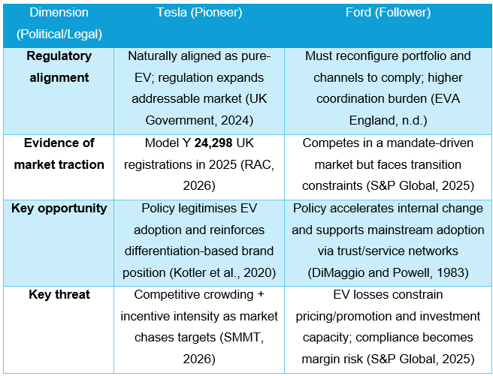

Macro Actor 2: Technological Forces (battery economics + charging infrastructure + digital capability)
Technology is a macro-PESTLE of creative destruction and new value logics (Kotler et al., 2020). With EVs, it defines value-in-use (range / charging), overall cost of ownership and software-defined experience. The higher the relative advantage and compatibility, the more mainstream adoption becomes (Rogers, 2003). The Competitiveness relies on evolving capabilities to feel, grab and reorganize quickly (Teece, 2007).

Evidence: ecosystem maturity and remaining “infrastructure constraint”
Instead of the repeat numbers of previous headline totals, two more indicators reflect how technology is making it easy and difficult at the same time:
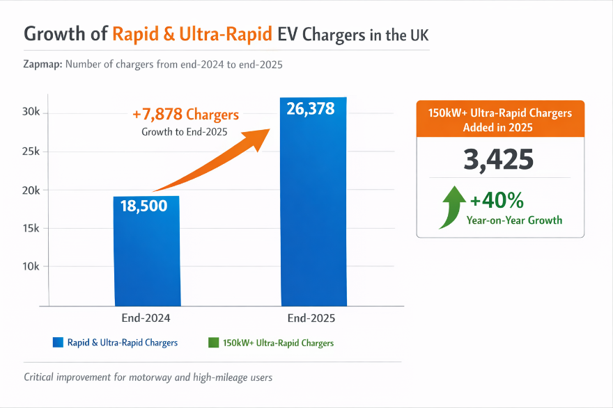
Figure 4 Growth of Rapid and Ultra-Rapid EV Chargers in the UK, End-2024 to End-2025
Source: (Zapmap, 2026).
(a) Faster charging network is scaling, but unevenly. Zapmap forecasts rapid + ultra-rapid chargers grow 26,378 (end-2025), and 150kW+ ultra-rapid chargers 3425 (end-2025) which is a gamechanger to the motorway and high-mileage user (Zapmap, 2026). Nevertheless, formal planning assumptions remain that there is a significant rollout gap: a revised demand figure of UK Department of Transport is 250,000-550,000 public chargepoints by 2030 (DfT, 2026). The Financial Times reports over 88,000 charge points in the UK would require approximately 32,000 installations annually to achieve the same low-end target (and much more on the high-end end), indicating an ongoing macro-level infrastructure constraint (Financial Times, 2026).
(b) Vehicle experience is becoming software defined. OEMs are also competing more aggressively through OTA updates, digital interfaces and connected services. Ford itself highlights over-the-air software updates as a continuous process of improvement of the digital experience of the company (Ford, 2023-2026). This changes the consumer expectation of the evolution of products that appear phone-like, increasing the strategic emphasis on software platforms and data capabilities (S&P Global, 2025).

Implications for Tesla (pioneer)
Opportunity (tech leadership → perceived superiority and faster diffusion). Ecosystem gains (increasing the speed of charging) can be translated into better perceived convenience an adoption accelerator by Tesla on the lines of Rogers so-called relative advantage and trialability attributes (Rogers, 2003). Tactically, Tesla can leverage its strength by combining vehicle + software + charging into a consistent customer promise that makes technology a brand meaning rather than a specification (Kotler et al., 2020).
Threat (technology diffusion + platform parity). Differentiation is threatened with commoditisation of Tesla as the rapid charging spreads networks and software-driven features spread (Fan, Li and Yao, 2024). Rivalry can subsequently shift to who innovates first to who is more reliable, service recovery and portfolio breadth, enhancing competition and price war particularly where infrastructure and affordability are adoption bottlenecks (Financial Times, 2026).

Implications for Ford (follower)
Opportunity (ecosystem maturity lowers adoption barriers). Development of rapid/ultra-rapid charging lowers one of the greatest objections of the convenience of mainstream buyers giving Ford the ability to capitalize on trust, dealer service, and financing to attract late adopters (Rogers, 2003). Marketing wise, the category loses its educative laden characteristics and has more to do with competitive positioning and perceived reduction in risk (Huang and Zhang, 2025).
Threat (dynamic capability gap in software and iteration speed). EV competitions are being more rewarding to swift learning cycles and platform integration. The legacy development architectures may have difficulty keeping up the pace and predictability of software-defined improvement, and in that case, the organisational capability renders technology a threat not only to product cost (Teece, 2007). When digital experience falls behind (OTA cadence, UI stability, connected-service reliability), Ford could face a perceived value that is less strong despite hardware parity (Liu et al., 2022).
Table: Technological impact on competitive position
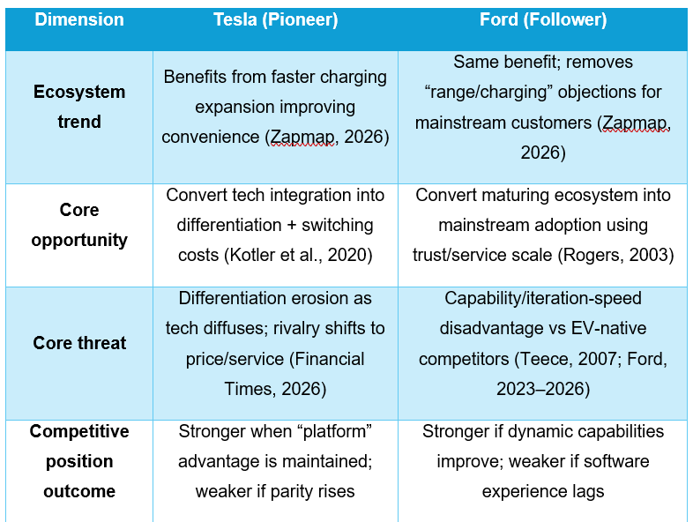
EV competition is being transformed by political/legal and technological forces. Electrification is a rule-driving transition subject to regulations (emissions rules, EV mandates) that benefits EV leaders such as Tesla and adds to the cost and urgency of electrification to follower such as Ford (Huang and Zhang, 2025). Simultaneously, declining battery prices and a growing charging infrastructure expand the market and lower the barrier to adoption of either but also creates even greater competition as it allows more players to enter and shifts the advantage to software power, ecosystem adoption, and speed of innovation. All in all, Tesla is more in line with the current demand and category credibility, with Ford in a strained catch-up where execution speed and renewability will determine whether the mandated demand turns into sustained competitive advantage (Liu et al., 2022).

TASK 2: Strategic responses to sustain growth (Tesla as pioneer vs Ford as follower) using Porter + Ansoff
EV industry strategic responses should balance political/legal pressure (mandates, compliance routes, fines) and technological disruption (charging convenience, software-defined vehicles, platform ecoystems) (Liu et al., 2022). Based on Task 1, the following section assesses the way Tesla and Ford react to these forces and continue to grow and protect their competitive edge through the prism of Porters Generic Strategies and Ansoff Growth Matrix (Farrukh et al., 2025).

Tesla (pioneer): scaling differentiation into an ecosystem-based advantage

Porter: Differentiation with selective cost-leadership logic
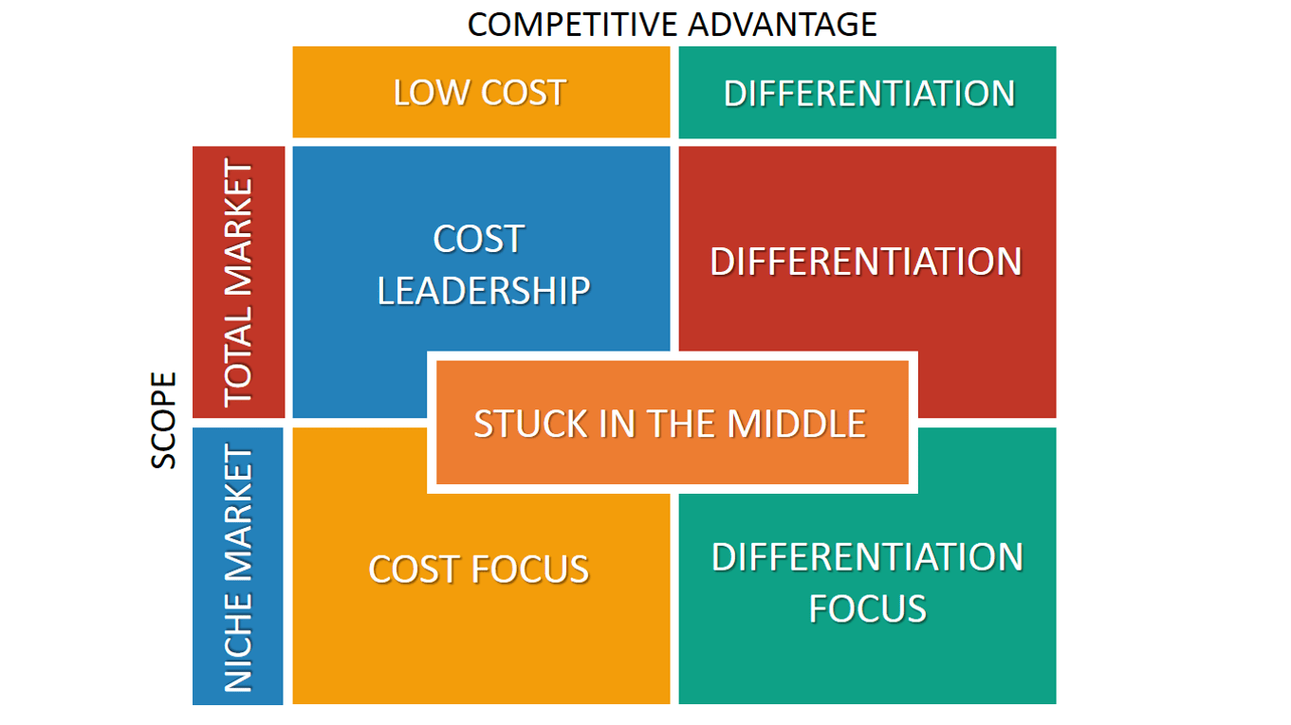
Figure 5 Porter’s Generic Strategies Matrix: Competitive Advantage (Cost vs Differentiation) and Scope (Total vs Niche)
Tesla’s core posture remains differentiation: it competes on software-led user experience, felt innovation leadership, and integration of ecosystems and not on car-as-hardware alone (Kotler et al., 2020). Platform choices contributing to this distinction include the creation of switching costs and perceived convenience (e.g. integrated routing/charging) (Park and Yi, 2023). Nevertheless, Tesla also seeks a selective cost-leadership mechanism by manufacturing scale and simplification (high-volume platform strategy). The mix is important since target-delays-target policy-driven markets tend to be price-competitive, and Tesla must have both brand premium and cost-resilience (Liu et al., 2022).

Ansoff: market penetration + diversification as the growth engine
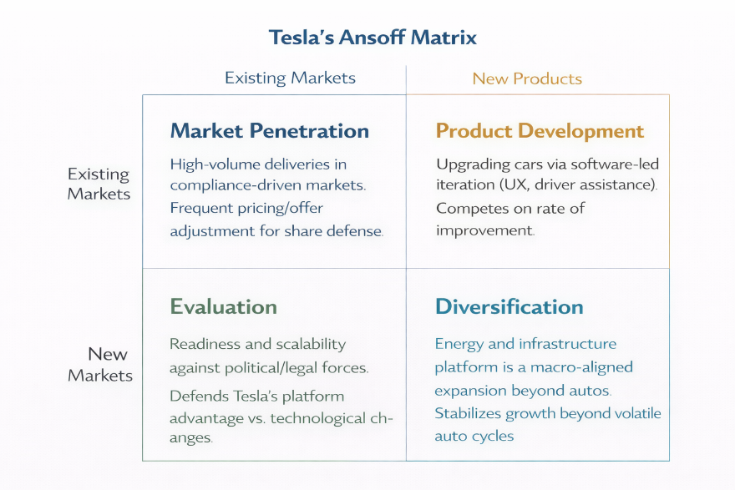
Figure 6 Tesla Ansoff Matrix
Market penetration (existing markets, existing products). The primary reaction of Tesla to compliance-based markets is to ensure that high-volume models continue to flow and category salience is preserved. The scale of its operations around the globe can already be seen in its 2025 deliveries: 1,636,129 vehicles delivered in 2025 (Tesla IR, 2026). This scale enables the common pricing/offer changes and swift production allocation features which help protect share in the increasingly dense, mandate shaped markets (Park and Yi, 2023).
Product development (existing markets, new/improved products). To increase differentiation, Tesla constantly iterates the product experience through software-based innovation (updates, driver assistance, UX) (Liu et al., 2022). The strategic rationale is applicable to dynamic markets, where expectations of the customers change rapidly: Tesla can compete based on the rate of improvement rather than specs (Kotler et al., 2020).
Diversification (new markets, new products): energy + infrastructure platform. One very powerful example of a response that is macro-aligned is the diversification of Tesla into energy, beyond autos. Tesla reported 46.7 GWh of deployments of energy storage in 2025 (Tesla IR, 2026). This is also strategically pertinent to the same macro forces: electrification policy and grid constraints create a higher demand in storage and flexibility. Diversification has the potential to stabilise the growth in cases when the auto cycles turn unstable, and the competitors flock around similar EVs features (Farrukh et al., 2025).
Evaluation (effectiveness vs macro forces).
- Against political/legal forces, Tesla’s advantage is readiness + scalability: it can comply without reallocating away from ICE profitability (because it lacks ICE exposure) (Dreiling and Bican, 2022).
- Against technological forces, Tesla’s ecosystem positioning helps but diffusion threatens uniqueness. The sustainability of Tesla’s advantage therefore depends on protecting “platform differentiation” (ecosystem + software cadence + charging integration) rather than only battery/range specs (Fan, Li and Yao, 2024).

Ford (follower): dual-track strategy profit pools now, capability-building for EV scale

Porter: Focused differentiation (commercial) + transitional strategy discipline
The most justifiable generic strategy response that Ford can make is focused differentiation in commercial mobility (where their customers consider uptime, service, financing, and fleet productivity) (Faris, 2023). This agrees with Porter: focus strategies are successful when there are unique needs of a segment, and the firm is able to create a value chain that meets the segment needs more effectively (Porter, 1980). Ford operationalises this through Ford Pro: in 2025, Ford Pro made over $66.3bn and $6.843bn revenue and EBIT, and software subscriptions paid by consumers increased 30% in 2025 (Ford, 2026). That fact signals a shift to services-based, recurrence-based value generation, which mattered as the macro environment enhances competition and margin squeezes consumer EVs (Leibenath, 2024).
Meanwhile, the follower status of Ford dictates a transitional approach: safeguarding the profit base and investing in capability refreshing. The 2025 outcomes published by Ford formally organize the business into segments and underline connected services and always-on digital experiences as a growth logic (Ford, 2026). This is a capability answer to technological change (software-defined competition) (Rosenberger et al., 2024).

Ansoff: market development + product development enabled by ecosystem partnerships
Market development (new markets/segments, existing or adapted products). Ford broadens EV adoption by eliminating charging friction via access and partnership. Ford has developed a strategy to address the challenge of range anxiety in all-in-one charging offerings to neutralise the effect of range anxiety as a conversion obstacle to late adopters and fleet adoption in Europe (Ford, 2026; Ford UK, 2025).
Product development (existing markets, new products). The earnings story of Ford focuses on affordability of next-generation EVs and structural cost reduction, indicating a product-development trajectory that would not destroy permanent margins while responding to policy pressure (Ford, 2026). That is the major challenge: to compete in EVs, restore the cost base and software strength (Friedman and Meredeen, 2024).
Diversification (services/energy adjacencies). In 2026, capex is part of the outlook of Ford Energy (Ford, 2026). This is a strategic reflection of the industry trend where the energy + mobility ecosystem (charging, optimisation, fleet energy management) is going. It also assists Ford in reacting to technology as a platform phenomenon, rather than merely as a vehicle attribute (Rosenberger et al., 2024).
Evaluation (effectiveness vs macro forces).
- Against political/legal forces, The most favorable reaction of Ford is to compete and win by parts that could absorb the complexity of the transition (commercial/fleet) and develop the cost structure of mass EV competitiveness. Ford Pro performance indicates that this is the most powerful pillar at present, growth + resilience (Rosenberger et al., 2024).
- Against technological forces, Risk at Ford is speed of iteration. Its mitigation strategy is to servitise the relationship (subscriptions, telematics, ADAS) and develop always-on digital experience capacity that transforms technology into a recurring-value engine and not a product feature (Ford, 2026).
Comparative judgement: whose strategy better sustains competitive advantage?
Tesla has a comparative advantage in a mandate market, where it is structurally aligned to zero-emission compliance and has the capability to scale a uniform global EV brand (Yeung, 2025). Convergence is its major weakness: as competitors narrow down distances, charging access and software, the only way to differentiate is through ecosystem lock-in, service quality and ongoing innovation (Leibenath, 2024). Ford strategy that focuses on protection of cash flows and expansion of EVs based on commercial focus, partnering and building capabilities in software and services are the key strategies; this is the primary risk as capabilities need to be renewed at a high rate to prevent the sustained gap in the platform (Park and Yi, 2023).
Table: Task 2 comparison using Porter + Ansoff
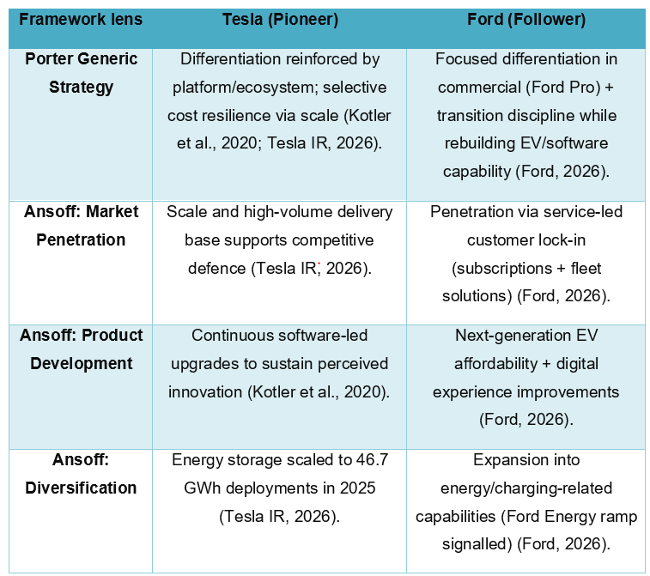

References
Bhadkamar, A. and Bhattacharya, S. (2022). Tesla Inc. Stock Prediction using Sentiment Analysis. Australasian Business, Accounting and Finance Journal, [online] 16(5), pp.52–66. doi: https://doi.org/10.14453/aabfj.v16i5.05.

Department for Transport (2026). Electric vehicle charging infrastructure statistics: frequently asked questions. [online] GOV.UK. Available at: https://www.gov.uk/government/publications/electric-vehicle-charging-device-statistics-information/electric-vehicle-charging-infrastructure-statistics-frequently-asked-questions [Accessed 27 Feb. 2026].

DiMaggio, P.J. and Powell, W.W. (1983) The Iron Cage Revisited Institutional Isomorphism and Collective Rationality in Organizational Fields. American Sociological Review, 48, 147-160. - References - Scientific Research Publishing. [online] Available at: https://www.scirp.org/reference/referencespapers?referenceid=2494584.

Dreiling, A. and Bican, P.M. (2022). Pioneer or Follower. Routledge eBooks, pp.100–115. doi: https://doi.org/10.4324/9781003046899-10.

EVA England (n.d.) ZEV Mandate Explained: What Fleets Need to Know. [online] U-drivepro.co.uk. Available at: https://www.u-drivepro.co.uk/about-us/news/zev-mandate-explained-what-fleets-need-know.

Fan, B., Li, B. and Yao, C. (2024). Analysis of the Development of China’s New Energy Vehicle Industry and Its Export Market Expansion to the UK. Journal of Business and Marketing, 1(6), pp.37–49. doi: https://doi.org/10.62517/jbm.202409606.
Faris, M. (2023). Analysis of Fundamental and Technical Financial Ford Motor Company with The Arrangements of Implication Black Volatility. [online] Social Science Research Network. doi: https://doi.org/10.2139/ssrn.4482880.

Farrukh, C., Routley, M., Manthos Kotsiopoulos and Athanassopoulou, N. (2025). Profiling innovation velocity in automotive and hydrogen production settings. Cam.ac.uk. [online] doi: https://doi.org/10.17863/CAM.122174.

Financial Times (2026) UK needs far faster EV charger rollout to hit 2030 demand. [online] @FinancialTimes. Available at: https://www.ft.com/content/611599ea-9e61-4366-881b-d66126f9f185.

Ford (2023–2026) Future Proof Driving | Ford UK. [online] Available at: https://www.ford.co.uk/technology/software-updates [Accessed 27 Feb. 2026].

Ford Motor Company (2026) Ford Reports Fourth-Quarter, Full-Year 2025 Financial Results. [online] Available at: https://www.fromtheroad.ford.com/us/en/articles/2026/ford-reports-fourth-quarter-full-year-2025-financial-results.

Ford UK (2025) Ford and Octopus Enable Seamless Public Charging with New Partnership | Ford of Europe | Ford Media Center. [online] Available at: https://media.ford.com/content/fordmedia/feu/en/news/2025/09/02/Ford-and-Octopus-Enable-Seamless-Public-Charging.html [Accessed 27 Feb. 2026].

Friedman, H. and Meredeen, S. (2024). The Dynamics of Industrial Conflict. doi: https://doi.org/10.4324/9781003515036.
Ghosh, S. (2025). Architecture and Pricing Strategies for Commercial EV Battery Swapping—Dual-Market Cournot Model and Degradation-Sensitive Regulated Framework. World Electric Vehicle Journal. [online] doi: https://doi.org/10.3390/wevj16090518.

GOV.UK (2023). Government Sets out Path to Zero Emission Vehicles by 2035. [online] GOV.UK. Available at: https://www.gov.uk/government/news/government-sets-out-path-to-zero-emission-vehicles-by-2035.

Huang, X. and Zhang, X. (2025). Analysis of the Operating Capacity of Chinese New Energy Electric Vehicles Industry: Taking NIO as an Example. Journal of Frontier in Economic and Management Research, [online] 1(1), pp.487–511. doi: https://doi.org/10.63944/m8wz.jfemr.

Kotler, P. and Armstrong, G. (2020). Principles of Marketing. [online] Available at: https://commecsinstitute.edu.pk/wp-content/uploads/2024/08/Kotler-and-Armstrong-Principles-of-Marketing.pdf.

Large, P. (2026). UK new car market breaches two million as almost one in four buyers go electric - SMMT. [online] SMMT. Available at: https://www.smmt.co.uk/uk-new-car-market-breaches-two-million-as-almost-one-in-four-buyers-go-electric/.

Leibenath, M. (2024). Tesla vs. Trees: An Agonistic Look at the Conflict Over e-mobility, Forest Clearance and Planning Law Related to a Suburban Landscape Near Berlin, Germany. RaumFragen: Stadt - Region - Landschaft, pp.351–365. doi: https://doi.org/10.1007/978-3-658-43352-9_19.

Li, W., Wang, M., Liu, X. and Tan, S. (2025). Configurations Driving High Performance in Hydrogen Fuel Cell Vehicle Enterprises. Systems, 13(9), p.779. doi: https://doi.org/10.3390/systems13090779.

Liu, C.C., Boothman, S.G. and Graham, J.D. (2025). The Rise and Recent Decline of Tesla’s Share of the U.S. Electric Vehicle Market. World Electric Vehicle Journal, [online] 16(2), pp.90–90. doi: https://doi.org/10.3390/wevj16020090.

Liu, Y., Shen, Y., Zhang, L. and Zhang, Y. (2022). A Comprehensive Analysis of Tesla. [online] www.atlantis-press.com. doi: https://doi.org/10.2991/978-94-6463-054-1_39.

Ndubuisi Shammah, Favour, C., Precious, N. and Nwankwo Emeka (2025). Towards a Low-Carbon Energy Industry: Financial and Reputational Resilience Strategies of Integrated Energy Companies. SPE Nigeria Annual International Conference and Exhibition. [online] doi: https://doi.org/10.2118/228677-ms.

Park, G. and Yi, S. (2023). Why do leaders help followers follow? Technology Analysis & Strategic Management, pp.1–14. doi: https://doi.org/10.1080/09537325.2023.2242505.

Porter, M. (1980). Competitive strategy: Techniques for Analyzing Industries and Competitors. [online] Harvard Business School. Available at: https://www.hbs.edu/faculty/Pages/item.aspx?num=195.

RAC (2026) Tesla statistics, data and sales numbers - all the latest figures. [online] Rac.co.uk. Available at: https://www.rac.co.uk/drive/electric-cars/choosing/tesla-data-statistics-and-projections/.
Ribo, M., Sami Al Kasab, Sheth, S., Ortega‐Gutierrez, S., Rai, A.T., Given, C.A., Ramesh Grandhi, Maxim Mokin, Katz, J.M., Maud, A., Gupta, R., Smith, W.S., Diederik W.J. Dippel, Gress, D., Nguyen, T.N., Brown, S., Jadhav, A.P., Eljovich, L., Charles B.L.M. Majoie and Patterson, M.S. (2023). TESLA Trial: Rationale, Protocol, and Design. doi: https://doi.org/10.1161/svin.122.000787.

Rogers, E. M. (2003). Diffusion of Innovations (5th ed.). Free Press. - References - Scientific Research Publishing. [online] Available at: https://www.scirp.org/reference/referencespapers?referenceid=3275637.

Rosenberger, N., Rosner, P., Bilfinger, P., Schöberl, J., Teichert, O., Schneider, J., Kareem Abo Gamra, Allgäuer, C., Dietermann, B., Schreiber, M., Ank, M., Kröger, T., Köhler, A. and Lienkamp, M. (2024). Quantifying the State of the Art of Electric Powertrains in Battery Electric Vehicles: Comprehensive Analysis of the Tesla Model 3 on the Vehicle Level. World electric vehicle journal, 15(6), pp.268–268. doi: https://doi.org/10.3390/wevj15060268.

S&P Global (2025) Daily Global Market Summary - 2 December 2020. [online] S&P Global. Available at: https://www.spglobal.com/marketintelligence/en/mi/research-analysis/daily-global-market-summary-2-december-2020.html [Accessed 27 Feb. 2026].

Sanci, E., Daskin, M.S., Hong, Y.-C., Roesch, S. and Zhang, D. (2021). Mitigation strategies against supply disruption risk: a case study at the Ford Motor Company. International Journal of Production Research, 60(19), pp.1–21. doi: https://doi.org/10.1080/00207543.2021.1975058.

Singh, A., Bajpai, A. and Singh, S. (2025). Electric Vehicle Evolution in the United Kingdom and India: A Comparative Case Analysis for Stakeholders. Cureus Journal of Business and Economics. [online] doi: https://doi.org/10.7759/s44404-025-06730-5.

Teece, D.J. (2007). Explicating dynamic capabilities: The nature and microfoundations of (Sustainable) enterprise performance. Strategic Management Journal, [online] 28(13), pp.1319–1350. Available at: https://www.jstor.org/stable/20141992.

Tesla (2026) Fourth Quarter 2025 Production, Deliveries & Deployments (Investor Relations press release). Austin, TX: Tesla, Inc. Available at: https://ir.tesla.com/press-release/tesla-fourth-quarter-2025-production-deliveries-deployments.

Tesla (2026) Q4 2025 Update (shareholder/update report). Tesla, Inc. Available at: https://ir.tesla.com/press-release/tesla-fourth-quarter-2025-production-deliveries-deployments.

UK Government (2024) Pathway for zero emission vehicle transition by 2035 becomes law. [online] GOV.UK. Available at: https://www.gov.uk/government/news/pathway-for-zero-emission-vehicle-transition-by-2035-becomes-law.

Ural Arslangulov and Ackrill, R. (2024). Advancing the concept of windows of opportunity to explore the dynamics of the sustainability transition: The development of the EV market in the UK. European policy analysis. doi: https://doi.org/10.1002/epa2.1216.

YEUNG, K. (2025). Understanding Value Creation And Appropriation In A Disruptive Narrative: The Uk Ev Sector. International Journal of Business & Management Studies, [online] 06(01), pp.23–42. doi: https://doi.org/10.56734/ijbms.v6n1a3.

Zapmap. (2025). EV charging statistics 2025 - Zapmap. [online] Available at: https://www.zapmap.com/ev-stats/how-many-charging-points.

