Improving Service Efficiency and Customer Satisfaction at Greenbean Café: A Practical Solution to Operational Challenges
Name of Institute : University Trinity saint David London
Moodle Name : LCLMLON_4004
Name of Student : Camano Benedictus
Soudent ID : 4212206
Lectures Name : Rita Ukhaci Lois
Data : 28-04-2028

Table of Contents

Introduction 3
Defining the Problem 3
What is the problem? 3
Where is the problem happening? 3
When did the problem start? 4
How is the problem happening? 4
Its Scope and Impact 4
Analysis of the Organisation and Problem 4
Propose Alternative Solutions 5
Identification of Alternative Solutions for the Problem 5
How These Solutions Address the Problem 6
Basic Risk Analysis 6
Evaluation: PMI (Plus, Minus, Interesting) technique 7
Solution 1: Hiring More Part-Time Staff 7
Plus 7
Minus 7
Interesting 7
Solution 2: Digital Ordering System 8
Plus 8
Minus 8
Interesting 8
Plan for Implementing Solution, Monitoring and Review Process/System 8
Conclusion 9
REFERENCES 10

Improving Service Efficiency and Customer Satisfaction at GreenBean Café: A Practical Solution to Operational Challenges

Introduction
The main problem faced by the small family owned café GreenBean Café in Oxford is to be identified and the most effective solution to the problem is to be proposed. To look at the situation and offer a practical way forward, the report will use simple problem solving and decision making processes (Pérez-Morón et al., 2022). Problem solving is finding a problem and trying out ways of solving the problem. The decision making is choosing the best option from a list of possible solutions to that problem. GreenBean Café has been experiencing declining sales and customer satisfaction in the past year. The revenue has been shaved off by 15%, and customers are piling in with their complaints about long waiting times, especially during peak periods. These issues have tarnished the café’s image and the café has not been able to keep loyal customers (Cui et al., 2023). The owner Alex Taylor has to find a reliable and affordable solution to the problem and to increase the business performance.

Defining the Problem

What is the problem?
GreenBean Café’s main problem is a 15% revenue drop and a 40% drop in customer satisfaction. The reason for this is mainly because of slow service during peak hours, such as lunchtime and weekends, which has made customers frustrated and dissatisfied (Talapatra et al., 2022).

Where is the problem happening?
The problem is taking place at GreenBean Café’s only location in Oxford, UK. It is a small family run business that has established itself as a sustainable and ethical business.

When did the problem start?
This problem has been growing over the last 12 months. During this period, customer complaints have increased steadily and the number of returning customers has decreased.

How is the problem happening?
The problem is because the café is not able to cope with a large number of customers at busy times. The waiting time has gone up from 7 minutes to 15 minutes. The reason for this delay is that there are not enough staff or an efficient system to handle orders quickly. This means that customers are not happy with the slow service and that many no longer think the café is good value for money, which is bad for the café’s reputation and its financial performance (Umashankar et al., 2022).

Its Scope and Impact
At first glance, this problem may seem short term, but if not resolved quickly, it could become a long term problem that could lead to the closure of the café. The given drop in revenue of 15% is significant to a small business that keeps operation by means of a healthy flow of loyal customers. The problem is not only financial but it also affects the café’s daily operations and its relationship with the community (Devaraj, 2024).
The decline in revenue financially means that the café may not be able to pay staff wages, ingredients, rent and other bills. During busy times, staff members are operationally under pressuring and may intentionally or not make mistakes or offer poor service. Customers who used to support the café for its ethical and eco-friendly values may now switch to another place if they feel they are not getting their money’s worth. This will weaken the café’s brand image and may cause a further decline in customer loyalty (Okeke et al., 2024).

Analysis of the Organisation and Problem
A PESTLE analysis is useful to understand the situation better. Also, during busy time it adds pressure to follow local regulations regarding health and safety politically. Customers may be more careful with their spending because of rising living costs, which is economical. People still care about social sustainability, but their expectation for a fast friendly service is still there. The café has not yet adopted tools that can speed uservice technologically. The business must also make sure that staff has fair working hours and safe conditions legally. The café is environmentally friendly, but this is not enough to attract a certain customer base, and good service is still expected (Nogalski et al., 2021).
The Fishbone diagram allows looking deeper, to find the root causes of the problem. The main problem is long waiting times. It is possible that under staffing is at work during peak periods. The other is the lack of a modern order management system. Other factors include poor staff scheduling, slow service process and high customer volume during peak times. The combination of these causes leads to customer dissatisfaction, fewer repeat visits and lower revenue (Wujarso, 2023).

Propose Alternative Solutions

Identification of Alternative Solutions for the Problem
GreenBean Café can think of two main solutions to the problem of long waiting times and falling customer satisfaction. The first solution is to recruit part time staff to help the team during busy hours like lunch time and weekends. The second solution would be the installation of a digital ordering system, although it could be a mobile app or self-service kiosks that the customers can use for order placing without being in line (Okeke et al., 2024).
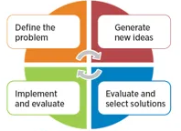
Figure-1; Source: (Ahmed, 2019)

How These Solutions Address the Problem
Part time staff would help manage peak time crowds, speed up service and reduce waiting times. It better improves customer experience and can help in rebuilding trust and boost sales. Customers would be able to order over the phone or kiosks, reducing queues and errors, and a digital ordering system would be used. This also frees up staff to prepare for service, making service more efficient and organized (Udeh, 2024).

Basic Risk Analysis
Wage expenses increase with hiring part-time staff and there is additional time needed for training new employees. Additionally, the café may not be able to recoup the extra costs, and overall profitability may be at risk if customer numbers do not increase quickly enough (Udofia et al., 2021). With digital ordering system, the cafe is going to have to spend upfront in buying software, devices, and even possibly maintenance. Also, some customers, especially the older ones or those who prefer personal service, may not be comfortable using the system. If no alternative options or support are provided however, this could basically lead to confusion or dissatisfaction (Harahap et al., 2024).
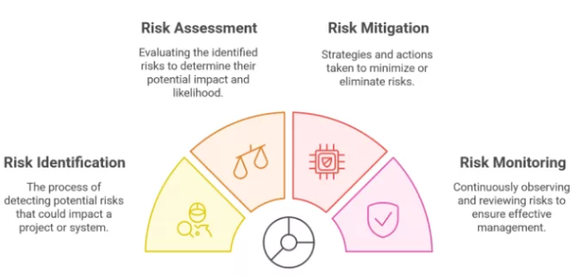
Figure-2; Source: (SixSigma.us, 2025)

Evaluation: PMI (Plus, Minus, Interesting) technique
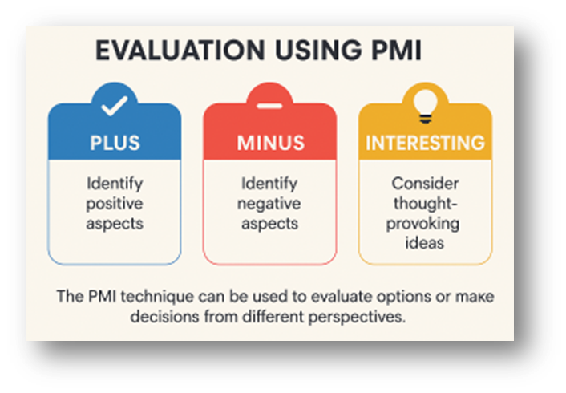
Figure-3; Source: Generated Using Canva

Solution 1: Hiring More Part-Time Staff

Plus
With its help, pressure can be relieved during busy times, service can be provided sooner and the overall customer satisfaction can be enhanced. It is also easy to implement and does not require big changes to the current setup (Wujarso, 2023).

Minus
Wage expenses include hiring additional staff and cafe have to spend time recruiting and training new employees, sometimes temporarily affecting operations.

Interesting
This may give staff a feeling of being more supported by management, which is essential in boosting team morale. It could improve teamwork and make a workplace a warm and friendly place to work (Okeke et al., 2024).

Solution 2: Digital Ordering System

Plus
Queuing/waiting time can be reduced and human error minimized in a digital system. In addition, it gives a chance to get hold of customer information to promote or offer targeted promotions.

Minus
The main drawbacks are that installation is very expensive and very expensive to maintain. Furthermore, not all customers will be comfortable with the technology (Udeh, 2024).

Interesting
This system would introduce the café as a modern and innovative one. The company could also attract tech savvy customers who want convenience and efficiency.
After analyzing the two options, it is better to hire more part time staff for now. It is easier to implement and cheaper, it also directly fixes the problem. After revenue and customer satisfaction improve, the digital ordering system could be introduced as an upgrade later (Top and Ali, 2021).

Plan for Implementing Solution, Monitoring and Review Process/System
Week | Activity | Details | Responsible | Monitoring
Week 1 | Post job ads | Boards, sites, socials | Manager | Applications received
Week 2 | Review, interview | Shortlist, schedule, meet | Manager, Supervisor | Candidate suitability
Week 3 | Hire staff | Select, confirm, notify | Manager | All roles filled
Week 4 | Staff training | Service, roles, teamwork | Trainer | Training feedback
Weeks 5–8 | Start shifts | Peak times, weekends | Manager, Leads | Staff performance
Weeks 5–8 | Track experience | Wait time, feedback | Staff, Manager | 7-min goal
Weeks 5–8 | Monitor revenue | Compare monthly totals | Manager, Accountant | Sales increase
Bi-weekly | Review progress | Check data, adjust | Manager, Leads | Plan success

In the first two months, the café should review progress every two weeks. If things go well, the same strategy can be continued and further improvements can be considered in the future (Devaraj, 2024).

Conclusion
Currently, GreenBean Café is in a serious problem due to slow service during peak hours, which has caused a 15% drop in sales and low customer satisfaction. The two main solutions that were considered were hiring part time staff and using a digital ordering system. Using the PMI technique, it was found that hiring part time staff is more suitable as it is cheaper, easier to implement and will directly affect the speed of the service.
A recruitment, training and monitoring plan has been laid out and success will be measured by waiting times, customer feedback and revenue performance. Following this approach, GreenBean Café can strive to earn customer’s trust back, augment revenue streams and create a solid foundation for growth in the future.

REFERENCES

Ahmed, A., 2019. Problem Solving & Critical Thinking. Medium. Available at: https://medium.com/@afaqahmed_1845/problem-solving-critical-thinking-af9cc4600a22 [Accessed 13 April 2025].
Cui, H., Qiu, J., Cao, J., Guo, M., Chen, X. and Gorbachev, S., 2023. Route optimization in township logistics distribution considering customer satisfaction based on adaptive genetic algorithm. Mathematics and Computers in Simulation, 204, pp.28-42.
Devaraj, S.M., 2024. Cloud, Ai, And Digital Transformation: A Winning Combination. International Journal Of Computer Engineering And Technology (Ijcet), 15(5), pp.1020-1032.
Harahap, A.T., Kadir, A.R., Nohong, M., Sobarsyah, M. and Sabbar, S.D., 2024. Impact of Service Digitalization on Operational Efficiency and Company Performance: Mediating Effect of Customer Satisfaction in Perumda Tirta Benteng. International Journal of Operations and Quantitative Management, 30(3), pp.36-60.
Nogalski, B., Tien, N.H., Kuc, B.R., Dung, T.A. and Anh, D.B.H., 2021. The role of R-logistics in customer satisfaction improvement in Vietnam's retail industry. Himalayan Journal of Humanities and Cultural Studies, 2(6), pp.14-22.
Okeke, N.I., Alabi, O.A., Igwe, A.N., Ofodile, O.C. and Ewim, C.P.M., 2024. Customer journey mapping framework for SMEs: Enhancing customer satisfaction and business growth. World Journal of Advanced Research and Reviews, 24(1).
Pérez-Morón, J., Madan, S., Cheu, J.Y., Kee, D.M.H., Cheong, L.C., Chin, R., Cheng, J. and García, A.P.M., 2022. Effect of service quality and customer satisfaction on customer loyalty: A case study of Starbucks in Malaysia. International journal of tourism and hospitality in Asia Pasific, 5(1), pp.62-74.
SixSigma.us, 2025. Quantitative Risk Analysis: Six Sigma's Key to Success. Available at: https://www.6sigma.us/six-sigma-in-focus/quantitative-risk-analysis-qra/ [Accessed 13 April 2025].
Talapatra, S., Santos, G. and Gaine, A., 2022. FACTORS AFFECTING CUSTOMER SATISFACTION IN EATERY BUSINESS-AN EMPIRICAL STUDY FROM BANGLADESH. International Journal for Quality Research, 16(1).
Top, C. and Ali, B.J., 2021. Customer satisfaction in online meeting platforms: Impact of efficiency, fulfillment, system availability, and privacy. Amazonia Investiga, 10(38), pp.70-81.
Udeh, E., 2024. Examining The Impact of Operation And Production Management Failure On Customer Satisfaction And Organizational Growth: A Qualitative Study. European Journal of Political Science Studies, 7(1).
Udofia, E.E., Adejare, B.O., Olaore, G.O. and Udofia, E.E., 2021. Supply disruption in the wake of COVID-19 crisis and organisational performance: mediated by organisational productivity and customer satisfaction. Journal of Humanities and Applied Social Sciences, 3(5), pp.319-338.
Umashankar, N., Bahadir, S.C. and Bharadwaj, S., 2022. Despite efficiencies, mergers and acquisitions reduce firm value by hurting customer satisfaction. Journal of Marketing, 86(2), pp.66-86.
Wujarso, R., 2023. Effect of digital transformation on company operational efficiency. Asadel Publisher.

