Semester two
Sam Tucker
2018390
Work Based Project
ACBA 5009

Table of Contents
1.0 Chapter 1 – Introduction 2
1.1 Aims 2
1.2 Objectives 2
1.3 Hypothesis 2
2.0 Chapter 2-Literature review 3
2.1 Skills shortage in the UK 3
2.2 Apprenticeship schemes (General) 3
2.3 Government funding 4
2.4 Construction levy 4
2.5 Apprenticeship levy 4
2.6 Brexit and the UK construction industry Skills shortage 5
3.0 Chapter 3- Research Methodology 6
Chapter 4 – Results analysis 6
4.1 Introduction 6
4.1.1 Collection of data 7
4.1.2 Questionnaire Structure 7
4.1.3 Cover letter 7
4.1.4 Questionnaire delivery and response 7
4.2 Data analysis 8
4.2.1 Skills shortage 8
4.2.2 Apprenticeship schemes 9
4.2.3 Government funding 9
4.2.4 Alternative resources 10
5.0 Chapter 5 – Conclusion/ Reflection 11
5.1 Aims 11
5.2 Objectives 11
5.3 Hypothesis 11
5.4 Critical Analysis/Reflection 11
References 13
Appendix 14
Appendix A 14
Appendix B 15
Appendix C 15
Appendix D 16
Appendix E 16
Appendix F 17
Appendix G- Updated delivery Gant chart 18
Appendix H- Cover letter 19
Appendix I -Questionnaire 20

Chapter 1 – Introduction

1.1 Aims

The aim of the project is to establish if Apprenticeship Schemes are helping construction companies amid skill shortages within the UK construction industry.

1.2 Objectives

To be able to answer the Aim, the following objectives will need to be completed
- To review all background literature on the topic surrounding Apprenticeship schemes and available funding
- To Fully understand the views of senior figures in control of local construction companies about the research topic
- Development of a questionnaire to capture the views
- Prove statistically differing of opinions and views on the subject
- Analyse data received to generate a conclusion to satisfy the Hypothesis proving apprenticeship schemes help with the skills shortage.

1.3 Hypothesis

Apprenticeship schemes help with the skills shortage within the UK construction sector

2.0 Chapter 2-Literature review

2.1 Skills shortage in the UK

A survey completed for a cross industry report into shortage occupations in construction it was identified that the leading area of skill shortage was that of construction project managers and construction trade supervisors (Appendix A). One of the main factors in the skills shortage in the UK construction industry has been encouraging young people to choose a career within this sector. Despite heavy investment from the government and a wide range of opportunities available for school leavers, it remains that a potential career in construction is often overlooked. With over 20% of construction workers in their fifties, a concern that demand for skilled professionals will outweigh supply thus meaning experienced construction workers retiring along with the industry losing valuable experience. (solutions, 2021). Alternatively, Sue Richardson writing for the National institute of labour study states “there are sufficient people who have the essential technical skills who are not already using them, but they are not willing to apply for the vacancies under current conditions” (Richardson, 2007) . With a record 1.2 million job vacancies in the three months leading up to November 2021, over more than half of businesses who reported a worker shortage stated they were unable to meet demands (statistics, 2021)
Within the Governments industry strategy for construction 2025 the government believe engagement with the public must begin at a young age, around 11 years old prior to making curriculum choices and then be consistently applied right through to further and higher education level. “There is a pressing need to properly inform young people, and their influencers (parents and teachers), about the rewards offered by a career in construction” (Government, 2013).This strategy expands a real opportunity to convey to the younger generation a sense of excitement about opportunities in the built environment sector, potential to addressing climate change and pursuing innovation and technological advance, to creating a more sustainable and better built environment (Government, 2013).
In 2005 a survey around skills shortages was conducted by the CIOB. These surveys concluded that Charted members of the CIOB believed there to be a skills shortage in the UK construction industry (CIOB, 2008). See (Appendix B)

2.2 Apprenticeship schemes (General)

Apprenticeships schemes are a great way to enter industries, including the construction sector. Apprenticeships are a style of training that combine practical work in a job and studying. “Apprenticeships can help apprentices develop experience, gain job-specific skills and obtain a formal qualification whilst at the same time earning a wage” (people, 2021) There are many different forms of apprenticeships. They Can vary over numerous years to complete and will involve studying at least one day a week. Apprenticeships can be started from 16 but most recent studies show more over 25s starting apprenticeships compared to this time ten years ago. (See Appendix C). Apprenticeships can also start at differing qualification levels and can be noted that higher levels of Intermediate and Advanced apprenticeship start in recent years. showing apprentices are seeking higher qualifications through an apprenticeship route (See Appendix D). The largest growth by sector in the year 2012-2020 being the construction sector (See Appendix E).

2.3 Government funding

A multi-million-pound fund to help aid the construction skills shortage in the UK has been was launched on 18/6/18 by the Skills Minister Anne Milton. 158,000 new construction jobs are expected to be created in the UK over the next five years, the £22million Construction Skills Fund will take training from the classroom to construction sites, thus allowing learners to apply their knowledge in a real-world environment. Minister Anne Milton quoted
“For our economy to thrive we need everyone, regardless of their age or background, to be able to get the training and the skills they need to make the most of the opportunities that lie ahead” (Government, 2018)
“This will help meet the needs of employers and tackle the construction skills shortage, while also supporting those who want to join the industry, particularly adult learners” (Government, 2018).

2.4 Construction levy

Across Britain, £140m of the Construction industry levy will be invested into construction in 2021/22, The funding for employers to train and in business support and services. The investment will see 94 pence out of every pound of the levy that CITB receives prioritises the current shortage issue.
The key investments for Wales include grants, training and apprenticeship support with immediate needs as well as supporting new learners and workers. Leigh Hughes, CITB Cymru Wales Nation Council Chair, said: “This plan shows we’re listening to the industry and investing in what it has told us is most important. We’re targeting levy money at fewer initiatives to ensure industry funds work hard to tackle priority issues, addressing future needs and current challenges” (journal, 2021)
Investment in training in the UK has fallen over the last 20 years, Although, the government points to research that indicates for every pound invested in adult apprenticeships at Level 2 and Level 3, the country benefits by £26 and £28 respectively (See Appendix F).

2.5 Apprenticeship levy

In the 2015 Emergency Budget, the Government announced the introduction of a levy on large companies to help fund three million much needed new apprenticeships by the year 2020. It was suggested the levy introduced in April 2017 would increase investment in training and apprenticeships. Skills Minister Nick Boles said,
“Skilled people are the lifeblood of a strong economy but for too long UK businesses have invested too little in developing their employees’ skills to meet the demands of a competitive, global market. The apprenticeship levy will ensure that businesses invest in skills and training, and will act as a much-needed shot in the arm for the country’s productivity.” (Designingbuildings/wiki, 2021)
However, in March 2017, the cross-party sub-committee on Education, Skills and the Economy criticised this by announcing
“We recommend that the government, as part of its continuing review of the operation of the levy, consider whether a single rate is the best approach and explore ways of restructuring the levy on a sectoral and regional basis…. The government has not set out how its increase in apprenticeship numbers will help fill the country’s skills gaps. The current balance of provision is skewed towards sectors with low wage returns and few skills shortages and we are not convinced that tinkering will bring about the major changes necessary.” (Designingbuildings/wiki, 2021). Despite this, the levy went ahead.

2.6 Brexit and the UK construction industry Skills shortage

Although the UK construction industry is working in close partnership with the government to ensure a continued entry of talent entering the Construction profession, numbers entering are nowhere near the 700,000 who are set to retire in the next 10 year (wiki, 2021)
Brexit imposes added potential to further intensify the skills shortage problem within the UK construction industry by potentially taking away access to the possible abundance of hundreds of thousands of skilled European migrants. Developing more home-grown skilled workers will take time, therefore, access to foreign workers is critical to current ambitions and targets set out by the UK government. On 29th of November 2017, Many Major construction trade bodies joined together to complete and publish the Construction Industry Brexit Manifesto. Within this document, It Warned the government. “Industries with a current reliance on immigrant workers should not face a ‘cliff edge’ in terms of incoming migrant workers.” (www.acenet.co.uk, N.D), the bodies set out their shared vision of the UK constructions sector’s responsibilities and requirements in a post-Brexit labour market. The manifesto calls for a transition period of 2 years, followed up by a migration system that serves and provides the required skills. The manifesto “commits the trade bodies to recruit and retain more UK workers, but it recognises that this is a slow process and skilled EU construction workers will continue to be needed in the meantime” (wiki, 2020)

3.0 Chapter 3- Research Methodology

During the literature review I found out a lot about what was on offer to companies in regards available funding, available levies and apprenticeship schemes, yet it didn’t fully answer my aim, for answering the hypothesis ‘Apprenticeship schemes help with the skills shortage within the UK construction sector’. To help aid my objectives to fully understand the views of senior figures in control of local construction companies about the research topic, I developed a questionnaire to capture the views to give statistical data to answer the hypothesis. This questionnaire was developed with Respect for the dignity of the research participants along with full consent. A cover letter was sent out explaining the reasonings behind the questionnaire. The questionnaire was trailed and proof read by my Managing director and after discussions on what he felt may obtain more in-depth views, further questions were added to the questionnaire. From the list of eligible construction companies, a questionnaire was sent out via post for completion. It was originally planned and noted in the sequence of work table provided in the research proposal that the questionnaire was to be sent out on the 3/2/22, but due to the ongoing COVID-19 pandemic limiting the number of senior figures attending work and working from home addresses, the questionnaire was sent out on 26/2/22. Appendix Gshows the updated Gant chart highlighting the movement. The research title was removed from the questionnaire, thus not obtaining bias data. The protection of the privacy of research participants was ensured throughout the whole process along with an adequate level of confidentiality. All findings provided gave both Quantitative and qualitative data. Combining qualitative and quantitative research gave more in-depth data to analyse. The data obtained from the questionnaire will be shown by the use of Pie charts. The Graphical method of investigation uses a graphical representation of the answers. Views and opinions given in the answers will be analysed and the most common or most reoccurring answers will be given alongside the Pie charts to give a more in-depth answer and add depth to the answers and personal views, but as mentioned within the research proposal this method only provides some visual guidance.

Chapter 4 – Results analysis

4.1 Introduction

The aim of the research is to establish if Apprenticeship schemes help tackle skills shortages in the UK construction sector?
Within this chapter I will be highlighting the most significant findings from the results obtained from the questionnaires and illustrated by graph to clearly show the reader. This research is representative of construction directors within the construction industry in South Wales.

4.1.1 Collection of data

Within this section it gives clarity on the different methods from which the quantitative and qualitative data has been collected and used to investigate and answer the aims and objectives set out within my research proposal.

4.1.2 Questionnaire Structure

My questionnaire was constructed using Six main questions to meet the aims and objectives set out in section 4 of the research proposal, as well answering the research question. The questionnaire can be found in Appendix I. The questionnaire was designed with up front closed end questions, which the participant had to choose from a selection of answers provided by myself. The second part of the question was to explain in detail their reasonings. This open end set of questions is Qualitative data. Although Qualitative research is often “criticized as biased, small scale, anecdotal, and/or lacking rigor; however, when it is carried out properly it is unbiased, in depth, valid, reliable, credible and rigorous” (Educ., 2010).

4.1.3 Cover letter

The use of a cover letter (see Appendix H) was sent to all local construction companies to engage with potential participants. The cover letter was used to explain the reasoning for which the primary research was to be used and the purpose of the questionnaire attached. A cover letter is as important because the cover letter “accompanies or transmits another document such as a survey questionnaire. Its purpose is to alert the respondent about the questionnaire it accompanies and to provide the details of requested actions on the part of the respondent. When used as a part of multiple communications or overall research strategy, such as an advanced contact or future reminder mailings, it can help increase response by conveying important information (e.g., research topic, survey sponsor, incentives) that is likely to influence a respondent's decision to cooperate and/or to comply fully and accurately with the survey task” (Lavrakas, 2008) The Questionnaires were sent out giving sufficient allocated time for fulfilment.

4.1.4 Questionnaire delivery and response

A total of 14 questionnaires were sent out to local construction companies. This was to try to maximise the potential response to whom 8 responded with complete questionnaires. This amounts to a response rate of (57.14%). “PIAAC (OECD, 2013) sets a target response rate of 70%. In this study a response rate of 50% or better is acceptable if the results of a nonresponse bias analysis (when necessary) determine that no significant bias is present. Similarly, the US Office of Management and Business (OMB, 2006) prescribes that for a survey with an overall unit response rate of less than 80%, an analysis of nonresponse bias should be conducted, with an assessment of whether the data are missing completely at random” (Wolf, 2016). The questionnaires were sent out on the 26/2/22 and allowing a week return period, followed by a curtsey email for all respondents from which there was no return. An additional return week was given to maximise the number of responses for analysing the primary data. One additional questionnaire was returned bringing the total number of responses to nine from the fourteen sent. This equated to (64.29%). The questionnaire was attached with the cover letter and the questionnaire delivery of choice was mail Questionnaire. These sort of questionnaires “involve the researcher to send the questionnaire list to respondents through post, often attaching pre-paid envelope. Mail questionnaires have an advantage of providing more accurate answer, because respondents can answer the questionnaire in their spare time. The disadvantages associated with mail questionnaires include them being expensive, time consuming and sometimes they end up in the bin put by respondents” (BRM, ND).

4.2 Data analysis

4.2.1 Skills shortage

The first part of the questionnaire was constructed to gain the senior figure participants general opinion on the well documented situation within the UK construction industry regarding the skills gap and thus the shortage of skilled labour within the UK construction industry. The use of Closed-ended questions was adopted. The graph below Illustrates the response. It is clear to see that the majority or participants (62%) are in agreement that there is a shortage of skilled labour within the construction industry, Undecided (22%) and only (11%) think there is no shortage. The second question asked the participant as to why they believed there was a shortage. The most common answer was Lack of awareness (30%) with Wage demands, Brexit and Low apprenticeship wages following all at (20%).
Figures 4.2.1

4.2.2 Apprenticeship schemes

Participants where asked whether or not If they would continue to use schemes such as the apprenticeship schemes to build their workforce. The majority said yes (78%), with (11%) saying no, and (11%) being undecided. The second part of the question asked the participant to explain their answers. The positive feedback was encouraging to read with the common denominator being that they all believed the schemes benefited the company. However, this answer can be read as a bias answer towards the companies own objectives and needs rather than the Construction industry as a whole.
Figure 4.2.2

4.2.3 Government funding

Participants were asked if they had used Funding available to obtain apprentices. Additionally, if they believed there was enough support from the government in relation to the ease of obtaining the funding. The results clearly show most participants (89%) all used funding while obtaining apprentices, with only the remaining (11%) not. This shows the Government are being proactive and funding is available, however it is alarming to see the majority (37%) of participants said trying to obtain the funding was a complicated process and (13%) stating it was very complicated. This shows improvement needs to be made by the government to ensure the funding is easier and more obtainable.

Figures 4.2.3

4.2.4 Alternative resources

Construction directors were also asked within the questionnaire whether they had employed alternative resources for expanding their business or to fulfil the needs of the company. Accompanying this question, participants were asked for their reasoning behind their decision. From a list of closed answers given to choose from, the data obtained showed that and older experienced workforce (45%) was used as short-term employment instead of apprentices (22%), Agency workers (22%) or others (11%). The overriding conclusion obtained from the reasonings was the need for instant results in pressure situations being the preferred option taken by company hierarchy, rather than employing apprentices to bridge the gap. This would indicate that Senior figures do not believe apprentices have the skills needed to give companies the desired level of output for short term employment and putting trust in experienced workers is the majority decision.
Figure 4.2.4

5.0 Chapter 5 – Conclusion/ Reflection

5.1 Aims

The aim of this project was to establish if Apprenticeship Schemes are helping construction companies amid skill shortages within the UK construction industry.

5.2 Objectives

To be able to answer the Aim, the following objectives were completed
- Reviewed background literature on the topic surrounding Apprenticeship schemes and available funding
- Analysed data obtained from Primary research; this was obtained from a questionnaire that captured views understand the views of senior figures in control of local construction companies about the research topic
- Proved statistically differing of opinions and views on the topic
- Analysed data received to generate a conclusion to satisfy the Hypothesis proving if apprenticeship schemes help with the skills shortage or not

5.3 Hypothesis

Apprenticeship schemes help with the skills shortage within the UK construction sector

5.4 Critical Analysis/Reflection

It is the opinion of the author that the aims and objectives were met, however the hypothesis, the author believes sufficient data obtained from both Primary and secondary research help prove the hypothesis as inconclusive. The results showed the author that the skills shortage was well known and that from the responsive participants. The reasonings as to why the participants believed there to be a skills shortage however was very different to my own opinion. Lack of awareness was the majority answer, which indicates the participants believe there being a lack of awareness about a career in Construction. I have been in the construction industry since the age of sixteen so was surprised at the majority answer. On further thought, I entered the construction industry due to the fact my family worked within it and therefore my views were bias as being within the construction environment since a young age probably shielded the lack of awareness at secondary school level. Apprenticeship schemes are being used and the government are funding schemes, although obtaining the funds was viewed complicated. The researcher believes more research into these reasoning’s are needed. It was alarming however to conclude that the majority opted for alternative labour resource to bridge the skills gap rather than employ or promote apprentices to higher roles. The main reasons for this outcome were the pressure for instant results within the construction industry with tight programs and lack of faith in the apprentice being the highlighted views. The author however does feel had he had more responses to the questionnaire, this may have altered the result.
This exercise has taught me the value of both quantitative and qualitative primary research. Even though I was unable to prove my own view that the hypothesis was correct, this project has shown me that apprenticeship schemes are being used within the industry and that companies are willing to take on apprentices like myself. From the literature review It has taught me a lot about the construction levies available. I believe this will aid me in the future as I have an ambition to own my own construction company one day. The construction and apprenticeship levy are funding I would look at it the future as well as discussing with future employers if put into a position of Senior management. The secondary research has most definitely helped me explore avenues I did not know where currently existing within the industry. If I was to do this project again, I would change my approach to the way in which the questionnaires were sent out. I would use emails in the future as I believe a higher response rate may have been obtained. I would also include the Linkert scale method for obtaining a more precise degree of agreement or disagreement. I believe more closed questions would have given more quantitative data. Concluding answers from participants point of view was challenging and the Linkert scale method would have eliminated the authors possible error in judgment while collating the views into statistical outputs. I would also ensure I received more responses by identifying a wider range of participants. Perhaps allowing more time in identifying a larger selection of companies would have increased the accuracy of the survey. This project has opened my eyes into the topic and given me an increased willingness to help promote apprenticeship schemes and also raise more awareness about the industry at a younger age. I will be actively looking to seek more research into the topic as a continued development plan and assist my current employers in raising awareness with school visits and construction fares and talks to engage with potential future apprentices, thus helping to shorten the skills gap and help towards ensuring a continuing thriving apprentice pool for construction companies to utilize and strengthen the industry in which I work in.

References
Government, H., 2013. Industrial Strategy: government and industry in partnership. [Online]
Available at: https://assets.publishing.service.gov.uk/government/uploads/system/uploads/attachment_data/file/210099/bis-13-955-construction-2025-industrial-strategy.pdf
[Accessed 26 January 2022].
Richardson, S., 2007. What is a skill shortage , Adelaide: NCVER.
solutions, E., 2021. The UK construction sector skills shortage - what you need to know. [Online]
Available at: soloutions, E., 2021. The UK construction sector skills shortage. [Online]
[Accessed 12 December 2022].
statistics, o. f. n., 2021. Changing trends and recent shortages in the labour market, UK: 2016 to 2021. [Online]
Available at: https://www.ons.gov.uk/employmentandlabourmarket/peopleinwork/employmentandemployeetypes/articles/changingtrendsandrecentshortagesinthelabourmarketuk/2016to2021
[Accessed 30 January 2022].
uk, B., 2019. Shortage occupations in construction:A cross industry report. [Online]
Available at: https://builduk.org/wp-content/uploads/2019/01/Shortage-Occupations-in-Construction-A-cross-industry-research-report-January-2019.pdf
[Accessed 30 January 2022].
Wolf, C. J. D. S. T. W. &. F. Y., 2016. The Sage Handbook of survey methodology. s.l.:Sage Publications Ltd.
CIOB, 2008. Skills shortage in the uk construction industry. [Online]
Available at: https://www.ciob.org/sites/default/files/CIOB%20research%20-%20Skills%20in%20the%20UK%20Construction%20Industry%202008.pdf
[Accessed 7 December 2021].
wiki, B. d., 2021. Skills shortage and Brexit. [Online]
Available at: https://www.designingbuildings.co.uk/wiki/Skills_shortage_and_Brexit
[Accessed 25 February 2022].
wiki, D. b., 2020. construction industry brexit manifesto. [Online]
Available at: https://www.designingbuildings.co.uk/wiki/Construction_industry_Brexit_manifesto
[Accessed 26/2/22 February 2022].
www.acenet.co.uk, N.D. Construction Industry Brexit manifesto. [Online]
Available at: https://www.acenet.co.uk/media/1477/construction-industry-brexit-manifesto.pdf
[Accessed 27 February 2022].
BRM, ND. Questionnaires. [Online]
Available at: https://research-methodology.net/research-methods/survey-method/questionnaires-2/?msclkid=4aef2d20afa211ec9b716eae064d3636
[Accessed 24 March 2022].
Educ., A. C. .. A. J. P., 2010. Presenting and evaluating qualitative research. American journal of pharmaceutical education, 74(141), p. 7.
Lavrakas, P. J., 2008. cover letter. Encyclopaedia of survey research methods, Volume 1.

Appendix

Appendix A

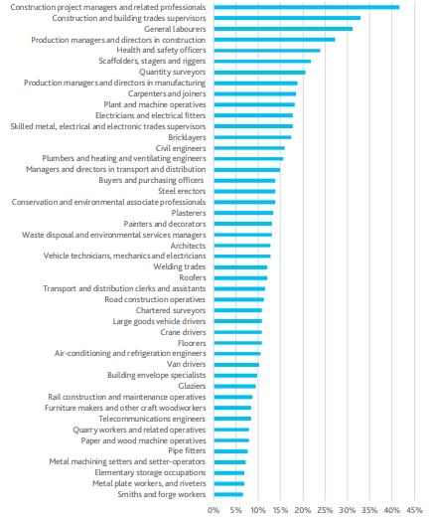

(uk, 2019)

Appendix B
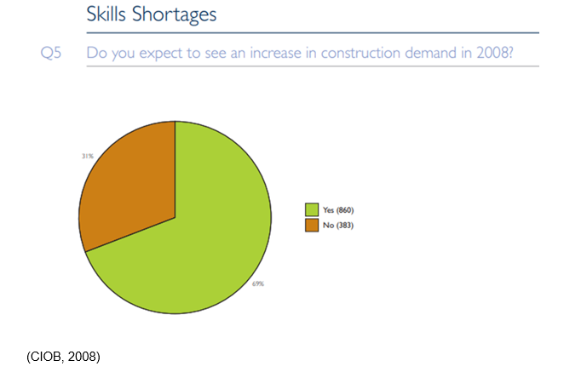

Appendix C

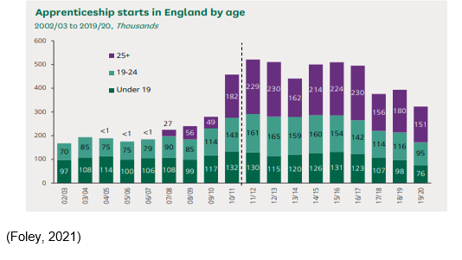

Appendix D

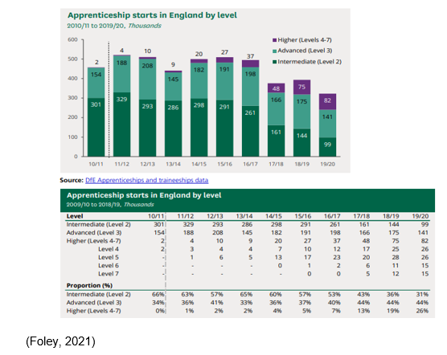

Appendix E

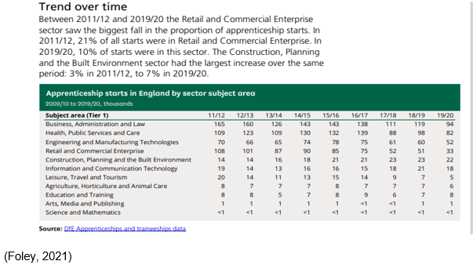

Appendix F

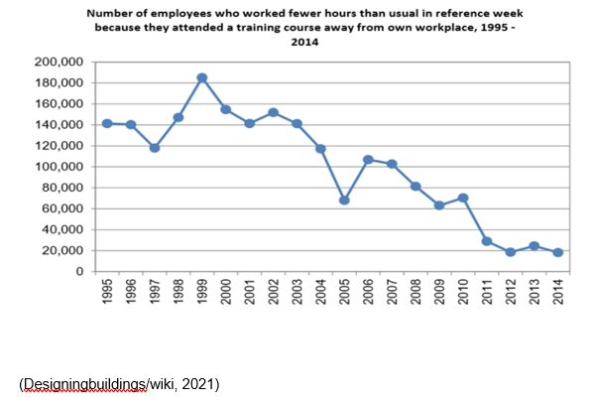

Appendix G- Updated delivery Gant chart

Appendix H- Cover letter



Appendix I -Questionnaire

