Getting your point data onto the map

For demonstration purposes for this technique of placed a simple spreadsheet onto Moodle it's called coastal locations and has some data over a period of time and season where waste and litter has been observed in coastal locations and the observations have been categorised. Download this data from model into your own file management system and we can use this to practise the technique of transferring points onto a map.

Once you have cleansed the data within your excel spreadsheet the next thing you need to do is save this spreadsheet as a CSV file. Within excel simply choose the save as option until you have particular file types choose CSV you notice it will say, delimited. You don't need to change the name of your spreadsheet you will just have two versions within your folder.

In QGIS choose layer then add delimited text layer and you should see the following window

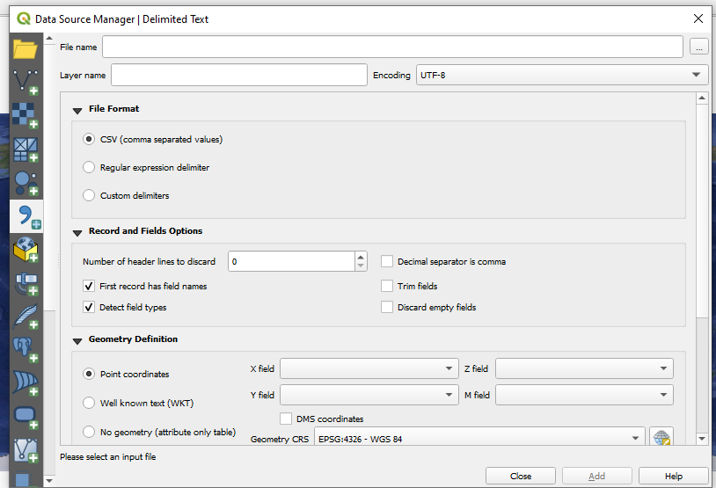

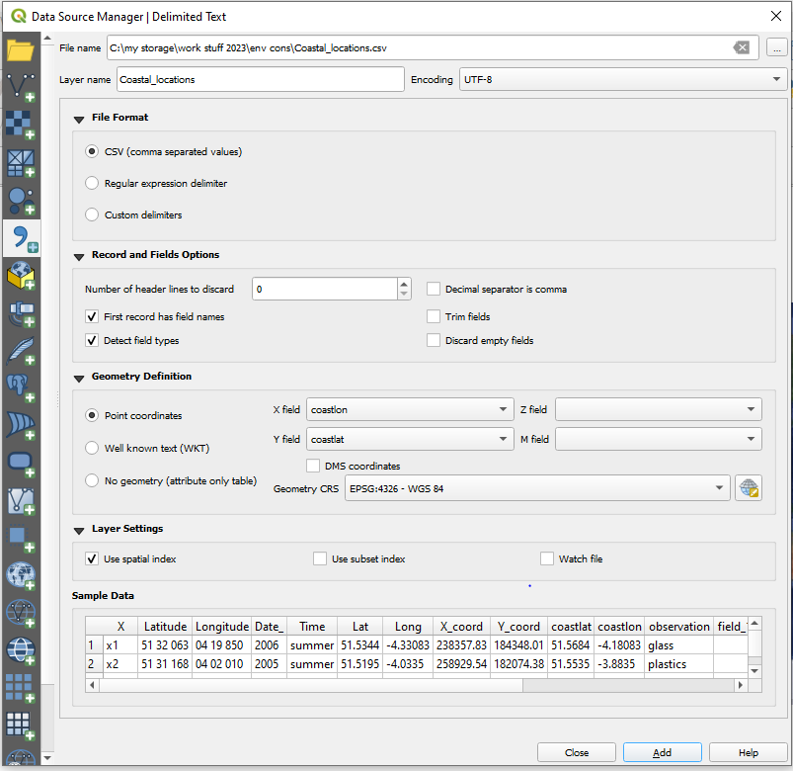

Make sure your window looked as above and notice that QGIS has already decided that the most relevant data comes from your coaslon and coastlat fields so it's quite intuitive in its selection of data requirements for creating points as you have specified.

Once you click add you should see points appear on your map.

