ANALYSIS AND PRACTICAL APPLICATION OF WINDOWS AND LINUX OPERATING SYSTEMS: CLI COMMANDS AND SCRIPTING

Abstract: This report outlines the essential functionality and use of Windows 10 and Ubuntu Linux operating systems. It breaks down process, memory, file system, device, and user interface management in screenshots and descriptions. It also provides ten recommended CLI commands per OS and illustrates how to script operations with PowerShell and Bash to monitor systems, administer files, and control resources. The conclusion highlights the applicability of command line experience and scripting skills to effective system maintenance and everyday computing operations.
Keywords: Operating System, Windows 10, Ubuntu Linux, Command-Line Interface (CLI), PowerShell, Bash, Process Management, Memory Management, File System Management, Scripting, System Administration

Introduction
This report dwells on the main implementation, scripting, and conceptual visions of contemporary operating systems such as windows 10 and Ubuntu Linux. It shows how the operating systems are capable of coordinating processes, memory, files, and hardware, and offering graphic and command-line interfaces. Usage of CLI commands and scripting-based operations to execute system, file, and automation exercises are also recorded in the report.

Task 1: Key Functions of General Operating Systems
Modern operating systems play a critical role in the management of resources of computer hardware and software as well as an access point where the user can access the system. General-purpose operating system is designed to organize processes, manage memory and storage, oversee hardware devices, and provide a graphical and command-line interface [1].

Process Management
Process management The ability of the operating system to orchestrate the running of two or more programs simultaneously. Any processes include any executing applications or background services and should be allocated efficiently to processor time and system resources. The operating system schedules tasks in a manner that gives the CPU a just amount of control to avoid system overloading.
Process control is also vital because uncontrolled processes may end up consuming too much CPU resources, freezing the machine or even collapsing. The operating system is responsive and stable by prioritizing tasks and terminating unresponsive applications.
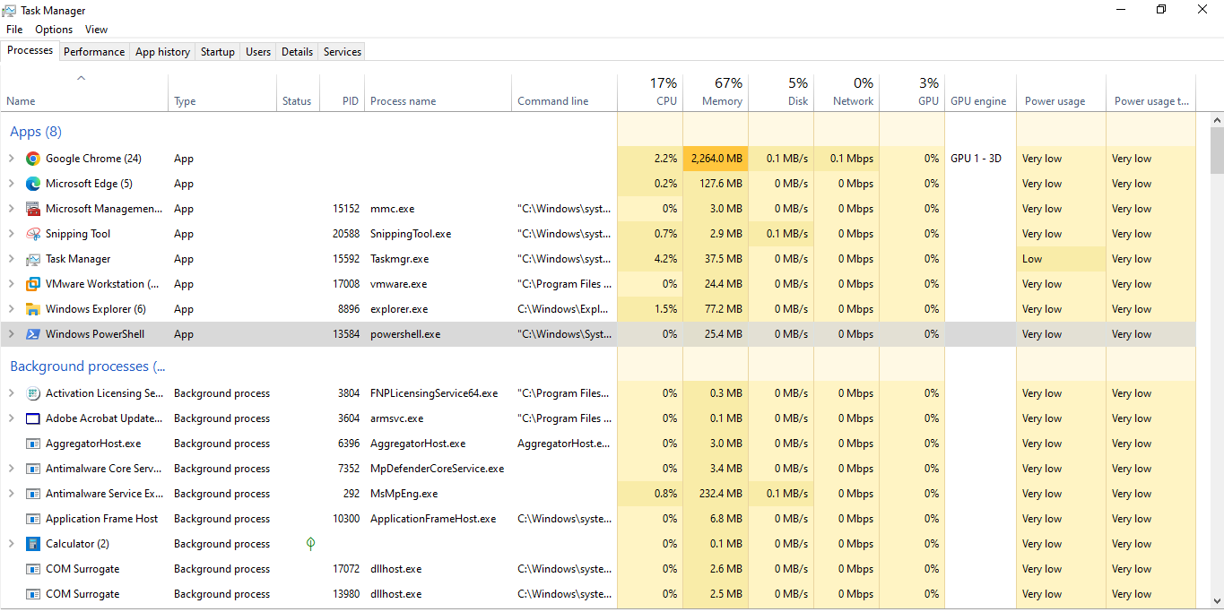
Fig 1. Windows Process Management
Fig 1. depicts the Windows Task Manager with active applications and background programs. This interface enables the operating system to keep track of real-time CPU load, memory, and process health. Task Manager allows windows to manage the processes efficiently, with the users able to cancel unresponsive processes and schedule them.

Memory Management
Memory management is the art of managing the allocation, use, and deallocation of system memory (RAM) to execute programs. The operating system ensures that every process has sufficient memory, and that any programs that might desire to share the same memory address does not preempt one another [2].
Memory management is another significant area of system performance. Failure on memory allocation can result in slowness of application requests or system instabilities. Modern operating systems would work around the physical RAM constraints by employing virtual memory tricks, which means writing temporary data to disk where it is required most.
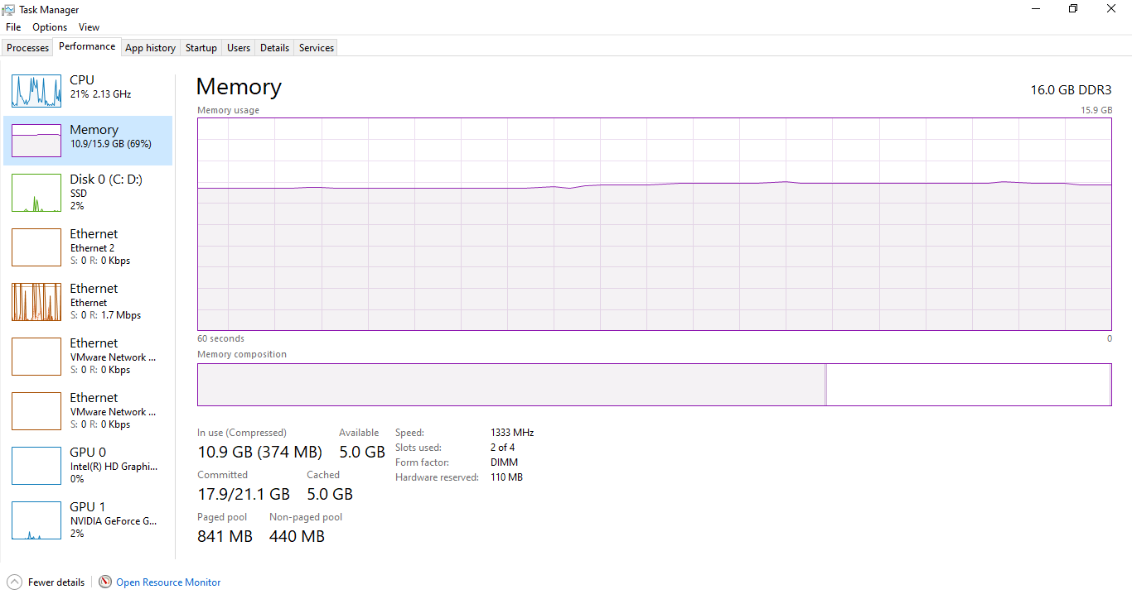
Fig 2. Windows Memory Managment
Fig 2. depicts Windows memory performance, total installed memory, current memory, and available memory. In this visualization, the operating system constantly checks the amount of memory used to ascertain that the system is at equilibrium and that the programs will actually execute without causing undue strain to the system resources.

File System Management
The file system management is a process through which an operating system controls, stores, retrieves, and protects data stored on storage media. The file system offers a hierarchical structure of directories and files that enable users and applications to locate information effectively [3].
Organized file systems enhance reliability, security, and storage efficiency. Access control and disk space monitoring and permissions are utilized to prevent unauthorised access and to ensure that storage issues do not disrupt the system operations.
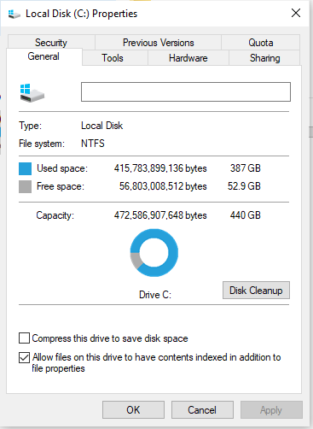
Fig 3. File System Management
Fig 3. displays local disk properties with NTFS file system. Windows relies on NTFS to store files, monitor disk space use and availability, and offer security permissions. This shows that information is held in integrity and that it is stored properly with the operating system ensuring that the process is easy.

Device Management
Hardware like graphics cards, storage, keyboards, and network adapters are also handled by the operating system. The device drivers facilitate this communication by serving as an intermediary to software and hardware.
The best thing to remember is to maintain the devices in good condition because that improper drivers or even their absence can cause the hardware to fail or the whole system. The operating system takes care of the coordinated interactions between programs and devices to guarantee that the hardware resources are functioning in harmony.
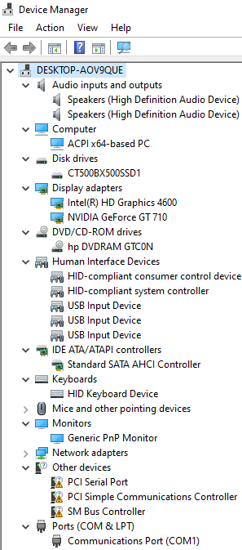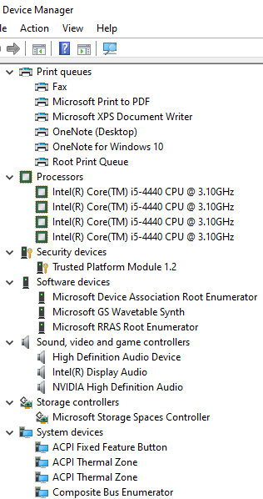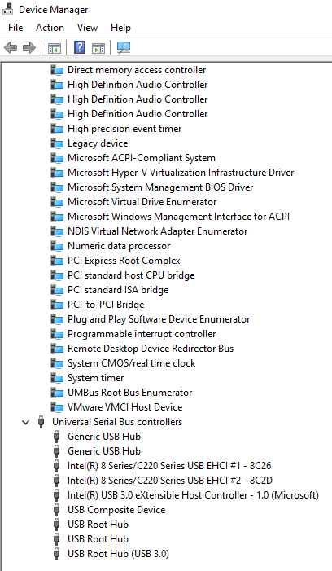
Fig 4. Device Manager
Fig 4. of Windows Device Manager, where all hardware is listed. The software enables the operating system to control drivers, troubleshoot hardware problems, and verify that the hardware is operating properly in the operating system environment.

User Interface (GUI and CLI)
The user interacts with an operating system. Modern systems also have a graphical user interface (GUI) to interact with a system graphically and a command-line interface (CLI) to interact with the system more closely [4].
The GUI is created to be user-friendly to any average user by showing it as icons and menus and windows. By contrast, the CLI is more administrative, automation-oriented to control and efficiency, especially system administration and scripting.
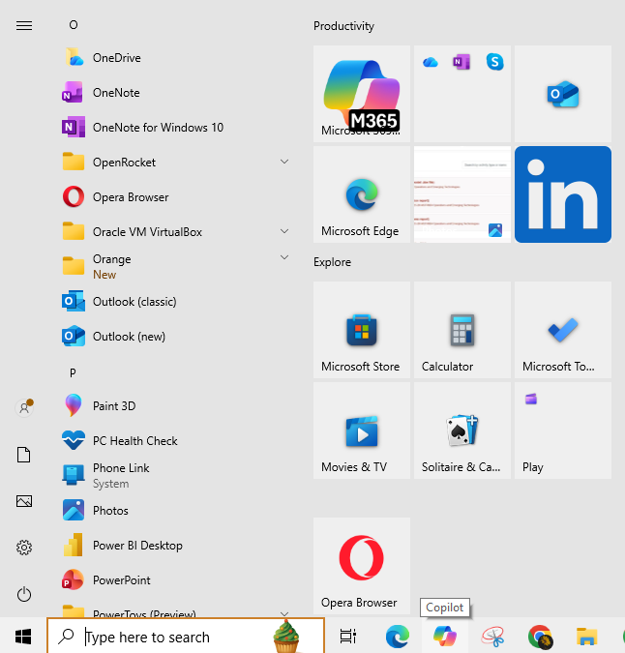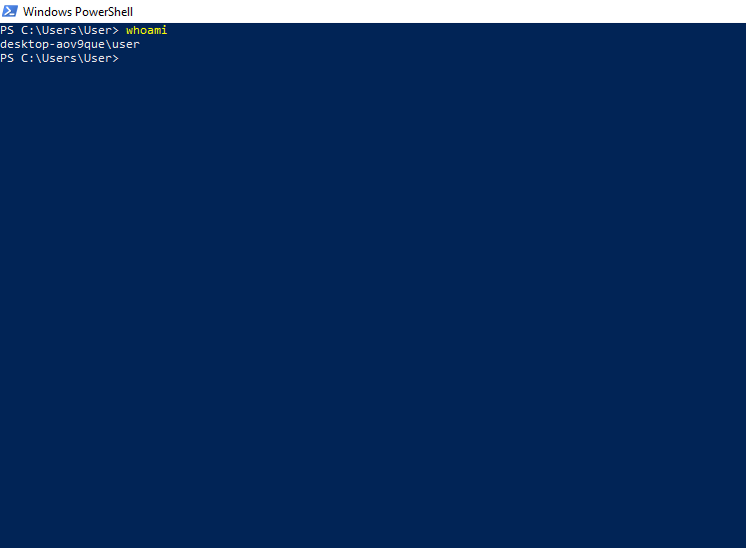
Fig 5. User Interface (GUI and CLI)
Fig 5. illustrates a graphical user interface (Windows Start Menu) and a command-line interface (PowerShell). These interfaces integrated together provide the flexibility in user interaction, allowing both the amateur and the sophisticated system administrator [5].

Summary
Task 1 examined the most popular five windows operating system features: process management, memory management, file system management, device management and user interface. They also provided screenshots of how each functionality functions in the real world. The assignment has illuminated the role of OS in resource allocation, system stability, files, hardware management, and in graphical interfaces and command line interfaces.

Task 2: Windows CLI Commands (PowerShell)
Power Shell is a command line interface that enables users and administrators to communicate meaningfully with the windows operation system. In this exercise, the ten basic PowerShell statements are illustrated in managing system processes, services, files, and hardware, and in maintaining system health and connectivity [6].

Get-Process
Get-Process command displays all processes currently running on the system with memory and CPU consumption. This helps keep track of resource assignments and system performance. It assists administrators in decision-making concerning resource-hungry processes and shutting down of non-responsive applications.
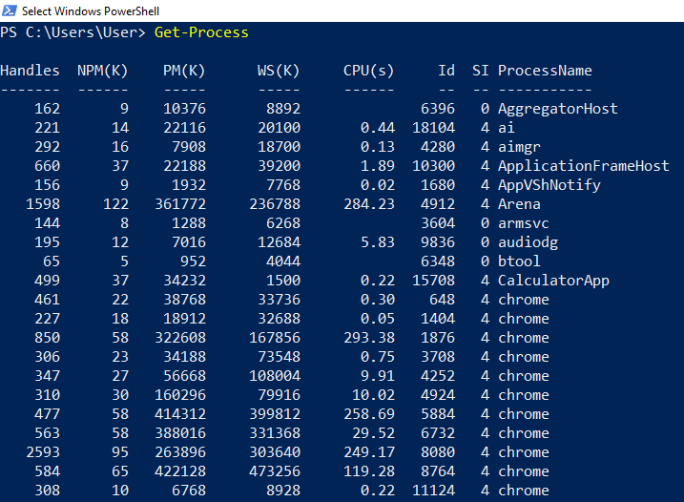
Fig 6. Get-Process
Fig 6. shows PowerShell Get process output. It is active, it uses CPU and memory, and it implies that the operating system works with processes.

Get-Service
Get-Service enumerates every window service and its state (running, stopped, or suspended). Administrators can verify the availability of the required services and debug services that fail to boot.
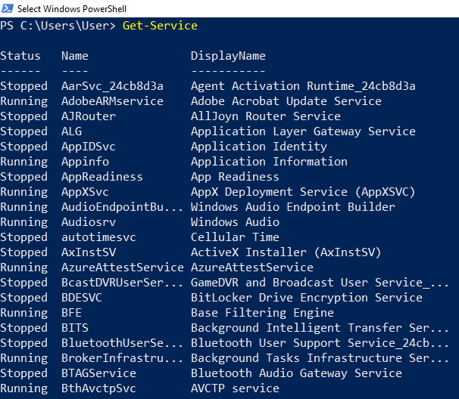
Fig 7. Get-Service
Fig 7. Service monitoring and management in windows can be explained by the output of Get-Service, where the essential system services and their state are shown.

Get-ChildItem
In Command Prompt, dir displays files and sub-folders in the active directory using get-childitem. It allows that to preview the arrangement of files and also navigate without the graphic user interface.
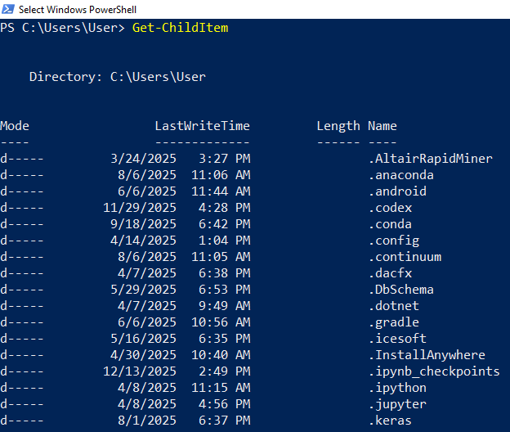
Fig 8. Get-ChildItem
Fig 8. CLI file system navigation This example describes how to navigate the file system using Get-Childitem to show files and folders within the current directory.

Set-Location C:
Set-Location C: changes directory to C. It enables users to navigate through directories efficiently in the CLI [7].
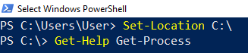
Fig 9. Set-Location C
Fig 9. depicts command-line navigation, with Set-Location changing the working directory to C.
Get-Help Get-Process
Get-Help Get-Process displays syntax, parameters, and an example of how to use the Get-Process command. It checks syntax in commands, and documents itself to administrators and users.
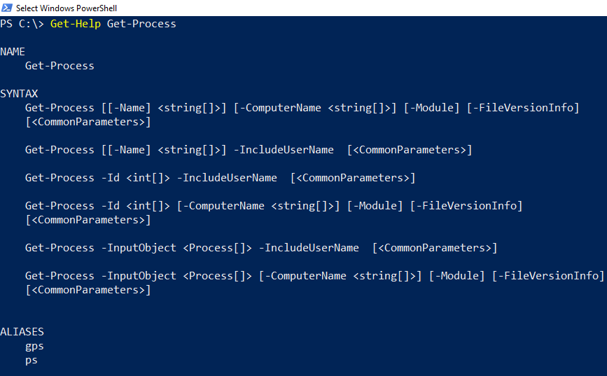
Fig 10. Get-Help Get-Process
Fig 10. illustrates the help output of Get-Process, indicating how PowerShell assists with documentation and use.

Get-EventLog -LogName System -Newest 10
Shows the last 10 lines of the Windows system event log. It enables administrators to track errors, warning or other meaningful system events to troubleshoot [8].
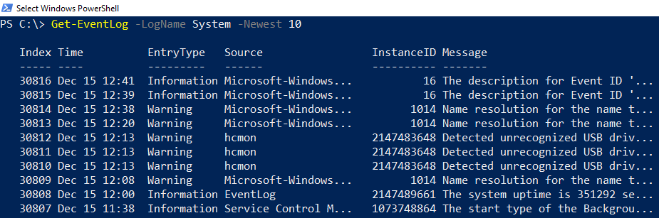
Fig 11. Get-EventLog
Fig 11. displays the most recent ten system events using Get-EventLog -logname System -newest 10 and demonstrates how system events can be monitored.

Test-Connection google.com
Ping ICMP messages to measure network latency by pinging Google.com. It checks that the system is able to connect to other servers and times responses.
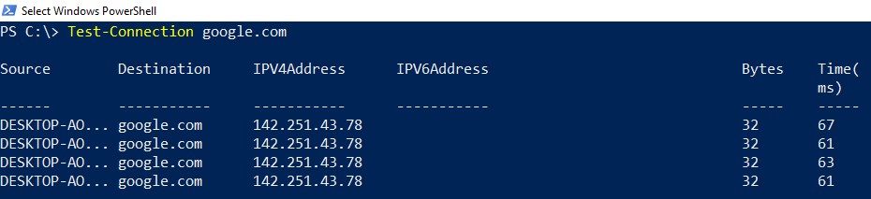
Fig 12. Test-Connection google
Fig 12. According to Test-Connection of google.com CLI is conducting network connection testing.

Get-ComputerInfo
Shows system information: version, hardware, and memory size.
It aids in auditing, inventory, and configuration.
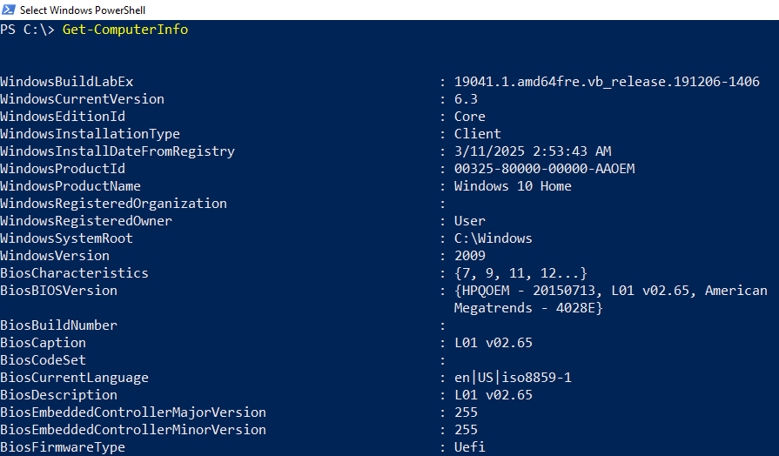
Fig 13. Get-ComputerInfo
Fig 13. demonstrates the result of Get-ComputerInfo which gives detailed system information in PowerShell.

Get-History
Shows a history of executed PowerShell commands in the active session. It enables auditing/re-running features and reviewing of past work.
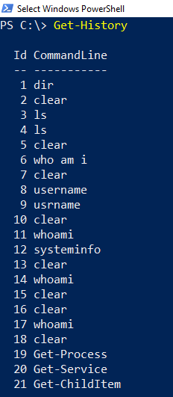
Fig 14. Get-History
Fig 14. shows the history of the command along with the output of Get-History, which demonstrates how to trace PowerShell sessions.

whoami
Shows the account are on. It authorizes user identity and access within the system.
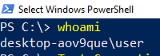
Fig 15. whoami
Fig 15. displays the outcome of whoami, which confirms the identity and the security context of windows.

Summary
In Task 2, ten PowerShell commands were introduced, such as Get-process, Get-service, Get-childitem, and Test-Connection among others. Each command was run, and the result was converted into screenshots to demonstrate processes, services, file management, network connectivity, and system data. The assignment also explained how to practically use CLI commands to monitor and maintain windows systems and how administrators can carry out routine and advanced tasks using scripts and command lines.

Task 3: Linux CLI Commands (Bash)
Linux also has a command-line interface (CLI) that allows users to interact directly with the operating system, allowing them to manipulate files, monitor system resources, and execute administrative functions. The most commonly used shell in Linux, bash (Bourne Again Shell), provides a very few commands to do anything useful without the help of a graphic user interface.

ls
Shows a list of files and subfolders in the current directory. Demonstrate a short listing of directory entries and permissions.
Fig 16. ls
Fig 16. displays the ls output, enumerating files and directories in the home directory.

pwd
Shows the current directory. Helps tells users where they are in the filesystem.
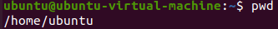
Fig 17. pwd
Fig 17. shows the output of the command pwd, which confirms this position in a directory.
cd /home/username
Alters the current directory to the given path. Learn how to navigate the filesystem.
Fig 18. cd
Fig 18. demonstrates navigation with the use of CLI by demonstrating a directory change using the command cd.

mkdir test_folder
Make a new folder named test_folder. Shows file treatment by Bash.
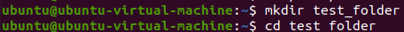
Fig 19. mkdir
Fig 19. demonstrates the creation of the test_folder, exposing the ability to manipulate the directories.

touch test_file.txt
Opens a blank file called test_file.txt. Useful in scripting and file writing.
Fig 20. Touch
Fig 20. The new file is created to demonstrate the management of Bash files.

cp test_file.txt copy_file.txt
Copies a file to a new file. Facilitates data duplication and recovery.
Fig 21. cp
Fig 21. shows copying of test_file.txt to copy_file.txt.

mv copy_file.txt new_folder/
Copies file to a new directory. Shows how to organize and navigate files in Linux.
Fig 22. mv
Fig 22. shows how to copy_file.txt into new_folder/.

rm copy_file.txt
Deletes a file within the filesystem. Removal and cleanup of files.
Fig 23. rm
Fig 23. illustrates the deletion of copy_file.txt to ensure system hygiene remains intact.

cat test_file.txt
List the lines of a file in terminal. Shows a preview of file contents without opening an editor.
Fig 24. cat
Fig 24. shows the contents of test_file.txt, a file that illustrates file investigation.

top
An interactive presentation of ongoing processes and resource consumption. Assist with the tracking of CPU, memory and system performance.
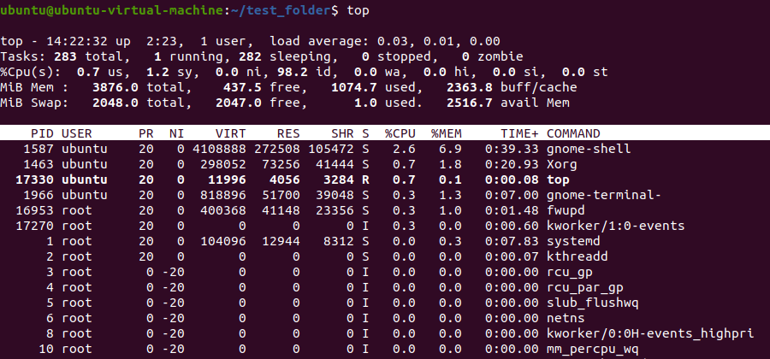
Fig 25. top
Fig 25. depicts the output of top that exemplifies active process management in Linux.

Summary:
Task 3 demonstrated ten fundamental Bash commands on Ubuntu, including ls, pwd, cd, mkdir, and top. Screen shots are used to capture all command output, including file and directory navigation, system monitoring, and process control. The practice also highlighted the practicality of Linux CLI in dealing with files, directories, and system resources. Hands-on experience developed some familiarity with Linux command-line interaction, and ensured that the operating system could handle both administration and everyday use.

Task 4: Windows OS Scripting (PowerShell)
PowerShell programming is a convenient way of automating functions, system settings, and routine operations on the windows operating system. The activity illustrates two simple PowerShell scripts that enumerate variables, loops, and conditionals to manipulate system information and files. To illustrate graphical cues of script execution and output, screenshots were taken [10].

Script 1: List All Running Processes
The script is based on Get-Process, which retrieves all processes running and appends it to a variable and proceeds to loop through each process to retrieve the process name, process id and CPU usage.
It enables administrators to monitor what is currently running, to identify applications that use resources heavily, and to take corrective action where required [9].
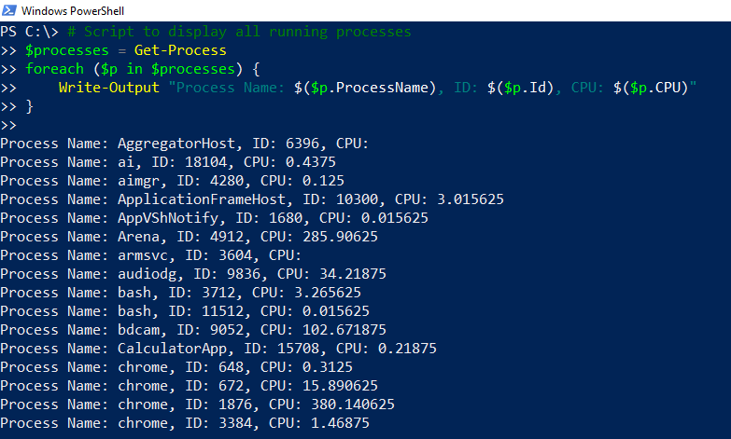
Fig 26. Scrip1

Script 2: Check Disk Space and Warn
This script enumerates all drives within the filesystem and computes the percentage of available space. It warns when it has less than 20 free space. It will aid in stabilizing the system by warning the administrators about low disk space way before the system starts causing operational difficulties.
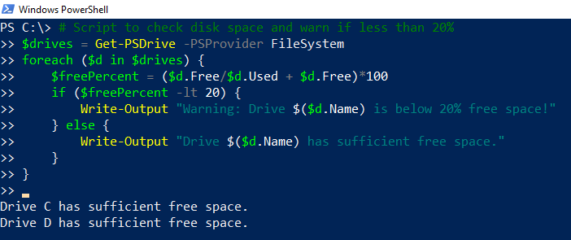
Fig 27. Script2
Fig 27. shows Script 2 output. The script in PowerShell comprises conditional statements, loops, and arithmetic operation to monitor the system.
Below are PowerShell scripts that demonstrate some of the major scripting concepts such as variables, looping, conditionals, and formatted output. Screenshots will serve as a visual confirmation of script execution, and they will confirm its validity when carrying out regular actions during system administration. This scripting can save time and minimize human intervention and, thus, reveals the promise of Windows OS scripting in professional IT.

Summary
These PowerShell scripts exemplify some of the most important concepts in scripting: variables, loops, conditionals, and formatted output. Graphic visualization of script implementation can be found in screenshots and bears witness to its practical application to automated system administration. Not only does this scripting save human labor but also makes things simpler and that is where the future of Windows OS scripting in professional IT application resides.

Task 5: Linux OS Scripting (Bash)
Linux supports bash scripting, whereby users can automate their operations, file management and administration. This activity focuses on 2 bash scripts, which illustrates variables, loops, and conditional logic, and real Linux scripting on Ubuntu. Photographs were photographed to offer graphic evidence of script operation [11].

Script 1: Create and Organize Files
The script writes the command mkdir -p first. Then it copies one file to a new folder with mv and touches two files. Lastly, it enumerates files in the current directory and in the new folder. This demonstrates how Bash scripting can be used to perform file and directory processing, such as automating everyday tasks and maintaining files.
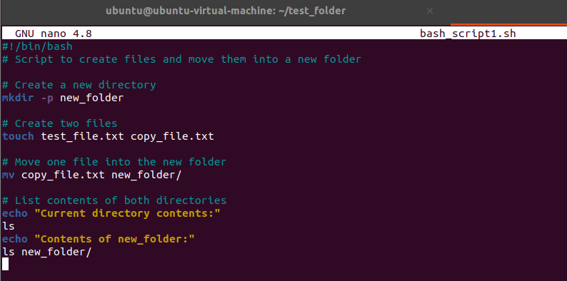
Fig 28. Script1
Fig 28. shows Script 1 executing. Its output shows it made files, new-folder and moved the copy-file.txt to new-folder and the updated directory structure.

Script 2: Disk Space Monitoring
It is a script that monitors disk usage on the root filesystem and compares it to the 80% threshold. It labels warning when overused and leaves safe usage. It automates disk health, and assists administrators keep a list of the wellness of their devices and avert the maladies of storage.
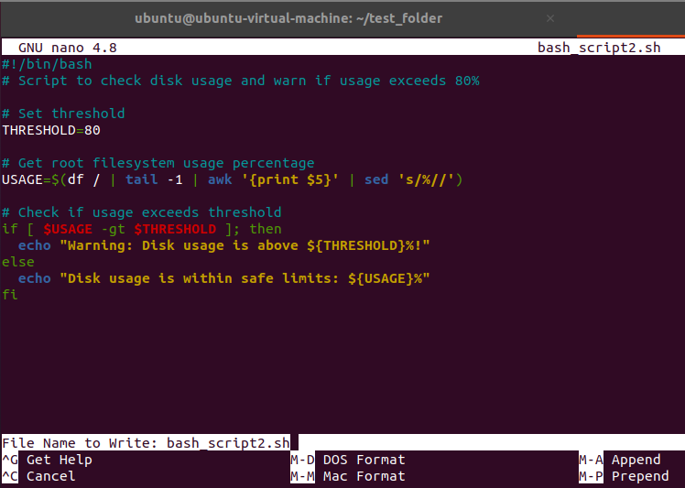
Fig 29. Script2
Fig 29. The sample below of conditional statements and system checks in Bash, as illustrated by the output of Running Script 2 in, logs disk use and peril at an established threshold; this output is a sample.

Summary
These bash scripts demonstrate important scripting capabilities of Linux such as directory creation, file processing, looping, variables, and condition logic. The implementation and output images demonstrate realistic use in Ubuntu. This kind of scripting boosts performance and minimizes human interference in system administration.

Conclusion
This report has demonstrated the fundamental roles and practical application of Windows and Linux operating systems. These processes underscore the significance of CLI, scripting, and OS administration expertise to efficient system administration and troubleshooting in practical computer manufacturing settings.

References
- Mahfud, A.Z., Sabila, M.T., Wibowo, N.A., Rhamdhan, A. and Priambodo, D.F., 2023, August. A Systematic Literature Review on Operating System Security: Distribution and Issues. In 2023 3rd International Conference on Electronic and Electrical Engineering and Intelligent System (ICE3IS) (pp. 70-75). IEEE.
- Liu, Y., Yao, M., Yang, X., Qin, M., Ma, L. and Xiang, H., 2024, October. Advanced Virtualization in Automotive Operating System: Technology Overview and Scheme Design. In 2024 IEEE International Symposium on Parallel and Distributed Processing with Applications (ISPA) (pp. 74-81). IEEE.
- Raza, A. and Ahmed, W., 2022. Threat and Vulnerability management life cycle in operating systems. A systematic review. Journal of Multidisciplinary Engineering Science and Technology (JMEST), 9(1).
- Macenski, S., Foote, T., Gerkey, B., Lalancette, C. and Woodall, W., 2022. Robot operating system 2: Design, architecture, and uses in the wild. Science robotics, 7(66), p.eabm6074.
- Javed, A.R., Ahmed, W., Alazab, M., Jalil, Z., Kifayat, K. and Gadekallu, T.R., 2022. A comprehensive survey on computer forensics: State-of-the-art, tools, techniques, challenges, and future directions. IEEE Access, 10, pp.11065-11089.
- Landauer, M., Mayer, K., Skopik, F., Wurzenberger, M. and Kern, M., 2024, December. Red team redemption: A structured comparison of open-source tools for adversary emulation. In 2024 IEEE 23rd International Conference on Trust, Security and Privacy in Computing and Communications (TrustCom) (pp. 117-128). IEEE.
- Ferdous, J., Islam, R., Mahboubi, A. and Islam, M.Z., 2023. A review of state-of-the-art malware attack trends and defense mechanisms. IEEe Access, 11, pp.121118-121141.
- Microsoft Learn, “Automate administrative tasks by using PowerShell,” Microsoft, 2025. [Online]. Available: https://learn.microsoft.com/en-us/powershell/scripting/learn/. [Accessed: 15-Dec-2025].
- Cisco Networking Academy, “Linux Unhatched: Basics,” Cisco, 2025. [Online]. Available: https://www.netacad.com/courses/linux. [Accessed: 15-Dec-2025].
- Ubuntu Community Help Wiki, “Linux Command Line Basics,” Canonical Ltd., 2025. [Online]. Available: https://help.ubuntu.com/community/CommandLine [Accessed: 15-Dec-2025].
- Yarovenko-Kuzminykh, N., Caeiro-Rodríguez, M., Mikic-Fonte, F.A. and Llamas-Nistal, M., 2024, June. Using a generative AI chatbot for SRL measurement and intervention. In 2024 International Symposium on Computers in Education (SIIE) (pp. 1-6). IEEE.

