

University of Wales
Trinity Saint David
International Business Communications

Daniel-Florin Lazar | 2009160
Galina Rais | 2020307
Andrei Nalivaico | 2021614
Kamil Chodnicki | 2020641
Gheorghe Bogatii | 2020309

Table of Contents
Assessment Component 2 (Practical) – Presentation 3
Main Content / Agenda of the presentation 3
Introduction to the context 3
Introduce the Chinese culture 3
Introduce the Chinese culture 4
Success and failure factors of joint ventures 4
Cultural sensitivity in China / The differences from the UK 6
Hofstede cultural Dimensions: UK and China 6
Hofstede cultural Dimensions: UK and China 7
Recommendations 7
Recommendations 8
Conclusion 8
References List 9

Assessment Component 2 (Practical) – Presentation

Main Content / Agenda of the presentation
- The presentation focuses on underlining and evaluating varied international cultures within the business
- Analysis of many business communication situations based on the evolving global business context
- Shedding light on the prevailing cross-cultural issues and challenges to be faced by the organisation in the host country
- Referring to the use of Hofstede's Cultural Dimensions along with other intercultural communication theory
The presentation is based on determining the feasibility of a cross-cultural business venture by underlining the cultural differences and challenges to be faced by the organisation. Besides, the presentation would also shed light on the prevailing cross-cultural strategies by referring to the implication of intercultural theories.

Introduction to the context
- J.W. Lees, a family brewing company with more than 1,300 employees and approximately more than 100 pub partners (J. W. Lees, 2023)
- Considering the scope and extent of market opportunities within the Chinese beer market J.W Lees have been planning on expanding its business in China
- In order to enter into the Chinese beer market, J.W. Lees Is planning on getting into a joint venture with Tsingtao Brewery Co Ltd
- Joint venture allows businesses to enter international markets thereby, fostering growth beyond their existing capability (Tien and Ngo, 2019)
Referring to the above claims it can be underlined that J. W Lees have been planning on expanding its business in the Chinese beer market by entering a joint venture with one of the market dominators Tsingtao Brewery Co Ltd. As per the views of Tien and Ngo, (2019), there exist different methods to enter a foreign market, besides, the selection of market entry modes explicitly depends on the level of deepening within the international business context.

Introduce the Chinese culture
- The traditional cultural values of wisdom, loyalty, filial piety, righteousness, benevolence, honesty, and harmony are engraved within the national culture of China (Pan et al. 2019)
- United Kingdom's national culture is considered a highly individualistic culture, favouring the implication of a task-focused culture (Santander Trade Markets, 2023)
- The Chinese business culture is extremely influenced by the Confucian concept of Guanxi (Santander Trade, 2023)
- On the contrary, the specifications of business culture in the UK are dominated by the traits of courtesy, politeness, discipline and punctuality (Santander Trade Markets, 2023)
- British brands such as Burberry is a household names in China, with a whopping 40% of revenue from China (CHERNAVINA, 2020)
As per Deloitte, Chinese-based international joint ventures are likely to attract Western nations post-COVID due to the high growth rates within the Chinese market (CBBC, 2022). One of the major reasons for the popularity of the brand is the capitalisation of e-commerce markets in China by collaborating with local and regional players. Hence, it can be stated that Burberry has been leveraging a task-focused approach to expand its business within the highly fragmented Chinese market.

Introduce the Chinese culture
- The UK national culture is more individualistic focusing on the aspect of meritocracy; besides, the Chinese culture focuses on relationship building (Sheng, 2022)
- Additionally, Chinese people have greater control over their lives and businesses, making them highly spontaneous and dynamic
- The national culture in the UK is highly scheduled and people value time
- One instance can be witnessed in Unilever, which is a multinational FMCG brand that planned to expand its deodorant business in China, but the prevalence of cultural beliefs led to its downfall (The Business Times, 2018)
In light of the above findings, it can be underlined that the Chinese culture is highly collectivist as compared to the British culture is individualistic. Unilever focused on expanding into the Chinese market with its product Rexona. Although, such a product was a hard sell in China, as only 10% of the population in China uses deodorants (The Business Times, 2018). Additionally, due to the prevalence of conventional thinking a greater section of the population believed that perspiration is a part of metabolism and hence, should not be blocked which led to a massive fall in sales of Rexona deodorants in China.

Success and failure factors of joint ventures
Success Factors
- The Chinese beer market growth as of 2021 accounted for 88.8%, besides, China accounts for 12% of overall global beer sales (Interesse, 2023)
- As of 2021, CR Snow, Anheuser-Busch InBev, Tsingtao Brewery were recognised as the top players dominating the Chinese beer market (Interesse, 2023)
- Affluential brand image of Tsingtao Brewery
- Coherent branding strategy of Tsingtao Brewery
- British Craft beer manufacturer, BrewDog expanded its business to the Chinese market by partnering with Budweiser China, considering the growing demand for craft beer within the market (BBC, 2023)
The diverse product portfolio, along with a cohesive supply chain network would allow J.W Lees to establish its position within the fragmented Chinese market. The branding strategy of Tsingtao Brewery integrating its brand proposition with the sports culture would allow J.W. Lees to cater to a diverse pool of customers. Hence, referring to the case of BrewDog, J.W. Lees must focus on diversifying its product segment to actively cater to the evolving taste and preferences of customers.
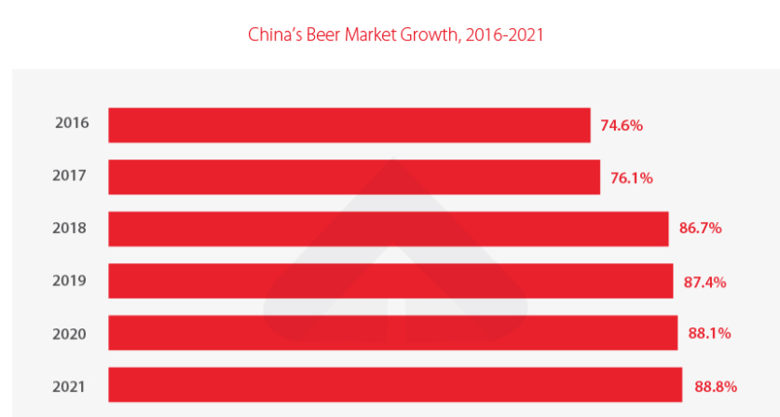
Figure 1: China’s Beer Market Growth in 2021
(Source: Interesse, 2023)
Failure Factors
- Recurrences of Cultural Differences in terms of deciphering J.W. Lees brand values and objectives
- Evolving and different tastes and preferences of customers
- Excessive dominance of domestic players with a local loyal customer base
- Prevalence of agency issues demanding greater control over business operations
The recurrence of excessive competition from domestic players having local loyal customers is a significant threat to the feasibility of a joint venture between J.W Lees and Tsingtao Brewery. On the other hand, the prevalence of cultural differences in terms of beer consumption by customers is also likely to affect the business operations of the joint venture.

Cultural sensitivity in China / The differences from the UK
- Cultural sensitivity is defined as acknowledging and accepting the prevailing differences and similarities within the national culture (Peng and Zhang, 2022)
- China having a collectivist culture is a high-context culture, besides, the UK being individualistic culture is a low-context culture
According to Halls's Context Theory, different cultures adhere to different methods of communicating and are categorised as low-context culture and high-context culture (Colpani, 2022). Due to the prevalence of contemporary norms and values within the Chinese market, J.W. Lees must focus on effectively incorporating cultural differences to graft cohesive strategies.

Hofstede cultural Dimensions: UK and China
- Power Distance: Power distance score of China is higher standing at 80 compared to 35 for the UK (Hofstede Insights, 2023)
- Individualism: Individualism score of China is significantly low standing at 20 compared to the high score of 89 for the UK
- Masculinity: Both nations have the same masculinity score standing at 66
The higher power distance score of China hints that there exists an unequal distribution of power within the society when compared to the UK. On the other hand, the lower individualism score hints towards the prevalence of a collectivist culture compared to an individualistic culture in the UK (He and Filimonau, 2020). Additionally, the similar masculinity score suggests that both nations hint that is highly competitive.
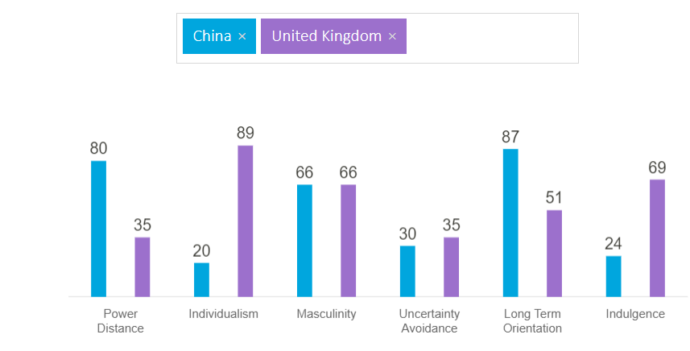
Figure 2: Comparing the differences in National Culture as per Hofstede's Cultural Dimensions
(Source: Hofstede Insights, 2023)

Hofstede cultural Dimensions: UK and China
- Uncertainty Avoidance: The UK has a higher uncertainty avoidance score of 35 compared to 30 for China
- Long-term Orientation: China’s long-term orientation score stands at 87 compared to 51 for the UK
- Indulgence: Low indulgence score for China and a higher score for the UK
China is a long-term-oriented nation focusing on persistence and adapting to the prevailing circumstances, whereas the UK is short-term-oriented (He and Filimonau, 2020). UK’s high indulgent score suggests that the nation seeks gratification, besides the Chinese culture abides by strong life control. On the other hand, China has a lower uncertainty avoidance score making it less adaptive to uncertainties due to the recurrence of conventional beliefs.

Recommendations
- J.W Lees should focus on diversifying the products segment to leverage the prevailing trends within the Chinese beer market
- Incorporating the cultural values of loyalty, harmony, and righteousness within its brand to create a separate niche of customers
In light of the above insights, it can be stated that to quantify the success of the joint venture J.W Lees must focus on diversifying its product segment to cater to the needs of diversified audiences along with utilising the prevailing market trends.

Recommendations
- Considering the dynamic and spontaneous nature of the Chinese culture it can be advised to J.K Lees devising a cohesive communication plan can help in establishing transparency thus, fostering intercultural relations
- Identifying and implementing specific Key Performance Indicators (KPIs) to monitor the progress of the venture
Excessive focus on devising a communication plan would help J.W. Lees to establish two-way communication between various institutional actors contributing to the success of the organisation.

Conclusion
- The Chinese beer market has been experiencing prolonged growth followed by the dominance of local players
- The identified issues in line with the joint venture are the prevalence of cultural differences
Establishing effective intercultural communication practices and devising a communication plan can limit the recurrences of the identified issues

References List
BBC (2023) Brewdog: UK craft beer giant expands into China. BBC News. 20 Feb. Available at: https://www.bbc.com/news/business-64700857 (Accessed: 28 March 2023).
CBBC (2022) Has Covid-19 created new opportunities for joint ventures in China? Focus - China Britain Business Council. Available at: https://focus.cbbc.org/has-covid-19-created-new-opportunities-for-joint-ventures-in-china/#.ZCKOPnZBxEY (Accessed: 28 March 2023).
CHERNAVINA, K. (2020) Popular British Brands In China 2020. HI-COM. Available at: https://www.hicom-asia.com/popular-british-brands-in-china/#:~:text=been%20less%20successful.- (Accessed: 28 March 2023).
Colpani, G. (2022) Two theories of hegemony: Stuart Hall and Ernesto Laclau in conversation. Political Theory, 50(2), pp.221-246.
He, L. and Filimonau, V. (2020) The effect of national culture on pro-environmental behavioural intentions of tourists in the UK and China. Tourism management perspectives, 35, p.100716.
Hofstede Insights (2023) Compare countries. Hofstede Insights. Available at: https://www.hofstede-insights.com/fi/product/compare-countries/ (Accessed: 28 March 2023).
Interesse, G. (2023) China’s Beer Market: Outlook and Opportunities. China Briefing News. Available at: https://www.china-briefing.com/news/chinas-beer-market-outlook-and-opportunities/#:~:text=Beer%20consumption%20in%20China (Accessed: 28 March 2023).
J. W. Lees (2023) JW Lees | Pubs, Inns & Hotels | Independent Family Brewers | Manchester. JW Lees. Available at: https://www.jwlees.co.uk/about#:~:text=About%20JW%20Lees (Accessed: 28 March 2023).
Pan, Z., Chaffee, S.H., Chu, G.C. and Ju, Y. (2019).] To see ourselves: Comparing traditional Chinese and American values. Routledge.
Peng, X. and Zhang, R. (2022) Corporate governance, environmental sustainability performance, and normative isomorphic force of national culture. Environmental Science and Pollution Research, 29(22), pp.33443-33473.
Santander Trade Markets (2023) Business practices in the United Kingdom - Santandertrade.com. santandertrade.com. Available at: https://santandertrade.com/en/portal/establish-overseas/united-kingdom/business-practices#:~:text=The%20fundamental%20principles%20of%20business%20culture%20in%20the%20United%20Kingdom (Accessed: 28 March 2023).
Santander Trade (2023) Business practices in China - Santandertrade.com. santandertrade.com. Available at: https://santandertrade.com/en/portal/establish-overseas/china/business-practices#:~:text=Chinese%20business%20culture%20is%20largely (Accessed 28 Mar. 2023).
Sheng, A. (2022) The Difference between Chinese and British Business Practice. www.linkedin.com. Available at: https://www.linkedin.com/pulse/difference-between-chinese-british-business-practice-alice-sheng/?trk=pulse-article (Accessed: 28 March 2023).
The Business Times (2018) Foreign brands that misfire in China. Businesstimes.com.sg. Available at: https://www.businesstimes.com.sg/companies-markets/consumer-healthcare/foreign-brands-misfire-china (Accessed: 28 March 2023).
Tien, N.H. and Ngoc, N.M. (2019) Comparative Analysis of Advantages and disadvantages of the Modes of Entrying the International Market. International journal of advanced research in engineering and management, 5(7), pp.29-36.
Tsingtao Brewery Co Ltd (2023) About us: Tsingtao Brewery Co Ltd. www.tsingtao.com.cn. Available at: http://www.tsingtao.com.cn/EN/about/about.html?gsry#:~:text=Tsingtao%20Brewery%20Co.%2C%20Ltd. (Accessed: 28 March 2023).

Appendix

