

University of Wales Trinity Saint David (London)
Module: Marketing Fundamentals
Module code: LCBB4004
Lecturer: Afzal Munna
Assignment Title: - Assessment 2 Marketing Fundamentals Analysis and Evaluation
By: Kristina D. Ralcheva
Date: September 2022

Table of Contents

- Introduction…………………………………………………………………………………. p.2

- SWOT Analysis……………………………………………………………………….…p-p.3-5

- PESTLE analysis………………………………………………………………………. p-p.5-7

- Porter’s Five Forces ……………………………………………………………………p-p.7-10

- Segmentation……………………………………………………………………….………. p.9

- Targeting……………………………………………………………………………………. p.9

- Positioning………………………………………………………………………………. p-p.10

- Marketing Mix………………………………………………………………………...p-p.10-11

- Conclusion…………………………………………………………………………………. p.11

- Recommendations…………………………………………………………………………. p.12

- References…………………………………………………………………………………. p.13

Introduction.
To start with, COVID-19 has affected businesses worldwide. Many companies have struggled with their business, and they have tried to support the sales and customers as much as they can. Many businesses decide to conduct analyses so they can maintain the losses and benefits from the Pandemic.
The author will go through this report as a marketing manager with the company Scrivens Opticians and Hearing Care.
As a marketing manager hired by the organisation below, the author will provide internal and external analysis as well as segmentation, targeting, and positioning.
That analysis would explain more about the situation after COVID-19 and mainly where the company stands now.
In this report, the marketing manager will be exampled by SWOT analysis, PESTLE analysis, Porter’s Five Forces and STP (Segmentation, Targeting and Positioning). Moreover, the marketing executive will explain the 7 pieces of marketing mix and will evaluate and reflective on Scrivens Opticians and Hearing care.
It will be explained the meaning of this analysis and it will be provided feedback to the company during this tough time. Furthermore, the author will evaluate the companies’ challenges and where Scrivens and Hearing care stand in a position in the UK market.
As a marketing executive, the author’s work is to leave recommendations to the company, so stakeholders can be prepared if this situation happens again.

SWOT Analysis
Before all else, an explanation of Marketing will be provided, so the audience can meet the main idea of the whole work and process below.
Marketing should always be interpreted in the modern meaning of meeting client demands rather than the outdated idea of "telling and selling," or making a transaction.
Marketing is a social and management process through which people meet their needs and desires by producing and exchanging value with others. Building lucrative, value-driven exchange relationships with clients is what marketing entails in a more constrained commercial setting. (Kotler et al. 2019, p. 5)

A SWOT analysis examines the internal and external opportunities and challenges that are present in the environment of a business. According to Sammut-Bonnici (2015) the internal analysis is used to discover the organization's assets, skills, core competencies, and competitive advantages. The external study looks at the resources of rivals, the industry environment, and the overall environment to identify market opportunities and dangers.
In addition to this a SWOT analysis will be provided for Scrivens Opticians and Hearing care from the hired executive manager.
Strengths  - Operating since 1938  - Wide ranges of products including hearing service  - Online Booking | Weaknesses  - Stop providing home visits  - Does not stock high quality brands  - High prices in lenses/contact lenses comparing to other Opticians
Opportunities  - Good location to brands  - Partnership with M&S  - Qualified staff | Threats  - Massive competition-Specsavers- both Hearing and Optical  - Competitive prices in another Optician-Specsavers (for instance)  - Volatility in Price of Fuel
Table of SWOT Analysis for Scrivens Opticians

The company's SWOT analysis reveals that its strengths lie in its broad product offering, reputation for providing a competent eye care service since 1938 and an opportunity for customer to book their appointments online.
The weaknesses, like the decision to stop providing home visits during COVID-19, are one of the biggest disadvantages, though. Especially for old people who are not very mobile and vulnerable this could be a good reason to change their family Optician.
A good opportunity is to work in cooperation with Marks and Spencer and expand the list of the company’s customers. Mostly when qualified staff deliver quality services and advice.
One of the biggest threats to the company is the competitive prices of other opticians. Companies such as Specsavers sell two pairs of glasses for £69, whereas Scrivens sells lenses for one pair for the same price.
However, the weaknesses can be reversed and become the strengths, and all the threats can be reversed into opportunities. Opportunities can be transformed into strengths, and if the company has a good advisor and follows all the directions during these tough times, the range of customers could be expanded, and more benefits could come to the company.

PESTLE Analysis
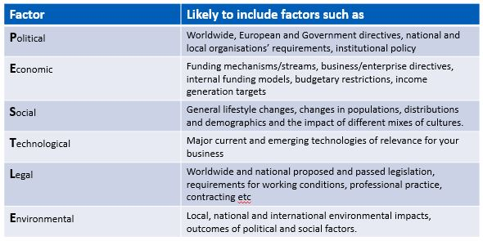Graphic of PESTLE Analysis

The word PESTEL refers to a method for determining the macro (external) forces that affect an organization. The letters stand for Political, Economic, Social, Technological, Environmental, and Legal. In this post, we'll look at the aim of a PESTEL analysis, as well as the advantages and disadvantages of using it in business.
Conducting a thorough scenario analysis is crucial in marketing before implementing any form of strategy or tactical plan. Every six months, this study should be performed again to look for any changes in the macro-environment. Organizations that properly track and react to macroenvironmental changes might set themselves apart from the competition and so have a competitive advantage (Oxford College of Marketing, 2022)
Political, economic, social, technological, legal, and environmental concerns will all have an impact on the eye care sector to various levels.
Political – potential changes to corporate tax in the UK and elsewhere. Is the political environment favorable to foreign investment, with activities throughout Europe and other parts of the world. In addition, EU brands such as MYKITA, Oliver Peoples, and others could not deliver on time or have them at all. Scrivens is facing a problem already with stocks of contact lenses with Bausch and Lomb suppliers.
Economic- Any economy's rate of inflation would have an impact on how much Scrivens would charge for goods and services. Additionally, it would have an impact on a consumer's purchasing power and alter the demand and supply models for their economy. Specifically, with rising energy costs, all employees and management should be aware to turn off all lights and machines.
Social - The eye care sector faces both possibilities and risks because of shifts in customer preferences and lifestyles. Opportunities in the field of designer-branded eyewear are now well-liked by groups with high discretionary incomes, and there is also a rising trend in the use of eyeglasses as a fashion item. The demand for eye care goods and services will increase as the population in the UK and throughout the world ages. Threats include alternate vision correction methods like laser surgery and a lack of competent workers. If the educational system does not promote the development of future licensed opticians and audiologists, there may be a shortage of these professionals.
Technological- The company should be aware of the new technologies such as OCT scan, Henson 9000 Visual Field, or Diabetic Screening. Not just a few branches should provide this service, but all should have this equipment.
As in the 21st century, there is an opportunity for laser operation of the eyes, and this could lead to a degression of the range of customers for contact lenses. That is why it is vital to keep good customer-company engagement, and if additional care is needed, the customer could come back for it.
Moreover, if we talk about hearing aids, new models with extras to customer such as converting the voice into 12 or 15 languages, the company must supply the customers and increase their figures.
Legal- As we talk about opticians in the UK, the law is pretty much clear-all children under 16 must be seen by a qualified person such as an optometrist, dispensing optician or contact lens optician to check the frame fitting or the vision is clear for the patient. It is against the law for sales advisors or receptionists, etc., to deal with such customers.
It is vital to have knowledge as well when dealing with NHS vouchers. All the patients are different, with different needs and entitlements from the NHS. That is why it is crucial for the company to be aware of the process and follow all the legal procedures. There are fees charged if you do not follow the legal process.
Environmental-
The usage of oil as an energy source has significant ecological and environmental effects. Fines and an increase in the price of raw materials are the dangers. Future profitability of the corporation will be impacted by the implementation of carbon taxes.
Moreover, an example could be provided for the Dorset area. At the beginning of September, there is an air show running with red arrows and the Typhoon, and this could be an issue for hearing tests going on in branches during this time. This loud noise could affect the hearing test and deliver an inaccurate result for the patient.

Porter’s Five Forces
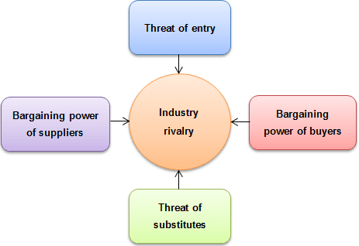
Graphic of Porter’s Five Forces

The Porter Five Forces Analysis is a tool for evaluating industry competitiveness and developing company strategy. It develops five industrial organization (IO) economic dynamics that influence the amount of competitiveness and, hence, the allure of an industry. In this context, attractiveness refers to the sector's total profitability (Britton, 2006). The interaction of these five factors reduces overall profitability in a "unappealing" sector. An industry that is close to "pure competition," in which all firms' potential revenues are lowered to normal profit, would be extremely undesirable. Michael E. Porter of Harvard University is well-known as the principal originator of this strategy.
Using Porter's Five Competitive Forces model, market structure and competitive environment may be examined carefully and officially. The concept may be applied to individual enterprises, market segments, industries, or geographical locations. Therefore, it is critical to determine the size of the market that will be investigated in the first step. Then, all relevant market factors are identified and investigated. As a result, it is not necessary to completely assess each component of every contending force. Porter’s
Five forces model explains, there are five dynamics at play in every market that together define the level of competition of Scrivens and the eye care sector's profitability.
The first is the risk provided by new competitors, as seen by the increase in designer eyewear being supplied by stores like Vision Express, Kelly Eye etc. This force could be explained as high because the company may lose customers if they do not meet their needs.
The second is the danger of alternatives, the debate over laser vision correction surgery vs eyeglasses, and the rising demand for these procedures. This can be low risk because people can be afraid to have operation for their eyes lack of funds.
The third element is the danger of buyers' negotiating power, which is extremely strong for Scrivens Opticians and the broader eye care sector due to the abundance of alternative suppliers. This power can be determined as medium for the company because they are in the market since 1938 and have a massive range of loyal customers.
Therefore, there are so many two-for-one deals and aggressive price strategies. As a result, there is intense competition among companies in the sector.

Segmentation
Market segmentation is the process separating the customers into small groups according to their needs. They can be combined by needs, characteristics, or interest. (Camilleri, 2017)
As a reflection on Scrivens Opticians and Hearing Care, it can be stated that these opticians divide their customers into contact lens wearers, optical-eye test and supply with glasses, and hearing care. They split customers into groups so they could meet their needs smoothly and deliver better service.
In all the branches, they have a contact lens champion who is responsible for all the supply of contact lenses for customers and teaches. With a hearing champion who is dealing with hearing aid purchases and getting advice from an audiologist and GP,
Finally, this is the dispensing optician, who advises customers on the lenses and coating they will use and any complications such as glaucoma and cataract.

Targeting
The company must comprehend the needs and preferences of the categories it has selected after market segmentation. It is in the company's best advantage to identify unmet market needs since there may be customers who are not being adequately served by competitors. The following stage is to choose which market categories will be catered to and to identify which market segments are the most profitable. The three possibilities for market coverage are undifferentiated marketing, differentiating marketing, and targeted marketing.
As related and evaluated for the company, some customers can wear only gas-permeable contact lenses, which their eye health requires. They cannot wear soft contact lenses. That’s why the company always makes sure they can deliver the best services and products on time.
In addition of that, it is the same with the frame range. In every branch they are different sections in the shop floor when the target is different for all customers such as young’s fashion, designer fashion, men’s fashion etc.
Positioning
Marketers must develop positioning strategies to change how consumers (and potential customers) perceive their products. A defendable stance prohibits a quick opponent reaction as a new positioning approach. For example, a full-service national airline may distinguish itself from competitors by being the only one offering a better degree of service in the regions it selects. For instance, in Scrivens Opticians, customers can see all the different brands positioned in the right place, under the right label. As it follows, all the frames are positioned by colour match and price range.
All coatings, such as UV or anti-glare coating, can be demonstrated to customers in sample lenses.
Finally, the company needs to be aware that the staff are qualified to sell the product and services. To make good money, they need to understand how products or services work.

Marketing Mix- Product, Price, Place, Promotion, People, Process, Physical Evidence
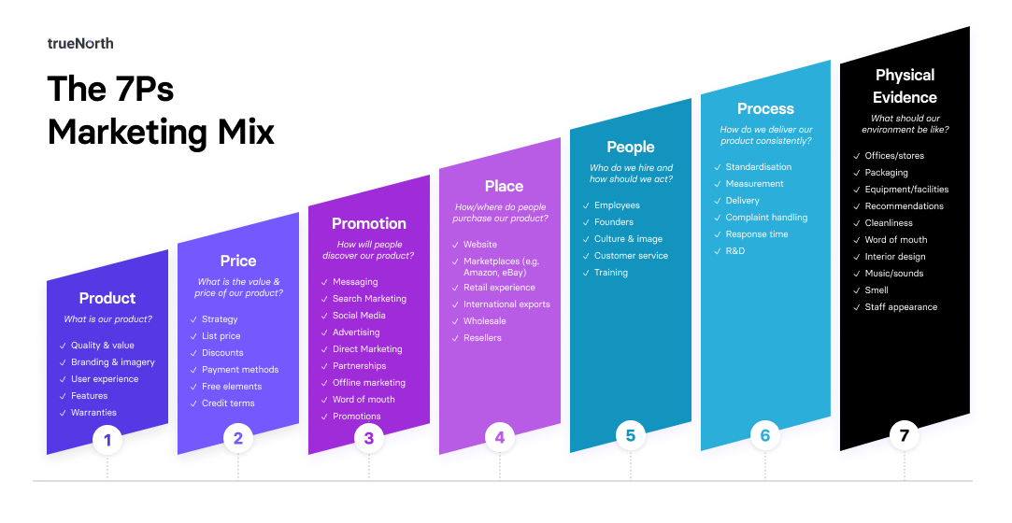Graphic of 7pcs of Marketing Mix

The 7pcs Marketing Mix describes the behavior of the company, how they deliver to their customers each product or service, and how they will notify their customers about the services and offers.
Product- The product in Marketing Mix is the actual need for customers' usage. The price they are paying is for the goods they are receiving from the company. This can all include warranties or other customer experience, but the product is one of the most important pieces in the marketing mix. Ask why? Because without a product or service, no one can run a business. (East et al. 2022, p.201)
For Scrivens Opticians and Hearing care is important to deliver a good range of quality product and warranties. This company uses its own brand to identify itself and its products.
Price- The price that customers are willing to pay for a thing determines its value. There should be a strategy assured in Scrivens for good offers and discounts not only for loyal customers.
Promotion- Promotion is how a business tells clients what it does and what it can do for them. Branding, advertising, public relations, corporate identity, social media outreach, sales management, exclusive deals, and exhibits are all included. Promotion needs to attract attention, be enticing, convey a consistent message, and, most importantly, provide the buyer a reason to select your product over competing ones. And this is how effective Scrivens is in dealing with their customers. They provide their own website with an opportunity to book an appointment online. They do send a letter as a reminder to their customer’s house or eight emails and make sure their eye health is well monitored.
Place- The product must be accessible at the appropriate time, location, and amount while containing storage, inventory, and distribution expenses to a manageable level. This is vital for the company here as in the Opticians it can be stored contact lenses, sunglasses, and accessories.
People- Each person that interacts with your consumers will leave a lasting impression.
Because many customers cannot tell the difference between a good or service and the individual who delivers it, your staff will have a huge influence on customer satisfaction, either favorably or adversely. Here, this is a tricky moment for the company, so if the customers are not satisfied with the staff in the branch, this could lead to negative feedback in the digital world.
Process- The process in the marketing mix refers to customers and how the services are delivered to them. It is all about the response time and the quality of service and behaviour.
For instance, Scrivens offers a scheme for wearing contact lenses. They invite the patient to their eye appointment and check if the eyes are suitable for contact lenses. Then they conduct a contact lens test and offer coffee and biscuits during the process. Everything to engage customers with the company and to meet certain standards.
Physical Evidence- Everything the company posts on its website or the customers share as an experience must be evidenced as proof. Displays on the shop floor or products that can be seen etc. Without physical evidence, the company could struggle.
For instance, there needs to be some reassurance as one customer is coming from Kelly’s eyecare and it is cheaper there, so they can be aware of why they are paying more at Scrivens Opticians and Hearing Care.
In addition to that, Scrivens offers its range of customers a digital visualizer of lenses so they can see what they can expect from the product they would like to purchase.
Moreover, one of their offers is recommending a friend. If one of their customers recommends someone to the company, they can both see the benefits of that- as the recommended person gets a free eye test and the one who recommended received an 25% discount.

Conclusion
To sum up, since the pandemic happened, all business has dropped. Thankfully, in marketing, there are several instruments to analyse and follow certain steps to help the business survive and progress.
As a hired marketing manager, the author conducted an internal analysis and stated the strengths, weaknesses, opportunities, and threats for Scrivens Opticians and hearing care.
Then he went through external analyses such as PESTLE and Porter's Five Forces. In such an analysis, the manager points out all the risks and factors that the company cannot control. Pictures and tables were included, so the audience could get a better explanation of the main idea.
Furthermore, the author reflects and evaluates Scrivens Opticians and hearing care to theory explanation of the analyses, to help the audience understand the whole process of the analyses and benefits.
Likewise, the executive marketing manager alluded to marketing segmentation, targeting, and positioning.
It is vital in the explanation of the reflection and evaluation of the company.

Recommendation
As a marketing executive, the main purpose of the author is to provide an analysis and reflection of the company.
After the analyses and the evaluation, a few recommendations can be provided.
First, be aware of all the weaknesses and threats the company has and transform them into strength.
Second, when we talk about the external environment, business should be flexible and adaptive.
This is the key to survival in business and meeting your customers' needs.
Third, invest in facilities and digitalizing machines. The company needs to move forward, not backwards, especially since the Covid-19 pandemic happened.
The current position of Scrivens Opticians and Hearing Care in the market is not bad at all. They are dealing with the pandemic well. However, this dreadful experience brought to the company's awareness to provide the best services and products and be flexible even better than before.
With the recommendations provided above, the company could grow and expand its range of customers and figures in the future.

References
East, Singh et al. (2022) Consumer Behavior. Fourth edn. London: Sage Publications
Camilleri, M. (2017) ‘Market Segmentation, Targeting and Positioning’ Research Gate, December 2017
Available at: https://www.researchgate.net/publication/319085560_Market_Segmentation_Targeting_and_Positioning
(Accessed: 4th September 2022)
Kotler, Phil T., et al. (2019) Principles of Marketing, Pearson Education Limited
Sammut-Bonnici, Tanya (2015) ‘SWOT Analysis’ Research Gate, Jan 2015
Available at: https://www.researchgate.net/publication/272353031_SWOT_Analysis/references
(Accessed: 3rd September 2022)
Oxford College of Marketing (2022) Pestle Analysis.
Available at: https://blog.oxfordcollegeofmarketing.com/2016/06/30/pestel-analysis/
(Accessed: 4th September 2022)
Worthington, I. & Britton, C. (2006) The Business Environment – 5th Edition, Prentice Hall Financial Times

