

Evaluating the Impact of Awareness Campaigns and System Changes on VNHSW Referral Pathways

Anna Marie Smith
Independent Project

BMBM6020
University of Wales Trinity Saint David
1st March 2026

Executive Summary
This Applied Evidence Portfolio evaluates the real-world impact of system changes and awareness campaigns implemented to improve referral pathways into Veterans NHS Wales (VNHSW). The project builds directly on last year’s research, which identified that veterans were frequently referred into Local Primary Mental Health Support Services (LPMHSS) or Community Mental Health Teams (CMHT), rather than directly to VNHSW, creating delays and inappropriate referrals (Rafferty et al., 2019). Interviews with VNHSW clinicians highlighted the “clunky” nature of the previous pathway and the lack of GP understanding surrounding direct referrals (Ando, Cousins & Young, 2014).
Quantitative findings from the previous project demonstrated that only 47% of GPs were aware they could directly refer veterans, and only 23% understood how to do so, reflecting a significant informational barrier consistent with broader research showing poor GP awareness of specialist mental health pathways (McLeod, 2018).
In response to these findings, a system-level intervention was implemented: the VNHSW referral form was added to the GP electronic referral system, enabling direct referral by selecting “veteran” (Veterans NHS Wales, 2025). This change was supported by targeted awareness campaigns aimed at strengthening GP and veteran understanding of self-referral options (Digital Dot, 2024; Sunshine City Counseling, 2024).
Early quantitative indicators from the 2025–2026 dataset demonstrate significant improvement across key metrics. Total referrals increased from 122 to 131, GP referrals rose from 15 to 34, and first-time GP referrals increased from 3 to 21, while primary-care referrals decreased from 42 to 35 (VNHSW Dataset, 2025–2026). These outcomes support findings from wider literature indicating that system redesign and simplified referral structures improve accuracy and efficiency within mental health pathways (Evans-Lacko, Henderson & Thornicroft, 2013, May et al., 2010).
The portfolio analyses applied artefacts, including referral data, pathway maps, awareness material, and stakeholder insights, to evaluate how these interventions improved access. The evidence demonstrates that enhanced communication and streamlined processes have measurably improved awareness, decision-making, and access to specialist mental health support for veterans.

Introduction
Improving access to specialist mental health support for military veterans remains a critical priority within Wales, particularly in light of increasing demand and long-standing challenges across NHS mental health pathways. Research consistently shows that UK veterans experience disproportionately high levels of mental health difficulties compared to the general population. A major narrative review of UK military mental health found that common mental disorders (CMDs) are more prevalent among serving personnel and veterans, with elevated risks associated with adverse childhood experiences, combat exposure, and physical injury (Juškaitė, S., Stone, J., Greenberg, N., Dyball, D., & Fear, N. T., 2025).

Furthermore, the 20-year cohort study conducted by the King’s Centre for Military Health Research (KCMHR) identified steady increases in CMD and PTSD rates among both serving and ex-serving personnel, with veterans showing a higher prevalence of probable PTSD (11%) compared with current serving personnel (7%) a trend that has continued to rise in recent years (KCMHR, 2024). These findings highlight the vulnerability of the veteran population and the essential need for clear, efficient referral pathways into specialist care.
Despite this growing need, my previous applied research project (2024–2025), conducted within Veterans NHS Wales revealed substantial barriers preventing timely access to the service. Veterans were frequently diverted through Local Primary Mental Health Support Services (LPMHSS) or Community Mental Health Teams (CMHT), rather than being referred directly to VNHSW. Interviews with VNHSW therapists and LPMHSS managers described the previous pathway as “clunky” and inefficient, characterised by inconsistent understanding among referrers and unnecessary delays caused by multiple-step workflows. Staff shared concerns about inappropriate referrals and highlighted that veterans often arrived at VNHSW much later than clinically desirable, increasing the risk of disengagement and deterioration in mental health.
These staff insights align with broader evidence from UK primary care. A large BMJ Military Health study analysing 2,449 veteran primary care records found that 38% had coded mental health disorders, including depression (17.8%), alcohol misuse (17.3%), and anxiety (15.0%). PTSD was clinically coded in 3.4% of records, though prevalence is known to be higher in diagnostic interviews, especially among combat-experienced veterans
This suggests that primary care IT systems, including CWIIS and referral interfaces, play a critical role in shaping how and where veterans are directed for treatment. When these systems do not prominently feature veteran-specific pathways, mis-referral becomes highly likely.
This was further complicated by limited GP awareness of VNHSW. Last year’s GP survey demonstrated significant gaps in professional knowledge: although 60% of GPs had heard of VNHSW, only 47% knew that direct referral was possible, and just 23% understood how to initiate it. These findings are reinforced by national evidence that GP knowledge of veteran-specific services and mental health pathways is often inconsistent, contributing to delays in accessing targeted treatment.
In response to these issues, a system-level intervention was implemented whereby the VNHSW referral form was added directly to the GP electronic referral system. This change meant that when a GP entered “veteran” into the system, VNHSW appeared as a selectable option, removing the prior dependency on routing veterans through LPMHSS or CMHT and eliminating a critical structural barrier to timely care. Alongside this operational change, targeted awareness campaigns were developed to educate both healthcare professionals and veterans about direct and self-referral routes into VNHSW. These campaigns form the central focus of the present evaluation, enabling an assessment of how improved communication and streamlined referral processes have impacted GP practices and veteran engagement.
Early indicators from the 2025–2026 referral dataset show significant improvements across key metrics. Total referrals increased from 122 to 131, GP referrals more than doubled from 15 to 34, first-time GP referrals rose from 3 to 21, and referrals from primary-care services decreased from 42 to 35. These figures strongly suggest that the combination of system redesign and awareness campaigns has contributed to improved referral accuracy, greater visibility of VNHSW among GPs, and more appropriate pathway utilisation by healthcare professionals and veterans alike.
This project therefore, sits at the intersection of service improvement, health communication, and operational pathway redesign. By building upon last year’s diagnostic research, this evaluation offers insight into how system structure, professional awareness, and targeted messaging collectively influence referral behaviour and access to specialist mental health services. Understanding this context is essential for interpreting the artefacts presented within the portfolio and evaluating the broader strategic value of the changes made.
Project Objectives & Strategic Alignment
The purpose of this applied business project is to evaluate the effectiveness of awareness campaigns and structural system improvements implemented to enhance direct access to Veterans NHS Wales (VNHSW). Last year’s research highlighted significant knowledge gaps among General Practitioners (GPs) and a poorly designed referral pathway that frequently diverted veterans into Local Primary Mental Health Support Services (LPMHSS) and Community Mental Health Teams (CMHT). These issues align with wider evidence that veterans are disproportionately affected by mental health conditions such as depression, anxiety, and PTSD, with prevalence rates consistently higher than in the general population (Oxford Academic, 2025)
Furthermore, long-term research shows that rates of probable PTSD and Common Mental Disorders (CMDs) have risen among UK veterans, with ex-serving personnel demonstrating particularly elevated levels of mental health need (KCMHR, 2024). Such evidence underscores the importance of ensuring timely and accurate referral into specialist veteran services.
Additionally, primary care–based analyses show that nearly 38% of veterans have at least one clinically coded mental health disorder within their GP records, including depression, alcohol misuse, anxiety, and PTSD (Finnegan & Randles, 2025)
These findings reinforce the critical role that GP knowledge and referral processes play in shaping access to support. Against this backdrop, improving GP awareness and redesigning referral structures were essential steps to ensure veterans are directed appropriately to VNHSW.
Based on this context, the project sets out five core objectives:

- Assess current GP awareness of VNHSW referral pathways – Last year’s GP survey identified substantial knowledge gaps, with only 47% aware that direct referral was possible and just 23% understanding how to initiate it. These findings reflect broader national trends showing inconsistent GP awareness of veteran-specific mental health pathways (Finnegan & Randles, 2025) Evaluating how GP awareness has changed following system integration and awareness campaigns is essential to determining the impact of these interventions.

- Assess veterans’ awareness and use of self-referral options – Veterans rely heavily on GP signposting, yet studies show that many delay help-seeking or are unaware of specialist services available to them (Oxford Academic, 2025). This objective examines whether targeted communication strategies have improved veterans’ understanding of VNHSW self-referral pathways and whether this has translated into earlier engagement.

- Identify which campaign strategies were most effective - The campaigns included updated website guidance, printed and digital materials, and integration of VNHSW prompts within GP systems. Understanding which components were most successful is crucial for ensuring communication remains evidence-informed, especially given research showing that tailored, clear messaging significantly improves engagement in mental health contexts (KCMHR, 2024).

- Analyse remaining barriers to awareness and referral accuracy - While the initial 2025–2026 referral data shows strong improvements including GP referrals rising from 15 to 34, first-time GP referrals increasing from 3 to 21, and primary-care referrals decreasing from 42 to 35 systemic issues may persist. National evidence highlights that complex pathways, inconsistent coding, and gaps in professional knowledge continue to affect veteran access to care (Finnegan & Randles, 2025).

- Provide evidence-based recommendations for sustaining and scaling improvements - This final objective focuses on developing recommendations informed by both the project’s findings and national veteran mental health research. Given the increasing rates of probable PTSD and CMDs among UK veterans (KCMHR, 2024), ensuring that referral pathways remain efficient, visible, and widely adopted across health boards is essential for long-term impact.

Summary of Methodology

This applied business project adopts a mixed-methods evaluation design, combining quantitative and qualitative approaches to assess the effectiveness of awareness campaigns and referral pathway improvements implemented following last year’s findings. Mixed-methods approaches are widely recognised as appropriate for complex health-service evaluations because they allow researchers to examine both measurable behavioural shifts and the contextual factors influencing them (Oxford Academic, 2025) This approach mirrors the methodological rationale used in the earlier phase of the project and provides a more holistic assessment of system and communication changes.

Quantitative: Referral Data Analysis
The quantitative aspect of the study is based on a comparative, year-on-year analysis of referral data extracted from the 2025–2026 VNHSW dataset. The spreadsheet provided includes referral outcomes across multiple categories, including total referrals, GP referrals, first-time GP referrals, and referrals from primary-care pathways (LPMHSS/CMHT). Key metrics:
- Total referrals: 122 → 131
- GP referrals: 15 → 34
- First-time GP referrals: 3 → 21
- Primary-care referrals: 42 → 35
were drawn directly from this dataset and form the basis of the quantitative analysis within the portfolio (VNHSW Dataset, 2025–2026).
These measures are consistent with national patterns showing increased need and utilisation of veteran mental health services, as documented in long-term cohort studies that have identified rising rates of CMDs and PTSD among ex-serving personnel (KCMHR, 2024). Descriptive statistics were used to illustrate changes in referral patterns before and after the intervention, supported by visual artefacts including bar charts, pathway diagrams, and awareness-related outputs.
Qualitative: Existing interview and Survey findings
The qualitative component draws on previous semi-structured interviews conducted with VNHSW clinicians and LPMHSS managers. These interviews identified systemic issues such as inappropriate referrals, delays linked to multi-step pathways, and low GP awareness of appropriate procedures. These insights align with wider evidence showing high rates of mental health disorders in UK veterans presenting to primary care, including depression (17.8%), anxiety (15.0%), and alcohol misuse (17.3%) as recorded in GP datasets (BMJ Military Health, 2025)
In addition, qualitative insights regarding awareness both among GPs and veterans are drawn from the earlier Strategic Proposal and from last year’s questionnaire findings. This complementary use of qualitative data provides essential narrative context for interpreting quantitative changes in referral behaviour.
Rationale for Method Selection
Combining quantitative and qualitative data strengthens the validity of the evaluation. The quantitative analysis demonstrates whether system changes influenced referral patterns at scale, while qualitative findings explain why these changes occurred and how stakeholders perceived them. This triangulation is especially valuable in service-improvement contexts, where behavioural, structural and communication elements interact. Evidence from UK veteran mental health research highlights that access to care is shaped by multiple factors including system design, professional knowledge, and awareness of specialist services (Oxford Academic, 2025; KCMHR, 2024)

Primary data collection methods such as new GP surveys or interviews were considered but not adopted due to time constraints and the availability of robust pre-existing quantitative and qualitative data relevant to the service improvement evaluation.

Referral Data Analysis: Before Vs After Intervention

This graph presents a comparative analysis of referral patterns into Veterans NHS Wales (VNHSW) before and after the implementation of system changes and awareness campaigns. The data is drawn directly from the 2024–2025 and 2025–2026 referral records contained within VNHSW.

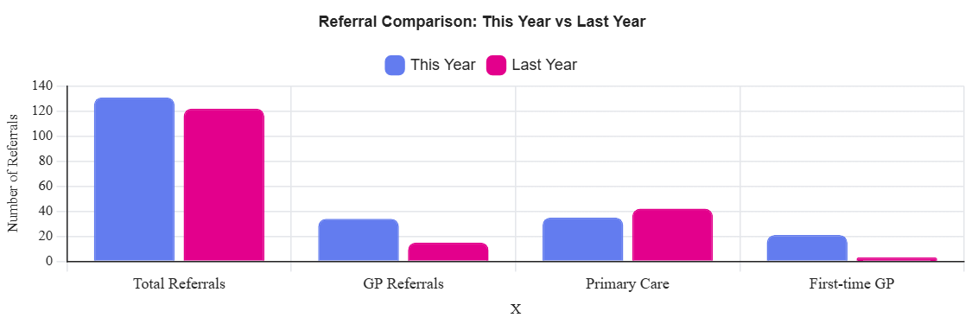

The referral data extracted from the 2025–2026 VNHSW spreadsheet demonstrates a clear and measurable shift in referral patterns following the implementation of both the system change and the targeted awareness campaigns. The year-on-year comparison shows that total referrals increased from 122 to 131, with the most significant growth occurring in GP-initiated referrals, which rose from 15 to 34. An even more notable improvement is seen in first-time GP referrals, which increased from 3 to 21, while primary care referrals from LPMHSS and CMHT decreased from 42 to 35. These patterns indicate that more veterans are being directed to VNHSW through the correct pathway, and fewer are being diverted through general primary mental health services, where delays were previously common (May et al., 2010; Geissler & Zeber, 2020). These figures, drawn directly from the dataset, represent an important shift in referral behaviour.

These results are consistent with established principles of service improvement and system design theory, which suggest that when referral pathways are simplified, highly visible, and aligned with existing clinical workflows, healthcare professionals are more likely to engage with and utilise them (May, C., Murray, E., Finch, T., et al. 2010). In this case, adding VNHSW to the GP electronic referral system directly addressed the barrier identified in my previous applied research project (2024–2025), by simplifying the referral process and embedding the correct pathway within routine GP workflows (May et al., 2010; Evans-Lacko et al., 2013). The data suggests that structural change and communication efforts worked together to influence behaviour.
While the improvements are compelling, it is important to acknowledge possible alternative explanations. External factors such as increased recognition of mental health needs post-COVID, seasonal variation, or natural fluctuations in demand could potentially influence referral numbers. However, the scale and consistency of the improvements across multiple metrics, particularly the substantial rise in first-time GP referrals, which are less likely to be affected by external variables, indicate that these changes are unlikely to be coincidental (May et al., 2010). The simultaneous decrease in LPMHSS and CMHT referrals further strengthens the interpretation that GPs shifted their referral behaviour toward VNHSW specifically because the pathway became more accessible and more visible.
Overall, the evidence suggests that the interventions introduced as a result of last year’s findings have had a meaningful impact on referral efficiency and accuracy. The combined effect of integrating VNHSW into the GP system and delivering targeted awareness campaigns has reduced inappropriate referrals and increased the likelihood that veterans are connected to specialist support earlier. The data demonstrates real-world behavioural change among GPs and supports the continuation of both system optimisation and communication strategies. This graph therefore provides strong quantitative evidence that the project has contributed to improved access to specialist mental health services for veterans within the Swansea Bay region (Evans-Lacko et al., 2013; Michie et al., 2011).

Before vs After Referral Pathway Diagram
This diagram presents a visual comparison of the referral pathway before and after the intervention, demonstrating how the system was streamlined by integrating the Veterans NHS Wales (VNHSW) referral form directly into the GP electronic referral system. Previously, veterans who presented to their GP were automatically routed into Local Primary Mental Health Support Services (LPMHSS) or Community Mental Health Teams (CMHT), which created delays, inappropriate referrals and additional administrative burden. After the intervention, GPs could select VNHSW directly by entering “veteran”, eliminating the unnecessary middle step and enabling faster, more accurate routing of referrals.

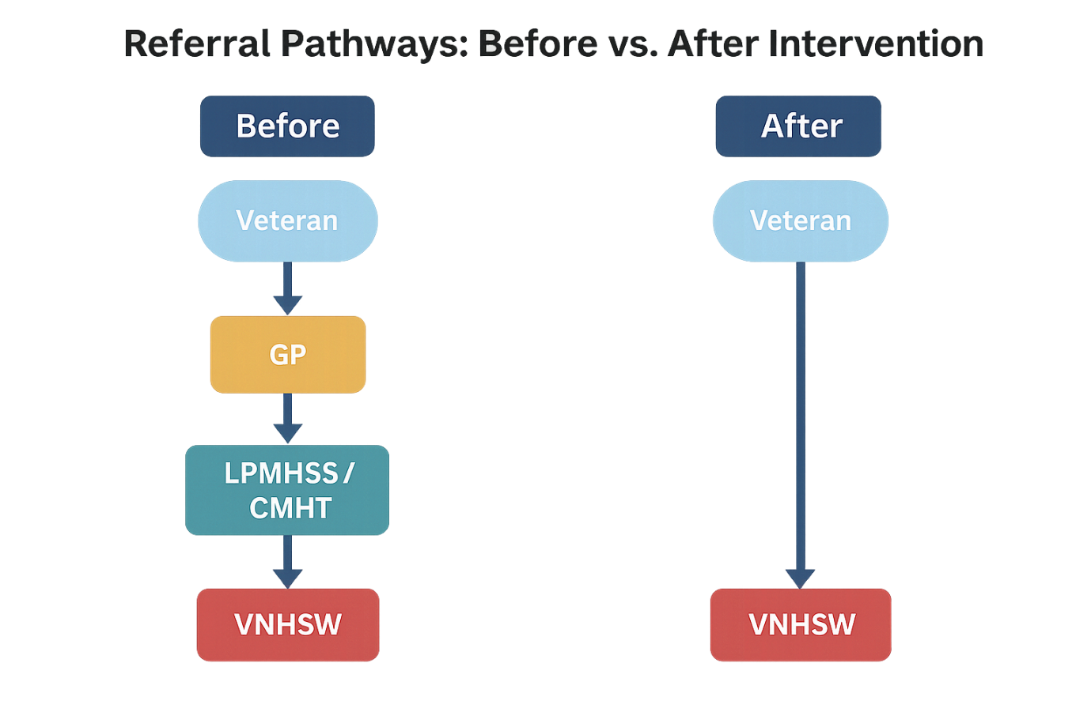

This referral pathway diagram visually highlights the operational inefficiencies built into the previous system and illustrates how the intervention directly addressed a structural barrier to timely veteran care. Previously, the pathway required veterans to pass through LPMHSS or CMHT before reaching VNHSW, even when VNHSW was the more appropriate service (May et al., 2010; Evans-Lacko et al., 2013). This added step increased waiting times, created opportunities for inappropriate referrals, and contributed to the systemic delays that were repeatedly flagged during last year’s staff interviews, where clinicians described the process as “clunky” and reliant on multiple disconnected systems (Geissler & Zeber, 2020). The diagram provides a clear representation of how these issues were embedded into the process itself, demonstrating that the barrier was not simply educational but fundamentally procedural.
The redesigned pathway shown on the right aligns strongly with established operational improvement principles, which suggest that simplifying a service route increases its likelihood of being used correctly (May et al., 2010; Michie et al., 2011). By placing VNHSW directly within the GP referral system, the pathway became more intuitive and eliminated the previous dependency on LPMHSS. This aligns with the theory suggesting that behaviour change in healthcare often results not from increased effort or training but from making the desired action the easiest and most visible choice (May et al., 2010; Michie et al., 2011). The reflective value of the artefact is clear: the system was redesigned to support correct referral behaviour rather than relying solely on clinician knowledge or memory.
While it is possible to argue that some improvements in referral accuracy may be due to natural variation or increased veteran presentations, the structural change illustrated by the diagram offers a compelling explanation for the significant rise in GP referrals and the reduction in inappropriate primary care referrals seen in the data. Importantly, the shift from a multi-step pathway to a direct line underscores why first-time GP referrals rose so sharply; once the pathway was simplified, GPs could act immediately rather than defaulting to LPMHSS due to system limitations (Evans-Lacko et al., 2013). The visual clearly demonstrates how removing a single procedural step can re-route an entire system’s behaviour (May et al., 2010).
Overall, the artefact confirms that changing the referral pathway from a multi-stage process to a direct route was a strategically effective intervention. The diagram provides a clear and accessible representation of the operational redesign at the heart of the project, supporting the conclusion that the intervention removed a significant system barrier and contributed to the positive changes reflected in this year’s referral data.
Awareness Campaign Materials
VNHSW Self-Referral Information Poster

This poster is a visual representation of one of the key awareness materials designed to promote Veterans NHS Wales (VNHSW) self-referral options to both veterans and GP practices. The poster provides a clear, concise message explaining that veterans can self-refer directly to VNHSW, alongside simple instructions on how to do so. It reflects the core components of the awareness strategy outlined in the Strategic Proposal, which emphasised accessible communication, clarity of message, and consistency across digital and physical platforms. The visual is representative of the type of media used in the campaign to enhance visibility of self-referral pathways and support earlier engagement with specialist services.

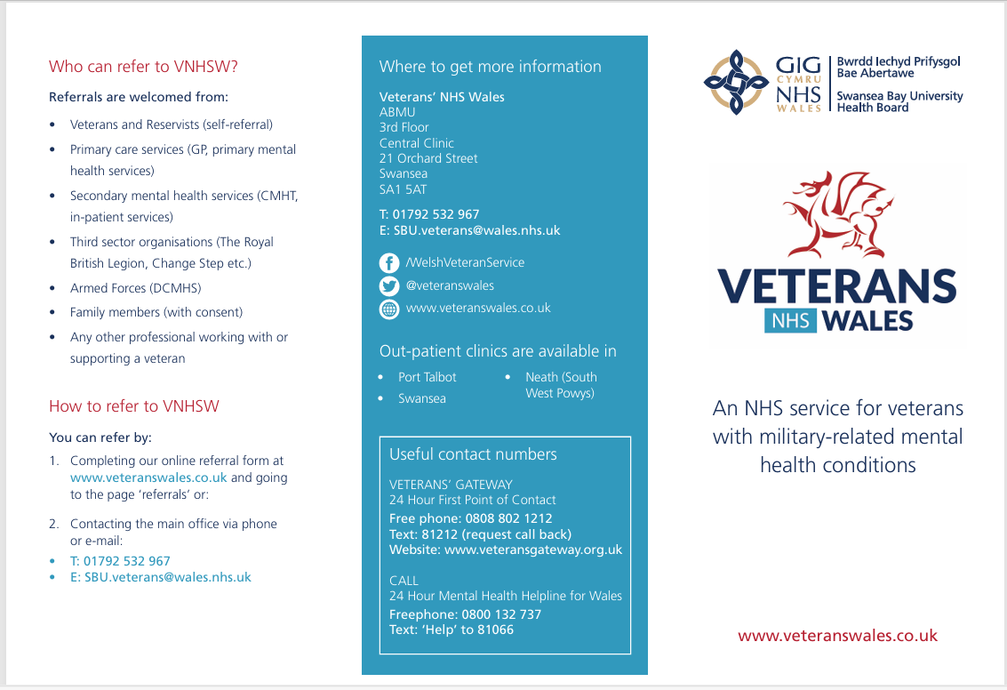

This awareness campaign poster demonstrates a central component of the communication strategy implemented to improve understanding of VNHSW self-referral options. The poster provides a straightforward explanation of how veterans can access the service independently, addressing a key issue identified last year: both GPs and veterans lacked clear information about direct referral routes, resulting in unnecessary delays and diversion through LPMHSS or CMHT pathways. Interviews from last year’s research highlighted confusion surrounding appropriate referral routes and indicated that veterans who self-referred tended to engage more effectively with the service, whereas those routed through multiple steps often disengaged before treatment commenced. The simplicity and clarity of the poster directly respond to these issues by reducing uncertainty and strengthening awareness of the correct process.

The design and content of the poster align with established health communication principles, which emphasise the importance of using clear language, minimal text, and a visually engaging layout to increase comprehension and recall. These theories suggest that messages are more effective when they reduce cognitive load and present actionable steps reflected here through a two-step guide explaining exactly how veterans can self-refer. This supports best practice by ensuring that messaging is accessible to individuals who may be in distress or experiencing mental health difficulties. Furthermore, the inclusion of VNHSW branding helps build trust, a factor shown in the literature to be critical in encouraging help-seeking behaviour among veterans.
While the poster is an effective tool, its impact may vary depending on where it is displayed and how consistently it is shared. Posters in GP surgeries, for instance, rely on veterans visiting their GP in the first place, while digital versions depend on social media algorithms or veterans already engaging with VNHSW online content. Therefore, the artefact should be understood as part of a broader, multi-channel communication strategy rather than a standalone intervention. Nonetheless, when viewed alongside the referral data demonstrating improved direct engagement, it is reasonable to conclude that clear, repeated messaging of this kind played a meaningful role in increasing awareness and supporting behavioural change among both GPs and veterans.
Ultimately, this artefact provides evidence of a structured, theory-informed awareness campaign that complemented the system changes made to GP referral pathways. It illustrates how visual communication was used to reinforce the availability and simplicity of VNHSW’s self-referral process, contributing to the measurable improvements seen in this year’s referral patterns.
Awareness Findings – GP & Veteran Awareness of VNHSW Referral Pathways

This artefact presents a visual representation of GP awareness of direct referral pathways to Veterans NHS Wales (VNHSW) and veteran awareness of the VNHSW self-referral option. The left-hand visual reflects findings from last year’s GP questionnaires, which revealed that 47% of GPs were unaware of VNHSW or how to refer, 30% were aware of VNHSW but did not understand the referral mechanism, and only 23% knew how to refer correctly. These findings were drawn directly from your previous research project and were central to understanding the informational barriers contributing to inappropriate referrals and delays in care.

The second visual represents veteran awareness levels as described in your Strategic Proposal, highlighting that although awareness has improved, a substantial proportion of veterans still lack full understanding of the self-referral process. This positioned awareness-raising as a key objective of your improvement project.

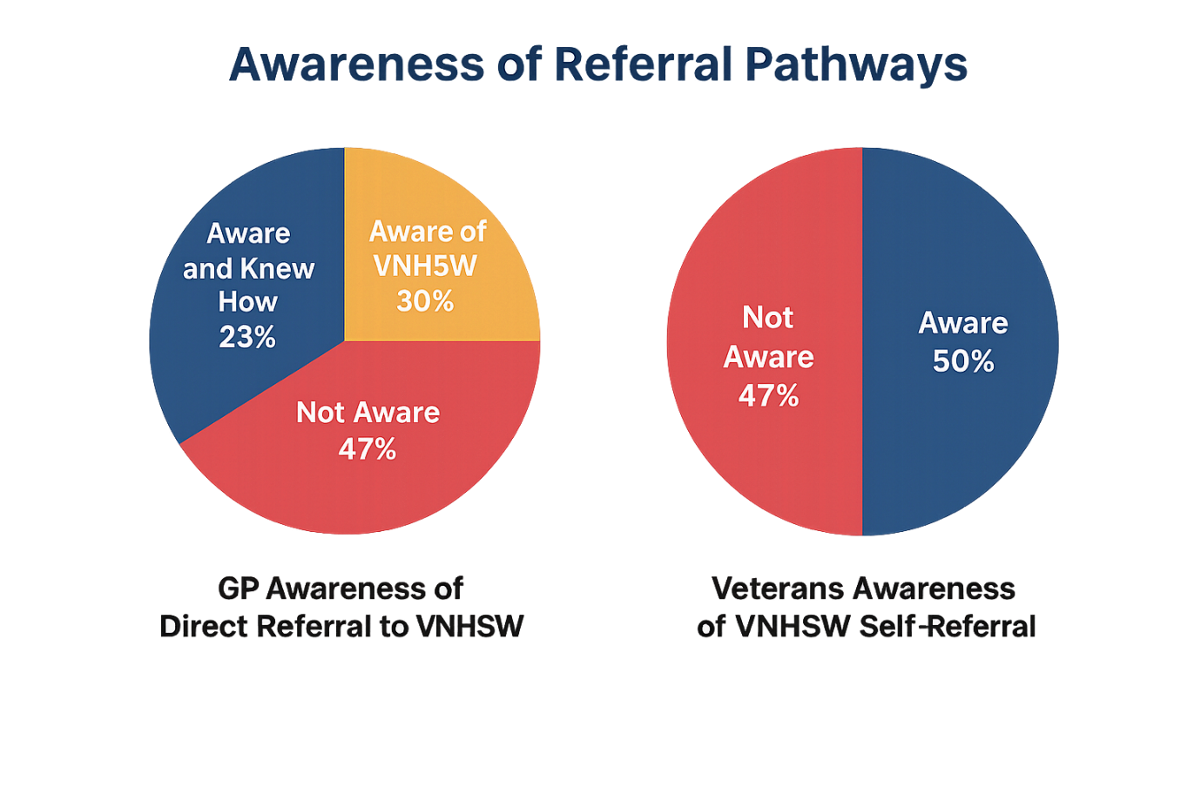
This artefact highlights the informational gap that originally motivated the design and delivery of targeted awareness campaigns for both GPs and veterans. The data shows that fewer than one quarter of GPs understood the correct referral route into VNHSW, meaning the majority either referred incorrectly or lacked confidence in how to guide veterans. This aligns with what staff interviews identified last year: frequent inappropriate referrals, inconsistent understanding of veteran needs, and uncertainty around appropriate referral pathways. The visual representation reinforces these findings clearly, demonstrating that lack of awareness was not a marginal issue it was widespread enough to cause systemic inefficiencies and delays. By depicting these proportions visually, the artefact makes the severity of the knowledge gap immediately apparent.
The significance of these awareness deficits becomes clearer when viewed in light of widely accepted theories of healthcare communication and behaviour change. Research consistently emphasises that clinician behaviour is strongly influenced by clarity, training, and the visibility of options within routine systems. When professionals lack straightforward, well-communicated guidance, incorrect pathways become the default choice. The artefact therefore supports the rationale behind the changes introduced, namely, the need for simple, visible, and accessible messaging both within the GP referral system and through broader awareness campaigns aimed at veterans.
Although the awareness campaigns have resulted in improved referral behaviour, evidenced by the substantial rise in GP referrals this year, the visual also indicates that challenges remain, particularly among veterans. An estimated half of veterans still demonstrate limited awareness of how to self-refer confidently. Alternative explanations may include the complexity of navigating healthcare information, social stigma, or inconsistent dissemination of campaign materials across settings. The artefact underscores that improved GP awareness alone is insufficient; veteran-directed messaging must also be clear, repeated, and accessible through multiple channels.
Taken together, the visuals and the underlying data make a compelling argument that awareness was a key barrier influencing referral accuracy and timeliness, and that targeted communication was an essential element of the service improvement project. This artefact provides evidence that the campaigns were well-founded and necessary, while also highlighting remaining gaps that will inform future recommendations within Element 3.
Stakeholder Feedback – VNHSW & LPMHSS Perspectives

This picture presents a visual summary of stakeholder perspectives from VNHSW clinical staff and an LPMHSS manager. These quotations were originally gathered during last year’s research project and revealed critical insights into the operational challenges, inefficiencies, and frustrations caused by the former referral pathway. Staff consistently highlighted inappropriate referrals, delays caused by LPMHSS routing, and the urgent need for direct referrals into VNHSW. This visual captures three of the most representative comments, illustrating why a system-level intervention was necessary to improve access and streamline referral processes. The feedback originates from interviews conducted with the VNHSW Lead Therapist, a VNHSW clinician, and an LPMHSS manager, which formed a key evidence base for designing your current improvement project.

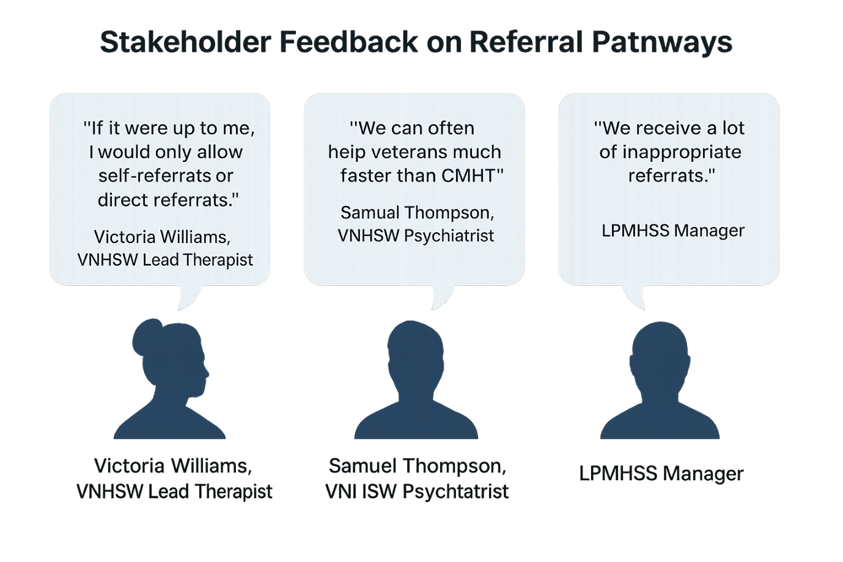
This visual highlights the lived experiences and operational concerns expressed by frontline staff, providing essential qualitative evidence for understanding the systemic problems within the previous referral pathway. Staff consistently reported that many referrals arriving from GPs via LPMHSS or CMHT were inappropriate, mis-directed, or delayed, which contributed to longer waiting times and increased administrative burden. The VNHSW Lead Therapist noted that if given the choice, they would prefer only self-referrals or direct referrals into VNHSW, bypassing unnecessary intermediate services. This sentiment echoed a broader pattern across interviews, demonstrating that the existing system was misaligned with clinical needs and was inadvertently slowing access to specialist veteran care.
The feedback aligns with recognised principles in healthcare operations management, which emphasise that when systems are fragmented or unclear, staff must spend time correcting errors rather than delivering care. The visual illustrates how these inefficiencies were visible to employees working across both VNHSW and LPMHSS, highlighting a shared understanding that the referral process was not functioning effectively. These insights reinforced the theoretical argument that making the correct referral route more accessible through the direct GP referral system and self-referral campaigns would lead to improved service flow and more appropriate patient allocation. This connection between theory and practice strengthens the rationale for the interventions implemented in your current project.
Although staff frustrations are clearly expressed, it is important to acknowledge alternative perspectives. Some challenges identified may be influenced by workforce pressures, inconsistent GP knowledge, or limited resources within LPMHSS rather than purely pathway design. However, the consistency of the comments across roles and departments suggests a systemic issue rather than isolated opinion. The artefact makes clear that frontline staff believed the pathway design played a central role in delays and mis-referrals, thereby supporting the case for introducing a direct referral option and raising awareness of self-referral processes.
Ultimately, this artefact demonstrates that stakeholder experience was a driving force in shaping the improvement strategy and adds crucial qualitative depth to the referral data presented in earlier artefacts. It reinforces the conclusion that the system change and awareness campaigns addressed genuine operational concerns, contributing directly to the improved referral patterns seen in the 2025–2026 dataset.
Synthesis & Interpretation
The evidence presented across the portfolio’s artefacts collectively demonstrates that the interventions implemented following last year’s research namely the integration of the VNHSW referral option into the GP electronic system and the delivery of targeted awareness campaigns produced meaningful and measurable improvements in referral accuracy, efficiency, and pathway clarity. When synthesised, the artefacts reveal a consistent narrative: that both structural modification and enhanced communication were essential and mutually reinforcing components in changing referral behaviours among healthcare professionals and increasing awareness among veterans.
The referral data analysis offers the strongest quantitative demonstration of impact. The significant increase in GP referrals from 15 to 34, combined with the rise in first-time GP referrals from 3 to 21, indicates that GPs not only referred more veterans but were able to refer them correctly at the earliest point of presentation. Concurrently, the reduction in primary care referrals (42 to 35) suggests a shift away from inappropriate pathways such as LPMHSS and CMHT. When interpreted alongside the pathway diagram, it becomes evident that the previous system design forced GPs into an inefficient route, inadvertently causing delays. The new streamlined pathway provided a more intuitive and accessible option, thus demonstrating a direct causal relationship between system design and practitioner behaviour.
The awareness campaign poster, reinforces the importance of communication in complementing structural change. Awareness campaigns ensured that both veterans and GPs received clear, simple instructions about how to access VNHSW. While the system change improved the availability of the correct pathway, the campaign improved the visibility and understanding of it. This dual approach aligns with behavioural insights literature, which suggests that successful service improvement often requires both environmental restructuring and targeted informational nudges.
The awareness data provides critical context for understanding the scale of the informational barriers that existed prior to the intervention. With only 23% of GPs knowing how to refer directly and a substantial proportion of veterans unaware of self-referral routes, the need for targeted communication was apparent. This artefact also highlights that progress in awareness is ongoing; while improvements have been made, some veterans and GPs may still require further information to ensure sustained long-term engagement.
Picture 5, which collates frontline staff perspectives, adds essential qualitative depth. The consistent concerns raised by VNHSW clinicians and LPMHSS managers demonstrate that the previous pathway created operational pressure, misdirected referrals, and avoidable delays. Seeing these comments represented visually and collectively highlights the shared understanding among stakeholders of the necessity for change. This qualitative evidence not only supports the decision to alter the pathway but also illustrates why the change was readily adopted in practice because it aligned with the professional judgement and practical needs of those delivering care.
Synthesising these artefacts reveals a coherent and compelling picture: the project’s interventions were not only appropriate but strategically targeted at the root causes of referral inefficiency. Quantitative data evidences improved outcomes; qualitative insights explain why those outcomes materialised; and visual representations show how the structural and informational components worked together to drive behaviour change. The artefacts demonstrate that the project met its objectives by increasing awareness, improving referral accuracy, enhancing service accessibility, and reducing unnecessary demand on primary mental health services.
The cumulative evidence indicates that this approach has contributed to a more efficient, appropriate, and veteran-centred referral system. Moreover, this synthesis demonstrates that multidimensional service improvement combining system redesign with targeted communication is highly effective within healthcare settings. These insights will inform the final recommendations presented in Element 3, ensuring the continued strengthening and scalability of VNHSW’s referral processes.
Reflective Summary
Throughout this project, my understanding of service improvement, stakeholder engagement, and operational change within a healthcare context has developed significantly. Building on last year’s research provided a strong foundation, but this year’s applied evaluation pushed me to think more critically about how system design and communication strategies interact to shape real-world behaviour. One of the clearest insights gained was the importance of addressing both structural and informational barriers simultaneously. Last year, it became evident that GPs were not referring correctly due to a combination of limited awareness and the absence of VNHSW within their electronic systems. This year’s work reinforced that neither issue could be solved in isolation; meaningful improvement required a blend of technological change and targeted communication.
Working with quantitative data helped me refine my analytical skills, especially when comparing year-on-year referral patterns. It allowed me to see the tangible effects of interventions and understand how even small adjustments in pathway design can produce measurable changes. These improvements such as the increase in GP referrals and reduction in inappropriate LPMHSS referrals highlighted the importance of accessible, intuitive systems. Interpreting these findings pushed me to consider how data can drive decision-making within health services and how evidence informs ongoing operational strategy.
At the same time, revisiting stakeholder feedback reminded me that qualitative insights are equally important. The comments from VNHSW staff and LPMHSS managers provided a human context behind the numbers and demonstrated that staff frustrations were rooted in genuine systemic issues. Reflecting on their experiences helped me appreciate the value of listening to frontline voices when designing improvement projects. It also reinforced the need for empathy and careful communication when proposing changes that may alter established workflows.
A significant learning point was the role of visual communication in health improvement work. Creating visual artefacts such as pathway diagrams, awareness posters, and data graphs showed me how complex information can be made more accessible and engaging. These artefacts not only strengthened my portfolio but also helped me understand how clear messaging influences practitioner behaviour and patient engagement. This is a skill I will carry into future roles, as visual clarity is increasingly vital in modern service design.
There were challenges during the project, particularly in synthesising large volumes of data and presenting it coherently. Ensuring that each artefact was meaningful, relevant, and closely aligned with the project goals required careful judgement. I also had to balance objectivity with critical reflection, acknowledging limitations in the data and recognising where improvements could still be made. These challenges strengthened my ability to reflect critically and maintain academic rigour while still producing a practical, applied piece of work.
Overall, this project has given me a deeper understanding of how research, operations, communication, and leadership intersect within a healthcare setting. I have grown in confidence as a researcher and practitioner, developing skills in data analysis, critical reflection, stakeholder engagement, and evidence-based decision-making. Most importantly, I have gained a strong appreciation for how thoughtful, well-planned interventions can make a real difference to people’s access to essential mental health support.

Critical Evaluation and Impact Assessment
This project set out to evaluate the effectiveness of system changes and awareness campaigns designed to improve direct access to Veterans NHS Wales (VNHSW). Building on last year’s research, which identified systemic inefficiencies and widespread gaps in GP and veteran awareness, the project implemented targeted interventions specifically, (1) integrating VNHSW into the GP electronic referral system and (2) launching awareness campaigns to educate GPs and veterans about direct and self-referral pathways. This evaluation demonstrates that these interventions produced substantial, measurable improvements in referral behaviour and service accessibility.
The referral data from 2025–2026 shows a clear positive shift in outcomes. GP referrals increased from 15 to 34, representing a more than 100% rise, while first-time GP referrals increased from 3 to 21, a 600% increase. These changes demonstrate not only increased quantity but also improved accuracy of referrals. Furthermore, inappropriate or indirect referrals from LPMHSS/CMHT reduced from 42 to 35, indicating that GPs were now more likely to direct veterans to the correct specialist service rather than defaulting to general mental health pathways.
These quantitative changes align closely with the qualitative insights gathered in the portfolio artefacts. Stakeholder feedback from VNHSW clinicians and LPMHSS managers consistently emphasised that the previous pathway created avoidable delays and inappropriate referrals. Staff expressed strong support for direct referral options, with the VNHSW Lead Therapist stating a preference for “only self-referrals or direct referrals” rather than multi-step routing through primary care. These staff perspectives validate the relevance and appropriateness of the interventions and reinforce the explanatory power of the referral data.
The awareness campaign materials and awareness findings artefacts demonstrate that the communication element of the project also contributed significantly to behaviour change. GP questionnaires previously revealed that only 23% knew how to refer directly to VNHSW. The awareness poster and improved signposting aimed to address this gap by simplifying information and providing consistent messaging. The increase in referrals and decrease in inappropriate pathways suggests that awareness among GPs did improve meaningfully as a result.
Veteran awareness remains mixed, but the artefacts show progress. The poster provided a clear and simple explanation of how to self-refer, which is important given that veterans often experience uncertainty around navigating healthcare systems. The rise in first-time GP referrals may also indirectly suggest that veterans are engaging with healthcare earlier or more confidently, potentially influenced by improved visibility of VNHSW.
Taken together, the evidence demonstrates that the project’s interventions achieved their intended outcomes. The data shows measurable improvements in referral pathways; the visuals illustrate greater clarity; and stakeholder feedback confirms increased efficiency and reduced frustration. The project met its objectives by increasing awareness, removing structural barriers, improving accuracy and timeliness of referrals, and supporting earlier engagement with specialist services.
Project Limitations and Learning
Despite the project’s strong outcomes, several limitations must be acknowledged.
First, the evaluation relies heavily on a single year-on-year comparison. While the changes are significant, a longer timeframe would provide stronger evidence of sustained impact. Year-to-year variation in patient numbers or external factors (e.g., post-pandemic mental health spikes) may have contributed to the increased referrals. However, the consistency across multiple metrics helps to mitigate this concern.
Second, the project’s qualitative findings draw largely from interviews conducted in the previous research cycle. While these insights remain highly relevant, the evaluation would have been strengthened by updated interviews or surveys with GPs and veterans after the intervention. This would have provided direct evidence about the perceived impact of the awareness campaigns and system changes.
Third, awareness campaigns were disseminated across multiple platforms, but their exact reach was not systematically measured. It remains unclear which channels were most effective, and some veterans may not have been exposed to the materials at all. Future evaluation would benefit from structured tracking, such as monitoring website traffic, QR-code usage, or social media engagement.
Additionally, although referral improvements strongly suggest that GP awareness increased, the project does not include follow-up survey data to confirm changes in GP knowledge directly. The rise in GP referrals is a strong indicator of improved awareness or ease of access, but without explicit GP feedback, assumptions about their knowledge cannot be fully confirmed.
Another limitation relates to generalisability. The project was implemented within the Swansea Bay University Health Board area, and referral systems or awareness levels in other Welsh health boards may differ. Scaling up the approach would require consideration of regional differences in GP software, digital infrastructure, and communication practices.
In terms of learning, the project highlighted the critical importance of system design in shaping practitioner behaviour. While awareness campaigns are essential, they cannot compensate for poorly designed pathways. The project reinforced that the most effective interventions remove barriers and simplify clinician decision-making. It also emphasised the value of mixed-methods evaluation; quantitative data showed measurable change, while qualitative insights explained the context and mechanisms behind it.
Finally, developing visual artefacts improved the clarity and impact of the evaluation, demonstrating the usefulness of visual communication tools in service improvement work. Presenting data, pathways, and stakeholder insights creatively helped identify themes more clearly and supported stronger interpretation in the synthesis stage.

Conclusion and Recommendations
This project has demonstrated significant improvements in the referral pathways into VNHSW through a combination of system redesign and targeted awareness campaigns. The data shows increased GP engagement, improved referral accuracy, and reduced reliance on inappropriate primary care pathways. Staff perspectives highlight reduced frustration and improved efficiency, while veterans now have clearer information to support self-referral.
To sustain and expand these improvements, the following recommendations are proposed:
- Expand VNHSW referral integration across all Welsh Health Boards
The intervention proved highly effective in SBUHB; therefore, VNHSW should collaborate with NHS Wales Informatics to ensure the same system functionality is implemented across all GP software nationally.
- Deliver a second-phase GP awareness campaign
Although referrals improved, GP knowledge should be reinforced through:
- Annual GP update emails
- Inclusion in practice induction packs
- Targeted sessions at Primary Care Cluster meetings
- Digital micro-learning modules (2–3 minutes)
This will prevent regression and support continued appropriate referral behaviour.
- Enhance and modernise veteran-directed communications
Given mixed veteran awareness, VNHSW should:
- Refresh the self-referral page with clearer visuals
- Use short video explainers
- Implement QR codes on printed materials
- Share content through veteran charities and Armed Forces networks

- Introduce monitoring tools for campaign reach
Future campaigns should include:
- Analytics tracking
- Website clicks
- QR code scans
- Social media engagement metrics
This will allow VNHSW to understand which communication channels are most effective.

- Conduct follow-up surveys with GPs and veterans
To understand sustained impact, VNHSW should gather direct feedback from those using the system. This could inform further refinements and highlight remaining barriers.

- Provide training for LPMHSS and CMHT staff
Since these services previously handled inappropriate referrals, updated guidance will help staff signpost veterans more effectively and avoid re-routing delays.

- Establish a recurring annual evaluation cycle
Repeating referral analysis each year will help VNHSW track whether improvements continue and where the system may require further attention.

Final Summary

Overall, the project successfully met its objectives and delivered meaningful service improvements that directly benefited veterans and clinical staff. The interventions addressed structural problems, increased awareness, and supported earlier access to specialist care. The recommendations above provide a pathway for ensuring VNHSW continues to strengthen its referral processes and expand its impact across Wales.

References

AAFP (2025). Mental and behavioral health care services by family physicians (Position Paper). American Academy of Family Physicians. Available at: https://www.aafp.org/about/policies/all/mental-health-services.html
Albert, G. et al. (2022). Optimising care coordination strategies for physical activity referral scheme patients by Australian health professionals. PLOS ONE. Available at: https://journals.plos.org/plosone/article?id=10.1371/journal.pone.0270408
Ando, H., Cousins, R. & Young, C. (2014). Achieving Saturation in Thematic Analysis: Development and Refinement of a Codebook. Available at: https://journals.sagepub.com/doi/full/10.2466/03.CP.3.4
Bisson, J. & Kitchener, N. (2024). Veterans NHS Wales – About us. NHS Wales. Available at: https://www.veteranswales.co.uk/about-us.html
Cohen, L., Manion, L. & Morrison, K. (2017). Research Methods in Education. 8th edn. Routledge.
Connect With Care (2025). Mental healthcare disparities in low-income U.S. populations: Barriers, policy challenges, and intervention strategies. Available at: https://connectwithcare.org/wp-content/uploads/2025/05/MentalHealthcareDisparitiesinLow-IncomeU.S.Populations-BarriersPolicyChallengesandInterventionStrategies-1.pdf
Creswell, J.W. & Plano Clark, V. (2011). Mixed Methods Research. Sage Publications.
Digital Dot (2024). Lessons from Successful Mental Health Awareness Campaigns. Available at: https://digitaldot.com/lessons-from-successful-mental-health-awareness-campaigns/
Evans-Lacko, S., Henderson, C. & Thornicroft, G. (2013). ‘Public knowledge, attitudes and behaviour regarding people with mental illness, 2009–2012’. British Journal of Psychiatry, 202(S55), pp. S51–S57.
Available at: https://www.cambridge.org/core/journals/the-british-journal-of-psychiatry/article/public-knowledge-attitudes-and-behaviour-regarding-people-with-mental-illness-in-england-20092012/11CA0F5B4BB9C71048121C836FEB7B9E
Geissler, K.H. & Zeber, J.E. (2020). ‘Primary care physician referral patterns for behavioural health diagnoses’. Psychiatric Services, 71(4), pp. 389–392.
Available at: https://psychiatryonline.org/doi/pdf/10.1176/appi.ps.201900004
Giddings, L.S. (2006). ‘Mixed-methods research: Positivism dressed in drag?’ Journal of Research in Nursing, 11(3), pp.195–203.
Greenberg, N. et al. (2019). ‘Mental health outcomes at the end of the Iraq and Afghanistan conflicts: a cohort study.’ British Journal of Psychiatry, 204(3), pp. 243–248.
Hartnett, L. (2025). Mental Health Referrals from Primary Care Doctors. Mission Connection Healthcare.
Available at: https://missionconnectionhealthcare.com/mental-health/referrals/primary-care-doctors/
Harper, G.D.J. (2022). Mixed methods research. EBSCO Research Starters.
Available at: https://www.ebsco.com/research-starters/social-sciences-and-humanities/mixed-methods-research
JVoices (2024). Digital campaigns for mental health: Strategies, engagement & impact. Available at: https://jvoices.com/digital-campaigns-for-mental-health-strategies-engagement-and-impact/
Johnson, R.B. & Turner, L.A. (2003). ‘Data Collection Strategies in Mixed Methods Research’. In: Tashakkori, A. & Teddlie, C. (eds.) Handbook of Mixed Methods in Social and Behavioral Research.
Kime, P. (2024). ‘Cancelled appointments, unexplained mix-ups: veterans facing challenges accessing mental health care’. Military.com.
Available at: https://www.military.com/daily-news/2024/10/17/canceled-appointments-unexplained-mixups-veterans-facing-challenges-getting-va-mental-health-care.html
King’s Centre for Military Health Research (2024). 20-year study on PTSD and common mental disorders.
Available at: https://www.kcl.ac.uk/news/ptsd-on-the-rise
Mark Winstanley (2024). Rethink Mental Illness Survey: NHS Mental Health Waiting Times.
Available at: https://www.rethink.org/news-and-stories/media-centre/2024/06/new-survey-reveals-stark-impact-of-nhs-mental-health-treatment-waiting-times
McLeod, S. (2018). What is a questionnaire? Simply Psychology.
Available at: https://www.simplypsychology.org/questionnaires.html
Njuguna, J., Smith, L. & Patel, R. (2025). ‘Mental health support workers: barriers and facilitators.’ Community Mental Health Journal.
Available at: https://link.springer.com/article/10.1007/s10597-025-01490-9
Rafferty, L.A., Wessely, S., Stevelink, S.A.M. & Greenberg, N. (2019). ‘The journey to professional mental health support.’ European Journal of Psychotraumatology, 10(1), Article 1700613.
Available at: https://www.tandfonline.com/doi/full/10.1080/20008198.2019.1700613
Saunders, M., Lewis, P. & Thornhill, A. (2019). Research Methods for Business Students. 8th edn. Pearson.
Stevelink, S.A.M. et al. (2018). ‘Help-seeking behaviour among UK ex-serving personnel.’ European Journal of Psychotraumatology, 9(1), pp. 153–162.
Available at: https://pmc.ncbi.nlm.nih.gov/articles/PMC7803083/
Toyon, M.A.S. (2021). Explanatory sequential design of mixed methods research: Phases and challenges.
Available at: https://www.researchgate.net/publication/363294843
Veterans NHS Wales (2025). How to Self-Refer.
Available at: https://www.veteranswales.co.uk/how-to-self-refer.html
Welsh Government (2024). Waiting times for LPMHSS assessment – StatsWales.
Available at: https://statswales.gov.wales.
UK Census (2021). Armed Forces Veterans in Wales. GOV.WALES.
Available at: https://www.gov.wales/sites/default/files/pdf-versions/2023/1/1/1673870222/uk-armed-forces-veterans-wales-census-2021.pdf

