

Postgraduate/Distance Learning
Assignment coversheet & feedback form

THIS SHEET MUST BE THE FIRST PAGE OF THE ASSIGNMENT YOU ARE SUBMITTING (DO NOT SEND AS A SEPARATE FILE)

For completion by the student:
Student Name: SARA SUCENA

Student University Email: 1917253@student.uwtsd.ac.uk
Module code:  HPCA7019  Module title: Sacred Skies | Student ID number:  1917253 |  |  | Educational support needs:  No
Assignment title:
Essay based on a sky journal

Assignment due date: 14th May 2021
This assignment is for the 1st 2nd X 3rd 4th 5th 6th module of the degree
I confirm that this is my original work and that I have adhered to the University policy on plagiarism.
Signed ……………………………………………………………
Email submission: if you are submitting this form via email, please tick this box X
(as a substitute for your signature) to confirm that you agree to the above declaration.
Assignment Mark
1st Marker’s Provisional mark
2nd Marker’s/Moderator’s provisional mark
External Examiner’s mark (if relevant)
Final Mark

NB. All marks are provisional until confirmed by the Final Examination Board.

For completion by Marker 1:
Comments:

Marker’s signature: |  |  | Date:
For completion by Marker 2/Moderator:

Comments:

Marker’s Signature: |  | Date:
External Examiner’s comments (if relevant)

External Examiner’s Signature: |  | Date:

Essay Measurement based
[Word Count: 5000 > 5250]

INTRODUCTION
This essay aims to reflect on the role of the sun – if any – in regards to the orientation of a set of modern parish catholic churches and their relation to the street grid within the city of Porto, Portugal. The assumption is that the sun’s daily/yearly path may have acted as a determinant factor in the building’s setting within the street layout, thus being the reason for dissonances between both; but it may well be that no such influence is found and instead urban planning guidelines superimpose its alignments to the building-street interrelation.
Erected between 1931 and 1996, these new churches stand in diversely urbanised areas regarding both its built density and building typologies, in the external ring of the city, namely responding to the population growth and the subsequent need to expand into previously undeveloped areas. The Liturgical Movement (and the changes in liturgy) ongoing from the nineteenth century, as well as the Modern Movement in Architecture, both considered under the Portuguese specificity, are taken into account as influential explaining factors. This contextualisation of the measurement findings within the cultural mindset that framed the building/design of the churches aims at making some qualitative sense out of the more abstract and quantitative data.
Having not found any research that has systematically addressed the interrelation between the layout of the city and the settlement of modern/contemporary churches in regards to the light as a decisive building (im)material, I compared it with the Western medieval city. Taken, on one hand, as the expression of the Augustinian Civitas Dei by Christian Norberg-Schulz, i.e., the synthesis of an essential interdependence between urban form, Church and (sun)light, and on the other, as the city structure to avoid within the Charter of Athens, the basic document of the Modern urbanism, it seemed opportune to build my starting point from it while reasoning about/questioning that same interdependence (urban form, Church and (sun)light) in the 20th century city.
LITERATURE REVIEW
- Church-City-Light
Church, city and light combined have the utmost harmonious expression in the Middle Ages. Lewis Mumford pointed out with great clarity the institutional strength of the Church when he wrote that ‘after the fall of the Roman Empire, the only powerful and universal institution was the church’ and that ‘until the 16th century, kings themselves trembled at the threat of excommunication’;1 this pre-eminence was clearly materialized in the territory. Via the parish church in the villages, the cathedral in the cities, and the monasteries and other sanctuaries scattered throughout the agricultural territory, ‘the Church was visibly present in all communities’, added Mumford. The birth of the medieval city, often founded on grounds of defence against external threat and as the result of the human grouping around the cathedral or the monastery (or the castle), lend ‘substance to the image of the medieval church as the fortified city of God’, as noted Spiro Castoff. In fact, as Fernando Chueca Goitia stated, ‘the cathedrals, the great abbeys, the pilgrimage sanctuaries are decisive for the morphogenesis of the medieval city’, which very often in the medieval West is associated with the radioconcentric type, despite the many typological variants that identify the medieval city and that led Kostoff to say that ‘there is no such thing as the “medieval town”’. He was certainly referring to its great morphological diversity since, although it can be planned, it seldom is, most likely being shaped instead by the local conditions and human will.
The religious building in the medieval city regularly has a central position in the urban fabric, surrounded by houses that also enclose and shape the square, which is often also that of the market and the guilds. There, in Kostoff’s words, the church is set ‘as the framer of a public space, the town square’. For Norberg-Schulz, this central location of the cathedral in the village interacted with the church’s nave which ‘[d]espite its longitudinal plan... represents a true centre’, likely to ‘be interpreted as an ideal extension of the routes of the surrounding urban settlement’. This adds strength to Kostoff’s view of the church standing “as an image of Heaven, as the city of God”, one that went beyond the building, carried out by its structure in a way that lead Norberg-Schulz to state ‘the Gothic era extended the concept of “Civitas Dei” to the totality of the urban medium’ with the exterior structure of the cathedral transmitting the spiritualized space of the interior to the surrounding environment.
Light is the privileged channel for transmitting this spirituality. As a ‘fundamental symbol of the Christian space’, it is the ‘spiritual element’ that, as Norberg-Schulz said, ‘transforms natural and anthropomorphic matter’ by giving everyday things ‘a new meaning’. Indeed, in Kostoff’s words, ‘[t]he new emphasis on light is what distinguishes Gothic architecture’. And it is in the dematerialization it imprints – which is not only technical, as Norberg-Schulz emphasizes, but is made perceptible outside the building precisely because of that technique – that ‘the gothic cathedral transmits to the whole community the symbolic order that results from interaction of light and matter’. With the cathedral representing an image of the cosmic order, according to Norberg-Schulz, ‘Gothic “enlightenment” means something more than the presence of divine light. It implies clarification and understanding…’.
Indeed, says Kostoff, one of the points to remember in relation to the Gothic cathedral, even when ‘we talk of it as a luminous, light-filled environment’ is that,
‘in reality, Gothic interiors were not at all bright. The thick, coloured panes of the stained glass glowed only under direct sunlight, and even then it was misted, chromatic illumination… It was precisely that rich, encrusted transparency that recalled the bejewelled structure of heavenly Jerusalem (…) This then was no ordinary light. It sifted through sacred pictures and was transmuted into something new, the new light, lux nova, which is how Suger, 12th century abbot of Saint-Denis and one of the early gothic builders, refers to Christ’.
Finally, it should be noted that at no point in the readings the authors mentioned solar orientation as an explanatory argument for the location of the building’s church or light’s entry, neither in general descriptions nor when explaining specific examples.
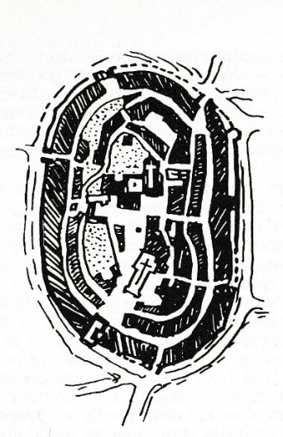  Fig. 1 – Lucignano (Italy), a radioconcentric type of city, as designed by Chueca Goitia (p.91). In the central area, the cathedral, the church and the sequence of squares that interrelate them. | 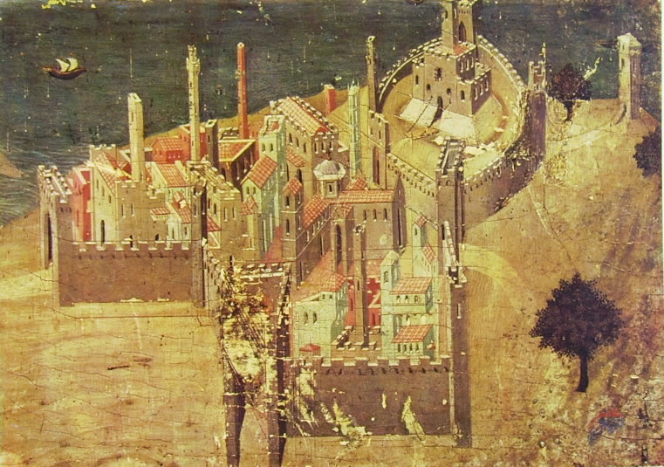  Fig. 2 – Edmund N. Bacon chose Ambrogio Lorenzetti's painting as one of the opening images of its “Medieval Design” chapter ns. Roughly in the middle, stands the cathedral. Ambrogio Lorenzetti, Veduta di città sul mare, 22,5 x 33,5 cm, Pinacoteca di Siena.
- Solar Orientation
Although the architecture/urbanism books above lacked reference to the solar orientation of churches in the medieval city, this gap is partially filled by a set of studies emerging from the discipline of archeoastronomy that reflected on this issue within different historical-geographical environments. Generically authors asserted that, in the medieval period, the churches’ alignment to the sun was a common aspect of their settlement and the East (NE-SE) was a recurring reference in the buildings they surveyed, even if True East was seldom verified.
Reflecting on this constancy and its variants, Stephen McCluskey identified two main models in the orientation of Christian churches: on the one hand, the axis in which the building points to the rising sun on the day of the patron saint; and, on the other, the one that follows the equinoctial alignment due East-due West. He additionally explained that due East stands for Jesus Christ either as rising day light (the True Light) or rising sun (the Sun of Justice), or alludes to “Paradise, from which humankind had been expelled’, all of them representations that justify praying in that direction. As to the E-W axis it can be the line that separates, contrasts and/or distinguishes, meaning, according to Isidore of Seville, ‘the line from the east to the west [that] would make the right and left parts of the sky equal’.
Were the orientation towards East either a mere suggestion, as in Vitruvius’s – ‘if there is no reason to hinder and the choice is free, the temple and the statue placed in the cella should face the western quarter of the sky’ – or a prescription, religious buildings did not seem to have followed the True East orientation. Peter G. Hoare, studying the English Medieval Parish Churches, claims that ‘A relatively small proportion of medieval parish churches faces due east’ (p.1713); Eva Spinazzè, focusing on medieval churches in northern-central Italy and in the Alps, says that only 3.3% of the holy medieval buildings she analysed are aligned with the sunrise of the equinox (p.461). McCluskey explained the deviations from this guideline due to constraints on the site itself or due to the lack of knowhow/skills of the builders, also suggesting the possibility of the greatest importance being attributed to the patron saint, or the church being conditioned by built pre-existences and old dedications, or even alluding to the building’s foundation date (pp.1707-8).
The dedication to the patron saints seems to be a viable alternative for Spinazzè, who counts high percentages for alignments with the sun in the four days of Mary’s feast celebrated during the medieval period: Annunciation, Purification, Assumption and Nativity of the Virgin Mary (40.3%) and with the feast of the patron saint (30.9%) (p.461). Brady el al. also identified this in some of the Cistercian churches studied in Wales, namely on Michaelmas or Saint David’s Day (pp.291-297). Inconclusive in this regard was the study by Juan Pérez and Victoria Pérez on the Romanesque churches in the Iberian Peninsula. In their case, the building criterion, resulting from the best time of the year for building/laying the building’s foundations in respect to weather conditions was the one largely privileged, a feature that Hoare also mentioned, but which, given the obvious coincidence with the unfavourable vernal equinox leaves him in doubt (p.1714).

What, however, leaves no doubt to any of these researchers is the orientation of the churches towards the solar arc of sunrise. Hoare states that ‘Nearly all English medieval parish churches are oriented within the “solar sunrise arc”, that is, between the solstice sunrise azimuths’ (p.1714), and Perez & Perez that ‘the solar orientation to east is the criterion used in a systematic way in the Romanesque churches in Hispania’ (p. 787), although they did not find any special reason for alignment. The only triggering subject was the symbolism involved in the orientation ‘towards the solar arc and not the geographic one, which could have been achieved without great effort’ (p. 788). In contrast, for Brady et al. the alignment of the churches was always intentional ‘repeatedly,… alignments to sunsets’ (p. 298) and making ‘use of the local topography to engage with the sun on theologically significant days’ (p.301 ). Like Perez & Perez, they also noticed a preference for astronomical alignments over theological ones (in their cases, setting apart from true equinox).
- Liturgical Movement and Modern Movement
Unlike that portrayed above to the Middle Ages, in the 20th century, church and city were not clearly and inextricably dependent. Church and architecture, however, and despite the parallel transformation processes they both underwent in response to modernity, continued to relate and assert themselves mutually within that relationship. The Church’s path of transformation culminated in the Second Vatican Council (1962-65), although following from what William Barde called the ‘modern’ Liturgical Movement, which was underway since the 19th century; as to Architecture, it embodied the Modern Movement.
3.1. The changing Church
In the twentieth century the forces moving the world were happening outside the Church (contrary to what occurred in the Middle Ages when it largely determined them) and it was now the Catholic structure that had to make an effort to accompany it, as noted by Harry Emerson Fosdick, in 1913:
‘The Church, as a mystical communion of saints, may escape the compelling effects of democracy and science; but the churches as organisations… can no more evade the transforming influences of the modern world than can institutions of politics and business.’ (p.615)
Fosdick calls for the need for the Church to reunite and live up to the expectations of modern devotees who were seduced by the ‘two master powers of our age’ – democracy and science. (p.616) He was certainly reacting to the regression of religious practice by the Catholic community that Barden portrays as follows: ‘We all know how depressing the figures for Mass-attendance, especially for men, are in many places’ (p.668).
The reconnection with the faithful was thus needed and, in fact, was already happening since the early 19th century due to the influence of a sequence of Benedictine monks, as explained by Barden, first in Solesmes, then in Louvain and more recently in the abbey of Maria- Laach. Gradually moving towards an active participation of parishioners in public worship and liturgy, a profound transformation of the church known as the Liturgical Movement was taking place, laying and spreading its new foundations. And if, as Roland Millare (p.132) asserted, it did not have as main concerns
‘Changing the language in which the liturgy was celebrated from the exclusive use of Latin to the vernacular, shifting from the celebrant’s ad orientem position to a versus populum, or making evening Masses available’,
it would come to be significantly represented by these transformations, since the most immediately visible to the eyes of parishioners and atheists.
3.2. Church and Architecture
The fact is that it was those secondary changes that introduced a potential impact on both the spatial organization of the church and its renewed conceptualization, and produced the encounter with the modern architects, as encapsulated by Dom Frédéric Debuyst:
Modern religious architecture was born around 1930 out of the union of two different phenomena: on the one hand modern architecture […], on the other hand, the liturgical movement, with its theological, pastoral and cultural implications’.
In a way, it was also happening the encounter with science (one of the 'master powers' mentioned above by Fosdick) through their technological manifestations, as it was exactly its seduction – ‘Machinery (…) has aroused a new spirit’ – which founded the ‘revolution in architecture’ proclaimed by Le Corbusier, one of the most emblematic representatives of Modern Architecture and Urbanism, in Vers une architecture, published in 1923.
Thus took shape what Anne-Françoise Morel and Stephanie Van de Voorde considered an ‘important strategy or concept advanced by the Church continuously throughout the twentieth century’: the identification of the Liturgical Movement with contemporary architecture. (p.270) They also claimed that ‘the radical changes in Catholic church-building in the mid- to late twentieth century were not primarily due to Vatican II but actually to earlier renewal movements within the Catholic Church’ (p.272 ), in these changes including the relationship with Modern architecture, as well as the rediscovery of the Church’s Fathers and, consequently, the revaluation of the altar. Free to return to the location and configuration prior to the year 1000 AD (Barden’s threshold), the altar became the main key and triggering piece for the new layout of the new church and the materialization of the new architecture.
According to Barden, the period between Gregory VII and the Council of Trent (1073-1545) converted Catholics into spectators of the liturgy, not only for imposing ‘the silent recitation of the Canon’, but also for the positioning of the altar ‘against the wall of the church, so that the priest had his back turned to the people’ (p.669). More recently the liturgical changes within the Second Vatican Council formally reversed that imposition and allowed great flexibility to this special ‘table or stand on which sacrifice is offered’, as demonstrated by the word’s definition in the Catholic Culture website. There one learns that the altar can be fixed to the floor or movable, be shaped, sized and ornamented accordingly with the structure and character of the sanctuary, as long as both
‘The main altar should be freestanding, away from any wall, so that the priest can walk all around it and can celebrate facing the people’ and be positioned in such a way ‘that the entire congregation will naturally focus their attention on it.’
In this process of reconceptualizing the altar and its positioning, the light, which symbolically represents Christ, found new themes for its expression. Modern architecture claimed it as one of its three constituent materials – ‘light and shade’, so Le Corbusier designated it (alongside walls and space) – and as a result new reasons (and freedom) – were gained for its materialization in church building, internally and externally.
3.3. The Sun and the Modernist City
The step towards the city, however, remains to be taken. The connection between the building/altar and the sunlight that once guided the temple’s alignment and is now independent of its walls, makes it harder to explain a relationship with the city. Still, the sun had a central place in the organization of the Modern City.
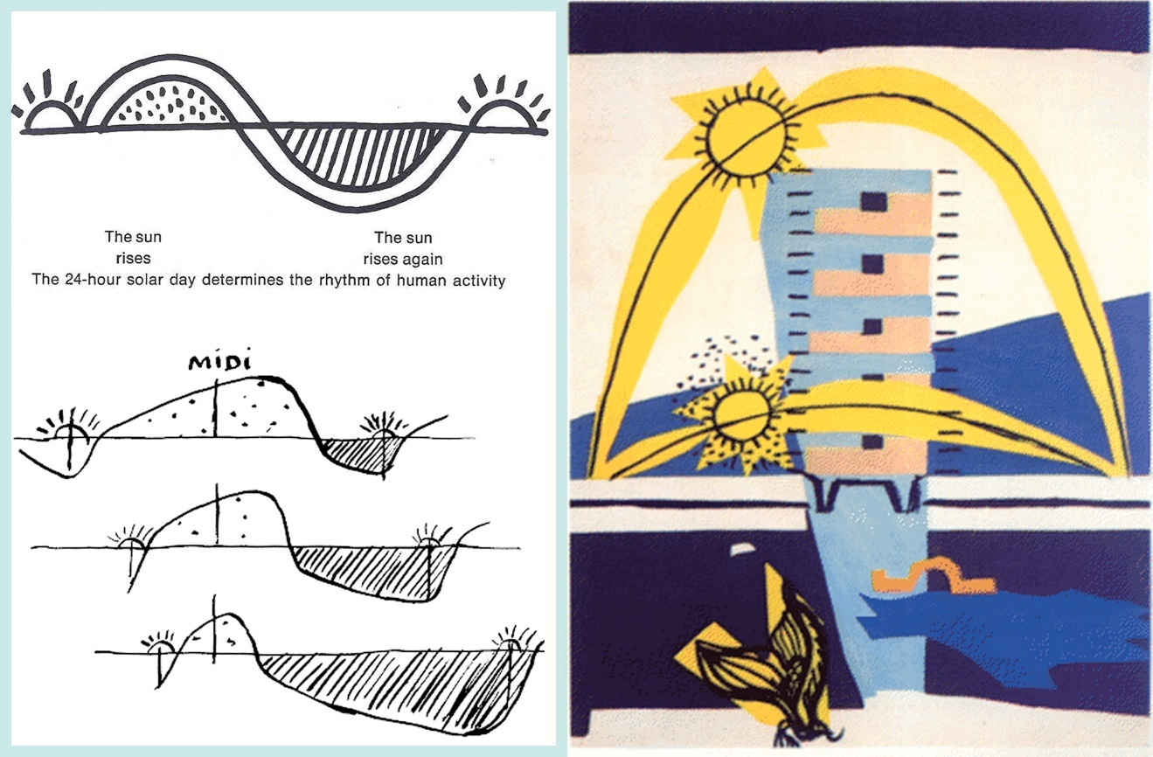
Fig 3 – Le Corbusier and the sun’s cyclical movement. Source: top left image: Le Corbusier, the Athens Charter (New York, Grossman, 1973), p15. Bottom left and right-side images: Le Corbusier, Le poème de l'angle droit (Paris, Fondation Le Corbusier, 2006[1955]), p.15, 69.
The sun was presented as one of the ‘three raw materials of urbanism’ (p.55) in the Charter of Athens, the document that reported the main conclusions of the Fourth Congress of the CIAM, (from the French; Congrès Internationaux d'Architecture Moderne), held on a Mediterranean cruise to Athens], in 1933, where the functional city was discussed, and constitutes the doctrinal basis of modern urbanism. The Charter’s main corpus characterized the four functions of the city – Dwelling, Recreation, Work and Transportation – and, addressing the first one, called for ‘a minimum number of hours of exposure to the sun’ for each housing unit (nº26). This was actually the argument that determined the basic shaping of the modernist city as dwelling is the city’s most dominant and space-extensive use. Indeed, according to Le Corbusier’s comments on article 26, an exclusive orientation to the north was cause for condemnation and denial of the building permit, and a sun’s diagram was a required part of submitting a design. Only dwelling, out of the four city’s functions, is thus conditioned. The Charter of Athens lists some collective institutions necessary for the support of this housing areas, but churches are not mentioned.
Still, there is a general principle for the location of buildings in the city that can also affect that of the churches – the refusal of closed city blocks on the basis of insufficient sun exposure:
‘…one facade out of four, whether it faces the street or the courtyard, is oriented to the north and never knows the sun, while the other three, owing to the narrowness of the streets and courts they face and to the resulting shadow, are half deprived of sunlight also.’ (17º)
Due to the lack of sun, therefore, the alignment of buildings following the streets was rejected and with it the structuring matrix in the shape of the traditional city, which the Charter of Athens wanted to replace with a model for the free settlement of buildings, on the grounds of the best sun exposure (23º).
METHODOLOGY
My research methodology was both fieldwork and literature-based within a case study approach. As it is fundamentally based on measurement, fieldwork was structured and developed twofold, predominantly virtually and occasionally on the ground.
The celestial coordinate system I referred to in the churches’ solar measurement was the ‘horizontal system’. In order to measure the azimuth referred to the line that crosses the church nave perpendicular to the altar, the first step of virtual fieldwork was the observation of the building plan through Google Earth, seeking to recognize that line as closely as possible. At the same time, the in situ visit to the churches took place to confirm the exact location of the altar and to observe the natural light source (s) of the altar, if any.
The subsequent step was finding the azimuth for the thirteen churches using Google Earth by reading the ‘heading’ (in decimal degrees) in the ‘ruler’ tool, as well as their geographic coordinates – latitude and longitude. As Google Earth provides the true Azimuth, I progressed to measure the horizon’s altitude of each site using ‘HeyWhatsThat’, after which I entered these values in a calculation spreadsheet to find the solar declination. The next step was the identification of the dates for the rising or the setting sun using the Solar Declination Table (extended in some days due to the level of uncertainty of ±1°). The decision for considering the sun’s rising or setting dates was determined by the altar’s heading to east or west, respectively.
Aside from measurement, Google Earth was also a tool to further virtual fieldwork. On the one hand, to observe (and map) the churches from the zenith’s position in relation to the street grid, comparing how they sit regarding the surrounding buildings in order to assess its driving force, if the sun or the street grid plan (or neither). On the other hand, to analyse the church’s facades through both the 3D Buildings’ layer and the street view, specifically focusing on the south-facing one and checking for the existence of windows. This privileged orientation justifies in the sun’s culmination (Porto being located in the northern hemisphere) where both the exposure is maximum and does not change over the year, varying in elevation angle, but not the x/y coordinates (or does so in negligible fashion). The former issued from and aims at a relation to the premises of the charter of Athens, discussed above, and the latter to a certain ‘control’ over the sun’s movement (occasionally discussed below regarding the altar’s location). In tandem with the fieldwork, the literature review allowed for an appraisal of the quantitative findings, putting them in context within the cultural mind-set of the original architectural patrons and designers, making qualitative sense out of the more abstract data sourced.
Lastly, some brief notes on the case-study approach. According to McCluskey, some criteria should structure any investigation: the level of consistency regarding the specific geographic regions, a logic and fair chronological order and a sufficient number of cases in order to validate the results This investigation accommodates the first two guidelines on the one hand by focusing on the city of Porto as the specific geography where all thirteen churches locate (the differences within the city consubstantiate part of the research) on the other by restraining the erecting time-frame of the churches to the 20th century. As for the number of cases analysed, the statistical validity based on the quantity was conditioned by the small number of churches at stake. Thirteen buildings do not allow for valid generalisation. Therefore, although some quantitative relations have been established over the findings’ discussion, the core of the investigation aims at a certain deepening of the individual instances, believing that insights that would not otherwise happen may be gained from this more specific focus, thus matching the case-study theoretical framework as proposed by Martyn Denscombe. The focus on observing the location of each church on the street grid, within a specific landscape, aimed at opening up to considerations of a particular order (of both the building and the site) and the possibility of finding specific ‘subjects’ that would otherwise not be known.
FINDINGS/DISCUSSION
Framed by both the context above and the search for a shared pattern in the orientation setting of the thirteen urban catholic parish churches built in Porto between 1931-96, the discussion below focuses on two main themes: the reading of the interrelation between the churches and the sun from the measurements, on one side, and from the cityscape/street grid, on the other. Under a comparative approach, the former interprets the fieldwork’s data from a more abstract viewpoint as systematized in

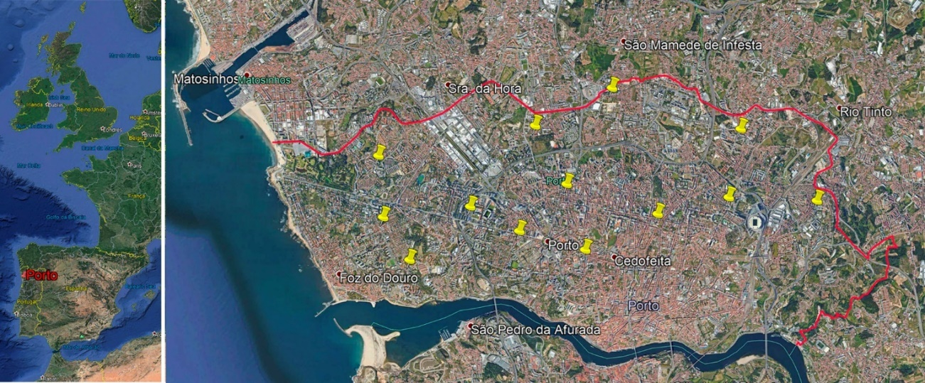
Fig. 3 Location of the thirteen churches in the city of Porto (Portugal). Image/Source: Free composition, Sara Sucena & ©Google Earth
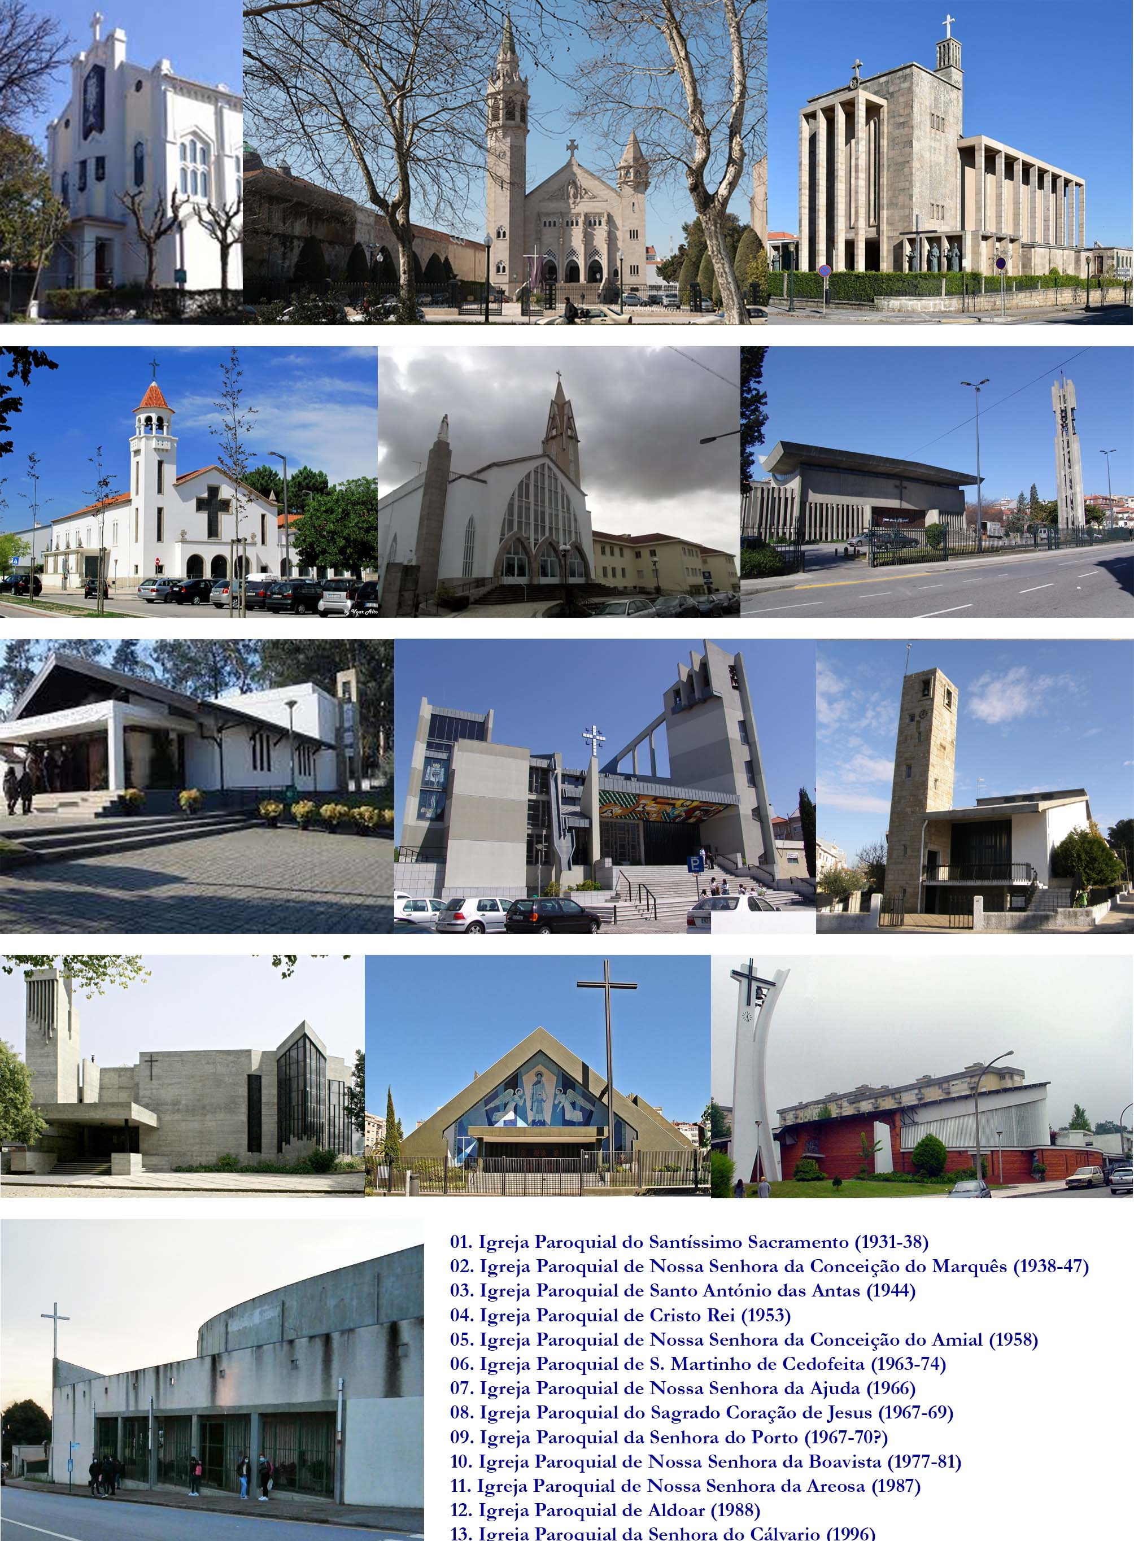
Fig. 4 The thirteen churches in Porto Location
tables/diagram, and the latter takes these data to the specific landscape of each church, making sense of both the orientation of the building and of the line perpendicular to the altar in relation to the street grid.
The churches and the sun: a figure-driven reading
The orientation of the churches under consideration was defined by a perpendicular drawn from the altar towards the congregation, which in twelve buildings has at its opposite end the main entrance in the church’s nave (in Church 08 the entrance is made laterally). Two tables organize the fieldwork measurement data: table 1 groups the general information on the churches distinguishing them according to the orientation of the altar, to the right of a N-S axis – Eastern location – or to its left – Western location. Table 2 stresses the observation of the sunrise dates regardless of the orientation of the altar. From the azimuths’ measurement a diagram was resulted a diagram (Fig5), allowing for an easier visualization of the building/altar’s heading in space.

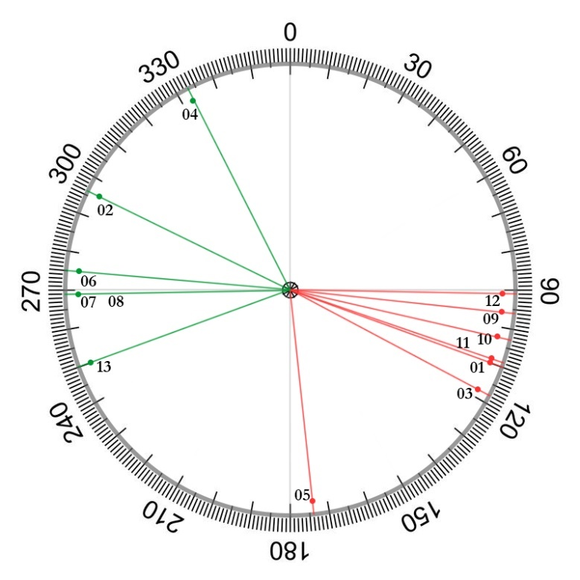
Fig. 5 Diagram presenting the true azimuths of the thirteen churches under analysis: in red, the churches whose altar is located to the East of a North-South axis; in green, the churches whose altar is located West of that axis. Source: Author, based on fieldwork data.

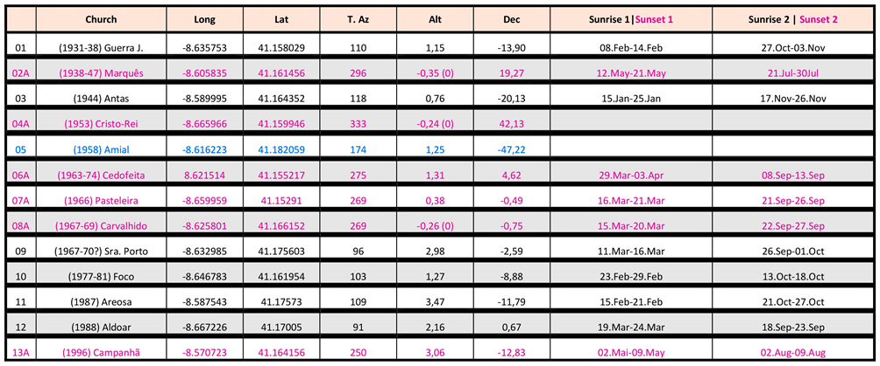
Table.1 – Fieldwork data collection: Location of the churches’ main altar on a E-W axis. Black stands for the churches whose altar have an Eastern location and pink for those that have it in a Western placement. Blue highlights the church where the altar is set almost due South. Source: Author, based on fieldwork data.

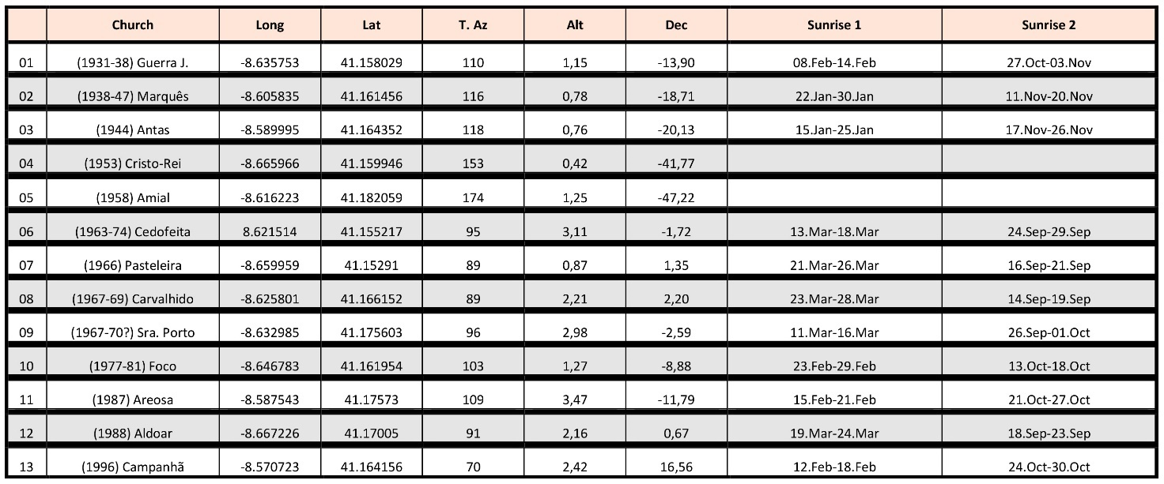
Table.2 – Fieldwork data collection: Sunrise dates for the line perpendicular to the churches’ main altar. In churches 04 and 05 the line does not point at any sunrise position. Source: Author, based on fieldwork data.

Regarding the diagram, ten of the thirteen churches analysed are located in the second and fourth quadrants of the graded circle, thus having a southeast-northwest orientation. Taking into consideration the location of the altar, most churches are located in the second quadrant, with the altar oriented to the southeast – seven churches out of the thirteen (in Fig.5 represented by the red colour), six of which locate within the azimuth 90°-120°. Three of the six remaining turn the altar to the northwest (in green), two of which with exactly the same azimuth on the border of the true west (269º).
According to table 1, the observation of the solar declinations (as mentioned by Clive Ruggles, nowadays equal to about ±23.4°) shows that all but two churches (04 and 05) are positioned within the ‘solar sunrise/sunset arc’, that is, between the solstice sunrise/sunset azimuths. Like both Hoare and Spinazzè discussed above, I found out that most of the churches face the sunrise arc although the difference is not much in relation to those that turn towards the sunset arc – six turn to sunrise and five to sunsetely (Fig5). Also worth noticing, from the solar declination values and the corresponding sunrise/sunset dates, is the series of churches that point to equinoxes (either the vernal or the autumn one) that according to Ruggles ‘can be defined technically as the times when the sun’s declination is 0°’. Five buildings set under a declination’s variation of ±5°, therefore close enough to the equinox and to allow the observation of the distinct movement of the sun when compared to solstices, when the sun gets the further away possible from the equinoctial axis. None of the churches reaches a declination of ±23.4°, but some are close enough and the comparison below shows that the sun moves much quicker at the equinoxes than at the solstices, as Juan Antonio Belmonte states when discussing the main solar stations. In the literature review section authors highlighted the religious and symbolic importance given to this axis, an aspect that still seems to be topical since a significant part of the modern churches under analysis seem to follow or be sensitive about it.
The observation of sunrise dates closer to the winter solstice and to the vernal equinox, for instance, for churches 03 and 12 (Table 2) bears witness to that. Considering the declination figures for each one of them increased by the uncertainty level of ±1°, one can see that, within that same interval, church 03 (declination -20,13° ±1°) benefits from the sun’s extended presence, of about ten days between January 15th-25th, when compared to the five days it faces church 12 (declination 0,67°±1°), between March 19th-24th. This also brings light to another of Belmonte’s statement – ‘an equinoctial marker can be extremely precise and may act as nearly a perfect tool for the control of time’ – as the sun’s faster movement makes differences in time more easily intelligible, namely when naked-eye observations are the ones in place.
As to making sense of the collected data regarding the churches’ orientation taking into account the churches’ patronal orientation, as McCluskey mentions this is one of the popular principles to be referred when discussing the churches setting (like the equinoctial orientation and that based on the date of the building’s foundation), results showed no relation with it whatsoever. The connection between the church’s altar and ‘the rising Sun on the feast day of the saint to whom the building was dedicated’, as explained by Hoare, was considered in table 3, that interrelated the churches’ patron, their titular days according to the liturgical calendar and the sunrise/sunset dates.

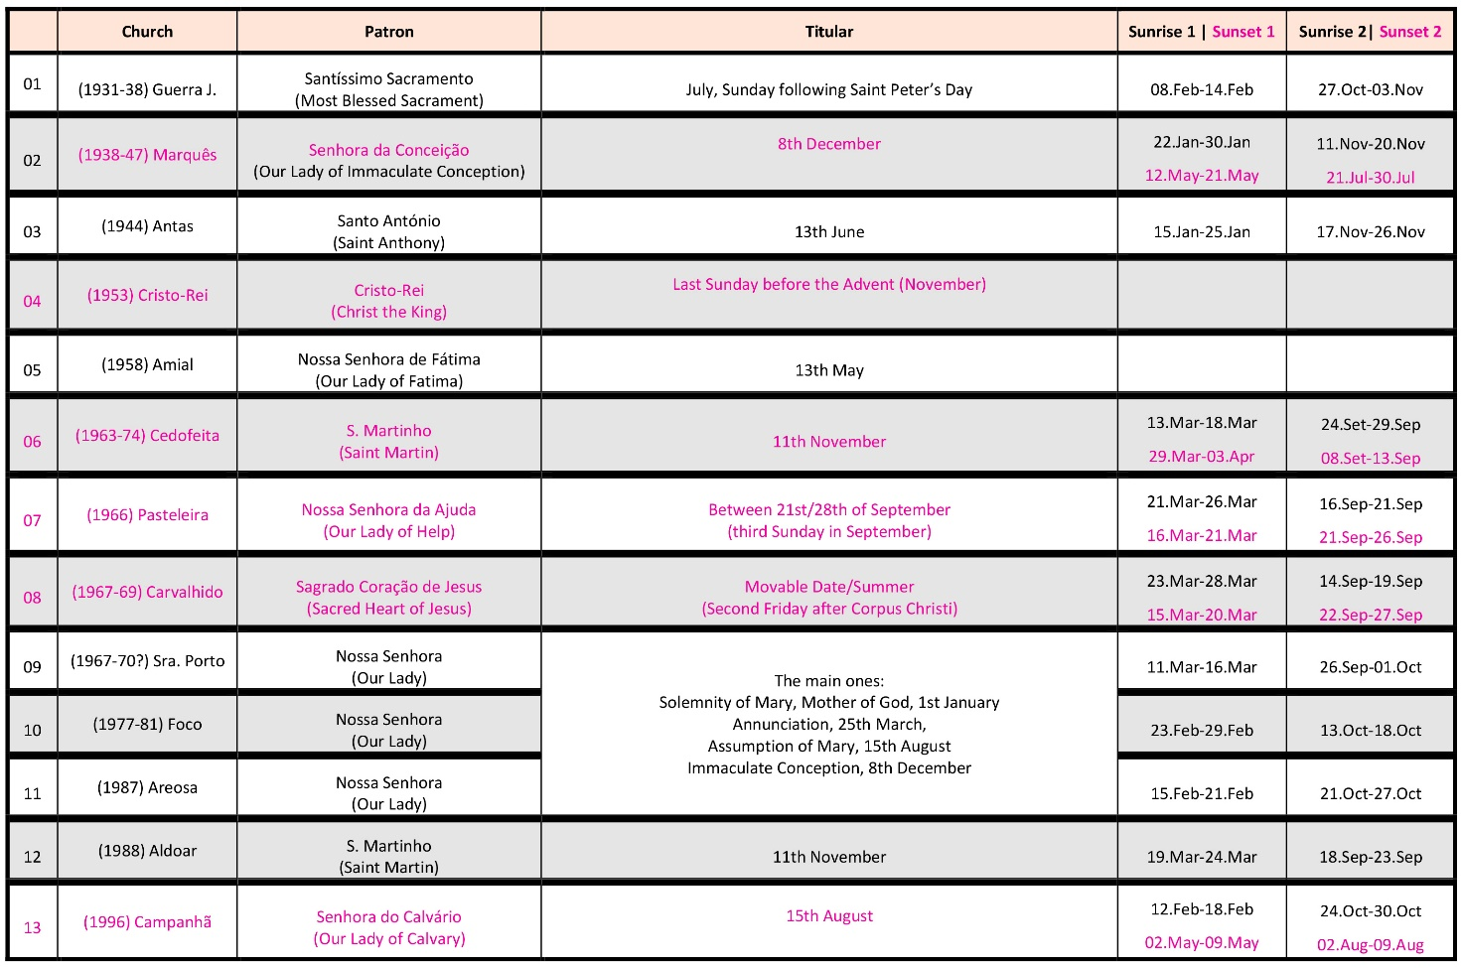
Table.3 – Fieldwork data collection. The patron of the church, its titular feast and the Sunrise/sunset dates for the line perpendicular to the churches’ main altar. Source: Author, based on fieldwork data.

The churches and the sun: a reading from the cityscape /street grid
- Integration on the street grid
An observation of these buildings setting on Google Earth (for additional information see Annex) shows that all these churches establish an articulated relationship with the street grid, being directly subordinate to it, and/or correlating with the plane composition of the surrounding built masses. This leads to the assumption that an interaction with the cityscape ranked higher than other design justifications, namely a specific solar orientation. An examination of the building permit files for the churches 06 and 08 in the planning department of the City Hall also reinforces that takeaway. Both dossiers comprise a section titled “integration within the landscape” and in the one referring to church 06 it is stated that it “is integrated in the local urban environment” and that “it faces the most important side of the parish”. In similar fashion, the text justifying the design options of church 08 mentions that the building will be set on a somewhat ramshackle area, bordered by residential backyards, and that it is meant to ‘entirely hide those rear façades’.
Contrary to what the Athens Charter advocated, these modern churches do not stress an independence from the street layout, except in the case of church 07, that is set in a social housing development that, as a whole, is composed under that dissociation between buildings and circulation. Had that been the case maybe a different approach to solar orientation might have emerged. That is not to say, however, that a connection with the sun was entirely discarded.
- The importance of the south façade/windows
Examining the south-facing façade in particular became an important topic of analysis having considered that the sun culminates on that direction, given that Porto is in the northern hemisphere. As discussed in the methodology, that side is bathed in light all year round, and is additionally the one easiest to capitalize on, for the sun always culminates in that direction, with negligible variations, albeit in varying higher or lower vertical angles. The building permit files of churches 06 and 08 confirm that light was considered in the designs, but solely in its broadest utilitarian virtues. The text regarding church 06 refers light as crucial in establishing an environment conducive to prayer, in articulation to surface materials, colours, acoustics… Be that as it may, the file about church 08 does attribute a higher role to light, specifically stressing its ability to differentiate the altar from the space for the congregation, a distinction ‘accentuated by a higher intensity of light and the presence of two pillars that define its boundaries’.
Illustrating this point, and the preceding one, the five churches with an altar oriented over an E-W axis (mentioned in the previous section), that include churches 06 and 08 are highlighted ahead.

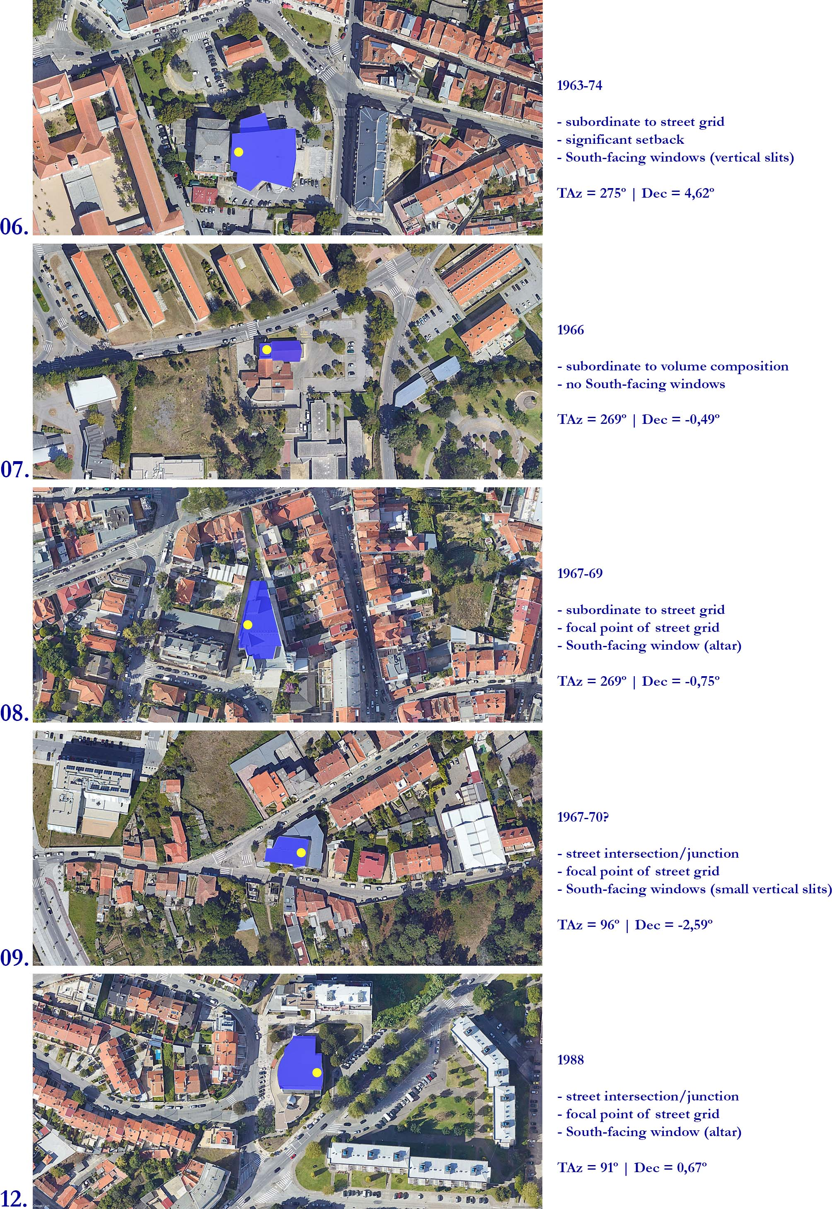
- The equinoctial orientation of the altar
Fig.6 (above) depicts the five churches whose altar has an azimuth falling between 0º and ±5°. It synthetizes the set of collected data relating to the setting of these churches in the landscape and in relation to the street grid, It also shows their insertion in the landscape through a Google image, and the approximate placement of the altar. In the first three churches the altar is placed in the West, while in the remaining two it stands in the East side. In four of them the Equinox marks the main entrance to the church’s nave. Only on church 07 the entrance is through the side of the nave. Nevertheless, the walls standing behind the altars (facing the vernal or autumn equinox) are blank and do not receive sunlight; solely on church 06 light enters through that side, but no contrast is achieved since that results from a single horizontal gap between ceiling and walls, running the entire perimeter of the space and separating the two tectonic entities. Thus, the relationship with the equinoctial axis does not appear to be particularly valued in any of these buildings, at least in terms of actual sunlight, even if interior spaces seem to take it into account, as it corresponds to the line connecting altar-nave-main entrance, that structures the distribution of the congregation.
CONCLUSION
This essay reflected on the role of the sun in regards to the orientation of thirteen modern parish catholic churches and their relation to the street grid within the city of Porto, Portugal. Erected between 1931 and 1996, and located in diversely urbanised areas regarding both its built density and building typologies, provided the opportunity to investigate whether the sun could be a standardizing element in the face of the diverse cityscape.
The main driving force was the age-old tradition, especially explored in the Middle Ages, of associating East light with divine meaning, representing Jesus Christ, or the direction of biblical Paradise. Therefore, due East-due West equinoctial alignment was particularly important. The special interest of this topic arose from the coincidence between the period of construction of the churches and the atmosphere of profound transformation experienced by both the Church and Architecture, in response to the challenges of modernity and science /technology as preponderant values. The Liturgical Movement that culminated in the Second Vatican Council, and the affirmation of modernist architecture, especially referred to the Charter of Athens that established the new doctrine for the organization of the city, constituted the reference context of the analysis.
Through an essentially virtual based methodology, strongly supported on Google Earth, the dates for sunrise and sunset falling on the perpendicular to the altar were calculated for each church and the reflection on this data, synthesized in tables and discussed with the support of Google images allowed me to come to some conclusions on three lines of inquiry. On the one hand, the detection of a sensible compromise between the churches and public space – the street grid – even if not necessarily adhering to formal traditions of urban composition, on the other a clear tendency to favour south-facing exposure that could arguably be attributed to the prescriptions of the Modern Movement and the maximum exposure of the buildings possible. Lastly, a likely preference for a E/W orientation of the axis between altar and congregation, generally reflected in the general grouping of architectural volumes and access options, but with an imprecise astronomical definition. It is possible to assume a common sense approach to a long-standing tradition of sunrise/sunset orientation.

References
Brady, Bernadette, ‘Chartres Cathedral and the Role of the Sun in the Cathedral's Christian Platonist Theology’, in Sky and Psyche. The Relationship Between Cosmos and Consciousness, ed. by Nicholas Campion and Patrick Curry (Edinburgh, Floris Books, 2006), pp. 59-76
Ruggles, Clive L. N., ‘Basic Concepts of Positional Astronomy’, in Handbook of Archaeoastronomy and Ethnoastronomy, ed. by Clive L.N. Ruggles (Springer, New York, 2015), pp. 459-471
McCluskey, Stephen C., ‘Orientation of Christian Churches’, in Handbook of Archaeoastronomy and Ethnoastronomy, ed. by Clive L.N. Ruggles (Springer, New York, 2015), pp. 1703-1710
Lewis Mumford, A cidade na história: suas origens, desenvolvimento e perspectivas, trad. Neil R. da Silva (São Paulo, Martins Fontes, 1982) pp.267-305 [‘Claustro e comunidade’]
Spiro Kostof, History of Architecture. Settings and Rituals (New York/Oxford, Oxford University Press, 1995), pp. 295-374 [‘The birth of Nations: Europe after Charles’, The French Manner’ and ‘The urbanization of Europe, 1100-1300’]. PDF
Fernando Chueca Goitia, Breve história do Urbanismo (Lisboa, Presença, 1982)
Norberg-Schulz, Christian, Arquitectura Occidental (Barcelona, Gustavo Gili, 1999), pp. 77-114 [‘La arquitectura románica’ and ‘La arquitectura gótica’]. PDF
Congress Internationaux d'Architecture Moderne (CIAM), La Charte d'Athenes or The Athens Charter, 1933. Trans J. Tyrwhitt. Paris, France: The Library of the Graduate School of Design, Harvard University, 1946. PDF
Edmund N. Bacon, Design of cities (London, Thames and Hudson, 1992)

Annex

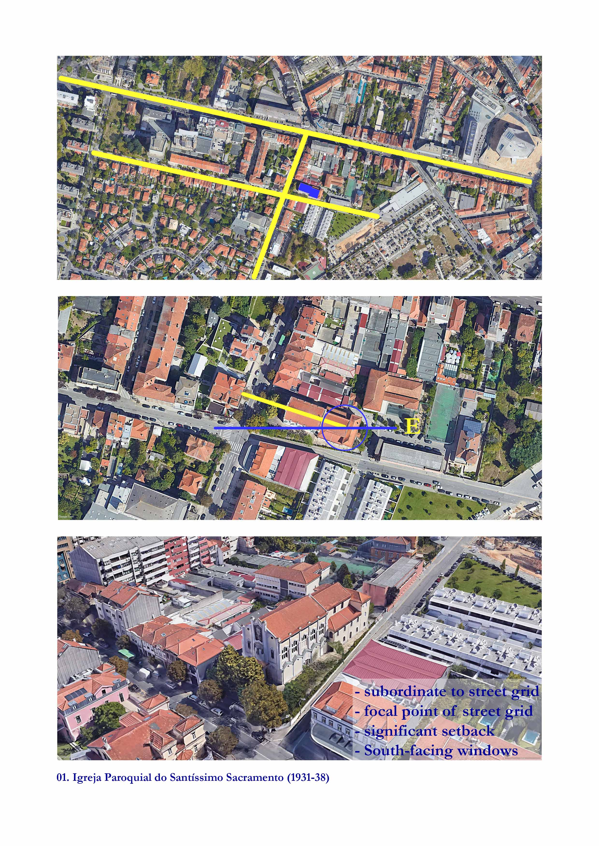
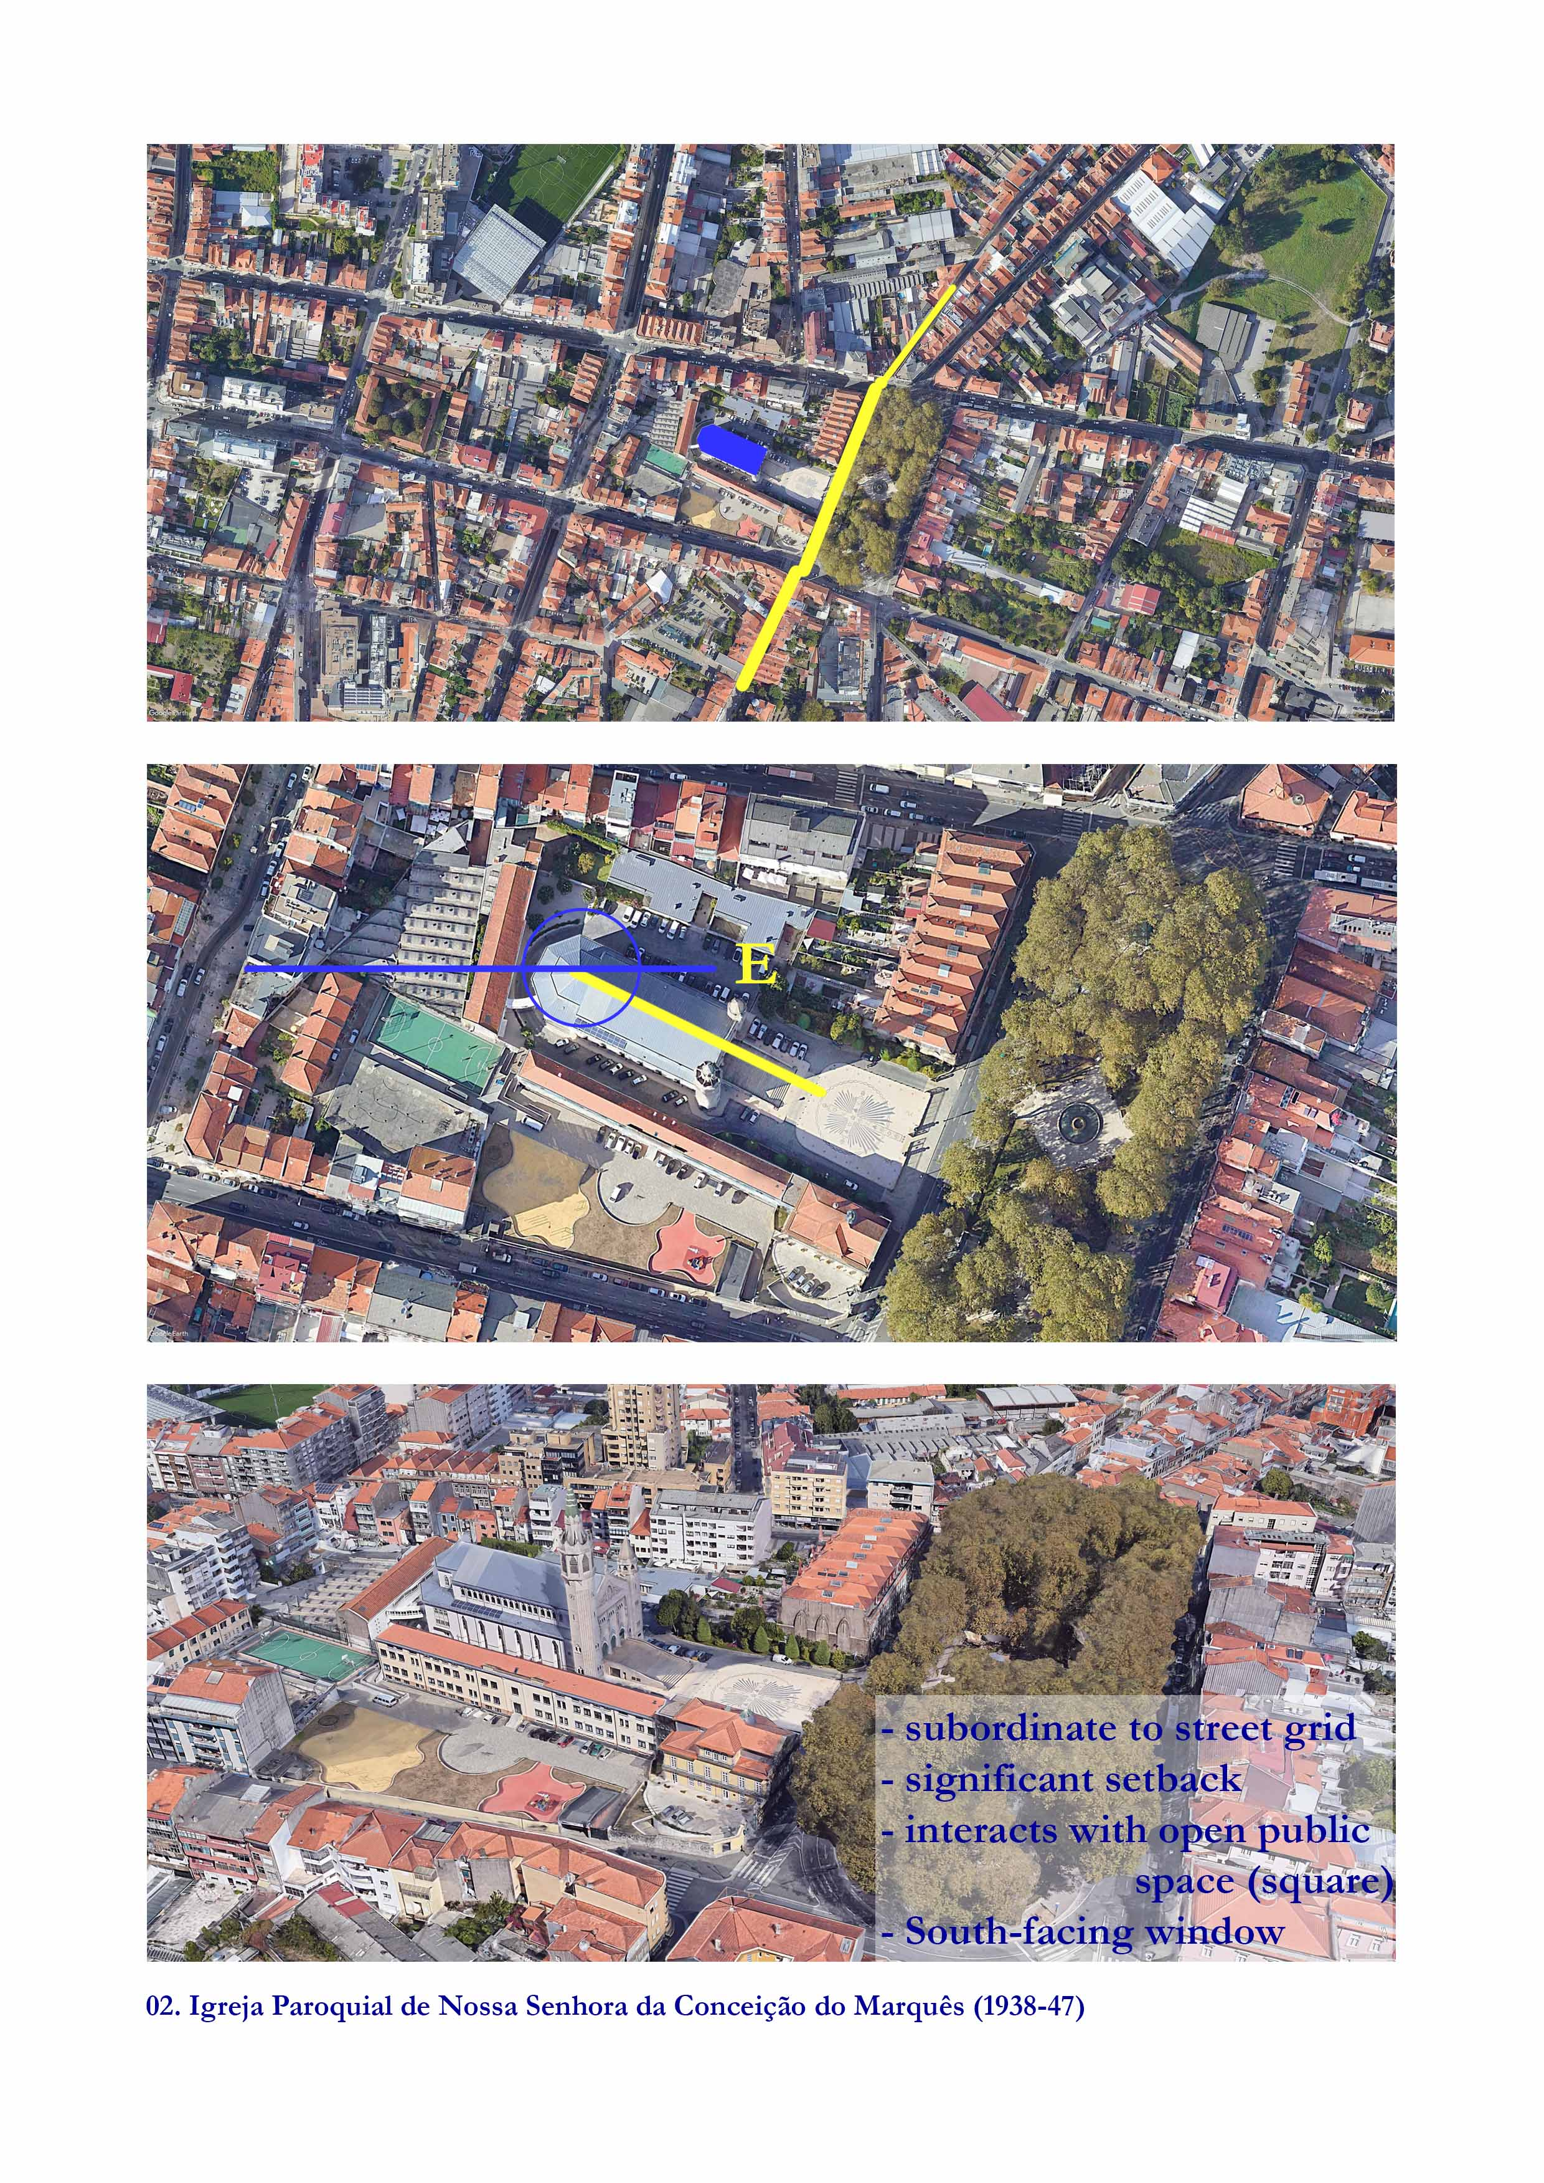
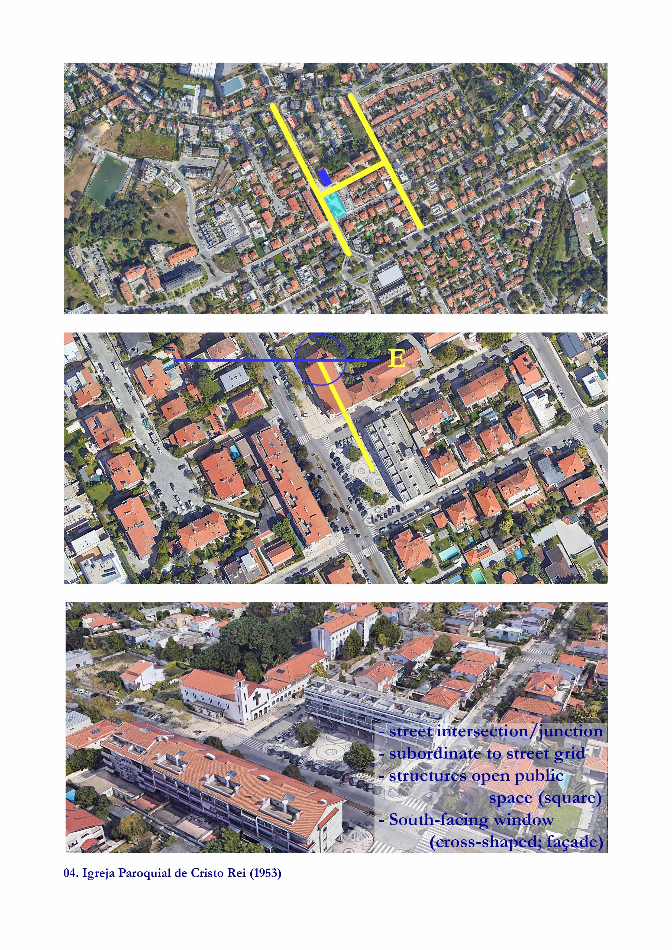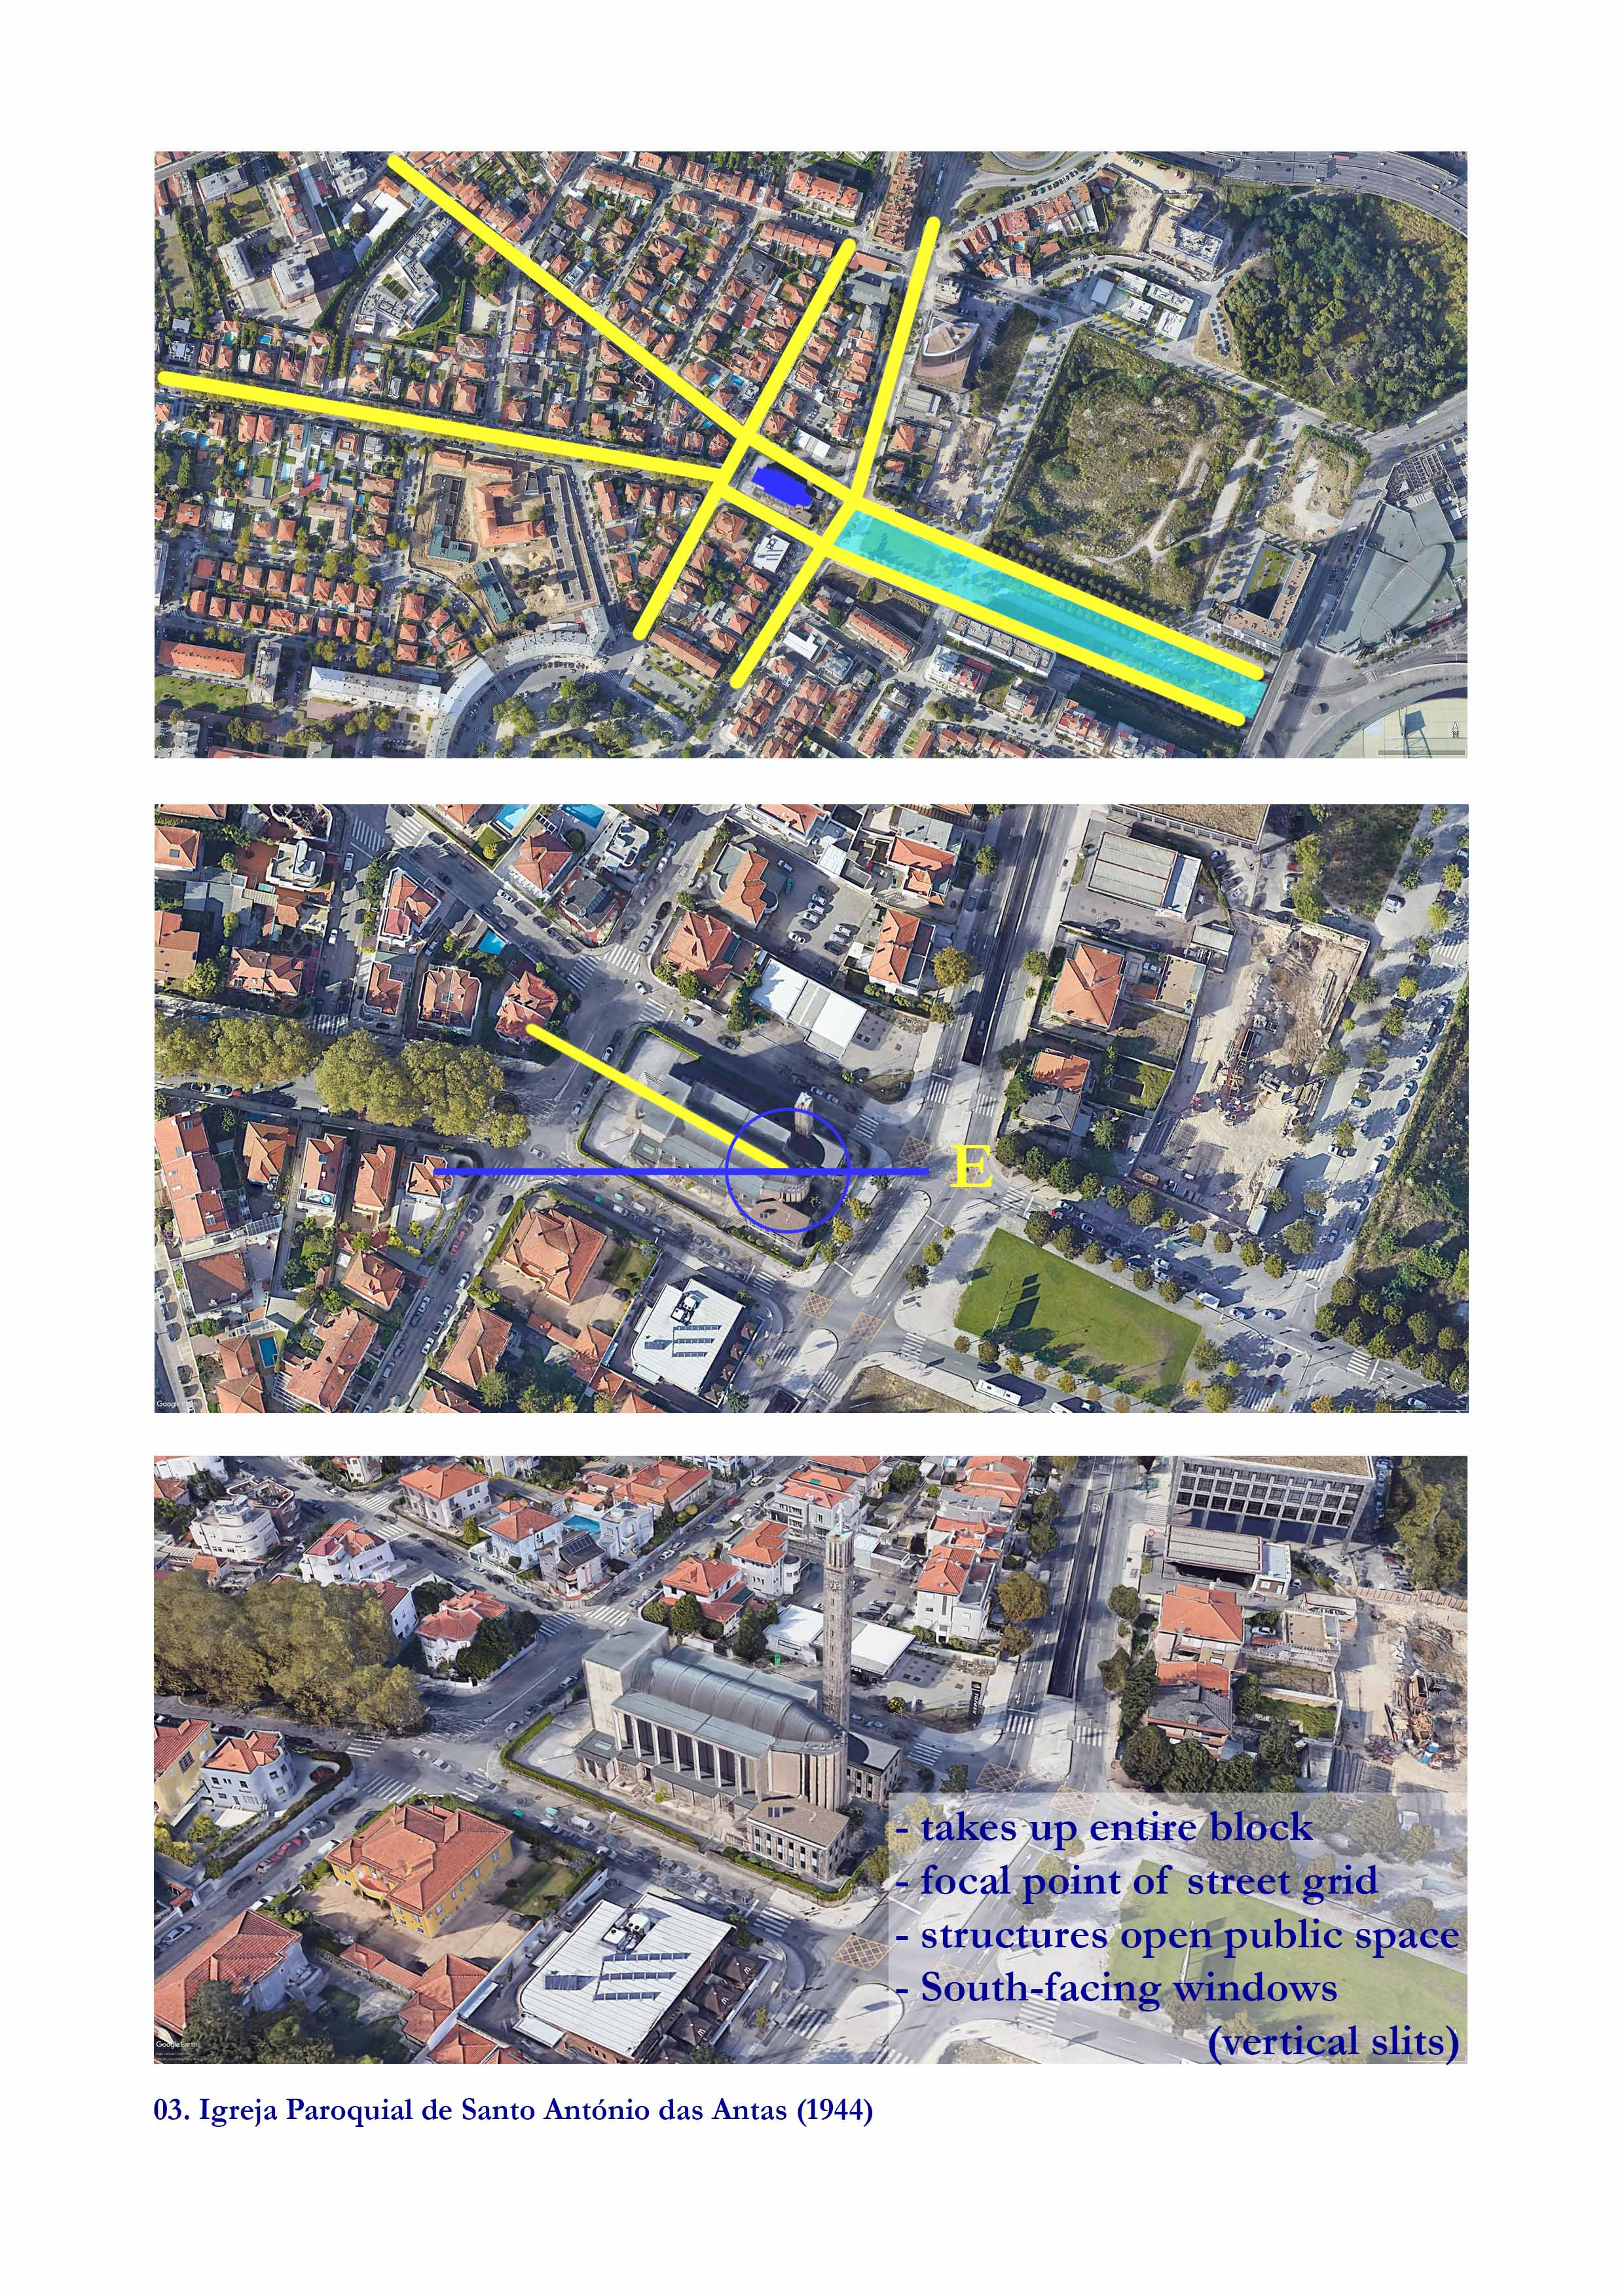
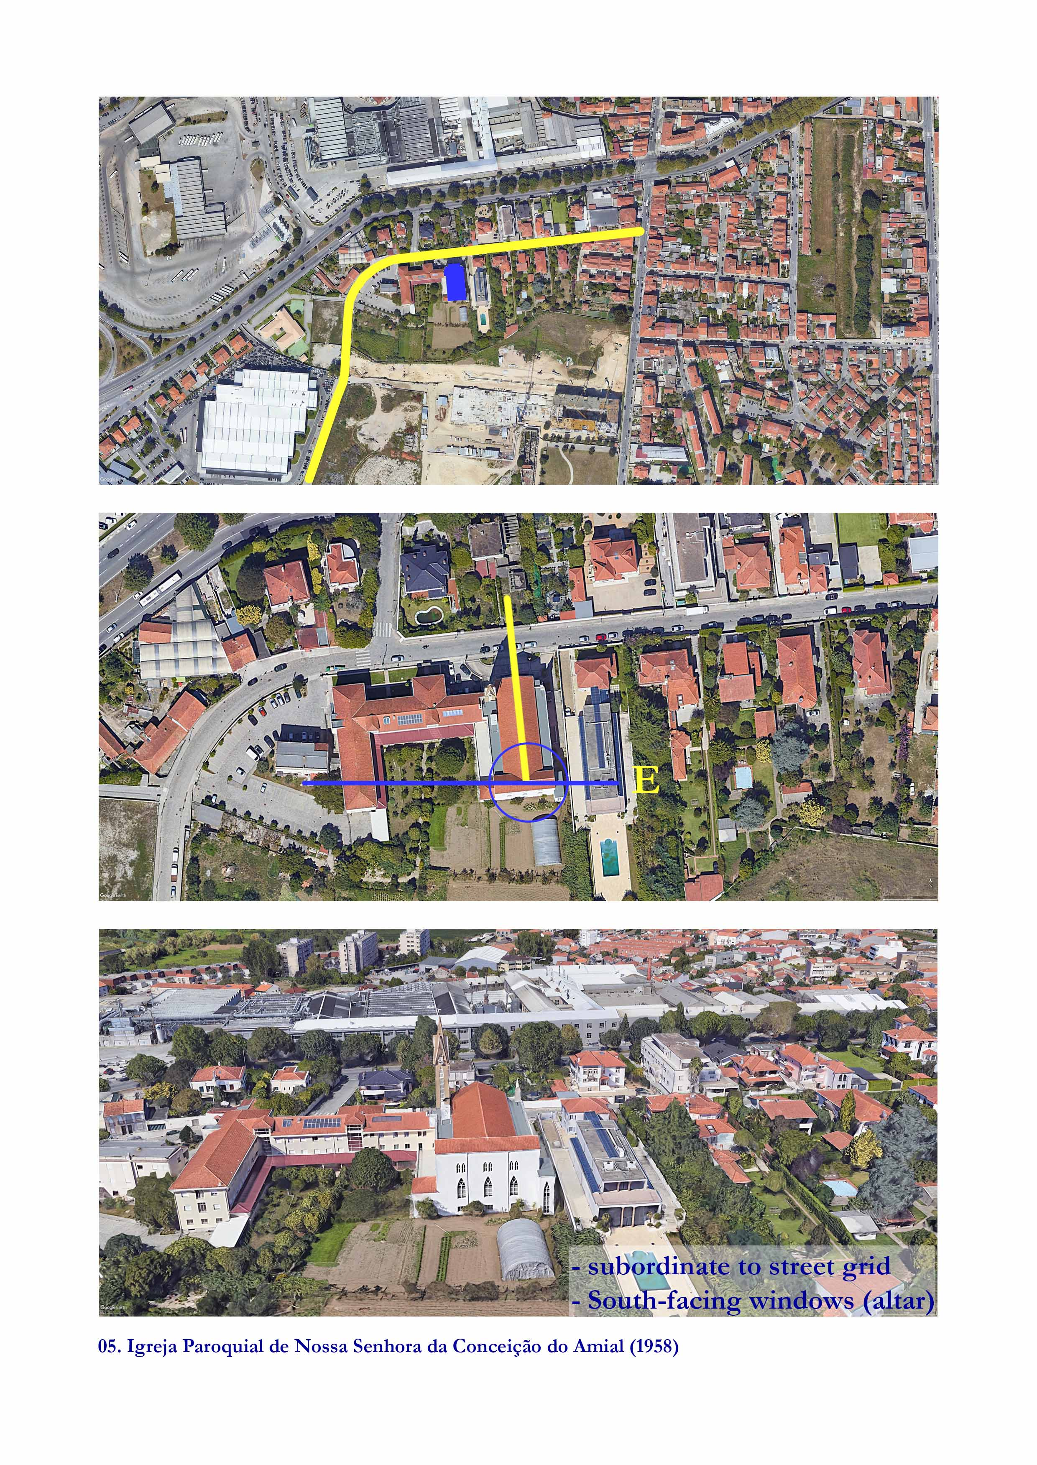
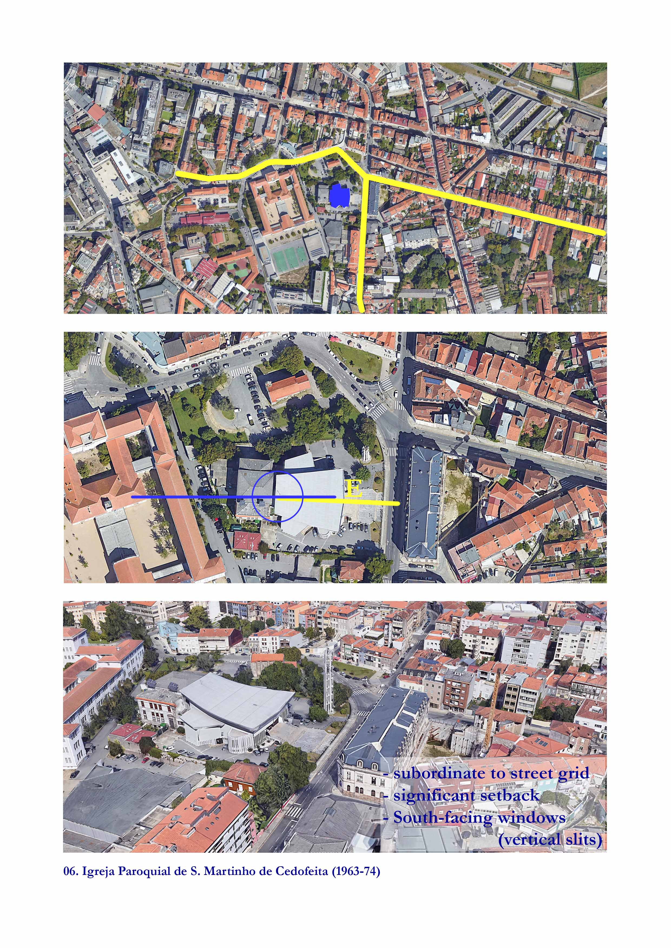
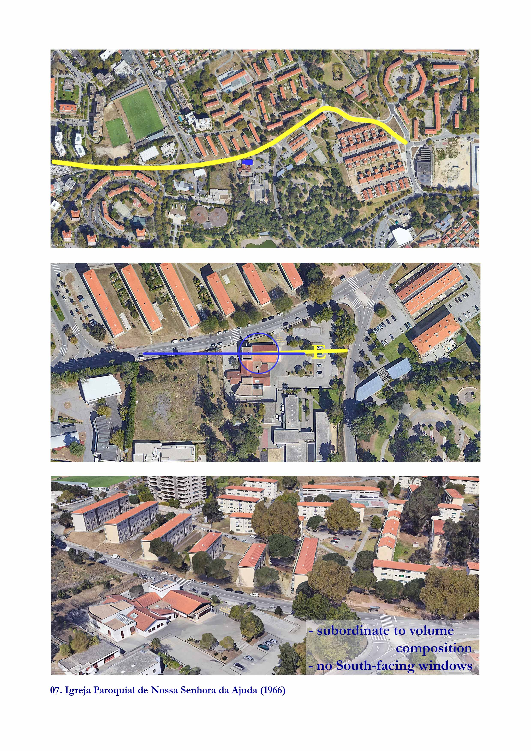
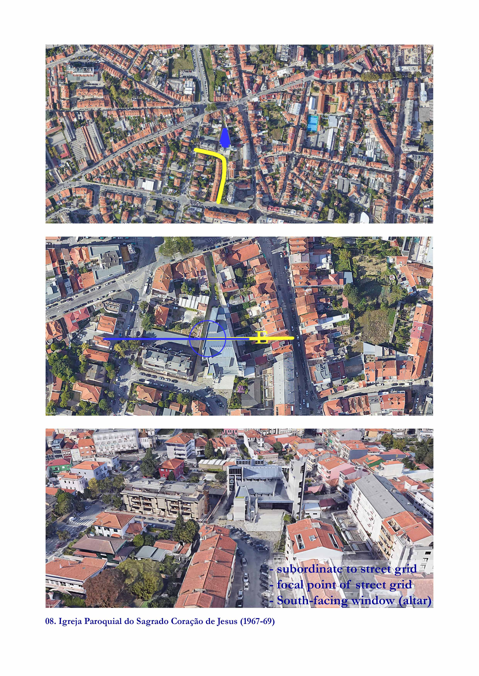
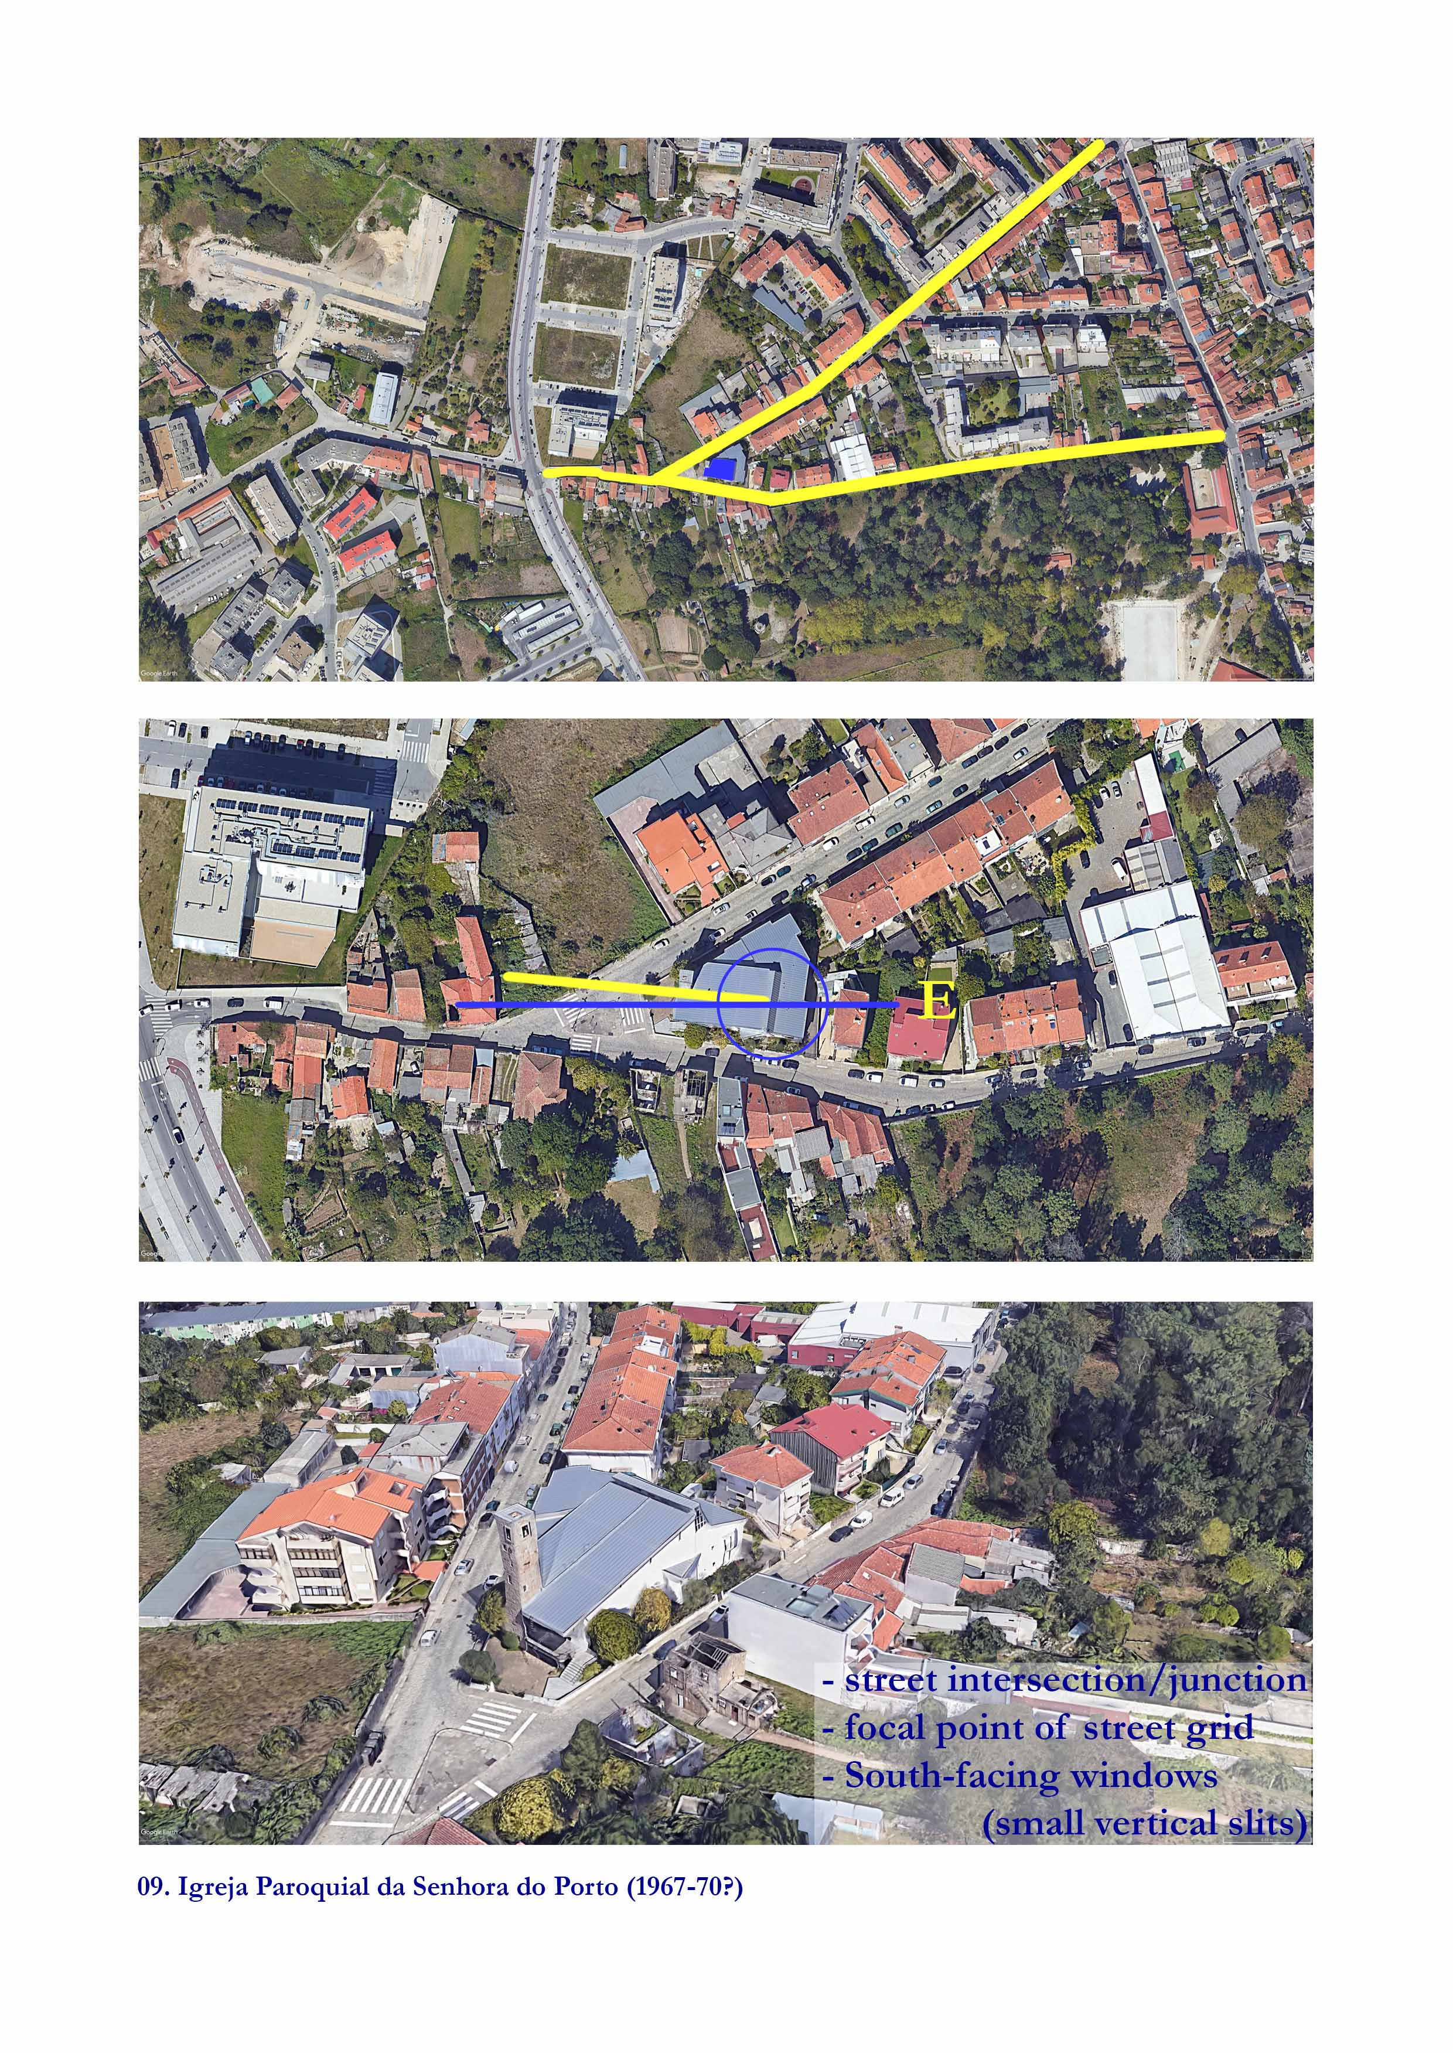
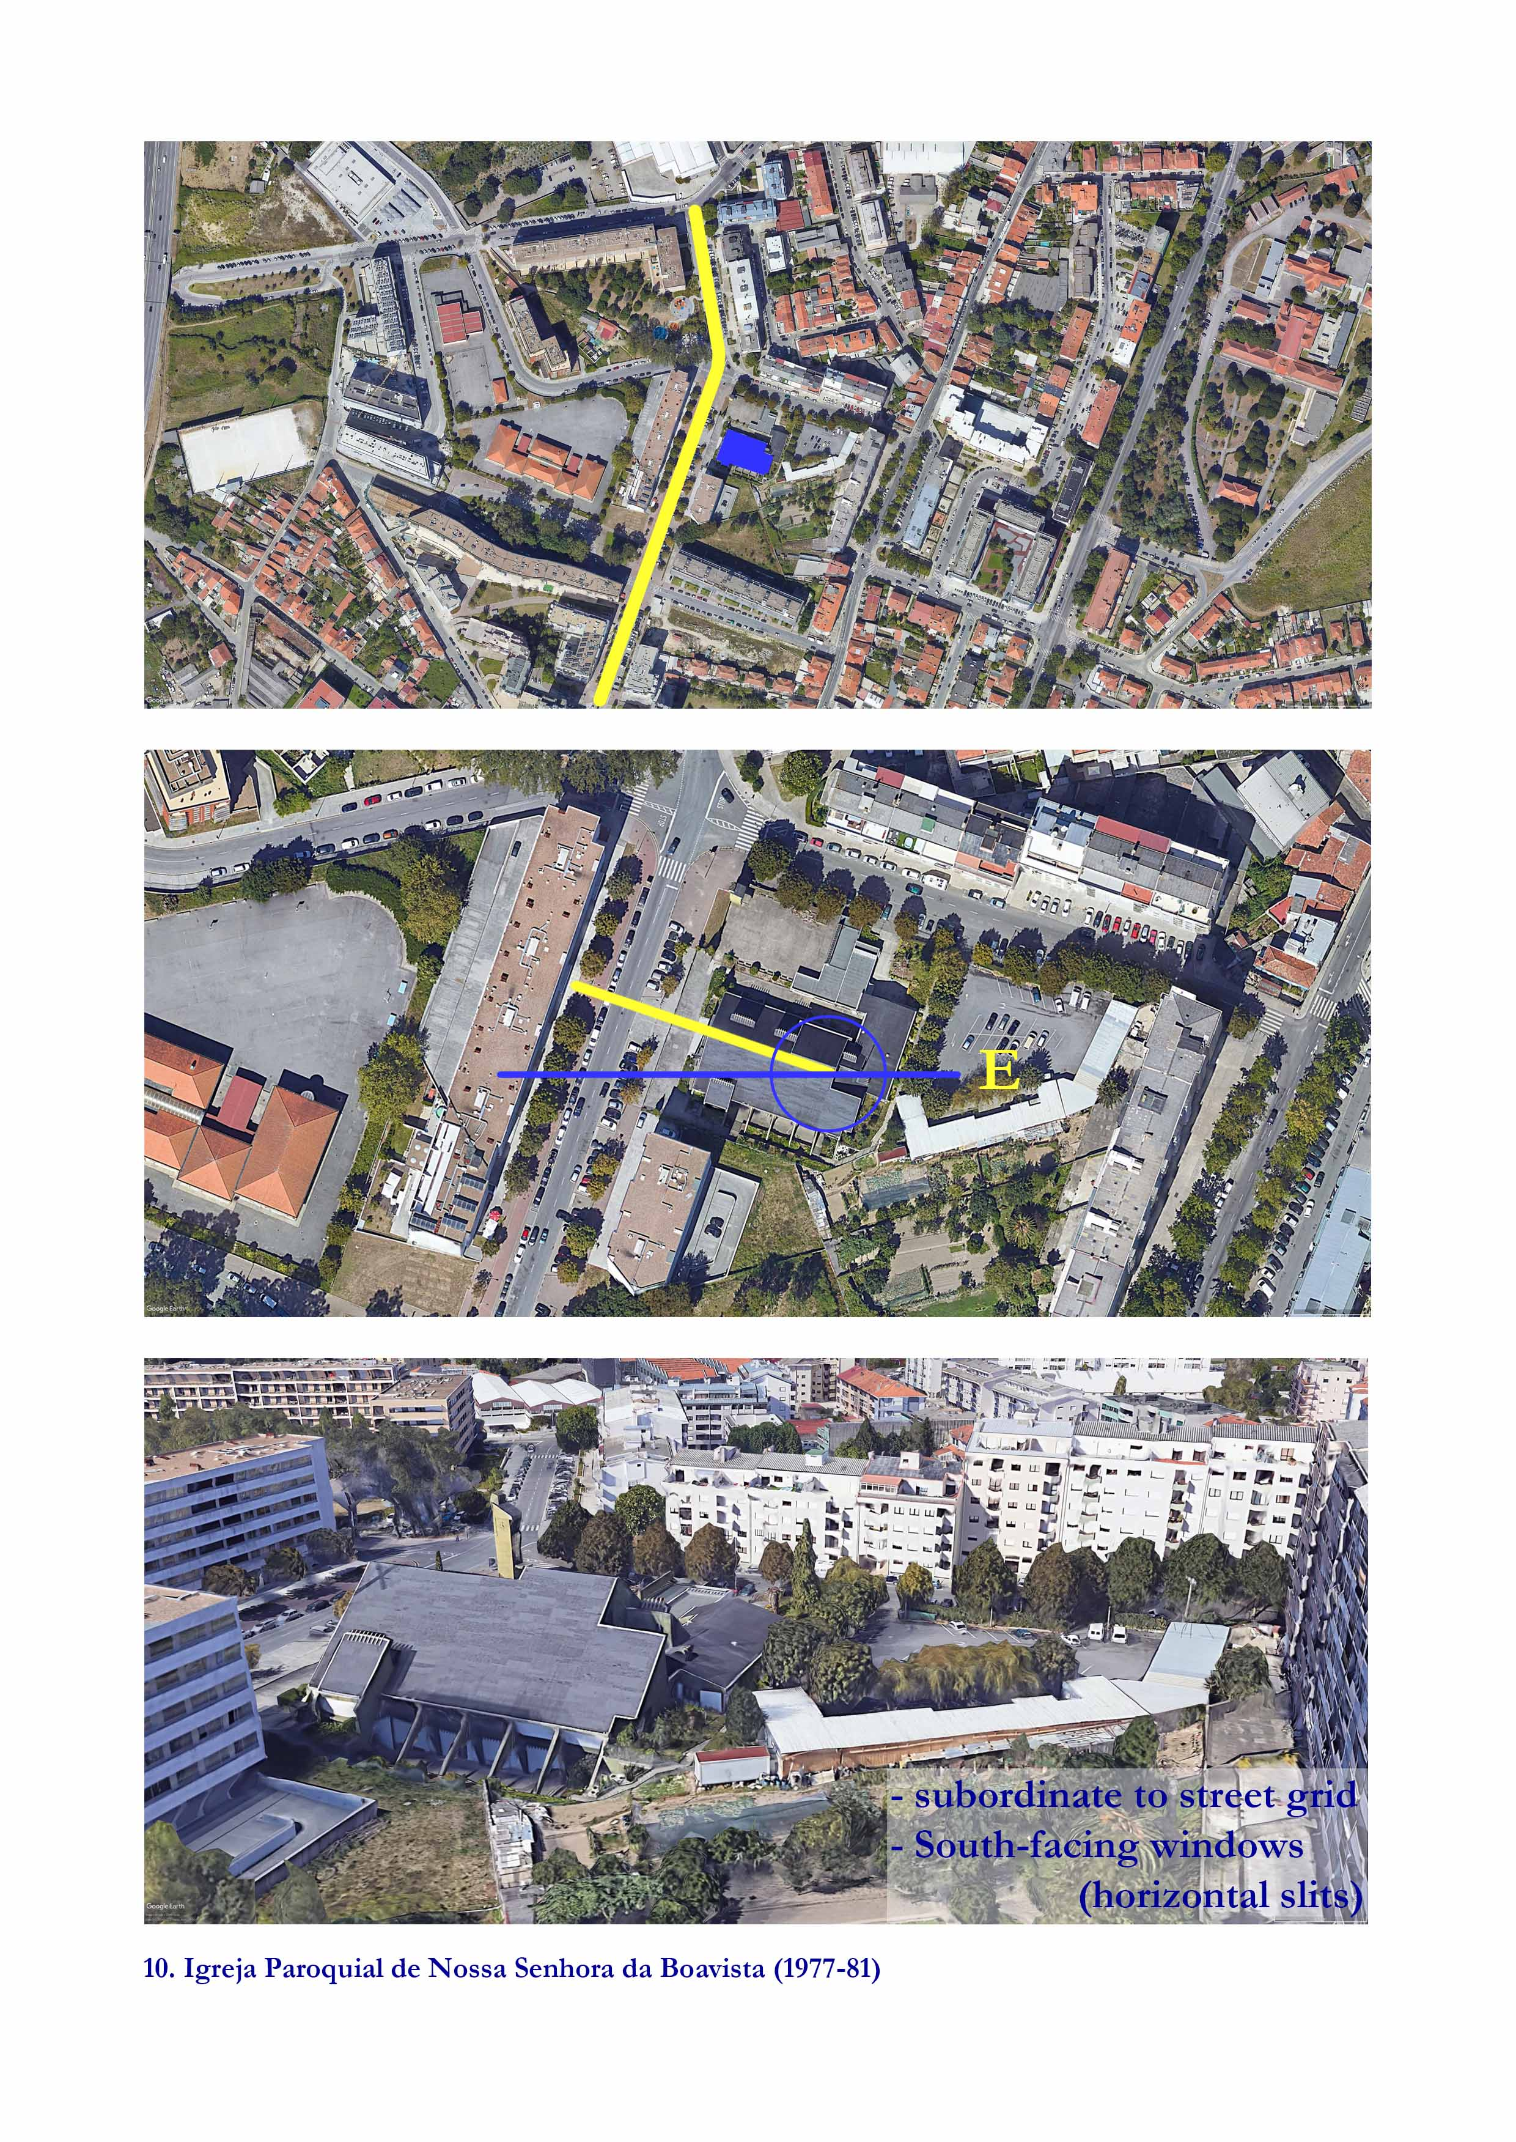
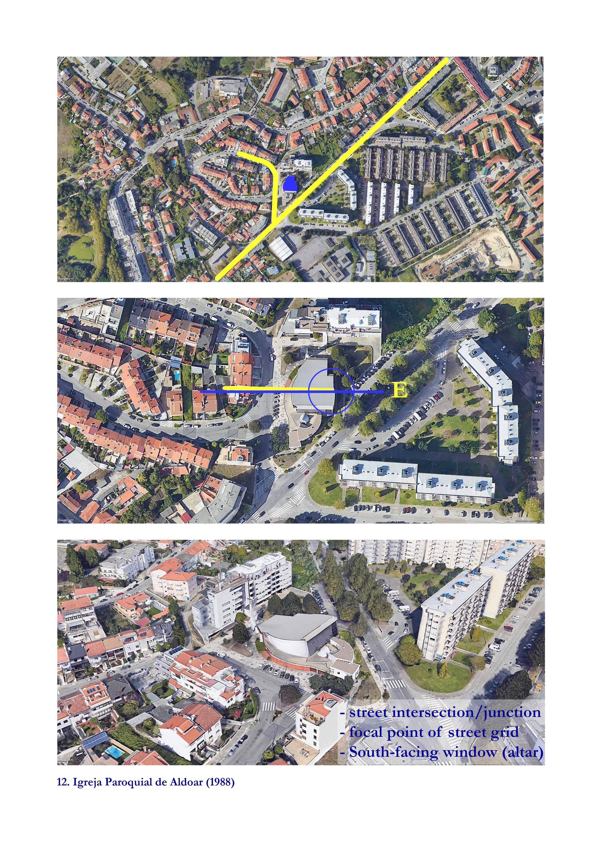
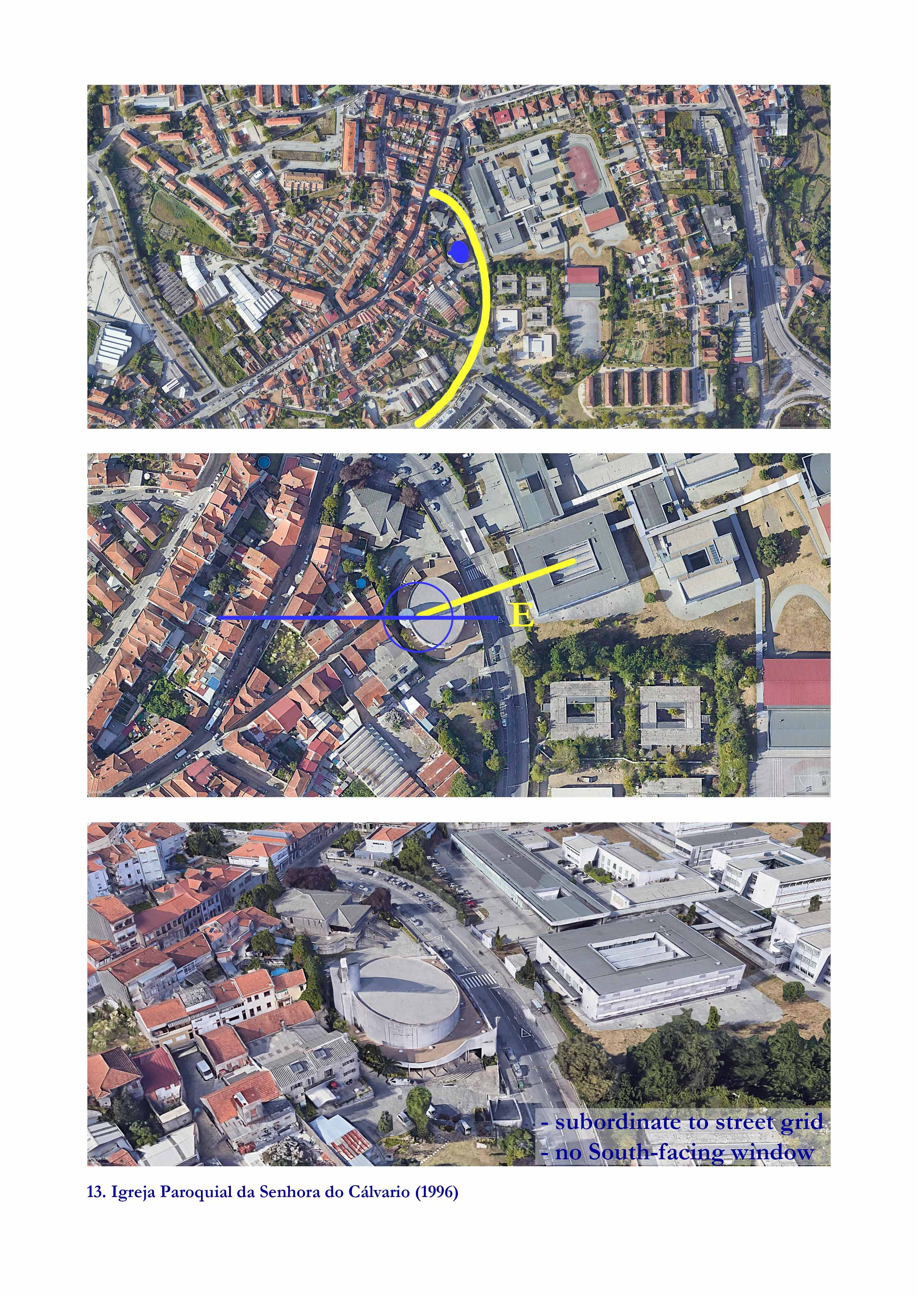

Christian Norberg-Schulz, Arquitectura Occidental, trad. Alcira Gonzalez Malleville, Antonio Bonano, (Barcelona, GG Reprints, 2004) and Congress Internationaux d'Architecture Moderne (CIAM), La Charte d'Athenes or The Athens Charter, 1933. Trans J.Tyrwhitt. Paris, France: The Library of the Graduate School of Design, Harvard University, 1946. PDF
Lewis Mumford, A cidade na história: suas origens, desenvolvimento e perspectivas, trad. Neil R. da Silva (São Paulo, Martins Fontes, 1982) pp.267-305 [‘Claustro e comunidade’] AQUI: P.290 My translation
Mumford P.290 My translation
Spiro Kostof, History of Architecture. Settings and Rituals (New York/Oxford, Oxford University Press, 1995), pp. 295-374 [‘The birth of Nations: Europe after Charles’, The French Manner’ and ‘The urbanization of Europe, 1100-1300’] AQUI: P.298
Fernando Chueca Goitia, Breve história do Urbanismo (Lisboa, Presença, 1982) AQUI: (p. 89-91) My translation
Kostof (p.349)
Chueca Goitia (p.89-90)
Kostof (p.316)
Norberg-Schulz (p.95)
Norberg-Schulz (p.95)
Kostof (p.331)
Norberg-Schulz (p.99)
Norberg-Schulz (p. 111)
Kostof (p.330)
Norberg-Schulz (p. 112)
Norberg-Schulz (p.113)
(Kostof, p.331-332)
Stephen McCluskey, p.1705)
Isidore of Seville Cit in Brady et al, p.276.
Vitruvius p. (116)
William Barden, Phases of the Liturgical Movement, The Furrow, Nov., 1954, Vol. 5, No. 11 (Nov., 1954), pp. 667-675
Harry Emerson Fosdick, Reuniting the Church, The North American Review, Vol. 197, No. 690 (May, 1913), pp. 615-628
Roland Millare, The Spirit of the Liturgical Movement. A Benedictine Renewal of Culture, Logos 17 : 4, 2014, pp.130-154
Cit in Anne-Françoise Morel and Stephanie Van de Voorde, Rethinking the Twentieth-Century Catholic Church in Belgium: the Inter-Relationship Between Liturgy and Architecture, Architectural History, 2012, Vol. 55 (2012), pp. 269-297, p.270
Le Corbusier. Towards a New Architecture. Translated by Frederick Etchells. London: J. Rodker, 1931. Reprint New York: Dover Publications, 1986. P. 93
https://www.catholicculture.org/culture/library/dictionary/index.cfm?id=31748
Le Corbusier, Towards, p.5
Le Corbusier, the Athens Charter (New York, Grossman, 1973) Trans. Anthony Eardley, p.64
Clive L. N. Ruggles, ‘Basic Concepts of Positional Astronomy’, in Handbook of Archaeoastronomy and Ethnoastronomy, ed. by Clive L.N. Ruggles (Springer, New York, 2015), p. 460
Stephen C. McCluskey, Orientation of Christian Churches, p. 1709
Martyn Denscombe, The Good Research Guide, for small-scale social research projects (Berkshire/England, Open University Press, 2010), pp. 52-64 [‘Case Studies’]
Clive Ruggles, ‘Basic Concepts of Positional Astronomy’, in Handbook of Archaeoastronomy and Ethnoastronomy, ed. by Clive L.N. Ruggles (Springer, New York, 2015), pp. 459-471.
Hoare (p.1714), e de Spinazzè, p???
Ruggles p.466
Belmonte, p.486
McCluskey, p.1708.

