

Student Name : RAJESH LILABHAI AGATH
Student ID : 2531869
Lecturer: Gladius Kulothungan

Master of Business Administration (MBA)

LCMB7034 - International Business Concepts

COSTCO WHOLESALE CORPORATION: A CRITICAL ASSESSMENT OF CONSUMER-RETAIL ENTRY INTO INDIA
USE OF GENERATIVE AI IN ASSESSMENT
RESEARCH | For this assessment, you can use Generative AI to support you in research, including searching for bibliography, using tools to summarise, compare and  interrogate materials. | Yes ☒  No ☐
STRUCTURE | For this assessment, you can use Generative AI to support you in structuring your submission, including creating a draft argument structure, identifying parts  and headings, etc. | Yes ☐  No ☒
PROOFREADING | For this assessment, you can use Generative AI to check your own text/creation for grammatical and syntactical mistakes, including rephrasing of your  own work within specific standards. | Yes ☒  No ☐
WRITING | For this assessment, you can use Generative AI to create text for submission. | Yes ☐  No ☒
CREATIVE | For this assessment, you can use Generative AI to create creative materials, such as images. | Yes ☒  No ☐
PROGRAMING | For this assessment, you can use Generative AI to create and check code. | Yes ☐  No ☒
NONE | For this assessment, you are not allowed to use any type of Generative AI support. This includes research support, structure support, writing/proofreading  support and creative support. | ☐

Generative AI Acknowledgement

I note, in accordance with the assessment guidelines, the use of Generative AI (Gen AI) and electronic tools in preparing this assignment.
Research: Generative AI tools were used in the research process: search, summarise, compare, question and explore relevant academic and other research materials. Reliability and quality are assured for the information and sources discovered in this process and before being used in this assignment. Suitable referencing of all sources made.
Proofreading: I used Grammarly to proof read my work and correct grammar, spelling, punctuation, sentence structure and syntactical accuracy. I checked all the proposed suggestions and finalized the phrases and contents of my assignment.
Creative materials: Where relevant, application of Canva to create and produce visual/creative materials for assignment. It was only a tool to enhance the look and presentation of my artwork.
I am responsible for the content of this assignment including research, analysis, interpretation, arguments, conclusions, referencing and presentation of the assignment. I have read the final version and confirmed it is my own understanding and work and meets the assessment requirements and academic honesty.

Table of Contents
Section 1: International Business Analysis 5
1. Organisational Classification and Global Strategy 5
1.1 Strategic Categorisation 5
1.2 Global Configuration and Value Creation 5
2. Macro-Environmental Appraisal and Market Attractiveness 6
2.1 Political and Policy Environment 6
2.2 Economic and Market Conditions 8
2.3 Legal and Regulatory Conditions 11
2.4 Cultural and Consumer Conditions 13
2.5 OLI Synthesis and Market Attractiveness 14
3. Entry Mode Strategy and Strategic Synthesis 15
3.1 Historical Pattern Recognition 15
3.2 Evaluation of Strategic Alternatives 15
3.3 Recommended Phased Entry Strategy 17
3.4 Conclusion and Final Recommendation 18
Section 2: Gibbs Reflective Account 19
Description 19
Feelings 19
Evaluation 19
Analysis 20
Conclusion 21
Action Plan 21
References 22

Section 1: International Business Analysis

1. Organisational Classification and Global Strategy

1.1 Strategic Categorisation
Bartlett and Ghoshal’s global approach typically involves Bartlett's standardisation of membership, buying, store product line and store procedures. But studies indicate that successful integration in multinationals generally depends on local responsiveness in the human resources and operating systems of the companies (Chung and Sparrow, 2024). Costco should thus be defined as globally integrated, and yet with emerging transnational features in culturally remote markets.
However, a global classification would still be a gross understatement of what adaptation is already needed in Costco's overseas markets. The internationalisation process is usually not linear, it is not just a succession of more and more committed investments, but rather a circular learning process (Domínguez Romero et al. 2024). This learning pattern is constrained by headquarters, but market knowledge is provided by the subsidiaries, which over time alter organizational routines.
Costco's best ownership benefits are membership info, purchasing power, supplier relationships, inventory control, and trusted private brands. Firms can protect valuable capabilities by establishing higher control arrangements, which can influence decision-making processes of entry (Wang et al. 2024). It is an asset that prefers significant control, but Indian law does not allow Costco to simply copy its preferred ownership model.
Its business model also relies on continued revenue, high stock turnover, and very favorable retention rates. Costco is reporting a membership of 81 million paid members, 145.2 million cardholders and renewal rates of nearly 90 percent in 2025 (Costco Wholesale Corporation, 2025a). India has a huge base of potential subscribers, but making a one-off buyer into a recurring one is a trickier proposition.

1.2 Global Configuration and Value Creation
However, even as Costco expands to certain parts of Asia and Europe, its geographic footprint is still very strong in the U.S. and Canada. Similarly, Costco's sustainability reporting outlines its sustainability Strategy's and priorities, including supplier standards, responsible sourcing, waste reduction, and environmental targets, which are all enterprise-wide priorities of the company (Costco Wholesale Corporation, 2025b). Central governance would facilitate a consistency in brand but would need to be developed by the Indian suppliers, not just met with compliance.
There is a lot of value created by a simple operation in the warehouse retailing; however, simplicity needs to be backed up by advanced forecasting, replenishment, and category management. The study of retail operations in India relates customer convenience with consistent processes, integration of technology and customer service experiences throughout the operations (Kumar and Agrawal, 2024). However, bulk packaging and out-of-town warehouses and limited delivery choices may affect the convenience of households without vehicles or storage.
The international operations also provide learning opportunities related to private label, fresh foods, local sourcing and alternative formats of the warehouse. The more economic performance matches environmental and customer expectations the more the retail innovation is sustainable (Šálková et al. 2023). But the region's diversity in India is far greater than what is available in most of the markets available and it is commercial impractical to have one national mix.
Overall, the mix of centralised scale benefits and measured adaptation – instead of being responsive in all markets – are Costco's top features. India might need more adaptation than Costco would like, especially in terms of ownership, digital retailing, pack sizes, and local tastes for food. The keys to strategic success, therefore, lie in maintaining the model's economic fabric while not considering the obvious standardisation as an organisational virtue.

2. Macro-Environmental Appraisal and Market Attractiveness

2.1 Political and Policy Environment
Foreign investment in multi-brand retail is allowed in India only with Government approval, and 51 percent foreign equity is allowed. The policy stipulations encompass at least $100 million investment, significant backend spending, specific local procurement, state approval, and limitations on ecommerce (DPIIT, 2020). Political attractiveness thus depends on circumstantial factors, as the structural implications of national retail policy cannot be eliminated by the size of the market.
Institutional distance impacts entry costs in various ways: unfamiliar rules, entry enforcement, entry expectations. New research indicates that institutional distance impacts firms' attitudes toward shared-equity, but results are contingent on the regulatory environment (da Silva et al. 2024). But there are also issues of pricing discipline and investment timing, employment practices, and Kirkland quality standards that can cause conflict.
Costco has financial resources that allow it to withstand long approvals and infrastructure investments, as well as early losses while it is operating. Slack resources have been found to buffer institutional barriers and facilitate entry in difficult host-country contexts (Donnelly et al. 2024). A staged investment program would ensure the flexibility of learning while providing a credible signal to national and state authorities.
The quality of the institutions is also a determinant of whether a formal rule will result in a predictable commercial outcome in various locations. Evidence from emerging-market internationalisation shows that regulatory quality and governance conditions materially affect firms’ foreign commitments (Ho and Nguyen, 2024). For whatever reason, location selection needs to be based not just on the central government's announcement, but on the ability to implement the location.
Conditions of global investment are also uncertain due to geopolitical tensions, trade conflicts, and declining productive capital inflows. During 2025, there was a slowdown in international investment and uneven concentration of investment in the digital sector (UNCTAD, 2025). While sourcing from greater India would minimise exposure, it could have a negative impact on assortment quality and purchasing economies in the short term.
The policy trajectory of India, however, is focused on the aspects of infrastructure and manufacturing, consumption, digitalisation and private investment.
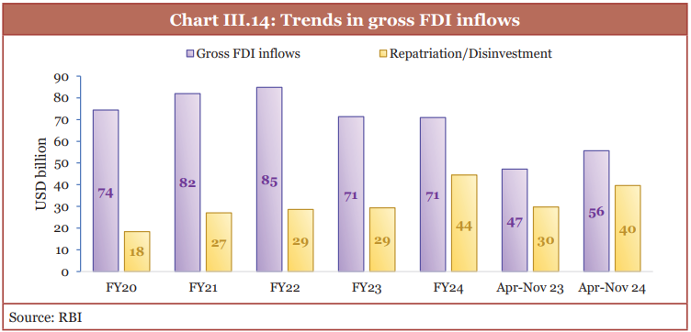
Figure 1: Trends in gross FDI inflows
(Source: Indiabudget, 2026)
Domestic demand and investment in public capital formation are seen as key pillars to ensure growth (Government of India, 2026). This would help with legitimacy, but there is no policy alignment that guarantees approval and cannot ensure profitability.

2.2 Economic and Market Conditions
India has an incredible macroeconomic scale, and growth continues to be high compared to the majority of the big economies.
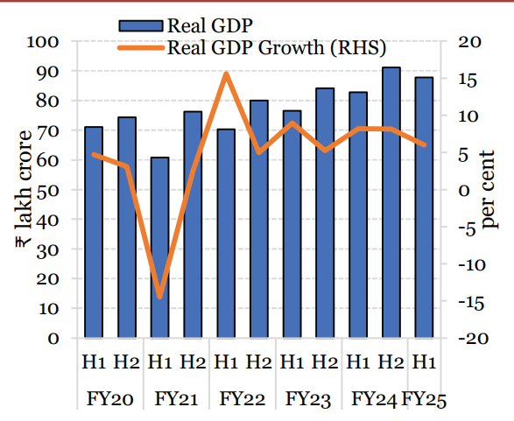
Figure 2: GDP growth in H1 FY25 at 6.0 per cent
(Source: Indiabudget, 2026)
The International Monetary Fund estimated the GDP growth rate at 6.5 percent for 2026, and predicted that inflation and income limitations would continue (IMF, 2026). But the national growth averages mask large variations between the well-off urban households and price-sensitive consumers found elsewhere.
According to the World Bank, there were 1.46 billion people, a GDP of almost $3.96 trillion, and growing Internet use in the world (World Bank 2025a). These signals give rise to a big pool of potential members, digital communication, and supplier development. So, the size of a population should be viewed as the potential size in the long-term and not as the actual demand in the warehouse.
According to the industry estimates, Indian retail may be on a growth trajectory from about $109 billion (in 2025) to $236 billion by 2030. Organised retail growth, foreign investment and rising middle class households (IBEF, 2026) are also noted as some of the industry's strengths. Costco should invest based on actual spending at the city level, not on national figures. The overall affordability of customers, derived from the evidence of their household spending, is more conservative. The average monthly expenditure in rural areas at ₹4,122 and in urban areas at ₹6,996 during 2023-2024 (MoSPI, 2024).
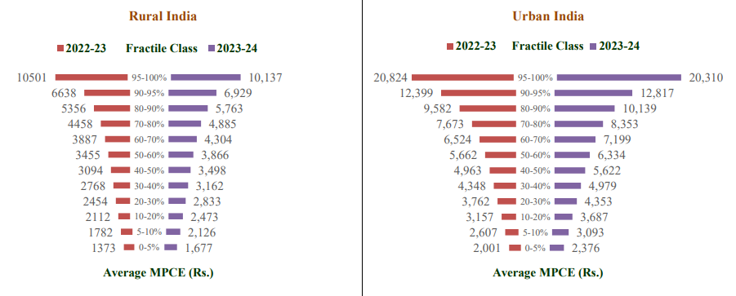
Figure 3: Average MPCE value for different fractile classes of MPCE
(Source: Mospi, 2024)
Costco's annual fee and massive baskets would then affect high-income individuals and businesses, not the typical consumer, as is suggested.
Indian consumers also assess the speed of products based on well-known brands, price comparisons, retailer relationships, and product usefulness. Studies in northern India have also found that there are significant variations in purchase rules among different locations and consumer segments (Verma et al. 2023). The smaller family packs along with transparent savings calculations would make it more accessible without giving up on the bottom line of the warehouse economics.
India's fast commerce is a unique competitive challenge as the small orders have become a matter of minutes rather than hours. Despite profitability concerns, quick commerce accounted for over two thirds of online grocery orders, and continued to grow at a quick pace, Reuters reported (2025). Rather, Costco needs to focus on the quality, value, discovery, and reliability of its product.
The channels that are important are consistent with omnichannel retailing, as customers often use a mix of information from various online and offline channels before making a purchase. Recent research outlines stores and screens as complementary when retailers are able to effectively coordinate information, convenience, and fulfilment (Sharma et al. 2025). While click-and-collect would need careful examination, digital support would be crucial to alleviate warehouse inconvenience.
Channel migration is impacted more by online information when customers are considering the fresh food quality, origin and delivery reliability. The study reveals that information quality can influence consumer journeys across digital and physical channels for agricultural products (Cui et al. 2024). The transparency of information would decrease uncertainty, but skewed availability would erode trust more quickly than the availability of information.
India's payment system has a huge operational benefit as electronic transactions have become popular. According to RBI, the volume of digital methods was nearly all the volume of non-cash retail payment, and that the number of transactions based on unified payments grew in volume (RBI, 2024). This convenience alleviates some of the checkout friction, but payments ease does not outweigh lacklustre product-market fit.
The usefulness and trust of the unified payments, social influence and perceived payment security are factors for consumer adoption. The study findings in India support the conclusion that adoption intentions are the result of both behavioural and technical factors (Razi-ur-Rahim et al. 2024). Recurring fees would be particularly important as resolution procedures would need to be reliable or, otherwise, they could lead to suspicion.
There is also significant variation in districts, merchants, infrastructure quality and user capability with regard to digital adoption. Research on the supply side indicates that acceptance is more a function of local services than national transactions (Motheram and Buteau, 2026). Adopting a digital first approach needs to be inclusive, not assuming a competence which is evenly spread across the metropolis.
Physical logistics are also important as Costco relies on high volume replenishment, cold chain systems, parking and effective regional logistics. India made it to the 38th rank in the 2023 Logistics Performance Index and policy aspirations aim towards reducing costs and enhancing capabilities (World Bank, 2025b). Therefore, sites near ring roads and distribution corridors would be desirable to prestigious central locations.
The supply chains of fresh food should be resilient, agile, environmentally friendly, and well-coordinated between producers and intermediaries. Research in India identifies integrated enablers and not a single solution to fulfil these objectives (Sharma et al. 2023).
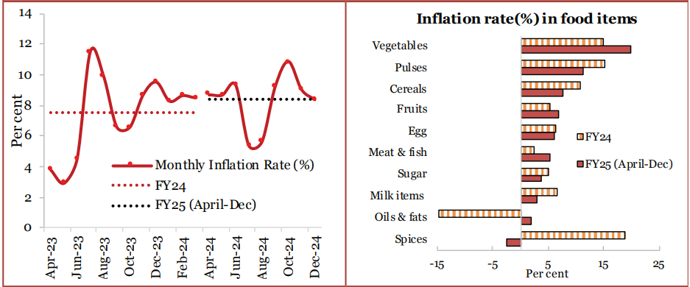
Figure 4: Food inflation driven by vegetables and pulses
(Source: Indiabudget, 2026)
While direct procurement may enhance quality and farmer income, it is important to avoid imposing too many standards, which might result in smaller farmers who are able to produce being unable to enter the market.
Wastages in agriculture persist and are linked to the storage constraints in addition to the transport weaknesses, information gap and poor market linkages. It has been found that coordinated institutional and operational improvements in Indian supply chains are needed to reduce losses (Shekhar et al. 2023). However, it brings a high price tag on capital investment before consumer demand can be seen.
The resilience of the supply chain is particularly crucial following disruptions, when a need for mobility, inter dependency and gaps in market access were brought to light. The research findings on India's lockdown highlight the varying responsiveness of food systems to different products and locations in large-scale shocks (Gupta et al. 2023). While central purchasing helps the buyer have a greater buying power, the excessive concentration may cause the buyer to be vulnerable in a diversified national market.

2.3 Legal and Regulatory Conditions
The Digital Personal Data Protection Rules come into force in India in November 2025, setting out specific requirements in terms of consent, notifying, security, and individual rights. The rules impact Costco due to the fact that membership databases are linked to ID, transactions, payments, advertising and marketing, and family members connection (MeitY, 2025). There would also be a data minimisation benefit in that the exposure would be reduced and yet there would be enough information for inventory and loyalty decisions.
Digital trust is important in the commercial world when it comes to consumer interactions with automated account services, recommendations, and assistance. Studies in India indicate that trust and perceived usefulness impact online shopping technology acceptance (Singh et al. 2024). While it is important to have robust privacy governance, overly deferential consent obstructions could result in usability problems.
Food retailing has also specific labelling, nutrition, allergen, language, packaging and display requirements that need to be adhered to. The food regulator updated these standards till March 2026 and the need is for more up-to-date regulatory monitoring (FSSAI, 2026). Costco should form an Indian regulatory team and a supplier approval lab prior to launching significant new Kirkland lines.
The rates of goods and services tax differ by category of products and services—food, household, apparel, electronic and service. Several grocery items have a five percent rate while other merchandise rates are higher (CBIC, n.d.). For low-margin operations, there would be a need for reliable technology and independent audits at centre.
Consumer ecommerce laws mandate that sellers be clear about their information, grievance resolution, refunds and unfair commercial practices protections. The obligations still apply where the digital elements are primarily used to support membership and store trips (Department of Consumer Affairs, 2020). The cancellation and renewal conditions would be better to be clear to minimize legal complaints and damage to reputation.
Package is another compliance challenge due to bulk retailing being able to increase material usage even though the number of units is decreasing. The plastic-waste regulations in India impose greater producer responsibility, registration, reporting and recycling requirements on covered packaging (MoEFCC, 2024). If environmental compliance is done by early design, it will cost more than if it is done later (reactively).
Traceability technology can enhance the food safety of products by linking together the product, journey, storage and supplier information. Research in India shows that connected systems can be used in the monitoring of perishable products across supply networks (Sathiya et al. 2024). With practical traceability, it is important to have a reliable process from people, otherwise technology can do nothing about it.
Blockchain supply-chain solutions further offer greater transparency, coordination and verification on scattered networks. There are several important enablers identified in research, but this depends on the readiness of the organisations and cooperation of the participants (Patidar et al. 2023). Less sexy technology, with standardized records, incentives for vendors, and interoperable systems would be more valuable than flashy tech, if it wasn't for the lack of operational discipline.

2.4 Cultural and Consumer Conditions
Increasingly, Indian consumers are concerned about the environment; however, their stated preferences do not always reflect their actual purchase behaviours.
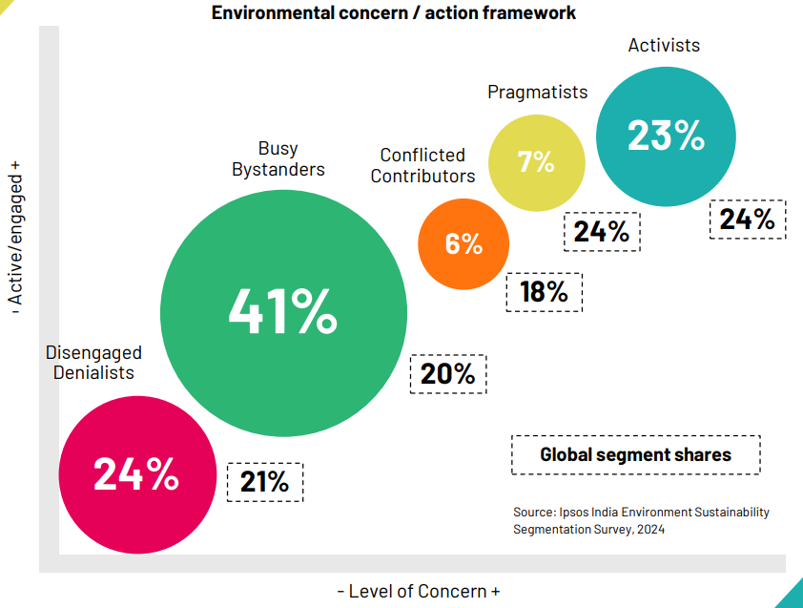
Figure 5: Environmental Concern and Sustainability-Related Behaviour among Indian Consumers
(Source: Ipsos, 2024)
In India, green consumption is correlated with awareness, attitudes, perceived control, and situational barriers (Megha, 2024). Claims should be cost-effective, as there's no substitute for a positive price sensitivity in mass markets when it comes to ethical positioning.
The way food is stored in the home as well as household waste disposal also affect the provision of real value to the customer by bulk packs. According to Indian evidence, planning, storage, awareness and consumption behaviour are identified as significant sources of household food waste (Priya et al. 2023). Pack size flexibility should be added to new product categories and for durable products larger pack sizes can be used.
Positioning, pricing, information and product availability are potential areas for supermarket intervention that can impact on healthier food purchase. A systematic review revealed more effective results with having multiple mechanisms implemented in addition to providing education (Brooker et al. 2024). But, commercial goals need to be clearly understood and can't be presented in the guise of health claims.
Retailers consider healthy food strategies based on sales, reputation, implementation cost and operational compatibility. The findings from the experiments indicate that measures adopted by the public health sector have significant impacts on the willingness of the organization to implement initiatives (Alsubhi et al. 2024). This way, social value is acknowledged without the idea that any intervention must be focused on achieving warehouse profitability.
Customers are more likely to use environmental and health messages when they can filter through complex arrays based on relevant attributes. In an environment with more products to choose from, filtering can increase the power of the decision making process (Gustafson et al. 2024). These tools should enable informed choice and should not give algorithmic recommendations as it was declared as the truth.
Costco should have vegetarian depth, regionals, festival packs, business memberships and multilingual assistance available in the pilot stores. Limited private vehicles and smaller homes lessen the traditional bulk shopping, whereas multi-generational families and small businesses bolster potential demand. The market created is appealing in specific market segments, but not ready to be replicated at the national level.

2.5 OLI Synthesis and Market Attractiveness
Dunning's ownership element is good due to the brand credibility, purchasing power, private brands, member analytics and established warehouse habits that Costco has. Location advantages include demand growth, supplier potential, digital payments and regulatory, income, logistics and cultural disadvantages. The internalisation benefits are in favour of control as quality and value of the membership relies on coordinated action. The overall situation in OLI thus gives grounds to open up only via a carefully controlled and locally designed structure.
The results of the entry mode evidence indicate that the three factors of control, uncertainty, experience, resources and conditions in the institutions have a joint impact on a performance. A wide-ranging meta-analysis has also confirmed that none of the entry modes has been consistently shown to be superior in all host environments (Wan et al. 2023). There is a need for a scheme that is both feasible from a regulatory perspective and has a local knowledge component, protects brands, and is reversible.
The international retailers' approach of introducing brand systems in India as part of a franchise partnership is a good example of separating brand systems from executing the market. In this partnership, Apparel Group will take responsibility for Carrefour India, and it will commence its stores in the north (Apparel Group, 2024). However, as is apparent in the comparison, partnership based adaptation may be justified by regulatory and institutional obstacles.

3. Entry Mode Strategy and Strategic Synthesis

3.1 Historical Pattern Recognition
Costco's global model has been one of developing its stores under subsidiaries with central buying and a sharing of membership. This pattern ensures an operation's order and provides the company the opportunity to move existing practice from one market to another. Historical success is, therefore, a measure of controlled replications but in India, it is not legally available.
The well-known pattern has significant advantages such as uniformity of quality, safeguarded data, member investment and strong member value accountability. It also has negative impacts when HQs are not attuned to the local institutions or are slow to adapt. Those disadvantages are exacerbated in India, where a typical warehouse needs political clearance, sourcing from the region and thumos from the local people. It still is important to have a strategic control, but it is not possible and desirable to have the absolute ownership.

3.2 Evaluation of Strategic Alternatives
Full ownership of a wholly owned greenfield subsidiary would be ideal, but would violate the foreign-equity restriction on multi-brand retailing.
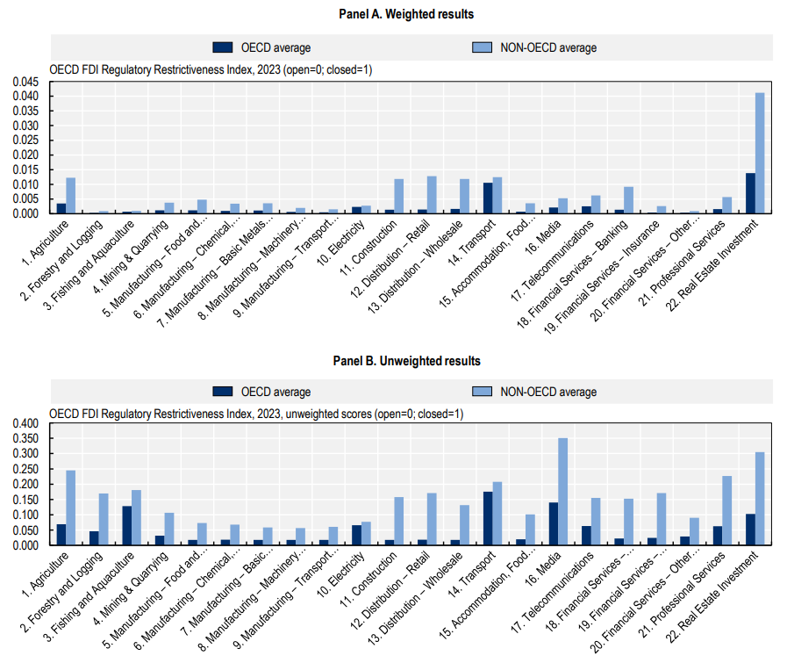
Figure 6: Sectoral FDI Restrictions within Distribution and Retail Markets
(Source: Oecd, 2024)
A non-equity franchise would place less capital risk, but might have a negative impact on purchasing power, membership governance and private-label assurance. To allow for just the Costco name would be an unacceptable reputational risk as it is about to rely on operating parameters.
The 51:49 equity joint venture is the best fit in terms of regulatory and strategic factors and the allowed foreign stake is held by Costco. The Indian partner should provide the capability of sharing property, governmental knowledge, logistics network, supplier network, and local employment. Costco should keep the power over the brand standards, Kirkland products, member information, ethics, food safety and merchandising principles. A staged approach would eliminate governance risk and so would deadlock clauses, but it would also diminish the value of the partnership.
Political risk would still exist as it could be subject to change during implementation as a result of approval, state participation and rules relating to retail. Warehouse, cold chain and inventory costs, technology, and slow membership growth are all sources of financial risk. These operational risks include things like supplier inconsistencies, congestion, food waste, talent retention and partner disagreements. Flexibility should be achieved through a multi-stage commitment and not through insufficient control of critical capabilities.

3.3 Recommended Phased Entry Strategy
The first phase is to be implemented at the Hyderabad capability centre to research, engineer data, map suppliers and design digital memberships. The joint venture then should apply for two pilot warehouses in the states which are willing to allow them. Professional population, business customers, transport and relevant state permissions are good in Bengaluru and Pune metropolitan region.
Pilot warehouses should be smaller than the typical format of a Costco, but should include wide aisles, exposure to value, and effective stock handling. Assortments should include large packs of durable foods, smaller packs of fresh foods, regional vegetarian foods, festival foods and a few imports. Market membership should encompass wealthier homes, offices, professional services, caterers and restaurants. Communication in pricing should include clear comparisons of unit savings, but not make false claims of universal affordability.
Joining, renewal, stock checking, shopping lists, payments and refunds, as well as personalised communication should be supported by digital services. Online retail via inventory should stay on hold until a clear legal framework is established by regulators. With this conservative strategy, speed of ecommerce isn't achieved but neither is the development of the strategy based on uncertainty.
Supplier development should be done prior to the warehouse construction as there is a need for reliable volume, quality and documentation for supplier local procurement obligations. Costco needs to create testing stations, packaging improvement stations, cold chain support and training stations in the region. Supplier contracts should provide incentives for performance but not for shifting to lower quality businesses. Quality would be maintained by independent audits, but termination should come before improvements are made.
Management should review pilots based on their renewal rate, acquisition costs, basket values, cash flow, waste, private-label acceptance, supplier quality and stock turnover. Some cultural indicators are the regional assortment performance, digital complaints, language-support usage and customer travel patterns. Expansion should be only after 2 full rounds of the membership cycles of stable economics. This proof-of-concept gate is a first step towards making national ambition an irreversible commitment not prematurely.

3.4 Conclusion and Final Recommendation
While the prospect of Costco is greatly promising in India, the immediate entry into the market would be unbalanced as the regulatory, financial and cultural exposure would be very high. Conditions that favour Costco's traditional model are not present in the market, which is rewarding value, quality, formal retailing, digital convenience and trusted sourcing. The most balanced regulatory approach and protection of key ownership features is offered by a controlled equity joint venture. Costco should start two adapted warehouses, make sure that supplier invests and have strict expansion gates.
The recommendation is not a promotional one, since the need for membership in India has not been proved. Renewal, basket, compliance and supplier indicators that are not met or are below agreed indicators should result in Costco discontinuation or redesign of the project. Such discipline is aware that while good national figures may not mean a good business model. So, strategic patience would bring more value than quick commitment in the early market development period based on market size only.

Section 2: Gibbs Reflective Account

Description
I started the assignment by trying to rephrase it as more of a market entry decision as opposed to a company profile. The significant early learning was the planned capability centre in Hyderabad by Costco, which made the initial country selection a difficult one. I thus 'restricted my research question' as it were, and stated that restriction right at the beginning.
Next, an evidence matrix was developed for company capabilities, political environment, economic need, legal requirements, cultural behaviour and entry options. Academic evidence sources were distinguished from company, government, international-organisation and newspaper evidence sources. In each case a single planned purpose of analysis was given, thus limiting repetitive citation and description without support. Finally, connecting environmental findings by ownership, location and internalisation logic was done before choosing an entry mode.

Feelings
At first, I was feeling confident as India's population and retail growth looked like a very good expansion case. Following a review of foreign investment regulations, consumer spending, ecommerce regulations, and Costco's current technology footprint, that confidence fanned out. I worried about a basic yes-reply assuming that there are no important institutional obstacles. This pain was helpful in analysing the situation, as the market attractiveness would differ from the feasibility of entry. The evidence volume was also challenging due to the variation of source dates, definitions, units and geographical levels. Forecasts were generally upbeat from the industry, with data from households more conservatively suggesting household affordability. I was taught to deal with disagreement as an analytical rather than a troublesome problem to be solved.

Evaluation
Almost all of my process was the fusion of company and independent academic and institutional evidence. The company disclosures revealed its assets, its size and footprint, and government regulations set limits on which corporate optimism might have masked itself. The fields of consumer behaviour, supply chains, digital adoption and institutional distance were clarified with the help of recent research. This association led to a balanced judgement which is not a description of political, economic, legal and cultural facts.
The other advantage was in switching from the proposed entry mode when the historical preferences of Costco were matched with Indian regulation. I started off thinking it would be a straight recommendation to do a 100% greenfield investment, to insure the company's model. The policy analysis indicated it would be not be possible legally in multi-brand retailing to give such an answer. Revising the recommendation added practicality and showed theory should be adjusted to respond to the evidence.
There were also constraints in the process; as the public cannot see when Costco's internal thresholds are met or conversations with its partners, or demand forecasts in each location. Some market reports relied on forecasts, outside of the scope of the assignment period. Occasionally, studies on academic research covered retail areas in addition to membership warehouses. So, the recommendation is still tentative and must be backed by primary research for investors' approval.

Analysis
I found that Gibbs' cycle allowed me to look at the process of research and its impact on the final judgement rather than just the process of completed activities. The lecture about the global strategy explained why it is that Costco is not a standardisable brand. Integration leads to scale benefits, and responsiveness is required if there are differences in institutions and consumption patterns. So I selected a qualified, approach which acknowledged both global control and selective transnational learning.
The eclectic paradigm was then used to give a synthesis, as it took the firm strengths apart from country attractiveness and governance choices. Its ownership advantages seemed to be positive but its location advantages were not even across cities and consumer groups in India. Internalisation was a good way to control, but required partnership and shared ownership for regulation when entering. This was why it was more convincing to go for a controlled joint venture than for either franchising or independent entry.
In the past I thought of external frameworks as checklists, where I could make my own observations on political, economic, social and legal aspects. This assignment demonstrated that the value of the factors alone really becomes apparent with operational consequences.
Evaluation of the sources became another learning outcome as if the sources were not credible, there were interpretation issues. The state information was authoritative for rules and there might also be variations in implementing the rules from city to city and state to state. Company reports were able to present accurate operating information, but naturally focused on strengths and risks selected. While academic research provided some theories, the sample of stores in those studies were not necessarily the same as the atypical Costco.

Conclusion
The methodology used in the research process was systematic and resulted in an acceptable recommendation, but was still based on secondary data. My biggest learning was to transition from being market enthusiasts to arriving at conclusions based on the evidence before me – institutional and consumer evidence. Also, I got to be better at putting theories together as opposed to just presenting one theory at a time. The main drawback was the lack of primary data on willingness to buy memberships in specific Indian cities.

Action Plan
In the future, I will be stating the decision question and exclusion boundaries prior to gathering a myriad of evidence. I will design a source matrix earlier, that notes the credibility, date, method, relevance, limitations and planned use of analysis. Primary research (interviews, surveys, visits to competitors and/or expert opinions) will be added where possible. I also will try out different recommendations using financial scenarios rather than primarily using qualitative comparisons.
Prior to submission I will check each numerical statement or statement that uses words against the source and will re-count the total word count. I will mark consistency of paragraph endings, placement of quotes, sentence length and consistency of arguments and recommendations. I will also seek disconfirming evidence in order to disconfirm my preferred conclusion, as early as possible. Rather such practices should promote critical thinking and limit the occurrence of confirmation bias, and enhance professional judgment in dynamic international settings.

References
Alsubhi, M., Blake, M.R., Livingstone, A., Moodie, M. and Ananthapavan, J. (2024) ‘How supermarket retailers value business outcomes of healthy food retail strategies: A discrete choice experiment’, Frontiers in Public Health, 12, 1450080. Available at: https://doi.org/10.3389/fpubh.2024.1450080
Apparel Group (2024) ‘Apparel Group and Carrefour forge strategic partnership in India’. Available at: https://www.apparelgroup.in/news/apparel-group-and-carrefour-forge-strategic-partnership-in-india/
Brooker, P.G., Howlett, C.A., Brindal, E. and Hendrie, G.A. (2024) ‘Strategies associated with improved healthiness of consumer purchasing in supermarket interventions: A systematic review’, Frontiers in Public Health, 12, 1334324. Available at: https://doi.org/10.3389/fpubh.2024.1334324
Central Board of Indirect Taxes and Customs (CBIC) (n.d.) ‘GST goods and services rates’. Available at: https://cbic-gst.gov.in/gst-goods-services-rates.html
Chung, C. and Sparrow, P. (2024) ‘Exploring the configuration of international HRM strategies for global integration and local responsiveness in MNEs’, The International Journal of Human Resource Management, 35(11), pp. 1943–1969. Available at: https://doi.org/10.1080/09585192.2024.2320768
Costco Wholesale Corporation (2025a) Annual Report 2025: Form 10-K. Available at: https://www.sec.gov/Archives/edgar/data/909832/000090983225000101/cost-20250831.htm
Costco Wholesale Corporation (2025b) Costco 2025 Sustainability Report. Available at: https://www.costco.com/f/-/sustainability-resources
Costco Wholesale Corporation (2026) ‘Costco Wholesale Corporation reports third quarter and year-to-date operating results for fiscal 2026’, 28 May. Available at: https://investor.costco.com/news/news-details/2026/Costco-Wholesale-Corporation-Reports-Third-Quarter-and-Year-To-Date-Operating-Results-For-Fiscal-2026/default.aspx
Cui, N., Dong, J., Fan, X., Zhao, D., Liang, M. and Shi, J. (2024) ‘The influence of online information on consumers’ channel migration behavior of fresh agricultural products’, Frontiers in Sustainable Food Systems, 8, 1349607. Available at: https://doi.org/10.3389/fsufs.2024.1349607
da Silva, F.M., Ogasavara, M.H. and Pereira, R. (2024) ‘Institutional distances and equity-based entry modes: A systematic literature review’, Management Review Quarterly, 74, pp. 1723–1790. Available at: https://doi.org/10.1007/s11301-023-00346-4
Department for Promotion of Industry and Internal Trade (DPIIT) (2020) Consolidated FDI Policy Circular of 2020. Available at: https://www.dpiit.gov.in/static/uploads/2025/07/6457fc2703ee6082366c4a958b6473a8.pdf
Department of Consumer Affairs (2020) Consumer Protection (E-Commerce) Rules, 2020. Available at: https://consumeraffairs.nic.in/theconsumerprotection/consumer-protection-e-commerce-rules-2020
Domínguez Romero, E., Durst, S. and Navarro García, A. (2024) ‘Rethinking internationalization processes: Toward a circular framework’, Review of Managerial Science, 18, pp. 3363–3394. Available at: https://doi.org/10.1007/s11846-023-00719-9
Donnelly, R., Purkayastha, S., Manolova, T.S. and Edelman, L.F. (2024) ‘Institutional distance, slack resources, and foreign market entry’, Journal of International Business Studies, 55(2), pp. 194–211. Available at: https://doi.org/10.1057/s41267-023-00647-6
Food Safety and Standards Authority of India (FSSAI) (2026) ‘Amendment on Food Safety and Standards (Labelling and Display) Regulations, 2020’. Available at: https://www.fssai.gov.in/cms/amendment-fss-labelling-display.php
Government of India (2026) Economic Survey 2025–26. Available at: https://www.indiabudget.gov.in/economicsurvey/
Government of India, Ministry of Finance (2025a) Economic Survey 2024–25: Chapter 3, External Sector—Getting FDI Right. New Delhi: Department of Economic Affairs. Available at: https://www.indiabudget.gov.in/budget2025-26/economicsurvey/doc/eschapter/echap03.pdf (Accessed: 31 July 2026).
Government of India, Ministry of Finance (2025b) Economic Survey 2024–25: Chapter 1, State of the Economy—Getting Back into the Fast Lane. New Delhi: Department of Economic Affairs. Available at: https://www.indiabudget.gov.in/budget2025-26/economicsurvey/doc/eschapter/echap01.pdf (Accessed: 31 July 2026).
Government of India, Ministry of Finance (2025c) Economic Survey 2024–25: Chapter 4, Prices and Inflation—Understanding the Dynamics. New Delhi: Department of Economic Affairs. Available at: https://www.indiabudget.gov.in/budget2025-26/economicsurvey/doc/eschapter/echap04.pdf (Accessed: 31 July 2026).
Gupta, N., Vemireddy, V. and Shaw, A. (2023) ‘Food supply chains and resilience to shocks: Evidence from India’s COVID-19 lockdown’, Applied Economic Perspectives and Policy, 45(4), pp. 1801–1834. Available at: https://doi.org/10.1002/aepp.13365
Gustafson, C.R., Gitungwa, H., Sapkota, S.C. and Rose, D.J. (2024) ‘The impact of health and environmental messaging with and without product filtering in complex retail markets: The case of pulses’, Frontiers in Nutrition, 11, 1454271. Available at: https://doi.org/10.3389/fnut.2024.1454271
Ho, B.D. and Nguyen, T. (2024) ‘Institutional quality and internationalization: Empirical evidence from manufacturing SMEs in Vietnam’, Economies, 12(6), 144. Available at: https://doi.org/10.3390/economies12060144
India Brand Equity Foundation (IBEF) (2026) ‘Retail industry in India’, updated February 2026. Available at: https://www.ibef.org/industry/retail-india
International Monetary Fund (IMF) (2026) World Economic Outlook Database, April 2026. Available at: https://www.imf.org/en/Publications/WEO/weo-database/2026/April
Ipsos (2024) Ipsos India Sustainability Report 2024: Environment Sustainability Segmentation and Its Implication for Marketers. Mumbai: Ipsos India. Available at: https://www.ipsos.com/sites/default/files/ct/publication/documents/2024-04/Ipsos%20India%20Sustainability%20Report%202024_6.pdf (Accessed: 31 July 2026).
Kumar, S.C.V. and Agrawal, R. (2024) ‘Developing customer convenience and experience through increased service offerings in Indian retailing’, Heliyon, 10(16), e36395. Available at: https://doi.org/10.1016/j.heliyon.2024.e36395
Megha, M.E. (2024) ‘Determinants of green consumption: A study of Indian consumers’, Frontiers in Sustainability, 5, 1428764. Available at: https://doi.org/10.3389/frsus.2024.1428764
Ministry of Electronics and Information Technology (MeitY) (2025) Digital Personal Data Protection Rules, 2025. Available at: https://www.meity.gov.in/documents/act-and-policies/digital-personal-data-protection-rules-2025-gDOxUjMtQWa
Ministry of Environment, Forest and Climate Change (MoEFCC) (2024) Plastic Waste Management (Amendment) Rules, 2024. Available at: https://moef.gov.in/uploads/2024/03/Plastic-Waste-Management-Amendment-Rules-2024.pdf
Ministry of Statistics and Programme Implementation (2024) Household Consumption Expenditure Survey 2023–24: Press Note. New Delhi: Government of India. Available at: https://mospi.gov.in/sites/default/files/press_release/HCES_Press_Note_2023-24_27122024_rev.pdf (Accessed: 31 July 2026).
Ministry of Statistics and Programme Implementation (MoSPI) (2024) Factsheet of Household Consumption Expenditure Survey 2023–24. Available at: https://www.mospi.gov.in/sites/default/files/publication_reports/HCES_2023-24_Factsheet.pdf
Motheram, A. and Buteau, S. (2026) ‘Supply side drivers of digital payment adoption in India’, Discover Sustainability, 7, 560. Available at: https://doi.org/10.1007/s43621-026-02901-x
Organisation for Economic Co-operation and Development (OECD) (2024) OECD FDI Regulatory Restrictiveness Index: Key Findings and Trends. OECD Business and Finance Policy Papers, No. 72. Paris: OECD Publishing. Available at: https://www.oecd.org/content/dam/oecd/en/publications/reports/2024/12/oecd-fdi-regulatory-restrictiveness-index_3b446fc8/c56f8a14-en.pdf (Accessed: 31 July 2026).
Patidar, S., Sukhwani, V.K. and Shukla, A.C. (2023) ‘Modeling of critical food supply chain drivers using DEMATEL method and blockchain technology’, Journal of The Institution of Engineers (India): Series C, 104(3), pp. 541–552. Available at: https://doi.org/10.1007/s40032-023-00941-0
Priya, S.S., Dixit, S.K., Kabiraj, S. and Priya, M.S. (2023) ‘Food waste in Indian households: Status and potential solutions’, Environmental Science and Pollution Research, 30, pp. 124401–124406. Available at: https://doi.org/10.1007/s11356-023-31034-1
Razi-ur-Rahim, M., Rabbani, M.R., Uddin, F. and Shaikh, Z.H. (2024) ‘Adoption of UPI among Indian users: An extended technology acceptance model perspective’, Digital Business, 4(2), 100093. Available at: https://doi.org/10.1016/j.digbus.2024.100093
Reserve Bank of India (RBI) (2024) Annual Report 2023–24. Available at: https://www.rbi.org.in/Scripts/AnnualReportPublications.aspx?Id=1409
Reuters (2025) ‘India’s quick commerce sector made two-thirds of all 2024 e-grocery orders, report says’, 27 March. Available at: https://www.reuters.com/world/india/indias-quick-commerce-sector-made-two-thirds-all-2024-e-retail-orders-report-2025-03-27/
Sadam, R. and Ishwarbharath, S. (2025) ‘US retail giant Costco to set up global capability centre in India, to employ 1000 people, sources say’, Reuters, 21 July. Available at: https://www.reuters.com/world/india/us-retail-giant-costco-set-up-global-capability-centre-india-employ-1000-people-2025-07-21/
Šálková, D., Hes, A. and Kučera, P. (2023) ‘Sustainable consumer behavior: The driving force of innovation in retail’, Sustainability, 15(24), 16648. Available at: https://doi.org/10.3390/su152416648
Sathiya, V., Nagalakshmi, K., Raju, K. and Lavanya, R. (2024) ‘Tracking perishable foods in the supply chain using chain of things technology’, Scientific Reports, 14, 21621. Available at: https://doi.org/10.1038/s41598-024-72617-3
Sharma, M., Antony, R. and Tsagarakis, K.P. (2023) ‘Green, resilient, agile, and sustainable fresh food supply chain enablers: Evidence from India’, Annals of Operations Research. Available at: https://doi.org/10.1007/s10479-023-05176-x
Sharma, N., Acquila Natale, E., Dutta, N. and Hernández García, Á. (2025) ‘A tale of stores and screens: Unveiling consumer behaviour in omnichannel retailing through the lens of behavioural reasoning’, Electronic Commerce Research and Applications, 70, 101480. Available at: https://doi.org/10.1016/j.elerap.2025.101480
Shekhar, S., Singh, R. and Khan, S. (2023) ‘Barriers to minimisation of agri-products wastage in the Indian supply chain’, Heliyon, 9(11), e21551. Available at: https://doi.org/10.1016/j.heliyon.2023.e21551
Singh, C., Dash, M.K., Sahu, R. and Kumar, A. (2024) ‘Investigating acceptance intentions of online shopping assistants in India’, Heliyon, 10(3), e25031. Available at: https://doi.org/10.1016/j.heliyon.2024.e25031
United Nations Conference on Trade and Development (UNCTAD) (2025) World Investment Report 2025: International Investment in the Digital Economy. Available at: https://unctad.org/publication/world-investment-report-2025
Verma, S., Rojhe, K.C., Horská, E., Sharma, S. and Šedík, P. (2023) ‘Consumer decision-making rules for FMCG products: Study of rural consumers in North India’, Economies, 11(1), 26. Available at: https://doi.org/10.3390/economies11010026
Wan, C., Sousa, C.M.P., Lengler, J. and Tan, Q. (2023) ‘Entry mode choice: A meta-analysis of antecedents and outcomes’, Management International Review, 63, pp. 193–246. Available at: https://doi.org/10.1007/s11575-022-00499-6
Wang, C., Tao, K., Cui, X. and Qin, S. (2024) ‘How do creative assets affect overseas market entry modes? The moderating role of the institutional environment’, PLOS ONE, 19(2), e0296791. Available at: https://doi.org/10.1371/journal.pone.0296791
World Bank (2023) Connecting to Compete 2023: Trade Logistics in an Uncertain Global Economy. Washington, DC: World Bank. Available at: https://documents1.worldbank.org/curated/en/099042123145531599/pdf/P17146804a6a570ac0a4f80895e320dda1e.pdf (Accessed: 31 July 2026).
World Bank (2025a) ‘India: Data’. Available at: https://data.worldbank.org/country/india
World Bank (2025b) ‘Logistics for India: Challenges and opportunities’. Available at: https://www.worldbank.org/en/news/opinion/2024/06/14/logistics-for-india-challenges-and-opportunities

