A Strategic Analysis and Digital Change Recommendation
Of Nuffield Health Fitness and Wellbeing Centres



March 2024

Leading Digital and Strategic Change
BMSW7003

Alexander Kairouz 2306433
Table of Contents
List of Figures 2
List of Tables 2
Executive Summary 2
Introduction 3
Findings 4
Ansoff’s Matrix 6
Porter’s Five Forces 8
Leadership Theories 11
Digital Change Strategy 13
Conclusion 15
Recommendations 15
Enhancement of Member Experience 16
Data Analytics and Personalisation 17
Community Engagement 17
Continued Innovation 17
Reference List 19
Bibliography 21

List of Figures
Figure 1: Nuffield Health Values 4
Figure 2 - Ansoff's Matrix 6
Figure 3 - Porter's Five Forces 8

List of Tables
Table 1 - Comparison of Instagram Followers 7
Table 2 – Number of gyms in UK 2012 – 2022 10
Table 3 - Turnover and Income Analysis, 2022 12

Executive Summary
This report aims to conduct a strategic analysis of Nuffield Health Fitness and Wellbeing Centres, evaluating its internal and external environment, identifying strengths, weaknesses, opportunities, and threats, and assessing its competitive position and strategic options.
A digital change strategy will be offered, involving leveraging technology to enhance service delivery, improve operational efficiency, and meet evolving customer needs.
The organisation has been analysed using models provided by Ansoff’s Matrix and Porter’s Five Forces, amongst other tools such as SWOT and PESTEL. The report highlights the impact of digital developments on current strategy and threats to the organisation if digital change is not adopted.
Transaction and transformational leadership theories are referenced which result in findings that Nuffield Health should shift its leadership style and work to embrace digital change in its fitness and wellbeing centres.
Recommendations include; implementation of innovative technologies such as wearable fitness devices, with AI driven technology to attract a new and tech-savvy audience, reduction of paper-based and archaic processes, maximising automation, and integration of 24 hour unstaffed access using a newly designed mobile phone application.

Introduction

Nuffield Health is a not-for-profit healthcare charity, established within the UK in 1957. Nuffield Health offers 37 hospitals providing treatments ranging from physiotherapy to mental ill health support, and prides itself on holistic wellbeing and working collaboratively with the NHS and others within the health service.

This report focusses on the 114 Nuffield Health Fitness and Wellbeing Centres across the UK, which ordinarily would be considered a gymnasium or health club. On this basis, this report will simply refer to Nuffield Health Fitness and Wellbeing Centres as “gyms”. Nuffield Health gyms provide conventional services such as personal training, swimming facilities and squash courts, whilst also highlighting the availability of physiotherapists, physiologists, and nutritional therapists. This reinforces the charity’s objective “To advance, promote, and maintain health and healthcare of all descriptions and to prevent, relieve and cure sickness and ill health of any kind” (Nuffield Health, 2024).

As a trading charity, Nuffield Health has adopted a familiar multidivisional organisational structure. Such a structure consists of defined areas of strategic business, with centralised decision making. Nuffield Health offers a “Network of hospitals, medical clinics, fitness and wellbeing centres and diagnostic units across the UK” (Nuffield Health, 2024). The organisation is managed by a Board of Governors, who delegate authority to the Group Chief Executive. The Board (consisting of health executives, Doctors, and other clinical professionals) are directors of the company and trustees of the not-for-profit organisation.

Six Senior Executives follow, taking roles as a Chief Executive Officer (CEO), Chief Operating Officer Central Services (COO), Chief Operating Officer Quality and Operations (COO), Chief Communication Officer (CCO), Chief Customer and Strategy Officer (CSO), and Chief Financial Officer (CFO).

Strategic direction is set by the Board of Governors and Nuffield Health is currently within a 10 year strategy introduced in 2016 to improve health and wellbeing in the UK. The Board ensure that appropriate physical and financial resources are available to meet its aims. It is within the authority of the Senior Executive team to implement the strategy, with each area of business carrying its own risks and profit/loss responsibility. This organisational structure can be criticised as there is potential for Senior Executives to become siloed (Ellis, 2023).

Nuffield Health also importantly has ‘members’; unpaid individuals in non-executive functions who played a role in the development of the organisation and who hold the Board accountable annually. These members comprise of “Former staff, former Governors, consultants, and people who were involved in raising the funds which founded some of our hospitals” (Nuffield Health, 2024).

The Nuffield Health brand distinctly angles itself towards preventing illness and injury through healthcare and wellbeing. Promotional activity has previously been driven towards such initiatives as improving joint pain, hydrotherapy, or rehabilitation from long-term effects of Covid-19 (Nuffield Health, 2024). Nuffield Health also boasts a creche, offering a stance of looking after customers children whilst they workout. The premise is largely angled towards a particular demographic and may limit the attraction to the brand from a younger audience, those without children, or those that are regular gym-users or not seeking rehabilitation in a traditional so-called healthcare environment.

The company’s purpose, vision and values are well published on their website:

“Our Purpose - To build a healthier nation, we advance, promote and maintain health and healthcare of all descriptions, and prevent, relieve and cure sickness and ill health of any kind, all for the public benefit.

Our Vision - To help individuals achieve, maintain and recover to the level of health and wellbeing that they aspire to, by being a trusted provider and partner.” (Nuffield Health, 2024).

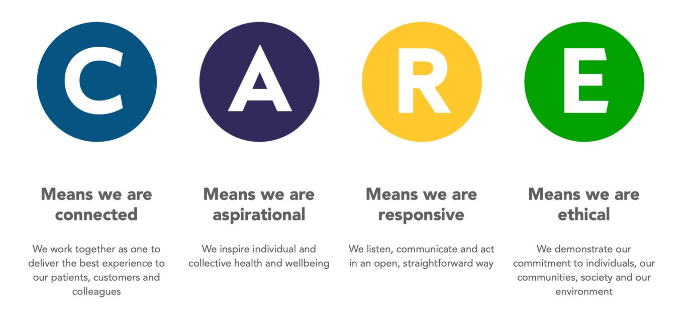
Figure 1: Nuffield Health Values
(Nuffield Health, 2024)

Findings

In considering the strategic environment of Nuffield Health in the fitness industry, examination must be afforded to various factors:

The UK fitness industry is substantial and growing, with an ever-increasing emphasis on health and wellbeing. Market growth is naturally driven by increasing health consciousness and a popular desire for healthy-eating and active lifestyles. The State of the UK Fitness Industry Report (Hudson, 2023) advises that gym memberships increased by 3.9% in 2023, despite a reduction in gyms nationally.

The report also indicates that the industry is highly competitive and is not limited to large, national scale gym chains. Independent businesses, fitness studios, specialised workout areas and online fitness platforms litter the strategic environment. The Register of Exercise Professionals indicated in April 2023 that major competitors of Nuffield Health include David Lloyd (over 100 locations nationwide), PureGym (over 230 locations nationwide) and The Gym Group (over 150 locations nationwide), (REPs, 2023).

Digital technology continues to reshape the fitness landscape and is a key element of this report. Innovation has allowed such trends as wearable fitness devices, mobile fitness apps, online platforms, and has enabled home workouts to be more accessible than ever. These technologies offer convenience, personalisation and often money-saving alternatives to the customer. Competitors like PureGym offer 24 hour access, via a fob or code entry. This also negates the need for staff during night time hours (PureGym, 2024).

Generally, consumers seek a personalised fitness experience, tailored to their needs and preferences. There is a growing demand for diverse fitness services including group classes, yoga, personal training, etc. This report argues that Nuffield Health may limit its potential audience through focussing efforts on rehabilitation and the healthcare industry, shining less light on the modern gym facilities available which inherently attract consumers otherwise more inclined to use an alternative provider for convenience and value.

The UK demands strict regulations related to health and safety, hygiene, employment practices and data protection. Compliance with such regulations is essential for organisations operating in this strategic environment.

The UK has seen a growing focus on health and wellness (Public Health England, 2021), coupled with increasing awareness of the importance of physical activity. This presents opportunities for the fitness industry and consumers seek holistic wellness solutions that are not limited to conventional gyms. Nuffield Health flourishes in this arena, offering services that encompass fitness, nutrition, mental health and stress management.

Conditions including disposable income levels, consumer spending patterns, and employment rates influence the demand for fitness services. In an economic downturn it follows that discretionary spending, such as gym memberships, will be reduced. Conversely prosperity in the economy may boost such demand.

Changing societal attitudes towards mental and physical health, body image, and wellbeing impact the behaviour of consumers in the sector. Trends such as ‘body positivity’, diversity, and inclusivity are quickly moulding the types of fitness offerings and strategies employed by key organisations in this arena (Yeboah, 2020).

The pandemic has profoundly affected the fitness industry, leading to temporary closures of some facilities or whole businesses. Restrictions on indoor and outdoor activities led a number of gyms to become non-viable and the lack of custom ultimately caused some permanent closures (Hewgill and Roper, 2020). This did however shift consumers towards online fitness solutions and accelerated trends such as virtual workouts and home gym equipment sales.

As with most organisations there is a growing emphasis on environmental sustainability within the fitness industry, with the public and regulatory agents increasingly concerned about the environmental impact of fitness facilities, equipment, and practices. Adopting eco-friendly initiatives such as energy-efficient facilities, sustainable materials, and waste reduction measures hugely shape the strategic environment.

In adopting a digital change strategy in line with the recommendations of this report, Nuffield Health can position itself as a leader in the fitness and wellbeing industry, grow its customer base, and deliver superior value to customers, employees, and stakeholders alike.

Ansoff’s Matrix
Conducting an Ansoff Analysis generally involves four growth strategies: market penetration, market development, product development, and diversification. These areas are then scaled against increasing risk.

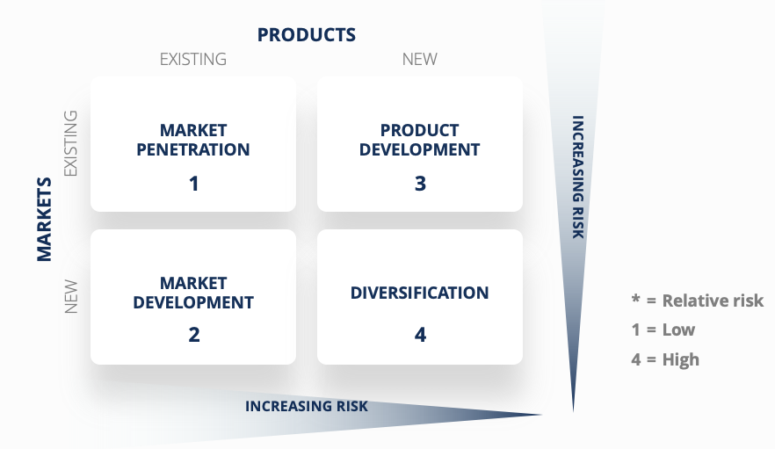
Figure 2 - Ansoff's Matrix
(Corporate Finance Institute, 2024)
Nuffield Health could focus on increasing its market share within the fitness and wellbeing market. Marketing campaigns and loyalty schemes for new or existing members could benefit the organisation. Promotional events showcasing the available gym facilities and making Nuffield Health more appealing to regular gym users who are well-acclimated to fitness and wellbeing could attract new members. This could include offering discounted membership rates for referrals, introducing new classes for more seasoned gym-users (shifting a focus away from rehabilitation and injury prevention), or primarily investing in digital marketing to reach a broader audience using social media or a Nuffield Health smart phone application, thus penetrating a new market.

For example, as of 11th April 2024, compared to its competitors on the social media application ‘Instagram’, the following table shows the number of followers each profile has:

Profile | Followers
Nuffield Health | 25.1k
David Lloyd | 54.9k
The Gym Group | 100k
PureGym | 212k
Table 1 - Comparison of Instagram Followers
(Instagram, 2024)

This does not include subsidiary or related profiles or accounts, such as specific geographic PureGym profiles, which often have upwards of 20k followers individually. The profiles shown above are the main accounts of the brand and showcase any company-wide promotions, advertisements, campaigns, etc. Nuffield Health has significantly less followers that competitors, and the related content would suggest that if they employed a social media strategy similar to that of PureGym – who have over 8 times the following – they may well attract a wider audience to utilise gym facilities. Suggestions would include posting workout plans, competitions between customers, fitness journeys of customers, or the facilities available at specific gyms.

Strategising market development could involve expanding to new geographic locations, targeting more specific demographic segments. For example, where there is a high demand for health and fitness facilities but less so rehabilitation or mental health support, Nuffield Health could cater to these needs with limited competition as an established brand name. Again, best use of digital technology could be leveraged, developing smart phone apps and a separate social media strategy to appease a new audience.

Nuffield Health gyms can introduce new products to its existing market as alluded to above, by adding specialised equipment and incorporating technologies into their services. This would support their vision and values as some equipment becomes increasingly energy efficient, such as NOHrD; a leading fitness equipment provider who hold sustainability at the heart of their products. NOHrD state “We’re committed to making environmentally conscious decisions and using sustainable materials and production methods. Our fitness equipment is designed with consideration for the environment, without compromising on quality” (NOHrD, 2024).
Similarly, development of a smart phone application could see members tracking their fitness goals or linking their workouts to personalised training programs or virtual fitness classes. Wearable fitness technology could be introduced into premium memberships.

Nuffield Health can diversify by exploring new markets or products outside of its current offerings, entering related industries such as tourism. The organisation has a strong reputation for providing high-quality healthcare services including nutritional advice and counselling. An unrelated industry such as tourism could see Nuffield Health partnering with travel agencies to offer wellness retreats. Other ventures could include the production of gym equipment or a clothing line, or healthcare related products such as supplements, healthy energy drinks, or protein rich snacks.

By conducting this Ansoff Analysis, the organisation can clearly identify suitable growth strategies. It’s strengths and the market conditions become prevalent; however, each strategy does come with risk. Nuffield Health has a strong brand and already offers a range of services. It’s presence across the UK is already significant, which has already enhanced its accessibility. The integration of technology will enhance service delivery and improve efficiency, providing innovative healthcare solutions.

The strong brand reputation and diversified portfolio position new gyms well in the market, however Nuffield Health does face competition from traditional players in the fitness sector, such as PureGym and The Gym Group (Dawood, 2018). Rapid advancements in technology could also create challenges, particularly around availability of resources, adoption, and integration. Essentially, Nuffield Health must evaluate and prioritise these opportunities versus risks according to long term goals and must not be resistant to change.

Porter’s Five Forces

The so-called ‘five forces’ were created by Professor Michael Porter and published in 1979. The model includes: Competitive Rivalry, Supplier Power, Buyer Power, Threat of Substitution, and Threat of New Entry. The model encourages an organisation to look further than at direct competitors and consider broader, environmental factors. The aim therefore is to identify the main sources of competition in the fitness and wider healthcare industry, a key tool to use in this strategic analysis.
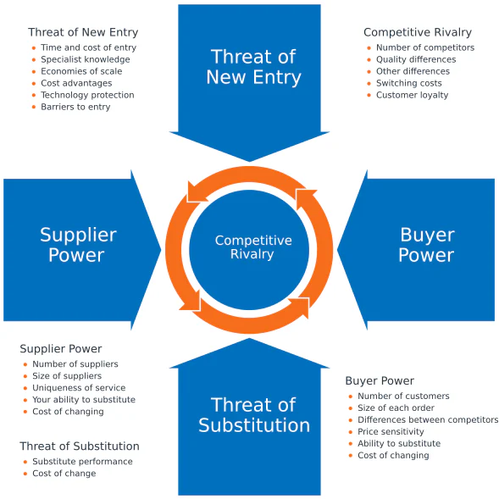
Figure 3 - Porter's Five Forces
(Michael E. Porter, 1989)

Threat of New Entrants – low to medium
The fitness industry has relatively low entry requirements (National Careers Service, 2024), with new gyms occasionally entering the market. Established brands like Nuffield Health have strong brand recognition, a loyal customer base, and significant investment in existing infrastructure and facilities. The capital required to establish a new gym at a comparable level (i.e. with similar amenities and services) is prohibitive and greatly limits the potential for new entrants.

Bargaining Power of Suppliers – medium
Nuffield Health relies on specific suppliers for equipment and services. Multiple suppliers are available to the industry, but only some have substantial bargaining power. The industry demands niche products such as specialised equipment and as recommended in this report, technology solutions. The scale of Nuffield health mitigates some bargaining power and poses an ability to negotiate preferred terms.

Bargaining Power of Members – medium to high
Nuffield Health is a registered not-for-profit organisation. To this end there are no shareholders and ‘buyers’ in this sense are the members themselves. Gym members have the continual option to switch to other fitness centres or healthcare providers, often with little or no notice. Alternative gyms in their locality, the quality of the equipment or services provided, and the membership costs are all factors within the bargaining power of members. In order to minimise risk in this area, Nuffield Health Gyms should adopt a digital transformation strategy in line with these recommendations to offer unique and personalised services, loyalty schemes and reward programmes.
Threat of Substitutes – low
There are few substitutes for a high quality or premium gym membership. Home workouts or engaging in outdoor activities are relevant alternatives, however the services provided by Nuffield Health differentiate it from many substitutes. The vision and value of holistic health and wellness, including services such as physiotherapy, rehabilitation, mental ill health support amongst others does reduce the threat of substitution. Areas of risk here could be addressed through digital transformation; providing a social media strategy and personalised smart phone application or wearable fitness device could leverage Nuffield Health to dominate the home workout arena, encouraging users to enrol on virtual workouts whilst still remaining a member of the brand.

Intensity of Competitive Rivalry – high
As has been identified, the industry is highly competitive with numerous gyms, spas, fitness chains or other wellness centres vying for market share. Competitors range from small independent businesses to large international chains. Pricing competition, diversity in services and amenities, location, and marketing strategies all contribute to intense rivalry. Nuffield Health gyms face competition from both traditional gym chains and new entrants who offer innovative fitness concepts and newer digital solutions, such as CrossFit. The number of gyms has steadily increased year on year in the UK, with the exception being in 2021 as described for reasons surrounding the Covid-19 Pandemic.

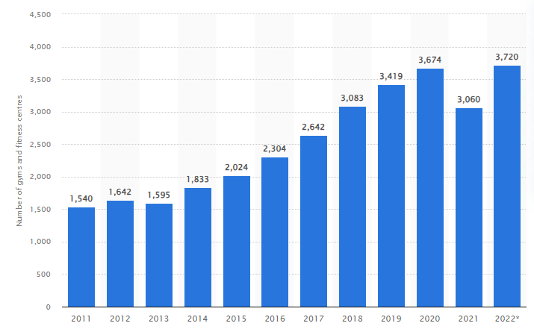
Table 2 – Number of gyms in UK 2012 – 2022
(Statista, 2024)

Overall, it would seem the organisation operates in a favourable competitive environment, with its strong reputation, comprehensive services, and loyal customer base offering a competitive advantage. However, digital transformation and innovation must be a priority for Nuffield Health if it hopes to meet evolving customer needs and market preferences. This is corroborated by competitors technological advantage in 24 hour unstaffed access, mobile phone applications, and use of social platforms.

Leadership Theories

Leaders should look to the future and accept that change can be healthy. This fosters innovative and strategic thinking and enables leaders to make informed decisions based on an organisation’s needs. In discussing digital transformation, CIO of Johnson & Johnson stated “In the centre of it all is leadership and culture, you could have the products and services, data, and really cool technologies – but if leadership and culture aren’t at the heart, it fails” (Swanson, 2023).

Nuffield Health would appear to adopt a transactional leadership style. It’s clear organisational structure and drive for fundraising, improvement of health and wellbeing, and its unique place as a competitive company in a not-for-profit space lends itself well to this leadership style. There is a clear and justified motivation to seek donations from reputable sources and take these into funding if this would result in meeting set goals. The Nuffield Health Annual Report (MacDonald, 2022) states that £1.173 million worth of funding that year arose from charity; be it charitable activities, donations, grant income or otherwise. A further £1.238 million was calculated as gross income through fees charged to patients as a private healthcare provider.

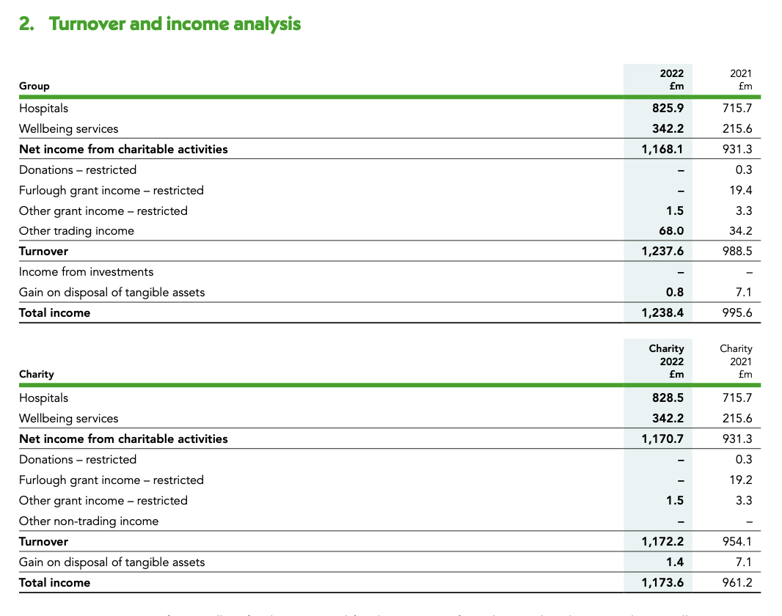
Table 3 - Turnover and Income Analysis, 2022
(Nuffield Health, 2022)

In adopting a digital change strategy in line with this report, the organisation would benefit from considering a shift towards a transformational leadership style, offering optimism and confidence to the wider workforce. The Board and Chief Executives, whilst highly regarded individuals, could look ahead and plan for future technological advancements in the fitness and wellbeing sector. In cascading this vision through the organisation, leaders could foster a genuine ethos within the company to consider what good the non-profit could achieve. In 2022, Nuffield Health CEO Steve Gray was reportedly paid £1.2 million, around double his salary the year prior (Downes, 2022). The Nuffield Health website intimates transparency in publishing remuneration for all Senior Executives, however the most recent link via that same webpage forwards the user to a 2016 Annual Report. The values of a transformational leadership team would not allow for such ambiguity. It is noteworthy that as a trading charity, Nuffield Health does not specifically fundraise, and states that “We invest all our income back into our purpose to build a healthier nation…” (Nuffield Health, 2024).

Digital Change Strategy

Nuffield Health should leverage technology to enhance its service delivery to gym users and meet their evolving needs. The Board of Governors must reflect this within their strategic plan, and this should be appropriately led through a transformational Chief Executive. An assessment of current digital capabilities in Nuffield Health gyms should take plan, including engagement with stakeholders at all levels to understand their needs. A clear vision for digital change should then be set, aligned to the already well-established ethos of the brand.

Accountability is required to meet objectives and through adopting a transformational leadership style, Nuffield Health can seek to encourage innovation and readiness amongst its staff members. This can be addressed through training, additional resources, and by introducing incentives for employees to embrace change. To avoid any silos in leadership, The Board should encourage collaboration across departments and offer cross-functional teamwork to ultimately provide smooth implementation of any change. Leaders should communicate transparently and frequently with employees and customers, affirming the purpose and progress of the change implementation.

Ultimately, the customer experience is paramount. If a gym user is unhappy with amenities offered or cannot achieve what they hope to in a fitness environment, they are less likely to use the service again. This is not unique to the industry and common sense should prevail. Nuffield Health should prioritise customer experience through surveys and feedback and develop solutions in line with those needs. Such goals could be to enhance accessibility, enhance personalisation, or to increase convenience.

Financial investment must be afforded by the Board in scalable digital infrastructure. Modern solutions such as cloud-based applications or programmes offer flexibility in cost. As identified earlier in this report, legislative and regulatory measures must always be followed. Whilst the recommendations below centre around the gym user experience, investment in other operational efficiency is equally as important. Administrative tasks and work streams can be automated and minimised, preventing staff from taking valuable time filling out registration paperwork and creating physical access cards using an outdated system. This will in turn boost a positive user experience in line with suggested goals above.

Digital transformation should allow for errors, and consistent monitoring and evaluation (such as customer satisfaction surveys or other efficiency key performance indicators) should be used to measure success. Where necessary, strategy can be adapted to new and changing dynamics and other technological advancements.

This strategy can be further corroborated through a brief PESTEL analysis. In this way, the political, economic, social, technological, environmental, and legal factors can be clarified.

Political
Operations could be affected by changes in regulations or legislation, for example those related to insurance policies, quality standards, or how charities are funded.

Economic
Fluctuations in economy can affect the affordability of a premium gym membership and private healthcare services, potentially impacting revenue. Similarly, any changes in government spending or insurance coverage could impact the demand on private gym or healthcare usage.

Social
Social media health trends, increasing body positivity, and general health awareness can increase demand and Nuffield Health should exploit social opportunities using new technology in order to promote their services.

Technological
The advancement of health monitoring applications, wearable devices, and personalised virtual workouts provide significant areas for innovation. If not leveraged, the organisation runs the risk of becoming outdated and this will contradict the strategic vision and values set by the Board of Governors.

Environmental
Facility management and the use of eco-friendly machines and products can improve sustainability and influence Nuffield Health’s reputation.

Legal
As alluded to, compliance with British Standards, healthcare regulations, information protection laws and licensing requirements are essential to the legal operation of the company. Changes to law around pay for healthcare workers or working hours could affect costs and therefore level of service. This could be mitigated through aforementioned process automation, creating efficiency for both the employee and the end user.

Conclusion

Strategic analysis models and tools have been used to highlight areas of strength and threats to Nuffield Health gyms. By considering these factors, Nuffield Health can better place itself in the environment in which it operates and seek to minimise risks by acknowledging the below recommendations in line with a digital transformation strategy.

If recommendations are not followed in line with the findings of this report, there are implications to the sustainable growth of Nuffield Health gyms. Nuffield Health is in a strong position in the market and is a well-known brand. However, their gyms are at risk of falling behind in a fast-moving technological era. Investment is necessary to safeguard this sustainability and increase its customer base to a modern client.

Digital developments present both opportunities and challenges for Nuffield Health’s current strategy. By leveraging their strengths, addressing areas of weakness, and adapting their strategy to the evolving digital landscape, Nuffield Health can position itself as a leader in a digital fitness and wellbeing industry whilst navigating potential threats, and maximising opportunities for growth.

Recommendations

A horizon planning approach was first articulated in The Alchemy of Growth (Baghai, Coley and White, 2000); a planning tool used to help an organisation manage their growth. Nuffield Health must apply the following three horizons to these recommendations to develop transformational potential:

- Horizon 1, defend and extend current core activities.
- Horizon 2, develop emerging business.
- Horizon 3, create viable options (accepting some higher risk activities that may take some years to generate growth).

Recommendations must be prioritised using the three horizons and Nuffield Health should seek to implement short term change, fast. This will ensure short term reward and afford appropriate time to implementation of horizons 2 and 3.

Recommendations and indeed horizons needn’t be consecutive; that is horizon 1 doesn’t need to be complete and concluded before horizon 2 begins. This model offers a degree of fluidity and each horizon should run concurrently for a period of time. These time frames should be set by the Board of Governors and advised horizon planning has been added to the below recommendations. This comprehensive approach will enhance overall member experience, optimise internal operations, and drive growth.

Enhancement of Member Experience

In 2022 Nuffield Health introduced a mobile phone application which allows users to book classes and sessions. Development is required as a priority to redesign the application and extend its capability. In cohesion with other recommendations, a new application should track the user’s fitness progress, provide access to personalised workout or diet plans, and offer a facility to engage with personal trainers or other gym members.

The application should also act as an identification card, mitigating the need for physical membership cards and archaic paper-based application forms. A user should be able to gain access and egress to a gym facility through using their application, track how busy a specific gym is, and access training videos for new equipment or exercises.

This is not innovative; it only brings Nuffield Health in line with competitors and opens the gyms to a wider audience. The app should be appropriately promoted through social media outlets and within the physical gyms. Development of a mobile application therefore sits within horizon 1.

Additionally, gyms need to offer virtual training classes, either through the application or via a dedicated online platform. This will further cater to the needs of members who prefer isolated or remote workouts, or who are away from their home gym or have scheduling constraints. As personal training is already a facility available within the gyms, this too sits within horizon 1 and is an extension of core business, although does require serious financial investment in web and app development.

Finally, Nuffield Health gyms can develop emerging business under horizon 2 by integrating wearable fitness devices. Many devices are already available on the open market; Nuffield Health should position itself by enabling these devices to link with the newly designed mobile application and state of the art gym equipment in line with other recommendations. A wearable device should therefore offer real-time tracking of workouts, health metrics, and progress. Wearable devices encourage fitness, forcing the wearer to enter a game style of progress such as beating 10,000 steps in a day, or highlighting when a wearer has been inactive for a period of time.

Gym equipment should be updated in line with current technology to enable seamless connectivity between any wearable with the use of the facility. An example would be a member ‘logging in’ to use a treadmill by simply tapping their wearable device, and then tracking the length and duration of their run, their pace, their heart rate, any improvement in fitness, etc. A survey conducted by Xplor Gym stated that “45% of members expect their gym to integrate with smart fitness devices and wearable technology [and] when members come and train, 59% said they want their gym to provide ways to track calories, measure statistics and record workouts”. (Xplor Gym, 2022). Similarly, Nuffield Health needs to bring itself in line with competitors by enabling 24 hour access during unstaffed times through a digital entry system.

Data Analytics and Personalisation

In tandem with the above enhancements of member experience, Nuffield Health must utilise analytics tools to gather insights from member preferences and feedback. This will enable personalised recommendations, content, and promotions tailored to the needs of the individual member. As robot learning and AI transitions into such data analytics, this process could become fully automated and would therefore fall under horizon 3 as a long-term goal.

Similarly, predictive analytics should be implemented in horizon 3 to forecast fitness outcomes based on member data (submitted via wearable devices and applications). This will facilitate personal training sessions and benefit the current vision in preventative healthcare strategies.

Community Engagement

Social media platforms must be leveraged to build a strong online community. Competitors offer such a platform to share fitness tips, promote events, and encourage overall member interaction. Through use of various strategic analysis tools this reports highlights a clear threat to Nuffield Health in the lack of a social media strategy. Integration with social media and a mobile application is fundamental and will attract a new and wide audience.

Gyms should arrange virtual fitness challenges and competitions to foster community engagement and build motivation in members. Rewards and recognition is an optional recommendation for participants.

In additional to personalised training or coaching, live webinars or Q&A style events should be broadcast through dedicated platforms and as part of a wider social media strategy. Nuffield Health can build on its already wide array of professional staff, utilising current skills to facilitate conversations with fitness experts, nutritionists, and other healthcare professionals. This manner of work promotes the implementation of a transformational leadership theory and benefits both the customer and staff member.

These areas of business form core activities and are to be exploited to maximise effectiveness; they therefore fall under horizon 1.

Continued Innovation

Processes should be consistently reviewed and adapted to meet changing demands.

Automation of administrative tasks should be implemented in order to minimise number of staff, and increase available time of those employed. This increased availability can be directed to member focus, engagement and service delivery.

In tandem with wearable technology, digital health records and appointments booking will streamline processes for both the customer and staff member, helping to reduce the time spent on bureaucratic tasks.

Partnerships and collaborations with other technology companies or research facilities will aid Nuffield Health gyms in staying abreast of emerging trends, innovations and best practices.

Ultimately, a detailed implementation plan should follow. Recommendations should be agreed and budget and time constraints should be set. Internal development should be sought through a project manager or managers. This report recommends utilising a matrix organisational structure on a short to mid-term basis. This will assist in the sharing of leadership and is designed to keep open communication between various teams. Such a structure will avoid siloes and will place Nuffield Health in a strong position post implementation. A preferable outcome is to outsource this plan to the author of this report.

In adherence with this strategy, Nuffield Health can not only enhance its competitive advantage in the strategic environment, but also deliver greater value to members, improve efficiency, and increase sustainable growth in a digital scope.

Reference List

Baghai, M. et al. (2000) The alchemy of growth: Kickstarting and sustaining growth in your company. London, England: Orion Business.
Dawood, S. (2018) Nuffield Health Drops ‘corporate, confusing and uninspiring’ branding, Design Week. Available at: https://www.designweek.co.uk/issues/20-26-august-2018/nuffield-health-drops-corporate-confusing-and-uninspiring-branding/ (Accessed: 28 March 2024).
Downes, S. (2022) Nuffield Health chief executive Doubles Pay to £1.2m, Third Sector. Available at: https://www.thirdsector.co.uk/nuffield-health-chief-executive-doubles-pay-12m/management/article/1802303 (Accessed: 18 April 2024).
Ellis, C. (2023) What are divisional organizational structures?, THE ORG. Available at: https://theorg.com/iterate/divisional-organizational-structures (Accessed: 30 March 2024).
Hewgill, C. and Roper, E. (2020) Gyms and coronavirus: What are the facts?, BBC News. Available at: https://www.bbc.co.uk/news/newsbeat-54540188 (Accessed: 16 April 2024).
Hudson, K. (2023) State of the UK fitness industry report 2023: HCM Insight, HCM: one of the world’s leading magazines for senior professionals in the fitness and physical activity sector. Available at: https://www.healthclubmanagement.co.uk/health-club-management-features/Insight-The-shape-of-now/36493 (Accessed: 16 April 2024).
Instagram (2024) Login • instagram. Available at: https://www.instagram.com/nuffield.health/ (Accessed: 30 March 2024).
Instagram (2024) Login • instagram. Available at: https://www.instagram.com/davidlloydclubs/ (Accessed: 30 March 2024).
Instagram (2024) Login • instagram. Available at: https://www.instagram.com/puregymofficial/ (Accessed: 30 March 2024).
Instagram (2024) Login • instagram. Available at: https://www.instagram.com/thegymgroup/ (Accessed: 30 March 2024).
MacDonald, N. (2022) 2022 Annual report, Nuffield Health. Available at: https://www.nuffieldhealth.com/about-us/how-we-are-governed/2022-annual-report (Accessed: 02 April 2024).
National Careers Service (2024) Fitness instructor, Fitness instructor | Explore careers | National Careers Service. Available at: https://nationalcareers.service.gov.uk/job-profiles/fitness-instructor (Accessed: 16 April 2024).
NOHrD (2024) Waterrower: Nohrd - Sustainability, NOHRD. Available at: https://www.nohrd.com/uk/sustainability/ (Accessed: 16 April 2024).
Nuffield Health (2024a) Joint pain programme, Nuffield Health. Available at: https://www.nuffieldhealth.com/about-us/our-impact/healthy-life/joint-pain-programme (Accessed: 02 April 2024).
Nuffield Health (2024b) Our structure, Nuffield Health. Available at: https://www.nuffieldhealth.com/about-us/how-we-are-governed/our-structure (Accessed: 02 April 2024).
Peterdy, K. (2023) Ansoff matrix, Corporate Finance Institute. Available at: https://corporatefinanceinstitute.com/resources/management/ansoff-matrix/ (Accessed: 02 April 2024).
Porter, M.E. (1989) ‘How competitive forces shape strategy’, Readings in Strategic Management, pp. 133–143.
Public Health England (2021) Seven in 10 adults are motivated to get healthier in 2021 due to covid-19, GOV.UK. Available at: https://www.gov.uk/government/news/seven-in-10-adults-are-motivated-to-get-healthier-in-2021-due-to-covid-19 (Accessed: 16 April 2024).
PureGym (2024) Cheap 24 Hour gym memberships: No contract, PureGym. Available at: https://www.puregym.com/ (Accessed: 02 April 2024).
REPs (2023) The 10 best gym chains in the UK, REPs. Available at: https://repsuk.org/blog/the-10-best-gym-chains-in-the-uk#:~:text=The%2010%20Best%20Gym%20Chains%20in%20the%20UK,Gyms%20...%208%20%C3%A9nergie%20Fitness%20...%20More%20items (Accessed: 16 April 2024).
Statista Research Department and 13, F. (2024) Number of UK fitness/health clubs 2022, Statista. Available at: https://www.statista.com/statistics/1194837/gyms-fitness-centres-uk/ (Accessed: 18 April 2024).
Swanson, J. (2023) Johnson & Johnson CIO: Transformational leadership needed now more than ever, The Enterprisers Project. Available at: https://enterprisersproject.com/article/2020/5/why-transformational-leadership-needed-now (Accessed: 18 April 2024).
Yeboah, S. (2020) Body positivity: Why the work is far from finished, British Vogue. Available at: https://www.vogue.co.uk/beauty/article/body-positivity-movement (Accessed: 10 April 2024).
Xplor Gym (2022) Connecting with members: How to use wearable tech in your gym, Xplor Gym UK. Available at: https://xplorgym.co.uk/blog/connecting-with-members-how-to-use-wearable-tech-in-your-gym/ (Accessed: 18 April 2024).

Bibliography
Allcott, G. (2019, January 3). How to Be a Productivity Ninja. Productivity Ninja. http://books.google.ie/books?id=jSQiugEACAAJ&dq=productivity+ninja&hl=&cd=1&source=gbs_api
Baghai, M. et al. (2000) The alchemy of growth: Kickstarting and sustaining growth in your company. London, England: Orion Business.
Dawood, S. (2018) Nuffield Health Drops ‘corporate, confusing and uninspiring’ branding, Design Week. Available at: https://www.designweek.co.uk/issues/20-26-august-2018/nuffield-health-drops-corporate-confusing-and-uninspiring-branding/ (Accessed: 28 March 2024).
Deng, C., Gulseren, D. B., Isola, C., Grocutt, K., & Turner, N. (2022, October 13). Transformational leadership effectiveness: an evidence-based primer. Human Resource Development International. https://doi.org/10.1080/13678868.2022.2135938
Downes, S. (2022) Nuffield Health chief executive Doubles Pay to £1.2m, Third Sector. Available at: https://www.thirdsector.co.uk/nuffield-health-chief-executive-doubles-pay-12m/management/article/1802303 (Accessed: 18 April 2024).
Ellis, C. (2023) What are divisional organizational structures?, THE ORG. Available at: https://theorg.com/iterate/divisional-organizational-structures (Accessed: 30 March 2024).
Hewgill, C. and Roper, E. (2020) Gyms and coronavirus: What are the facts?, BBC News. Available at: https://www.bbc.co.uk/news/newsbeat-54540188 (Accessed: 16 April 2024).
Hudson, K. (2023) State of the UK fitness industry report 2023: HCM Insight, HCM: one of the world’s leading magazines for senior professionals in the fitness and physical activity sector. Available at: https://www.healthclubmanagement.co.uk/health-club-management-features/Insight-The-shape-of-now/36493 (Accessed: 16 April 2024).
Instagram (2024) Login • instagram. Available at: https://www.instagram.com/nuffield.health/ (Accessed: 30 March 2024).
Instagram (2024) Login • instagram. Available at: https://www.instagram.com/davidlloydclubs/ (Accessed: 30 March 2024).
Instagram (2024) Login • instagram. Available at: https://www.instagram.com/puregymofficial/ (Accessed: 30 March 2024).
Instagram (2024) Login • instagram. Available at: https://www.instagram.com/thegymgroup/ (Accessed: 30 March 2024).
MacDonald, N. (2022) 2022 Annual report, Nuffield Health. Available at: https://www.nuffieldhealth.com/about-us/how-we-are-governed/2022-annual-report (Accessed: 02 April 2024).
National Careers Service (2024) Fitness instructor, Fitness instructor | Explore careers | National Careers Service. Available at: https://nationalcareers.service.gov.uk/job-profiles/fitness-instructor (Accessed: 16 April 2024).
NOHrD (2024) Waterrower: Nohrd - Sustainability, NOHRD. Available at: https://www.nohrd.com/uk/sustainability/ (Accessed: 16 April 2024).
Nuffield Health (2024a) Joint pain programme, Nuffield Health. Available at: https://www.nuffieldhealth.com/about-us/our-impact/healthy-life/joint-pain-programme (Accessed: 02 April 2024).
Nuffield Health (2024b) Our structure, Nuffield Health. Available at: https://www.nuffieldhealth.com/about-us/how-we-are-governed/our-structure (Accessed: 02 April 2024).
Peterdy, K. (2023) Ansoff matrix, Corporate Finance Institute. Available at: https://corporatefinanceinstitute.com/resources/management/ansoff-matrix/ (Accessed: 02 April 2024).
Porter, M.E. (1989) ‘How competitive forces shape strategy’, Readings in Strategic Management, pp. 133–143.
Public Health England (2021) Seven in 10 adults are motivated to get healthier in 2021 due to covid-19, GOV.UK. Available at: https://www.gov.uk/government/news/seven-in-10-adults-are-motivated-to-get-healthier-in-2021-due-to-covid-19 (Accessed: 16 April 2024).
PureGym (2024) Cheap 24 Hour gym memberships: No contract, PureGym. Available at: https://www.puregym.com/ (Accessed: 02 April 2024).
REPs (2023) The 10 best gym chains in the UK, REPs. Available at: https://repsuk.org/blog/the-10-best-gym-chains-in-the-uk#:~:text=The%2010%20Best%20Gym%20Chains%20in%20the%20UK,Gyms%20...%208%20%C3%A9nergie%20Fitness%20...%20More%20items (Accessed: 16 April 2024).
Statista Research Department and 13, F. (2024) Number of UK fitness/health clubs 2022, Statista. Available at: https://www.statista.com/statistics/1194837/gyms-fitness-centres-uk/ (Accessed: 18 April 2024).
Swanson, J. (2023) Johnson & Johnson CIO: Transformational leadership needed now more than ever, The Enterprisers Project. Available at: https://enterprisersproject.com/article/2020/5/why-transformational-leadership-needed-now (Accessed: 18 April 2024).
Yeboah, S. (2020) Body positivity: Why the work is far from finished, British Vogue. Available at: https://www.vogue.co.uk/beauty/article/body-positivity-movement (Accessed: 10 April 2024).
Xplor Gym (2022) Connecting with members: How to use wearable tech in your gym, Xplor Gym UK. Available at: https://xplorgym.co.uk/blog/connecting-with-members-how-to-use-wearable-tech-in-your-gym/ (Accessed: 18 April 2024).

