
BA Business Management
LCBB6000 - Dissertation
Component 1: Coursework – a written research proposal

The Future of Remote Work in the UK’s Technology & IT Sector: Impacts on Productivity and Organizational Culture



Lecturer Name: Navid Nasirpourosgoei
Student Name: Sava Daniela
Student Number: 2028792
Submission date: 30.03.2025
Table of Contents
Introduction 2
Aim, Objectives, Questions & Hypotheses of Research 2
Literature Review 4
Conceptual Framework 6
Research Methods and Methodology 8
Gantt Chart: 10
Conclusion 11
References 12

Introduction

Remote work has become an integral component of modern employment, particularly in the Technology and IT sector of the UK. As the global pandemic accelerated the shift to remote working, organizations have had to rethink their traditional working models. Remote work refers to a work arrangement where employees perform their job roles outside conventional office spaces, often from home, using digital communication tools (Allen et al., 2015).

The significance of this topic lies in understanding how long-term remote work impacts productivity and organizational culture within the UK’s tech industry. This research aims to explore the transformation in business operations and employee dynamics due to remote work, providing insights into future strategic decisions.

Remote work adoption has become widespread post-COVID-19. While offering flexibility and cost-efficiency, it also challenges traditional management and workplace culture (Messenger, 2019). As remote work becomes more embedded in business models, it is essential to explore its impact on workforce performance to inform strategic decision-making.

Aim, Objectives, Questions & Hypotheses of Research

Aim:
To examine the impact of remote work on employees productivity, and organizational culture in the UK’s Technology & IT sector.

Objectives:
- To analyse the impact of remote work on employee productivity.
- To explore challenges and opportunities of remote work implementation.
- To evaluate the role of technology in remote work effectiveness.

Research Questions:
- How does remote work influence employee productivity?
Hypothesis (H₁): Remote work positively influences employee productivity when supported by clear communication strategies and performance-tracking tools.

- Which are the key challenges and benefits for organizational culture?

- How are companies adapting policies to sustain productivity?

- What role does technology play in productivity and culture?
Null Hypothesis (H₀): The use of collaborative digital tools has no significant impact on employee productivity or organizational culture in remote settings.

- What are future trends and best practices in remote work?

In this chapter I have outlined the growing significance of remote work in Technology and IT field, highlighting its impact on productivity and organizational culture. While offering flexibility, remote work presents challenges related to communication, performance, productivity, and organization’s culture. (Allen et al., 2015; Messenger, 2019).

Literature Review

Remote work, also known as telecommuting, has undergone significant evolution over the past decade, with a rapid acceleration post-2020 due to global health crises and advances in technology (Bloom et al., 2015). It is broadly defined as a work arrangement where tasks are conducted outside traditional office environments (Allen et al., 2015). This literature review synthesises existing research around the themes of remote work characteristics, productivity and performance, organisational culture, technology, and the associated benefits and challenges. The aim is to contextualise the current study within established knowledge, identify gaps, and build a conceptual foundation guided by the Job Demands-Resources (JD-R) model and Technology Acceptance Model (TAM).

- Characteristics and Importance of Remote Work
Remote work is characterised by flexibility, reliance on technology, and decentralised communication. These elements enhance employee autonomy and satisfaction (Felstead & Henseke, 2017), a recurring theme in the literature. However, reduced informal interaction has raised concerns around weakening organisational cohesion. This duality highlights the need for organisations to strike a balance between autonomy and structured team engagement.

While early literature focused on the flexibility remote work offered, more recent studies emphasise its role in redefining traditional working models and its potential to increase inclusivity, particularly for those with caregiving responsibilities or accessibility needs (Messenger & Gschwind, 2016).

- Productivity and Performance
In a quasi-experimental study, was reported a 13% productivity boost among remote workers in a Chinese travel agency. (Bloom et al. 2015) However this results are inconsistent. The OECD (2020) highlighted differences across countries and sectors, mainly due to technology infrastructure and management adaptability.

This suggests that remote productivity is conditional, requiring alignment between job roles, digital support, and performance expectations. Furthermore, individual motivation, environmental factors, and supervisory styles significantly mediate performance outcomes.

- Organisational Culture and Digital Adaptation
Remote work significantly affects organisational culture, including shared values, beliefs, and norms (Schein, 2010). The absence of physical presence necessitates intentional efforts to maintain cohesion. Ford et al. (2021) argue for the development of digital culture-building strategies, such as virtual social spaces, rituals, and inclusive communication tools.

Literature also notes a shift in leadership styles: from supervisory control to trust-based models. These cultural adaptations are vital for long-term success in hybrid or fully remote settings.

- Technological Enablers and Barriers
Technology is both an enabler and barrier to remote work. Tools like Zoom, Microsoft Teams, and Slack facilitate communication and project management, but also introduce challenges such as digital fatigue and constant connectivity (Wang et al., 2020).

The Technology Acceptance Model (TAM) offers a valuable lens for understanding employee engagement with digital tools. According to Davis (1989), perceived ease of use and perceived usefulness play a critical role in the adoption of innovative technologies. This implies that choosing intuitive and user-friendly platforms is more than a technical choice—it is a strategic investment in workforce engagement and productivity.

Advantages and Disadvantages

- Advantages
Flexibility: Enhanced autonomy and work-life integration (Felstead & Reuschke, 2020)
Wider Talent Pool: Organisations can hire across geographies (Donnelly & Johns, 2021)
Cost Efficiency: Reduced office space and utilities (CIPD, 2021)

- Disadvantages
Social Isolation: Lack of spontaneous communication
Blurred Boundaries: Difficulty separating work and home life (Choudhury et al., 2021)
Monitoring Challenges: Harder to assess employee engagement and performance remotely.

These dichotomies illustrate the importance of strategic planning in remote work design, aligning policy with both organisational and employee needs.

- Challenges and Opportunities
Remote work presents complex challenges in communication, trust-building, and performance monitoring. However, it also offers transformative opportunities. According to Messenger & Gschwind (2016), remote work can catalyse shifts toward inclusive, sustainable, and agile work models. With the right structural supports, it can move beyond being a contingency measure to becoming a core element of organisational strategy.

Conceptual Framework
This framework summarises key academic contributions across five major themes related to remote work. It enables comparison and contrast of perspectives from different authors and highlights literature gaps and overlapping areas.

Authors | Theme 1:  Characteristics & Importance | Theme 2:  Productivity & Performance | Theme 3:  Organizational Culture | Theme 4:  Technological Enablers | Theme 5:  Challenges & Opportunities
Allen et al. (2015) | ✔️ Defined remote work; flexibility
Felstead & Henseke (2017) | ✔️ Autonomy & satisfaction |  |  |  | ✔️ Social cohesion issues
Bloom et al. (2015) |  | ✔️ +13% productivity
OECD (2020) |  | ✔️ Productivity varies by context |  | ✔️ Tech infrastructure
Schein (2010) |  |  | ✔️ Culture definition
Ford et al. (2021) |  |  | ✔️ Digital culture-building | ✔️ Tech dependency & communication
Wang et al. (2020) |  |  |  | ✔️ Digital fatigue
Felstead & Reuschke (2020) | ✔️Flexibility & autonomy
Donnelly & Johns (2021) |  |  |  |  | ✔️Access to broader talent
CIPD (2020) |  |  |  |  | ✔️Operational cost reduction
Choudhury et al. (2021) |  |  |  |  | ✔️Work-life boundary issues
Messenger & Gschwind (2016) |  |  |  |  | ✔️Inclusivity & sustainability
Davis (1989) |  |  |  | ✔️TAM – tech adoption framework
Turetken et al. (2011) |  | ✔️ Impact of virtual work on performance | ✔️Collaboration challenges | ✔️Reliance on tools
Bailey & Kurland (2002) | ✔️ Early benefits of remote work | ✔️  Productivity contingent on trust |  |  | ✔️ Limitations in monitoring
Kramer & Kramer (2020) |  |  | ✔️  Organizational change in crises |  | ✔️ Remote resilience and adaptation
Grant et al. (2013) | ✔️ Autonomy & trust | ✔️ Mixed performance impacts | ✔️Social connections matter

This literature review explored the multi-faceted dimensions of remote work, highlighting its potential and pitfalls. By synthesising current findings and critically evaluating key themes, it identifies a need for further research into how digital tools, organisational culture, and performance metrics interact in remote settings. The review sets the stage for empirical exploration, particularly in understanding how organisations can harness remote work to drive sustainable productivity.

Research Methods and Methodology
This study employs the Research Onion framework developed by Saunders et al. (2019) to guide its methodological design. The framework supports a structured and reflective approach, addressing essential elements such as research philosophy, methodological approach, strategy, and data collection methods.

Research Philosophy
The study follows a positivist philosophy, considering reality as objective and measurable. Positivism supports the analysis of observable facts, making it ideal for evaluating existing secondary data such as industry reports and government publications (Walliman, 2011; Saunders et al., 2019).

Research Approach
This study will adopt a deductive approach, starting with well-established theories like the Job Demands-Resources (JD-R) model and the Technology Acceptance Model (TAM) to shape the research focus. By using existing theoretical frameworks, this method enables the testing of hypotheses through the analysis of pre-existing data (Bryman and Bell, 2015).

Research Paradigm
Aligned with its philosophical stance, this study adopts a quantitative paradigm. This supports statistical analysis and pattern identification in numerical data derived from existing, credible sources such as databases, government statistics, and published academic findings (Creswell, 2014).

Research Methodology
This is a desk-based, secondary research study, utilising cross-sectional data available at a specific point in time. The use of published datasets and reports allows for a timely examination of remote work trends in productivity, culture, and technology (Denscombe, 2017).

Research Strategy
The research uses a documentary research strategy, analysing secondary sources such as:
- Government publications (e.g., Office for National Statistics)
- Industry reports (e.g., CIPD)
- Academic literature and meta-analyses
- White papers and consulting reports (e.g., McKinsey, Deloitte)

This strategy allows the study to synthesise data from diverse and reputable sources to form conclusions about remote work impacts in the UK IT sector.

Sampling Consideration
Sampling participants are unnecessary since no primary data will be collected. Instead, sampling occurs at the document level, with careful selection of secondary sources based on relevance, credibility, and currency. The reports will encompass data from a range of organisations, including small, medium, and large entities, to provide comprehensive and representative insights.

Data Collection Tools
Data will be collected from published sources such as:
- Online databases (e.g., Statista, OECD)
- Public sector reports (e.g., ONS)
- Industry studies (e.g., CIPD, Gartner)
- Academic journals and research reviews

This approach ensures breadth and depth, while maintaining the rigour expected of business research.

Data Interpretation
The secondary quantitative data will be subject to analysis through descriptive statistics, including frequencies and averages, as well as inferential insights derived from published reports. These findings will be studied and compared against theoretical frameworks (Field, 2013).

Gantt Chart:
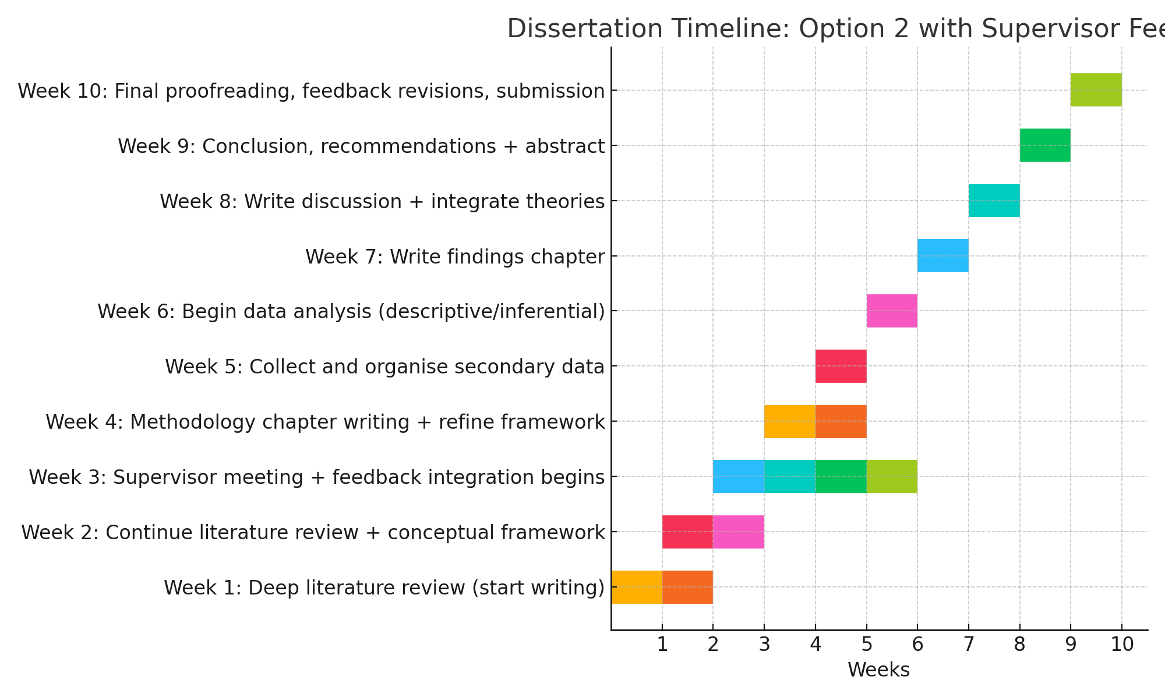

Ethical Considerations
This research will rely solely on secondary data, such as academic literature and publicly available datasets. No human participant primary data will be gathered. The study will obtain ethical approval from the university to ensure compliance with institutional guidelines, although it does not pose direct ethical risks. All data sources will be properly cited in accordance with principles of academic integrity, transparency, and responsible data utilization.

Conclusion
This research proposal aims to explore the long-term effects of remote work on productivity and organisational culture within the UK’s Technology and IT sector. As remote work continues to transform conventional business operations, the study seeks to offer a comprehensive understanding of its influence on employee performance, workplace dynamics, and the development of strategic policies.
By addressing key objectives - analysing productivity outcomes and evaluating the role of technology - the research seeks to generate valuable insights for organisations navigating digital transformation. The study will focus on understanding how remote work influences employee productivity, how organisations maintain and adapt their cultures in virtual environments, and what role technology plays in shaping these outcomes.

Through clearly defined research questions and hypotheses, the investigation will assess whether productivity is enhanced under remote arrangements and how digital collaboration tools impact both efficiency and team cohesion. Using secondary data, the research will also explore how organisations are adapting policies and identifying emerging best practices for long-term success in remote settings. Ultimately, this research aims to contribute actionable findings for business leaders and policymakers.

References

- Allen, T.D., Golden, T.D. and Shockley, K.M., 2015. How effective is telecommuting? Assessing the status of our scientific findings. Psychological Science in the Public Interest, 16(2), pp.40–68.

- Bailey, D.E. and Kurland, N.B., 2002. A review of telework research: Findings, new directions, and lessons for the study of modern work. Journal of Organizational Behaviour, 23(4), pp.383–400.

- Bloom, N., Liang, J., Roberts, J., and Ying, Z.J., 2015. Does working from home work? Evidence from a Chinese experiment. The Quarterly Journal of Economics, 130(1), pp.165–218.

- Bryman, A. and Bell, E., 2015. Business research methods. 4th ed. Oxford: Oxford University Press.

- Choudhury, P., Foroughi, C. and Larson, B.Z., 2021. Work-from-anywhere: The productivity effects of geographic flexibility. Strategic Management Journal, 42(4), pp.655–683.

- CIPD, 2020. Embedding new ways of working: Implications for the post-pandemic workplace. [online] Available at: https://www.studocu.com/en-gb/document/leeds-trinity-university/public-law/embedding-new-ways-of-working-implications-for-the-post-pandemic-workforce/84472169 [Accessed 29 Mar. 2025].

- Creswell, J.W., 2014. Research design: Qualitative, quantitative, and mixed methods approaches. 4th ed. London: SAGE Publications.

- Davis, F.D., 1989. Perceived usefulness, perceived ease of use, and user acceptance of information technology. MIS Quarterly, 13(3), pp.319–340.

- Denscombe, M., 2017. The good research guide: For small-scale social research projects. 6th ed. London: Open University Press.

- Donnelly, R. and Johns, J., 2021. Recontextualising remote working and its HRM in the digital economy: An integrated framework for theory and practice. The International Journal of Human Resource Management, 32(1), pp.84–105.

- Felstead, A. and Henseke, G., 2017. Assessing the growth of remote working and its consequences for effort, well-being, and work-life balance. New Technology, Work and Employment, 32(3), pp.195–212.

- Felstead, A. and Reuschke, D., 2020. Homeworking in the UK: Before and during the 2020 lockdown. WISERD Report. Cardiff: Wales Institute of Social and Economic Research.

- Field, A., 2013. Discovering statistics using IBM SPSS statistics. 4th ed. London: SAGE Publications.

- Ford, D., Storey, M.A., Zimmermann, T., Bird, C. and Jaffe, S., 2021. A tale of two cities: Software developers working from home during the COVID-19 pandemic. ACM Transactions on Software Engineering and Methodology, 31(2), pp.1–37.

- Grant, C.A., Wallace, L.M. and Spurgeon, P.C., 2013. An exploration of the psychological factors affecting remote e‐worker’s job effectiveness, well‐being, and work‐life balance. Employee Relations, 35(5), pp.527–546.

- Kramer, A. and Kramer, K.Z., 2020. The potential impact of the Covid-19 pandemic on occupational status, work from home, and occupational mobility. Journal of Vocational Behaviour, 119, p.103442.

- Messenger, J.C., 2019. Telework in the 21st century: An evolutionary perspective. Cheltenham: Edward Elgar Publishing.

- Messenger, J.C. and Gschwind, L., 2016. Three generations of telework: New ICTs and the (r)evolution from home office to virtual office. New Technology, Work and Employment, 31(3), pp.195–208.

- OECD, 2020. Productivity gains from teleworking in the post COVID-19 era: How can public policies make it happen? [online] OECD Publishing. Available at: https://www.oecd.org/publications/productivity-gains-from-teleworking-in-the-post-covid-19-era-a9c75a19-en.htm [Accessed 28 Mar. 2025].

- Saunders, M., Lewis, P. and Thornhill, A., 2019. Research methods for business students. 8th ed. Harlow: Pearson Education Limited.

- Schein, E.H., 2010. Organizational culture and leadership. 4th ed. San Francisco: Jossey-Bass.

- Turetken, O., Jain, A., Quesenberry, B. and Garber, S., 2011. Organizational adoption of telecommuting: Barriers and opportunities. International Journal of Business and Social Science, 2(3), pp.9–22.

- Walliman, N., 2011. Research methods: The basics. London: Routledge.

- Wang, B., Liu, Y., Qian, J., and Parker, S.K., 2020. Achieving effective remote working during the COVID-19 pandemic: A work design perspective. Applied Psychology, 70(1), pp.16–59.

