Thomas Rhys Evans
Student Number: 1810164
Software Development
Programs in C and documentation
(Part C)

Pairs card game
- Store an array of 12 integers to act as values for the pairs
- Store an array of 12 integers to act as values for each card
- Store int values for both card selections along with pairs counter/guesses counter
- Randomise array each time program is compiled to allow pairs order to be different each game
- Display on screen 12 cards for the user to choose from
- Allow user to input choice of which card to “turn over” first
- Check card hasn’t already been picked up and is within required range
- Display the value behind the chosen card to the user
- Allow user to input choice of which card to “turn over” second
- Check card hasn’t already been picked up and is within required range
- Display the value behind the chosen card to the user
- Check both values
- If values match
  - Add 1 to a pairs counter
  - Add 1 to a guesses counter
  - Set values to 0 to stop same cards being picked repeatedly
- If value don’t match
  - Add one to guesses counter
- Loop game until all pairs have been found
- Display how many guesses the user took to find all pairs

To allow the game to be used repeatedly, we must first randomise the order of the array containing the pairs values. A Fisher-Yates shuffled allows us to do this [1] [2]

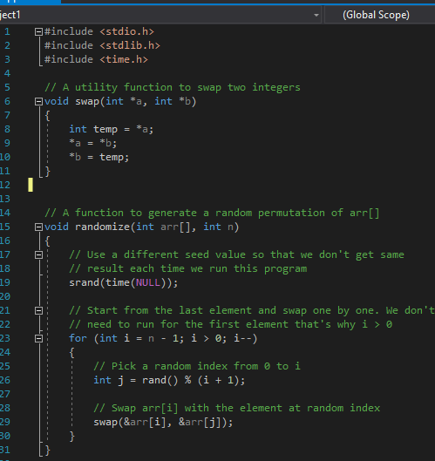

To test the function and randomization the array is printed multiple times to see the order of display

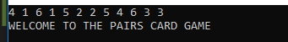
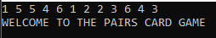
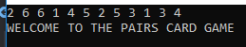
The order of each array is different each time. Once this has been confirmed, the game can be laid out for the user.

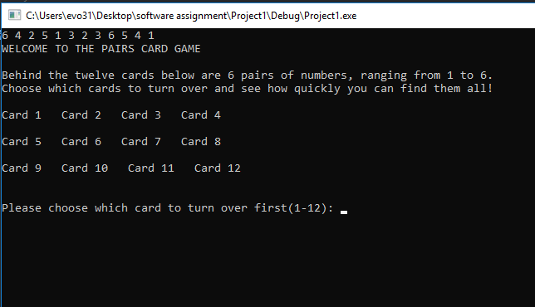

For testing and illustrative purposes, the array is left in the program initially. The program prompts the user for their first card selection, ranging from 1-12. Before prompting for card two

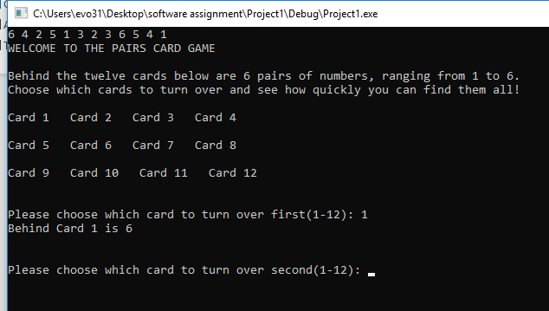

Once the user enters card number two, the program checks to see if their values match

If the values don’t match, the user is notified no pair has been found. Their guess counter increases by one and they are prompted to guess again

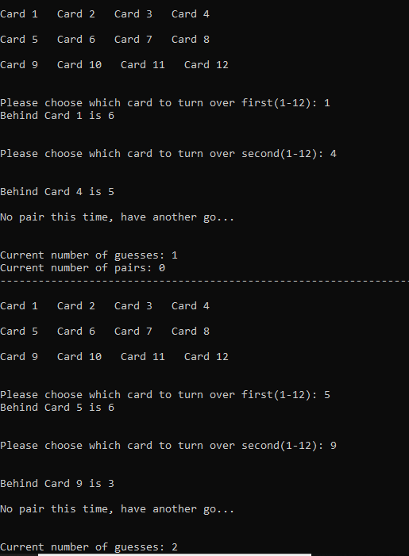

If a pair is found, then the user is notified that a pair has been found. One is added to both the pair counter and guess counter
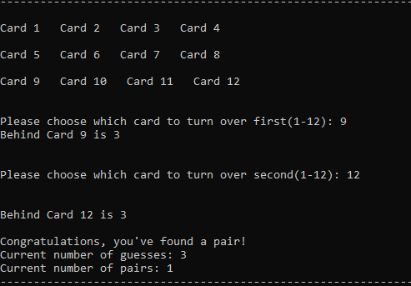

The program then sets the values behind the chosen cards to zero, before looping again. The only difference this time is that the 12 card grid displays “Card 0” for cards that have already been selected. This helps the user to keep track of what cards have already been selected as pairs

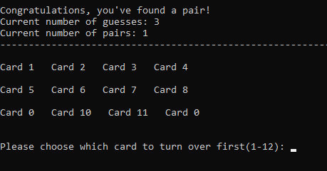

The user then works their way through the game, finding pairs.
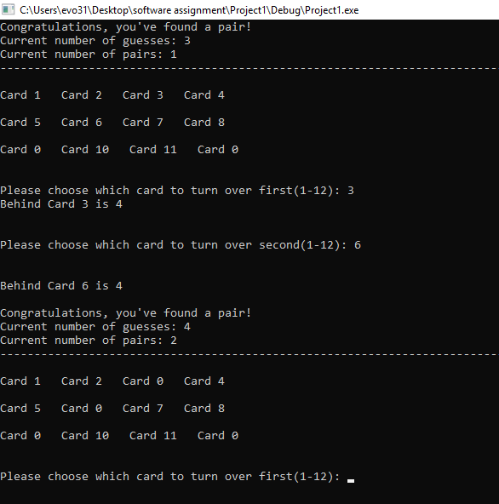

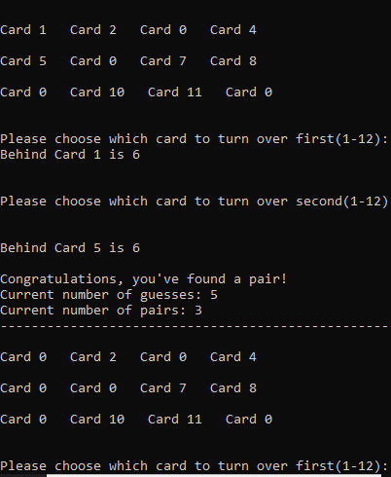
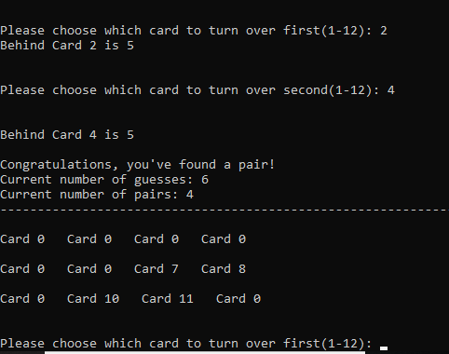

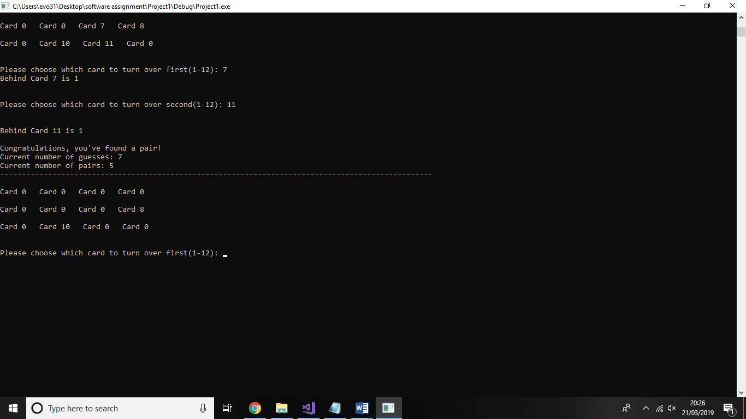
Until finally the final pair has been found:
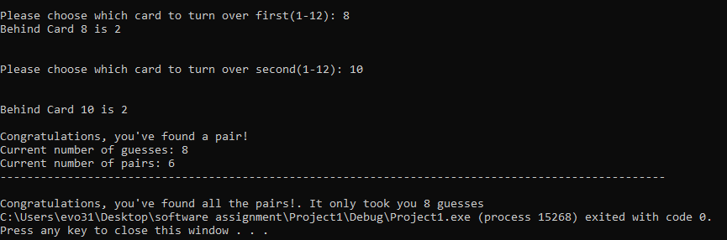

This is the outcome of the game if a player plays through without making any mistakes. Rules have been created to ensure that if a user inputs an incorrect card value, or tries to pick a card that’s already been chosen as part of a pair, then they are notified and prompted to reselect a card

Once the program has been fully tested, the print array is removed so the array order is a mystery to the user

Example of notification when trying to select a card that’s been previously picked as part of a pair (Card 1):

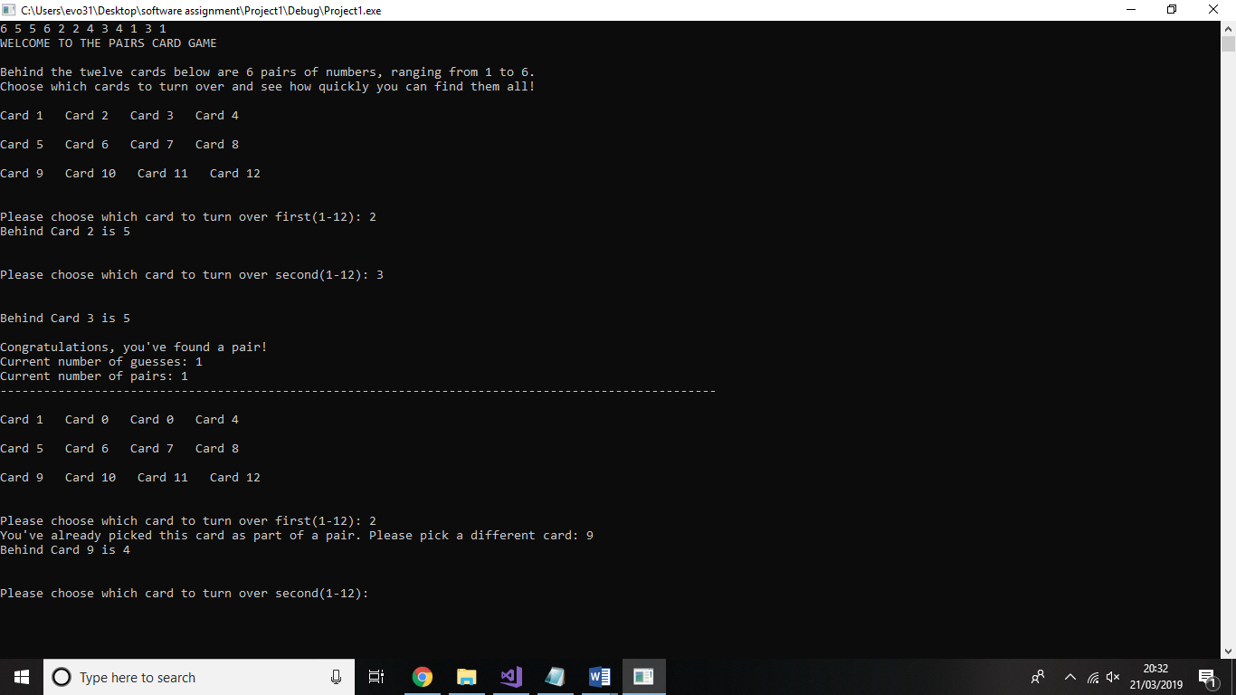

Example of notification when trying to select a card that’s been previously picked as part of a pair (Card 2):

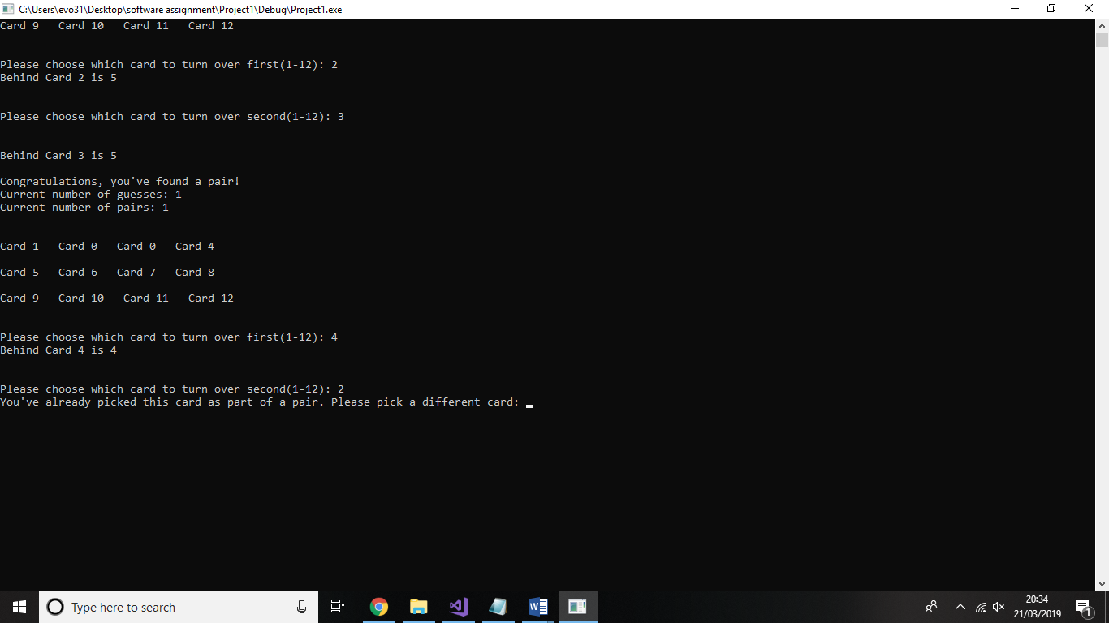

Example showing notification if card outside of range 1-12 is picked (Card 1):

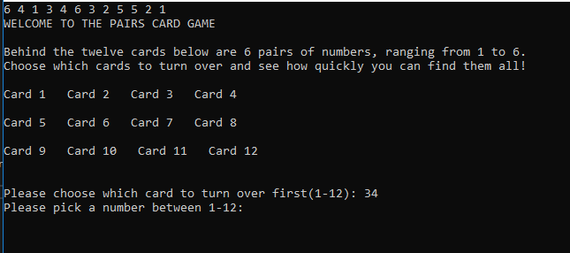

Example showing notification if card outside of range 1-12 is picked (Card 2)

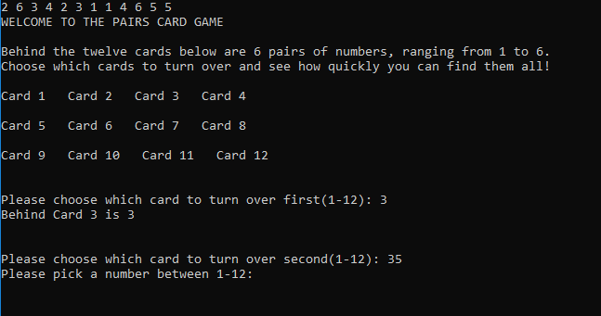

Annotated Code

#include <stdio.h>
#include <stdlib.h>
#include <time.h>

// A utility function to swap two integers
void swap(int *a, int *b)
{
int temp = *a;
*a = *b;
*b = temp;
}

// A function to generate a random permutation of arr[]
void randomize(int arr[], int n)
{
// Use a different seed value so that we don't get same
// result each time we run this program
srand(time(NULL));

// Start from the last element and swap one by one. We don't
// need to run for the first element that's why i > 0
for (int i = n - 1; i > 0; i--)
{
// Pick a random index from 0 to i
int j = rand() % (i + 1);

// Swap arr[i] with the element at random index
swap(&arr[i], &arr[j]);
}
}

// Driver program to test above function.
int main()
{
int arr[12] = { 1, 1, 2, 2, 3, 3, 4, 4, 5, 5, 6,6 }; //Array containing the values for each of the pairs
int card[12] = { 1,2,3,4,5,6,7,8,9,10,11,12 }; //Array for each of the Card numbers. Needed so once a pair has been found, int can be changed to 0 to stop user from picking same card twice
int n = sizeof(arr) / sizeof(arr[0]);

int paircount, overallcount, runningcount; // paircount keeps track of pairs. overallcount keeps track of number of guesses, both incorrect and correct. runningcount used to start off while loop
int card1, card2, choice1, choice2; //card 1 is the user first card pick. card 2 is the second card pick. choice1 and choice2 allow for a simple calculation that allows thee users selection to point to the appropriate array.

overallcount = 0; //All start on zero
paircount = 0; //All start on Zero
runningcount = 0; //All start on Zero

randomize(arr, n); //Function that randomises the array used for the order of the pairs. Allows game to have a differently arranged order of pair each time

printf("WELCOME TO THE PAIRS CARD GAME\n\nBehind the twelve cards below are 6 pairs of numbers, ranging from 1 to 6.\nChoose which cards to turn over and see how quickly you can find them all! ");

while (runningcount = 0 || runningcount < 6) //loop starts and continues until pairscount reaches 6 (the final pair)
{

printf("\n\nCard %d Card %d Card %d Card %d", card[0], card[1], card[2], card[3]);
printf("\n\nCard %d Card %d Card %d Card %d", card[4], card[5], card[6], card[7]);
printf("\n\nCard %d Card %d Card %d Card %d", card[8], card[9], card[10], card[11]);

printf("\n\n\nPlease choose which card to turn over first(1-12): ");
scanf("%d", &card1);

choice1 = card1 - 1; //This simple equation just points the card selection at the correct array. i.e card 1 points to array[0], card 7 to array[6] etc

while (card[choice1] == 0) // This checks if the card value has been set to zero. Values get set to 0 once pairs are found. If card = 0 then user is prompted to pick a new card and loops until completed

{
printf("You've already picked this card as part of a pair. Please pick a different card: ");
scanf("%d", &card1);

choice1 = card1 - 1;
}
while (card[choice1] < 0 || card[choice1] > 12) // This makes sure that the user chooses a card between 1-12 and loops until completed
{
printf("Please pick a number between 1-12: ");
scanf("%d", &card1);
choice1 = card1 - 1;
}

printf("Behind Card %d is %d", card1, arr[choice1]);

printf("\n\n\nPlease choose which card to turn over second(1-12): ");
scanf("%d", &card2);
choice2 = card2 - 1;

while (card[choice2] == 0) //This checks if the card value has been set to zero.Values get set to 0 once pairs are found.If card = 0 then user is prompted to pick a new card and loops until completed

{
printf("You've already picked this card as part of a pair. Please pick a different card: ");
scanf("%d", &card2);
choice2 = card2 - 1;
}

while (card[choice2] < 0 || card[choice2] > 12) // This makes sure that the user chooses a card between 1-12 and loops until completed
{

printf("Please pick a number between 1-12: ");
scanf("%d", &card2);
choice2 = card2 - 1;
}

printf("\n\nBehind Card %d is %d", card2, arr[choice2]);

if (arr[choice1] == arr[choice2]) // if the value of the number behind the first and second card match, a pair has been found. This part of the code then runs
{

card[choice1] = 0; //sets card1 value to 0. Stoops card being reselected and also displays "Card 0" in the card grid to help display to the user what cards have already been selected for ease of use
card[choice2] = 0; //sets card2 value to 0. Stoops card being reselected and also displays "Card 0" in the card grid to help display to the user what cards have already been selected for ease of use
overallcount++; //adds 1 to the overall guess counter
paircount++; // adds 1 to the pairs counter

printf("\n\nCongratulations, you've found a pair!");
printf("\nCurrent number of guesses: %d\nCurrent number of pairs: %d", overallcount, paircount);
printf("\n---------------------------------------------------------------------------------------------------"); //displays the current numbers of overall guesses, the number of pairs found so far, then loops if there are still remaining pairs to be found

}

else
{
overallcount++; //if not a pair, then one is added to guess counter
printf("\n\nNo pair this time, have another go...");
printf("\n\n\nCurrent number of guesses: %d\nCurrent number of pairs: %d\n", overallcount, paircount);
printf("---------------------------------------------------------------------------------------------------"); //displays the current numbers of overall guesses, the number of pairs found so far, then loops if there are still remaining pairs to be found

}

runningcount = paircount;
}
printf("\n\nCongratulations, you've found all the pairs!. It only took you %d guesses\n\n\n", overallcount); // once runningcount = 6, all pairs have been found. The message notifying the user the game is over is displayed, along with how many guesses it took to completed
}

[1] | “Fisher–Yates shuffle Wikipedia,” [Online]. Available: https://en.wikipedia.org/wiki/Fisher%E2%80%93Yates_shuffle. [Accessed 21 March 2019].
[2] | “GeeksForGeeks,” [Online]. Available: https://www.geeksforgeeks.org/shuffle-a-given-array-using-fisher-yates-shuffle-algorithm/. [Accessed 21 March 2019].

