An information sheet of the work placement
Dr Mz is a drop-in centre for 6–25-year-olds in the town of Carmarthen, Carmarthenshire. The Youth Service provides “a comfortable, safe, informative and stimulating place for young people to meet” and “enjoy good food and plenty of great activities, learn new skills, volunteer and get involved” (DrMz, 2020). The access to opportunities and experiences provided by Dr Mz allows young people to thrive and enrich their own personal development (Welsh Government, 2020).
The centre is run by Carmarthen Youth Project, and as of 2023 Dr Mz has been open and serving Carmarthen youth and its surrounding rural communities for 25 years.
Projects include:
- Gardening
- Cooking
- Free Meal Friday
- Community Volunteering
- Health and Well-being
- LGBTQ+ group
- Group trips out of the centre
- Parent and toddlers’ group
Dr Mz is a Charitable Company Limited by Guarantee which relies mainly on grant funding and donations, such as People’s Postcode Lottery and BBC Children in need (DrMz, 2020). The Youth Project is also supported by, and works closely with, Carmarthenshire County Council and Carmarthen Town Council, developing the project to support the needs of the young people and following the Youth Work Strategy for Wales (DrMz, 2020).
Dr Mz is educational, informative, and safe, aiming to “promote the best interests of young people” while assisting them to “develop their physical, mental, emotional and spiritual capabilities” (DrMz, 2020). This is in line with the Purposes of Youth Work in Wales through providing “safe environments and supports the development and well-being of young people” (Welsh Government, 2019).
Dr Mz’ commemorates Dr. Margaret Evans, a local G.P. and Councillor, ‘who’s vision enthusiasm and selfless efforts inspired the project’ (Dr Mz, 2020).

A critical examination of the roles and responsibilities of the trainee youth worker whilst on placement.
As a trainee youth worker, you are responsible for supporting young people aged 11-25 (or younger in some centres who have ‘transitional’ groups from the age of 7) with their personal, social, and educational development. Youth work can play a vital role by “providing opportunities for young people to establish a relationship with an adult (the youth worker) through which they can participate in personal and social development activities which are likely to improve their lives” (Ford et al., 2005, p96).
The diversity of youth workers, programmes and services offered by youth workers represent the enormous mix of youth work roles and responsibilities and the different priorities and relationships which are formed with the youth work settings (Davidson et al, 2011). Responsibilities of a youth worker can vary depending on the context they are working in with the young people. One of the main responsibilities of a trainee youth worker, or any youth worker, is the ability to act upon any issue that arises regarding a young person’s safety. The role and ethical responsibility of a youth worker to protect young people’s confidential and private information is uncontroversial, but being able to have the awareness to fulfil the role of safeguarding the young person and making them aware that their information cannot be kept when keeping them safe is also an important role (Sercombe, 2010). The role to undertake research to training on safeguarding of vulnerable groups of people is important within the youth work setting. Being able to distinguish between your roles and relationships with the young people and being clear about the limits to your role as a trainee youth worker, such as not having the responsibility of a senior youth worker when making decisions and acting upon the disclosures from young people. It is important for a trainee youth worker to make senior youth workers aware of disclosures and any concerns they may have.
Having a passion for the youth work sector is essential for ensuring you apply yourself in the best possible way while supporting young people. “Respect for young people is at the heart of youth work values in a profession that works ‘where young people are’ with positive, participative, and anti-oppressive approach” (Sapin, 2012, p3). These values need to remain at the forefront of the youth workers’ mind when delivering or taking on the responsibility of managing an area of youth work, and then reflected upon to ensure that your work is aligned with your values (Tyler et al., 2009). Youth workers recognise the strengths of the young people, who then use their approachable manner to encourage the young people to develop themselves. Blacker (2010, p.23) believes that “relationships are central to our practice” as youth workers. The effectiveness of our work relies upon our approach and the multiple different ways we can approach our conversation and interactions with others, such as with our young people. One of the main aspects of a youth worker’s role seen by many academics and youth workers, is the ability and importance to form positive relationships with young people. “Being friendly, accessible and responsive while acting with integrity” is seen to have fundamental importance when applying yourself as a youth worker (Jeffs & Smith, 2010). Davidson et al. (2011) findings show that more innate personality characteristics, such as “extroversion, high stress tolerance, or a nurturing personality” may support the explanation as to why some youth workers have the enhanced ability to form positive relationships with youth. The role of encouraging young people’s educational, social, ethical, and promoting social change encourages the young people to undertake activities that make a positive difference. This can include running and delivering projects on issues affecting the youth of today (National Careers Service, 2023), this could include focusing on issues such as health and wellbeing, and providing them with the skills for their future, such as cooking or resilience.
Trainee youth workers should be continuously seeking opportunities for their own development and learning. This includes asking questions and using the experience of the more experienced youth workers to enhance learning and development to provide better youth work and more opportunities and support to the young people. The role of a trainee youth worker is dependent on keeping up to date with the regulations and ways of delivering youth work. These include reading and adhering, where possible, to the National Occupational Standards for Youth work (Standards Council Scotland, 2022) and the Education Workforce Council’s Code of Professional Conduct and Practice (2023). These resources help the trainee youth worker maintain and improve their standards of professional conduct (EWC, 2023) while having the support to improve their practice throughout their careers to support the young people to thrive (EWC, 2023). Taking opportunities to gain familiarity with or experience of the demographic of youth, or the culture and environments (such as street experience) can help the youth worker with developing the relationships with the young people, therefore also benefiting the organisation outcomes as a result (Davidson et al., 2011). I was provided with the opportunity to take upon the role of planning and providing a session for the young people within the drop-in centre. Responsibilities included incorporation of the youth work NOS, such as ensuring that the young people were consulted and that it facilitated the development of the young people. I assisted in completing paperwork afterwards and reviewing the feedback of the activity from the young people, which contributes to the outcomes of the youth centre.
The setting where youth work is usually carried out is informal and incorporates educational, care and leisure activities. Sapin (2012, p9) identifies that “a centre-based youth worker may be responsible for the workers and activities within and around the centre as well as maintenance and upkeep. I was a part of overseeing the upkeep of the building/area that youth work is carried out in, such as ensuring the recreational areas and facilities are used appropriately and keeping the centre clean. This is a collective responsibility for all youth workers and volunteers. This was also done through supporting the message from the youth workers by educating the young people on how to ensure that their space is clean and accessible, facilitating life skills and social appropriateness.
Sapin (2012) identifies that acknowledging, identifying, and applying the values of youth work practice is important when in professional practice and establishing voluntary relationships with young people. When in the youth work setting the trainee youth worker should positively engage in conversation and activities with the young people to build strong professional and supportive relationships. Immersing yourself as a trainee youth worker is important to develop knowledge strategies of approach to the young people. This is seen in my reflective practice journals (see appendix). Developing relationships can be though the incorporation of ‘sideways conversations’ where activities, such as board games or pool, allow for opportunity informal conversations to develop relationships. Allowing conversation to take place without the stress of formal dialogue in a place where one “simply can ‘be’” can produce the most meaningful conversations (Smith, 2010, p26). Some young people are more difficult to engage with, but taking control of your own learning is important when managing an area where youth work can take place. Being able to ‘tip the power of control into young people’s favour’ has considerable potential learning opportunities for young people as well as other practical gains for the young people concerned (Batseeler & Davies, 2010). This role of empowerment and enabling the young people to choose how they can get involved and shape youth work is important to a trainee youth workers’ role as they are aligned and aware of the pillars of youth work. It demonstrates a commitment to creating a safe space that all young people can voluntarily choose to enter (Welsh Government, 2019).
According to Tyler et al. (2009, p.16), “all youth workers are responsible for the quality of their own work and are accountable formally to their employing organisation and their manager and informally to young people”, the responsibility is lower in the organisation hierarchy as a trainee youth worker. Working with a strong ethical base is important when working with young people, which involves management of oneself. Whilst developing the skills needed to become informal educators, the trainee youth worker is also building the necessary management skills, which “steadily becomes integrated in the wider range of responsibilities that the emerging professional undertakes” (Tyler et al., 2009, p16). According to Collander-Brown (2010), youth workers have a choice of what role they want to use and how to approach the young person, where judgements can be made, and responses are often needed in a short space of time. Knowing how to understand and respond to a situation, and making a judgement of how to respond is a responsibility that is placed upon the youth worker. “Choosing your role becomes with practice, a conscious professional action, an element of reflective practice” (Collander-Brown, p.44). They “must identify a feasible and appropriate way” of behaving and reacting depending upon the three factors: “the young person, situation and yourself” (Collander-Brown, 2010, p.45). There are limitations to the role such as not knowing the young people on a great enough personal level to act in a way that is appropriate to them. As the trainee youth worker continues throughout the placement, they can develop professional relationships and understand the young people and the different issues they may be facing and ways of communicating in a way which is most appropriate.

A community profile
According to the 2021 census the county of Carmarthenshire is the 4th largest local authority in Wales, with a 9.5% population increase since 2001 (ONS 2021). Carmarthen is the oldest continuously occupied town in Wales dissected by the longest river in Wales, the River Tywi, described as the town’s ‘main artery’ which still supports the ancient generational craft of coracle fishing (Williams, 2021). The town of Carmarthen is split into three Middle Layer Super Output Areas (MSOA); Carmarthen West & Cynwyl Elfed, Carmarthen North and Carmarthen South & Llangynnwr (ONS, 2021). These are geographical areas of between 2,000 and 6,000 households (ONS, 2023). These MSOA areas encompass the postal addresses of Carmarthen, SA31 1, SA31 2 & SA31 3 (Royal Mail, 2018, p.3). The population of Carmarthen during the 2021 Census is 14,600 people (rounded to the nearest 100 people) (ONS, 2021). 18% of the population are 0-14 years, 9% are 15-24 years, the main working population aged 25-64 years make up 73.8%, and 65+ are 22.7% of the population (see figure 1).

Figure 1: The Age of a person (in three Carmarthen MSOA; Carmarthen West & Cynwyl Elfed, Carmarthen North and Carmarthen South & Llangynnwr) on Census Day, 21 March 2021 (ONS, 2021)
93.1% of the population identified as White, 3.3% with Asian ethnic descent, 1.0% with Black ethnic descent, and 2.7% as mixed/multiple ethnicities or another ethnic group (ONS, 2021). The Census (Census) indicates that 9.1% of Carmarthen’s population are born outside of the UK.
Across the three Carmarthen MSOA, 52.5% (combined average) of people aged 16 years and over are in employment (excluding full-time students), with the largest Socio-economic Classification (NS-SEC) being L4, L5 and L3: Higher managerial, administrative, and professional occupations (ONS, 2021). “The NS-SEC indicates a person’s socio-economic position based on their occupation and other job characteristics” (ONS, 2021). The main major employers are Carmarthenshire County Council and Dyfed Powys Police (Carmarthen Town Council, 2022b).
Poverty is identified as a main issue affecting the population. 52.1% of the population within the three MSOA are defined as deprived in one or more dimensions of education, employment, health, or housing (ONS, 2021). At the time of the 2021 Census 47.2% of the Carmarthenshire population rated their general health as ‘very good’, 31.5% as ‘good’, 14.4% as ‘fair’, and 6.9% as ‘bad or ‘very bad’ (ONS, 2021). These figures were collected during the COVID-19 pandemic, which could have had a negative effect on the overall health of the general population at the time, and therefore the responses. 10.5% of the Carmarthenshire population who identified as disabled (under the 2010 equality act) stated that their long-term health problem or disability (including conditions or illness related to old age) limits their day-to-day activities ‘a lot’ (ONS, 2021). While 11.1% stated that their disability limits their day-to-day activities ‘a little’ (ONS, 2021).
The ‘prioritise/critical issue for areas’ within the Carmarthenshire well-being report identified that almost a third of children and households are living in poverty, with in-work poverty becoming an increasing problem (CPSB, 2022). Carmarthen town is one of the areas identified as being a Carmarthenshire ‘pocket of deprivation’ (Carmarthenshire Youth Justice Team, 2021). More working families are experiencing poverty in conjunction with the cost of living rising across the UK (CPSB, 2022). The average total household income for the three MSOA (financial year ending March 2020) is £39.3 thousand (ONS, 2023). Whereas the disposable (net) average household income after housing costs is £26.6 thousand, or only 2.2 thousand a month (ONS, 2023). This is compared to the Carmarthenshire average of £27,148, which the 8th lowest out of the 22 Wales local authorities, which is 3% below the Wales median of 27,962 (Carmarthenshire County Council, 2021). These household income figures from the Office for National Statistics are an average. This obscures the true distribution of local area incomes, which hides the more extreme low values that exist within the area (ONS, 2023). The highest concentration of households socially renting from council or local authority are in Carmarthen North, with 16.3% of household tenure (ONS, 2021). Carmarthen North also have the lowest disposable household income, after housing costs, of £26 thousand, compared to Carmarthen West & Cynwyl Elfed at £27.4 thousand, and Carmarthen South & Llangynnwr at £26.5 thousand (financial year ending March 2020) (ONS, 2023).
42.9% of people aged 16 years and over (combined average %) are classed as economically inactive, with an average of 7.5% in the NS-SEC of ‘never worked and long-term unemployed’ (ONS,2021). These figures also include the concentration of student population of roughly 1,800 (Carmarthen Town Council, 2020). According to the Office for National Statistics (2021), full-time students are recorded in the ‘full-time students’ category regardless of whether they are economically active, such as having part-time jobs alongside their studies. The student population disproportionately increases the unemployment figures, with the University of Wales Trinity Saint David (UWTSD) situated within the MOSA of Carmarthen West & Cynwyl Elfed, where 9.1% of people aged 16 years and over are full-time students. Across the three Carmarthen MOSA the average combined full-time students aged 16 years and over is 7.1% of the population, with an average of 1.9% of full-time students also in a form of employment (ONS, 2021).
Carmarthen remains an important commercial, educational, and administrative centre within Wales. Its port reflects the historical and industrial importance along with one of the oldest indoor markets in the UK still drawing shoppers to the Fairtrade Town (Williams, 2021; Royal Mail, 2018). The Carmarthen Chamber of Trade and Commerce represents the business community of Carmarthen and promotes trade in the town (Carmarthen Town Council, 2022c). The historical importance of farming within the town and surrounding Carmarthenshire County has attracted manufacturing and other food industries to the county (Carmarthen Town Council, 2022c), further developing the town’s industries. Carmarthen also houses one of the Welsh Government office buildings (Welsh Government, 2023). Education within Carmarthen is available in both the English and Welsh language, along with primary and secondary provision of special educational needs education (Carmarthen Town Council, 2022c). Coleg Sir Gâr provides a range of further and higher education courses, while The University of Wales Trinity Saint David (UWTSD) offers a range of bilingual degree courses (Carmarthen Town Council, 2022c; UWTSD, 2023).
Carmarthen Town Council was established in 1974 and covers three wards occupying “some 2,064 hectares,” which consists of eighteen elected members operating on a committee-based structure (Carmarthen Town Council, 2020). Carmarthen Town Council communicates its key messages and information across the communities within Carmarthen through its various social media platforms (Carmarthen Town Council 2022a). This helps promote health and well-being, highlight the events and activities within the local community and create opportunities for people to come together, such as the council loneliness project, in line with the Carmarthenshire County Well-being Assessment objectives (Carmarthenshire County Council, 2022). The Carmarthen Town Council (2022b) website states 6 charity organisations, including the Carmarthen Foodbank and Mind mental health, 3 religious organisations, 2 youth organisations, 2 social/sports clubs and a Community Team for Learning Disabilities in its geographical area. The young people of Carmarthenshire have the chance to be involved in giving the young people within the county a voice through being a part of the Carmarthenshire Youth Council (or CYC), which is made up of 50 young people aged 11-21 years old within 4 main areas of Education, Universal, Special Interest and Welsh Youth Parliament (CYC, 2024). The aim of the CYC is to create opportunities for young people within the county to participate in decisions and issues which impact their lives, and bring about positive change (CYC, 2024).
At local level, Carmarthen Town Council are responsible for the maintenance of several public parks and play areas within Carmarthen (Carmarthen Town Council, 2020). These are public spaces which are ‘predominantly natural’ and “make an important contribution to the quality of the environment and life in urban and rural areas” (Carmarthenshire County Council, 2020). 69% of Carmarthen residents are within 480m of Public Amenity Green Space (Carmarthenshire County Council, 2020), which is a good figure across the Carmarthenshire settlements. Numerous research studies conclude that “access to local, quality green space improves the physical and mental health and wellbeing of all sections of the community” (Fields in Trust, 2018, p.6). Near the centre of the town lies Carmarthen Park which encompasses a concrete cycle track and arena, a rugby club, open parkland with skatepark and a children’s play area (Carmarthen Town Council, 2022c). The Carmarthenshire Local Well-being Assessment (CPSB, 2022) identified from recent consultation in 2020, that “77% of interviewees referred to community cohesion as good” with in Carmarthenshire. The county is one of the safest areas in the UK, ranking 9th safest out of 22 local authorities in Wales (ONS, 2021). Despite this, the crime rate in Carmarthen itself has increased, with violence and sexual offences being the most common crime, increasing by 16% over the 2021-22-year period (Crime Rate, 2023).
Although the county of Carmarthenshire has an increasing population, the numbers of Welsh speakers continue to decrease. For the first time ever, the 2011 census showed that the percentage of Welsh speakers in Carmarthenshire fell below half of the population (Phillips, 2014). 49.8% of the population of Carmarthen can speak, read, write, or understand Welsh, while 50.2% of have no skills in Welsh (ONS, 2021). Reported in the 2021 Census, 39.9% of people aged 3 years and over in Carmarthenshire can speak Welsh, with the three MSOA of Carmarthen having a combined average of 37.9% of Welsh speakers (ONS, 2021). In some of the surrounding Carmarthenshire communities, Welsh is the majority language used on a day-to-day basis (Carmarthen Town Council, 2022c). Phillips (2014) states that “Welsh speakers in the county are now the minority in an area traditionally considered to be one of the language’s heartlands”.

An in-depth SWOT analysis of the organisation
The organisation has a good stance within the community and has been running for 25 years. This strong position within the community provides the opportunity for the continuous support and acknowledgement of importance from the local town council and the county council. The youth centre closely observes the changes and current legislation within the within the Youth Work Strategy for Wales, helping them formulate their sessions and projects by promoting equality and building resilience (DrMz, 2020). The charity has good links with external organisations, such as the Carmarthenshire County Council youth service team and the local secondary school, who both rent out a meeting/classroom space. This provides links for funding and support, along with an extra income for the charity. The use of social media increases their reach to those in need and increases awareness of the charity’s mission, resulting in the possibility of extra support and financial assistance. Through the application and securing of the position on the Tesco Blue Token scheme the organisation has been able to raise funds and awareness from local shoppers, who can read the charity’s project mission and donate. The funding from this scheme will go towards resources for their outdoor garden in the summer which will help educate the youth on where their food comes from, gain food preparation skills, and reduce the financial strain of food provision on the charity.
Recent funding secured has meant that the charity is now able to offer a free meal to all youth who attend on a Friday evening. This supports many families who are struggling with the cost-of-living crisis or are in poverty within the area. The sociological change of increased numbers of those within poverty in the community has placed increased pressure on the charity to provide their free meal. As with most of their income avenues, this is threatened by the uncertainty of the length of time this funding will last, or if further funding is available to continue the project. The young mum’s (under 25 years old) and baby group has currently been put on pause due to the funding running out. The application for further funding has been put in, but there is no date for when this project can recommence.
Acting strategically to the possible and emerging threats and opportunities can make the organisation more able to find new ways of obtaining funding to increase their impact and use their funds and resources more wisely. Taylor (2017) identifies that the threats to open forms of youth work, such as drop-in centres, are not just post-recession funding cuts but more far-reaching, such as ideological threats from capitalism and the impact measurement agenda. There are no dedicated roles within the charity, the team leader/manager has responsibility for finance, fundraising applications and cleaning is done by the youth workers. There are no external businesses involved with the charity’s day to day workings and functions. These are some of the many pressures that continue to threaten the functioning of the organisation. Many believe that the youth workers aren’t paid what they should be for all the hard work they give to the charity, but they are very passionate and put their young people first through the strength of their strong dedication to the organisation. The strength of the youth workers enables the organisation to foresee when the funding will run out, and when to apply for their next financial funding creating more opportunities for the young people.

A summary of your own learning and development, linked to your professional development plan and underpinned with reference to examples from your practice and appropriate literature such as National Occupational Standards for Youth Work.
A Youth Worker should be “outwardly proud of the valued, essential work they do with young people” (Welsh Government, 2019). Throughout the placement, as new opportunities for learning and development arose, my self-confidence increased and my recognition of the importance of my participation within a youth work placement was ever more apparent. Actively seeking opportunities to engage in conversation and interaction with the young people in different ways enabled me to gain new ways of developing professional relationships between myself and the young people. As a result, this has helped my practice develop, allowing me to provide more support to the young people and carry out more effective youth work. I have been able to build professional relationships and have learnt different ways of engaging with the different groups of young people, and developing the ability to “initiate, build and maintain relationships with young people” (Standards Council Scotland, 2022). I was able to build upon my current approaches of interacting with young people from my time as a youth worker within Girlguiding, but also develop new approaches to interaction and building relationships with young people in a drop-in centre environment. I have learnt new ways of communication and delivering non-formal activities to support the personal, social, and educational development of the young people.
I have promoted and developed ways to incorporate the 5 pillars of principles and purposes of youth work in Wales within my practice, ensuring that the youth work I carry out is Educative, Expressive, Participative, Inclusive and Empowering. This was seen within my session planning of activities to ensure that the principles and purposes were met. I provided the young people with the opportunity to lead the youth work through the planning and choice of activity they wanted to participate in. This helped me to learn how young people want to get involved with youth work and helped me develop my methods of engagement with the young people. Through being open and approachable I had positive engagement and multiple ideas by using pre-activity consultation with the young people. Hart’s (1992) ladder of participation helped support my learning of participative youth work. I ‘consulted and informed’ the young people which enabled the choice of activity to be ‘child initiated and directed’. This reflects the values and pillars of youth work, creating an opportunity for young people to be participative in their youth work, being inclusive so young people can get involved and empowering and expressive, educative due to allowing young people to learn new things enabling the opportunity for young people to build on their strengths and trying new things while having fun. Throughout this process I ensured my development and learning of implementing the Youth Work NOS (2019) while planning, consulting, and carrying pout the activity, such as ‘planning and implementing learning activities in youth work’ and ‘engaging young people in the strategic development of youth work’. After the activity I discussed with the young people and my learning mentor to gain feedback on my practice of what went well and what could have been improved or done differently next time. This was important in my learning and development as I was able to reflect upon my practice, gain insight into what the young people like, different approaches to working with the young people, and how I am using the 5 pillars within my youth work and how I can improve further for next time I plan and carry out activities.
The opportunity to interact with young people in a different setting allowed me to develop my confidence when encouraging young people to participate. The activities and open youth work opportunities allowed me to facilitate the personal and social development of the young people while allowing me to engage in conversation and develop my active listening skills. I started conversations in an environment where the young person is comfortable and relaxed, such as engaging in mindfulness colouring or sitting at the bar. Through my time at the youth centre, I developed ways of moving the conversation forwards, allowing the young person to take control of the situation, tipping the balance of power in favour of the young person. This enables the young person to converse in a way they are able to exercise their ongoing choice to engage. This allows for engagement within the purposes and values of youth work, laying the opportunity for power to be held by the young person, making youth work inclusive and participative. Being interactive and approachable enabled me to build trust and positive professional relationships to allow the youth to express themselves and communicate their experiences and feelings when in the safe space of the drop-in youth centre. “By initiating dialogue and listening closely to youth we can find a way to those experiences”, while also “orienting the conversation towards topics that matter to youth” (Wasserman, C. et al, 2018, p64). While listening and openly having conversations with the young people they became more comfortable with beginning conversations with me, asking me questions or asking for help when completing tasks. Positive relationships with trusted adults allow young people to benefit from youth work and helps to guide them though and explore new experiences (Welsh Government, 2019). Sometimes it does prove difficult to come up with conversation starters or to ensure that the conversation continues to develop, especially with the young people who are quieter when engaging with conversation with the youth workers, but I am developing my dialogue and engagement skills. I have been able to also develop my professional relationship with the other youth workers through these conversations with the young people, and asking for support to aid my development where I can.
Over the course of my time in the youth centre I developed my awareness and inclusivity of the different groups of young people. The opportunity to participate in the LGBTQ+ drop-in session was a valuable learning and personal and professional experience for me. Having respect and unconscious bias, which I can develop upon further as my understanding develops, was a good way to enter their safe space. It was nice to listen to open conversations between the young people and youth workers about issues facing them and the process and struggles they go through. I actively listened to gain knowledge and understanding and asked a question on how the transitioning process and barriers made the young person feel. I have since done some of my own reading to facilitate the development of my learning and knowledge, into professional boundaries, having conversations and focusing on the use of oneself within youth work. Being a good youth worker is being able to adapt to the different situations and developing trusting, respectful and voluntary relationships with young people within professional boundaries that can change and develop as the work with the young person increases over time. Youth work practitioners should know what range of internal and external aspects influence the life and responses from young people, along with understanding how their identities impact upon their understanding of their self and the young people (Hatton, 2022).
Having critical and ongoing reflective practice can help increase awareness and support the understanding of the youth worker. Using reflective practice, I was able to analyse my own practice and the situations I was a part of. I could use the positive and negative experiences as opportunities for learning, which enabled me to build upon my practice. I did this through obtaining keeping a reflective journal and asking for feedback from others, such as colleagues, learning mentor, young people, and utilised supervision opportunities to discuss my practice and reflect upon everything which is encompassed in my practice as a youth worker within a drop-in environment. While participating in the placement I kept notes and records of my own learning and development and anything I found necessary for the development of my own knowledge within the field. I changed my way of record keeping while on the placement in the drop-in centre which resulted in being a more effective way for myself to record information, and to make it easier to transfer into my work. I learnt to keep on referring to the National Occupation Standards where possible, such as in planning and when reflecting upon my practice, which helped me keep in mind the standards at which my practice should be adhered to, promoting my development within the youth work field.
I will take forward my positive engagement strategies with the young people more and whenever the opportunity is available, whether being asked to join in or beginning conversation, allowing for the young person to be the centre of the youth work. The engagement strategies have a positive impact on my practice moving through my youth work as it allows for dialogue, making way for a deeper understanding of the young person and building upon ecological intelligence of the young person (Jeffs & Smith, 2010). I have reflected upon my communication skills and have learnt to pause and process my response in a way which is appropriate to the young person and the situation within a professional context. This has helped me develop my communication response and reflect upon how my body language provides valuable non-verbal cues.

Appendices

Reflective Journals
Gibb’s Reflective Cycle – Gibbs G (1988). Learning by Doing: A guide to teaching and learning methods. Further Education Unit. Oxford Polytechnic: Oxford.
- Description of the experience
- Feelings and thoughts about the experience
- Evaluation of the experience, both good and bad
- Analysis to make sense of the situation.
- Conclusion about what you learned and what you could have done differently.
- Action plan for how you would deal with similar situations in the future, or general changes you might find appropriate.

Journal 1 – boundaries within youth work.
A young person was upset and came to me once I asked if they were ok, they explained why they were upset. I feel that from previous experience I am aware and can notice when a young person is upset. I can offer support to those who are struggling and have previous experience of having difficult safeguarding conversations. This positively helped me when approaching the situation of a young person being upset and asking if they are ok. The young person became confident in me and shared the personal situation of being adopted. This positively made me feel that I come across as a trusting person, but also made me feel sightly anxious about the responsibility if something was disclosed or said to me. Being someone who is there to listen to their problems, worries and provide support when it is needed is an important part of being in youth work. Being a successful youth worker is built upon the trust within relationships formed which supports open communication and sharing of information, but also being able to identify limits around the appropriate behaviours within the professional relationships (National Youth Agency, 2021). This is important within my reflection upon the situation, as it could have been a lot worse, such as a major safeguarding issue being reported to myself without another youth worker around, rather than the misunderstanding and heightened emotions. The limitation of my role as a trainee youth worker during this situation was that I didn’t have the rapport built up with the young person and knowledge of their family situation that the other youth workers already have. I should ask another youth worker to come into the situation and make sure there are two of us at the time of disclosure for personal safeguarding and account of the situation and then they can use their responsibilities, such as making a phone call to parent or guardian.
Boundaries are in place to ensure that everyone involved are safe in relationships where there is an impower balance (National Youth Agency, 2021). This includes myself as a professional, where the importance of safeguarding yourself is significant within the youth work setting (in response to someone reporting me being seen to offer the young person a hug of reassurance).
I will improve my learning and development by looking at different identities, attachment styles and trauma experiences of young people with looked after or care experiences. This will help improve my knowledge and ways of providing support to improve wellbeing of young people. Improving my active listening skills going forward can make a big impact upon my practice and professional development but will also improve the support I can provide to young people, ensuring that they feel heard and understood which is important in building trust, creating and safe space and supporting their personal and social development (Young Minds, 2023).
Journal 2 – developing an understanding through positive relationships.
I am happy with the development of my relationships with the young people who regularly attend the drop-in centre. The relationship with one young person with ALN (Additional Learning Needs) has positively been developing over the two weeks I have been in the youth centre. He now answers my conversation and has less negativity and aggression to me chatting with him. He willingly explained his computer game to me and smiles when we joke together. He has also begun to ask me for items in the tuck shop rather than just the employed youth workers. This is an example of a positive development of a professional relationship with the young person, this is important for my professional development and the personal and social development of the young person. I am aware and recognised that previous behaviour seen as aggressive was not personally directed towards me, which was not the young person’s intention. Knowledge provided by other youth workers about the young person’s care experience was important in how I approach the behaviour as previous trauma situations young people have experienced can impact the behaviour which they display to others around them. I was able to use this experience, previous knowledge, and discussions with youth work colleagues to help me think about strategies of support, and how to help make the young person feel comfortable and accepted within the youth work environment while helping to support their personal and social development. This helps the ensure that young people are equal and face no discrimination within their environment, and as a space for support while being inclusive, following the Youth Work Strategy for Wales (Welsh Government, 2019). The youth centre received feedback from the young person’s foster parents, his aggression and development of relationships with themselves, peers and youth workers has seen to have positively improved. This captures the positive outcomes that youth work plays with in a young person’s life. This was noted by the youth centre which is positive for the youth centre to measure success.
I believe it was a good experience for both me and the young person for supporting both of our developments in personal, social, and professional ways. It is difficult to develop the initial breakthrough of a creating positive relationships with a young person who isn’t as easily adaptable to change within a familiar environment due to their past experiences or ALN. Speaking with a senior youth worker for an informal development plan for young people with ALN could be implemented within the youth centre. This will allow for all youth workers and those who are on placement to understand the youth person and what approaches, or extra support is needed for them to achieve their full potential while at the youth centre. This could include aspects such as behaviours, targets, and monitoring their progress and development, which is important for their self-esteem & social development to be able to overcome issues with aggressive communication, and positively interact with in a group setting.
As I continue through my placement, I will continue to actively seek opportunities to engage in conversation with young people in different ways to develop the professional relationships between myself and the young people to enable me to provide support and better youth work. Getting to know young people on an individual basis can help me to understand them and develop my youth work approach which can support the young people on their level. This can be though the incorporation of ‘sideways conversations’ where activities, such as board games or pool, allow for opportunity informal conversations to develop relationships. Allowing conversation to take place without the stress of formal dialogue in a place where one “simply can ‘be’” can produce the most meaningful conversations (Smith, 2010). Some young people are more difficult to engage with, but I am trying to progress with the relationships and my youth work practice.

Journal 3 – putting young people first.
This evening the Christmas decorations were put up in the centre. The centre manager encouraged all the young people to help and put three baubles of their choice on the tree. I did initially struggle with many things happening at once and others interrupting what I was doing when I was trying to complete a task, but I adapted to the busy environment and continued to ask the youth to help me with the tree. I took into consideration the young peoples’ participation within the youth centre, having a say in how the space is used to bring young people together in groups and shared activities, this wasn’t an activity that was just for me to complete. These arts-based activities can facilitate discussions and create the opportunity for myself to build positive professional relationships with the young people. Many willingly engaged in the decorations and it was a positive environment for everyone involved.
The young people asked me to join in with their card game today, rather than me asking to join in. This made me feel good about the work I have done to get to know them, and its positive to know that they want me to be a part of their youth centre experience. These activities and games allow for group relationships to develop, facilitate personal development and learning, such as taking turns and communicating with others.
A new young person with ALN joined the centre tonight with their carer/support worker. I supported her with learning a new card game with other young people. I used my previous experience of engaging with ALN young people to converse with her in a way she felt supported and included while playing the game with others. I felt confident in my experience of working with young people with ALN, and the young person left the centre happy with her experience.

Journal 4 – inclusion and engagement with young people.
I took part in an LGBTQ+ drop-in session for the first time. I do have friends within the LGBTQ+ community, but it was unknown for me as I am not a part of the LGBTQ+ community myself. There was Christmas craft and activities available for the young people, so I encouraged them to try something, and I joined in myself.
I mistakenly using the wrong pronouns for the young people once or twice due to social bias and habit within my life as I haven’t been in this social situation before. One of the youth workers abruptly made me aware of what I said, thinking I used the wrong pronouns, but it was a mishearing. I did apologise openly before I left if I did use the wrong pronouns in case anyone was misaddressed as I did not want to make the young people feel as if I wasn’t inclusive or was rude towards their identity. This situation made me feel like more of an outsider and that I need to increase my awareness and change my usual way of thinking. I am willing to continue to learn about the different communities and social aspects young people today are a part of and how society affects their lives.
I came into the session open minded but learnt a lot more about the different aspects of acceptance and inclusion from the young people and the other youth workers. It was good to have the opportunity to experience a new demographic of young people, which was a new experience out of my own comfort zone. Having respect and unconscious bias, which I can develop upon further as my understanding develops, was a good way to enter their safe space. It was nice to listen to open conversations between the young people and youth workers about issues facing them and the process and struggles that come with transitioning. I actively listened to gain knowledge and understanding and asked a question on how the transitioning process and barriers made the young person feel.
I have since done some of my own reading into professional boundaries, having conversations and focusing on the use of oneself within youth work. Being a good youth worker is being able to adapt to the different situations and developing trusting, respectful and voluntary relationships with young people within professional boundaries that can change and develop as the work with the young person increases over time. Youth work practitioners should know what range of internal and external aspects influence the life and responses from young people, along with understanding how their identities impact upon their understanding of their self and the young people (Hatton, 2022). Having critical and ongoing reflective practice can help increase awareness and support the understanding of the youth worker.
A reflective discussion took place with my where we went through the best way to approach the topic and address the young people with your pronouns when you introduce yourself, so they can too. This can help prevent any confusion or accidental misuse of pronouns. We also went through developing relationships with the young people, but also how to wind down the reliance on the relationships before I finish the placement.

Journal 5 – consultation, participation, and planned activity.
My planned activity – Christmas craft – cork reindeers, pipe cleaner Christmas trees & wool pompoms.
My aim was to present the young people with an opportunity to choose an age-appropriate activity they would choose to participate in and have a positive engagement with while bringing them together and create opportunity for conversation to take place, resulting in a development of relationships.
Before the session I consulted with the young people at the centre about what they would like to do at the youth drop-in. In the previous Christmas activity (journal 3) I noticed that some of the young people wanted to take some of the decorations made home with them and it created an opportunity for creative activities. The consultation had positive engagement and multiple different ideas (see consultation plan in appendix). I acted open and facilitated youth-led youth work to take place. This is important to provide opportunities for personal, social, and educational development, and empower choice and voluntary participation. The goal of youth work should be to involve the young people in the managing and facilitation of the activities to promote their ownership of the youth work the participate in. I implemented the Youth Work NOS while planning, consulting, and carrying pout the activity. ‘Plan and implement learning activities in youth work’, engage young people in the strategic development of youth work’. “The participative nature of youth work recognises young people’s rights to choose whether to be involved and to make decisions about issues that affect them” (Sapin, 2009).
Hart’s (1992) ladder of participation reflects the level of participation and decision I provided to the young people within the youth work activity I provided. I involved the young people in the planning of my activity. I ‘consulted and informed’ the young people of the task I had, which enabled the choice activity to be ‘child initiated and directed’. This reflects the values and pillars of youth work, creating an opportunity for young people to be participative in their youth work, being inclusive so young people can get involved and empowering and expressive, educative due to allowing young people to learn new things enabling the opportunity for young people to build on their strengths and trying new things while having fun.
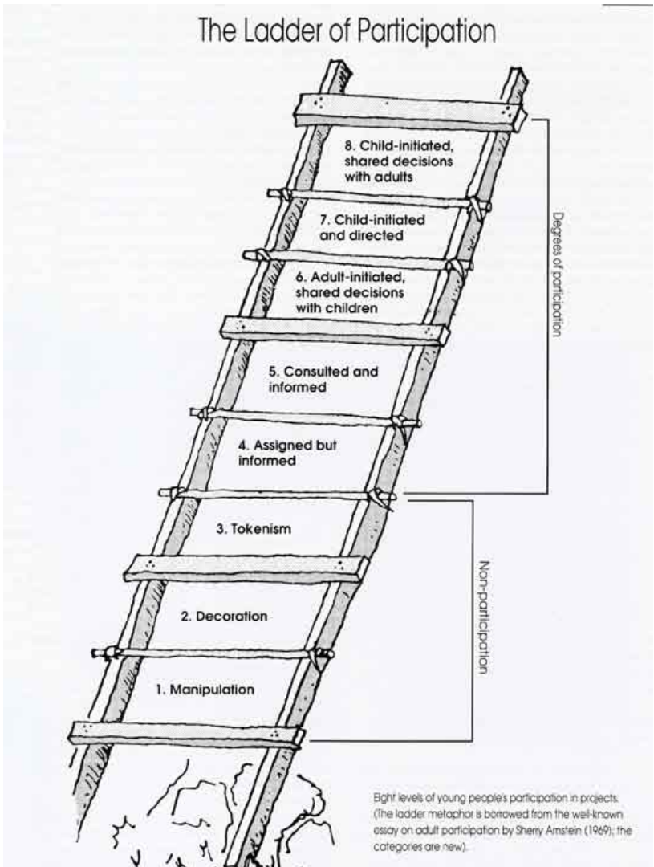
Image: Hart, Roger A. (1992). Children's Participation: From tokenism to citizenship, Innocenti Essay, no. 4, International Child Development Centre, Florence
If I had more time at the youth centre or if I was an employed youth worker I would provide more sessions where the other activities and ideas that were put forward by the young people would be further consulted upon and then planned so the young people can engage with different opportunities and have more of a say in what they participate in and what is provided to them in the youth centre.
When planning the activity, I ensured to use as much of the resources that were already at the centre, to ensure that there wasn’t a big financial impact upon the youth centre and what they provide. I used my previous experience and knowledge to make informed decisions of activity set up. I ensured that health and safety was adhered to, such as placing the glue gun where the wire would not be a trip hazard and provided supervised use. I complied with legal, regulatory, and ethical requirements for youth work (NOS) and complied with workplace health and safety. I promoted and enabled independence with the provision of instructions (see activity instructions in appendix), and use of glue gun while supervised. 4 young people engaged with the activity, all replied with positive feedback and were happy with the outcome of their craft.
I would have liked more engagement, but the evening was quiet with low numbers of young people during that session. Those who did engage provided positive feedback of the activity. I enjoyed providing the activity and used my previous experience with Girl Guides to create the craft activity and knowledge of safety using glue guns during craft, and developed upon my knowledge of providing support but ensuring boundaries were in place to provide a safe space while bringing young people together to enjoy activities.

Journal 6 – development of my inclusivity and awareness.
Board games night at the LGBTQ+ dop in evening.
I more confidently approached and welcomed the young people when they came in. I felt that I was more aware and confident within the setting than the first time in the LGBTQ+ drop in (see journal 4). I have developed my awareness of the group of young people to be more inclusive in my practice and be conscious of developing trusting relationships and engaging in conversations which allow the young people to feel accepted within the safe space of the youth centre. I have developed my practice in accordance with the Youth Work National Occupational Standards to enable the facilitation of the personal, social, spiritual, and educational development of young people I am working with and supporting.
I joined in with the games and encouraged participation. The game was fun and inclusive and supported the young people to develop their relationships with each other and help me gain an understanding of the individuals within the group. This is important to help understand the individual needs along with the needs of the group of young people. Understanding how discrimination, disadvantage, and trauma impact young people within different communities, such as LGBTQ+, is important in creating an understanding of psychological safety as well as a safe place. I actively listened to the conversations the young people were having with each other and with the other youth workers. This increased my knowledge of what challenges and experiences different groups of young people face. I am now more aware of situations which may arise because of mis-recognising pronouns or language used which is not inclusive (development from journal 4).
As my confidence and understanding increases I could try and engage while also actively listening in future conversations with the young people. I am engaging with the NOS within my practice as I continue to promote inclusion, equity, and the valuing of diversity, developing a culture and ethos that promotes inclusion and values diversity, promoting young people’s self-awareness, confidence, and participation while I initiate, build, and maintain relationships with young people. The Youth Work Strategy for Wales also emphasises how youth work should be accessible and inclusive to “create safe spaces that all young people can voluntarily choose to access” (Welsh Government, 2019).
Journal 7 – opportunity for conversation.
While engaging in mindfulness colouring, I chatted and created conversation with the young people. I also ensured resources were tidied up and organised (such as sorting out colours and sharpening pencils). This is also important for the collective maintenance and upkeep of the youth centre.
The informal and voluntary conversations enabled open dialogue between me and the young people. I did this through asking open questions and enabling the young people to reflect upon their day in school and hobbies. This helped me to build upon the relationships between myself and the young people and between each other. I started the conversation where the young person is within a comfortable and relaxed environment (mindfulness colouring) and moved forwards, allowing the young person to take control of the situation, tipping the balance of power in favour of the young person. This enables the young person to converse in a way they exercise their ongoing choice to engage. This allows for engagement within the purposes and values of youth work, laying the opportunity for power to be held by the young person, making youth work inclusive and participative.
I enjoyed myself during the conversations and had positive conversations with the young people. Sometimes it does prove difficult to come up with conversation starters or to ensure that the conversation continues to develop, especially with the young people who are quieter when engaging with conversation with the youth workers, but I am developing my dialogue and engagement skills. I have been able to also develop my relationship with the other placement youth worker within these conversations with the young people. This is important to maintain healthy working professional relations with the colleagues and young people, having positive cohesion enables youth workers to have a more positive attitude towards their youth work and provide a more inclusive and welcoming environment for the young people. Maintaining a positive attitude towards the work and having respect for the young people through engaging in open and honest dialogue youth workers can gain respect and understanding for the young persons expressed individual needs and interests (Sapin, 2009). This provides the ethical foundation that define the professional principles and practice of the nature of youth work.
I will take forward my positive engagement strategies with the young people more and whenever the opportunity is available, whether being asked to join in or beginning conversation, allowing for the young person to be the centre of the youth work. The engagement strategies have a positive impact on my practice moving through my youth work as it allows for dialogue, making way for a deeper understanding of the young person and building upon ecological intelligence of the young person (Jeffs & Smith, 2010).

Journal 8 – allowing time for reflection on my placement experience.
I had a chat with the manager and reflected upon my time at the youth centre so far as my time ends soon. Personally, it was a positive reflective experience and has helped me look at my future career positively. The youth centre team have been supportive and created a positive environment for me to develop my practice and learn from experience, whether positive or difficult.
“Monitoring and evaluating practice, responding to feedback and accepting responsibility for own actions, shortcomings and education” (Sapin, 2009). My strengths are my confidence, positive ability to engage and be inclusive with all the young people and giving new experiences and opportunities a go. Youth workers recognise young people’s strengths and are there to encourage them to take part in activities that make a positive difference (Sapin, 2009). Having a positive, inclusive, and participative approach to youth work can help to bring young people together to enjoy activities while facilitating and supporting their personal, social, and educative development.
I have developed my awareness and knowledge of the LGBTQ+ community, different engagement strategies, conversation starters, knowledge of different projects and youth engagement activities.
Have had some obstacles and learning experiences that have facilitated my development within myself and within my approach to youth work practice. These include the lack of knowledge and awareness of the LGBTQ+ community and the inclusive use and personal importance of pronouns. These were overcome by having open conversations with the young people and developing my knowledge and awareness of the community of young people and the obstacles they face, and how I can support their wellbeing and development.
I will continue to develop my knowledge of youth work strategies and policies, be more engaging, create more inclusive spaces, be supportive and share my knowledge to young people and colleagues, ask questions to other youth workers, play an active role in youth work development, give more opportunities to the young people to have an active role within youth work. Spread the importance of youth work and be an advocate for young people. This is important so that young people have a say in their own development and the youth work they take part in. This will help young people play an active role within their communities as young citizens. (Advocate on behalf of young people so that their interests are represented’- NOS). I will ensure that I help support young people to be aware of their rights and help to defend the young people in situations where decisions are made and keep up to date with appropriate legislation where young people are concerned and safeguarding training.
Supervision has been beneficial to enable my continuous professional development and increase my knowledge. This enables me to improve my practice and reflect upon my work. This will help benefit my own development and the youth work I carry out helping to improve the lives and development of the young people I work with. The use of Gibbs model of reflection was very useful when analysing my role, responsibilities, and experiences within the placement setting. This helped me analyse why relationships have developed and how my practice has improved and developed.

Journal 9 – neurodiversity advocacy.
The relationships with the young people have developed throughout as I have initiated, built upon, and engaged with the young people (Youth Work NOS). They come to me more openly to engage in conversation and tell me about their day or any troubles they have had in school. Being there and listening to young people while they are engaging openly and voluntarily is a core value of a youth worker (Sapin, 2009). A positive approach while being warm and nurturing can help young people to be open and engage in youth work practice. I was able to relate to one of the young people who explained that teachers see her ADHD as a negative and that it causes her to have aggressive behaviour. I empathised with them and explained that I have had a very similar experience with teachers in school due to my ADHD. This was a needed conversation as I saw how it made the young person feel accepted and seen, I felt like I had made an impact upon the young person. This also made me feel proud of my experiences as I was able to use a negative and turn it into a positive so young people have support. I am conscious of appropriate boundaries and oversharing, but I feel a reasonable level of sharing made the conversation benefit as I used the situation as an opportunity for informal learning. This was a positive situation for me and the young person to experience. I saw this as an agency for change, to take positive steps towards addressing negative discrimination and attitudes to young people with neurodiversity.
Creating a safe space in a youth work setting is important so that the young people can express themselves and build healthy relationships with each other and adults that they feel are supporting them and respond to their needs. This can create opportunities to assist the young people through being inclusive and empowering. I enabled the young person to ‘identify reflect and use their learning to enhance their future development’ and ‘develop a culture and ethos that promotes inclusion and values diversity’ (NOS, 2022). – justify, helping them learn and access additional support
Action plan, next steps – I had a conversation with senior staff to see what support could be provided from the youth centre to the young person. I used this as an opportunity for advocacy on behalf with of the young person. There is a potential for the youth centre to create a partnership with other agencies & professionals to provide more and alternative forms of support for young people, such as working with school for development opportunities, connect with drama groups, scenario-based work. This will help young person learn ways of coping, help schools learn more about neurodivergence and improve partnership work with other organisations of the community the youth centre is in. Research and talk to young person on how to become a self-advocate. This could be done by providing resources and information for young person.
Journal 10 – bringing young people together.
Drop-in session was filled with many different activities, and I ensured to take part in socialising with the young people. One young person said that they were ‘bored’, so I encouraged them to play a game with me, which brought together other young people to participate too. This was positive as I provided the young people with an activity that was also a financial literacy-based game. Being educative through youth work is a way of young people learning in a way that suits them while also building on strengths and trying new things to encourage confidence so that they can develop life skills such as financial awareness and budgeting. Enabling young people to be participative within youth work will enable them to build upon confidence and knowledge with the support to make a positive contribution to their community. “Participative practice brings young people together in groups to gain support and learn from each other” (Sapin, 2009).
I encouraged some others to participate but knew when to leave them decide to participate or not. This is important within youth work as it allows choice and self-participation. Having respect for young people and their choices and working with an anti-oppressive practice helps to define professional boundaries. Recognising body language from the young people such as posture and facial expressions is important and is done through building relationships upon a voluntary boundary.
Being able to see youth work as an agent for change is important to imprint within my practice to provide young people with a voice in their communities and opportunities. This helps to support the young people through challenging inequality and oppression to help make a positive impact upon the young people’s lives, supporting them to achieve their potential. I also reflected further upon the importance of psychological safety (as seen in reflective journal 6).

Personal  Development  Plan | 1. Work in accordance with the 5 pillars of Principles and Purposes of Youth Work in Wales (YWWRG, 2018) (Educative, Expressive, Participative, Inclusive, Empowering) | 2. Facilitate the personal, social, and educational development of young people | 3. Promote inclusion, equality and young people’s interests and wellbeing | 4. Work with young people and others
What do you need to learn? | Ways of promoting and incorporating the Youth Work Pillars into my practice. | Ability to communicate effectively and conflict resolution.  Build professional and effective relationships to provide support.  Active listening.  How to facilitate and measure my impact upon the personal, social, and educational development of the young people.  Ways to plan and implement learning activities through youth work activities. | Have the willingness to learn about other groups of young people.  Improve adaptability and learn new skills to keep up with new developments within the field.  Ways to promote and safeguard the rights, welfare, and well-being of young people. | How to increase motivation of others – through youth work and management.  How to be more proactive.  Ways to promote and safeguard the rights, welfare and well-being of young people and others.  Ways to build professional relationships with young people and others.  How to build upon working relationships and multi-agency networks.
Activities you will learn from (how will you learn, what will you learn from) | Include the 5 pillars within my planning when creating sessions and activities to ensure they are met when delivering youth work.  Provide young people with the opportunity to lead the youth work they are involved in at the drop-in centre when planning and doing youth work – this will allow me to learn how young people want to engage and participate in youth work.  Evaluate and discuss my practice with the young people and learning mentor, to see what they think could be done differently or what I am doing well.  Recognise where I am already incorporating the 5 pillars and utilise supervision and feedback to discuss learning reflections to evaluate how I am using the 5 pillars in my practice and how I can improve. | Deliver non-formal educational activities to support young people’s personal and social development.  Read academia, participate in lectures and research to understand different views and methods of facilitating young people’s development.  Ask questions and view other youth workers and learning mentors while on placement to develop my support and communication methods.  Discuss and research how different organisations (placement providers) supports, monitors, and measures their impact upon young people’s development.  Explore the concept and values of beliefs with young people – this will enable me to reflect upon the young people’s views and learn from them.  Plan, deliver and get involved with activities and projects at the drop-in centre while on placement – this will allow me to develop my creativity and come up with new ideas or solutions – to engage young people in educational, and innovative ways.  Where appropriate, seek feedback from young people on ways I can support them with their development, such as delivery of activities and conversations. | Improve my knowledge of mental health and wellbeing through research, observation, and training course opportunities – will provide me with the knowledge of how to approach conservation and how to provide support to young people.  Engage with communities to promote the voice and needs of young people – increase my knowledge of different communities.  Read and discuss organisation policies (safeguarding, confidentiality, relationships) with the learning mentor and colleagues – will provide me with knowledge if any issues arise and learn from these situations – help me to support young people to equip them with safeguarding techniques.  Participate in the LGBTQ+ drop-in sessions to increase my awareness and knowledge on the issues and matters that affect and are important to them – this will enable me to learn from them about acceptance and inclusion within the youth work setting and the wider community. | Utilise opportunities for leadership and supervision – will allow me to develop my skills and become a better youth work practitioner to provide better youth work for young people and support to colleagues.  Use reflective practice – allow me to analyse my practice and positive and negative experiences to build upon my practice and learn and develop from them.  Obtain feedback from others, such as colleagues, learning mentor & supervisor.  Utilise opportunities on placement to gain new knowledge through experiences.  Work collectively with others – take part in projects at the drop-in centre and tasks to build upon professional relationships with the young people and colleagues.

Area of (Concern  Hazard / Task / Activity) | Person(s) at risk | Existing Controls | RA Score | Additional Actions / Protective Measures | Actions by Whom | Actions by when | Updated RA Score
Leads and cables from TV, Games Consoles & Extension sockets.  -Trips & falls | All | -Ensure all leads and cables are placed underneath machines etc. safely. | 9 | -Make young people aware of cables and sockets if in view or across an area  -Keep vigilance on cable management and ensure young people are aware when using equipment | All staff | Continuous & when applicable | 3
Recycling and refuse bins.  -Risk of tripping over if full or waste overflowing  -Risk of contamination and bacteria if not emptied regularly | All | -Ensure all recycling and waste is placed in the appropriate bins  -If full empty and place in appropriate area for collection | 4 | -Empty bins at end of day regardless of capacity  -Educate young people on appropriate bins for waste and recycling | All staff | When bins are full and at end of day | 2
Craft activities / materials.  e.g. scissors, glue gun | All | -Provide suitable craft equipment  -Supervise young people with glue gun | 4 | -All young people taught how to use new equipment |  | When crafts being used | 2
Activities out of the centre  -Trips, Slips & Falls  -Cuts  -Public  -Young Person gets lost or separated from group | Staff, young people &  public | -Have appropriate risk assessment for activity (own & venue if applicable)  -Carry first aid kit when out (designated first aider)  -Have appropriate ratios  -Brief all young people on what to do if they become separated/create meeting point  -Ensure all young people have consent forms | 9 | -Make all young people and staff aware of health and safety risks  -Staff to supervise when risk is great/increased during activities  -Teach all young people road safety awareness  -Staff wear high-vis if applicable  -Staff wear uniform/lanyard  -Young people to not remain alone – divide staff into groups |  | When outside of centre | 4
Heaters in main room  -risk of fire if covered  -risk of burning if touched when hot/on | All | -Ensure all sockets and settings are correct – plugs are safe, not covered by coats, plugs are switched off when not in use for long periods of time. | 6 | -Place signs nearby to warn young people and others  -Verbally warn young people to acknowledge risk | All staff | Always | 3
Pool table, cues & pool balls  -Getting hit by pool cue  -Balls getting hit off table  -Cues & balls being used to harm another  -Fingers getting caught when placing money into table | All | -Ensure that young people are aware of being respectful to the equipment by staying on the table  -Careful use of pool cue – stay close to table  -Watch fingers when inserting money  -Ensure an adult/youth worker is in the room to provisionally supervise use of pool table  -No sitting on table | 8 | -Keep food and drinks away from table  -Put up signs of safe and responsible use of the pool table  -Make young people aware of respectful use of provisions | Everyone | When pool table being used | 6
Floors  -Slipping on a wet floor  -Tripping over obstacles on the floor | All | -Put a ‘wet floor’ sign up if wet from mopping up or wet shoes in busy areas (in/out of centre)  -Ensure spills are cleared up immediately  -Keep floor clear of obstacles  -Keep belongings (coats/bags/shoes) in appropriate designated area  -Staff to wear appropriate footwear when in centre  -Young people told not to run around and be careful when carrying food or drinks | 9 | -Mop before or after centre is being used – to minimise slipping risk  -Make everyone aware of wet floor | Everyone | Whenever appropriate | 6
Coffee Bar  -Bumping into people  -Spilling hot substances  -Tripping over cables behind bar | All | -Ensure all exits are clear  -Keep cables tendered behind bar  -Ensure floor is dry and clear  -Be aware and make others aware when staff carrying food out | 2 | -Make all staff members aware of keeping the area clean | All staff | Always | 2
Fire  -Blockage of fire exits & not able to open fire exits  -Burns  -Smoke inhalation | All | -Keep fire exits clear from furniture, equipment, and personal belongings  -maintenance and upkeep of fire exits & signage  -Ensure appropriate fire blanket in kitchen  -Ensure staff are suitably trained in fire procedures  -Ensure all staff are first aid appropriate trained  -Service electricals regularly | 5 | -Have safety exits serviced on a regular basis, such as in line with fire drills/tests  -Test fire & carbon monoxide alarms regularly  -Create a specific fire risk assessment  -Have fire drills with young people | All staff & Centre manager/Health and safety lead | Always | 3
Violent behaviour by young people |  | -All young people should have access to code of conduct within the centre  -display code of conduct on wall  -Ensure staff are aware when an escalation may happen, or bad behaviour begins  -Provide a ‘safe space’ if a young person needs to be spoken to or de escalated | 9 | -Get young people involved in creating the code of conduct (what is acceptable/ non-acceptable behaviour)  -Invite PCSO/ local police to talk with the young people about appropriate behaviour  -Provide staff with behaviour management or further communication training | All staff | Always | 4
Safeguarding risk |  | -Staff to remain vigilant and aware of safeguarding policies and potential safeguarding risks  -Staff to report any concerns or suspicious activity as per safeguarding policy  -Ensure staff are up to date safeguarding trained appropriately | 20 | -Provide staff with safeguarding policy regularly/when amendments are made  -Staff to have briefings when appropriate with all other staff to be made aware of safeguarding risk | All staff | Always | 9
Kitchen equipment  -Scalds & Burns  -cuts  -food allergies / cross contamination | All | -Only allow staff to use deep fryer equipment  -Adequate oven gloves/safety equipment available  -Ensure all young people are supervised when in kitchen  -Keep kitchen clean, floor dry  -Wash hands and use gloves where appropriate  -Label produce accordingly  -Turn off kitchen equipment when not used | 9 | -Ensure no young people enter the kitchen when fryers being used  -Teach young people appropriate knife handling skills  -Keep first aid kit in kitchen also  -Have schedule of what to clean, in what order and how frequently |  | When using kitchen | 4

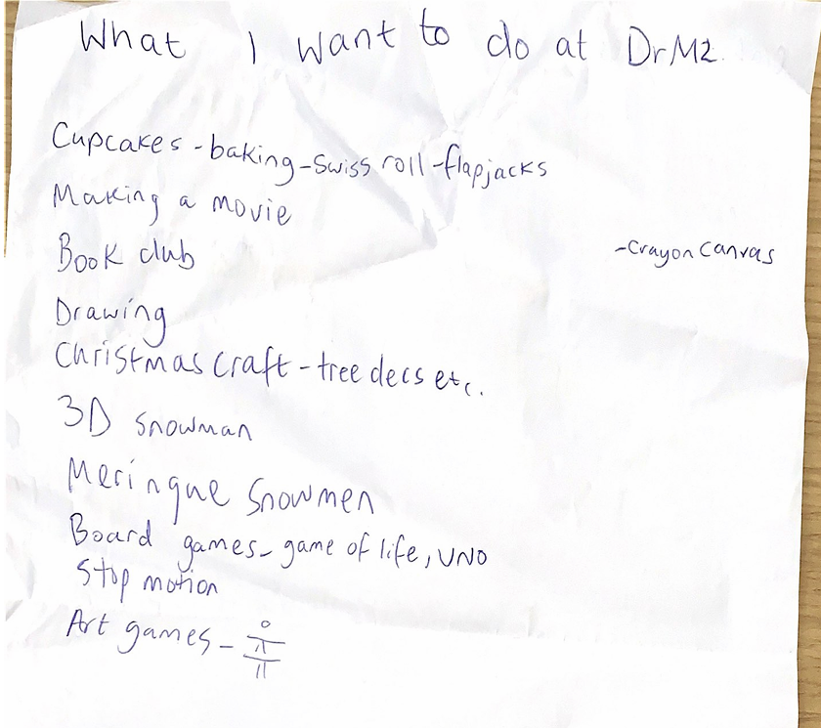
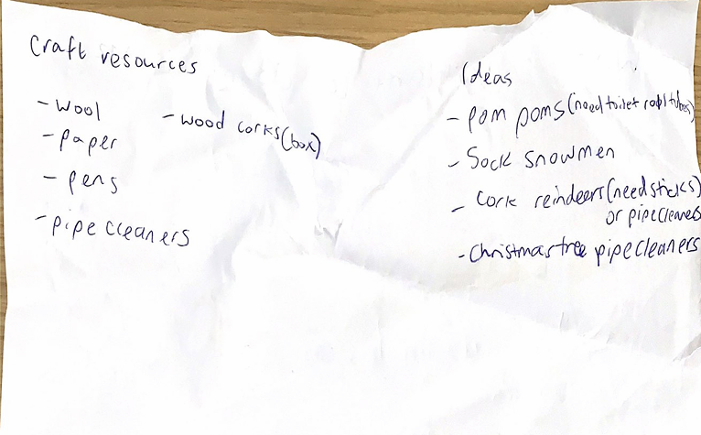

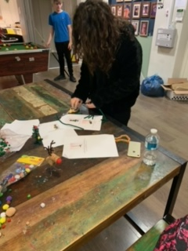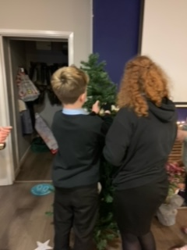

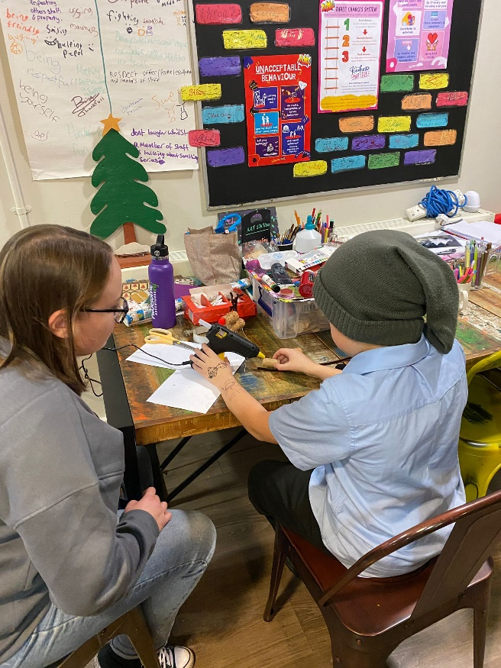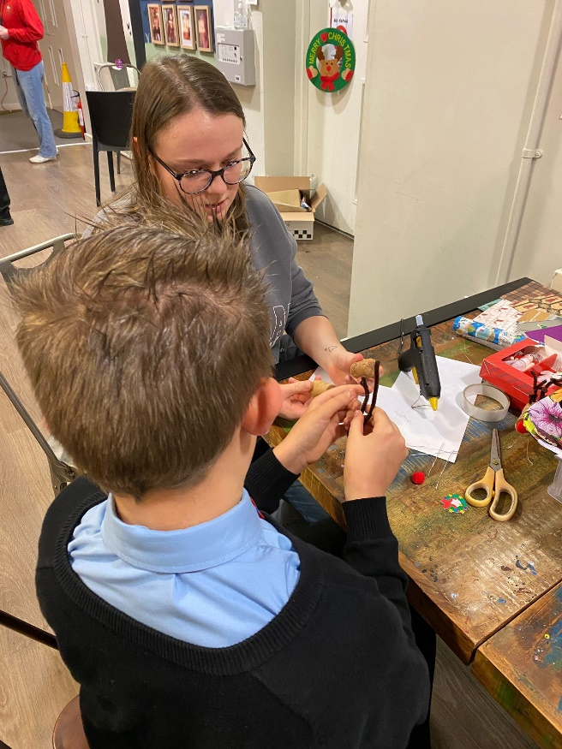

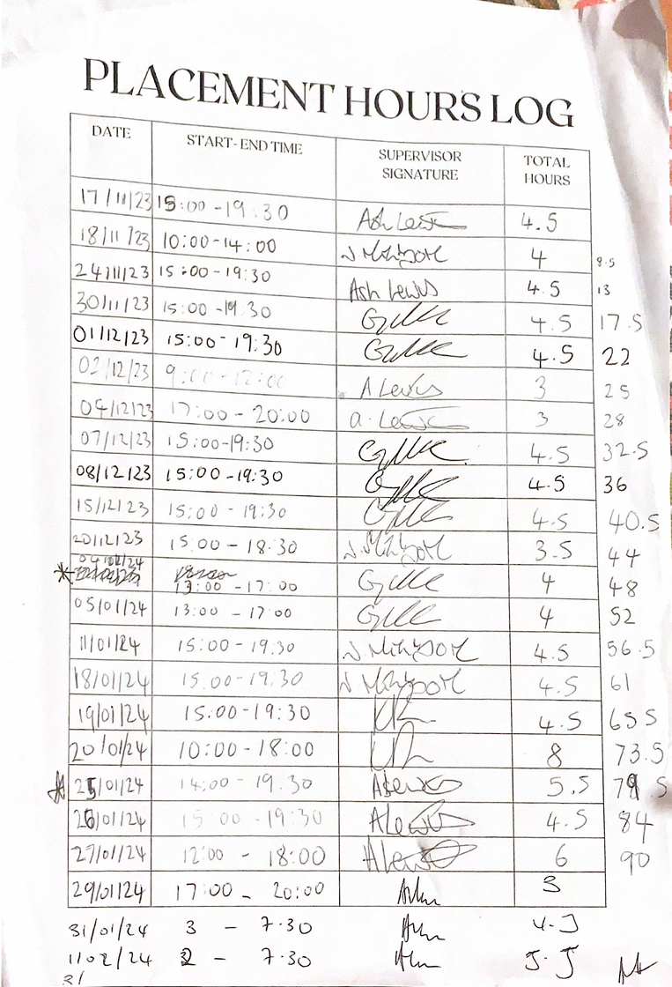

References
Batsleer, J. & Davies, B. (2010) What is Youth Work? Exeter: Learning Matters Ltd.
Blacker, H. (2010) ‘Relationships, friendships and youth’ in Jeffs, T. & Smith, M. (eds) Youth Work Practice. Houndmills, Basingstoke, Hampshire: Palgrave Macmillan, pp. 15-30.
Carmarthen Town Council (2020a) Carmarthen Town Council. [Online] Available at: http://www.carmarthentowncouncil.gov.uk/Town_Council_1958.aspx [Accessed 27 October 2023]
Carmarthen Town Council (2020b) Community Groups. [Online] Available at: http://www.carmarthentowncouncil.gov.uk/Community_Groups_34592.aspx
Carmarthen Town Council (2022¹) Carmarthen Town Council Annual Report Civic Year 2021-22. [Online] Available at: http://www.carmarthentowncouncil.gov.uk/_UserFiles/Files/CTC%20Annual%20Report%202021-22%20FINAL.pdf [Accessed 27 October 2023]
Carmarthen Town Council (2022c) A Guide to Carmarthen. [Online] Available at: http://www.carmarthentowncouncil.gov.uk/Guide_to_Carmarthen_1923.aspx [Accessed 02 November 2023]
Carmarthenshire County Council (2020) Carmarthenshire Revised Local Development Plan (LDP) 2018-2023: Open Space Assessment. [Online] Available at: https://www.carmarthenshire.gov.wales/media/1221675/open-space-assessment-january-2020.pdf [Accessed 27 October 2023]
Carmarthenshire County Council (2020²) Welsh Language. [Online] Available at https://www.carmarthenshire.gov.wales/home/council-democracy/welsh-language/ [Accessed 30 October 2023]
Carmarthenshire County Council (2021) Carmarthenshire County Profile. [Online] Available at: https://www.carmarthenshire.gov.wales/media/1224912/county-profile.pdf#:~:text=The%20estimated%20median%20houshold%20income%20for%20Carmarthenshire%2C%20based,and%203%25%20below%20the%20Wales%20median%20of%20%C2%A327%2C962 [Accessed 02 November 2023]
Carmarthenshire Public Service Board (CPSB) (2022) Carmarthenshire Local Well-being Assessment. [Online] Available at: https://www.thecarmarthenshirewewant.wales/media/quipyh1k/1-well-being-assessment.pdf [Accessed 26 October 2023]
Collander-Brown, D. (2010) ‘Being with an other as a professional practitioner: uncovering the nature of working with individuals’, in Jeffs, T. & Smith, M. (eds) Youth Work Practice. Houndmills, Baisingstoke, Hampshire: Palgrave Macmillan, pp. 41-53.
Crime Rate (2023) ‘Crime and Safety in Carmarthen’, Brighton Analytics Limited. [Online] Available at: https://crimerate.co.uk/dyfed/carmarthen#carmarthen-historical-crime-rates [Accessed 27 October 2023]
CYC, Carmarthenshire Youth Council (2024) “The voice of young people in Carmarthenshire”. [Online] Available at: “The Voice of Young People in Carmarthenshire” - Youth Sirgar [Accessed 26 January 2024]
Davidson, L., Evans, W. P. & Sicafuse, L. (2011) ‘Competency in Establishing Positive Relationships With Program Youth: The Impact of Organization and Youth Worker Characteristics’, Child and Youth Services, 32(4), pp. 336-354. Available at: Full article: Competency in Establishing Positive Relationships With Program Youth: The Impact of Organization and Youth Worker Characteristics (tandfonline.com)
DrMz (2020) Carmarthen Youth Project. [Online] Available at: https://www.drmz.co.uk/ [Accessed 23 October 2023]
Education Workforce Council (2023) Code of Professional Conduct and Practice: for registrants with the Education Workforce Council (EWC). [Online] Available at: https://www.ewc.wales/site/index.php/en/documents-eng/fitness-to-practise/code-of-professional-conduct-and-practice/37-j16540-ewc-code-of-professional-conduct-e-web-1-1/file [Accessed 02 November 2023]
Fields in Trust (2018) Revaluing parks and green spaces: measuring their economic and wellbeing value to individuals. London: Fields in Trust
Ford, K., Hunter, R., Merton, B. & Waller, D. (2005) Leading and Managing youth work and services for young people. Oxford: The Nuffield Press Ltd.
Hart, Roger A. (1992). Children's Participation: From tokenism to citizenship, Innocenti Essay, no. 4, International Child Development Centre, Florence
Hart, Roger A. (1992). Children's Participation: From tokenism to citizenship, Innocenti Essay, no. 4, International Child Development Centre, Florence
Hatton, J. (2022) The Conscious Use of Self in Youth Work Practice. Youth and Policy. Available at: The Conscious Use of Self in Youth Work Practice – Youth & Policy (youthandpolicy.org)
Jeffs, T. & Smith, M. (2010) Youth work practice. Houndmills, Basingstoke, Hampshire: Palgrave Macmillan.
National Careers Service. (2010) Youth Worker. [Online] Available at: https://nationalcareers.service.gov.uk/job-profiles/youth-worker [Accessed 10 Novemeber 2023]
National Youth Agency (2021) Guidance and Personal, Professional and Environmental Boundaries. [Online] Available at: guidance on personal professional and environmental boudnaries (amazonaws.com) [Accessed 20 January 24]
Office for National Statistics (2023) Income estimates for small areas, England and Wales: financial year ending 2018. [Online] Available at: https://www.ons.gov.uk/peoplepopulationandcommunity/personalandhouseholdfinances/incomeandwealth/bulletins/smallareamodelbasedincomeestimates/financialyearending2020#cite-this-statistical-bulletin [Accessed 02 November 2023]
Office for National Statistics (ONS) (2021) Census Maps. [Online] Available at: Census Maps - Census 2021 data interactive, ONS [Accessed 26 October 2023].
Phillips, Dylan (2014) 2011 Census: The Welsh Language in Carmarthenshire. [Online] Available at https://www.carmarthenshire.gov.wales/media/1216429/adroddiaddps.pdf [Accessed 30 October 2023]
Royal Mail (2018) ‘Carmarthen Town Guide 2018/19’, Local Authority Publishing Co. Ltd. [Online] Available at: https://www.localauthoritypublishing.co.uk/flip_guides/carmarthenguide/index.html#
Sapin, K. (2012) Essential Skills for youth work practice. 2nd ed. London: SAGE.
Smith, H (2010) ‘Engaging in Conversation’, in Jeffs, T & Smith, M. (eds) Youth Work Practice. Palgrave Macmillan: Baisingstoke, Hampshire, pp. 31-40.
Standards Council Scotland (2022) Youth Work NOS 2019: Functional Map – Including Signposted NOS. [Online] Available at: https://s3.eu-west-1.amazonaws.com/assets.nya2.joltrouter.net/wp-content/uploads/2022/09/22143731/YOUTH-WORK-NOS-2019-inc-Signposts.pdf
Taylor, T. (2017) Treasuring, but not measuring: personal and social development. Youth and Policy. [Online] Available at: Treasuring, but not measuring: Personal and social development – Youth & Policy (youthandpolicy.org) [Accessed 09 January 23]
Tyler, M., Hoggarth, L. & Merton, B. (2009) Managing Modern Youth Work. Exeter: Learning Matters Ltd.
University of Wales Trinity Saint David (2023) The University. [Online] Available at: https://uwtsd.ac.uk/about/ [Accessed 02 November 2023]
Wasserman, C., Postuvan, V., Herta, D., Iosue, M., Varnik, P. & Carli, V. (2018) Interactions between youth and mental health professionals: The Youth Aware of Mental health (YAM) program experience. PLoS ONE, 13(2) Available at: https://journals.plos.org/plosone/article?id=10.1371/journal.pone.0191843
Welsh Government (2019) Youth Work Strategy for Wales. [Online] Available at: https://www.gov.wales/sites/default/files/publications/2019-06/youth-work-strategy-for-wales.pdf [Accessed 27 October 2023]
Welsh Government (2019) Youth Work Strategy for Wales. [Online] Available at: https://www.gov.wales/sites/default/files/publications/2019-06/youth-work-strategy-for-wales.pdf [Accessed 19 December 23]
Welsh Government (2023) Welsh Government Offices. [Online] Available at: https://www.gov.wales/welsh-government-offices [Accessed 02 November 2023]
Williams, S. (2021) ‘Carmarthen – Merlin’s Fortress’, Historic UK. [Online] Available at: https://www.historic-uk.com/HistoryMagazine/DestinationsUK/Carmarthen/ [Accessed 27 October 2023]
Young Minds (2023) How to be a good listener. [Online] Available at: How to be a good listener | Resource | Professionals | YoungMinds [Accessed 20 February 24]
Figures
Figure 1: Office for National Statistics (ONS) (2021) Census Maps. [Online] Available at: https://www.ons.gov.uk/census/maps/choropleth?ltla=W06000010&msoa=W02000148 [Accessed 30 October 2023].

