Network Programmability
Assessment – 1 : Report

Introduction 3
Changing industry dynamics as a result of cloud computing 4
New entrants 5
Shifting Priorities of Customers 5
Technology Landscape 5
A look at how network professionals are evolving to meet cloud-based technical challenges 6
How RESTful Web Services have been used to facilitate these changes 7
The reasons why software-defined networking has been widely adopted by the industry, despite modifying the networking engineer's job role 8
How JSON and REST became standards in computer networks 10
Conclusion 11
Works cited 11

Introduction
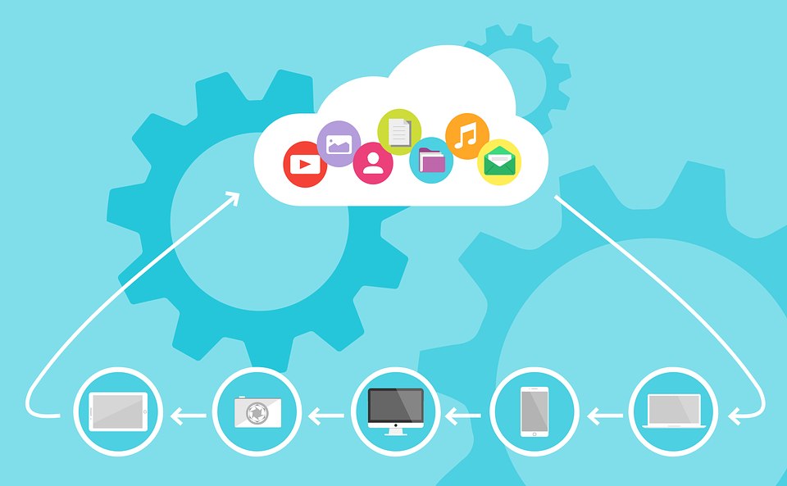
Figure 1: Showcase of cloud computing services
The field of computer networks has undergone a major shift in recent years, with a heightened emphasis on software and cloud computing. This shift has been driven by several factors, including the increasing popularity of cloud-based services, the rise of mobile and IoT devices, and the need for a more flexible and scalable network infrastructure [1], [2].
As more businesses move to the cloud, they are increasingly relying on software-based solutions for their networking needs. This includes both cloud-based and on-premises software, such as network virtualization, SDN, and NFV [1], [2].
Virtualization and SDN are particularly relevant for cloud computing, as they allow for the creation of virtual networks that can be easily provisioned and scaled. NFV is also becoming increasingly influential, as it allows for the use of network functions that are traditionally hardware-based, such as routers and firewalls, in a software-based format [1], [2].
The rise of mobile and IoT devices is another major factor contributing to the shift to software-based networking. These devices are often too small and/or resource-constrained to support traditional hardware-based solutions. As a result, they require a more flexible and scalable network infrastructure, which can be provided by software-driven solutions. The need for a more flexible and scalable network infrastructure is also driving the shift to software-defined networking. Traditional network infrastructure is rigid, inflexible, and difficult to scale, making it ill-suited to today's dynamic and ever-changing business environment. Software-based networking solutions, on the other hand, are much more adaptable and customizable, making them ideal for today's businesses [2], [3].
The shift to software-based networking is a major trend that is reshaping the landscape of the computer networking industry. This shift is being driven by some factors, including the increasing popularity of cloud-based services, the rise of mobile and IoT devices, and the need for a more flexible and scalable network infrastructure [1], [3].

Changing industry dynamics as a result of cloud computing
The cloud computing industry is in a state of flux, with new entrants and established players alike jockeying for positions. The competitive landscape is shifting, and the future is far from certain [4].
Cloud computing is still a relatively undeveloped technology, and it is evolving rapidly. The industry is being shaped by several forces, including the rise of brand-new players, the shifting priorities of customers, and the ever-changing technology landscape. As the industry continues to evolve, it is imperative to understand the dynamics that influence it. We will explore some of the key forces that are shaping the cloud computing industry [4], [5].

New entrants
One of the most significant forces shaping the cloud computing industry is the entry of new players. Numerous new entrants are looking to make their mark on the industry [5].
These recent entrants bring with them novel ideas, innovative technologies, and creative business models. They also bring with them increased levels of competition. The entry of newly emerging players puts pressure on established players to innovate and differentiate themselves. It is also forcing established players to re-evaluate their strategies and business models [5], [6].

Shifting Priorities of Customers
Another essential force shaping the cloud computing industry is the shifting priorities of customers. As the industry has matured, customers have become more demanding. They are now looking beyond basic features and functionality. They want cloud solutions that are reliable, scalable, and offer the highest levels of security. They are also looking for cloud solutions that are easy to use and that provide a positive user experience. In addition, they are seeking cloud solutions that are affordable and that offer a positive return on investment. The shifting priorities of customers are forcing established players to rethink their strategies. They are also causing new entrants to focus on different areas of the market [4], [5], [6].

Technology Landscape
Another driving force shaping the cloud computing industry is the ever-evolving technology landscape. The cloud computing industry is being shaped by several new technologies, including containers, serverless computing, and artificial intelligence. These advanced technologies are changing the way that cloud solutions are designed, developed, and deployed. They are also changing the way that customers use cloud solutions [4], [5], [6].
As the technology landscape continues to evolve, it is critical to stay abreast of the latest trends. This allows us to make the most of the available opportunities. The cloud computing industry is in a state of flux. It is being shaped by various forces, including the entry of new players, the shifting priorities of customers, and the ever-changing technology landscape. As the industry continues to evolve, it is imperative to understand the dynamics that shape it [4], [5], [6].

A look at how network professionals are evolving to meet cloud-based technical challenges
As the world of business becomes increasingly reliant on cloud-based technologies, it's no surprise that network professionals are having to evolve to meet the challenges posed by this shift. In recent years, we've seen a dramatic increase in the use of cloud-based services, with businesses of all sizes making the switch to take advantage of the many benefits they offer. However, as with any newly developed technology, there are always teething problems and challenges to be faced [7].
For network professionals, one of the biggest challenges posed by the cloud is the need to ensure that data is secure and can't be accessed by unauthorised individuals. With traditional network infrastructure, it's relatively easy to control who has access to what data. However, in a cloud-based environment, data is stored on remote servers and accessed via the internet, making it much more difficult to control who can see and use it [7], [8].
Another challenge faced by network professionals is the need to manage bandwidth usage. As more and more businesses move to the cloud, the amount of traffic on the network is increasing exponentially. This puts strain on network infrastructure and can lead to slow speeds and downtime [7], [8].
To combat these challenges, network professionals are increasingly turning to software-defined networking (SDN). SDN is a radically different approach to networking that allows network administrators to control and manage network traffic. By using SDN, network professionals can ensure that data is securely transmitted and that bandwidth usage is kept to a minimum [7], [8].
As the world of business continues to move to the cloud, network professionals must evolve to meet the challenges posed by this shift. SDN is one of the most promising technologies for meeting these challenges and ensuring that businesses can continue to take advantage of the many benefits offered by the cloud [8].

How RESTful Web Services have been used to facilitate these changes
In recent years, there has been a shift in the focus of network computing from hardware to software. This transition has been facilitated by RESTful web services, which have become increasingly popular due to their simple, scalable, and interoperable nature [9].
RESTful web services are based on the principles of Representational State Transfer (REST), which is a software architectural style that defines a set of constraints for designing web services. These constraints include the use of uniform resource identifiers (URIs) to identify resources, and the use of HTTP methods to manipulate them [9], [10].
RESTful web services have several advantages over other web service architectures. First, they are much simpler to develop and deploy than other architectures, which makes them ideal for small and medium-sized businesses. Second, they are highly scalable, which makes them suitable for large-scale deployments. Third, they are highly interoperable, which means that they can be used in conjunction with a wide variety of other software and hardware. The popularity of RESTful web services has led to countless changes in the way that network computers are utilized. In particular, there has been a shift towards using these services to facilitate the deployment of cloud computing [9], [10].
Cloud computing is a model of computing where resources are provided as a service over the Internet. This model allows businesses to access a pool of computing resources, which can be used on-demand, without the need to invest in and manage their infrastructure [9], [10], [11].
One of the main benefits of cloud computing is that it can help to reduce the cost of ownership of network computers. This is because businesses can avoid the need to purchase and maintain their hardware and software, and can instead rely on the resources provided by the cloud provider [9], [10], [11].
Another benefit of cloud computing is that it can help to improve the efficiency of network computing. This is because businesses can use the resources of the cloud to do more with less. For example, a business can leverage the resources of the cloud to run numerous virtual machines. These virtual machines can be used to test and develop software, without the need to purchase and maintain physical hardware [10], [11].
RESTful web services have been instrumental in the transition of network computers towards a focus on software. By providing a simple, scalable, and interoperable way to access and manipulate data, these services have made it possible for businesses to take advantage of the benefits of cloud computing [10], [11].

The reasons why software-defined networking has been widely adopted by the industry, despite modifying the networking engineer's job role
The term “software-defined networking” (SDN) first came about in the early 2000s, but it was only in the past few years that it has taken off in the business world. There are many reasons for this, but the main one is that SDN allows for a much more flexible and adaptable network infrastructure. This is because, with SDN, the control and management of network traffic are separated from the underlying hardware. This means that network engineers can more easily change how the network operates, without having to physically reconfigure the hardware. This flexibility is extremely critical in today's fast-paced business world, where companies need to be able to quickly adapt to changing market conditions. For example, if a company needs to roll out a novel service or application quickly, it can do so without having to wait for the network to be reconfigured. This can save the company a lot of time and money [12], [13].
Another reason why SDN has become so popular is that it can help to improve network security. With traditional networking, it can be difficult to isolate different parts of the network from each other. This can make it easy for malicious actors to gain access to sensitive data. However, with SDN, network administrators can easily create virtual networks that are isolated from each other. This makes it much more difficult for attackers to gain access to sensitive data [12], [13], [14].
SDN is becoming increasingly popular because it allows the creation of “overlay networks”. These are networks that sit on top of the existing network infrastructure but are not physically connected to it. This allows companies to easily set up private networks that are not accessible to the public. Overlay networks can be used for a variety of purposes, such as creating a private network for employees, or creating a secure network for customers [12], [13], [14].
Overall, there are many reasons why SDN has become so popular in the business world. It is flexible, adaptable, and secure, and it can be used to create private networks that are not accessible to the public. If we are thinking about implementing SDN in our own business, there are a few things we should keep in mind. First, we will need to train our network engineers to use SDN. Second, we need to invest in some SDN-compatible hardware. In the end, we should make sure that we have a plan in place for how we will transition the existing network to an SDN infrastructure [12], [13], [14].

How JSON and REST became standards in computer networks
As the world increasingly moves towards digitalisation, the need for interoperability between different systems and devices becomes ever more imperative. This is because, for devices and systems to be able to communicate with each other, they need to be able to understand the same language [15].
One way of ensuring that devices and systems understand each other is through the use of standards. Standards are critical because they provide a common language that can be used by all devices and systems. This means that, regardless of who created a particular system or device, as long as they adhere to the standards, they will be able to communicate with other systems and devices [15].
Several standards have been adopted to ensure interoperability. One of the most widely used standards is JSON. JSON, or JavaScript Object Notation, is a standard that has been designed for use with JavaScript. It can, however, be used in any programming language [16].
JSON is a popular choice for numerous reasons. Firstly, it is a human-readable format, which means that it is easy for developers to work with. Secondly, it is a lightweight format, which means that it requires less bandwidth and storage than other formats. Finally, it is a self-describing format, which implies that it is easy for systems to understand [16].
Another standard that has been utilised is REST. REST, or Representational State Transfer, is a standard that has been designed for use with web services. REST is a popular choice because it is easy to implement, and it is scalable [15], [16].
REST is a popular choice for some reasons. Firstly, it is an architectural style, which implies that it is easy to implement. Secondly, it is a stateless protocol, which means that it does not require sessions or cookies. Finally, it is a uniform interface, which means that it is easy for systems to understand [15], [16].
Standards are helpful because they provide a common language that can be used by all devices and systems. This means that, regardless of who created a particular system or device, as long as they adhere to the standards, they will be able to communicate with other systems and devices [15], [16].

Conclusion
The field of computer networks has undergone a major shift in recent years, with a heightened emphasis on software and cloud computing. This shift has been driven by several factors, including the increasing popularity of cloud-based services, the rise of mobile and IoT devices, and the need for a more flexible and scalable network infrastructure. As more businesses move to the cloud, they are increasingly relying on software-driven solutions for their networking needs. This includes both cloud-based and on-premise software, such as network virtualization, SDN, and NFV [3], [4].
Virtualization and SDN are particularly relevant for cloud computing, as they allow for the creation of virtual networks that can be easily provisioned and scaled. NFV is also becoming increasingly influential, as it allows for the use of network functions that are traditionally hardware-based, such as routers and firewalls, in a software-based format [4], [5].
In conclusion, the field of computer networks has undergone a major shift in recent years, with a pronounced emphasis on software and cloud computing. This shift has been driven by several factors, including the increasing popularity of cloud-based services, the rise of mobile and IoT devices, and the need for a more flexible and scalable network infrastructure [1], [7].

Works cited
[1] | L. L. Peterson, Computer Networks: A Systems Approach, 4th ed. Morgan Kaufmann, 2014.
[2] | B. Wellman, “Computer networks as social networks,” Science, vol. 293, no. 5537, pp. 2031–2034, 2001.
[3] | J. S. Quarterman and J. C. Hoskins, “Notable computer networks,” Commun. ACM, vol. 29, no. 10, pp. 932–971, 1986.
[4] | A. Sunyaev, “Cloud Computing,” in Internet Computing, Cham: Springer International Publishing, 2020, pp. 195–236.
[5] | N. Kshetri, “Privacy and security issues in cloud computing: The role of institutions and institutional evolution,” Telecomm. Policy, vol. 37, no. 4–5, pp. 372–386, 2013.
[6] | J.-M. Tsai and S.-W. Hung, “A novel model of technology diffusion: System dynamics perspective for cloud computing,” J. Eng. Technol. Manag., vol. 33, pp. 47–62, 2014.
[7] | J. W. Rittinghouse and J. F. Ransome, Cloud computing: Implementation, management, and security, 1st Edition. Boca Raton, FL: CRC Press, 2009.
[8] | O. Dimitriu and M. Matei, “Cloud accounting: A new business model in a challenging context,” Procedia econ. finance, vol. 32, pp. 665–671, 2015.
[9] | H.-L. Truong, S. Dustdar, A. Maurino, and M. Comerio, “Context, quality and relevance: Dependencies and impacts on RESTful web services design,” in Current Trends in Web Engineering, Berlin, Heidelberg: Springer Berlin Heidelberg, 2010, pp. 347–359.
[10] | L. Richardson and S. Ruby, “RESTful Web Services,” in Beginning JavaTM EE 6 Platform with GlassFishTM 3, Berkeley, CA: Apress, 2009, pp. 429–462.
[11] | H. Li, “RESTful Web service frameworks in Java,” in 2011 IEEE International Conference on Signal Processing, Communications and Computing (ICSPCC), 2011.
[12] | K. Kaur, K. Kumar, J. Singh, and N. S. Ghumman, “Programmable firewall using Software Defined Networking,” 2015 2nd International Conference on Computing for Sustainable Global Development (INDIACom), 2015.
[13] | A. Malik, B. Aziz, M. Adda, and C.-H. Ke, “Smart routing: Towards proactive fault handling of software-defined networks,” Comput. netw., vol. 170, no. 107104, p. 107104, 2020.
[14] | Á. L. Valdivieso Caraguay, A. Benito Peral, L. I. Barona López, and L. J. García Villalba, “SDN: Evolution and opportunities in the development IoT applications,” Int. J. Distrib. Sens. Netw., vol. 10, no. 5, p. 735142, 2014.
[15] | T. Vichyaloetsiri and P. Wuttidittachotti, “Web Service framework to translate text into sign language,” in 2017 International Conference on Computer, Information and Telecommunication Systems (CITS), 2017.
[16] | J. L. Cánovas Izquierdo and J. Cabot, “Discovering Implicit Schemas in JSON Data,” in Lecture Notes in Computer Science, Berlin, Heidelberg: Springer Berlin Heidelberg, 2013, pp. 68–83.

