RYAN DUGMORE-2023914-ASSIGNMENT 2
Assess the role of community policing in fostering and maintaining community cohesion.
In this essay, I will be assessing the role of community policing in fostering and maintaining community cohesion. I will be discussing what community cohesion is, and the benefits of building community cohesion on persons within a community. I will be discussing a recent case in which has happened which has had a dramatic effect on community cohesion, and the backlash that was faced regarding the incident. I will furthermore be discussing what a neighbourhood team does and the benefits that they provide their community, and the introduction of PCSOs and what their roles and responsibilities are to help build community cohesion. I will also be discussing how the OSARA model is adapted within policing and the benefits that social media usage has on the police force to maintain a good level of community cohesion.
Community cohesion is created by people in a community making sure that they all do the correct things for them to all get along together. There are many reasons to why community cohesion is very important to ensure that a community does get along properly with no issues. It enables persons within a community to have a sense of somewhere that they belong. Benefits to building community cohesion may include;
- Volunteering- persons who are part of a strong community cohesion may feel happy to participate in volunteering for the benefit of other people.
- Preventing anti-social behaviour and crime- persons within a community may feel less interested in committing crimes or causing anti-social behaviour due to the major effect it may have on a person and the persons around them
- Increases a sense of belonging- A person who is part of a community that has a strong cohesion may feel as though they are part of a “family”, and that they have persons who they can look to in their times of need. (NPIA, 2021).
There have been incidents in the past involving the police and its officers which have had a dramatic effect on the cohesion within a community.
The case of Sarah Everard.
On the 3^{rd of} March 2022, Sarah Everard was walking home from a friend’s house in South London, where she was kidnapped a serving Police Constable of the Metropolitan Police, Wayne Couzens. Everard was a random victim of choice by Couzens, however he had already pre planned his attack. Couzens used his powers under the Coronavirus act to stop Everard, and upon doing this he arrested her under a breach of this act. Couzens then subsequently handcuffed her and then placed her into a vehicle that he had rented out and took her away. Couzens then drove Everard to Dover in Kent, to where he then raped and murdered Everard in a gruesome attack. The next day, Couzens then decided to burn the body of Everard inside a fridge, in the hope that he would get away with his actions. A few days later, Couzens was arrested in relation to this incident, and has now been sentenced to life imprisonment (Morton, 2021).
"There are no words that can fully express the fury and overwhelming sadness that we all feel about what happened to Sarah. I am so sorry." (Dick, 2021)
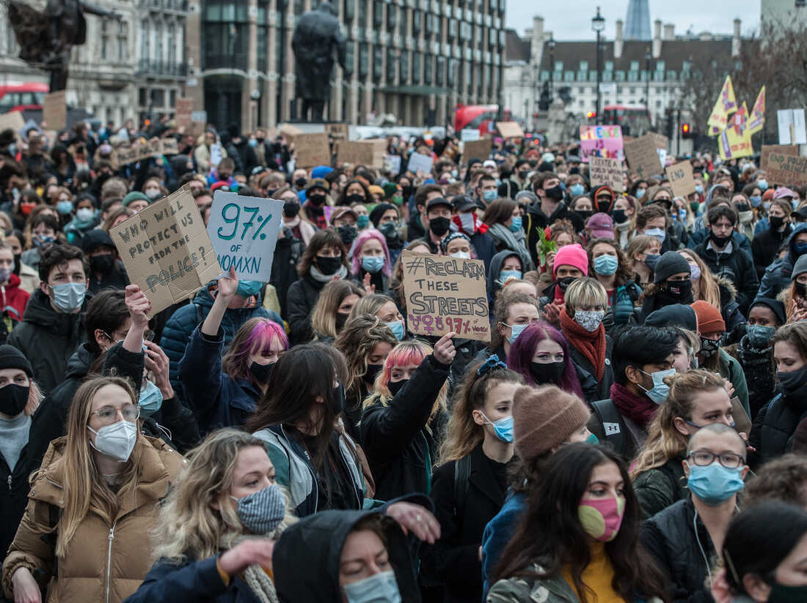
Persons protesting in London over the death of Sarah Everard (Treisman, 2021)
As a result of this, community cohesion was affected drastically. There were many riots all over the country to demand radical change to the police, to which many people at these riots were arrested, furthermore infuriating persons in the community. Thousands of females spoke out how they felt as though they had been failed by the policing system, and that they feel as though they will not get justice if the worst was to happen (Firetap, 2021). High profile incidents such as this will make the public feel as though they cannot turn to the police at their time of need, due to the lack of trust and wrongdoing that persons have received because of police contact.
What is community policing?
A neighbourhood policing team is a very important part of the day-to-day functions of a successful police force and enforces community policing. They are made up of several officers, where their main target being to focus on the problems in the local community and engage with persons in order to raise public confidence and provide reassurance. There are many essential elements which may be used in order for a neighbourhood policing team to provide the most efficient and effective service, to which these may include;
- Being a visual presence in their local community- This is very important for the police service as it gives the public confidence that the police are and about in the community, and it gives the public a chance to speak to officers and address issues which they may have. It is also beneficial to the police as well as by being out on foot can allow them to build intelligence and build more of an understanding about what is going on in the community that they are working in.
- Providing engagement which is best suited for the needs of the individuals they are dealing with- day to day, the police encounter and engage with persons from a wide range of ethnic backgrounds and diverse communities, therefore it is important that the police understandable and adjusting to the persons in who they may be dealing with to offer the best service to them
- Community engagement events- By hosting/ attending local events which are being held in the community, this allows the public to see the police on a more “human” level. Some children may fear the police due to things which they may have heard or seen from other persons, when they may learn that the police are not always there “telling” you off when you are in trouble, and that they are here to help and support you. (College of Policing, 2021).
Partnership working with the police and other partner agencies is an important part of fostering and maintaining community cohesion. The police may attend a call where there are several emergency services there such as the ambulance service and the fire service, where they will have to work together to achieve whatever goal they are hoping for. The police may work alongside the local council and attend things such as local meetings with councillors to address ongoing problems which may be occurring in their area. By working alongside such agencies, there are a number of benefits which some of these may include;
- Information and intelligence being shared to other partner agencies to allows other persons to be aware of an ongoing issue, which may allow the police to work with the agency in partnership to overcome the problem.
- By working in partnership, it helps agencies with safety reassurance responsibilities to develop and offer support to genuine victims of crime.
MARAC (multi agency risk assessment conference) meetings are a vital way of partner agencies linking together and distributing information to each other to offer safeguarding and further support to victims. These meetings are formed where the police submit what is called a public protection notification, which details circumstances and information about the victim in relation to an incident which has happened. During the meeting, they will talk about persons involved in the incident, previous incidents involving them persons, and ways they can help persons for them to overcome whatever problems that they may be facing. With the consent of the public protection notification, agencies will then contact the person who is in need, however if not consented they will get no further support provided.
Police Community Support Officers (PCSOs) were introduced in 2002 under the Police Reform Act 2002. They are standardly granted with 20 powers, however may be granted with additional powers which are granted by their police forces Chief Constable if they believe that this will better assist them in helping combat local issues and priorities in the area in which they work (GOV.UK, 2012).There has been many dispute over the years on what PCSOs can and cannot do with them having such limited powers, and persons not understanding exactly what their role may be in the community. A few members of the public do not see the point in them and believe that the money should be spent on having more full-time police officers on the streets, however below is the roles and responsibilities of a PCSO which is somewhat different to the role of a Police Constable and shows the importance of the impact it can have on community cohesion.
- Maintaining a high visibility presence and acting as a deterrent to crime, therefore improving public confidence.
- Supporting police investigations by submitting intelligence in what they have seen first-hand, or what they have been provided my member of the public who they have built trust with.
- Supporting of Police Constables at front line response incidents where they can prevent escalation of low-level offending and enable resolution within the powers in that they have been granted.
- Developing new way of working and innovation in community policing by using problem solving methods to come up with a solution to a a problem which is ongoing.
- Assisting with complex front-line incidents as a first officer at scene responder by offering immediate support to those people who may be in need.
(College of Policing, 2022 a)
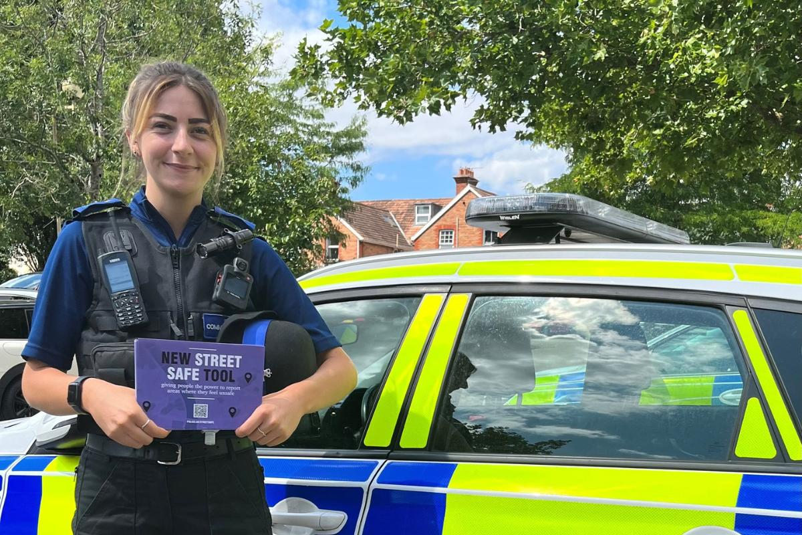
A PCSO working for Avon & Somerset Police (Leaman, 2022)
How the OSARA model is used to assist with community cohesion.
The OSARA model is a method used, especially by neighbourhood policing teams to help combat an issue which they may be facing in the community, and therefore by trying to come up to a solution with the problem can help build the publics trust and confidence within the service.
The first part of the model is the objective. The objective should be what the goal in which you are looking to achieve and should always be at the forefront of the mind when the incident is being dealt with. The next part of the model is the scanning element. This element is where you know that there Is a problem that needs to be dealt with, and what the problem is that you need to solve. This part of the method will allow you to understand how big the matter is that you are dealing with. Furthermore, you then must analyse. Good analysis of the situation will help you build towards an effective outcome. You must then respond; the responding part of the method is where you put all the information and facts that you have gathered and put that all into action by going ahead with the plan of action that you have decided to undertake (Dean, 2021).
Police forces and their use of social media to communicate with the public.
Nowadays, social media is an integral part of a person’s everyday life. It is used by most persons every day to communicate with one another, and to keep up to date with what is going on in the world. Police forces have now taken advantage of this “gap in the market” by creating their own social media platforms as a way of communicating with members of the public. Police forces attract up to tens of thousands of followers on pages such as Facebook and Twitter, and now are using applications such as TikTok to show a more interactive side with the police.
According to The Police Foundation (2014), the use of police forces social media use can be broadly divided into three area, which are;
- Providing information- distributing specific information that can be shared quickly at no cost.
- Engagement- it provides the police a way of connecting and building relationships with communities and strengthening the cohesion within the community.
- Intelligence and investigation- by the police listening to the people who live in the community, they can build valuable information and intelligence which can be acted upon.
In conclusion, I have been able to assess the role of community policing in fostering and maintaining community cohesion by listing several ways that they are able to do this. I have spoken about an incident in where community cohesion may be broken with the police, and the effect that this can have on both parties. I have been able to explain what community policing is, and the ways that they are able to offer an effect and effective service to reassure the communities that they work in. The use of social media has shown a great tool is assisting the police force for them to make direct contact with the communities that they represent, and how important partnership agency working is for the police force to offer the best service to its users.
(word count 2127)

Evaluate the disruption options available to target criminal activity on the road network.
In this assignment, I will be evaluating disruption options in which are available to the police to disrupt criminal activity on the roads in the United Kingdom. I will be discussing the different type of offences that criminals may commit linked to vehicle crime. I will also be discussing what type of powers that are available to the police to successfully stop vehicles and conduct relevant checks and will also be discussing how intelligence is formed to assist police officers in stopping such vehicles. Furthermore, I shall be touching upon tactics that the police may use such as TPAC (tactical pursuit and containment) and how the use of ANPR (automatic number plate recognition) can be beneficial in assisting police in combating crime.
Offenders may use the roads for many such things, which may be from low level offences to things such as serious and organised crime, to facilitate crimes. These could be offences such as;
- Drug related offences- criminals may use vehicles to distribute drugs across the country. This is linked in with county lines, which is where drug dealing by organised crime groups use mobile networks to supply drugs and move them, which is usually from the cities into smaller towns and more rural areas (Metropolitan Police, 2022).
- Burglaries- criminals may use vehicles to help with their escape and assist them with loading items after a positive burglary. Organised crime groups may pre plan targeted burglaries, where they may have a person wait in the vehicle, whilst other persons may go inside at take the items from the location in which they have targeted.
There are several powers in which can be utilised by the police to assist them in stopping a vehicle and allowing them to more thoroughly investigate crimes There are also powers which the police may use in order to search these vehicles for things such as drugs, or offensive weapons. If a person driving a vehicle fails to stop for a police vehicle requesting them to stop, then they may be committing further offences. These powers that the police may utilise are the following;
- Section 163 of the Road Traffic Act 1988- “A person driving a mechanically propelled vehicle on a road must stop the vehicle on being required to do so by a constable in uniform or a traffic officer” (Legislation.gov.uk).
- Section 60 of the Criminal Justice and Public Order 1994- gives preventive stop and search powers (subject to authorisation) to the police where violence is anticipated in a particular location (College of Policing, 2022a).
- Section 4 of the Police and Criminal Evidence act 1984- this section allows “either all vehicles or those selected by a particular criterion to be stopped in a particular locality to locate an offender or witness involved in an indictable offence (subject to authorisation). The location of such road checks is integral to achieving this objective. It should afford maximum protection to both the public and police while giving little warning to the suspect and no escape routes” (College of Policing, 2022a).
- Section 23 of the Misuse of Drug acts 1971 (2) (b)- “If a constable has reasonable grounds to suspect that any person is in possession of a controlled drug in contravention of this Act or of any regulations made thereunder, the constable may search any vehicle or vessel in which the constable suspects that the drug may be found, and for that purpose require the person in control of the vehicle or vessel to stop it”(Legislation.gov.uk).
For these vehicles to be stopped and searched by police, there must be build-up of intelligence and reasonable grounds to stop the vehicle and conduct such searches. Intelligence is information that has been analysed to assess how reliable and relevant it may be (National Crime Agency, 2019), and the national intelligence model 3 x 5 x 2 should be used to grade the legitimacy of the intelligence which is being submitted.
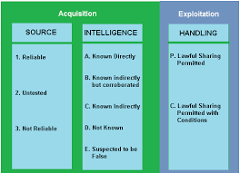
(nafn.co.uk)
The sources are firstly evaluated into how reliable they are, with reliable sources of intelligence including DNA or things such as fingerprints. Untested sources of information relate to a source which may have not previously provided information to the person receiving or has not been substantiated (College of Police, 2022b). Therefore, this information may not mean that it is unreliable, however it should be treated with caution. Not reliable sources of information are sources where the are reasonable grounds not to trust the information. These reasonable grounds to not trust the information being provided may be because of the lack of a trustworthiness and authenticity that the information has to offer. Next, the information is then established on how it become reliable to the source, whether it was such as known directly to the source such as witnessing what has happened first hand, or whether they suspect the information to be false as there is sufficient reasoning to believe that this may be the case. Then there are handling codes which are either lawful sharing permitted, or lawful sharing permitted with conditions. It must be for a policing purpose in order for intelligence to be shared, and there must be a need for intelligence to be received.
Roads Policing Units
Police forces have specialised units such as the roads policing team, which specifically target criminal activity which is being committed on the road. The NPCC roads policing 2022, states that road policing is based on four key pillars, with these being;
• Preventing harm and saving lives- On average, five persons die each day to road related incidents. This can have a disastrous effect on families and other persons in the community, therefore it is important that the police work with other organisations and agencies to try and decrease the amount of road related deaths per year.
• Tackling crime- by targeting persons who are committing offences on the public roads at the earliest opportunities, it will allow the best chance of prosecution and the potential to deter crime.
• Driving technology and innovation- the police are faced new challenges due to the upcoming rise of new electric vehicles such as e scooters or bikes. Therefore, it is important that the police and other agencies work together in order to promote safety and advice to persons using these kinds of vehicles, in order to lower the risk of potential injury.
• Changing minds- by leading by example can help in challenging problematic beliefs and such behaviours can have a positive impact on the roads in the United Kingdom, such as the understanding and acceptance of road traffic offences.
There are many roles and responsibilities that roads policing officers have to conduct their role in the most professional and sufficient manner, with the main roles of them being to prevent the number of deaths caused on the road by investigating, preventing, and prosecuting offences through intelligence led policing (College of Policing, 2022 c). A roads policing officer must attend road related incidents where they must use the appropriate legislation to what they may be facing, and must conduct all procedures that they carry out, such as a road side breath test in the correct and most appropriate manner. They can use specialised equipment which they have equipped to their vehicle such as ANPR cameras, to identify vehicles which may be linked to offences, and then must be held responsible for their next course of action in how they may respond and deal with such vehicles which are linked to such offences. Officers who are part of the roads policing unit are trained to a different standard that was is of your regular Police Constable. They are trained to a level where they are able to pursue cars which may be failing to stop for themselves or other officers and are also trained in pre-emptive tactics such as TPAC (tactical pursuit and containment).
What is TPAC?
TPAC is a range of methods which can be used by the police, in order to stop and manage a pursuit so that they can have the best result, and for the best safety for those that are involved in the pursuit and other members of the public.
According to PoliceInfoCentre 2022, there are several TPAC methods in which the police use which are;
- Boxing- Boxing is where there are a number of police vehicle surrounded around the vehicle in which is being pursued, with the police vehicles gradually slowing down, therefore slowing the pursuing vehicle down and also not allowing the vehicle any space to get out of the “box”.
- Tactical contact- This method includes the police vehicle making contact with the back of the vehicle in which is being pursued and should only be used by TPAC trained officers when there is a danger to life.
- Stinger- Stinger is a method which is used in situations where boxing of the vehicle and the pursuing vehicle is moving at too much of a fast speed. The officer using the stinger usually hides in a position not seen by the driver in the vehicle which is being pursued. The officer then throws the stinger in front of the moving vehicle which will hopefully then deflate the tyres.
- Static stop- police vehicles can block off a road as a last effort in order to stop a vehicle which is failing to stop and is a great danger to members of the public.
How ANPR can help disrupt criminal activity on the roads.
ANPR (automatic number place recognition) is a major tool in identifying offenders and details of who may be offending on the roads. It can be used to identify offenders such as persons who may be driving on the road without insurance, keeping track of vehicles which may have been stolen, and can also be used to assist in high profile cases such as murders.
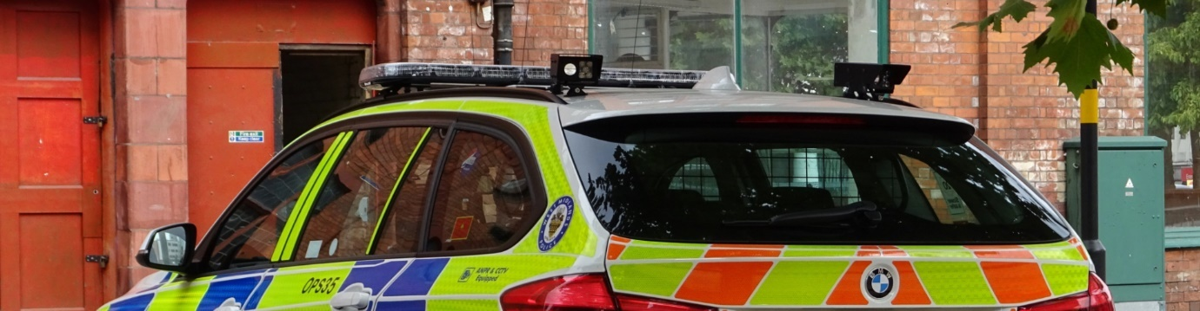
An ANPR camera fitted on a marked police traffic vehicle. (MAV, 2022)
“ANPR cameras are important to police in keeping people safe from crime. They are in place to detect and deter motoring offences and the activities of criminals. We are committed to maintaining a system that ensures that people in all parts of and have the same protection from the activities of criminals and motoring offenders” (Beatty, 2021).
ANPR cameras work by when a vehicle drive passed it, its registration is checked immediately against the database and makes a record of vehicles of interest (psni police, 2022).
“Around 11,000 ANPR cameras submit around 50 million ANPR records daily” (RAC,2022).
In conclusion, there are endless amounts of offences which may be committed by criminals on the roads to aid their escape after committing things such as a burglary, or for example many low levels offences such as not wearing a seatbelt whilst driving on the road. Therefore, this shows that it is important to have a high number of officers focused on road related offences in departments such as traffic to try and stop vehicles that are driving on the roads in such manner. The police are provided many powers to stop vehicles and search vehicles, which allows them to prevent any potential offences and to investigate potential offences into further detail. The road’s policing unit is a vital part in disrupting criminal activity on the roads, with them being trained with skills such as tactical pursuit and containment, which can further assist in capturing persons who may be committing serious offences. I have also discussed the use of ANPR and how vital it is for the police in gaining information and intelligence on vehicle, and how it is now an integral part of everyday policing.
(Word count-1922)

Reference list
Beatty, C. (2021). Police investigate damage to number plate recognition camera in Derry. belfasttelegraph. [online] 21 Mar. Available at: https://www.belfasttelegraph.co.uk/news/northern-ireland/police-investigate-damage-to-number-plate-recognition-camera-in-derry-40222289.html [Accessed 5 Sep. 2022].
College of Policing (2021). Engaging communities. [online] College of Policing. Available at: https://www.college.police.uk/guidance/neighbourhood-policing/engaging-communities [Accessed 5 Sep. 2022].
College of Policing (2022a). Police Community Support Officer (PCSO). [online] College of Policing. Available at: https://profdev.college.police.uk/professional-profile/police-community-support-officer-pcso/ [Accessed 5 Sep. 2022].
College of Policing. (2022b). Disrupting criminality. [online] Available at: https://www.college.police.uk/app/roads-policing/disrupting-criminality [Accessed 5 Sep. 2022].
College of Policing. (2022c). Intelligence report. [online] Available at: https://www.college.police.uk/app/intelligence-management/intelligence-report#:~:text=Untested%20%E2%80%93%20this%20relates%20to%20a [Accessed 5 Sep. 2022].
College of Policing. (2022d). Roads Policing Constable. [online] Available at: http://production-cop-web-elb-883774526.eu-west-2.elb.amazonaws.com/professional-profile/roads-policing-constable/ [Accessed 4 Sep. 2022].
Dean, N. (2021). Problem solving. [online] South Cambs District Council. Available at: https://www.scambs.gov.uk/community-safety-and-health/community-action/community-safety-toolkit/crime-prevention-in-your-community/problem-solving/ [Accessed 5 Sep. 2022].
Dick, C. (2021). Cressida Dick: I can’t describe my fury at Wayne Couzens - I am so sorry. [online] LBC. Available at: https://www.lbc.co.uk/news/cressida-dick-i-cant-describe-my-fury-at-wayne-couzens-i-am-so-sorry/ [Accessed 5 Sep. 2022].
Firetap (2021). Sarah Everard – The Story, The Backlash, The Aftermath. [online] FireTap Digital. Available at: https://firetap.co.uk/sarah-everard-the-story-the-backlash-the-aftermath/ [Accessed 5 Sep. 2022].
GOV.UK. (2012). Police community support officer powers. [online] Available at: https://www.gov.uk/government/publications/police-community-support-officer-powers [Accessed 5 Sep. 2022].
Intelligence Management 3 x 5 x 2. (2020). [online] nafn.co.uk. Available at: https://www.local.gov.uk/sites/default/files/documents/Intelligence%20Management%20Training.pdf [Accessed 4 Sep. 2022].
Jasmine (2021). ANPR cameras: what are they and what do they do? [online] Fluxposure. Available at: https://www.adrianflux.co.uk/blog/2021/04/what-are-anpr-cameras.html [Accessed 4 Sep. 2022].
Leaman, T. (2022). Taunton PCSO leaving role to train as constable will be ‘massively missed’. [online] Somerset County Gazette. Available at: https://www.somersetcountygazette.co.uk/news/20584646.taunton-pcso-leaving-train-constable-will-massively-missed/ [Accessed 5 Sep. 2022].
Legislation.gov.uk (2020). Road Traffic Act 1988. [online] Legislation.gov.uk. Available at: https://www.legislation.gov.uk/ukpga/1988/52/section/163 [Accessed 5 Sep. 2022].
legislation.gov.uk (2011). Misuse of Drugs Act 1971. [online] Legislation.gov.uk. Available at: https://www.legislation.gov.uk/ukpga/1971/38/section/23 [Accessed 1 Sep. 2022].
MAV. (2022). Police Forces worldwide use ANPR cameras to protect and prevent crime. [online] Available at: https://www.anprcameras.com/anpr-solutions/police-security/police-2/ [Accessed 5 Sep. 2022].
Morton, B. (2021). Sarah Everard: How Wayne Couzens covered up her murder. BBC News. [online] 30 Sep. Available at: https://www.bbc.co.uk/news/uk-58746108 [Accessed 5 Sep. 2022].
National Crime Agency (2019). Intelligence: Enhancing the Picture of Serious Organised Crime Affecting the UK - National Crime Agency. [online] Nationalcrimeagency.gov.uk. Available at: https://www.nationalcrimeagency.gov.uk/what-we-do/how-we-work/intelligence-enhancing-the-picture-of-serious-organised-crime-affecting-the-uk [Accessed 4 Sep. 2022].
NPCC Roads Policing. (2022). [online] Available at: https://library.college.police.uk/docs/NPCC/Roads_Policing_Strategy_2022.25.pdf [Accessed 5 Sep. 2022].
NPIA. (2021). [online] Available at: https://library.college.police.uk/docs/npia/CohesionGuide.pdf [Accessed 5 Sep. 2022].
Policeinfocentre. (2022). TPAC. [online] Available at: http://policeinfocentre.weebly.com/tpac.html# [Accessed 4 Sep. 2022].
RAC. (2022). What is ANPR and how does it work? | RAC Drive. [online] Available at: https://www.rac.co.uk/drive/advice/cameras/what-is-anpr-and-how-does-it-work/ [Accessed 5 Sep. 2022].
the Police Foundation (2014). briefing The Series 3, Edition 1. [online] Available at: https://www.police-foundation.org.uk/2017/wp-content/uploads/2017/08/Social_media_briefing_FINAL.pdf [Accessed 5 Sep. 2022].
Treisman, R. (2021). London Police Under Fire For Treatment Of Women At Sarah Everard Vigil. NPR. [online] 15 Mar. Available at: https://www.npr.org/2021/03/15/977486666/london-police-under-fire-for-treatment-of-women-at-sarah-everard-vigil [Accessed 5 Sep. 2022].
www.met.police.uk. (2022). County lines. [online] Available at: https://www.met.police.uk/advice/advice-and-information/cl/county-lines/ [Accessed 5 Sep. 2022].
www.psni.police.uk. (2022). Automatic Number Plate Recognition. [online] Available at: https://www.psni.police.uk/inside-psni/our-policies-and-procedures/automatic-number-plate-recognition/ [Accessed 5 Sep. 2022].

