Title of the Coursework: Database Analysis and Design
Author: Andrew Gunney
Student ID: 2014950
Module Name and Code: Introduction to Web and Database Concepts ACCA4023
School of Applied Computing
Wales Institute of Science and Art
Date and Time of submission: Wednesday 21st July 2021 @ 15:30pm

Main Menu

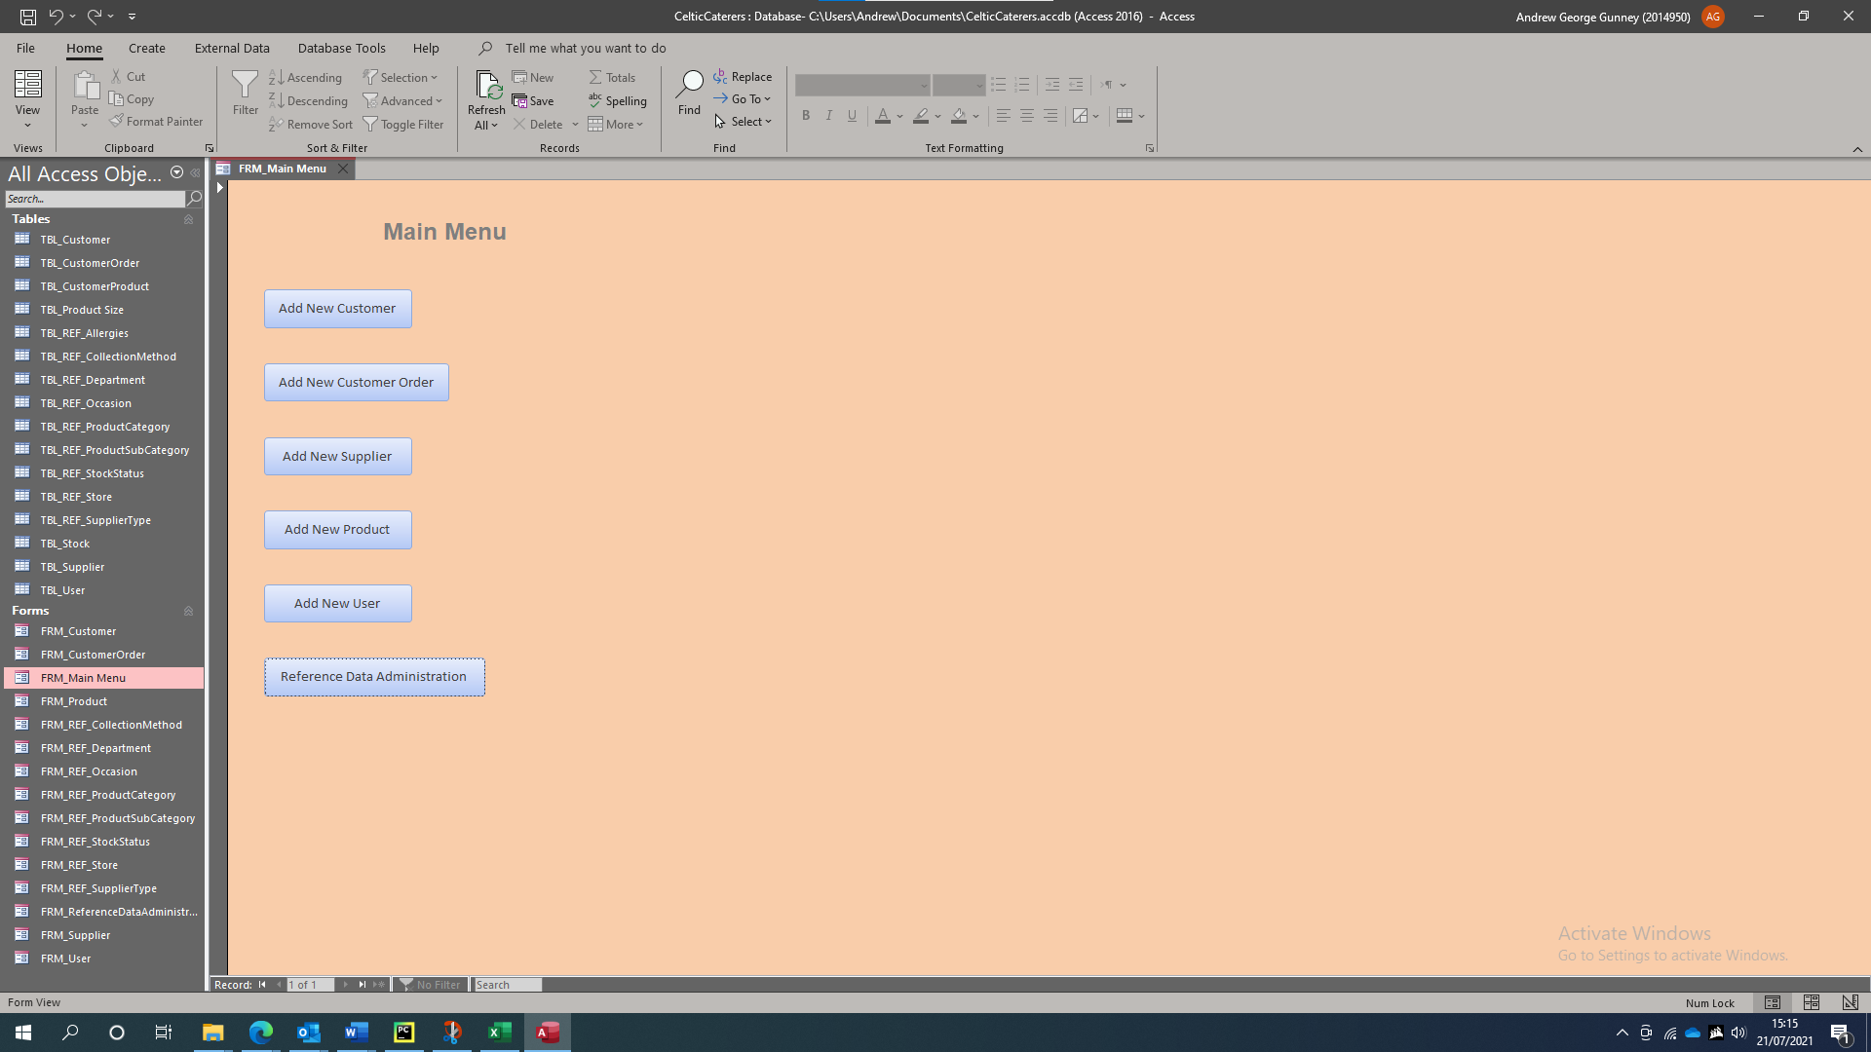

New Customer

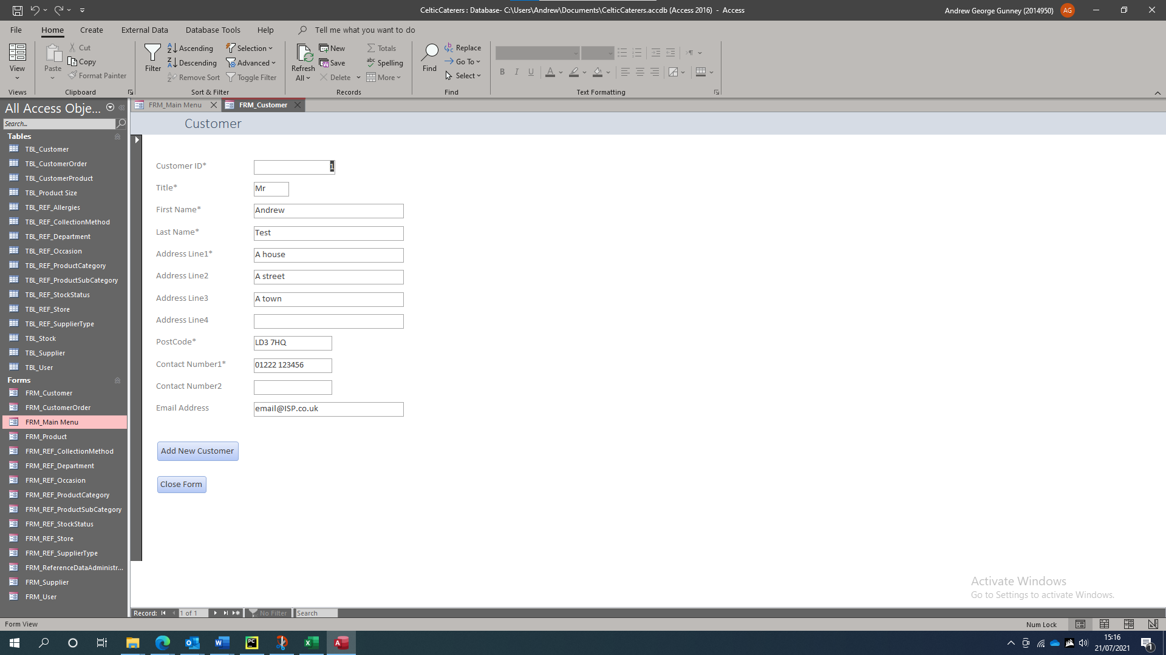

New Customer Order

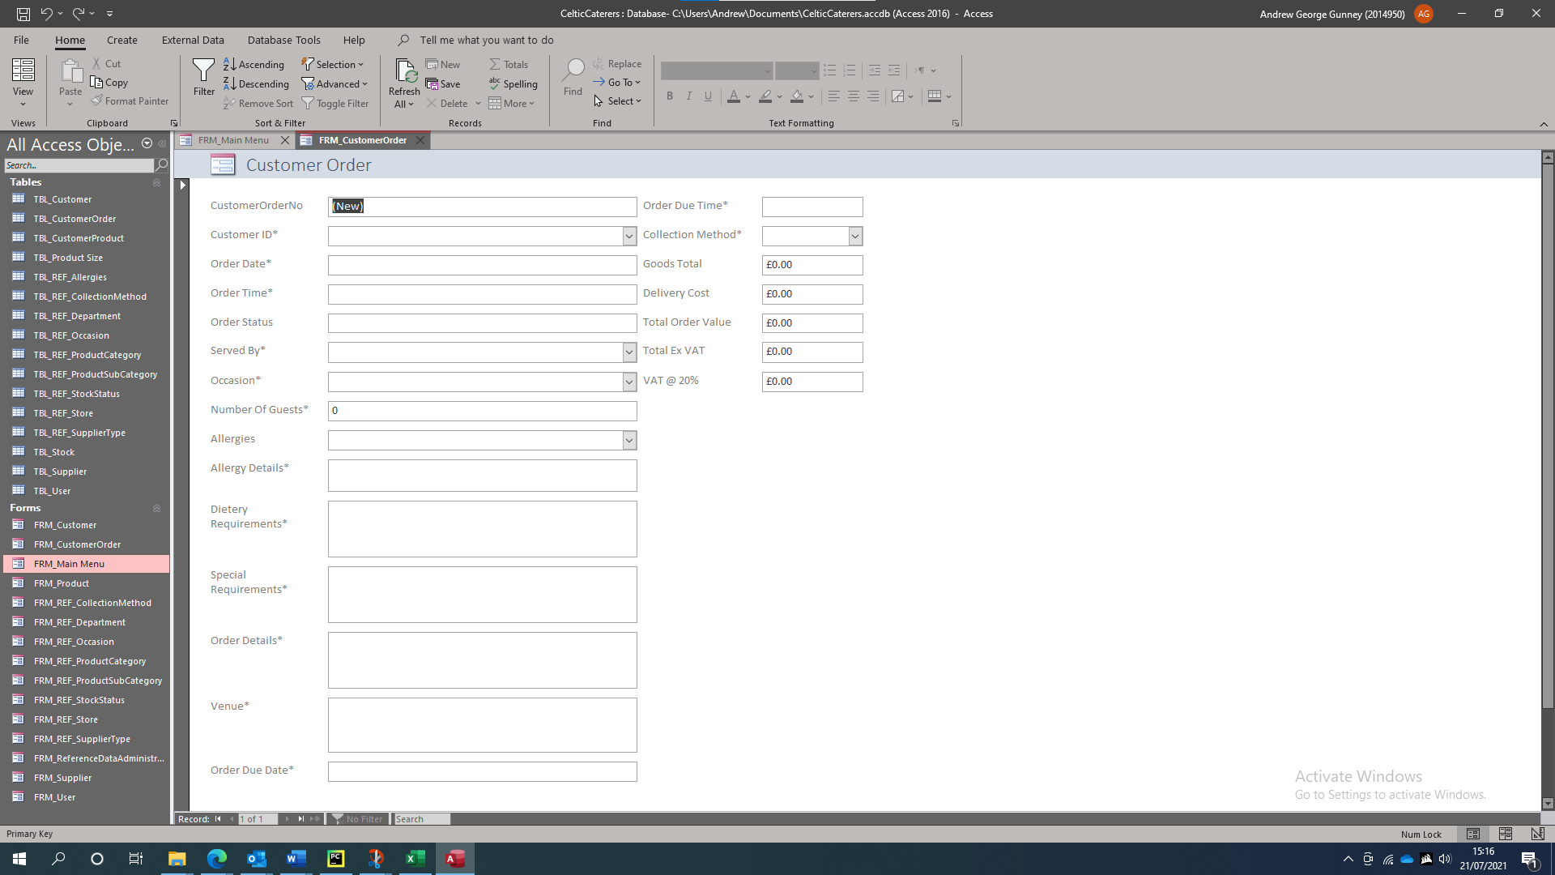

New Supplier

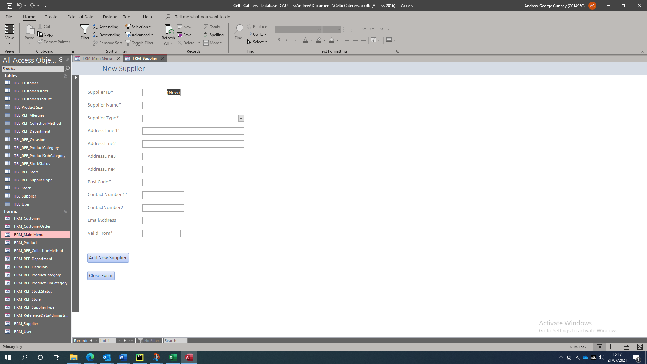

New Product

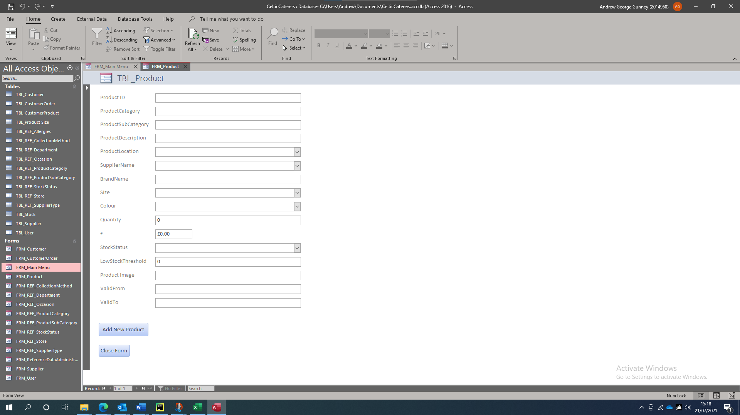

Add New User

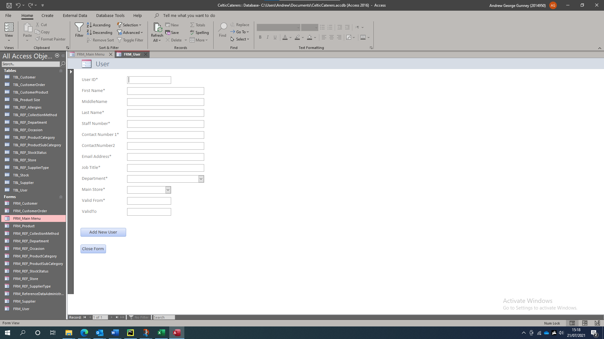

Reference Data Administration

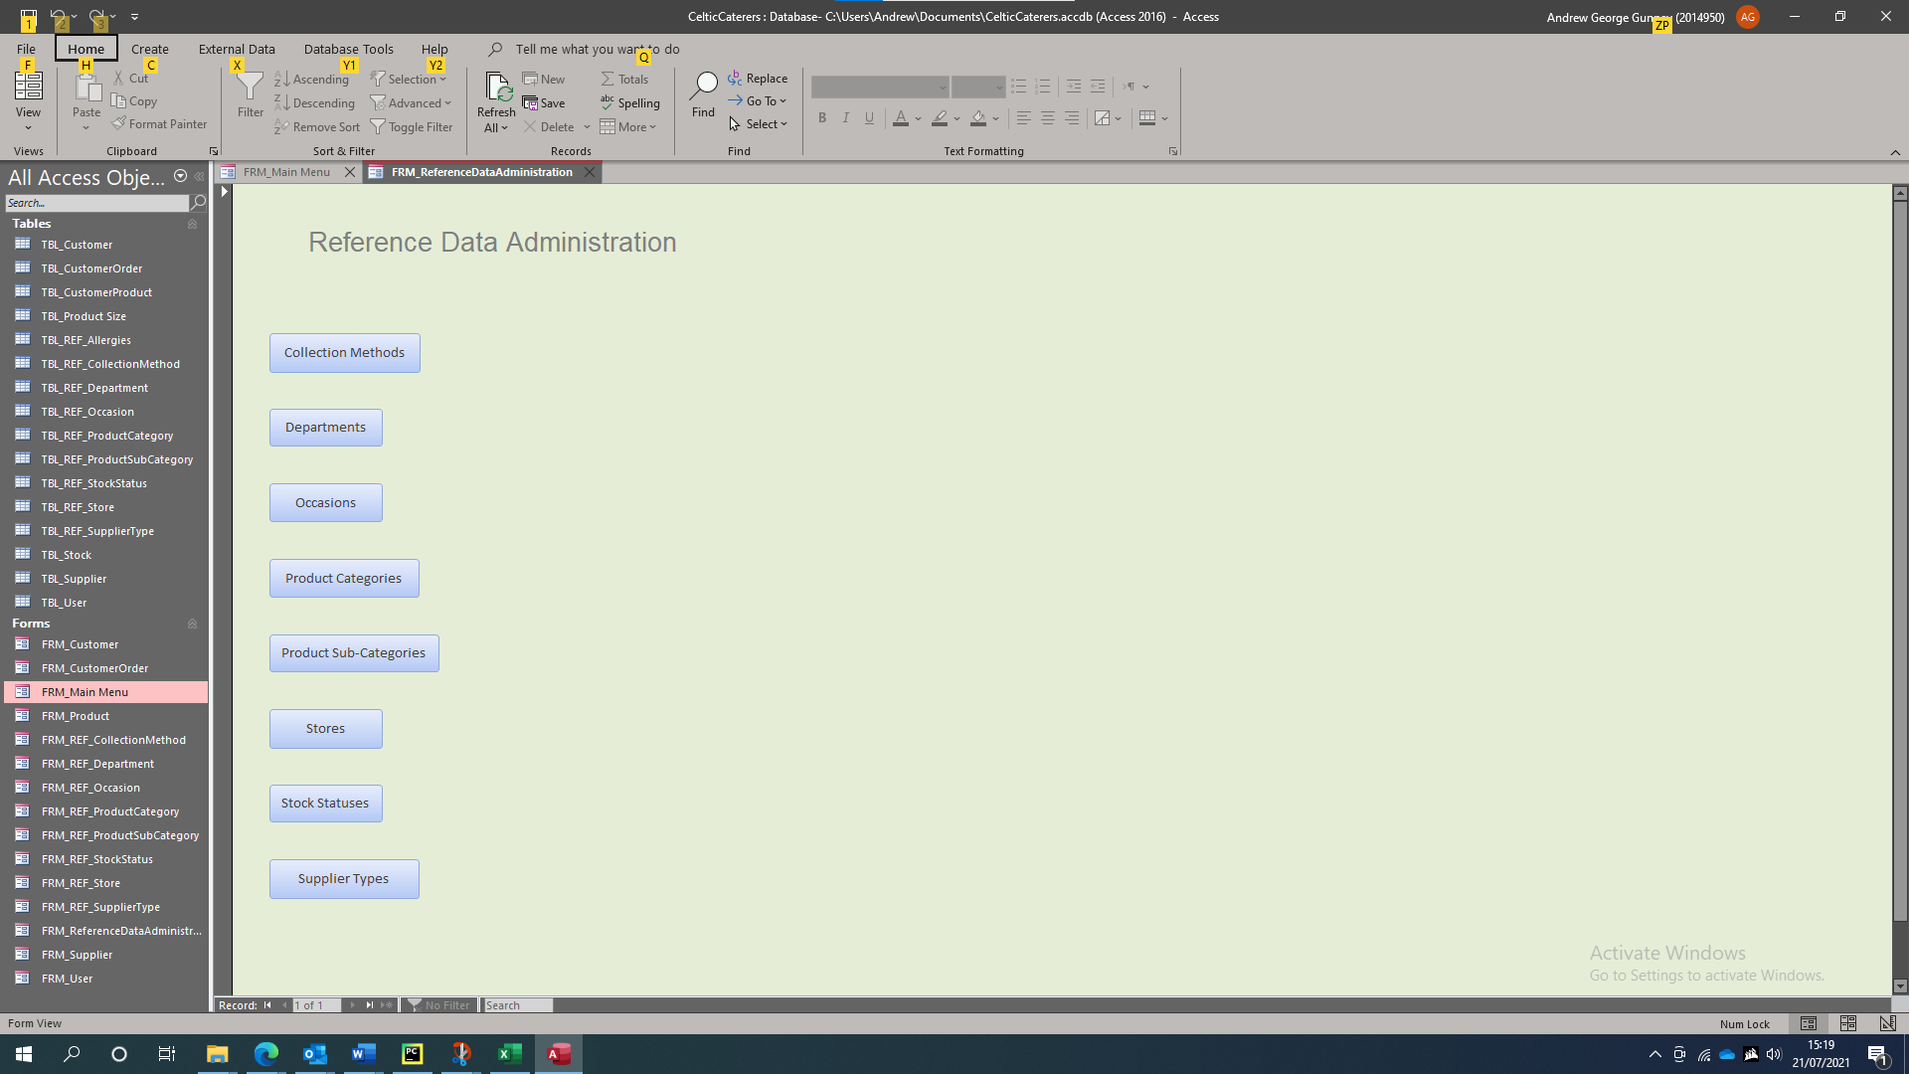

Entity Relationships



