ASSIGNMENT 2
MENU ENGINEERING

Student name: Stefan Lucian Mihaita
Student ID number: 2234126
Module title: Food and Beverage Operations
Lecturer’s name: Muhammad Cassamo
Word count: 1339
Date: 09/06/2023

Table of Contents
PART 1: Restaurant Concept 2
Restaurant concept 2
Target audience 2
The reason behind menu choices 3
PART 2: Menu Design 3
Food and Beverage Selection: 3
Pricing Strategy: 5
Nutrition and Special Dietary Requirements: 7
Menu Layout and Design: 7
References list 9

PART 1: Restaurant Concept

Restaurant concept
The Trinity Hotel chain will have an all-you-can-eat system to serve the menu to the customer. The same as a buffet, all-you-can-eat food services let patrons come back for more food and eat as much as they want. They vary in that patrons at all-you-can-eat establishments purchase meals from a menu or choose products from a restricted selection of selections.
This kind of service is frequently utilised at eateries that specialise in informal dining, including barbecue. The menu contains different types of fruits, vegetables and some sea fish which contain protein and nutrition and are healthy and tasty. The utensils or the serving plates and bowl are colourful which make the customers more happy (Collis et al. 2023). The decoration of the hotel is normal like a home and the Trinity hotel has 6 to 10 seater and also arrange the tables as part of the requirement of customers for any family gathering.
The Trinity Hotel chain provides fresh fruits and vegetables and they allow customers to visit their cooking place to keep transparency between them. The hotel not only provides tasty food but also serve its products with care and respect which will make the hotel more unique than other food and beverage company in the UK.

Target audience
A specific group of customers that the Trinity Hotel chain wants to attract and appeal to is known as the target audience. The restaurant's offerings are most likely to be purchased by this group. Single grown-ups, families with small kids, wellbeing-cognizant people, occupied experts, void nesters, retired people, understudies, guests to a city or town, and people with food sensitivities or dietary limitations are instances of the interest group of the Trinity Inn network (BABIJDIR and ORLENCO, 2022).
Some people might be looking for new dining experiences, the best of fast food and casual dining, healthy food at a reasonable price, good food that doesn't take too long to get, good food that doesn't take too long to get, or good food that doesn't take too long to get. It is possible to start with the end in mind or make use of existing assets when defining the target audience.

The reason behind menu choices
The menu gives grilled Salmon, it gives 121 calories, 5.4g of fat counting useful omega-3 unsaturated fats and refreshing polyunsaturated or monounsaturated fats, and 37.4mg of sodium. Treacle Tart has 382 calories, 64.1 g of total carbohydrates, 63 g of net carbohydrates, 14 g of fat, and 2.9 g of protein per serving (Carbmanager, 2023). Cock-a-Leekie Soup, canned 22 Calories, and Cheddar Scone has Calories 250, Fat 10g of, Carbs 34g, and Protein 7g. Cawl has 51 grams of protein, 22 grams of carbohydrates (including 10.5 grams of sugar), 36 grams of fat (including 16 grams of saturated fat), 7 grams of fibre, and 0.7 grams of salt per serving (Verywellfit, 2023). 1263 calories are in cranachan, while 202 calories, 3% fats, 91% carbohydrates, and 6% protein are in the seasonal pudding. That is why the above menus are designed by the Trinity Hotel chain.

PART 2: Menu Design
“Hangover of Q-Quality and Quantity”

Food and Beverage Selection:
- Grilled Salmon
- Cock-a-Leekie Soup
- Cawl
- Spaghetti Carbonara served with bacon and garlic bread
- Tweed Kettle
- Phall
- Cheddar Scone
- Mulligatawny
- Cranachan
- Treacle Tart
- Seasonal pudding
- Knickerbocker Glory
- Salted caramel chocolate cups served with roasted nuts
- Avocado mac and cheese
- Shredded rainbow salad with edamame
- Chicken nuggets
- Fish and chips
- Pizza
- Spaghetti and meatballs
- Quesadillas
- Butter bean salad with avocado, pesto and pumpkin seeds
- Red Pea Soup
- Peanut Butter Chicken
- Honey Chicken
- Harissa Cauliflower Pilaf
- Szechuan Crispy Tofu and Vegetable Stir Fry
- Sheet-Pan Honey Mustard Chicken
- Pulled Mushroom Tacos With Salsa Guille
- Cauliflower Puttanesca
- Strawberry smoothie
- Blackberry smoothie
- Mixed fruit smoothie
- Black coffee
- Coffee
- Scotch Eggs
- Crumpets
- Chip Butty
- Welsh Cakes
- Marmite on Toast
- Jaffa Cakes
- Diet
- Pepsi
- Tango
- Water
- Grace Bridge Chardonnay, Californi
- Banfi Pinot Grigio, Italy
- Shallow Seas Rose, Oregon
- Manhattan
- Cosmopolitan
- Old fashioned

Pricing Strategy:
Grilled Salmon - £3
Cock-a-Leekie Soup - £2
Cawl - £2.5
Tweed Kettle - £2
Spaghetti Carbonara served with bacon and garlic bread- £6
Phall- £2.5
Cheddar Scone - £2
Mulligatawny - £2
Cranachan- £1.5
Treacle Tart - £1.5
Seasonal pudding - £2
Knickerbocker Glory - £1.5
Avocado mac and cheese- £4
Shredded rainbow salad with edamame- £3.5
Chicken nuggets- £2.5
Fish and chips- £3
Pizza- £2.5
Spaghetti and meatballs- £3
Quesadillas- £2.5
Butter bean salad with avocado, pesto and pumpkin seeds- £3.8
Salted caramel chocolate cups served with roasted nuts -- £6.99
Red Pea Soup - £2.7
Peanut Butter Chicken - £2.8
Honey Chicken - £1.5
Harissa Cauliflower Pilaf - £1.9
Szechuan Crispy Tofu and Vegetable Stir Fry- £1.5
Sheet-Pan Honey Mustard Chicken- £2.5
Pulled Mushroom Tacos With Salsa Guille- £2
Cauliflower Puttanesca- £2.5
Strawberry smoothie - £1.3
Blackberry smoothie - £1.3
Mixed fruit smoothie- £1.5
Black coffee- £1
Coffee- £1
Scotch Eggs - £1
Crumpets - £1
Chip Butty - £1
Welsh Cakes - £1.5
Marmite on Toast - £2
Jaffa Cakes - £1.5
Diet- £2.99
Pepsi- £2.99
Tango- £2.99
Water- £2.99
Grace Bridge Chardonnay, Californi- £3.99- £15.99
Banfi Pinot Grigio, Italy- £3.99- £15.99
Shallow Seas Rose, Oregon- £3.99- £18.99
Manhattan- £8
Cosmopolitan- £7.99
Old fashioned- £9.99
Value-based pricing is one of the most common pricing techniques used by the Trinity Hotel company. Customers are assumed to note price as the key determinant of an item's worth under value pricing (Ing et al. 2020).
Another tactic is penetration pricing, which involves establishing the first selling price far less than what would typically be the case in order to gain entry into the UK market. The Trinity Hotel sets its rates in accordance with the perceived worth of its menu items. This may enable the business to charge more for dishes that are special or of better calibre.

Nutrition and Special Dietary Requirements:
The most common ingredients for the selected menu are milk, egg, apple, seasonal fruits, Salmon fish, bread, chicken, lamb, water and so on which contain a huge amount of protein and nutrition to the customers (Paris and McKown, 2023). All the materials are mostly gluten and lactose-free and maintain the calories as per the human body.

Menu Layout and Design:
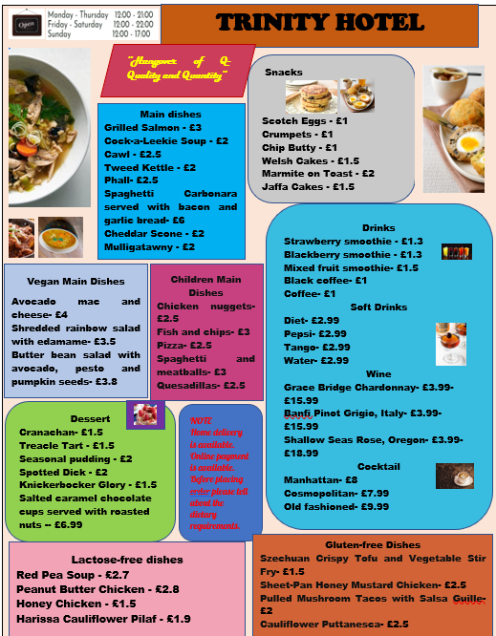
Sustainability and Seasonality:
The main vegetables and fruits that have been selected as ingredients in the recipes are fresh parsley, corn, apple and carrots. There are several fruit selections available here that are both healthy and delicious for all visitors.
People are increasingly interested in staying in shape, thus the restaurant chose a seasonal menu to maintain the viability of the business. Additionally, food and catering establishments will adhere to the "Health and Safety at Work Act 1974" statute (Moretta, Tombs, and Whyte, 2022).

References list

BABIJDIR, Z. and ORLENCO, O., 2022. Statistical analysis of the restaurant business based on a local network.
Carbmanager.com. 2023. https://www.carbmanager.com/food-detail/md:bad75371b133b8254b589966afec53cd/treacle-tart [Accessed on 03/06/2023]
Collis, B., Baxter, W., Baird, H.M., Meade, K. and Webb, T.L., 2023. Signs of Use Present a Barrier to Reusable Packaging Systems for Takeaway Food. Sustainability, 15(11), p.8857.
Ing, P.G., Zheng Lin, N., Xu, M. and Thurasamy, R., 2020. Customer loyalty in Sabah full service restaurant. Asia Pacific Journal of Marketing and Logistics, 32(7), pp.1407-1429.
Moretta, A., Tombs, S. and Whyte, D., 2022. The Escalating Crisis of Health and Safety Law Enforcement in Great Britain: What Does Brexit Mean?. International Journal of Environmental Research and Public Health, 19(5), p.3134.
Paris, J. and McKown, K., 2023. Chapter Fifteen: Menu Planning and Food Safety. Safety, Health and Nutrition in Early Childhood Education.
Verywellfit.com. 2023. https://www.verywellfit.com/daily-diet-composition-calculator-charts-carbs-protein-fat-3861072 [Accessed on 03/06/2023]

